Cite this: ACS Appl. Mater. Interfaces 2021, 13, 32, 38499–38507
Publication Date: August 7, 2021
https://doi.org/10.1021/acsami.1c09750

Supporting Information
Determining out-of-plane hole mobility in CuSCN via the time-of-flight technique to elucidate its function in perovskite solar cells
Lokeshwari Mohan^{1,2}, Sinclair R. Ratnasingham^{1,2}, Julianna Panidi³, Matyas Daboczi³, Ji-Seon Kim³, Thomas D. Anthopoulos⁴, Joe Briscoe^{2*}, Martyn A. McLachlan^{1*} and Theo Kreouzis^{5*}
¹ Department of Materials and Centre for Processable Electronics, Imperial College London, Molecular Sciences Research Hub, White City Campus, London W12 0BZ, United Kingdom
² School of Engineering and Materials Science and Materials Research Institute, Queen Mary University of London, Mile End Road, London E1 4NS, United Kingdom
³ Department of Physics and Centre for Processable Electronics, Imperial College London, South Kensington, London SW7 2AZ, United Kingdom
⁴ Division of Physical Sciences and Engineering, King Abdullah University of Science and Technology (KAUST), Thuwal 23955-6900, Saudi Arabia
⁵ School of Physics and Astronomy, Queen Mary University of London, Mile End Road, London E1 4NS, United Kingdom
*t.kreouzis@qmul.ac.uk, martyn.mclachlan@imperial.ac.uk, j.briscoe@qmul.ac.uk

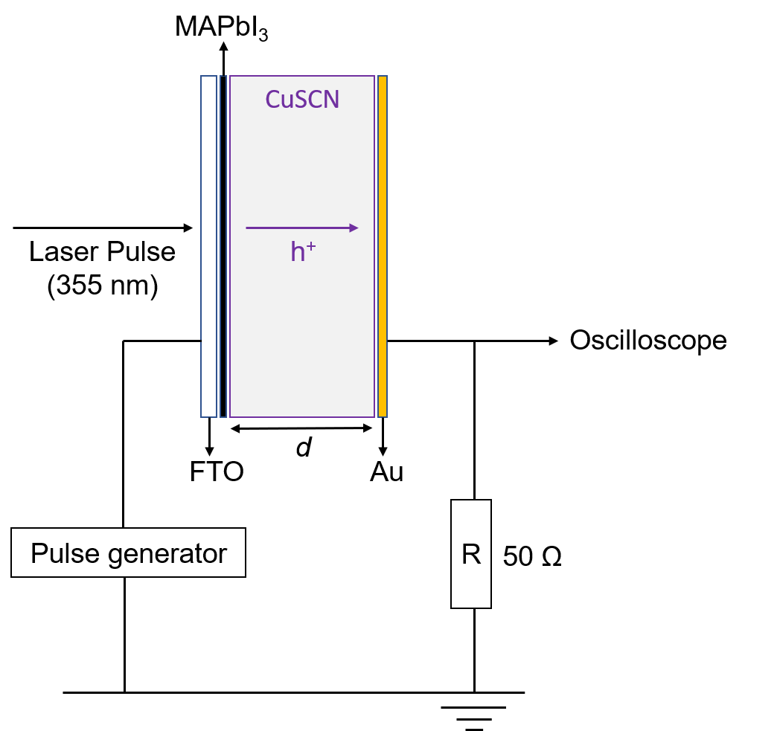
Figure S1. Schematic of ToF set up (d= 1.5 or 4 µm).
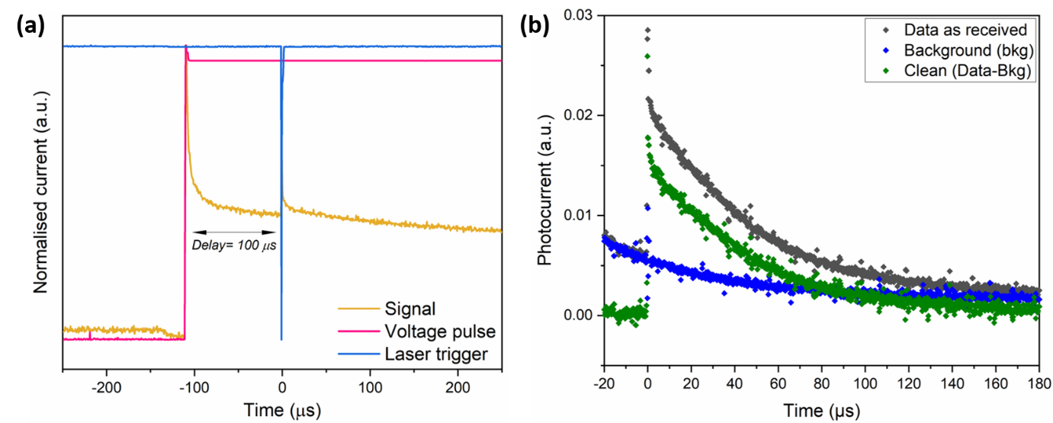
Figure S2. (a) Example oscilloscope trace showing the timing sequence: the first signal peak is displacement current and the second peak is photocurrent. (b) Example of how the data was normalised using background/ dark current.
The oscilloscope trace in Figure S2a shows the timing sequence of each component. The assembly was synchronized such that the delay between the voltage being applied and laser trigger was 100 µs. This allowed prevention of the displacement current (the first signal peak) from influencing the photocurrent, which is the second signal peak.
Background measurement in Figure S2b was obtained by blocking the laser output. Background was corrected for each measurement taken at different voltages.

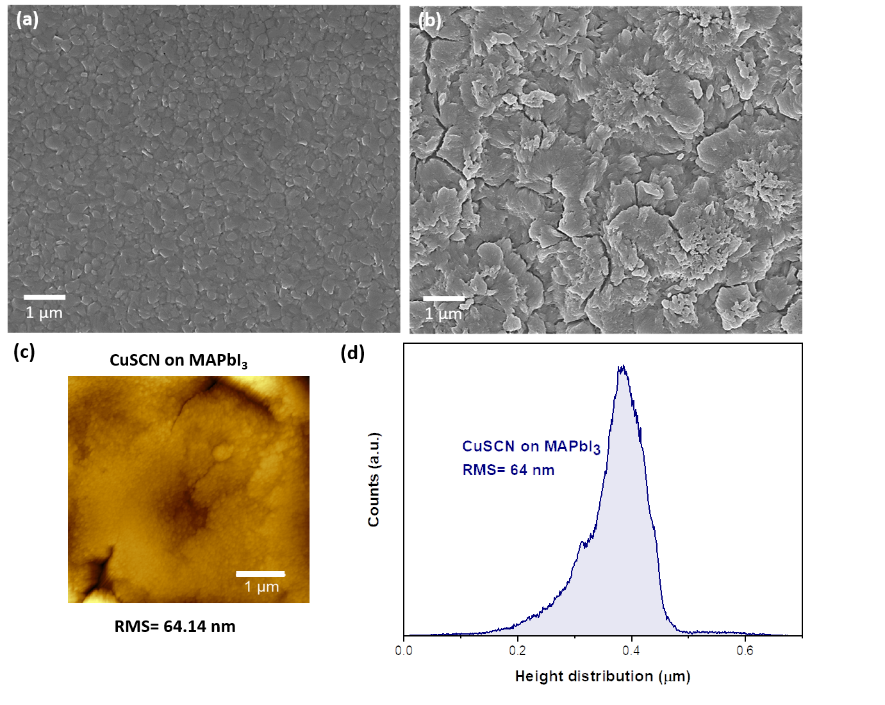
Figure S3. (a) Morphology of 1.5 M MAPbI₃ film on FTO and (b) AACVD CuSCN on MAPbI₃. (c) AFM topography scans and corresponding height distribution (d) indicating root mean square roughness (RMS) of 64 nm for CuSCN on MAPbI₃.
SEM surface morphology images of the 1.5 M MAPbI₃ layer (Figure S3a) shows even coverage with no pinholes which could compromise PSC performance due to charge recombination and increased rate of degradation. Figure S3b shows uniform coverage of AACVD CuSCN on MAPbI₃ with a RMS roughness of ~64 nm. This value is considerably lower than the RMS roughness of CuSCN when it is directly deposited on FTO (92 nm) ¹.

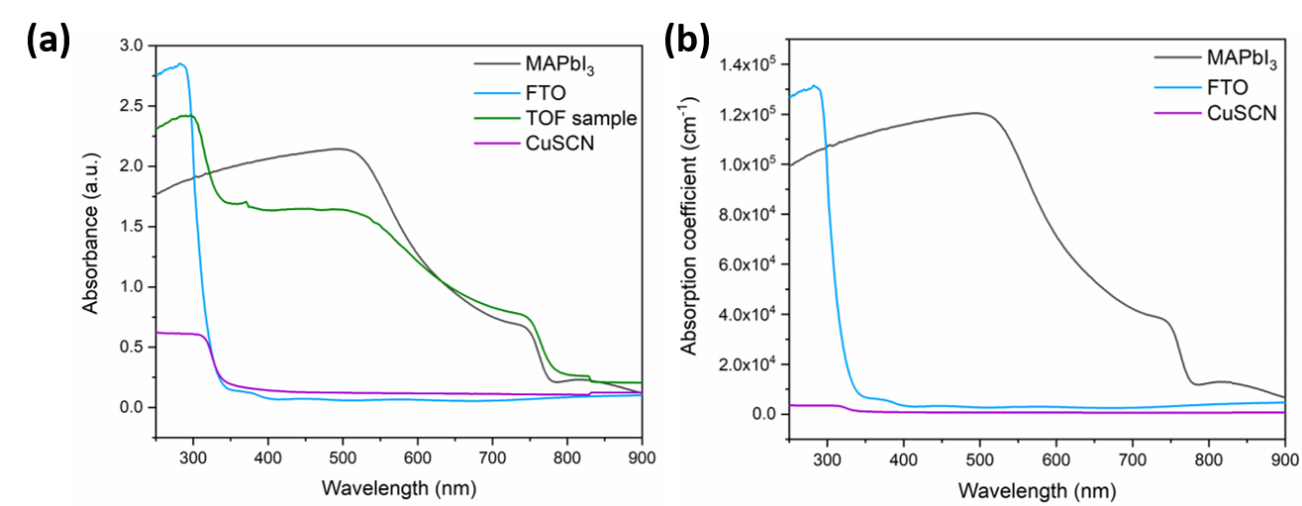
Figure S4. (a) Raw absorbance data for the different layers and complete ToF device shown in Figure 1b in the main paper. (b) Absorption coefficient as a function of wavelength for MAPbI₃, FTO and CuSCN.

Table S1. Layer thickness used to calculate the absorption coefficients in Figure S4b.
Layer | Thickness (nm)
FTO | 500
MAPbI₃ | 410
CuSCN | 4000

Figure S5. Indexed XRD patterns for MAPbI₃ and 4 µm CuSCN on MAPbI₃ plotted on a logarithmic scale.

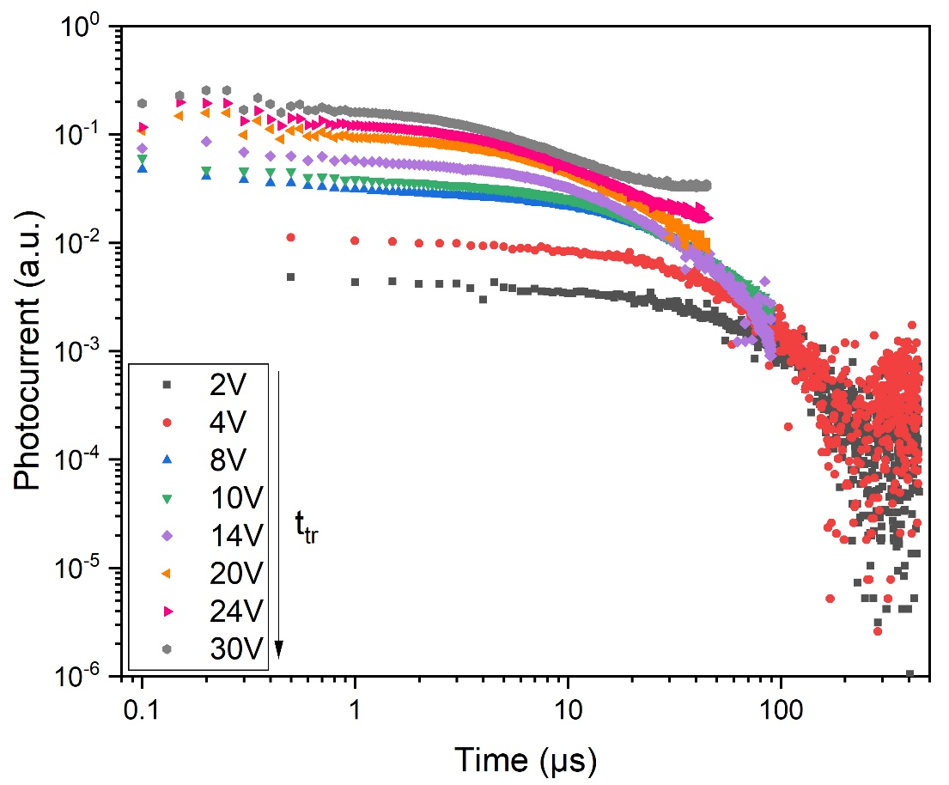

Figure S6. Hole transients ranging from 2-30 V are plotted on the same graph showing the shift in arrival times with increasing voltage.
The whole range of ToF transients plotted on a double logarithmic plot showing a decrease in transit time with an increase in voltage as expected.

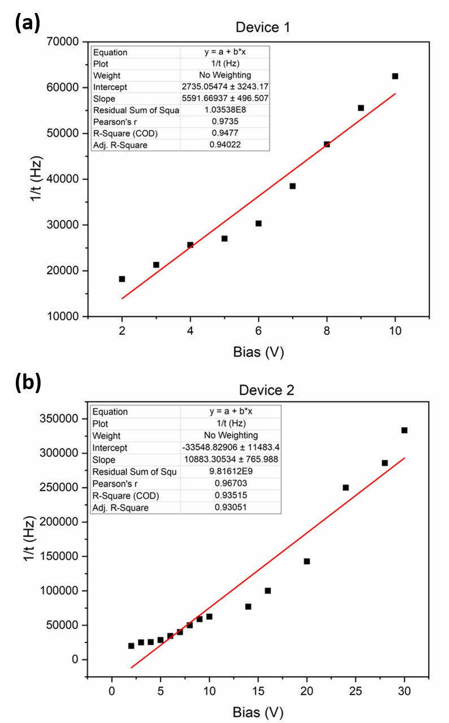
Figure S7. Plots a and b are used to calculate the mobility for (a) device 1 and (b) device 2. Mobility was calculated to be ~ 10⁻³ cm²/Vs similar to the values obtained from Poole-Frenkel plots.
1/t_{tr} vs V plots for two devices are shown in Figure S7. Device 1 is measured from 2-10 V and device 2 is measured across a broader range of voltages from 2-30 V. The mobility ($μ$) is calculated using the slope value and bulk thickness ($d$) according to equation (S1).
$$μ= slope×d^{2} (S1)$$
The mobilities calculated are ~10⁻³ cm²/Vs and are in support of those stated in Poole-Frenkel plots (Figure 3 in the main paper).
For example, in Figure S7a the slope is 5591 (Vs)⁻¹ and the CuSCN layer thickness is 4000 nm giving an average mobility of 8.9 x 10⁻⁴ cm²/Vs (~10⁻³ cm²/Vs). For device 2 in Figure S7b, the slope is 10883 (Vs)⁻¹ and with the same CuSCN layer thickness, the average mobility is calculated to be 1.7 x 10⁻³ cm²/Vs. Here, at higher fields the average linear fit is less appropriate justifying the use of a Poole-Frenkel plot (Figure 3b in the main paper).

Figure S8. Poole-Frenkel plot showing weak field dependence of charge carrier mobility at low fields.

Table S2. Series (R_{S}) and shunt (R_{SH}) resistance values for champion cells
PSC architecture (scan direction) | R_{s} (Ω cm²) | R_{SH} (Ω cm²)
FTO/ TiO₂/ MAPbI₃/spin coated CuSCN/Au (forward) | 13.5 | 114.4
FTO/ TiO₂/ MAPbI₃/ spin coated CuSCN/ Au (reverse) | 9.2 | 847.5
FTO/ TiO₂/ MAPbI₃/ AACVD CuSCN/ Au (forward) | 22.7 | 152.7
FTO/ TiO₂/ MAPbI₃/ AACVD CuSCN/ Au (reverse) | 15.3 | 1395.9

Figure S9. Ambient photoemission spectra of AACVD and spin coated CuSCN. A linear fit was used to determine the valence band edge (E_{v}) value.

References

(1) Mohan, L.; Ratnasingham, S. R.; Panidi, J.; Anthopoulos, T. D.; Binions, R.; McLachlan, M. A.; Briscoe, J. Low Temperature Scalable Deposition of Copper(I) Thiocyanate Films via Aerosol-Assisted Chemical Vapor Deposition. Cryst. Growth Des. 2020, 20 (8), 5380–5386. https://doi.org/10.1021/acs.cgd.0c00605.

