Original article
Morphology and Computational Fluid Dynamics Support a Novel Classification of Common Iliac Aneurysms

Louis P Parker,^{a,b} Janet T Powell,^{c} Lachlan J Kelsey,^{a,b} Maarit Venermo,^{d} Igor Koncar,^{e} Paul E Norman,^{a,f} and Barry J Doyle^{a,b,g,h}

a. Vascular Engineering Laboratory, Harry Perkins Institute of Medical Research, QEII Medical Centre, Nedlands and Centre for Medical Research, The University of Western Australia, Perth, Australia.
b. School of Engineering, The University of Western Australia, Perth, Australia.
c. Vascular Surgery Research Group, Imperial College London, London, UK.
d. Division of Vascular Surgery, Helsinki University Central Hospital, Helsinki, Finland.
e. Clinic for Vascular and Endovascular Surgery, Belgrade, Serbia.
f. Medical School, The University of Western Australia, Perth, Australia.
g. Australian Research Council Centre for Personalised Therapeutics Technologies, Australia.
h. BHF Centre for Cardiovascular Science, The University of Edinburgh, Edinburgh, UK.

Running head: Common Iliac Aneurysms.

Word Count: 2,750 (main body).

Corresponding Author:
Barry Doyle, Tel: +61 8 6151 1084, Fax: +61 8 6151 1084, Email: barry.doyle@uwa.edu.au
6 Verdun Street, Nedlands, Western Australia, 6009.
Some of these data were presented at the European Society of Vascular Surgery meeting in Valencia, Spain, September 2018.

What this paper adds:
This paper proposes a novel classification of common iliac artery aneurysms, which is relevant for future studies on the prognosis of such aneurysms. The three groups are differ in size, shape, calcification, thrombosis and haemodynamics. The observations of this study question the applicability of a 35 mm threshold for CIAA repair and explore an alternative which seeks to summarise aneurysm haemodynamics through morphology. This classification has the potential to aid in the risk stratification of CIAA however these morphological groups need to be assessed longitudinally and in larger cohorts.

ABSTRACT
Objectives: Isolated common iliac artery aneurysms (CIAAs) are uncommon and evidence concerning their development, progression and management is weak. Our objective was to describe the morphology and haemodynamics of isolated CIAAs in a retrospective study.
Methods: Initially a series of 25 isolated CIAAs (15 intact, 10 ruptured) in 23 patients were gathered from multiple centres, reconstructed from computed tomography (CT), then morphologically classified and analysed with computational fluid dynamics. The morphological classification was applied in a separate, consecutive cohort of 162 patients assessed for elective aorto-iliac intervention, in which 45 patients had intact CIAAs.
Results: In the isolated CIAA cohort, three distinct morphologies were identified: complex, fusiform and kinked (distal to a sharp bend in the CIA), with mean diameters 90.3, 48.3 and 31.7 mm, and mean time-averaged wall shear stress of 0.16, 0.31 and 0.71 Pa, respectively (both ANOVA p<.001). Kinked cases, compared to fusiform cases, had less thrombus and favourable haemodynamics similar to the non-aneurysmal contralateral CIA. Ruptured isolated CIAA were large (mean diameter 87.5mm, range 55.5-138.0mm) and predominantly complex. Mean CIA length for aneurysmal arteries was greatest in kinked cases followed by complex and fusiform (100.8mm, 91.1mm and 80.6mm respectively). The morphological classification was readily applicable to a separate elective patient cohort.
Conclusions: A new morphological categorization of CIAAs is proposed. This is potentially associated with both haemodynamics and clinical course. Further research is required to determine whether the kinked CIAA is haemodynamically protected from aneurysm progression and establish the wider applicability of the categorization presented.
Keywords (MeSH): iliac aneurysm, hemodynamics, aneurysm, iliac artery, aorta.

INTRODUCTION
Isolated common iliac artery aneurysms (CIAAs) are uncommon. The development and progression of these aneurysms has received scant attention, with the few available studies focusing on the outcomes of surgery. One of the largest published series, 59 patients, was collected over a 10-year period 1990-1999, where Reber et al. classified these aneurysms according to the extent of the disease (unilateral, bilateral, involvement of internal iliac artery).¹ More recently others have proposed classifying CIAAs from the perspective of suitability for endovascular repair, with classification according to the proximal and distal landing zones.² As with abdominal aortic aneurysm (AAA), isolated CIAAs are usually asymptomatic and many present with rupture.^{1, 3} Therefore, professional bodies in both Europe and the USA have recommended elective repair of CIAAs when the threshold of 35 mm is reached,^{4, 5} although the diagnostic threshold of >25 mm has also been proposed.⁴ Recent data⁶ shows that few internal iliac artery aneurysms rupture below 40 mm, an observation which may also be relevant to CIAAs.
Computational fluid dynamics (CFD) has been used to investigate thrombus formation and risk of rupture in AAA.^{7, 8} ⁹⁻¹¹ Low shear stress and high oscillation in the flow are established as contributing to aneurysm initiation and progression as well as increased thrombus and calcification burden.^{8, 12-14} Unilateral isolated CIAAs offer unparalleled opportunities for haemodynamic research, as the contralateral artery provides an in-built control. Nevertheless, the literature on this topic is sparse. There are two case reports of the application of CFD to explore the haemodynamics in CIAAs and very recently we have reported on the association between CIAA and proximal aortic remodelling.^{12, 15, 16} As part of our programme of work on CIAAs, we also identified a novel morphological classification of CIAAs. This novel classification and associated morphological and haemodynamic changes is presented here.

MATERIALS AND METHODS
Isolated CIAA Cohort
We identified 23 Caucasian patients (two with bilateral CIAAs) without an AAA, with pre-operative contrast-enhanced CT imaging (slice thickness 1-4mm) before either elective repair of intact CIAA (n=15) or emergency repair of ruptured CIAA (n=10). None of the CIAAs were reported as being associated with either connective tissue disorders or infection (mycotic aneurysm). Patients were from the UK (n=6), Finland (n=6), Serbia (n=9) and the Osirix Dicom Image Library (Pixmeo SARL, Switzerland) (n=2). For all cases except those from the online library, local ethics approvals were obtained before data were anonymised at the local institution and included in this study.

Patient-Specific Reconstructions and Geometric Analyses
The CT scans were used to reconstruct the CIAAs into three dimensions (3D) using commercially available software (Mimics v18.0, Materialise, Belgium) with each reconstruction beginning immediately distal to the renal arteries and terminating distal to the CIA bifurcation. All reconstructions were performed by one analyst (LP) and were processed further using the surface repair tools of STAR-CCM+ (v11.06, Siemens, Berlin) in order to remove reconstruction artefacts, conservatively smooth the lumen wall and remove the minor branching arteries that are not critical to the analyses.¹⁶ For each case; the aortic bifurcation angle, maximum CIAA diameter (perpendicular to the centreline, outer-to-outer diameter) and length of the CIA from the aortic bifurcation to the iliac bifurcation were measured (the repeatability of CIA length measurement was 0.17 mm and the repeatability of other measurements is given in the supplement to Parker et al.¹²). The most acute 3-point angle in the CIA (each point 1cm apart) was also used for morphology classification, these measurements were made in the coronal plane of the CT data. Calcification and intraluminal thrombus (ILT) were also reconstructed into 3D by Hounsfield value and volume was measured. Reconstruction and morphological measurement followed methods used previously, where inter- and intra-user variability was quantified and determined to be low.¹²

Computational Fluid Dynamics Simulations and Haemodynamic Metrics
All simulations follow previous methods¹² but in brief, STAR-CCM+ was used to create high quality computational meshes with data independent of element number. We applied a generalised massflow waveform obtained from 36 patients with AAA at the infrarenal aorta and flow splits at the outlet.¹⁷ We have showed previously that these boundary conditions do not noticeably affect the distributions of haemodynamic surface conditions and have included further sensitivity analysis in the Supplemental Material.¹² We simulated each case for at least six cardiac cycles and extracted time-averaged wall shear stress (TAWSS) and oscillatory shear index (OSI) data from the three final cycles: the ratio OSI/TAWSS was calculated and termed low and oscillatory shear (LOS), which is a useful metric of haemodynamic conditions (low is favourable, high indicates adverse conditions). Simulations were performed on the Magnus Supercomputer (Pawsey Supercomputing Centre, Perth, Western Australia) and typically took 60 min of computing time on 512 cores for a mesh with 2 million elements.

Validation Cohort
To determine if the morphological classification suggested in the isolated CIAA cohort was applicable more widely, a separate validation patient cohort was analysed. This was a consecutive series of 162 patients (including 25 women) at Charing Cross Hospital (London, UK), from a previous study comparing contrast-enhanced CT and duplex ultrasonography to evaluate suitability for a range of elective aorto-iliac endovascular interventions, including AAA repair and iliac angioplasty. This cohort included 117 patients with large AAA (5.6-9.4 cm diameter) evaluated for repair (of whom 36 also had CIAA; 26 unilateral and 10 bilateral) and 9 patients with CIAA evaluated for repair (4 isolated CIAA with maximum infrarenal aortic diameters of <3 cm and 5 with small AAA 3.2-4.8 cm diameter): none of the aneurysms were of an infectious aetiology or had a connective tissue disorder. Morphological parameters had been measured (using semi-automated methods for CT scans) and entered on to a database by vascular scientists. The morphological parameters assessed included abdominal aortic deflection, maximum aortic and CIA diameters (both outer-to-outer measurements), whether the CIA was tortuous or straight (tortuosity index ≥1.5 versus <1.5) and aortic bifurcation angulation. As there is no consensus on the definition of CIAA using diameter, CIAA was defined when the maximum external diameter was ≥25 mm (2 SD above the mean diameter for this cohort), in agreement with a previously recommended diagnostic threshold.⁴ On this basis, intact CIAAs were identified in 45 patients, with bilateral CIAAs in 10 patients but isolated CIAAs (no AAA) in only 4 patients. The morphology of the CIAAs was assessed in the CT image by 2 independent observers (one vascular scientist and one vascular surgery research fellow), according to a protocol abstracted from Table 1 by a senior vascular radiologist. Any differences of opinion were to be resolved by discussion with the radiologist.

Data Analysis
Data were adjusted for maximum CIA diameter and we compared the predictive quality of geometry and haemodynamic variables in the ruptured and intact groups. Morphological parameters were inspected for normality using the Shapiro-Wilk test, with summary data presented as mean (SD) for parametric data and median (IQR) for non-parametric data. Comparison of quantities across morphology categories were made using a student’s t-test for normally distributed data and the Mann-Whitney U test for all non-normally distributed data. Haemodynamic quantities in the CIAA were compared with the corresponding contralateral artery using a paired student’s t-test for normally distributed data and a Wilcoxon signed-rank test for non-normally distributed data. All statistics were performed using Real Statistics Resource Pack software (Release 5.4) for Excel (Microsoft, Washington, USA).

RESULTS
Three morphological variants of isolated CIAA
Inspection of the imaging of this relatively large number of different CIAAs made it apparent that they could be visually classified into three distinct morphological categories which we have named: complex, fusiform or kinked CIAA, this latter being an aneurysm which occurs distal to a tight bend in a tortuous common iliac artery (CIA) (Table 1). These classifications were initially made by an experienced vascular surgeon (PN) and the primary analyst (LP). To make these distinct morphological groups identifiable by others, a classification based on repeatable morphological measurements was defined in the isolated CIAA cohort. Complex cases had evidence of either aortic or iliac bifurcation involvement in the aneurysmal sac whilst fusiform cases displayed normal aortic and iliac bifurcation morphology. Kinked aneurysms then had a unique angulation in the coronal plane <100° and no bifurcation involvement.
The details and measurements according to morphological category are shown in Table 2. The diameter range for the unilateral or index CIAAs was 25 to 138 mm, and the diameters of the two contralateral CIAAs were 28 and 35 mm. All kinked aneurysms occurred in left CIAs, whereas fusiform CIAAs occurred in left and right CIAs. The complex group were the largest in diameter (vs. fusiform, p=.001), with the most ILT (vs. fusiform, p=.015) and calcification (vs. fusiform, p=.963). Furthermore, most complex cases (8/9) presented with rupture and were on the left side (8/9). Aneurysmal CIAs were longer than their corresponding contralateral CIA (90.8(22.0) vs. 78.8(20.0) mm, p<.001) and kinked CIAAs occurred in the longest arteries (100.8(24.1) mm) followed by complex (91.1(23.3) mm) and fusiform (80.6(10.9) mm).

Kinked CIAAs (n=8) had the least ILT (vs. fusiform (n=8), p=.001; vs. complex (n=9), p<.001) but there were no significant differences in calcifications and no ruptures.

Application of the three morphological variants to a separate validation cohort
In the validation cohort, 45/162 patients had CIAAs ≥25 mm diameter (10 bilateral) but only four of these were isolated CIAAs, the remainder being associated with an AAA (from 3.2 to 9.4 cm diameter). One case with a post-dissection aneurysm (large dissected flap at the proximal aneurysm) was difficult to classify but all the remaining CIAAs (54/55) could readily be classified as either kinked (n=28), fusiform (n=23) or complex (n=3) (Table 3). Kinked cases were more common in the left CIA (19/28), whilst fusiform CIAAs were more common in the right CIA (14/23). Fusiform aneurysms were larger than kinked aneurysms (mean diameter 44 vs. 29 mm, p<.001) and complex aneurysms, one on the right and two on the left, projected anteriorly and were larger still (diameters 41, 52 and 62 mm).

Haemodynamics and morphology of isolated CIAAs
In all eight kinked CIAA cases the angulation of the CIA was observed to direct blood at high velocity close to the aneurysm wall, creating high wall shear stress (i.e. high TAWSS) and favourable haemodynamic conditions, in contrast to the fusiform cases (Figure 1). Both TAWSS and LOS were similar in unilateral kinked CIAA and the non-aneurysmal contralateral artery (TAWSS: 0.71 vs. 0.70 Pa, p=.58 and OSI: 0.19 vs. 0.17, p=.47). In contrast, for the complex variants, TAWSS was lower than in the non-aneurysmal contralateral artery (p=.004, Table 2). Wall shear stress was lowest in the large complex CIAAs and although fusiform and kinked CIAAs had an overlapping diameter spectrum, TAWSS in fusiform CIAAs was less than half that in the kinked variants (0.31 vs. 0.71 Pa, p=.010). The changes in OSI were less marked. However, the LOS increased markedly in fusiform and complex aneurysms, was higher than in the contralateral non-aneurysmal artery and was higher in fusiform and complex aneurysms compared with kinked variants (p=.010 and p=.011, respectively).

DISCUSSION
Inspection of the morphology of isolated CIAAs, has suggested a novel morphological categorization; kinked (fusiform aneurysm distal to a sharp bend in the proximal CIA), fusiform and complex. This simple categorization also was readily applicable to 54/55 CIAAs in a separate cross-sectional clinical cohort, where the majority of CIAAs occurred distal to an AAA. The haemodynamic studies showed that wall shear stress decreased with increasing CIAA diameter and that although there were adverse haemodynamic characteristics for the fusiform and complex variants, the unilateral kinked variants had similar haemodynamics to the non-aneurysmal contralateral artery. Therefore, this study suggests a new classification of CIAAs, which is pertinent to questions concerning the natural history and clinical progression of CIAAs.

First, are the three morphological variants at different stages of CIAA progression (Figure 2)? The kinked morphologies were predominantly in the left CIA and could have stabilised at an early phase of progression because of the proximal angulation of the CIA creating high wall shear stress throughout the CIAA (similar to the non-aneurysmal contralateral CIA for unilateral cases). Our snapshot data provide no information as to whether any of these kinked CIAAs would progress to the fusiform variant, although this seems unlikely since it would involve loss of the sharp bend in the proximal CIA if, and when, they enlarge, or whether tortuous remodelling of the CIA might halt CIAA progression altogether. Fusiform CIAAs were larger, in shorter arteries with less tortuosity and were not predominantly in left CIAs and had more adverse haemodynamic conditions than kinked CIAAs (Figure 1). The reduced wall shear stress in fusiform CIAAs is likely to drive both aneurysm growth and ILT deposition, potentially increasing the risk of rupture. Over time, the aneurysm enlarges and assumes a complex morphology with rising thrombus burden, the haemodynamic characteristics worsen to further increase the likelihood of rupture. However, longitudinal studies are needed to answer such hypotheses.
Second, what should the threshold for intervention be, based on diameter alone? Current guidelines recommend elective repair of CIAAs when they reach 35 mm diameter.⁵ However, this recommendation is not based on high quality evidence and the present data question whether this is an appropriate intervention threshold, especially since some of these CIAAs will have a kinked morphology and favourable haemodynamics. 3/8 of the kinked CIA cases observed in this study exceed this threshold and yet no ruptures were observed in the group. Adherence to the 35 mm threshold would make longitudinal studies of CIAAs very challenging or even impossible.
Third, could the development of adverse haemodynamic indices in larger CIAAs be an indication for urgent CIAA repair? In the cohort of patients with isolated CIAAs, the very large complex CIAAs had the most adverse haemodynamics with the highest LOS (indicative of low TAWSS and high OSI) and the point of rupture usually was associated with regions of high LOS gradient.¹² The complex CIAAs also had the greatest thrombus burden of the three groups. Indeed, this link between adverse haemodynamic characteristics, in particular, low shear stress, and aneurysm rupture has been recently described for AAAs^{7, 18} as well as CIAAs.¹² Boyd et al.¹⁸ showed in seven AAAs that the site of rupture occurred in areas of flow recirculation and low shear stress. Doyle et al.⁷ investigated a single AAA case over four imaging time-points until eventual rupture and showed that the AAA expanded locally in the region of recirculating flow and low shear stress, before also rupturing in the same location.
Fourth, does the involvement of the iliac and/or aortic bifurcation indicate increased rupture risk? Complex CIAAs had the highest rupture rate of the three groups and it is possible that the involvement of the bifurcation in the aneurysmal sac adversely affects the haemodynamics, significantly increasing the risk of rupture. With involvement of the iliac bifurcation comes a risk of internal iliac artery occlusion, another potential risk factor for CIAA rupture that warrants further investigation.

Limitations
This study started as a retrospective analysis of sporadic cases of CIAA and another retrospective study was used to assess the applicability of the morphological classification, whereas a prospective study would have provided stronger evidence. Whilst consecutive data was analysed in the validation cohort this was not possible for the initial cohort of isolated CIAAs which were sourced from multiple centres and collected intermittently. Patient-specific inlet waveform data and blood-pressure measurements were not available for the isolated CIAA cohort; the sensitivity of the model to these assumptions is shown in the Supplemental Material. CIAAs are not detected in population-based ultrasonographic screening programmes for AAA, so population-based studies are not currently feasible. Therefore it is likely that the isolated CIAAs analysed here are more likely to be large and/or ruptured when compared with those in the general population. The relative rarity of isolated CIAA means that the analysed cohort is small, particularly once divided into subgroups. These aneurysms do however represent clinically-relevant cases where such a classification system may be of particular use. It is possible that the proposed morphological categorisation of smaller CIAAs into kinked and fusiform will not be applicable to other cohorts and ethnic groups and further work is necessary to apply the categorization to more complex CIAAs, including those with co-existing internal iliac aneurysms. Structural wall stress calculations have not been performed in this study given the absence of patient specific blood pressure measurements and a method of accurately quantifying arterial wall thickness (i.e. MRI data). Where in the future these data are available, any potential relationship between aneurysm morphology and wall stress would be worthwhile defining. For the ruptured CIAAs, we only had CTA post-rupture and therefore the geometry pre-rupture may be slightly different. However we know from previous work that the overall geometry may not differ greatly.¹⁹ Single time-point data allows us to appreciate the instantaneous haemodynamics of these aneurysms but does not elucidate any progression between morphology groups over time. Serial CIAA CT data will form the basis of further studies into these morphology categories.

Conclusion
The morphology of CIAAs appears to fall predominantly into one of three basic categories that can be defined by routine measurements. Each has distinct haemodynamic qualities with kinked cases displaying favourable haemodynamics. The proposed morphological classification of CIAAs, and the impact on prognosis, should be assessed in a prospective, cross-sectional cohort.

ACKNOWLEDGMENTS
This work was supported by the National Health and Medical Research Council (grants APP1063986 and APP1083572), the Australia and New Zealand Society for Vascular Surgery Research Foundation, and the William and Marlene Schrader Trust. This work also was supported by resources provided by the Pawsey Supercomputing Centre with funding from the Australian Government and the Government of Western Australia and the UK National Institute for Health Research (NIHR) Health Technology Assessment (HTA) program (project number 07/37/64). R Ashleigh, S Carver, M Ellis, P Herbert and O Malik assisted with completion of data for the validation cohort.

CONFLICT OF INTEREST STATEMENT
None to disclose.

REFERENCES
1. Reber PU, Brunner K, Hakki H, Stirnemann P, Kniemeyer HW. Incidence, classification and therapy of isolated pelvic artery aneurysm. Chirurg. 2001;72(4):419-24.
2. Melas N, Saratzis A, Dixon H, Saratzis N, Lazaridis J, Perdikides T, et al. Isolated common iliac artery aneurysms: a revised classification to assist endovascular repair. J Endovasc Ther. 2011;18(5):697-715.
3. Kobe A, Andreotti C, Puippe G, Rancic Z, Kopp R, Lachat M, et al. Primary Endovascular Elective Repair and Repair of Ruptured Isolated Iliac Artery Aneurysms Is Durable-Results of 72 Consecutive Patients. J Vasc Interv Radiol. 2018;29(12):1725-32.
4. Khosa F, Krinsky G, Macari M, Yucel EK, Berland LL. Managing incidental findings on abdominal and pelvic CT and MRI, Part 2: white paper of the ACR Incidental Findings Committee II on vascular findings. J Am Coll Radiol. 2013;10(10):789-94.
5. Wanhainen A, Verzini F, Van Herzeele I, Allaire E, Bown M, Cohnert T, et al. European Society for Vascular Surgery (ESVS) 2019 Clinical Practice Guidelines on the Management of Abdominal Aorto-iliac Artery Aneurysms. Eur J Vasc Endovasc Surg. 2019;57(1):8-93.
6. Laine MT, Bjorck M, Beiles CB, Szeberin Z, Thomson I, Altreuther M, et al. Few internal iliac artery aneurysms rupture under 4 cm. J Vasc Surg. 2017;65(1):76-81.
7. Doyle BJ, McGloughlin TM, Kavanagh EG, Hoskins PR. From Detection to Rupture: A Serial Computational Fluid Dynamics Case Study of a Rapidly Expanding, Patient-Specific, Ruptured Abdominal Aortic Aneurysm. In: Doyle B, Miller K, Wittek A, Nielsen PMF, editors. Computational Biomechanics for Medicine: Fundamental Science and Patient-specific Applications. New York, NY: Springer New York; 2014. p. 53-68.
8. Salsac AV, Sparks SR, Lasheras JC. Hemodynamic changes occurring during the progressive enlargement of abdominal aortic aneurysms. Ann Vasc Surg. 2004;18(1):14-21.
9. Di Achille P, Tellides G, Figueroa CA, Humphrey JD. A haemodynamic predictor of intraluminal thrombus formation in abdominal aortic aneurysms. Proceedings of the Royal Society A: Mathematical, Physical and Engineering Science. 2014;470.
10. Kelsey LJ, Powell JT, Norman PE, Miller K, Doyle BJ. A comparison of hemodynamic metrics and intraluminal thrombus burden in a common iliac artery aneurysm. Int J Numer Method Biomed Eng. 2016;Epub ahead of print:1-14.
11. Bhagavan D, Di Achille P, Humphrey JD. Strongly Coupled Morphological Features of Aortic Aneurysms Drive Intraluminal Thrombus. Sci Rep. 2018;8(1):13273.
12. Parker LP, Powell JT, Kelsey LJ, Lim B, Ashleigh R, Venermo M, et al. Morphology and Hemodynamics in Isolated Common Iliac Artery Aneurysms Impacts Proximal Aortic Remodeling. Arterioscler Thromb Vasc Biol. 2019:ATVBAHA119312687.
13. Ku DN, Giddens DP, Zarins CK, Glagov S. Pulsatile flow and atherosclerosis in the human carotid bifurcation. Positive correlation between plaque location and low oscillating shear stress. Arteriosclerosis. 1985;5(3):293-302.
14. Salsac AV, Sparks SR, Chomaz JM, Lasheras JC. Evolution of the wall shear stresses during the progressive enlargement of symmetric abdominal aortic aneurysms. Journal of Fluid Mechanics. 2006;560:19-51.
15. Kelsey LJ, Powell JT, Norman PE, Miller K, Doyle BJ. A comparison of hemodynamic metrics and intraluminal thrombus burden in a common iliac artery aneurysm. Int J Numer Method Biomed Eng. 2016;Epub ahead of print:e2821.
16. Kelsey LJ, Miller K, Norman PE, Powell JT, Doyle BJ. The influence of downstream branching arteries on upstream haemodynamics. J Biomech. 2016;49(13):3090-6.
17. Les AS, Yeung JJ, Schultz GM, Herfkens RJ, Dalman RL, Taylor CA. Supraceliac and Infrarenal Aortic Flow in Patients with Abdominal Aortic Aneurysms: Mean Flows, Waveforms, and Allometric Scaling Relationships. Cardiovasc Eng Technol. 2010;1(1).
18. Boyd AJ, Kuhn DC, Lozowy RJ, Kulbisky GP. Low wall shear stress predominates at sites of abdominal aortic aneurysm rupture. J Vasc Surg. 2016;63(6):1613-9.
19. Doyle BJ, McGloughlin TM, Miller K, Powell JT, Norman PE. Regions of high wall stress can predict the future location of rupture of abdominal aortic aneurysm. Cardiovascular and interventional radiology. 2014;37(3):815-8.

TABLES
Table 1. The three morphologies identified in the isolated CIAA cohort.
Category | Description | Typical Anterior Appearance
Complex | Antero-lateral projection involving aortic or common iliac bifurcation | 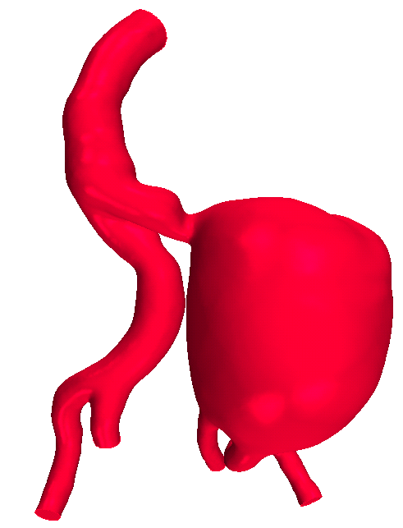
Fusiform | Fusiform aneurysm between the aortic and common iliac bifurcations (>10mm from centre of the bifurcation) | 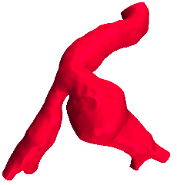
Kinked | Fusiform aneurysm distal to sharp coronal plane angulation in the CIA <100° | 

Morph. Class. | N | Left-sided  N [%] | Rupture  N [%] | Male  N [%] | Max. Diam.  mean (SD) [mm] | Diam. Range  [mm] | ILT Vol. mean [mm³] | Calc.  Vol.  mean [mm³] | Contra. TAWSS mean  [Pa] | Contra. OSI mean | Contra. LOS mean  [Pa⁻'] | CIAA TAWSS mean  [Pa] | CIAA OSI mean | CIAA LOS  mean [Pa⁻'] | Contra. length  mean | CIAA length  mean
Complex | 9 | 8 (89) | 8 (89) | 7 (78) | 90.3 (21.2) | 64.8-138.0 | 148,656 | 1,198 | 0.57 | 0.20 | 0.53 | 0.16 | 0.17 | 1.88 | 100.8 | 84.1*
Fusiform | 8 | 3 (38) | 2 (25) | 8 (100) | 48.3 (14.6) | 27.7-92.1 | 50,815 | 1,067 | 0.56 | 0.20 | 0.40 | 0.31 | 0.25 | 1.30 | 91.1 | 76.1
Kinked | 8 | 8 (100) | 0 (0) | 4 (50) | 31.7 (9.5) | 24.5-43.7 | 1,332 | 129 | 0.70 | 0.17 | 0.28 | 0.71 | 0.19 | 0.36 | 80.6 | 76.0
Table 2: Characteristics of the 23 patients with isolated CIAAs grouped by morphological classification.
* For one case contrast in the contralateral CIA was lost soon after bifurcation so measurement to the iliac bifurcation was not possible.
Morph. = morphological; Class. = classification Max. = maximum; Diam. = diameter; ILT = intraluminal thrombus; Vol. = volume; Calc. = calcification; Contra. = contralateral artery; TAWSS = time-averaged wall shear stress; OSI = oscillatory shear index; LOS = low and oscillatory shear.
Full details of numbers of cases for contralateral artery assessments and standard deviations of the haemodynamic parameters are given in the Supplement (Table S4).
As described in the methodology, 2 complex cases of CIAA were not assigned a morphological classification.

Table 3: Characteristics of the three morphology categories in the validation cohort.
Morphological classification | N | Left-sided  N (%) | Tortuous CIA  N (%) | Maximum Diameter (mm)  mean (SD)
Complex | 3 | 2 (67) | 2 (67) | 52.0 (8.6)
Fusiform | 23 | 9 (39) | 16 (70) | 43.8 (13.2)
Kinked CIAA | 28 | 19 (68) | 28 (100) | 29.5 (4.9)

LEGENDS FOR ILLUSTRATIONS
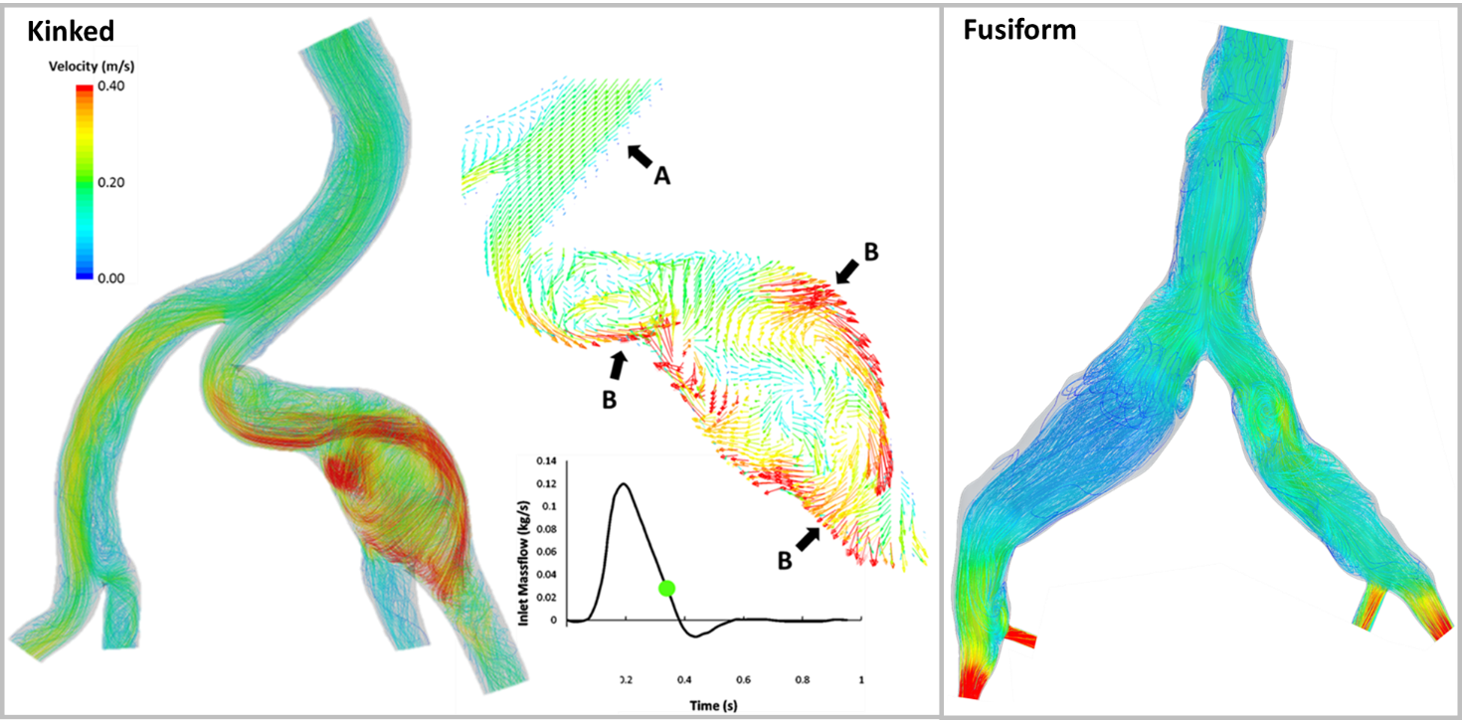
Figure 1. Kinked and fusiform velocity streamline representations. A. The laminar flow conditions proximal to the iliac arteries. B. The vectors of velocity inside the iliac aneurysm showing blood being directed at high velocity towards the arterial wall. The time point in the cardiac cycle for both cases is indicated on the infrarenal massflow waveform. These are Cases 20 and 16, respectively, in an earlier publication on this cohort.¹²

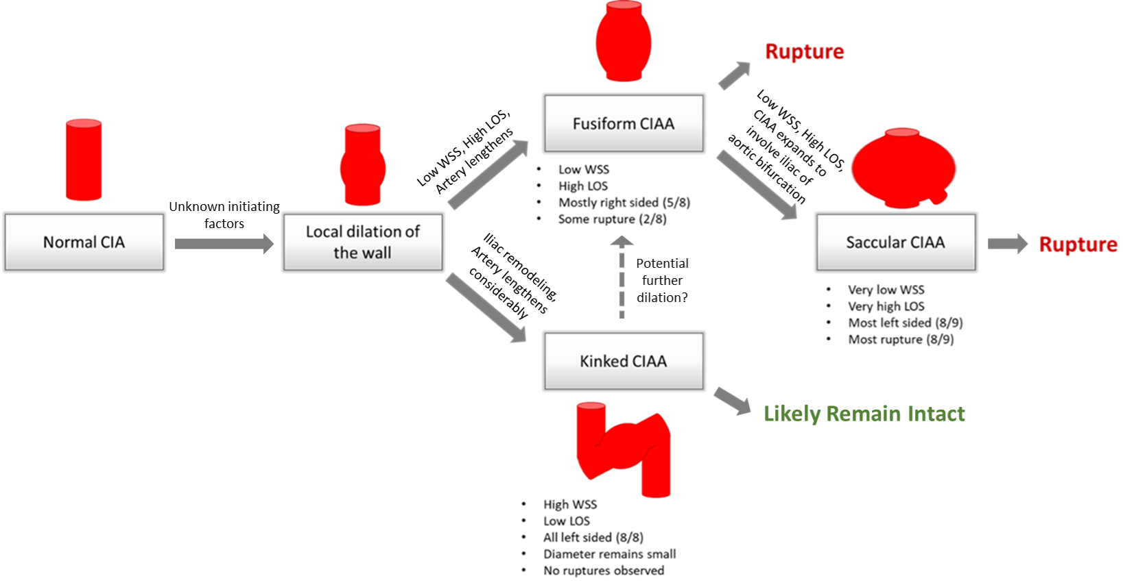
Figure 2. A flow chart showing our hypothesis for the progression of CIAAs.

