Local and systemic immunity against RSV induced by a novel intranasal vaccine (SynGEM)

Short running head: Particulate nasal vaccine induces durable immune responses
Descriptor number: 7.18 Mucosal Immunity of the Respiratory Tract
Impact on clinical medicine and basic science:
This study provides proof-of-concept that long-lasting anti-RSV antibodies can be induced in adults if viral antigen is delivered without the immunomodulation apparent during live RSV infection. The intranasal bacterium-like particle vaccine formulation that we used was well-tolerated and could potentially be adapted for other respiratory pathogens.

Authors:
Stephanie Ascough^{1,2}†, Iris Vlachantoni²†, Mohini Kalyan^{1,2}, Bert-Jan Haijema³, Sanna Wallin-Weber³, Margriet Dijkstra-Tiekstra³, Muhammad S Ahmed⁴, Maarten van Roosmalen³, Roberto Grimaldi³, Qibo Zhang⁴, Kees Leenhouts³, Peter J Openshaw²* and Christopher Chiu¹*

Affiliations:
¹ Section of Infectious Diseases and Immunity, Department of Medicine, Imperial College London, UK.
² Section of Respiratory Infections, National Heart and Lung Institute, Imperial College London, UK.
³ Mucosis B.V., represented by trustee Mr. Holtz LLM, Bout Advocaten, Groningen and Virtuvax B.V., The Netherlands.
⁴ Department of Clinical Infection, Microbiology and Immunology, University of Liverpool, UK.

†These authors contributed equally to this work.
* These authors contributed equally to this work.

Corresponding authors:
Dr Christopher Chiu
Section of Infectious Diseases and Immunity, Imperial College London, Hammersmith Campus
Du Cane Road, London W12 0NN, United Kingdom
Email: c.chiu@imperial.ac.uk
Professor Peter Openshaw
National Heart and Lung Institute, Imperial College London, St Mary’s Campus
Norfolk Place, London W2 0PG, United Kingdom
Email: p.openshaw@imperial.ac.uk

Authors Contributions:
CC, PJO, QZ, MvR, RG, BJH and KL designed and conceived the study; CC and IV supervised and carried out the clinical study; SA, MK, SW, MDT, MSA and MvR performed the laboratory experiments; CC, PJO, SA and IV wrote the manuscript; all authors reviewed the manuscript prior to submission.

Sources of support:
This research was funded by a Wellcome Trust Translation Award (Ref. WT108516). PJO is additionally supported by an NIHR Senior Investigator Award.
Word count: (4043)

Abstract
Rationale:
Needle-free intranasal vaccines offer major potential advantages, especially against pathogens entering via mucosal surfaces. As yet, there is no effective vaccine against respiratory syncytial virus (RSV), a ubiquitous pathogen of global importance that preferentially infects respiratory epithelial cells; new strategies are urgently required.
Objectives:
Here, we report the safety and immunogenicity of a novel mucosal RSV F protein vaccine linked to an immunostimulatory bacterium-like particle (BLP).
Methods:
In this phase I, randomised, double-blind placebo-controlled trial, 48 healthy volunteers aged 18-49 years were randomly assigned to receive placebo or SynGEM (low- or high-dose) intranasally by prime-boost administration. The primary outcome was safety and tolerability, with secondary objectives assessing virus-specific immunogenicity.
Measurements and Main Results:
There were no significant differences in adverse events between placebo and vaccinated groups. SynGEM induced systemic plasmablast responses and significant, durable increases in RSV-specific serum antibody in healthy seropositive adults. Volunteers given low-dose SynGEM (140 µg F, 2mg BLP) required a boost at day 28 to achieve plateau responses with a maximum fold-change of 2.4, whereas high-dose recipients (350 µg F, 5mg BLP) achieved plateau responses with a fold-change of 1.5 after first vaccination that remained elevated up to 180 days post-vaccination irrespective of further boosting. Palivizumab-like antibodies were consistently induced, but F protein site ∅-specific antibodies were not detected and virus-specific nasal IgA responses were heterogeneous, with strongest responses in individuals with lower pre-existing antibody levels.
Conclusions:
SynGEM is thus the first non-replicating intranasal RSV subunit vaccine to induce persistent antibody responses in human volunteers.
Abstract word count: 250
Key words: Mucosal, Respiratory, Virus, Clinical Trial, Immunology

At a glance commentary
Scientific Knowledge on the subject:
Respiratory syncytial virus (RSV) is a major global pathogen, especially affecting young children and older adults. Studies of natural and experimental infection indicate that mucosal antibodies are associated with protection from infection but after RSV infection, these are short-lived, likely due to viral immunomodulation. Despite the clear advantages of needle-free vaccines, the only currently available intranasal vaccine (live attenuated influenza vaccine) is known to be ineffective in adults with pre-existing immunity.
What this study adds to the field:
In this first-in-human phase I randomised controlled trial, SynGEM (a novel subunit intranasal vaccine comprising empty bacteria-like particles (BLP) linked with the surface glycoprotein F from RSV) is shown to be safe and immunogenic in healthy adults despite high pre-existing antibody levels. F protein-BLP rapidly induces RSV-specific systemic and local nasal immune responses that are more long-lasting than after natural infection, although antibodies unique to prefusion F protein were undetected and fold-changes were modest. SynGEM is therefore the first non-replicating intranasal RSV vaccine to induce persistent local and systemic antibodies and the BLP platform has wide potential applications where mucosal immunity is desired.
Commentary word count: 161

This article has an online data supplement, which is accessible from this issue’s table of content online at www.atsjournals.org

Introduction
Needle-free intranasal vaccines have major advantages over parenteral preparations, including public acceptability, reduced risk of complications, and, importantly, inducing local immune responses directed to the primary site of pathogen entry. However, existing intranasal vaccines are exclusively live attenuated agents that have poor efficacy in adults and must be balanced between immunogenicity and over-attenuation (1, 2). Subunit intranasal vaccines might offer an effective alternative, but none have yet found a place on the market.
Respiratory syncytial virus (RSV) is a major global pathogen especially important in infancy and old age. In children <5 years, it causes around 3 million severe cases, mostly in the developing world (3, 4). It is also responsible for ~10% of pneumonia admissions in older adults with attributable mortality up to 5% (5, 6). Despite the clinical need, no effective RSV vaccine yet exists (7). Inadequate understanding of protective immunity against RSV means that vaccine development continues to carry major risks, as demonstrated by recent negative phase III clinical trials (8). Novel vaccination strategies are therefore urgently required.
Studies in experimentally-infected volunteers indicate that reduced infection risk with RSV is most closely associated with mucosal secretory IgA (s-IgA) (9). IgA is actively transported across the respiratory epithelium and is therefore found at high levels in both upper and lower airways, mediating immune exclusion and sterilizing protection (10). Mucosal vaccine delivery may preferentially induce these antibodies. SynGEM is a novel subunit vaccine designed for intranasal administration, comprising RSV F protein linked to a peptidoglycan bacterium-like particle (BLP) derived from Lactococcus lactis (11). F protein is highly conserved across RSV strains (12), and is the target of the licensed protective monoclonal antibody palivizumab, making it the preferred antigenic target. Its pre-fusion conformation (pre-F), which predominates on infectious virions, displays a distinct antigenic site (site Ø) preferentially targeted by the most potent neutralizing antibodies (13). SynGEM therefore incorporates an F protein with mutations to maintain a pre-fusion conformation, while BLP-conjugation enhances mucosal stimulation via TLR2-dependent adjuvantation (11).
Pre-clinical studies using SynGEM showed induction of high levels of both systemic and mucosal antibodies (11). We now present the findings of the first-in-human placebo-controlled phase I clinical trial of SynGEM (clinicaltrials.gov identifier NCT02958540), the aim of which was to assess the safety and tolerability of the vaccine in humans and analyse the levels of serum anti-RSV IgG, nasal IgA and B cell responses.

Methods
Study design
Healthy volunteers were recruited to take part in the double-blind placebo-controlled study, MUC-SynGEM-001, according to the inclusion and exclusion criteria in Table E1 (clinicaltrials.gov identifier NCT02958540). Forty-eight volunteers received either placebo (phosphate buffered saline (PBS) + 2.5% glycerol) or SynGEM vaccine administered intranasally (125µl per nostril) at a ratio of 1:3. Heat and acid were used to treat non-recombinant Gram positive Lactococcus lactis, degrading internal proteins and other bacterial components to leave particles with bacteria-like shape and size made up of peptidoglycan alone. Addition of a Protan tag to the recombinant RSV F protein allowed covalent binding to the peptidoglycan shell on mixing to form SynGEM. The vaccine was given at 2 dose levels; a low dose, containing 140 µg of F protein and 2mg of BLP, and a high dose containing 350 µg of F protein and 5mg of BLP. These were administered according to a prime-boost schedule with the boost vaccination at 28 days post-prime. The sample size of 18 vaccinees at each dose level was computed from the binomial distribution to result in a 98% probability of one or more adverse events being observed with a true adverse event incidence of 20%, and 84% probability with a true incidence of 10%. Blood and nasal lavage were collected at study visits up to 180 days after first dosing. Nasal lavage was performed as previously described (9) by introducing 5mL of normal saline into each nostril using a syringe attached to a nasal olive attachment and washing by alternately withdrawing and advancing the plunger of the syringe 10 times while maintaining a tight seal with the nostril. The study was overseen by an independent Data Safety Monitoring Committee.

Randomisation and masking
Dose cohort allocation was sequential to the low- and then high-dose group. Participants were assigned to receive either SynGEM vaccine or an identical placebo by block randomisation; at each dose level, sentinel cohorts were randomised in the ratio of 1:1 in 2 blocks of 2 and remaining participants were randomised in the ratio of 4:1 in 8 blocks of 5, via a randomly generated sequence using an integer seed in the range 21-2147483649. An unmasked research nurse (with no subsequent involvement in participant follow-up) prepared and administered the vaccine in a masked syringe with Vaxinator device. Investigators and participants were masked to vaccine allocation until 28 days after boost vaccination. Laboratory staff were blinded for all time points (including days 120 and 180). Sealed opaque envelopes were provided for emergency code break, but none were used.

Antibody assays
Anti-RSV IgG and IgA antibodies were measured using stabilized pre-fusion or unstabilized F protein or Ga (from RSV A) or Gb protein (from RSV B) in ELISA assays as previously described (9). Serum plaque reduction neutralization titer (PRNT) assays were performed at Viroclinics Biosciences, Rotterdam, The Netherlands, as previously described (14). Palivizumab- and D25-competing antibodies were quantified in serum by competition ELISA. See online data supplement for additional detail.

Antibody-secreting cell quantification
Flow cytometry analysis was performed using heparinized whole blood with anti-CD19 FITC, anti-CD27 APC, anti-CD38 PE and anti-CD3/anti-CD20 both on PE-CF594 (BD Biosciences) run on a Fortessa flow cytometer (BD Biosciences) and analyzed with FlowJo software. Antibody-secreting cells (ASCs) were quantified using enzyme-linked immunospot (ELISpot) assays as previously described (15). Spots were counted using an automated ELISpot reader (AID), and results expressed as spot forming cells per million PBMCs.

Measurement of antibodies and cytokines in adenotonsillar cell culture supernatants
Adenotonsillar tissues were obtained from a separate cohort of non-vaccinated patients undergoing elective tonsillectomy from whom informed consent was obtained (ethics reference 14/SS/1058). Mononuclear cells (MNC) were isolated from adenotonsillar tissues and cultured, as described previously (16). Adenotonsillar MNC were co-cultured with SynGEM BLP-F with F-protein concentration at 1µg/mL or 5µg/mL, BLP alone (25µg/mL) and F-Protein alone (1µg/mL) or medium. Cell culture supernatants were harvested at day 12 and F protein-specific antibodies were measured by ELISA as described previously (17).
Following stimulation of adenotonsillar MNC for 3 days with the SynGEM BLP-F (5µg/mL), culture supernatants were analysed using cytometric bead array for cytokines (LEGENDplexTM, Biolegend, UK) following manufacturer’s instructions. T cell responses in adenotonsillar MNC were analyzed by Carboxyfluorescein succinimidyl ester (CFSE) (Molecular Probes, UK) labelling as previously described (16, 18).

Statistical analysis
Data analyses and graphs were produced using the software R and Graphpad Prism. Additional details on the statistical analysis is provided in an online data supplement.

Results
SynGEM vaccination is generally safe and well tolerated
Seventy-nine individuals were potentially eligible after pre-screening (Figure E1). Of these, 48 were recruited according to protocol-defined inclusion and exclusion criteria (Table E1).
No significant differences were found in demographics, baseline medical history or physical examination among the vaccinated or placebo groups (Table 1). At each dose level, 2 sequential sentinel cohorts of two subjects each were recruited initially, “prime”-vaccinated and followed up for three days post-dosing. No pre-defined pausing rules (Table 2) were met and recruitment was subsequently extended to the remaining twenty subjects in each dose-level group. All pre-defined study endpoints were adhered to (Table E2). Over the course of the study, no significant differences were seen in routine hematology and biochemistry blood tests between vaccinated and placebo groups (Table E3).
Five participants presented with respiratory tract symptoms at their vaccination or follow-up visits. On the basis of PCR-confirmed rhinovirus infection, boost vaccination was delayed by 3 days in 1 participant and withheld in another. Two additional participants described upper respiratory tract symptoms leading to delayed boost vaccination by 3 days. One subject was diagnosed with influenza A infection shortly after boosting. The severe sore throat reported as a serious adverse event (SAE) in this participant was temporally associated with the PCR-confirmed infection and therefore considered unrelated to the study vaccine.
One other SAE was noted, with a participant describing moderate pulsatile tinnitus and mild unilateral hearing loss manifesting 16 days after prime vaccination. This was not reported by the participant until after they had undergone boost vaccination. The participant was assessed by an ENT specialist but no clear aetiology was determined. Due to the timing of onset, the SAE was considered possibly related to the vaccine but symptoms persisted unchanged to the end of follow-up.
Other adverse events were most commonly local site reactions typical of intranasal administration (Tables E5 & E6). These events were all self-limiting and mild to moderate in severity. Four subjects in the low dose (22·2%), one in the high dose group (5·.5%) and four in the placebo group (33·3%) reported AEs within 1 hour of dosing with no significant differences between groups (relative risk compared with placebo RR [95% confidence interval (CI)]: low-dose 1·0 [0·29-3·39]; high-dose 0·25 [0·03-2·02]; Chi-square test for trend p=0·051)(Table E5). During the follow-up period, most participants reported at least one solicited local AE (15 (83·3%) in the low dose group; 15 (83·3%) in the high dose group; and 10 (83·3%) in the placebo group). Again there were no significant differences between the groups (low-dose RR 1.0 [0.72-1.39]; high-dose RR 1.0 [0.72-1.39]; Chi-square test for trend p>0·99)(Table E6). Moderate AEs were recorded for the 3 participants who had concurrent rhinovirus or influenza infection. The median duration of post-vaccination symptoms was 1·25 days (range 1-7 days).
Solicited systemic AEs were reported by 16 (88·9%) subjects in the low dose (RR 1·19 [0·82-1·71]); 13 (72·2%) subjects in the high dose (RR 0·96 [0·.62-1·49]); and 9 (75·0%) subjects in the placebo group (Table E5). Again, there were no significant differences between groups and no increase in AEs after boost compared with prime (Chi-square test for trend p=0·73). Severe solicited systemic AEs were reported only in those with concomitant viral infections. Therefore, with the caveat of a single SAE of uncertain aetiology, SynGEM was generally safe and well-tolerated.

SynGEM significantly boosts F protein-specific serum IgG
Since the study period overlapped with the local RSV season, natural RSV infection was assessed by measuring seroconversion of RSV G-specific IgG levels as well as multiplex respiratory viral PCR of nasal lavage if participants attended with suggestive symptoms. No RSV infections were detected by PCR but a total of 7 participants seroconverted with G protein-specific responses during the study period, suggestive of natural infection (Figure E2). Measurements from these individuals at time-points after G protein seroconversion were excluded from subsequent analysis to avoid over-estimation of antibody titers by infection-induced immune responses.
F-specific serum IgG titers over the course of the study were measured by ELISA with unstabilized F protein as coating antigen. Pre-vaccination, all individuals already had moderate-to-high levels of anti-F IgG (low-dose geometric mean titer (GMT) [95% confidence interval (CI)] 8·1 [7·5-8·7]; high-dose GMT 8·5 [8·1-8·9]; placebo GMT 8·1 [7·6-8·7])(Figure 1). There was a trend towards average baseline anti-F IgG being higher in the high-dose group (Mann Whitney test, placebo vs. high p=0·2804; placebo vs. low = 0·8841; high vs. low = 0·2173) (Figure 1A & 1B).
Following vaccination, anti-F IgG titres of both dosing groups increased significantly after the first dose; from GMT 8·1 to GMT 8·5 (low-dose, p=0·0005)(Figure 1C & 1D) and GMT 8·5 to GMT 9·0 (high-dose, p<0·0001)(Figure 1E & 1F). In the low-dose group, this incremented further on boost vaccination (GMT 8·5 at day 28 to GMT 8·8 on day 56, p=0·0108). Interestingly, anti-F IgG levels continued to increment to GMT 9·8 (p=0·0001) at day 180 (Figure 1E) after low-dose vaccination. In the high-dose group, peak anti-F IgG levels were achieved after a single vaccination with no further statistically significant increase. In both dosing groups, serum anti-F IgG titers remained significantly elevated through to the end of the follow-up period (6 months post-“prime”). Despite the significant increases in virus-specific serum IgG, maximal fold-changes following vaccination were modest (2.43 at day 120 in the low-dose and 1.54 at day 56 in the high-dose group), given the high pre-vaccination titers (Figure 1D & 1F). Nevertheless, F-specific antibodies were boosted in both vaccinated groups, with serum antibody levels persisting up to 6 months.

A second ELISA assay using a stabilized pre-F protein (DS-Cav1) was used to test whether additional pre-fusion specific antibodies could be detected. Surprisingly, anti-F IgG titers measured using the pre-fusion F antigen showed less statistically significant responses (Figure E3). The associated fold-changes were also less marked than detection by the post-F assay. Thus, measurement of serum anti-F IgG titers by stabilized F and unstabilized F-protein ELISAs did not give fully concordant results.

SynGEM preferentially induces non-neutralizing palivizumab-competing antibodies
To further investigate the quality and functionality of the induced antibodies, serum neutralizing antibodies against RSV were measured plaque-reduction neutralization titer (PRNT) assay (Figure 2A, 2D and 2G). In contrast to the highly significant increases in post-F ELISA-binding antibodies, no increment in neutralizing antibodies was detectable. This implied that the systemic antibodies induced by SynGEM were preferentially non-neutralizing. To investigate this in more detail, competition ELISAs were performed to estimate the contribution of palivizumab-competing antibodies, which recognize the site II epitope present on both pre- and post-fusion conformations of F (Figure 2B, 2E, 2H), and D25-competing antibodies, which bind the site Ø unique to pre-fusion F (Figure 2C, 2F and 2I). As with the total F protein ELISA, significant increments in palivizumab-competing antibodies were shown following prime and boost (low-dose GMT 12·7 [12·3-13·1] pre-vaccination to GMT 13·3 [12·8-13·8] at day 56, p<0·0001; high-dose GMT 12·7 [12·3-13·1] to GMT 13·6 [13·1-14·1] at day 56, p<0·0001). In contrast, no rises were seen in D25-competing antibodies. Thus, SynGEM primarily induced anti-F IgG directed against epitopes common to both pre- and post-fusion F but little site Ø or neutralizing antibody.

Nasal anti-RSV IgA responses demonstrate marked variance following SynGEM vaccination
We hypothesized that intranasal delivery of RSV F protein-BLPs could preferentially induce nasal s-IgA and therefore enhance local protection. Using a validated IgA ELISA, we therefore analyzed the induction of anti-F s-IgA in nasal lavage samples. Compared to serum anti-F IgG, there was greater inter-individual variability in nasal IgA titers and response to vaccination. Pre-vaccination, nasal IgA endpoint titers showed a wide range, with the greatest variance seen in the low dose group, within which the log2 titer ranged from a minimum of 6·0 to a maximum of 14·2. (Figure 3A, 3B, and 3C). Following vaccination, analysis of each group in totality showed a significant titer rise in the high-dose group at day 56 post-vaccination (GMT 9·9 at day 56 compared with 9·0 pre-vaccination, p=0·009). However, examining the individual participant-level data (Figure 3D-3F), it was evident that this masked the wide differences between individuals both in magnitude and kinetics. We therefore performed cluster analysis of vaccinees according to the timing of their maximal nasal IgA fold-change to further explore the diversity of responses.

By Fisher’s exact test, a significantly higher proportion of individuals in the vaccinated cohorts underwent a ≥2-fold rise at any time post-vaccination than in the placebo group (p=0·0236). While some changes were seen in the placebo group, these were few and of low magnitude (Figure 3D). In contrast, in the low dose group, 13/18 (72%) demonstrated a >2-fold rise (5 showing maximal change compared with pre-vaccination at day 28, 4 at day 56, and 4 at day 120) (Figure 3E). In the high-dose group, 13/18 (72%) also showed an increment (5 changing maximally compared with pre-vaccination at day 28, 5 at day 56, and 3 at day 120) (Figure 3F). Furthermore, while maximal fold-change in the placebo group was only 8·6, individuals in the vaccinated groups displayed strikingly large fold-changes of up to 98-fold increase. The size of vaccine responses correlated with lower pre-existing antibody titers (Figure E4), suggesting either that pre-existing anti-F IgA impaired the vaccine response or a ceiling of antibody production was being reached. Thus, although the small sample size and heterogeneity of responses limit interpretation, these data imply that SynGEM does induce RSV-specific mucosal IgA in most individuals, sometimes with highly dynamic responses particularly in those with low pre-existing F-specific IgA titers.

Intranasal SynGEM vaccination induces dose-dependent divergence in systemic plasmablast responses
Systemic vaccines including inactivated influenza and live yellow fever vaccines have been consistently shown to stimulate short-lived plasmablasts that correlate with seroconversion (19). In contrast, live attenuated intranasal and replication-incompetent viral vectored vaccines in adults rarely induce plasmablasts in the blood (20, 21). The plasmablast response to SynGEM was therefore investigated using flow cytometry but, due to high background and variance, no significant changes were seen (Figure E5).
To better assess the antigen-specific B cells response to vaccination, B cell ELISpots were then performed to quantify IgG- and IgA-producing antibody-secreting cells (ASCs) recognizing unstabilized recombinant F protein (Figure 4). Both low- and high-dose SynGEM induced IgG-producing ASCs in all vaccinated individuals 7 days post-“prime” (low-dose median 135 spots/million PBMCs IQR 139; high-dose median 230 spots/million IQR 330). The higher dose showed a trend towards larger plasmablast responses. In most individuals, ASCs had disappeared by the time of boost vaccination. However, the high-dose group had a significantly higher frequency of IgG+ ASCs remaining at the later time-point (high-dose median 5 spots/million IQR 41; low-dose median 0 spots/million, p=0·0076), suggesting a more protracted response. Similar frequencies were seen after boost vaccination (Figure 4G). Thus, SynGEM induced systemic IgG+ ASC responses in all vaccinated individuals, with significantly increased duration and a trend towards greater frequency responses with the higher dose.
At day 7 post-“prime”, IgA+ ASCs were less frequent than IgG+ ASCs following low-dose (median 41 IQR 57, p=0·0045) and high-dose vaccination (median 28 IQR 135, p=0·0091) (Figure 4). Again, the response to high-dose boost vaccination persisted for longer than low-dose, with significantly higher frequencies of IgA+ ASCs at day 56 in that group (high-dose median 20 spots/million IQR 122; low-dose median 0 spots/million IQR 54; p=0·0048). There was no correlation between IgA+ ASC frequencies in blood and changes in nasal F-specific IgA titers (Figure 4H). Thus, while the overall IgA+ ASC response in blood was lower than IgG+ ASCs, there was some discordance in the different isotypes, suggesting that higher doses are more efficacious in boosting prolonged IgA-producing ASC responses.

SynGEM induces F-specific antibody production by tonsillar cells in vitro in a dose-dependent manner
To investigate these dose-dependent effects, we tested the capacity of SynGEM to induce responses in human nasopharynx-associated lymphoid tissues cultured as previously described (16, 18). Recombinant F protein alone or BLP alone did not stimulate significant production of F-specific antibodies (Figure 5A-F). However, in adults, culture with SynGEM induced F-specific IgG (Figure 5A), IgA (Figure 5B) and IgM (Figure 5C), with the higher SynGEM concentration inducing significantly higher titers. As expected in these upper respiratory tissues, substantially higher concentrations of IgA were produced at both dose levels (p<0·05). Similar results were seen in pediatric samples, suggesting that comparable responses might be induced by SynGEM in children (Figure 5D-F). Additionally, antibody induction was associated with the significant production of interferon-γ, IL-22 and IL-21 suggesting the stimulation of type 1, type 17/22 and T follicular helper cell responses respectively (Figure 5G-I). Trends towards increased IL-2 production, TNF, IL-17A and IL-10 were also seen, but not type 2 cytokines (IL-4, IL-5 and IL-13) (Figure E6). Production of these cytokines was associated with proliferation of CD4+ and (to a lesser extent) CD8+ T cells in a dose dependent manner (Figure 5J and 5K), suggesting that CD4+ T cells were major contributors to cytokine production.
Thus, in vitro data support the clinical observations that SynGEM induces a dose-dependent antibody response associated with appropriate T-helper cytokine signalling. While antibodies targeting site ∅, that are believed to be the most potent for virus neutralization, were not significantly induced, further enhancement of the prolonged vaccine-induced responses seen may be achieved by additional alterations in antigen and/or dose.

Discussion
Previously, we showed that antibodies induced following RSV infection were short-lived and hypothesized that viral immunomodulatory mechanisms impaired anti-RSV humoral memory responses (9). Here, we have shown that delivering F protein using a non-living subunit mucosal vaccine not only induced bursts of plasmablast activity and mucosal IgA but also boosted systemic RSV-specific antibodies for at least 6 months. These data suggest that the BLP vaccine platform may permit more potent induction of both systemic and mucosal responses than existing intranasal vaccines, including live attenuated influenza vaccine (LAIV) (22) and live attenuated RSV vaccine candidates (2, 23). Indeed, adults do not respond to these vaccines, presumably due to pre-existing immunity that prevents attenuated virus replication. Futhermore, an adenovirus vector expressing F protein recently tested via intranasal administration (20) led to minimal boosting compared with intramuscular injection.
However, immunogenicity data are complicated where pre-existing immunity against vaccine antigens exists, such as with RSV in older children and adults (24, 25). Following SynGEM vaccination, serum antibody titers increased significantly despite the background of moderate-to-high levels of pre-existing F-specific antibodies. However, the seropositivity of the volunteers limited the size of vaccine responses with serum IgG only reaching a maximum of 2.43-fold increase (in the low-dose group late after boost vaccination). Furthermore, nasal IgA only significantly increased in the high-dose group with a fold-change of 1.87, although low pre-existing F-specific IgA titers were more predictive of the strongest response to vaccination, with in some cases >90-fold rise. Previous studies of intranasal subunit candidates (against diphtheria, tuberculosis, HIV and influenza) suggest that immunogenicity could be greater in the absence of high levels of strain-specific immunity. Indeed, an influenza vaccine using a similar BLP platform as SynGEM (26) induced significantly higher IgG and IgA levels than the inactivated vaccine comparator. Against pathogens where there is no prior immunity, the BLP platform may therefore have broad potential.
While intranasal diphtheria toxin adjuvanted with chitosan boosted both serum IgG and IgA with no safety issues (27), intranasal vaccines containing an inactive E.coli heat-labile toxin have been implicated in causing facial nerve (Bell’s) palsy (28)(29). In our study, a single participant complained of pulsatile tinnitus and hearing impairment after vaccination. These symptoms were sufficiently mild that the participant did not declare them on direct questioning and only reported them after boost vaccination due to their prolonged nature. No cause could be found and they did not worsen after the boost, but an association with the vaccine could not be excluded due to the timing of onset. Sudden sensorineural hearing loss is common, affecting 2-20 per 100,000 individuals each year (30). In most cases, as here, no cause is definitively identified, and it therefore remains unclear whether the vaccine was related.
One further unexplained observation is the lack of significant boosting of serum virus neutralization despite induction of F protein-binding antibodies. The F protein in SynGEM was engineered with stabilizing mutations to maintain the pre-F conformation and pre-clinical studies had shown stimulation of neutralizing antibodies in animal models (11). As part of product release testing, extensive stability tests were performed that showed stable D25-binding. It was therefore surprising to find no detectable neutralizing or D25-competing antibody responses. This may have been due to the limited overall size of antibody responses or suboptimal presentation of the F protein in vivo resulting in relatively little generation of the most potent neutralizing antibodies. While this does not preclude a protective role for the non-neutralizing and palivizumab-like antibodies that were induced, further iterations of SynGEM should overcome this limitation. In particular, we anticipate that better induction of site ∅ antibodies will enhance virus neutralizing responses both systemically and locally with likely concomitant increase in efficacy.
Nevertheless, the intranasal BLP platform used here did lead to prolonged increases in virus-specific antibodies in blood and mucosa of antigen-experienced adults. Testing of other BLP-conjugated antigens should further progress this novel and broadly-applicable strategy for mucosal vaccination.
Acknowledgments
We thank Cmed (Horsham, UK) for their assistance with regulatory applications, project management, clinical trial monitoring and statistical analysis. This paper presents independent research funded by the Wellcome Trust. Infrastructure and other support was provided by the NIHR Imperial Biomedical Research Centre and the NIHR Imperial Clinical Research Facility. The views expressed are those of the author(s) and not necessarily those of the Welcome Trust, the NHS, the NIHR or the Department of Health and Social Care.
References
1. Lin Y-H, Deatly AM, Chen W, Miller LZ, Lerch R, Sidhu MS, Udem SA, Randolph VB. Genetic stability determinants of temperature sensitive, live attenuated respiratory syncytial virus vaccine candidates. Virus Research 2006;115:9–15.
2. Buchholz UJ, Cunningham CK, Muresan P, Gnanashanmugam D, Sato P, Siberry GK, Rexroad V, Valentine M, Perlowski C, Schappell E, Thumar B, Luongo C, Barr E, Aziz M, Yogev R, Spector SA, Collins PL, McFarland EJ, Karron RA, International Maternal Pediatric Adolescent AIDS Clinical Trials (IMPAACT) P1114 Study Team. Live Respiratory Syncytial Virus (RSV) Vaccine Candidate Containing Stabilized Temperature-Sensitivity Mutations Is Highly Attenuated in RSV-Seronegative Infants and Children. J Infect Dis 2018;217:1338–1346.
3. Shi T, McAllister DA, O’Brien KL, Simoes EAF, Madhi SA, Gessner BD, Polack FP, Balsells E, Acacio S, Aguayo C, Alassani I, Ali A, Antonio M, Awasthi S, Awori JO, Azziz-Baumgartner E, Baggett HC, Baillie VL, Balmaseda A, Barahona A, Basnet S, Bassat Q, Basualdo W, Bigogo G, Bont L, Breiman RF, Brooks WA, Broor S, Bruce N, et al. Global, regional, and national disease burden estimates of acute lower respiratory infections due to respiratory syncytial virus in young children in 2015: a systematic review and modelling study. The Lancet 2017;390:946–958.
4. Scheltema NM, Gentile A, Lucion F, Nokes DJ, Munywoki PK, Madhi SA, Groome MJ, Cohen C, Moyes J, Thorburn K, Thamthitiwat S, Oshitani H, Lupisan SP, Gordon A, Sánchez JF, O’Brien KL, PERCH Study Group, Gessner BD, Sutanto A, Mejias A, Ramilo O, Khuri-Bulos N, Halasa N, de-Paris F, Pires MR, Spaeder MC, Paes BA, Simões EAF, Leung TF, et al. Global respiratory syncytial virus-associated mortality in young children (RSV GOLD): a retrospective case series. Lancet Glob Health 2017;5:e984–e991.
5. Falsey A, Walsh E. Respiratory syncytial virus infection in adults. Clin Microbiol Rev 2000;13:371–84.
6. Colosia AD, Yang J, Hillson E, Mauskopf J, Copley-Merriman C, Shinde V, Stoddard J. The epidemiology of medically attended respiratory syncytial virus in older adults in the United States: A systematic review. PLoS ONE 2017;12:e0182321.
7. Guvenel AK, Chiu C, Openshaw PJ. Current concepts and progress in RSV vaccine development. Expert Review of Vaccines 2014;13:333–344.
8. Falloon J, Yu J, Esser MT, Villafana T, Yu L, Dubovsky F, Takas T, Levin MJ, Falsey AR. An Adjuvanted, Postfusion F Protein–Based Vaccine Did Not Prevent Respiratory Syncytial Virus Illness in Older Adults. J Infect Dis 2017;216:1362–1370.
9. Habibi MS, Jozwik A, Makris S, Dunning J, Paras A, DeVincenzo JP, de Haan CAM, Wrammert J, Openshaw PJM, Chiu C. Impaired Antibody-mediated Protection and Defective IgA B-Cell Memory in Experimental Infection of Adults with Respiratory Syncytial Virus. Am J Respir Crit Care Med 2015;191:1040–1049.
10. Suzuki T, Ainai A, Hasegawa H. Functional and structural characteristics of secretory IgA antibodies elicited by mucosal vaccines against influenza virus. Vaccine 2017;35:5297–5302.
11. Rigter A, Widjaja I, Versantvoort H, Coenjaerts FEJ, van Roosmalen M, Leenhouts K, Rottier PJM, Haijema BJ, de Haan CAM. A Protective and Safe Intranasal RSV Vaccine Based on a Recombinant Prefusion-Like Form of the F Protein Bound to Bacterium-Like Particles. PLoS ONE 2013;8:e71072.
12. McLellan JS, Ray WC, Peeples ME. Structure and Function of RSV Surface Glycoproteins. Curr Top Microbiol Immunol 2013;372:83–104.
13. Ngwuta JO, Chen M, Modjarrad K, Joyce MG, Kanekiyo M, Kumar A, et al. Prefusion F–specific antibodies determine the magnitude of RSV neutralizing activity in human sera. Science Translational Medicine. 2015 Oct 14;7(309):309ra162.
14. Sande CJ, Mutunga MN, Medley GF, Cane PA, Nokes DJ. Group and genotype specific neutralising antibody responses against respiratory syncytial virus (RSV) in infants and young children with severe pneumonia. J Infect Dis. 2012 Feb 1; 207(3): 489–492.
15. Saletti G, Çuburu N, Yang JS, Dey A, Czerkinsky C. Enzyme-linked immunospot assays for direct ex vivo measurement of vaccine-induced human humoral immune responses in blood. Nat Protocols 2013;8:1073–1087.
16. Aljurayyan A, Puksuriwong S, Ahmed M, Sharma R, Krishnan M, Sood S, Davies K, Rajashekar D, Leong S, McNamara PS, Gordon S, Zhang Q. Activation and Induction of Antigen-Specific T Follicular Helper Cells Play a Critical Role in Live-Attenuated Influenza Vaccine-Induced Human Mucosal Anti-influenza Antibody Response. J Virol 2018;92:e00114-18.
17. Mullin J, Ahmed MS, Sharma R, Upile N, Beer H, Achar P, Puksuriwong S, Ferrara F, Temperton N, McNamara P, Lambe T, Gilbert SC, Zhang Q. Activation of cross-reactive mucosal T and B cell responses in human nasopharynx-associated lymphoid tissue in vitro by Modified Vaccinia Ankara-vectored influenza vaccines. Vaccine 2016;34:1688–1695.
18. Gray C, Ahmed MS, Mubarak A, Kasbekar AV, Derbyshire S, McCormick MS, Mughal MK, McNamara PS, Mitchell T, Zhang Q. Activation of memory Th17 cells by domain 4 pneumolysin in human nasopharynx-associated lymphoid tissue and its association with pneumococcal carriage. Mucosal Immunology 2014;7:705–717.
19. Li G-M, Chiu C, Wrammert J, McCausland M, Andrews SF, Zheng N-Y, Lee J-H, Huang M, Qu X, Edupuganti S. Pandemic H1N1 influenza vaccine induces a recall response in humans that favors broadly cross-reactive memory B cells. Proceedings of the National Academy of Sciences 2012;109:9047–9052.
20. Green CA, Scarselli E, Sande CJ, Thompson AJ, Lara CM de, Taylor KS, Haworth K, Sorbo MD, Angus B, Siani L, Marco SD, Traboni C, Folgori A, Colloca S, Capone S, Vitelli A, Cortese R, Klenerman P, Nicosia A, Pollard AJ. Chimpanzee adenovirus– and MVA-vectored respiratory syncytial virus vaccine is safe and immunogenic in adults. Science Translational Medicine 2015;7:300ra126-300ra126.
21. Sasaki S, Jaimes MC, Holmes TH, Dekker CL, Mahmood K, Kemble GW, Arvin AM, Greenberg HB. Comparison of the Influenza Virus-Specific Effector and Memory B-Cell Responses to Immunization of Children and Adults with Live Attenuated or Inactivated Influenza Virus Vaccines. Journal of Virology 2006;81:215–228.
22. Belshe R, Mendelman P, Treanor J, King J, Gruber W, Piedra P, Bernstein D, Hayden F, Kotloff K, Zangwill K, Iacuzio D, Wolff M. The efficacy of live attenuated, cold-adapted, trivalent, intranasal influenzavirus vaccine in children. N Engl J Med 1998;338:1405–12.
23. Karron RA, Luongo C, Thumar B, Loehr KM, Englund JA, Collins PL, Buchholz UJ. A gene deletion that up-regulates viral gene expression yields an attenuated RSV vaccine with improved antibody responses in children. Science Translational Medicine 2015;7:312ra175-312ra175.
24. Jounai N, Yoshioka M, Tozuka M, Inoue K, Oka T, Miyaji K, Ishida K, Kawai N, Ikematsu H, Kawakami C, Shimizu H, Mori M, Ishii KJ, Takeshita F. Age-Specific Profiles of Antibody Responses against Respiratory Syncytial Virus Infection. EBioMedicine 2017;16:124–135.
25. Falsey A, Walsh E. Relationship of serum antibody to risk of respiratory syncytial virus infection in elderly adults. J Infect Dis 1998;177:463–6.
26. Van Braeckel-Budimir N, Haijema BJ, Leenhouts K. Bacterium-Like Particles for Efficient Immune Stimulation of Existing Vaccines and New Subunit Vaccines in Mucosal Applications. Front Immunol. 2013 Sep 17 ;4.
27. Mills KHG, Cosgrove C, McNeela EA, Sexton A, Giemza R, Jabbal-Gill I, Church A, Lin W, Illum L, Podda A, Rappuoli R, Pizza M, Griffin GE, Lewis DJM. Protective Levels of Diphtheria-Neutralizing Antibody Induced in Healthy Volunteers by Unilateral Priming-Boosting Intranasal Immunization Associated with Restricted Ipsilateral Mucosal Secretory Immunoglobulin A. Infect Immun 2003;71:726–732.
28. Mutsch M, Zhou W, Rhodes P, Bopp M, Chen RT, Linder T, Spyr C, Steffen R. Use of the Inactivated Intranasal Influenza Vaccine and the Risk of Bell’s Palsy in Switzerland. New England Journal of Medicine 2004;350:896–903.
29. Lewis DJM, Huo Z, Barnett S, Kromann I, Giemza R, Galiza E, Woodrow M, Thierry-Carstensen B, Andersen P, Novicki D, Giudice GD, Rappuoli R. Transient Facial Nerve Paralysis (Bell’s Palsy) following Intranasal Delivery of a Genetically Detoxified Mutant of Escherichia coli Heat Labile Toxin. PLOS ONE 2009;4:e6999.
30. Lawrence R, Thevasagayam R. Controversies in the management of sudden sensorineural hearing loss: an evidence-based review. Clinical Otolaryngology 40:176–182.

Figure Legends

Figure 1. Intranasal SynGEM induces significant increases in F-specific serum IgG.
Volunteers were given SynGEM or placebo and serum IgG was measured by ELISA using unstabilized F protein as coating antigen at time-points up to 180 days post-“prime”. Titers and fold-changes compared to baseline are shown following (A and B) placebo, (C and D) low-dose and (E and F) high-dose. Geometric means are shown in red. Wilcoxon ranked sign test was used to test statistically significant rises compared to pre-vaccination; *** p<0·001; **** p<0·0001. Vaccinations are indicated by red triangles.

Figure 2. SynGEM induces palivizumab-like but not pre-fusion F-specific antibodies.
Participants were given SynGEM or placebo. (A, D and G) Serum neutralizing antibody titers were measured by classical plaque-reduction neutralization assay up to 28 days post-boost. Palivizumab-like (B, E and H) and D25-like (C, F and I) antibodies were measured by competition ELISA assays up to 28 days post-boost. Geometric means are shown in red. Wilcoxon ranked sign test was used to test statistically significant rises compared to pre-vaccination; ** p<0·01; **** p<0·0001. Vaccinations are indicated by red triangles.

Figure 3. Intranasal SynGEM protein induces heterogeneous mucosal IgA responses.
Subjects were given SynGEM or placebo and nasal wash IgA was measured by ELISA using unstabilized F protein as coating antigen at time-points up to 180 days post-“prime”. Individuals in the placebo (A), low-dose (B) and high-dose (C) groups were clustered if they displayed a >2-fold rise in nasal IgA titers according to the time-point of maximal increase. ** p<0·01. Vaccinations are indicated by red triangles.

Figure 4. Intranasal SynGEM protein stimulates IgG+ and IgA+ antibody-secreting cells in peripheral blood from volunteers administered low or high doses of SynGEM. (A-F) Antibody-secreting cells from peripheral blood at time-points up to 28 days post-boost were enumerated by B cell ELISpot. Median values are shown in red. * p <0·05; *** p<0·001; **** p<0·0001.

Figure 5. SynGEM (BLP-F) stimulation of adenotonsillar cells provokes dose-dependent antibody and T cell responses. Tonsil cells from (A-C) adult and (E-F) pediatric donors were cultured with SynGEM (BLP-F) containing 5 µg/mL and 1 µg/mL F-protein, BLP alone (25 µg/mL), F protein alone (1 µg/mL) and medium only. F-specific IgG, IgA and IgM in resulting supernatant were measured by ELISA. (G-I) Cytokines were measured in culture supernatant by cytometric bead array. Tonsil cells were cultured with SynGEM (BLP-F), BLP alone (25 µg/mL) or F-Protein alone (1 µg/mL). (J) CD4+ and (K) CD8+ T cell proliferation was then measured by analysis of CFSE dilution and expressed as a percentage of dividing cells in the CD3+CD4+ or CD3+CD8+ populations. Mann-Whitney U test, and Wilcoxon Signed Rank Test were used to test significant differences.

Tables
Group |  |  | Low-dose | High-dose | Placebo
 |  |  | (n=18) | (n=18) | (n=12)
Characteristic
 | Age (years)
 |  | Mean (SD) | 28·6 (7·99) | 27·3 (8·37) | 28·3 (8·55)
 |  | Median | 27·0 | 23·0 | 26·5
 |  | Min, Max | 20, 49 | 19, 46 | 20, 46
 | Gender, n (%)
 |  | Male | 11 (61·1) | 8 (44·4) | 5 (41·7)
 |  | Female | 7 (38·9) | 10 (55·6) | 7 (58·.3)
 | Race, n (%)
 |  | White or Caucasian | 12 (66·66) | 15 (83·33) | 10 (83·33)
 |  | Black British/Black Other | 3 (16·66) | 1 (5·55) | 1 (8·33)
 |  | Asian British/Indian/Asian other | 3 (16·66) | 2 (11·11) | 1 (8·33)
 |  | Mixed | 0 | 0 | 0
 |  | Other | 0 | 0 | 0
 | Height (cm)
 |  | Mean (SD) | 175·24(8·96) | 172·94(10·09) | 171·67(9·54)
 |  | Median | 174·0 | 170·5 | 170·0
 | Weight (kg)
 |  | Mean (SD) | 72·40(11·33) | 69·48(11·76) | 69·51(12·38)
 |  | Median | 71·8 | 71·57 | 68·8
 | BMI (kg/m²)
 |  | Mean | 23·50(2·68) | 23·12(2·62) | 23·54(3·31)
 |  | Median | 23·65 | 23·2 | 23·56

Table 1. Subject baseline physical and demographic characteristics.

 | Applicable to sentinel cohorts
 | 1. | Occurrence of any death
 | 2. | Occurrence of any serious adverse event, defined as life threatening, requiring hospitalization, resulting in a persistent or significant disability/incapacity, a congenital anomaly or birth defect in the offspring of a study participant, or a medically important condition that may have jeopardized the subject and may have required medical or surgical intervention to prevent a serious outcome
 | 3. | Occurrence of any case of severe allergic reaction such as anaphylaxis, generalized urticaria, laryngospasm or bronchospasm
 | 4. | One or more subjects experience a severe (non-serious) adverse event, including local, febrile or systemic reactions
 | Applicable to post-sentinel cohorts
 | 1. | Occurrence of any death
 | 2. | Occurrence of any serious adverse event other than the result from trauma or accident, regardless of relatedness to study product
 | 3. | Occurrence of any case of severe allergic reaction such as anaphylaxis, generalized urticaria, laryngospasm or bronchospasm
 | 4. | Two or more subjects recruited up to that point experience a severe (non-serious) adverse event, defined as causing inability to perform usual social and functional activities, including local, febrile or systemic reactions, considered at least possibly related to the investigational product
 | 5. | Three or more subjects recruited up to that point experience a severe (non-serious) adverse event, irrespective of the relationship with the investigational product

Table 2. Pausing rules

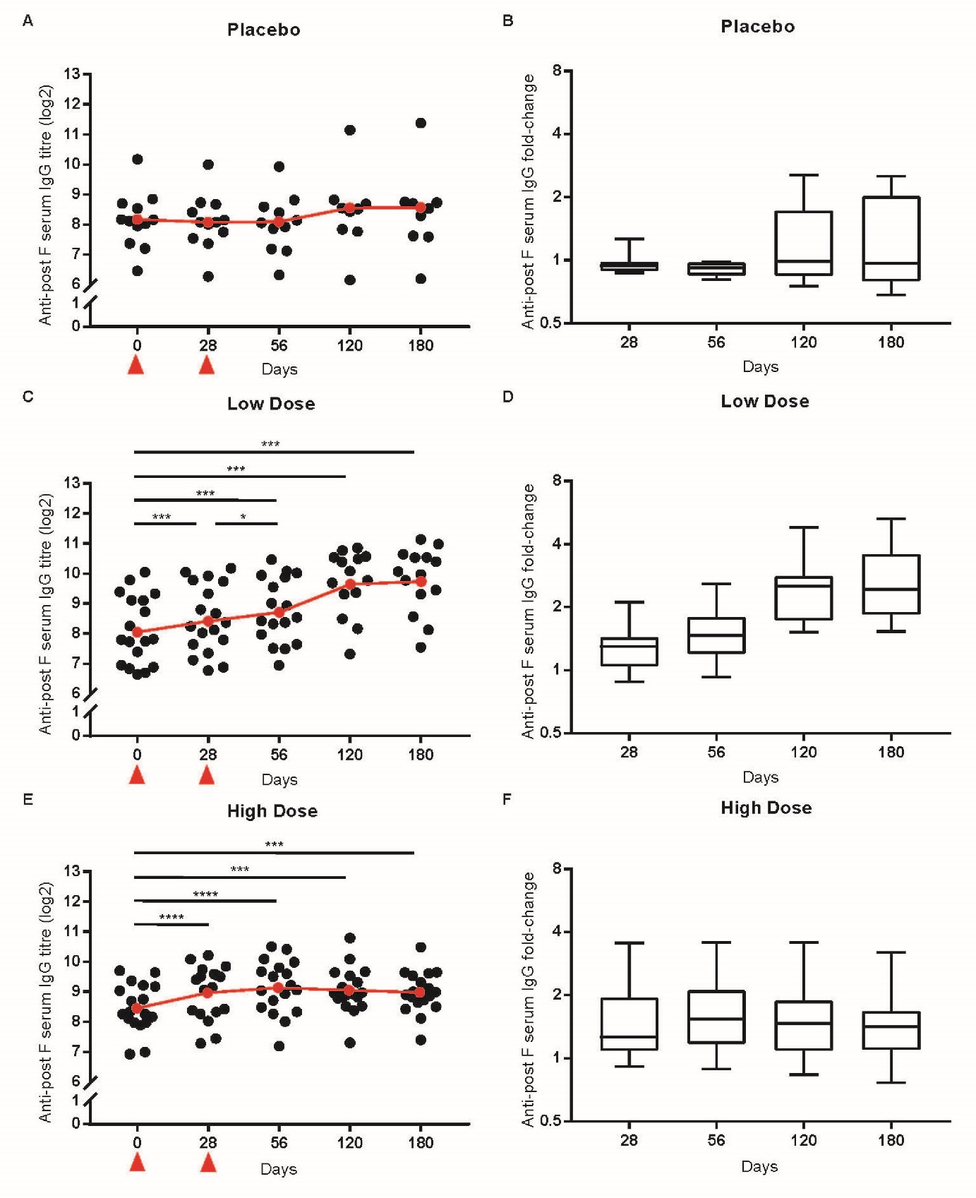
Figure 1.

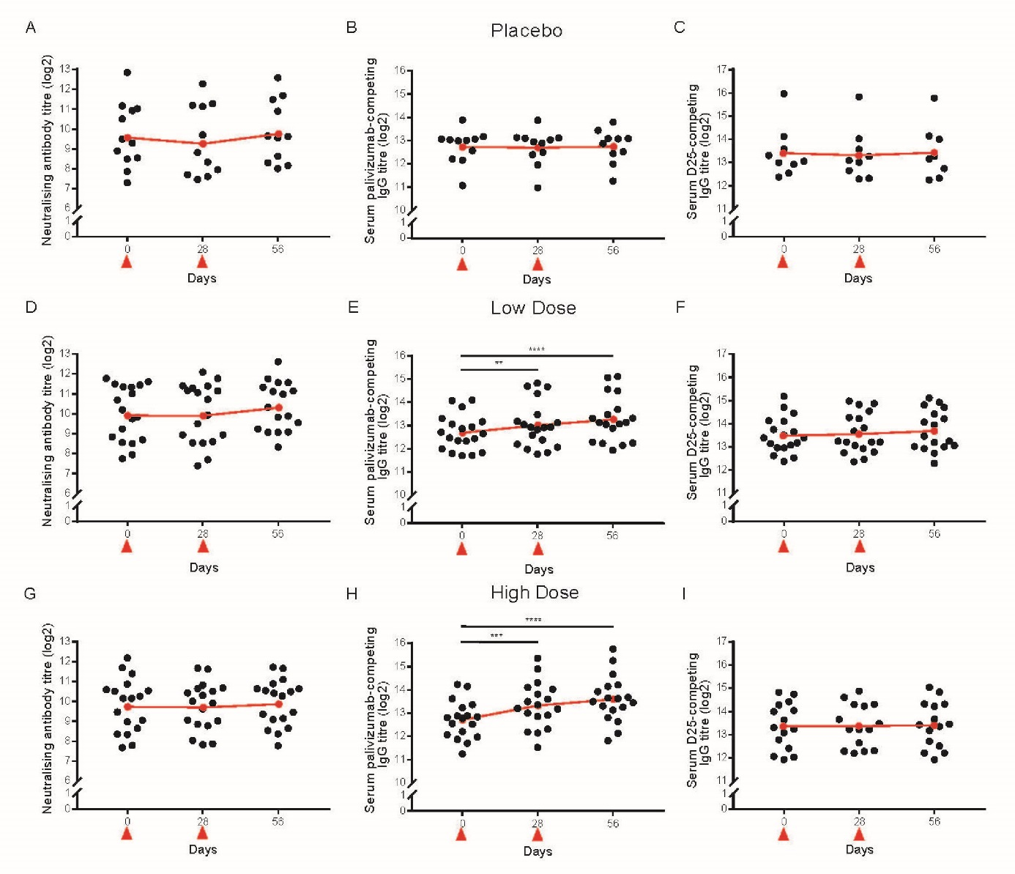
Figure 2.

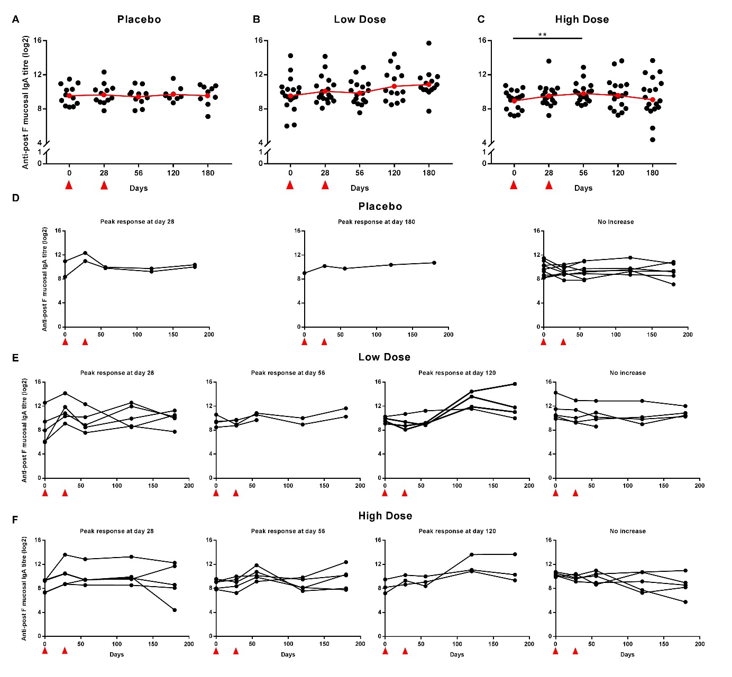
Figure 3.

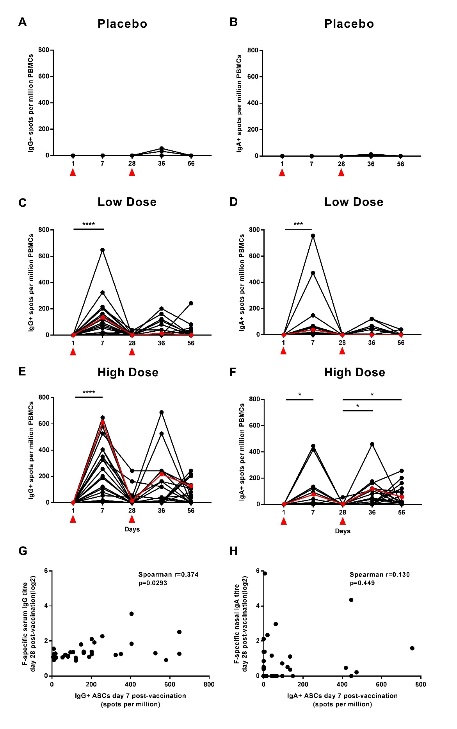
Figure 4.

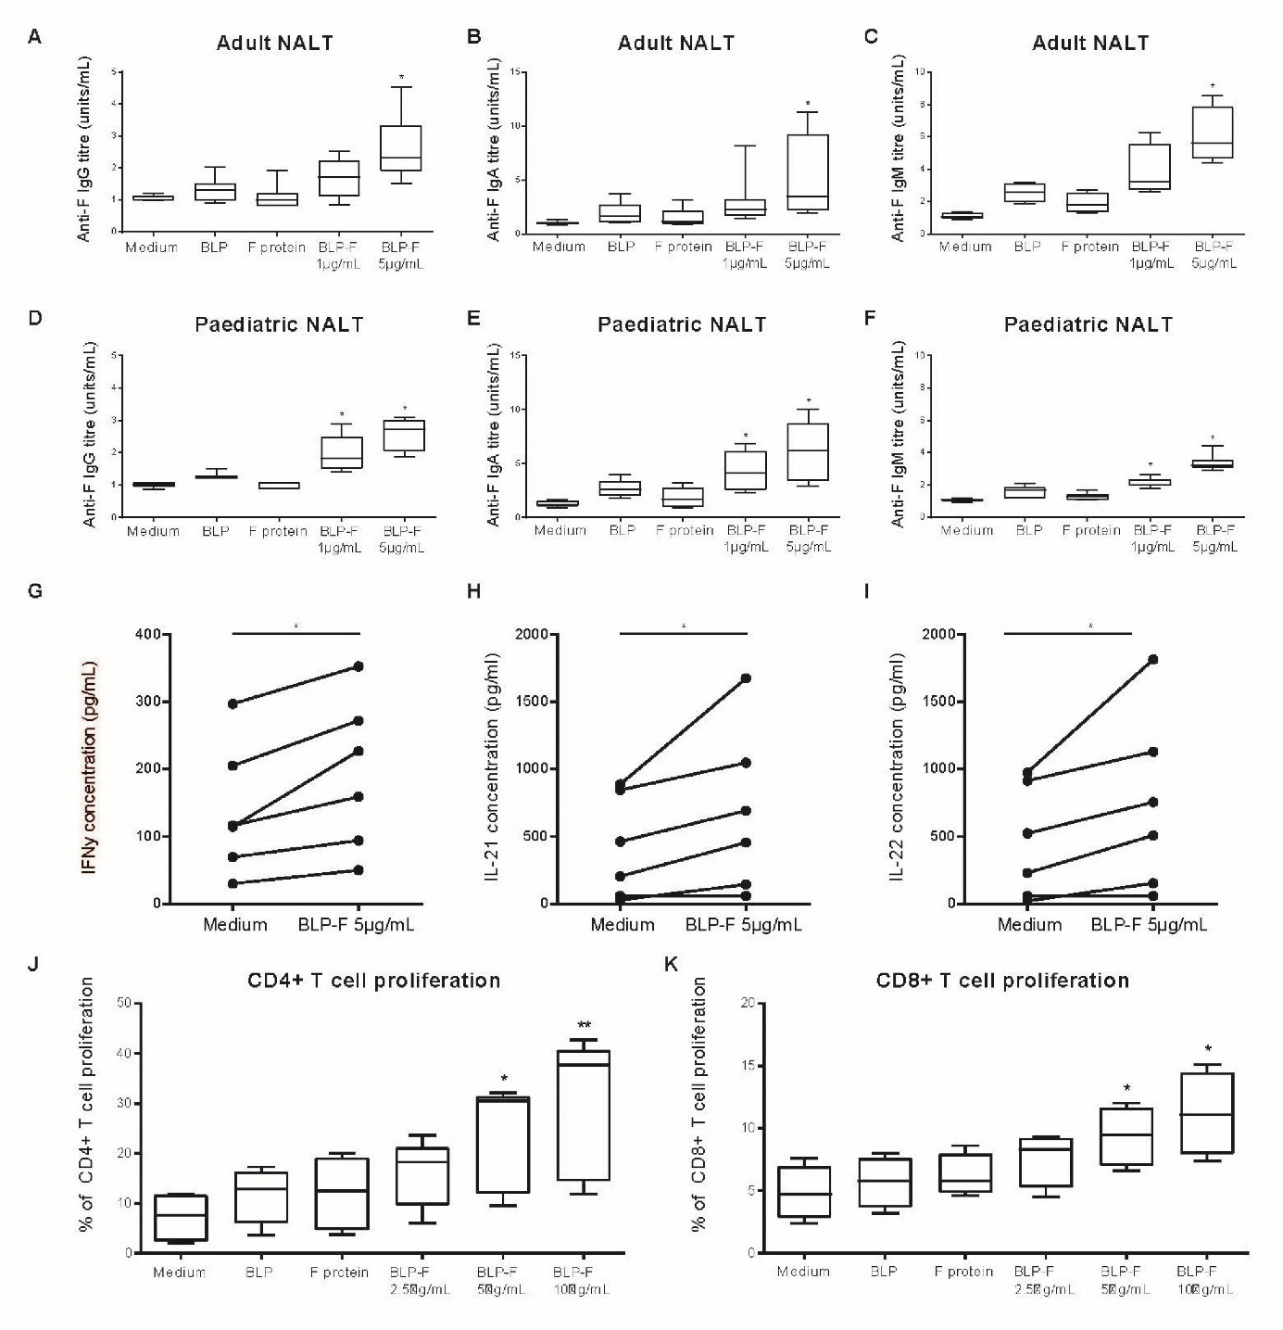
Figure 5.

Local and systemic immunity against RSV induced by a novel intranasal vaccine (SynGEM)

Authors:
Stephanie Ascough, Iris Vlachantoni, Mohini Kalyan, Bert-Jan Haijema, Sanna Wallin-Weber, Margriet Dijkstra-Tiekstra, Muhammad S Ahmed, Maarten van Roosmalen, Roberto Grimaldi, Qibo Zhang, Kees Leenhouts, Peter J Openshaw and Christopher Chiu

Online Data Supplement

Supplementary Methods
Study design
Healthy volunteers were recruited for the randomised double-blind placebo-controlled study, according to the inclusion and exclusion criteria in Table E1 (clinicaltrials.gov identifier NCT02958540). Enrolment took place between October 2016 and January 2017 with final follow-up visits in July 2017. Volunteers received either placebo (phosphate buffered saline (PBS) + 2.5% glycerol) or SynGEM vaccine administered intranasally. The vaccine was given at 2 dose levels; a low dose (140 µg F protein and 2mg BLP) and a high dose (350 µg F protein and 5mg BLP) at day 0 and day 28. Blood and nasal lavage samples were collected 0, 7, 28, 35 and 56 days post-prime vaccination. Intention to treat analysis was performed for primary safety analyses.

Ethics statement
The phase I study was approved by the UK National Research Ethics Service (reference 16/SC/0441), overseen by a Data Safety Monitoring Committee and carried out at the Imperial Clinical Research Facility (ICRF) at the Hammersmith Hospital. Adenotonsillar tissues were obtained from children and adults undergoing tonsillectomy; ethics approval was obtained (reference 14/SS/1058) and written informed consent was obtained in all cases.

Outcomes
The primary endpoint was the safety and tolerability assessed by solicited (local and systemic) and unsolicited adverse events (Table E3). Events were graded mild, moderate or severe and association with vaccination was recorded. Blood test abnormalities were determined using the FDA Toxicity Grading Scale for Healthy Adult and Adolescent Volunteers Enrolled in Preventive Vaccine Clinical Trials. Secondary endpoints assessed humoral systemic and mucosal immune responses to the vaccine. Exploratory endpoints were defined as the measurement of cellular immune responses.

F and G protein-specific enzyme linked immunoassay (ELISA)
Anti-RSV IgG and IgA antibodies were measured using stabilized pre-fusion or unstabilized F protein or Ga (from RSV A) or Gb protein (from RSV B) in ELISA assays as previously described (E1). Serum IgG titer was calculated as a midpoint EC₅₀ and s-IgA titers were calculated as endpoint titers, defined as the highest titer exhibiting an optical density of ≥10x the background. Endpoint titers for the IgA ELISAs were normalized using the ratio of urea in serum and nasal lavage measured using the Abcam Urea Assay Kit, the method adapted from the manufacturer’s protocol. The dilution factor for normalization was calculated as follows:
Dilution Factor = (Serum urea concentration) / (Nasal Lavage urea concentration). Normalized IgA titer=Dilution factors x Nasal s-IgA Titer.

RSV microneutralization assay
The titer of RSV-neutralizing antibodies was determined in serum by plaque reduction neutralization titer (PRNT) assays performed at Viroclinics Biosciences, Rotterdam, The Netherlands, as previously described (E2).

Palivizumab and D25 competing ELISA
Palivizumab- and D25-competing antibodies were quantified in serum by competition ELISA, with furin cleavage site-mutated F protein ectodomain extended with GCN4 trimerization motifs (FlysGCN4) as antigen. Briefly, 100 µL/well of solid phase FlysGCN4 was adsorbed to 96-well EIA plates (Greiner, UK). Dilutions of serum were prepared in duplicate and mixed with biotin-labeled epitope-specific antibodies (D25, Mucosis BV and Palivizumab, MedImmune). Biotinylation was achieved using an EZ-Link Sulfo-NHS-LC-Biotinylation Kit (Thermo Scientific). Plates were then incubated with streptavidin-HRP (Jackson ImmunoResearch), TMB (KPL) was added and the colorimetric reaction was stopped by addition of HCl. Absorbance was read at 450 nm on a microplate reader. Human RSV antiserum (NR-4021, NR-4022 and NR-4023, BEI Resources) and IgG-depleted human serum (SF142-7 and SF505-2, BBI Solutions) were used as controls.

Antibody-secreting cell ELISpots
Human antibody-secreting cells (ASCs) were quantified using enzyme-linked immunospot (ELISpot) assays as previously described (E3). Spots were counted using an automated ELISpot reader (AID), and results expressed as spot forming cells per million PBMCs.

Flow cytometry
Flow cytometry analysis was performed using heparinized whole blood. Cells were stained with anti-CD19 FITC, anti-CD27 APC, anti-CD38 PE and anti-CD3/anti-CD20 both on PE-CF594 (BD Biosciences). Fixed cells were run on a Fortessa flow cytometer (BD Biosciences) and analyzed with FlowJo software.

Measurement of antibodies and cytokines in adenotonsillar cell culture supernatants
Mononuclear cells (MNC) were isolated from adenotonsillar tissues and cultured, as described previously (E4). Tissues were obtained from children (age 2-10 years) and adults (16-30 years) undergoing adenoidectomy and/or tonsillectomy at Liverpool Alder Hey Children’s Hospital and Royal Liverpool and Broadgreen University Hospitals. Patients with known immunodeficiency and tissue samples with signs of gross inflammation were excluded. Adenotonsillar MNC were co-cultured with SynGEM BLP-F with F-protein concentration at 1µg/mL or 5µg/mL, BLP alone (25µg/mL) and F-Protein alone (1µg/mL) or medium. Cell culture supernatants were harvested at day 12 and F protein-specific antibodies were measured by ELISA as described previously (E5).
Following stimulation of adenotonsillar MNC for 3 days with the SynGEM BLP-F (5µg/mL), culture supernatants were analysed using cytometric bead array for cytokines (LEGENDplexTM, Biolegend, UK) following manufacturer’s instructions. T cell responses in adenotonsillar MNC were analyzed by Carboxyfluorescein succinimidyl ester (CFSE) (Molecular Probes, UK) labelling as previously described (E4, E6).

Statistical analysis
Data analyses and graphs were produced using the software R and Graphpad Prism. Non-parametric data was compared using Mann-Whitney-Wilcoxon tests with Holm’s correction for multiple comparisons. Binary response variables were related to continuous explanatory variables using logistic regression. Odds ratios (OR) and 95% confidence intervals (CI) of the OR for the explanatory variables were calculated. For estimation of serum neutralizing antibody titers, weighted (1/y) four-parameter logistic models were fitted to the plaque counts and the 50% neutralizing titer (EC50) was derived from the midpoint of the curve using package ‘drc’.

Supplementary References
E1. Habibi MS, Jozwik A, Makris S, Dunning J, Paras A, DeVincenzo JP, de Haan CAM, Wrammert J, Openshaw PJM, Chiu C. Impaired Antibody-mediated Protection and Defective IgA B-Cell Memory in Experimental Infection of Adults with Respiratory Syncytial Virus. Am J Respir Crit Care Med 2015;191:1040–1049.
E2. Sande CJ, Mutunga MN, Medley GF, Cane PA, Nokes DJ. Group and genotype specific neutralising antibody responses against respiratory syncytial virus (RSV) in infants and young children with severe pneumonia. J Infect Dis. 2012 Feb 1; 207(3): 489–492.
E3. Saletti G, Çuburu N, Yang JS, Dey A, Czerkinsky C. Enzyme-linked immunospot assays for direct ex vivo measurement of vaccine-induced human humoral immune responses in blood. Nat Protocols 2013;8:1073–1087.
E4. Aljurayyan A, Puksuriwong S, Ahmed M, Sharma R, Krishnan M, Sood S, Davies K, Rajashekar D, Leong S, McNamara PS, Gordon S, Zhang Q. Activation and Induction of Antigen-Specific T Follicular Helper Cells Play a Critical Role in Live-Attenuated Influenza Vaccine-Induced Human Mucosal Anti-influenza Antibody Response. J Virol 2018;92:e00114-18.
E5. Mullin J, Ahmed MS, Sharma R, Upile N, Beer H, Achar P, Puksuriwong S, Ferrara F, Temperton N, McNamara P, Lambe T, Gilbert SC, Zhang Q. Activation of cross-reactive mucosal T and B cell responses in human nasopharynx-associated lymphoid tissue in vitro by Modified Vaccinia Ankara-vectored influenza vaccines. Vaccine 2016;34:1688–1695.
E6. Gray C, Ahmed MS, Mubarak A, Kasbekar AV, Derbyshire S, McCormick MS, Mughal MK, McNamara PS, Mitchell T, Zhang Q. Activation of memory Th17 cells by domain 4 pneumolysin in human nasopharynx-associated lymphoid tissue and its association with pneumococcal carriage. Mucosal Immunology 2014;7:705–717.

Supplementary Figures

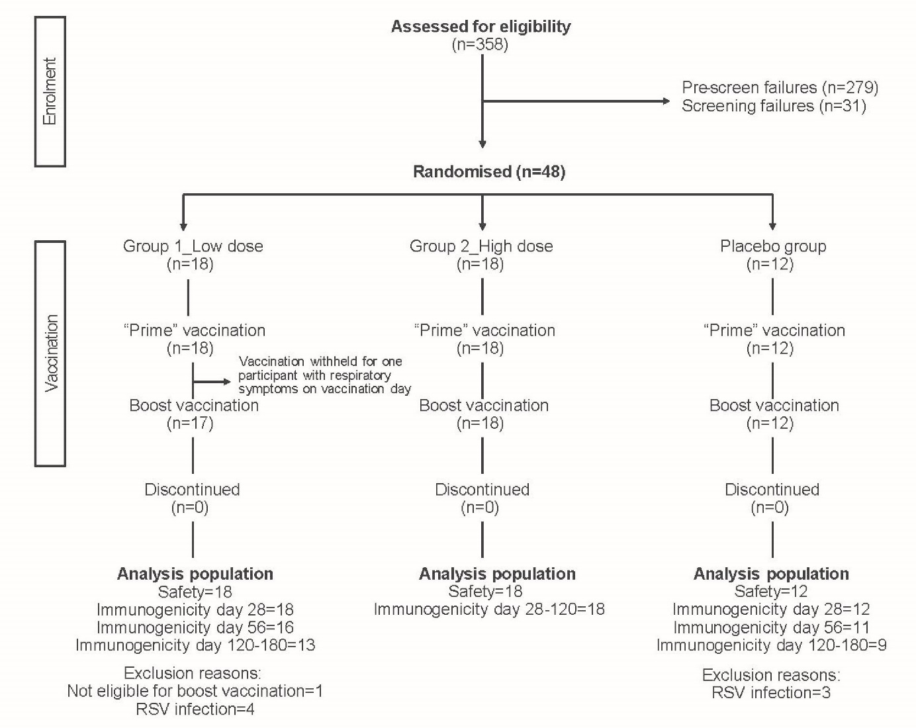
Figure E1 Flowchart summarizing recruitment and vaccination of 48 participants.
Healthy adult volunteers were enrolled and randomized to receive SynGEM intranasally at low-dose (n=18), high-dose (n=18) or placebo (n=12).

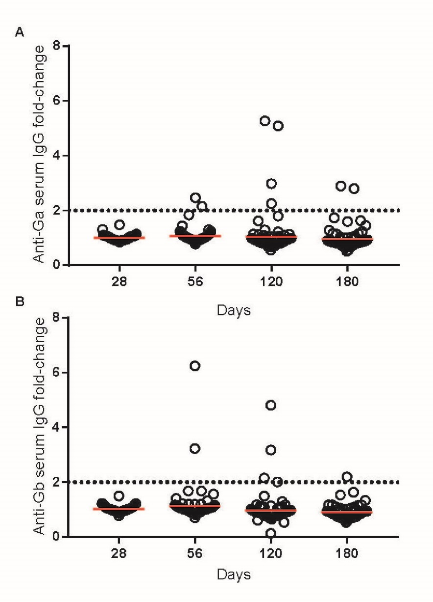
Figure E2. RSV infection in the study cohort revealed by antibodies against G protein.
(A) RSV A and (B) RSV B G protein-specific serum antibodies were measured by ELISA at time-points up to 180 days post-prime. Fold-changes compared with pre-vaccination are shown. A cut-off of 2-fold increase was defined as sero-conversion.

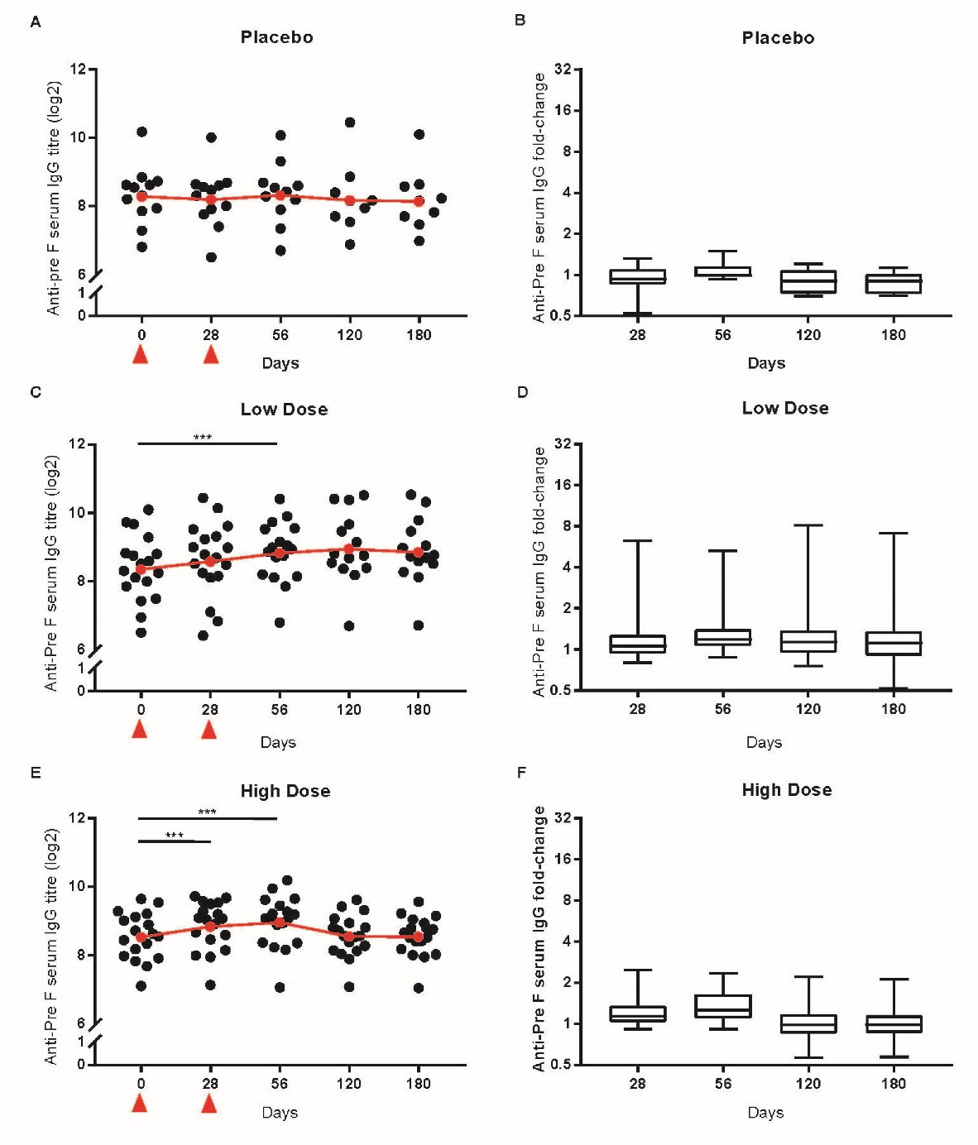
Figure E3. Intranasal SynGEM induces pre-fusion F protein-specific serum antibodies. Volunteers were given SynGEM or placebo and serum IgG was measured by ELISA using pre-fusion F protein as coating antigen at time-points up to 180 days post-“prime”. Titers and fold-changes compared to baseline are shown following (A and B) placebo, (C and D) low-dose and (E and F) high-dose. Geometric means are shown in red. Wilcoxon ranked sign test was used to test statistically significant rises compared to pre-vaccination. * p<0·05; ** p<0·01; *** p<0·001· Vaccinations are indicated by red triangles.
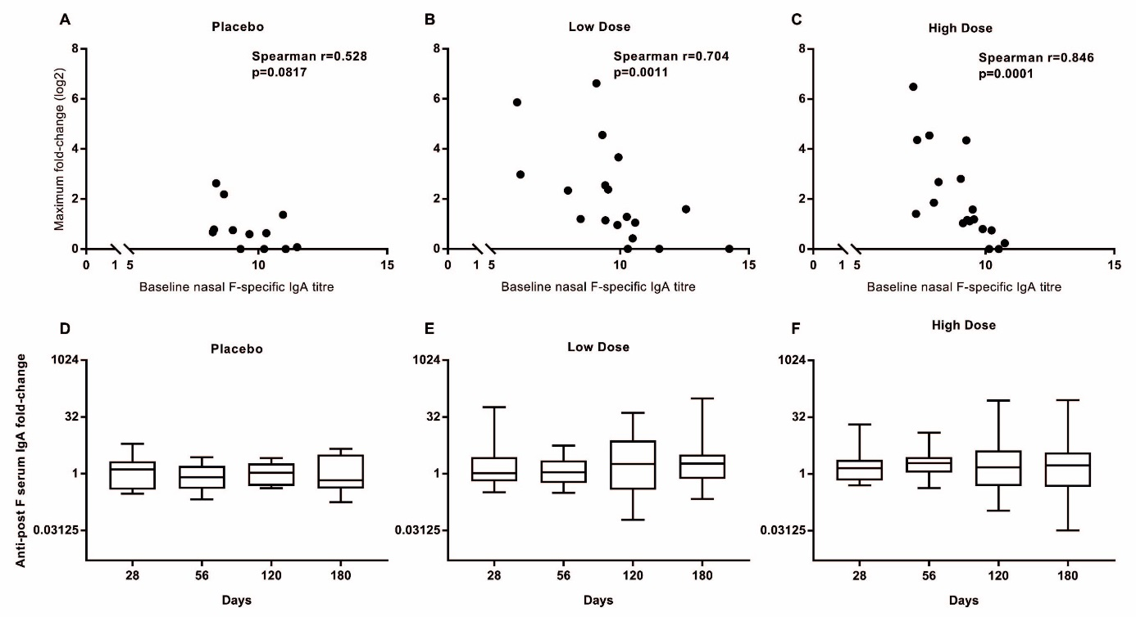
Figure E4. The magnitude of sIgA anti-F fold-change at any time-point from both low and high-dose groups correlates with lower pre-existing antibody titers.
Linear regression and Spearman correlation of pre-vaccination antibody titers and maximal antibody fold-change compared with baseline from placebo, low- and high-dose groups are shown (A-C). Fold-changes compared to baseline are shown following administration of placebo (D), low-dose (E) and high-dose (F). Wilcoxon ranked sign test was used to test statistically significant rises compared to pre-vaccination.

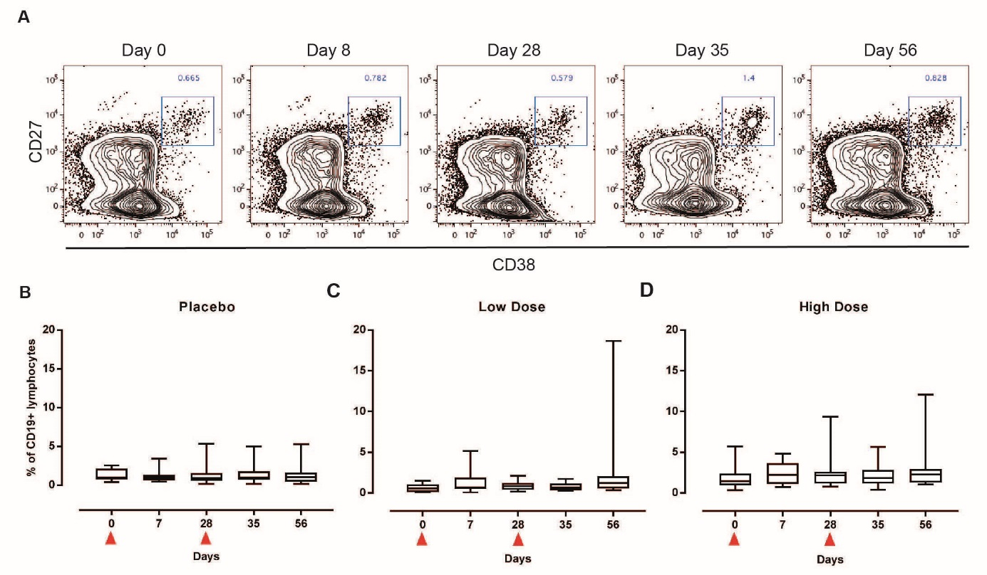
Figure E5. Plasmablasts are not significantly increased following SynGEM.
Whole blood was stained with anti-CD3, CD20, CD19, CD38 and CD27 for analysis by flow cytometry. (A) Representative plots are shown from time-points up to 28 days post-boost. Plots are gated on CD3-CD19+CD20+/- lymphocytes. (B, C and D) Box and whisker plots show frequencies of plasmablasts at each time-point. No significant differences are seen by Wilcoxon ranked sign test.

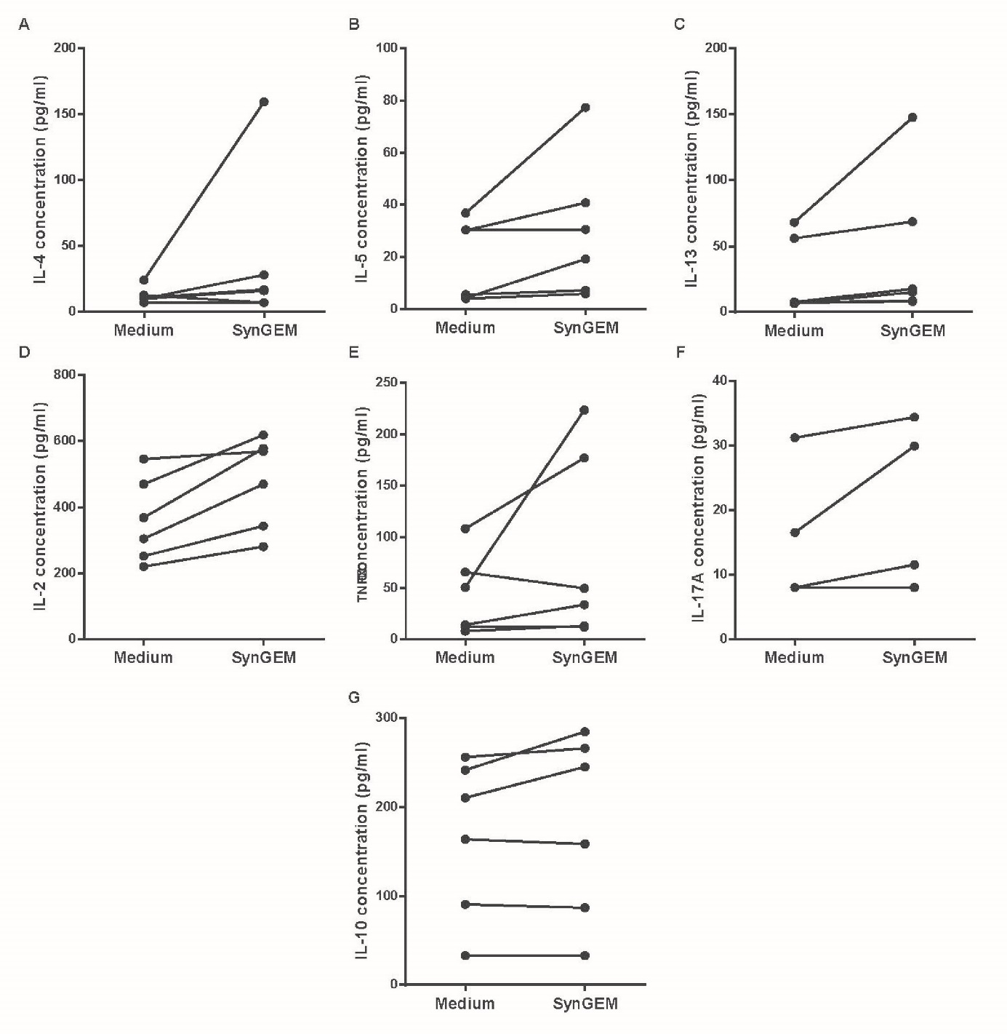
Figure E6. Tonsil cells cultured with SynGEM do not express Th2 cytokines.
Tonsil cells from healthy donors were cultured with SynGEM. Cytokines were measured in culture supernatant by cytometric bead array. Mann-Whitney U test, and Wilcoxon Signed Rank Test was used to test significant differences; no significant differences are seen.

 | Inclusion criteria
 | 1. | Male or female aged 18-49 years inclusive
 | 2. | Able to give written informed consent to participate
 | 3. | Comprehension of the study requirements, expressed availability for the required study period and ability to attend scheduled visits
 | 4. | Healthy, as determined by medical history, physical examination, vital signs and clinical judgement
 | 5. | Having acceptable laboratory parameters within 28 days before study day, defined as: haemoglobin, Red Blood Cell (RBC) count and haematocrit, White Blood Cell (WBC) count, sodium, potassium and total bilirubin within normal laboratory range and alanine aminotransferase (ALT)/ aspartate aminotransferase (AST) and serum creatinine ≤1·1x institutional upper limit normal (ULN)
 | 6. | Body Mass Index (BMI) between 18 and 32, inclusive
 | 7. | Women of childbearing potential are to have a negative serum β-human chorionic gonadotropin (β-hCG) pregnancy test at screening and a negative urine β-hCG pregnancy test within 24 hours preceding receipt of each dose and agree to practice, if not already practicing, highly effective birth control measures from 28 days before the prime vaccination until at least 90 days after the boost vaccination.  For women already practicing highly effective birth control measurements for at least 28 days at screening start, recruitment could occur as soon as all screening procedures were completed. The following birth control measures were considered highly effective:
 |  | a. | Combined (estrogen and progestogen containing) hormonal contraception associated with inhibition of ovulation (oral, intravaginal, transdermal), progestogen-only hormonal contraception associated with inhibition of ovulation (oral, injectable or implantable), intrauterine device, intrauterine hormone releasing system, bilateral tubal ligation, vasectomized partner (if the partner was the sole sexual partner and had received medical assessment of the surgical success)
 |  | b. | True abstinence: when this was in line with the preferred and usual lifestyle of the subject. Periodic abstinence (e.g., calendar, ovulation, symptothermal, post-ovulation methods), declaration of abstinence for the duration of a trial, and withdrawal are not acceptable methods of contraception
 |  | c. | If not heterosexually active at screening, must agree to practice highly effective birth control measures described above if they became heterosexually active from that moment onwards until at least 90 days after the boost vaccination
 |  | d. | Agree not to donate eggs (ova, oocytes) for the purposes of assisted reproduction from the start of screening onwards until at least 90 days after the boost vaccination
 | 8. | Women of non-childbearing potential, defined as postmenopausal (>45 years of age with amenorrhea for ≥2 years; for female of >45 years of age with amenorrhea for more than 6 months but less than 2 years confirmation of a serum follicle-stimulating hormone (FSH) >40 mIU/mL are required to consider them of non-childbearing potential) or surgically sterile (hysterectomy, bilateral tubal ligation, or bilateral oophorectomy), were not required to use the birth control methods as described in Inclusion Criterion #7
 | 9. | A man who has not had a vasectomy with medical assessment of the surgical success and is sexually active with a woman of childbearing potential must agree to consistently use a barrier method of birth control, such as condom with spermicidal foam/gel/film/cream/suppository. Men also gave to agree not to donate sperm from the first study vaccine administration (Day 1) until 90 days after the boost vaccination
 | 10. | Subjects have to be willing to provide verifiable identification and their National Insurance/Passport number for the purpose of The Over-volunteering Prevention System (TOPS) registration
 | 11. | Subject has to have a means to be contacted
 | Exclusion criteria
 | 1. | History of acute respiratory disease in the 30 days preceding start of screening or documented infection with RSV in the previous 3 months
 | 2. | Any chronic disease of the nasal cavity such as chronic hypertrophic or atrophic rhinitis, chronic sinusitis, ozena, Wegener’s granulomatosis or granulomatosis with polyangiitis.
 | 3. | History of asthma or chronic obstructive pulmonary disease
 | 4. | Presence of significant uncontrolled medical or psychiatric illness (acute or chronic). This includes institution of a new medical or surgical treatment, or a significant dose alteration for uncontrolled symptoms or drug toxicity within 3 months of screening
 | 5. | Subjects who are positive for hepatitis B surface antigen, hepatitis C antibodies or HIV
 | 6. | Pregnant or breastfeeding women or planning to become pregnant while enrolled in the study or within 90 days after the boost vaccination
 | 7. | Cancer, or treatment for cancer, within 3 years, excluding basal cell carcinoma or squamous cell carcinoma of the skin, which is allowed
 | 8. | Presence of any medical condition that may be associated with impaired immune responsiveness, including diabetes mellitus
 | 9. | Receiving at study start or history of receiving, during the preceding 3-month period, any medications or other treatments that may adversely affect the immune system such as allergy injections, immune globulins, interferon, immunomodulators, cytotoxic drugs or other drugs known to be frequently associated with significant major organ toxicity, or systemic corticosteroids (oral or injectable)
 | 10. | Receipt of any intranasal administration of drug or vaccine within the 30 days prior to the first administration of study vaccine or plans to receive any intranasal administration of drug or vaccine until the end of study visit
 | 11. | Receipt of live attenuated vaccine within 30 days of first SynGEM® administration or plans to receive within 30 days after the last study vaccine administration, and receipt of any other vaccine within 15 days of first SynGEM® administration or plans to receive within 15 days after the last study vaccine administration
 | 12. | Positive history of illicit drug use, of drug or alcohol abuse within the previous 6 months
 | 13. | History of anaphylactic type reaction to injected vaccines
 | 14. | History of allergic rhinitis or of allergy to food
 | 15. | History of allergy to insect bites, latex, pollens, house dust mites that were considered significant by the Investigator
 | 16. | Treatment with another investigational medicinal product (IMP) within 3 months prior to screening or with more than 2 IMPs in the past year
 | 17. | Receipt of blood or blood products 8 weeks prior to vaccination or planned administration during the study period
 | 18. | Loss of ˃ 500 mL blood within 3 months prior to screening
 | 19. | Any major neurological disease, including migraine
 | 20. | Any condition that, in the Investigator’s opinion, might interfere with the primary study objectives
 | 21. | Acute disease within 72 hours prior to vaccination, defined as the presence of a moderate or severe illness (as determined by the Investigator through medical history and physical examination) with or without fever, or a fever >38ºC did not represent an absolute exclusion criterion, but an exclusion criterion at that moment in time. Prime vaccination could be re-scheduled as deemed necessary by the Investigator
Table E1. Eligibility criteria

 | Primary objective
 | 1. | To assess the safety and tolerability of two different doses of SynGEM® ( 140 μg F- protein-  FP/2mg BLPs or 350 μg F-protein-FP/5mg BLPs) administered 28 days apart (Day 1 and Day  29) in healthy adult subjects.
 | Secondary objectives
 | 1. | To assess humoral systemic and mucosal immune responses to F-protein-BLP of the two doses measured by
 | a. | RSV A virus neutralization by plaque reduction neutralization titers (PRNT) assay
 | b. | F specific serum IgG and nasal Secretory IgA (S-IgA) antibody titers by enzyme-linked  immunosorbent assay (ELISA).
Table E2. Study endpoints

 |  | Low dose |  |  | High dose |  |  | Placebo
 |  | Decrease | Increase |  | Decrease | Increase |  | Decrease | Increase
 | Parameter | Any grade (%) [grade 3 or more (%)] | Any grade (%) [grade 3 or more (%)] |  | Any grade (%) [grade 3 or more (%)] | Any grade (%) [grade 3 or more (%)] |  | Any grade (%) [grade 3 or more (%)] | Any grade (%) [grade 3 or more (%)]
Haematology
 | Haemoglobin | 5 (27·8) | 0 |  | 2 (11·1) | 0 |  | 2 (16·7) [2 (16·7)] | 0
 | White Blood Cells (total) | 6 (33·3) | 6 (33·3) |  | 4 (22·2) | 4 (22·2) |  | 6 (50) | 6 (50)
 | Absolute lymphocytes | 2 (11·1) | 0 |  | 1 (5·6) | 0 |  | 2 (16·7) | 0
 | Absolute neutrophils | 3 (16·7) | 0 |  | 5 (27·8) | 0 |  | 3 (25·0) | 0
 | Absolute eosinophils | 1 (5·6) | 0 |  | 0 | 0 |  | 0 | 0
Biochemistry
 | Sodium | 0 | 0 |  | 0 | 0 |  | 0 | 0
 | Potassium | 0 | 0 |  | 0 | 0 |  | 0 | 0
 | Creatinine | 0 | 0 |  | 0 | 0 |  | 0 | 0
 | Urea | 0 | 0 |  | 0 | 0 |  | 0 | 0
 | Alanine aminotransferase | 0 | 1 (5·6) |  | 0 | 0 |  | 0 | 2 (16·7)
 | Aspartate aminotransferase | 0 | 2 (11·1) |  | 0 | 1 (5·6) |  | 0 | 1 (8·3)
Table E3. Hematology and biochemistry abnormalities by maximum severity (any visit)

 |  |  | Low dose |  |  | High dose |  |  |  | Placebo |  |  |  |  |  |  | Test of significance
 |  |  | Post prime | Post boost |  | Post prime | Post boost |  |  | Post prime |  |  | Post boost
 |  |  | (n=18) | (n=17) |  | (n=18) | (n=18) |  |  | (n=12) |  |  | (n=18)
 |  |  | Any grade (%) [grade 3 (%)] | Any grade (%) [grade 3 (%)] |  | Any grade (%) [grade 3 (%)] | Any grade (%) [grade 3 (%)] |  |  | Any grade (%) [grade 3 (%)] |  |  | Any grade (%) [grade 3 (%)]
Local
 | Epistaxis |  | 0 | 0 |  | 0 | 0 |  |  | 0 |  |  | 0 |  |  |  | ns
 | Facial discomfort |  | 0 | 0 |  | 0 | 0 |  |  | 2 (16·7) |  |  | 0 |  |  |  | ns
 | Facial numbness |  | 0 | 0 |  | 0 | 1 (5·6) |  |  | 0 |  |  | 0 |  |  |  | ns
 | Facial swelling |  | 0 | 0 |  | 0 | 0 |  |  | 0 |  |  | 0 |  |  |  | ns
 | Lacrimation |  | 0 | 0 |  | 0 | 0 |  |  | 0 |  |  | 0 |  |  |  | ns
 | Loss of smell |  | 0 | 0 |  | 0 | 0 |  |  | 2 (16·7) |  |  | 0 |  |  |  | ns
 | Nasal discomfort |  | 1 (5·6) | 0 |  | 0 | 0 |  |  | 1 (8·3) |  |  | 0 |  |  |  | ns
 | Nasal pain |  | 0 | 0 |  | 0 | 0 |  |  | 0 |  |  | 0 |  |  |  | ns
 | Red eyes |  | 0 | 0 |  | 0 | 0 |  |  | 0 |  |  | 0 |  |  |  | ns
 | Rhinorrhea |  | 3 (16·7) | 2 (11·8) |  | 1 (5·6) | 0 |  |  | 0 |  |  | 1 (8·3) |  |  |  | ns
 | Sneezing |  | 1 (5·6) | 0 |  | 0 | 0 |  |  | 0 |  |  | 0 |  |  |  | ns
 | Sore throat |  | 1 (5·6) | 0 |  | 0 | 0 |  |  | 0 |  |  | 0 |  |  |  | ns
 | Stuffy nose |  | 3 (16·7) | 1 (5·9) |  | 0 | 0 |  |  | 1 (8·3) |  |  | 1 (8·3) |  |  |  | ns
Systemic
 | Arthralgia |  | 0 | 0 |  | 0 | 0 |  |  | 0 |  |  | 0 |  |  |  | ns
 | Chills |  | 0 | 1 (5·9) |  | 0 | 0 |  |  | 0 |  |  | 0 |  |  |  | ns
 | Fatigue |  | 2 (11·1) | 2 (11·8) |  | 0 | 0 |  |  | 3 (25) |  |  | 1 (8·3) |  |  |  | ns
 | Feeling feverish |  | 2 (11·1) | 0 |  | 0 | 0 |  |  | 0 |  |  | 0 |  |  |  | ns
 | Itching |  | 0 | 0 |  | 0 | 0 |  |  | 0 |  |  | 0 |  |  |  | ns
 | Headache |  | 0 | 1 (5·9) |  | 0 | 0 |  |  | 1 (8·3) |  |  | 1 (8·3) |  |  |  | ns
 | Malaise |  | 1 (5·6) | 0 |  | 0 | 0 |  |  | 0 |  |  | 0 |  |  |  | ns
 | Myalgia |  | 0 | 0 |  | 0 | 0 |  |  | 0 |  |  | 0 |  |  |  | ns
 | Nausea |  | 0 | 0 |  | 0 | 0 |  |  | 0 |  |  | 1 (8·3) |  |  |  | ns
 | Rash |  | 0 | 0 |  | 0 | 0 |  |  | 0 |  |  | 0 |  |  |  | ns
 | Vomiting |  | 0 | 0 |  | 0 | 0 |  |  | 0 |  |  | 0 |  |  |  | ns
Table E4. Solicited adverse events within 1 hour of dosing
 | Low dose |  |  |  |  |  | High dose |  |  |  |  |  | Placebo
 | Post prime |  |  | Post boost |  |  | Post prime |  |  | Post boost |  |  | Post prime |  |  | Post boost
 | (n=18) |  |  | (n=17) |  |  | (n=18) |  |  | (n=18) |  |  | (n=12) |  |  | (n=12)
 | Any grade (%) [grade 3 (%)] | Median TTO (IQR)  (days) | Median duration (IQR)  (days) | Any grade (%) [grade 3 (%)] | Median TTO (IQR)  (days) | Median duration (IQR)  (days) | Any grade (%) [grade 3 (%)] | Median TTO (IQR)  (days) | Median duration (IQR)  (days) | Any grade (%) [grade 3 (%)] | Median TTO (IQR)  (days) | Median duration (IQR)  (days) | Any grade (%) [grade 3 (%)] | Median TTO (IQR)  (days) | Median duration (IQR)  (days) | Any grade (%) [grade 3 (%)] | Median TTO (IQR)  (days) | Median duration (IQR)  (days)
Local
Epistaxis | 0 (0) |  |  | 0 |  |  | 0 |  |  | 2 (11·1) | 2·5 (1) | 1 (0) | 0 |  |  | 2 (16·7) | 2 (2) | 1 (0)
Facial discomfort | 0 |  |  | 0 |  |  | 0 |  |  | 1 (5·6) | 1 (0) | 6 (0) | 2 (16·7) | 1 (0) | 1 (0) | 1 (8·3) | 1 (0) | 1 (0)
Facial numbness | 0 |  |  | 0 |  |  | 1 (5·6) | 1 (0) | 1 (0) | 1 (5·6) | 1 (0) | 5 (0) | 0 |  |  | 0
Facial swelling | 1 (5·6) | 2 (0) | 1 (0) | 0 |  |  | 1 (5·6) | 3 (0) | 1 (0) | 1 (5·6) | 1 (0) | 1 (0) | 0 |  |  | 0
Lacrimation | 1 (5·6) | 1 (0) | 1 (0) | 1 (5·9) | 7 (0) | 1 (0) | 1 (5·6) | 2 (0) | 3 (0) | 1 |  |  | 1 (8·3) | 1 (0) | 1 (0) | 0
Loss of smell | 3 (16·7) | 2 (1.0) | 3 (2) | 4 (23·5) | 4·5 (4·5) | 1·5 (1·5) | 1 (5·6) | 1 (0) | 7 (0) | 0 |  |  | 3 (25) | 1 (0) | 1 (4) | 0
Nasal discomfort | 3 (16·7) | 1 (2) | 1 (2) | 3 (17·6) | 5 (6) | 1 (2) | 3 (16·7) | 1 (1) | 2 (1) | 2 (11·1) | 1 (0) | 3 (2) | 3 (25) | 1 (0) | 2 (2) | 1 (8·3) | 1 (0) | 1 (0)
Nasal pain | 1 (5·6) | 4 (0) | 1 (0) | 0 |  |  | 1 (5·6) | 1 (0) | 2 (0) | 2 (11·1) | 4·5 (1) | 1 (0) | 1 (8·3) | 1 (0) | 1 (0) | 0
Red eyes | 0 |  |  | 1 (5·9) | 7 (0) | 1 (0) | 0 |  |  | 1 (5·6) | 3 (0) | 1 (0) | 0 |  |  | 0
Rhinorrhea | 8 (44) | 1 (1) | 2·5 (2) | 5 (29·4) | 5 (4) | 1 (2) | 6 (33·3) | 1 (3) | 1·5 (1) | 4 (22·2) | 1 (1) | 3 (3) | 3 (25) | 1 (0) | 2 (5) | 3 (25) | 3 (3) | 4 (4)
Sneezing | 6 (33·3) | 1·5 (4) | 2 (1) | 2 (11·8) | 3 (4) | 1 (0) | 1 (5·6) | 2 (0) | 1 (0) | 3 (16·7) | 1 (2) | 3 (2) | 2 (16·7) | 1·5 (1) | 1 (0) | 2 (16·7) | 3·5 (1) | 1·5 (1)
Sore throat | 2 (11·1) | 1 (0) | 1 (0) | 1 (5·9) [1(5·9)] | 6 (0) | 2 (0) | 5 (27·8) | 1 (1) | 3 (1) | 3 (16·7) | 6 (3) | 2 (1) | 3 (25) | 1 (3) | 2 (2) | 5 (41·7) | 3 (1) | 4 (3)
Stuffy nose | 8 (44·4) | 1 (0·5) | 2·5 (2·5) | 5 (29·4) | 1 (4) | 1 (1) | 6 (33·3) | 2 (1) | 1·5 (3) | 4 (22·2) | 2 (2) | 2 (2) | 4 (33·3) | 1 (1) | 3 (4·5) | 7 (58·3) | 1 (2) | 1 (3)
Systemic
Arthralgia | 1 (5·6) | 1 (0) | 2 (0) | 2 (11·8) | 5 (2) | 1 (0) | 1 (5·6) | 2 (0) | 1 (0) | 0 |  |  | 0 |  |  | 0
Chills | 0 |  |  | 2 (11·8) | 4 (6) | 1 (0) | 1 (5·6) | 4 (0) | 1 (0) | 1 (5·6) | 4 (0) | 1 (0) | 0 |  |  | 1 (8·3) | 7 (0) | 1 (0)
Fatigue | 9 (50)  [1 (5·6)] | 1 (0) | 2 (2) | 7 (41·2) | 1 (2) | 1 (1) | 6 (33·3) [1(5·6)] | 1 (1) | 1·5 (1) | 6 (33·3) | 1·5 (2) | 2 (3) | 7 (58·3) | 1 (2) | 2 (2) | 5 (41·7) | 1 (0) | 1 (1)
Feeling feverish | 3 (16·7) | 1 (0) | 2 (3) | 1 (5·9) | 6 (0) | 2 (0) | 1 (5·6) | 1 (0) | 1 (0) | 1 (5·6) | 3 (0) | 1 (0) | 1 (8·3) | 1 (0) | 1 (0) | 1 (8·3) | 5 (0) | 1 (0)
Itching | 1 (5·6) | 4 (0) | 2 (0) | 0 |  |  | 1 (5·6) | 4 (0) | 1 (0) | 1 (5·6) | 3 (0) | 1 (0) | 0 |  |  | 0
Headache | 8 (44·4) | 1·5 (2) | 1·5 (1) | 4 (23·5) | 2 (3·5) | 1 (0·5) | 8 (44·4) | 1·5 (4·5) | 1 (1) | 8 (44·4) | 2·5 (3·5) | 1 (1) | 4 (33·3) | 1 (0·5) | 1·5 (1·5) | 3 (25) | 1 (6) | 1 (3)
Malaise | 2 (11·1)  [1 (5·6)] | 2 (2) | 2 (2) | 2 (11·8) [1(5·9)] | 4·5 (3) | 1·5 (1) | 2 (11·1) | 1 (0) | 3·5 (5) | 0 |  |  | 1 (8·3) | 1 (0) | 2 (0) | 1 (8·3) | 6 (0) | 2 (0)
Myalgia | 5 (27·8) | 1 (1) | 2 (1) | 3 (17·6) | 5 (2) | 2 (2) | 0 |  |  | 2 (11·1) | 1·5 (1) | 1 (0) | 2 (16·7) | 2 (2) | 1·5 (1) | 1 (8·3) | 1 (0) | 1 (0)
Nausea | 1 (5·6) | 3 (0) | 1 (0) | 1 (5·9) | 6 (0) | 2 (0) | 1 (5·6) | 2 (0) | 1 (0) | 1 (5·6) | 1 (0) | 1 (0) | 0 |  |  | 1 (8·3) | 1 (0) | 1 (0)
Rash | 1 (5·6) | 4·0 (4·0-4·0) | 3·0 (3·0-3·0) | 0 |  |  | 1 (5·6) | 4 (0) | 1 (0) | 1 (5·6) | 3 (0) | 1 (0) | 0 |  |  | 0
Vomiting | 0 |  |  | 0 |  |  | 0 |  |  | 0 |  |  | 0 |  |  | 0
Table E5. Solicited adverse events

