DOI: 10.1002/adom.((please add manuscript number))
Article type: Communication

Influence of Silver Film Quality on the Threshold of Plasmonic Nanowire Lasers

Haichao Yu, Themistoklis P. H. Sidiropoulos, Wei Liu, Carsten Ronning, Peter K. Petrov, Sang-Hyun Oh, Stefan A. Maier, Peng Jin* and Rupert F. Oulton*

H. Yu, Dr. T. P. H. Sidiropoulos, Prof. S. A. Maier, Dr. R. F. Oulton
The Blackett Laboratory, Imperial College London, London SW7 2AZ, United Kingdom
E-mail: r.oulton@imperial.ac.uk
H.Yu, Prof. P. Jin
Center of Ultra-precision Optoelectronic Instrument, Harbin Institute of Technology, Harbin 150080, China
E-mail: p.jin@hit.edu.cn
W. Liu, Dr. P. K. Petrov
Department of Materials, Imperial College London, London SW7 2AZ, United Kingdom
Prof. Sang-Hyun Oh
Department of Electrical and Computer Engineering, University of Minnesota, Minneapolis, Minnesota 55455, United States
Prof. C. Ronning
Friedrich-Schiller-Universität Jena, Max-Wien-Platz 1, D-07743 Jena, Germany

Keywords: epitaxial growth, template stripping, plasmonic nanowire lasers, plasmonic films, silver films

Plasmonic nanowire lasers are nanoscopic sources of light operating at deep subwavelength scales with ultrafast dynamics.^{[1-6]} Such lasers enable the investigation of enhanced light-matter interactions and can have large impact on applications in the fields of non-linear optics, sensing, and optical communications.^{[7-12]} However, metal-based lasers suffer from high losses, caused by the inherent electron scattering in metals, which leads to an increased lasing threshold and limits their use in applications. To minimise losses and thus improve their performance, it has been suggested to use metal films of high quality which ideally have an ultra-flat surface with a high crystalline perfection.^{[1, 13-16]} However, investigating the effects of Ag film quality on the performance of hybrid-plasmonic zinc oxide (ZnO) nanowire lasers this work finds that such a laser geometry is dominated by losses in the gain material.

Typically, metal films are deposited by thermal evaporation or sputtering. However, the quality of thin metal films is strongly dependent on the growth conditions^{[17,18]} and without careful optimisation they are polycrystalline with a surface roughness on the order of a few nanometres.^{[19,20]} Alternatively, the template-stripping method can be used to obtain ultra-flat metal films,^{[21, 22]}, however stripped films are usually still polycrystalline. Optimally, the metal films should be a single crystal with an atomically flat surface over a large area. Epitaxial growth and chemical synthesis have been demonstrated as an effective way to obtain monocrystalline metal films for reducing the metal losses.^{[13,17,23-26]} It is known that a high deposition rate and high substrate temperature are essential to obtain epitaxial growth of continuous and flat monocrystalline metal films based on a general deposition system (thermal evaporator or sputtering system).^{[17,19]} In this work, firstly the film fabrication process for both template-stripping and epitaxial growth based on a thermal evaporator was optimized. Subsequently, the performance of room temperature hybrid plasmonic ZnO nanowire lasers with different silver films (general polycrystalline silver films, template-stripped silver films and monocrystalline silver films) was characterized.

The lasers under study consist of single-crystal, wurzite ZnO nanowires lying on a silver film with a 10nm thick magnesium fluoride (MgF₂) spacer layer, as shown in Figure 1.^{[27]} The wide-bandgap semiconductor ZnO (Eg ~ 3.37eV) emits in the ultraviolet regime (~ 380nm), which is close to the surface plasmon frequency of a silver/air interface.^{[6,28-31]} For optimizing the epitaxial growth of silver films, C-axis mica is chosen as a substrate due to its extremely clean and atomically flat surface, low cost and well lattice-matched crystalline structure with silver.^{[17,19,20,32]} For the template-stripping process monocrystalline silicon templates instead of mica were chosen, as individual sheets of mica usually remain on the stripped silver surface. Polycrystalline silver films were grown on monocrystalline silicon substrates. For all films 100nm of Ag were deposited using a commonly available thermal evaporator with a base pressure on the order of 5×10⁻⁷ Torr.

The surface morphology of the silver films was investigated with atomic force microscopy (AFM). Figure 2 shows the root mean square (RMS) roughness measured over 5 × 5 μm² of silver films fabricated with different methods and under different conditions (see also Table S1, Supporting Information). The silver films were deposited at room temperature for template-stripping off Si, Si substrates were cleaned with piranha solution (see details in Supporting Information). Increasing the deposition rate results in a slightly smoother stripped surface, though the as-deposited surface does not show this trend and the RMS roughness are much higher. The grain size distribution on the as-deposited surface follows a more complicated trend (see Figure S1, Supporting Information). For the silver films deposited on mica, higher deposition rates also give rise to better surface quality. A comparison of films deposited on mica and silicon under similar conditions reveals a better surface quality for the mica films. We relate this to the ultra-clean and ultra-flat surface of newly cleaved mica.

At high substrate temperatures and low deposition rates, the silver film surface forms islands or channels (see Figure S2, Supporting Information), which is consistent to the structure zone models of film growth.^{[33-35]} The substrate temperature here controls the grain growth process by tuning the ad-atoms mobility: the ad-atoms have low mobility and stick where they land at low temperature; with increasing temperature the ad-atoms mobility is enhanced and surface or bulk diffusion occurs, which helps to form epitaxial growth but results in non-continuous surfaces.^{[19,20,32]}. Furthermore, a high deposition rate can reduce the surface roughness dramatically; particularly for a deposition rate of 40 Å/s, the silver forms an ultra-flat continuous surface with RMS roughness as low as 0.53 nm ± 0.02 nm and without any grain boundaries (Figure S3, Supporting information). This is because the diffusion length decreases with faster deposition rates, increasing the density of agglomerations of silver, and at the same time the size of the agglomerations is reduced leading to a generally smoother surface.^{[32]} Furthermore, high deposition rates can also improve the film quality by reducing the interaction time of the deposited silver atoms and the residuals such as water or oxygen molecules in the chamber before deposition on the substrate.^{[18]} Thus, high deposition rates generally result in smoother film surfaces of higher purity (shown as in Figure 2 in the x-axis direction). In the end, high deposition rate and high substrate temperature result in ideally ultra-flat and continuous epitaxial growth with RMS values of ~0.5 nm, which is close to the resolution limit of the used AFM.

High-resolution X-ray diffraction was used to confirm the crystalline structure of these films. Figure 3 shows the XRD patterns for silver films fabricated under different conditions. The XRD pattern of a silver film deposited under ambient condition with a substrate temperature of 20 °C and a deposition rate of 1 Å/s (denoted PC) has a polycrystalline structure and a weak Ag(111) peak compared to the Mica peaks (the other Ag peaks are convoluted in the mica diffraction peaks). While the silver film deposited at 350 °C and 40 Å/s (denoted SC) has a much stronger Ag(111) peak, which indicates the formation of a monocrystalline structure. The rocking curve of silver’s (111) peak has a full-width-at-half-maximum (FWHM) of only 0.12$°$ (Figure S4, Supporting Information), which indicates low amounts of crystal defects. We also conducted the template-stripping process with this film, however, because of mica’s hierarchical structure and the strong adhesive force between the silver film and the mica substrate, it is difficult to mechanically strip the mica off completely. We only succeeded with a few samples. The XRD pattern of the stripped silver film (denoted TSSC) contains only Ag(111) and Ag(222) peaks, which further confirms its monocrystalline structure. The XRD pattern of the film stripped from the silicon substrate (denoted TSPC) deposited at 20 °C and 40 Å/s, on the other hand, shows a polycrystalline structure with many Ag diffraction peaks.

To compare the dielectric properties of our epitaxial grown monocrystalline, template-stripped and general deposited films, we performed spectroscopic ellipsometry measurements. The real and imaginary components of the permittivity, $ε^{'}$and $ε^{''}$ , respectively, are shown in Figure 4 and are compared to the data reported by Johnson/Christy^{[36]} and Palik^{[37]} (solid lines). In the range of 350nm-750nm the monocrystalline film (deposited at 350 °C and 40 Å/s on mica) shows a larger negative $ε^{'}$ than the other two films (template-stripped off Si deposited at 20 ºC and 40 Å/s, general deposited at 20 ºC and 1 Å/s on mica), which indicates a better conductivity. The template-stripped film and the general deposited film have similar real components, which can be attributed to their intrinsic polycrystalline structure. Comparing $ε^{''}$ of those films, which is related to the metal losses, shows that the monocrystalline films have lower losses than template-stripped films, and the template-stripped films have lower losses than the general ones. Around 370nm the monocrystalline and template-stripped films have an about 50% and 40% reduced $ε^{''}$, respectively, compared to the general films.

To study the impact of metal film quality on plasmonic nanowire laser structures, we characterized plasmonic nanowire lasers with optimized epitaxial grown silver film (40 Å/s deposition rate, 350 °C substrate temperature), template-stripped film (40 Å/s deposition rate, 20 °C substrate temperature) and general deposition film (12 Å/s deposition rate, 20 °C substrate temperature as comparison with our former work^{[6]}) substrates. The AFM images and related XRD patterns of these films are shown in Figure 5. 10nm of MgF₂ was deposited as a gap layer. Here, MgF₂ was deposited at base pressures <5e-7 Torr and at room temperature, we therefore do not except any changes to the metal film quality. For MgF₂ on a monocrystalline silver film we find an RMS surface roughness of 0.79nm$±$0.08nm (Figure S5 Supporting Information).Then ZnO nanowires were dry-transferred onto the substrate to form plasmonic nanowire laser. Single nanowires were optically pumped by a 150fs pulsed laser with a repetition rate of 266kHz at a wavelength of 355nm at room temperature. To ensure uniform illumination an elliptical spot of 2.5x25µm² was used for all devices. The near band-edge emission spectrum was measured for various pump irradiances. The dominant polarization of the emitted laser spectrum was along the nanowires axis, as expected for these hybrid plasmonic lasers.^{[6]} As the threshold of these plasmon nanowire lasers is dependent on the individual nanowire dimensions and quality besides the quality of metal films, we characterized several lasers on each sample. We selected nanowires with diameter size in the range of 120nm-180nm with a diameter standard deviation of a single nanowire of less than 10nm. The length of the nanowires considered varied between 7±2.5µm, see Figure 6. While nanowire length is known to influence cavity losses ^{[38, 39]}, the measured threshold variations of the nanowire lasers considered were much larger than the variation in nanowire length. Plasmon nanowire lasers based on monocrystalline silver films show on average an about 20% lower threshold than others devices (with average threshold of 1.69 GW cm⁻² compared to 2.16 GW cm⁻² and 2.10 GW cm⁻² ). This is consistent with our predictions that the epitaxial grown monocrystalline silver films provide better dielectric properties with high conductivity and lower optical absorption. We should point out that there are some plasmon lasers on the template-stripped silver film, which show lower threshold than the plasmon lasers on single crystalline silver film. One explanation might be that the nanowire is lying on a big silver grain area with ultra-flat surface. However, it is interesting to note that despite a 50% reduction of metal losses, we only observe a 20% reduction of the laser threshold between the monocrystalline and the general films. This suggests that cavity losses of our plasmonic lasers are not necessarily the limiting parameter for a reduction of laser threshold.

At threshold the gain in the laser devices has to compensate for both the material losses and the cavity losses. Thus, we can separate the laser threshold (P_{th}) into a material (P_{mat}) and cavity (P_{cav}) threshold.^{[11,40,41]} In our devices we only reduce P_{cav} and thus reduce the laser threshold by
$R=\frac{\frac{ηP_{cav}}{P_{mat}}+1 }{\frac{P_{cav}}{P_{mat}}+1},$ ( 1 )

where $η$ is the reduction of the cavity losses. By solving for the cavity loss to material loss ratio ${ξ^{-1}= P}_{cav}/P_{mat}$ and using the experimentally observed loss reduction of $η=$0.5 and threshold reduction of 0.2, we find $ξ^{-1}=$ 2/3, see also Figure 7. Thus, in these devices the threshold is dominated by material losses rather than cavity losses.^{[41]} Furthermore, we know that the material loss is related to the spontaneous emission rate A and the cavity loss to the cavity loss rate $γ$. In fact, we can write $ξ$ as^{[40,41]}
$ξ=\frac{FβΓ_{s}A{Vn}_{0}}{γ}.$ ( 2 )
Where F is the Purcell factor, $β$ the spontaneous emission factor, $Γ_{s}$ the mode overlap factor with the gain material, $V$ the volume of the nanowire, and $n_{0}$ the transparency carrier concentration. We can then use Eq. (2) to estimate $n_{0}$ for an average measured plasmonic ZnO nanowire with a diameter of $141±16$nm and a length of $6.5±1.1$µm, and typical parameter $β$ = 0.2, F = 10, $Γ_{s}=0.5$, and A = 1/350ps.^{[6]} Here, $Γ_{s}$ is estimated by^{[42]}:
$$Γ_{s}=\frac{n_{g}n_{s}^{'}}{d\left(ωε_{s}^{'}\right)/dω}\frac{\int_{A_{s}}{2U_{E}dA}}{∫UdA},$$
( 3 )

where $n_{g}$is the group index, $n_{s}^{'}$ the refractive index of unexcited ZnO^{[28]}, and U is the electric energy density. The term $d(ωε_{s}^{'})/dω$ takes the dispersion of the gain material into account. Here, our estimate of $Γ_{s}=0.5$ agrees well with previously reported confinement factors for this lasing geometry.^{[43]} Using a Drude model with $ℏω_{p}=9$eV^{[44]} and $ε^{''}$ at 370nm from Figure 4 we can calculate $γ$for the polycrystalline film to $γ^{PC}=1/3.4$fs and the single-crystalline film to $γ^{SC}= 1/$6.7fs; here we use $γ=$ 1/6.7fs. With these parameters we can give an estimate for the transparency carrier concentration $n_{0}≈7.7±2.2×{10}^{17}$cm⁻³. This value is similar to experimentally observed values see Ref. [38, 45, 46] but about two orders of magnitudes lower than recently calculated values see Ref. [47, 48].

In summary, we studied the role of the deposition rate and substrate temperature on the silver film growth process by means of AFM and XRD. The deposition rate controls the surface uniformity of silver films, while the substrate temperature tunes the crystalline structure during deposition. High substrate temperatures and high deposition rates allow epitaxial growth and result in monocrystalline films with ultra-flat surface over large area and with improved dielectric properties. The improved metal film quality allowed us to reduce the threshold of plasmonic lasers. However, the low reduction of the laser threshold, compared to the reduced metal losses, suggests that material losses in these devices are limiting a further reduction of the laser threshold. This is consistent with plasmonic laser operating under very high gain conditions well above the material band-gap where absorption from the gain material is very high. Our work increases the fundamental understanding of metal film growth, which can enhance the performance of plasmonics devices and furthermore, gives new insights into the fundamental loss processes of metal-based nanowire laser devices.

Supporting Information
Supporting Information is available from the Wiley Online Library or from the author.

Acknowledgements
This work was supported by the EPSRC Reactive Plasmonics Programme (EP/M013812/1) and Deutsche Forschungsgemeinschaft (FOR1616). H. Yu and T. P. H. Sidiropoulos contributed equally to this work. S.A.M. further acknowledges the Royal Society and the Lee-Lucas Chair in Physics. Requests for further information under the open data policy of the EPSRC should be sent to datainquiryEXSS@imperial.ac.uk.

Received: ((will be filled in by the editorial staff))
Revised: ((will be filled in by the editorial staff))
Published online: ((will be filled in by the editorial staff))

[1] H. Raether, Surface Plasmons, Springer-Verlag, Berlin 1988.
[2] D. J. Bergman, M. I. Stockman, Phys. Rev. Lett. 2003, 90, 027402.
[3] M. T. Hill, M. Marell, E. S. Leong, B. Smalbrugge, Y. Zhu, M. Sun, P. J. van Veldhoven, E. J. Geluk, F. Karouta, Y. S. Oei, R. Notzel, C. Z. Ning, M. K. Smit, Opt. Express 2009, 17, 11107.
[4] R. F. Oulton, V. J. Sorger, T. Zentgraf, R.-M. Ma, C. Gladden, L. Dai, G. Bartal, X. Zhang, Nature 2009, 461, 629.
[5] D. K. Gramotnev, S. I. Bozhevolnyi, Nat. Photonics 2010, 4, 83.
[6] T. P. H. Sidiropoulos, R. Röder, S. Geburt, O. Hess, S. A. Maier, C. Ronning, R. F. Oulton, Nat. Phys. 2014, 10, 870.
[7] S. I. Bozhevolnyi, V. S. Volkov, E. Devaux, J. Y. Laluet, T. W. Ebbesen, Nature 2006, 440, 508.
[8] J. N. Anker, W. P. Hall, O. Lyandres, N. C. Shah, J. Zhao, R. P. Van Duyne, Nat. Mater. 2008, 7, 442.
[9] P. Berini, I. De Leon, Nat. Photonics 2011, 6, 16.
[10] R. F. Oulton, Mater. Today 2012, 15, 26.
[11] R.-M. Ma, R. F. Oulton, V. J. Sorger, X. Zhang, Laser Photonics Rev. 2013, 7, 1.
[12] R.-M. Ma, S. Ota, Y. Li, S. Yang, X. Zhang, Nat. Nanotechnol. 2014, 9, 600.
[13] Y. J. Lu, J. Kim, H. Y. Chen, C. Wu, N. Dabidian, C. E. Sanders, C. Y. Wang, M. Y. Lu, B. H. Li, X. Qiu, W. H. Chang, L. J. Chen, G. Shvets, C. K. Shih, S. Gwo, Science 2012, 337, 450.
[14] Y.-H. H. Chou, B.-T. T. Chou, C.-K. K. Chiang, Y.-Y. Y. Lai, C.-T. T. Yang, H. Li, T.-R. R. Lin, C.-C. C. Lin, H.-C. C. Kuo, S.-C. C. Wang, T.-C. C. Lu, ACS Nano 2015, 9, 3978.
[15] Q. Zhang, G. Li, X. Liu, F. Qian, Y. Li, T. C. Sum, C. M. Lieber, Q. Xiong, Nat. Comms. 2014, 5, 4953.
[16] B.-T. Chou, Y.-H. Chou, Y.-M. Wu, Y.-C. Chung, W.-J. Hsueh, S.-W. Lin, T.-C. Lu, T.-R. Lin, S.-D. Lin, Scientific Reports 2016, 6, 19887.
[17] J. Park, P. Ambwani, M. Manno, N. C. Lindquist, P. Nagpal, S. H. Oh, C. Leighton, D. J. Norris, Adv. Mater. 2012, 24, 3988.
[18] K. M. McPeak, S. V. Jayanti, S. J. P. Kress, S. Meyer, S. Iotti, A. Rossinelli, D. J. Norris, ACS Photonics 2015, 2, 326.
[19] A. A. Baski, H. Fuchs, Surf. Sci. 1994, 313, 275.
[20] M. Levlin, A. Laakso, Appl. Surf. Sci. 2001, 171, 257.
[21] P. Nagpal, N. C. Lindquist, S.-H. H. Oh, D. J. Norris, Science 2009, 325, 594.
[22] N. C. Lindquist, T. W. Johnson, D. J. Norris, S.-H. Oh, Nano Lett. 2011, 11, 3526.
[23] Y. Wu, C. Zhang, M. N. Estakhri, Y. Zhao, J. Kim, M. Zhang, X. X. Liu, G. K. Pribil, A. Alù, C. K. Shih, X. Li, Adv. Mater. 2014, 26, 6106.
[24] A. A. High, R. C. Devlin, A. Dibos, M. Polking, D. S. Wild, J. Perczel, N. P. Leon, M. D. Lukin, H. Park, Nature 2015, 522, 192.
[25] Y. J. Lu, C. Y. Wang, J. Kim, H. Y. Chen, M. Y. Lu, Y. C. Chen, W. H. Chang, L. J. Chen, M. I. Stockman, C. K. Shih, S. Gwo, Nano Lett. 2014, 14, 4381.
[26] C.-Y. Wang, H.-Y. Chen, L. Sun, W.-L. Chen, Y.-M. Chang, H. Ahn, X. Li, S. Gwo, Nat. Commun. 2015, 6, 7734.
[27] C. Borchers, S. Müller, D. Stichtenoth, D. Schwen, and C. Ronning, J. Phys. Chem. C, 2006, 110, 1656.
[28] H. Yoshikawa, S. Adachi, Jpn. J. Appl. Phys. 1997, 36, 6237.
[29] C. Klingshirn, Chemphyschem 2007, 8, 782.
[30] T. Shih, E. Mazur, P. J. Richters, J. Gutowski, T. Voss, J. Appl. Phys. 2011, 109, 043504.
[31] R. Röder, M. Wille, S. Geburt, J. Rensberg, M. Zhang, J. G. Lu, F. Capasso, R. Buschlinger, U. Peschel, C. Ronning, Nano Lett. 2013, 13, 3602.
[32] J. Dumont, F. Wiame, J. Ghijsen, R. Sporken, Surf. Sci. 2004, 572, 459.
[33] B. A. Movchan, A. V. Demchishin, Fiz. Metal. Metalloved 1969, 28, 653.
[34] C. R. M. Grovenor, H. T. G. Hentzell, D. A. Smith, Acta Metall. 1984, 32, 773.
[35] R. Messier, J. Vac. Sci. Technol., A 1984, 2, 500.
[36] P. B. Johnson, R.-W. Christy, Phys. Rev. B 1972, 6, 4370.
[37] E. D. Palik, Handbook of optical constants of solids, Vol. 3, Academic press, 1998.
[38] J. P. Richters, J. Kalden, M. Gnauck, C. Ronning, C. P. Dietrich, H. von Wenckstern, M. Grundmann, J. Gutowski and T. Voss, Semicond. Sci. Technol. 2012, 27, 5.
[39] C. Z. Ning, Phys. Status Solidi B, 2010, 247, 774.
[40] G. Björk, A. Karlsson, Y. Yamamoto, Phys. Rev. A 1994, 50, 1675.
[41] G. Björk, Y. Yamamoto, IEEE J. Quantum Electron. 1991, 27, 2386.
[42] L. Lafone, T. P. H. Sidiropoulos, J. M. Hamm, R. F. Oulton, IET Optoelectron., 2014, 8, 122.

[43] S. Wuestner, J. M. Hamm, A. Pusch, and O. Hess, Laser Photonics Rev., 2015, 9, 256.
[44] A. D. Rakic, A. B. Djurisic, J. M. Elazar, M. L. Majewski, Appl. Opt. 1998, 37, 5271.
[45] K. Bohnert, G. Schmieder, C. Klingshirn, Phys. Status Solidi B 1980, 98, 175.
[46] P. Yu, Z. K. Tang, G. K. L. Wang, M. Kawasaki, A. Ohtomo, H. Koinuma, Y. Segawa, J. Cryst. Growth , 1998, 184, 601.
[47] M. A. M. Versteegh, T. Kuis, H. T. C. Stoof, and J. I. Dijkhuis, Phys. Rev. B 2011, 84, 035207.
[48] M. Wille, C. Sturm, T. Michalsky, R. Röder, C. Ronning, R. Schmidt-Grund, and M. Grundmann, Nanotechnology, 2016, 27, 7.
Figure 1. (a) Schematic of plasmonic nanowire laser: a ZnO semiconductor nanowire on a silver film with a thin insulating gap layer of MgF_{2.} (b) SEM image of a 6µm long and 160nm wide nanowire. (c) shows a microscope image of a lasing nanowire.

Figure 2. RMS surface roughness of different silver films under varying deposition conditions. Each sample was measured at 10 different positions to identify the uniformity shown as the error bar. The red lines are RMS results of the silver films deposited at high substrate temperature and based on mica substrates. The green lines are RMS results of template-stripped films which were originally deposited on silicon substrate.
Figure 3. XRD (θ-2θ) scan patterns of silver films fabricated in different conditions. For comparison, the XRD pattern of mica is also shown here (bottom panel). The abbreviations PC, SC, TSSC, and TSPC respectively denote polycrystalline silver film based on mica, monocrystalline film based on mica, template-stripped monocrystalline films stripped off from mica, and template-stripped polycrystalline film stripped off from silicon. The dash lines show the silver diffraction peak of cubic silver.

Figure 4. Real part (a) and imaginary part (b) of the dielectric function of epitaxial grown monocrystalline film (red line), template-stripped polycrystalline film (green line) and general evaporated polycrystalline film blue line). For comparison, data taken by Johnson/Christy^{[32]} and Palik^{[33]} are also shown as orange and turquoise solid lines, respectively. (c) shows the imaginary part of the dielectric function from (b) in the wavelength region of 350nm to 390nm.

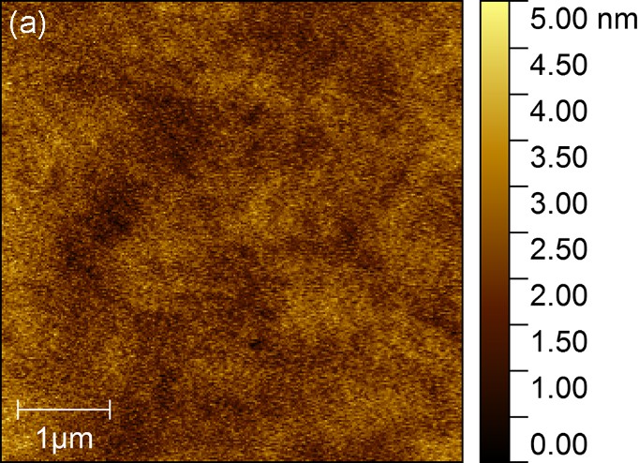

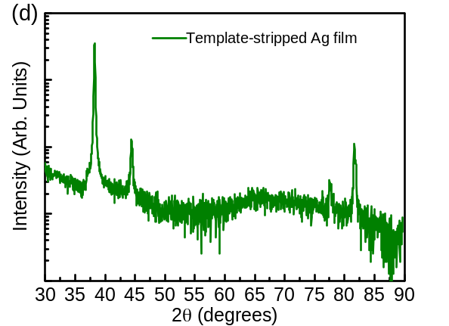

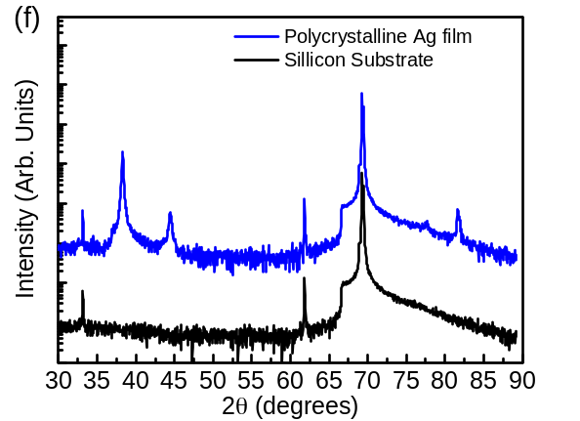
Figure 5. AFM images and related XRD patterns of silver films for the characterization of plasmonic lasers. (a) epitaxial grown (40 Å/s deposition rate, 350 °C substrate temperature) monocrystalline film, (c) template-stripped polycrystalline film (40 Å/s deposition rate, 20 °C substrate temperature), (e) general polycrystalline film (12 Å/s deposition rate, 20 °C substrate temperature) with RMS roughness of 0.53nm, 1.26nm and 2.3nm, respectively, and their related XRD patterns (b), (d), (f).
Figure 6. Measured ZnO plasmonic nanowire laser thresholds of plasmonic nanowire lasers based on different silver films. Only data of nanowires with a diameter standard deviation of less than 10nm are shown here. The red, blue and green transverse solid lines show average lasing threshold of three samples.

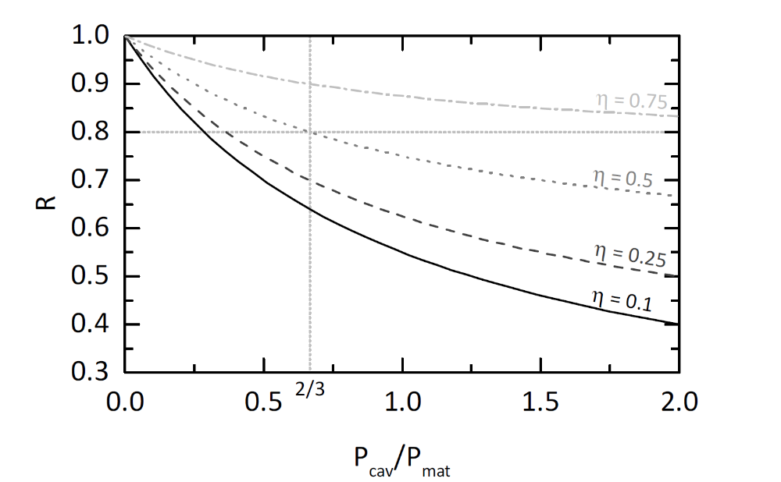
Figure 7. Reduction factor of the laser threshold R against the cavity to material loss ratio $P_{cav}/P_{mat}$. A 20%reduction of the laser threshold and a 50% reduction of the cavity loss give a cavity to material loss ratio of 2/3.

The table of contents
The role of deposition rate and substrate temperature on silver film growth process for improving the performance of hybrid-plasmonic nanowire lasers is studied. High substrate temperatures and high deposition rates allow near-epitaxial silver growth on mica. This work increases the fundamental understanding of metal film growth and gives new insights into the fundamental loss processes of metal based nanowire lasers.

Keyword: epitaxial growth, plasmon nanowire lasers, plasmonic films, silver films

H. Yu, T. P. H. Sidiropoulos, W. Liu, C. Ronning, P. K. Petrov, S.-H. Oh, S. A. Maier, P. Jin* and R. F. Oulton*

Influence of Silver Film Quality on the Threshold of Plasmonic Nanowire Lasers

ToC figure

