Supporting Information

A Model for Interpreting Surface Crystallisation using QCM: Theory and Experiments
Tomer Lapidot, Kyra L. Sedransk Campbell, Jerry Y. Y. Heng*
Surfaces and Particle Engineering Laboratory, Department of Chemical Engineering, Imperial College London, South Kensington Campus, London SW7 2AZ, U.K.
* Corresponding author: jerry.heng@imperial.ac.uk
Phone: +44-(0)207-594-0784. Fax: +44-(0)207-594-5700 Web: www.imperial.ac.uk/spel
  - ANALYTICAL SOLUTION TO POPULATION BALANCE
The population density function is governed by the popultion balance equation,
 | $$\frac{∂N}{∂t}+G\frac{∂N}{∂m}=Jδ\left(m-m^{*}\right)$$ | (1)
Using the transformations,
 | $$L\left\{\frac{∂N}{∂m}\right\}=s\hat{N}$$ | (2)
 | $$L\left\{δ\left(m-m^{*}\right)\right\}=\exp\left(-m^{*}s\right)$$ | (3)
This equation can be rewritten using a Laplace transformation on the spatial derivative,
 | $$\frac{∂\hat{N}}{∂t}+sG\hat{N}=J\exp\left(-m^{*}s\right)$$ | (4)
The transformed equation can now be solve as an an ordinary differential equation in time,
 | $$-\frac{1}{sG}\ln\left(J\exp\left(-m^{*}s\right)-sG\hat{N}\right)=\int{\frac{1}{J\exp\left(-m^{*}s\right)-sG\hat{N}}}d\hat{N}=\int{dt}'=t+k_{1}$$ | (5)
Here $k_{1}$ is an integration constant. The integration constant can be rewritten as$k_{2}=\exp\left(k_{1}\right)$, giving the general solution,
 | $$\hat{N}=\left(\frac{J}{G}\right)\frac{\exp\left(-m^{*}s\right)}{s}-\left(\frac{k_{2}}{G}\right)\frac{\exp\left(-sGt\right)}{s}$$ | (6)
Using the initial condition,$\begin{matrix}t=0 & N=\hat{N}=0\end{matrix}$, the integration constant is found to be,
 | $$k_{2}=J\exp\left(-m^{*}s\right)$$ | (7)
Giving the solution,
 | $$\hat{N}=\frac{J}{G}\left(\frac{\exp\left(-m^{*}s\right)}{s}-\frac{\exp\left(-s\left(Gt+m^{*}\right)\right)}{s}\right)$$ | (8)
Rewritting using inverse Laplace transformation,
 | $$L^{-1}\left\{\frac{\exp\left(-m^{*}s\right)}{s}\right\}=H\left(m-m^{*}\right)$$ | (9)

The final solution is given as,
 | $$N=\frac{J}{G}\left(H\left(m-m^{*}\right)-H(m-m^{*}-Gt)\right)$$ | (10)
When crystal nuclei are neglegibly small,$m^{*}≅0$,
 | $$N=\frac{J}{G}\left(1-H(m-Gt)\right)$$ | (11)
Here$H\left(m\right)=1$, since (by definition)$m≥0$.

  - ADDITION MODEL FITTINGS
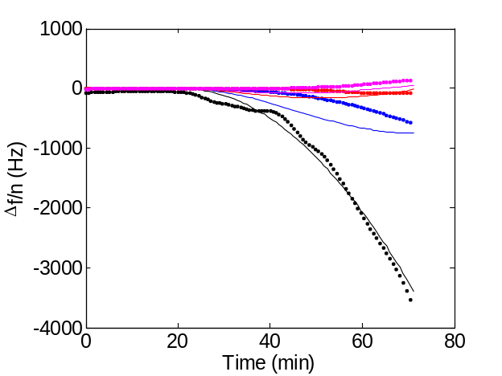a | 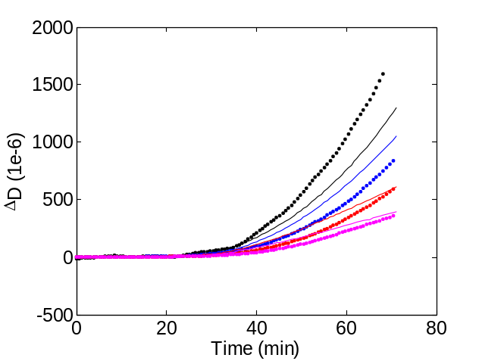c
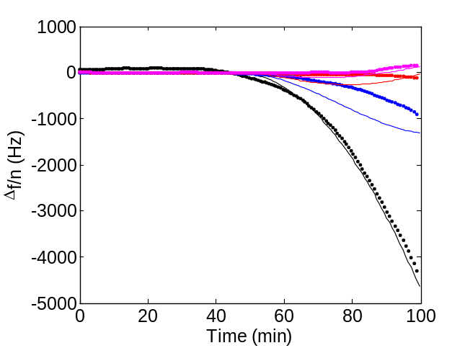b | 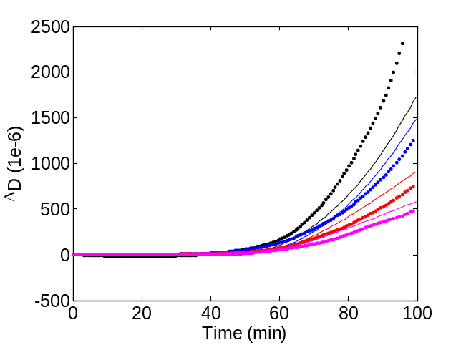d
Figure S1: Agreement between model and experimental data for addition experimental trials at supersaturation S=3.75 (supplementing Figure 5).
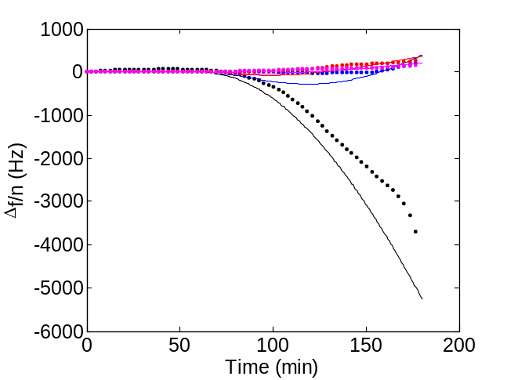a | 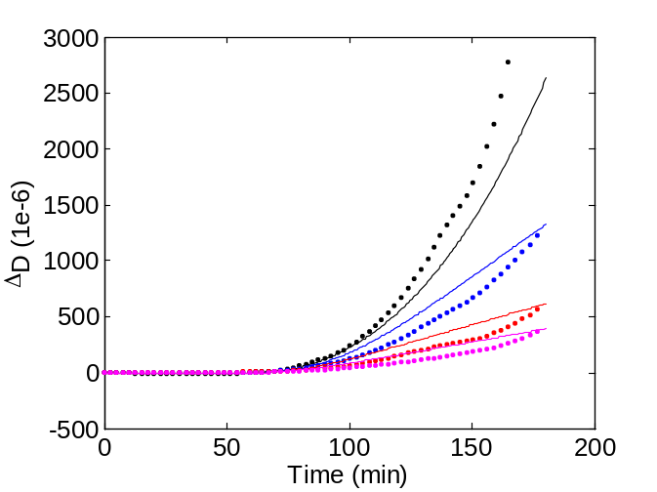c
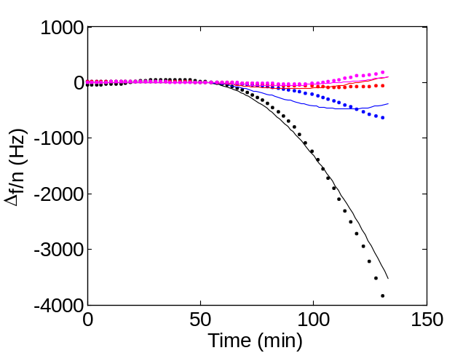b | 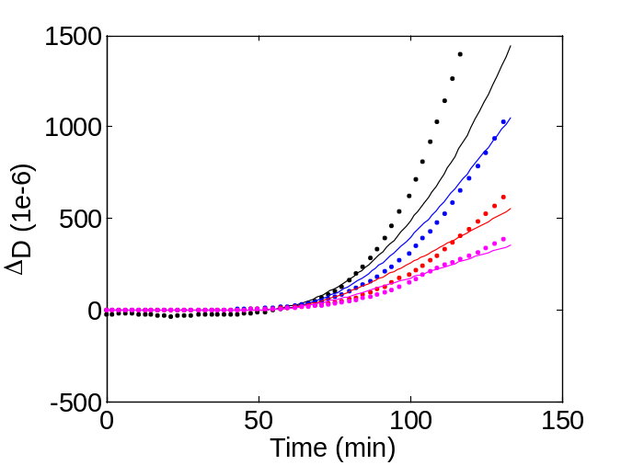d
Figure S2: Agreement between model and experimental data for addition experimental trials at supersaturation S=3.48 (supplementing Figure 5).

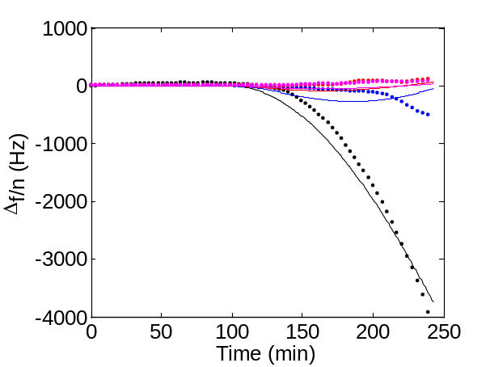a | 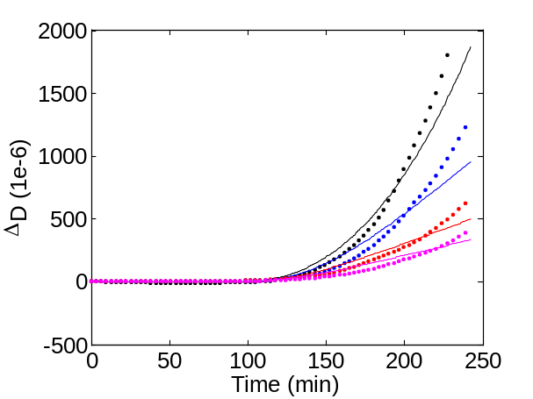c
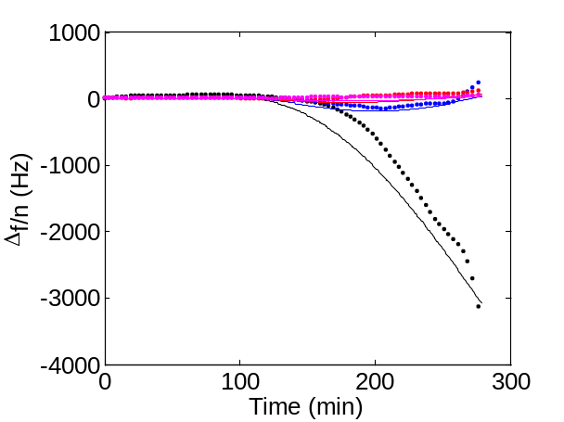b | 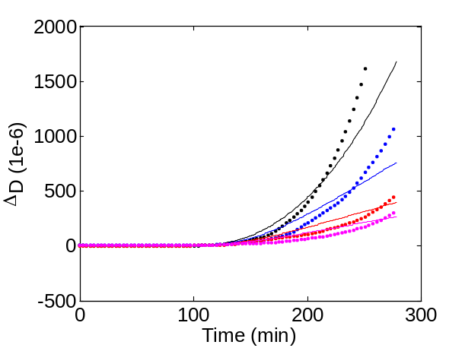d
Figure S3: Agreement between model and experimental data for addition experimental trials at supersaturation S=3.22 (supplementing Figure 5).

S.3. FITS WITH CONVETIONAL QCM MODELS
The experimental data is presented with a range of conventional models: Sauerbrey equation (Figure S4a), viscoelastic film in a liquid (Figure S4b), and mass with a Kelvin-Voigt link model (Figure S4c). The proposed model is shown in comparison (mass with a Kelvin-Voigt link and liquid impedance, Figure 5). To provide an accurate comparison between uniformed layer and point load models the following modification was necessary. When considering the deposited crystals as a uniform layer, the total mass is calculated using the first moment of the crystal distribution. By ignoring zero values of the distribution, Equation 4 can be simplified to $N=J/G$ for the domain$0≤m≤Gt$. The total mass is given by the first moment,
 | $$m_{Tot}=\frac{J}{G}\int_{0}^{Gt}{m dm}=\frac{JG}{2}t^{2}$$ | (12)
Equation 12 shows that mass increases with square of time for constant nucleation and growth. The model equations were modified to account for the nucleation induction time.
 | $$\frac{∆\tilde{f}}{f_{f}}=\left\{\begin{matrix}0 & t<t_{D} \\ \frac{i}{πA_{q}Z_{q}}Z_{load} & t≥t_{D}\end{matrix}\right.$$ | (13)

Sauerbrey Model
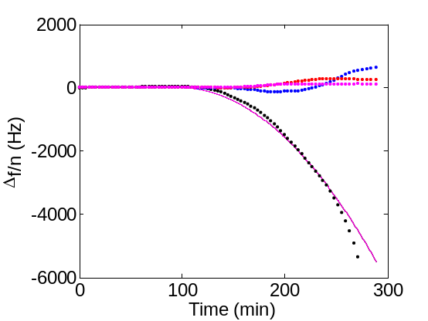  a | 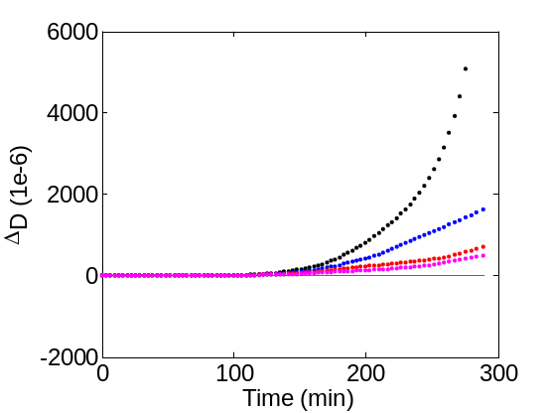  d
Viscoelastic Film in a Liquid
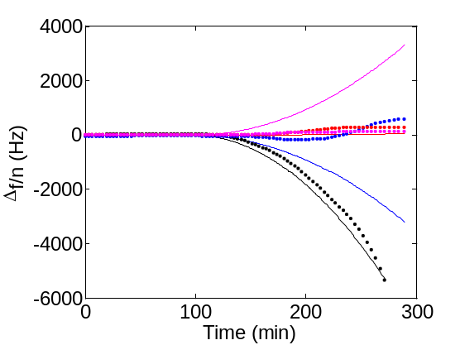  b | 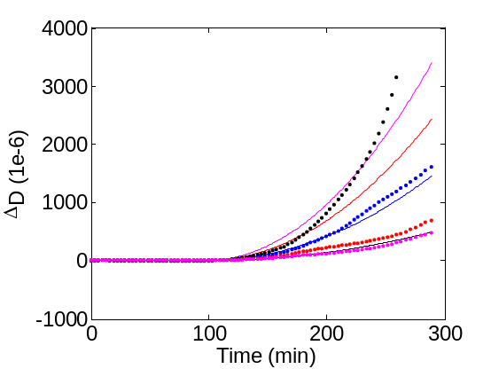  e
Mass with Kelvin-Voigt Link
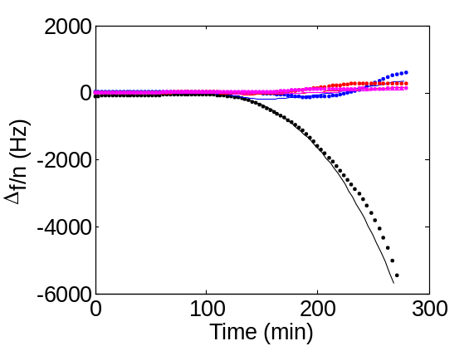  c | 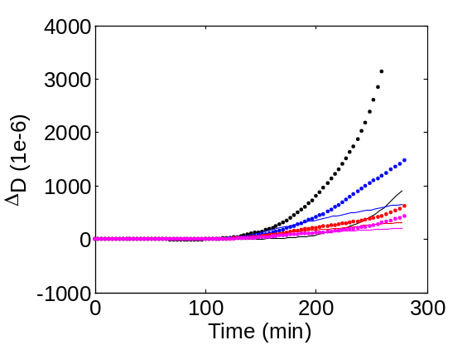  f
Figure S4: Comparison between experimental data ($S=3.22$) and the Sauerbrey model, uniform viscoelastic layer in liquid model, Kelvin-Voigt model. Experimental data presented as dots, fitted models presented as lines. Frequency of shifts (a-c) and Dissipation shifts (d-f) respectively.
The classic Sauerbrey model states that the mass is proportional to negative frequency shift,
 | $$\frac{∆\tilde{f}}{f_{f}}=-\frac{ωm_{Tot}}{πAZ_{q}}$$ | (14)
Figure S4 show that the Sauerbrey equation does not predict any variation in overtone or dissipation, and can therefore reproduce the fundamental harmonic only. The second conventional approach is the viscoelastic film in a liquid,
 | $$\frac{∆\tilde{f}}{f_{f}}=-\left(\frac{Z_{f}}{πAZ_{q}}\right)\frac{Z_{f}\tan\left(\frac{ωm_{Tot}}{AZ_{f}}\right)-iZ_{l}}{Z_{f}+iZ_{l}\tan\left(\frac{ωm_{Tot}}{AZ_{f}}\right)}$$ | (15)
Equation 15 is only appropriate when treating the deposited crystal clusters as a viscoelastic uniform layer in a liquid environment. For this case the impedance is a complex property defined as$Z_{f}=Z_{f}^{'}\left(1+ζi\right)$. Figure S4b and f show that although the viscoelastic model in a liquid predicts positive shifts at higher overtones (indicating the effect of the elastic impedance); it does not predict the inversions observed experimentally from negative to positive shifts at such small frequency shifts. Furthermore, the model predicts a faster dissipation increase at higher overtones rather than lower overtones. Both uniform layer models (Sauerbrey and viscoelastic in liquid) are clearly inappropriate to describe (calcium sulphate) crystallisation. The limitation of these models rests on the behavior where crystals nucleate and grow as individual clusters, for which a lumped element model is more appropriate. This can be rectified by applying the standard Kelvin-Voigt model, (Figure S4c and g),
 | $$\frac{∆\tilde{f}}{f_{f}}=\frac{iJ}{πA_{q}Z_{q}G}\int_{0}^{∞}{\frac{1-H(m-Gt)}{\frac{1}{iωm}+\frac{iω}{k+iωr}} dm}$$ | (16)

As is apparent from Figure S4c, frequency shifts can be reasonably reproduced by the model because it captures the inversion observed at higher overtones; however, the dissipation shifts are greatly underestimated (Figure S4g). Most notably, the fundamental dissipation increases later than higher dissipation overtones, unlike the dissipation shifts observed experimentally. As such, it is clear that the standard Kelvin-Voigt model does not describe the physical phenomenon sufficiently well. The contribution of the hydration layer has been previously neglected, and it contributes critically to the overall impedance of the crystal. The impact of this is clearly visible from the sharp increases in dissipation (Equation 9, Figure 5) which were not observed in the standard Kelvin-Voigt model.
Table S1: Summary of fitting parameters used in Figure 5, units provided in the nomenclature.
 | Sauerbrey Model | Viscoelastic Film in Liquid | Mass with KV Link | Mass with KV Link with Liquid Impedance
$$G$$ | $$8.0∙{10}^{-15}$$ | $$9.0∙{10}^{-19}$$ | $$6.3∙{10}^{-15}$$ | $$7.5∙{10}^{-14}$$
$$Z_{f}$$ | - | $$1.1∙{10}^{4}$$ | - | -
$$ζ$$ | - | $$0.5$$ | - | -
$$k$$ | - | - | $$9.0∙{10}^{4}$$ | $$2.8∙{10}^{5}$$
$$r$$ | - | - | $$9.5∙{10}^{-4}$$ | $$1.8∙{10}^{-3}$$
$α_{s}$ | - | - | - | $$1.0∙{10}^{3}$$

Fitting parameters used to compare the various models to experimental data (Figure S4 and Figure 5) are listed in Table 1. Crystal growth rates predicted by conventional models are lower by at least an order of magnitude than the growth rate determined by the proposed model. Incorrect interpretation of QCM data can result in significant underestimation of the deposited crystals’ mass.

S.4. FITTED PARAMETERS
a | b
c
Figure S5: Variation in the stiffness, dampening coefficient, and growth rate with supersaturation.

