Interfacial Tensions in the (CH₄ + CO₂ + H₂O) System Under VLLE and Biphasic Conditions
Pengfei Lv^{1,2}, Mihaela S P Stevar¹, and J P Martin Trusler^{1,*}
¹ Qatar Carbonates and Carbon Storage Research Centre (QCCSRC), Department of Chemical Engineering, Imperial College London, South Kensington Campus, London, SW7 2AZ, United Kingdom
² School of Energy and Power Engineering, North University of China, Taiyuan 030051, China
*Corresponding email address: m.trusler@imperial.ac.uk

Abstract
Interfacial properties of the (CH₄ + CO₂ + H₂O) system are of great importance in many geotechnical engineering applications. In this study, we report the first experimental measurements of the interfacial tensions in the (CH₄ + CO₂ + H₂O) system under both three-phase (VLLE) and biphasic conditions. The measurements were made by the pendant drop method. The compositions of the coexisting phases were obtained from a previous study of the phase behavior and the phase densities were then calculated from an equation of state. IFTs along five isotherms in the VLLE region and along six isotherms in biphasic region are reported. In the VLLE region, the IFT between the water-rich liquid and the gas phase varied between (33 and 39) mN·m⁻¹, with a sharp increase as the pressure increased along an isotherm towards the upper critical end point. In the same region, the IFT between the water-rich and CO₂-rich liquids varied between (30 and 33) mN·m⁻¹. The IFT between the gas phase and the CO₂-rich liquid phase was too small to measure accurately but an approximate value was obtained which is consistent with Antonov’s equality. In the biphasic region, measurements were made at temperatures up to 423 K and at pressures up to 30 MPa. As observed in other water-gas systems, the IFT declines monotonically along isotherms with increasing pressure and decreases with increasing temperature at constant pressure.
Keywords: Interfacial tension; VLLE; Ternary system; Pendant drop; Phase equilibrium

1. Introduction
The interfacial properties of the (CO₂ + H₂O) system play a crucial role in many geotechnical engineering applications, including CO₂ geological storage (CGS), enhanced oil recovery (EOR) and enhanced gas recovery (EGR) [1-6]. These properties have a significant influence on capillary pressure and relative permeability, which are two of the most fundamental and important parameters in porous-media flow [7-9]. Thus, the interfacial properties of the (CO₂ + H₂O) system significantly impact the mobility and distribution of each phase in the porous matrix [10, 11]. However, CO₂ captured from industrial processes may contain significant amounts of impurity gases, such as N₂, O₂, H₂, SO₂, NO_{x}, CO, CH₄, Ar, and H₂S [12-14], that can influence the interfacial properties against water. Furthermore, injection of CO₂ into an oil or gas reservoir can give rise to a gas phase containing a mixture of CO₂ and hydrocarbon gases. Therefore, it is of importance to investigate the interfacial properties between CO₂ and H₂O in the presence of impurities and, in this study, we focus on the (CH₄ + CO₂ + H₂O) system.
In the previous studies, the interfacial properties of ternary systems have been studied extensively using the Du Nouy ring [15-17], Wilhelmy plate [18, 19], capillary rise [20-22] and pendant drop [2, 23-28] methods, especially in systems including hydrocarbons. The methods of the Du Nouy Ring detachment and the Wilhelmy Plate are usually confined to atmospheric pressure conditions. The capillary rise method is perhaps the oldest technique used to measure surface tension [29-31], while the pendant drop is the most popular method in recent work. In this method, the more-dense phase is injected through a vertical capillary into a view cell containing the less-dense phase so as to create a stationary drop suspended from the end of the capillary. One then images the drop and, from its profile and knowledge of the density difference between the phases, the interfacial tension can be determined [32, 33]. The complementary method of a sessile drop can also be used in which a drop (or bubble) of the less-dense phase is created on the end of a capillary surrounded by the more-dense phase. The pendant/sessile drop methods are especially-well suited to measurements of interfacial tension under high-pressure conditions [34] and between fluids of different kinds, including liquid-liquid and liquid-gas systems [32, 33].
Generally, it has been found that the composition influences the IFT between the phases of a ternary system [16, 18, 28, 35] and that the IFT decreases with the increase of temperature [27, 36]. However, the influence of pressure is discrepant in different systems. Nagarajan et al. [37] studied the IFT of the (CO₂ + butane + decane) system and found that the IFT decreased with pressure increase, while Chun and Wilkinson [22] found that the IFT in (H₂O + CO₂ + alcohol) systems decreased linearly with pressure in the gas-liquid region but was largely independent of pressure at high pressures. Sun and Chen [1] reported that the IFT decreased with increase of pressure in (H₂O + CO₂ + crude oil) systems, but that the dependence became weak with increasing CO₂ mole fraction. The study of Bahramian et al. [25] showed that, in the (H₂O + decane + CH₄) system, the IFTs between the gas phase and the two liquid phases decreased with increase of pressure, while the liquid–liquid IFT was almost independent of pressure.
Several recent studies were also focused on (gas + water) systems, and especially on (CO₂ + diluent gas + H₂O) systems. Table 1 summarizes the previous IFT studies in ternary (water + gas) systems. Shah et al. [38] studied the IFT of the (CO₂ + H₂S + H₂O) system under reservoir conditions using both pendant-drop and sessile-drop methods. Their results indicated that the addition of H₂S as an impurity decreased the IFT between the CO₂-rich and H₂O-rich phases. The IFT varied strongly with the gas composition and was almost a linear function of the CO₂ (or H₂S) mole fraction in the gas phase. Yan et al. [3] measured the IFT in (CH₄ + N₂ + H₂O +) and (CO₂ + N₂ + H₂O) systems, and the results generally showed that the IFT decreased as the pressure, temperature, and CH₄ (or CO₂) content increased. Chow et al. [34, 39, 40] have systematically studied the influence of diluent gases on the IFT of (CO₂ + water) systems. They found that the addition of Ar, N₂, or H₂, increased the IFT relative to the (CO₂ + H₂O) system at the same temperature and pressure. The IFT of the ternary systems could be predicted with a simple empirical rule based on the coexisting phase compositions and the IFT of binary systems, except at low temperatures. Their results also indicated that the SAFT-VR Mie equation of state coupled with the square-gradient theory provided a valid means of modelling the interfacial properties of the systems comprising water, carbon dioxide and diluent gases [39].

Table 1. A summary of the IFT studies in ternary gas + water systems
System | Method | p/MPa | T/K | Year | Authors
CO₂+ H₂S + H₂O | pendant & rising drop | 0.1–15 | 350.15 | 2008 | Shah et al. [38]
CH₄ + N₂ + H₂O | pendant drop | 1–30 | 298–373 | 2001 | Yan et al. [3]
CO₂ + N₂ + H₂O
CO₂ + Ar + H₂O | pendant drop | 2–50 | 298.15–473.15 | 2016 | Chow et al. [39]
CO₂ + N₂ + H₂O | pendant drop | 2–40 | 298.15–448.15 | 2016 | Chow et al. [40]
CO₂ + CH₄ + H₂O | pendant drop | 1–30 | 298.15–373.15 | 2000 | Ren et al. [41]
CO₂ + H₂ + H₂O | pendant drop | 2–45 | 298.15–448.15 | 2018 | Chow et al. [34]

Even though it is important to know the interfacial properties of the (CH₄ + CO₂ + H₂O) system in many CCS, EOR and EGR processes, only one previous study is available for this system. Ren et al. [41] measured the IFT of (CH₄ + CO₂ + H₂O) at temperatures from 298 K to 373 K and pressures up to 30 MPa with different gas compositions. They reported that the IFT decreased with increase of either temperature or pressure. They observed that the IFT increased as the mole fraction of CH₄ increased but the change was not linear. However, the IFT was only measured under biphasic conditions (vapor-liquid or liquid-liquid) in their study. Nevertheless, vapor-liquid-liquid equilibrium (VLLE) can be encountered under conditions of low temperature and high pressure, such as in some cold oil or gas field, in the ocean or ground and also in pipelines. To our knowledge, there has been no study in which the IFT was measured under complex VLLE conditions. One reason for this was a lack of VLLE composition data. However, Al Ghafri et al. [42] have recently studied the phase behavior of (CH₄ + CO₂ + H₂O) experimentally in both VLLE and VLE regions, and their study provides the co-existing phase compositions required in the present work.
The objective of this study was to determine the IFTs of the (CH₄ + CO₂ + H₂O) system using the pendant-drop method under both VLLE and biphasic conditions.

2. Phase Diagram and Phase Properties
The phase diagram of the (CO₂ + CH₄ + H₂O) system has been studied in the VLLE region by Al Ghafri et al. [42] and we rely upon that study for the estimation of coexisting phase compositions. As shown in Figure 1(a), this region is delimited at lower pressures by the three-phase (3P) equilibrium line of the (CO₂ + H₂O) system, at high-pressures by the upper critical end point (UCEP) line, and at low temperatures by the quadruple-point (Q) line. Within the VLLE region an aqueous liquid phase L_{W} coexists with a CO₂-rich liquid phase L_{CO₂} and a gas phase G. The UCEP line is the locus of critical points L_{CO₂} = G, and the Q line is the locus of four-phase equilibrium L_{W} + L_{CO₂} + G + H, where H is a solid hydrate phase. Figure 1(b) illustrates the experimentally determined compositions of the phases in the VLLE region [42] along the isotherm at T = 290.15 K together with smoothing equations fitted to the data. The quantity plotted on the horizontal axis is the ratio x₁/(x₁ + x₂), where x is mole fraction, component 1 is CH₄, and component 2 is CO₂ (component 3 is H₂O). Starting on the 3P line, where methane mole fraction is zero, x₁/(x₁ + x₂) increases in all phases. The values for the two non-aqueous phases at first diverge and then converge at the UCEP. The aqueous phase has a nearly constant H₂O mole fraction of x₃ = 0.973 and the mole fraction of dissolved CH₄ increases slowly with pressure starting from zero on the 3P line, reaching about 3% of the non-aqueous solutes at p = 8 MPa. Figure 1(c) shows the experimental mole fraction of H₂O in the two non-aqueous phases at T = 290.15 K together with a smoothing equation fitted to the data. Finally, Figure 1(d) shows the phase densities at T = 290.15 K calculated as detailed below. As expected, the density of the aqueous phase varies little with pressure, while the densities of the two non-aqueous phases converge towards the UCEP.
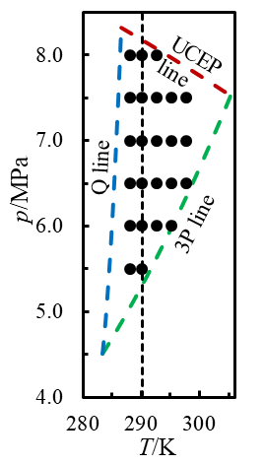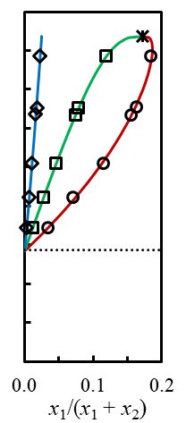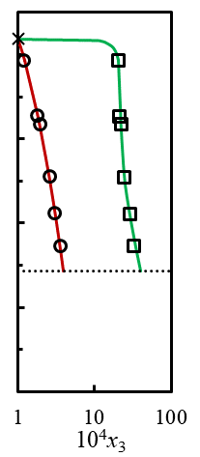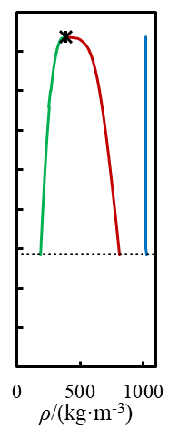
(d)
(c)
(b)
(a)
Figure 1. Phase diagram and properties of the CH₄ (1) + CO₂ (2) + H₂O (3) system: (a) VLLE region showing the quadruple-point (Q) line, three-phase (3P) line and the upper critical end point (UCEP) line [42]; (b) x₁/(x₁ + x₂) as functions of pressure p in the coexisting phases at T = 290.15 K [42]; (c) x₃ in the non-aqueous phases as a function of pressure at T = 290.15 K; (d) calculated phase densities ρ as functions of pressure at T = 290.15 K [43]. Symbols: , location of IFT measurements in the VLLE region; , critical point L_{CO₂} = G; , gas-phase composition; , CO₂-rich liquid phase composition; , aqueous-phase composition. Lines: solid blue, aqueous phase; solid green, CO₂-rich phase; solid red, gas phase; long-dashed lines show phase boundaries and critical lines, short-dashed line locates the isotherm at T = 290.15 K, and the dotted line shows the three-phase pressure at T = 290.15 K.

Also shown in Figure 1(a) are the locations of the IFT measurements carried out in this work in the VLLE region. In order to obtain the compositions of the three coexisting phases at each state points investigated in this work, the experimental data of Al Ghafri et al. [42] were fitted to smoothing equations as detailed in the Supporting Information. The densities of the coexisting phases were then calculated at these compositions from the multi-fluid Helmholtz-energy approximation (MFHEA) as implemented in the REFPROP software, version 10 [43]. We chose the MFHEA over other equations of state, such as the SAFT-VR equation used by Al Ghafri et al. [42], as it offers the most accurate means of estimating density for mixtures within the scope of the model. We also did not consider it feasible to determine the three coexisting-phase compositions experimentally under the conditions of the present work. We did not use the MFHEA model to solve for the coexisting phase compositions because we consider the experimental data to be more accurate and, in any case, REFPROP is unable to compute three-phase equilibrium states. The phase compositions and densities estimated at each experimental state are given in full in the Supporting Information. The calculated phase densities are plotted along all experimental isotherms in the VLLE region in Figure 2 and it can be noticed that the variation in composition leads to crossing of some isotherms.
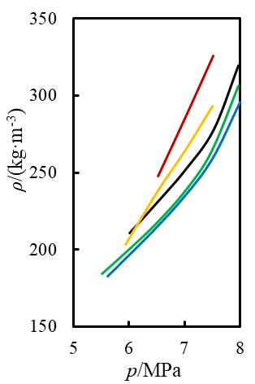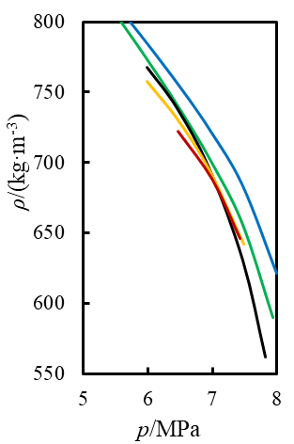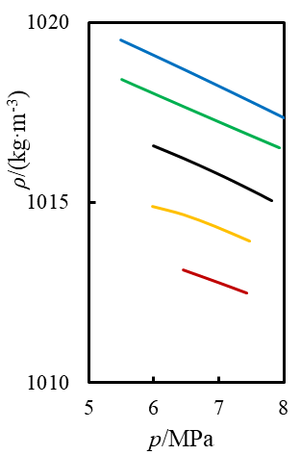
(c)
(b)
(a)
Figure 2. Densities of the coexisting phases in the VLLE region: (a) gas phase; (b) CO₂-rich liquid phase; (c) H₂O-rich liquid phase. Lines: blue, 288.15 K; green, 290.15 K; black, 292.15 K; orange, 295.15 K; red, 297.65 K.

The MFHEA model implemented in REFPROP version 10 uses the pure-fluid equations of state of Setzmann and Wagner for CH₄ [44], Span and Wagner for CO₂ [45] and Wagner and Pruss for H₂O [46] together with the GERG mixture model [47, 48]. The mixture model incorporates binary reducing parameters which, for (CH₄ + CO₂) and (CH₄ + H₂O), come from the original GERG study [48]. The model also includes a binary-specific departure function for (CH₄ + CO₂) [48]. The (CO₂ + H₂O) binary subsystem is modelled using a binary-specific departure function which, together with the binary reducing parameters, comes from the recent work of Gernert and Span [49].
Under biphasic experimental conditions, a gas mixture of specified initial composition contacted an initially pure aqueous phase. When this system came to equilibrium, some CO₂ and (on account of its low solubility) much less CH₄ would be dissolved in the aqueous phase, while the gas phase would be slightly depleted in CO₂ and enriched with H₂O [34, 50-53]. At low pressures, approaching the vapor pressure of water, the humidification of the gas phase is substantial, but the equilibrium water mole fraction falls rapidly with increasing pressure. The solution for the phase compositions requires an isochoric flash calculation for specified overall composition, temperature and volume and this was carried out using the method described by Chow et al. [40] for the analogous (N₂ + CO₂ + H₂O). In the present work, the IFT cell was 20% to 30% filled by the aqueous phase and hence flash calculations were carried out assuming a relative liquid volume of (25 ± 5)%. The calculation method, including the determination of the phase densities, is detailed in the Supporting Information.

3. Experiment method

3.1 Apparatus
Figure 3 is a schematic diagram of the apparatus used for the IFT measurements in this study. The main components were gas-supply cylinders, reagent-supply bottles, a dual-cylinder syringe pump, a high-pressure view cell and a vacuum system. Cylinders of CO₂, CH₄, and the binary mixture [z CO₂ + (1 - z) CH₄] with z = 0.5 were used in the IFT measurements. Deionized (DI) water and 2-propanol were stored in the reagent bottles. These liquids were injected into the view cell, using a high-pressure syringe pump (Quizix 5000, Chandler Engineering Co.), through a capillary located at the top of the cell. 2-propanol was used for cleaning and DI water for flushing and in the IFT measurements.
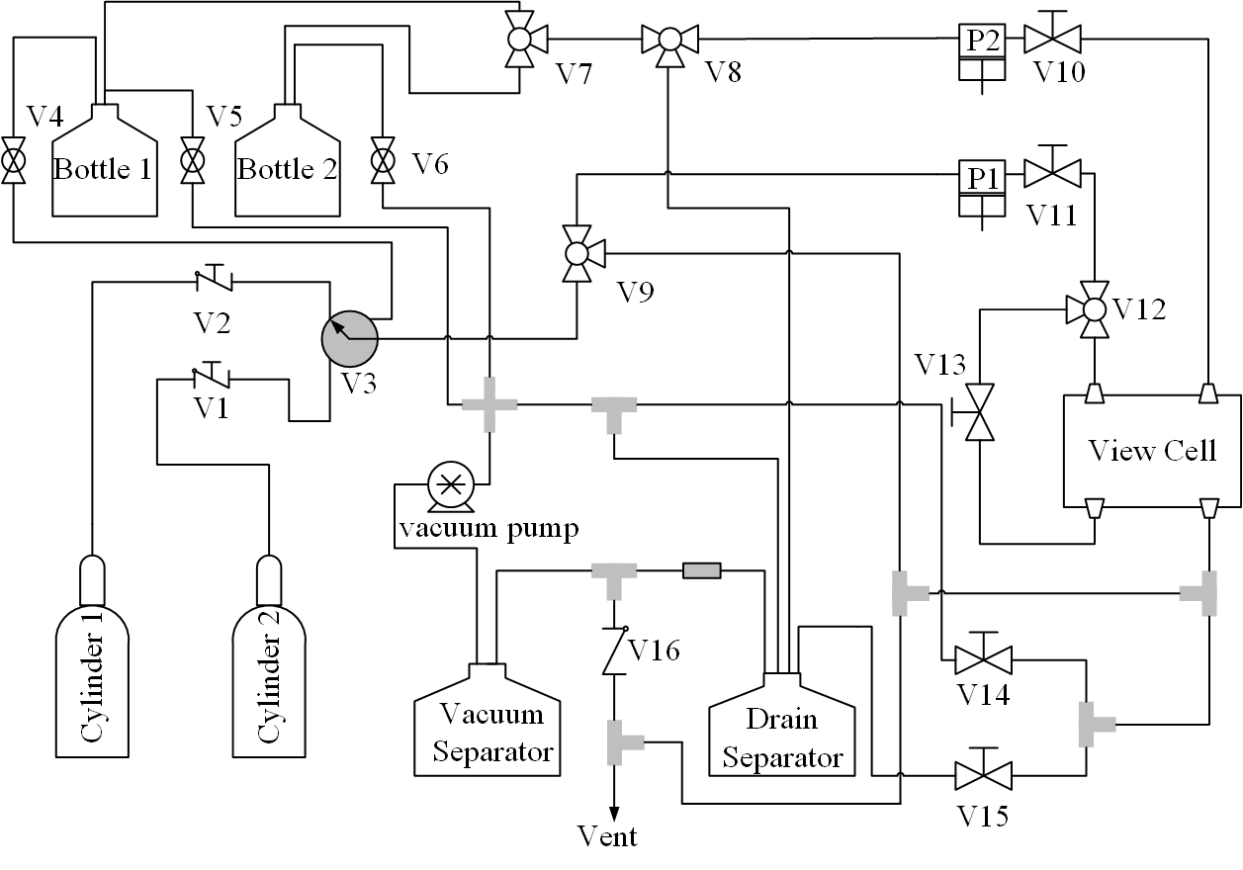
Figure 3. Schematic diagram of the interfacial tension apparatus.

The view cell was a horizontally-orientated vessel made from titanium alloy (grade 12) and closed by two axially-opposed sapphire windows sealed with viton o-rings. The cell was encased by an aluminum thermostat jacket and covered by a layer of silicone-rubber-sponge insulation. Two thermostat jackets were used in this work: one fitted with an electrical heating system, for measurements at temperatures above ambient, and a second fitted with fluid channels for use at temperatures below ambient. The heating jacket was fitted with electric cartridge heaters and a platinum resistance thermometer (PRT) and was controlled by a PID controller. The cooling jacket had eight axial fluid channels through which (ethanol + water) was circulated from a refrigerated thermostatic bath. Drain/vent lines and the vacuum system were used for emptying and evacuating the system. The diaphragm vacuum pump was also used to degas the DI water immediately prior to measurements.
The cell was provided with four fluid ports: one drain and three fluid inlet ports, two of which were fitted with capillaries for creating pendant drops or sessile bubbles. A light source and CCD camera were used to illuminate and image pendant drops or sessile bubbles within the cell. The chemicals used in this work are detailed in Table 2.

Table 2. Description of chemical samples, where x denotes mole-fraction purity of a pure substance or a mixture of defined composition, z denotes mole fraction of CO₂ in the mixture (1 - z) CH₄ + z CO₂, u(z) is the standard uncertainty of z, and ρ_{e} denotes electrical resistivity.
Chemical name | z | u(z) | Source | Purity as received | Additional  purification
CO₂ |  |  | BOC | x ≥ 0.99995 | None
CH₄ |  |  | BOC | x ≥ 0.9995 | None
(1 - z) CH₄ + z CO₂ | 0.5000 | 0.0025 | BOC | x ≥ 0.99995 | None
H₂O |  |  | Millipore | ρ_{e} ≥ 18 MΩ at 298 K | None

3.2 Measurement Procedure
The pendant drop method, with axisymmetric drop-shape analysis (ADSA), was used in all IFT measurements. The ADSA was carried out using commercial software (Advanced DROPimage, Rame-Hart Instrument Co.), based on integration of Young-Laplace equation in real-time. The IFT was evaluated from the relation
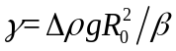, (1)
where γ is the interfacial tension, Δρ is the density difference between two phases, g is the gravitational acceleration, R₀ is the curvature radius at the apex of the pendant drop, and β is a dimensionless shape parameter. The parameters R₀ and β were determined from the images by the Advanced DROPimage software, which implements the algorithms described by Hansen et al. [54, 55].
The view cell was first cleaned and evacuated, and the DI water was degassed before the IFT measurements. For measurements under VLLE conditions, the procedure was as follows. A quantity of degassed DI water was first injected into the bottom of the cell to establish an aqueous phase filling approximately the lower third of the cell by height. Next, CO₂ was added until a liquid CO₂-rich phase accumulated. This was followed by addition of CH₄, while stirring the contents of the cell, until the pressure was slightly below the desired value within the VLLE region. Final adjustment of pressure was achieved by injecting additional H₂O through the upper capillary. The cell contents were stirred, while monitoring the pressure, until equilibrium was achieved, and this took up to several hours.
When measuring the IFT between the gas phase and the H₂O-rich liquid, the interface between the gas phase and the CO₂-rich liquid phase was arranged to be below the tip of the measurement capillary. Conversely, when measuring the IFT between the two liquid phases, the interface between the gas phase and the CO₂-rich liquid phase was above the capillary while that between the two liquids was below. To measure the IFT between the H₂O-rich phase and either of the other phases, a drop of pure H₂O was created on the tip of the upper measurement capillary and a few minutes were allowed for CO₂ and CH₄ to diffuse into it until compositional equilibrium was achieved. This process was monitored by continuous measurement of the drop volume and the IFT. Once the IFT was stable, measurements were averaged over a period of approximately 600 s.
We also attempted to measure the IFT between the gas and CO₂-rich liquid phases. To do this, the experimental base was first tilted such that the upper capillary entered the CO₂-rich liquid, some of which was sucked into the capillary tube. After returning the base to the horizontal position, the CO₂-rich mixture was slowly injected to form a pendant drop surrounded by the gas phase. Unfortunately, only small pendant drops of CO₂-rich liquid could be formed in this way and they were found to be unstable, resulting in fluctuating results of much larger uncertainty than in other cases. This will be discussed further below.
The measurements under biphasic conditions followed a similar procedure, except that only H₂O and an equimolar mixture of (CO₂ + CH₄) were injected and the relative aqueous-phase volume was restricted to (25 ± 5) %.
Table 3. State points investigated in this study, where T is temperature and p is pressure.
Region | T/K | p/MPa
VLLE | 288.15 | 5.5, 6.0, 6.5, 7.0, 7.5, 8.0
VLLE | 290.15 | 5.5, 6.0, 6.5, 7.0, 7.5, 8.0
VLLE | 292.65 | 6.0, 6.5, 7.0, 7.5, 8.0
VLLE | 295.15 | 6.0, 6.5, 7.0, 7.5
VLLE | 297.65 | 6.5, 7.0, 7.5
Biphasic | 313.15 | 0.5, 1, 2, 4, 6, 8, 10, 12, 14, 15, 16, 18, 20, 25, 30
Biphasic | 333.15 | 0.5, 1, 2, 4, 6, 8, 10, 12, 14, 15,16, 18, 20, 25, 30
Biphasic | 353.15 | 0.5, 1, 2, 4, 6, 8, 10, 12, 14, 15,16, 18, 20, 25, 30
Biphasic | 373.15 | 2, 4, 6, 8, 10, 12, 14, 15,16, 18, 20, 25, 30
Biphasic | 393.15 | 2, 4, 6, 8, 10, 12, 14, 15, 16, 18, 20, 25, 30
Biphasic | 423.15 | 2, 4, 6, 8, 10, 12, 14, 15, 16, 18, 20, 25, 30

The nominal temperatures and pressures of the state points investigated are listed in Table 3. The state points in the VLLE region were chosen to cover that region uniformly, while those in the biphasic region were chosen to extend over the temperature and pressure ranges accessible with the apparatus. As also illustrated in Figure 1(a), we measured five isotherms in the VLLE region with temperatures ranging from 288.15 K to 297.65 K at pressures ranging from just above the 3P line to just below the UCEP line. In the biphasic region, we measured six isotherms at temperatures ranging from 313.15 K to 423.15 K and with pressures ranging from 0.5 MPa to 30 MPa.
Phase compositions and densities were evaluated as discussed in section 2. Table S1 in the Supporting Information gives the composition and density of each phase under VLLE conditions, while Table S2 gives the estimated densities of the two coexisting phases, treating the aqueous phase as pure water and assuming that the gas-phase composition was identical to that of the feed gas.

3.3 Uncertainty analysis
The combined relative standard uncertainties of the IFT results u_{r}(γ) were calculated from the relation:
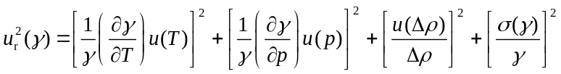, (2)
where u(T) is the standard uncertainty of the temperature, u(p) is the standard uncertainty of the pressure, u(Δρ) is the standard uncertainty of the calculated density difference between the phases in question and σ(γ) is the repeatability uncertainty of the IFT. In this work u(T) was 0.1 K under VLLE conditions and 0.05 K under biphasic conditions; the larger value in the VLLE region reflects greater temperature fluctuations when using the cooling jacket. The standard uncertainty of the pressure was 0.035 MPa. In the VLLE region, the relative repeatability uncertainty σ(γ)/γ was about 0.3%; in all cases it was < 0.9%, while it averaged 0.2% under biphasic conditions with a maximum of 0.5%. The uncertainty of the density difference is influenced in the VLLE region by the interpolation of the coexisting phase compositions from the conditions studied by Al Ghafri et al. [42] to those of the present study, and by the uncertainties of the equations of state. The former was investigated by comparing densities calculated at the phase compositions reported by Al Ghafri et al. with those calculated at the smoothed phase compositions used in this work. Relative differences were generally less than 1%. Under biphasic conditions, we have uncertainties arising from the model used to determine the phase compositions and again from the uncertainties of the equations of state. Overall, we estimate that the relative uncertainty of Δρ is bounded by rectangular distribution of half wide 2%, giving an equivalent standard relative uncertainty of 1.2%. The partial derivatives of the IFT with respect to temperature and pressure were estimated from the experimental data. The overall combined standard relative uncertainty of γ was found to be ≤ 1.5% under all conditions and, for simplicity, we ascribe that value to all state points.

3.4 Validation experiment
Since the present apparatus was newly constructed for this work, a validation experiment was conducted by measuring the surface tension of DI water at T = 303.15K and ambient pressure. The result was (71.2 ± 0.1) mN·m⁻¹, in close agreement with the value (71.19 ± 0.05) mN·m⁻¹ obtained from the IAPWS recommended correlation [56] implemented in the REFPROP software version 10 [43].

4. Results and discussion

4.1 IFT measurement under VLLE condition
Figure 4 illustrates the distribution of fluids within the view cell under conditions for the measurement of the IFT between (a) the gas phase and the water-rich liquid phase and (b) the CO₂-rich and water-rich liquid phases. In the first case, a relatively small drop is used because of the large density difference between the phases (a larger drop would fall off), while in the latter case a much larger drop is created to obtain a sensitive measurement. One can also observe a contact angle of close to 90° between the two non-aqueous phases and the titanium cell wall, while the contact angle between the two liquid phases and the wall, measured through the aqueous phase, is somewhat less than 90°. The aqueous phase can also be observed to wet the sapphire windows.
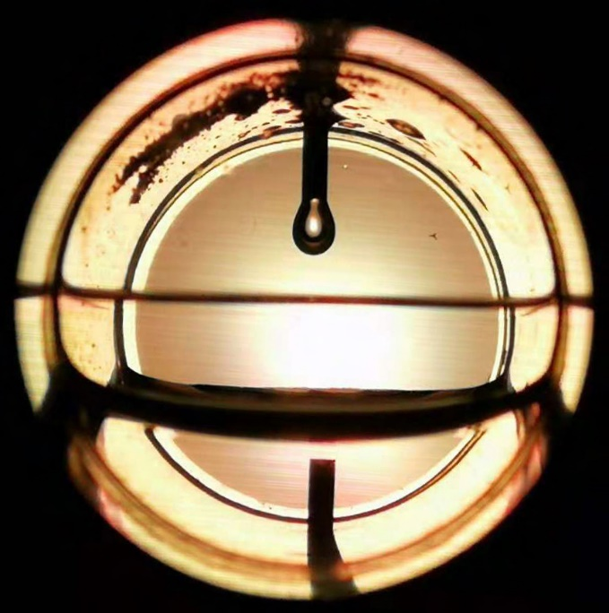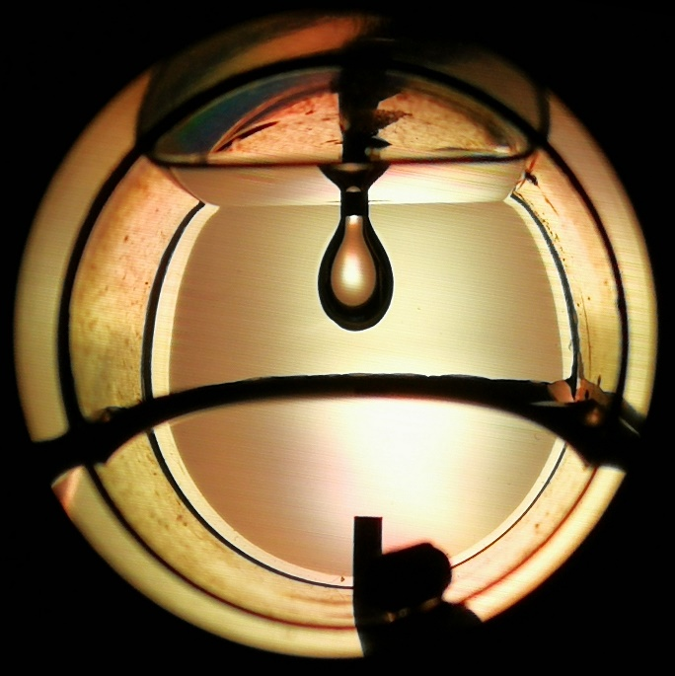
(b)
(a)
Figure 4: (a) water-rich drop suspended in the gas phase and (b) water-rich drop suspended in the CO₂-rich liquid under VLLE conditions

Table 4. Calculated density differences Δρ_{ij} and experimental interfacial tensions γ_{ij} between coexisting phases i and j under three-phase equilibrium conditions at temperature T and pressure p, where phase 1 is gas, phase 2 is CO₂-rich liquid and phase 3 is H₂O-rich liquid.ª Phase compositions at given T and p were interpolated from the experimental data of Al Ghafri et al. [42], as detailed in the Supporting Information, phase densities were calculated from the multi-fluid Helmholtz-energy approximation as implemented in REFPROP version 10 [43], and density differences were obtained by subtraction.
T/K | p/MPa | Δρ₁₃/kg·m⁻³ | γ₁₃/(mN·m⁻¹) | p/MPa | Δρ₂₃/kg·m⁻³ | γ₂₃/(mN·m⁻¹)
288.15 | 5.61 | 836.8 | 34.34 | 5.49 | 206.3 | 31.59
288.15 | 5.88 | 827.0 | 34.22 | 5.97 | 233.4 | 32.78
288.15 | 6.43 | 806.7 | 34.37 | 6.52 | 266.2 | 32.26
288.15 | 6.99 | 784.1 | 34.64 | 6.97 | 295.6 | 31.27
288.15 | 7.50 | 759.0 | 35.76 | 7.47 | 334.0 | 30.42
288.15 | 8.00 | 721.8 | 38.66 | 8.00 | 396.0 | 30.15
290.15 | 5.51 | 834.1 | 34.18 | 5.50 | 213.3 | 32.10
290.15 | 6.02 | 817.2 | 34.30 | 5.95 | 242.6 | 33.10
290.15 | 6.50 | 800.3 | 34.46 | 6.46 | 277.6 | 33.46
290.15 | 7.02 | 778.7 | 34.88 | 6.94 | 313.7 | 32.83
290.15 | 7.48 | 753.6 | 35.76 | 7.45 | 359.4 | 32.13
290.15 | 7.97 | 710.3 | 38.80 | 7.93 | 426.4 | 32.47
292.65 | 6.01 | 805.8 | 33.89 | 5.99 | 248.8 | 32.36
292.65 | 6.52 | 784.9 | 34.03 | 6.45 | 277.1 | 32.86
292.65 | 7.00 | 764.5 | 34.54 | 6.95 | 319.8 | 32.80
292.65 | 7.52 | 737.7 | 35.67 | 7.47 | 384.5 | 32.53
292.65 | 7.97 | 695.2 | 38.45 | 7.82 | 452.8 | 33.06
295.15 | 5.94 | 811.4 | 33.89 | 5.98 | 257.1 | 31.43
295.15 | 6.51 | 776.8 | 33.72 | 6.46 | 284.3 | 32.71
295.15 | 7.01 | 749.7 | 34.14 | 6.95 | 319.8 | 32.05
295.15 | 7.50 | 720.6 | 35.93 | 7.48 | 371.8 | 31.37
297.65 | 6.53 | 765.3 | 33.56 | 6.46 | 290.6 | 31.96
297.65 | 7.06 | 723.3 | 33.50 | 7.00 | 324.8 | 30.82
297.65 | 7.51 | 686.6 | 34.11 | 7.43 | 366.3 | 30.07
ª Expanded uncertainties at 95% confidence are U(T) = 0.2 K, U(p) = 0.07 MPa, and U_{c}(γ) =0.030γ.
Table 4 reports the results measured under VLLE conditions together with the calculated density differences. In Figure 5, the G-L_{w} (γ₁₃) and L_{CO₂}-L_{w} (γ₂₃) IFT data are plotted against pressure. Unlike vapor-liquid and liquid-liquid IFTs in biphasic systems, which usually exhibit monotonic variation with pressure and temperature, our results show that the IFT changes relatively little in the middle of the VLLE triangle but varies remarkably when the measurement point is close to a boundary, especially the UCEP curve. Thus, between 5.5 MPa and 7.0 MPa, γ₁₃ is almost constant but, at higher pressures, it increases sharply. This is attributed to the rapidly changing phase compositions in the approach to the UCEP. The influence of temperature on this IFT is seen to be quite small with only a slight downward trend with increasing temperature at constant pressure; this may simply reflect the small temperature range for VLLE behavior. Except on the highest isotherm studied, the L_{CO₂}-L_{w} IFT γ₂₃ passes through a maximum at a pressure between about (6.0 and 6.6) MPa. The temperature dependence at constant pressure is complex but the total range of these IFT values is small, amounting to only 3 mN·m⁻¹. Comparing with the IFT between gas phase and H₂O-rich liquid, which is always larger than 33.5 mN·m⁻¹, the IFT between CO₂-rich liquid and water-rich liquid is smaller and always less than 33.5 mN·m⁻¹.
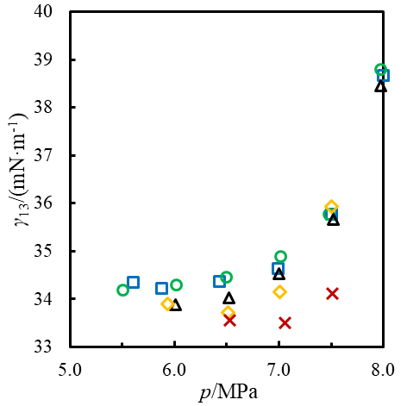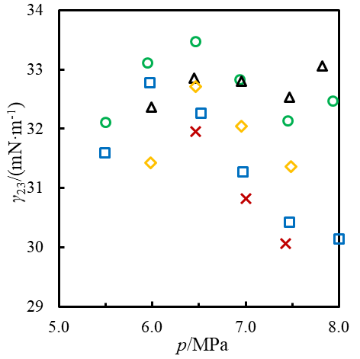
(a)
(b)
Figure 5. Interfacial tensions γ between the aqueous phase and the two non-aqueous phases as a function of pressure along isotherms: (a) G-L_{w} IFT γ₁₃ (b) L_{CO₂}-L_{w} IFT γ₂₃. Symbols: , T = 288.15 K; , T = 290.15 K; , T = 292.65 K; , T = 295.15 K; , T = 297.65 K.

The IFT values at the lower end of each isotherm in the VLLE region must approach the gas-liquid and liquid-liquid IFTs of the (CO₂ + H₂O) system on the three-phase line. Although the measurements do not extend close enough to the three-phase line to determine these values precisely, a comparison with measurements on the (CO₂ + H₂O) system is still meaningful. Hebach et al. [57], Chow et al. [40] and Pereira et al. [58] all report measurement at temperatures close to 298 K and we have analyzed their data at pressures below and above the three-phase line to estimate γ₁₃ and γ₂₃ on the three-phase line. The method of analysis was to fit linear functions of pressure to the data in each region and to extrapolate these to the three-phase pressure. The latter was obtained from the measurements of Wendland et al. [59] The results of this analysis are given in Table 5. The mean results from these literature sources are γ₁₃ = (33.5 ± 1.0) mN·m⁻¹ and γ₂₃ = (31.4 ± 0.7) mN·m⁻¹ at T = (298.3 ± 0.3) K, which compare favorably with the present results T = 297.65 K: γ₁₃ ≈ 34 mN·m⁻¹ and γ₁₃ ≈ 32 mN·m⁻¹. All these values are consistent with the gas-liquid IFT exceeding the liquid-liquid IFT by about 2 mN·m⁻¹ on the three-phase line.

Table 5. Literature data for the interfacial tensions γ_{ij} between coexisting phases i and j and estimated standard uncertainties u(γ) for the (CO₂ + H₂O) system under three-phase equilibrium conditions at temperature T and pressure p, where phase 1 is gas, phase 2 is CO₂-rich liquid and phase 3 is H₂O-rich liquid.
T/K | p/MPa | γ₁₃/(mN·m⁻¹) | γ₂₃/(mN·m⁻¹) | u(γ)/(mN·m⁻¹) | Reference
298.3 | 6.43 | 33.5 | 30.9 | 0.3 | Hebach et al.[57]
298.6 | 6.46 | 32.5 | 31.1 | 0.2 | Pereira et al. [58]
297.9 | 6.37 | 34.4 | 32.2 | 0.2 | Chow et al. [40]

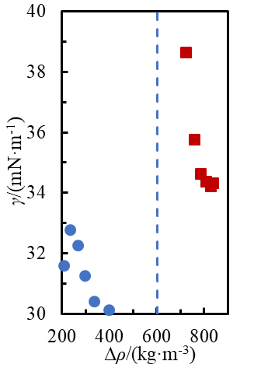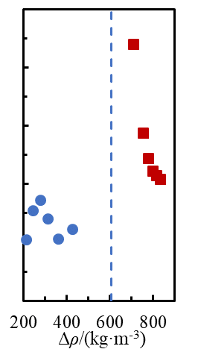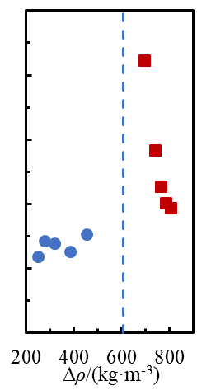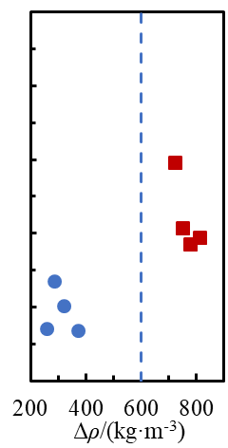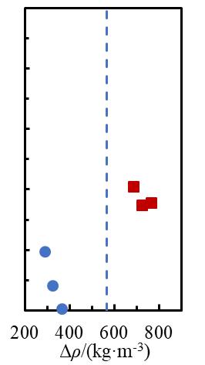
(e)
(d)
(c)
(a)
(b)
Figure 6. Interfacial tensions γ between the aqueous phase and the two non-aqueous phases as a function of the density difference Δρ = ρ(aqueous) - ρ(non-aqueous): (a) T = 287.65 K; (b) T = 290.15 K; (c) T = 292.15 K; (d) T = 295.15 K; (e) T = 297.65 K. Symbols: , γ₁₃; , γ₂₃. The dashed line indicates the density difference at the UCEP.

Figure 6 shows the IFT data as a function of the density difference for each individual isotherm. Also indicated is the density difference between the aqueous and non-aqueous phases at the UCEP. Despite the relatively close approach to the UCEP pressure on each isotherm, there is a substantial gap in the data between density differences of about (400 and 700) kg·m⁻³ and it is difficult to discern the behavior of the two IFTs in the approach to the UCEP. However, there is a suggestion from the G-L_{w} data that the IFT diverges towards large values in this limit, where γ₁₃ and γ₂₃ must become identical. One can at least conclude that the isotherms for γ₁₃ must exhibit an upturn between the greatest experimental pressure studied and the UCEP, despite the mainly downward trend observed in the experimental region. This upturn in the IFT approaching the UCEP mirrors the rapid decrease in the mole fraction of water in the non-aqueous phases, seen in Fig. 1(c).

Figure 7(a) shows the difference (γ₁₃ – γ₂₃) between the two IFTs involving the water-rich phase as a function of pressure. The relatively small value of this difference suggests that the third IFT, γ₁₂ between gas and CO₂-rich, is probably small. An attempt was made to determine γ₁₂ but, unfortunately, this quantity is extremely difficult to measure using the pendant drop method because it is small, and it was difficult to create a stable drop of the CO₂-rich liquid surrounded by the gas phase. As a result, we attempted to measure γ₁₂ at the lowest temperature and pressure only, where we found results that varied between (1 and 5) mN·m⁻¹. This range of values is also shown in Figure 7 and is consistent with the condition for mechanical stability: (γ₁₃ – γ₂₃) ≤ γ₁₂ [60]. We also compare in Figure 7(b) the available IFT data for the (CO₂ + H₂O) [57], (CH₄ + H₂O) [61] and (CH₄ + CO₂ + H₂O) systems under similar temperature conditions close to 298 K. As expected, the IFT between gas and aqueous phases in the VLLE region approaches the gas-liquid IFT of the (CO₂ + H₂O) system at the three-phase pressure, while that between the two liquid phases approaches the liquid-liquid IFT of that binary system.
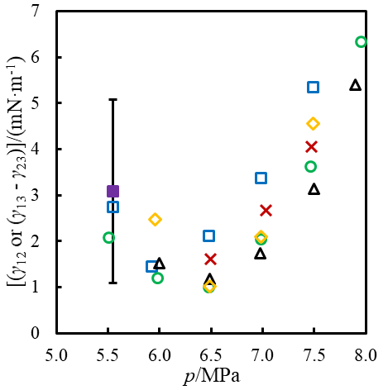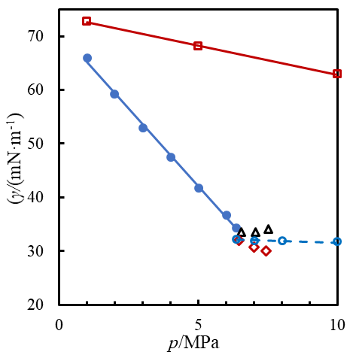
(b)
(a)
Figure 7. (a) IFT γ₁₂ () between gas and CO₂-rich liquid at T = 288.15 K in comparison with the difference (γ₁₃ – γ₂₃) between the two IFTs involving the water-rich phase as a function of pressure p at various temperatures T: , T = 288.15 K; , T = 290.15 K; , T = 292.65 K; , T = 295.15 K; , T = 297.65 K. (b) IFT data for (CO₂ + H₂O) at T = 297.9 K [40], (CH₄ + H₂O) at T = 298.15 K [61] and (CH₄ + CO₂ + H₂O) at T = 297.65 K: , (CO₂ + H₂O) in the G-L_{w} region; , (CO₂ + H₂O) in the L_{CO₂}-L_{w} region; , (CH₄ + H₂O) system; , (CH₄ + CO₂ + H₂O) G-L_{w} IFT; , (CH₄ + CO₂ + H₂O) L_{CO₂}-L_{w} IFT. Lines are linear regressions for the binary data.

4.2 IFT measurement under biphasic condition
In the biphasic region, we measured six isotherms at temperatures ranging from (313.15 to 423.15) K and at pressures from (0.5 to 30) MPa. The system was formed by injection of pure water and an equimolar mixture of CH₄ and CO₂. We chose an equimolar feed mixture to maximize the differences between the behavior of the mixed gas system and of either of the two pure-gas systems. As detailed in section 2, the phase compositions and densities were calculated from a thermodynamic model by means of isochoric flash calculations which are detailed in the Supporting Information. Table 6 lists the calculated phase compositions, the density differences and the experimental IFT values along each isotherm. In the gas phase, the ratio y₁/(y₁ + y₂) varies between 0.51 and 0.54, exceeding the value of 0.50 for the feed mixture because of preferential dissolution of CO₂ in the liquid phase.
The density difference between the gas and liquid phases decreases with increasing pressure on every isotherm. However, while the density difference decreases with increasing temperature at low pressures, the reverse behavior is observed at high pressures such that isotherms cross in the pressure region between about (6 and 20) MPa. Figure 7 shows the experimental IFT data in the biphasic region as functions of both pressure and the density difference. The IFT decreases with increase of both temperature and pressure, ranging between about (30 to 67) mN·m⁻¹. The partial derivative (∂γ/∂p)_{T} generally decreases with increasing pressure such that the isotherms show a tendency towards levelling out at high pressures. When plotted as a function of the density difference, the isotherms appear to converge at large values of Δρ (i.e. as the gas-phase density tends to zero) and the partial derivative (∂γ/∂Δρ)_{T} is continuingly increasing with increase of Δρ.

Table 6. Calculated liquid-phase mole fractions x_{i,} gas-phase mole fractions y_{i}, density differences Δρ and experimental interfacial tensions γ for CH₄ (1) + CO₂ (2) + H₂O (3) under gas-liquid equilibrium conditions at temperature T and pressure p. Phase compositions and densities were calculated as detailed in the Supporting Information.
T/K | p/MPa | x₁ | x₂ | y₁ | y₂ | Δρ/kg·m⁻³ | γ/(mN·m⁻¹)
313.15 | 0.50 | 5.4 × 10⁻⁵ | 9.2 × 10⁻⁴ | 0.533 | 0.451 | 987.2 | 66.79
313.15 | 1.03 | 1.1 × 10⁻⁴ | 1.9 × 10⁻³ | 0.536 | 0.456 | 981.7 | 64.83
313.15 | 2.01 | 2.1 × 10⁻⁴ | 3.5 × 10⁻³ | 0.535 | 0.461 | 971.1 | 61.74
313.15 | 4.00 | 4.0 × 10⁻⁴ | 6.4 × 10⁻³ | 0.531 | 0.467 | 947.0 | 57.19
313.15 | 5.98 | 5.6 × 10⁻⁴ | 8.7 × 10⁻³ | 0.526 | 0.472 | 919.4 | 52.25
313.15 | 7.99 | 7.1 × 10⁻⁴ | 1.0 × 10⁻² | 0.522 | 0.476 | 887.3 | 48.85
313.15 | 10.02 | 8.5 × 10⁻⁴ | 1.2 × 10⁻² | 0.518 | 0.480 | 850.5 | 45.64
313.15 | 11.99 | 9.8 × 10⁻⁴ | 1.3 × 10⁻² | 0.515 | 0.482 | 811.3 | 43.30
313.15 | 13.96 | 1.1 × 10⁻³ | 1.3 × 10⁻² | 0.513 | 0.485 | 770.5 | 41.47
313.15 | 14.95 | 1.1 × 10⁻³ | 1.4 × 10⁻² | 0.512 | 0.486 | 750.3 | 40.73
313.15 | 16.01 | 1.2 × 10⁻³ | 1.4 × 10⁻² | 0.511 | 0.486 | 729.3 | 40.12
313.15 | 17.99 | 1.3 × 10⁻³ | 1.4 × 10⁻² | 0.510 | 0.488 | 693.2 | 39.05
313.15 | 19.97 | 1.4 × 10⁻³ | 1.4 × 10⁻² | 0.509 | 0.488 | 661.7 | 38.23
313.15 | 24.97 | 1.6 × 10⁻³ | 1.5 × 10⁻² | 0.507 | 0.490 | 600.6 | 36.75
313.15 | 30.01 | 1.7 × 10⁻³ | 1.5 × 10⁻² | 0.506 | 0.490 | 557.6 | 35.87
333.15 | 0.51 | 4.4 × 10⁻⁵ | 6.5 × 10⁻⁴ | 0.510 | 0.450 | 978.3 | 63.63
333.15 | 1.00 | 8.7 × 10⁻⁵ | 1.3 × 10⁻³ | 0.519 | 0.460 | 973.4 | 62.36
333.15 | 2.00 | 1.7 × 10⁻⁴ | 2.5 × 10⁻³ | 0.522 | 0.466 | 963.1 | 59.66
333.15 | 4.00 | 3.3 × 10⁻⁴ | 4.6 × 10⁻³ | 0.522 | 0.472 | 940.7 | 55.99
333.15 | 6.00 | 4.7 × 10⁻⁴ | 6.4 × 10⁻³ | 0.519 | 0.475 | 916.0 | 52.57
333.15 | 7.97 | 6.0 × 10⁻⁴ | 7.9 × 10⁻³ | 0.517 | 0.478 | 889.2 | 49.40
333.15 | 10.02 | 7.3 × 10⁻⁴ | 9.1 × 10⁻³ | 0.515 | 0.481 | 858.8 | 46.33
333.15 | 12.02 | 8.4 × 10⁻⁴ | 1.0 × 10⁻² | 0.513 | 0.483 | 827.1 | 44.22
333.15 | 14.01 | 9.4 × 10⁻⁴ | 1.1 × 10⁻² | 0.511 | 0.485 | 794.5 | 42.32
333.15 | 15.01 | 9.9 × 10⁻⁴ | 1.1 × 10⁻² | 0.510 | 0.485 | 778.0 | 41.61
333.15 | 16.01 | 1.0 × 10⁻³ | 1.1 × 10⁻² | 0.510 | 0.486 | 761.7 | 40.86
333.15 | 18.00 | 1.1 × 10⁻³ | 1.2 × 10⁻² | 0.508 | 0.487 | 730.2 | 39.79
333.15 | 19.99 | 1.2 × 10⁻³ | 1.2 × 10⁻² | 0.507 | 0.488 | 701.0 | 38.96
333.15 | 24.99 | 1.4 × 10⁻³ | 1.3 × 10⁻² | 0.506 | 0.489 | 639.4 | 37.28
333.15 | 29.90 | 1.6 × 10⁻³ | 1.3 × 10⁻² | 0.505 | 0.489 | 593.9 | 36.12
353.15 | 0.50 | 3.7 × 10⁻⁵ | 4.7 × 10⁻⁴ | 0.474 | 0.429 | 967.3 | 60.41
353.15 | 1.00 | 7.7 × 10⁻⁵ | 9.7 × 10⁻⁴ | 0.498 | 0.452 | 962.5 | 59.29
353.15 | 1.95 | 1.5 × 10⁻⁴ | 1.9 × 10⁻³ | 0.509 | 0.464 | 953.2 | 57.40
353.15 | 4.01 | 3.0 × 10⁻⁴ | 3.7 × 10⁻³ | 0.513 | 0.472 | 931.9 | 54.20
353.15 | 5.97 | 4.3 × 10⁻⁴ | 5.1 × 10⁻³ | 0.513 | 0.476 | 910.0 | 51.57
353.15 | 7.90 | 5.6 × 10⁻⁴ | 6.3 × 10⁻³ | 0.512 | 0.478 | 886.9 | 48.72
353.15 | 9.98 | 6.8 × 10⁻⁴ | 7.4 × 10⁻³ | 0.511 | 0.480 | 860.4 | 46.46
353.15 | 12.08 | 7.9 × 10⁻⁴ | 8.4 × 10⁻³ | 0.509 | 0.482 | 832.4 | 44.26
353.15 | 14.08 | 8.9 × 10⁻⁴ | 9.1 × 10⁻³ | 0.508 | 0.483 | 805.0 | 42.53
353.15 | 15.01 | 9.4 × 10⁻⁴ | 9.4 × 10⁻³ | 0.508 | 0.484 | 792.1 | 41.71
353.15 | 15.96 | 9.8 × 10⁻⁴ | 9.7 × 10⁻³ | 0.507 | 0.484 | 779.0 | 40.97
353.15 | 17.98 | 1.1 × 10⁻³ | 1.0 × 10⁻² | 0.506 | 0.485 | 751.8 | 39.73
353.15 | 19.96 | 1.2 × 10⁻³ | 1.1 × 10⁻² | 0.505 | 0.486 | 726.0 | 38.67
353.15 | 25.13 | 1.3 × 10⁻³ | 1.2 × 10⁻² | 0.504 | 0.487 | 666.2 | 36.75
353.15 | 29.96 | 1.5 × 10⁻³ | 1.2 × 10⁻² | 0.503 | 0.487 | 621.4 | 35.48
373.15 | 2.01 | 1.5 × 10⁻⁴ | 1.6 × 10⁻³ | 0.491 | 0.453 | 940.4 | 54.78
373.15 | 3.97 | 2.9 × 10⁻⁴ | 3.0 × 10⁻³ | 0.502 | 0.466 | 921.4 | 51.50
373.15 | 6.00 | 4.3 × 10⁻⁴ | 4.4 × 10⁻³ | 0.505 | 0.472 | 900.6 | 49.39
373.15 | 7.99 | 5.6 × 10⁻⁴ | 5.5 × 10⁻³ | 0.506 | 0.475 | 879.2 | 47.36
373.15 | 10.02 | 6.8 × 10⁻⁴ | 6.5 × 10⁻³ | 0.505 | 0.477 | 856.3 | 45.25
373.15 | 12.05 | 7.9 × 10⁻⁴ | 7.4 × 10⁻³ | 0.505 | 0.479 | 832.7 | 43.18
373.15 | 14.01 | 9.0 × 10⁻⁴ | 8.2 × 10⁻³ | 0.504 | 0.480 | 809.4 | 41.53
373.15 | 15.01 | 9.5 × 10⁻⁴ | 8.5 × 10⁻³ | 0.504 | 0.481 | 797.4 | 40.81
373.15 | 16.02 | 1.0 × 10⁻³ | 8.8 × 10⁻³ | 0.504 | 0.481 | 785.4 | 39.94
373.15 | 18.01 | 1.1 × 10⁻³ | 9.4 × 10⁻³ | 0.503 | 0.482 | 761.9 | 38.78
373.15 | 20.01 | 1.2 × 10⁻³ | 9.9 × 10⁻³ | 0.503 | 0.483 | 738.9 | 38.01
373.15 | 25.00 | 1.4 × 10⁻³ | 1.1 × 10⁻² | 0.501 | 0.484 | 686.1 | 35.44
373.15 | 30.03 | 1.6 × 10⁻³ | 1.2 × 10⁻² | 0.501 | 0.484 | 640.8 | 34.39
393.15 | 1.97 | 1.5 × 10⁻⁴ | 1.3 × 10⁻³ | 0.462 | 0.429 | 926.7 | 50.34
393.15 | 3.94 | 3.0 × 10⁻⁴ | 2.6 × 10⁻³ | 0.486 | 0.454 | 908.9 | 48.12
393.15 | 5.92 | 4.4 × 10⁻⁴ | 3.9 × 10⁻³ | 0.493 | 0.463 | 890.1 | 46.07
393.15 | 8.00 | 5.9 × 10⁻⁴ | 5.0 × 10⁻³ | 0.497 | 0.468 | 869.7 | 44.37
393.15 | 10.00 | 7.2 × 10⁻⁴ | 6.0 × 10⁻³ | 0.498 | 0.471 | 849.4 | 42.35
393.15 | 11.93 | 8.4 × 10⁻⁴ | 6.8 × 10⁻³ | 0.498 | 0.473 | 829.3 | 40.73
393.15 | 13.98 | 9.6 × 10⁻⁴ | 7.7 × 10⁻³ | 0.499 | 0.475 | 808.0 | 39.45
393.15 | 15.02 | 1.0 × 10⁻³ | 8.0 × 10⁻³ | 0.499 | 0.475 | 797.0 | 38.47
393.15 | 15.95 | 1.1 × 10⁻³ | 8.4 × 10⁻³ | 0.498 | 0.476 | 787.2 | 37.90
393.15 | 18.05 | 1.2 × 10⁻³ | 9.0 × 10⁻³ | 0.498 | 0.477 | 765.2 | 36.88
393.15 | 20.01 | 1.3 × 10⁻³ | 9.6 × 10⁻³ | 0.498 | 0.478 | 745.1 | 36.18
393.15 | 25.04 | 1.5 × 10⁻³ | 1.1 × 10⁻² | 0.497 | 0.479 | 696.6 | 34.57
393.15 | 29.98 | 1.7 × 10⁻³ | 1.2 × 10⁻² | 0.497 | 0.480 | 654.7 | 33.11
423.15 | 2.01 | 1.5 × 10⁻⁴ | 1.1 × 10⁻³ | 0.388 | 0.362 | 902.2 | 45.13
423.15 | 3.94 | 3.3 × 10⁻⁴ | 2.3 × 10⁻³ | 0.445 | 0.417 | 886.2 | 43.70
423.15 | 6.01 | 5.1 × 10⁻⁴ | 3.5 × 10⁻³ | 0.465 | 0.437 | 868.6 | 42.28
423.15 | 8.00 | 6.7 × 10⁻⁴ | 4.6 × 10⁻³ | 0.474 | 0.447 | 851.2 | 40.73
423.15 | 10.01 | 8.3 × 10⁻⁴ | 5.6 × 10⁻³ | 0.479 | 0.453 | 833.2 | 39.12
423.15 | 11.98 | 9.8 × 10⁻⁴ | 6.5 × 10⁻³ | 0.482 | 0.457 | 815.4 | 37.83
423.15 | 13.98 | 1.1 × 10⁻³ | 7.4 × 10⁻³ | 0.484 | 0.460 | 797.2 | 36.37
423.15 | 15.03 | 1.2 × 10⁻³ | 7.8 × 10⁻³ | 0.485 | 0.461 | 788.1 | 35.78
423.15 | 16.02 | 1.3 × 10⁻³ | 8.2 × 10⁻³ | 0.485 | 0.462 | 779.2 | 35.34
423.15 | 17.98 | 1.4 × 10⁻³ | 8.9 × 10⁻³ | 0.486 | 0.464 | 761.5 | 34.11
423.15 | 19.97 | 1.5 × 10⁻³ | 9.6 × 10⁻³ | 0.487 | 0.465 | 743.9 | 33.19
423.15 | 24.91 | 1.8 × 10⁻³ | 1.1 × 10⁻² | 0.487 | 0.467 | 702.1 | 31.51
423.15 | 29.97 | 2.1 × 10⁻³ | 1.2 × 10⁻² | 0.488 | 0.469 | 663.3 | 30.04
^{b} Expanded uncertainties of experimental quantities at 95% confidence are U(T) = 0.1 K, U(p) = 0.07 MPa, and U_{c}(γ) =0.030γ.

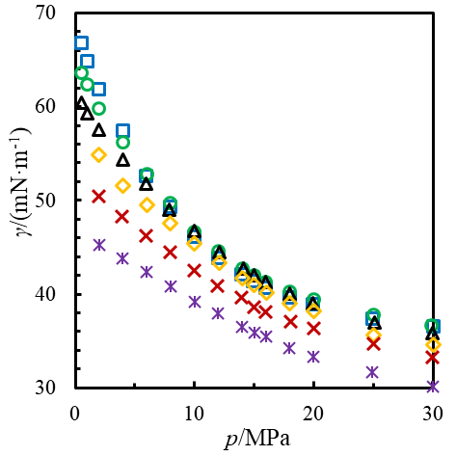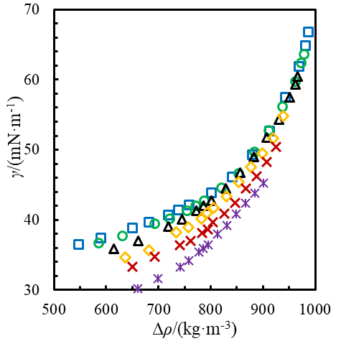
(b)
(a)
Figure 8. Experimental IFT γ between the aqueous and non-aqueous phases along isotherms as a function of (a) pressure p and (b) the calculated density difference Δρ = ρ(aqueous) – ρ(non-aqueous) between the aqueous and non-aqueous phases: , T = 313.15 K; , T = 333.15 K; , T = 353.65 K; , T = 373.15 K; , T = 393.65 K; , T = 423.15 K.

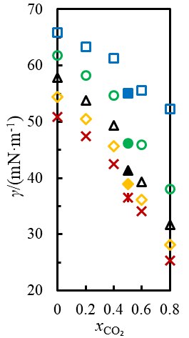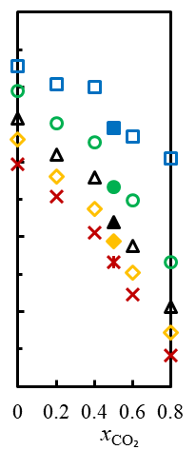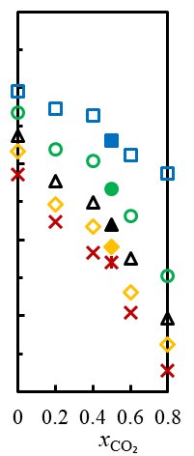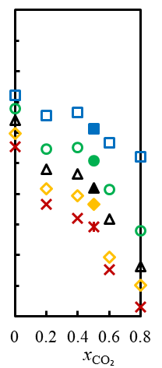
(d)
(c)
(b)
(a)
Figure 9. Comparison of experimental IFT γ between the aqueous and non-aqueous phases as a function of the mole fraction x_{CO₂} of CO₂ at four temperatures: (a) T = 313.15 K; (b) T = 333.15 K; (c), T = 353.15 K; (d), T = 373.15 K. This work: , p = 5 MPa; , p = 10 MPa; , p = 15 MPa; , p = 20 MPa; , p = 30 MPa. Ren et al. [41]: , p = 5 MPa; , p = 10 MPa; , p = 15 MPa; , p = 20 MPa; , p = 30 MPa.

In Figure 9, we compared our IFT results with the data of Ren et al. [41] as a function of the mole fraction x_{CO₂} of CO₂ in the feed gas at four temperatures and five pressures between (5 and 30) MPa. At the lowest temperature and pressure considered, T = 313.15 K and p = 5 MPa, our results fall 3.9 mN·m⁻¹ (approximately 6 %) below a smooth curve through the data or Ren et al. but with increasing temperature and/or pressure the agreement improves to within about 1 mN·m⁻¹. These differences can be compared with the combined uncertainty of about 1 mN·m⁻¹. To further validate our own measurements, we consider extrapolations down to the vapor pressure of water, in which limit the data should agree with the surface tension of pure water. At T = 313.15 K, a quadratic extrapolation based on the measured values at p = (0.5, 1.0 and 2.0) MPa gives γ = 68.8 mN·m⁻¹, which compares quite favorably with the water surface tension of 69.6 mN·m⁻¹ obtained from the IAPWS correlation [56]. Therefore, we conclude that, in the areas of disagreement, our data are to be preferred to those of Ren et al.

4. Conclusions
In this work, we conducted the first experimental measurement of the interfacial properties in a ternary water + gases system (H₂O + CO₂ + CH₄) under both VLLE and biphasic conditions. Five isotherms at temperatures between (288.15 and 297.65 K) were measured under VLLE condition while another six isotherms at temperatures between (313.15 and 423.15) K were measured under biphasic condition. The relative repeatability of the IFT measurements was always better than 1% and the overall combined relative uncertainty at 95% confidence was ≤ 3%.
In the middle of the VLLE region, the IFT between the aqueous phase and either of the non-aqueous phases were slowly-changing function of temperature and pressure but rapid variations were observed for the gas phase in the approach to the UCEP curve. It can be inferred that similar changes would have been observed for the IFT between the aqueous and CO₂-rich liquid phases had the measurements approached the UCEP curve more closely. From a scientific point of view, it would be interesting in future work to study further the region very close to the UCEP curve.
As for biphasic condition, the IFT between gas and liquid phases decreases with increase of both temperature and pressure. The result indicates that methane as an impurity would increase the IFT between carbon dioxide and water under biphasic condition. Referring to the list of ‘impurity’ gases mentioned in the Introduction, IFT data have now been reported between water and mixed-gas systems containing CO₂ with N₂ [40], H₂ [34], Ar [39], H₂S [38] or CH₄ (this work and [41]). To the best of our knowledge, the IFT between water and the mixed-gas systems comprising CO₂ with CO, O₂, SO₂, NO or N₂O have not been studied and these could be topics for future work.

Acknowledgment
This work was carried out as part of the Qatar Carbonates and Carbon Storage Research Centre (QCCSRC). We gratefully acknowledge the funding of QCCSRC provided jointly by Qatar Petroleum, Shell, and the Qatar Science & Technology Park, and for supporting the present project, and the permission to publish this research. The first author was also supported by the Research Foundation for Advanced Talents of North University of China, Key Laboratory of Ocean Energy Utilization and Energy Conservation of Ministry of Education, and China Scholarship Council.

References
[1] C.Y. Sun, G.J. Chen, Measurement of interfacial tension for the CO₂ injected crude oil plus reservoir water system, J. Chem. Eng. Data, 50 (2005) 936-938.
[2] A. Georgiadis, G. Maitland, J.P.M. Trusler, A. Bismarck, Interfacial Tension Measurements of the (H₂O + n-Decane + CO₂) Ternary System at Elevated Pressures and Temperatures, J. Chem. Eng. Data, 56 (2011) 4900-4908.
[3] W. Yan, G.Y. Zhao, G.J. Chen, T.M. Guo, Interfacial tension of (methane plus nitrogen) plus water and (carbon dioxide plus nitrogen) plus water systems, J. Chem. Eng. Data, 46 (2001) 1544-1548.
[4] Y. Liu, M. Mutailipu, L.L. Jiang, J.F. Zhao, Y.C. Song, L.Y. Chen, Interfacial tension and contact angle measurements for the evaluation of CO₂-brine two-phase flow characteristics in porous media, Environmental Progress & Sustainable Energy, 34 (2015) 1756-1762.
[5] P.F. Lv, Y.C. Song, Y. Liu, B. Wang, L.L. Jiang, B.H. Wu, S.Y. Liu, J.L. Chen, Pore-Scale Imaging and Analysis of Phase Topologies and Displacement Mechanisms for CO₂-Brine Two-Phase Flow in Unconsolidated Sand Packs, Wat. Resour. Res., 53 (2017) 9127-9144.
[6] S. Khosharay, F. Varaminian, Experimental and modeling investigation on surface tension and surface properties of (CH₄ + H₂O), (C₂H₆ + H₂O), (CO₂ + H₂O) and (C₃H₈ + H₂O) from 284.15 K to 312.15 K and pressures up to 60 bar, International Journal of Refrigeration, 47 (2014) 26-35.
[7] B. Bennion, S. Bachu, Relative permeability characteristics for supercritical CO₂ displacing water in a variety of potential sequestration zones, in: SPE Annual Technical Conference and Exhibition, Society of Petroleum Engineers, 2005.
[8] D.B. Bennion, S. Bachu, The impact of interfacial tension and pore size distribution/capillary pressure character on CO₂ relative permeability at reservoir conditions in CO₂-brine systems, in: SPE/DOE Symposium on Improved Oil Recovery, Society of Petroleum Engineers, 2006.
[9] T.K. Tokunaga, J. Wan, J.W. Jung, T.W. Kim, Y. Kim, W. Dong, Capillary pressure and saturation relations for supercritical CO₂ and brine in sand: High‐pressure Pc (Sw) controller/meter measurements and capillary scaling predictions, Wat. Resour. Res., 49 (2013) 4566-4579.
[10] M.J. Blunt, Multiphase flow in permeable media: A pore-scale perspective, Cambridge University Press, 2017.
[11] R. Juanes, E. Spiteri, F. Orr, M. Blunt, Impact of relative permeability hysteresis on geological CO₂ storage, Wat. Resour. Res., 42 (2006).
[12] H.L. Li, J.P. Jakobsen, O. Wilhelmsen, J.Y. Yan, PVTxy properties of CO₂ mixtures relevant for CO₂ capture, transport and storage: Review of available experimental data and theoretical models, Appl. Energy, 88 (2011) 3567-3579.
[13] A.T. Evulet, A.M. ELKady, A.R. Branda, D. Chinn, On the performance and operability of GE’s dry low NOx combustors utilizing exhaust gas recirculation for postcombustion carbon capture, Energy Procedia, 1 (2009) 3809-3816.
[14] H.-J. Ryu, G.-T. Jin, C.-K. Yi, Demonstration of inherent CO₂ separation and no NO_{x} emission in a 50kW chemical-looping combustor: Continuous reduction and oxidation experiment, in: Greenhouse Gas Control Technologies 7, Elsevier, Vancouver, 2004, pp. 1907-1910.
[15] B.M.S. Santos, A.G.M. Ferreira, I.M.A. Fonseca, Surface and interfacial tensions of the systems water plus n-butyl acetate plus methanol and water plus n-pentyl acetate plus methanol at 303.15 K, Fluid Phase Equilib., 208 (2003) 1-21.
[16] M.L. Kijevcanin, I.S.A. Ribeiro, A.G.M. Ferreira, I.M.A. Fonseca, Densities, viscosities, and surface and interfacial tensions of the ternary mixture water plus ethyl butyrate plus methanol at 303.15 K, J. Chem. Eng. Data, 48 (2003) 1266-1270.
[17] B. Li, J. Fu, Interfacial tensions of two-liquid-phase ternary systems, J. Chem. Eng. Data, 37 (1992) 172-174.
[18] J. Pandey, P. Chandra, T. Srivastava, N. Soni, A. Singh, Estimation of surface tension of ternary liquid systems by corresponding-states group-contributions method and Flory theory, Fluid Phase Equilib., 273 (2008) 44-51.
[19] H. Rodríguez, M. Francisco, A. Soto, A. Arce, Liquid–liquid equilibrium and interfacial tension of the ternary system heptane+ thiophene+ 1-ethyl-3-methylimidazolium bis (trifluoromethanesulfonyl) imide, Fluid Phase Equilib., 298 (2010) 240-245.
[20] E.W. Washburn, The dynamics of capillary flow, Phys. Rev., 17 (1921) 273.
[21] N. Rashidnia, R. Balasubramaniam, D. Del Signore, Interfacial tension measurement of immiscible liquids using a capillary tube, AlChE J., 38 (1992) 615-618.
[22] B.S. Chun, G.T. Wilkinson, Interfacial-tension in high-pressure carbon-dioxide mixtures, Ind. Eng. Chem. Res., 34 (1995) 4371-4377.
[23] S.-Y. Lin, H.-F. Hwang, Measurement of low interfacial tension by pendant drop digitization, Langmuir, 10 (1994) 4703-4709.
[24] B.-Y. Cai, J.-T. Yang, T.-M. Guo, Interfacial tension of hydrocarbon+ water/brine systems under high pressure, J. Chem. Eng. Data, 41 (1996) 493-496.
[25] A. Bahramian, A. Danesh, F. Gozalpour, B. Tohidi, A. Todd, Vapour–liquid interfacial tension of water and hydrocarbon mixture at high pressure and high temperature conditions, Fluid Phase Equilib., 252 (2007) 66-73.
[26] S. Enders, H. Kahl, J. Winkelmann, Surface tension of the ternary system water+ acetone+ toluene, J. Chem. Eng. Data, 52 (2007) 1072-1079.
[27] H. Akiba, R. Ohmura, Interfacial tension between (CO₂ + N₂) gas and tetrabutylammonium bromide aqueous solution, J. Chem. Thermodyn., 97 (2016) 83-87.
[28] M. Memari, A.M. Dehkordi, A.A. Seifkordi, Liquid–Liquid Equilibrium Data, Density, Viscosity, and Interfacial Tension of Ternary System (Toluene–Acetic Acid–Water) at 298.15 K: Experiment and Correlation, J. Chem. Eng. Data, 62 (2017) 4133-4143.
[29] R. Bressler, P. Wyatt, Surface wetting through capillary grooves, J. Heat Transfer, 92 (1970) 126-132.
[30] V.A. Prokhorov, Refinement of Rayleigh's equation for calculation of surface tension of a liquid from its capillary rise height, Colloids and Surfaces A: Physicochemical and Engineering Aspects, 116 (1996) 309-316.
[31] J. Drelich, C. Fang, C. White, Measurement of interfacial tension in fluid-fluid systems, Encyclopedia of surface and colloid science, 3 (2002) 3158-3163.
[32] B. Song, J. Springer, Determination of Interfacial Tension from the Profile of a Pendant Drop Using Computer-Aided Image Processing: 1. Theoretical, J. Colloid Interface Sci., 184 (1996) 64-76.
[33] B. Song, J. Springer, Determination of Interfacial Tension from the Profile of a Pendant Drop Using Computer-Aided Image Processing: 2. Experimental, J. Colloid Interface Sci., 184 (1996) 77-91.
[34] Y.T.F. Chow, G. Maitland, J.P.M. Trusler, Interfacial tensions of (H₂O + H₂) and (H₂O + CO₂ + H₂) systems at temperatures of (298–448) K and pressures up to 45 MPa, Fluid Phase Equilib., 475 (2018) 37-44.
[35] A. Bahramian, Mutual solubility–interfacial tension relationship in aqueous binary and ternary hydrocarbon systems, Fluid Phase Equilib., 285 (2009) 24-29.
[36] B.-S. Chun, G.T. Wilkinson, Interfacial tension in high-pressure carbon dioxide mixtures, Ind. Eng. Chem. Res., 34 (1995) 4371-4377.
[37] N. Nagarajan, K.A. Gasem, R.L. Robinson Jr, Equilibrium phase compositions, phase densities, and interfacial tensions for carbon dioxide+ hydrocarbon systems. 6. Carbon dioxide+ n-butane+ n-decane, J. Chem. Eng. Data, 35 (1990) 228-231.
[38] V. Shah, D. Broseta, G. Mouronval, F. Montel, Water/acid gas interfacial tensions and their impact on acid gas geological storage, International Journal of Greenhouse Control, 2 (2008) 594-604.
[39] Y.T.F. Chow, D.K. Eriksen, A. Galindo, A.J. Haslam, G. Jackson, G.C. Maitland, J.P.M. Trusler, Interfacial Tensions of Systems Comprising Water, Carbon Dioxide and Diluent Gases at High Pressures: Experimental Measurements and Modelling with SAFT-VR Mie and Square-Gradient Theory, Fluid Phase Equilib., 407 (2016) 159-176.
[40] Y.T.F. Chow, G.C. Maitland, J.P.M. Trusler, Interfacial tensions of the (CO₂ + N₂ + H₂O) system at temperatures of (298 to 448) K and pressures up to 40 MPa, J. Chem. Thermodyn., 93 (2016) 392-403.
[41] Q.-Y. Ren, G.-J. Chen, W. Yan, T.-M. Guo, Interfacial Tension of (CO₂ + CH₄) + Water from 298 K to 373 K and Pressures up to 30 MPa, J. Chem. Eng. Data, 45 (2000) 610-612.
[42] S.Z.S. Al Ghafri, E. Forte, G.C. Maitland, J.J. Rodriguez-Henriquez, J.P.M. Trusler, Experimental and Modeling Study of the Phase Behavior of (Methane + CO₂ + Water) Mixtures, J. Phys. Chem. B, 118 (2014) 14461-14478.
[43] E.W. Lemmon, I.H. Bell, M.L. Huber, M.O. McLinden, NIST Standard Reference Database 23: Reference Fluid Thermodynamic and Transport Properties-REFPROP, Version 10.0, in, National Institute of Standards and Technology, Gaitherburg, 2018.
[44] U. Setzmann, W. Wagner, A New Equation of State and Tables of Thermodynamic Properties for Methane Covering the Range from the Melting Line to 625 K at Pressures up to 100 MPa, J. Phys. Chem. Ref. Data, 20 (1991) 1061-1155.
[45] R. Span, W. Wagner, A new equation of state for carbon dioxide covering the fluid region from the triple-point temperature to 1100 K at pressures up to 800 MPa, J. Phys. Chem. Ref. Data, 25 (1996) 1509-1596.
[46] W. Wagner, A. Pruß, The IAPWS formulation 1995 for the thermodynamic properties of ordinary water substance for general and scientific use, J. Phys. Chem. Ref. Data, 31 (2002) 387-535.
[47] O. Kunz, W. Wagner, The GERG-2008 wide-range equation of state for natural gases and other mixtures: an expansion of GERG-2004, J. Chem. Eng. Data, 57 (2012) 3032–3091.
[48] O. Kunz, R. Klimeck, W. Wagner, M. Jaeschke, The GERG-2004 wide-range equation of state for natural gases and other mixtures. GERG TM15 2007., VDI Verlag GmbH, Düsseldorf, 2007.
[49] J. Gernert, R. Span, EOS-CG: A Helmholtz energy mixture model for humid gases and CCS mixtures, J. Chem. Thermodyn., 93 (2016) 274-293.
[50] X. Ji, S.P. Tan, H. Adidharma, M. Radosz, SAFT1-RPM approximation extended to phase equilibria and densities of CO₂−H₂O and CO₂−H₂O−NaCl systems, Ind. Eng. Chem. Res., 44 (2005) 8419-8427.
[51] Z. Duan, J. Hu, D. Li, S. Mao, Densities of the CO₂–H₂O and CO₂–H₂O–NaCl systems up to 647 K and 100 MPa, Energy Fuels, 22 (2008) 1666-1674.
[52] E.C. Efika, R. Hoballah, X. Li, E.F. May, M. Nania, Y. Sanchez-Vicente, J.P. Martin Trusler, Saturated phase densities of (CO₂+H₂O) at temperatures from (293 to 450) K and pressures up to 64 MPa, J. Chem. Thermodyn., 93 (2016) 347-359.
[53] W. Sachs, V. Meyn, Pressure and temperature dependence of the surface tension in the system natural gas/water principles of investigation and the first precise experimental data for pure methane/water at 25°C up to 46.8 MPa, J Colloids Surfaces A: Physicochemical and Engineering Aspects, 94 (1995) 291-301.
[54] F.K. Hansen, G. Rodsrud, Surface-Tension by Pendant Drop .1. A Fast Standard Instrument Using Computer Image-Analysis, J. Colloid Interface Sci., 141 (1991) 1-9.
[55] F.K. Hansen, Surface-Tension by Image-Analysis - Fast and Automatic Measurements of Pendant and Sessile Drops and Bubbles, J. Colloid Interface Sci., 160 (1993) 209-217.
[56] IAPWS, Revised Release on the IAPWS Formulation 1995 for the Thermodynamic Properties of OrdinaryWater Substance for General and Scientific Use, 2014., in, 2014.
[57] A. Hebach, A. Oberhof, N. Dahmen, A. Kögel, H. Ederer, E. Dinjus, Interfacial Tension at Elevated Pressures - Measurements and Correlations in the Water + Carbon Dioxide System, J. Chem. Eng. Data, 47 (2002) 1540-1546.
[58] L.M.C. Pereira, A. Chapoy, R. Burgass, M.B. Oliveira, J.A.P. Coutinho, B. Tohidi, Study of the impact of high temperatures and pressures on the equilibrium densities and interfacial tension of the carbon dioxide/water system, J. Chem. Thermodyn., 93 (2016) 404-415.
[59] M. Wendland, H. Hasse, G. Maurer, Experimental Pressure-Temperature Data on Three- and Four-Phase Equilibria of Fluid, Hydrate, and Ice Phases in the System Carbon Dioxide−Water, J. Chem. Eng. Data, 44 (1999) 901-906.
[60] Y. Seeto, J.E. Puig, L.E. Scriven, H.T. Davis, Interfacial-Tensions in Systems of 3 Liquid-Phases, J. Colloid Interface Sci., 96 (1983) 360-372.
[61] G. Wiegand, E.U. Franck, Interfacial tension between water and non-polar fluids up to 473 K and 2800 bar, Ber. Bunsen-Ges. Phys. Chem., 98 (1994) 809-817.

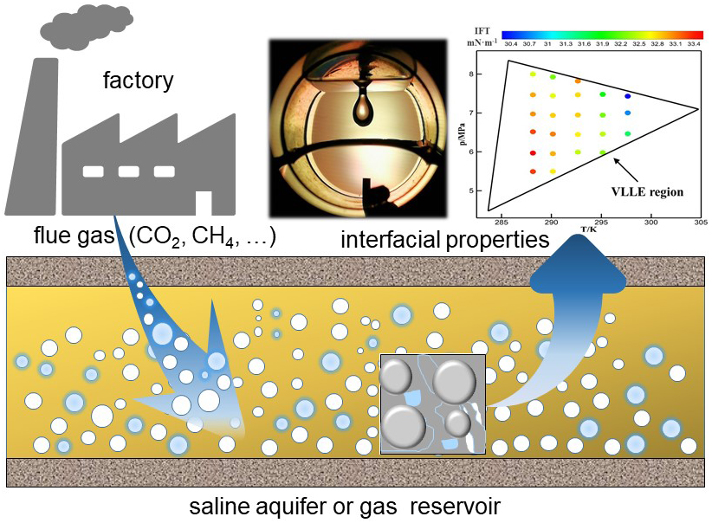

Table of contents graphic

