Mechanistic insights into the ORR on Metal–N–C electrocatalysts under fuel cell conditions
Thiago Lopes^{[a]}, Anthony Kucernak^{[b],*}, Daniel Malko^{[b]} and Edson A. Ticianelli^{[a]}

Abstract:
Three different transition metal-C-N catalysts are tested under a range of fuel cell conditions. It is found that common features of the polarisation curve can be explained by a change in electrocatalytic mechanism. Utilising a simple model to quantify the change in mechanisms, iR free results of the fuel cell experiments are fit and found to be represented by a common set of parameters. The change in mechanism is assumed to be a switch from four electron reduction of oxygen to water to a two electron reduction to hydrogen peroxide followed by disproportionation of the hydrogen peroxide to water and oxygen. The data is used to estimate a mass specific exchange current density towards the ORR in the range 10⁻¹¹-10⁻¹³ A g⁻¹ depending on the catalyst. For the reduction of oxygen to hydrogen peroxide, the mass specific exchange current density is estimated to be in the range 10⁻²-10⁻³ A g⁻¹. Utilising the electrokinetic model, it is shown how the mass transport losses can be extracted from the polarisation curve. For all three catalyst layers studied, these mass transport losses reach about 100mV at a current density of 1 A cm⁻². Finally a discussion of the performance and site density requirements of the non-precious metal catalysts are provided, and it is estimated that the activity towards the ORR needs to be increased by an order of magnitude, and the site density by two/three orders of magnitude in order to compete with platinum as an ORR electrocatalyst.
Introduction
Fuel cells can play a crucial role towards a future sustainable world, however, these devices are currently based on platinum group metals (PGMs), catalyst group of materials considered as critical raw materials^{[1]} Furthermore, the oxygen reduction reaction, which is more than six orders of magnitude slower than the hydrogen oxidation reaction, requires the cathode of polymer electrolyte fuel cells (PEFCs) to utilize eight times the amount of platinum of the anode (i.e. 0.4mg_{Pt} cm⁻²_{cathode} vs 0.05mg_{Pt} cm⁻²_{anode})^{[2]} . As a sustainable alternative, non-precious oxygen reduction catalysts have been a main focus of research, ^{[1, 3]} and in this regard, carbon-based catalysts are emerging as a viable alternative on a long term scenario^{[4-5]}. They are based on naturally abundant elements, e.g. C (> ~90%), N, Fe or other abundant transition metals and the present authors have recently shown that carbon catalysts can also be highly selective towards the oxygen reduction reaction, with tolerance to a wide range of poisons^{[6]}, which adversely affect PGM based catalysts^{[7-11]}. Even though extremely promising, some challenges remain regarding fundamental and applied developments of carbon catalysts, for instance: (i) understanding the kinetics of the oxygen reduction reaction on these materials; (ii) translation of fundamentally (e.g. RRDE) observed performances into power output in practical devices; (iii) dealing with degradation of these catalysts under operational conditions which limit their ultimate lifetime. There has been progress in addressing the oxygen reduction activity of carbon catalysts, ^{[6, 12-19]} however there is a gap in understanding the activity of the carbon catalyst cathodes, in part due to issues in appropriately determining ORR kinetics and mass transport overpotential under fuel cell conditions.
One of the first attempts to establish an ideal performance for carbon catalysed cathodes of PEFC was set by Gasteiger et al. ^{[2]}, aimed at promoting high practical power outputs. This proposition was based on the assumption of equivalent Tafel kinetics of carbon catalyst to platinum (a Tafel slope of 70 mV dec⁻¹ at 353 K) over the entire potential window, which in fact may not be appropriate for carbon-based catalysts or even platinum for that matter ^{[20]}. Current carbon-based catalyst cathode in a PEFC are unlikely to reproduce the performance of platinum catalyst cathode given that the location of the active sites on Pt/C are on the surface of an extended lattice, whilst those on the carbon catalysts are individual “molecular” sites mostly located at micropores ^{[21-23]}. This will hinder species transport – oxygen to and water from the active sites^{[24]}. Compared to previous work utilising rotating disk electrode measurements (RDE) to characterise the performance of the catalysts, we have used fuel cell measurements as they allow us to operate at much higher turnover frequencies than for catalysts under RDE conditions, and also allow us to study the performance under realistic conditions. Utilizing appropriate carbon-based catalysts under conditions of high mass transport or high oxygen partial pressures, the present work shows that the hypothesis of a single Tafel slope of 70 mV dec⁻¹ and no debilitating mass transport effect might not be directly applicable to carbon materials. Based on the finding that the ORR proceeds on carbon catalysts with two distinct Tafel slopes, we propose a mechanism for the ORR on these catalysts. Furthermore, a methodology is proposed for quantifying the various modes of voltage losses that limit power outputs in PEFCs utilising these materials as catalyst.
Results and Discussion
Carbon catalysts are emerging as potential candidates to replace finite precious metals as catalysts for the oxygen reduction in a range of pHs and under various adverse conditions^{[6]}. Adequate developments have been achieved in the last few years on developing carbon catalysts with progressively increasing catalytic activities ^{[6, 25-30]} and reliable short term practical durability^{[23]}. However, there has been a gap in quantifying the activity and voltage loss modes that limit the available power output of practical electrochemical devices based on the oxygen reduction reaction, i.e. PEFCs. Optimizing PEFCs (and generally electrochemical devices) requires a proper understanding of the voltage losses that defines the cell voltage (available power output), particularly the oxygen reduction reaction kinetics, the proton/hydroxide conduction in both catalyst layer and electrolyte, and of great importance for carbon catalysts the mass transport (oxygen to and oxygen reduction products from an active site). A suitably illustrative example of such development, based upon proper knowledge of each overvoltage contributing to the total power output in practical electrochemical devices, is that of platinum catalyst on PEFCs.
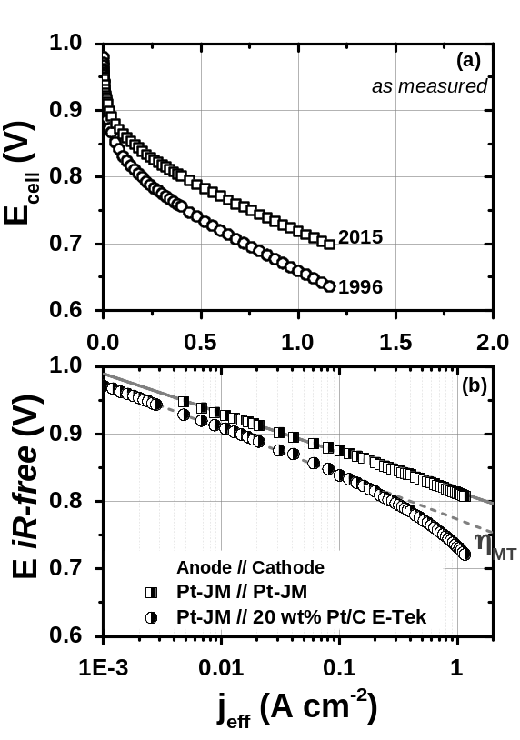
Figure 1. H₂/O₂ polarization response of a single PEFC under galvanostatic mode (a) as measured and (b) resistance corrected. Cells at 80 ⁰C and gases at 100 RH%, with H₂ at 160ccm and O₂ at 550ccm. H₂/O₂ at a partial pressure of 100 kPa_{abs}. A NafionTM membrane NR212 was utilized as electrolyte membrane. Square: Johnson Matthey platinum electrode with a loading of 0.4 mg_{Pt} cm⁻²; circle: a catalyst layer prepared with a method developed in 1996 ^{[31]} with a platinum loading of 0.4 mg_{Pt} cm⁻² and an ionomer to carbon ratio of 0.93. Half-filled symbols stand for resistance corrected PEFC performances, accounting for high-frequency-resistance and for proton transport resistance in the cathodic catalyst layer. Effective current density (j_{ef}) refers to hydrogen crossover corrected current densities..
Figure 01 compares the historical state-of-the-art performance of platinum based PEFCs, in the year of 1996 ^{[31]} and a present industrial standard, which amounts more than 25 years of development. It is clear from data in Fig. 1 that development of both catalyst layer structure (e.g. ~40 μm thick E-Tek Pt/C versus ~10 μm Johnson Matthey Pt electrode) and catalyst activity (ΔE = ~20mV) has greatly promoted the development of PEFCs in terms of practical performances, or ~0.3 A cm⁻² for 20 wt% Pt/Vulcan versus ~1.7 A cm⁻² for Johnson Matthey Pt electrode (extrapolated disregarding development of mass transport) at a cell potential of 0.8 V_{iR-free}, (i.e. corrected for Ohmic losses). This represents an improvement of about 6 times in performance, which has been obtained by properly tackling principally kinetic and mass transport overvoltage losses.
Carbon catalysts are discussed to present lower density of active sites and also lower ORR activity compared to precious metal catalysts^{[26]}. This feature generally leads researchers to apply high loadings of carbon catalysts onto the cathode catalyst layer of PEFCs, in order to reduce voltage losses associated with the oxygen reduction reaction (the catalyst effective exchange current density is dependent upon catalyst loading). However, high loadings of catalysts lead to thick catalyst layers which may exacerbate diffusion overvoltage losses on practical devices (quantified later in this text), as indirectly evidenced in Fig. 1 (10 μm thick Pt-JM versus 40 μm thick Pt E-Tek). Equation 01 summarizes the total overpotential components, for a PEFC under operating conditions:
$E_{cell}^{meas}=E_{{cell}_{(P_{H_{2}},P_{O_{2}}, T )}}^{theor}-ŋ_{HOR}^{an}+ŋ_{ORR}^{cath}-iR_{Ω}-i\left(R_{H^{+}}^{an}+R_{H^{+}}^{cath}\right)-ŋ_{MT}^{an}-ŋ_{MT}^{cath}$ eq. 1
where $E_{cell}^{meas}$ is the measured cell potential; $E_{{cell}_{(P_{H_{2}},P_{O_{2}}, T )}}^{theor}$ is the theoretical cell potential and refers to the difference between anode and cathode electrode equilibrium potentials, which follow the Nernst equation and is based on the partial pressure of the reactants in the flow field and reaction temperature; $ŋ_{HOR}^{an}$ is the hydrogen oxidation reaction overpotential on the anode; $ŋ_{ORR}^{cath}$ is the oxygen reduction reaction overpotential on the cathode; $R_{Ω}$ refers to the Ohmic resistances of the system (e.g. membrane resistance, contact resistances (FF/DM and DM/CL), bulk resistance of the diffusion media and the electronic resistance of the catalyst layers; $R_{H^{+}}^{an}$ and $R_{H^{+}}^{cath}$ refer to the anode and cathode proton transport resistances within the catalyst layers; and $ŋ_{MT}^{an}, ŋ_{MT}^{cath}$ refer to the mass transport overpotentials caused by reactant concentration gradients (between the flow field and the catalyst layer).
Terms in equation 01 have different contributions to the total overvoltage of a PEFC under operation. The ORR kinetic loss ($ŋ_{ORR}^{cath}$) is the most important factor contributing to the total overvoltage (easily greater than -300 mV). Ohmic resistance ($iR_{Ω}$) is also another important term in equation 1, with values for $R_{Ω}$ ranging between ~0.06 Ω cm² (-60 mV @ 1 A cm⁻²) to ~0.25 Ω cm² (-250 mV @ 1 A cm⁻²) for NafionTM membrane thicknesses between 50μm and 175μm and standard gas diffusion media^{[32-33]}. The proton transport resistance can also contribute remarkably to the total overvoltage of a PEFC, with $R_{H^{+}}^{cath}$ at about 0.10 Ω cm² and 0.030 Ω cm² (-100 mV and -30 mV @ 1 A cm⁻²) for platinum based standard catalyst layers^{[34-35]}. Where, Eikerling and Kornyshev have derived analytical expressions correlating the cathode catalyst layer structure/composition with the AC impedance response of PEFCs^{[36]}. Among the special cases described in this model, there is the proton transport resistance signature in the EIS spectrum, which appears as a 45⁰ straight line in the high frequency domain, as clearly observed in the inset of Figure S2 (dashed line) and indirectly in Figure 2. Eikerling and Kornyshev have also pointed out that the developed model can be approximated by using a finite transmission line equivalent circuit, therefore experimental data can be readily fitted with this element and the proton transport resistance in the catalyst layer obtained, as suitably carried out in the present work (for further details refer to experimental section and Supplementary Information S2.2).
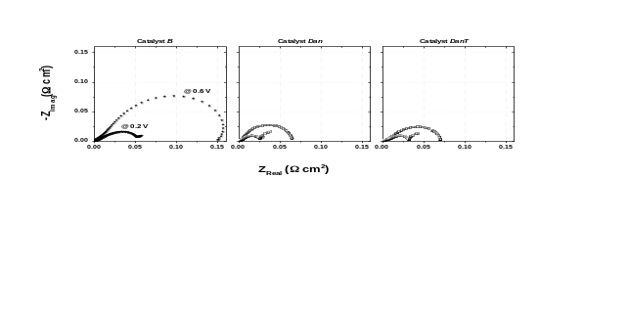
Figure 2. Complex plane impedance plot of a single PEFC cell fed with H₂/O₂. Symbols stand for: star to catalyst B, open circle to catalyst Dan and open square to catalyst DanT. MEA is composed of carbon catalyst B at a loading of 6 mg cm⁻², catalyst Dan and DanT at a loading of 4 mg cm⁻², and at an I/C ratio of 1.5 for Dan and 1 for remaining catalysts. Catalysts were deposited on a Toray carbon paper THP60 with microporous layer, a NafionTM N115 as membrane and a commercial electrode as anode (Johnson Matthey, 0.4mg_{Pt} cm⁻²). The EIS experiment was carried out under galvanostatic control at a cell potential of 0.6 V (0.09 A cm⁻² for B, 0.17 Acm⁻² for Dan and 0.29 A cm⁻² for DanT) and 0.2 V (0.77 A cm⁻² for B and 1 A cm⁻² for Dan and DanT), with an AC perturbation of 5% of the DC current for a frequency range between 100 kHz and 0.1 Hz. Cell hardware temperature at 80 ⁰C and water humidification at 95 ⁰C_{anode} and 85 ⁰C_{cathode}, with H₂ at 160ccm and O₂ at 450ccm, both anode and cathode compartments were pressurized to 210 kPa gauge (O₂ partial pressure of 244 kPa_{abs}).
$ŋ_{ORR}^{cath}$ and $ŋ_{MT}^{cath}$ are the main subject of research on fuel cell technologies due to their high magnitude, particularly when carbon-based catalysts are utilized in the cathode electrode^{[6, 24, 37]}. It is noteworthy mentioning that both proton and mass transport resistances at the anode are negligible when pure and fully humidified hydrogen is utilized with optimized electrodes (i.e. $ŋ_{HOR}^{an}$, $ŋ_{MT}^{an}$and $R_{H^{+}}^{an}$ are small) ^{[37]}. This work has utilized an appropriately optimized commercial platinum electrode as anode, therefore equation 1 can be rearranged to the form:
$E_{cell}^{meas}=E_{{cell}_{(P_{H_{2}},P_{O_{2}}, T )}}^{theor}+ŋ_{ORR}^{cath}-iR_{Ω}-iR_{H^{+}}^{cath}-ŋ_{MT}^{cath}$ eq. 2
Understanding each loss mode in equation 2 is crucial towards optimising power outputs of PEFCs utilizing carbon catalysts. In Supplementary Information, Ohmic resistances ($R_{Ω}$ or the high-frequency resistance and the $R_{H^{+}}^{cath}$) are discussed and determined towards obtaining PEFC polarization responses free of Ohmic contributions (iR-free), which are necessary to obtain suitable estimates of $ŋ_{ORR}^{cath}-ŋ_{MT}^{cath}$, or of ORR kinetic polarizations. A detailed analysis of the suitable optimization approach also utilized here, for optimizing $R_{H^{+}}^{cath}$ on the cathode catalyst layers of PEFCs employing carbon catalysts, is given in a separate work of the present authors^{[38]}. In subsequent sections, an oxygen reduction electrokinetic model is proposed to describe the ORR on carbon catalysts, which uniquely opens way for calculating ORR electrokinetic overpotentials ($ŋ_{ORR}^{cath}$) and mass transport overpotentials ($ŋ_{MT}^{cath}$) of carbon based cathodes of electrochemical systems. Based on these findings, and with an eye to the required site density mentioned previously, we assess the required electrocatalystic performance of Metal–N–C catalysts if they are to match that of PMG type catalysts.
iR-Free Polarization Response of PEFCs: Evidence for two Nernstian Tafel Regions
Experimentally determining both $R_{Ω}$ and $R_{H^{+}}^{cath}$ is important towards isolating Ohmic terms in equation 2 and obtaining a true iR-free polarization response of PEFCs.
Such results (E_{cell},_{iR-free} versus current density) are shown in Fig. 3(a) for PEFCs with cathodes containing different loadings of carbon catalyst B. For comparison with the experimental data, a dashed line tangent to the experimental results and with a Tafel slope of 140 mV/decade (i.e. α_{eff}=½ at the temperature of the experiment) is also plotted on the data. In fact, especially for the lowest loading catalysts layers, the data is well represented by such a line. At higher loadings, it is seen that there is a pronounced curvature to the data at high current densities due to the appearance of mass transport effects. It is interesting to note that the data in Fig. 3 deviates from the ideal α_{eff}=½ Tafel line at low current densities, suggesting a change in mechanism at high potentials. This effect is more clearly seen in Fig. 3(b) (catalyst B), in which the data presumed to be mass transport free (i.e. data well away from the area of increased curvature at high current densities) is plotted for all the electrodes from figure 3(a). In order to have a fair comparison, the data is corrected to mass specific activity. It is compelling to see that all the data representing different catalyst loadings falls on the same curve – this strongly supports the concept that the data is mass transport free. Furthermore, there is a transition from a region of low Tafel slope to that of high Tafel slope as the mass specific current density is increased. This transition does not appear to be due to a mass transport effect (as that data has been excluded from the plot), rather it seems as if it is associated with a transition of mechanism.
For comparison, data for other two different carbon catalyst (Dan and DanT) are also plotted in Figure 3(b) (NB In this case, mass-transport affected points were not excluded). It is interesting to note that the curve determined for catalyst B also gives a good approximation to that for Dan and DanT if the curve is offset vertically and slightly laterally as shown in Figure S3 (see below for description of fitting procedure).
Where does the change of mechanism come from? It is interesting to note that these catalysts can produce significant amounts of hydrogen peroxide^{[12-13, 39-40]}. For instance, in Fig 4, we show rotating ring disk electrode (RRDE) results for catalyst B in sulfuric acid electrolyte as a function of catalyst loading. It is seen that thinner catalysts layers result in increased H₂O₂ percentages detected in the ring, at less positive potentials.

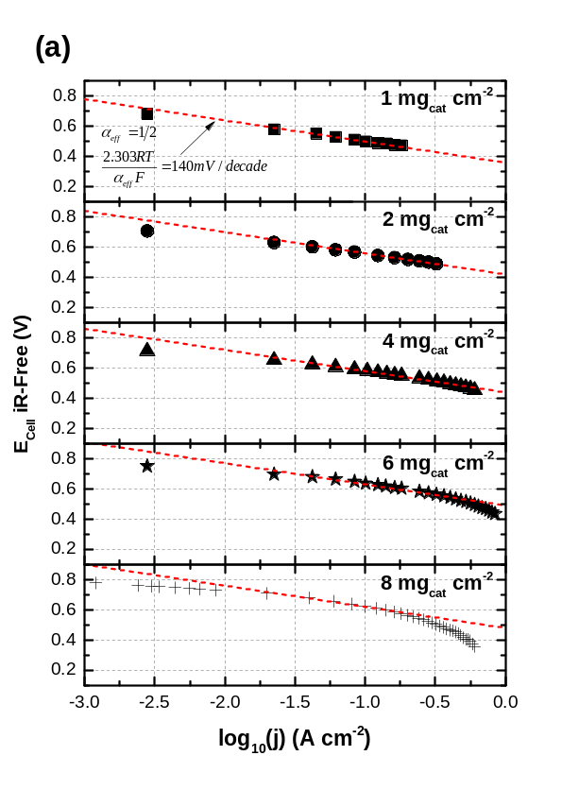
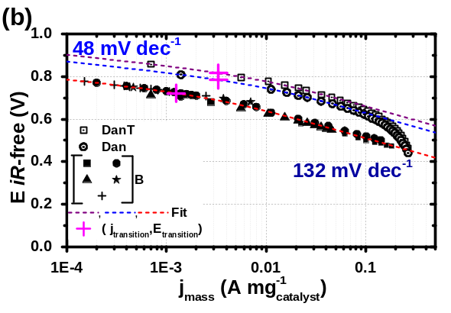
Figure 3. : (a) H₂/O₂ resistance corrected polarization response of single PEFCs under galvanostatic mode for the ORR on carbon catalyst B. Dashed line corresponds to a Tafel slope of 140 mV decade⁻¹ – equivalent to an effective transfer coefficient of ½ at the temperature of the experiment. 1 mg_{catalyst} cm⁻²; 2 mg_{catalyst} cm⁻²; 4 mg_{catalyst} cm⁻²; 6 mg_{catalyst} cm⁻²; and 8 mg_{catalyst} cm⁻². Experimental conditions as per Fig. 02. (b) mass-specific current density with mass transport unaffected data only (1 to 8 mg_{cat} cm⁻² Catalyst B), data from (a) with same symbols, and complete data set for catalysts Dan (4mg cm⁻², open circle) and DanT (4mg cm⁻², open square) under the same experimental conditions. Fits of data to Eq 6 ((-------,-------,-------), see Table 1 for parameters.

The results in Figure 4 are also supported by other literature results, and we interpret the results as being due to more effective mass transport of the H₂O₂ away from the electrode surface when the mass loading of the catalyst is lower – i.e. the likelihood of the H₂O₂ produced being autocatalytically decomposed is a function of catalyst layer thickness. For instance, Bonakdarpour at al. ^{[39]} have observed an increase in the percentage of H₂O₂ detected on the ring from 5% to 95% with a decrease in catalyst loading from 0.800 mg cm⁻² to 0.020 mg cm⁻² in the disk of the RRDE.
Although there are many ways in which a mechanistic transition from one slow step to another can occur, it is modelled here as a simple system in which two different oxygen reduction processes can occur on the same active site. This ultimately leads to water or hydrogen peroxide, the latter of which can then undergo autocatalytic decomposition to oxygen and water). Hence we ascribe a mechanism to this process as described schematically in Fig. 5. Under these conditions, there is competition between the decomposition pathway and mass transport of the peroxide away from the electrode.

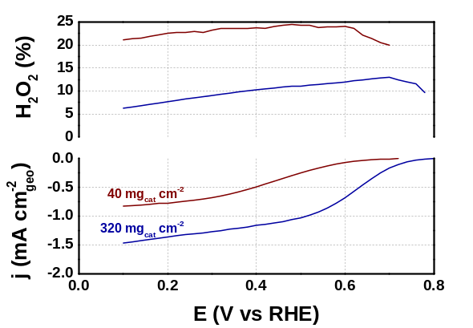
Figure 4: Steady state oxygen reduction current densities (bottom) and H₂O₂ (top) percentage measured on carbon catalyst B supported on a glassy-carbon rotating ring (gold) disk electrode at 1600 rpm in 1 M H₂SO₄ at 25 ⁰C ± 0.1 ⁰C and saturated with oxygen at 91 kPa. Blue curve stand for a catalyst loading of 320 mg cm⁻² and red curve for 40 mg cm⁻² deposited on the disk of the RRDE electrode. Steady-state measurement performed with a potential step of 30mV, and hold duration of 30s.
Based on the circumstances detailed in the last paragraph and as illustrated in Fig. 5, there are two possible oxygen reduction mechanisms which can occur on carbon catalysts, each associated with its own reversible potential (E_{rev,1}, E_{rev,2}), exchange current density (j_{o,1},j_{o,2}) and effective symmetry factor (α_{eff,1}, α_{eff,2}). If it is assumed that the electrode potential is sufficiently far away from each of the reversible potentials, such that the Tafel approximation applies, than each mechanism can be described as:
Mechanism 1: $j_{1}\left(E\right)=-j_{0,1}exp\left(\frac{-α_{eff,1}F\left(E-E_{rev,1}\right)}{RT}\right)$ Eq 3
Mechanism 2: $j_{2}\left(E\right)=-j_{0,2}exp\left(\frac{-α_{eff,2}F\left(E-E_{rev,2}\right)}{RT}\right)$ Eq 4

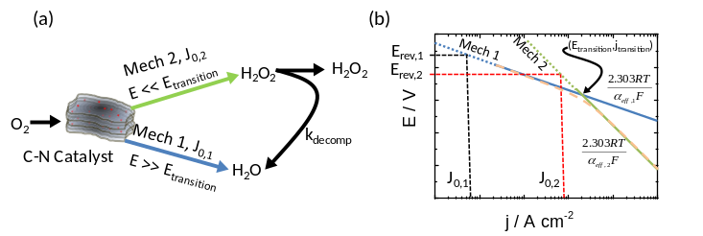
Figure 5: (a) Cartoon representing the reduction of oxygen on a Carbon-Nitrogen catalyst through two different mechanisms leading to the formation of either hydrogen peroxide or water. The mechanisms use the same catalytic site and mechanism 2 blocks mechanism 1 at a high enough current density. (b) Example of a Tafel plot showing what might be expected for mechanism 1(…..) and mechanism 2 (…..), each with a different reversible potential, exchange current density, and α_{eff}. The combination of both mechanisms leads to the dashed line. (- - - -) NB: for simplicity only the reduction side of the reactions are shown, and the effect of k_{decomp} is ignored.
As both mechanisms operate in parallel and utilise the same active site, at large overpotentials, mechanism 2 will block mechanism 1 (as shown in Fig. 5a) and the current densities are combined to represent the parallel nature of the reaction,
$\frac{1}{j_{Tot}\left(E\right)}=\frac{1}{j_{1}\left(E\right)}+\frac{1}{j_{2}\left(E\right)}$ Eq 5
where $j_{Tot}\left(E\right)$ is represented by the dashed line in Fig. 5b.
Although Eqs 3-5 could be utilised to fit the referent data in this work, there would be six possible fit parameters. This number can be reduced by one as we know the equilibrium potential for the 4 electron reduction of oxygen to water under our operating conditions (see Supplementary Information S3), however we do not know the corresponding equilibrium potential for the oxygen reduction to hydrogen peroxide reaction, as it is unclear what the equilibrium concentration of hydrogen peroxide will be in the system, and it should be closely coupled to the magnitude of k_{decomp}. Increasing k_{decomp} (or indeed increase mass transport of peroxide away from the catalyst layer) will drop the equilibrium peroxide concentration and thus increase the reversible potential for the oxygen/peroxide reaction, leading to a higher changeover potential. Nevertheless, the number of parameters can be further reduced by realising that the point of intersection of the Tafel slopes represents a fixed value, and the same result as Eqs 3-5 can be achieved by using
$j\left(E\right)=j_{transition}\left(\frac{1}{\frac{1}{exp\left(\frac{α_{eff,1}F\left(E-E_{transition}\right)}{RT}\right)}+\frac{1}{exp\left(\frac{α_{eff,2}F\left({E-E}_{transition}\right)}{RT}\right)}}\right)$ Eq. 6
where $(E_{transition},j_{transition})$represents the point at which the two Tafel lines intercept each other – i.e. the potential at which each mechanism would produce the same current.
It is important to note that $E_{transition}$ is only indirectly related to the electrochemical processes occurring, and should not be assumed to be representative of a reaction itself. Nonetheless, it is interesting to note that the values of $E_{transition}$ determined are close to the standard potential of oxygen reduction to peroxide.
Utilising Eq. 6 allows a suitable four parameter fit of data ($E_{transition},j_{transition}$, $α_{eff,1}$, $α_{eff,2}$) and this equation was utilized to fit the data in Fig 3 (b), and indeed the curves in figure 3(b) are the resultant fit, along with the fits for Dan and DanT. Details of the fitting procedure are provided in the experimental section. In this fitting procedure, it is assumed that the mechanistic slow steps remain the same for all catalysts, and thus they have a common value. It is interesting to see that a fit of only catalyst B also fits catalysts Dan and DanT, provided the fit is offset (i.e. E_{transition} is increased), as illustrated in figure S3. All three datasets in Fig. 3b were fitted simultaneously using a common set of values for $α_{eff,1}$, and $α_{eff,2}$ as it is assumed that the slow steps to the reactions remain the same in each region (mechanism). However, a different E_{transition} is assumed for each of the catalysts and a common value of J_{transition} for the Dan and DanT catalysts. A summary of the fitting parameters is provided in Table 1. It is found that the resultant fit produces a suitable representation of all data sets in Fig. 3b with common Tafel slopes of 132 mV decade⁻¹ (α_{eff}=0.53) at high current densities and 48 mV decade⁻¹ at low current densities (α_{eff}=1.45). If the process occurring at high potentials is considered to be the direct 4e⁻ reduction of oxygen to water, then the mass-specific exchange current density can be estimated under the conditions of the experiment for each of the catalysts. This is obtained via extrapolation of the Tafel line to the equilibrium potential (eq. 7), assuming that the overpotential losses on the anode can be neglected, as described before.
$j_{mass}^{0}=j_{transition}exp\left(\frac{α_{eff,1}F\left(E_{transition}-E_{{cell}_{(P_{H_{2}},P_{O_{2}}, T )}}^{theor}\right)}{RT}\right)$ eq. 7
The values of mass-specific exchange current densities, calculated for the different catalysts, are displayed in Table 1. The mass specific exchange current densities for the first mechanism are very low and about five orders of magnitude below that for platinum (Fig. 2, though at 100 kPa_{abs} O₂). This can be attributed to the relatively low density of active sites in the material compared to platinum. For the second process (assumed to be oxygen reduction to peroxide), the exchange current density can be estimated if we make some assumptions about the mechanism and the equilibrium activity of hydrogen peroxide in the catalyst layer. Using an equilibrium activity of peroxide in the catalyst layer of 6.4×10⁻⁵, which was calculated from the peroxide yield in the RDE experiment for the low loading electrode in Figure 4, and utilising the oxygen partial pressure, and standard potential for oxygen reduction to peroxide (Eº=0.695 V, ^{[41]}), exchange current densities for the second mechanism are calculated, Table 1. For all catalysts the estimated exchange current density for peroxide are nine-ten orders of magnitude higher than for the reduction of oxygen to water. This absolute values of this result are dependent on the assumption of equilibrium peroxide concentration in the catalyst layer, and ultimately the applicability of the RDE results (flooded electrode) to the fuel electrode. Nonetheless, it certainly points to the fact that peroxide generation in these electrodes is significantly favoured over the four electron reduction of oxygen to water. We have assumed in our model that the same site is responsible for both products, but it may be that a different site on the catalyst surface is responsible for peroxide formation. In principle, this configuration would give the same response as shown in figure 5. Some support to this thesis is given by the results in Table 1 which show that utilising a template to increase the total surface area in the catalyst Dan leads to an increase in both j_{o,1} and j_{o,2}. However, they increase by different amounts. Intriguingly, the ca. five-fold increase in j_{o,1} is mirrored by a five-fold increase in mesopore area (Table 2), whereas for j_{o,2}, a ca. two-fold increase is mirrored by a similar increase in micropore area (Table 2). Catalyst B has the largest mesopore area, but performs poorly in terms of oxygen reduction to water (i.e. low value of j_{o,1}) suggesting that it is not just the mesopore area, but also the density of active sites in the mesopores which is important. This may suggest that the sites for the reactions occur in different parts of the catalyst, and at least in principle might allow some selectivity over the density of each site in the catalyst.
Table 1. Fitting parameters to Eq 6 used to fit the data for catalysts B, Dan, and DanT in Fig 3(b), and derived exchange current densities. Common values of $α_{eff,1}$ and $α_{eff,2}$ were used for all catalysts, and a common value of J_{transition} was used for Dan and DanT.
 |  | Catalyst
 |  | B | Dan | DanT
$$α_{eff,1}$$ |  | 1.45 | 1.45 | 1.45
$$α_{eff,2}$$ |  | 0.53 | 0.53 | 0.53
J_{transition} | /mA mg⁻¹ | 1.25 | 3.34 | 3.34
E_{transition} | /V | 0.722 | 0.784 | 0.816
j_{o,1} | / mA mg⁻¹ | 3.0×10⁻¹³ | 1.5×10⁻¹¹ | 7.0×10⁻¹¹
j_{o,2} ª | / mA mg⁻¹ | 1.4×10⁻³ | 1.1×10⁻² | 2.0×10⁻²
ªCalculated assuming a steady-state activity of H₂O₂ in the catalyst layer of 6.4×10⁻⁵, E^{rev}_{H2O2}=0.754V.
The high value of α in Table 1 for reaction 1 does not necessarily imply a highly asymmetrical barrier to the electrochemical reaction. This is because for multi-step electron transfer reactions, involving adsorbed intermediates, the observed value of α is influenced by the underlying mechanism in a complex way. For instance, one of us has recently shown how effective values for α_{eff} of β, 1+β, and 2 are possible for an electrochemical reaction with adsorbed intermediates (where β is the true molecular symmetry factor) ^{[42]}.
Describing the existence of two Tafel slopes/oxygen reduction mechanisms is of remarkable importance for fostering appropriate future works in this suitable research field on developing renewable catalysts, once oxygen reduction kinetic overpotentials and mass transport overpotentials can be determined in electrochemical devices, e.g. PEFCs. Where, ORR kinetics and mass transport are the major sources of overpotential limiting the performance of oxygen reduction carbon catalysed PEFCs^{[24]}, therefore quantifying these losses can adequately assist in developing appropriate carbon catalysts and suitably guide to high performance PEFCs (see next sections), as illustrated by the historical development of platinum based cells in Fig. 1.

Carbon Catalyst on PEFC Cathodes: Electrokinetic and Mass Transport Overpotential
The electrokinetic model developed in section 3.1 (i.e. Eq. 6) may be now used to determine the overpotential losses for oxygen reduction on carbon based catalysts, i.e. oxygen reduction kinetic, and from that determine the remaining mass transport loses. This appropriate finding allows researchers to determine how different catalyst synthesis approaches are beneficial or detrimental to oxygen reduction kinetic and mass transport.
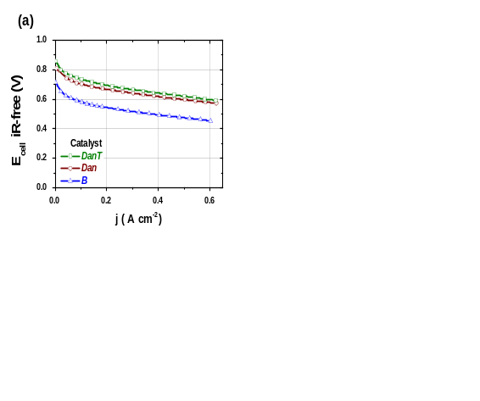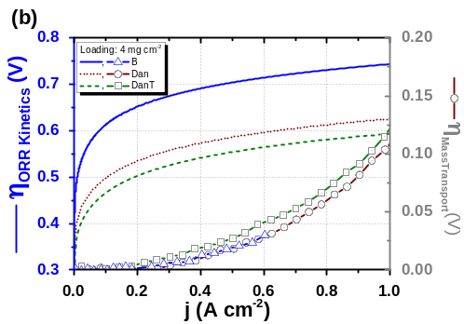
Figure 6: (a) H₂/O₂ resistance corrected area-specific polarization response of single PEFCs under galvanostatic mode employing various carbon catalysts as cathode at 4 mg cm⁻². The ionomer to carbon (I/C) ratio employed are, for catalyst B 1.0, for catalyst Dan 1.5 and for catalyst DanT 1.0; (c) Comparison of area-specific performance of catalysts B, Dan and DanT with the breakdown of cathodic overpotential and mass transport overpotentials at a loading of 4 mg cm⁻³ for all catalysts. Overpotential for ORR kinetics calculated from the fitting results to Eq 6 using the parameters in Table 1. Experimental conditions as per Fig. 2.
For instance, Figure 6(b) presents the expected area specific oxygen reduction overpotential loss (calculated using the parameters in Table 1), and mass transport loss (calculated by successive removal of the electrokinetic overpotential from the iR free results for all three catalysts at a loading of 4 mg cm⁻²) for data in Fig. 6(a).
For all three catalysts layers which have the same loading and close to the same thickness and density (See S1 for further details), mass transport losses are similar and approach 100mV at current densities of 1 A cm⁻². Of the catalyst layers, DanT has slightly higher loses, and this is correlated with the fact that it is the thickest of the catalyst layers. Furthermore, the mass transport overpotential difference between catalysts Dan and DanT is suitably corroborated by comparing the starting of a Warburg type feature seen on electrochemical impedance spectroscopy results in Fig. S4, which further and appropriately evidences that the electrokinetic model proposed in section 3.1 is suitable and guide to correct quantifications of mass transport phenomena within the cathode catalyst layer with carbon-based catalysts
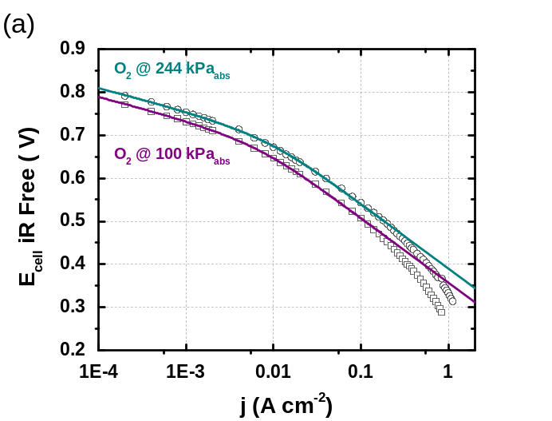
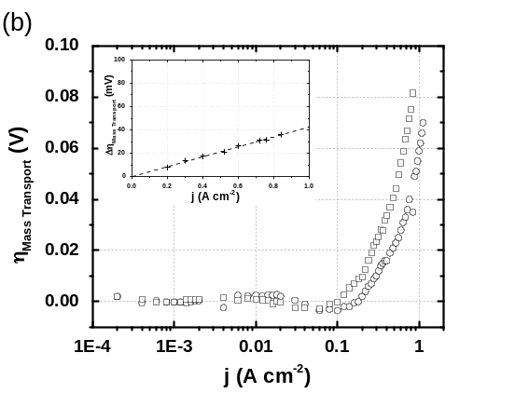
Figure 7: (a) IR-free results for catalyst B (2mg cm⁻²) as a function of oxygen partial pressure: (Square: 100 kPa_{O2}, Circle: 244 kPa_{O2}). Lines on the points represent the best fit line to Eq 6 with $α_{eff,1}$ = 1.37, $α_{eff,2}$ = 0.47, E_{transition} = 0.705 (100 kPa), 0.718 (244 kPa), and j_{transition} = 1.19 mA mg⁻¹ (100 kPa), 1.60 mA mg⁻¹ (244 kPa). (b) plot of mass transport losses for the systems studied in (a) where the mass transport loses are calculated as the difference between the data and the fitted electrokinetic curve. Inset: Mass transport difference between 100 kPa_{O2} and 244 kPa_{O2} calculated from main data. Other experimental conditions as per Fig. 2.
It is clear that the majority of the losses experienced by the catalyst layer are predominantly electrokinetic in form, especially as the systems are being operated under pure oxygen, Operating such systems under lower partial pressures of oxygen is expected to lead to significantly greater mass transport loses.
An example of this is shown in figure 7 where at lower oxygen partial pressures (e.g. 100 kPa) mass transport losses are significantly increased. Figure 7 shows the performance of an electrode composed of catalyst B (2 mg cm⁻²) under different partial pressures of oxygen. These data have been corrected for iR losses, and fitted to Equation 6 using common values of $α_{eff,1}$ and $α_{eff,2}$, but independent values of j_{transition} and E_{transition}. The $α_{eff}$ values at 1.37 and 0.47 are close to those determined for the other catalysts, Table 1. Figure 7(b) illustrates the mass transport losses for the catalyst layer in Fig. 7, determined by subtracting the experimental iR-free polarization curve (symbols in Fig. 7(a) from the extrapolated electrokinetic curve (lines in Fig. 7a). At low current densities, the voltage gain (21mV) experienced upon varying the oxygen partial pressure from 244 kPa to 100 kPa fits quite well the theoretical value (22mV) for ORR to water. However the experimental value (~36mV) at high current densities is somewhat less than that expected for oxygen reduction to H₂O₂ (54mV), suggesting that the reaction is operating in a rather complex kinetic regime, probably complicated by the autocatalytic decomposition of the hydrogen peroxide.
An Idealized Performance of ORR Carbon-based Catalyst Layers for PEFCs and other Electrochemical Systems
From the above experimental results, it is clear that that the performance of the M-C-N catalysts needs to be significantly improved in order to compete with platinum. The question to this would be “but by how much”?. Hence, it is useful to set some benchmarks as to what is required. As has been shown in Figure 1, by moving to thinner catalyst layers with higher catalyst density, the performance of fuel cells can be improved considerably. It is fruitful to consider the number of active sites which exist within the catalyst layer of a fuel cell based on Pt/C, such as the one described in Figure 1. At a loading of 0.4 mg_{Pt}cm⁻², and assuming a specific surface area of the catalyst of 90 m² g⁻¹_{Pt} (Johnson Matthey HiSPEC 9100) the number of surface platinum atoms which exist in the catalyst layer is 4.7×10¹⁷ Pt_{surf} cm⁻². If we reasonably assume that two platinum atoms are required for oxygen reduction then this corresponds to 2.4×10¹⁷ sites cm⁻² (or 2.4×10²⁰ sites cm⁻³ of catalyst layer). If we look at the performance of the catalyst layer at 0.8 V from Figure 1 we see an extrapolated performance of about 1.69 A cm⁻². This corresponds to a turnover frequency of 11 electrons site⁻¹ s⁻¹. Recently, the turnover frequency of Metal-N-C catalysts have been measured, and at 0.8 V show values of around 1.5-1.6 electrons site⁻¹ s⁻¹ – about an order of magnitude lower than that for platinum^{[5, 43]}. However, the estimated site density is relatively low, at about 0.07 ± 0.01 nm⁻² with respect to the mesopore surface area. Translating this to a volumetric site density using the typical values we have achieved with our catalyst layers provides a value of 3.1×10¹⁸ sites cm⁻³ of catalyst layer – about two orders of magnitude lower than that for the platinum catalyst layer. In order to match the site density of platinum in a fuel cell catalyst layer, we would need to simultaneously increase the site density to 1 active site per nm² and increase the mesoporous surface area to more than 500 m² g⁻¹. Both of these aspects are not unfeasible, although they might cause some problems as this number of sites would require about 4.5 wt% of iron (or other transition metal), at which concentration there would surely be phase segregation. Furthermore, to match the performance of the catalyst layer, we would then need to increase the turnover frequency on the M-N-C catalyst by about an order of magnitude.
Conclusions
The present work has studied and analyzed the performance of polymer electrolyte fuel cells utilizing representative carbon based catalysts and two distinct platinum catalysts under different conditions of oxygen partial pressure, catalyst loading and catalyst layer thickness.
Ohmic resistance corrected cell voltages versus mass-specific and geometric current densities evidence that oxygen reduction on carbon catalysts presents two distinct Tafel regions. A first Tafel region at low cell overpotentials presenting a slope of ~48 mV dec⁻¹ and a second Tafel region with a slope of ~132 mV dec⁻¹. We believe that these two regions represent a changeover from predominantly oxygen reduction to water to that in which peroxide is the main product. It is shown that the fitted electrocatalytic curves can be used to extract the mass transport loses from the fuel cell data, and these vary as one would expect when changing the oxygen partial pressure and catalyst layer thickness.
In order to match the performance of platinum catalyst layers we estimate that the intrinsic activity of the catalytic sites need to increase by about an order of magnitude, and the site density need to increase about 2-3 orders of magnitude. With these changes it would be possible to produce a catalyst layer with similar performance to those produced using platinum today.
Experimental Section
  - Catalyst Synthesis
Catalyst B was synthesized following a published method^{[4]}. In a typical route, 0.5 g of carbon black (Ketjenblack® EC-600JD) was refluxed in 200 mL of 1.0 mol dm⁻³ HCl solution at 80 °C for 8 h to remove trace metals from the carbon black. Subsequently, the carbon was vacuum filtered and washed with deionized (DI) water (18.2 MΩ cm) and dried at 80⁰C for 10 h. 200 mg of this pre-treated carbon black was weighted and dispersed in approximately 70 cm³ of absolute ethanol in a ultrasound bath. A separate beaker was utilized to dissolve, in 30 cm³ of absolute ethanol, approximately 0.0583 g of FeCl₃ (Sigma-Aldrich), 0.0629 g of Co(NO₃)₂ (Sigma-Aldrich) along with 2 cm³ of N-ethylamine (Sigma Aldrich). This solution was added to the carbon black suspension and allowed to reflux for 8 h at 80 °C. The resulting solids were filtered and washed with DI water and dried in an oven at 100°C for 8 h. The dried powders were heat-treated in a tubular oven at 900 °C under a nitrogen atmosphere for 1 h using a heating ramp of 20°C min⁻¹. Finally, the catalysts were refluxed in 100 mL of 0.5 mol dm⁻³ H₂SO₄ at 80°C for 24 h to remove residual metal. This suspension was vacuum filtered, washed with excess of DI water and dried at 80⁰C for 10 h.
Catalyst Dan was synthesized following a published method^{[6]}. In a typical route, 500mg of 1,5-Diaminonaphthalene (97% from Alfa Aesar), 500mg of (NH₄)₂S₂O₈ (98% from Sigma-Aldrich) and 1 wt% of Fe (as FeCl₂) was dissolved in 50 cm³ of ethanol (absolute from VWR). The dispersion was stirred for 24h at room temperature. The resulting mixture was heated to 80 °C in order to evaporate the solvent. When dried, the resulting residue was transferred to an alumina boat and heat treated at 1000 °C for 2h in a tube (quartz) furnace (from Carbolite) at a heating rate of 20 °C min⁻¹. This heat treatment was performed in an inert atmosphere, under a continuous flow of 50 ccm of nitrogen. After cooling under nitrogen atmosphere, the resulting material was removed from the alumina boat and refluxed in 100 cm³ of 0.5 mol dm⁻³ H₂SO₄ at 80°C for 8 h to remove residual metal. This suspension was vacuum filtered and washed with excess of DI water and dried at 80⁰C. The catalyst denoted DanT was prepared as Dan, with the addition of a 1/1 weight ratio of MgO nanopowder (5 nm, Sigma-Aldrich) to 1,5-Diaminonaphtalene in the precursor synthesis, in order to change the microstructure. The MgO support is removed during the acid leaching step.
  - RDE results
Measurements were conducted with a Rotating Ring Disk Electrode (Pine Instruments, model AFE6R1AU, with a mirror polished glassy carbon disk and rotator model AFMSRCE). To prepare the electrode, 10 mg of catalyst was dispersed ultrasonically into 1 mL of ethanol, 0.9 mL of H₂O and 0.1 mL of 5 wt% Nafion solution (Sigma-Aldrich). The respective amount of ink was drop coated onto the disk of the RRDE tip which was mounted upside down onto the rotator. While drying, the rotator was set to 700 rpm thus obtaining a uniform catalyst distribution across the electrode surface. The disk electrode was scanned cathodically at a rate of 1 mVs⁻¹ and the ring potential was set constant at 1.5 V vs RHE.
  - Membrane Electrode Assembly Preparation, PEFC Test Conditions and Data Fitting
Membrane Electrode Assemblies (MEA) were prepared using a method developed by Paganin et al. ^{[31]}. Briefly, considering the desired ionomer to carbon ration (I/C, specified in figure captions), the desired amount of catalyst was mixed with Nafion™ ionomer solution (Aldrich, 5 wt.%, 1050EW) in 1.5 cm³ of isopropanol (IPA). For Pt/C catalyst from E-Tek, the lot number was 0820623 with a platinum loading of 20.3 wt%. The solution of catalyst, NafionTM ionomer and IPA was homogenized in an ultrasonic bath for 15 min, followed by complete evaporation of the solvents at room temperature. The dried solids were dissolved in isopropanol and quantitatively deposited on a gas transport medium (Toray paper TGP 60 with microporous layer, Alfa Aesar). As anode electrodes, commercial Johnson Matthey platinum electrodes were utilized (platinum loading of 0.4 mg_{Pt} cm⁻², from Alfa Aesar). The membrane and electrode assemblies (MEAs) were obtained by hot-pressing anode and cathode electrodes on both sides of a pre-treated Nafion™ membrane (H⁺, DuPont) at 145°C and 400 kg cm⁻², for 3 min. Nafion™ 115 was used in MEAs for carbon-catalyst containing cathodes and Nafion™ NR212 was used for Pt/C containing cathodes. A thicker Nafion™ 115 membrane was deliberately chosen rather than thinner Nafion™ membranes (211) in order to categorically avoid any Pt crossover from the anode. Single PEFC tests were performed using 5 cm² electrode area and single serpentine flow fields (PEFC hardware from Fuel Cell Technologies, Inc.). During PEFCs tests, the cell hardware was maintained at 80 ⁰C and humidification water bottles temperature were maintained at 80 ⁰C (80 ⁰C dew points) for MEAs with NR212 membranes and at 95 ⁰C_{anode} and 85 ⁰C_{cathode} for MEAs with N115 membranes. During PEFC tests pure hydrogen (White Martins, 99.999) at a flow rate of 160 ccm and pure oxygen (White Martins, 99.999) at a flow rate of 550 ccm were utilized. It is noteworthy noting that 550 ccm O₂ was chosen given that below 450 ccm the catalyst layer is not completely utilized due to an improper distribution of oxygen^{[44]}. Anode and cathode operated at a gauge backpressure of ~210/210 kPa (H₂ and O₂ partial pressure at approximately 217 kPa_{abs} and 244 kPa_{abs} taking into account water vapour) or ~65/65 kPa (H₂ and O₂ partial pressure at approximately 100 kPa_{abs} taking into account water vapour), where the ambient pressure was ~91 kPa. PEFCs activation and polarization curves were performed under galvanostatic mode with a fuel cell test station from Fuel Cell Technologies, Inc. Polarization curves was also carried out with a galvanostat, Autolab model 302N, with results in agreement with experiments performed using the fuel cell test station. The dwell time at each current density prior to recording the cell voltage was either 60s for current densities below 5 mA cm⁻² or 10 seconds for the remaining window based on a potential change of less than 1 mV after the respective waiting time, measure during preliminary chronoamperometry experiments.
Hydrogen crossover from the anode to the cathode occurs in a PEFC due to the low, however finite, solubility and diffusivity of H₂ in NafionTM. Upon crossing to the cathodic compartment, H₂ can be oxidized on an active electrode, e.g. Pt. This process generates a parasitic current, which is generally referred to as hydrogen crossover current density. This was determined experimentally by purging the cathode compartment with argon and polarizing the cathode at 0.4 V vs the anode using a potentiostat, while the anode was purged with hydrogen. At this potential, the resulting hydrogen oxidation current is purely limited by the H₂ permeation rate. Backpressures and gas flow rates were as in the experiments under fuel cell mode. For PEFC tests where platinum catalyst was utilized as cathode, the effective current density (j_{eff}) reported refers to H₂-crossover corrected current densities (j_{eff} = j + j_{Hydrogen crossover}); where the later was measured to be 0.8 mA cm⁻² for NR212 membranes). It is noteworthy that carbon catalysts are inactive towards the hydrogen oxidation reaction, therefore PEFCs employing this catalysts as cathode did not have current densities corrected for hydrogen crossover.
Electrochemical Impedance spectroscopy (EIS) experiments were carried out using the aforementioned potentiostat. These experiments were carried out under galvanostatic mode, with current densities selected which would produce cell potentials (without iR corrections) of 0.600 V, 0.470 V, 0.400 V and 0.200 V for carbon catalyst based PEFCs and of 0.900 V, 0.850 V, 0.800V, 0.750 V, 0.700V, 0.650 V and 0.600 V for platinum catalyst based PEFCs. An AC perturbation was superimposed on top of this DC current, as 5% of the DC current magnitude. Meticulous care was taken to reduce the effect of cable inductance^{[35]}. Cells were conditioned at the desired DC current for 60 s prior to EIS experiments. Linearity of the current/potential response was verified for every measurement. Towards ensuring proper signal to noise ratio, every data point was collected for 5 integration cycles with an integration time of 0.125 s per cycle. To further ensure validity of the collected data, collection was performed from high to low frequency, and from low to high frequency, for selected cells with several hours of operation in between. No significant deviation was detected. Data were checked for Kramers-Kronig conformity according to an improved method developed by Schoenleber et al. ^{[45-46]}. No drift in the spectra is detected. EIS spectra were analysed and fitted with the use of the software ZViewTM (Scribner Associates, Inc.). Fitting was carried out utilizing an equivalent circuit composed of a resistor in series with a Transmission Line-Open Circuit Terminus, this last component representing the catalyst layer and the former the high frequency resistance (the sum of the RH dependent membrane resistance and RH independent electronic and bulk resistances).
Multi-parameter fits of performance curves (iR-free) were performed in Excel utilising the GRG nonlinear solver module to simultaneously fit multiple datasets using equation 6.
  - BET Measurements
BET analyses were carried out in a Micromeritics TriStar 3000 surface area and porosity analyser. The adsorbent was N₂ at a temperature 77.2 K. The Rouquerol method was used to determine the best region for the linear fit. The molecular cross sectional area for nitrogen used was 0.1620 nm². The BJH method was used for determining the pore size distribution from the desorption branch of the isotherm. BET measurements for the three catalysts studied are shown in Table 2.
Table 2: BET surface area, pore analysis and median pore width of studied carbon catalysts.
 |  | Catalyst
 |  | B | Dan | DanT
BET Surface Area | (m² g⁻¹) | 789 | 478 | 1249
Micropore Area | (m² g⁻¹) | 393 | 362 | 679
Mesopore Area | (m² g⁻¹) | 398 | 53 | 285
Micropore Volume | (cm⁻³ g⁻¹) | 0.11 | 0.14 | 0.21
Mesopore Volume | (cm⁻³ g⁻¹) | 0.7 | 0.13 | 0.67
Median Pore Width* | (Å) | 24.8 | 25 | 23.4
Acknowledgements
TL and EAT thank the Brazilian funding agency CNPq (process # 150249/2014-4) for TL postdoc fellowship. Authors also thank the following funding agencies for financing this work, FAPESP (process # 13/16930-7), Global Engagement Scheme of Imperial College London (collaboration building grant scheme) and the Engineering and Physical Sciences Council (EPSRC) under grant EP/J016454/1.
TL, EAT and AK supervised the project. ARK supervised DM and TL co-supervised DM. TL and DM worked out the concepts and DM synthesized the carbon catalyst. TL and DM carried out single PEFC and EIS experiments. TL and DM carried out XRD analysis and DM the various other physical characterizations. TL and DM contributed to data analysis and interpretation. TL prepared and DM revised the manuscript. AK developed the electrokinetic models to explain the data and did all the data fitting and manipulation. EAT and ARK contributed to further data interpretation and manuscript finalization. The data used to generate the figures in this paper is available at the following DOI:[DOI to be added at proofing stage]..
Keywords: : Oxygen Reduction • Carbon Catalysts • Fuel Cell • Electrocatalysis

[1] Z. Chen, J.-P. Dodelet, J. Zhang, Non-Noble Metal Fuel Cell Catalysts., Wiley-VCH Verlag GmbH & Co. KGaA, 2014.
[2] H. A. Gasteiger, S. S. Kocha, B. Sompalli, F. T. Wagner, Applied Catalysis B: Environmental 2005, 56, 9-35.
[3] N. M. Markovic, Nat Mater 2013, 12, 101-102.
[4] T. Lopes, P. Olivi, Electrocatalysis 2014, 5, 396-401.
[5] D. Malko, T. Lopes, A. Kucernak, Submitted 2016.
[6] D. Malko, T. Lopes, E. Symianakis, A. R. Kucernak, Journal of Materials Chemistry A 2016, 4, 142-152.
[7] D. J. L. Brett, A. R. Kucernak, P. Aguiar, S. C. Atkins, N. P. Brandon, R. Clague, L. F. Cohen, G. Hinds, C. Kalyvas, G. J. Offer, B. Ladewig, R. Maher, A. Marquis, P. Shearing, N. Vasileiadis, V. Vesovic, Chemphyschem 2010, 11, 2714-2731.
[8] X. Cheng, Z. Shi, N. Glass, L. Zhang, J. Zhang, D. Song, Z.-S. Liu, H. Wang, J. Shen, Journal of Power Sources 2007, 165, 739-756.
[9] N. Zamel, X. Li, Progress in Energy and Combustion Science 2011, 37, 292-329.
[10] T. Lopes, V. A. Paganin, E. R. Gonzalez, Journal of Power Sources 2011, 196, 6256-6263.
[11] F. H. Garzon, T. Lopes, T. Rockward, J.-M. Sansinena, B. Kienitz, R. Mukundan, T. Springer, in Proton Exchange Membrane Fuel Cells 9, Vol. 25 (Eds.: T. Fuller, H. Uchida, P. Strasser, P. Shirvanian, C. Lamy, C. Hartnig, H. A. Gasteiger, T. Zawodzinski, T. Jarvi, P. Bele, V. Ramani, S. Cleghorn, D. Jones, P. Zelenay), 2009, pp. 1575-1583.
[12] J. Chlistunoff, Journal of Physical Chemistry C 2011, 115, 6496-6507.
[13] F. Jaouen, J.-P. Dodelet, Journal of Physical Chemistry C 2009, 113, 15422-15432.
[14] F. Jaouen, in Non-Noble Metal Fuel Cell Catalysts (Eds.: Z. Chen, J.-P. Dodelet, J. Z. Dodelet), Wiley-VCH Verlag GmbH & Co. KGaA, 2014, pp. 29-118.
[15] D. Singh, K. Mamtani, C. R. Bruening, J. T. Miller, U. S. Ozkan, Acs Catalysis 2014, 4, 3454-3462.
[16] R. Kothandaraman, V. Nallathambi, K. Artyushkova, S. C. Barton, Applied Catalysis B-Environmental 2009, 92, 209-216.
[17] K. H. Lim, H. Kim, Applied Catalysis B-Environmental 2014, 158, 355-360.
[18] H.-J. Zhang, H. Li, X. Li, S. Zheng, B. Zhao, J. Yang, Applied Catalysis B-Environmental 2014, 160, 676-683.
[19] J. Qiao, L. Xu, L. Ding, L. Zhang, R. Baker, X. Dai, J. Zhang, Applied Catalysis B-Environmental 2012, 125, 197-205.
[20] M. Markiewicz, C. Zalitis, A. Kucernak, Electrochimica Acta 2015, 179, 126-136.
[21] J.-P. Dodelet, in Electrocatalysis in Fuel Cells (Ed.: M. Shao), Springer London, 2013, pp. 271-338.
[22] J. Herranz, M. Lefevre, N. Larouche, B. Stansfield, J.-P. Dodelet, Journal of Physical Chemistry C 2007, 111, 19033-19042.
[23] G. Wu, K. L. More, C. M. Johnston, P. Zelenay, Science 2011, 332, 443-447.
[24] K. Strickland, E. Miner, Q. Jia, U. Tylus, N. Ramaswamy, W. Liang, M.-T. Sougrati, F. Jaouen, S. Mukerjee, Nature Communications 2015, 6.
[25] M. Lefevre, E. Proietti, F. Jaouen, J.-P. Dodelet, Science 2009, 324, 71-74.
[26] H. A. Gasteiger, N. M. Markovic, Science 2009, 324, 48-49.
[27] P. Zelenay, G. Wu, (Ed.: USA), 2014.
[28] E. Proietti, F. Jaouen, M. Lefevre, N. Larouche, J. Tian, J. Herranz, J.-P. Dodelet, Nature Communications 2011, 2.
[29] J. Y. Cheon, T. Kim, Y. Choi, H. Y. Jeong, M. G. Kim, Y. J. Sa, J. Kim, Z. Lee, T.-H. Yang, K. Kwon, O. Terasaki, G.-G. Park, R. R. Adzic, S. H. Joo, Scientific Reports 2013, 3.
[30] H. T. Chung, J. H. Won, P. Zelenay, Nature Communications 2013, 4.
[31] V. A. Paganin, E. A. Ticianelli, E. R. Gonzalez, Journal of Applied Electrochemistry 1996, 26, 297-304.
[32] T. Lopes, D. S. Kim, Y. S. Kim, F. H. Garzon, Journal of the Electrochemical Society 2012, 159, B265-B269.
[33] T. Lopes, J.-M. Sansinena, R. Mukundan, D. S. Hussey, D. L. Jacobson, F. H. Garzon, Journal of the Electrochemical Society 2014, 161, F703-F709.
[34] T. E. Springer, T. A. Zawodzinski, M. S. Wilson, S. Gottesfeld, Journal of the Electrochemical Society 1996, 143, 587-599.
[35] R. Makharia, M. F. Mathias, D. R. Baker, Journal of The Electrochemical Society 2005, 152, A970-A977.
[36] M. Eikerling, A. A. Kornyshev, Journal of Electroanalytical Chemistry 1999, 475, 107-123.
[37] D. Sebastian, V. Baglio, A. S. Arico, A. Serov, P. Atanassov, Applied Catalysis B-Environmental 2016, 182, 297-305.
[38] D. Malko, T. Lopes, E. A. Ticianelli, A. Kucernak, Journal of Power Sources 2016, 323, 189-200.
[39] A. Bonakdarpour, M. Lefevre, R. Yang, F. Jaouen, T. Dahn, J.-P. Dodelet, J. R. Dahn, Electrochemical and Solid State Letters 2008, 11, B105-B108.
[40] N. D. Leonard, S. C. Barton, Journal of the Electrochemical Society 2014, 161, H3100-H3105.
[41] A. J. Bard, R. Parsons, J. J., Standard Potentials in Aqueous Solution, Marcel Dekker, New York 1985.
[42] A. R. Kucernak, C. Zalitis, The Journal of Physical Chemistry C 2016, 120, 10721-10745.
[43] N. R. Sahraie, U. I. Kramm, J. Steinberg, Y. Zhang, A. Thomas, T. Reier, J.-P. Paraknowitsch, P. Strasser, Nature Communications 2015, 6.
[44] T. Lopes, M. Ho, B. K. Kakati, A. R. J. Kucernak, Journal of Power Sources 2015, 274, 382-392.
[45] M. Schönleber, D. Klotz, E. Ivers-Tiffée, Electrochimica Acta 2014, 131, 20-27.
[46] M. Schönleber, E. Ivers-Tiffée, Electrochemistry Communications 2015, 58, 15-19.

Entry for the Table of Contents (Please choose one layout)

ARTICLE
Can carbon based catalysts replace platinum in fuel cells? Mechanistic insights into the oxygen reduction reaction points the way forward to the improvements required to equal the performance of platinum based catalyst layers in fuel cells.  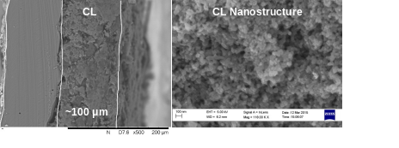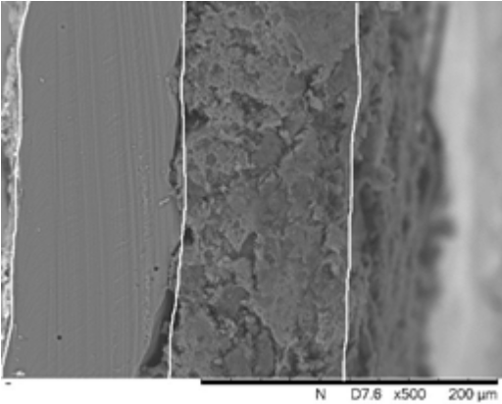 |  | Thiago Lopes, Anthony Kucernak*, Daniel Malko and Edson A. Ticianelli  Page No. – Page No.  Mechanistic insights into the ORR on M–N–C electrocatalysts under fuel cell conditions

