Supplementary Information
Nanoceria provides antioxidant and osteogenic properties to mesoporous silica nanoparticles for osteoporosis treatment.
Alessandra Pinna,^{a*} Mohammad Torki Baghbaderani, ª Victoria Vigil Hernández, ª Parichart Naruphontjirakul,^{b} Siwei Li, ª Taneisha McFarlane, ª Daniel Hachim, ª Molly M. Stevens,^{a,c,d} Alexandra E, Porter,ª Julian R. Jones ^{a*}
ª Department of Materials, Imperial College London, South Kensington Campus, London, SW72AZ, UK.
^{b} Biological Engineering Program, King Mongkut’s University of Technology Thonburi, Thailand
^{c} Department of Bioengineering, Imperial College London, South Kensington Campus, London, SW7 2AZ, UK
^{d} Institute of Biomedical Engineering, Imperial College London, South Kensington Campus, London, SW7 2AZ, UK
Corresponding author: a.pinna@imperial.ac.uk; julian.r.jones@imperial.ac.uk

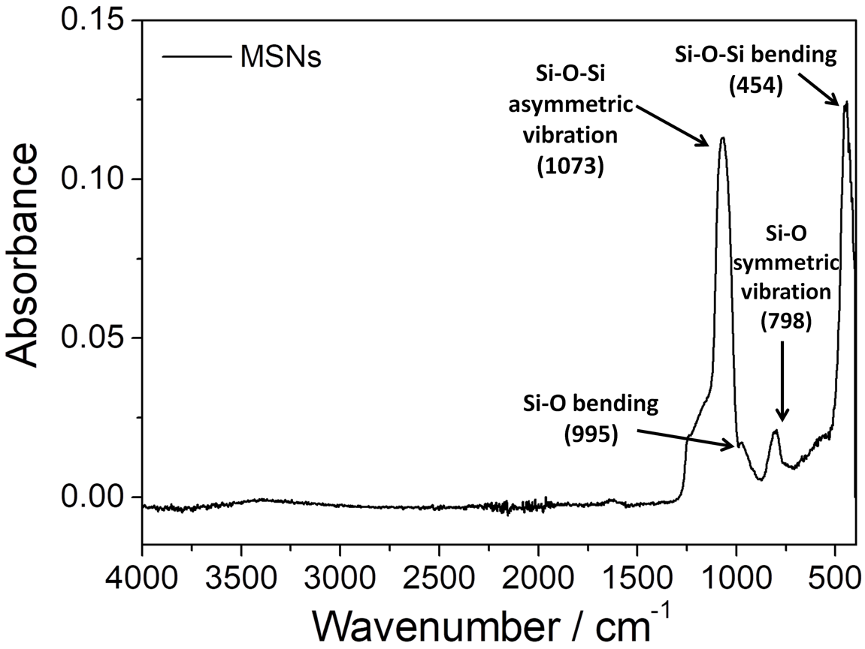
Fig. S1 FTIR spectrum of MSNs after thermal treatment at 550 °C for 6 hours.
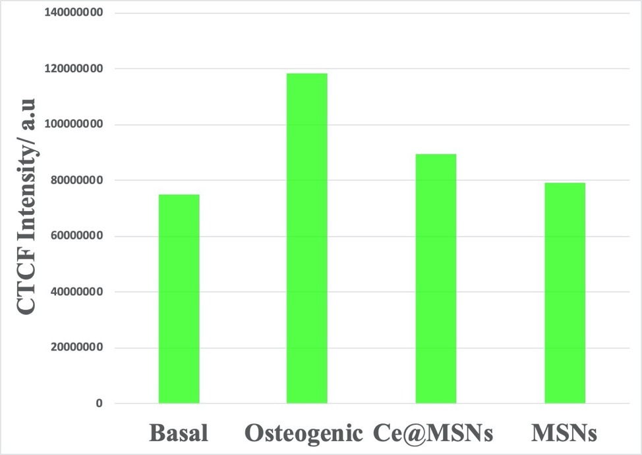
Fig. S2 Total cell fluorescence (CTCF) quantification of the images related to Collagen Type I (Fig.6c), of MC3T3-E1 cells in basal and osteogenic conditions and in basal media containing 100 μg mL⁻¹ of MSNs and Ce@MSNs. ImageJ software was used for CTCF analysis.

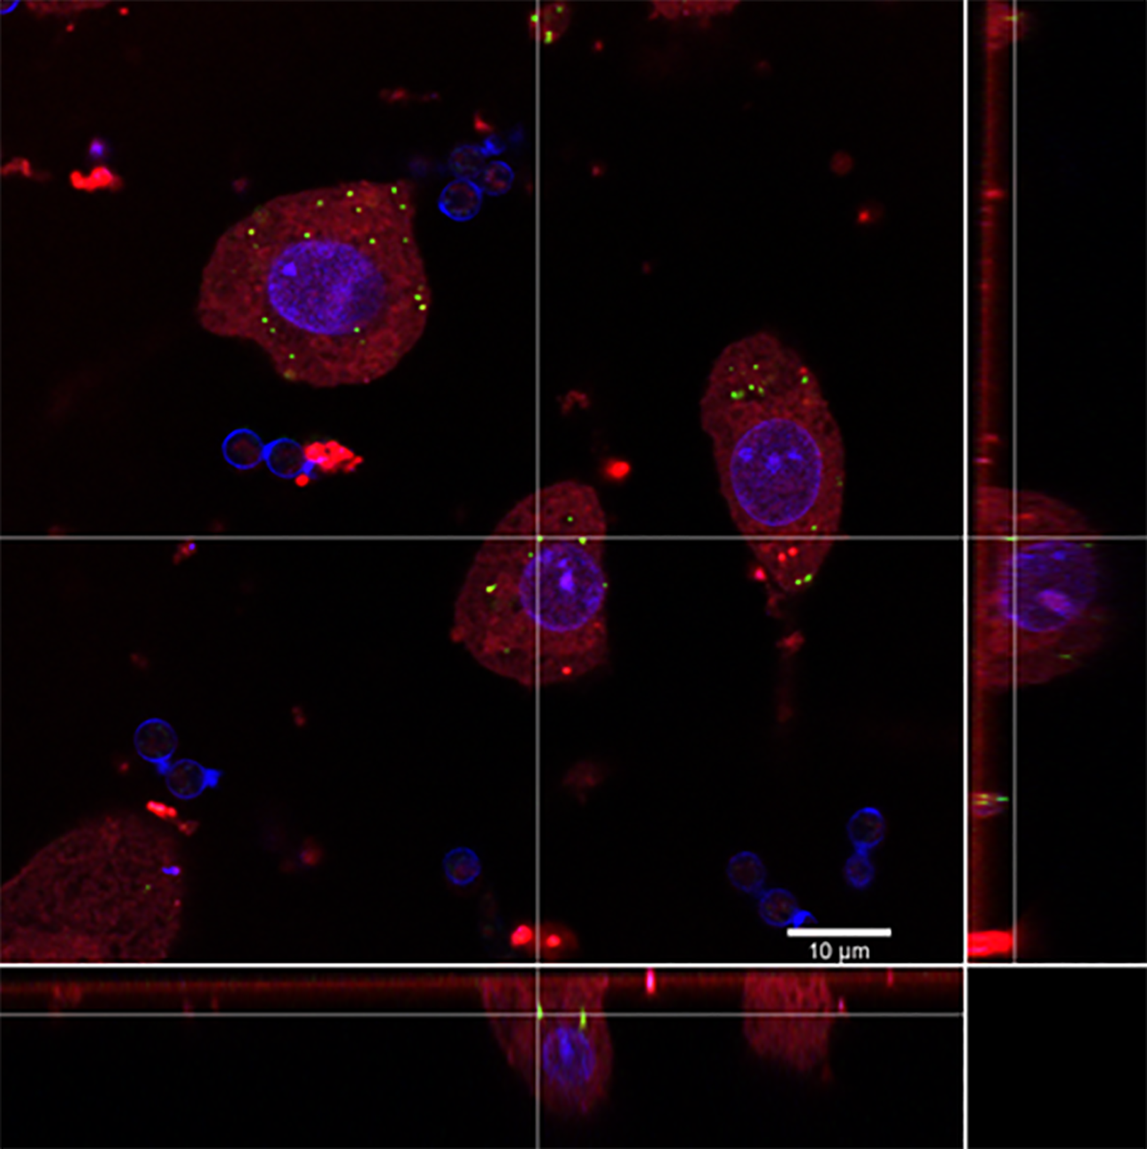

Fig. S3 3D rendering through side projections of confocal Z-stack confirming FITC-Ce@MSNs (green spots) internalization in Raw264 cells.

