Force ﬁelds for coarse-grained molecular simulations from a corresponding states correlation
Andrés Mejía ª, Carmelo Herdes ^{b}, Erich A. Müller ^{b} *

ª Departamento de Ingeniería Química, Universidad de Concepción, Chile.
^{b} Department of Chemical Engineering, Imperial College London, U. K.
* corresponding author , E-mail: e.muller@imperial.ac.uk

ABSTRACT

We present a corresponding states correlation based on the description of fluid phase properties by means of a Mie intermolecular potential applied to tangentially-bonded spheres. The macroscopic properties of this model fluid are very accurately represented by a recently proposed version of the statistical associating fluid theory (the SAFT-γ version). The Mie potential can be expressed in a conformal manner in terms of three parameters that relate to a length scale, σ, an energy scale, ε, and the range or functional form of the potential, λ, while the non-sphericity or elongation of a molecule can be appropriately described by the chain length, m. For a given chain length, correlations are given to scale the SAFT equation of state in terms of three experimental parameters: the acentric factor, the critical temperature and the saturated liquid density at a reduced temperature of 0.7. The molecular nature of the equation of state is exploited to make a direct link between the macroscopic thermodynamic parameters used to characterize the equation of state and the parameters of the underlying Mie potential. This direct link between macroscopic properties and molecular parameters is the basis to propose a top-down method to parametrize force fields that can be used in the coarse grained molecular modelling (Monte Carlo or molecular dynamics) of fluids. The resulting correlation is of quantitative accuracy and examples of the prediction of simulations of vapour-liquid equilibria and interfacial tensions are given. In essence, we present a recipe that allows one to obtain intermolecular potentials for use in the molecular simulation of simple and chain fluids from macroscopic experimentally determined constants, namely the acentric factor, the critical temperature and a liquid density.

Keywords SAFT, intermolecular potentials, parameters, fluids, coarse graining, multiscale modelling

1. Introduction

The corresponding states principle stems from the empirical observation that the behaviour of most common fluids may be described in a generalized way if the variables that describe their thermodynamic states are scaled accordingly. Much in the same way as Leonardo da Vinci’s Vitruvian Man exemplified a canon of proportions for the human body, the corresponding states principle was originally derived as a heuristic relationship which allowed the mapping of volumetric properties of fluids into unique generalized graphs and equations.

There is a myriad of empirical and semi-theoretical approaches that apply the corresponding state principle,. In engineering, most are based on the use of the critical properties of the vapor-liquid transition, e.g. the critical pressure, P_{c}, the critical temperature, T_{c}, the critical density, ρ_{c ;} or some combination thereof, e.g. the critical compressibility factor, Z_{c.} A prototypical example championed originally by van der Waals , is that based on his equation of state (EoS)

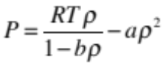 (1)

Where P is the pressure, T is the temperature, ρ the density and R the ideal gas constant. The two additional constants, the co-volume, b, and the cohesion factor, a, may be determined by forcing the equation to pass through the critical point and the critical isotherm to have an inflexion point at the critical point. By doing this both constants become unique and defined in terms of the critical point itself,

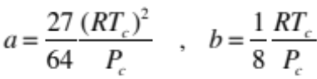 (2)

One can see from that above, that the fluid phase behaviour is completely specified by the fixing any pair of critical constants (although T_{c} and P_{c} are usually chosen). The previous approach to the description of volumetric properties is frequently referred to as a two-parameter corresponding states model in reference to the characteristic scales employed to non-dimensionalize the relations.

Derivations of the van der Waals EoS based on statistical thermodynamics , illustrate how one may establish a relation between the EoS and an underlying Sutherland pair potential, where molecules are described as hard core spheres with a central attractive potential which decays as – ε(σ/r)⁶ , r being the interparticle distance, ε the minimum energy well depth and σ the hard sphere diameter. It can be shown that the two constants in the van der Waals treatment may then alternatively related to intermolecular potential parameters,

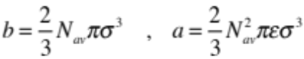 (3)

where N_{av} is Avogadro’s number. Comparing equations (2) and (3) one can immediately establish a link between the macroscopic description of fluids through an EoS and the molecular description, which relates these parameters to intermolecular size and energy parameters. Unfortunately, in order to derive a closed-form analytical expression for the macroscopic thermodynamic properties from the potential, some approximations (e.g., additivity of excluded volumes, a mean-field treatment of the attractive contribution) must be made, which decouple the correspondence between the EoS to the precise form of the underlying microscopic model, i.e., the van der Waals EoS would not be able to model accurately a fluid that behaves following the Sutherland potential. Furthermore, neither the van der Waals equation nor the related potential are accurate enough for our current requests for the fitting of experimental data.

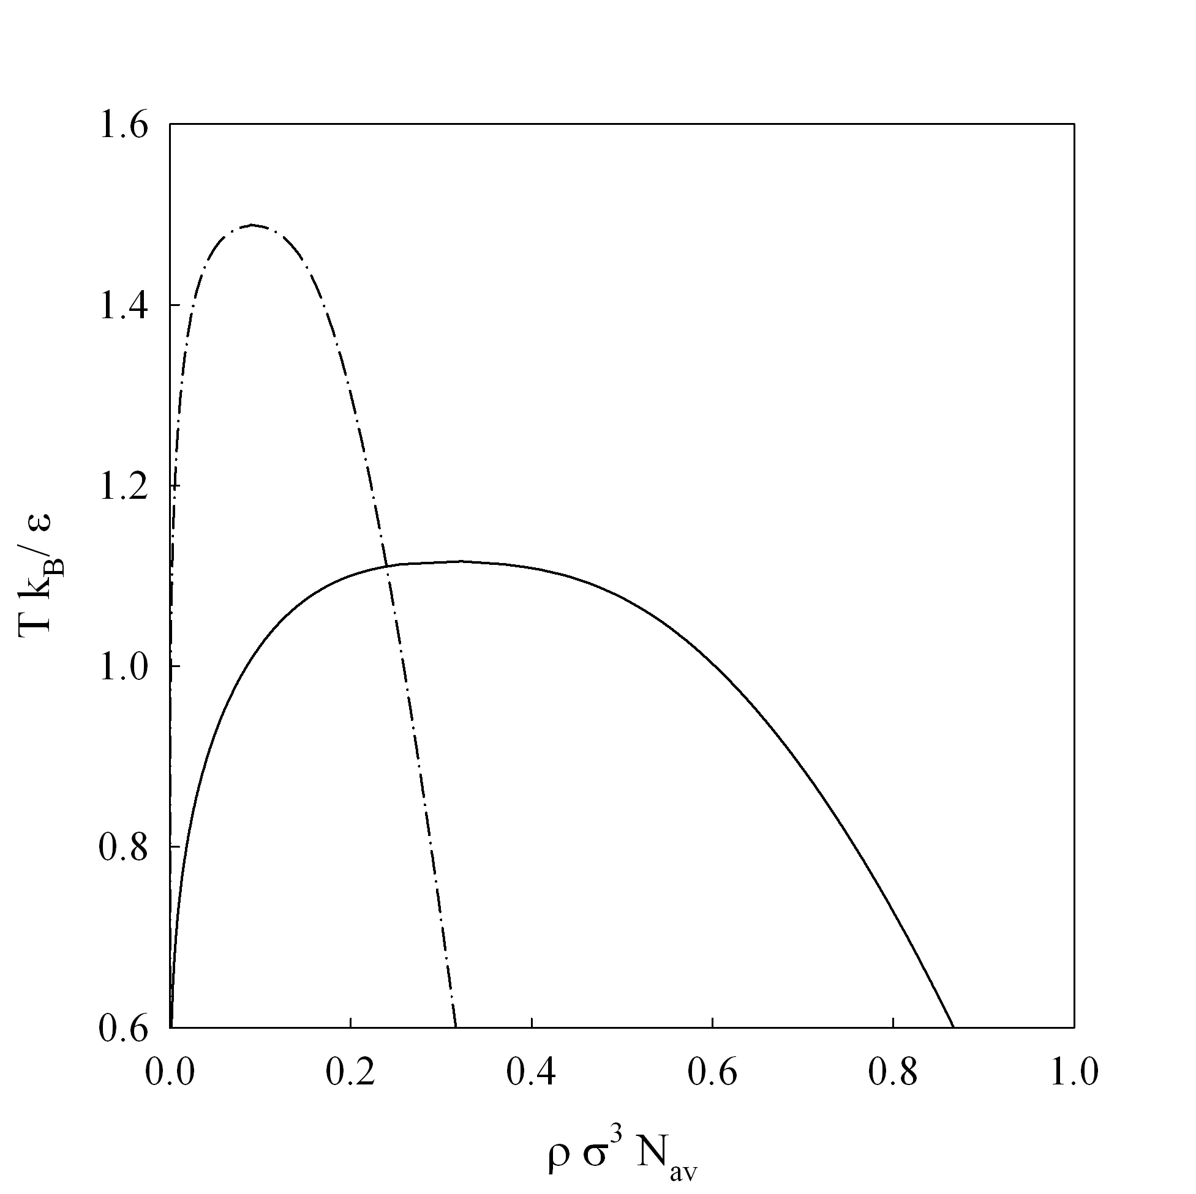

Figure 1 : Temperature, T – density, ρ, phase diagram of an attractive sphere (solid line) and the corresponding trimer (dashed-dotted) oligomer formed by spheres of the same type.

A more complicated scenario arises if one is willing to recognize that the non-sphericity, particularly in the context of elongated and chain-like fluids, has a profound effect on the vapor-liquid equilibria. Figure 1 shows the corresponding temperature-density plot of a fluid of spheres, as compared to a fluid composed of a chain of three linear tangentially joined spheres (an oligomer of the latter). It is apparent how elongation of a molecule increases the critical temperature, decreases the number density and changes the slope of the vapor-pressure curve (not shown). It is clear that these two fluids (the monomer and the chain) cannot be conformal, i.e. do not obey a two-parameter corresponding principle in the terms stated above, i.e. they cannot be described with the a unique intermolecular potential having only two scales, (in this case σ and ε) . This restriction on conformality was recognized decades ago; the most salient example of this was the Soave modification of the van der Waals model. Upon using a cubic EoS to attempt to fit the n-alkane series, Soave recognized the above behaviour and included in his equation of state an additional parameter that could, in principle, account for this. The third parameter (along with the previous ones, T_{c} and P_{c}) was Pitzer’s acentric factor, ω, defined as

(4)

The acentric factor is an empirical constant, based on the observation that for the heavier noble gases, the base 10 logarithm of the ratio of the saturation pressure to the critical pressure at a given point of the vapour pressure curve (T/T_{c} = 0.7) is numerically equal to (-1). The acentric factor of noble gases is by construction equal to zero, and for most simple fluids is a small positive number that quantifies the deviation of the slope of the vapor pressure curve from that of the “idealized” spherical fluid. As a fortunate aside, it happens that other deviations from the simple dispersion model found in a noble gas: polarity, polarizability, hydrogen bonding, non-sphericity; all contribute to the change in slope of the vapor pressure curve in the same fashion, hence a single parameter may be used to fit all the previously mentioned non-conformalities.

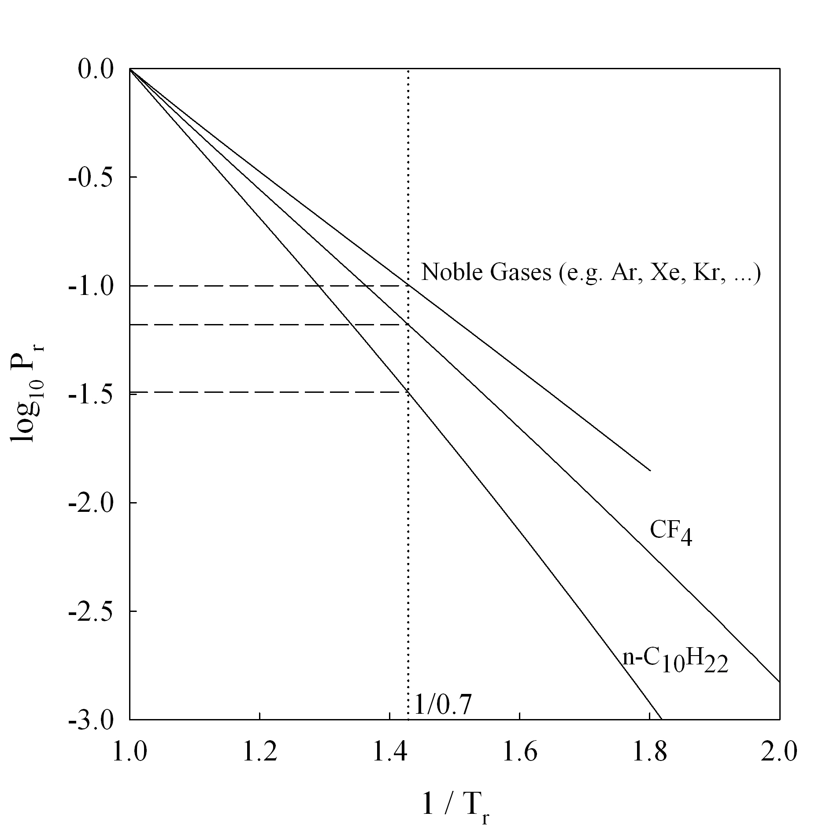

Figure 2 Effect of intermolecular interactions on the slope of the vapor pressure curve. The ordinate corresponds to the base 10 log of the ratio of the vapor pressure to the critical point (corresponding to -1-ω ). For the noble gases this takes on the value of zero, and becomes larger as the interaction deviates either because of non-sphericity (e.g. n-C₁₀H₂₂) and/or as a consequence of deviations from simple dispersive interactions (e.g. CF₄)

The three-parameter corresponding states (3PCS) correlation based on the inclusion of the acentric factor, e.g. using variables such as T_{c} , P_{c} and ω for describing the universality of fluid behaviour, has become a staple of chemical and process engineering. Notwithstanding its success, the grouping of all deviations from simple spherical molecules in a single parameter such as the acentric factor, fails to distinguish between the effects mainly attributable to size asymmetry and those related to the range of the intermolecular potential. Empirical attempts to separate these effects lead to four-parameter corresponding states correlations, and the reader is referred to standard textbooks , , , for reviews of such approaches.

In the rest of this communication we present an advance in the state of the art of the above described scenario; we start off with an intermolecular potential of the Mie form which has sufficient flexibility to take into account differences in the softness (range) of the force field experienced between two spherical particles. We recognize that there exists an accurate description of fluids composed of Mie spheres and chains composed of tangent Mie sphere in the form of a closed form molecular equation of state. In the third section we formulate said EoS as a four parameter corresponding state correlation (4PCS) that retains the direct coupling to an intermolecular potential. In the final sections we note how this particular 4PCS may be used to bridge the gap between experimental data and force fields. The aim is to develop a simple recipe that can be employed to extract intermolecular potentials for use in the molecular simulation of simple and chain fluids from a few macroscopic experimentally determined constants.

2. Conformality and the Mie potential

In spite of the success of the 3PCS correlations, as exemplified by the deluge of modern cubic EoS available, the direct connection between said EoS and the intermolecular potential is, in most of the published reports, lost. On a speculative note, the difficulty in establishing a connection between a predetermined Hamiltonian function and a theory that accurately describes it has probably severed the link between molecular simulation and experiments. On the other hand, the simulation community itself has adopted the use of increasingly more complex analytical expressions to improve on the Sutherland (and similar) potentials. A widely used intermolecular potential being the Lennard-Jones (LJ) potential, φ_{LJ}.

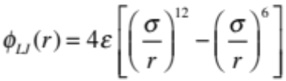 (5)

The evaluation of the parameters ( σ, ε) is in most cases done by trial and error fitting to simulations that describe either some aspect of the molecular structure, such as a radial distribution function or via a macroscopic observable such as virial coefficients, densities, etc. The LJ model can be understood as a sum of a repulsion term, the first term in the right hand side of Eq (5), and an attraction term (the latter term). The form of the attractive term has a basis on the London theory of dispersion and is accepted as a mathematical closed form description of the average dispersion forces for a simple atom. In contrast, the form, and most importantly the choice of exponent, of the repulsive term has a much more tenuous link to theory. It was chosen, in an era of manual calculations to be of the same functional form and happening to be the square of the attractive exponent, providing both analytical and computational advantages. The LJ potential, not only does not have the flexibility to be the basis of a 3PCS model, it has a more systemic flaw in the choice of the repulsive (12) exponent. Curiously enough, Lennard-Jones (née Jones) himself was aware of the empiricism behind this choice and championed other repulsive exponents, spanning from 13¹/₃ to 24 to describe the interaction between argon atoms. If one employs modern terminology, one recognizes that the acentric factor for the LJ fluid is close to -0.02, a small but significant departure from the noble gas behaviour. It is clear from the above that the LJ fluid is ill-suited as the basis of corresponding states correlations for simple fluids. We suggest herein the use of the Mie potential , , , also known as the (m,n) potential, a generalized form of the LJ potential (albeit predating it by decades)

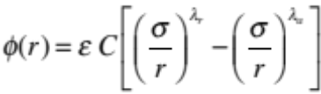 (6a)

where

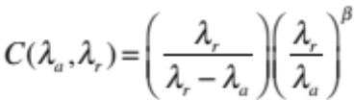 with 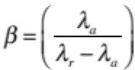 (6b)

The Mie function, as written above, deceivingly suggests that four parameters are needed to characterize the behaviour of a fluid, however the exponents are intimately related. This can be shown by calculating the unweighted volume average of the attractive contribution of the intermolecular potential, a₁. Assuming pairwise additivity,

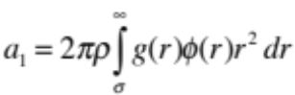 (7)

where g(r) is the radial distribution function. If one further assumes a mean field approximation, whereas the fluid is locally uniformly distributed, g(r) = 1, and upon substituting the Mie function, eq. (6) into the integral in (7), the latter can be solved analytically. The result may be condensed into an expression function of density and temperature and three parameters, ε, σ and most importantly, α, the van der Waals constant,

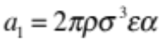 (8)

The latter is a term depending exclusively on the Mie exponents

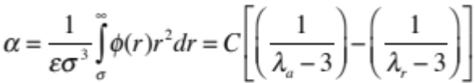 (9)

It can be shown that at the same temperature and density, two fluids sharing the same values of the parameters ( σ, ε) will have the same properties ( to the point in which their free energies are equal) if they share a value of the van der Waals constant, α. In other words, the equality of the van de Waals constant amongst the Mie fluids can actually be taken as a measure of the conformality of the fluid . The conformality hinted above is not exact as it pertains only to a mean field approximation of the fluid and is based on an underlying assumption that the particles do not interrogate the repulsive region of the potential (distances smaller than r = σ). The approach described should not be used to consider solid phases or even the precise location of the triple point. Figure 3 exemplifies these points and shows the extent of the conformality of the Mie potentials for the fluid phase. The phase diagrams of potentials which share the same size and energy parameters ( σ, ε) are plotted; one of them, a LJ (12-6) and one, a (14-7) which retains the ratio of attractive vs repulsive exponents q = λ_{r} / λ_{a} are compared. Clearly this ratio is not a good measure of conformality. If on the other hand one imposes the constraint that the van der Waals parameter, α, be maintained equal to the LJ value for a repulsive exponent of λ_{a} = 7, an alternative potential (9.159-7) is obtained, which follows closely the behaviour of the LJ potential.

Th conformality of Mie potentials described above implies that an infinite number of pairs (λ_{a} - λ_{r}) can be chosen, all sharing the same macroscopic properties, as long as they give the same integrated value of α. Since both λ_{a} and λ_{r} can be varied, we choose herein an attractive exponent of λ_{a} = 6 which would be expected to be representative of most simple fluids and would have a more solid theoretical background. We drop the subscripts on the exponents of the Mie potential, understanding that henceforth λ = λ_{r} and λ_{a} = 6. The resulting potential can be used as the basis of a 3PCS model, with ( σ, ε, λ) as parameters, e.g. a size, energy and fluid-dependent non-dimensional parameter; otherwise, the potential may be expressed in terms of ( σ, ε, α ).

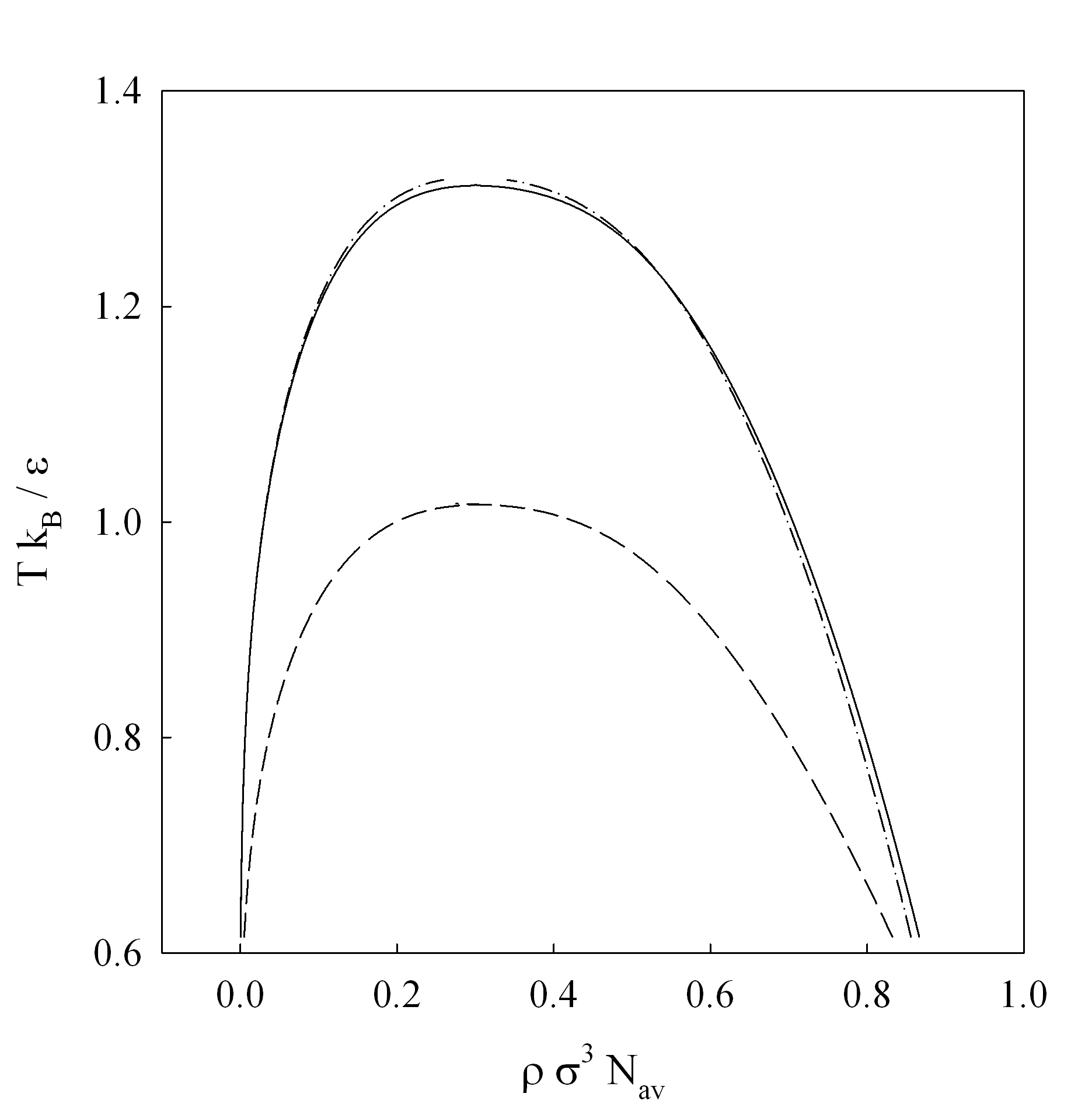

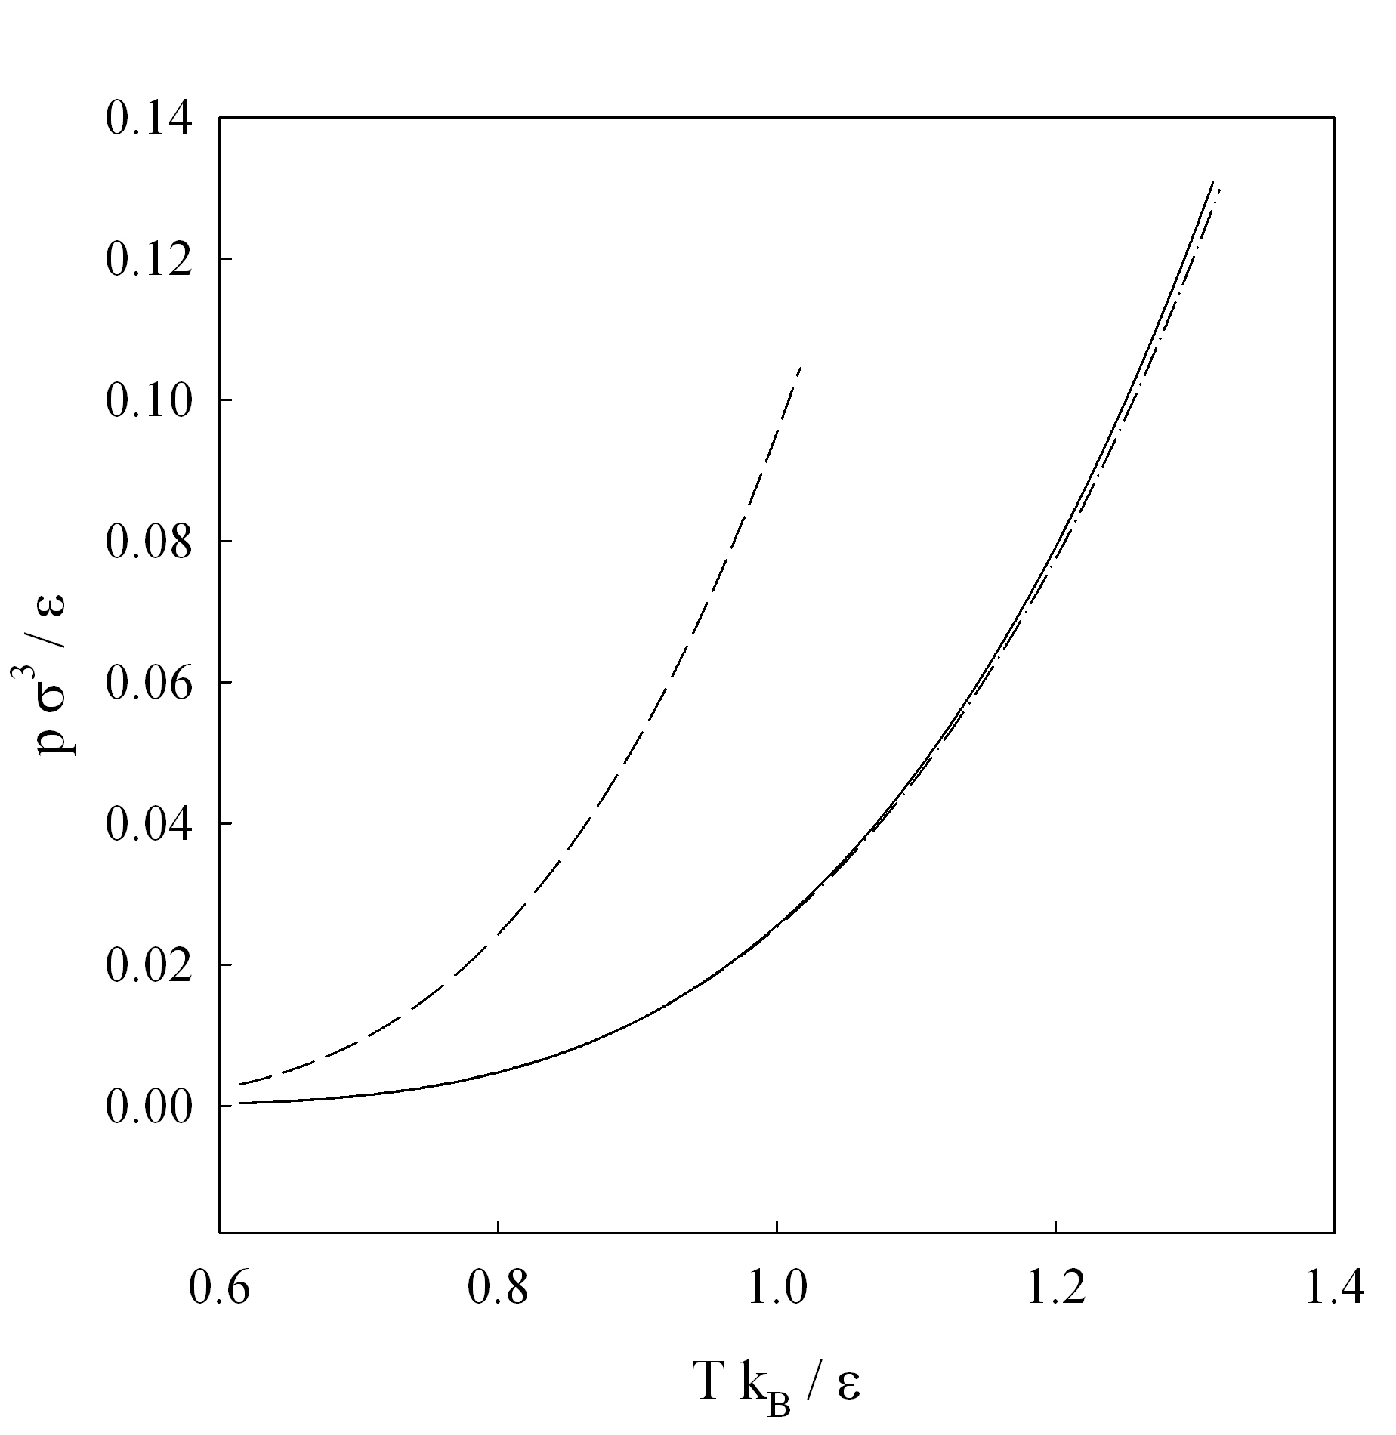

Figure 3 Conformality of the Mie potential. Phase behaviour of a LJ (12-6) potential (solid line) as compared to the Mie (14-7) (dashed line) where the ratio λ_{r} / λ_{a} is kept the same as the LJ and the Mie (9.159-7) (dashed-dotted) where the van der Waals constant α , is kept the same as the LJ potential. In all cases the parameters, ( σ, ε ) are kept equal. Top is the temperature, T – density, ρ, diagram, bottom is the vapour pressure curve.

3. The SAFT-γ equation of state

The crucial element for the development of this corresponding states correlation is the employment of an accurate EoS for a fluid of chains formed by Mie spheres. The Statistical Associating Fluid Theory (SAFT) family of equations of state is a promising route for this purpose. The reader is directed to reviews of the SAFT methodology, , , where details of the various versions of the theory are outlined with numerous examples of the successful application of this family of EoS for the description of the fluid-phase behavior and other thermodynamic properties of a wide variety of systems. We employ here the most recent third-generation model, referred generically as SAFT-γ model. In its more general form, the SAFT-γ EoS is a versatile group contribution approach that allows the description of chains fluids made up of heteronuclear fused spheres. Here we will use a simplified version of the theory, limited to tangent spheres composed of m segments. The development of this version of the theory is given in ref. and the working equations used herein are presented in an abridged way in refs. and . It suffices to say that the EoS is an analytical closed-form equation in terms of the Helmholtz energy of the fluid, A (T, V) . A particular fluid is described in terms of the chain length m, taken as an integer and three additional parameters ( σ, ε, λ) characteristic of the pairwise Mie interaction. Figure 4 shows a typical representation for n-hexane. Note that there is no requirement that the atomic description follow the model as essentially this is a coarse grained (CG) description, i.e. in this case each sphere or bead averages out the contribution of 1/2 of the interactions between two hexane molecules. Although SAFT has provision for the inclusion of associating sites to mimic hydrogen-bonding, this aspect of the theory is not exploited.

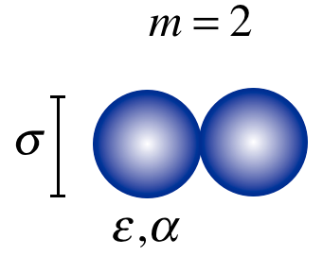
Figure 4 Coarse graining of a simple fluid. A molecule of n-hexane is rendered as a dimer (m =2) composed of twin tangent spheres, each described via a Mie potentials with size σ, and energy ε parameters and a van der Waals constant α describing the range or form of the potential. No geometric or bottom-up mapping is employed.

If the theoretical description (with its inherent approximations) is of a high enough quality that the equation of state describes in an accurate manner the system with the intermolecular potential that inspired it, one can envision a direct bridge between the macroscopic thermophysical data and the average effective parameters of the force field that is used to describe the molecules. While conceptually simple and intuitive, the use of top-down methodologies of this type are however surprisingly rare. The philosophy of coupling the development of intermolecular parameters from an accurate algebraic theory with molecular simulation was employed early on by Müller and Gubbins who used a high-fidelity semi-empirical representation of the LJ fluid together with dipolar and associative contributions combined as an EoS of the SAFT form to obtain a model for water. The adequacy of the approach is limited only by the deteriorating accuracy of the theory for low-temperature, high-density states and in the neighborhood of the critical region. In a similar fashion, Cuadros et al. employed an engineering EoS for the LJ fluid to regress from it molecular parameters for isotropic fluids. Ben-Amotz et al. also discuss the direct use of the LJ EoS to obtain corresponding states parameters for the underlying intermolecular potential. In a similar vein, Vrabec et al.,,, have championed the use of EoS to aid in the fitting of models for fluids of industrial interest. These are based on intermolecular potentials for 2-center LJ models with added dipoles and quadrupoles. These latter approaches, however, are restricted to the use of a LJ potential and suffer from a lack of flexibility as compared to the Mie potential. For a more complete discussion on the most recent schemes used to combined EoS to simulations the reader is referred to a review by Muller and Jackson.

4. Corresponding states parametrization

We consider molecules composed of m tangent spheres, where no restriction is placed on the bonding angle between spheres (a pearl-necklace model). We take here six cases, m = 1, 2, 3, 4, 5 and 6; although no element in the theory limits the value of m. An integer value is used to retain the compatibility with molecular simulations. For each of the values of m we calculate the critical coordinates and the subcritical phase equilibria at T_{r} = T / T_{c} = 0.7 for fluids with repulsive exponent 9 < λ < 50 (including fractional values). The critical coordinates are calculated by solving the van der Waals (or mechanical) condition of stability at the critical point :

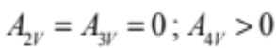 (10)

In equations (10) A_{nV} is a shorthand notation for A_{nV} = (∂^{n}A / ∂V^{n})_{T} and A is the Helmholtz energy, calculated here from the SAFT−γ EoS, and V represents the molar volume. Solution of equations (10) provide the critical temperature, T_{c}, and the critical volume, V_{c}, (or critical density, ρ_{c}) coordinates. The self-consistent critical pressure, P_{c}, may be obtained from the EoS model by evaluating the following expression at T_{c} and V_{c} or (ρ_{c}):

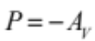 (11)

Isothermal subcritical liquid, L, – vapor, V, phase equilibria at T / T_{c} = 0.7 is obtained by solving, simultaneously, the mechanical equilibrium (P^{L} = P^{V}) and the diffusive or chemical potential constraint (μ^{L} = μ^{V}) conditions restricted to the differential stability of a single phase (A_{2V} > 0). Mathematically, both equilibrium conditions may be expressed in terms to A and A_{V} by the following expressions:

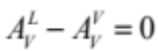 (12a)

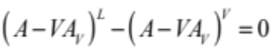 (12b)

In equations (12), the superscripts L and V represent the liquid and vapour bulk phases, respectively. Solution of equations (12), constrained to A_{2V} > 0, yield the isothermal used to evaluate volume or density at the equilibrium state for the liquid and vapour phases. These volumes or densities may be used to evaluated the vapour pressure at the isothermal condition (T/T_{c} = 0.7) according to Eq. (11), and then evaluate the acentric factor, ω, (c.f. equation 4).

For a fixed set of (m, σ , ε ) a change in the repulsive exponent, λ, increases the acentric factor proportionally. As an illustration, Figure 5 shows the variation of the repulsive exponent with the acentric factor for the case of a Mie spherical fluid (m = 1). From this figure, it is interesting to note that the limit of ω = 0 (a noble gas) corresponds to an exponent of 14.8, reinforcing the idea that the choice of a (12-6) potential to represent simple isotropic molecules is not optimal.

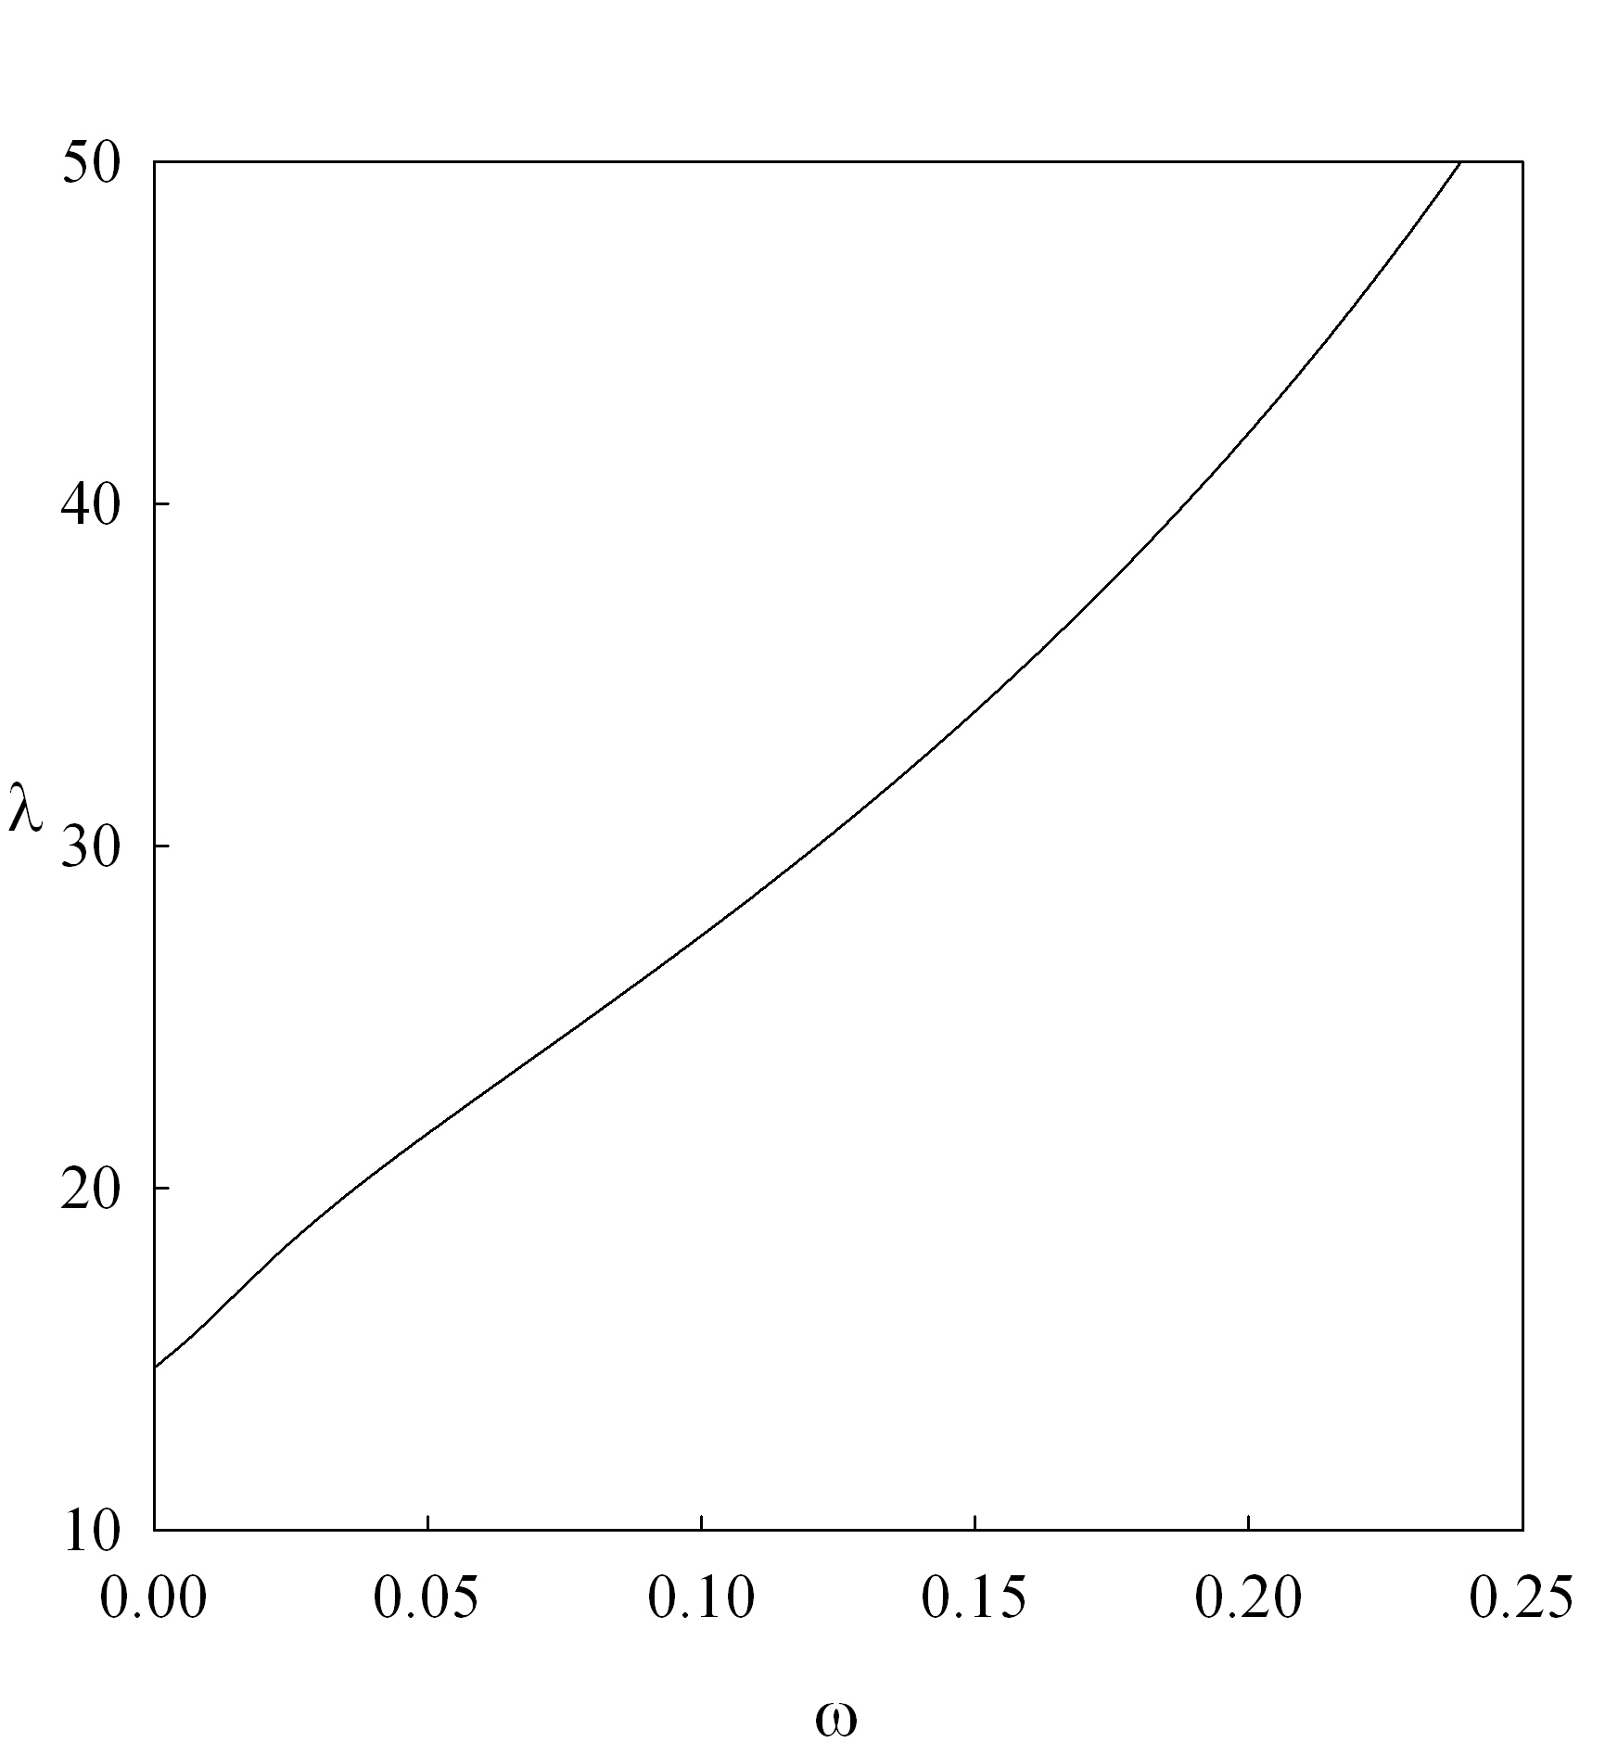

Figure 5 Repulsive exponent, λ, for a Mie (λ-6) spherical fluid (m = 1) as a function of the acentric factor.

The linearity of the relationship between the Mie exponent and the acentric factor suggests that one can correlate, by using a Padé series, the repulsive exponent:

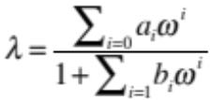 (13)

The values of the parameters a_{i} and b_{i} are given in Table 1 for a single sphere (m = 1), for dimer (m = 2), trimer (m = 3), tetramer (m = 4), pentamer (m = 5) and hexamer (m = 6) molecules. The expression is valid for a repulsive range 9 < λ < 50 although the smoothness of the curves allow for some degree of confidence in the extrapolation. The very high values of the repulsive exponent will provoke premature freezing of the fluid and the disappearance of the fluid phase region.

Table 1. Coefficients for the equations (13), (15) and (18)

m = 1 (-0.0847 < ω < 0.2387)

i | 0 | 1 | 2 | 3 | 4 | 5
a_{i} | 14.8359 | 22.2019 | 7220.9599 | 23193.4750 | -6207.4663 | 1732.9600
b_{i} |  | -6.9630 | 468.7358 | -983.6038 | 914.3608 | -1383.4441
c_{i} | 0.1284 | 1.6772
d_{i} |  | 0.4049 | -0.1592
j_{i} | 1.8966 | -6.9808 | 10.6330 | -9.2041 | 4.2503
k_{i} |  | -1.6205 | -0.8019 | 1.7086 | -0.5333 | 1.0536

m = 2 ( 0.0489 < ω < 0.5215)

i | 0 | 1 | 2 | 3 | 4
a_{i} | 8.0034 | -22.5111 | 3.5750 | 60.3129
b_{i} |  | -5.2669 | 10.2299 | -6.4860
c_{i} | 0.1125 | 1.5404 | -5.8769 | 5.2427
d_{i} |  | -3.1954 | 2.5174 | 0.3518 | -0.1654
j_{i} | -0.0696 | -1.9440 | 6.2575 | -5.4431 | 0.8731
k_{i} |  | -10.5646 | 25.4914 | -20.5091 | 3.6753

m = 3 (0.1326 < ω < 0.7371)

i | 0 | 1 | 2 | 3 | 4 | 5
a_{i} | 6.9829 | -13.7097 | -1.9604 | 17.3237
b_{i} |  | -3.8690 | 5.2519 | -2.3637
c_{i} | -0.2092 | 4.2672 | -9.7703 | 4.8661 | -0.1950 | 4.2125
d_{i} |  | -1.3778 | -2.4836 | 3.5280 | 0.7918 | -0.1246
j_{i} | 0.0656 | -1.4630 | 3.6991 | -2.5081
k_{i} |  | -8.9309 | 18.9584 | -11.6668 | -0.2561

m = 4 (0.2054 < ω < 0.9125)

i | 0 | 1 | 2 | 3 | 4 | 5
a_{i} | 6.4159 | -34.3656 | 59.6108 | -21.6579 | -35.8210 | 27.2358
b_{i} |  | -6.9751 | 19.2063 | -26.0583 | 17.4222 | -4.5757
c_{i} | 0.1350 | 1.3115 | -10.1437 | 24.07292 | -24.8084 | 9.7109
d_{i} |  | -5.8540 | 13.3411 | -14.3302 | 6.7309 | -0.7830
j_{i} | 0.1025 | -1.1948 | 2.8448 | -1.9519
k_{i} |  | -8.1077 | 16.7865 | -9.6354 | -1.2390

m = 5 (0.1326 < ω < 0.7371)

i | 0 | 1 | 2 | 3 | 4
a_{i} | 6.1284 | -9.1568 | -0.2229 | 4.5311
b_{i} |  | -2.8486 | 2.7828 | -0.9030
c_{i} | 0.1107 | 1.9807 | -6.6720 | 5.4841
d_{i} |  | -3.1341 | 2.7657 | -0.2737 | -0.0431
j_{i} | 0.1108 | -0.9900 | 2.2187 | -1.5027
k_{i} |  | -7.3749 | 14.53173 | -7.4967 | -1.9209

m = 6 (0.3378 < ω < 1.1974)

i | 0 | 1 | 2 | 3
a_{i} | 5.9217 | -8.0711 | 0.4264 | 2.5560
b_{i} |  | -2.5291 | 2.1864 | -0.6298
c_{i} | 0.1302 | 1.9357 | -6.4591 | 5.1864
d_{i} |  | -3.1078 | 2.8058 | -0.4375
j_{i} | 0.2665 | -0.4268 | -0.2732 | 0.6486
k_{i} |  | 1.7499 | -10.1370 | 9.4381

Upon fixing the repulsive exponent of the Mie potential (through the relation to the acentric factor) a value of the van der Waals constant can be calculated from the direct application of equation (9)

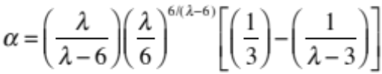 (14)

Once the range has been fixed, the corresponding (λ-6) fluid will have a unique critical point, if expressed in terms of reduced properties. This critical 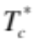 can be appropriately correlated with the van der Waals constant, α, as they behave in a very linear fashion ( c.f. figure 6).

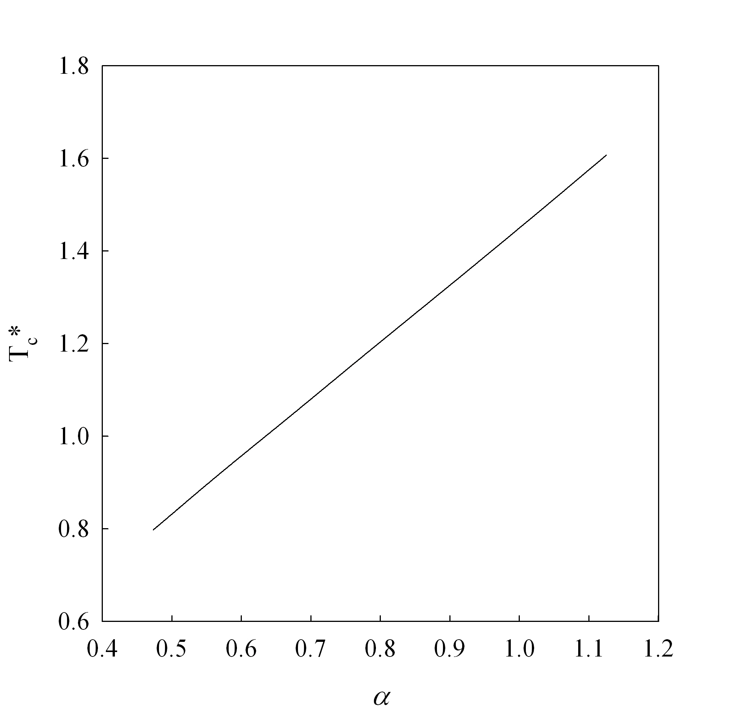

Figure 6 Linear dependency of the reduced critical temperature for a Mie (λ-6) spherical fluid (m = 1) as a function of van der Waals constant, α .

Hence, the reduced critical temperature can be related to α by means of a Padé series:

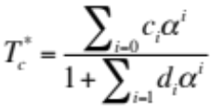 (15)

where the values of c_{i} and d_{i} are given in Table 1. Furthermore, as for a given fluid the critical coordinates (temperature, pressure, and density) and acentric factor are commonly reported (see for example the databases described in refs. , , ), so the above equations allow the use of the critical temperature of a fluid to determine in a direct fashion the corresponding energy scale of the associated Mie fluid. One only needs to compare directly both the experimental critical temperature T_{c} of a real fluid and the energy parameter of the Mie potential, ε as scaled by the Boltzmann constant k_{B} .

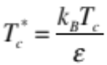 (16)

Similar correlations can be obtained for the other critical properties, such as the critical pressure and density or compressibility factor. These could be employed to obtain, in an analogous fashion as above, the corresponding link between properties of real fluids and the size parameter, σ of the Mie fluid. Our experience has shown that the values of σ obtained in this fashion would consistently underestimate (if σ were regressed from critical pressure data) or overestimate (if σ were regressed from critical density data) the saturated liquid densities. Scaling of the size parameter has a clear relationship to the liquid density;

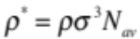 (17)

hence an alternative is to employ a parameter, similar in essence to the acentric factor, i.e. the saturated liquid density at T_{r} = 0.70. Again, as before, we correlate the reduced liquid density at T_{r} = 0.7 of the Mie fluids, 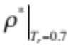, with the van der Waals constant α by using the results obtained from the equation of state. The results can be summarized in terms of a Padé series:

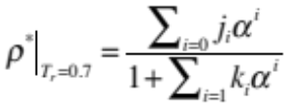 (18)

In eq. (18), j_{i} and k_{i} are coefficients given in Table 1 and N_{av} is Avogadro’s number. 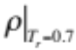corresponds to the experimental saturated liquid density at T_{r} = T/ T_{c} = 0.7 which may be obtained from common databases (32,33,34) and can be related to the reduced property by means of equation (17).

As a summary and an explanation of the basic procedure we calculate here intermolecular CG parameters for n-hexane. From the onset, a decision has to be made to the level of coarse graining required and the number of beads, m, to be used for representing the fluid. In view of the length-to breadth ratio of an extended hexane molecule it is not unreasonable to describe it with a value of m = 2 (c.f. figure 4) . One could, of course use other values, but the closer the ratio is to the real geometry, the better the prediction of the model. Values that are too small (or too large) affect the value of the repulsive exponent, tending to produce unrealistic potential parameters. In practice, the inclusion of three backbone atoms in a CG bead seems to give the best overall results.

The following “recipe” is suggested:

- Fix a value of m. In the example, we use m = 2 for hexane
- Using the experimental acentric factor ω one calculates the value of the repulsive exponent λ using equation (13) and the constants in table 1 corresponding to the value of m. Taking ω = 0.299 ³⁴ one obtains λ = 19.26
- Using equation (14) one obtains the value of the van der Waals constant α . In this case, α = 0.6693
- From eq. (15) and the constants in table 1 corresponding to the value of m one obtains the reduced critical temperature for the Mie model. In the example = 1.349.
- This reduced property is compared to the experimental critical point to obtain a scaling of the potential energy via equation (16). For hexane, a value of T_{c} = 507.82 K³⁴ gives ε/k_{B} = 376.35 K.
- Similarly, the application of equation (18) gives a reduced density, of for the corresponding Mie fluid. For α = 0.6693 and m=2 one obtains = 0.38466.
- Finally, comparison of the above value with an experimental value of the liquid phase density at a reduced temperature T/T_{c} =0.7 gives the size scale σ of the model, through the use of equation (17). In this case, we seek the molar density at a T = (0.7)(507.82)K = 355.47 K, which is found to be ³⁴ = 6971.6 mol/m³ from which a value of σ = 4.508 Å is determined.

5. Molecular simulations employing the CG models

With the values of the potential found from the recipe described in the previous section, one can perform CG molecular simulations to predict the thermophysical properties of real fluids. Molecular dynamics (MD) simulation details are given in the appendix A. They correspond to classical canonical MD runs where the liquid and the vapour are both present in the simulation cell. By specifying the temperature and the intermolecular potential parameters, one may obtain from these particular simulations a prediction of the coexisting equilibrium densities, the vapour pressure and the surface tension of the system. Following the example given above, for n-hexane it can be modelled as a tangent dimer with a (19.26-6) Mie potential, with ε/k_{B} = 376.35 K and σ = 4.508 Å. In figure 7 we plot the temperature-density plot obtained both from MD simulations as compared to the smoothed experimental data. One can observe that the prediction of the correlation is excellent. A minor deviation in the vapour pressure is observed in figure 8 for the same system and this is related to the inability of the equation of state of simultaneously fitting both subcritical properties and critical points. In addition, we present in figure 7 the results calculated from SAFT-γ using the same parameter values The curves calculated with the SAFT-γ EoS are presented for comparison purposes only and exemplify the close agreement between the theory and the simulations results, a sine qua non condition for employing a methodology as the one proposed herein.

Figure 9 exemplifies the real potential use of the correlation, as the force field can be used for molecular simulations of properties not considered in the original parametrization, for example surface properties and interfacial tensions. Here, the equation of state is not amenable to be used, unless a more sophisticated theory is employed ,. However the simulations provide an accurate prediction of the interfacial properties over the full temperature range. Analysis of the simulations would also provide interfacial profiles, and structure correlations for the inhomogeneous fluid. Similarly, other interfacial properties such as adsorption could be studied.

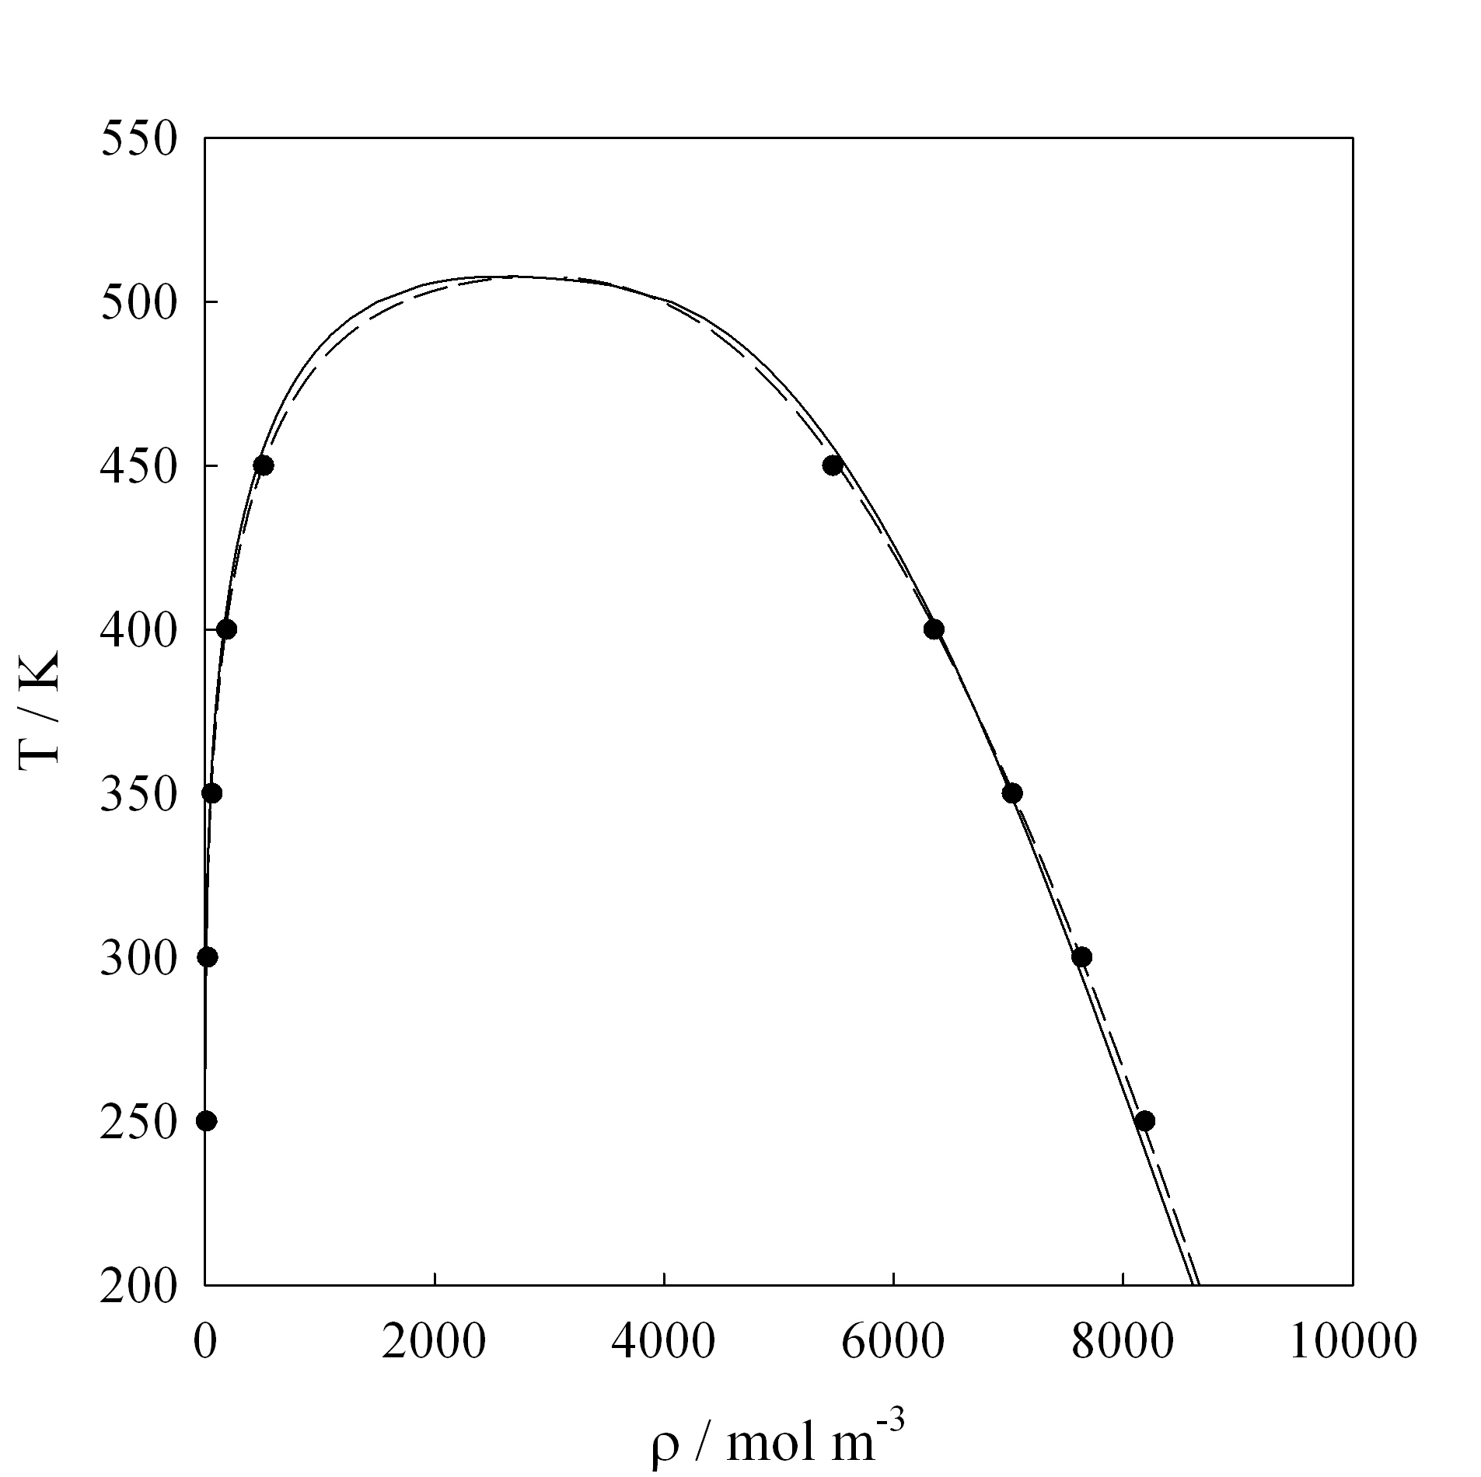

Figure 7 Temperature, T, as a function of molar density ρ, for n-hexane. Solid line corresponds to the smoothed experimental data⁴⁰ dashed lines are the description from the SAFT-γ equation of state. Solid symbols are MD simulation data. In both the EOS and the simulations the Mie (λ-6) model parameters (λ = 19.26, ε/k_{B} = 376.35 K, σ = 4.508 Å) are obtained from the correlation with m taken as 2.

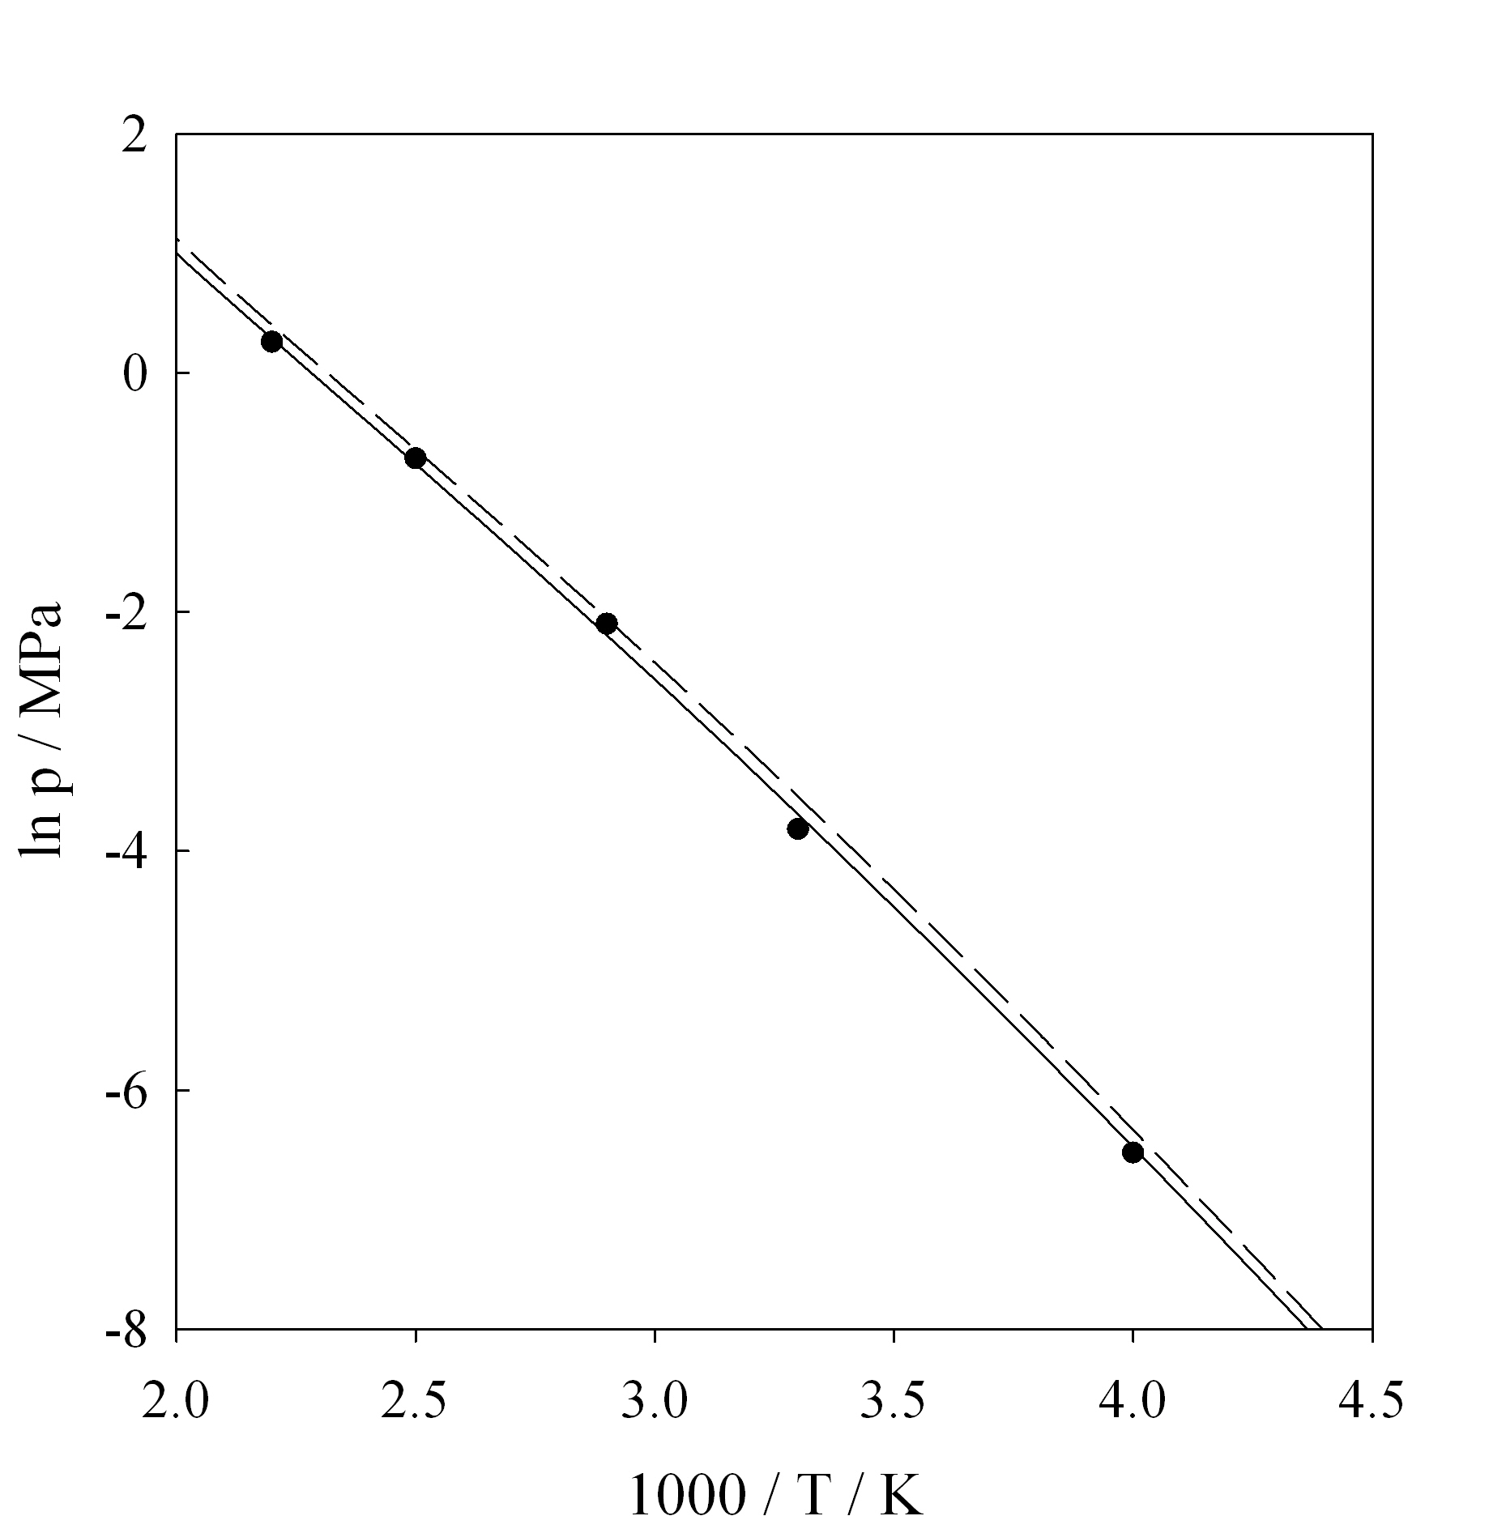

Figure 8 Vapor pressure P, as a function of temperature, T, for n-hexane. Symbols as in figure 7

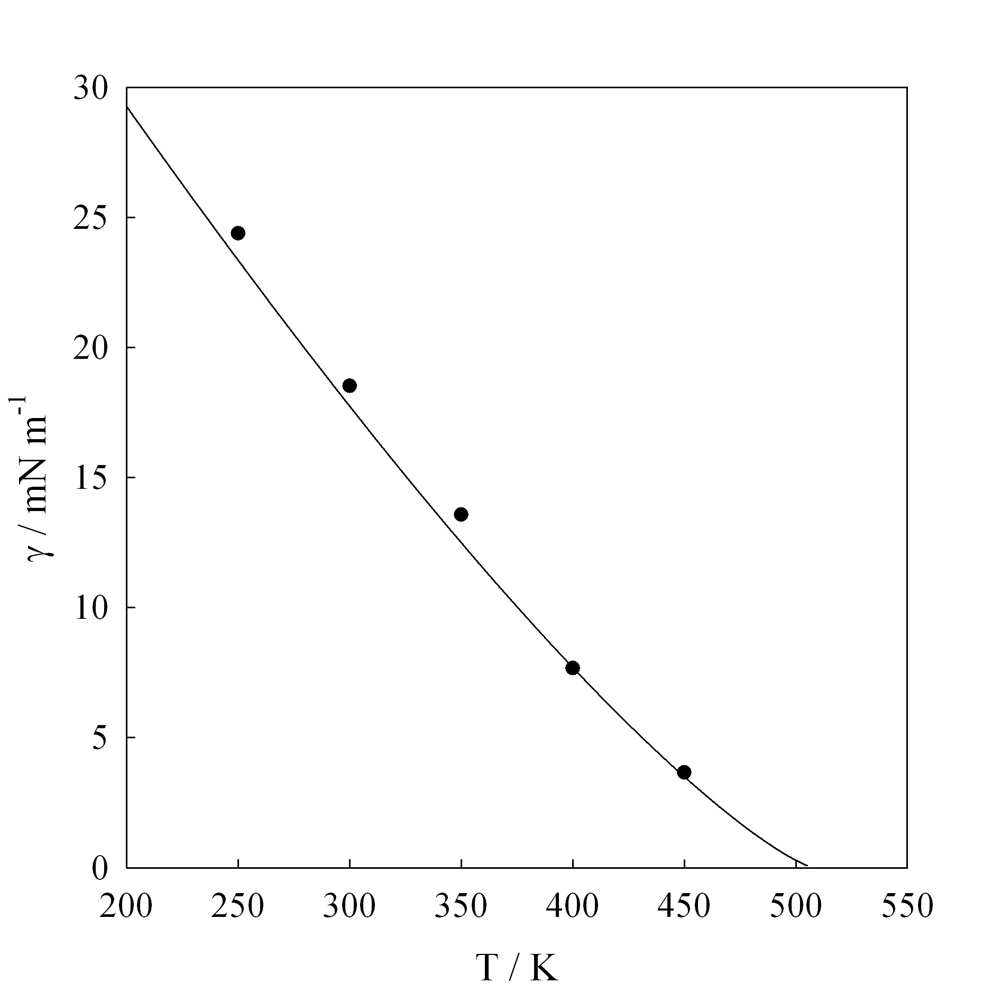

Figure 9 Interfacial tension, γ, as a function of temperature, T, for n-hexane. Solid line corresponds to the smoothed experimental data⁴⁰ while solid symbols are MD simulation data. In the simulations the Mie (λ-6) model parameters (λ = 19.26, ε/k_{B} = 376.35 K, σ = 4.508 Å) are obtained from the correlation with m taken as 2.

As further examples, in figures 10 and 11 we plot the phase equilibria and the interfacial tension of 5-nonanone (C₉H₁₈O). This molecule is an example of a non-trivial polar elongated molecule. Here, the acentric factor is capturing both the effects of polarity and elongation. If we choose to model the fluid as a trimer ( m = 3) we effectively decouple both effects. The correlation in equation (13) gives then the exponent of each of the three beads that averages out the polar contribution. The quality of the prediction made by the molecular simulation of the CG model for both the phase diagram, vapour pressure (not shown) and the interfacial tension is excellent.

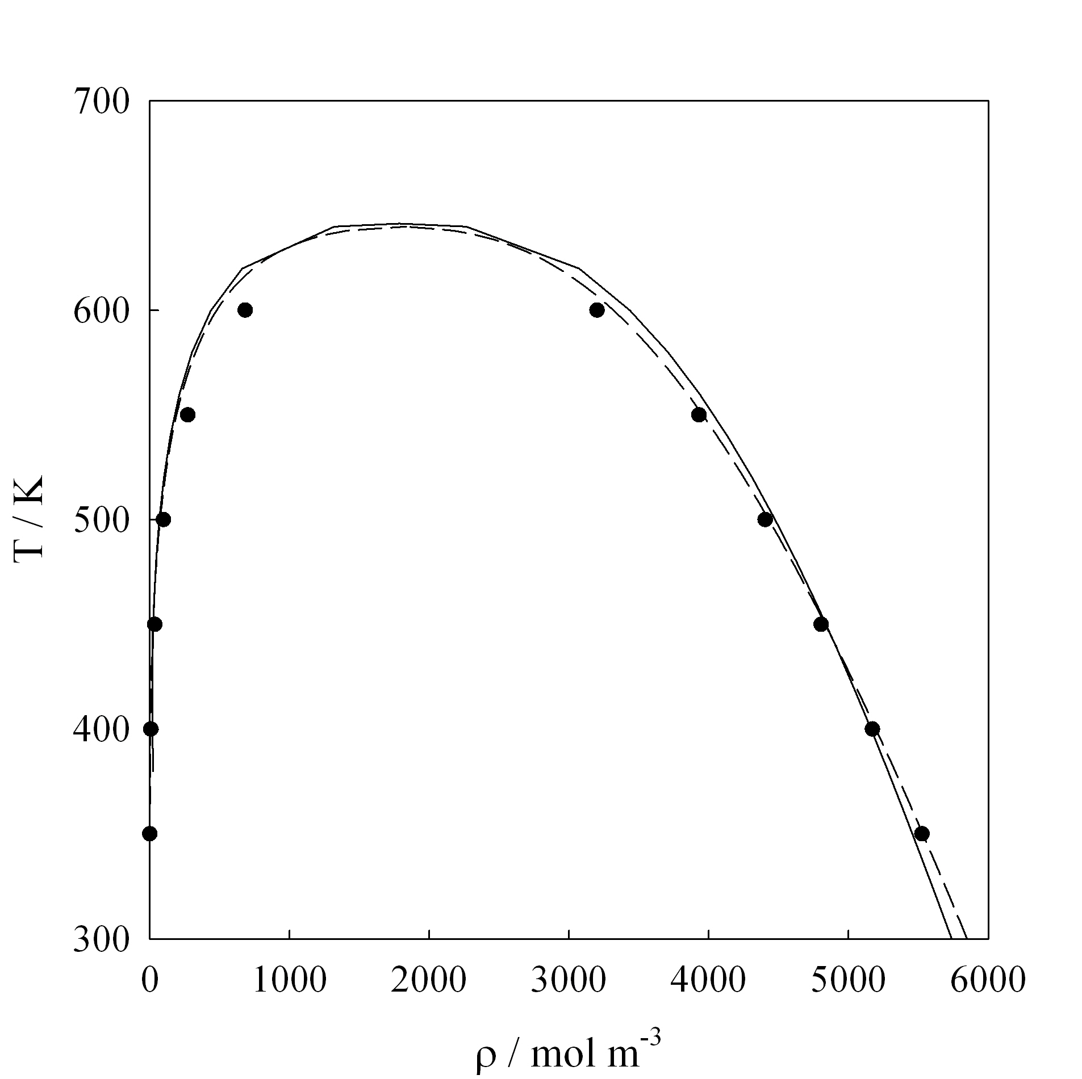

Figure 10 Temperature, T, as a function of molar density ρ, for for C₉H₁₈O ( 5-nonanone). Solid line corresponds to the smoothed experimental data⁴⁰ dashed lines are the description from the SAFT-γ equation of state. Solid symbols are MD simulation data. In both the EOS and the simulations the Mie (λ-6) model parameters (λ = 22.72, ε/k_{B} = 445.81 K, σ = 4.433 Å) are obtained from the correlation with m is taken as 3.

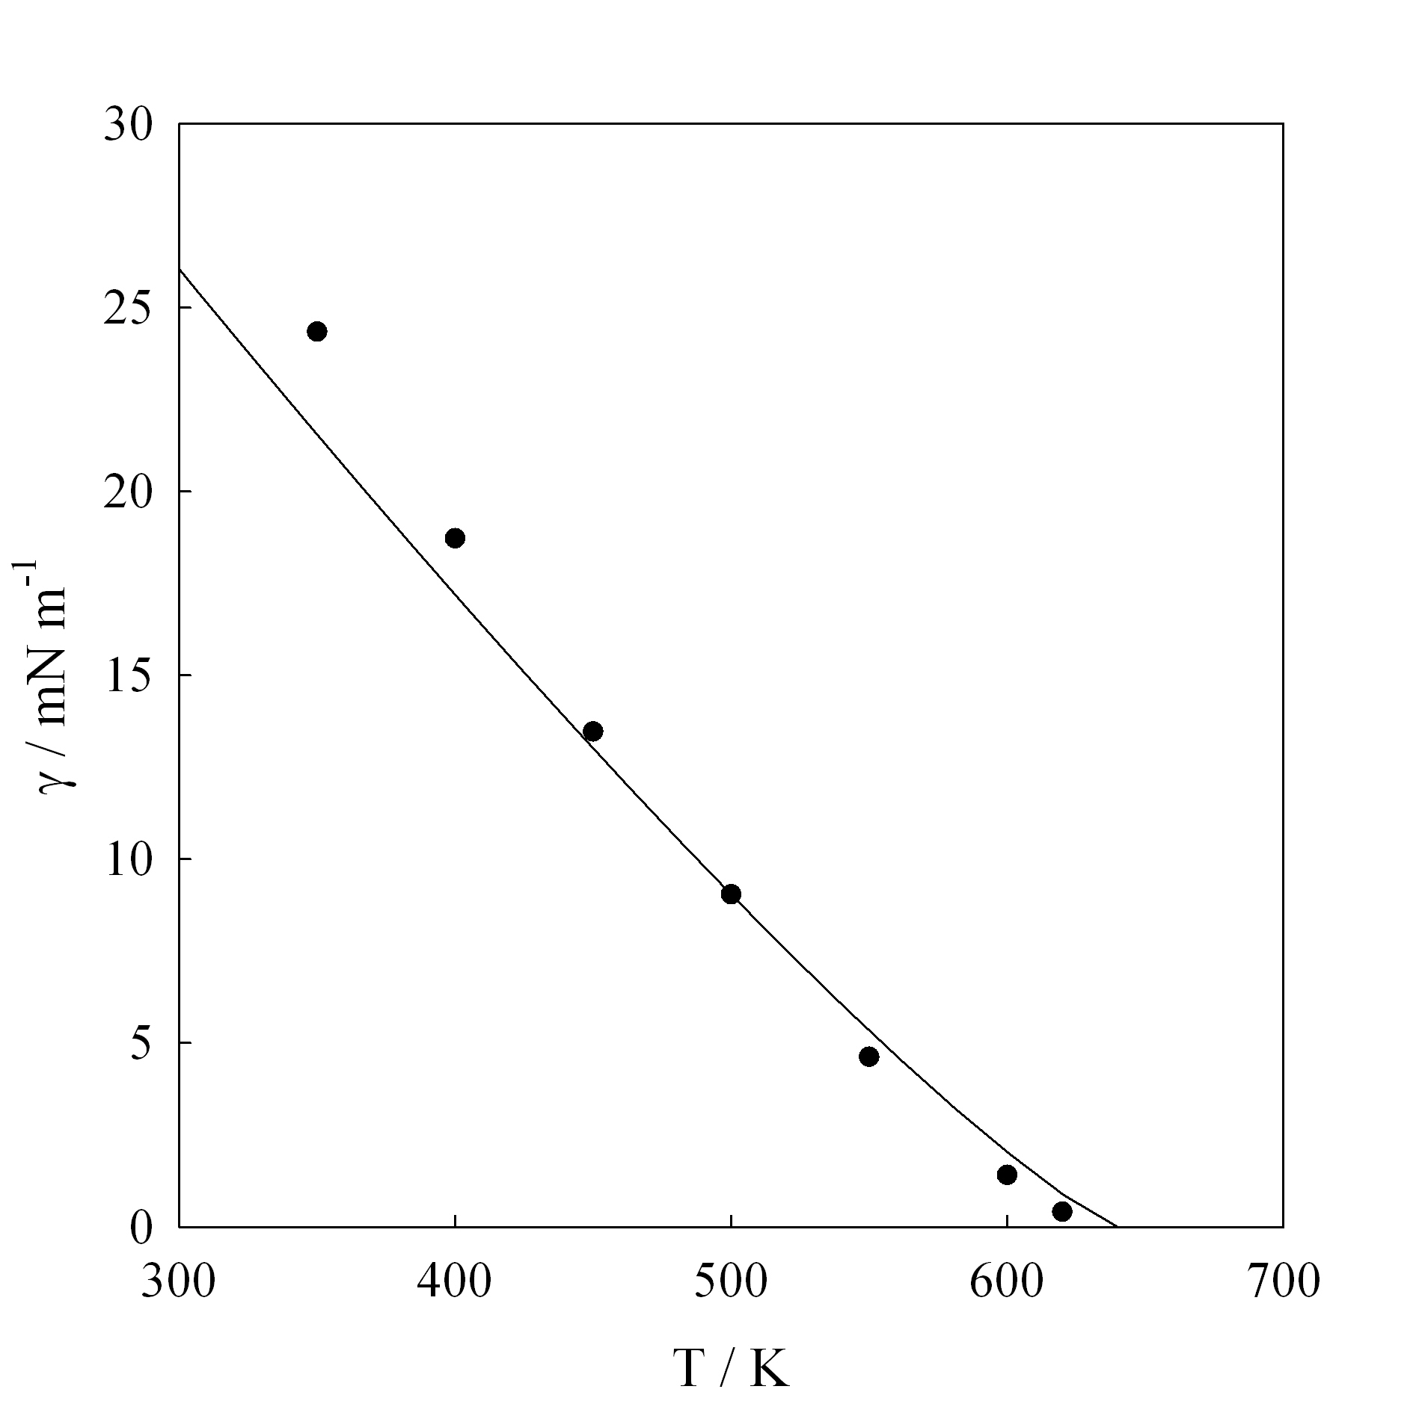

Figure 11 Interfacial tension, γ, as a function of temperature, T, for C₉H₁₈O (5-Nonanone). Solid line corresponds to the smoothed experimental data⁴⁰ while solid symbols are MD simulation data. In the simulations the Mie (λ-6) model parameters (λ = 22.72, ε/k_{B} = 445.81 K, σ = 4.433 Å) are obtained from the correlation with m taken as 3.

The CG potentials presented here are effective force fields that offer an appropriate average of the volumetric properties, as expressed in a phase diagram. Notwithstanding the simplifications, these potentials provide a representation that is of similar quality as that delivered by more detailed atomistic models. In figure 12 we show the prediction for eicosane ( C₂₀H₄₂ ), a long chain n-alkane, along with the simulation results for a detailed atomistic model³⁸. Given the uncertainty of the experimental results, the simulations show a remarkable agreement with both experiments and more sophisticated force fields. We have used the critical data suggested in ref. 33 ( ω = 0.906878, T_{c} = 768 K, = 2188.388 mol/m³). In this particular case, the model parameters depend on the values of the critical temperature of this fluid, which can not be measured, as eicosane would decompose before reaching the critical region.

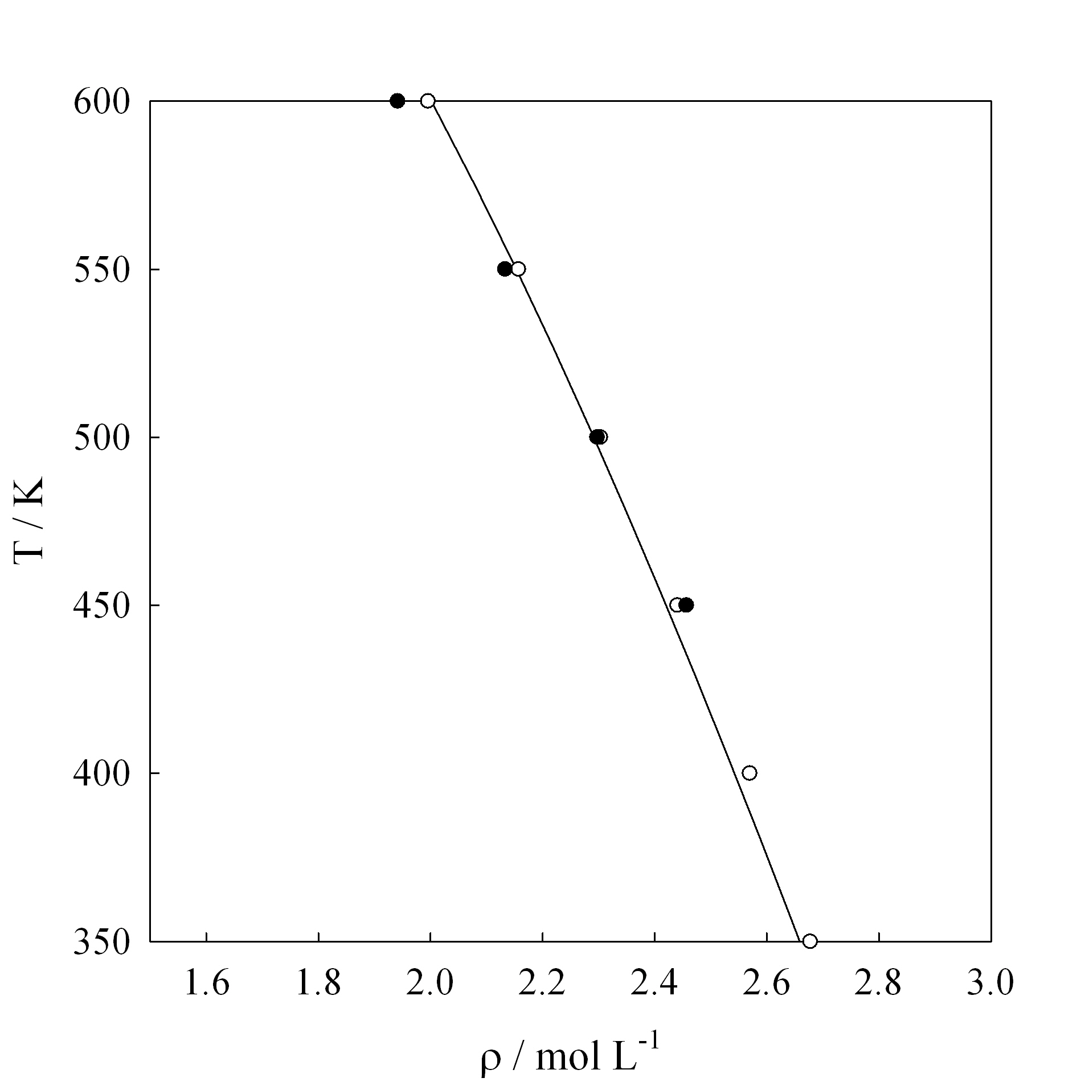

Figure 12 Temperature, T, as a function of molar density ρ, for n-C₂₀H₄₂ with m = 6. Solid line corresponds to the smoothed experimental data⁴⁰, symbols are MD simulation data for a) detailed united atom potentials (38) open circles, and b) and for the CG Mie (λ-6) model full circles with parameters (λ = 24.70, ε/k_{B} = 453.10 K, σ = 4.487 Å) obtained from the correlation.

There is nothing in the SAFT theory that restricts the use of the potentials to pure fluids, however, no attempt has been made here to consider mixtures. The most crucial aspect of the description of mixtures is the determination of the cross parameters between unlike beads. Ideally, these should be determined from mixture data. In lieu of any information, simple combining rules can be applied, e.g.

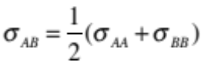 (18a)
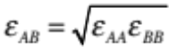 (18b)
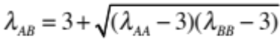 (18c)

where the subscripts A and B refer to the individual components of the mixture.

The correlations in the previous section assume that the intermolecular potential is isotropic in nature and has a simple repulsion-dispersion interaction that can be mapped into a Mie potential. When used within the framework of coarse-grained modelling, such assumptions might break down, e.g. the modelling of a complexly bonded group of atoms or the presence of delocalized charges with subsequent formation of hydrogen bonds. In these cases, the models presented here can only be taken as first guesses and crude approximations. Consider, for example the case of water. Clearly coarse graining using a simple isotropic sphere is far from reality. Notwithstanding, many attempts to parametrize water at this level of coarse graining have been made. Water has an abnormally large acentric factor which is caused by the relatively strong intermolecular attractions brought by the presence of the hydrogen bonding network formed in the liquid phase. If one attempts to use the recipe given in this paper to water, an immediate observation is that it suggests the use of a very large repulsive exponent. In terms of the correlation, this high acentric factor suggests the use of an unrealistically large value for the repulsive exponent. While this procedure will force the system to have a sensible values of the vapor pressure, other properties will be poorly represented. Particularly, the very high values of the repulsive exponent induce the freezing of the model at temperatures above those expected, rendering the model unsuitable for fluid phase modelling. This is a classical example where coarse graining techniques struggle to give satisfactory results. In the case of water, the premature freezing may be avoided by considering a different approach for determining the value of α that should be used in the correlations. The fluid phase region of the Mie spherical fluid is determined by the value of α through a simple relationship¹⁸ between the critical and triple points; T_{c}/T_{t} = 1.464 α + 0.608. This allows one to use a different value of alpha (α = 1.203) and a corresponding value of the repulsive exponent through equation (14), the former being compatible with maintaining the fluid phase region. The rest of the procedure, i.e. fitting the depth of the potential with the critical temperature and the size parameter with a density follows in the usual fashion. The full set of parameters for this simple model of water correspond to a (8.4-6) potential with ε/k_{B} = 378.87 K ; σ = 2.915 Å and represent a sensible compromise for the prediction of fluid properties of water with an isotropic, temperature independent model. Reassuringly, it resembles other models of water obtained by heroic parametric force fitting efforts of water data to thermophysical properties.

The data points needed for each molecule are the acentric factor, the critical temperature and the liquid density at the reduced temperature of 0.7. One of course, can envision scenarios where this particular piece of information is absent, in particular the latter. In such cases we suggest the density to be calculated from a suitable correlation such as the Rackett model

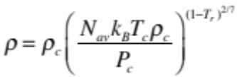 (17)

although many other options are available and could equivalently be employed. The quality of the potentials obtained is decreased, in expense of the universality of the method. A table of parameters for over 7000 organic compounds is available from the authors. No attempt has been made to be exhaustive, and the compilation is presented as an example of the breadth and depth of the proposed method. It includes not only simple fluids, but refrigerants and polar compounds, elongated molecules and general fluids of industrial interest.

In the case of chain molecules the intramolecular interactions must additionally be defined. Following the SAFT treatment, all pairs of beads are assumed to be bonded at a distance corresponding to σ. The nature of the bond is rigid, although a harmonic spring with a large constant is equivalent. For molecules consisting of three or more beads, an issue arises with respect to the geometry or bonding angle of the molecule. Wertheim’s first order thermodynamic perturbation theory, which underlies the SAFT treatments, only considers bonding between pairs of molecules and makes an assumption that any further bonding on a bead is independent of the existing bonds. The practical consequence of this is that the theory is more accurate for stretched out chains. In most cases a fully flexible model will suffice, but an improved mapping between simulation and theory is achieved if a bending potential is added between trios of beads as to favour the linear configuration.

6. Conclusion

The corresponding states principle is not a physical law, but rather a handle to understand and correlate in a systematic way the behaviour of simple fluids. Modern corresponding states correlations for the description of thermophysical properties of fluids are based on the assumption that there is an underlying (and universal) function that can describe the intermolecular potential of said fluids. Following such a postulate, statistical mechanics treatments allow the calculation of the properties of a particular fluid. Most interestingly, the results may be generalized if they are scaled appropriately. The number of independent scales employed, dictates the way the fluids can be mapped into such a “universal” function. We have employed here the premise that most simple non-associating fluids may be well described by an intermolecular potential of the Mie type and molecules described as linear chains of said spheres. This representation of a fluid, in terms of four scales (m, σ , ε, λ ) is the basis, facilitated by the SAFT-γ EOS, of the proposed four parameter corresponding state correlation. The unique element of this correlation is that the parameters obtained can be directly employed in molecular simulation of fluids with no loss in accuracy and as such are comparable to more detailed atomistic models.

The procedure described herein is a top-down approach (also called thermodynamic approach) to the development of force fields. In its more accurate implementation, one would use the EOS to fit the available volumetric experimental data of a fluid, hence obtaining an effective average force field. Intramolecular interactions could also be obtained from first principles simulations to complete the description of the potential. Such an approach is very effective and has been used in a variety of scenarios to predict by simulation the behaviour of complex fluids such as liquid crystals, surfactants, and polymers 40. The correlation presented here is a short-cut of the aforementioned philosophy, and allows the determination in a very fast and effective way of intermolecular force field parameters that can be used in efficient computational schemes.

References

() Hirschfelder, J. O.; Curtiss, C. F.; Bird, R. B. Molecular Theory of Liquids and Gases; Wiley: New York, 1965.
() Reed, T. M.; Gubbins, K. E. Applied Statistical Mechanics; McGraw-Hill: New York, 1973.
() van der Waals, J. D. Onderzoekingen Omtrent de Overeenstemmende Eigenschappen der Normale Verzadigden-Damp - en Vloeistoflijnen Voor de Verschillende Stoffen en Omtrent een Wijziging in Den Vorm Dier Lijnen Bij Mengsels [Investigations on the Corresponding Properties of the Normal Saturated Vapor and Liquid Curves for Different Fluids, and About A Modification in the Form of These Curves for Mixtures]. Verhand. Kon. Akad. Wetensch. Amst. 1880, 20, 1.; Over de Coëfficiënten van Uitzetting en van Samendrukking in Overeenstemmende Toestanden der Verschillende Vloeistoffen [On the Coefficients of Expansion and Compression in Corresponding States of Different Liquids]. Verhand. Kon. Akad. Wetensch. Amst. 1880, 20, 1.
() van der Waals, J. D. Over de Continuiteit Van Den Gas- En Vloeistoftoestand. Ph.D. Dissertation, University of Leiden, Leiden, 1873.
() Vera, J. H.; Prausnitz, J. M. Generalized van der Waals Theory for Dense Fluids. Chem. Eng. J. 1972, 3, 1.
() Widom, B. Statistical Mechanics: A Concise Introduction for Chemists; Cambridge University Press: Cambridge, 2002.
() Soave, G. Equilibrium Constants From a Modified Redlich – Kwong Equation of State. Chem. Eng. Sci. 1972, 27, 1197.
() Pitzer, K. S.; Lippman, D. Z.; Curl, R. F.; Huggins, C. M.; Petersen, D. E. The Volumetric and Thermodynamic Properties of Fluids. II. Compressibility Factor, Vapor Pressure and Entropy of Vaporization 1. J. Am. Chem. Soc. 1955, 77, 3433.
() Bett, K. E.; Rowlinson, J. S.; Saville, G. Thermodynamics for Chemical Engineers; Athlone Press:, 1975.
() Prausnitz, J. M.; Lichtenthaler, R. N.; Gomes de Azevedo, E. Molecular Thermodynamics of Fluid-Phase Equilibria; 3rd Edition, Prentice Hall: New Jersey, 1998.
() Assael, M. J.; Trusler, J. P. M.; Tsolakis, T. F. Thermophysical Properties of Fluids; Imperial College Press: London, 1996.
() Xiang, H. The Corresponding-States Principle and its Practice; Elsevier: Amsterdam, 2005.
() Jones, J. E. On the Determination of Molecular Fields. II. From the Equation of State of a Gas. Proc. R. Soc. Lon. A. 1924, 106, 463.
() Mie, G. Zur kinetischen Theorie der Einatomigen Körper. Ann. Phys. 1903, 316, 657.
() Grüneisen, E. A. Theorie des Festen Zustandes Einatomiger Elemente Ann. Phys. 1912, 344, 257.
() Lennard-Jones, J. E. Wave Functions of Many-Electron Atoms. Proc. Phys. Soc. 1931, 27, 469.
() Gil-Villegas, A.; Galindo, A.; Whitehead, P. J.; Mills, S. J.; Jackson, G.; Burgess, A. N. Statistical Associating Fluid Theory for Chain Molecules with Attractive Potentials of Variable Range. J. Chem. Phys. 1997, 106, 4168.
() Ramrattan, N. Simulation and Theoretical Perspectives of the Phase Behaviour of Solids, Liquids and Gases Using the Mie Family of Intermolecular Potentials. Ph.D. Dissertation, Imperial College London, London, 2013.
() Kulinskii, V. L. The Vliegenthart-Lekkerkerker Relation: The Case of the Mie-Fluids. J. Chem. Phys. 2011, 134, 144111.
() Müller, E. A.; Gubbins, K. E. Molecular-Based Equations of State for Associating Fluids: A Review of SAFT and Related Approaches. Ind. Eng. Chem. Res. 2001, 40, 2193.
() Economou, I. G. Statistical Associating Fluid Theory: A Successful Model for the Calculation of Thermodynamic and Phase Equilibrium Properties of Complex Fluid Mixtures. Ind. Eng. Chem. Res. 2002, 41, 953.
() Tan, S. P.; Adidharma, H.; Radosz, M. Recent Advances and Applications of Statistical Associating Fluid Theory. Ind. Eng. Chem. Res. 2008, 47, 8063.
() McCabe, C.; Galindo, A. SAFT associating fluids and fluid mixtures. In Applied Thermodynamics of Fluids; Goodwin, A. R., Sengers, J., Peters, C. J., Eds.; Royal Society of Chemistry: London, 2010, Chapter 8.
() Papaioannou, V.; Lafitte, T.; Avendaño, C.; Adjiman, C. S.; Jackson, G.; Müller, E. A.; Galindo. A. Group Contribution Methodology Based on the Statistical Associating Fluid Theory for Heteronuclear Molecules Formed From Mie Segments. J. Chem. Phys. 2014,140, 054107
() Lafitte, T.; Apostolakou, A.; Avendaño, C.; Galindo, A.; Adjiman, C. S.; Müller, E. A.; Jackson, G. Accurate Statistical Associating Fluid Theory for Chains of Mie Segments. J. Chem. Phys. 2013, 139, 154504.
() Avendaño, C.; Lafitte, T.; Galindo, A.; Adjiman, C. S.; Jackson, G.; Müller, E. A. SAFT-γ Force Field for the Simulation of Molecular Fluids. 1. A Single-Site Coarse Grained Model of Carbon Dioxide. J. Phys. Chem. B 2011, 115, 11154.
() Avendaño, C.; Lafitte, T.; Adjiman, C. S.; Galindo, A.; Müller, E. A.; Jackson, G. SAFT-γ Force Field for the Simulation of Molecular Fluids: 2. Coarse-Grained Models of Greenhouse Gases, Refrigerants, and Long Alkanes. J. Phys. Chem. B 2013, 117, 2717.
() Müller, E. A.; Gubbins, K. E. An Equation of State for Water From A Simplified Intermolecular Potential. Ind. Eng. Chem. Res. 1995, 34, 3662.
() Cuadros, F.; Cachadiña, I.; Ahumada, W. Determination of Lennard- Jones Interaction Parameters Using A New Procedure. Mol. Eng. 1996, 6, 319.
() Ben-Amotz, D.; Gift, A. D.; Levine, R. D. Improved Corresponding States Scaling of the Equations of State of Simple Fluids. J. Chem. Phys. 2002, 117, 4632.
() Lotfi, A.; Vrabec, J.; Fischer, J. Vapor-Liquid-Equilibria of the Lennard-Jones Fluid from the NPT Plus Test Particle Method. J. Mol. Phys. 1992, 76, 1319.
() Stoll, J.; Vrabec, J.; Hasse, H.; Fischer, J. Comprehensive Study of the Vapour-Liquid Equilibria of the Pure Two-Centre Lennard-Jones Plus Point Quadrupole Fluid. Fluid Phase Equilib. 2001, 179, 339.
() Vrabec, J.; Stoll, J.; Hasse, H. A Set of Molecular Models for Symmetric Quadrupolar Fluids. J. Phys. Chem. B 2001, 105,12126
() Stoll, J.; Vrabec, J.; Hasse, H. Comprehensive Study of the Vapour-Liquid Equilibria of the Two-Centre Lennard-Jones Plus Point Dipole Fluid. Fluid Phase Equilib. 2003, 209, 29.
() Vrabec, J.; Huang, Y.-L.; Hasse, H. Molecular Models for 267 Binary Mixtures Validated by Vapor-Liquid Equilibria: A Systematic Approach. Fluid Phase Equilib. 2009, 279, 120.
() Müller, E. A.; Jackson, G. Force Field Parameters from the SAFT-γ Equation of State for Use in Coarse-Grained Molecular Simulations. Ann. Rev. Chem. Biomol. Eng. 2014, in press, doi: 10.1146/annurev-chembioeng-061312-103314
() Tester, J. W.; Modell, M. Thermodynamics and its Applications; 3rd Ed. Prentice Hall: New Jersey, 1997.
() Daubert, T. E.; Danner, R. P. Physical and Thermodynamic Properties of Pure Chemicals. Data Compilation; Taylor and Francis: Bristol, PA, 1989.
() DECHEMA Gesellschaft für Chemische Technik und Biotechnologie e.V., Frankfurt am Main, Germany, https://cdsdt.dl.ac.uk/detherm/ (retrieved November, 2013).
() Lemmon, E. W.; McLinden, M. O.; Friend, D. G. Thermophysical Properties of Fluid Systems in NIST Chemistry WebBook, NIST Standard Reference Database Number 69; Linstrom, P. J., Mallard, W. G., Eds.; National Institute of Standards and Technology: Gaithersburg MD; http://webbook.nist.gov (retrieved November, 2013).
() Müller, E. A.; Mejía, A. Interfacial Properties of Selected Binary Mixtures Containing n-Alkanes. Fluid Phase Equilib. 2009, 282, 68.
() Müller, E. A.; Mejía, A. Comparison of United-Atom Potentials for the Simulation of Vapor-Liquid Equilibria and Interfacial Properties of Long-Chain n-Alkanes up to n-C100. J. Phys. Chem. B 2011, 115, 12822.
() Lobanova, O.; Avendaño, C.; Lafitte, T.; Jackson, G.; Müller, E.A. SAFT-γ Force Field for the Simulation of Molecular Fluids. 4. A Single-Site Coarse Grained Model of Water Valid Over a Wide Temperature Range. Mol Phys. Submitted.
() He, X. B.; Shinoda, W.; DeVane, R.; Klein, M. L. Exploring the Utility of Coarse-Grained Water Models for Computational Studies of Interfacial Systems. Mol. Phys. 2010, 108, 2007.
() Rackett, H. G. Equation of State for Saturated Liquids. J. Chem. Eng. Data 1970, 15, 514.
() Mulero, A.; Cachadiña, I.; Parra, M. I. Liquid Saturation Density from Predictive Correlations Based on the Corresponding States Principle. Part 1: Results for 30 Families of Fluids. Ind. Eng. Chem. Res. 2006, 45, 1840.
() Müller, E. A.; Gubbins, K. E.; Simulation of Hard Triatomic and Tetratomic Molecules. A Test of Associating Fluid Theories. Mol. Phys. 1993, 80, 957. Acknowledgment This paper is dedicated to the 40 years of academic career of Prof. Claudio Olivera-Fuentes, a pioneer in equation of state development, whose ideas have inspired the paths of all three authors. The authors gratefully acknowledge the many fruitful discussions with the members of Imperial College’s Molecular Systems Engineering group and in particular with Prof. George Jackson, Dr. Carlos Avendaño and Dr. Thomas Lafitte. The efforts of two exceptional undergraduate students, Karson Wong and Muhammad Jansi who compiled some of the published test data is much appreciated. This work was financed by FONDECYT, Chile (Project 1120228) and supported by the U.K. Engineering and Physical Sciences Research Council (EPSRC) through research grants (EP/I018212 and EP/J014958). Simulations described herein were performed using the facilities of the Imperial College High Performance Computing Service. Supporting Information Available: Supporting Information S1: Molecular Dynamics Simulation details, This information is available free of charge via the Internet at http: //pubs.acs.org. Figure Captions Figure 1 : Temperature, T – density, ρ, phase diagram of an attractive sphere (solid line) and the corresponding trimer (dashed-dotted) oligomer formed by spheres of the same type. Figure 2 Effect of intermolecular interactions on the slope of the vapor pressure curve. The ordinate corresponds to the base 10 log of the ratio of the vapor pressure to the critical point (corresponding to -1-ω ). For the noble gases this takes on the value of zero, and becomes larger as the interaction deviates either because of non-sphericity (e.g. n-C₁₀H₂₂) and/or as a consequence of deviations from simple dispersive interactions (e.g. CF₄) Figure 3 Conformality of the Mie potential. Phase behaviour of a LJ (12-6) potential (solid line) as compared to the Mie (14-7) (dashed line) where the ratio λ_{r} / λ_{a} is kept the same as the LJ and the Mie (9.159-7) (dashed-dotted) where the van der Waals constant α , is kept the same as the LJ potential. In all cases the parameters, ( σ, ε ) are kept equal. Top is the temperature, T – density, ρ, diagram, bottom is the vapour pressure curve. Figure 4 Coarse graining of a simple fluid. A molecule of n-hexane is rendered as a dimer (m =2) composed of twin tangent spheres, each described via a Mie potentials with size σ, and energy ε parameters and a van der Waals constant α describing the range or form of the potential. No geometric or bottom-up mapping is employed. Figure 5 Repulsive exponent, λ, for a Mie (λ-6) spherical fluid (m = 1) as a function of the acentric factor. Figure 6 Linear dependency of the reduced critical temperature for a Mie (λ-6) spherical fluid (m = 1) as a function of van der Waals constant, α . Figure 7 Temperature, T, as a function of molar density ρ, for n-hexane. Solid line corresponds to the smoothed experimental data⁴⁰ dashed lines are the description from the SAFT-γ equation of state. Solid symbols are MD Figure 8 Vapor pressure P, as a function of temperature, T, for n-hexane. Symbols as in figure 7 Figure 9 Interfacial tension, γ, as a function of temperature, T, for n-hexane. Solid line corresponds to the smoothed experimental data⁴⁰ while solid symbols are MD simulation data. In the simulations the Mie (λ-6) model parameters (λ = 19.26, ε/k_{B} = 376.35 K, σ = 4.508 Å) are obtained from the correlation with m taken as 2. Figure 10 Temperature, T, as a function of molar density ρ, for for C₉H₁₈O ( 5-nonanone). Solid line corresponds to the smoothed experimental data⁴⁰ dashed lines are the description from the SAFT-γ equation of state. Solid symbols are MD simulation data. In both the EOS and the simulations the Mie (λ-6) model parameters (λ = 22.72, ε/k_{B} = 445.81 K, σ = 4.433 Å) are obtained from the correlation with m is taken as 3. Figure 11 Interfacial tension, γ, as a function of temperature, T, for C₉H₁₈O (5-Nonanone). Solid line corresponds to the smoothed experimental data⁴⁰ while solid symbols are MD simulation data. In the simulations the Mie (λ-6) model parameters (λ = 22.72, ε/k_{B} = 445.81 K, σ = 4.433 Å) are obtained from the correlation with m taken as 3. Figure 12 Temperature, T, as a function of molar density ρ, for n-C₂₀H₄₂ with m = 6. Solid line corresponds to the smoothed experimental data⁴⁰, symbols are MD simulation data for a) detailed united atom potentials (38) open circles, and b) and for the CG Mie (λ-6) model full circles with parameters (λ = 24.70, ε/k_{B} = 453.10 K, σ = 4.487 Å) obtained from the correlation. For Table of Contents only

