Subsurface Ag-modified Bi₃NbO₇: Kinetic Modulation of Photocatalytic Oxidation and Hydrogen Evolution

Tanachat Eknapakul^{a,b}, Nursabeelan Kadasae ^{a,b}, Andreas Kafizas^{c,d}, Choe Earn Choong^{e}, Theeranun Siritanon^{f}, Wutthigrai Sailuam^{g}, Suwilai Chaveanghong^{h}, Yuttanun Pansong^{i}, Napat Supmeak^{a,b}, Claire J. Carmalt^{j}, Arreerat Jiamprasertboon^{a,b,*}

ª Functional Materials and Nanotechnology Center of Excellence, School of Science, Walailak University, Thasala, Nakhon Si Thammarat, 80160, Thailand
^{b} Drug and Cosmetics Excellent Center, Walailak University, Thasala, Nakhon Si Thammarat, 80160, Thailand
^{c} Department of Chemistry, Molecular Science Research Hub, Imperial College London, White City, London, W12 0BZ, U.K.
^{d} London Centre for Nanotechnology, Imperial College London, London, SW7 2AZ, U.K.
^{e} Plasma Bioscience Research Center/Department of Electrical and Biological Physics, Kwangwoon University, Seoul 01897, Republic of Korea
^{f} School of Chemistry, Institute of Science, Suranaree University of Technology, 111 University Avenue, Muang, Nakhon Ratchasima, 30000, Thailand
^{g} Department of Applied Physics, Faculty of Engineering, Rajamangala University of Technology ISAN (Khon Kaen Campus), Khon Kaen, 40000, Thailand
^{h} Mahidol University Frontier Research Facility, Mahidol University, Salaya, Phuttamonthon, Nakhon Pathom, 73170, Thailand
^{i} Center for Scientific and Technological Equipment, Walailak University, Thasala, Nakhon Si Thammarat,80160, Thailand
^{j} Material Chemistry Centre, Department of Chemistry, University College London, 20 Gordon Street, London, WC1H 0AJ, U.K.

*Corresponding author’s email: jiampraa@gmail.com

Abstract
In this work, subsurface silver modified bismuth niobate (Bi₃NbO₇) photocatalysts were synthesized via a hydrothermal method. The influence of Ag spatial location and dispersion on photocatalytic charge-carrier behaviour was systematically investigated. Structural refinement, energy-dispersive X-ray spectroscopy and X-ray photoelectron spectroscopy confirm that Ag neither substitutes into the Bi₃NbO₇ lattice nor forms surface-exposed metallic nanoparticles but instead induces localized lattice distortion while preserving the long-range defect fluorite structure. Optical and optoelectronic spectroscopies, electrochemical measurements, and density functional theory calculations reveal that Ag incorporation does not significantly alter the electronic band structures of Bi₃NbO₇, indicating that the photocatalytic reactions are not driven by thermodynamics. However, the photocatalytic Rhodamine B degradation and H₂ evolution are varied among all Ag incorporated samples. The dispersion state of subsurface Ag governs the photocatalytic performance by modulating charge carrier separation and transfer kinetics. The oxidation is primarily governed by initial charge carrier density and hole availability, whereas reduction is more sensitive to electron-hole separation efficiency.
This study demonstrates that subsurface metallic Ag can regulate photocatalytic reaction selectivity through subsurface-mediated kinetic control. The insights presented here provide a new strategy for designing photocatalysts with tuneable oxidation-reduction pathways by controlling the spatial location of metal species.

Keywords: bismuth niobate, photocatalysis, silver incorporation, subsurface species, charge carrier dynamics

Introduction
Over the past few decades, environmental pollution has emerged as a critical global crisis driven by rapid industrialization, urban expansion, and continued reliance on fossil fuel-based energy systems. Anthropogenic emissions have accelerated climate change and deterioration of the atmosphere, while the discharge of industrial and municipal effluents has severely contaminated water resources [1,2]. According to projections by the International Energy Agency (IEA), global energy consumption is expected to increase by approximately one-third over the first half of the 21st century, and a 20% expansion in fossil fuel-based energy production could result in tens of gigatons of additional CO₂ emissions [3]. In response to these trends, the IEA has set a global target of achieving net-zero greenhouse gas emissions by 2050, emphasizing the urgent need to reduce industrial dependence on fossil fuels and accelerate the deployment of renewable and clean energy technologies.
Semiconductor-based photocatalysis has emerged as a promising strategy to address both environmental remediation and sustainable energy conversion by directly utilizing solar energy to drive redox reactions. Upon light irradiation, photogenerated electrons and holes can participate in the degradation of organic pollutants in water and air, as well as in solar fuel production such as hydrogen evolution, offering a dual-function environmental remediation pathway toward pollution control and clean energy generation [2,3]. Recent studies have emphasized that overall photocatalytic efficiency is governed by several interconnected processes, including solar light harvesting, charge carrier generation, separation and migration, and surface redox reactions, all of which are strongly influenced by the crystal lattice, surface structure, and interfacial properties of photocatalysts [2]. Despite substantial progress, most pristine photocatalysts still suffer from insufficient visible-light utilization and rapid recombination of photogenerated electron-hole pairs, significantly limiting their quantum efficiency and practical applicability. To overcome these challenges, recent advances have focused on rational material engineering strategies–including heterojunction construction, cocatalyst integration, and interface modulation–to enhance charge separation and reaction kinetics, thereby improving photocatalytic efficiency for both environmental and energy-related applications [2–4].
Among various photocatalysts, bismuth-based niobates have emerged as promising candidates due to their suitable electronic band structures, visible-light response and chemical stability [5–8]. Bi₃NbO₇ has emerged as a promising visible-light-responsive photocatalyst owing to its oxygen-deficient fluorite structure and favourable electronic configuration, which enable strong absorption in the visible region and good redox capability. Previous studies have demonstrated that Bi₃NbO₇ exhibits appreciable photocatalytic activity toward a wide range of environmental applications, including the degradation of organic dyes and phenolic compounds in water, removal of gaseous pollutants such as NO_{x}, and photocatalytic H₂ evolution under visible-light irradiation [9–13]. To further enhance its photocatalytic performance, various modification strategies have been explored, such as morphology control (e.g., hollow structures, nanoplates, and porous nanosheets), surface area enlargement and defect engineering, which collectively improve light harvesting, mass transfer and surface reaction kinetics [11–13]. More recently, introducing oxygen vacancies has been shown to effectively tailor the electronic structure of Bi₃NbO₇, leading to enhanced visible-light absorption and promoted charge carrier separation [14].
In recent years, extensive efforts have been devoted to overcoming the intrinsic limitations of pristine Bi₃NbO₇, particularly rapid charge recombination, limited solar utilization, and sluggish interfacial kinetics. Among various modification strategies, constructing Bi₃NbO₇-based composite photocatalysts via heterojunction engineering has emerged as one of the most effective approaches to enhance charge separation and broaden photocatalytic functionality. By coupling Bi₃NbO₇ with complementary semiconductors, including layered bismuth oxyhalides, bismuth oxycarbonate, metal oxides, carbonaceous materials, and polymeric semiconductors, diverse heterostructures such as type-II, Z-scheme, and more recently S-scheme systems have been successfully developed. Representative composites involving Bi₂O₃, BiO_{2-x}, BiOCl, BiOBr_{x}I_{1-x}, Bi₂O₂CO₃, Bi₂MoO₆, Bi₂Sn₂O₇, LaFeO₃, g-C₃N₄, CuO, and carbon-based components have demonstrated significantly enhanced photocatalytic performance toward the degradation of dyes and antibiotics, reduction of Cr(VI), NO_{x} removal, CO₂ photoreduction, and oxygen activation [15–27]. These improvements are generally attributed to the formation of internal electric fields at heterointerfaces, which facilitate spatial separation of photogenerated electrons and holes, accelerate interfacial charge transfer, and promote synergistic redox reactions. Beyond conventional binary junctions, advanced architectures such as p-n junctions, 0D/2D and 2D/2D hierarchical heterostructures have been explored to further shorten charge diffusion pathways and increase the density of accessible active sites [28–30].
Metal depositions have been scarcely used to enhance the photocatalytic performance of Bi₃NbO₇-based materials even though it is well-known as an effective strategy to promote charge separation and interfacial electron transfer. Bi⁰-decorated Bi₃NbO₇ has been reported to exhibit significantly enhanced visible-light photocatalytic activity, such as improved NO_{x} removal, where metallic Bi functions as an efficient electron sink and facilitates directional charge migration, thereby suppressing electron-hole recombination [31]. In parallel, Ag metal deposition has been extensively investigated owing to the dual role of Ag nanoparticles as electron traps and plasmonic light harvesters. Surface-loaded Ag on Bi₃NbO₇ has been shown to markedly enhance the degradation of methyl orange under visible-light irradiation through Schottky junction formation and surface plasmon resonance effects [32]. In parallel, metallic cocatalyst-composite systems have been extended toward functional integration and catalyst immobilization. Bi-BDC/Bi₃NbO₇ heterojunctions embedded in cellulose aerogels serve as a synergistic adsorption-photocatalysis system that enhances tetracycline removal while improving catalyst recyclability [33].
In this work, we show, for the first time, how Ag can be incorporated into the subsurface of Bi₃NbO₇ photocatalysts. The samples were synthesized via a hydrothermal method using controlled Ag precursor concentrations. A combination of structural, spectroscopic, electrochemical, and theoretical analyses was employed to elucidate the role of Ag species in regulating charge carrier separation, interfacial transfer and charge carrier dynamics. By establishing correlations between the Ag distribution and the photocatalytic degradation of Rhodamine B and hydrogen evolution performance, this study may provide a new strategy for enhancing photocatalytic activity and tuning the catalytic selectivity of related materials.

Experimental
Materials.
Bi(NO₃)₃5H₂O (≥99%, Sigma-Aldrich), C₄H₄NNbO₉ (99.99%, Sigma-Aldrich), AgNO₃ (≥99%, Carlo Erba), NH₃ (30 %w/w, Carlo Erba) and HNO₃ (68-70%, Carl Roth) were employed as starting materials and used as received without any additional purification.
Sample preparation.
Bi₃NbO₇ was synthesized using a hydrothermal method. In a typical synthesis process, Bi(NO₃)₃5H₂O and C₄H₄NNbO₉ were initially dissolved in different solvents. Bi(NO₃)₃5H₂O (0.9707 g, 2 mmol) was dissolved in 3 mL of 4 M HNO₃, whereas C₄H₄NNbO₉ (0.4854 g, 1.6 mmol) was dissolved in 14 mL of deionized water. The resulting solutions were combined and stirred briefly to obtain a homogeneous mixture. Subsequently, 10 mL of 30 wt.% NH₃ solution was introduced, and the suspension was further stirred for 30 min. The mixture was then transferred into a Teflon-lined stainless-steel autoclave and subjected to hydrothermal treatment at 180 °C for 24 h. After completion of the reaction, the solid product was recovered by centrifugation, rinsed three times with deionized water, followed by washing with ethanol, and finally dried at 100 °C overnight. The synthesized sample was designated as BNO.
Silver-incorporated Bi₃NbO₇ samples (denoted as Ag-BNO) were synthesized following a procedure analogous to that used for BNO, with the incorporation of Ag species. An aqueous silver precursor solution was prepared by dissolving AgNO₃ in 3 mL of deionized water and was introduced into the precursor mixture before the addition of NH₃. The resulting suspension was then subjected to hydrothermal treatment at 180 °C for 36 h under identical conditions. To investigate the influence of silver on its incorporation into Bi₃NbO₇, the amount of AgNO₃ was systematically varied between 0.04 and 1.2 mmol (0.04, 0.4, 0.8 and 1.2 mmol). The corresponding samples were designated as Ag-BNO 01, Ag-BNO 02, Ag-BNO 03, and Ag-BNO 04, respectively.
Sample characterizations.
X-ray diffraction analysis was carried out using a benchtop diffractometer (Bruker D2 PHASER) employing Cu Kα radiation (λ = 1.5406 Å) operated at an accelerating voltage of 30 kV and a current of 10 mA. X-ray diffraction (XRD) patterns were recorded over a 2θ range of 10-80° with a step size of 0.02° and a counting time of 1 s per step. Structural parameters were subsequently determined through Rietveld refinement. Raman spectra were recorded using a Horiba XploRA PLUS Raman microscope equipped with a 532 nm excitation laser. Surface morphology and elemental composition were examined by field-emission scanning electron microscopy (FE-SEM) using a Zeiss Merlin Compact microscope coupled with an Oxford Instruments Aztec energy-dispersive X-ray spectroscopy (EDS) system. Both FE-SEM imaging and EDS analysis were conducted at an accelerating voltage of 10 kV. High-resolution transmission electron microscopy (HRTEM) imaging was performed using a Talos F200X field-emission transmission electron microscope (Thermo Fisher Scientific) and EDS analysis was operated using an Oxford X-Max 50 mm EDX spectrometer. UV-visible diffuse reflectance spectra were acquired using a Cary 60 UV-visible spectrophotometer (Agilent Technologies), with BaSO₄ employed as the reflectance reference. Nitrogen adsorption-desorption measurements were carried out using a Micromeritics ASAP 2420 surface area and porosity analyzer with N₂ as the probe gas. The specific surface areas were calculated according to the Brunauer-Emmett-Teller (BET) method. Prior to analysis, all samples were degassed at 150 °C for 3 h to remove physisorbed species. X-ray photoelectron spectroscopy (XPS) analysis was performed using a Kratos AXIS ULTRA^{DLD} spectrometer. All binding energy values were referenced to the C 1s peak at 284.8 eV, and spectral deconvolution was conducted using CasaXPS software. Electron paramagnetic resonance (EPR) measurements were conducted at room temperature using a Bruker EMXmicro spectrometer.
Mott-Schottky (M-S), photocurrents and electrochemical impedance spectra (EIS) analysis of the prepared photocatalysts were measured using a three-electrode potentiostat (Ivium Compact Stat). Pt rode, Ag/AgCl electrode, and indium tin oxide glass (ITO) as the counter, reference, and working electrodes, respectively. The prepared photocatalyst was coated on ITO electrodes using Nafion solution and dried overnight at room temperature. 0.1M of Na₂SO₄ solution was utilized as electrolyte for M-S, photocurrent and EIS analysis. The photocurrent responses were recorded under the consecutive-light-illumination and dark conditions. The EIS analysis was conducted in the range of 0.1~100,000 Hz. The M-S analysis was performed in the range of -1.6 ~1.6V vs. Ag/AgCl, 500~1500 Hz and a scan rate of 50 mV/s. The flat band potential of the prepared photocatalysts can be obtained using the equation:
$$C^{-2}=(\frac{2}{eεrε0Nd})+(Va -E_{fb}-\frac{KT}{e})$$
where C is the space charge layer capacitance, e is the electron charge, ε_{r} is the dielectric constant, ε₀ is the permittivity of vacuum, N_{d} is the donor density, V_{a} is the applied potential, and E_{fb} is the flat potential.
Transient absorption spectroscopy (TAS) was measured from the microsecond to second timescale in diffuse reflection mode. A Nd:YAG laser (OPOTEK Opolette 355 II, ~6 ns pulse width) was used as the excitation source, generating 355 nm UV light from the third harmonic (~288 μJ.cm⁻² per pulse, repetition rate of 0.7 Hz). The probe light was a 100 W Bentham IL1 quartz halogen lamp. Long pass filters (Comar Instruments) were placed between the lamp and sample to minimize short wavelength irradiation of the sample. Transient changes in diffuse reflectance from the sample was collected by a 2” diameter, 2” focal length lens and relayed to a monochromator (Newport Cornerstone 130B) and measured at select wavelengths between 500 and 1000 nm. Time-resolved changes in diffuse reflectance were collected using a Si photodiode (Hamamatsu S3071). Data at times faster than 3.6 ms was recorded by an oscilloscope (Tektronics DPO3012) after passing through an amplifier box (Costronics), whereas data slower than 3.6 ms was recorded on a National Instrument DAQ card (NI USB-6251). Each kinetic trace was obtained from the average of 150 laser pulses. Acquisitions were triggered by a photodiode (Thorlabs DET10A) from laser scatter. Data was acquired and processed using home-built software written in Labview. Measurements were carried out in air.
Photocatalytic test.
The photocatalytic performance of the synthesized materials was evaluated using rhodamine B (Rh B), tetracycline (TC), and methyl orange (MO) as representative organic contaminants. In a typical experiment, 50 mg of the photocatalyst was dispersed in 50 mL of an aqueous pollutant solution with an initial concentration of 10 ppm in a photocatalytic reactor. Prior to light irradiation, the suspension was magnetically stirred in the dark for 30 min to establish adsorption-desorption equilibrium. Photocatalytic reactions for organic pollutant degradation were conducted under visible-light illumination provided by a 300 W xenon lamp (PLS-SXE300D/300DUV, PerfectLight) equipped with a cutoff filter (≥400 nm). The reaction temperature was maintained at 25 °C using a cooling system. At predetermined time intervals, aliquots were withdrawn and centrifuged to remove the photocatalyst. The residual concentrations of Rh B, TC and MO were determined by monitoring their characteristic absorbance peaks (λ_{max}) at 554, 357 and 464 nm, respectively, using a Mettler Toledo UV5Bio UV-Vis spectrophotometer.
Photocatalytic H₂ evolution test was conducted using a mixture of 50 mg of photocatalyst, 5.3 μL of 0.25 M H₂PtCl₆·6H₂O, and 120 mL of Milli-Q water/methanol (80/20 % v/v), which was transferred into a photocatalytic reactor. The suspension was continuously stirred under a nitrogen atmosphere, while a water-cooling system maintained the reactor temperature at 25 °C. To remove dissolved oxygen, nitrogen was bubbled through the mixture at a flow rate of 20 mL·min⁻¹ for 1 hour. The reactor was then irradiated for 4 hours using a 1000 W xenon lamp fitted with AM 1.5 and infrared filters, providing simulated solar light at an intensity of 1 sun (100 mW·cm⁻² at the reactor surface). The gaseous products generated during the reaction were analyzed every 300 seconds using a compact gas chromatograph.
Active species trapping experiments were performed to elucidate the dominant active species involved in the photocatalytic process. The experiments were carried out under identical reaction conditions, with the introduction of specific scavengers, including 1 mM ethylenediaminetetraacetic acid disodium salt (EDTA-2Na) for hole (h⁺) quenching, 0.1 mL of isopropyl alcohol (IPA) for hydroxyl radical (•OH) scavenging, and 1 mM benzoquinone (BQ) for superoxide radical O₂^{•-}) suppression [34,35].

Computational method
All calculations were performed using the Vienna ab initio Simulation Package (VASP), which is based on first-principles density functional theory (DFT) [36]. The interaction between the ion cores and valence electrons was described using the projector augmented wave (PAW) method [37]. The exchange-correlation energy was treated within the generalized gradient approximation (GGA) using the Perdew-Burke-Ernzerhof (PBE) functional [38]. Brillouin zone integrations were carried out using a Monkhorst-Pack k-point mesh of 10 × 10 × 10 for the supercell calculations [39]. The pristine Bi₃NbO₇ crystal structure crystallizes in the cubic space group Fm-3m, with the calculated lattice parameter is fixed to the experimental value of 5.4599 Å. The conventional unit cell consists of 3 Bi atoms, 1 Nb atom, and 8 O atoms. To model the bulk system and defect configurations accurately, a 2 × 2 × 2 supercell was constructed, resulting in a total of 88 atoms (Bi₂₄Nb₈O₅₆), as illustrated in Figure 8c.To investigate the effect of Ag interstitial doping, one 2 Ag atoms was introduced at an interstitial site within the Bi₂₄Nb₈O₅₆ supercell, yielding the Ag₂Bi₂₄Nb₈O₅₆ configuration, as shown in Figure 8c.
Results and discussion
1. Crystal structure and crystallographic characteristics
The phase composition and crystallographic structure of BNO and Ag-BNO samples were examined by X-ray diffraction. As shown in Figure 1a, all diffraction peaks can be indexed to the cubic Bi₃NbO₇ phase (defected fluorite-type structure, space group Fm$\overline{3}$m) [40], indicating that the presence of Ag⁺ ions in the precursor solution does not alter the crystal structure of Bi₃NbO₇ formed during the hydrothermal reaction. No secondary phases are detected for BNO, Ag-BNO 01, Ag-BNO 02 and Ag-BNO 03. Notably, a weak diffraction feature attributable to metallic Ag appears only in Ag-BNO 04 (Figure S 1b), implying that excessive Ag addition leads to the formation of Ag⁰ phase in the Bi₃NbO₇ lattice.
To further elucidate the structural details, Rietveld refinement was performed on the XRD patterns of all samples, the refinement plots are shown in Figure 1b-f and the refined parameters are summarized in Table 1. By using the cubic Bi₃NbO₇ structural model, the refined lattice parameter a and unit-cell volume V are similar across all samples. This observation suggests that Ag does not substitute into the Bi₃NbO₇ lattice as a dopant. Furthermore, noticeable variations are observed in the refined Bi-O/Nb-O bond lengths. The elongation of the Bi-O bond and the shortening of the Nb-O bond indicate a significant structural rearrangement. As Bi₃NbO₇ adopts a defect fluorite-type structure with an intrinsic oxygen vacancy located at one vertex of the MO₇ polyhedron, this intrinsic vacancy framework provides local free volume and structure flexibility, which may accommodate Ag cluster species without disrupting the long-range crystal symmetry [10]. Such bond-length modulation without significant changes in lattice parameters implies that Ag primarily causes the local lattice distortion rather than the long-range crystal structure [40]. Notably, Ag-BNO 04 exhibits lattice parameters comparable to those of BNO, despite the presence of metallic Ag diffraction peaks. This result indicates that Ag phase segregation at high Ag loading does not significantly alter the Bi₃NbO₇ lattice but instead introduces structural heterogeneity at the local scale. Further insight into the local structural perturbation can be obtained from the refined atomic coordinates, as summarized in Table 2. The progressive shift of the oxygen x coordinate reflects local distortion of the oxygen sublattice, which directly correlates with the observed refined Bi-O/Nb-O bond lengths.
Raman spectroscopy further elucidates the structural details of the synthesized compounds (Figure 1g). All samples exhibit characteristic vibrational bands associated with the MO₇ framework in Bi₃NbO₇, indicating that the defect fluorite-type crystal structure is preserved in Ag-BNO samples [41,42]. Notably, no additional Raman bands corresponding to secondary crystalline phases are detected, even for Ag-BNO 04, which supports the absence of bulk structural transformation. Upon Ag incorporation, pronounced attenuation of Raman intensity and slight band broadening are observed. These features suggest the presence of local lattice distortion, manifested as perturbation of the MO₇ polyhedral environment, rather than a breakdown of long-range crystal symmetry. Such behaviour can be attributed to the incorporation of highly dispersed subsurface Ag clusters, which locally disrupt lattice polarizability without inducing a global structural change. The observed reduction in Raman intensity further indicates that Ag species are incorporated within the lattice rather than deposited on the surface, as surface-deposited metallic Ag typically gives rise to surface plasmon resonance effects that enhance Raman scattering. These Raman observations correlate well with the Rietveld refinement results, which reveal noticeable modulation of Bi-O and Nb-O bond lengths without significant changes in lattice parameters. Taken together, the combined XRD and Raman analyses demonstrate that Ag incorporation predominantly induces short-range lattice distortion within the defect fluorite-type Bi₃NbO₇ framework while preserving the overall crystallographic structure.
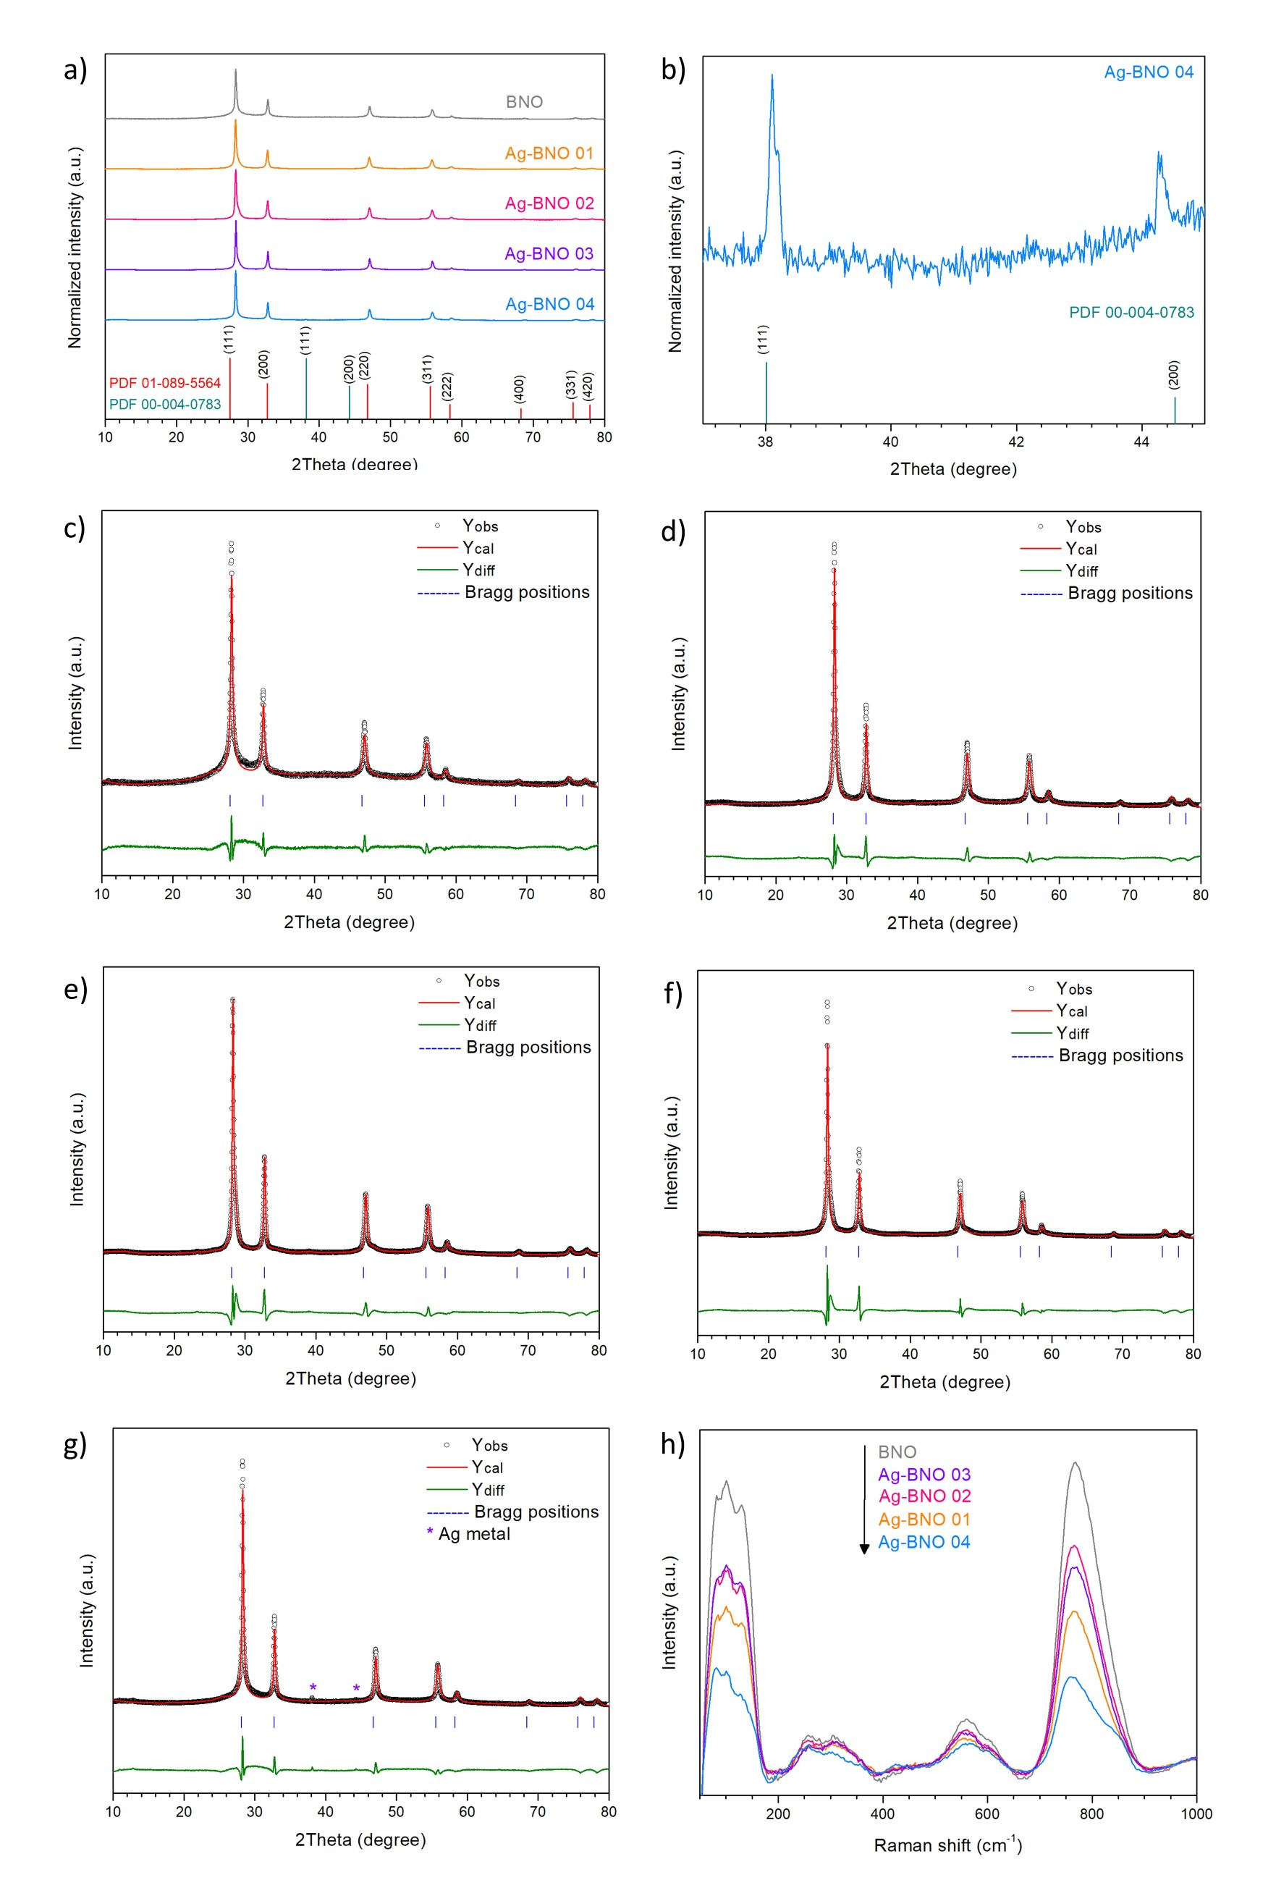
Figure 1. XRD patterns of all samples, along with the standard XRD patterns of Bi₃NbO₇ and metallic Ag correspond to PDF 01-089-5564 and PDF 00-004-0783, respectively (a). Enlarged X-ray diffraction pattern of Ag-BNO-04 highlighting the metallic Ag peaks corresponding to PDF 00-004-0783 database (b). Rietveld refinement plots of all samples, including BNO (c), Ag-BNO 01 (d), Ag-BNO 02 (e), Ag-BNO 03 (f) and Ag-BNO 04 (g). Raman spectra of all samples (h).
Table 1. Rietveld refinement parameters including lattice parameter a, unit-cell volume (V), Bi-O/Nb-O bond lengths, %R_{exp}, %R_{wp}, specific BET surface area (S_{BET}) and band gap energy (E_{g}) of BNO, Ag-BNO 01, Ag-BNO 02, Ag-BNO 03 and Ag-BNO 04.
Sample | a (Å) | V (Å³) | Bi-O/Nb-O (Å) |  | %R_{exp} | %R_{wp} | S_{BET} (m².g⁻¹) | E_{g} (eV)
BNO | 5.4616(19) | 162.9(2) | 2.014(9) | 2.896(21) | 3.42 | 10.41 | 20.54 | 2.94
Ag-BNO 01 | 5.4648(13) | 163.2(1) | 2.045(7) | 2.827(2) | 2.51 | 12.28 | 20.67 | 2.96
Ag-BNO 02 | 5.4644(17) | 163.2(2) | 2.038(8) | 2.842(17) | 1.89 | 14.28 | 18.48 | 2.96
Ag-BNO 03 | 5.4599(15) | 162.8(1) | 2.078(10) | 2.752(19) | 1.90 | 14.78 | 22.92 | 2.96
Ag-BNO 04 | 5.4580(11) | 162.6(9) | 2.042(8) | 2.823(16) | 1.97 | 10.94 | 16.75 | 2.94

Table 2. Crystallographic information of all samples: BNO, Ag-BNO 01, Ag-BNO 02, Ag-BNO 03 and Ag-BNO 04.
Atom | Site | x | y | z | Occupancy | Beq. (Å²)
BNO
Bi/Nb | 4a | 0 | 0 | 0 | 0.75/0.25 | 0.93
O | 48g | 0.1049(52) | 1/4 | 1/4 | 0.1458 | 2.4
Ag-BNO 01
Bi/Nb | 4a | 0 | 0 | 0 | 0.75/0.25 | 0.93
O | 48g | 0.1224(38) | 1/4 | 1/4 | 0.1458 | 2.4
Ag-BNO 02
Bi/Nb | 4a | 0 | 0 | 0 | 0.75/0.25 | 0.93
O | 48g | 0.1186(43) | 1/4 | 1/4 | 0.1458 | 2.4
Ag-BNO 03
Bi/Nb | 4a | 0 | 0 | 0 | 0.75/0.25 | 0.93
O | 48g | 0.1409(49) | 1/4 | 1/4 | 0.1458 | 2.4
Ag-BNO 04
Bi/Nb | 4a | 0 | 0 | 0 | 0.75/0.25 | 0.93
O | 48g | 0.1225(40) | 1/4 | 1/4 | 0.1458 | 2.4

High-resolution TEM images (Figure 2 and Figure S1) reveal well-defined lattice fringes corresponding to the (111) planes of Bi₃NbO₇ in all samples, confirming high crystallinity in all the synthesized materials. The interplanar spacing of the (111) planes are approximately 0.33 nm for pristine BNO, which agrees well with literature [9,21,23,25–27,43,44]. The d₁₁₁ value slightly decreases to ∼0.32 nm for Ag-BNO 01, Ag-BNO 02 and Ag-BNO 03, indicating minor lattice contraction induced by Ag incorporation. Notably, additional lattice fringes corresponding to the (200) planes are observed only in BNO and Ag-BNO 01, suggesting negligible variations in crystal orientation or growth behaviour in the lattices [13,24,28,29]. In contrast, Ag-BNO 04 exhibits a significantly reduced (111) interplanar spacing of approximately 0.30 nm. This pronounced lattice contraction is consistent with the appearance of metallic Ag diffraction peaks in XRD and can be attributed to strain effects and local structural distortion arising from Ag phase segregation. These observations indicate that low to moderate Ag incorporation preserves the crystalline framework of Bi₃NbO₇ with only minor lattice perturbation, whereas excessive Ag loading induces substantial lattice distortion and structural heterogeneity.
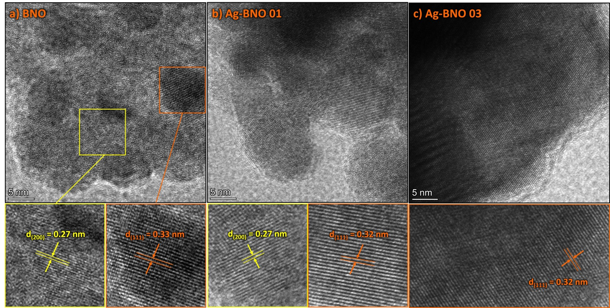
Figure 2. High resolution TEM images of BNO (a), Ag-BNO 01 (b), Ag-BNO 02 (c), Ag-BNO 03 (d) and Ag-BNO 04 (e).

2. Chemical composition and location of metallic Ag
To elucidate the chemical composition and spatial distribution of Ag species, a combination of SEM-EDS, TEM-EDS, and XPS analyses was employed. SEM-EDS elemental mappings (Figure 3) confirm the uniform distribution of Bi, Nb and O across the particles in all samples. Table S1 summarizes the atomic percentage (at.%) of all constituent elements. Interestingly, Ag signals are detected only in Ag-BNO 04. This observation is consistent with the presence of metallic Ag diffraction peaks in the XRD pattern of Ag-BNO 04, indicating that excessive Ag loading leads to Ag phase segregation in the bulk sample. However, the absence of detectable Ag in Ag-BNO 01, Ag-BNO 02 and Ag-BNO 03 by SEM-EDS suggests that the metallic Ag species are either present at very low concentrations or are exposed to the near surface.
In contrast, TEM-EDS analysis (Figure 4 and Table S2) reveals the presence of Ag in all Ag-BNO samples. The presence of Ag detected by TEM-EDS but not by SEM-EDS for Ag-BNO 01, Ag-BNO 02 and Ag-BNO-03 suggest that Ag species are present in very low concentrations (i.e. below the EDS detection limit of ∼0.1 wt.%) and are predominantly exposed to the near surface (i.e. less than 100 nm).
X-ray photoelectron spectroscopy provides details of the surface chemical states of the samples. XPS survey spectra confirm the presence of Bi, Nb and O in all samples (Figure 5a). Notably, no Ag-related signals (Ag 3d_{5/2} or Ag 3d_{3/2}) are detected in the XPS spectra of any Ag-BNO samples (Figure 5b). Considering the limited detection depth of XPS (ca. 1-10 nm), this observation strongly suggests that Ag species are not exposed to the outermost surface but are embedded beneath the surface or highly dispersed within the near-surface region of Bi₃NbO₇. Shen and coworkers reported the detection of Ag 3d XPS spectrum for Ag deposited on the surface of Bi₃NbO₇ [32], which further confirms that Ag species in our samples are incorporated beneath the surface, beyond the XPS detection depth (i.e. approximately 10 nm). High-resolution spectra of Bi 4f and Nb 3d (Figure 5c-d) of all samples display well-defined spin-orbit doublets characteristic of Bi³⁺ and Nb⁵⁺, respectively, with the binding energies summarized in Table S2. For BNO, the Bi 4f_{7/2} and Bi 4f_{5/2} peaks are located at 158.62 and 163.94 eV, while the Nb 3d_{5/2} and Nb 3d_{3/2} peaks appear at 206.24 and 208.96 eV, consistent with the reported values for Bi₃NbO₇ [13,15,16,23,27,28,30,32,45]. Upon Ag incorporation, both Bi 4f and Nb 3d core levels exhibit slight positive shifts in binding energy (ca. 0.2-0.5 eV), without changes in peak shape or splitting. These subtle shifts suggest a modification of the local electronic environment around Bi and Nb atoms, likely arising from interfacial electronic interactions induced by subsurface Ag species rather than changes in oxidation state. The O 1s spectra (Figure 5e) of all samples can be deconvoluted into two or three components. The dominant low-binding-energy component at approximately 529.5-529.9 eV (O_{I}) is attributed to lattice oxygen (Bi-O/Nb-O), while the higher-binding-energy components at approximately 531.3-532.0 eV (O_{II}) and approximately 533.2-533.4 eV (O_{III}) are commonly associated with surface hydroxyl groups or adsorbed oxygen species [8,15,25,46]. Notably, no significant change in the relative contribution of lattice O species is observed upon Ag incorporation, indicating that subsurface Ag does not induce significant surface hydroxylation or oxygen-defect formation, consistent with the absence of oxygen vacancy signals in EPR measurements (Figure 5f).
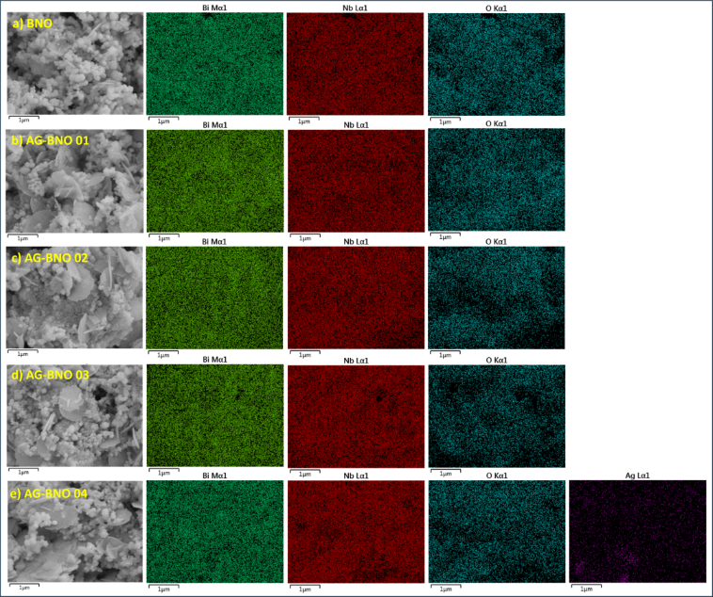
Figure 3. Scanning electron microscopy (SEM) images and its corresponding energy dispersive X-ray spectroscopy (EDS) mappings of BNO (a), Ag-BNO 01 (b), Ag-BNO 02 (c), Ag-BNO 03 (d) and Ag-BNO 04 (e).

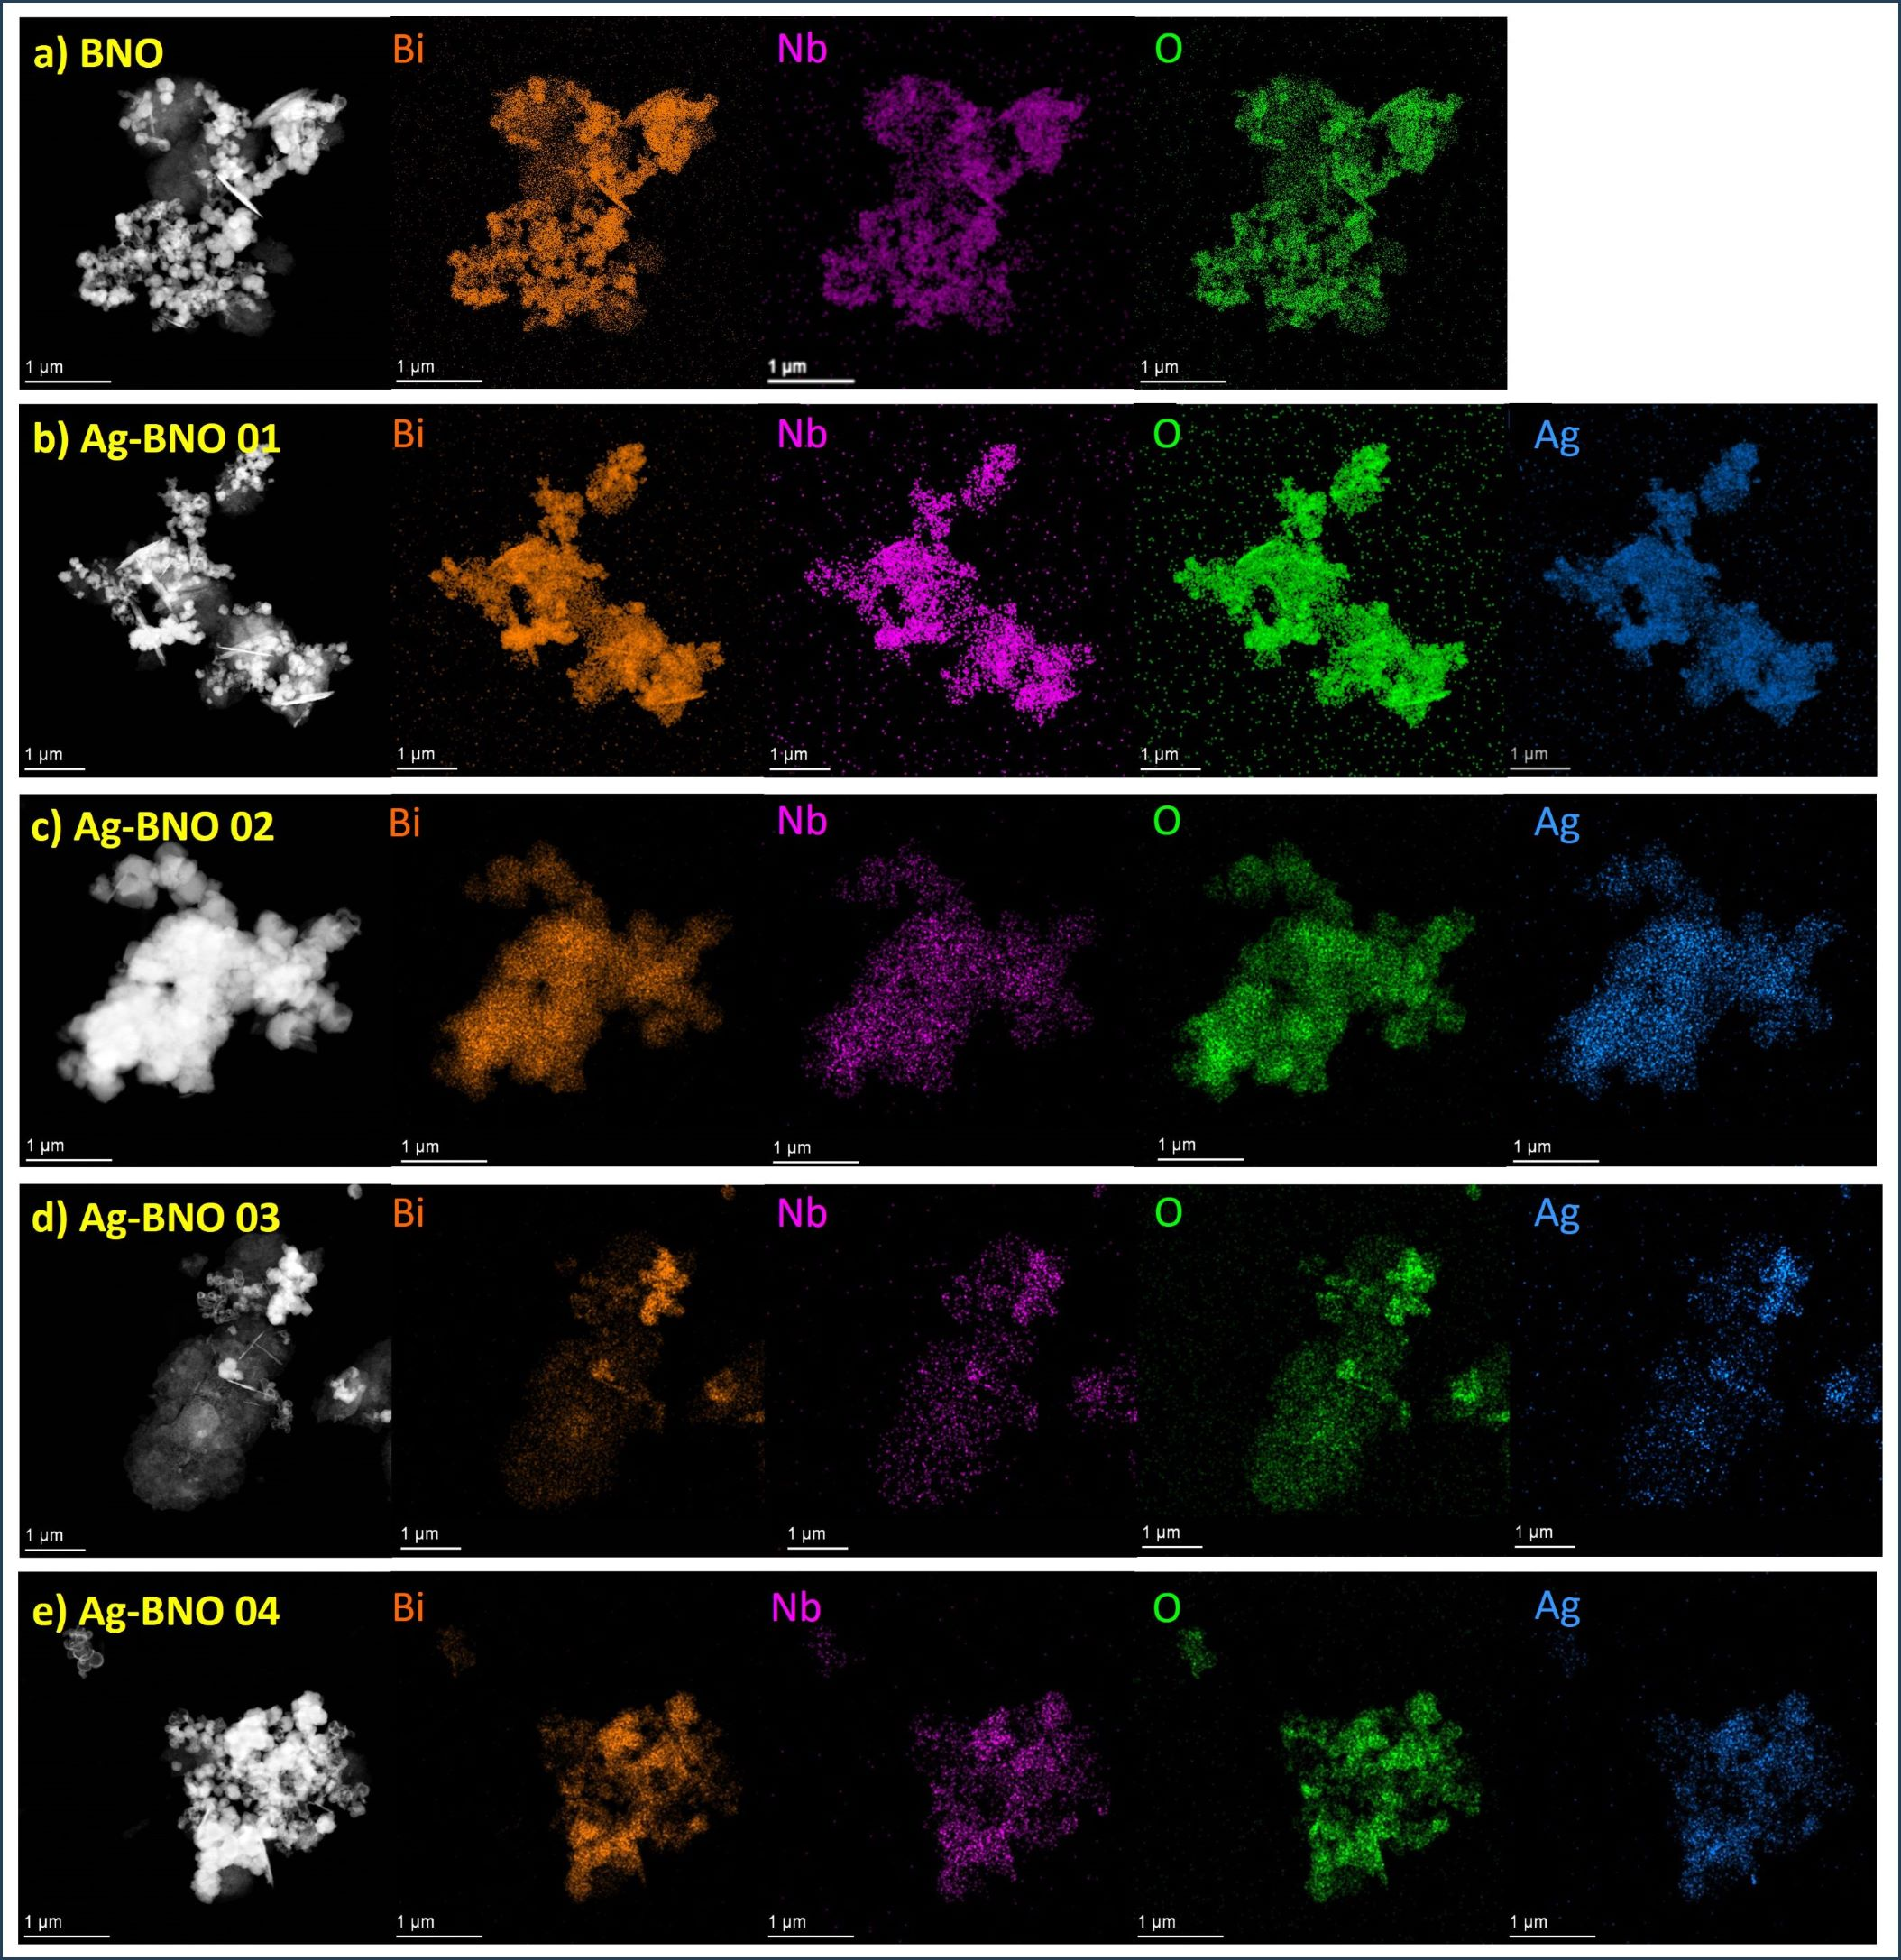
Figure 4. Transmission electron microscopy (TEM) images and its corresponding energy dispersive X-ray spectroscopy (EDS) mappings of BNO (a), Ag-BNO 01 (b), Ag-BNO 02 (c), Ag-BNO 03 (d) and Ag-BNO 04 (e).

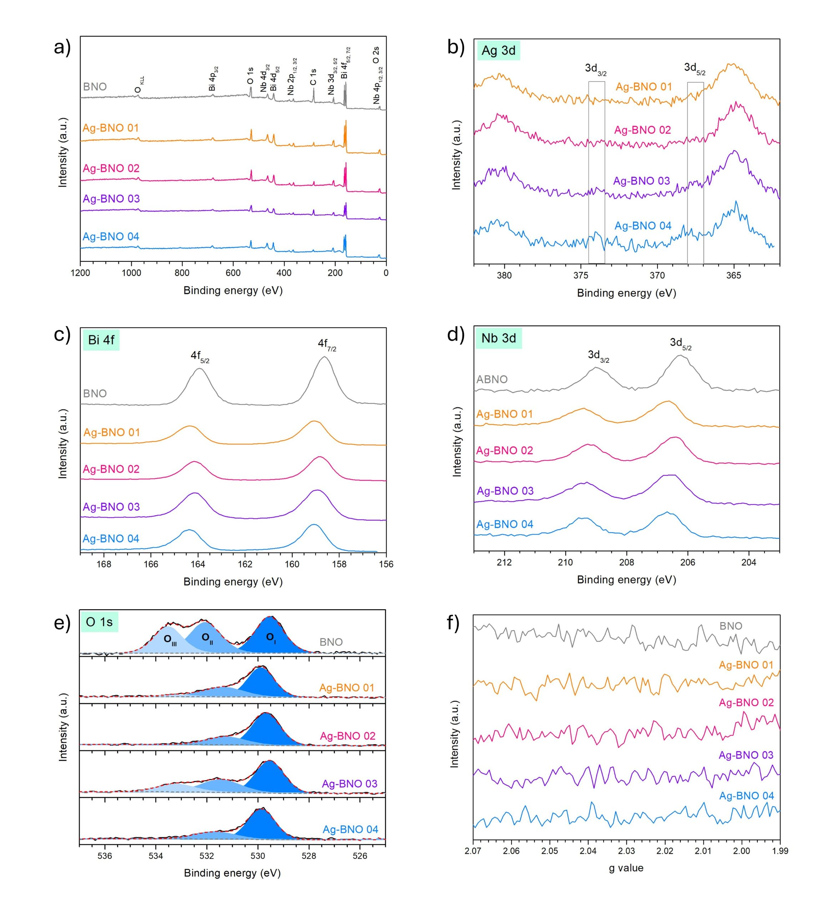
Figure 5. Survey XPS spectra (a) of all samples and the corresponding high-resolution XPS spectra including Ag 3d (b), Bi 4f (c), Nb 3d (d) and O 1s (e). EPR spectra of all samples (f).

3. Morphology and surface properties
The morphological features of the samples were examined by SEM (Figure 6). BNO consists mainly of nanoparticles with a relatively uniform size distribution (Figure 6a), which is consistent with observations in other studies that utilize hydrothermal methods for the synthesis of Bi₃NbO₇ [14,15,25,26]. Upon Ag incorporation, round nanosheet-like structures gradually develop and coexist with nanoparticles in Ag-BNO samples (Figure 6b-6e). This morphological evolution suggests that Ag precursor influences the nucleation and growth processes during hydrothermal synthesis. At highest Ag concentration in precursor solution (Ag-BNO 04), severe particle coalescence and partial fusion are observed, indicating sintering-like behaviour (Figure 6e).
Nitrogen adsorption-desorption isotherms (Figure 7) of all samples exhibit characteristics close to type III behaviour according to the IUPAC classification, suggesting weak adsorbate-adsorbent interactions [45]. The Barrett-Joyner-Halenda (BJH) pore size distribution plots (insets in Figure 7) reveal the coexistence of mesopores (2-50 nm) and macropores (>50 nm), indicating a hierarchical porous structure. This observation is further supported by the presence of a narrow hysteresis loop at high relative pressures (P/P₀), which could be attributed to interparticle voids and a mixed meso-macroporous architecture. Compared with BNO, Ag-BNO 01 and Ag-BNO 02 display broader mesopore distributions with contributions extending toward larger pore diameters, indicating a more heterogeneous mesoporous structure, likely associated with interparticle voids induced by Ag incorporation. In contrast, Ag-BNO 03 exhibits a pore size distribution centred at similar mesopore diameters (∼4 nm) to those of BNO but with higher pore population density. This behaviour may arise from an optimal Ag loading that promotes more uniform particle packing or prevents agglomeration, thereby enhancing the availability of mesopores. On the other hand, Ag-BNO 04 shows a reduced pore population at similar pore diameters compared with BNO, which can be attributed to excessive Ag loading leading to obstruction of mesoporous domains.
The specific surface areas of all samples, determined using the Brunauer-Emmett-Teller (BET) method, are summarized in Table 1. The S_{BET} value of BNO is 20.54 m²/g. Although the hydrothermal method is commonly used, variations in precursors, reaction temperature and time, and the use of additives can lead to a wide range of S_{BET} values, such as 5.464 m²/g [25], 7.87 m²/g [12], 13.9 m²/g [10], 71.61 m²/g [27]. Upon the incorporation of Ag, noticeable variations in the BET surface area were observed among the Ag-BNO samples, suggesting that the presence of Ag influences the textural properties of BNO. The Ag-BNO 01 sample exhibited a BET surface area (20.67 m²/g) comparable to that of BNO, implying that a low Ag loading in the precursor solution does not substantially alter pore accessibility in the BNO lattice. In the case of Ag-BNO 02, the BET surface area decreased to 18.48 m²/g, which can be attributed to partial pore blockage or surface coverage by Ag clusters, leading to a reduction in the accessible surface area. With further Ag incorporation, Ag-BNO 03 exhibited a marked increase in BET surface area, reaching the highest value of 22.92 m²/g, which is notably higher than that of BNO. This enhancement indicates that an optimal Ag loading facilitates a more homogeneous dispersion of incorporated Ag species and may suppress particle agglomeration or restacking of BNO, thereby increasing the available surface area. This increase in surface area can be attributed to an increase in the fraction of small mesopores, described earlier. However, when the Ag aggregates presence, the BET surface area of Ag-BNO 04 markedly decreased to 16.75 m²/g. This decline is likely due to excessive Ag clusters, which intensifies pore blockage and surface shielding effects, ultimately limiting the accessible surface area.
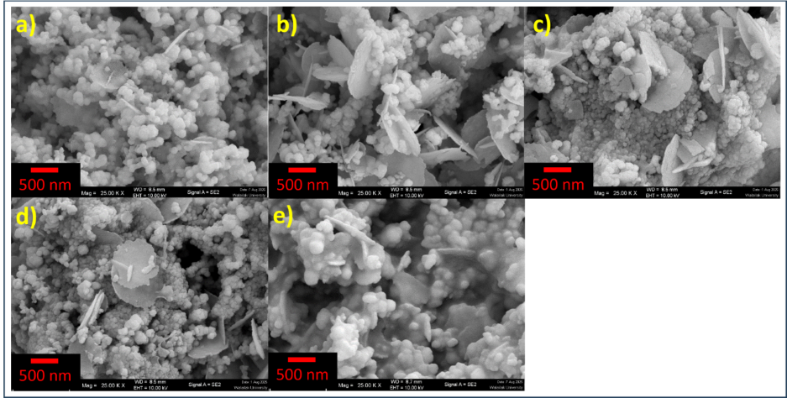
Figure 6. Scanning electron microscopy (SEM) images of BNO (a), Ag-BNO 01 (b), Ag-BNO 02 (c), Ag-BNO 03 (d) and Ag-BNO 04 (e).

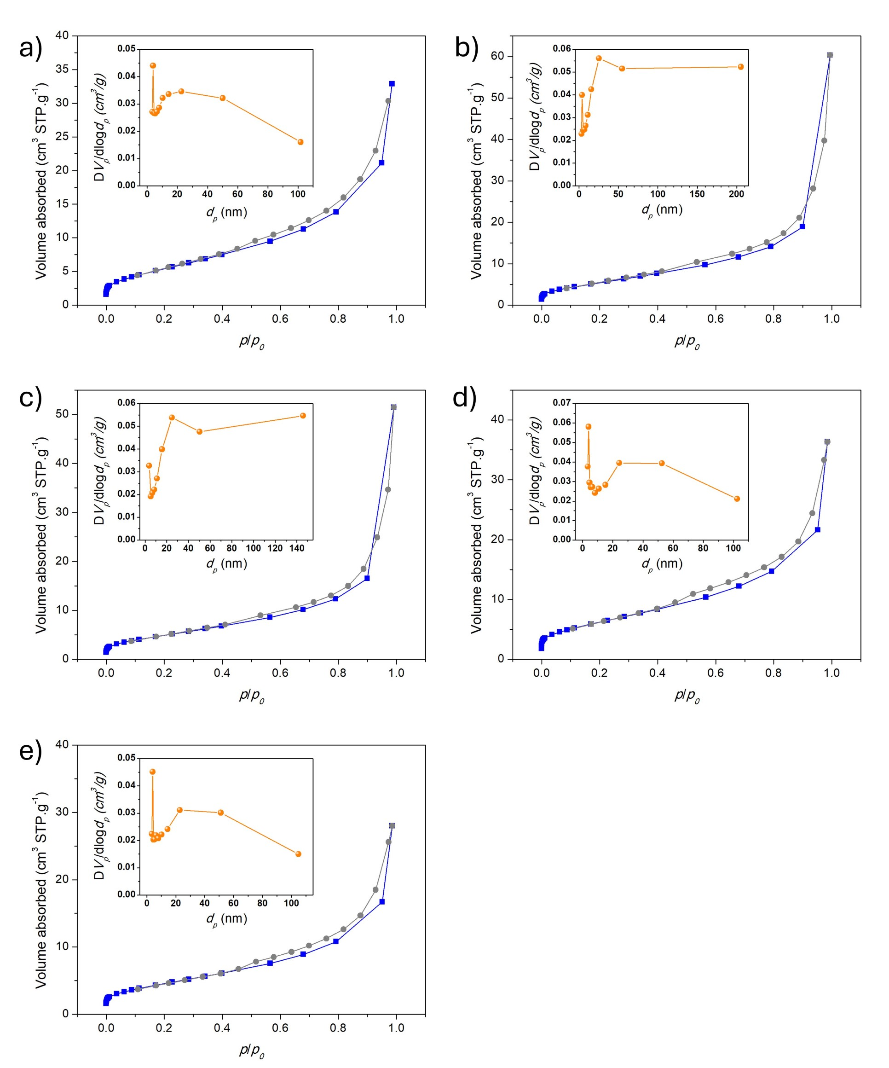
Figure 7. N₂ adsorption-desorption isotherms and pore size distributions of BNO (a), Ag-BNO 01 (b), Ag-BNO 02 (c), Ag-BNO 03 (d) and Ag-BNO 04 (e).

4. Optical properties and electronic band structure
The optical properties of the samples were investigated by UV-vis diffuse reflectance spectroscopy (DRS), as shown in Figure 8a. All samples exhibit a sharp absorption edge in the visible-light region. The optical band gap energies were estimated using the Kubelka-Munk function in combination with the Tauc plot method. The Kubelka-Munk function was defined as F(R∞​) = (1-R∞​)²/2R∞​, where R∞​ denotes the diffuse reflectance of the sample relative to the standard. Given that Bi₃NbO₇ exhibited an indirect allowed transition [25,26,32,33], the band gap energy (E_{g}) was determined using the Tauc equation, [F(R∞​)hν]^{1/2} = α(hν - E_{g}), where α represents the absorption coefficient, h is Planck’s constant and ν corresponds to the photon frequency [46,47]. As shown in Figure 8b, BNO exhibits an optical band gap of approximately 2.94 eV, which is consistent with previously reported values for Bi₃NbO₇ [12,14,22,23,27,44]. Upon Ag incorporation, the absorption edges remain nearly unchanged, with band gap energies of approximately 2.94-2.96 eV for all Ag-BNO samples. The negligible variation in band gap energy indicates that Ag incorporation does not induce bandgap narrowing or alter the fundamental electronic transition of Bi₃NbO₇.
To gain further insight into the electronic structure, density functional theory (DFT) calculations were performed for pristine Bi₃NbO₇ and Bi₃NbO₇ containing subsurface Ag clusters. The total density of states (TDOS) and partial density of states (pDOS) are shown in Figure 8d-8f. For pristine Bi₃NbO₇, the valence band maximum (VBM) is primarily composed of O 2p states with some hybridization from Nb 4d orbitals, while the conduction band minimum (CBM) is dominated by Nb 4d with notable contribution from Bi 6p orbitals, consistent with its oxide semiconductor nature. Upon the introduction of subsurface Ag clusters, the overall band gap remains essentially unchanged. The Ag 4d states are mainly located in the upper valence band region and show hybridization with O 2p orbitals. The structural models and simulated XRD patterns (Figures S2) further confirm that Ag incorporation does not disrupt the long-range crystal structure of Bi₃NbO₇, supporting the experimental observations from XRD and Rietveld refinement results.
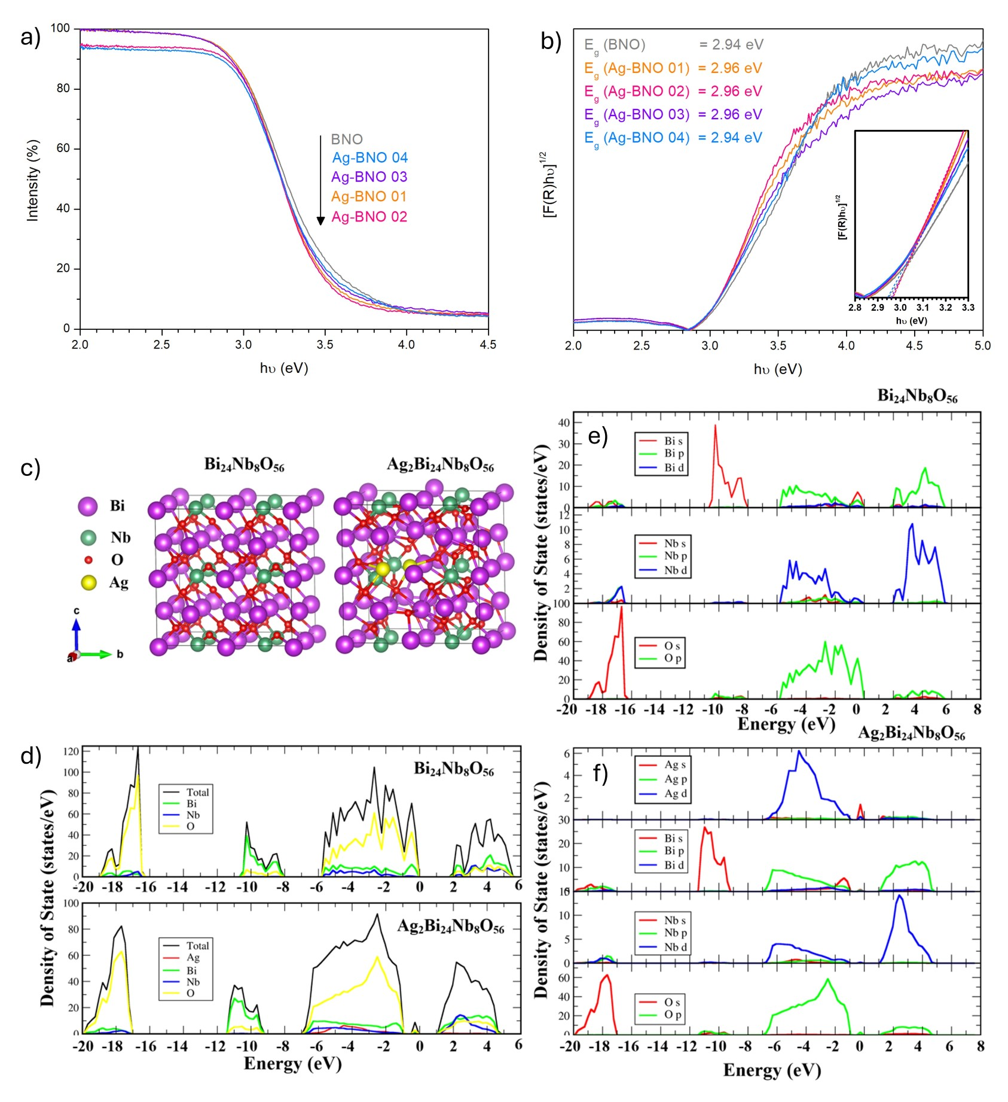
Figure 8. Diffuse reflectance spectroscopy (DRS) plots (a) and corresponding Tauc plots obtained using the Kubelka-Munk function (b), along with the extracted band gap energies (inset). The total density of states (TDOS) of pristine Bi₂₄Nb₈O₅₆ and Ag clusters-incorporated Bi₂₄Nb₈O₅₆ (d) and the partial density of states (pDOS) of pristine Bi₂₄Nb₈O₅₆ (e) and Ag clusters-incorporated Bi₂₄Nb₈O₅₆ (f).

4. Photocatalytic properties
The photocatalytic activities of the samples were evaluated using degradation of Rh B, TC and MO under visible-light irradiation and photocatalytic hydrogen evolution in the presence of methanol as a sacrificial agent.
Figure 9a shows the changes in Rh B concentration expressed as C/C₀, where C₀ and C represent the initial and instantaneous concentrations, respectively. Negligible Rh B degradation is observed in the absence of photocatalyst, indicating that photolysis is insignificant. BNO exhibits moderate photocatalytic activity, while a progressive enhancement in photocatalytic performance is observed from Ag-BNO 01 to Ag-BNO 03. While Ag-BNO 01 exhibits a degradation efficiency slightly lower than that of BNO, Ag-BNO 02 shows enhanced photocatalytic activity. Notably, Ag-BNO 03 achieves the highest Rh B degradation efficiency, reaching 67% degradation within 120 min. However, the degradation rate decreases again to below that of BNO in Ag-BNO 04. These results suggest that the photocatalytic performance is governed by the state and distribution of Ag species rather than the absolute Ag content in the final materials. The corresponding apparent reaction rate constants (k_{app}), obtained by fitting the degradation data to a pseudo-first-order kinetic model (Figure S3), are summarized in Figure 9b. The k_{app} values follow the order: Ag-BNO 03 > Ag-BNO 02 > BNO > Ag-BNO 01 ∼ Ag-BNO 04. Furthermore, photocatalytic degradation tests for TC and MO were also conducted. Ag-BNO 03 achieved 46% degradation of TC; however, it showed no detectable activity toward MO.
To identify the dominant reactive species during Rh B degradation, radical scavenging experiments were performed (Figure 9c). The addition of EDTA-2Na, a hole (h⁺) scavenger, results in a pronounced decrease in degradation efficiency, while isopropanol (IPA), a hydroxyl radical (•OH) scavenger, exhibits a moderate inhibitory effect. In contrast, benzoquinone (BQ), a superoxide radical (O₂^{•-}) scavenger, shows negligible influence. These results indicate that photogenerated holes are the main active species, with hydroxyl radicals playing a minor role in the degradation process.
Photocatalytic hydrogen evolution was further investigated to assess the reduction capability of the samples. As shown in Figure 9d, among all samples, only 1 wt.%Pt deposited Ag-BNO 01 exhibits H₂ evolution activity under visible-light irradiation, with a hydrogen production rate of 66.2 μmol h⁻¹ g⁻¹. A higher photocatalytic H₂ production rate of 110.7 μmol h⁻¹ g⁻¹ was previously reported for single-crystalline Bi₃NbO₇ nanoparticles deposited with a Ni/NiO cocatalyst in the presence of a hole scavenger (15 v/v% MeOH), indicating that the observed activity in Ag-BNO 01 is consistent with earlier reports of visible-light-driven H₂ evolution in similar materials [10].
The photocatalyst remained excellent stability after photocatalytic test, as evidenced by structural, chemical and physical characterizations (Figure S4). The XRD patterns confirmed that the crystal structure was preserved (Figure S4a). In addition, the particle morphology remained unchanged (Figure S4b) and EDS elemental mapping showed a uniform distribution of chemical components throughout the sample (Figure S4c). The FT-IR spectra of the Ag-BNO 01 sample obtained before and after the photocatalytic test shows absorption bands corresponding to the stretching vibrations of Bi-O, Nb-O and Nb-O-Nb as well as Bi-O coordination vibrations characteristics of Bi₃NbO₇, consistent with previous reports in the literature (Figure S4d) [19,23,28,29,33,48].
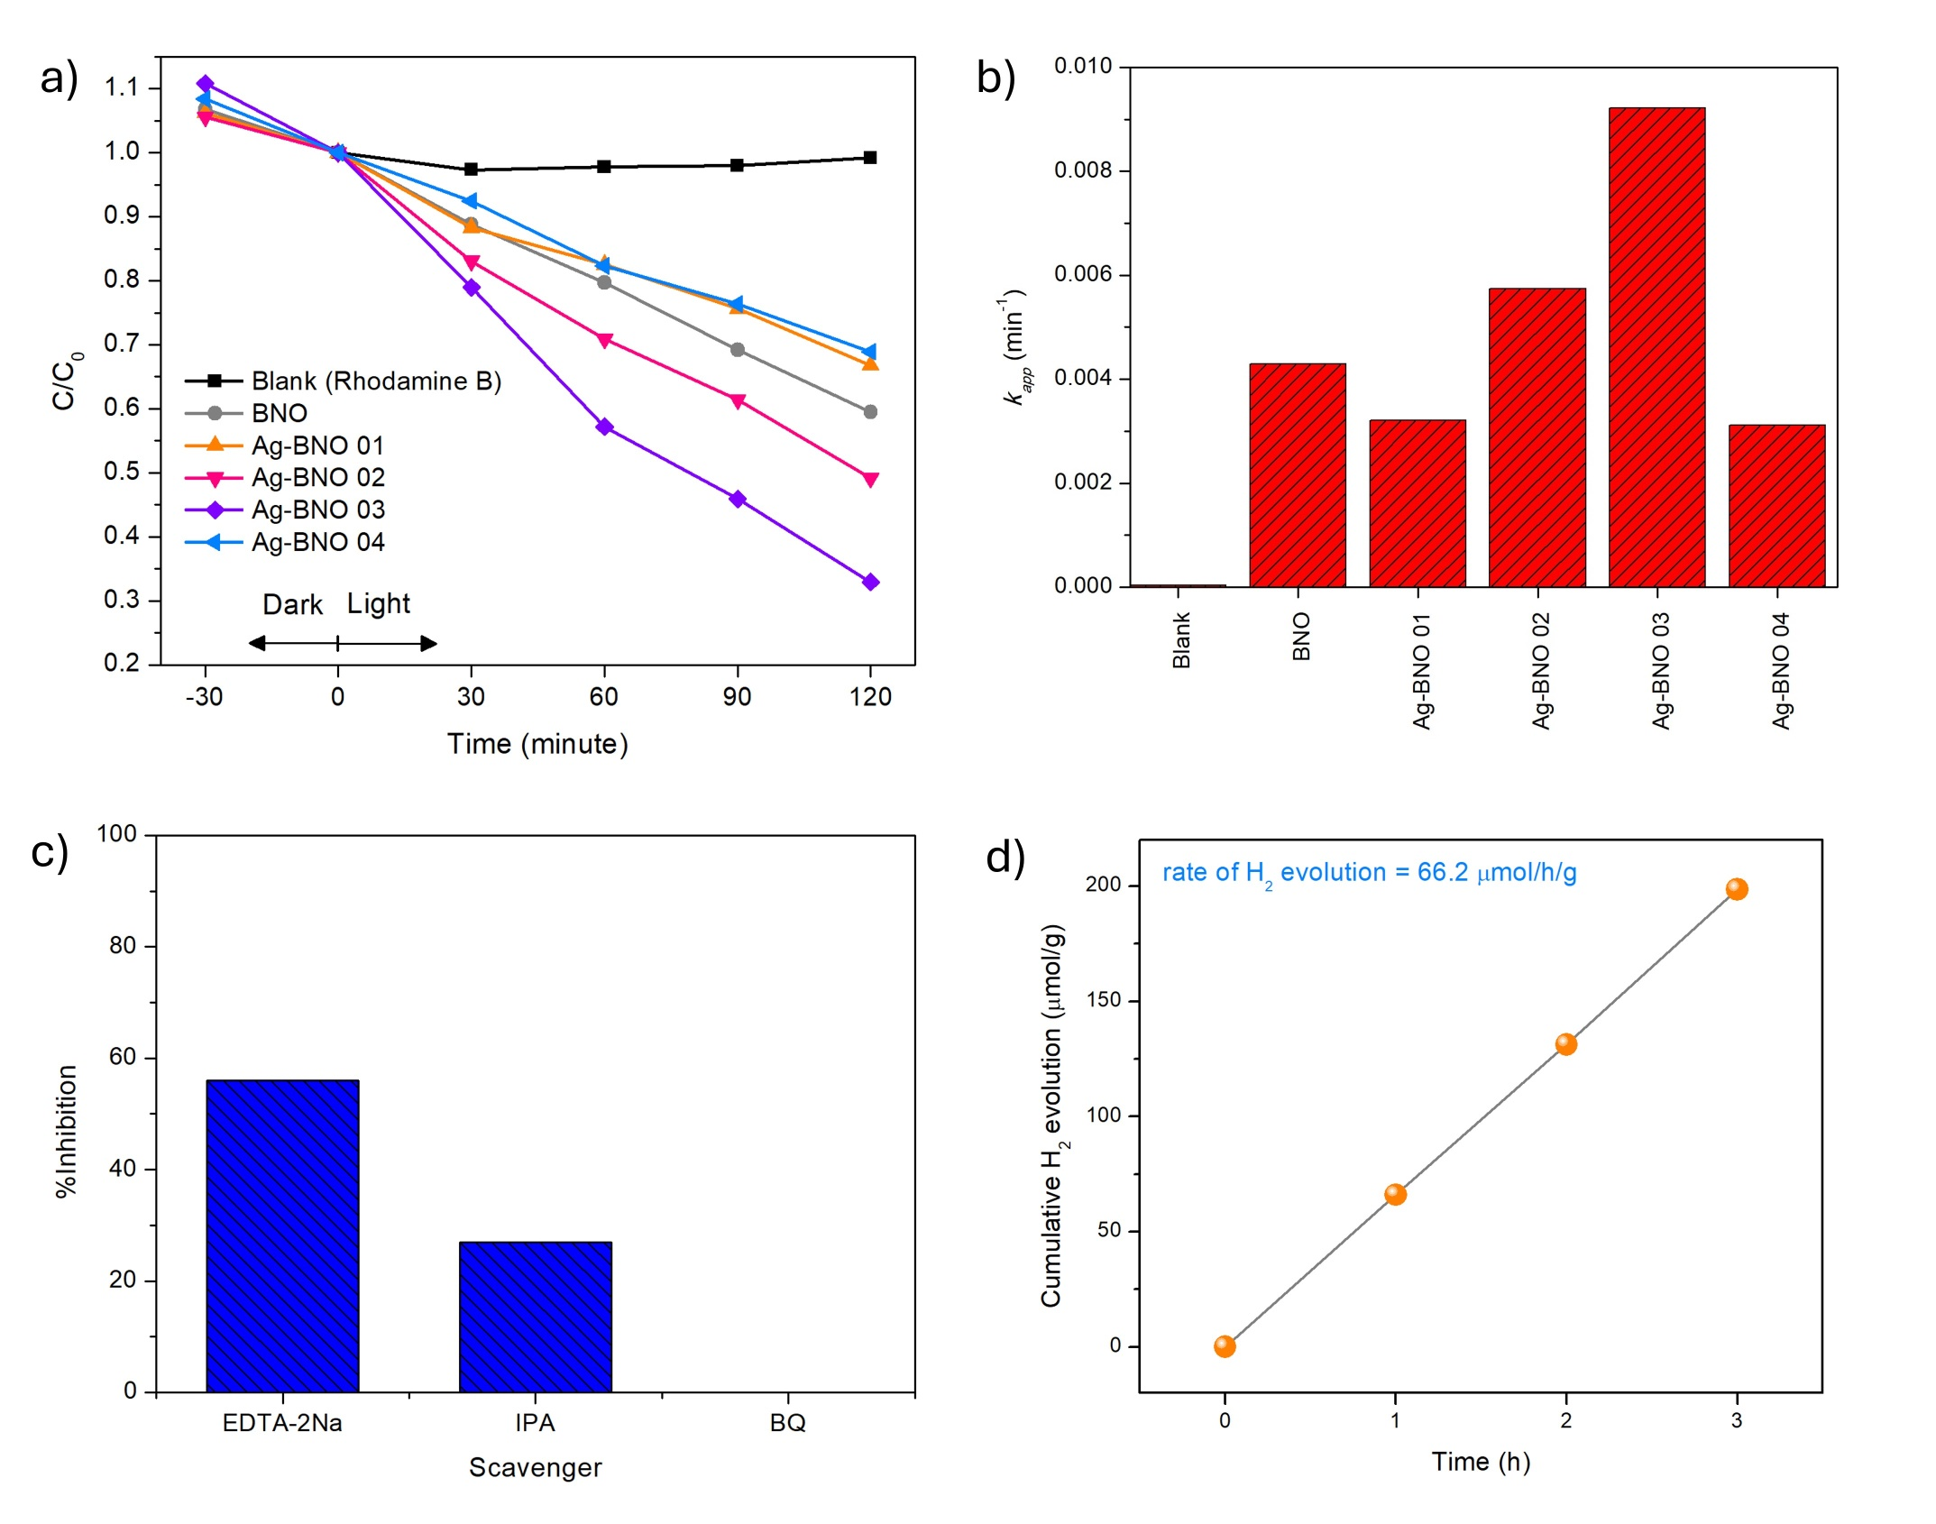
Figure 9. Photocatalytic degradation profiles of Rhodamine B (C/C₀) for all samples and Rhodamine B solution as the blank (a), corresponding apparent kinetic constants (k_{app}) (b), Active-species trapping experiments for Ag-BNO 03 (c), and photocatalytic H₂ evolution performance of Ag-BNO 01 (d).

5. Charge carrier separation, transfer and dynamics
To elucidate the role of subsurface Ag incorporation on the photocatalytic behaviour of Bi₃NbO₇, the charge carrier separation and interfacial charge transfer properties were investigated by photoelectrochemical (PEC) and transient absorption spectroscopy (TAS) methods.
Our PEC approach applied transient photocurrent measurements, electrochemical impedance spectroscopy (EIS), including Nyquist and Mott-Schottky analyses, to evaluate charge separation and transfer efficiency and to develop a band energy model [14,16,30,49]. Figure 10a shows the transient photocurrent responses of all samples under dark and light irradiation. BNO exhibits a stable but moderate photocurrent density, indicating limited photoinduced charge separation efficiency. Upon Ag incorporation, although all Ag-BNO samples contain subsurface metallic Ag species, their photocatalytic behaviours differ. Ag-BNO 01 shows the highest photocurrent response, suggesting that a structural distribution with highly dispersed subsurface Ag leads to the most efficient electron-hole separation. In contrast, excessive Ag aggregation in Ag-BNO 04 results in degraded charge transfer and increased spatial recombination.
Electrochemical impedance spectroscopy (EIS) was employed to further evaluate the interfacial charge transfer properties of the samples. As shown in the Nyquist plots (Figure 10b), BNO exhibits the largest semicircle radius, indicating the highest charge-transfer resistance at the electrode-electrolyte interface. Upon incorporation of subsurface Ag species, the semicircle radius decreases significantly. Among all samples, Ag-BNO 02 shows the smallest semicircle, corresponding to the lowest charge transfer resistance, indicating the most facile interfacial charge transfer. Ag-BNO 01 and Ag-BNO 03 exhibit comparable semicircle sizes, suggesting similar charge-transfer resistances and interfacial kinetics. In contrast, Ag-BNO 04 presents a noticeably larger semicircle than other Ag-BNO samples, although still smaller than that of pristine BNO, indicating that excessive Ag loading partially impedes charge transfer. The increased impedance observed for Ag-BNO 04 can be attributed to the formation of metallic Ag aggregates, as evidenced by XRD, which may introduce electron scattering centres or disrupt continuous charge transport pathways at the semiconductor-electrolyte interface. Conversely, samples containing well-dispersed or subsurface Ag species (Ag-BNO 01-03) benefit from improved interfacial conductivity and reduced charge-transfer resistance.
Further insight into the electrochemical properties of the samples was obtained from Mott-Schottky analysis. As shown in Figure 10c, all samples exhibit positive slopes in the Mott-Schottky plots, confirming their n-type semiconductor characteristics. The linear regions of the plots allow the estimation of the flat-band potentials (E_{fb}) versus Ag/AgCl, which are converted to NHE scale using the Nernst equation: E_{NHE} = E_{Ag/AgCl} + 0.209. For n-type semiconductors, the conduction band minimum (CBM) is generally assumed to be located approximately 0.1 V more negative than E_{fb} [14,30]. Notably, the Mott-Schottky plots of BNO and Ag-BNO samples show very similar slopes and interceptions (Table 3), indicating that Ag incorporation does not significantly alter the charge carrier density or the intrinsic electronic structure of Bi₃NbO₇. As shown in Table 3, the extracted flat-band potentials for all samples are nearly identical, suggesting that the CBM positions remain essentially unchanged upon Ag modification. This observation is consistent with the optical band gap and DFT results, which show negligible variation in band gap energies and band edge positions among the samples.
Based on the flat-band potentials derived from the Mott-Schottky analysis and the optical band gap values, the corresponding band structure alignments of all samples are illustrated in Figure 10d. The band diagrams reveal that both the CBM and valence band maximum (VBM) positions of Ag-BNO samples are closely aligned with those of BNO. Importantly, the CBM positions of all samples are more negative than the H⁺/H₂ reduction potential, while the VBMs remain sufficiently positive relative to the H₂O/O₂ oxidation potential, indicating that all materials are thermodynamically capable of driving photocatalytic redox reactions. Importantly, band alignment analysis reveals that all samples possess nearly identical conduction band minimum (CBM) and valence band maximum (VBM) positions, indicating that Ag incorporation does not significantly alter the intrinsic band structure of Bi₃NbO₇.
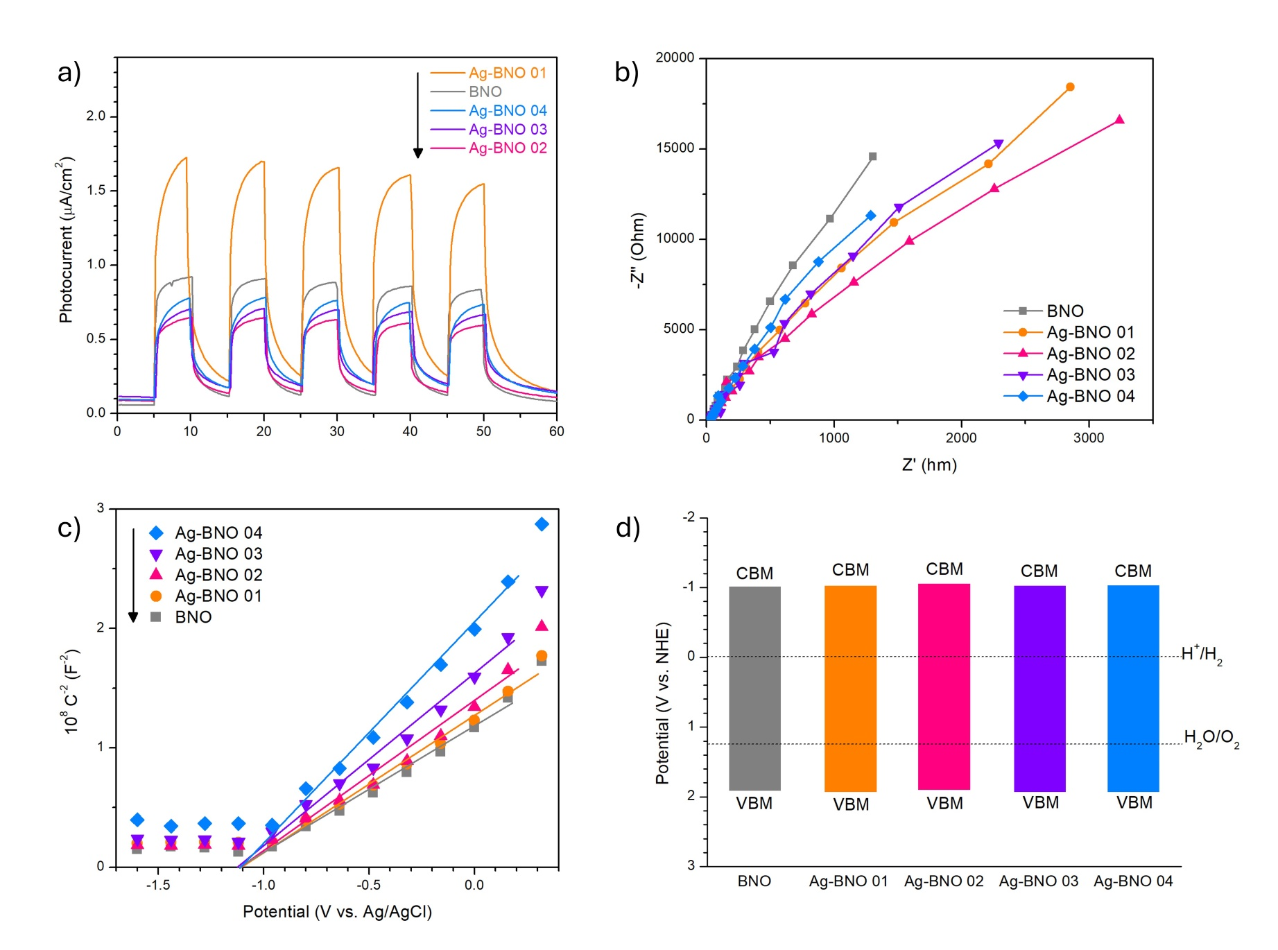
Figure 10. Transient photocurrent density measurement (I-t plot) (a), electrochemical impedance (EIS) Nyquist plots (b) and Mott-Schottky plots (c) and schematic diagram for the band structure alignment (d) of all samples.

Table 3. The slope, flat band potential (E_{fb}) and donor density (N_{D}) obtained from the Mott-Schottky analysis. The calculated positions of conduction band minimum (E_{CBM}) and valence band maximum (E_{VBM}).
Sample | Slope  (F⁻² cm⁴ V⁻¹) | N_{D}  (cm⁻³) | E_{fb}  (V vs. NHE) | E_{CBM}  (V vs. NHE) | E_{VBM}  (V vs. NHE)
BNO | 1.589 × 10⁸ | 8.86 × 10²³ | -0.921 | -1.021 | 1.919
Ag-BNO 01 | 2.788 × 10⁸ | 5.05 × 10²³ | -0.926 | -1.026 | 1.934
Ag-BNO 02 | 2.449 × 10⁸ | 5.75 × 10²³ | -0.964 | -1.064 | 1.896
Ag-BNO 03 | 1.854 × 10⁸ | 7.60 × 10²³ | -0.925 | -1.025 | 1.935
Ag-BNO 04 | 1.710 × 10⁸ | 8.24 × 10²³ | -0.927 | -1.027 | 1.913

The detailed charge carrier dynamics underlying these effects are further elucidated by transient absorption spectroscopy (TAS). TAS was carried out on all samples in air. To our knowledge, this is the first transient absorption study of Bi₃NbO₇ on the μs to s timescale, where previously, researchers have studied ultrafast timescales from the fs to ns [50]. At early timescales (i.e from 10 μs), all samples showed a bleach (i.e. a negative transient absorption signal) in the blue region of the electromagnetic spectrum at 500 nm. For all samples, this signal transitioned from a bleach to a positive signal by ~25 μs after the laser pulse, and by ~100 μs, had reached a maximum transient absorption value, where the signal began to decay. At probe wavelengths in the red region of the electromagnetic spectrum, this behaviour was not observed (i.e. from 700 nm 1000 nm). The observation of bleach states at probe wavelengths close to the band edge of a semiconductor is common, and is indicative of the presence of defect energy levels within the bandgap (i.e. Urbach tail states) [51]. Neglecting the bleach states seen at early times, and considering the peak degree of transient absorption seen at ~100 μs after the laser pulse, all samples showed a far higher degree of transient absorption in the blue than in the red. Exemplar transient absorption kinetics and spectra are shown in Figure S5 and Figure S6, respectively, for BNO and Ag-BNO 03. And the evolution of the transient absorption spectra from 10 μs to 10 ms of all samples are shown in Figure S7.
To avoid any contribution from the bleach component seen at early timescales in the blue, we compare the transient decay kinetics in the red (i.e. at 900 nm) in Figure 11a. All samples show a similar shape in their transient decay kinetics, which can be well described by a power law decay function:
ΔO.D. (%) = A.t^{α} (Eq. 1)
where ΔO.D. (%) is the concentration of charge carriers at time, t, and A and α are fitting constants. A power law of this kind occurs when ideal bimolecular electron-hole recombination (a power law decay of order -1) is disrupted by a multiple trapping process, in which a carrier is repeatedly thermally excited to the band-edge to move, and ultimately recombine [52]. Fitting values for α for all samples are summarised in Figure S8. Importantly, differences were observed in the degree of transient absorption, which can be related to differences in charge carrier populations. The sample with the highest transient absorption signal at early times was Ag-BNO 03, followed by BNO, Ag-BNO 04 ~ Ag-BNO 01 and then Ag-BNO 02. These differences were quantified and compared in Figure 11b, alongside the time taken for each transient decay to reach half of the original value (i.e. t_{50%}). Importantly, all samples showed similar rates of recombination, with t_{50%} spanning from ~0.2 to 0.4 ms, except for sample Ag-BNO 02, that showed a t_{50%} of ~1.2 ms. Figure 11c shows the correlation between the degree of transient absorption seen at early timescales and the apparent rate constant k_{app} (min⁻¹) for the photocatalytic degradation of Rh B, with the only exception to this correlation being sample Ag-BNO 02. This indicated that the ability to produce a higher population of charge carriers would more likely result in a more active photocatalyst for this reaction. For example, sample Ag-BNO 03 showed the highest charge carrier concentration and was the most active photocatalyst, and thus indicated that the mechanism to achieve high activity is related to enhancements in the spatial separation of charge carriers at early timescales (i.e. pre-μs timescales).

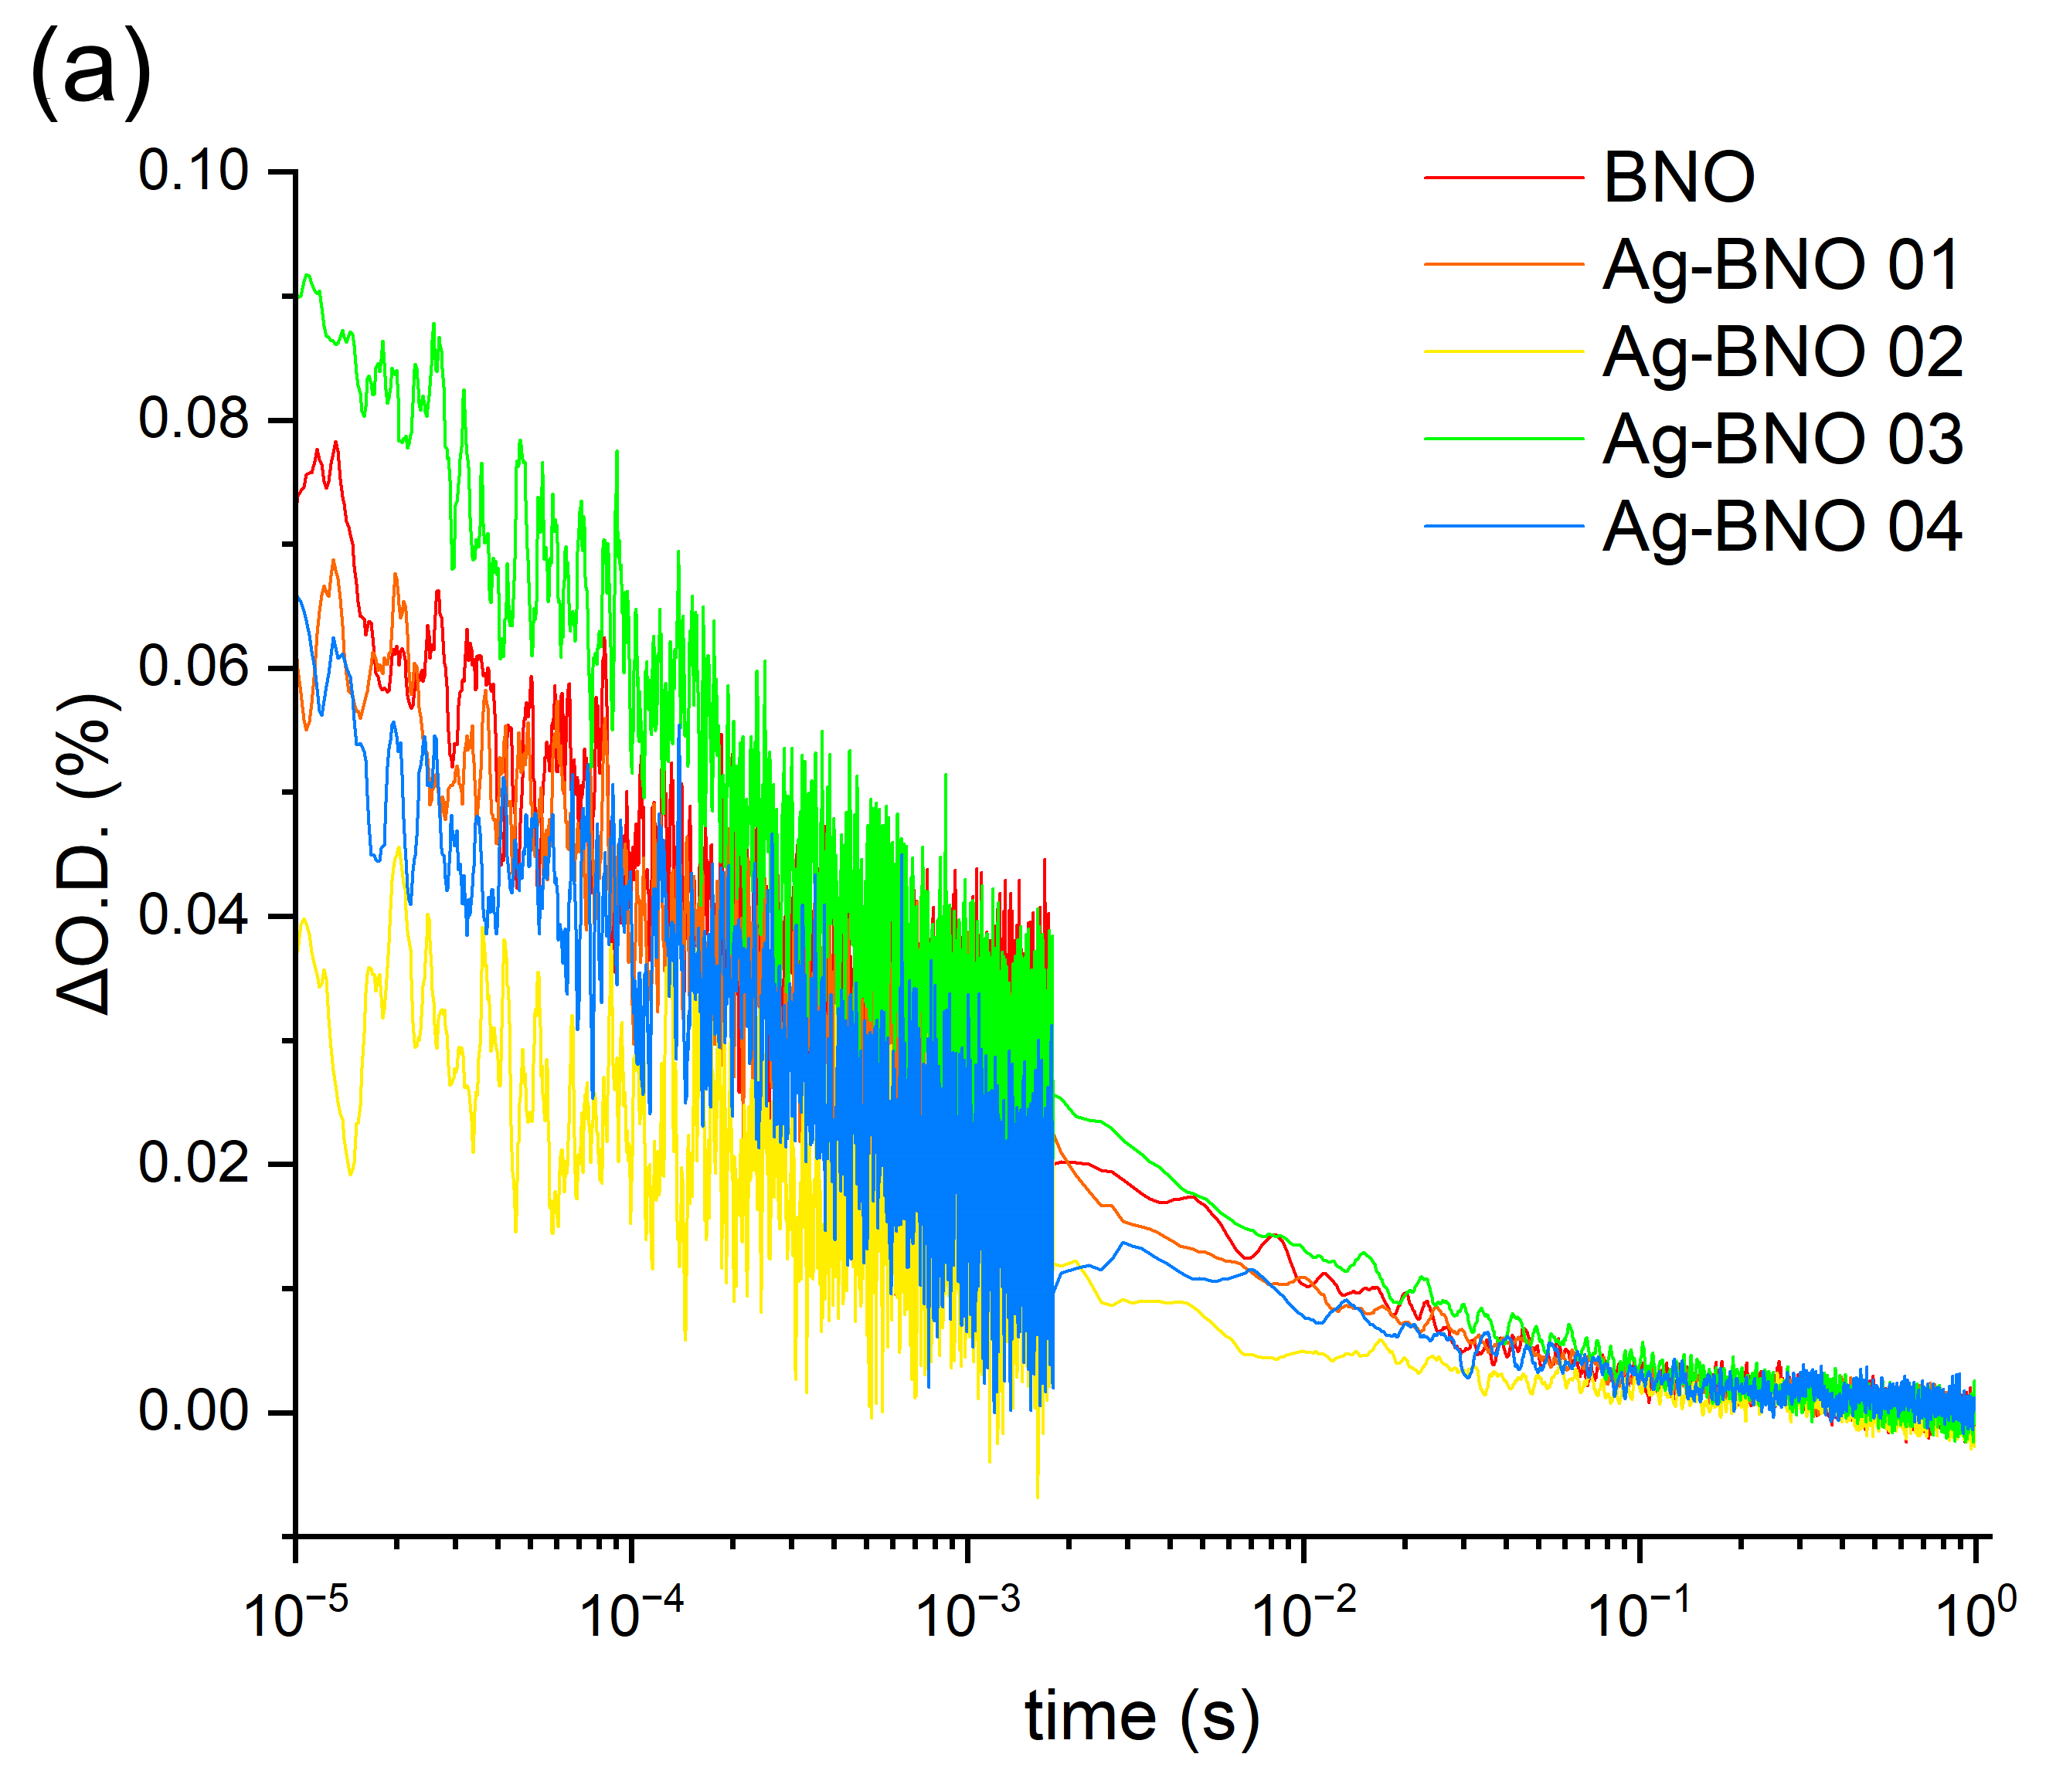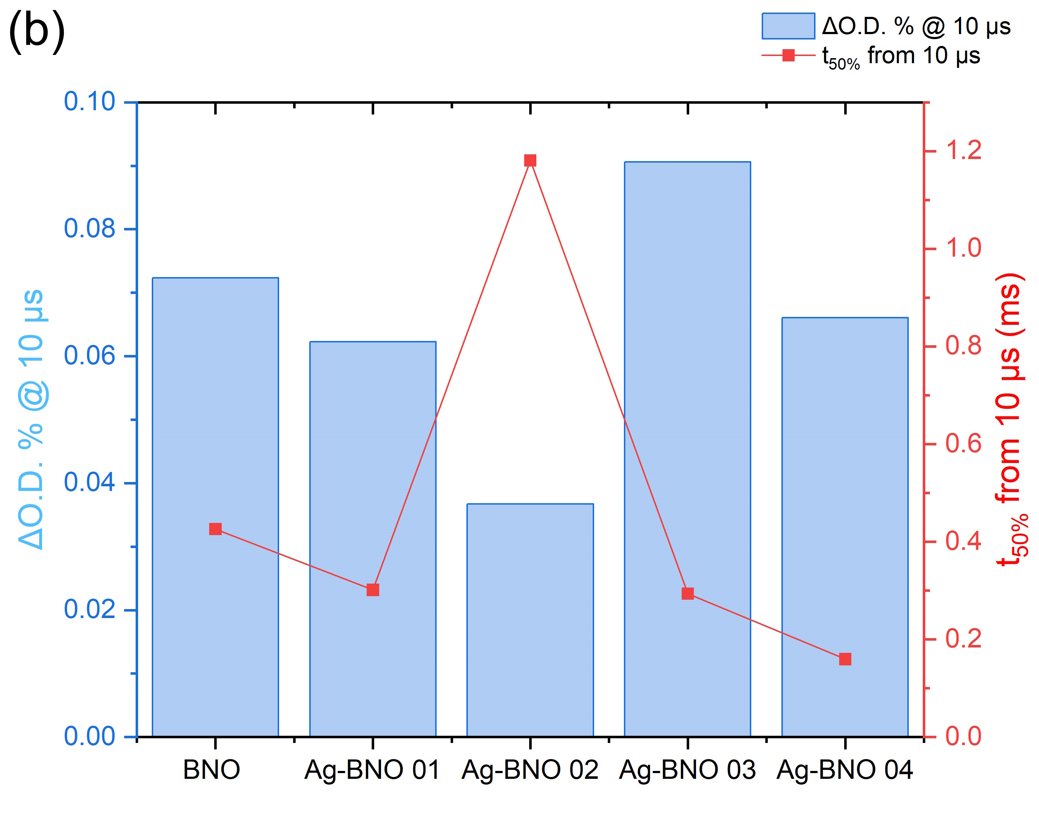
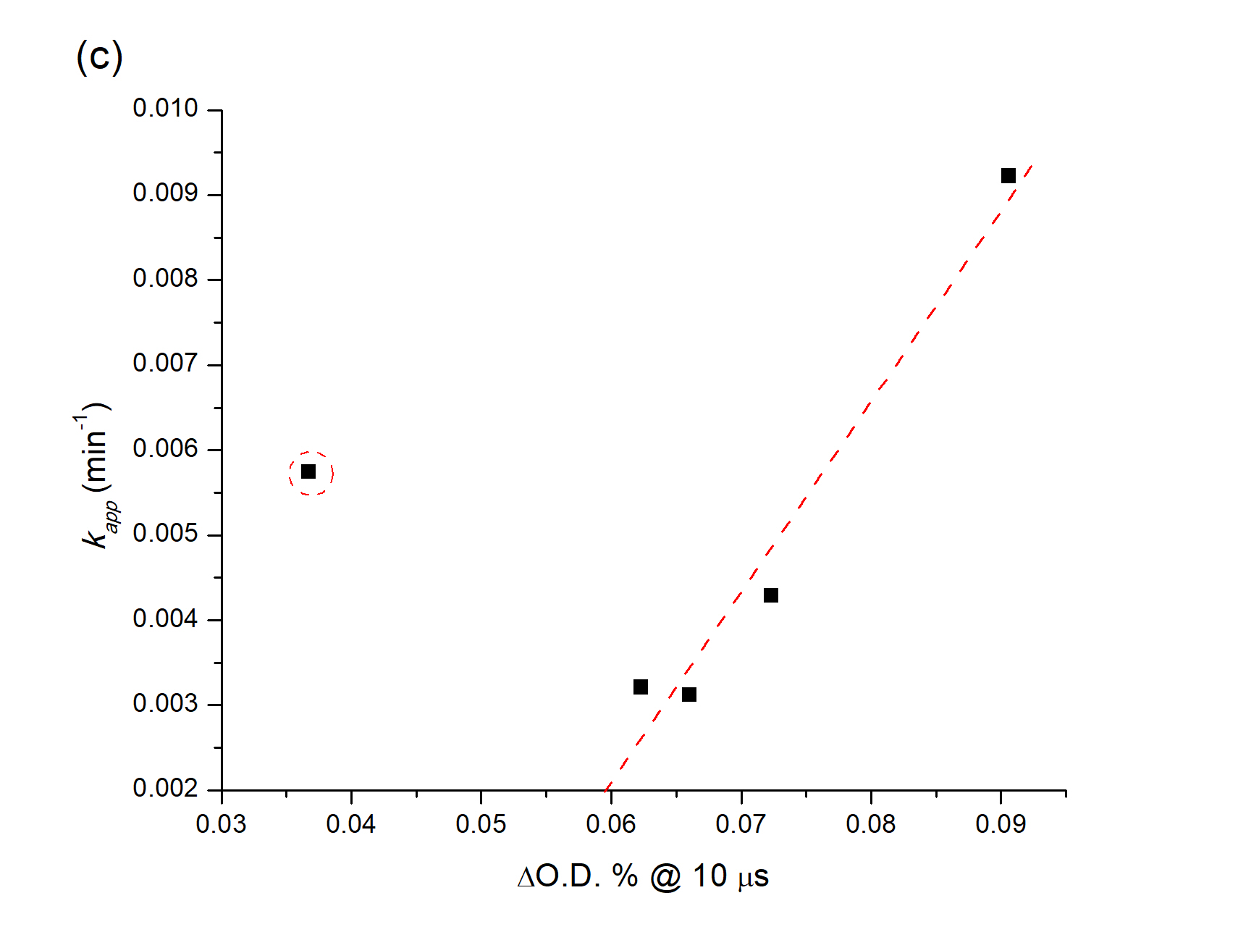
Figure 11. Transient absorption spectroscopy of all samples carried out in air, across probe wavelengths ranging from 500 to 1000 nm with time resolution from 10 μs to 1 s after the laser excitation pulse (λ_{exc} = 355 nm, power = ~288 μJ.cm⁻² per pulse, repetition rate = 0.7 Hz). (a) Transient decay kinetics at the probe wavelength of 900 nm, from 10 μs to 1s. (c) Analysis of the transient kinetics seen at the probe wavelength of 900 nm. The left y-axis (columns) shows the degree of transient absorption (ΔO.D. %) seen at 10 μs after the laser pulse and the right y-axis (scatter-line plot) shows the time taken (ms) for this absorption to decay to 50% of its value (i.e. t_{50%}). (d) A plot of the degree of transient absorption (ΔO.D. %) seen at 10 μs after the laser pulse at the probe wavelength of 900 nm (x-axis) against the apparent rate constant k_{app} (min⁻¹) for the photocatalytic degradation Rho B solution (y-axis) [NOTE: a red dashed guideline is drawn to show the proportional relationship between these two parameters, where the outlier (for Ag-BNO 02) is circled].

Discussion
The present study demonstrates that silver incorporation via hydrothermal precursor introduction results in a fundamentally different modification mechanism compared with conventional surface-deposited Ag cocatalysts. Rather than forming surface-exposed metallic nanoparticles or substituting into the Bi₃NbO₇ lattice, Ag predominantly exists as subsurface or near-surface embedded species, inducing localized lattice perturbation while preserving the intrinsic electronic band structure. This spatial configuration plays a decisive role in regulating charge-transfer kinetics without altering the intrinsic band structure of the semiconductor.
Comprehensive structural analyses consistently indicate that Ag incorporation does not induce long-range crystallographic transformation. XRD patterns and Rietveld refinements confirm preservation of the cubic defect-fluorite structure, with negligible variation in lattice parameters. However, modulation of Bi-O and Nb-O bond lengths and progressive shifts in oxygen atomic coordinates clearly reveal localized lattice distortion. Raman attenuation and peak broadening further support perturbation of the MO₇ polyhedral framework without symmetry breaking. The absence of Ag signals in XPS, combined with its detection by TEM-EDS and partial detection by SEM-EDS only at high loading, confirms that Ag species are not surface-deposited but embedded beneath the outermost surface. The slight positive shifts in Bi 4f and Nb 3d binding energies suggest subtle electronic redistribution induced by subsurface Ag, rather than changes in oxidation state. Importantly, optical and electrochemical measurements show that the fundamental electronic structure of Bi₃NbO₇ remains unchanged. The band gap energies, flat-band potentials, and Mott-Schottky slopes are nearly identical across all samples. Density functional theory calculations further confirm that Ag incorporation results in Ag 4d states primarily located within the upper valence band region, hybridizing with O 2p orbitals. This orbital interaction slightly perturbs the valence band electronic density without significantly modifying the overall band dispersion or band gap energy. Collectively, these findings demonstrate that subsurface Ag induces structural perturbation without band structure modification.
The distinct photocatalytic activity trend among Ag-BNO samples suggests that optimal dispersion of incorporated Ag species is required to enhance photocatalytic oxidation, whereas excessive Ag incorporation leads to reduced activity. Structural densification in Ag-BNO 04 is expected to negatively affect surface accessibility and charge transport. In particular, the inferior performance of Ag-BNO 04 can be attributed to Ag aggregation and particle coalescence, which may block active sites and introduce recombination centres, as supported by XRD and SEM observations. From a physical perspective, the moderate increase in specific surface area (S_{BET}) and preservation of porous morphology in Ag-BNO 03 could provide improved adsorption and surface reaction sites for Rh B molecules. However, as the differences in S_{BET} among samples are relatively small compared to the change in photocatalytic rate the activity, enhancement cannot be solely attributed to surface area effects. This indicates that surface area plays a supportive rather than dominant role. As electronic band structures are nearly identical across all Ag-BNO samples, the driving force for photocatalytic reactions occurred in our catalyst are not influenced by thermodynamic driving force.
The decisive factor arises from charge carrier behaviour, pronounced differences are observed in charge carrier separation, interfacial transfer and dynamics. Transient photocurrent responses reveal that Ag-BNO 01 exhibits the highest photocurrent density, indicating enhanced photoinduced charge separation efficiency. Electrochemical impedance spectroscopy shows significantly reduced charge-transfer resistance for Ag-incorporated samples compared with BNO, confirming improved interfacial charge migration ability. Transient absorption spectroscopy provides deeper insight into carrier dynamics on the microsecond timescale. All samples exhibit similar recombination kinetics (i.e. power-law decay behaviour), indicating that the fundamental recombination mechanism is not altered. However, substantial differences are observed in the initial transient absorption amplitude, which reflects the population of long-lived charge carriers generated immediately after excitation. Ag-BNO 03 exhibits the highest early-time carrier population, followed by BNO and other Ag-BNO samples. A strong correlation is observed between this initial carrier density and the apparent rate constant for Rhodamine B degradation. This relationship indicates that photocatalytic oxidation activity is primarily governed by the quantity of spatially separated carriers generated at early times rather than by slower recombination dynamics. These results clearly establish that subsurface Ag originates from kinetic regulation of charge separation efficiency and carrier population induced by subsurface structural-orbital interactions.
A key finding of this work is that photocatalytic oxidation and reduction reactions respond differently to subsurface Ag incorporation. For Rhodamine B degradation, the reaction is dominated by hole-driven oxidation pathways, as confirmed by radical trapping experiments. Photocatalytic performance correlates strongly with the availability of long-lived holes at the surface. The superior activity of Ag-BNO 03 is mainly attributed to its highest early-time charge-carrier population, which ensure sufficient availability at the surface to promote oxidation reactions, and is further supported by its highest surface area and reduced interfacial charge-transfer resistance. In contrast, photocatalytic hydrogen evolution is observed exclusively for Ag-BNO 01, which exhibits the highest degree charge separation, suggesting the most efficient electron migration toward the reduction sites. It is believed that the reduction reaction therefore appears more sensitive to subtle changes in electron transport integrity than oxidation reactions, which depend primarily on hole availability and surface interaction.

Conclusions
Subsurface Ag-modified Bi₃NbO₇ photocatalysts were successfully synthesized via a hydrothermal precursor introduction strategy, enabling precise control over the location and dispersion of Ag species. Comprehensive structural and spectroscopic analyses confirm that Ag does not substitute into the Bi₃NbO₇ lattice form subsurface or internally dispersed species. This unique Ag configuration induces local lattice distortion without altering the long-range crystal structure or intrinsic band structure.
Optical, electrochemical and theoretical investigations consistently demonstrate that Ag incorporation does not modify the band gap energy or band-edge positions of Bi₃NbO₇. Instead, subsurface Ag primarily regulates charge carrier separation and transfer kinetics by inducing localized electronic perturbations. This kinetic modulation is directly reflected in enhanced photocurrent responses, reduced interfacial charge-transfer resistance and initial charge-carrier populations. The photocatalytic oxidation and reduction reactions can be tuned by distinct optimal Ag configurations. While Ag-BNO 03 shows the highest photocatalytic oxidation activity toward Rh B degradation due to enhanced hole-driven processes and favourable surface accessibility, photocatalytic hydrogen evolution is observed exclusively for Ag-BNO 01. This unique behaviour highlights that efficient reduction reactions require a more delicate balance of electron extraction and transport pathways, which can be disrupted by excessive Ag incorporation or aggregation despite favourable thermodynamic band alignment.
Overall, this work demonstrates that noble-metal modification enhances photocatalytic performance in the way that the spatial location and dispersion of metal species play a decisive role in governing charge-transfer pathways and reaction selectivity. The concept of subsurface-mediated charge separation introduced here provides a new design paradigm for photocatalyst engineering, offering a rational strategy to tune oxidation-reduction selectivity and charge carrier dynamics in complex photocatalytic systems.

Acknowledgement
This work is supported by PMUB. This project is conducted within the Reinventing project for Enhancing Thai Universities into the International Education", the Ministry of Higher Education, Science, Research and Innovation. The XPS measurement was conducted at Thailand Center of Excellence in Physics. A. K. thanks the EPSRC for a Programme Grant (EP/W017075/1).

References
[1] Q. Wang, T. Hisatomi, Q. Jia, H. Tokudome, M. Zhong, C. Wang, Z. Pan, T. Takata, M. Nakabayashi, N. Shibata, Y. Li, I.D. Sharp, A. Kudo, T. Yamada, K. Domen, Scalable water splitting on particulate photocatalyst sheets with a solar-to-hydrogen energy conversion efficiency exceeding 1%, Nat. Mater. 15 (2016) 611–615. https://doi.org/10.1038/nmat4589.
[2] J. Luo, S. Zhang, M. Sun, L. Yang, S. Luo, J.C. Crittenden, A Critical Review on Energy Conversion and Environmental Remediation of Photocatalysts with Remodeling Crystal Lattice, Surface, and Interface, ACS Nano 13 (2019) 9811–9840. https://doi.org/10.1021/acsnano.9b03649.
[3] S. Yaghoubi, S.M. Mousavi, A. Babapoor, M. Binazadeh, C.W. Lai, R.H. Althomali, M.M. Rahman, W.-H. Chiang, Photocatalysts for solar energy conversion: Recent advances and environmental applications, Renewable and Sustainable Energy Reviews 200 (2024) 114538. https://doi.org/10.1016/j.rser.2024.114538.
[4] A. Kumar, P. Sharma, G. Sharma, P. Dhiman, G.T. Mola, M. Farghali, A.K. Rashwan, M. Nasr, A.I. Osman, T. Wang, Simultaneous hydrogen production and photocatalytic pollutant removal: a review, Environ. Chem. Lett. 22 (2024) 2405–2424. https://doi.org/10.1007/s10311-024-01756-w.
[5] A. Jiamprasertboon, A. Waehayee, T. Eknapakul, S. Li, C.J. Carmalt, P. Phonsuksawang, T. Siritanon, Efficient synthesis of Bi2O2S nanoparticles for photocatalytic tetracycline degradation, Mater. Lett. 369 (2024) 136776. https://doi.org/10.1016/j.matlet.2024.136776.
[6] A. Jiamprasertboon, P. Phonsuksawang, C. Sunkhunthod, S. Sertwatsana, S. Wet-osot, A. Kamkaew, T. Siritanon, {001} facet exposed Na0.5Bi2.5Nb2O9 nanosheet: An effective visible light responsive photocatalyst for wastewater treatment, Mater. Res. Bull. 144 (2021) 111501. https://doi.org/10.1016/j.materresbull.2021.111501.
[7] A. Jiamprasertboon, A. Kafizas, E. Hawkins, S. Singsen, T. Butburee, S. Wannapaiboon, W. Sangkhun, S. Nijpanich, T. Eknapakul, N. Chanlek, A. Waehayee, S. Suthirakun, T. Siritanon, Photocatalytic NOx Oxidation of BiOCl Nanostructure-Based Films Grown Using Aerosol-Assisted Chemical Vapor Deposition, ACS Appl. Nano Mater. 6 (2023) 738–749. https://doi.org/10.1021/acsanm.2c05034.
[8] A. Jiamprasertboon, A. Kafizas, T. Eknapakul, T. Choklap, J. Quinet, W. Sailuam, P. Jiang, R. Supruangnet, S. Nijpanich, A. Bootchanont, U. Boonyang, T. Siritanon, T. Cottineau, Insights into unlocking the latent photocatalytic H2 production activity in the protonated Aurivillius-phase layered perovskite Na0.5Bi2.5Nb2O9, Mater. Res. Bull. 186 (2025) 113352. https://doi.org/10.1016/j.materresbull.2025.113352.
[9] G. Zhang, J. Yang, S. Zhang, Q. Xiong, B. Huang, J. Wang, W. Gong, Preparation of nanosized Bi3NbO7 and its visible-light photocatalytic property, J. Hazard. Mater. 172 (2009) 986–992. https://doi.org/10.1016/j.jhazmat.2009.07.089.
[10] L. Wang, W. Wang, M. Shang, S. Sun, W. Yin, J. Ren, J. Zhou, Visible light responsive bismuth niobate photocatalyst: enhanced contaminant degradation and hydrogen generation, J. Mater. Chem. 20 (2010) 8405. https://doi.org/10.1039/c0jm01669a.
[11] J. Fang, J. Ma, Y. Sun, Z. Liu, C. Gao, Synthesis of Bi3NbO7 nanoparticles with a hollow structure and their photocatalytic activity under visible light, Solid State Sci. 13 (2011) 1649–1653. https://doi.org/10.1016/j.solidstatesciences.2011.06.017.
[12] Z. Ai, W. Ho, S. Lee, A stable single-crystal Bi3NbO7 nanoplates superstructure for effective visible-light-driven photocatalytic removal of nitric oxide, Appl. Surf. Sci. 263 (2012) 266–272. https://doi.org/10.1016/j.apsusc.2012.09.041.
[13] Q. Wang, L. Yuan, M. Dun, X. Yang, H. Chen, J. Li, J. Hu, Synthesis and characterization of visible light responsive Bi3NbO7 porous nanosheets photocatalyst, Appl. Catal. B 196 (2016) 127–134. https://doi.org/10.1016/j.apcatb.2016.05.026.
[14] Y. Zhang, X. Li, B. Ji, B. Li, J. Xiong, P. Liu, C. Ma, C. Wang, S. Xu, Q. Wang, Synthesis of Bismuth Niobate Nanoparticles Rich in Oxygen Vacancies and Efficient Degradation of Tetracycline Hydrochloride, Langmuir 41 (2025) 9810–9820. https://doi.org/10.1021/acs.langmuir.5c00241.
[15] Y. Liu, J. Xu, M. Chen, Synthesis of direct Z-Scheme Bi3NbO7/BiOCl photocatalysts with enhanced activity for CIP degradation and Cr(VI) reduction under visible light irradiation, Sep. Purif. Technol. 276 (2021) 119255. https://doi.org/10.1016/j.seppur.2021.119255.
[16] X. Sun, L. Shi, Q. Bai, Z. Yin, H. Song, X. Qu, Synthesis of BiOCl/Bi3NbO7 heterojunction by in-situ chemical etching with enhanced photocatalytic performance for the degradation of organic pollutants, Appl. Surf. Sci. 587 (2022) 152633. https://doi.org/10.1016/j.apsusc.2022.152633.
[17] H. Zhang, Y. Xiao, Z. Shi, L. Tian, Y. Tang, X. Liu, Y. Tian, Y. Lin, Facile in situ fabrication of a direct Z-scheme BiOCl/bismuth niobate heterojunction and its effective photodegradation of RhB, J. Dispers. Sci. Technol. 45 (2023) 80–90. https://doi.org/10.1080/01932691.2022.2127755.
[18] H. Zhang, Y. Xiao, Y. Peng, L. Tian, Y. Wang, Y. Tang, Y. Cao, Z. Wei, Z. Wu, Y. Zhu, Q. Guo, Selective degradation of ceftriaxone sodium by surface molecularly imprinted BiOCl/Bi3NbO7 heterojunction photocatalyst, Sep. Purif. Technol. 315 (2023) 123716. https://doi.org/10.1016/j.seppur.2023.123716.
[19] H. Zhang, Y. Xiao, Z. Zhang, J. Han, Z. Wu, Z. Wei, Y. Zhu, Q. Guo, L. Tian, Y. Tang, Simultaneous removal of CTRX and Cr(Ⅵ) by CQDs-doped bifunctional molecular imprinted BiOCl/Bi3NbO7 photocatalyst: The enhanced selective performance and charge separation abilities, J. Environ. Chem. Eng. 12 (2024) 113597. https://doi.org/10.1016/j.jece.2024.113597.
[20] J. Hou, Z. Wang, S. Jiao, H. Zhu, Bi2O3 quantum-dot decorated nitrogen-doped Bi3NbO7 nanosheets: in situ synthesis and enhanced visible-light photocatalytic activity, CrystEngComm 14 (2012) 5923. https://doi.org/10.1039/c2ce25504a.
[21] H. Gan, G. Zhang, H. Huang, Enhanced visible-light-driven photocatalytic inactivation of Escherichia coli by Bi2O2CO3/Bi3NbO7 composites, J. Hazard. Mater. 250–251 (2013) 131–137. https://doi.org/10.1016/j.jhazmat.2013.01.066.
[22] J. Xu, C. Liu, J. Niu, Y. Zhu, B. Zang, M. Xie, M. Chen, Synthesis of LaFeO3/Bi3NbO7 p-n heterojunction photocatalysts with enhanced visible-light-responsive activity for photocatalytic reduction of Cr(Ⅵ), J. Alloys Compd. 815 (2020) 152492. https://doi.org/10.1016/j.jallcom.2019.152492.
[23] Y. Ren, T. Gong, S. Tan, M. Chen, F. Zhou, Y. Lin, L. Yang, Q. Peng, Photocatalytic activities of g-C3N4, Bi3NbO7 and g-C3N4/Bi3NbO7 in photocatalytic reduction of Cr(Ⅵ), J. Alloys Compd. 902 (2022) 163752. https://doi.org/10.1016/j.jallcom.2022.163752.
[24] D. Xu, G. Li, Y. Dong, Q. Wang, J. Zhang, T. Yang, S. Pang, G. Zhang, L. Lv, Y. Xia, Z. Ren, P. Wang, Photocatalytic O2 activation enhancement and algae inactivation mechanism of BiO2−x/Bi3NbO7 van der Waals heterojunction, Appl. Catal. B 312 (2022) 121402. https://doi.org/10.1016/j.apcatb.2022.121402.
[25] B. Cui, W. Leng, X. Wang, Y. Wang, J. Wang, Y. Hu, Y. Du, Enhanced visible‐light photocatalytic activity of S-scheme Bi3NbO7/Bi2MoO6 heterojunction composite photocatalyst, Vacuum 217 (2023) 112589. https://doi.org/10.1016/j.vacuum.2023.112589.
[26] Y. Hu, X. Wang, Y. Wang, S. Li, B. Cui, Y. Du, Persulfate Activation of Photocatalysts Based on S-Scheme Bi ₃ NbO ₇ /BiOBr _{0.75} I _{0.25} Nanosheet Heterojunctions for Degradation of Organic Pollutants, ACS Appl. Nano Mater. 6 (2023) 10768–10778. https://doi.org/10.1021/acsanm.3c01911.
[27] F. Li, Y. Wang, K. Wang, L. Zhang, G. Han, M. Ye, W. Shi, S. Zhang, L. Jin, J. Feng, Enhanced photocatalytic degradation of tetracycline by a H ₂ O ₂ -assisted Bi ₃ NbO ₇ /Bi ₂ Sn ₂ O ₇ composite under visible light, Physical Chemistry Chemical Physics 25 (2023) 4553–4562. https://doi.org/10.1039/D2CP05609G.
[28] K. Wang, Y. Li, G. Zhang, J. Li, X. Wu, 0D Bi nanodots/2D Bi3NbO7 nanosheets heterojunctions for efficient visible light photocatalytic degradation of antibiotics: Enhanced molecular oxygen activation and mechanism insight, Appl. Catal. B 240 (2019) 39–49. https://doi.org/10.1016/j.apcatb.2018.08.063.
[29] K. Wang, X. Feng, Y. Shangguan, X. Wu, H. Chen, Selective CO2 photoreduction to CH4 mediated by dimension-matched 2D/2D Bi3NbO7/g-C3N4 S-scheme heterojunction, Chinese Journal of Catalysis 43 (2022) 246–254. https://doi.org/10.1016/S1872-2067(21)63819-6.
[30] B.H. Graimed, Z.H. Jabbar, M.M. Alsunbuli, S.H. Ammar, A. G. Taher, Decoration of 0D Bi3NbO7 nanoparticles onto 2D BiOIO3 nanosheets as visible-light responsive S-scheme photocatalyst for photo-oxidation of antibiotics in wastewater, Environ. Res. 243 (2024) 117854. https://doi.org/10.1016/j.envres.2023.117854.
[31] T. Gao, J. Lin, K. Zhang, M. Padervand, Y. Zhang, W. Zhang, M. Shi, C. Wang, Porous Defective Bi/Bi3NbO7 Nanosheets for Efficient Photocatalytic NO Removal under Visible Light, Processes 11 (2022) 115. https://doi.org/10.3390/pr11010115.
[32] Y. Shen, Q. Wei, W. Guo, L. Fan, D. Liu, S. Li, Fabrication of Ag loaded Bi3NbO7 nanoparticles and its photocatalytic activity under visible light irradiation, J. Alloys Compd. 618 (2015) 311–317. https://doi.org/10.1016/j.jallcom.2014.08.165.
[33] L. Zhang, Y. Wang, Y. Shen, H. Xu, C. Mu, Y. Wang, Z. He, Z. Zhang, J. Xue, High-efficiency tetracycline degradation via adsorption-photocatalysis synergy over recyclable Bi-BDC/Bi3NbO7 /cellulose aerogel composites, Int. J. Biol. Macromol. 328 (2025) 147600. https://doi.org/10.1016/j.ijbiomac.2025.147600.
[34] Y. Zhang, Y. Ma, Q. Liu, H. Jiang, Q. Wang, D. Qu, J. Shi, Synthesis of Er3+/Zn2+ co-doped Bi2WO6 with highly efficient photocatalytic performance under natural indoor weak light illumination, Ceram. Int. 43 (2017) 2598–2605. https://doi.org/10.1016/j.ceramint.2016.11.069.
[35] M. Wang, Z. Qiao, M. Fang, Z. Huang, Y. Liu, X. Wu, C. Tang, H. Tang, H. Zhu, Synthesis of Er-doped Bi 2 WO 6 and enhancement in photocatalytic activity induced by visible light, RSC Adv. 5 (2015) 94887–94894. https://doi.org/10.1039/C5RA19164E.
[36] G. Kresse, J. Furthmüller, Efficiency of ab-initio total energy calculations for metals and semiconductors using a plane-wave basis set, Comput. Mater. Sci. 6 (1996) 15–50. https://doi.org/https://doi.org/10.1016/0927-0256(96)00008-0.
[37] J.P. Perdew, A. Zunger, Self-interaction correction to density-functional approximations for many-electron systems, Phys. Rev. B 23 (1981) 5048–5079. https://doi.org/10.1103/PhysRevB.23.5048.
[38] J.P. Perdew, K. Burke, M. Ernzerhof, Generalized Gradient Approximation Made Simple, Phys. Rev. Lett. 77 (1996) 3865–3868. https://doi.org/10.1103/PhysRevLett.77.3865.
[39] H.J. Monkhorst, J.D. Pack, Special points for Brillouin-zone integrations, Phys. Rev. B 13 (1976) 5188–5192. https://doi.org/10.1103/PhysRevB.13.5188.
[40] A. Castro, E. Aguado, J.M. Rojo, P. Herrero, R. Enjalbert, J. Galy, The New Oxygen-Deficient Fluorite Bi3NbO7: Synthesis, Electrical Behavior and Structural Approach, Mater. Res. Bull. 33 (1998) 31–41. https://doi.org/10.1016/S0025-5408(97)00190-6.
[41] R.L. Moreira, F.M. Matinaga, U. Pirnat, D. Suvorov, A. Dias, Optical phonon characteristics of incommensurate and commensurate modulated phases of Bi3NbO7 ceramics, J. Appl. Phys. 103 (2008). https://doi.org/10.1063/1.2919063.
[42] S. Vadivel, B. Paul, B. Saravanakumar, P.A. Periasamy, Facile synthesis of bismuth niobium oxide (Bi3NbO7) micro squares as a novel pseudocapacitive electrode material for supercapacitors, Mater. Lett. 363 (2024) 136295. https://doi.org/10.1016/j.matlet.2024.136295.
[43] Y. Wang, P. Zhang, F. Li, L. Zhang, B. Xu, K. Wang, Z. He, Y. Sun, S. Zhang, H2O2-assisted Bi3NbO7 loaded on porous carbon for enhancing the photocatalytic degradation of tetracycline, Solid State Sci. 158 (2024) 107763. https://doi.org/10.1016/j.solidstatesciences.2024.107763.
[44] W. Wu, S. Liang, L. Shen, Z. Ding, H. Zheng, W. Su, L. Wu, Preparation, characterization and enhanced visible light photocatalytic activities of polyaniline/Bi3NbO7 nanocomposites, J. Alloys Compd. 520 (2012) 213–219. https://doi.org/10.1016/j.jallcom.2012.01.021.
[45] B. Cui, H. Xue, Y. Pan, Y. Du, S-Scheme Nanometer-Sized Bi ₃ NbO ₇ /Bi ₂ O ₂ CO ₃ Heterojunction Photocatalysts for Efficient Pollutant Degradation, ACS Appl. Nano Mater. 7 (2024) 15547–15556. https://doi.org/10.1021/acsanm.4c02457.
[46] A. Jiamprasertboon, T. Kongnok, S. Jungthawan, P. Kidkhunthod, N. Chanlek, T. Siritanon, Investigation on crystal structures, optical properties, and band structure calculations of In2-xMxTeO6 (M = Ga, Bi, La), J. Alloys Compd. 702 (2017) 601–610. https://doi.org/10.1016/j.jallcom.2017.01.227.
[47] A. Jiamprasertboon, A. Waehayee, N. Chanlek, N. Yong, S. Suthirakun, T. Siritanon, Understanding structure, optical, and electrical properties of In4Sn3O12 and In4.5Sn2M0.5O12 (M = Nb and Ta), J. Alloys Compd. 783 (2019) 28–36. https://doi.org/10.1016/j.jallcom.2018.12.288.
[48] W. Zhang, Y. Chu, C. Wang, Y. Zhao, W. Chu, J. Zhao, Enhancing photocatalytic hydrogen production efficiency in all-inorganic lead-free double perovskites via silver doping-induced efficient separation of photogenerated carriers, Sep. Purif. Technol. 357 (2025) 130111. https://doi.org/10.1016/j.seppur.2024.130111.
[49] A. Jiamprasertboon, S. Sertwatsana, L. Ngamwongwan, W. Sangkhun, A. Waehayee, P. Phonsuksawang, A. Bootchanont, S. Nijpanich, W. Busayaporn, H. Nakajima, S. Suthirakun, T. Butburee, T. Siritanon, Controllable synthesis of nanostructured bismuth vanadate thin films as an efficient catalyst for photoelectrochemical water splitting, New Journal of Chemistry 47 (2023) 14758–14767. https://doi.org/10.1039/D3NJ01456H.
[50] Z. Shao, C. Ye, Y. Zhang, Y. Wu, J. Xiong, M.M. Li, W. Jiang, J. Di, Epitaxial Active Interface to Construct Intralattice‐Bonded Asymmetric Bi ₁ ─O─Bi ₂ Sites for Robust CO ₂ Photoreduction to Acetic Acid, Angewandte Chemie International Edition (2026). https://doi.org/10.1002/anie.202524970.
[51] I. Itskou, A. Kafizas, I. Nevjestic, S.G. Carrero, D.C. Grinter, H. Azzan, G. Kerherve, S. Kumar, T. Tian, P. Ferrer, G. Held, S. Heutz, C. Petit, Effects of Phosphorus Doping on Amorphous Boron Nitride’s Chemical, Sorptive, Optoelectronic, and Photocatalytic Properties, The Journal of Physical Chemistry C 128 (2024) 13249–13263. https://doi.org/10.1021/acs.jpcc.4c02314.
[52] B. Moss, K.K. Lim, A. Beltram, S. Moniz, J. Tang, P. Fornasiero, P. Barnes, J. Durrant, A. Kafizas, Comparing photoelectrochemical water oxidation, recombination kinetics and charge trapping in the three polymorphs of TiO2, Sci. Rep. 7 (2017) 2938. https://doi.org/10.1038/s41598-017-03065-5.

