Title:
Association of a Combined Measure of Adherence and Treatment Intensity with Cardiovascular Outcomes in Patients with Atherosclerosis or Other Cardiovascular Risk Factors Treated with Statins and/or Ezetimibe
Authors:
Kamlesh Khunti, MD, FMedSci (1); Mark D. Danese, MHS, PhD (2); Lucie Kutikova, PhD (3); David Catterick, MSc, PhD (4); Francisco Sorio Vilela (3); Michelle Gleeson, PhD (3); Sreenivasa Rao Kondapally Seshasai, MBBS, MD, MRCP, MPhil, PhD (5); Jack Brownrigg, MBChB, BSc, MRCS, PhD (6); Kausik K. Ray, MD, FAHA (7)
Affiliations:
(1) Diabetes Research Centre, University of Leicester, Leicester, UK; (2) Outcomes Insights, Inc., Outcomes Research, Westlake Village, CA; (3) Amgen (Europe) GmbH, Health Economics, Zug, Switzerland; (4) Amgen Limited, Uxbridge, UK; (5) St George’s, University of London, London, UK; (6) St George’s Vascular Institute, London, UK; (7) Imperial Centre for Cardiovascular Disease Prevention, School of Public Health, Imperial College London, London, UK
Key words:
Adherence, compliance, intensity, cardiovascular disease, hypercholesterolemia, lipid lowering
Contact information:
Mark Danese, MHS, PhD
2801 Townsgate Road, Suite 330
Westlake Village, CA 91361
1-805-498-0034 (office)
1-805-715-8106 (fax)
Word Count:
3,483 (excluding abstract, tables, and references)
Revision date: October 15, 2018

Key Points
Question: What are the contributions of adherence and treatment intensity to cardiovascular outcomes in patients newly treated with statins and/or ezetimibe?
Findings: This observational study of three patient cohorts (documented cardiovascular disease, type 2 diabetes primary prevention without chronic kidney disease, and CKD primary prevention) showed a continuous association between the combination of adherence and treatment intensity with low density lipoprotein cholesterol (LDL-C) reduction and with cardiovascular outcomes. The largest reductions in LDL-C and cardiovascular risk were observed among adherent patients receiving high intensity therapy and smallest were observed among non-adherent patients receiving low intensity therapy.
Meaning: Strategies that improve adherence and greater utilization of intensive therapies could achieve greater reductions in LDL-C and substantially reduce cardiovascular risk.

Abstract (350 words)
Importance: Both adherence and treatment intensity can affect the effectiveness of lipid-lowering therapy in routine clinical practice.
Objective: To evaluate the associations of adherence and treatment intensity on cardiovascular outcomes in patients with documented cardiovascular disease (CVD), type 2 diabetes primary prevention without chronic kidney disease (CKD), and CKD primary prevention.
Design: Retrospective cohort study using the Clinical Practice Research Datalink from January 2010 through February 2016.
Setting: United Kingdom primary care.
Participants: Newly treated patients who received their first statin and/or ezetimibe prescription between January 1, 2010 and December 31, 2013 plus one additional prescription for statin and/or ezetimibe during the following year.
Exposures: Adherence was assessed annually using the proportion of days covered (PDC) with “adherent” defined as a PDC ≥80%. Treatment intensity was classified according to guidelines based on expected percent LDL-cholesterol reduction as low (<30% reduction), moderate (30%-50% reduction), or high (>50% reduction). Adherence and treatment intensity were multiplied to create a combined measure reflecting treatment intensity after accounting for adherence.
Main Outcomes and Measures: Composite endpoint of cardiovascular death or hospitalization for myocardial infarction, unstable angina, ischemic stroke, heart failure, or revascularization. Hazard ratios (HR) were estimated against patients not treated for ≥1 year.
Results: There were 16,701, 12,422, and 674 patients with CVD, diabetes, and CKD. Mean ages were 68, 59, and 67 years, and male proportions were 61%, 55%, and 47%. In the CVD cohort, patients receiving high intensity therapy were the most likely to be adherent. Using a combined measure of adherence and intensity, a graded relationship was observed with both LDL-C reduction and outcomes; each 10% increase was associated with a 10% lower risk (HR 0.90, 95% CI 0.86 to 0.94). Adherent patients receiving a high intensity regimen had the lowest risk (HR 0.66, 95% CI 0.56-0.78) versus patients untreated for ≥1 year. Diabetes and CKD findings were similar.
Conclusions and Relevance: The lowest cardiovascular risk was observed among adherent patients receiving high intensity therapy and the highest risk among non-adherent patients receiving low intensity therapy. Strategies that improve adherence and greater utilization of intensive therapies could substantially improve cardiovascular risk.

Introduction
Cardiovascular disease (CVD) is a major cause of premature death and disability worldwide.^{1–3} Medications that reduce low density lipoprotein cholesterol (LDL-C) levels have been proven to reduce the risk of cardiovascular events, and statins are first-line therapy in global treatment guidelines. Recent guidelines from the American College of Cardiology and American Heart Association (ACC/AHA), the National Institute for Health and Care Excellence (NICE), the Joint British Societies (JBS) and the European Society of Cardiology (ESC), among others, have emphasized the importance of aligning the intensity of LDL-C reduction with the risk of future cardiovascular events.^{2–5}
However, patients may not derive the intended benefit from the use of lipid-lowering agents for a number of reasons related to physician and patient-level factors. Physician-level factors include limited knowledge about the evidence^{6–8} and a real or perceived risk of adverse effects.⁹ There is also reluctance to use high intensity statin therapy among physicians.^{10,11} Patient-level factors include poor adherence, either from not taking medication consistently (i.e., low compliance), or by discontinuing medication (i.e., low persistence).^{12,13}
These issues can lead to suboptimal risk reduction in high risk populations that may benefit from high intensity therapy. Trial evidence suggests that higher treatment intensity achieves greater reductions in LDL-C and is associated with improved cardiovascular outcomes; similarly, observational studies have shown that higher adherence with lipid-lowering therapy is associated with improved cardiovascular outcomes.^{14–18} The aim of our study was therefore to evaluate the potential contributions of both adherence and treatment intensity jointly over time on cardiovascular outcomes in newly treated patients with important cardiovascular risk factors or documented cardiovascular disease.⁴

Methods
We conducted a retrospective observational cohort study from September 2017 through August 2018 using linked data from the following sources: Clinical Practice Research Datalink (CPRD), Hospital Episode Statistics, and Office for National Statistics. All data were de-identified.
The study included newly treated patients with hypercholesterolemia, defined as those who received their first statin and/or ezetimibe prescription between January 1, 2010 and December 31, 2013 and who also received at least one additional prescription for statin and/or ezetimibe during the following year. The index date (start of the period at risk for outcomes) was the date of the second prescription. On the first prescription date, patients must have been at least 18 years old, been registered in a general practice with at least two years of up-to-standard data beforehand, and received no prior lipid-lowering therapy based on their available medical history. Serum LDL-C levels were assessed on or before the first prescription date.
To be included, patients must have had documented CVD, type 2 diabetes, or stage 4-5 chronic kidney disease (CKD) at the time of the initial lipid-lowering therapy prescription to reflect very high-risk patients as described in the ESC guidelines.⁴ Documented CVD was defined as any of the following: myocardial infarction (MI), unstable angina (UA), ischemic stroke (IS), surgical or percutaneous revascularization, transient ischemic attack (TIA), carotid stenosis, peripheral artery disease, abdominal aortic aneurysm, or stable angina.⁴ CKD was identified based on diagnoses or estimated glomerular filtration rate (eGFR) values. Type 2 diabetes was based on diagnoses or the use of antidiabetic medication.¹⁹ (eMethods)
Patients were analyzed in three cohorts: those with documented CVD (CVD cohort), those with type 2 diabetes without CVD or CKD (diabetes cohort), and those with CKD without CVD (CKD cohort).

Exposures and Outcomes
Adherence was measured using the proportion of days covered (PDC).^{20,21} In keeping with other studies, we defined patients with a PDC ≥ 80% as “adherent”.¹⁸ Lipid-lowering regimens were analyzed based on the expected percent LDL-C reduction measured in trial data (eTable 1).³ According to the ACC/AHA guidelines, they can be grouped into low intensity (≤ 30% reduction), moderate intensity (31%-50% reduction), and high intensity (> 50% reduction).^{3,5} Ezetimibe monotherapy was considered low intensity (19% expected LDL-C reduction) and combination therapy assumed a 24% reduction in LDL-C after applying the statin reduction.^{22,23} Individuals who received no treatment during the entire year were included in the reference group for that year using time-varying covariates for adherence and intensity (eFigure 1).
We explored continuous measures of adherence and treatment intensity in separate models. For our primary model, we combined adherence and intensity into a single value intended to reflect the treatment intensity of a regimen after accounting for a patient’s adherence.²⁴ This combined measure was created by multiplying adherence (range: 0 to 100%) and treatment intensity (range: 0-66%); as a result, the combined measure ranged from 0 to 66% (i.e., 0.66 x 1.0 = 0.66). Because the combined measure is continuous, it was more efficient than using a categorical representation and facilitated estimates in untreated patients (i.e., 0% treatment intensity and 0% PDC).
The primary outcome measure was a composite endpoint of cardiovascular death or hospitalization for MI, UA, IS, HF or revascularization (eTable 2). Because HF is less commonly used as an outcome measure in lipid-lowering trials but is relevant in health economic evaluations, we excluded HF from the composite in sensitivity analyses.
Time at risk for cardiovascular events began after the index date. The baseline period for assessing demographics, comorbidity, and laboratory values was defined as the period prior to the index date. Measures of adherence and treatment intensity were calculated based on prescriptions during each year of follow-up and were updated annually for each patient. Adherence and intensity calculations for patients who ended follow-up within a year were based on the data through the end of follow-up. The follow-up period for the assessment of cardiovascular events continued until death, cardiovascular event of interest, last known up-to-standard CPRD record for the patient in the practice, switch to a therapy other than a statin or ezetimibe, or 29 February 2016, whichever came first.
Analyses
We used Cox proportional hazards regression models to quantify the association of adherence and treatment intensity with the risk of cardiovascular events. Analyses were conducted separately for each cohort. First, we assessed a continuous measure of adherence and a continuous measure of treatment intensity in two separate models, and then modeled the combined measure of adherence and treatment intensity as our primary analyses. We also present results for specific patient profiles (e.g., “adherent patients”) based on the mean value of the continuous measure for patients with the specific adherence and/or intensity profile.
In all Cox regression models, we used age as the time scale to minimize any association between the event rate and time, particularly for the CVD cohort.²⁵ Because adherence, treatment intensity, and the combined measure were annual estimates, all were modeled using a 1-year lag to provide a stable PDC estimate; hence, adherence and intensity in one year were used to predict cardiovascular events in the following year. As a result, events occurring during the first year after treatment were attributed to the lack of treatment in the year beforehand (eFigure 1). Exposure during this period was included in the reference group (defined as “untreated for at least a year”). The adherence and intensity measures, as well as the year of follow up, were included as time-varying covariates and updated annually. As a result, patients moved into and out of the reference group over time as a function of their time-varying covariates.
We also estimated the residual cardiovascular event risk if all patients in the CVD cohort were to receive and comply with a high intensity regimen (“Optimal Adherence and Intensity”). To do this, we used the information from the fitted Cox proportional hazards model to estimate the expected rate of events assuming everyone had a combined measure of 50% (i.e., a 50% expected LDL-C reduction after accounting for adherence). We used bootstrapping to estimate the 95% confidence intervals (CI) for the estimates.
In addition to analyses for the three primary cohorts, we also evaluated a variety of pre-planned subgroups in the documented CVD cohort based on risk factors, comorbidity scores, and polypharmacy (eMethods).
To assess whether the changes in adherence and intensity were also associated with changes in LDL-C, thus representing a biologically plausible mechanism, we evaluated the effect of the combined adherence and intensity measure on the percent change in LDL-C over time. We included patients with at least one pre- and one post-treatment LDL-C measure within each cohort.
All analyses were conducted in R (version 3.4.4). Additional details are available in eMethods.

Results
Of the 29,797 newly treated patients, there were 16,701 (56%) in the documented CVD cohort, 12,548 (42%) in the type 2 diabetes without CVD or CKD cohort, and 674 (2%) in the CKD without CVD cohort (eFigure 2). Mean age was similar in the CVD and CKD cohorts (68 and 67 years), but lower in the diabetes cohort (59 years). The CVD cohort had a higher proportion of males (61%) than did the diabetes (55%) and CKD (47%) cohorts. Baseline LDL-C (for 64% of patients with available data) was 128 mg/dL for the CVD cohort, 135 mg/dL for the diabetes cohort, and 143 mg/dL for CKD cohort. In the CVD cohort, 79% had been diagnosed with a cardiovascular condition in the year before initiating therapy. Mean duration of follow-up was approximately 3 years for each cohort (Table 1 and eTable 3).
The initial lipid-lowering therapy was a high intensity statin for 23% of the CVD cohort, compared to 1.1% of the diabetes cohort and 3.1% of the CKD cohort. The majority of patients received moderate intensity statins (74% for the CVD cohort, 95% for the diabetes cohort, and 87% for the CKD cohort). Initial use of ezetimibe alone, with or without a statin, was extremely rare at both the initial and last prescriptions (< 1% for all cohorts; Table 1). At the end of follow-up for each person, moderate intensity regimens were still the most common. Between 33% and 43% of patients, depending on cohort, did not have an active prescription at the end of follow up.
Adherence, as measured by PDC, varied by cohort and by treatment intensity and generally declined after the first year. In the CVD cohort, patients receiving high intensity therapy were more likely to be adherent over time (84% in Year 1 and 72% in Year 6) than patients receiving low intensity therapy (57% and 44%). Adherence was generally similar across treatment intensity groups for the diabetes and CKD cohorts (Figure 1).
Cardiovascular event rates varied by cohort. The CVD cohort had the highest mean event rate (72 per 1,000 person-years of follow-up). This rate was highest during the first year at 136 and was lower afterward, ranging from a minimum of 30 to a maximum of 46. The decrease in rates is most likely due to the effects of treatment. The mean event rate in the diabetes cohort was 13 and ranged from 10 to 20; the mean rate in the CKD cohort was 38 and ranged from 20 to 52 (eTables 4, 5).

Association of Adherence and Intensity on Outcomes
Higher adherence and higher intensity were each associated with a lower risk of a cardiovascular events in separate adjusted regression models. The relationships were graded and consistent across all three cohorts (Table 2). In particular, in the CVD cohort the hazard ratio (HR) for each 10% increase in adherence (e.g., 70% to 80%) was 0.95 (95% CI 0.94 to 0.97). Based on the mean PDC for all adherent patients, the HR was 0.65 (95% CI 0.60-0.70). Similarly, for each 10% increase in treatment intensity (e.g., 30% to 40%), the HR was 0.90 (95% CI 0.86 to 0.95). Based on the mean intensity for patients receiving high intensity therapy, the HR was 0.60 (95% CI 0.52-0.68). Results were similar for the diabetes and CKD cohorts. The reference group for all analyses was defined as patients untreated for at least a year.
The relationship between the combined measure of adherence and treatment intensity and outcomes was also graded (Figure 2). For example, in the CVD cohort, each increase of 10% in the combined measure (e.g., from 40% to 50%) was associated with a lower risk of cardiovascular event by 10% (HR 0.90, 95% CI 0.86 to 0.94). As a particular example, in the CVD cohort, adherent patients receiving a high intensity regimen had a 34% lower cardiovascular event risk than patients who were untreated for at least a year (the reference group). In contrast, non-adherent patients receiving a low intensity regimen had a 5% lower risk. Results were similar for the diabetes and CKD cohorts (Figure 2).
We conducted additional subgroup and sensitivity analyses within the CVD cohort (Figure 3). The associated risk reduction for each 10% increase in the combined measure appeared more marked among high risk subgroups including those with diabetes (HR 0.70, 95% CI 0.60 to 0.82) and those with both LDL-C ≥ 135 mg/dL and multiple cardiovascular events in their history (21%, HR 0.79, 95% CI 0.68 to 0.92). We tested ezetimibe use as an independent predictor, but it was not associated with an additional reduction in risk (HR 1.06, 95% CI 0.53 to 1.59).
We estimated there would have been 2069 events across all patients over the same period of follow up if patients were treated optimally (50% combined measure), compared to the 3086 actual observed events (21% combined measure; eFigure 2). This represents a theoretical decline from the observed rate of 72 events per 1,000 person-years to 48.3 per 1,000 person-years, reflecting an absolute difference of 23.7 (95% CI 15.7 to 31.4) per 1,000 person-years. Results were similar for the diabetes and CKD cohorts.
Sensitivity analyses excluding HF from the composite measure yielded very similar results to the primary endpoint (Table 2).
In analyses of percent LDL-C change (Figure 2) a 10% increase in the combined adherence and treatment intensity measure was associated with a mean 9.1% (95% CI 8.8 to 9.4) reduction in LDL-C in the CVD cohort, a 10.3% (95% CI 10.0 to 10.5) reduction in the diabetes cohort, and a 10.2% reduction (95% CI -8.7 to 11.7) in the CKD cohort.

Discussion
Our study assesses, for the first time, the association of the combined effects of adherence and treatment intensity with LDL-C reduction and with cardiovascular outcomes in patients newly treated with lipid-lowering therapy who are at high risk of cardiovascular events by virtue of having documented CVD, diabetes or CKD. Adherent patients receiving high intensity therapy had a 34% lower risk of a cardiovascular event, as compared with 5% among non-adherent patients receiving low intensity therapy. These findings were consistent across the three cohorts and suggest that high intensity regimens are feasible and effective in routine clinical practice. Optimal therapy, with complete utilization of, and adherence to, high intensity regimens could result in a one-third reduction in the number of cardiovascular events in patients with CVD within approximately 3 years. However, it may not be possible for non-adherent patients to receive the full benefits of therapy because adherence is a proxy for a wide array of patient-related factors.
Reducing the likelihood of preventable cardiovascular events is the purpose of recent updates from UK and European clinical guidelines for patients either with established CVD or those at high risk of developing cardiovascular disease. The NICE guidelines recommend high intensity statin therapy with the goal of ensuring at least a 40% reduction in non-HDL cholesterol after 3 months.³ The ESC has recently recommended a reduction of 50% if the baseline LDL-C is between 70 and 135 mg/dL or a target of < 70 mg/dL if the LDL-C is higher than 135 mg/dL in an attempt to ensure that physicians maximize the absolute LDL-C reduction.⁴ This is based in part on the observations from the Cholesterol Treatment Trialists (CTT) meta-analysis showing that the absolute LDL-C reduction is proportional to the benefit in risk reduction.¹⁷
In contrast to the guidelines, patients in the three cohorts were primarily treated with moderate intensity regimens, a finding consistent with other research.²⁶ While it might be hypothesized that clinicians avoided using higher intensity regimens out of concern about patients’ ability to adhere to therapy, patients receiving high intensity therapy were at least as likely to be adherent as other patients. In particular, patients with documented CVD receiving high intensity therapy were the most adherent throughout follow up; those receiving low intensity therapy were the least adherent. The reasons for this are unclear; however, one explanation might be that the patients treated with high intensity regimens had a greater understanding of their disease severity, making them more diligent. Conversely, adverse events or statin intolerance may have lead to discontinuation or reductions in the intensity of therapy, but we did not have data to evaluate this hypothesis.
The use of a combined measure of adherence and treatment intensity is intended to reflect the magnitude of LDL-C reduction after accounting for adherence (i.e., it is the product of adherence x intensity). Results using the combined measure are consistent with the CTT meta-analysis results for more versus less LDL-C intensive therapy.¹⁷ In the CTT results, a 20 mg/dL mean LDL-C reduction (20% lower than the 100 mg/dL baseline) was associated with a 15% reduction in the risk of major vascular events. In our CVD cohort, this same difference might be accomplished by increasing treatment intensity by 20% (e.g., from 30% to 50%). In someone with an adherence of 75%, this would result in a 15% change in the adherence x intensity product (0.75 x 0.50 - 0.75 x 0.30 = 0.15). According to our model, this change would be associated with a 15% lower risk of events (HR 0.85, 95% CI 0.80 to 0.91). In patients with better adherence, the difference in risk for the same intensity of statin therapy would be even greater. Since the combined measure assessed in our study demonstrates concordance with the risk reductions observed in clinical trials, we feel that other assumptions are reliable.
To provide biological plausibility for our findings we also compared the observed reduction in LDL-C against the value that would be expected by the adherence x intensity product. This additional finding provides a biological framework around which our findings can be interpreted, namely, the combined measure reflects “average achieved treatment intensity.” Our findings are consistent with the observations from others that LDL-C is not only causal but also cumulative; that is, a modest difference in LDL-C of about 13 mg/dl maintained over 52 years from genetic studies affords the same protection as a difference of 39 mg/dl maintained over a 5 year period with statins.²⁷ Moreover those individuals who have the greatest variability in LDL-C reduction over time in statin trials have the worst outcomes independent of the intensity of therapy.²⁸ Taken together these prior observations and our own novel findings suggest that public health would be better served by optimizing the cumulative reduction in LDL-C over time.
There are several limitations to our study. Adherence is a proxy for a variety of patient-related health care behaviors. Patients who adhere to therapy tend to have better adherence to other lifestyle factors such as diet and physical activity. We could not address such factors in our analyses because this data is not captured in routine health care records. Similarly, we could not account for better adherence to other cardiovascular medications which could explain part of the benefit of adherence with lipid-lowering therapy. Because of these factors, it may be challenging for non-adherent patients to experience the full benefits of statins.
Because we required a year to estimate adherence, patients were considered to be “untreated” during their first year on therapy. Constructing a control group in an observational study of adherence requires trade-offs; however, our approach may be considered conservative because at least some treatment effect is likely to be present during this untreated period. Based on CTT this benefit is about half the benefit observed in subsequent years. Some guidelines, such as those from the ESC, consider diabetic patients with “marked hypercholesterolemia” to be at very high-risk, and other diabetic patients to be at high-risk. However, because LDL-C was not available for all patients and because clinicians may treat these patients to reduce their risk of cardiovascular events regardless of LDL-C, we included all diabetic patients who initiated lipid-lowering therapy. While we used age as the time scale to avoid a spurious, temporal association between diagnosis of cardiovascular conditions and initiation of lipid-lowering therapy, we cannot rule out the effects of other interventions. Finally, prescription data may not reflect the actual utilization by the patient.
In conclusion, our study not only provides evidence that newly treated patients are as adherent to high intensity regimens as to lower intensity regimens, but also demonstrates the joint effects of both adherence and treatment intensity on the risk of cardiovascular events which is likely mediated through the average reduction in LDL-C. High intensity with high adherence was associated with the lowest risk, and lower adherence with lower intensity was associated with the highest risk. Strategies which optimize LDL-C reduction through better use of high intensity statins and improved adherence could reduce the risk of cardiovascular disease in high-risk populations.

Figures
Figure 1: Proportion of Adherent Patients Over Time, by Cohort and Treatment Intensity
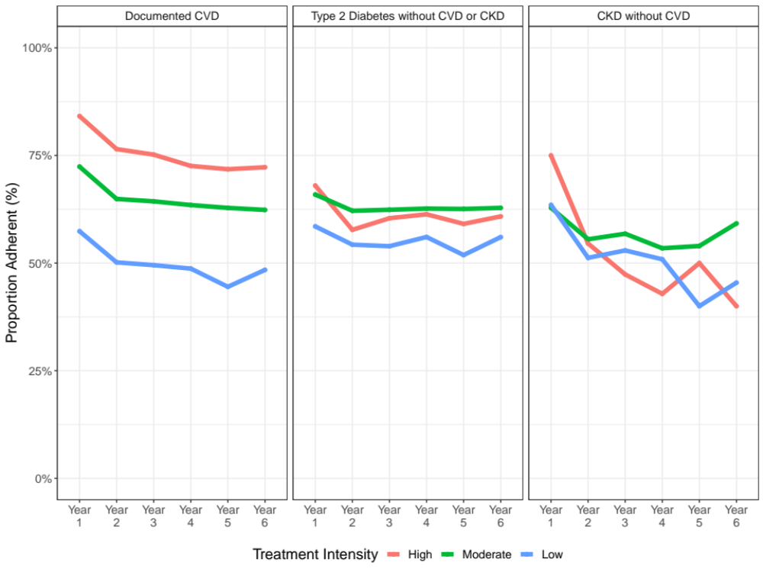
Note: Adherent patients defined as those with a PDC of 80% or higher for the year. Mean duration of follow-up was approximately 3 years; therefore, sample sizes in Years 4-6 are smaller.

Figure 2: Cardiovascular Risk Reduction and LDL-C Reduction Using the Combined Measure of Adherence and Treatment Intensity
[Cardiovascular Risk Panel]
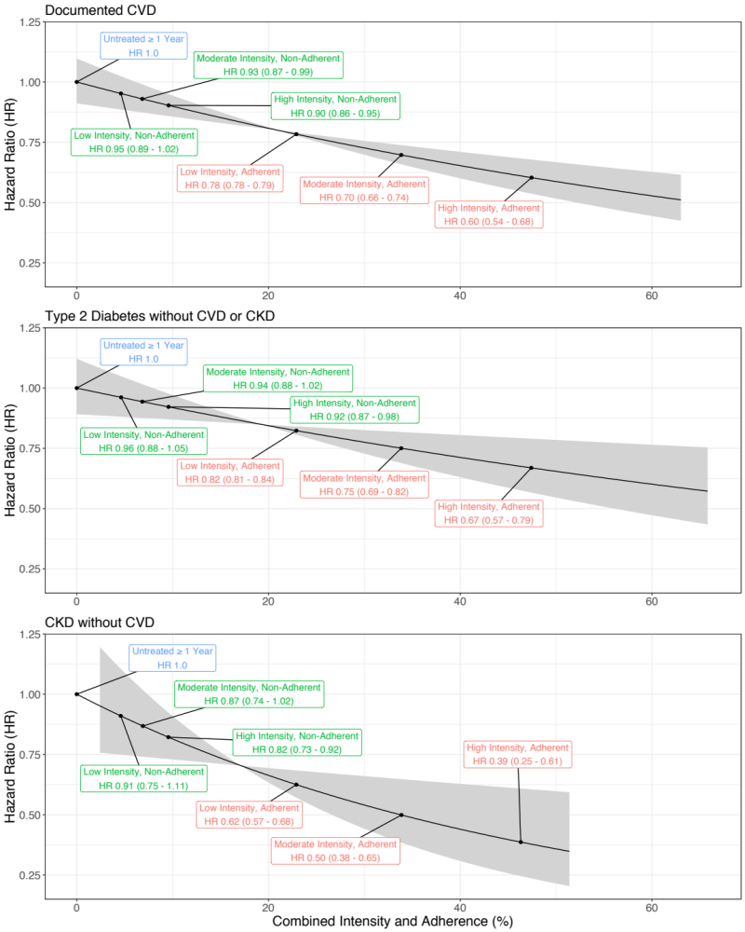

[ LDL-C Reduction Panel]
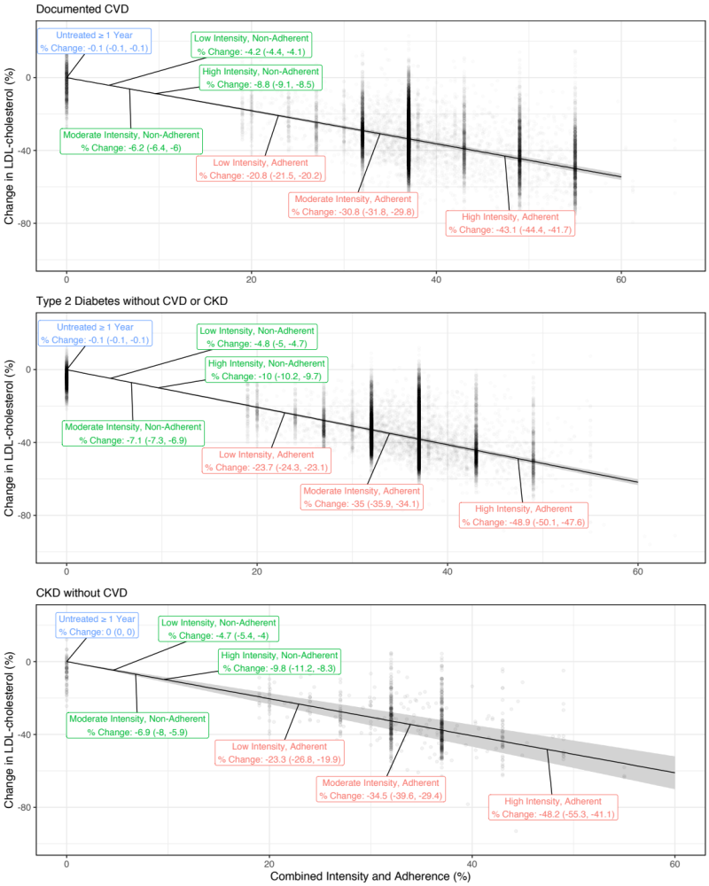
Note: Adherent defined as proportion of days covered ≥ 80%. CVD = cardiovascular disease, CKD = chronic kidney disease. Figures are based on the analysis of the combined adherence x intensity measure as a continuous variable. For patient subgroups by adherence and intensity, labels illustrate the result at the mean value of the combined measure for the subgroup. Shaded areas reflect the 95% CI. Cardiovascular risk models are adjusted for initial use of high intensity therapy, sex, smoking status, hypertension status, anti-thrombotic medication use, chronic kidney disease (CKD) status (except CKD cohort), history of chronic CVD (CVD cohort only), diabetes status (except diabetes cohort), duration of diabetes (diabetes cohort only), atrial fibrillation status, year of follow-up, and Charlson comorbidity score. LDL-C change models include random effects for patient and baseline LDL-C above 135 mg/dL, and fixed effects for age, sex, hypertension, smoking, CKD (except CKD cohort), diabetes (except diabetes cohort), Charlson score, and year of follow up. LDL-C change figures show the adjusted percent LDL-C change for individuals.

Figure 3: Cardiovascular Risk Reduction per 10% Increase in the Combined Measure of Adherence and Treatment Intensity for Documented CVD and Subgroups
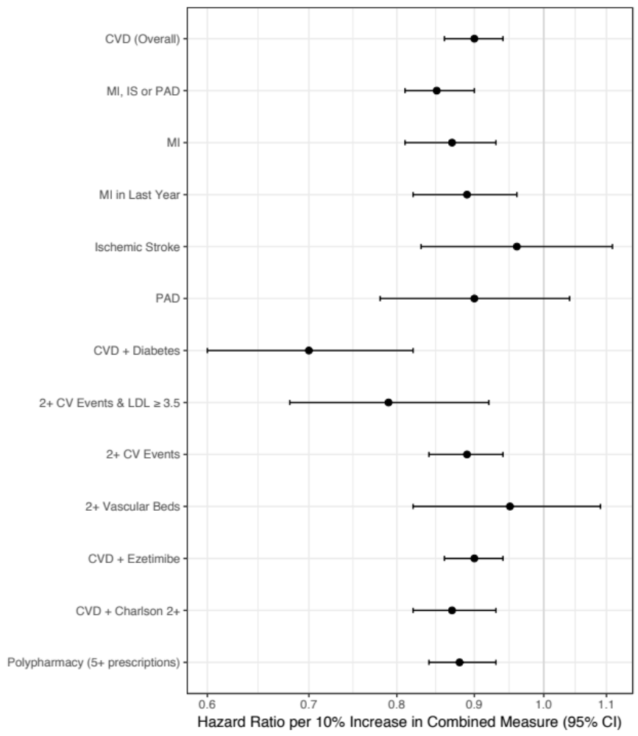
Note: Subgroups are not mutually exclusive. CV = cardiovascular, CVD = cardiovascular disease, MI = myocardial infarction, PAD = peripheral artery disease, IS = ischemic stroke. Vascular beds range from 1 to 3 (coronary, cerebrovascular, peripheral). Model adjusted for initial use of high intensity therapy, sex, smoking status, hypertension status, anti-thrombotic medication use, chronic kidney disease status, history of chronic CVD, diabetes status, atrial fibrillation status, year of follow-up, and Charlson comorbidity score.

Tables
Table 1: Baseline Characteristics of the Cohorts
Variable | Documented CVD  (N = 16,701) | Type 2 Diabetes without CVD or CKD  (N = 12,422) | CKD without CVD  (N = 674)
Variable | Mean (SD) or No. (%) | Mean (SD) or No. (%) | Mean (SD) or No. (%)
Age (years) | 68.3 (13.2) | 59.3 (12.4) | 67.3 (15.1)
Male | 10,117 (60.6%) | 6,832 (55.0%) | 317 (47.0%)
BMI (kg/m²) ª | 27.6 (5.4) | 32.3 (6.6) | 29.3 (6.2)
Follow-up Time (years) | 2.9 (1.5) | 3.1 (1.5) | 3.2 (1.6)
Smoking
Current Smoker | 3,246 (19.4%) | 2,210 (17.8%) | 103 (15.3%)
Former Smoker | 6,384 (38.2%) | 3,990 (32.1%) | 228 (33.8%)
Never Smoker | 7,071 (42.3%) | 6,222 (50.1%) | 343 (50.9%)
Charlson Comorbidity Index
Charlson 0 | 4,040 (24.2%) | 68 (0.5%) | 141 (20.9%)
Charlson 1 | 6,531 (39.1%) | 7,646 (61.6%) | 87 (12.9%)
Charlson 2+ | 6,130 (36.7%) | 4,708 (37.9%) | 446 (66.2%)
Risk Factors
Hypertension | 14,455 (86.6%) | 8,605 (69.3%) | 581 (86.2%)
Type 2 Diabetes | 1,043 (6.2%) | 12,422 (100.0%) | 126 (18.7%)
Potential Familial Hypercholesterolemia ^{b} | 15 (0.1%) | 13 (0.1%) | 1 (0.1%)
Stage 4-5 CKD | 286 (1.7%) | 0 (0.0%) | 674 (100.0%)
Anti-hypertensive drug | 12,833 (76.8%) | 6,420 (51.7%) | 509 (75.5%)
Anti-thrombotic drug | 14,114 (84.5%) | 1,614 (13.0%) | 226 (33.5%)
Anti-diabetic drug | 726 (4.3%) | 8,159 (65.7%) | 104 (15.4%)
Atrial Fibrillation | 1,584 (9.5%) | 373 (3.0%) | 62 (9.2%)
Systolic Blood Pressure (mmHg) ª | 138 (15.7) | 139 (14.0) | 139 (15.6)
Diastolic Blood Pressure (mmHg) ª | 79 (8.8) | 82 (8.3) | 79 (8.7)
Chronic Disease Medications (Multimorbidity/ Polypharmacy) ^{c} | 5.7 (3.8) | 4.8 (3.6) | 6.6 (4.2)
Cholesterol Measures
LDL Cholesterol (mg/dL) ª | 128 (39) | 135 (35) | 143 (39)
Total Cholesterol (mg/dL) ª | 205 (46) | 220 (43) | 228 (50)
HDL Cholesterol (mg/dL) ª | 54 (15) | 46 (12) | 54 (15)
Initial Prescription
High Intensity Statin | 3,916 (23.4%) | 140 (1.1%) | 21 (3.1%)
Moderate Intensity Statin | 12,364 (74.0%) | 11,743 (94.5%) | 587 (87.1%)
Low Intensity Statin | 388 (2.3%) | 514 (4.1%) | 61 (9.1%)
Statin with Ezetimibe | 5 (0.0%) | 6 (0.0%) | 2 (0.3%)
Ezetimibe Alone | 28 (0.2%) | 19 (0.2%) | 3 (0.4%)
Last Prescription ^{d}
High Intensity Statin | 3,050 (18.3%) | 586 (4.7%) | 23 (3.4%)
Moderate Intensity Statin | 7,653 (45.8%) | 6,870 (55.3%) | 320 (47.5%)
Low Intensity Statin | 345 (2.1%) | 376 (3.0%) | 38 (5.6%)
Statin with Ezetimibe | 22 (0.1%) | 14 (0.1%) | 0 (0.0%)
Ezetimibe Alone | 73 (0.4%) | 56 (0.5%) | 4 (0.6%)
None | 5,558 (33.3%) | 4,520 (36.4%) | 289 (42.9%)

Notes: ª Laboratory measures only available on a subset of the population. ^{b} Potential familial hypercholesterolemia (FH) identified using the Dutch Lipid Clinic score (retrospectively) and/or FH-specific Read codes. ^{c} Unique medication count excludes lipid-lowering therapies. ^{d} Last Prescription refers to the prescription at the end of observation for each person. Patients without an active prescription on this date were included as “none.” CVD = cardiovascular disease; CKD = chronic kidney disease; BMI = body mass index; SD = standard deviation; N = sample size.
Table 2: Separate and Combined Effects of Adherence and Intensity on Cardiovascular Risk by Cohort
Measures | Documented CVD  HR (95% CI) | Type 2 Diabetes without CVD  HR (95% CI) | CKD without CVD  HR (95% CI)
Model 1: Adherence alone
Per 10% increase | 0.95 (0.94 - 0.97) | 0.97 (0.95 - 0.99) | 0.93 (0.88 - 0.98)
Adherent | 0.65 (0.60 - 0.70) | 0.74 (0.68 - 0.81) | 0.52 (0.41 - 0.66)
Non-adherent | 0.78 (0.78 - 0.78) | 0.85 (0.84 - 0.85) | 0.69 (0.68 - 0.70)
Model 2: Intensity Alone
Per 10% increase | 0.90 (0.86 - 0.95) | 0.93 (0.89 - 0.98) | 0.87 (0.76 - 0.99)
High Intensity | 0.60 (0.52 - 0.68) | 0.71 (0.62 - 0.81) | 0.47 (0.32 - 0.71)
Moderate Intensity | 0.69 (0.65 - 0.73) | 0.78 (0.73 - 0.83) | 0.59 (0.49 - 0.72)
Low Intensity | 0.78 (0.78 - 0.78) | 0.85 (0.85 - 0.85) | 0.70 (0.68 - 0.73)
Model 3: Combined Adherence and Intensity
Per 10% increase | 0.90 (0.86 - 0.94) | 0.92 (0.87 - 0.97) | 0.81 (0.70 - 0.95)
Per 10% increase, no heart failure* | 0.90 (0.86 - 0.94) | 0.90 (0.85 - 0.96) | 0.86 (0.73 - 1.02)
High Intensity + Adherent | 0.60 (0.54 - 0.68) | 0.67 (0.57 - 0.79) | 0.39 (0.25 - 0.61)
High Intensity + Non-adherent | 0.90 (0.86 - 0.95) | 0.92 (0.87 - 0.98) | 0.82 (0.73 - 0.92)
Moderate Intensity + Adherent | 0.70 (0.66 - 0.74) | 0.75 (0.69 - 0.82) | 0.50 (0.38 - 0.65)
Moderate Intensity + Non-adherent | 0.93 (0.87 - 0.99) | 0.94 (0.88 - 1.02) | 0.87 (0.74 - 1.02)
Low Intensity + Adherent | 0.78 (0.78 - 0.79) | 0.82 (0.81 - 0.84) | 0.62 (0.57 - 0.68)
Low Intensity + Non-adherent | 0.95 (0.89 - 1.02) | 0.96 (0.88 - 1.05) | 0.91 (0.75 - 1.11)
Note: HR = hazard ratio. The adherent patient profile is defined as patients with a proportion of days covered ≥80%. Models adjusted for sex, smoking status, hypertension status, anti-thrombotic medication use, chronic kidney disese (CKD) status (except CKD cohort), history of chronic cardiovascular disease (CVD; CVD cohort only), diabetes status (except diabetes cohort), duration of diabetes (diabetes cohort only), atrial fibrillation status, year of follow-up, and Charlson comorbidity score. * sensitivity analysis excluding heart failure from the composite endpoint.

References
1. Catapano AL, Graham I, De Backer G, et al. 2016 ESC/EAS Guidelines for the Management of Dyslipidaemias. Eur Heart J. 2016;37(39):2999-3058. doi:10.1093/eurheartj/ehw272.
2. JBS3 Board. Joint British Societies’ consensus recommendations for the prevention of cardiovascular disease ( JBS3). Heart. 2014;100(Suppl 2):ii1-ii67. doi:10.1136/heartjnl-2014-305693.
3. NICE. Lipid modification: NICE guideline (CG181). Natl Inst Heal Clin Excell. 2014;12(July):231-254.
4. Piepoli MF, Hoes AW, Agewall S, et al. 2016 European Guidelines on cardiovascular disease prevention in clinical practice. Eur Heart J. 2016;37(29):2315-2381. doi:10.1093/eurheartj/ehw106.
5. Stone NJ, Robinson JG, Lichtenstein AH, et al. 2013 ACC/AHA guideline on the treatment of blood cholesterol to reduce atherosclerotic cardiovascular risk in adults: a report of the American College of Cardiology/American Heart Association Task Force on Practice Guidelines. Circulation. 2014;129(25 Suppl 2):S1-45. doi:10.1161/01.cir.0000437738.63853.7a.
6. Jansen J, McKinn S, Bonner C, et al. General practitioners’ decision making about primary prevention of cardiovascular disease in older adults: A qualitative study. PLoS One. 2017;12(1):1-13. doi:10.1371/journal.pone.0170228.
7. Reiner Z, Sonicki Z, Tedeschi-Reiner E. Physicians’ perception, knowledge and awareness of cardiovascular risk factors and adherence to prevention guidelines: the PERCRO-DOC survey. Atherosclerosis. 2010;213(2):598-603. doi:10.1016/j.atherosclerosis.2010.09.014.
8. Mosca L, Linfante AH, Benjamin EJ, et al. National study of physician awareness and adherence to cardiovascular disease prevention guidelines. Circulation. 2005;111(4):499-510. doi:10.1161/01.CIR.0000154568.43333.82.
9. Ramkumar S, Raghunath A, Raghunath S. Statin therapy: Review of safety and potential side effects. Acta Cardiol Sin. 2016;32(6):631-639. doi:10.6515/ACS20160611A.
10. Setia S, Fung SS-W, Waters DD. Doctors’ knowledge, attitudes, and compliance with 2013 ACC/AHA guidelines for prevention of atherosclerotic cardiovascular disease in Singapore. Vasc Health Risk Manag. 2015;11:303-310. doi:10.2147/VHRM.S82710.
11. Laufs U, Karmann B, Pittrow D. Atorvastatin treatment and LDL cholesterol target attainment in patients at very high cardiovascular risk. Clin Res Cardiol. 2016;105(9):783-790. doi:10.1007/s00392-016-0991-z.
12. Boggon R, Eaton S, Adam T, et al. Current prescribing of statins and persistence to statins following ACS in the UK: a MINAP/GPRD study. Br J Cardiol. 2012;19(24). doi:10.5837/bjc.2012.003.
13. Kotseva K, Wood D, De Bacquer D, et al. EUROASPIRE IV: A European Society of Cardiology survey on the lifestyle, risk factor and therapeutic management of coronary patients from 24 European countries. Eur J Prev Cardiol. 2016;23(6):636-648. doi:10.1177/2047487315569401.
14. Lindgren P, Eriksson J, Buxton M, et al. The economic consequences of non-adherence to lipid-lowering therapy: Results from the Anglo-Scandinavian-Cardiac Outcomes Trial. Int J Clin Pract. 2010;64(9):1228-1234. doi:10.1111/j.1742-1241.2010.02445.x.
15. Rasmussen JN, Chong A, Alter D a. Relationship between adherence to evidence-based pharmacotherapy and long-term mortality after acute myocardial infarction. Jama. 2007;297(2):177-186. doi:10.1001/jama.297.2.177.
16. De Vera MA, Bhole V, Burns LC, Lacaille D. Impact of statin adherence on cardiovascular disease and mortality outcomes: a systematic review. Br J Clin Pharmacol. 2014;78(4):684-698. doi:10.1111/bcp.12339.
17. Treatment C, Ctt T. Efficacy and safety of more intensive lowering of LDL cholesterol: A meta-analysis of data from 170 000 participants in 26 randomised trials. Lancet. 2010;376(9753):1670-1681. doi:10.1016/S0140-6736(10)61350-5.
18. Deshpande S, Quek RGW, Forbes CA, et al. A systematic review to assess adherence and persistence with statins. Curr Med Res Opin. 2017;33(4):769-778. doi:10.1080/03007995.2017.1281109.
19. Stone MA, Camosso-Stefinovic J, Wilkinson J, De Lusignan S, Hattersley AT, Khunti K. Incorrect and incomplete coding and classification of diabetes: A systematic review. Diabet Med. 2010;27(5):491-497. doi:10.1111/j.1464-5491.2009.02920.x.
20. Nau DP. Proportion of days covered (PDC) as a preferred method of measuring medication adherence. Pharm Qual Alliance. 2006;2012:1-3.
21. Andrade SE, Kahler KH, Frech F, Chan KA. Methods for evaluation of medication adherence and persistence using automated databases. Pharmacoepidemiol Drug Saf. 2006;15(8):565-74; discussion 575-7. doi:10.1002/pds.1230.
22. Reiner, De Backer G, Fras Z, et al. Lipid lowering drug therapy in patients with coronary heart disease from 24 European countries - Findings from the EUROASPIRE IV survey. Atherosclerosis. 2016;246:243-250. doi:10.1016/j.atherosclerosis.2016.01.018.
23. Cannon CP, Blazing M a., Giugliano RP, et al. Ezetimibe Added to Statin Therapy after Acute Coronary Syndromes. N Engl J Med. 2015;372(25):2387-2397. doi:10.1056/NEJMoa1410489.
24. Holme I, Szarek M, Cater NB, et al. Adherence-adjusted efficacy with intensive versus standard statin therapy in patients with acute myocardial infarction in the IDEAL study. Eur J Cardiovasc Prev Rehabil. 2009;16(3):315-320. doi:10.1097/HJR.0b013e32832130f5.
25. Griffin BA, Anderson GL, Shih R a, et al. Use of Alternative Time Scales in Cox Proportional Hazard Models : Implications for Time-Varying Environmental Exposures. Stat Med. 2013;31(27):3320-3327. doi:10.1002/sim.5347.Use.
26. Lin I, Sung J, Sanchez RJ, et al. Patterns of Statin Use in a Real-World Population of Patients at High Cardiovascular Risk. J Manag Care Spec Pharm. 2016;22(6):685-698. doi:10.18553/jmcp.2016.22.6.685.
27. Ference BA, Ginsberg HN, Graham I, et al. Low-density lipoproteins cause atherosclerotic cardiovascular disease. 1. Evidence from genetic, epidemiologic, and clinical studies. A consensus statement from the European Atherosclerosis Society Consensus Panel. Eur Heart J. 2017;38(32):2459-2472. doi:10.1093/eurheartj/ehx144.
28. Bangalore S, Breazna A, DeMicco DA, Wun C-C, Messerli FH, TNT Steering Committee and Investigators. Visit-to-visit low-density lipoprotein cholesterol variability and risk of cardiovascular outcomes: insights from the TNT trial. J Am Coll Cardiol. 2015;65(15):1539-1548. doi:10.1016/j.jacc.2015.02.017.

Additional Study Information

Contributorship:
Design: All authors
Analyses: MDD, MG
Initial draft: MDD, MG
Revisions: All authors
Final approval: All authors
Agreement to be accountable: All authors
MDD and KK contributed equally to this manuscript

Funding:
This study was funded by Amgen, Europe GmbH.

Role of the funder:
Amgen reviewed and approved the design of the study, and reviewed and approved the manuscript for publication. Amgen did not participate in any of the following: conduct of the study; collection, management, analysis, and interpretation of the data; preparation of the manuscript; or the decision to submit the manuscript for publication.

Competing interests:
Mark Danese and Michelle Gleeson work with Outcomes Insights, Inc., which was funded to conduct this study. Lucie Kutikova, Francisco Sorio Vilela, and David Catterick are employees of Amgen, Inc and owners of Amgen stock. Kamlesh Khunti has acted as a consultant for Novartis, Novo Nordisk, Sanofi-Aventis, Lilly, AstraZeneca, Servier and Merck Sharp & Dohme, Boehringer Ingelheim, Amgen, Bayer, and Abbot; and as a speaker for Novartis, Novo Nordisk, Sanofi-Aventis, Lilly, AstraZeneca Merck Sharp & Dohme, and Boehringer Ingelheim. He has received research grants from Novartis, Novo Nordisk, Sanofi-Aventis, Lilly, Pfizer, Boehringer Ingelheim, Merck Sharp & Dohme, and Roche. SR Kondapally Seshasai has provided consulting to Amgen and received grants from Kowa and Sanofi. Jack Brownrigg has received consulting fees from Amgen and employment from Pfizer. Kausik K. Ray has acted as a consultant for Amgen, Sanofi, Regeneron, MedCo, Cerenis, Lilly, Ionis Pharma, Esperion, and Abbvie; and as a speaker for Kowa, AstraZeneca, Pfizer, Takeda, Boehringer Ingelheim, Algorithm, Cipla. He has received research grants from Sanofi, Regeneron, Amgen, Merck Sharpe & Dohme, and Pfizer through his institution.

Acknowledgments:
Dr. Khunti’s participation was supported by the National Institute for Health Research (NIHR) Collaboration for Leadership in Applied Health Research and Care in East Midlands (CLAHRC EM) and the Leicester Biomedical Research Centre. The views expressed are those of the authors and not necessarily those of the NHS, the NIHR or the Department of Health.
Dr. Danese had full access to all the data in the study and takes responsibility for the integrity of the data and the accuracy of the data analysis.

Data sharing:
To ensure patient privacy and confidentiality, the CPRD data cannot be shared.
Authors:
Kamlesh Khunti, MD, FMedSci (1); Mark D. Danese, MHS, PhD (2); Lucie Kutikova, PhD (3); David Catterick, MSc, PhD (4); Francisco Sorio Vilela (3); Michelle Gleeson, PhD (3); Sreenivasa Rao Kondapally Seshasai, MBBS, MD, MRCP, MPhil, PhD (5); Jack Brownrigg, MBChB, BSc, MRCS, PhD (6); Kausik K. Ray, MD, FAHA (7)
Affiliations:
(1) Diabetes Research Centre, University of Leicester, Leicester, UK; (2) Outcomes Insights, Inc., Outcomes Research, Westlake Village, CA; (3) Amgen (Europe) GmbH, Health Economics, Zug, Switzerland; (4) Amgen Limited, Uxbridge, UK; (5) St George’s, University of London, London, UK; (6) St George’s Vascular Institute, London, UK; (7) Imperial Centre for Cardiovascular Disease Prevention, School of Public Health, Imperial College London, London, UK

