Computational prediction of head-ground impact kinematics in e-scooter falls

Pasinee Posirisuk, Claire Baker, Mazdak Ghajari
HEAD lab, Dyson School of Design Engineering, Imperial College London

Abstract
E-scooters are the fastest growing mode of micro-mobility with important environmental benefits. However, there are serious concerns about injuries caused by e-scooter accidents. Falls due to poor road surface conditions are a common cause of injury in e-scooter riders, and head injuries are one of the most common and concerning injuries in e-scooter falls. However, the head-ground impact biomechanics in e-scooter falls and its relationship with e-scooter speed and design, road surface conditions and wearing helmets remain poorly understood. To address some of these key questions, we predicted the head-ground impact force and velocity of e-scooter riders in different falls caused by potholes. We used multi-body dynamics approach to model a commercially available e-scooter and simulate 180 falls using human body models. We modelled different pothole sizes to test whether the pothole width and depth influences the onset of falls and head-ground impact speed and force. We also tested whether the e-scooter travelling speed has an influence on the head-ground impact force and velocity. The simulations were carried out with three human body models to ensure that the results of the study are inclusive of a wide range of rider sizes. For our 10inch diameter e-scooter wheels, we found a sudden increase in the occurrence of falls when the pothole depth was increased from 3cm (no falls) to 6cm (41 falls out of 60 cases). When the falls occurred, we found a head-ground impact force of 13.2±3.4kN, which is larger than skull fracture thresholds. The head-ground impact speed was 6.3±1.4m/s, which is nearly the same as the impact speed prescribed in bicycle helmet standards. All e-scooter falls resulted in oblique head impacts, with an impact angle of 65±10° (measured from the ground). Decreasing the e-scooter speed reduced the head impact speed. For instance, reducing the e-scooter speed from 30km/h to 20km/h led to a 14% reduction in the mean impact speed and 12% reduction in the mean impact force, as predicted by the models. The models also showed that the median male riders were sustaining higher head-ground impact force and speed compared with the small female and large male riders. The findings of this study can assist authorities and e-scooter hiring companies to take more informed actions about road surface conditions and speed limits. These results can also help define representative impact test conditions for assessing the performance of helmets used by e-scooter riders in order to reduce head and brain injuries in e-scooter falls.
Keywords: e-scooter, fall, brain injury, pothole, impact, multi-body dynamics
Highlights
- Falls of e-scooter riders caused by potholes are modelled.
- Pothole depth has a clear effect on causing falls of e-scooter riders.
- The predicted head-ground impact force is larger than skull fracture thresholds.
- Head-ground impact speed is nearly the same as that in bicycle helmet standards.
- Decreasing the e-scooter speed reduces head-ground impact speed and force.

Introduction
Electric scooters, or e-scooters, have become increasingly popular as a convenient and affordable transportation means. They are also a green alternative to cars and motorbikes, helping to alleviate carbon emission and traffic congestion in urban areas. E-scooters are the fastest-growing mode of micro-mobility with ridership increasing by over 100% from 38.5 million trips in 2018 to 86 million trips in 2019 in the US (NACTO 2020). Because of its popularity, the e-scooter industry spanned its geographical footprint to 626 cities in 53 countries across the US, Europe and Asia after two years of launching (Møller, Simlett et al. 2020).
The growing number of e-scooter related injuries match their growing popularity, raising safety concerns for the riders as well as receiving criticisms of being a public risk. Like cyclists and pedestrians, e-scooter riders are vulnerable road users and are likely to sustain severe injuries in accidents. According to the US Consumer Product Safety Commission, e-scooter accidents had the largest proportion of micro-mobility transportation fatalities in the US in 2019, with a substantial increase since 2017 (Tark 2020). Many cases of e-scooter accidents require the deployment of emergency medical services and hospitalisation, placing burden on cities’ local healthcare systems. A recent study found that the total cost of e-scooter injuries within the Auckland region (New Zealand) was over £650,000 for a period of 7 months, with an average cost per injury of £850 (Bekhit, Le Fevre et al. 2020).
Falls are the most common cause of injuries of e-scooter riders, and head and face injuries are reported in a considerable number of e-scooter falls. A study on 105 adults (mean age 39.5 years and 50% female) injured while riding e-scooters in Washington DC found that two third of accidents were falls due to adverse surface features or infrastructure, in contrast to only 10% of accidents from collision with motorised vehicles (Cicchino, Kulie et al. 2021). Head and face injuries were reported in 15% of the riders who fell, and less than 2% of the riders wore a helmet. Similar results were found in a study involving 112 injured e-scooter riders (median age 27 years, 57% female) in Copenhagen (Denmark), which showed that 86.6% of patients fell off their e-scooter without involving another vehicle (Blomberg, Rosenkrantz et al. 2019). 20.5% of the riders had minor head injuries (including all closed-head injuries without skull fracture or intracranial haemorrhage). Facial injuries occurred in 38.4% of the riders. Helmet use was confirmed in only 4% of the riders. In a study in the US on 228 e-scooter riders (mean age 34 years, 42% female), facial fractures were documented in 5.6% of the cases and head injury in 40.4% (Trivedi, Liu et al. 2019). Out of the head injuries, 38.2% were minor (any closed head injuries without skull fractures or intracranial haemorrhage). Out of 15 admitted patients, 5 had intracranial haemorrhage and 1 had a concussion. The prevalent mechanism of injury was fall (80.2%). Another study of 90 injured e-scooter riders (mean age 32 years, 38% female) found that 58% of admissions involved head and face injuries (Trivedi, Kesterke et al. 2019). 33% of the riders sustained major craniofacial injury (fracture, internal haemorrhage and loss of consciousness). Of craniofacial injuries, most injuries had occurred in the upper face and midface. Another study reported 89 e-scooter injuries in Hamburg (mean age 34 years, 37% female) (Kleinertz, Ntalos et al. 2021). The mechanism of injury in 79% of the riders was fall. 54% of the riders reported an impact to the head or face. 14% had a severe head injury and 16% had a severe facial injury. In another study in one emergency department in the US between 2018 and 2019, 58 e-scooter patients were identified (mean age 34 years, 50% female) (Badeau, Carman et al. 2019). 8% of the patients suffered major head injuries (skull fractures and intracranial haemorrhage) and 12% suffered minor head injuries (closed head injury and concussion). Another study on 190 cases of e-scooter related injuries in Austin Texas (median age 29 years, 55% male) reported that 50% of the injured riders believed that road surface conditions like a pothole or crack in the street contributed to their falls and subsequent injuries (Hawes, Hernandez-Ayala et al. 2019). The research also showed that 48% of injured riders had head injuries, with 7% sustaining craniofacial fractures. Interestingly, less than 1% of the riders were wearing a helmet. Another study reported head injuries in one third of injured e-scooter riders, which is more than double the rate of head injuries in cyclists (Namiri, Lui et al. 2020). These studies show that a large proportion of injuries in e-scooter riders are head and face injuries (20 to 58%) and a considerable number of head and face injuries are severe (8 to 33%). They also show that the main cause of injuries is falls (79-87% of cases).
The head-ground impact has been identified as an important determinant of severe head injuries in cyclists and pedestrians (Otte and Pohlemann 2001, Yang 2005, Crocetta, Piantini et al. 2015), and it is likely to be an important cause of severe head injuries in e-scooter riders after falls. However, as e-scooters are a newly emerging mode of transportation, there is limited previous work on understanding the biomechanics of e-scooter accidents. Particularly, the head-ground impact dynamics in e-scooter falls remains unexplored.
In this study, we use multi-body dynamics simulations to predict the biomechanics of head-ground impact in e-scooter falls. We test whether the head-ground impact force is large enough to cause fractures. To simulate falls, we incorporate potholes in the models and vary the widths and depths of the potholes to explore their effects on the head-ground impact force and velocity. Scooter speed contributes to falls and injuries, and some authorities and e-scooter companies impose a speed limit on e-scooters (Hawes, Hernandez-Ayala et al. 2019, Santacreu, Yannis et al. 2020, Ma, Yang et al. 2021). Hence, we also vary the travel speed to test whether it has a significant effect on the head-ground impact force and velocity. Riders with different sizes are likely to experience different head-ground impact force and velocity. Hence, we study the effects of rider anthropometry on the head impact force and velocity. This work can help us to determine the effects of road surface conditions and speed limits on causing head injuries after e-scooter falls. It can also show the importance of wearing a helmet when riding e-scooters and help in defining suitable conditions for testing helmets.

Methods
We used the MADYMO multi-body dynamics software for our simulations. MADYMO has been widely used to study biomechanics of accidents, particularly in vulnerable road users (Van Rooij, Bhalla et al. 2003, Elliott, Simms et al. 2012, Peng, Chen et al. 2012, Shang, Masson et al. 2021).

The multi-body dynamics model of e-scooter
The e-scooter model was based on a Lime Gen 3.0 e-scooter with 10 inch wheels (Figure 1A). The CAD model of the e-scooter was used to extract key information for multi-body modelling, including the main dimensions, mass, mass moments of inertia and location of centre of mass. The multi-body model of the e-scooter consisted of two rigid bodies, the front wheel and the rest of the e-scooter, connected by a revolute joint at the axis of the wheel. We used this approach to allow the front wheel to rotate freely when it comes in contact with the pothole. The e-scooter was modelled using 5 ellipsoids, representing the front and rear wheels, chassis, handlebar and steering column. Figure 1B shows the key dimensions of the model and Table 1 presents the inertial properties of the rigid parts.

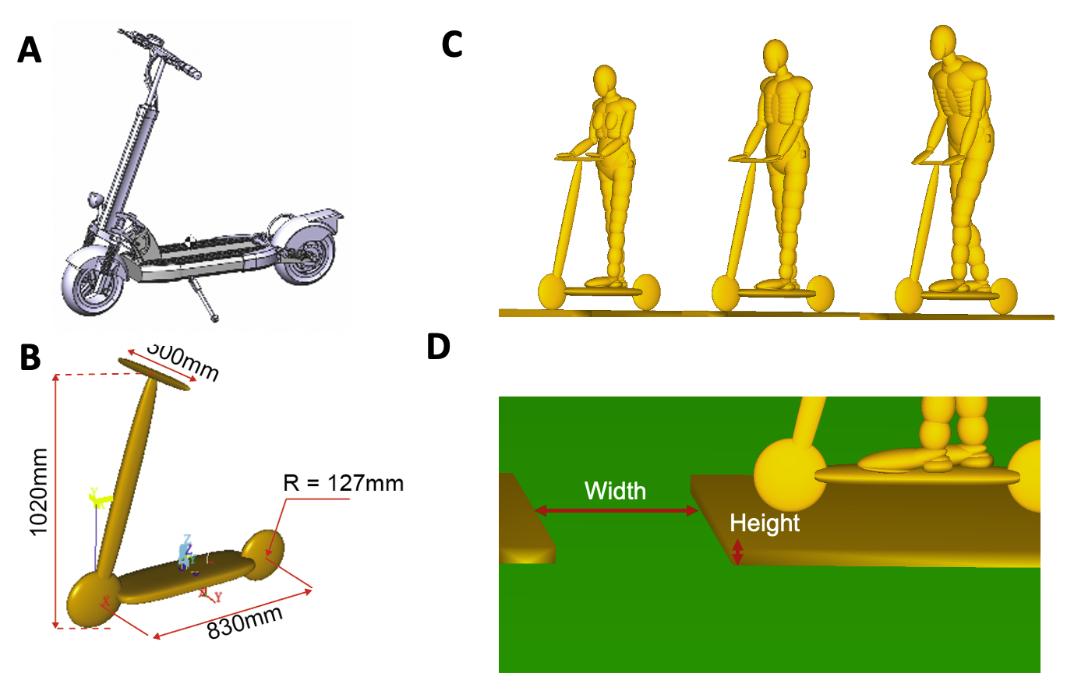
Figure 1 The computer models. A) the CAD model of the e-scooter, B) The multi-body model of the E-scooter, showing its key dimensions, C) Different posture of riders after positioning them on the e-scooter, D) The model of the pothole.

Table 1 Inertial properties of the parts of the e-scooter model.
Body | Mass [kg] | Centre of mass position [mm] | Mass moments of inertia (Ixx Iyy Izz Ixy Iyz Izx) [kg.cm²]
Front wheel | 1.10 | (450, -2, -27) | (60, 100, 56, 0, 0, -2)
Rest of the e-scooter | 13.53 | (8, -2, 79) | (6600, 15700, 10300, -5, -80, 2300)

Human body models
We used the 5th percentile female, 50th percentile male and 95th percentile male ellipsoid pedestrian models of MADYMO to represent a large group of e-scooter riders (Figure 1C). Each model consists of 52 rigid bodies with an outer surface described by 64 ellipsoids. The mass of the models is 49.8kg, 75.7kg and 101.1kg respectively and their heights are 1.53m, 1.74m and 1.91m respectively. The 50th percentile male model has been widely used in previous studies and validated against collision data (Ishikawa, Kajzer et al. 1993, Van Rooij, Bhalla et al. 2003, Crocetta, Piantini et al. 2015). The 5th percentile female and 95th percentile male models have been generated through scaling the 50th percentile male model, with anthropometry based on the RAMSIS database (RAMSIS 1997). It should be noted that these human body models do not actively react to the fall for instance by holding their hands out.
E-scooters have a narrow deck, thus few standing options. We searched pictures on google to determine common riding postures. We found that riders often place one foot on the front and one at the back, as in our models. The handlebar of shared e-scooter has a fixed height. Hence, we slightly bent the large male and elbows of the small female to make sure their hands are on the handlebar.

Contact characteristics
In multi-body dynamics simulations, contact is based on a force-deflection curve defined for the contacting bodies. In MADYMO, human body models have a default force-deflection curve for each part. Based on previous studies (Crocetta, Piantini et al. 2015, Xu, Shang et al. 2016, Xu, Shang et al. 2016), we defined force-deflection curves for different parts of the e-scooter and adopted a combined contact algorithm to take into account the stiffness of the human body and scooter parts when evaluating contact forces. For the tyre-ground and head-ground contacts, we used the slave contact algorithm, which uses the force-deflection curves of the tyre and head. The force-deflection curve of the head was based on the data obtained from dynamic experiments on cadaver heads (Yoganandan, Pintar et al. 1995). The force-deflection curves for the head and different parts of the e-scooter are presented in Table 2. The hysteresis slope for all e-scooter contacts were set to 10⁸ as in previous studies (Crocetta, Piantini et al. 2015, Shang, Masson et al. 2021). The values for coefficient of friction at different contact surfaces were based on a recent study that reconstructed a scooter-microvan collision (Zou, Zhang et al. 2019). The coefficient of friction was 0.4 between the rider and e-scooter, 0.67 between rider and road surface and 0.55 between e-scooter wheels and road surface.
Table 2 Force-deflection data for the e-scooter parts and head
Wheel |  | Chassis |  | Steering column |  | Handlebar |  | Head
Deflection (mm) | Force (N) | Deflection (mm) | Force (N) | Deflection (mm) | Force (N) | Deflection (mm) | Force (N) | Deflection (mm) | Force (N)
0  1.5  2.0 | 0  4000  9000 | 0  1  5  10  16  29  36  55 | 0  1500  2000  3000  4000  6500  6750  6950 | 0  40  70 | 0  5000  10000 | 0  40  70 | 0  1500  2000 | 0  1  2  3  4  5  6  7  8 | 0  480  1411  3326  6242  9784  11938  11940  11942

Validating model predictions
Currently there are no sufficiently detailed published data on e-scooter accidents nor are there any published e-scooter crash test results. Hence, we used two preliminary approaches to validate the model predictions of the e-scooter and head kinematics. In the first approach, we simulated a volunteer test carried out by the Swifty scooter company (Allerton 2020). The test involved a volunteer riding an e-scooter at nearly 10km/h speed and falling to the ground after entering a pothole with a 800mm width and 72mm depth. We simulated this test using the 50th percentile male model and predicted the time that it takes for the e-scooter to fall on the ground after contacting the edge of the pothole and compared this with the time measured from the test video. In the second approach, we predicted the distance that a rider’s head travels after e-scooter collides with an obstacle at 10km/h speed and compared this with the theoretical travel distance of the centre of mass of the head with the same initial velocity, assuming that the head is a free object.

Fall scenarios and travel speeds
E-scooter falls are often caused by poor road surface conditions like potholes or cracks in the street. A survey of 125 e-scooter riders has shown that 50% of the riders believed that surface conditions like potholes or cracks in the street contributed to their injuries (Hawes, Hernandez-Ayala et al. 2019). In another study, adverse surface features were implicated in large proportions of falls on roads (33%), bike lanes (25%) and sidewalks (25%) (Cicchino, Kulie et al. 2021). Hence, we simulated riding over potholes or cracks with different widths and depths. The pothole was represented by two rectangular bodies, constructed using hyper-ellipsoids placed apart from each other to represent the width of the pothole (Figure 1D). The height of the bodies represented the depth of the pothole. We included 12 different pothole sizes in the study, representing moderate and high pothole severities reported in a pothole severity classification study (Tiong, Mustaffar et al. 2012) and supported by another study (Kim and Ryu 2014). For each pothole size, we used the three different human body models (Table 3). We used five different travel speeds: 10km/h, 15km/h, 20km/h, 25km/h and 30km/h. This speed range includes the speed limits imposed by some e-scooter hiring companies and local authorities (DfT 2020). This approach allowed us to investigate the effects of e-scooter travel speeds and poor road surface conditions on the head-ground impact kinematics in e-scooter falls.
Table 3 Simulation parameters for the pothole impact scenario.
Pothole width (cm) | Pothole depth (cm) | Travel speed (km/h) | Rider
26, 40, 60, 80 | 3, 6, 9 | 10, 15, 20, 25, 30 | Small female, median male, large male

In total, 185 simulations of different e-scooter falls were performed. All simulations were executed using MADYMO solver version 7.8 on an Intel Core i7 2.80GHz CPU with a 16GB memory.

Outcome measures and statistical analysis
We predicted the head impact velocity (speed and angle to the ground) just before the first head-ground collision. This information can help with designing suitable methods for testing e-scooter helmets. We also predicted the peak value of the normal component of the head-ground contact force (called impact force hereafter). Force is a key determinant of skull fractures (Yoganandan and Pintar 2004).
Statistical tests were performed in the open-source software R. One-way ANOVA was used to assess the effects of pothole depth and width, e-scooter speed and rider size on the outcome measures, i.e. head-ground impact force, speed and angle. The ANOVA results were reported as F-value (degrees of freedom of independent variables, residuals) and p-value.

Results

Validation of the e-scooter kinematics
In the test, the e-scooter’s wheel hits the second edge of the pothole, which leads to the rotation of the e-scooter about the wheel (Figure 2). The volunteer rider, who is anticipating the impact, jumps off the e-scooter, and the e-scooter falls on the ground. The MADYMO simulation of this case also predicts that the e-scooter rotates about the front wheel’s axis after the wheel hits the second edge of the pothole and falls on the ground. The simulation predicted that the e-scooter took 560ms to fall on the ground after impact with pothole’s edge. This time was 570ms in the test. The human body model continues its motion passively and falls on the ground on its knees. There are large differences between the motion of the volunteer rider and model, which can be attributed to the fact that the rider holds his posture as the scooter enters the pothole, applies force on the handlebar and reacts to the collision, but the dummy does not. Despite these differences, this comparison validates some aspects of the model prediction. For instance, the contact between the tyre and pothole edge produced expected results and the predicted motion of the e-scooter was reasonable. We however could not make more detailed comparisons between the kinematics of the rider and model due to the differences between them.
The simulations of e-scooter falls showed that in the majority of impacts the rider was thrown after impact, with the head often following a trajectory like a projectile. A similar head trajectory has been found in bicycle-curb impacts (Werner, Newberry et al. 2001, Bourdet, Deck et al. 2012). Hence, we compared the travel distance of the centre of mass of the head with the travel distance of a projectile. The distance travelled by the head was predicted to be 3.7m, which is nearly 8% larger than the travel distance of a projectile, 3.4m.
These comparisons provide preliminary validation for the predictions of the multi-body dynamics models, in the absence of more detailed experimental data.
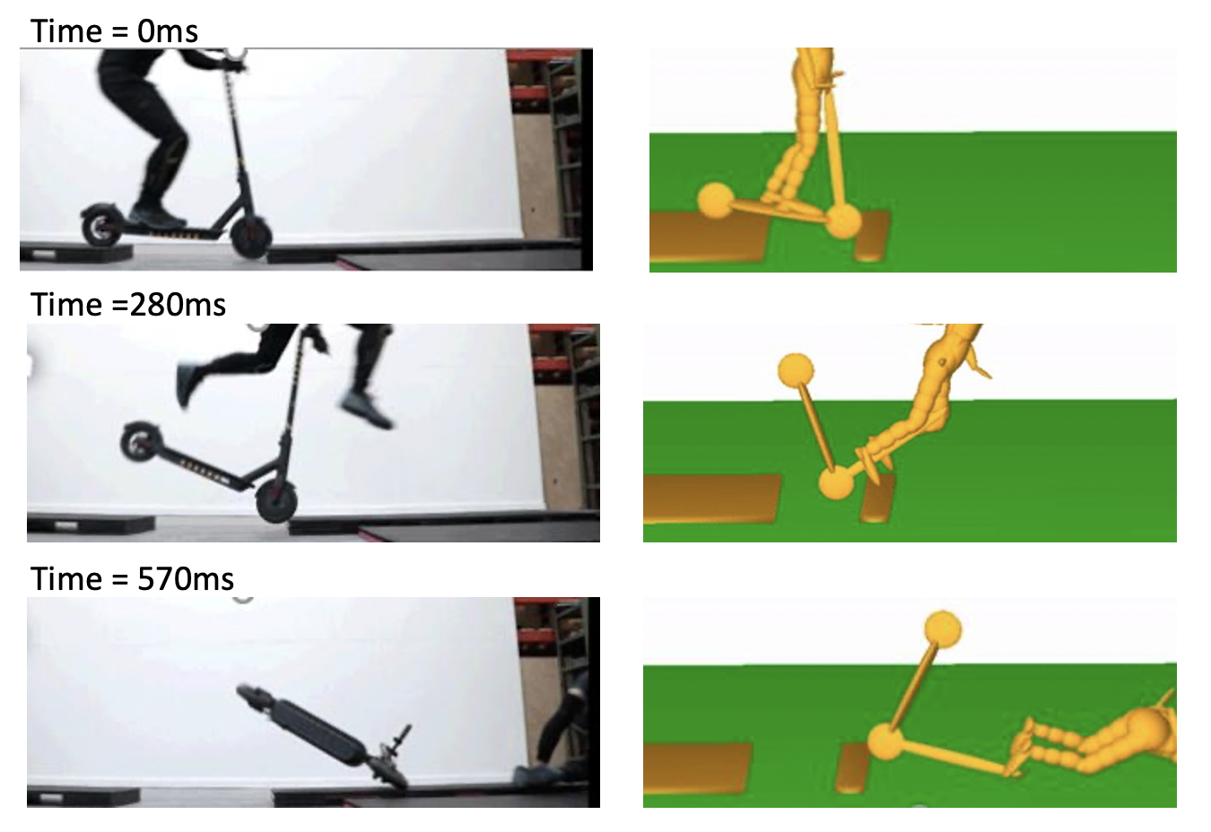
Figure 2 Comparison between the pothole test by Swifty (Allerton 2020) and MADYMO predictions.

Potholes deeper than 6cm significantly increase the risk of falls
Our model predicts that none of the riders fall when the depth of the pothole is 3cm (12% of wheel’s diameter) (Figure 3). When the pothole depth was increased to 6cm (24% of wheel’s diameter), fall was predicted in 75% of the cases for the 5th and 50th percentile riders. This number was decreased to 55% for the 95th percentile rider. When the pothole was 9cm deep, 75%, 80% and 65% of the cases led to a fall for the 5th, 50th and 95th percentile riders respectively.
The 5th and 50th percentile riders fell across all speeds when the pothole width was 60cm or larger and the depth was 6cm or larger. The 90th percentile rider fell across all speeds when the pothole size was 80cm or larger and the depth was 9cm. At narrower pothole widths, higher e-scooter speed helped the rider to pass the pothole without falling. The heavy 95th percentile rider had fewer falls when passing the pothole than the other two riders.
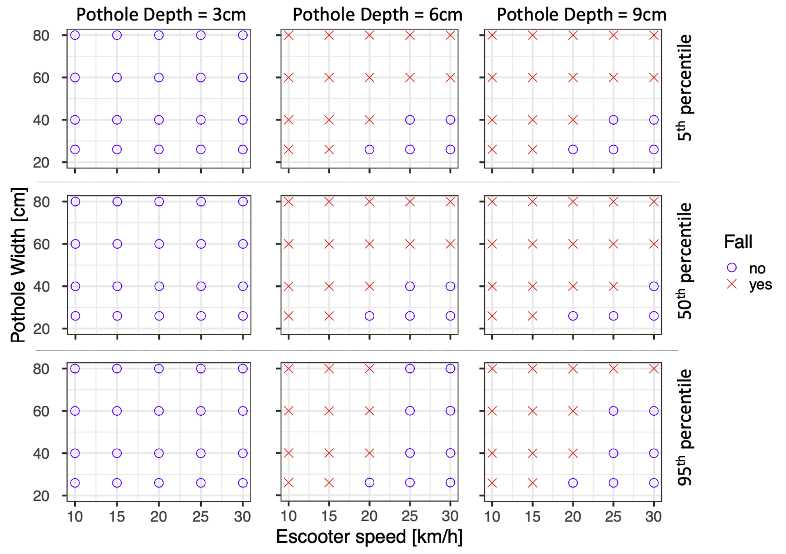
Figure 3 The effects of the pothole width and depth and travel speed on the likelihood of rider’s fall.

Fall kinematics
From the preliminary analysis of the animations generated from each simulation, the fall can be divided into two phases: the contact phase and the discharging phase (Figure 4). In the contact phase, the e-scooter comes in contact with pothole’s second edge. In the discharge phase, the rider shoots off from the e-scooter and flies airborne before impacting with the ground. The analysis also showed three types of fall kinematics (Figure 4). Type 1: the rider is discharged from the e-scooter and the head contacts the ground first. Type 2: the rider is discharged from the e-scooter and before the head contacts the ground, another body part contacts the ground. Type 3: the rider is discharged from the e-scooter and the body rotates to the side before impacting the ground on the side followed by head-ground impact.
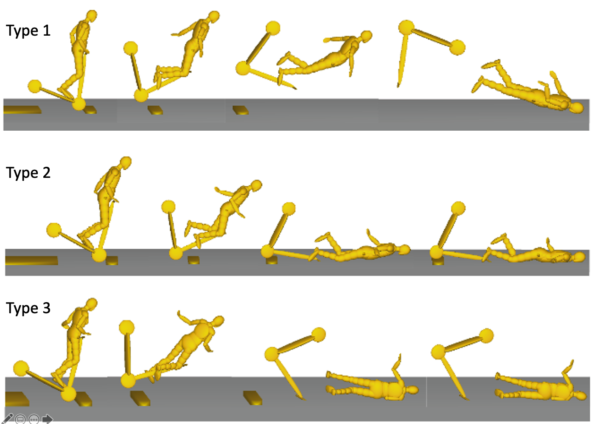
Figure 4 Different types of e-scooter fall kinematics.

The analysis of the simulation videos showed that 28%, 66% and 6% of the kinematics were types 1, 2 and 3 respectively. Further analysis showed that the proportion of type 3 falls increased by increasing the pothole depth to 9cm (Figure 5). The proportion of type 1 falls increased by increasing the pothole width from 25cm (no type 1 fall) to 60cm. The e-scooter speed had a clear effect on fall kinematics when it was increased from 25km/h to 30km/h; all falls were type 1 at the latter speed. The rider size also influenced the fall type. The median male rider had a mix of fall types with the largest proportion of type 2 falls. Type 1 falls had the largest proportion in the small female rider. Finally, in the large male rider, the dominant fall type was type 2.
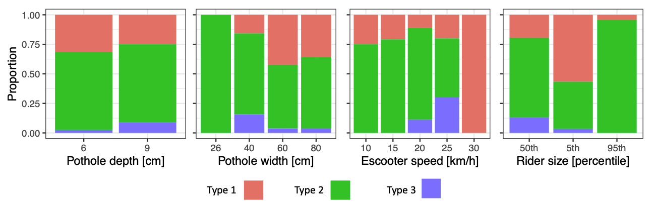
Figure 5 The distribution of fall types versus study variables.

We also analysed the videos to determine the location of impacts on the head. The head is modelled with two ellipsoids, one representing the cranium and the other representing the face, which were used to classify the impact location. The forehead or upper face area was included in the cranium category. We found that 56% of the impacts were to the cranium (mainly forehead) and 44% were to the face.

The pothole depth and width do not influence the head-ground impact force and velocity
The mean and standard deviation of the impact force was 13.0±3.4kN for the 6cm deep pothole and 13.4±3.5 for the 9cm deep pothole. A one-way ANOVA confirmed that there was no significant effect of the pothole depth on the impact force (F(1,81) = 0.286, p = 0.59). The impact speed and angle were 6.1±1.4m/s and 64±10° for the 6cm deep pothole and 6.5±1.3m/s and 66±10° for the 9cm deep pothole (Figure 6). Increasing the pothole depth slightly increased the impact speed and angle. However, a one-way ANOVA confirmed that there was no significant effect of the pothole depth on impact speed (F(1,83) = 1.193, p = 0.28) and angle (F(1,83) = 0.563, p = 0.45).
The mean impact force was increased when the pothole width was increased from 26cm (13.0±3.8kN) to 40cm (13.4±2.9kN) (Figure 6). Further increase in the pothole width, did not lead to a noticeable increase (60cm: 13.2±4.0kN, 80cm: 13.1±3.2kN). The impact speed was slightly increased by increasing the pothole width (26cm: 6.1±0.9m/s, 40cm: 6.3±1.2m/s, 60cm: 6.4±1.6m/s, 80cm: 6.3±1.5m/s). The impact angle was slightly decreased by increasing the pothole width (26cm: 68±4°, 40cm: 69±7°, 60cm: 63±11°, 80cm: 63±11°). However, a one-way ANOVA confirmed that there was no significant effect of the pothole width on the impact force (F(3,81) = 0.048, p = 0.99) and speed (F(3,81) = 0.158, p = 0.93). A one-was ANOVA indicated a significant effect of pothole width on the impact angle (F(3,81) = 2.792, p = 0.046). Post-hoc HSD tests showed that this effect was driven by a borderline significant difference between 40cm and 80cm pothole widths (p=0.085).

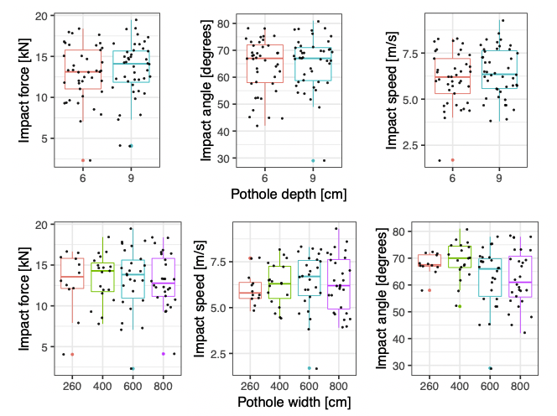
Figure 6 The effect of the pothole depth and width on the head-ground impact force, speed and angle. No significant effect was found.

E-scooter speed has a significant effect on head-ground impact speed
Increasing the e-scooter speed increased the head-ground impact force but this increase was not monotonic (Figure 7 and Table 4). The increase in the mean impact force was 27% for an increase in the travel speed from 10 to 30km/h. A one-way ANOVA however showed no significant effect of the e-scooter speed on the head-ground impact force (F(4,80)=2.039, p = 0.097).
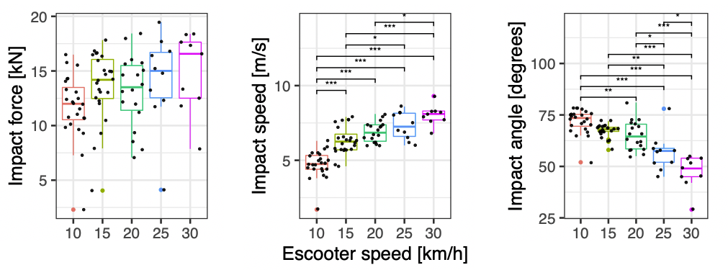
Figure 7 The head-ground impact force, speed and angle depend on the e-scooter speed. *p<0.05, **p<0.01, ***p<0.001.

Increasing the e-scooter speed also increased the head-ground impact speed (Figure 7 and Table 4). An increase in the e-scooter speed from 10 to 30km/h led to a 67% increase in the head-ground impact speed. A one-way ANOVA showed a significant effect of the e-scooter speed on the head-ground impact speed (F(4,80)=35.46, p<0.001). Post-hoc HSD tests showed that this was driven by significant differences between impact speeds at all e-scooter speeds, except 15-20km/h, 20-25km/h and 25-30km/h.
Increasing the e-scooter speed decreased the head-ground impact angle (Figure 7 and Table 4). An increase in the e-scooter speed from 10 to 30km/h led to a 34% reduction in the head-ground impact angle. A one-way ANOVA showed a significant effect of the e-scooter speed on the head-ground impact angle (F(4,80)=30.18, p<0.001). Post-hoc HSD tests showed that this was driven by significant differences between impact angles at all e-scooter speeds, except 10-15km/h and 15-20km/h.
Table 4 Head-ground impact force, speed and angle at different e-scooter speeds (mean and standard deviation)
E-scooter speed [km/h] | 10 | 15 | 20 | 25 | 30
Impact force [kN] | 11.7±3.0 | 13.6±3.2 | 13.1±3.3 | 14.2±4.3 | 14.9±3.7
Impact speed [m/s] | 4.8±0.9 | 6.3±0.9 | 6.9±0.7 | 7.3±0.9 | 8.0±0.7
Impact angle [degrees] | 72±6 | 67±3 | 65±7 | 57±9 | 47±8

The size of the rider influences head-ground impact force and speed
We then analysed the effects of the rider size. Our results show that the 50th percentile rider sustains largest impact force (16.1±1.8kN), then the 5th percentile rider (12.7±2.0kN) followed by the 95th percentile rider (9.9±3.3kN). A one-way ANOVA indicates a significant effect of the rider size on the head-ground impact force (F(2,82)=45.95, p<0.001). A post-hoc Tukey HSD shows that this is driven by significant differences between impact forces of all riders (Figure 8).
The impact speed was also largest for the 50th percentile rider (7.2±1.2m/s), followed by the 5th percentile rider (6.2±1.0m/s) and the 95th percentile rider (5.4±1.3m/s). Again an ANOVA indicated a significant effect of the rider size on the impact speed (F(2,82)=15.31, p<0.001) and a post-hoc Tukey HSD showed that this effect is driven by significant differences between impact speeds of all riders (Figure 8).
The impact angle was not considerably different between the riders (5th: 63±12°, 50th: 66±9°, 95th: 67±7°). This was confirmed by a one-way ANOVA (F(2,82)=1.222, p=0.3).
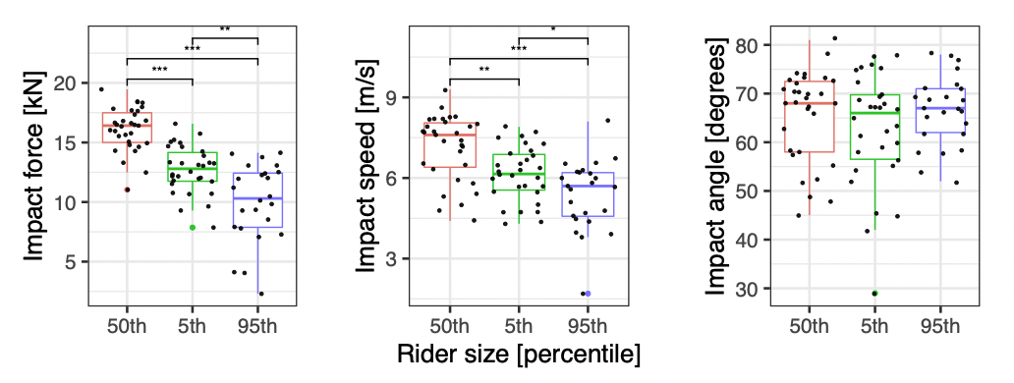
Figure 8 The effect of the rider size on the head-ground impact force, speed and angle. *p<0.05, **p<0.01, ***p<0.001.
In order to better understand kinematics of the riders with different sizes, we compared the kinematics of riders travelling at 20km/h and passing a 6cm deep and 40cm wide pothole. The predicted impact force for these riders was 12kN (small female), 16kN (median male) and 8.5kN (large male), which are close to the median impact force in each rider size group (Figure 8). For all riders, e-scooter’s front wheel hits the second edge of the pothole, and the e-scooter rotates about the wheel (Figure 9). The knee is the first point of contact with the ground for all riders. For the 95th percentile rider, the pelvis contacts the ground next followed by the chest and head, leading to an impact speed of 6.2m/s and impact angle of 71° (to the ground). The head of the 5th percentile rider contacts the ground after the knee. This leads to an impact speed of 6.5m/s, which is like the 95th percentile rider, but the impact velocity has a shallower angle (58°) indicating that a larger component of velocity is tangential to the ground. For the 50th percentile rider, the chest contacts the ground followed by the head. For this rider, the impact speed is increased to 7.4m/s compared with the other riders and the impact angle is large (73°), meaning that the vertical component of impact velocity is large.

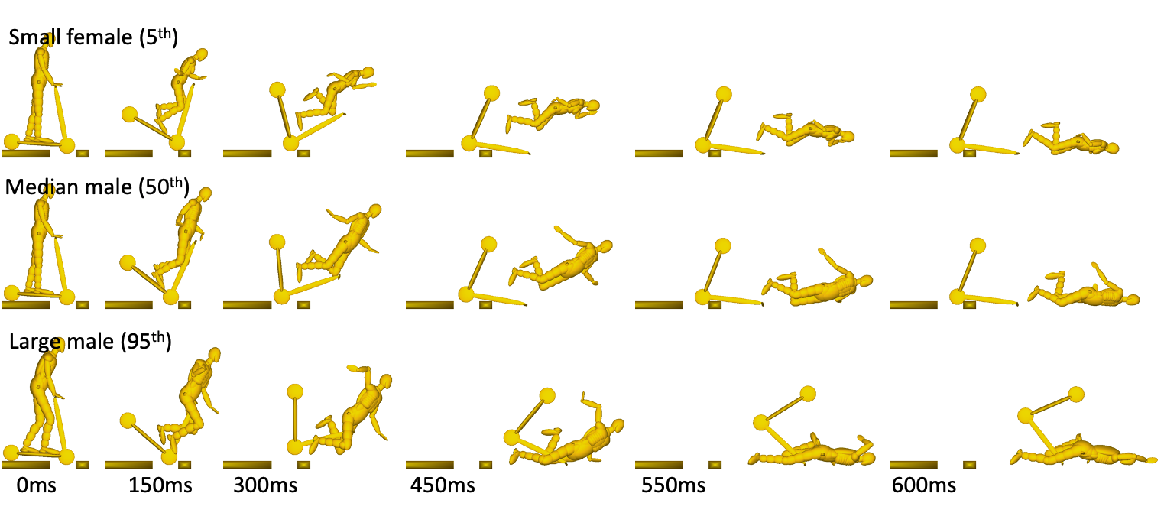
Figure 9 Predicted motion of the human body and e-scooter for the three rider sizes. For all riders the travel speed is 20km/h and they pass a 6cm deep and 40cm wide pothole.

Discussion
This study shows that the pothole depth has a significant effect on causing falls of e-scooters and the e-scooter speed has a significant effect on increasing the head-ground impact speed. We used multi-body dynamics models of a commercially available e-scooter and different riders, including male and female, to simulate many falls and predict head-ground impact force and velocity. Our results show that different riders can sustain different impact forces and speeds, but for all riders reducing the depths of the pothole can prevent falls. We also show that only at higher travel speeds, reducing the width of the pothole can prevent falls. In addition, when falls occur, reducing the e-scooter speed can reduce the head-ground impact speed, thus the risk of craniofacial and brain injuries.
The simulations predicted that the e-scooter falls lead to large head-ground impact force and speed, 13.2±3.5kN and 6.3±1.4m/s. These values are larger than the range of impact force and speed that have been shown to produce skull fractures in post-mortem human subjects (PMHS). For instance, by exposing PMHS heads to lateral impacts on a hard surface, a 5.3m/s speed at skull fracture has been predicted (Zhang, Yoganandan et al. 2009). Another study on the response of skull to impacts of hemispherical metal impactors at different locations has reported a 4.5-14.1kN range for force at fracture (Yoganandan, Pintar et al. 1995). A study on frontal skull fractures in PMHS heads has reported fracture forces of 10.2±2.6kN at a 5.2±0.0m/s impact speed and 11.1±2.7kN at a 7.0±0.0m/s impact speed (Delye, Verschueren et al. 2007). The alarmingly large head-ground impact force and speed predicted by the models may explain the significant number of craniofacial and brain injuries in e-scooter riders admitted to Emergency Departments (Blomberg, Rosenkrantz et al. 2019, Hawes, Hernandez-Ayala et al. 2019, Trivedi, Kesterke et al. 2019, Namiri, Lui et al. 2020). We predicted that over 56% of the first impacts were to the cranium (including forehead) than the face in the simulated falls. We could not find studies that estimated the location of major craniofacial impact in e-scooter patients. However, epidemiology studies report more head injuries than facial injuries in them. For instance, a study on 249 injured e-scooter riders reported 40.2% head injuries and only 5.6% facial fractures (Trivedi, Liu et al. 2019). Another study on 90 injured e-scooter riders reported 36.7% head injuries, 28% injuries to the upper face (forehead), 28% injuries to midface and 9% to the lower face (Trivedi, Kesterke et al. 2019). Our results and field data further stress the importance of wearing helmets as less than 1-2% of injured e-scooter riders are reported to have worn a helmet at the time of accident.
Our results show that the head-ground impact speed increases as the e-scooter speed increases. A similar effect has been reported in previous studies on pedestrian-vehicle and self-balancing scooter-vehicle collisions, where an increase in the vehicle impact speed was predicted to increase head-ground impact speed (Crocetta, Piantini et al. 2015, Xu, Shang et al. 2016, Xu, Shang et al. 2016). Large head-ground impact speed can lead to more severe head and brain injuries (Chinn, Canaple et al. 2001), hence reducing the e-scooter speed can help reduce these injuries. Most authorities impose a limit on the e-scooter speed. For instance, the UK Department for Transport imposes a 25km/h speed limit, the US state-dependent speed limit ranges from 20 to 32km/h and the speed limit in Germany is 20km/h (Santacreu, Yannis et al. 2020). Our computational predictions suggest that such limits can be beneficial in terms of reducing head injuries. For instance, reducing the e-scooter speed from 30km/h to 20km/h leads to a 23% reduction in the mean head-ground impact speed as predicted by the models. More studies, particularly those using real-world accident data, are required to provide further evidence in support of certain speed limits, with an aim to prevent or reduce injuries to riders and other road users in e-scooter related falls and collisions.
We predicted a mean head-ground impact speed of 6.2m/s, which is nearly the impact speed used for testing bicycle helmets in a number of standards (6.3m/s) (Whyte, Stuart et al. 2019). The mean head-ground impact speeds at higher travel speeds of 25 and 30km/h are even higher (7.2 and 8m/s respectively) and close to the impact speed for testing motorcycle helmets (e.g. 7.5m/s for vertical impacts and 8m/s for oblique impacts on a 45° anvil as in (UNECE22.06 2020)). However, the rate of helmet use in e-scooter riders is far less than that in cyclists. This may explain why the rate of head injuries is much higher in e-scooter riders than cyclists (Namiri, Lui et al. 2020, Cicchino, Kulie et al. 2021). For instance, a recent study reported less than 25% head injuries in bicycle accidents in contrast to over 57% in e-scooter accidents (Uluk, Lindner et al. 2021). Helmets are shown to be effective in preventing skull fractures and some types of brain injuries in road traffic collisions (Cripton, Dressler et al. 2014, Dodds, Johnson et al. 2019). Our results showed that over 50% of the impacts were to the cranium, which is protected by current helmets, e.g. bicycle helmets. Hence, their use is likely to significantly reduce these injuries in e-scooter riders as shown in previous work (Mitchell, Tsao et al. 2019). A large proportion of the impacts were to the face, which can only be protected against by using closed-face helmets or novel designs.
Helmets are being improved for protecting the brain against rotational effects of head impacts, which produce axonal injuries and long-term effects (Khosroshahi, Duckworth et al. 2019, Siegkas, Sharp et al. 2019, Abayazid, Ding et al. 2021). This is further driven by new methods for assessing helmet performance in mitigating rotational effects of oblique impacts (Ghajari, Peldschus et al. 2013, Willinger, Deck et al. 2014, Stigson, Rizzi et al. 2017). Our results show that most of the simulated falls lead to an oblique impact with the ground. The predicted impact angle is 65±10°, which is larger than the 45° angle proposed in the new methods for testing bicycle and motorcycle helmets, e.g. CEN/TC158/WG11 and (UNECE22.06 2020). Interestingly, a finite element modelling study of motorcycle helmets has shown that impact angles between 30° and 45° produce larger strains in the brain (Meng, Fahlstedt et al. 2018). By collecting and analysing more real-world accident cases, we will be able to define impact test conditions that better represent e-scooter falls and collisions for the assessment of helmets.
The pothole sizes used here represented moderate to high severities based on pothole classification studies (Tiong, Mustaffar et al. 2012, Kim and Ryu 2014). We found that at higher travel speeds, the rider is more likely to fall when the pothole is wider than 40cm. Moreover, we observed a sudden increase in the occurrence of falls when the pothole depth was increased from 3cm (no falls) to 6cm (41 falls out of 60 cases). These pothole depths are respectively 12% and 24% of e-scooter’s wheel diameter (10inch). It is likely that larger wheels will prevent some falls. However, most e-scooter wheels are 6 to 10inch in diameter. Another factor that interacts with the wheel size on causing falls is the depth of potholes on public roads. Interestingly, a number of local councils in the UK consider potholes of less than 5cm in depth not presenting immediate or imminent hazard and aim to repair them in 90 days (Makwana 2018). However, our simulations suggest that a combination of such deep potholes and small wheel diameters can pose a significant threat to e-scooter riders. Hence, there is a need to re-consider wheel size and pothole depth from both e-scooter design and road maintenance perspectives in order to reduce the large proportion of fall-related injuries in e-scooter riders.
We found that the rider size influenced the head-ground impact force and speed, with the median male rider sustaining the largest force and speed and the large male sustaining the lowest. Simulations of collisions between self-balancing scooters and cars have also shown that the head-ground impact speed is lowest for the large male and highest for the median male (Xu, Shang et al. 2016). Even though the median male rider was found to sustain the largest head-ground impact force and speed, it is important for future studies as well as safety gears testing standards to involve a range of human anthropometry. This is to ensure that the results from these studies are applicable to a large proportion of the population.
The results presented here should be considered along with several limitations of this study. An important limitation is that the human body models are passive, i.e. they do not react to the fall. The same limitation exists in other studies that use human body computational and physical models. Our models predict that in type 2 and 3 kinematics (Figure 4 and Figure 9) knees, pelvis, chest and arms can come in contact with the ground before the head. These predictions corroborate with the fact that musculoskeletal injuries are common in e-scooter riders (Beck, Barker et al. 2020, Cicchino, Kulie et al. 2021). In real-world, the rider may react to the fall by using arms for instance, which can change the head/ground impact kinematics and possibly reduce the head-ground impact speed and force at the expense of exacerbating injuries to other parts of the body. However, it is also likely that the rider holds the handlebar for longer to avoid the fall when hitting the pothole, leading to fall kinematics like our predictions. Hence, the results obtained here are likely to represent worst case conditions.
The average male pedestrian model has been validated by comparing its overall kinematics and kinematics of different parts, such as the head, with PMHS in pedestrian-car accidents, showing good agreements between them (Ishikawa, Kajzer et al. 1993, Yang, Lövsund et al. 2000). This model and a scaled version of it have been used to predict the throw distance and injury risk to different parts of the body in real-world pedestrian-car collisions, with good results (Van Rooij, Bhalla et al. 2003). Further validation of the overall response and head kinematics of the male model and its scaled versions have been performed using a range of pedestrian-vehicle impact tests, which involved 16 males and 2 females (van Hoof, de Lange et al. 2003). Despite the differences between e-scooter falls and pedestrian-vehicle collisions, the validity of the overall kinematics of the body and head of the MADYMO human body models in collisions with vehicles supports their use for the current study. For further validation of these models in e-scooter falls, controlled experiments should be performed, where kinematics of the body and e-scooter are recorded with sensors and high-speed videography. These experiments can be done using volunteers, dummies and PMHS, though each of these have limitations. Alerted volunteers do not represent the majority of unpredictable e-scooter falls. Dummies and PMHS are passive and may not respond as the human would do in real-world accidents. However, these experiments can build more confidence in the predictions of the human and e-scooter models. In addition, videos of real-world accidents and injury outcomes can be very helpful in reconstructing e-scooter falls and testing the predictions of computational models.
This study has other limitations. The e-scooter model used here was developed based on accurate physical properties of the e-scooter, but it was only partially validated due to the lack of experimental data. The response of the tyres was based on the data used in previous studies, which used MADYMO to simulate self-balancing scooters (Xu, Shang et al. 2016, Xu, Shang et al. 2016). There is limited information available on dynamic response of e-scooter tyres to loading. Further research is required to fully understand the dynamic response of e-scooter tyres, both pneumatic and solid types, particularly in contact with edges and curbs. We used hyper-ellipsoids to model the pothole. The main purpose of the contact definition is to predict the fall when the e-scooter wheel meets the second edge of the pothole, rather than quantifying the deformation of the tyre or contact force. The contact between hyper-ellipsoids of different orders has been validated in the context of pedestrian collision with sharp edges of older cars, with good agreement with experimental results in terms of whole body kinematics and head kinematics (Van Wijk, Wismans et al. 1983). This approach has also been used for quantifying accelerations of a vehicle model in road side barrier collisions, with good agreements with tests (Amato, O’Brien et al. 2013). Our preliminary validation shows that the model can predict the fall of the e-scooter due to the contact between the wheel and second edge of the pothole. Since the focus of this study is on falls, these results partially validate the modelling approach. However, if the contact force is of concern, there need to be more rigorous validation of the contact, which requires more information from experiments.
We used a force-penetration function to predict the head-ground contact force in MADYMO simulations. A recent study that used MAYMOD ellipsoid pedestrian models to simulate PMHS/car collisions has shown that the head translational acceleration (thus the contact force) can be predicted accurately by using a force-penetration function (Shang, Masson et al. 2021). We defined the force-penetration fuction using an average of force-deflection results from several dynamic experiments on PMHS heads at different locations. The data that we have used fall well within the broad range of force-deflection data that have been reported in several PMHS studies, e.g. those reported in a review by (Yoganandan and Pintar 2004). It should also be noted that any inaccuracy in the head-ground contact force prediction does not influence the predicted head-ground impact speed or angle.
We simulated e-scooter motion perpendicular to the pothole edge only. We struggled to find studies that have taken a biomechanical approach to determine fall patterns in e-scooter falls. However, it is reasonable to assume that falling forward is a most likely pattern when e-scooter encounters road surface defects. The large number of extremities and facial injuries in e-scooter riders support this assumption. Hence, we believe that we have investigated an important subset of falls, but this study should be extended in future. For instance, future studies can investigate falls when the direction of travel is not perpendicular to the edge of the pothole or those caused by man-made features such as curbs.
The values for coefficient of friction (COF) at different contact surfaces were based on a recent study that reconstructed a scooter-microvan collision (Zou, Zhang et al. 2019). In our study, the COF between the rider and ground was 0.67, which is within the range of the COFs determined and used for pedestrian/road contact in previous studies (0.3-0.93) (Wood and Simms 2000, Crocetta, Piantini et al. 2015, Xu, Shang et al. 2016). The large variation in the COF is likely to be due to the surface conditions and clothing. Some studies have used a value between 0.58 and 0.6 for human/road contact (Crocetta, Piantini et al. 2015, Xu, Shang et al. 2016). The COF used in our study is slightly larger than these values. Analyses of the three riders passing a 6cm deep and 80cm wide pothole at 20km/h showed that a reduction in the COF from 0.67 to 0.58 had a small effect on the impact force (-0.3% to 6%, where the negative sign indicates a reduction). The COF between the rider and e-scooter was 0.4. Some studies have used a 0.3 COF for pedestrian/vehicle and rider/scooter contact (Crocetta, Piantini et al. 2015, Xu, Shang et al. 2016). Our analyses showed that reducing the COF between rider/e-scooter had a larger effect on the impact force (-16% to 6%). These results show that COF can influence the head/ground impact response. However, we did not include COF as a variable in this study and future work may explore its effects more comprehensively.
In summary, we studied the effects of pothole size, travel speed and rider size on the head-ground impact force and velocity in e-scooter falls, using multi-body dynamics computational modelling. The following conclusions can be drawn from the results:
- Increasing the pothole depth can lead to falls across all riders and travel speeds. The critical depth for a 10inch wheel e-scooter is predicted to be between 3 and 6cm. For scooters with smaller wheels, this critical depth would be smaller.
- A large proportion of e-scooter falls simulated here can lead to large head-ground impact forces that pass the threshold of skull fractures.
- The predicted head-ground impact speed is as large as the speed used in bicycle and motorcycle helmet test methods. Decreasing the e-scooter travel speed can decrease the head-ground impact speed.
- Amongst all riders, median male rider has a higher probability of sustaining a larger head-ground impact speed that can lead to more severe head injuries in e-scooter fall accidents.
The findings of this study can assist authorities and e-scooter hire companies to take more informed actions about speed limits and road surface conditions. They will also increase awareness among riders in regard to the importance of wearing helmets. They can also help define representative impact test conditions for assessing the performance of helmets used by e-scooter riders in order to reduce head and brain injuries in e-scooter falls.

Acknowledgement
We would like to acknowledge the financial support from EPSRC’s Centre for Doctoral Training in Neurotechnology (project reference: 1974730). We would also like to thank Dr Ianto Guy from Transport Research Laboratory for the initial discussions leading to the formulation of this research and feedback on the manuscript.

References
Simcenter Madymo Reference Manual. S. P. Software.
Abayazid, F., K. Ding, K. Zimmerman, H. Stigson and M. Ghajari (2021). "A New Assessment of Bicycle Helmets: The Brain Injury Mitigation Effects of New Technologies in Oblique Impacts." Annals of Biomedical Engineering.
Allerton, S. (2020). "Scooter Safety – Pothole Test Results!" Scooter Safety – Pothole Test Results! https://swiftyscooters.com/blogs/journal/scooter-safety-pothole-test-results.
Amato, G., F. O’Brien, B. Ghosh and C. K. Simms (2013). "Multibody modelling of a TB31 and a TB32 crash test with vertical portable concrete barriers: Model verification and sensitivity analysis." Proceedings of the Institution of Mechanical Engineers, Part K: Journal of multi-body dynamics 227(3): 245-260.
Badeau, A., C. Carman, M. Newman, J. Steenblik, M. Carlson and T. Madsen (2019). "Emergency department visits for electric scooter-related injuries after introduction of an urban rental program." The American journal of emergency medicine 37(8): 1531-1533.
Beck, S., L. Barker, A. Chan and S. Stanbridge (2020). "Emergency department impact following the introduction of an electric scooter sharing service." Emergency Medicine Australasia 32(3): 409-415.
Bekhit, M. N. Z., J. Le Fevre and C. J. Bergin (2020). "Regional healthcare costs and burden of injury associated with electric scooters." Injury 51(2): 271-277.
Blomberg, S. N. F., O. C. M. Rosenkrantz, F. Lippert and H. Collatz Christensen (2019). "Injury from electric scooters in Copenhagen: a retrospective cohort study." BMJ Open 9(12): e033988.
Bourdet, N., C. Deck, R. P. Carreira and R. Willinger (2012). "Head impact conditions in the case of cyclist falls." Proceedings of the Institution of Mechanical Engineers, Part P: Journal of Sports Engineering and Technology 226(3-4): 282-289.
Chinn, B., B. Canaple, S. Derler, D. Doyle, D. Otte, E. Schuller and R. Willinger (2001). "COST 327 Motorcycle safety helmets." European Commission, Directorate General for Energy and Transport.
Cicchino, J. B., P. E. Kulie and M. L. McCarthy (2021). "Injuries related to electric scooter and bicycle use in a Washington, DC, emergency department." Traffic injury prevention 22(5): 401-406.
Cicchino, J. B., P. E. Kulie and M. L. McCarthy (2021). "Severity of e-scooter rider injuries associated with trip characteristics." Journal of safety research 76: 256-261.
Cripton, P. A., D. M. Dressler, C. A. Stuart, C. R. Dennison and D. Richards (2014). "Bicycle helmets are highly effective at preventing head injury during head impact: head-form accelerations and injury criteria for helmeted and unhelmeted impacts." Accident Analysis & Prevention 70: 1-7.
Crocetta, G., S. Piantini, M. Pierini and C. Simms (2015). "The influence of vehicle front-end design on pedestrian ground impact." Accident Analysis & Prevention 79: 56-69.
Delye, H., P. Verschueren, B. Depreitere, I. Verpoest, D. Berckmans, J. Vander Sloten, G. Van Der Perre and J. Goffin (2007). "Biomechanics of frontal skull fracture." Journal of neurotrauma 24(10): 1576-1586.
DfT (2020). E-scooter trials: guidance for local areas and rental operators. United Kingdom, Department for Transport GOV.UK.
Dodds, N., R. Johnson, B. Walton, O. Bouamra, D. Yates, F. E. Lecky and J. Thompson (2019). "Evaluating the impact of cycle helmet use on severe traumatic brain injury and death in a national cohort of over 11000 pedal cyclists: a retrospective study from the NHS England Trauma Audit and Research Network dataset." BMJ open 9(9): e027845.
Elliott, J., C. K. Simms and D. P. Wood (2012). "Pedestrian head translation, rotation and impact velocity: The influence of vehicle speed, pedestrian speed and pedestrian gait." Accident Analysis & Prevention 45: 342-353.
Ghajari, M., S. Peldschus, U. Galvanetto and L. Iannucci (2013). "Effects of the presence of the body in helmet oblique impacts." Accident Analysis & Prevention 50: 263-271.
Hawes, A., F. Hernandez-Ayala, R. Holder, D. P. Huang, A. Klioueva, M. Paz, J. Pichette, J. Stradford, J. Taylor, A. Tisdale and D. Zane (2019). "Dockless electric scooter-related injuries study."
Hawes, A., F. Hernandez-Ayala, R. Holder, P. Huang, A. Klioueva, M. Paz, J. Pichette, J. Stradford, J. Taylor and A. Tisdale (2019). "Dockless Electric Scooter-Related Injuries Study." Austin Public Health: Austin, Texas 43.
Ishikawa, H., J. Kajzer and G. Schroeder (1993). Computer simulation of impact response of the human body in car-pedestrian accidents, SAE Technical Paper.
Khosroshahi, S. F., H. Duckworth, U. Galvanetto and M. Ghajari (2019). "The effects of topology and relative density of lattice liners on traumatic brain injury mitigation." Journal of biomechanics 97: 109376.
Kim, T. and S.-K. Ryu (2014). "A guideline for pothole classification." International Journal of Engineering and Technology 4(10): 618-622.
Kleinertz, H., D. Ntalos, F. Hennes, J. V. Nüchtern, K.-H. Frosch and D. M. Thiesen (2021). "Accident Mechanisms and Injury Patterns in E-Scooter Users: A Retrospective Analysis and Comparison With Cyclists." Deutsches Ärzteblatt International 118(8): 117.
Ma, Q., H. Yang, A. Mayhue, Y. Sun, Z. Huang and Y. Ma (2021). "E-scooter safety: The riding risk analysis based on mobile sensing data." Accident Analysis & Prevention 151: 105954.
Makwana, B. (2018). What is a pothole? A look at Local Highways Authorities road maintenance policy, RAC Foundation.
Meng, S., M. Fahlstedt and P. Halldin (2018). The effect of impact velocity angle on helmeted head impact severity: A rationale for motorcycle helmet impact test design. 2018 International Research Council on the Biomechanics of Injury, IRCOBI 2018, 12-14 September 2018, Athens, Greece, International Research Council on the Biomechanics of Injury.
Mitchell, G., H. Tsao, T. Randell, J. Marks and P. Mackay (2019). "Impact of electric scooters to a tertiary emergency department: 8‐week review after implementation of a scooter share scheme." Emergency medicine Australasia 31(6): 930-934.
Møller, T., J. Simlett and E. Mugnier (2020). "Micromobility: Moving cities into a sustainable future." EY: London, UK.
NACTO. (2020). "Shared Micromobility in the U.S.: 2019."
Namiri, N. K., H. Lui, T. Tangney, I. E. Allen, A. J. Cohen and B. N. Breyer (2020). "Electric scooter injuries and hospital admissions in the United States, 2014-2018." JAMA surgery 155(4): 357-359.
Otte, D. and T. Pohlemann (2001). Analysis and load assessment of secondary impact to adult pedestrians after car collisions on roads. IRCOBI conference.
Peng, Y., Y. Chen, J. Yang, D. Otte and R. Willinger (2012). "A study of pedestrian and bicyclist exposure to head injury in passenger car collisions based on accident data and simulations." Safety science 50(9): 1749-1759.
RAMSIS (1997). "RAMSIS Manual version 3.1." Tecmath Gmbh, Kaiserlautern, Germany.
Santacreu, A., G. Yannis, O. de Saint Leon and P. Crist (2020). "Safe micromobility."
Santacreu, A., G. Yannis, O. de Saint Leon and P. Crist (2020). "Safe micromobility." International Transport Forum.
Shang, S., C. Masson, M. Llari, M. Py, Q. Ferrand, P.-J. Arnoux and C. Simms (2021). "The predictive capacity of the MADYMO ellipsoid pedestrian model for pedestrian ground contact kinematics and injury evaluation." Accident Analysis & Prevention 149: 105803.
Siegkas, P., D. J. Sharp and M. Ghajari (2019). "The traumatic brain injury mitigation effects of a new viscoelastic add-on liner." Scientific reports 9(1): 1-10.
Stigson, H., M. Rizzi, A. Ydenius, E. Engström and A. Kullgren (2017). Consumer testing of bicycle helmets. Proceedings of the IRCOBI Conference. Antwerp, Belgium.
Tark, J. (2020). Micromobility Products-Related Deaths, Injuries, and Hazard Patterns 2017–2019. U. S. C. P. S. Commission.
Tiong, P., M. Mustaffar and M. Rosli (2012). "Road surface assessment of pothole severity by close range digital photogrammetry method." World Appl. Sci. J. 19: 867-873.
Trivedi, B., M. J. Kesterke, R. Bhattacharjee, W. Weber, K. Mynar and L. V. Reddy (2019). "Craniofacial injuries seen with the introduction of bicycle-share electric scooters in an urban setting." Journal of Oral and Maxillofacial Surgery 77(11): 2292-2297.
Trivedi, T. K., C. Liu, A. L. M. Antonio, N. Wheaton, V. Kreger, A. Yap, D. Schriger and J. G. Elmore (2019). "Injuries Associated With Standing Electric Scooter Use." JAMA Network Open 2(1): e187381-e187381.
Uluk, D., T. Lindner, M. Dahne, J. W. Bickelmayer, K. Beyer, A. Slagman, F. Jahn, C. Willy, M. Moeckel and U. Gerlach (2021). "E-scooter incidents in Berlin: an evaluation of risk factors and injury patterns." Emergency medicine journal.
UNECE22.06 (2020). "Uniform Provisions Concerning the Approval of Protective Helmets and of their Visors for Drivers and Passengers." United Nations.
van Hoof, J., R. de Lange and J. S. Wismans (2003). Improving pedestrian safety using numerical human models, SAE Technical Paper.
Van Rooij, L., K. Bhalla, M. Meissner, J. Ivarsson, J. Crandall, D. Longhitano, Y. Takahashi, Y. Dokko and Y. Kikuchi (2003). Pedestrian crash reconstruction using multi-body modeling with geometrically detailed, validated vehicle models and advanced pedestrian injury criteria. Proceedings of the 18th International Technical Conference on the Enhanced Safety of Vehicles (ESV), Citeseer.
Van Wijk, J., J. Wismans, J. Maltha and L. Wittebrood (1983). MADYMO pedestrian simulations, SAE Technical Paper.
Werner, S., W. Newberry, R. Fijan and M. Winter (2001). "Modeling of Bicycle Rider Collision Kinematics." SAE Transactions 110: 869-879.
Whyte, T., C. Stuart, A. Mallory, M. Ghajari, D. Plant, G. P. Siegmund and P. A. Cripton (2019). "A review of impact testing methods for headgear in sports: considerations for improved prevention of head injury through research and standards." Journal of biomechanical engineering 141(7).
Willinger, R., C. Deck, P. Halldin and D. Otte (2014). Towards advanced bicycle helmet test methods. International Cycling Safety Conference.
Wood, D. and C. Simms (2000). "Coefficient of friction in pedestrian throw." Impact 9(1): 12-15.
Xu, J., S. Shang, H. Qi, G. Yu, Y. Wang and P. Chen (2016). "Simulative investigation on head injuries of electric self-balancing scooter riders subject to ground impact." Accident Analysis & Prevention 89: 128-141.
Xu, J., S. Shang, G. Yu, H. Qi, Y. Wang and S. Xu (2016). "Are electric self-balancing scooters safe in vehicle crash accidents?" Accident Analysis & Prevention 87: 102-116.
Yang, J. (2005). "Review of injury biomechanics in car-pedestrian collisions." International journal of vehicle safety 1(1-3): 100-117.
Yang, J., P. Lövsund, C. Cavallero and J. Bonnoit (2000). "A human-body 3D mathematical model for simulation of car-pedestrian impacts." Traffic Injury Prevention 2(2): 131-149.
Yoganandan, N. and F. A. Pintar (2004). "Biomechanics of temporo-parietal skull fracture." Clinical Biomechanics 19(3): 225-239.
Yoganandan, N., F. A. Pintar, A. SANCES JR, P. R. Walsh, C. L. Ewing, D. J. Thomas and R. G. Snyder (1995). "Biomechanics of skull fracture." Journal of neurotrauma 12(4): 659-668.
Zhang, J., N. Yoganandan and F. Pintar (2009). "Dynamic biomechanics of the human head in lateral impacts." Annals of advances in automotive medicine / Annual Scientific Conference ... Association for the Advancement of Automotive Medicine. Association for the Advancement of Automotive Medicine. Scientific Conference 53: 249-256.
Zou, D., X. Zhang, Z. Li, J. Sun, J. Zhang, P. Huang, K. Ma and Y. Chen (2019). "Prediction of injury risks and features among scooter riders through MADYMO reconstruction of a scooter-microvan accident: Identifying the driver and passengers." Journal of forensic and legal medicine 65: 15-21.

