Local biodiversity actions for sustainable development goal 15 (life on land) in China

Guangjin Zhou ^{1,2}; Riqi Zhang ³; Yiming Su ^{4,5}; Yang Lan ^{6,7}; Lingqing Wang ^{4,5}; Matilda Eve Dunn ³; Xinming Xia ^{8,9}; Tao Liang ^{4,5}; Li Guan ¹⁰; Yizhong Huan ^{11,12,*}; Siyu Wang ^{13,*};

- Satellite Application Center for Ecology and Environment, Ministry of Ecology and Environment, Beijing, China
- Institute of Land Surface System and Sustainable Development, Faculty of Geographical Science, Beijing Normal University, Beijing, China
- Centre for Environmental Policy, Imperial College London, London, UK
- Key Laboratory of Land Surface Pattern and Simulation, Institute of Geographic Sciences and Natural Resources Research, Chinese Academy of Sciences, Beijing, China
- University of Chinese Academy of Sciences, Beijing, China
- School of Economics and Management, Beihang University, Beijing, China
- Key Laboratory of Natural Resource Coupling Process and Effects, Ministry of Natural Resources, Institute of Geographic Sciences and Natural Resources Research, Chinese Academy of Sciences, Beijing, China
- School of Public Policy & Management, Tsinghua University, Beijing, China
- Institute for Contemporary China Studies, Tsinghua University, Beijing, China
- China Academy of Urban Planning & Design, Beijing, China
- College of Humanities and Development Studies, China Agricultural University, Beijing, China
- College of International Development and Global Agriculture, China Agricultural University, Beijing, China
- College of Ecology and Environment, Xinjiang University, Urumqi, China

Correspondence to
- Yizhong Huan
College of Humanities and Development Studies, China Agricultural University, 100084 Beijing, China
Email: yizhonghuan@gmail.com; Tel.: +86-18613388164

- Siyu Wang
College of Ecology and Environment, Xinjiang University, 830049 Urumqi, China
Email: wangsiyu191@mails.ucas.ac.cn; Tel: +86-13121171235

Funding
This research was funded by the National Natural Science Foundation of China (Nos. 72204140; 42361144882).

Declaration of Competing Interest
The authors declare that they have no known competing financial interests or personal relationships that could have appeared to influence the work reported in this paper.

Abstract
Achieving sustainable development goal (SDG) 15 (life on land) depends on local conservation efforts. However, the lack of species data and inadequate ecological corridor designs significantly hinder conservation efficiency. This study focused on Sanmenxia City in China and utilized the Integrated Valuation of Ecosystem Services and Trade-offs model, the GeoDetector model, and the Minimum Cumulative Resistance model to identify potential habitats, their influencing factors, and ecological corridors. We then adopted a new corridor feasibility model to compare the impacts of different ecological resistance, thereby identifying key biodiversity spaces. Results indicated a decline in habitat quality since 2000, primarily influenced by climate, topography, and land use. Simulation-derived corridors using the habitat quality method were more effective than those based on expert experience. We identified 2808.45 km² of potential habitats and 20 critical corridors for land animals. This study deepens the understanding of ecological resistance impacts on corridors and provides new insights into local actions for SDG 15.

Keywords
Ecological conservation; Habitat; Ecological corridor; Ecological resistance; Conservation planning; Yellow River basin

1. Introduction
The sustainable development goals (SDGs), the Paris Agreement on Climate Change, and the Kunming-Montreal Global Biodiversity Framework (GBF) have underscored the critical importance of biodiversity conservation. However, approximately 25% of global species have been threatened (Intergovernmental Science-Policy Platform on Biodiversity and Ecosystem Services (IPBES), 2019), and none of the Aichi Biodiversity Targets (the predecessor of the GBF) were fully met by the end of 2020 (Hansen et al., 2021). Notably, the expansion of protected areas in key biodiversity regions has largely stagnated since 2015 (United Nations, 2023). Rapid urbanization plays a significant role in driving global land use changes, resulting in the ecosystem degradation, habitat fragmentation, and consequent biodiversity loss (Keyes et al., 2021; Li et al., 2022a). Therefore, a gap exists in both knowledge and policy domains regarding species habitats, which leads to the impedance of achieving SDG 15 (life on land) within intricate environmental landscapes.
Various approaches exist for identifying habitat conservation priorities (Wang et al., 2022). The species distribution model (SDM) is a prevalent approach in biodiversity modeling (Araújo et al., 2019), which establishes statistical associations between species and environmental factors to predict potential species distribution areas (Myllyviita et al., 2019). However, SDM often necessitates extensive species monitoring datasets (Huang et al., 2020), incurring substantial human and financial resources, thereby restricting its widespread application (Hochkirch et al., 2021). Another approach, the composite index model, identifies habitats based on relevant physical environmental parameters (e.g., elevation and climate) essential for species survival, is selected based on species habits and expert knowledge. This method primarily involves qualitative analysis and lacks objective evaluation criteria (Wu et al., 2021). Moreover, habitat quality can be indirectly assessed by identifying multiple threats to biodiversity, e.g., urban development and traffic disturbances (Ding et al., 2022). Notably, the Integrated Valuation of Ecosystem Services and Trade-offs (InVEST) stands out as a representative model extensively utilized for this purpose. Integrating land use data with biodiversity threat information, InVEST generates habitat quality maps (Xiao et al., 2020), circumventing the need for species distribution or presence data (Terrado et al., 2016).
In addition to protecting natural habitats, connectivity and integrity are key indicators for assessing progress towards the GBF’s 2030 targets and 2050 vision (Hansen et al., 2021). Nevertheless, as of 2020, less than 8% of the land is both protected and connected (United Nations Environment Programme, 2021). Habitat connectivity poses a significant challenge for current biodiversity conservation, particularly in regions where human-induced encroachment on natural ecosystems, driven by agricultural expansion, urbanization, and industrialization, leads to habitat fragmentation (Keeley et al., 2016). To address these challenges, ecological corridors have emerged as essential tools in landscape planning (Salviano et al., 2021). Various methods have been developed for ecological corridor identification, such as the Minimum Cumulative Resistance (MCR) model, the Circuit model (Peng et al., 2018), and the Gravity model (Yang et al., 2021). Among them, the MCR model demonstrates notable compatibility and applicability, widely utilized in constructing biodiversity and ecological security patterns (Dong et al., 2021). The construction of resistance surfaces is a crucial step in identifying ecological corridors using the MCR model. Most studies predominantly rely on expert knowledge, using hypotheses or proxies that vary in realism and could potentially skew results (Lalechere and Berges, 2021). Consequently, there is no definitive solution or widely accepted scientific consensus on this process (Xiao et al., 2020). Different resistance surfaces often lead to varying directions for the extracted ecological corridors. Despite this variability, few studies have thoroughly examined the effectiveness and rationality of these corridors to assess the impacts of resistance surfaces on ecological corridor identification (Peng et al., 2018; Ding et al., 2022).
Sanmenxia City is an important ecological function zone and species habitat in the Yellow River basin of China. In recent decades, its habitat fragmentation has increased due to population growth and intensification of human activities, resulting in a significant reduction in the population size and range of local flora and fauna (Fu et al., 2021). Research in Sanmenxia City has largely concentrated on agricultural ecosystem vulnerability (Niu et al., 2022), wetland protection (Cheng et al., 2015), and forest conservation (Liu et al., 2017) . However, there is a significant research gap on habitat and connectivity, which should be addressed to inform local governments in their efforts to achieve SDG 15 (life on land).
This study focused on Sanmenxia City to achieve three primary objectives. First, to analyze the spatio-temporal variations and influencing factors of habitat quality from 2000 to 2020. Second, to identify the differences in ecological corridor simulations based on two main existing measurement methods of resistance surface. Finally, to identify biodiversity conservation spaces in Sanmenxia City. Our study provides new insights into addressing the serious loss of biodiversity, restoring natural ecosystems, and accelerating the implementation of SDG 15 (life on land) in the Yellow River basin.

2. Study area and data sources
Sanmenxia City, covering an area of 10,496 km² and with a population of 2.035 million, is bordered by two major hydrological systems in China, the Yellow River and the Yangtze River. It is located at the confluence of the Qinling Mountains, the Taihang Mountains, and the Loess Plateau (Figure 1). Sanmenxia City falls within the purview of a warm temperate continental monsoon climate zone, with an average annual temperature of 13.2°C and average annual rainfall between 550 and 1000 mm. Sanmenxia City features a complex topography, characterized by an average slope of 18.2° and an elevation of 841.2 meters. The dominant land use is covered by forests, accounting for 43.1% of the total area, followed by cropland at 34.3%. As an important species habitat in the Yellow River basin, Sanmenxia City has documented 367 species of wild terrestrial vertebrates, accounting for 70.6% of the total species of wild animals recorded in Henan Province (Henan Provincial Bureau of Statistics, 2023).
We used seven datasets, including administrative division, land use, digital elevation model (DEM), net primary production (NPP), annual precipitation, road, and railway. Their detailed information is shown in Table S1. All datasets were reprojected to the WGS84 coordinate system to avoid spatial misalignment and inaccuracies stemming from different coordinate systems. Data resolution was standardized to 30 m through resampling to enhance the precision of spatial analyses. These processing steps ensure that data overlay and comparison are accurate, promoting compatibility and comparability across different data sources.
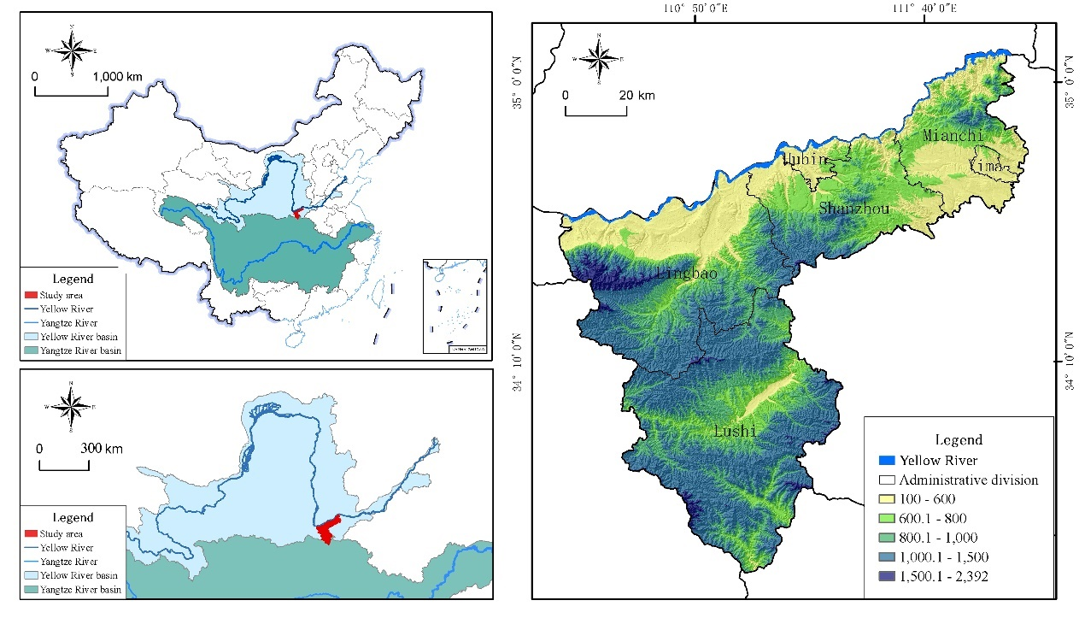
Figure 1. Location of study area in China

3. Methods
The assessment framework includes four steps (Figure 2) that can provide useful information for biodiversity conservation planning and decision-making in most urban regions. First, we assessed the spatio-temporal variations in habitat quality from 2000 to 2020 using the InVEST model, and identified potential habitats through hotspot analysis. Second, we developed two types of ecological resistance surfaces based on expert experience and habitat quality, subsequently identifying various ecological corridors with the MCR model. Third, we utilized the GeoDetector model (GDM) to pinpoint key factors impacting habitat quality and established a feasibility evaluation model for ecological corridors to determine optimal paths. Finally, we identified a biodiversity conservation space to prioritize specific habitats and corridors.

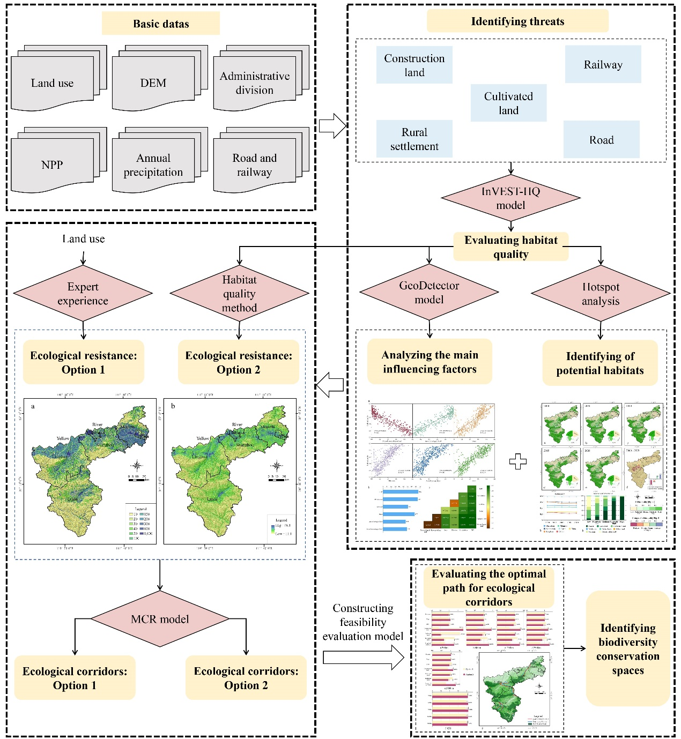
Figure 2. Procedures for identifying biodiversity conservation spaces

3.1 Evaluating habitat quality
Due to the limited availability of species monitoring data, the application of SDMs in the study area is constrained. Therefore, we evaluated habitat quality in Sanmenxia City using the InVEST model (version 3.10.2), developed collaboratively by Stanford University, the Nature Conservancy, and the World Wildlife Fund. The core of this method (Eq.1) is to evaluate the negative impacts of threat sources on habitats. The model’s parameter settings primarily encompass four aspects: the relative impact and weight of each threat, along with the suitability and sensitivity of various land use types to each threat factor (Sun et al., 2019; Yohannes et al., 2021), as detailed in Tables S2 and S3.
$Q_{xj}=H_{j}\left[1-\left(\frac{D_{xj}^{z}}{D_{xj}^{z}+k^{z}}\right)\right]$ (1)
In Eq.1, $Q_{xj}$was the habitat quality of raster x in land use type j; $D_{xj}$ was the threat level of raster x in land use type j (Eq. 2); $H_{j}$ was the habitat suitability of land use type j; and k was half the saturation constant, equivalent to half of the maximum value of $D_{xj}$.
$D_{xj}=\sum_{r=1}^{R}{\sum_{y=1}^{Y_{r}}{\left(\frac{ω_{r}}{\sum_{r=1}^{R}{ω_{r}}}\right)}}r_{y}i_{rxy}β_{y}S_{jr}$ (2)
In Eq.2, R was the number of threat factors; $Y_{r}$ represented the set of grid cells on r’s raster map; $ω_{r}$ denoted the impact weight of threat r; $r_{y}$ was the stress value of grid y; $i_{rxy}$ represented the degradation decay function through distance; $β_{y}$ indicated the accessible grid cell y; and $S_{jr}$ was the relative sensitivity of land type j to threat factor r. $i_{rxy}$ can be represented as the linear or exponential function of distance from threats to habitats (Eqs. 3-4).
If linear：$i_{rxy}=1-\left(\frac{d_{xy}}{d_{r max}}\right)$ (3)
If exponential：$i_{rxy}=exp\left(-\left(\frac{2.99}{d_{r max}}\right)d_{xy}\right)$ (4)
In Eqs. 3-4, $d_{xy}$ was the distance between grid cells x and y; and $d_{rmax}$ was the maximum effective distance of the threat r’s reach across space in grid cells y.

3.2 Analyzing main influencing factors of habitat quality
To analyze the influencing factors of habitat quality, we quantified the correlations between habitat quality and six factors: elevation, slope, annual precipitation, NPP, area of ecological land (including forest, grassland, wetland, and water bodies), and area of non-ecological land (including cultivated and construction land). First, we constructed a 5 km × 5 km grid. We then determined the average habitat quality, elevation, slope, annual precipitation, NPP, and areas of ecological, cultivated, and construction land for each grid cell. Finally, we calculated the correlations between habitat quality and these variables.
Methods commonly used to identify factors affecting habitat quality include correlation analysis, principal component analysis, redundancy analysis, and regression analysis (Fang et al., 2021). To fully understand changes in habitat quality, it is necessary to consider the interactions among multiple influencing factors and determine the contribution of each factor. This can be achieved by using the GDM (Zhang et al., 2021). GDM enhances traditional statistical methods by not only clarifying the explanatory power of each independent variable on the dependent variable, but also identifying the interactions among different factors. Therefore, we applied GDM to analyze the impacts of different factors on the spatial heterogeneity of habitats (Eq. 5).
$q=1-\frac{\sum_{h=1}^{L}{N_{h}σ_{h}^{2}}}{Nσ^{2}}$ (5)
In Eq. 5, q was the explanatory power of the driving factors to habitat quality; 0 ≤ q ≤ 1; $σ_{h}^{2}$ and $σ^{2}$ were the variance of habitat quality of layer h and the whole region; ${L, N}_{h}$, and N represented the stratification of the driving variables, the number of units of layer h and the whole region, respectively.

3.3 Identifying potential habitats
Hotspot areas are regions where there are concentrated high-value distributions of various services (Cai et al., 2017). First, we classified habitat quality into five levels—high, relatively high, medium, relatively low, and low—using equal intervals. Then, we constructed a 1 km × 1 km grid and quantified the areas of high habitat quality within each grid cell. Utilizing the hotspot analysis tool in ArcGIS, we identified spatial clusters of high-value potential habitats within each grid cell. Finally, we aggregated and analyzed the identified hotspots to identify areas exceeding 10 km², designating them as potential habitats.

3.4 Evaluating ecological resistance surface
Two approaches for setting the resistance surface were further adopted. Option 1 utilized the expert elicitation method, setting ecological resistance surfaces based on ecosystem type (Yu et al., 2017; Li and Hu, 2019; Sun et al., 2019). Specifically, resistance values were assigned as follows: wetland - 10, forest - 20, shrubland - 30, grassland - 40, water - 60, garden - 100, unused land - 200, cultivated land - 300, rural settlement - 600, and urban construction area - 1000. Option 2 adopted the habitat quality method, where ecological resistance surfaces were modeled based on habitat quality, as outlined in Eq. 6 (Keeley et al., 2016; Lalechere & Berges, 2021).
$R_{habitat}=\frac{1}{HQ}×100$ (6)
In Eq. 6, $R_{habitat}$ was the resistance value determined form habitat quality for Option 2, and HQ was the habitat quality.

3.5 Identifying potential ecological corridors
The identification and construction of potential migration corridors play a crucial role in addressing habitat fragmentation and enhancing ecological connectivity (Mohammadi et al., 2021). This goal is typically achieved by quantifying the migratory costs for species across different habitats (Yu et al., 2017). Although circuit theory can simulate various corridor choices, it does not identify the most optimal path (Peng et al., 2018). The gravity model, known for its high data requirements, is commonly used to analyze corridor importance (Yang et al., 2021). In contrast, the MCR model offers advantages such as simplicity, low data requirements, and strong interpretability. Therefore, we adopted the MCR model (Eq. 7) to evaluate the potential for species migration (Li et al., 2022b).
$MCR=fmin\sum_{j=n}^{i=m}{{(D}_{ij}×R_{i})}$ (7)
In Eq, 7, MCR was the cumulative resistance value of a landscape to an ecological habitat in space; $f$ reflected the positive correlation between the cumulative resistance value and the ecological process of the landscape; min indicated that the minimum value of cumulative resistance was taken; $D_{ij}$ denoted the spatial distance from spatial landscape unit i to habitat j; and $R_{i}$ denoted the resistance coefficient of landscape unit i to the movement diffusion of a target unit.

3.6 Evaluating ecological corridor feasibility
We developed two ecological corridor plans based on the ecological resistance surfaces described in Section 3.3. First, referring to previous research (Xie et al., 2023), we considered five corridor widths: 200 m, 600 m, 1200 m, 2500 m, and 5000 m. Second, to minimize subjectivity and uncertainty in indicator selection, we identified evaluation indicators that influence ecological corridor construction based on the analysis of factors affecting habitat quality presented in Section 3.2. We then calculated specific values for these evaluation indicators, tailored to the different ecological corridor widths. In this study, the selected evaluation indicators included the area of cultivated land, area of construction land, area of ecological land, NPP, slope, elevation, and length of ecological corridors. Third, the statistics for these indicators were normalized to enhance comparability between datasets (Eqs. 8-9). Finally, we computed the ecological corridor feasibility indices using Eq. 10. Corridors with high feasibility indices were selected as linkages between key ecological source sites.
For positive indicators: $X_{ij}=\frac{x_{ij}}{{\overline{x}}_{ij}}$ (8)
For negative indicators: $X_{ij}=\frac{{\overline{x}}_{ij}}{x_{ij}}$ (9)
$CFI=\sum_{i=1}^{n}{W_{i}×X_{ij}}$ (10)
In Eqs. 8-10, $X_{ij}$ was the normalized data of indicator j of i m ecological corridors; $x_{ij}$ and ${\overline{x}}_{ij}$ were the original and average values of indicator j of i m ecological corridors; $CFI$ was the ecological corridor feasibility indices; and $W_{i}$ was the weight of indicator j.

4. Results

4.1 Spatio-temporal characteristics of habitat quality
Between 2000 and 2020, the average habitat quality in Sanmenxia City declined slightly from 0.61 to 0.59 (Figure 3). In 2020, high-quality habitats encompassed 38.24% of the city’s total area, marking a minor increase of 0.07 percentage points from 2000. However, areas classified as relatively high-quality habitats decreased by 3.04%. Urban and agricultural areas, particularly Hubin District and parts of Shanzhou, consistently exhibited lower habitat quality. In contrast, Lushi's habitat quality remained stable, supporting high biodiversity. The most notable decline occurred in Lingbao City, primarily due to extensive terracing, which reduced habitat area. Additionally, habitat quality along the banks of the Yellow River experienced significant declines.
There was a clear spatial differentiation in habitat quality (Figure 3e). Lushi County boasted the highest habitat quality index, consistently maintaining levels above 0.77 over the past two decades. This indicated that Lushi County played a crucial role in preserving biodiversity in Sanmenxia City. Favorable hydrothermal conditions, diverse vegetation types, and complex terrain helped minimize human disturbances in Lushi County, thereby maintaining relatively high habitat quality. The lowest habitat quality was observed in Hubin District, which exhibited a declining trend due to concentrated urban development and intensive agricultural activities, leading to significant human disturbances. The scarcity of land resources, coupled with expanding urban construction, further squeezed the already fragile ecological spaces.
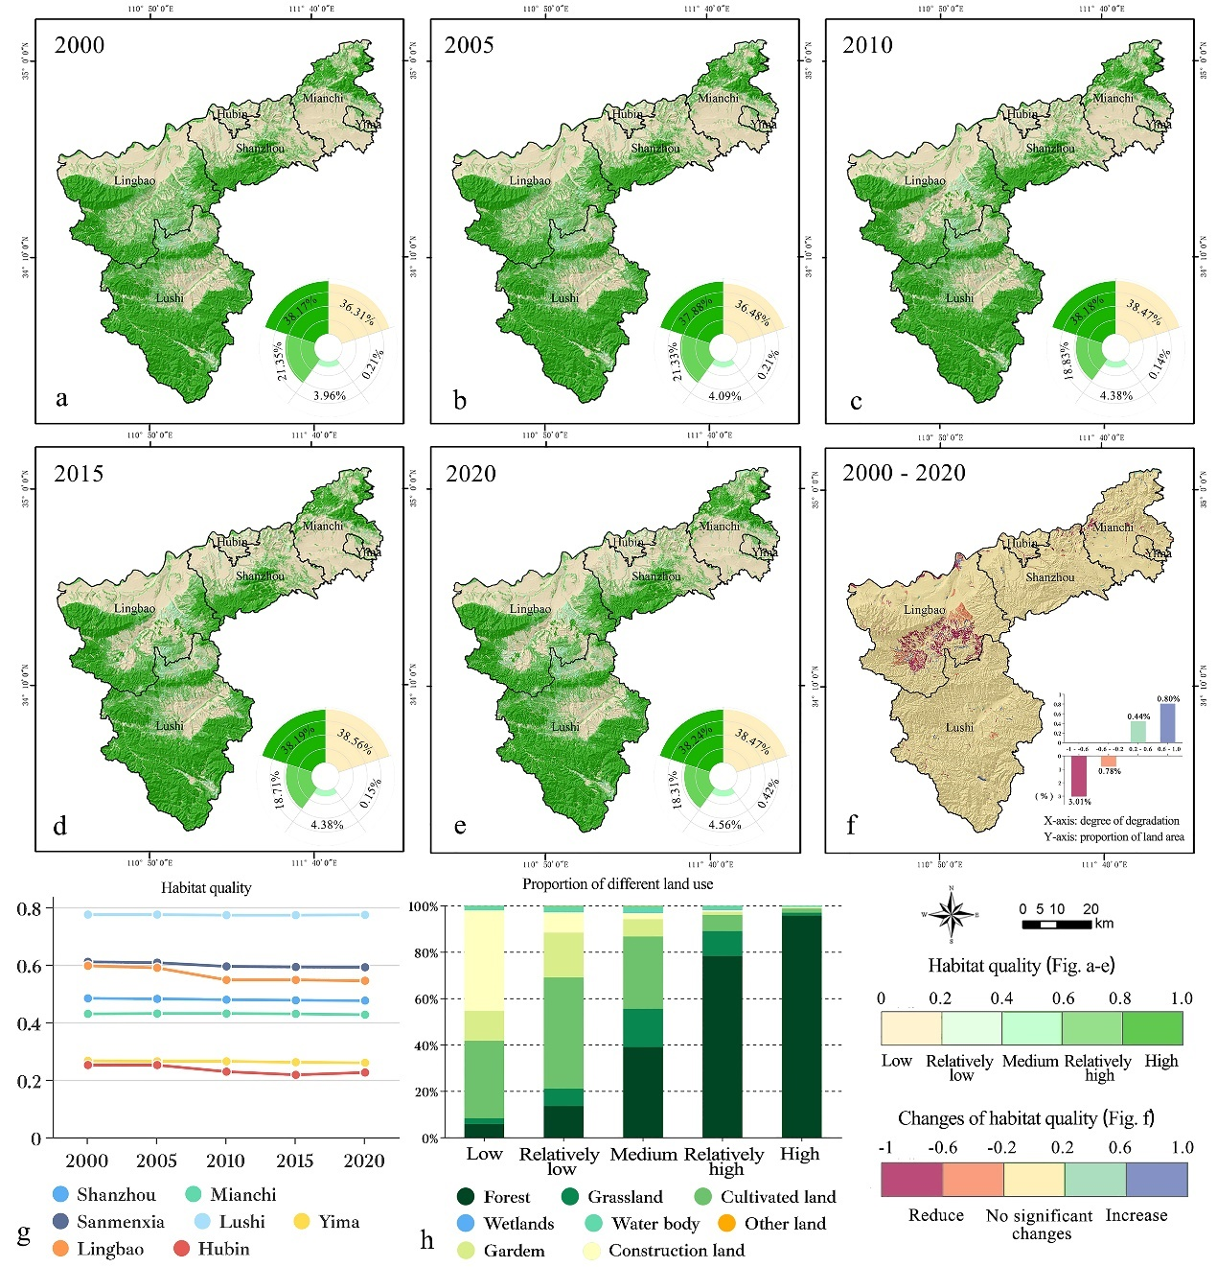
Figure 3. Spatio-temporal variations of habitat quality. a.-e. Habitat quality from 2000 to 2020. f. Spatial variations in habitat quality. g. Temporal variations in habitat quality. h. Land use structure across different habitat quality levels.

4.2 Main factors influencing habitat quality
Habitat quality showed significant correlations with topographical factors (slope and elevation), natural conditions (NPP and annual precipitation), and human activities (land use) as depicted in Figure 4a. Specifically, habitat quality was negatively correlated with non-ecological land use but positively correlated with other factors, indicating that human activities were a major factor contributing to habitat degradation. Abundant precipitation and high NPP values indicated favorable climatic conditions and ample food resources, while complex terrain, subjected to lesser human disturbance, facilitated the preservation and formation of habitats. However, these correlation characteristics did not apply to aquatic ecosystems. Despite low slope, NPP, and altitude, a small number of discrete samples indicated that habitat quality remained high.
The detection results for six variables were obtained through the GDM, revealing influencing coefficients (q-statistic values) and degrees of significance (p-values). All six variables demonstrated strong statistical significance, each with a p-value of 0. Figure 4b presents the q-statistic value of each variable to reveal their influence on habitat quality. The q-statistic values ranked the influencing coefficients as follows: NPP (0.86), annual precipitation (0.84), slope (0.77), elevation (0.61), non-ecological land (0.58), and ecological land (0.55). Among these six variables: precipitation was classified as a climate factor; NPP, as a result of the combined effects of precipitation, temperature, and soil factors, was also considered a climate factor; slope and elevation were categorized as topographic factors; and non-ecological and ecological lands were defined as land-use factors. Overall, climate, topography, and land-use predominantly governed the spatial distribution of habitat quality. At the macro level, climate and topography determined this distribution, while land-use significantly influenced local habitat quality under human intervention. These variables did not independently affect habitat quality but interacted synergistically, enhancing each other's effects (Figure 4c). The combined explanatory power of climate and land-use factors was the most significant.
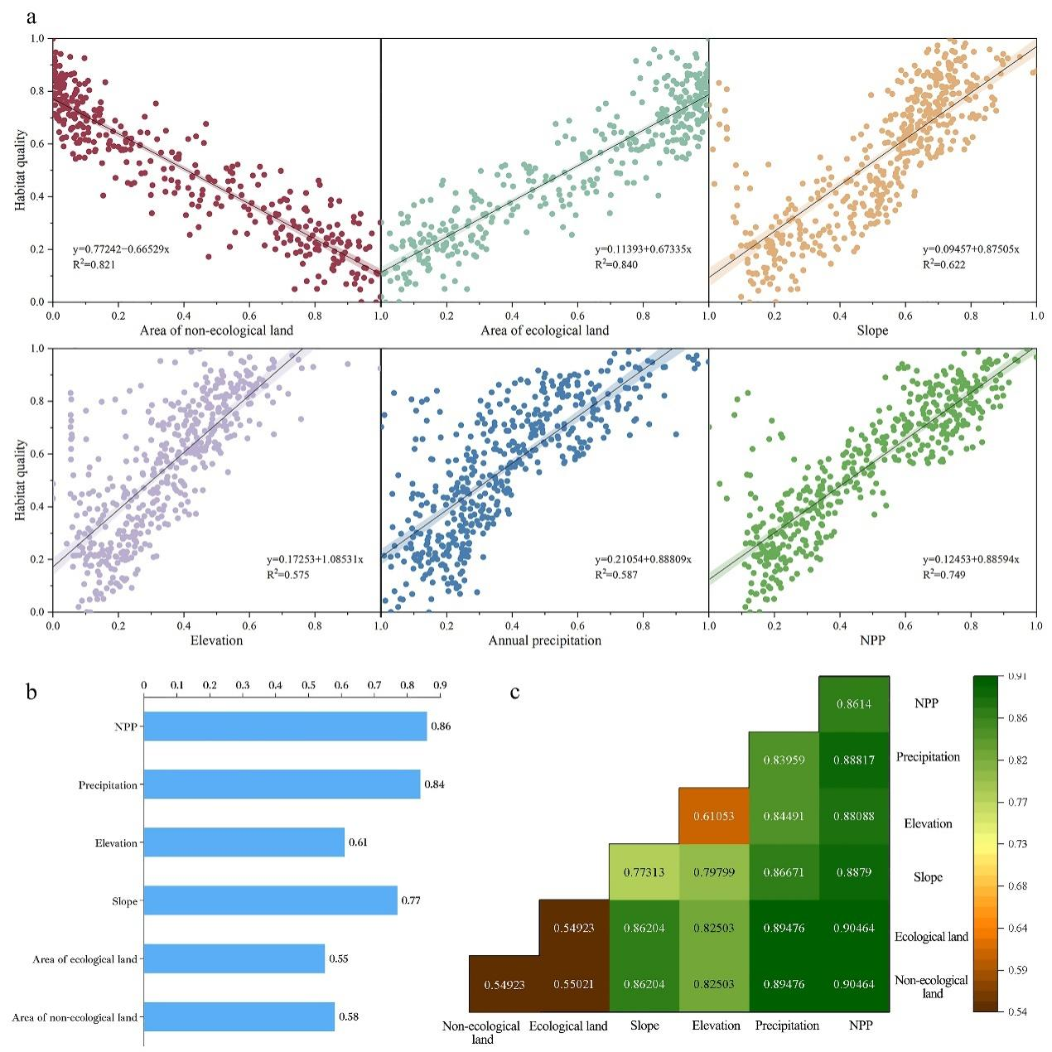
Figure 4. Main influencing factors of habitat quality. a. Correlations between habitat quality and each influencing factor. b. The q-statistic of different influencing factors. c. The interaction influence between factors on the spatial heterogeneity of habitat quality.

4.3 Spatial distribution of potential habitats
In Sanmenxia City, 14 potential habitat hotspots were identified, located in Lushi County, Lingbao City, Mianchi County, and Shanzhou District (Figure 5). Of these, Lushi County represented 55.68% of the hotspots, followed by Lingbao City at 26.17%. This distribution was primarily due to the habitats' strong environmental dependencies. Specifically, the southern areas received more abundant precipitation, had better light and heat conditions, and supported lush vegetation. Additionally, mountains and hills dominated these areas, and the complex topography limited human interference. No potential habitat hotspots were identified in Hubin District and Yima City. The habitats in these two areas, covering only 3.57 km², were small and fragmented, surrounded by built-up towns and farmland, existing primarily as ecological islands. ﻿
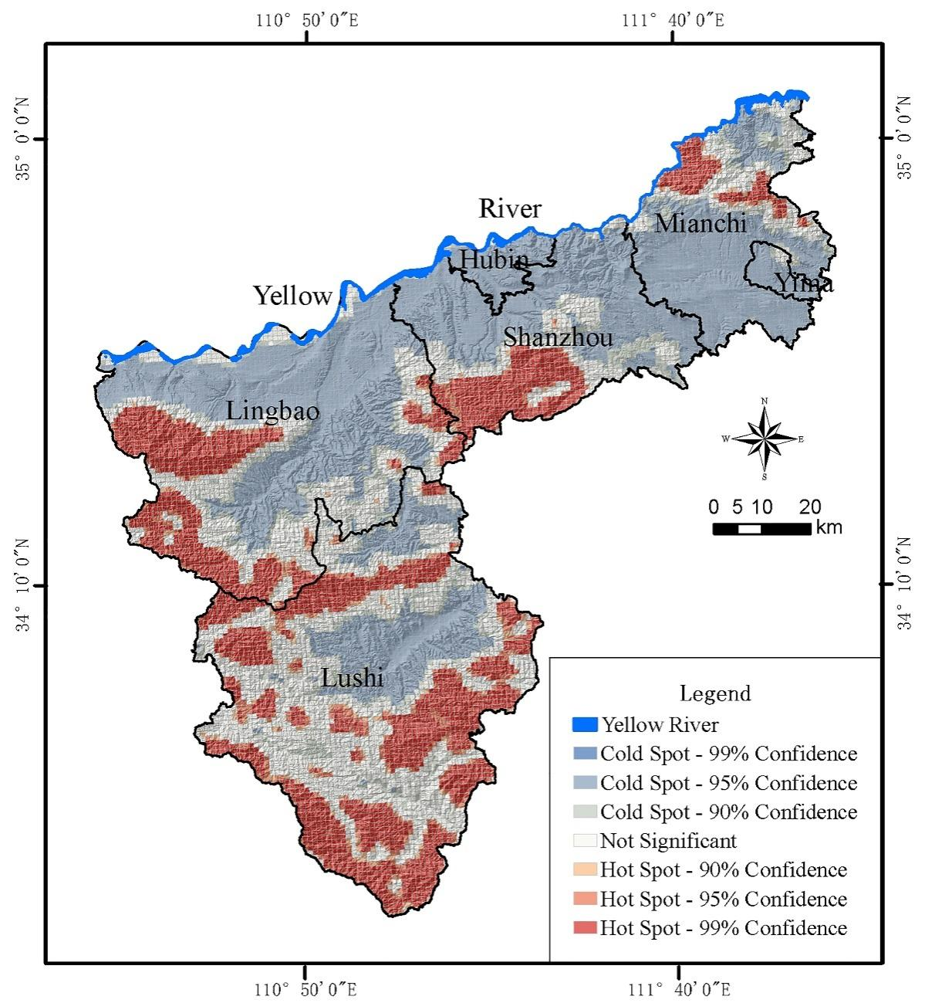
Figure 5. Hotspots and coldspots of potential habitats

4.4 Simulation of resistance surface
The ecological resistance surface for Option 1 (Figure 6a) was developed using the expert elicitation method, referencing previous studies to assign resistance values ranging from 10 to 1000 across various ecosystem types. The order of increasing resistance values was as follows: wetland, forestland, grassland, water, garden land, unused land, arable land, rural residential areas, and urban construction land. Option 2 calculated resistance values using the Habitat Suitability Index, with ecological resistance values ranging from 11.1 to 78.1 (Figure 6b). Although the resistance values for the two options significantly differed, the pattern of spatial heterogeneity remained broadly consistent, with ecological resistance values high in the north and low in the south. Areas with high ecological resistance were concentrated in the flatter northern terrain, where a dense transport network and significant urban and agricultural development created substantial obstacles to ecosystem linkages.

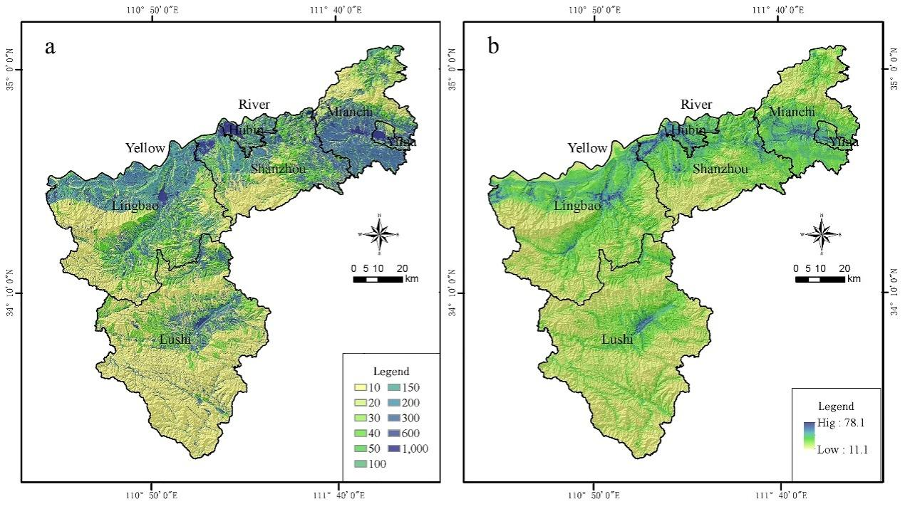
Figure 6. Ecological resistance surface. The results acquired by adopting expert elicitation method (a) and habitat quality method (b).

4.5 Identification of potential ecological corridors
Based on the two different resistance surface options (Figure 6), the least-cost paths between potential habitats were calculated using the MCR model to determine different ecological corridors (Figure 7g). In general, there were 20 corridors, and the spatial layout of the two types of ecological corridors was consistent. The total lengths of the ecological corridors for Option 1 and Option 2 were 223.42 km and 200.59 km, respectively. The assessment indicators for the two ecological corridor options displayed a similar pattern of change as corridor width increased (Figures 7a-e; Table S4). Notably, at a corridor width of 5000 m, the areas of construction land and cultivated land increased to approximately 69 times and 37 times their sizes at a corridor width of 200 m, respectively. This suggested that wider corridors, while providing greater ecological benefits, also faced greater challenges in balancing other ecosystem services. In terms of slope, built-up land area, and ecological corridor length, Option 2 outperformed Option 1. Conversely, it lagged behind Option 1 in arable land area and ecological land area (Figures 7a-e). Overall, Option 2 surpassed Option 1 in the feasibility indices for ecological corridors of five different widths (Figure 7f), indicating that the ecological resistance surface modeled by the habitat quality method was superior to that modeled by the expert experience method. Therefore, we identified Option 2 as the optimal path for the ecological corridor.

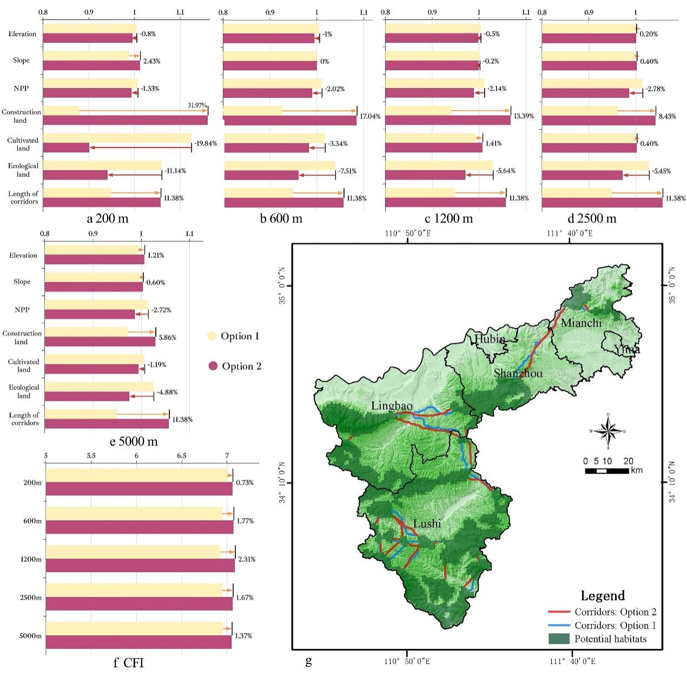

Figure 7. Feasibility evaluation of the two ecological corridor plans. a.-f. Comparative analysis results of five corridor widths: 200 m, 600 m, 1200 m, 2500 m, and 5000 m. g. Spatial layout of two ecological corridor plans.

5. Discussion
Diversity within species, between species, and across ecosystems has been declining at a rate unprecedented in human history (IPBES, 2019). It is crucial to implement more transformative conservation measures to reverse this trend. Constructing ecological patterns that integrate point, line, surface, and network elements can effectively address habitat fragmentation and mitigate biodiversity loss (Peng et al., 2018). Addressing these challenges to achieve SDG 15 (life on land) necessitates close collaboration and concerted efforts among scientists and decision-makers.

5.1 Potential obstacles and possible actions
Our results indicated that the potential habitat space for terrestrial animals covered 2808.45 km², while nature reserves comprised only 777.5 km² (27.68%). This suggests that nature reserves occupy a relatively small proportion of the habitat, with current zoning deemed unreasonable. The spatial distribution of these nature reserves does not align with priorities established on biological criteria, thereby posing potential risks to species conservation (Wu et al., 2018). The GBF advocates reducing the loss of ecologically important areas to near zero by 2030. It is thus imperative to expand and optimize the scope and area of existing protected zones to meet these objectives effectively. Notably, expanding protected areas could deprive indigenous residents of their resource rights, potentially displacing them and impacting their livelihoods (Alden Wily, 2018). Balancing ecological conservation with local livelihood development is crucial for the long-term health of ecosystems (Chaplin-Kramer et al., 2022). Therefore, exploring and expanding pathways to transform ecological resources into ecological products is vital—such as through eco-tourism (Chen, 2020), sustainable agriculture and forestry projects (Pashkevich et al., 2022), and ecological compensation mechanisms (Zhu et al., 2021). It is essential to ensure that biodiversity protection also promotes local economic development and improves living standards (Mastrantonis et al., 2022).
In Sanmenxia City, climate, topography, and land use were the main factors affecting habitat quality, with clear positive correlations between habitat quality and both elevation and slope (Figure 4). However, this does not imply that regions with higher elevations or steeper slopes are more suitable for species survival. The primary reason is that areas with favorable terrain conditions are largely occupied by human activities, reflecting intense competition for land resources between humans and nature. Previous studies have demonstrated that many protected areas are not as effective as expected. For example, even within designated protected areas, species decline still reached 56% (Morton et al., 2021). Thus, simply expanding the area of protected zones may not necessarily achieve the intended goals, and the quality and effective management of protected areas are equally important. Anthropogenic activities, including cultivation, gardening, and construction within the potential habitat, covered an area of 70.33 km², accounting for approximately 2.5% of the total (Figure 3h). It is crucial to develop management strategies that control these anthropogenic activities within this area to prevent the degradation of ecological environment quality (Hemraj et al., 2024). Effective conservation management necessitates the involvement of local communities, landowners, governments, and non-governmental organizations (Zhu et al., 2021). Collaborative governance frameworks and participatory decision-making processes are essential to ensure that diverse perspectives are considered, leading to more equitable and sustainable outcomes. Engaging stakeholders in conservation efforts also fosters a sense of ownership and accountability, which is crucial for the long-term success of conservation initiatives.
Our study identified 20 important ecological corridors for Sanmenxia City, and the corridors located in the southern and western parts were generally short, while those in the east were notably longer (Figure 7g). The corridor extending from Ganshan Mountain to Shaoshan Mountain was the longest, measuring 41.1 km (Figure 7g). Habitat fragmentation in these areas were exacerbated by urban construction and agricultural activities. Additionally, traffic disturbances posed significant challenges, with 38 major obstacles arising from traffic infrastructure development across the corridors. These barriers might impede animal migration and increase the risk of roadkill. Implementing measures such as constructing underpass-style ecological corridors is crucial for restoring these areas and improving habitat connectivity. Our study shows that as ecological corridor widths increase from 200 m to 5000 m, the impacts of human activities multiply significantly. This indicates substantial potential trade-offs between biodiversity functions and other ecosystem services (e.g., food production, mineral development, and timber supply) in these areas. The design of ecological corridors should comprehensively consider various factors such as conservation objective, current land use, terrain condition, and economic cost. In economically or agriculturally developed areas, constructing wide ecological corridors often presents challenges (Dai et al., 2021). However, in areas with significant biodiversity functions, such as Lushi County, corridors can be built up to 1 km wide or even wider (Peng et al., 2018; Zhou et al., 2023). Overall, it is vital not only to protect potential habitats but also to develop ecological corridors, thereby enhancing regional ecological connections and establishing a unified biodiversity conservation network.

5.2 Modeling challenges in biodiversity conservation
Existing biodiversity models face challenges due to data restrictions and the intrinsic complexities of biological systems (Araújo et al., 2019). Researchers should select appropriate models that balance scientific rigor with practical feasibility. While some previous studies have determined conservation areas through monitoring data of target species, three major shortcomings need to be avoided to prevent unreasonable outcomes. First, the selection of species for protection should avoid subjective biases, ensuring that conservation targets are based on scientific evidence and expert knowledge rather than personal or decision-maker preferences (Zvereva & Kozlov, 2019). Second, the quality and reliability of monitoring data need to be meticulously examined (Hochkirch et al., 2021). Habitat quality is typically assessed by the number of species observed; however, good habitats often provide sufficient cover, making species harder to detect. Thus, the quality of monitoring data can significantly influence assessment outcomes (Dambly et al., 2021). Third, special attention should be given to management practices intended to 'improve' habitats, which may benefit certain species but adversely affect others (Romañach et al., 2022). In studies lacking specific protected species, it is often necessary to quantitatively predict the impact of human factors on biodiversity (Araújo et al., 2019). The InVEST model exemplifies such tools, offering cost-effectiveness and reduced dependence on intensive field data collection (Bai et al., 2018). Thus, it is often used to identify prioritization areas for biodiversity conservation policy-making.
A key challenge in accurately identifying ecological corridors is modeling the resistance surface. However, no effective solution for accurately modeling ecological resistance surfaces has been found (Keeley et al., 2017). Additionally, few studies have explored the specific effects of differences in ecological resistance on ecological corridors. To address this research gap, this study compared two commonly used methods for setting ecological resistance and proposed a set of specific steps for assessing the feasibility of ecological corridors. Our results showed significant differences in ecological corridors identified under different resistance settings. Ecological resistance surfaces modeled by the habitat quality method were superior to those modeled by the expert elicitation method. Although the expert-empirical method of assigning values through land use is currently the most popular method for modeling ecological resistance, it increases uncertainty in identifying ecological corridors due to the heterogeneity of land use classification and frequent negligence of resistance changes within the same land type (Dong et al., 2021). Species migration is influenced by multiple factors, including climate, terrain, and human activities (Yang et al., 2021). Therefore, compared to methods that simulate based on a single factor, integrating various influences in modeling ecological resistance offers a distinct advantage in accurately predicting and facilitating species migration.

5.3 Uncertainties and limitations
Biodiversity assessment is characterized by complexity and uncertainty, influenced by multiple factors from both natural and social environments (Keyes et al., 2021). Thus, this study has some inherent uncertainties and limitations. First, we assumed that ecological resistance increased linearly as habitat quality decreased, simplifying the understanding of species dispersal behavior (Keeley et al., 2016). For example, species with strong dispersal capabilities can cross landscapes with lower suitability levels. Second, we did not assess ecosystem services, which may overlook the synergies between biodiversity and ecosystem services, potentially missing opportunities for achieving multiple co-benefits. We highlight some future research directions to accelerate progress toward SDG 15 (life on land). First, improving species monitoring technology and expanding the monitoring scale are necessary to address the current issue of insufficient species monitoring data. Second, a comprehensive model covering multiple factors, processes, and scales should be developed to simulate and predict the complex interactions between biodiversity and ecosystem services, thereby enhancing the practical application value and prediction accuracy of current models. Finally, it is crucial to strengthen research on biodiversity conservation policies, particularly focusing on the trade-offs and synergies between biodiversity and ecosystem services, the construction of ecological corridors, and the development of ecological compensation mechanisms.

6. Conclusion
Biological populations are highly dependent on and sensitive to habitat quality. In the absence of biological monitoring data, assessing potential threats to identify animal habitats has proven effective for achieving quantitative and spatial representations of biodiversity conservation. This study proposed an assessment framework for identifying biodiversity conservation spaces from the perspective of an ecological network. This framework can be applied in habitat conservation to design strategies that effectively mitigate the adverse effects of habitat fragmentation. We selected Sanmenxia City as our study area to empirically test the framework. Additionally, we assessed the differences in ecological corridor simulations using two primary methods for measuring resistance surfaces. The results revealed potential habitat spaces spanning 2,808.45 km² and 14 habitat hotspots. A more viable ecological corridor was identified through the construction of a resistance surface based on habitat quality. Our assessment framework utilized basic data universally available in the Yellow River basin, indicating its applicability in other regions with limited species distribution data. Habitat loss often begins with fragmentation and marginalization. Thus, conservation strategies should focus not only on core biodiversity areas but also on the migratory corridors and habitat connectivity of species. Policy responses in the study area should intensify efforts to protect the 20 identified ecological corridors, thereby advancing the GBF and SDG 15 (life on land).

References
Alden Wily, L. (2018). Risks to the sanctity of community lands in Kenya. A critical assessment of new legislation with reference to forestlands. Land Use Policy, 75, 661–672. https://doi.org/10.1016/j.landusepol.2018.02.006
Araújo, M. B., Anderson, R. P., Márcia Barbosa, A., Beale, C. M., Dormann, C. F., Early, R., & Rahbek, C. (2019). Standards for distribution models in biodiversity assessments. Science Advances, 5, eaat4858. https://doi.org/10.1126/sciadv.aat4858
Bai, Y., Wong, C.P., Jiang, B., Hughes, A.C., Wang, M., & Wang, Q. (2018). Developing China’s Ecological Redline Policy using ecosystem services assessments for land use planning. Nature Communications, 9, 3034. https://doi.org/10.1038/s41467-018-05306-1
Cai, W., Gibbs, D., Zhang, L., Ferrier, G., & Cai, Y. (2017). Identifying hotspots and management of critical ecosystem services in rapidly urbanizing Yangtze River Delta Region, China. Journal of Environmental Management, 191, 258-267. https://doi.org/ 10.1016/j.jenvman.2017.01.003
Chaplin-Kramer, R., Neugarten, R. A., Sharp, R. P., Collins, P. M., Polasky, S., Hole, D., & Watson, R. A. (2023). Mapping the planet’s critical natural assets. Nature Ecology & Evolution, 7(1), 51-61. https://doi.org/ 10.1038/s41559-022-01934-5
Chen, H. (2020). Land use trade-offs associated with protected areas in China: Current state, existing evaluation methods, and future application of ecosystem service valuation. Science of the Total Environment, 711, 134688. https://doi.org/10.1016/j.scitotenv.2019.134688
Cheng, Q., Wang, R., Huang, W., Wang, W., & Li, X. (2015). Assessment of heavy metal contamination in the sediments from the Yellow River Wetland National Nature Reserve (the Sanmenxia section), China. Environmental Science and Pollution Research, 22(11), 8586–8593. https://doi.org/10.1007/s11356-014-4041-y
Dai, L., Liu, Y., & Luo, X. (2021). Integrating the MCR and DOI models to construct an ecological security network for the urban agglomeration around Poyang Lake, China. Science of The Total Environment, 754, 141868. https://doi.org/ 10.1016/j.scitotenv.2020.141868
Dambly, L.I., Jones, K.E., Boughey, K.L., & Isaac, N.J.B. (2021). Observer retention, site selection and population dynamics interact to bias abundance trends in bats. Journal of Applied Ecology, 58, 236–247. https://doi.org/10.1111/1365-2664.13760
Ding, M., Liu, W., Xiao, L., Zhong, F., Lu, N., Zhang, J., Zhang, Z., Xu, X., & Wang, K. (2022). Construction and optimization strategy of ecological security pattern in a rapidly urbanizing region: A case study in central-south China. Ecological Indicators, 136, 108604. https://doi.org/10.1016/j.ecolind.2022.108604
Dong, J., Peng, J., Xu, Z., Liu, Y., Wang, X., & Li, B. (2021). Integrating regional and interregional approaches to identify ecological security patterns. Landscape Ecology, 36, 2151-2164. https://doi.org/10.1007/s10980-021-01233-7
Fang, L., Wang, L., Chen, W., Sun, J., Cao, Q., Wang, S., & Wang, L. (2021). Identifying the impacts of natural and human factors on ecosystem service in the Yangtze and Yellow River Basins. Journal of Cleaner Production, 314, 127995. https://doi.org/ 10.1016/j.jclepro.2021.127995
Fu, B., Wang, S., Shen, Y., Cheng, C., Li, Y., Feng, X., & Liu, Y. (2021). Mechanisms of Human-natural System Coupling and Optimization of the Yellow River Basin. China Science Foundation, 35, 504-509. https://doi.org/10.16262/j.cnki.1000-8217.2021.04.002.
Hansen, A. J., Noble, B. P., Veneros, J., East, A., Goetz, S. J., Supples, C., & Virnig, A. L. (2021). Toward monitoring forest ecosystem integrity within the post‐2020 Global Biodiversity Framework. Conservation Letters, 14(4), e12822. https://doi.org/ 10.1111/conl.12822
Hemraj, D. A., Bishop, M., Carstensen, J., Krause-Jensen, D., Stæhr, P. A. U., & Russell, B. D. (2024). Nature protection must precede restoration. Science, 383(6679), 158–158. https://doi.org/10.1126/science.adn0543
Henan Provincial Bureau of Statistics. (2023). 2023 Henan statistical yearbook. https://oss.henan.gov.cn/sbgt-wztipt/attachment/hntjj/hntj/lib/tjnj/2023nj/zk/indexch.htm (accessed on 07 April 2024).
Hochkirch, A., Samways, M. J., Gerlach, J., Böhm, M., Williams, P., Cardoso, P., & Dijkstra, K. D. B. (2021). A strategy for the next decade to address data deficiency in neglected biodiversity. Conservation Biology, 35(2), 502-509. https://doi.org/ 10.1111/cobi.13589
Huang, Z., Bai, Y., Juha M,A., & Yang, Z. (2020). Mapping biodiversity conservation priorities for protected areas: A case study in Xishuangbanna Tropical Area, China. Biological Conservation, 249, e108741. https://doi.org/ 10.1016/j.biocon.2020.108741
Keeley, A.T.H., Beier, P., & Gagnon, J.W. (2016). Estimating landscape resistance from habitat suitability: effects of data source and nonlinearities. Landscape Ecology, 31, 2151-2162. https://doi.org/10.1007/s10980-016-0387-5
Keeley, A.T.H., Beier, P., Keeley, B.W., & Fagan, M.E. (2017). Habitat suitability is a poor proxy for landscape connectivity during dispersal and mating movements. Landscape and Urban Planning, 161, 90–102. https://doi.org/ 10.1016/j.landurbplan.2017.01.007
Keyes, A.A., McLaughlin, J.P., Barner, A.K., & Dee, L.E. (2021). An ecological network approach to predict ecosystem service vulnerability to species losses. Nature Communications, 12, 1586. https://doi.org/10.1038/s41467-021-21824-x
Lalechere, E., & Berges, L. (2021). A Validation Procedure for Ecological Corridor Locations. LAND, 10, 1320. https://doi.org/10.3390/land10121320
Li, G., & Hu, W. (2019). A network-based approach for landscape integration of traditional settlements: A case study in the Wuling Mountain area, southwestern China. Land Use Policy, 83, 105-12. https://doi.org/10.1016/j.landusepol.2019.01.043
Li, G., Fang, C., Li, Y., Wang, Z., Sun, S., He, S., Qi, W., Bao, C., Ma, H., Fan, Y., Feng, Y., & Liu, X. (2022a). Global impacts of future urban expansion on terrestrial vertebrate diversity. Nature Communications, 13(1), 1628. https://doi.org/10.1038/s41467-022-29324-2
Li, Q., Zhou, Y., & Yi, S. (2022b). An integrated approach to constructing ecological security patterns and identifying ecological restoration and protection areas: A case study of Jingmen, China. Ecological Indicators, 137, 108723. https://doi.org/ 10.1016/j.ecolind.2022.108723
Liu, X., Wu, P., Shao, X., Songer, M., Cai, Q., He, X., & Zhu, Y. (2017). Diversity and activity patterns of sympatric animals among four types of forest habitat in Guanyinshan Nature Reserve in the Qinling Mountains, China. Environmental Science and Pollution Research, 24(19), 16465–16477. https://doi.org/10.1007/s11356-017-9232-x
Mastrantonis, S., Craig, M.D., Hobbs, R.J., Grigg, A.H., & Renton, M. (2022). Identifying optimal solutions between competing economic and conservation land use objectives for species that require widely distributed resources. Environmental Modelling & Software, 148, 105292. https://doi.org/ 10.1016/j.envsoft.2021.105292
Mohammadi, A., Almasieh, K., Nayeri, D., Ataei, F., Khani, A., Lopez-Bao, J.V., Penteriani, V., & Cushman, S.A. (2021). Identifying priority core habitats and corridors for effective conservation of brown bears in Iran. Scientific Reports, 11, e1044. https://doi.org/10.1038/s41598-020-79970-z
Morton, O., Scheffers, B.R., Haugaasen, T., & Edwards, D.P. (2021). Impacts of wildlife trade on terrestrial biodiversity. Nature Ecology & Evolution, 5, 540–548. https://doi.org/10.1038/s41559-021-01399-y
Myllyviita, T., Sironen S., Saikku L., Holma, A., Leskinen, P., & Palme, U. (2019). Assessing biodiversity impacts in life cycle assessment framework - Comparing approaches based on species richness and ecosystem indicators in the case of Finnish boreal forests. Journal of Cleaner Production, 236, 117641. https://doi.org/10.1016/j.jclepro.2019.117641
Niu, P., Jiang, Y., Yang, Y., & Wang, L. (2022). The characteristics and influencing factors of change in farmland system vulnerability: A case study of Sanmenxia City, China. Frontiers in Environmental Science, 10, 887570. https://doi.org/10.3389/fenvs.2022.887570
Pashkevich, M. D., d’Albertas, F., Aryawan, A. A. K., Buchori, D., Caliman, J.-P., Chaves, A. D. G., Hidayat, P., Kreft, H., Naim, M., Razafimahatratra, A., Turner, E. C., Zemp, D. C., & Luke, S. H. (2022). Nine actions to successfully restore tropical agroecosystems. Trends in Ecology & Evolution, 37(11), 963–975. https://doi.org/10.1016/j.tree.2022.07.007
Peng, J., Yang, Y., Liu, Y., Hu, Y., Du, Y., Meersmans, J., & Qiu, S. (2018). Linking ecosystem services and circuit theory to identify ecological security patterns. Science of the Total Environment, 644, 781-790. https://doi.org/ 10.1016/j.jclepro.2019.117641
Romañach, S.S., Haider, S.M., Hackett, C., McKelvy, M., & Pearlstine, L.G. (2022). Managing multiple species with conflicting needs in the Greater Everglades. Ecological Indicators, 136, 108669. https://doi.org/ 10.1016/j.ecolind.2022.108669
Salviano, I.R., Gardon, F.R., & dos Santos, R.F. (2021). Ecological corridors and landscape planning: a model to select priority areas for connectivity maintenance. Landscape Ecology, 36, 3311-3328. https://doi.org/10.1007/s10980-021-01305-8
Sun, X., Jiang, Z., Liu, F., & Zhang, D. (2019). Monitoring spatio-temporal dynamics of habitat quality in Nansihu Lake basin, eastern China, from 1980 to 2015. Ecological Indicators, 102, 716-723. https://doi.org/ 10.1016/j.ecolind.2019.03.041
Terrado, M., Sabater, S., Chaplin-Kramer, B., Mandle, L., Ziv, G., & Acuña, V. (2016). Model development for the assessment of terrestrial and aquatic habitat quality in conservation planning. Science of the Total Environment, 540, 63-70. https://doi.org/10.1016/j.ecolind.2019.03.041
United Nations Environment Programme. (2021). Protected planet report. United Nations Environment Programme, Cambridge.
United Nations. (2023). The sustainable development goals report (2023): special edition. United Nations, New York.
Intergovernmental Science-Policy Platform on Biodiversity and Ecosystem Services (IPBES). (2019). Summary for policymakers of the global assessment report on biodiversity and ecosystem services of the Intergovernmental Science-Policy Platform on Biodiversity and Ecosystem Services. IPBES secretariat, Bonn, Germany.
Wang, Y., Qin, P., & Onal, H. (2022). An optimisation approach for designing wildlife corridors with ecological and spatial considerations. Methods in Ecology and Evolution, 13, 1042–1051. https://doi.org/ 10.1111/2041-210x.13817
Wu, J., Gong, Y., & Wu, J. (2018). Spatial distribution of nature reserves in China: Driving forces in the past and conservation challenges in the future. Land Use Policy, 77, 31-42. https://doi.org/ 10.1016/j.landusepol.2018.05.021
Wu, L., Sun, C., & Fan, F. (2021). Estimating the Characteristic Spatiotemporal Variation in Habitat Quality Using the InVEST Model-A Case Study from Guangdong-Hong Kong-Macao Greater Bay Area. Remote Sensing, 13, 1008-1032. https://doi.org/ 10.3390/rs13051008
Xiao, S., Wu, W., Guo, J., Ou, M., Pueppke, S.G., Ou, W., & Tao, Y. (2020). An evaluation framework for designing ecological security patterns and prioritizing ecological corridors: application in Jiangsu Province, China. Landscape Ecology, 35, 2517-2534. https://doi.org/10.1007/s10980-020-01113-6
Xie, Y., Wang, Q., Xie, M., & Shibata, S. (2023). Construction feasibility evaluation for potential ecological corridors under different widths: A case study of Chengdu in China. Landscape And Ecological Engineering, 19, 381–399. https://doi.org/ 10.1007/s11355-023-00547-9
Yang, K., Cao Y., Feng, Z., Geng, B., Feng, Y., & Wang, S. (2021). Research Progress of Ecological Security Pattern Construction Based on Minimum Cumulative Resistance Model. Journal of Ecology and Rural Environment, 37, 555-565. https://doi.org/10.19741/j.issn.1673-4831.2020.0850
Yohannes, H., Soromessa, T., Argaw, M., & Dewan, A. (2021). Spatio-temporal changes in habitat quality and linkage with landscape characteristics in the Beressa watershed, Blue Nile basin of Ethiopian highlands. Journal of Environmental Management, 281, 111885. https://doi.org/10.1016/j.jenvman.2020.111885
Yu, Q., Yue, D., Wang, J., Zhang, Q., Li, Y., Yu, Y., Chen, J., & Li, N. (2017). The optimization of urban ecological infrastructure network based on the changes of county landscape patterns: a typical case study of ecological fragile zone located at Deng Kou (Inner Mongolia). Journal of Cleaner Production, 163, 54-67. https://doi.org/10.1016/j.jclepro.2016.05.014
Zhang, Y., Lu, X., Liu, B., Wu, D., Fu, G., Zhao, Y., & Sun, P. (2021). Spatial relationships between ecosystem services and socioecological drivers across a large-scale region: A case study in the Yellow River Basin. Science of The Total Environment, 766, 142480. https://doi.org/10.1016/j.scitotenv.2020.142480
Zhou, G., Huan, Y., Wang, L., Lan, Y., Liang, T., Shi, B., & Zhang, Q. (2023). Linking ecosystem services and circuit theory to identify priority conservation and restoration areas from an ecological network perspective. Science of the Total Environment, 873, 162261. https://doi.org/10.1016/j.scitotenv.2023.162261
Zhu, L., Hughes, A.C., Zhao, X., Zhou, L., Ma, K., Shen, X., Li, S., Liu, M., Xu, W., & Watson, J.E.M. (2021). Regional scalable priorities for national biodiversity and carbon conservation planning in Asia. Science Advances, 7, e4261. https://doi.org/ 10.1126/sciadv.abe4261
Zvereva, E.L., & Kozlov, M.V. (2019). Biases in studies of spatial patterns in insect herbivory. Ecological Monographs, 89, e01361. https://doi.org/ 10.1002/ecm.1361

