Engineering Structures, 166 (2018), 526-545

Performance of Rubberised Reinforced Concrete Members under Cyclic Loading
A.Y. Elghazouli*, D.V. Bompa, B. Xu, A.M. Ruiz‐Teran, P.J. Stafford
Department of Civil and Environmental Engineering, Imperial College London, UK

Abstract
This paper presents an experimental investigation into the cyclic behaviour of reinforced concrete members incorporating a significant proportion of recycled rubber particles as a replacement for mineral aggregates. Tests were carried out on thirteen large scale members of circular cross-section, with and without external confinement, and with different proportions of rubber content and axial loads. The specimens were subjected to inelastic lateral cyclic displacements and predefined levels of co-existing axial loading. After describing the testing arrangement and specimen details, the main results and observations are provided and discussed. The test results enable a direct comparative assessment of the key response characteristics of the specimens, with focus on stiffness properties and strength interaction, as well as ductility and energy dissipation. It is shown that rubberised reinforced concrete members can offer a good balance between bending capacity and ductility in comparison with conventional reinforced concrete members, particularly for low levels of axial loads. In the presence of relatively high axial loading and when a significant proportion of rubber content is used, external confinement such as through FRP sheets as employed in this study, can be adopted to recover the required capacity and to provide highly stable hysteretic response. The implications of the findings on the use of rubberised reinforced concrete members in practice, and procedures that can be used to determine the main design parameters, are also highlighted within the discussions.

Keywords: Cyclic response; inelastic behaviour; rubberised concrete; RC members.

________________________________________
* Corresponding author: Prof. A.Y. Elghazouli
E-mail: a.elghazouli@imperial.ac.uk

Introduction
In addition to the environmental benefits of using rubber as replacement for mineral aggregates in concrete, the presence of rubber particles can also offer other merits in terms of structural performance. In recent years, several investigations considered the combination of rubber particles resulting from tyre recycling with cementitious materials in various applications including crash barriers [1-4], floors and pavements [5-8], blast panels [9-10], amongst others. These studies focused primarily on the response of combined rubber and concrete materials at the constitutive level through detailed studies including their fresh and hardened properties [11-21], durability [22-23], rubber-cement matrix interactions [10, 24-26], sound absorption [27-28], as well as thermal and dynamic characteristics [29-33].
The above-noted previous studies showed that the embedded rubber particles modify the fresh and hardened properties of the concrete as a function of the percentage of rubber replacement and grain size, with only a marginal effect arising from the type of rubber used. The relatively low specific gravity of rubber leads to a reduction in the unit weight in comparison with conventional concrete. The presence of rubber particles also leads to a reduction in compression strength, splitting tensile strength, elastic modulus and shear resistance of rubberised concrete materials [14,34], yet it can provide improved ductility and energy dissipation characteristics. Although investigations on the behaviour of structural members incorporating rubberised concrete materials have been limited compared to studies at the material level, the potential benefits have been illustrated [35-43].
Earlier studies on members included tests on rectangular columns with varying rubber content subjected to uniaxial compressive loading [35]. These tests showed that apart from the reduction in load carrying capacity, rubberised columns were capable of undergoing up to twice the lateral deformations before buckling compared to conventional concrete columns. Other tests on reinforced concrete beam and column specimens with replacement of sand by rubber of up to 18% showed that while the material compressive strength reduced by about 31%, the reductions in the ultimate beam and column member capacities was about 6% and 12%, respectively [42]. On the other hand, tests on rubberised reinforced concrete columns, with and without external confinement using polymeric sheets, showed that high levels of energy dissipation can be obtained in comparison with conventional reinforced concrete members [37]. Other tests in which thin steel tubes were in-filled with rubberised or normal concrete indicated only a marginal influence from the type of concrete infill on the inelastic behaviour of the members [41].
Although previous tests have demonstrated the viability and potential benefits of using rubberised concrete materials in structural elements, available experimental results have been limited to member configurations in which relatively small proportions of total aggregate replacement, typically well below 20%, have been employed [36,37]. In general, there is a need for further research on the inelastic performance of structural members, especially for cases in which relatively large proportions of rubber particles as a replacement for mineral aggregate are incorporated. In this respect, an earlier study by the authors on rubberised concrete materials showed that the loss of strength is significant up to replacement levels of 10-15%, but the rate of reduction decreases with higher replacement ratios [14]. It was also shown that the rubber content has a less detrimental influence on the bond properties in comparison with its influence on the uniaxial compressive strength, with bond coefficients exhibiting largely constant trends irrespective of the rubber content up to replacement ratios of 60% [44]. This suggests that higher replacement ratios may offer an improved balance between the environmental benefits of using rubber as well as enhanced ductility, energy dissipation, and reliable bond behaviour on the one hand, and the loss in concrete strength on the other hand.
This paper describes a detailed experimental study on reinforced concrete member specimens subjected to inelastic lateral cyclic displacements and different levels of co-existing axial loads. The test series includes specimens that employ concrete materials incorporating rubber particles representing relatively large replacement proportions of mineral aggregates up to 60%. A detailed account of the test results from thirteen large-scale tests on 350 mm and 250 mm diameter circular reinforced rubberised concrete members, with or without external confinement through FRP sheets, is given. Based on the test results and observations, key response characteristics including stiffness properties and strength interaction, as well as ductility, spread of plasticity and energy dissipation, are assessed and compared, and the main implications on practical design application are discussed.

Experimental Programme

2.1 Specimen details
Thirteen specimens of circular cross-section of which three with a diameter of Ø250 mm and ten with a diameter of Ø350 were tested as shown in Figure 1a-c, with full details of the specimens given in Table 1; these had a moment length of 1000 mm and 1350 mm, respectively. The specimen reference given in Table 1 adopt the format of Dvvv-Rxx-Fy-Nz which indicate the member diameter (D) in mm, the rubber content (R) in percentage, the number of confining layers (F) and the level of axial load (N: N0 for members without axial load, N1 for ‘low’ axial loads below 10% of the nominal cross-section axial capacity, and N2 for ‘high’ axial loads above 10% of the nominal cross-section axial capacity).
For comparison purposes, the experimental assessment presented herein includes three specimens of Ø250 mm diameter that were tested as part of an initial study on rubberised members [43]. As illustrated in Figure 2a, these three specimens were provided with 8×Ø12 mm bars as longitudinal reinforcement and Ø10 mm circular stirrups with a spacing s_{w}=100. One of the specimens (D250-R00-F0-N1) was made of conventional reinforced concrete (RC) for comparison, the second (D250-R60-F0-N1) had rubberised concrete replacement (RRuC) over a length of 450 mm from the footing, whilst the third (D250-R60-F3-N1) was provided with rubberised concrete at the bottom and external AFRP confinement (CRRuC), as indicated in Table 1.
The ten Ø350 specimens were provided with identical longitudinal reinforcement detailing consisting of 8×Ø16 mm symmetrically positioned bars (Figure 2a,b). All members had transverse circular stirrups of Ø10 mm at a spacing s_{w}=70 mm except D350-R60-F0-N2S which had s_{w}=40 mm. Six of the Ø350 specimens in Table 1 were provided with rubberised concrete (RRuC) on a length of approximately 450 mm from the footing-to-member interface as depicted in Figure 2c. Four of these six members were externally confined (CRRuC) with two or three layers of Aramid fibre reinforced polymer (AFRP), with confined lengths measured from the bottom of the member as illustrated in Figure 2d and depicted in Table 1.
The specimens were designed to provide a scaled representation of a bridge pier, with due consideration of experimental constraints. Each Ø350 specimen had a rectangular footing (2100×600×400 mm) at its base, and a rectangular cap (400×400×300 mm) at the top as depicted in Figure 1a. The footing and specimen caps were designed to remain relatively rigid in comparison with the element with circular cross-section. The two different diameters (Ø250 and Ø350) were selected to assess any influence from the section size on the response of flexurally governed members that are provided with similar levels of confinement, with due account for experimental constraints.

2.2 Material properties and mix designs
For the rubberised concrete specimens, ready-mix concrete was typically used in the footing and top parts of the members, whilst concrete with high rubber content mixed in the laboratory was placed in the bottom regions. Two rubberised concrete mixes with volumetric replacement ratios of ρ_{vr}=0.45 and ρ_{vr}=0.60, described below in detail and referred to here as R45 and R60, were considered. The constituents used in the materials prepared in the laboratory were mineral aggregates, rubber particles, binders, tap water and admixtures, with the quantities provided in Table 2. Within the quantity of binders depicted in the table, 80% was CEM I 52.5 [45] conforming to EN 197-1 [46], 10% was EN 450-1 [47] fineness Category S fly ash and the remaining 10% was Grade 940 silica fume [48]. The sand (< 5 mm) and gravel (5-10 mm) had a specific gravity of 2.65, whilst the moisture content was 5 and 3%, respectively. The particle size distribution of mineral aggregates and rubber determined following EN 933-1:2012 [49], are depicted in Table 3 and Figure 3. A blend of rubber particles with smaller sizes up to 10 mm resulting from recycling of car tyres [50], and larger sizes up to 20 mm from truck tyre recycling [51] with specific gravity of 1.1 and water absorption of 7% and 1%, respectively, were employed in the rubberised concrete.
The quantities described in Table 2 were placed in a large 500 l rotary mixer in the following order: mineral aggregates, half of the water, rubber particles, binders, remaining water and admixtures. The first phase of dry mixes consisting of mineral aggregates and half of the water was mixed for one minute, followed by mixing the second phase of the dry mix that included rubber particles and binders, for another minute. After the remaining components were placed in the mixer, these were homogenised up to 5 minutes. The workability for the designed low water-to-cement ratio of 0.35 content was maintained in both fresh concretes by adjusting the initial designed admixtures quantity given in Table 2. One-third of the quantity of admixtures was plasticisers [52], whilst the other two-thirds were super-plasticisers [53]. This mixing procedure was maintained throughout the experimental programme. Fresh concrete properties were determined by means of a slump cone. Both ready-mix normal concrete and rubberised concrete materials were poured in the prepared member forms and compacted using concrete vibrators. The casting was performed in three phases, namely the normal concrete in the footing in wood forms, the rubberised region in plastic circular forms [54] and, ultimately, the remaining region of the member and specimen cap with normal concrete. After casting, these were covered with plastic sheets to ensure concrete hydration. The circular forms were removed from the members approximately one week after casting.
The sampling of concrete materials was made according to EN206-1 [55] for the assessment of mechanical properties in terms of compressive strength using Ø100×200 mm cylinders and 100 mm cubes, and splitting strength using Ø102×254 mm cylinders. These were compacted with a vibrating table until the air release from the fresh concrete was at a minimum. Material samples were submersed in water after removal from forms at 24h and kept in the wet environment until 28 days when they were prepared for testing. The ends of the cylindrical samples were ground and capped with high strength mortar, and further polished with sand paper to ensure flatness of the surfaces and good contact conditions with the testing machine. Material tests on all concrete materials were carried out at 28 days and throughout the experimental programme. Average values of tests performed at 28 days from a minimum of three samples are provided in Table 1.
The complete compressive stress-strain σ-ε responses were assessed by means of testing for the rubberised concrete (R45 and R60), confined rubberised concrete (R45F2 and R60F3), as well as for the reference conventional concrete (R00) from which the rubberised concrete materials were derived (see Figure 4). These are plotted in a normalised form in relation to the strength f_{rc} as well as axial and corresponding lateral crushing strain of the rubberised concrete (ε_{rc1,1} and ε_{rc2,1}, respectively). As observed in Figures 4a,b, the compressive strengths of the reference concrete materials f_{c0} are about 5 times that of the rubberised R45 counterpart and about 10 times of the R60 counterpart. These values are in good agreement with predictions using the rubberised-to-reference concrete compressive strength degradation curve (f_{rc}/f_{c0}), proposed by the authors [14], and depends on rubber content (ρ_{vr}) and type of mineral aggregate replaced (λ). This degradation relationship (Figure 4c) is derived from a detailed analysis of a collated database on average test results from about 240 rubberised concrete mixes and their reference concrete mixes. As observed in Figure 4d, for a λ=2.90 that corresponds to the replacement of both coarse and fine mineral aggregates, the predicted values (f_{c0}/f_{rc}) are in good agreement with data points representing the σ/f_{rc} ratios at peak for the cases described above for the curves in Figures 4a,b.

For the five externally confined specimens, two (F2) or three (F3) layers of aramid fibre reinforced polymer (AFRP) sheets oriented perpendicular to the longitudinal axis of the member were used as external confinement as indicated in Table 1. The same arrangement was also used in the corresponding Ø100×200 mm cylinders for material testing in order to determine the confined properties (see Table 1). Aramid sheets S&P Grade A120/290 [56] with 0.2 mm design thickness, mean sheet elastic modulus 116 kN/mm², mean tensile strength of sheet 2400 N/mm² and mean strain capacity of sheet 2-10%, were used. A 100-mm overlapping length for the member specimens, and 50 mm for material cylinders, was adopted to ensure sufficient transfer length. Two-component epoxy resin bonding adhesive from the same producer as the aramid sheets, conforming to BS EN 1504-4 [57] was applied to the fibre sheets prior to their application to the specimen.
As illustrated in Figures 4a,b, two layers of external AFRP confinement, added to the R45 cylinders, enhanced the compressive strength f_{rcc} to nearly 5 times the unconfined R45, which is similar to the compressive strength of the reference concrete f_{c0}. On the other hand, the three layers of AFRP used to confine the R60 cylinders increased the f_{rcc} to about 6 times the rubberised concrete, which recovers a significant proportion of the strength of its reference f_{c0}. This shows that external confinement, in the form of AFRP, may compensate for the strength loss due to the presence of rubber, whilst enhancing the axial and lateral deformation capacity of the material.
In all specimens, hot rolled deformed bars with diameters of Ø10 mm, Ø12 and Ø16 mm, made of steel Grade B500C, were used without any surface treatment for stirrups and longitudinal reinforcement, depending on the specimen. The properties of the steel materials were different for each of the casting groups with average strengths from steel coupon tests determined on a minimum of three samples, as provided in Table 1.

2.3 Test rig and instrumentation
The testing arrangement is shown schematically in Figure 1a. The test rig was designed to enable realistic experimental assessment of the ultimate behaviour of the large-scale members subjected to lateral cyclic displacements and co-existing axial loading. The footing of the test specimen was directly supported and connected by means of pre-stressed Ø33 mm ties and transfer beams to the strong floor of the laboratory to avoid potential sliding and overturning under lateral loads. Pre-stressing loads were recorded by means of 600 kN load cells positioned at each tie. The actuators were connected to the rig and to the specimen through two swivel hinges. A vertical actuator of 1000 kN capacity was connected directly to the loading frame as illustrated in Figure 1a, whilst another 250 kN actuator placed horizontally was connected to the reaction frame. Transfer plates of 30 mm thickness were used between the hinges and member cap, and steel rail guides were provided to the test rig to ensure restraint against any out of plane movement (Figure 1b).

The specimens were tested in an upright position as shown in Figure 1c, with the vertical load applied directly to the member. The inclination of the vertical actuator load was corrected for in the determination of the lateral loading as a function of the level of lateral displacement. After application of the constant axial load, the lateral cyclic displacements were applied based on one cycle at 0.25, 0.5, and 0.75×δ_{y}, followed by three cycles at 1.0δ_{y}, 2.0 δ_{y} and (2+2n)×δ_{y} up to fracture of the flexural reinforcement where δ_{y} is the estimated lateral yield deformation and n=1, 2, 3, 4, etc. The tests continued until the fracture of at least one flexural reinforcement bar occurred or the lateral actuator displacement limit was reached.
In addition to the load cells and displacement transducers incorporated within the horizontal and vertical actuators, the instrumentation included 5 additional displacement transducers, 4 inclinometers, up to 37 strain gauges on the longitudinal, transverse reinforcement and external confinement (if present), as well as inclinometers and up to 25 potentiometers as concrete surface gauges (Figure 5a,b). Additionally, a digital image correlation (DIC) system, illustrated in Figure 5c was employed to record detailed local deformations and strains within the expected plastic hinge zone of the specimens.

Test Results and Observations
As noted before, the experimental assessment included ten Ø350 and three Ø250 diameter RC members. Out of these 13 specimens, and as shown in Table 1, seven were Reinforced Rubberised Concrete (RRuC) members provided with only stirrup confinement (D250-R60-F0-N1, D350-R45-F0-N0, D350-R45-F0-N1, D350-R60-F0-N0, D350-R60-F0-N1, D350-R60-F0-N2, D350-R60-F0-N2S), one was conventional Reinforced Concrete (RC) (D250-R00-F0-N1), whilst the remaining five were Confined Reinforced Rubberised Concrete (CRRuC) specimens which were provided with stirrups and external AFRP confinement (D250-R60-F3-N1, D350-R45-F2-N0, D350-R45-F2-N2, D350-R60-F3-N0, D350-R60-F3-N2). As observed in Table 4, the axial load applied to the members varied between zero and 800 kN which corresponds to about 15% of the nominal axial capacity accounting for the concrete strength and the contribution of the longitudinal reinforcement. In all cases, the axial load was first applied and maintained throughout the test, followed by application of the lateral cyclic displacements up to failure using a displacement rate of about 0.3mm/sec. The influence of the horizontal component of the axial load at large lateral deformations was accounted for in determining the lateral loads. Figure 6 depicts the lateral load versus displacement (V-δ) response of the Ø250 members, whilst the V-δ responses for the RRuC and CRRuC Ø350 members are given in Figures 7 and 8, respectively. The behaviour of the members and key test observations are described below.

3.1 Rubberised concrete members
For the Ø250 rubberised reinforced concrete (RRuC) specimen (D250-R60-F0-N1), the initial vertical load applied was 20 kN. In this specimen (Figure 6a), yielding of the main reinforcement occurred at a lateral displacement δ_{y} of about 10mm, and was followed by a relatively gradual compressive crushing behaviour of the concrete in comparison to the conventional RC member D250-R00-F0-N1 (Figure 6b) which was characterised by a more rapid deterioration and less ductile response. The maximum lateral force V_{max} of the Ø250 RRuC member (D250-R60-F0-N1) was 38.5 kN with longitudinal reinforcement fracture occurring at a drift (δ_{f}) of 87.5mm (i.e. approaching 9% drift with respect to the specimen height).
For the Ø350 RRuC members (Figure 7), cracking was followed by flexural yielding at a displacement δ_{y} = 13 mm, with corresponding drift levels of about Δ_{y}=1.0% as recorded by strain gauges positioned at the member-to-footing interface. The lateral load at yield V_{y} and corresponding yield displacement δ_{y} are given in Table 4 for all members. The ultimate lateral load V_{max} reached was in the range of 73.9-84.9 kN. Although cyclic degradation affected all members, this behaviour was more pronounced for members with high axial load. After reaching V_{max}, the loss in lateral capacity between the first and subsequent cycles was up to 17% prior to fracture of the flexural reinforcement.
Figure 9 shows the typical degradation state of two Ø350 RRuC members as obtained from the DIC recordings at δ = 50, 75 and 100 mm (corresponding to drift ratios Δ = 3.7, 5.5, and 7.4%, respectively). A relatively soft crushing behaviour was observed at the compression zone of the members leading to the first signs of spalling at applied lateral displacements exceeding 75 mm. Although the bottom part of the rubberised concrete zone was subjected to considerable dilation, up to this level of displacement the rubber particles kept the concrete cover clamped to the member core. After the cover separated from the specimen, generally after or at the 1st cycle at δ = 100 mm (Δ = 7.4%), the member rotation was combined with some sliding at the reverse lateral loading direction. Prior to fracture, notable pinching was observed at high inelastic deformations due to the significant deterioration in the plastic hinge region.
With increasing cycles and more accumulation of damage, for all Ø350 RRuC members, the longitudinal reinforcement fracture occurred at δ_{f} of at least 100 mm (Δ = 7.4%). For example, for D350-R45-F0-N1 (Figure 7b), D350-R60-F0-N1 (Figure 7d), D350-R60-F0-N2 (Figure 7e) and D350-R60-F0-N2S (Figure 7f), the rebar fracture was recorded at δ_{f} = 100 (Δ = 7.4%). For the remaining specimens (D350-R45-F0-N0 and D350-R60-F0-N0), fracture occurred at δ marginally higher than 110 mm (Δ > 8.1%) as depicted in Figures 7a,c. The displacements at fracture δ_{f} are observed on the V- δ curves for all members and reported in Table 4. Figure 10 also shows a typical view of the plastic hinge region of a RRuC specimen (D350-R45-F0-N1) at the end of the test, illustrating the fracture of longitudinal reinforcement. In contrast to the longitudinal rebars at ultimate, in most of the cases the circular stirrups remained in the elastic range up to the 2nd cycle of δ = 100 mm (Δ = 7.4%) with some yielding occurring afterwards due to the evident degradation.

3.2 Confined rubberised concrete members
The behaviour of the Ø250 CRRuC specimen (D250-R60-F3-N1) was characterised by a relatively soft crushing behaviour due to the presence of rubber particles, combined with an elastic response of the external AFRP confinement [43]. This specimen had a highly stable cyclic response and significant energy dissipation, as demonstrated by the shape of the hysteretic loops in Figure 6c, particularly when compared with its unconfined rubberised counterpart (D250-R60-F0-N1 in Figure 6a) as well as its RC counterpart (D250-R00-F0-N1 in Figure 6b).
For the externally confined rubberised concrete (CRRuC) Ø350 members, for each of the two rubberised concrete types (i.e. R45 and R60), one member had no axial load, whilst the other was subjected to 800kN, representing a relatively high axial load. The lateral load-displacement (V-δ) responses are illustrated in Figure 8a-d. For Specimens D350-R45-F2-N0 and D350-R60-F3-N0 with no axial load, yielding of flexural reinforcement was recorded at δ_{y} of 12.4 and 12.2 mm, respectively, with a corresponding lateral force V_{y} of 63.7 and 55.0 kN, respectively. The maximum lateral force for D350-R45-F2-N0 was V_{max}=84.4 kN, which is 8.1% higher than for D350-R60-F3-N0 (V_{max}=78.1 kN). Specimens with high axial load had a similar yield displacement of about δ_{y}=8.8 mm. As for the members without axial load, the R45-F2 members subjected to axial load had higher V_{y} and V_{max} in comparison with the corresponding R60-F3 members (i.e. V_{y}=82.6 kN and V_{max}= 94.4 kN for D350-R45-F2-N2; V_{y}=57.9kN and V_{max}=78.1 kN for D350-R60-F3-N2).
The external confinement maintained the integrity of concrete at significant inelastic deformation levels as illustrated in Figure 11. A relatively soft crushing behaviour, due to the presence of rubber particles, as in the case of the RRuC members, was observed. Combined with the effect of the external AFRP confinement, this resulted in a highly stable cyclic response and significant enhancement in energy dissipation for the CRRuC members subjected to axial load in comparison with the corresponding RRuC members. This is demonstrated by the shape of the hysteretic loops in Figures 8d for D350-R60-F3-N2 and in Figure 7e for D350-R60-F0-N2, respectively. For the CRRuC members with no axial load (D350-R45-F2-N0 and D350-R60-F3-N0), the hysteretic responses in Figures 8a,c resembles those of their RRuC counterparts without AFRP confinement (D350-R45-F0-N0 and D350-R60-F0-N0) as depicted in Figures 7a,c, indicating an insignificant contribution from the external confinement to the energy dissipation. The strain measurements showed that the AFRP sheets remained in the elastic range in both the axial and lateral directions, although some stretched regions, corresponding to locations of flexural cracks, were observed as shown in Figure 12a.
Figure 12b shows the plastic hinge region after removal of the confinement sheets in Specimen D350-R45-F2-N0. The presence of the external confinement restricted the member lateral dilation, limiting concrete damage in compression and keeping the concrete core and cover intact. Although some cracks formed within the confined length of the member, most of the energy was dissipated at the footing-to-member interface where a gap was formed at reversed cycles (Figure 12a). For D350-R45-F2-N0 and D350-R60-F3-N0 with no axial load, fracture of the longitudinal rebars near the footing-to-member interface occurred at the 2nd and 1st cycles of δ = 112 mm (Δ > 8.3%) whilst for members with high axial load (D350-R45-F2-N1 and D350-R60-F3-N1) rebar fracture was not reached.

3.3 Moment-rotation response
The envelope lateral moment-rotation curves, depicted in Figure 13, were determined from the peak values of the first cycle for each lateral displacement level. As observed in Figure 13a, the RC member (D250-R00-F0-N1) showed higher lateral strength in comparison with the RRuC (D250-R60-F0-N1) and CRRuC (D250-R60-F3-N1) members, yet accompanied by an increased deterioration with higher lateral displacement. The R45 RRuC members (D350-R45-F0-N0 and D350-R45-F0-N1) with low and no axial load, respectively, showed similar levels of ductility with some enhancement in strength for the axially loaded member (Figure 13b). On the other hand, as depicted in Figure 13c for the Ø350 R60 RRuC members, for cases with high axial load (D350-R60-F0-N2), an observed increase in capacity was combined with more notable deterioration with the increase in lateral deformation in comparison with their counterparts with low or no axial load (D350-R60-F0-N1 and D350-R60-F0-N0, respectively). Similarly, as shown in Figure 13d, for CRRuC members, the presence of axial load produced a combined effect of enhancement in V_{max} with more rapid degradation in comparison with the CRRuC members without axial load.
Comparing the envelope curves for the Ø350 RRuC members in Figures 13b,c with the Ø350 CRRuC members in Figure 13d, shows that for both R45 and R60 materials, the influence of the external confinement on the capacity and inelastic degradation of the members without axial load is minimal. In contrast, the presence of axial load combined with external confinement leads to higher stiffness and capacity in comparison with specimens with no axial loads.
The envelope curves in Figure 13 and member stiffness k_{cr,test} values in Table 5 (determined in the post-cracking regime from the ratio of the lateral load at 40% of V_{max} and the corresponding lateral displacement (δ) indicate varying stiffness with concrete type and level of axial load. The RRuC member with R45 and no axial load (D350-R45-F0-N0) had 30% higher stiffness in comparison with the R60 member (D350-R60-F0-N0), whilst the R45 member with low axial load (D350-R45-F0-N1) had 10% higher stiffness compared to the corresponding R60 member (D350-R60-F0-N1). Additionally, D350-R60-F0-N2 subjected to high axial load showed about 21% and 37% proportional enhancement in stiffness in comparison to D350-R60-F0-N1 and D350-R60-F0-N0, respectively.
Irrespective of the concrete type, externally confined CRRuC members without axial load (D350-R45-F2-N0 and D350-R60-F3-N0) developed an initial stiffness similar to the equivalent RRuC specimens within about 10% (D350-R45-F0-N0 and D350-R60-F0-N0, respectively). The axially loaded CRRuC members (D350-R45-F2-N2 and D350-R60-F3-N2) had the stiffest elastic response with k_{cr,test} 2.16 and 1.76 times higher than the CRRuC R45 and R60 counterparts with no axial load (D350-R45-F2-N0 and D350-R60-F3-N0), respectively. The above observations, in conjunction with the envelopes in Figure 13, indicate that members with higher rubber content develop lower stiffness as expected, whilst the axial load produces an enhancement in stiffness up to two folds in the presence of axial confinement.
The experimental observations described above also show that AFRP confined members (CRRuC) typically exhibit relatively high levels of energy dissipation and low cyclic degradation, with the confinement also leading to enhancement in lateral capacity in comparison with the rubberised specimens (RRuC). Both RRuC and CRRuC members show gradual compressive crushing of concrete, due to the presence of flexible rubber particles as compared to conventional concrete. Generally, members subjected to a lower axial load had lower flexural strength and stiffness, whilst those with higher axial load with or without external confinement showed enhancements in terms of both stiffness and strength. Also, CRRuC members sustained considerable levels of lateral deformation before fracture of the longitudinal reinforcement and developed significant ductility, as discussed below.

3.4 Ductility considerations
Table 4 provides the member rotations at yield as well as at ultimate (assumed herein to correspond to 20% reduction in lateral capacity) as illustrated in the envelope curves in Figure 13. As observed from Table 4, the lowest rotation at ultimate (ψ_{u}=41.8 mrad) was obtained for the conventional RC member (D250-R00-F0-N1) due to the comparatively sudden compressive crushing behaviour and more visible inelastic deterioration in comparison to other members. Considerably larger rotations at ultimate were obtained for the RRuC and CRRuC members in comparison with the RC member, for both the Ø250 and Ø350 specimens. These vary between ψ_{u}=53.9 mrad for CRRuC with high axial load (D350-R60-F3-N2) and ψ_{u}=79.5 mrad for CRRuC without axial load (D350-R45-F2-N0). In most cases, specimens with no axial load developed higher ultimate rotation capacities in comparison to those with axial load. The CRRuC Ø350 members (D350-R45-F2-N0 and D350-R60-F3-N0) had an average of 8.50% increase in ψ_{u} in comparison with their RRuC counterparts (D350-R45-F0-N0 and D350-R60-F0-N0, respectively). On the other hand, the Ø250 mm CRRuC member (D250-R60-F3-N1) had 5.7% lower ψ_{u} when compared to the Ø250 mm RRuC member (D250-R60-F0-N0), whilst the R60 Ø350 mm CRRuC specimen subjected to a relatively high axial load (D350-R60-F3-N2) exhibited nearly the same ψ_{u} as its RRuC counterpart (D350-R60-F0-N2). Overall, the test results show that rubberised concrete members provide significant levels of inelastic deformation and energy dissipation as discussed in more detail in subsequent sections.

Comparative Assessments
Based on the test results and observations, a number of performance characteristics which are important for assessment and design purposes can be examined. These include the prediction of member stiffness, axial-bending strength interaction as well as ductility and energy dissipation properties, as discussed in more detail in this section.

Member stiffness

The envelope curves shown in Figure 13 illustrate the varying stiffness with rubber content and axial load. As discussed in Section 3.3, comparison between the experimentally-obtained member stiffness k_{cr,test} show that, as expected, members with higher rubber content develop lower stiffness, whilst the axial load produces enhancement in stiffness up to two folds in the presence of axial confinement. Table 5 includes the elastic cross-sectional stiffness EI_{el} corresponding to the concrete modulus of elasticity E_{rc} using Equation (1), proposed previously by the authors for rubberised concrete materials [14]. In the same table, the ratio λ_{k,test} between the experimental member stiffness k_{cr,test} and the calculated elastic stiffness k_{el,calc} indicate values varying from 0.45 to 0.99 as a function of the level of axial load and concrete type. Higher λ_{k,test} values, above 0.85, are obtained for the Ø350 CRRuC members with high axial load, whilst the lowest values, around 0.45, are obtained for members with low or no axial load.
Figure 14 shows a comparison between the axial load ratio (ν) which is determined considering the cross-section capacity using the f_{c} or f_{rc} values for normal and rubberised concrete and f_{rcc} for confined rubberised concrete as obtained from the Ø100 × 200 cylinder tests presented in Table 4, and the λ_{k} parameter obtained from the member tests. The solid black points represent the RRuC members and the grey squares depict the response of the CRRuC members. As described before, for the confined rubberised members the increase in axial load had a more significant effect on the stiffness enhancement in comparison to the rubberised members. This behaviour may be estimated in terms of the experimental cracked to calculated elastic stiffness λ_{k} parameter depicted in Equation (2a) for RRuC members and Equation (2c) for the CRRuC specimens, by accounting for the influence of ν.
(1)
(2a)
(2b)
where and
An assessment of the λ_{k} values shows good agreement with the λ_{k,test} values with an average of λ_{k}/λ_{k,test} of 1.01 and coefficient of variation of 0.08. Considering the results in Table 5, Equations (2a,b) in conjunction with constitutive Equations (1) [14] may be directly used for the assessment of the cracked stiffness of both rubberised and confined rubberised concrete members with rubber replacement ratios up to 60% and subjected to low and high axial load levels.

Strength interaction
Moment-axial (M-N) strength interaction diagrams are typically adopted to characterise the cross-sectional strength under combined loading [58]. For members provided with rubberised concrete, the assessment of M-N interaction may be considered using a simplified parabola-rectangle constitutive stress-strain σ-ε relationship for rubberised concrete with a crushing strain ε_{rc1} defined in Equation (3a) and the concrete compressive strength f_{rc} in Equation (3b), derived from the closed-form non-linear σ-ε proposed previously by authors [14] (Figure 15). The crushing strain ε_{c0,1} [59], and compressive strength f_{c0} from Equation (3a,b) are material properties for the conventional reference concrete from which the rubberised concrete is derived, whilst ρ_{vr} and λ in Equation (3b) are the rubber content and a factor dependent on the size of the mineral aggregate replaced, respectively.
and (3a)
and (3b)
in which
Implicitly, for the Ø250 RC member (ρ_{vr}=0), the material properties considered are those of normal concrete. For this member, the ultimate compressive strain (referred to herein as ε_{cu2} for conventional concrete or ε_{c0u2} for conventional reference concrete) was determined using the Eurocode 2 recommendations for concrete with f_{c} > 58 MPa (Equation 3c). On the other hand, for RRuC members, rubberised concrete may be considered as a low-strength concrete according to Eurocode 2 guidelines [59]. Hence, the ultimate compressive strain for rubberised concrete may be considered as in Equation (3d). For the members considered in this study, the test strengths given in Table 1 were accounted for in the assessments, whilst the remaining parameters were determined as described above. The steel yield strain ε_{sy} is determined from the yield strengths f_{y}, given in Table 1 by considering an elastic modulus E_{s}=200 GPa.

(3c)
(3d)
For externally-confined AFRP specimens, the same procedure as for RC and RRuC members are used, except that the σ-ε in compression accounts for the external confinement [60] and the influence of the eccentricity on the prediction of the compression governed failure region in the axial-bending interaction diagram [61]. Fibre polymer sheets exhibit a linear-elastic response up to failure, without cumulative damage and largely constant lateral strains at successive loading cycles [60]. For conventional concrete members, previous tests showed that the determined dilation strains on the fibre jacket were typically around ε₂ of up to 0.0048 (i.e. 0.48%) [62, 63].
For the rubberised concrete materials employed in this study, Ø100 cylinder tests indicated ε_{2u}=1.78% for R60-F3, and ε_{2u}=1.55% for R45-F2. Strain gauges located on the Ø350 externally confined CRRuC members with axial loading reached lateral strains of ε₂=0.6-0.7% at the ultimate moment M_{u} and ε₂₌1.47-1.64% at maximum deformation δ_{u}, reflecting a more significant activation of the fibre polymer sheets in comparison to previous FRP confined RC tests [62]. For CRRuC members without axial load, these strains were on average about ε₂=0.25%. This is in line with results from the literature indicating that for the same level of confinement, by two layers of carbon FRP, rubberised concrete columns with ρ_{rv}=0.09 subjected to axial load and lateral deformation, developed maximum dilation strains. At maximum deformation δ_{u}, these strains were in the range of ε₂₌0.80% which were larger than the dilation strains recorded for reference RC counterpart (ε₂₌0.59%) [37].
The above remarks suggest that the level of dilation affecting the lateral confinement is a function of the transverse strain generated by the concrete material, and implicitly, the rubber content ρ_{vr} and confinement thickness. To this end, Figure 16a shows a decreasing trend of ε₂ in relationship to ρ_{vr} which corresponds to an increase in lateral strains with an increase in rubber content for members from this investigation as well as others from the literature [37,62]. As observed in the figure, the strain ε₂ at M_{u} is about half in comparison to the strain ε₂ at δ_{u} for members with high rubber content (ρ_{vr}=0.45-0.60), whilst for ρ_{vr}=0, ε₂ at δ_{u} should be similar to ε₂ at M_{u}. Although the strains at ultimate deformation δ_{u} are of importance for ductility considerations, for M-N strength interaction, the lateral strain ε₂ at M_{u} should be employed as discussed further below.
In previous studies on concrete-filled FRP tubes subjected to bending and axial loading, it was shown that the gradual change in the state of stress in the jacket with eccentricity influences the level of confinement activated [61]. The effect of confinement becomes more significant for high axial loads (i.e. when the eccentricity M/N=e→0) and there is no notable effect from confinement on the pure bending strength (i.e. when e→∞) [64]. The test observations described in Section 3 indicated similar trends. There is minimal influence from the external confinement on the response of both RRuC and CRRuC members without axial loads, with similar hysteretic response and energy dissipation. In contrast, for RRuC and CRRuC members with axial loads, a significant difference was observed in terms of both capacity and energy dissipation.
Figures 16b,c shows the compression σ-ε employed for the assessment of M-N curves for CRRuC members. For cases of bending without axial load (ν=0, e→∞), the compressive σ-ε follows the unconfined shape for rubberised concrete (RuC) as illustrated in Figure 15. On the other hand, for concentric loading, it follows the σ-ε obtained from material testing (ν=max, e=0) with the corresponding influence of the member diameter and jacket thickness using proportionality factors obtained from the material tests described in Section 2.2 and in other complementary material tests, as presented in Figure 16d [65].
The proportionality factors were obtained from a regression analysis on the limited test results for the materials investigated in this paper. For such configurations, as illustrated in Figure 16d, Equations (4a-c) (represented by dashed red lines and solid black points) offer good agreement between the ultimate strengths f_{rcc} and strains (ε_{rcc1} and ε_{rcc2}) obtained from Ø100×200 mm cylinder tests for R60-F0 to R60-F4 and 150×150 mm vertical prisms for R60-F1. For the R45 members, a similar approach was used by maintaining the slope of Equations (4a-c), but adapted to the corresponding material test results illustrated in Figure 4a. Although the estimated properties of the confined material (f_{rcc}, ε_{rcc1}, ε_{rcc2}) are in good agreement with the test results, Equations (4a-c), noting that this is only validated within the range of materials considered in this study.
(4a)
(4b)
(4c)
For intermediate cases of M-N interaction, σ-ε was determined using the lateral strains ε₂ obtained from strain gauges at M_{u}, as discussed above, and assuming the same ε₂/ε₁ weighting function as obtained from Ø100 cylinder tests. The obtained ε_{rccu} values for the three cases (namely: pure bending, intermediate eccentricity e=M_{u}/N represented by Specimens D350-R45-F2-N2 or D350-R60-F3-N2, and concentric loading without bending) were used to determine the M-N interaction curve at three characteristic points (i.e. e→∞, e=M_{u}/N, e→0, respectively).
Figures 17a-g illustrate the predicted M-N interaction curves, using the above-discussed assumptions, for the 13 test members, with the figures also indicating the experimentally obtained strengths. The test results, represented by a pair of (M_{u},N) values, as given in Table 4, consistently lie just outside or coincide with the M-N curves. For the M-N curves of RRuC members (Figure 17a,b,f), the balance point (corresponding to the largest moment capacity), occurs at relatively low axial loads, indicating a wider compression-governed domain in comparison to the interaction curve of the RC member in Figure 17e. The latter shows a wider domain in which reinforcement tension yielding governs up to eccentricity levels of about e=0.08, while for the former cases the balance point is at about e=0.25.
The predictions of the idealised M-N curves for CRRuC members show similar values to those for RRuC members in the low axial load regions below the balance point, since the confinement plays a minimal role in capacity enhancement, and the behaviour of the concrete reduces to the unconfined compressive σ-ε. In contrast, for the case of concentric loading (e=0), the squash capacity of CRRuC members is about two-folds of the RRuC members. The balance points of the interaction curves in Figure 17c-d are determined using the σ-ε for partial confinement with intermediate levels of eccentricity (e=M_{u}/N). As described above, the effect of confinement becomes more pronounced with an increase in axial load and a corresponding decrease in eccentricity. However, for the regime of compression governed failures (i.e. above the balance point), no member test data is available. Accordingly, the interaction curve in that region was conservatively determined by linearly joining the capacity at the balance point and at concentric axial loading (i.e. at e=0). These are represented by the dashed lines in Figure 17c-d for the externally confined members.

Ductility considerations
Based on observations from the test results, the rubberised members developed a relatively soft post-peak response, indicating a more ductile response in comparison with conventional RC. It is therefore important to assess the influence of this local material behaviour on the overall ductility of members. To this end, the member rotational ductility μ_{ψ} was examined by considering the rotation at yield ψ_{y} (corresponding to the first yield of longitudinal reinforcement, as obtained from strain gauges located above the member-to-footing interface), and the ultimate rotation ψ_{u} as represented by Equation (5), in which ψ_{u} is the ultimate rotation as illustrated in Figure 18 [66]. The ultimate rotation ψ_{u} is assumed herein to correspond to a reduction of 20% from the ultimate moment M_{u}.
(5a)
(5b)
Figure 19a illustrates the ultimate rotation ψ_{u} as obtained from the member tests. For the Ø250 members, the RC member had the lowest ψ_{u,} whilst the rubberised and confined rubberised member had consistently higher values (Table 6). As the yield rotation ψ_{y} was nearly identical for all Ø250 members, the rotation ductility μ_{ψ}, plotted in Figure 19b, followed the same trend as ψ_{u.} From Figure 19b, it may be observed that the Ø250 RC member with low axial load (D250-R00-F0-N1) had the lowest rotation ductility with μ_{ψ}=3.9. The Ø250 RRuC and CRRuC specimens (D250-R60-F0-N1 and D250-R60-F3-N1), had μ_{ψ} of 5.5-5.9 which represents more than 50% improvement in rotational ductility in comparison with the RC specimen subjected to a similar axial load ratio.
As mentioned in Section 3.4, the presence of axial load reduces ψ_{u} for both RRuC and CRRuC members in comparison to the pure bending specimens. A similar trend is observed for the Ø350 RRuC members in Figure 19b in terms of rotation ductility μ_{ψ}, with higher values up to μ_{ψ} = 7.8 obtained for members without axial load (e.g. D350-R45-F0-N0) and a minimum of μ_{ψ} = 4.6 for members with high axial load (i.e. D350-R60-F0-N2). The increase in confinement pressure due to the denser stirrup arrangement of s_{w}=40mm in Specimen D350-R60-F0-N2S led to enhanced ductility with 22% in comparison with its counterpart (D350-R60-F0-N2) with wider stirrup spacing (s_{w}=70 mm).
The Ø350 CRRuC members indicated improved ductility characteristics in comparison with the Ø350 RRuC specimens. For the Ø350 CRRuC members, μ_{ψ} varied in the range of μ_{ψ}=6.1-8.7 with higher values for non-axially loaded members (D350-R45-F2-N0 and D350-R60-F3-N0) and lower bounds for members subjected to high axial loads (D350-R45-F2-N2 and D350-R60-F3-N2). Externally confined members D350-R45-F2-N0 and D350-R60-F2-N0 without axial load reached μ_{ψ} levels 43% higher than their RRuC counterparts without external confinement (μ_{ψ}=8.4-8.7). As described in Section 3, the hysteretic response of the two groups with no axial load was similar. Hence, in such cases, the external confinement was only partly activated since the level of concrete lateral dilation was relatively low. In contrast, D350-R60-F3-N2 had a μ_{ψ} about 41% higher than D350-R60-F0-N2 since the external confinement contributed in a more significant manner as the lateral dilation of the concrete increases in comparison to members without axial load.
As discussed above and depicted in Figure 19a,b and Table 6, it is clear that for both RRuC and CRRuC members, the ultimate rotation ψ_{u} is reduced with the increase in axial load. The rotational ductility μ_{ψ} typically reduces as well, but is sensitive to the actual yield rotation ψ_{y}. An increase in confinement by stirrups has a positive influence on μ_{ψ}, reducing the detrimental effect of axial loads. In the same manner, external confinement by means of AFRP sheets enhances μ_{ψ}, with a minimal increase for members without axial load and a more significant increase when axial loading is present as the external sheets develop larger strains due to the more pronounced lateral concrete dilation.

Plastic hinge length
For conventional RC members with seismic detailing, an estimate of the plastic hinge length Lpl may be obtained from Equation (6) as a sum of the moment-to-shear ratio (for cantilevers M/V=l_{col}), a tension shift component and strain penetration [67]. Whilst the moment-to-shear ratio influences directly the moment gradient [68], the latter occurs due to localised deformations in the axially loaded reinforcing bars and accounts for a potential rebar slip from the structural member or footing [69]. The equivalent plastic hinge length L_{pl} is the length over which the plastic curvature is integrated to assess the total plastic rotation.
(6)
Figure 20 shows the reinforcement strain levels plotted along the length of the member as recorded in selected tests at various drift ratios. The typical strain profiles corresponding to various drift ratios show concentrations of strains near the member-to-footing interface. The dashed black line shows the yield strain of the flexural reinforcement ε_{s,y}, as obtained from the material tests described in Section 2.3. The intersection between the maximum strain ε_{s} and the ε_{s,y} line shows the limit between inelastic-to-elastic deformations, and implicitly, the plastic hinge region L_{pl,test}. As observed, L_{pl,test} has the smallest value for the Ø250 RC member (D250-R00-F0-N1), followed by the Ø250 RRuC member (D250-R60-F0-N1) and the Ø250 CRRuC specimen (D350-R60-F3-N1). These values are also given in Table 6. On the other hand, for the Ø350 RRuC R60 members, L_{pl,test} was in the range of 400-480 mm, whilst for the Ø350 RRuC R60 L_{pl,test} was in the range of 390-418 mm, with typically lower values obtained for members subjected to higher axial load.
Figure 21 depicts the plastic hinge length τ obtained in the tests as a ratio between L_{pl,test}/l_{col}, whilst Table 6 gives both the test values and estimated L_{pl} using Equation (6). As in Figure 20, the shortest plastic hinge length is obtained for the RC member in comparison with the remaining members. Additionally, regardless of the section size, the RRuC and CRRuC members exhibit τ values in the range of 0.31-0.34 due to the more significant spread of plasticity throughout the member length in comparison with the RC member. As shown in Table 6, the average of the test-to-estimated plastic hinge lengths is about 1.00, indicating that Equation (6) may be used for estimating the plastic hinge length for both rubberised and confined rubberised concrete members.

Energy dissipation
For comparison purposes, the energy dissipation of the test members is estimated from the hysteretic behaviour shown in Figures 6-8 as the enclosed areas from the first and third cyclic loops at each deformation level, which are represented in Figure 22 by continuous and dashed lines, respectively. The difference between the two lines at the same deformation level may be regarded as the inter-cycle degradation. Firstly, Figure 22a compares the energy dissipation of the three Ø250 specimens. As expected, the CRRuC specimen D250-R60-F3-N1 had the highest energy dissipation of the Ø250 specimens (by a factor of 2.7 compared to the RRuC member - D250-R60-F0-N1). The RC specimen (D250-R00-F0-N1) dissipated the same amount of energy up to δ=60 mm (Δ=6%) in comparison with the CRRuC specimen. The energy dissipated by this member was 25% less than of the CRRuC member. The RRuC specimen D250-R60-F0-N1 also behaved reasonably well, despite the low concrete strength, and was able to dissipate energy even at higher displacements.
Figure 22b-e shows the energy dissipation at each applied lateral deformation level for the Ø350 members. For members with ν=0, the behaviour up to displacement levels of δ=75 mm (Δ=5.5%) is essentially the same (Figure 22b,c). At higher displacement levels, the RRuC members degrade faster than other members. After δ=75 mm, the energy dissipation in externally-confined members increases linearly since the confinement maintains the concrete strength. The sudden drop in the energy dissipation versus lateral displacement curve at around δ=100 mm (Δ=7.4%) is attributed to rebar fracture. In contrast, for RRuC members without external confinement, the energy dissipation decreases with the accumulation of damage after the δ=75 mm point and drops significantly at δ=100 mm. This shows that externally-confined members have a more stable response with an increase of lateral deformations in comparison to non-laterally confined members.
The behaviour of Ø350 CRRuC members with ν>0 shows significant improvement (up to 145%) in energy dissipation in comparison with members with no axial load (Figure 22d,e). As the axial load increases, the confinement is activated thus allowing considerably more energy dissipation. Unlike RRuC members, the energy dissipated through hysteresis in CRRuC increases with the deformation level, which shows a change in slope at 75 mm due to concrete degradation and the onset of spalling. For both types of member, without and with axial load (Figure 22b-e), the external confinement had a beneficial effect restricting concrete from dilation and resulting in enhancement in the energy dissipation. The inter-cycle degradation, for specimens from Figures 22a-e, represented by the difference between the continuous and corresponding dashed lines, suggests minor reduction in the energy dissipated by the CRRuC members in comparison to RRuC members between the first and third cycle, particularly for cases in which ν>0. In contrast, for RC and RRuC, the level of inter-cycle degradation increases with the applied deformation.

Concluding Remarks
This paper presented an experimental study into the behaviour of reinforced concrete structural members, incorporating a significant proportion of rubber particles of up to 60% as a replacement for mineral aggregates, and subjected to inelastic lateral cyclic displacements and co-existing axial loads. A detailed account of the results from thirteen large-scale tests on circular reinforced rubberised concrete members, with or without external confinement, was given. Based on the test results and observations, a number of performance characteristics were examined, including the member stiffness, axial-bending strength interaction as well as ductility and energy dissipation properties.
The experimental results provided direct information on the influence of the rubber content and axial loading on the behaviour. In comparison with conventional reinforced concrete members, the tests showed that reinforced rubberised concrete specimens exhibit soft crushing behaviour leading to favourable ductility and energy dissipation properties. Highly stable hysteretic response was also obtained for externally confined reinforced rubberised concrete members provided with external AFRP confinement, which offers a viable solution in the presence of significant axial loading to compensate for the reduction in compressive strength when a large rubber content is employed in concrete.
The envelope curves of the tested specimens show that members with up to 60% rubber content develop lower member stiffness, as expected, reaching 34% of those using conventional concrete, while the axial load may produce a stiffness enhancement up to two folds in the presence of lateral confinement. For members without axial load, the inelastic stiffness is about 45% of the elastic member stiffness, whilst the difference in the inelastic stiffness between rubberised and confined rubberised concrete members is in the range of 6%. Members subjected to a relatively low axial load, below 10% of the axial load capacity, and without external confinement, have a higher flexural strength in the range of 5% and a higher stiffness between 7% and 25%, in comparison with members without axial load. Additionally, members with comparatively high axial loads, in the range of 15% of the axial cross-section capacity, with or without external confinement, showed enhancements in terms of both stiffness and strength, in the range of 15% and 12%, respectively, in comparison with non-axially loaded counterparts.
The evaluation of ductility related parameters showed that the ultimate rotations are influenced by the type of concrete and level of axial load, with rubberised concrete members typically exhibiting relatively high rotation capacity levels, up to 50% higher in comparison with conventional concrete members, depending on the level of axial load. The tests also demonstrate the beneficial effects on ductility from the level of confinement, particularly when external wrapping is employed. For externally confined rubberised members with high axial loads, the rotational ductility levels reached were up to 40% higher than in rubberised members without external confinement.
An estimation of the spread of plasticity along the member length was obtained from the distribution of the longitudinal reinforcement strains. The plastic hinge varied in the range of 29% to 39% of the moment length for the rubberised members, with lower values obtained for members subjected to axial load. These values were higher than those typically obtained for similar conventional reinforced concrete members. Estimates of the plastic hinge length using existing methods for RC members showed good agreement with the full range of test results, and can therefore be used for both rubberised and confined rubberised concrete members.
In order to provide information necessary for the assessment and design of rubberised concrete members, the experimental results were used to provide simplified procedures that can be employed in practical application. These include expressions for determining the member stiffness, as well as approaches for assessing the bending-axial strength interaction diagrams, by employing relatively simple methods in conjunction with modified material characteristics that account for rubber content. The proposed procedures were shown to offer reliable estimates in comparison with the test results reported in this investigation.

Acknowledgements
The financial support of the European Union Seventh Framework Programme FP7/2007- 2013 under grant agreement No 603722 within the project ‘Anagennisi: Innovative Use of all Tyre Components in Concrete’ is gratefully acknowledged. The discussions with project collaborators, particularly from the University of Sheffield, as well as the support of the technical laboratory staff at Imperial College London, especially Mr. T. Stickland and Mr. R. Millward, are also acknowledged. Materials for testing were kindly provided by Adria-Abruzzo, Hope Construction Materials, Euro Accessories Ltd, Elkem and Sika.

References
- Toutanji HA. The use of rubber tyre particles in concrete to replace mineral aggregates. Cement and Concrete Composites 1996;18(2):135-139
- Taha MMR, El-Dieb AS, Ab El-Wahab MA, Abdel-Hameed ME. Mechanical, fracture, and microstructural investigations of rubber concrete. ASCE J. Mater. Civ. Eng. 2008;20(10):640-649
- Atahan AO, Yücel AÖ. Crumb rubber in concrete: Static and dynamic evaluation. Construction and Building Materials 2012;36:617–622
- Najim KB, Hall MR. Workability and mechanical properties of crumb-rubber concrete. Proceedings of the Institution of Civil Engineers-Construction Materials. 2012 Oct 18;166(1):7-17.
- Cairns RA, Kew HY, Kenny MJ. The use of recycled rubber tyres in concrete construction. In: Sustainable Waste Management and Recycling. Thomas Telford Ltd 2004;135-142 [London, UK]
- Khatib ZK, Bayomy FM. Rubberised Portland cement concrete. ASCE J. Mater. Civ. Eng. 1999;11(3): 206-213
- Kardos AJ, Durham SA. Strength, durability, and environmental properties of concrete utilizing recycled tire particles for pavement applications. Construction and Building Materials. 2015 Nov 15;98:832-45.
- Hesami S, Hikouei IS, Emadi SA. Mechanical behavior of self-compacting concrete pavements incorporating recycled tire rubber crumb and reinforced with polypropylene fiber. Journal of Cleaner Production. 2016 Oct 1;133:228-34.
- Naito C, States J, Jackson C, Bewick B. Crumb Rubber Concrete Performance under Near-Field Blast and Ballistic Demands. Journal of Materials in Civil Engineering. 2013 Oct 16;26(9):04014062.
- Naito C, States J, Jackson C, Bewick B. Assessment of crumb rubber concrete for flexural structural members. Journal of Materials in Civil Engineering. 2013 Nov 20;26(10):04014075.
- Ganjian E, Khorami M, Maghsoudi AA. Scrap-tyre-rubber replacement for aggregate and filler in concrete. Construction and Building Materials 2009; 23(5):1828–1836
- Fattuhi NI, Clark LA. Cement-based materials containing shredded scrap truck tyre rubber, Construction and Building Materials 1996;10(4): 229-236.
- Bing C, Ning L. Experimental research on properties of fresh and hardened rubberised concrete. ASCE J. Mater. Civ. Eng. 2014;26(8):
- Bompa DV, Elghazouli AY, Xu B, Stafford PJ, Ruiz-Teran AM. Experimental assessment and constitutive modelling of rubberised concrete materials. Construction and Building Materials. 2017 Apr 15;137:246-60.
- Li L, Ruan S, Zeng L. Mechanical properties and constitutive equations of concrete containing a low volume of tire rubber particles. Construction and Building Materials. 2014 Nov 15;70:291-308.
- Moustafa A, ElGawady MA. Mechanical properties of high strength concrete with scrap tire rubber. Construction and Building Materials. 2015 Sep 15;93:249-56.
- Toma IO, Taranu N, Banu OM, Budescu M, Mihai P, Taran RG. Efectul înlocuirii agregatului cu granule din cauciuc provenite din anvelope uzate/The effect of the aggregate replacemebt by waste tyre rubber crumbs on the mechanical properties of concrete. Revista Romana de Materiale. 2015 Oct 1;45(4):394.
- Gargouri A, Daoud A, Loulizi A, Kallel A. Laboratory Investigation of Self-Consolidating Waste Tire Rubberized Concrete. ACI Materials Journal. 2016 Sep 1;113(5).
- Gholampour A, Ozbakkaloglu T, Hassanli R. Behavior of rubberized concrete under active confinement. Construction and Building Materials. 2017 May 1;138:372-82.
- Mendis AS, Al-Deen S, Ashraf M. Behaviour of similar strength crumbed rubber concrete (CRC) mixes with different mix proportions. Construction and Building Materials. 2017 Apr 15;137:354-66.
- Raffoul S, Garcia R, Pilakoutas K, Guadagnini M, Medina NF. Optimisation of rubberised concrete with high rubber content: an experimental investigation. Construction and Building Materials. 2016 Oct 15;124:391-404.
- Topçu İB, Demir A. Durability of rubberized mortar and concrete. Journal of Materials in Civil engineering. 2007 Feb;19(2):173-8.
- Richardson A, Coventry K, Dave U, Pienaar J. Freeze/thaw performance of concrete using granulated rubber crumb. Journal of Green Building. 2011 Feb 1;6(1):83-92.
- Onuaguluchi O, Panesar DK. Hardened properties of concrete mixtures containing pre-coated crumb rubber and silica fume. Journal of cleaner production. 2014 Nov 1;82:125-31.
- Su H, Yang J, Ghataora GS, Dirar S. Surface modified used rubber tyre aggregates: effect on recycled concrete performance. Magazine of Concrete Research. 2015 Jan 1;67(12):680-91.
- He L, Ma Y, Liu Q, Mu Y. Surface modification of crumb rubber and its influence on the mechanical properties of rubber-cement concrete. Construction and Building Materials. 2016 Sep 1;120:403-7.
- Medina NF, Flores-Medina D, Hernández-Olivares F. Influence of fibers partially coated with rubber from tire recycling as aggregate on the acoustical properties of rubberized concrete. Construction and Building Materials. 2016 Dec 30;129:25-36.
- Ghizdăveț Z, Ștefan BM, Nastac D, Vasile O, Bratu M. Sound absorbing materials made by embedding crumb rubber waste in a concrete matrix. Construction and Building Materials. 2016 Oct 15;124:755-63.
- Marie I. Thermal conductivity of hybrid recycled aggregate–Rubberized concrete. Construction and Building Materials. 2017 Feb 15;133:516-24.
- Eldin NN, Senouci AB. Rubber-tyre particles as concrete aggregate, ASCE J. Mater. Civ. Eng. 1993;5(4):478-496.
- Dehdezi PK, Erdem S, Blankson MA. Physico-mechanical, microstructural and dynamic properties of newly developed artificial fly ash based lightweight aggregate–Rubber concrete composite. Composites Part B: Engineering. 2015 Sep 15;79:451-5.
- Liu F, Meng LY, Chen GX, Li LJ. Dynamic mechanical behaviour of recycled crumb rubber concrete materials subjected to repeated impact. Materials Research Innovations. 2015 Nov 1;19(sup8):S8-496.
- Guo YC, Zhang JH, Chen GM, Xie ZH. Compressive behaviour of concrete structures incorporating recycled concrete aggregates, rubber crumb and reinforced with steel fibre, subjected to elevated temperatures. Journal of cleaner production. 2014 Jun 1;72:193-203.
- Xu B, Bompa DV, Elghazouli AY, Ruiz-Teran AM, Stafford PJ. Behaviour of rubberised concrete members in asymmetric shear tests. Construction and Building Materials, 2018, https://doi.org/10.1016/j.conbuildmat.2017.10.091.
- Son KS, Hajirasouliha I, Pilakoutas K. Strength and deformability of waste tyre rubber-filled reinforced concrete columns. Construction and building materials. 2011 Jan 31;25(1):218-26.
- Youssf O, ElGawady MA, Mills JE. Experimental investigation of crumb rubber concrete columns under seismic loading. Structures 2015 Aug 31 (Vol. 3, pp. 13-27). Elsevier.
- Youssf O, ElGawady MA, Mills JE. Static cyclic behaviour of FRP-confined crumb rubber concrete columns. Engineering Structures. 2016 Apr 15;113:371-87.
- Ismail MK, Hassan AA. Performance of Full-Scale Self-Consolidating Rubberised Concrete Beams in Flexure. ACI Materials Journal. 2016 Mar 1;113(2).
- Ismail MK, Hassan AA. Shear behaviour of large-scale rubberized concrete beams reinforced with steel fibres. Construction and Building Materials. 2017 Jun 1;140:43-57.
- Duarte AP, Silva BA, Silvestre N, de Brito J, Júlio E, Castro JM. Tests and design of short steel tubes filled with rubberised concrete. Engineering Structures. 2016 Apr 1;112:274-86.
- Silva A, Jiang Y, Castro JM, Silvestre N, Monteiro R. Experimental assessment of the flexural behaviour of circular rubberised concrete-filled steel tubes. Journal of Constructional Steel Research. 2016 Jul 31;122:557-70.
- Hassanli R, Youssf O, Mills JE. Experimental investigations of reinforced rubberized concrete structural members. Journal of Building Engineering. 2017 Mar 31;10:149-65.
- Elghazouli AY, Bompa DV, Xu B, Stafford PJ, Ruiz‐Teran AM. Inelastic Behaviour of RC Members Incorporating High Deformability Concrete. InHigh Tech Concrete: Where Technology and Engineering Meet 2018 (pp. 2399-2406). Springer, Cham.
- Bompa DV, Elghazouli AY, Bond-slip response of deformed bars in rubberised concrete, Construction and Building Materials, 2017:154:884-898.
- HOPE Construction Materials, High Strength 52.5N Cement, http://hopecement.com/product/high-strength-52-5n-cement/
- CEN (European Committee for Standardization) EN 197-1:2011 Cement. Composition, specifications and conformity criteria for common cements CEN, Brussels (Belgium);; 2012
- CEN (European Committee for Standardization) EN 450-1:2012 Fly ash for concrete - Part 1: Definition, specifications and conformity criteria. CEN, Brussels (Belgium);; 2012
- ELKEM, Elkem Microsilica Grade 940 for Concrete, https://www.elkem.com/silicon-materials/high-performance-concrete/microsilica-concrete-grades/microsilica-grade-940-construction/
- CEN (European Committee for Standardization) EN 933-1:2012 Tests for geometrical properties of aggregates - Part 1: Determination of particle size distribution - Sieving method. CEN, Brussels (Belgium); 2012
- AD.RI.A Abruzzo SRL, Adriatica Riciclaggio e Ambiente, Granulato di Gomma, http://www.adria-abruzzo.it/ADRIA/index.html
- CONICA, Recycled Rubber from Used Tyres, http://www.conica.com/en/commodities/black-granules/rubber-granules/recycled-tyre-rubber/
- Sika ViscoFlow 1000, High range water reducing/superplasticing concrete admixture with enhanced workability retention, Product data sheet, Edition 21/5/2015, Sika Limited, UK.
- Sika ViscoFlow 2000, High range water reducing/superplasticing concrete admixture with enhanced workability retention, Product data sheet, Edition 17/2/2016, Sika Limited, UK.
- BAG column formers http://www.euroacc.co.uk/products/
- CEN (European Committee for Standardization) EN 206:2013 Concrete. Specification, performance, production and conformity. CEN, Brussels (Belgium); 2012
- weber.tec force aramid sheet - enforce aramid A120 sheet http://www.epms-supplies.co.uk/admin/products/documents/Weber%20(SBD)/Data/10.025%20weber.tec%20force%20aramid%20sheet.pdf
- BSI (British Standards Institute) BS EN 1504-4:2004 Products and systems for the protection and repair of concrete structures. Definitions, requirements, quality control and evaluation of conformity. Structural bonding. BSI, London (UK), 2004
- Hognestad E. Study of combined bending and axial load in reinforced concrete members. University of Illinois at Urbana Champaign, College of Engineering. Engineering Experiment Station.; 1951. University of Illinois Bulletin 49:22, (1951)
- CEN (European Committee for Standardization). EN 1992-1-1, Eurocode 2: Design of concrete structures, Part 1–1: General rules for buildings. CEN, Brussels (Belgium); 2004
- Rocca S, Galati N, Nanni A. Interaction diagram methodology for design of FRP-confined reinforced concrete columns. Construction and Building Materials. 2009 Apr 30;23(4):1508-20.
- Fam A, Flisak B, Rizkalla S. Experimental and analytical modeling of concrete-filled FRP tubes subjected to combined bending and axial loads. ACI Struct. J. 2003 Jul;100(4):499-509.
- Priestley, M. J. N., Seible, E, and Calvi, M. (1996). Seismic design and retrofit of bridges. John Wiley & Sons, Inc., New York
- Seible F, Priestley MN, Hegemier GA, Innamorato D. Seismic retrofit of RC columns with continuous carbon fiber jackets. Journal of composites for construction. 1997 May;1(2):52-62.
- Teng JG, Chen JF, Smith ST, Lam L FRP : Strengthened RC Structures pp. 266. Frontiers in Physics. ISBN 0-471-48706-6. Wiley-VCH , January 2002
- Anagennisi Project, ’Innovative Use of all Tyre Components in Concrete’: http://www.anagennisi.org/.
- Elghazouli AY, Treadway J. Inelastic behaviour of composite members under combined bending and axial loading. Journal of constructional steel research. 2008; 64(9):31008-1019.#
- CEN (European Committee for Standardization) Eurocode 8: Design of structures for earthquake resistance - part 3: Assessment and retrofitting of buildings. Building code, CEN, Brussels (Belgium); 2004
- Hines EM, Seible F, Priestley MN. Experimental spread of plasticity in reinforced concrete bridge piers. Department of Structural Engineering, University of California, San Diego; 2002 Aug 9.
- Priestley, M. J. Nigel, Calvi, Gian Michele, and Kowalsky, Mervyn J. Displacement based seismic design of structures. IUSS Press Pavia Italy, 2007.

List of Tables
Table 1 Specimen details and material properties
Table 2 Concrete mixes
Table 3 Sieve analysis
Table 4 Summary of test results
Table 5 Stiffness characteristics
Table 6 Ductility assessments

List of Figures
Figure 1 Testing arrangement: a) test-rig layout, b) side view, c) skew view
Figure 2 Specimen details: a) cross-section of the Ø350 mm and Ø250 mm diameter members, b) view of reinforcement layout, c) typical reinforced rubberised concrete specimen (RRuC), d) typical AFRP confined reinforced rubberised concrete member (CRRuC)
Figure 3 Sieve analysis for aggregates and rubber
Figure 4 Constitutive σ-ε response: a) R45 Ø100 cylinders, b) R60 Ø100 cylinders, c) strength degradation curve [14], d) strength degradation curve and properties of the rubberised concrete materials in this study
Figure 5 Instrumentation details: a) location of strain gauges, b) position of displacement transducers and surface gauges, c) digital image correlation system
Figure 6 Load-deformation (V-δ) response for Ø250 members: a) D250-R60-F0-N1, b) D250-R00-F0-N1, c) D250-R60-F3-N1
Figure 7 V-δ response for Ø350 RRuC members: a) D350-R45-F0-N0, b) D350-R45-F0-N1, c) D350-R60-F0-N0, d) D350-R60-F0-N1, e) D350-R60-F0-N2, f) D350-R6-F0-N2S
Figure 8 V-δ response for Ø350 CRRuC members: a) D350-R45-F2-N0, b) D350-R45-F2-N2, c) D350-R60-F3-N0, d) D350-R60-F3-N2.
Figure 9 RRuC member kinematics from camera and DIC processing: a) D350-R45-F0-N0 with no axial load, b) D350-R45-F0-N2 with high axial load
Figure 10 Longitudinal rebar fracture in Specimen D350-R45-F0-N1 after removal of the concrete cover
Figure 11 CRRuC member kinematics as obtained from the DIC: a) D350-F60-F3-N0, b) D350-R60-F3-N2
Figure 12 Views of Specimen D350-R45-F2-N0 after testing: a) stretched regions and interface gap, b) damage state after removal of external confinement
Figure 13 Envelope moment-rotation (M-ψ) curves for: a) Ø250 members, b) Ø350 R45 RRuC members, c) Ø350 R60 RRuC members, d) Ø350 CRRuC members
Figure 14 Stiffness parameter λ_{k} versus axial load ratio ν
Figure 15 Typical stress-strain response of rubberised concrete materials
Figure 16 a) Influence of ρ_{vr} on ε₂; stress-strain σ-ε curves for assessment of M-N interaction diagram for: b) D350-R60-F3 columns, c) D350-R45-F2 columns; d) regression analysis for assessment of proportionality factors in Equation (4)
Figure 17 Bending-axial interaction curves for Ø350 RRuC members a) D350-R45-F0, b) D350-R60-F0; Ø350 CRRuC members c) D350-R45-F2, d) D350-R60-F3; Ø250 members e) RC - D350-R00-F0-N1, f) RRuC – D350-R60-F0-N1, g) CRRuC – D350-R60-F3-N1
Figure 18 Inelastic response assessment: a) member configuration, b) definitions of slope and deflection angle, c) plastic hinge zone, d) moment diagram at ultimate, e) rotational ductility
Figure 19 Ductility considerations: a) ultimate rotation ψ_{u}, b) rotation ductility μ_{ψ}
Figure 20 Reinforcement strains and plasticity distribution
Figure 21 Estimated plastic hinge length
Figure 22 Energy dissipation: a) Ø250 members, b) Ø350 R60 members without axial load, c) Ø350 R45 members without axial load, d) Ø350 R45 members with axial load, e) Ø350 R60 members with axial load

Nomenclature

Greek letters
δ – lateral displacement or deformation
δ_{cr} – lateral deformation at cracking
δ_{f} – lateral deformation at rebar fracture
δ_{y} – lateral deformation at flexural yielding
δ_{u} – lateral deformation at ultimate load corresponding herein to 20% decrease in capacity
ε - strain
ε₁ – axial strain
ε₂ – lateral strain
ε_{c0,1} – crushing strain of conventional reference concrete
ε_{cu} – ultimate concrete strain
ε_{cu2} – ultimate concrete strain for simplified design
ε_{c0u2} - ultimate concrete strain of reference concrete for simplified design
ε_{rcu2} – ultimate concrete strain of rubberised concrete for simplified design
ε_{2u} – ultimate lateral strain
ε_{rc1,1} – axial crushing strain
ε_{rc2,1} – lateral strain at crushing
ε_{rcc1 –} axial strain for confined rubberised concrete
ε_{rcc2 –} lateral strain for confined rubberised concrete
ε_{rccu} – ultimate strain for confined rubberised concrete
ε_{sy –} steel yield strain
θ – slope
λ - factor for the size of mineral aggregate replaced
λ_{k} – assessed stiffness parameter
λ_{k,test} – test stiffness parameter
μ_{ψ} - rotation ductility
ν – axial load ratio
ρ_{l} – flexural reinforcement ratio
σ - stress
τ – plastic hinge parameter
Δ_{y} – drift at yielding
ψ – rotation
ψ_{y} - rotation at yielding
ψ_{p} – plastic rotation
ψ_{u} - ultimate rotation
Lowercase latin letters
d_{b} – longitudinal rebar diameter
e – eccentricity
f_{c0} – cylinder reference concrete strength
f_{c} – cylinder concrete strength
f_{c,cube} – cube concrete strength
f_{ct} – concrete splitting strength
f_{cc} – confined concrete strength
f_{c,top -} cylinder concrete strength above the rubberised region
f_{rc} – rubberised concrete strength
f_{rcc} – confined rubberised concrete strength
f_{t} – fracture strength of the longitudinal steel
f_{tw} – fracture strength of the transverse steel
f_{y} –yield strength of the longitudinal steel
f_{yw} – yield strength of the transverse steel
h_{f} – footing depth
k_{cr,test} – test member inelastic stiffness
k_{el,calc} – assessed member elastic stiffness
l_{f} – footing length
l_{rub} – length of the rubberised concrete region
l_{conf} - length of the externally confined region
s_{w} – stirrup spacing

Uppercase latin letters
D – column diameter
E_{d} – energy dissipation
E_{s} – steel elastic modulus
E_{rc} – rubberised concrete elastic modulus
EI_{el} – elastic cross-sectional stiffness
L – moment length
Lpl - plastic hinge length
L_{pl,test} – test assessed spread of plasticity
L_{tot} – total member length
M – bending moment
M_{y} – bending moment at yield
M_{u} – bending moment at ultimate
N – axial load
N_{max} – maximum axial capacity of the member
Ø – diameter
P – applied lateral load
V – shear force
V_{cr} – cracking lateral force
V_{max} – maximum lateral force
V_{y} – yielding lateral load

Tables

Table 1 Specimen details and material properties

Specimen | Geometry |  | Concrete type / Rubber content (%) |  | Concrete strength |  |  |  |  |  |  | Steel strength |  | Age at testing
Specimen |  |  | Concrete type / Rubber content (%) | No. | Bottom region |  |  |  |  |  | Top region | Longi- tudinal | Trans-  verse | Age at testing
Specimen |  |  | Concrete type / Rubber content (%) | AFRP | at 28 days |  |  | at testing |  | confined | at 28 days | Longi- tudinal | Trans-  verse | Age at testing
Specimen | l_{rub} (mm) | l_{conf} (mm) | Concrete type / Rubber content (%) | layers | f_{c} or f_{rc} (MPa) | f_{c,cube} or f_{rc,cube}  (MPa) | f_{ct} or f_{rct} (MPa) | f_{c} or f_{rc}(MPa) | f_{c,cube} or f_{rc,cube} (MPa) | f_{rcc} (MPa) | f_{c,top}  (MPa) | f_{y}/f_{t} (MPa) | f_{yw}/f_{tw} (MPa) | Age at testing
D250-R00-F0-N1 | - | - | R00 | 0 | 70.2 | 77.0 | 4.99 | 72.0 | 86.8 | - | 72.0 | 526/619 | 496/603 | 27
D250-R60-F0-N1 | 450 | - | R60 | 0 | 6.58 | 11.8 | 1.14 | 7.54 | - | - | 73.0 | 526/619 | 496/603 | 54
D250-R60-F3-N1 | 450 | 500 | R60 | 3 | 6.58 | 11.8 | 1.14 | 9.17 | - | 54.6 | 72.9 | 526/619 | 496/603 | 68
D350-R45-F0-N0 | 450 | - | R45 | 0 | 9.17 | 16.1 | 1.58 | 10.7 | 18.3 | - | 76.0 | 574/675 | 507/636 | 111
D350-R45-F0-N1 | 450 | - | R45 | 0 | 9.17 | 16.1 | 1.58 | 10.5 | 18.1 | - | 75.8 | 574/675 | 507/636 | 98
D350-R60-F0-N0 | 470 | - | R60 | 0 | 7.95 | 11.5 | 1.22 | 7.91 | 11.6 | - | 55.4 | 551/640 | 588/713 | 27
D350-R60-F0-N1 | 470 | - | R60 | 0 | 7.95 | 11.5 | 1.22 | 7.97 | 13.4 | - | 59.7 | 551/640 | 588/713 | 34
D350-R60-F0-N2 | 470 | - | R60 | 0 | 7.95 | 11.5 | 1.22 | 8.14 | 12.9 | - | 61.9 | 551/640 | 588/713 | 56
D350-R60-F0-N2S | 470 | - | R60 | 0* | 7.95 | 11.5 | 1.22 | 7.99 | 11.6 | - | 65.0 | 551/640 | 588/713 | 63
D350-R45-F2-N0 | 450 | 500 | R45 | 2 | 9.17 | 16.1 | 1.58 | 10.7 | 18.3 | 54.6 | 76.1 | 574/675 | 507/636 | 117
D350-R45-F2-N2 | 450 | 450 | R45 | 2 | 9.17 | 16.1 | 1.58 | 10.4 | 17.9 | 54.6 | 75.6 | 574/675 | 507/636 | 85
D350-R60-F3-N0 | 470 | 600 | R60 | 3 | 7.95 | 11.5 | 1.22 | 7.94 | 11.7 | 43.7 | 62.4 | 551/640 | 588/713 | 48
D350-R60-F3-N2 | 470 | 600 | R60 | 3 | 7.95 | 11.5 | 1.22 | 7.94 | 11.7 | 43.7 | 60.9 | 551/640 | 588/713 | 42
Notes: * denser stirrup arrangement (s_{w}=40mm)

Table 2 Concrete mixes
 |  | R45 | R60
Binders (kg) |  | 314 | 425
Aggregates (kg) | 5-10 mm | 740 | 400
Aggregates (kg) | 0-5 mm | 479 | 328
Rubber (kg) | 0/5 mm | 134 | 149
Rubber (kg) | 5/10 mm | 24 | 33
Rubber (kg) | 10/20 mm | 110 | 148
Admixture (l) | (PL+SPL) | 7.6 | 7.6
w/c (-) |  | 0.35 | 0.35

Table 3 Sieve analysis
Sieves of square aperture (mm) | Percentage %
Sieves of square aperture (mm) | Rubber blend | Sand | Gravel
0 | 0 | 0 | 0
0.15 | 1.82 | 2.43 | 0.39
0.30 | 4.78 | 24.0 | 1.06
0.60 | 8.21 | 64.9 | 1.95
1.25 | 15.4 | 84.7 | 2.95
2.50 | 35.4 | 91.7 | 4.71
5.00 | 48.7 | 97.6 | 16.1
10.0 | 95.5 | 100 | 85.5
14.0 | 100 | 100 | 99.5
20.0 | 100 | 100 | 100

Table 4 Summary of test results

Specimen | N (kN) | V_{y} (kN) | V_{max} (kN) | δ_{y} (mm) | δ_{u} (mm) | δ_{f} (mm) | M_{y} (kNm) | M_{u} (kNm) | ψ_{y} ×1000 (rad) | ψ_{u}  ×1000 (rad)
D250-R00-F0-N1 | 200 | 54.0 | 57.3 | 10.8 | 41.5 | 62.5 | 56.0 | 61.2 | 10.8 | 41.8
D250-R60-F0-N1 | 20 | 29.8 | 38.5 | 10.8 | 63.4 | 87.5 | 30.1 | 39.0 | 10.8 | 63.4
D250-R60-F3-N1 | 200 | 39.9 | 43.4 | 10.8 | 59.8 | 87.5 | 42.1 | 47.0 | 10.8 | 59.8
D350-R45-F0-N0 | 0 | 63.9 | 80.1 | 12.4 | 96.6 | 110 | 86.3 | 108.2 | 9.2 | 71.5
D350-R45-F0-N1 | 140 | 70.4 | 84.9 | 14.6 | 96.0 | 100 | 96.1 | 116.7 | 10.8 | 71.1
D350-R60-F0-N0 | 0 | 60.3 | 74.0 | 12.7 | 96.9 | 112 | 81.5 | 100.1 | 9.4 | 71.8
D350-R60-F0-N1 | 140 | 66.5 | 77.0 | 15.1 | 101.9 | 100 | 91.2 | 106.6 | 11.2 | 75.5
D350-R60-F0-N2 | 280 | 67.5 | 79.2 | 15.8 | 72.9 | 100 | 95.6 | 111.4 | 11.7 | 54.0
D350-R60-F0-N2S | 280 | 65.9 | 73.9 | 14.6 | 79.5 | 100 | 91.6 | 104.9 | 10.8 | 58.9
D350-R45-F2-N0 | 0 | 63.7 | 84.4 | 12.4 | 107.4 | 113 | 86.2 | 114.3 | 9.2 | 79.5
D350-R45-F2-N2 | 800 | 82.6 | 94.4 | 12.0 | 76.4 | N/F* | 115.5 | 140.7 | 8.9 | 56.6
D350-R60-F3-N0 | 0 | 55.0 | 78.1 | 12.2 | 102.6 | 100 | 68.9 | 105.7 | 9.0 | 76.0
D350-R60-F3-N2 | 800 | 57.9 | 78.1 | 12.0 | 72.5 | N/F* | 83.9 | 119.0 | 8.9 | 53.9
*N/F – specimens for which fracture of flexural reinforcement was not observed

Table 5 Stiffness characteristics

Specimen | Axial load (-) | v (-) | k_{cr,test} (N/mm) | f_{c} (N/mm²) | E_{rc} or E_{c} (N/mm²) | EI_{,el} (Nmm²) | k_{el,calc} (N/mm) | λ_{k,test*} (-) | λ_{k} (-) | λ_{k}/  λ_{k,test} (-)
D250-R00-F0-N1 | Low | 0.05 | 11338 | 72.0 | 39776 | 8.38E+12 | 25144 | 0.45 | 0.51 | 0.88
D250-R60-F0-N1 | Low | 0.03 | 3888 | 7.5 | 9937 | 2.80E+12 | 8400 | 0.46 | 0.48 | 0.96
D250-R60-F3-N1 | Low | 0.06 | 5844 | 9.2 | 11326 | 3.06E+12 | 9180 | 0.64 | 0.65 | 0.98
D350-R45-F0-N0 | None | 0 | 7623 | 10.7 | 12518 | 1.22E+13 | 14847 | 0.51 | 0.45 | 1.14
D350-R45-F0-N1 | Low | 0.07 | 8157 | 10.5 | 12431 | 1.21E+13 | 14771 | 0.55 | 0.54 | 1.02
D350-R60-F0-N0 | None | 0 | 5865 | 7.9 | 10259 | 1.05E+13 | 12863 | 0.46 | 0.46 | 1.00
D350-R60-F0-N1 | Low | 0.08 | 7382 | 8.0 | 10315 | 1.06E+13 | 12912 | 0.57 | 0.55 | 1.03
D350-R60-F0-N2 | High | 0.16 | 9291 | 8.1 | 10457 | 1.07E+13 | 13037 | 0.71 | 0.65 | 1.09
D350-R60-F0-N2S | High | 0.17 | 7994 | 8.0 | 10328 | 1.06E+13 | 12923 | 0.62 | 0.66 | 0.93
D350-R45-F2-N0 | None | 0 | 6747 | 10.7 | 12553 | 1.22E+13 | 14878 | 0.45 | 0.46 | 0.99
D350-R45-F2-N2 | High | 0.13 | 14599 | 10.4 | 12326 | 1.20E+13 | 14679 | 0.99 | 0.87 | 1.15
D350-R60-F3-N0 | None | 0 | 6225 | 7.9 | 10294 | 1.06E+13 | 12893 | 0.48 | 0.45 | 1.06
D350-R60-F3-N2 | High | 0.16 | 11015 | 7.9 | 10286 | 1.06E+13 | 12886 | 0.85 | 0.96 | 0.89
 |  |  |  |  |  |  |  |  | AVG | 1.01
 |  |  |  |  |  |  |  |  | COV | 0.08
*λ_{k,test} =k_{el,calc}/k_{cr,test}

Table 6 Ductility assessments
 | N (kN) | M_{y} (kNm) | M_{u} (kNm) | ψ_{y}  (mrad) | ψ_{u}  (mrad) | μ_{ψ}  (-) | L_{p,test} (mm) | L_{p,EC8} (mm) | L_{p,test} / L_{p,EC8} (-)
D250-R00-F0-N1 | 200 | 56.0 | 61.2 | 10.8 | 41.8 | 3.9 | 280 | 165 | 0.59
D250-R60-F0-N1 | 20 | 30.1 | 39.0 | 10.8 | 63.4 | 5.9 | 303 | 336 | 1.11
D250-R60-F3-N1 | 200 | 42.1 | 47.0 | 10.8 | 59.8 | 5.5 | 365 | 313 | 0.86
D350-R45-F0-N0 | 0 | 86.3 | 108.2 | 9.2 | 71.5 | 7.8 | 388 | 424 | 1.09
D350-R45-F0-N1 | 140 | 96.1 | 116.7 | 10.8 | 71.1 | 5.4 | 410 | 426 | 1.04
D350-R60-F0-N0 | 0 | 81.5 | 100.1 | 9.4 | 71.8 | 7.6 | 400 | 460 | 1.15
D350-R60-F0-N1 | 140 | 91.2 | 106.6 | 11.2 | 75.5 | 6.7 | 478 | 459 | 0.96
D350-R60-F0-N2 | 280 | 93.9 | 111.4 | 11.7 | 54.0 | 4.6 | 427 | 455 | 1.07
D350-R60-F0-N2S | 280 | 91.6 | 104.9 | 10.8 | 58.9 | 5.4 | 415 | 458 | 1.10
D350-R45-F2-N0 | 0 | 86.2 | 114.3 | 9.2 | 79.5 | 8.7 | 445 | 424 | 0.95
D350-R45-F2-N2 | 800 | 115.5 | 140.7 | 8.9 | 56.6 | 6.4 | 525 | 428 | 0.82
D350-R60-F3-N0 | 0 | 74.3 | 105.7 | 9.0 | 76.0 | 8.4 | 418 | 459 | 1.10
D350-R60-F3-N2 | 800 | 82.5 | 119.0 | 8.9 | 53.9 | 6.1 | 390 | 460 | 1.18
 |  |  |  |  |  |  |  | Average | 1.00

Figures

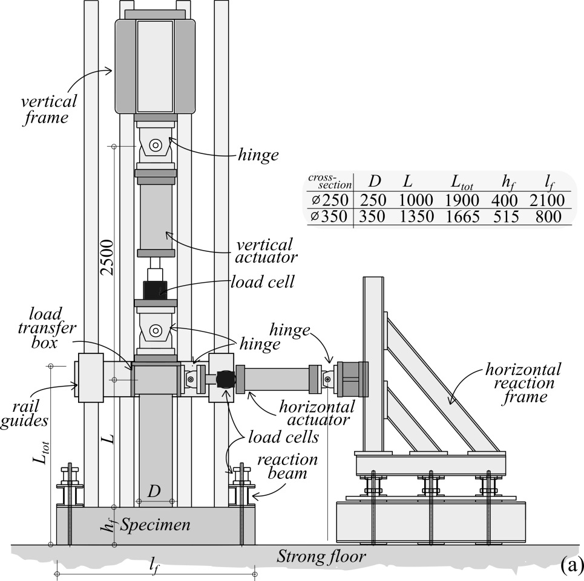

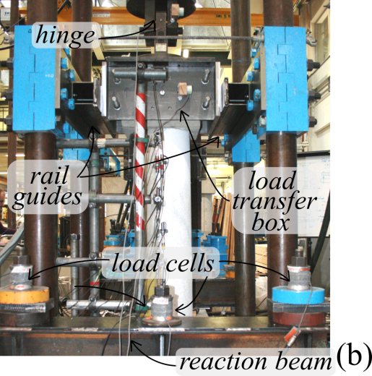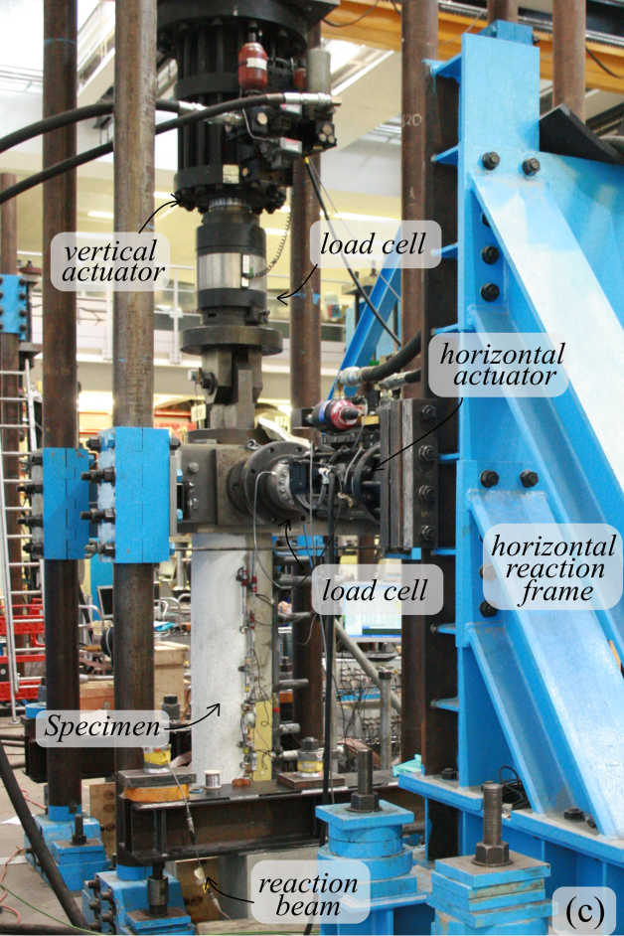

Figure 1 Testing arrangement: a) test-rig layout, b) side view, c) skew view

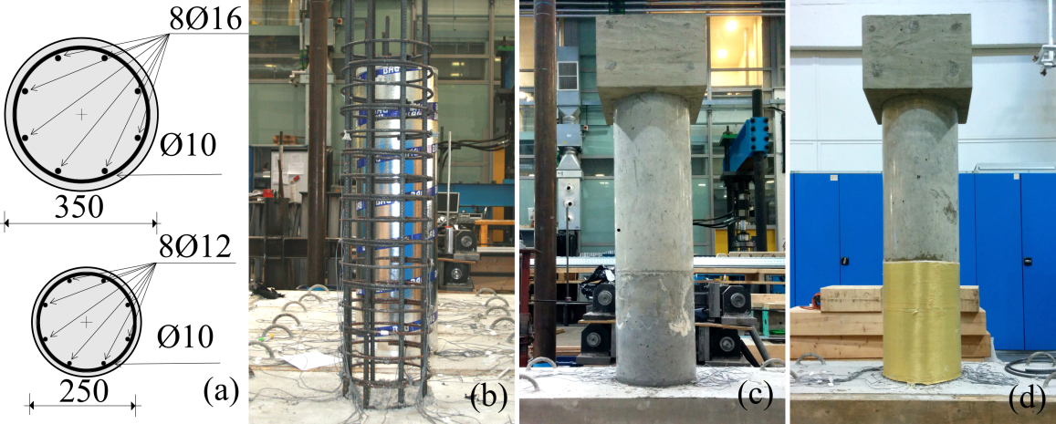

Figure 2 Specimen details: a) cross-section of the Ø350 mm and Ø250 mm diameter members, b) view of reinforcement layout, c) typical reinforced rubberised concrete specimen (RRuC), d) typical AFRP confined reinforced rubberised concrete member (CRRuC)

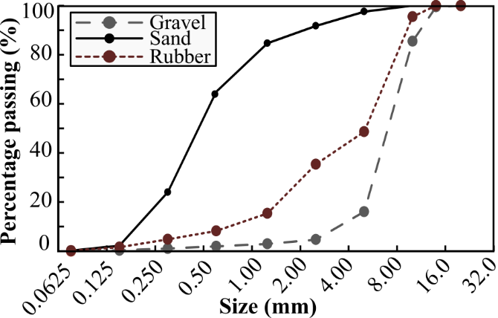

Figure 3 Sieve analysis for aggregates and rubber

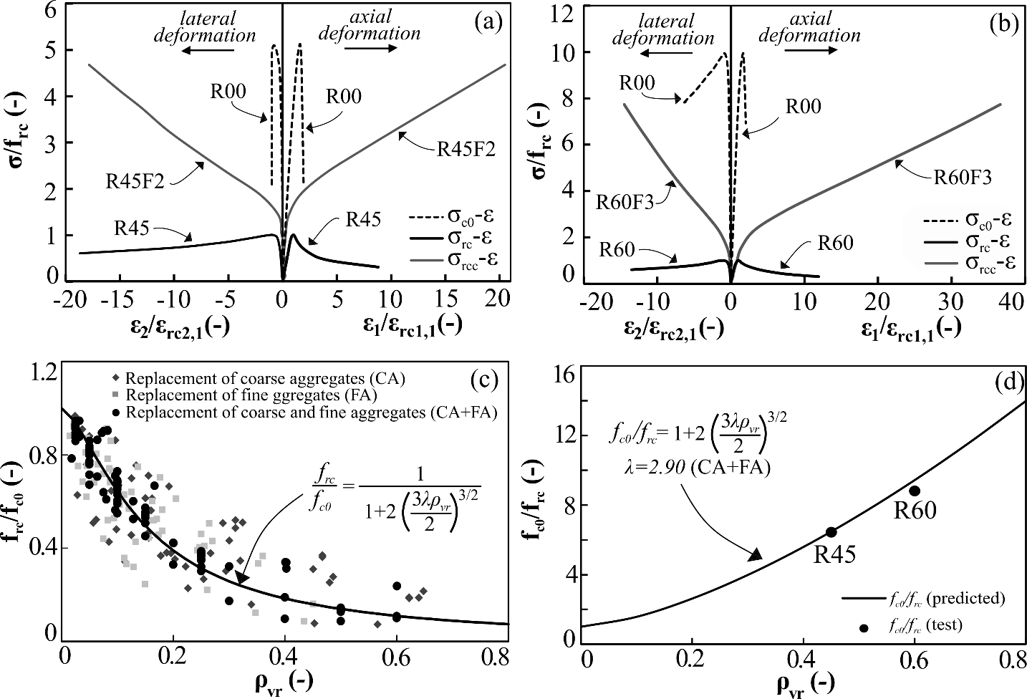

Figure 4 Constitutive σ-ε response: a) R45 Ø100 cylinders, b) R60 Ø100 cylinders, c) strength degradation curve [14], d) strength degradation curve and properties of the rubberised concrete materials in this study

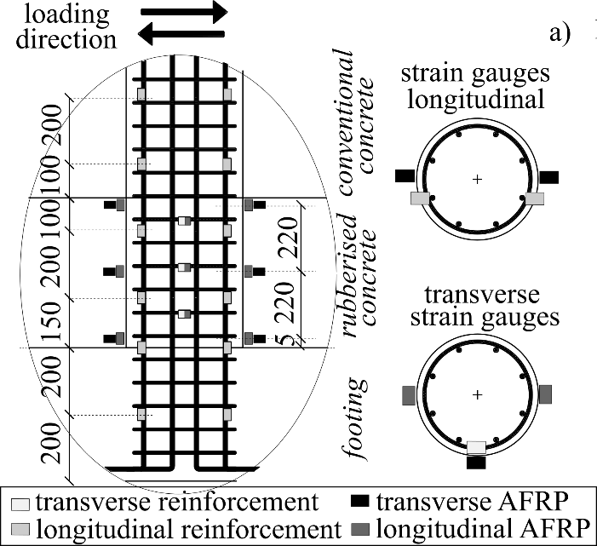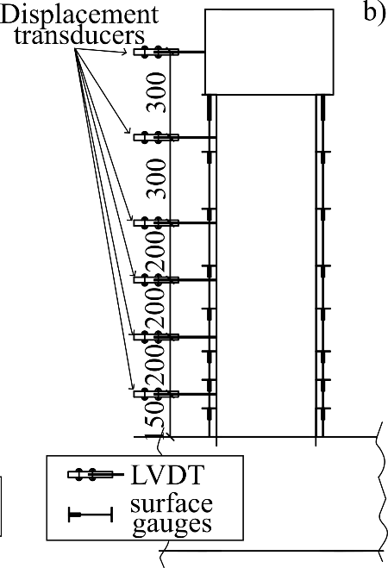
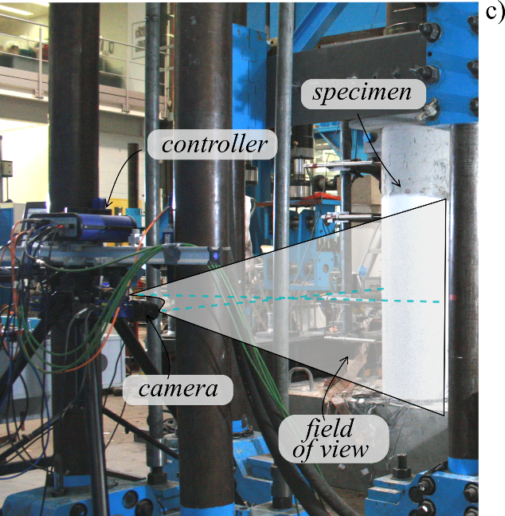

Figure 5 Instrumentation details: a) location of strain gauges, b) position of displacement transducers and surface gauges, c) digital image correlation system

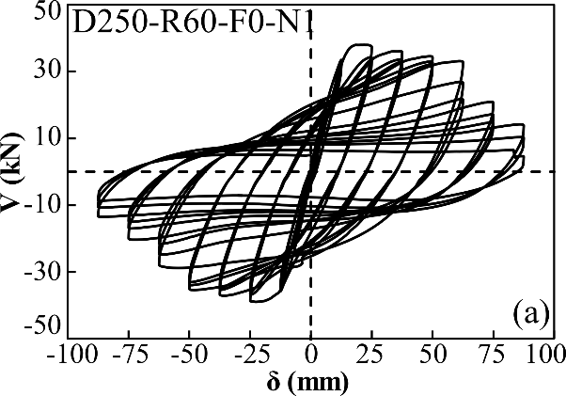
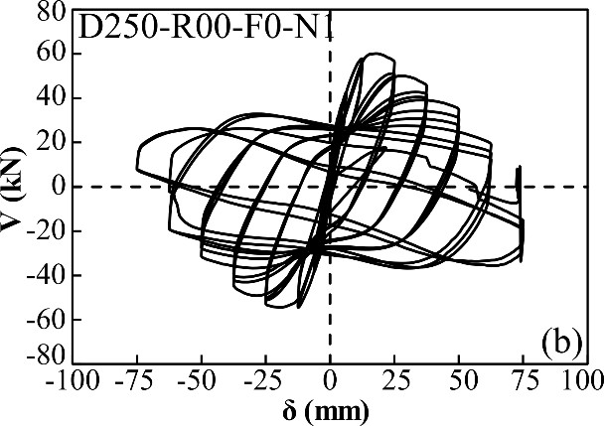
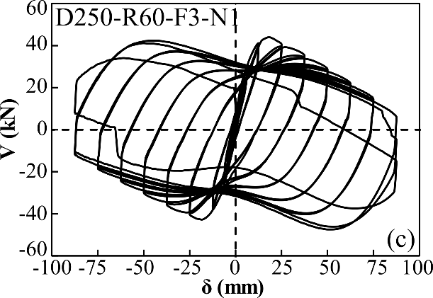

Figure 6 Load-deformation (V-δ) response for Ø250 members: a) D250-R60-F0-N1, b) D250-R00-F0-N1, c) D250-R60-F3-N1

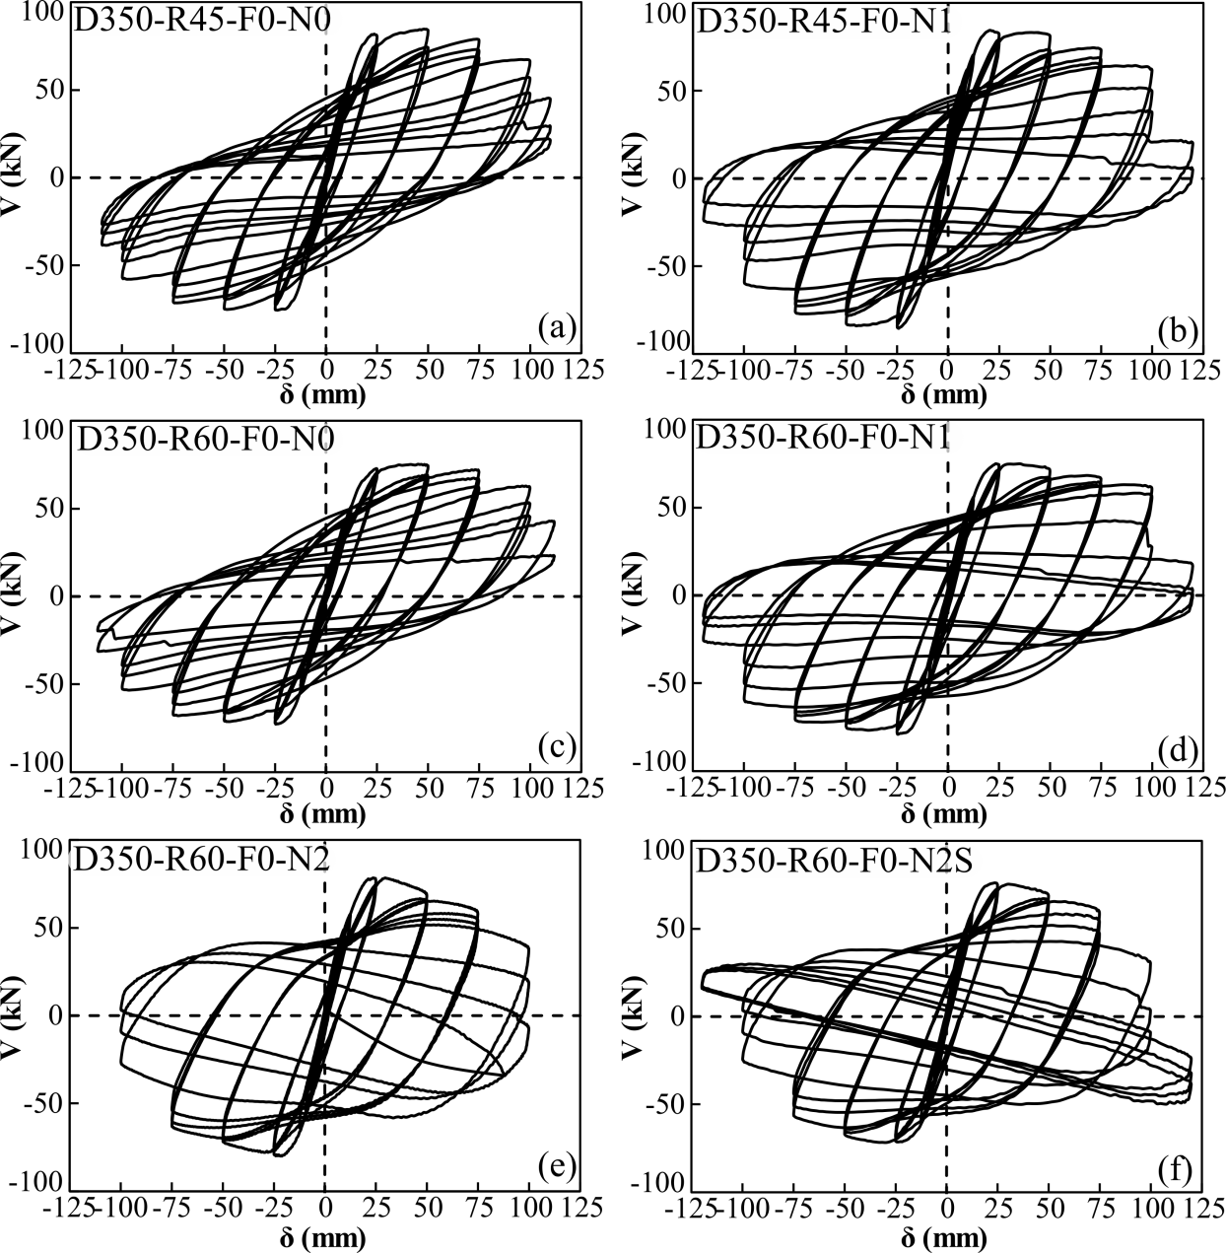

Figure 7 V-δ response for Ø350 RRuC members: a) D350-R45-F0-N0, b) D350-R45-F0-N1, c) D350-R60-F0-N0, d) D350-R60-F0-N1, e) D350-R60-F0-N2, f) D350-R6-F0-N2S

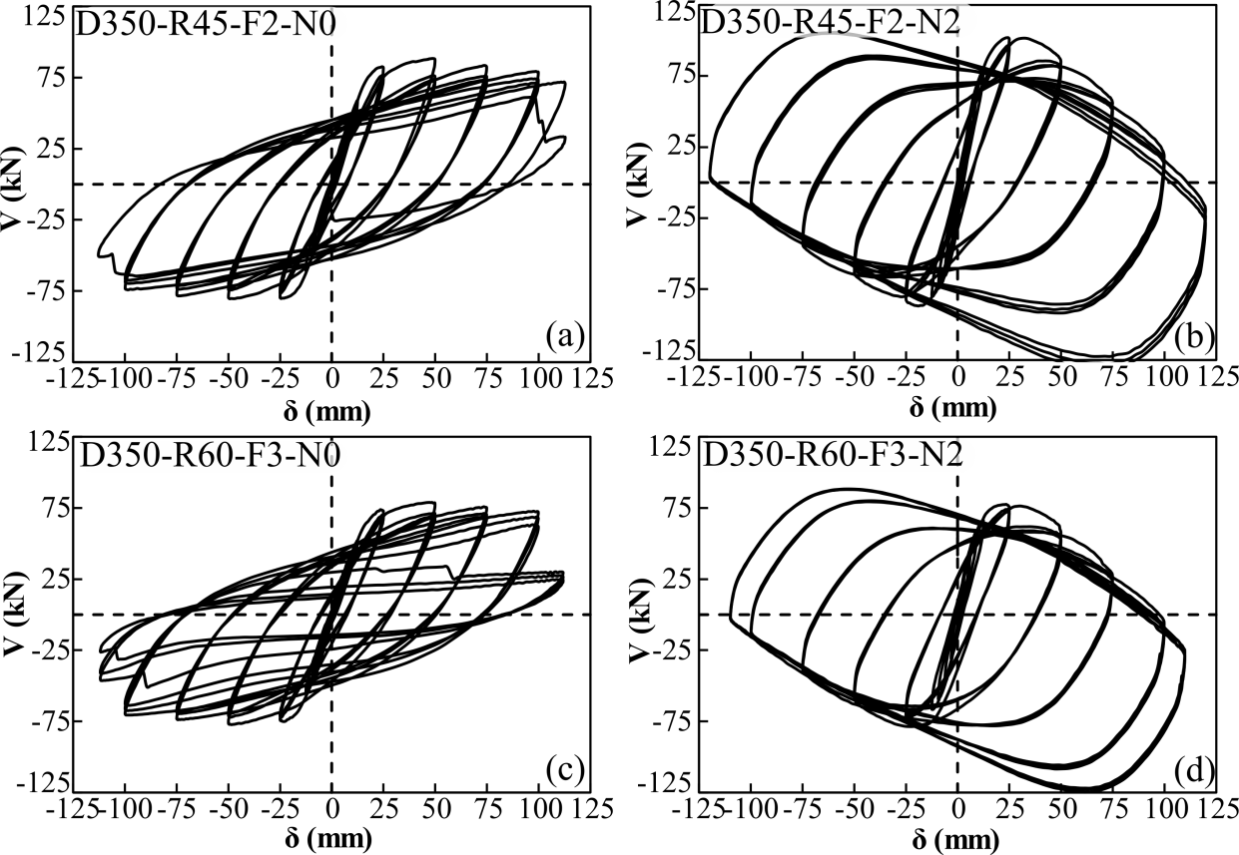

Figure 8 V-δ response for Ø350 CRRuC members: a) D350-R45-F2-N0, b) D350-R45-F2-N2, c) D350-R60-F3-N0, d) D350-R60-F3-N2.

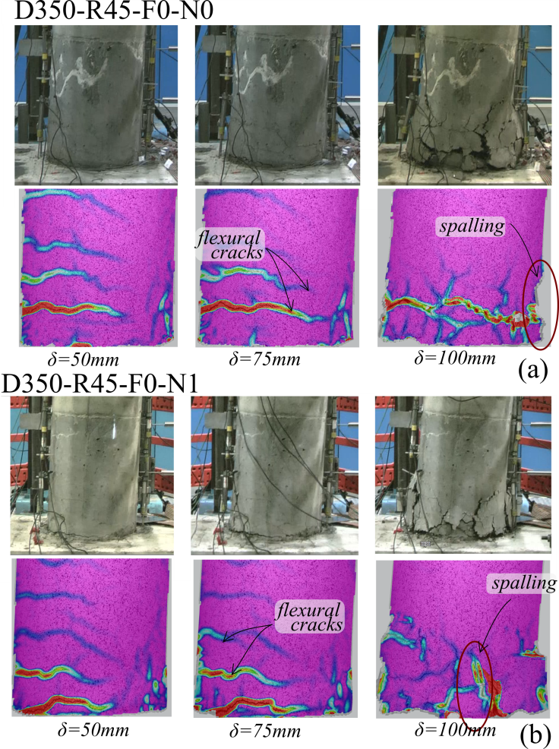

Figure 9 RRuC member kinematics from camera and DIC processing: a) D350-R45-F0-N0 with no axial load, b) D350-R45-F0-N2 with high axial load

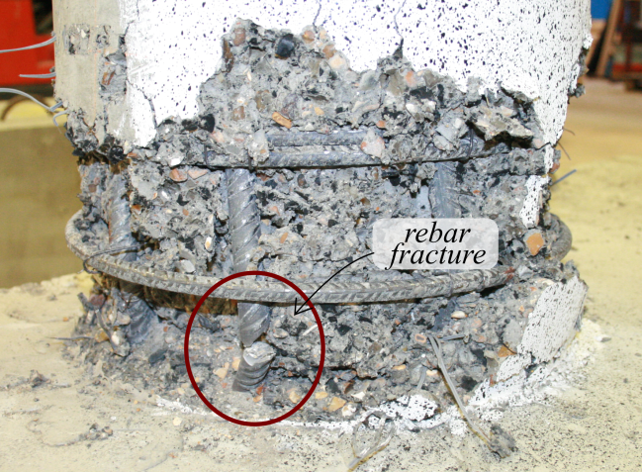

Figure 10 Longitudinal rebar fracture in Specimen D350-R45-F0-N1 after removal of the concrete cover

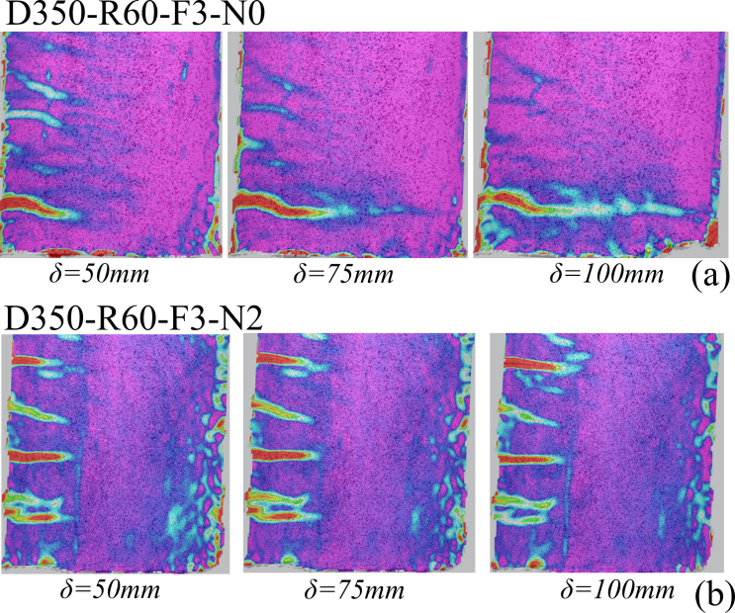

Figure 11 CRRuC member kinematics as obtained from the DIC: a) D350-F60-F3-N0, b) D350-R60-F3-N2

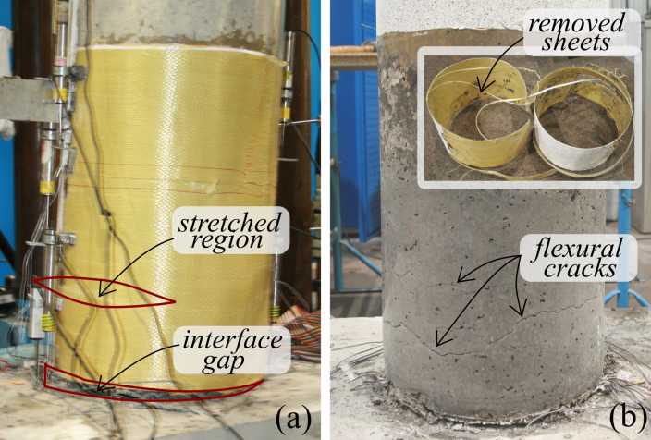

Figure 12 Views of Specimen D350-R45-F2-N0 after testing: a) stretched regions and interface gap, b) damage state after removal of external confinement

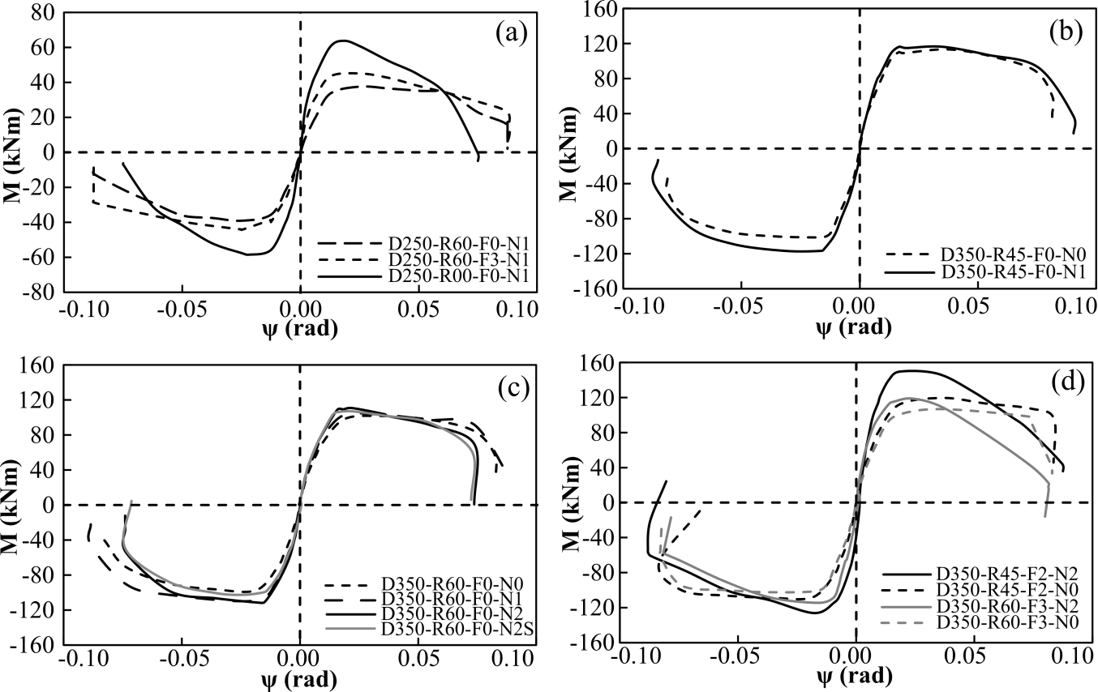

Figure 13 Envelope moment-rotation (M-ψ) curves for: a) Ø250 members, b) Ø350 R45 RRuC members, c) Ø350 R60 RRuC members, d) Ø350 CRRuC members

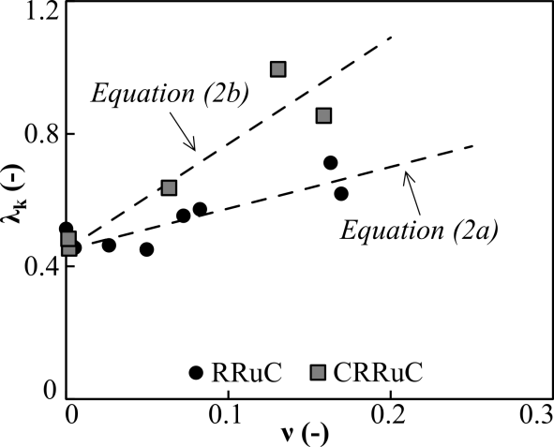

Figure 14 Stiffness parameter λ_{k} versus axial load ratio ν

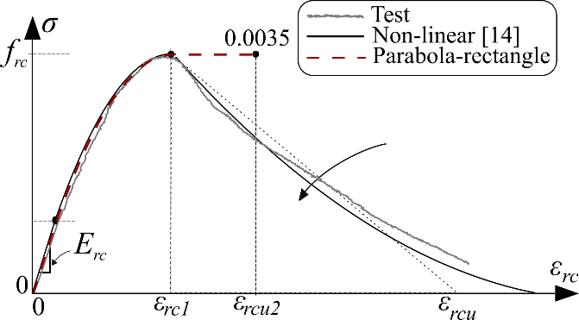

Figure 15 Typical stress-strain response of rubberised concrete materials

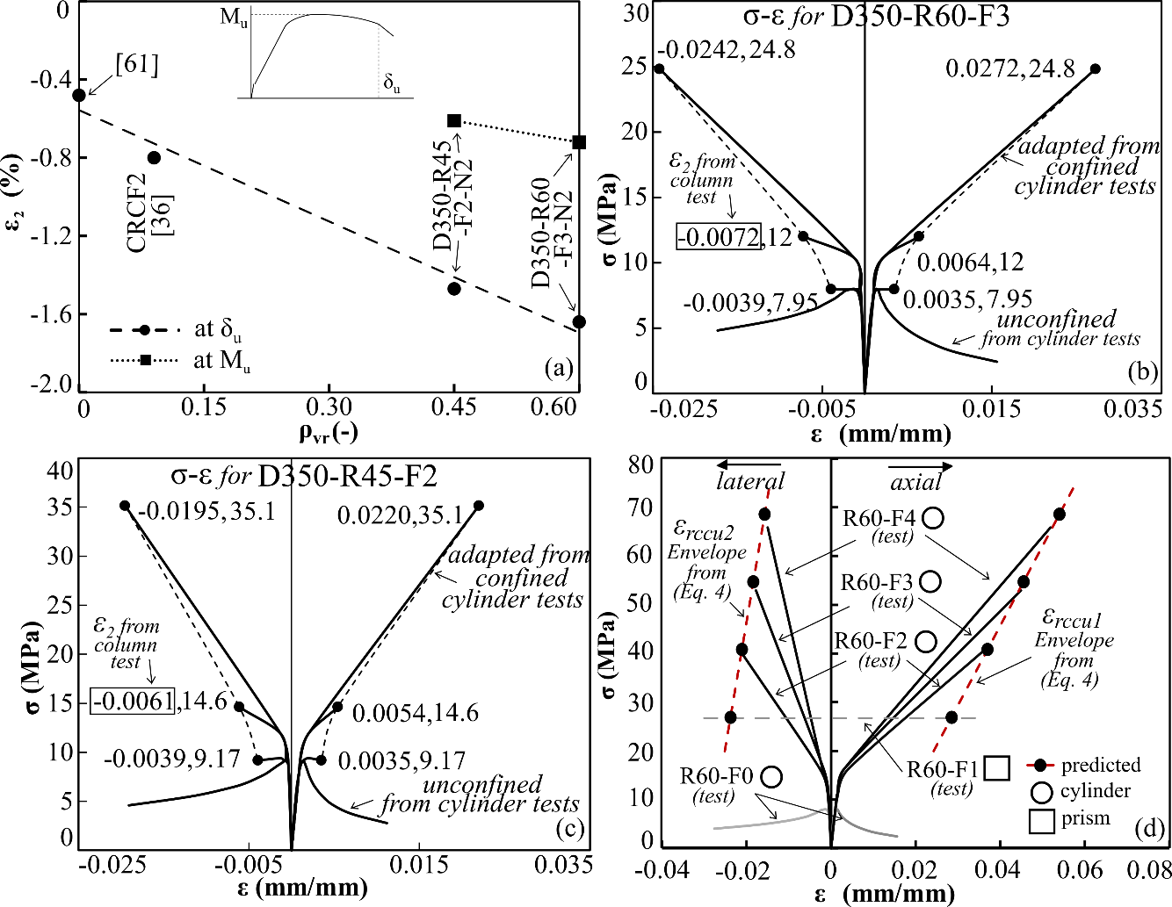

Figure 16 a) Influence of ρ_{vr} on ε₂; stress-strain σ-ε curves for assessment of M-N interaction diagram for: b) D350-R60-F3 columns, c) D350-R45-F2 columns; d) assessment of proportionality factors in Equation (4)

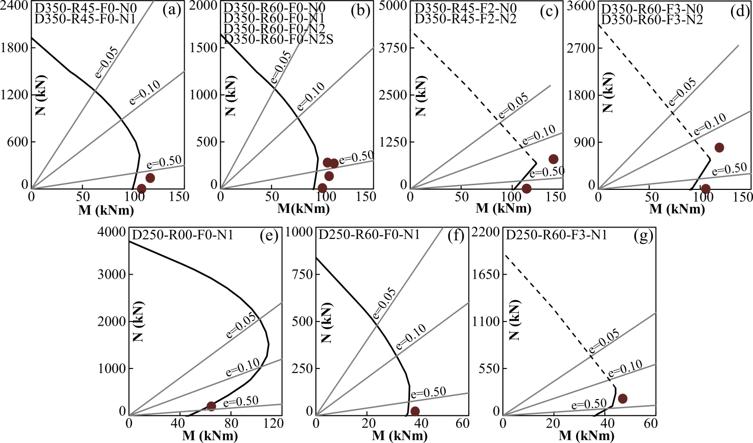

Figure 17 Bending-axial interaction curves for Ø350 RRuC members a) D350-R45-F0, b) D350-R60-F0; Ø350 CRRuC members c) D350-R45-F2, d) D350-R60-F3; Ø250 members e) RC - D350-R00-F0-N1, f) RRuC – D350-R60-F0-N1, g) CRRuC – D350-R60-F3-N1

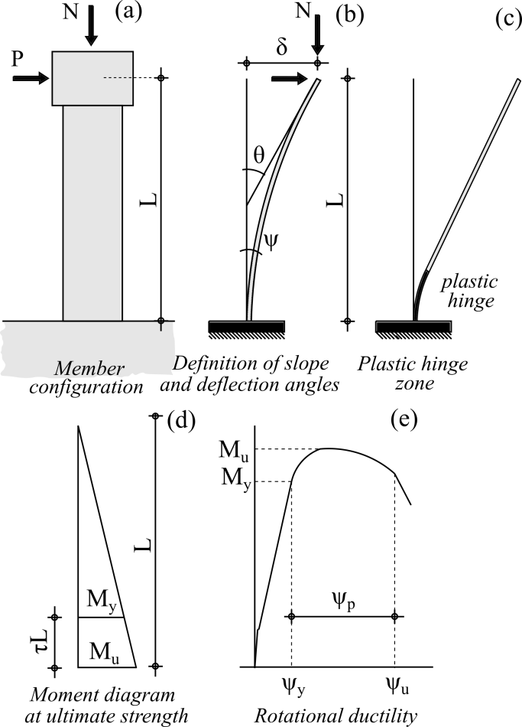

Figure 18 Inelastic response assessment: a) member configuration, b) definitions of slope and deflection angle, c) plastic hinge zone, d) moment diagram at ultimate, e) rotational ductility

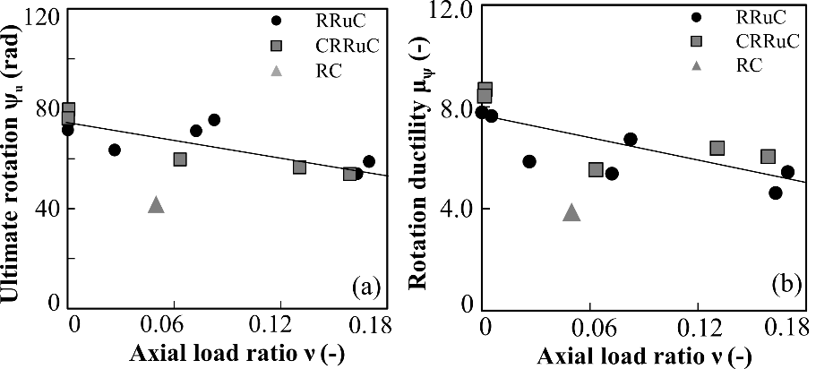

Figure 19 Ductility considerations: a) ultimate rotation ψ_{u}, b) rotation ductility μ_{ψ}

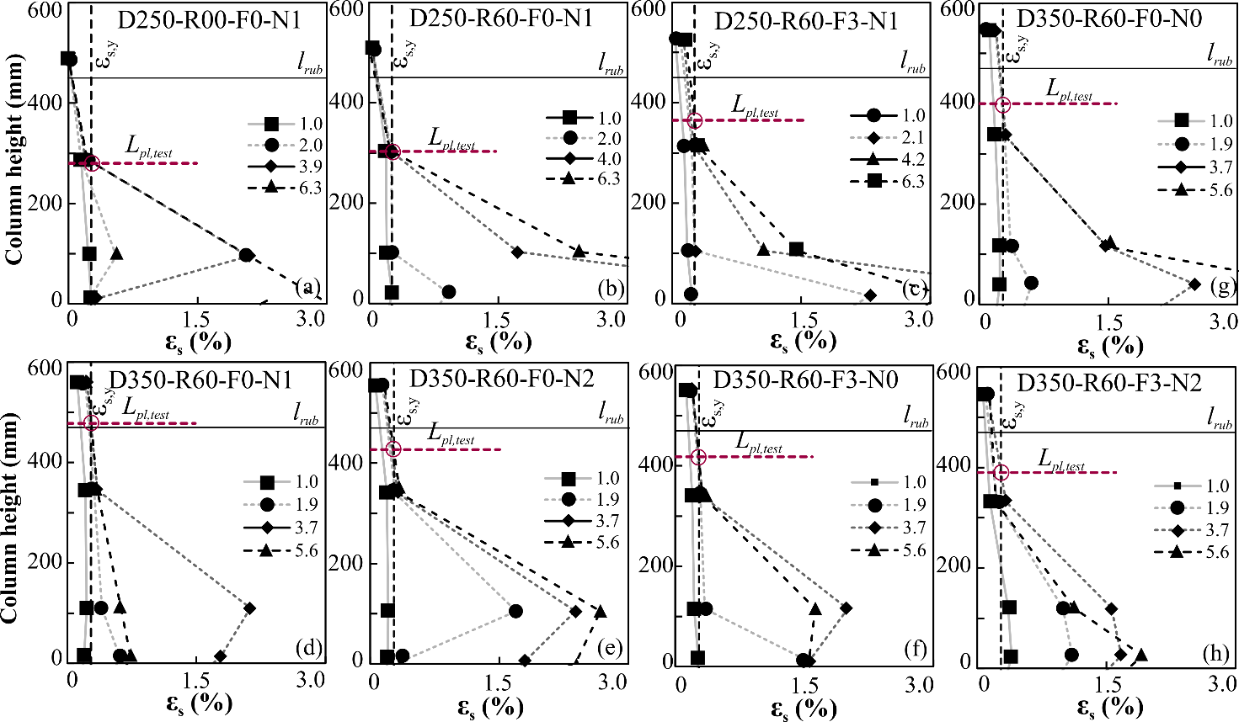

Figure 20 Reinforcement strains and plasticity distribution

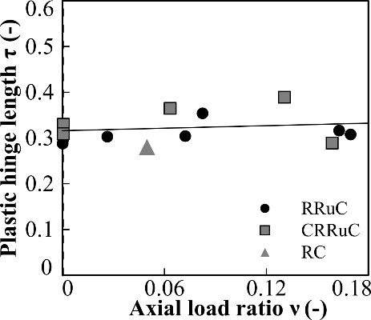

Figure 21 Estimated plastic hinge length

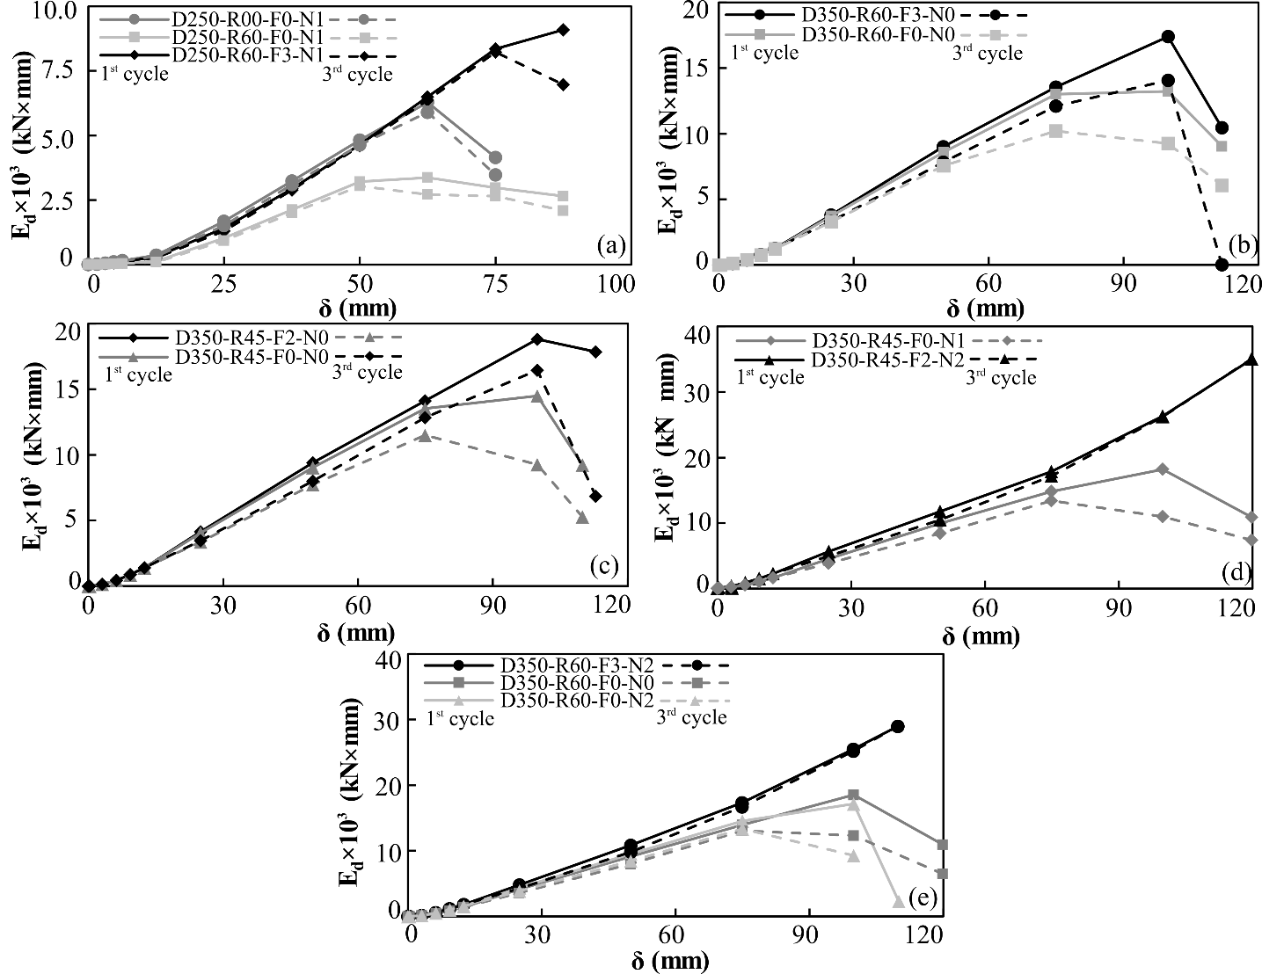

Figure 22 Energy dissipation: a) Ø250 members, b) Ø350 R60 members without axial load, c) Ø350 R45 members without axial load, d) Ø350 R45 members with axial load, e) Ø350 R60 members with axial load

