Piezoresistive structural composites reinforced by carbon nanotube-grafted quartz fibres

H.G. De Lucaª, D.B. Anthony^{b, c}, E.S. Greenhalgh^{c}, A. Bismarck^{d}, and M.S.P. Shaffer^{a, b*}

ª Department of Materials, Imperial College London, London, United Kingdom
^{b} Department of Chemistry, Imperial College London, London, United Kingdom
^{c} Department of Aeronautics, Imperial College London, London, United Kingdom
^{d} Institute of Materials Chemistry, Faculty of Chemistry, University of Vienna, Währinger Str. 42, 1090 Vienna, Austria

* Corresponding author (m.shaffer@imperial.ac.uk)
Nano-engineered fibre/matrix interfaces can improve state-of-the-art fibre-reinforced composites. Grafting carbon nanotubes (CNTs) to high temperature quartz glass fibres produces “hairy” or “fuzzy” fibres, which combine reinforcements at micrometre and nanometre length scales. Fuzzy quartz fibres were produced continuously, reel-to-reel, on whole tows in an open chemical vapour deposition reactor. The resulting uniform coverage of 200 nm long CNTs increased the interfacial shear strength with epoxy (90.3 ± 2.1 MPa) by 12% compared to the commercially-sized counterpart, as measured by single fibre pull-out tests. The improved interfacial properties were confirmed at the macroscale using unidirectional hierarchical bundle composites, which exhibited a delayed onset of fibre/matrix debonding. Although the quartz fibres are electrically insulating, the grafted CNT create a conductive path, predominantly parallel to the fibres. To explore the applicability for structural health monitoring, the resistivity was recorded in situ during mechanical testing, and correlated with simultaneous acoustic emission data. The baseline resistivity parallel to the fibres (ρ₀ = 3.9 ± 0.4 x 10⁻¹ Ω m) displayed a linear piezoresistive response (K = 3.64) until failure at ca. 2.1% strain, also referred to as "gauge factor”, a two-fold improvement over traditional resistance strain gauges (e.g. constantan). Hierarchical, fuzzy quartz fibres, therefore, simultaneously enhance both structural and sensing performance, offering multifunctional opportunities in large composite parts.

Keywords: (A) Glass fibres; (E) Chemical vapour deposition (CVD); (A) Carbon nanotubes; (B) Interfacial strength; Strain sensor

Introduction
The incorporation of nanoscale reinforcements, and more specifically carbon nanotubes (CNTs), into conventional fibre reinforced polymer composites can improve the structural [1], electrical [2] and thermal properties [3] of these state-of-the-art lightweight materials. CNTs are typically introduced either by dispersion into the polymer matrices [4], grafting to fibre surfaces [5] or a combination thereof [6]. Dispersion into resin, usually by shear mixing [7], sonication [8], or calendering [9], provides modest loadings of nanofiller in the final fibre composites, but uses conventional, scalable methods. Depending on the type of filler and the nature of the dispersion, micro- and nano-scale toughening mechanisms such as crack diffusion/branching and CNT debonding/pull-out [10, 11] can be observed. At the same time, the formation of an interconnected network of CNTs can increase the thermal and electrical conductivities of typically insulating polymeric materials [10]. Electrical percolation thresholds vary widely in the range 0.01 to 4 wt.% depending on aspect ratio and processing conditions. However, many thermosets can be optimised to exhibit an electrical percolation threshold of ${}_{c}≈0.1$ wt.% and electrical conductivities ranging from 2 x 10⁻² to 2 S m⁻¹ at CNT loadings of 1.0 wt.% [12]. These types of CNT networks demonstrate a strain-sensitive bulk resistance variation attributed to various mechanisms including deformation of the CNT network conductive path [13], changes in the intertube tunnelling resistance [14] and the inherent piezoresistivity of CNTs [15]. The composite matrix can therefore act as a sensitive strain sensor [16, 17], as well as responding to matrix microcracking, enabling non-invasive detection of in-service damage, and the development of life prediction methodologies [18-20]. These in situ measurements provide an insight into the nature, onset and evolution of matrix-dominated fracture mechanisms, such as transverse microcracking and ply delamination [18], yet are poorly sensitive to fibre breakage [21]. Despite the great potential of CNT as multifunctional reinforcement, the dispersion of CNTs in polymeric matrices is associated with a number of processing issues, especially when combined with a conventional microscale reinforcement, such as glass or carbon fibre. CNTs tend to entangle and/or aggregate, increasing resin viscosity and filtering against the fibre preform during infusion processes. Inhomogeneous CNT distributions can introduce voids and other stress concentrations detrimental to the nanocomposites mechanical properties [22]. In addition, the resin dispersion methods offer little control of CNTs spatial orientation or distribution [23].
Grafting CNTs onto fibre surfaces, on the other hand, forms a nanostructured interphase that directly reinforces the fibre/matrix interface, where stress concentrations dominate due to a mismatch in mechanical properties [24]. In contrast with traditional glass fibre surface treatments, such as silane coupling agents (SCA), which can also provide graded interfacial properties due to the formation of an SCA/matrix interpenetrating network [25], CNTs offer high electrical conductivity, high aspect ratio and surface area, leading to multifunctional opportunities including strain-sensing. Numerous methods have been reported to deposit CNTs to form “fuzzy” or “hairy” fibres, including: electrophoretic deposition [26-28], the application of a CNT-containing size [29] or direct CNT growth through chemical vapour deposition (CVD) [5, 30-34]. CNTs typically act as a protective layer around the fibres, displacing stress concentrations away from the fibre/matrix interface to the end of the CNT forest/sizing [35] and developing a graded CNT/epoxy interphase [36]. The combination of a larger effective diameter, reduced stress concentrations, CNT breakage and/or mechanical keying leads to an increased interfacial shear strength (IFSS) [5]. Electrophoretic deposition and CNT-sizing commonly provides CNTs with a random planar arrangement on fibre surfaces which is of interest for reducing crack opening displacement after fibre failure [37] but inefficient for enhancing transverse mechanical and electrical properties. In contrast, CVD can control the CNT orientation, typically providing either fully random or radially aligned structures [34]. In addition to higher CNT densities at the critical fibre/matrix interface, which correlate to higher IFSS [38], CVD CNT growth methods, in principle, may be integrated directly into the fibre production. However, the majority of literature studies have grafted CNTs onto small batches of short fibre sections. Larger scale studies and commercial application rely on the development of a continuous, reel-to-reel process. Whilst some progress has been made [5, 39-43], depending on the supporting material used, challenges arise, particularly in the retention of the underlying fibre substrate mechanical properties. Carbon fibres are typically etched by the catalysts used for CVD growth; whilst some potential solutions have been proposed recently [44-48], carbon systems themselves are not the best choice for piezoresistive monitoring parallel to the fibre direction; they have a high conductivity, with a limited sensitivity to strain before final failure [49, 50]. General purpose glass fibres melt/soften at typical CVD growth temperatures (600-1000 °C) [51, 52], and their mechanical properties can even degrade at temperatures as low as 250 °C [53]. Special purpose glass fibres, however, and more specifically quartz fibres (also referred to as “ultrapure silica fibres”), are designed for high in-use temperatures, and are an interesting candidate for the direct production of hierarchical reinforcements. The introduction of a conductive, nanostructured, interfacial region could both provide a piezo-resistive response and improved interfacial properties.
The present work focusses on the production of CNT-grafted quartz fibres in a continuous fashion (Fig. 1). The CNT growth was carried out on a full tow in an open CVD reactor, as developed previously for carbon fibres [5]. The effect of the CNT microstructure on the mechanical performance and failure of the fibre/matrix interface was investigated at the single fibre level. Unidirectional hierarchical bundle composites were manufactured, and their mechanical properties assessed in tension. Simultaneous real time monitoring through both acoustic emission (AE) and electronic transport measurements, allowed the capabilities for structural health monitoring to be explored.

Experimental section

Materials
A continuous roving of 6000 filaments of sized quartz fibres (QFs), Quartzel® C14 1600 QS1318, was kindly provided by Saint-Gobain, FR. The fibre diameter was 13.0 ± 0.2 μm as determined from field emission scanning electron microscopy (FE-SEM). The precursor bi-catalyst solution for CNT synthesis consisted of nickel(II) acetylacetonate (≥98%, VWR, GB) and iron(III) acetylacetonate (≥99% ACS reagent, Merck, DE) in ethanol (EtOH, 96%, Brenntag, AT). Acetylene in nitrogen (N₂: 98.7 vol.% and C₂H₂: 1.3 vol.%, C certificate), hydrogen in N₂ (N₂: 97.6 vol.% and H₂: 2.4 vol.%, C certificate) and N₂ (99.998 vol.% minimum) were respectively used as carbon source, reduction and carrier gases. All gases were purchased from BOC gases, GB. Epon 828 (Netmro, US) and Jeffamine T-403 (Huntsman, US) were used as resin epoxy and hardener (100:42 by weight), respectively, for the preparation of single fibre composites. The epoxy infusion system employed for the production of the unidirectional bundle composites was PRIME 20LV (Gurit, GB) with a slow hardener (ULV); epoxy/hardener mixing weight ratio of 100:19 as per manufacturer recommendations.

Experimental methods
The continuous production of carbon nanotube-grafted quartz fibres (CNT-g-QFs), can be separated into two distinct sections (Fig. 1). Prior to their insertion into the open chemical vapour deposition (CVD) reactor, the as-received sized quartz fibre (AR-QF-S) must be decorated with catalyst precursor, by passing the continuous QF tow through a bath containing a mixture of 1 wt.% nickel(II) acetylacetonate and iron(III) acetylacetonate (2:1 mol.) in ethanol (previously vigorously stirred), for 2 min. The Fe/Ni bimetallic catalyst system was previously found to be especially effective at catalysing CNT growth on carbon fibres (CFs) [5] as it displays a higher activity than its individual elements [52] and a lower eutectoid [44] allowing CNT growth at a reduced temperature. The tow was kept under modest tension (ca. 0.4-0.5 N) during deposition to allow for sufficient spreading in the catalyst precursor containing bath. The QFs were then dried in a set of infrared-furnaces (Fig. 1) at temperature of ca. 40 °C and 70 °C, and collected on a reel.
The bi-catalyst precursor coated QFs (QF-BiCat) were subsequently passed through a hot-walled CVD set-up, described previously [5]; briefly, an open 3-zone tubular furnace (PTF 15/-/610, Lenton, GB) was designed with an adjustable arrangement of internal quartz tubes that define successive regions with specific gas conditions to separate zones for catalyst reduction and CNT growth. The QF tow was kept taut during the entire process by passing it over a set of tensioning pins. As the QF tow entered the furnace it was initially exposed to N₂ (7500 SCCM). Then, once in the hot-zone (760 °C) to a mixture of 2.4 vol.% H₂ in N₂ (3400 SCCM) for catalyst reduction and afterwards, the QFs were subjected to a mixture of 1.3 vol.% C₂H₂ in N₂ (325 SCCM), acting as the carbon source. The growth of CNTs was completed for two different line speeds through the continuous CVD set-up, 1.2 and 2.4 m h⁻¹ corresponding to a dwell time in the furnace stable hot zone of 30 and 15 min, respectively. Finally, the fibres were cooled down in an inert gas sleeve to exit the reactor unimpeded. As a control, similar conditions were used to produce heat-treated (thermally desized) fibres (QF-HT), exposed to high temperature (760 °C) for 30 min under an equivalent absolute flow of N₂ (11140 SCCM at a line speed of 1.2 m h⁻¹) but in absence of active gases. It should be noted that the pre-catalyst deposition and CNT growth lines were not combined into a single run, due to the requirement for an overall length exceeding 15 m, not feasible in our laboratory; however, since both operate reel-to-reel, there is no difficulty in principle to integrate them in the future.
The morphology of the CNT-g-QFs (short and long designated S and L, respectively) was investigated using high resolution FE-SEM (LEO Gemini 1525) operating at an accelerating voltage ranging from 2.0 to 5.0 kV to confirm the formation of CNTs. The fibres were arranged in small bundles (ca. 100 filaments) on an aluminium stub and fixed using silver DAG (Agar Scientific, GB). SEM of CNT-g-QFs cross-sections were taken on specimens prepared by isolating a single fibre from the tow and using carbon tape to fix the fibre onto a slotted aluminium stub (AGG301D, Agar Scientific, GB). Similarly, the morphology of AR-QF-S, QF-HT and QF-BiCat was assessed (Fig. S9).
The thermal stability of QFs and CNT-g-QFs was assessed via thermal gravimetric analysis (TGA) using a Mettler Toledo TGA/DSC 1 with a GC200 flow controller. Thermals scans were carried out in air (60 SCCM) from 100 to 850 °C at 10 °C min⁻¹, after a pre-treatment from 30 to 100 °C at 35 °C min⁻¹ and a 30 min isothermal plateau both under N₂ to remove moisture.
Single fibre tensile tests were carried out on a TST350 Tensile Stress Tester (Linksys32, V1.9.1, Linkam Scientific Instruments Ltd., GB), following the standard BS EN ISO 11566, 1996, Method B [54]. The single fibre specimens were tested at a gauge length of 25 mm with a 20 N load cell at crosshead speed of 15 μm s⁻¹.
Single fibre pull-out tests were carried out using a bespoke apparatus previously reported [55] following an identical procedure. In short, the specimens were prepared by embedding a single fibre in an epoxy droplet while altering the embedded length (ca. 30-100 μm) using a fine vertical adjustment screw. The epoxy resin was then heated at 100 °C for 20 min using a built-in heating stage, removed from the holder, then placed in an oven for the completion of the curing cycle at 100 °C for 5 h 40 min. The specimens were then mounted on a piezo-force sensor, measuring the force with a resolution of 0.1 mN, while the free fibre end (ca. 10 mm) was glued (cyanoacrylate) to a needle, attached to a piezo-translator (resolution of 1.8 nm). The pull-out test was operated at a cross-head speed of 0.2 μm s⁻¹. The apparent interfacial shear strength (IFSS, $τ_{app}$) was calculated using the following Equation (1):
$τ_{app}=\frac{F_{max}}{A_{e}}=\frac{F_{max}}{{πd}_{f}l_{e}}$ , (1)
where the fibre diameter ($d_{f}$), which includes any contribution from grafted CNTs, and embedded length ($l_{e}$) were measured via FE-SEM for each specimen after single fibre pull-out tests. A minimum of 13 specimens were tested for each sample set, and the average IFSS was obtained from a linear fit fixed at the origin of the population when pull-out peak force ($F_{max}$) is plotted as a function of embedded fibre area ($A_{e}$).
The graphitic nature of the CNTs produced was investigated through Raman spectroscopy using a Renishaw inVia micro-Raman spectrometer with 532 nm (2.33 eV) DPSS diode laser (NA 0.8/50x, sample power 3.2 mW), in a backscattered geometry with relative spot size diameter of 1.2 μm [56]. Raman spectra in the range of 80-3200 cm⁻¹ were collected and averaged for at least five different locations on the CNT-g-QFs tow. The intensity ratio of G- (1582 cm⁻¹) to D-mode (1350 cm⁻¹) (I_{G}/I_{D}), which characterises the degree of order of the sp² framework, was measured [57]. In addition, Raman mapping was performed along the CNT-g-QF fracture surfaces after single fibre pull-out in an attempt to identify the locus of failure.
Unidirectional (UD) bundle composites were manufactured following the ASTM D4018 standard. As required by this standard, the fibre mass fractions of the samples (Table S2) were kept between 40 and 65 wt.% (26-49 vol.%), by adjusting the mould dimensions. For comparative purposes, the data were normalized to the largest volume fraction (49 vol.%) permitted in the standard, which approaches values most typically used in practical composites. 250 mm long sections of the QF tows were cut and introduced into the slit of a stainless steel mould. To keep the fibres taut and ensure alignment, 30 g weights were attached at each end of the tow. Prime 20ULV, an ultra-low viscosity epoxy system was vigorously mixed and degassed for 20 min in a vacuum oven prior to infusion (in excess, ca. 8 ml). A lid was then pressed down on top of the mould to remove excess epoxy and adjust the composite thickness. Finally, the samples were cured at room temperature for 24 h followed by a post-cure in an oven for 16 h at 50 °C following manufacturer’s recommendations. The ends of cured UD bundle composites were then polished and end-tabbed using glass fibre-reinforced polymer (GFRP) panels and Araldite 2011 thus fixing the gauge length to 150 mm as per standard’s requirements. Tensile testing was carried out using an Instron 5980 equipped with a 250 kN load cell at quasi-static strain rate of 1 mm min⁻¹. Strain was recorded tracking painted marks using a video gauge (iMETRUM MG223B PoE E0022522, iMETRUM Ltd, GB) equipped with a general purpose lens (iM-LENS GP006) with a focal length of 50 mm. Acoustic emission (AE) events, characteristic of microcracking occurring in the composite under load and generally concentrated within the 10-550 kHz frequency range for GFRPs [58] were detected using a ultra-miniature wideband sensor (PICO, 200-750 kHz, Mistras Group Inc., Physical Acoustics Corporation, US). The sensor was held in place (ca. 10 mm from bottom end-tab) using a purpose-built aluminium clamp and contact to the specimen ensured with a coupling agent gel (Sonagel W1, Sonatest, GB). The AE sensor was used in association with a 2/4/6 preamplifier with 20 dB gain, AE Express-8 PCI chassis and AEwin software (version E5.71) from the same supplier. Amplitude threshold, peak definition time, hit definition time, time drive rate and hit lockout time were set to 65 dB, 100 ms, 200 ms, 10 ms and 200 ms, respectively. In-situ electrical conductivity measurements were performed using a Gamry Instruments Interface 1000 potentiostat/galvanostat/ZRA, with Gamry Instruments Framework™ (v.6.24). UD hierarchical bundle composites had both ends, sticking out of the end-tabs (ca. 10 mm), silver painted and connected to the circuit with hook clips. A constant voltage of 500 mV was applied and the current measured using a sampling interval of 100 ms. The cross-sectional area along with the original length of each bundle specimens were measured to calculate the in-plane electrical conductivity. For clarity, plotting electrical conductivity and $∆R/R_{0}$ (the ratio of electrical resistance variation $∆R$ and initial electrical resistance $R_{0}$) as a function of strain, 30 and 10 data points were skipped between each displayed measurement, respectively. CNT loading was estimated from TGA data and associated bundle composite fibre volume fraction. Photographs of the bundle composite tensile test set-up (Fig. S11 and Fig. S12) along with the collated tensile data (Fig. S13) are included in the Supplementary Information.

Results and discussion

Morphology of carbon nanotube-grafted quartz fibres
The presence of the catalyst particles on the QFs surface introduced a uniform yellow tinge to the previously colourless fibres, due to the presence of the metal salts (Fig. S1). After exposure to reactive gases, at high temperature, the tow turned black; longer dwell times produced a darker tint and noticeable fuzziness (Fig. S1). Adjusting the reduction and growth times, via the pull-through speed, promoted distinctive CNT morphologies: shorter dwell time produced a uniform, 200 nm thick layer of highly entangled CNTs (Fig. 2a, b and c); extended exposure to the active gas grew much longer (up to 30 μm) CNT arrays (Fig. 2e, f and g). For these longer CNTs, the radial symmetry around the fibres was broken, with the formation of a splayed “Mohawk” morphology, as reported previously in similar geometries [36, 39, 59]. In addition, the resulting longer arrays had a rather uneven length along the tow fluctuating from 5 to 30 μm (Fig. 2f, g). Both configurations, namely CNT-g-QF (S) and CNT-g-QF (L) exhibited CNT diameters of sub-20 nm (Fig. S10).

Carbon nanotube loading and quality
Thermogravimetric analysis (TGA) in air (Fig. S2) provides information about the carbon/organic content and stability of the various samples. As-received (sized) QFs showed a mass loss (1.4 wt.%) at the lowest initial decomposition temperature (ca. 150 °C), corresponding to the degradation of the protective sizing present on their surface. Both QF-HT and QF-BiCat showed a delayed onset of degradation when compared to AR-QF-S at ca. 250 °C, likely due to the presence of partially carbonised residual sizing. CNT-g-QF (S) and CNT-g-QF (L) on the other hand were relatively stable up until ca. 450 °C, when the CNTs started to combust significantly. The weight ratio of CNTs introduced onto the QFs was estimated to be around 0.6 and 1.6 wt.% for CNT-g-QF (S) and CNT-g-QF (L), respectively. The thermal stability of the nanoengineered QFs make them an interesting reinforcement, particularly if combined with resin systems designed for high service temperatures.
The Raman spectra for both AR-QF-S and QF-BiCat (Fig. S3a, c) showed characteristic features associated with fused silica, ranging from 450 to 1200 cm⁻¹. After thermal treatment of the QF-HT control at 760 °C in N₂, the silica signals were greatly weakened, likely due to overcoating with amorphous carbon from the decomposition of the sizing, leading to a relatively featureless spectrum, with a rising fluorescent background (Fig. S3b). In contrast, in addition to the weak silica peaks, the CNT-g-QF (S) sample showed strong D- and G-modes at ca. 1340 and 1580 cm⁻¹, respectively, characteristic of the graphitic carbons such as CNTs (Fig. 2d). The CNT-g-QF (L) showed similar graphitic features (Fig. 2h), but the silica peaks were lost, due to the increased thickness of the CNT layer. The longer CNT array obtained for CNT-g-QF (L) was relatively crystalline with the appearance of a 2D-mode (also referred to as G′) around 2700 cm⁻¹. The CNT-g-QF (L) also exhibited a higher intensity ratio of the G-mode to the D-mode (I_{G}/I_{D}) when compared to CNT-g-QF (S), 1.37 ± 0.01 and 1.11 ± 0.01, respectively, indicating greater ordering of the sp² bonded graphitic domains. This morphological difference can be attributed to the transition from an unconstrained disordered growth (with a lower nucleation density [60]) to the concerted growth of arrays [61], at higher nucleation density [62]. In addition, the altered growth kinetics and more specifically the prolonged exposure to H₂ may also reduce the defect concentration [63] and shift from random to aligned CNT growth [64].

Single fibre mechanical and interfacial properties
The mechanical properties of composites depend both on the intrinsic tensile properties of the reinforcing fibres, and the fibre/matrix interface. The ability to transfer stress from the matrix to the parent fibres is characterised by the IFSS, a measure of adhesion. QFs are typically coated with a polymeric sizing and/or silanised which enhances compatibility and promotes adhesion to epoxy [65]. Commercial sizing is the industrial benchmark; however, the terminology commonly used in the research field creates confusion. Terms such as ‘pristine’, ‘barren’, ‘virgin’, ‘raw’ and ‘untreated’ do not clearly define the surface conditions of the reference fibres; it is frequently unclear whether the performance of the grafted fibres exceeds that of the commercial sizing. IFSS can be measured by a variety of micromechanical approaches or inferred from larger coupon tests [66, 67]. Single fibre pull-out tests, performed here, provide a full load-displacement curve for the interfacial failure as a fibre is removed from a resin block. The IFSS presented have an interaction area determined from the fracture surface for each fibres. For the baseline QFs, an initially elastic regime was followed by plastic yielding of the resin; after an abrupt drop, associated with complete debonding, there was a region of lower frictional force, linearly decreasing until the fibre was fully extracted from the resin. In direct comparison, the pull-out curves for CNT-g-QF (S) (Fig. 3 bottom) exhibited a stick-slip response in the extraction region (blue area) as a result of the presence of CNTs. The difference may be explained by the surface roughening of the quartz fibres and the introduction of a mechanical interlocking effect between the CNTs and epoxy.
The collated IFSS data (Fig. 3 top) showed that the partial removal of the sizing from as-received QFs, both thermally (QF-HT) and chemically (QF-BiCat), greatly impaired performance, with decreases of 13% (70.3 ± 4.5 MPa) and 31% (55 ± 0.9 MPa), respectively, compared to the original commercially-sized QFs (AR-QF-S). The relatively large scatter associated with QF-HT IFSS measurements is consistent with incomplete sizing removal, in agreement with the TGA results (Fig. S2). QFs, nanoengineered with a short and uniform CNT coverage (CNT-g-QF (S)) had the highest IFSS of 90.3 ± 2.1 MPa, a 12% increase over the baseline sized fibres. CNT-g-QF (L), however, did not show any statistically significant difference when compared to AR-QF-S with an IFSS of 79.2 ± 2.2 MPa, possibly due to the asymmetric CNT coverage creating a complex stress state at the interface, leading to a premature failure. The fracture surface of CNT-g-QF (S) (Fig. 4a) was relatively rough due to the presence of epoxy residues. Moreover, the partially textured fibre surface indicated the presence of CNTs which would suggest a cohesive failure in the CNT/epoxy interphase close to the parent fibre, in agreement with the high IFSS measured. The CNT-g-QF (L) fracture surface (Fig. 4c), on the other hand, appeared cleaner with only limited matrix residue remaining on the fibres. CNTs can be seen to have bridged from the epoxy wetting cone (or “meniscus region”), aligned with the pull-out shear stresses generated during the test. Raman spectra performed on the fracture surfaces after pull-out of both CNT-g-QFs (Fig. 4b, d) and away from the fracture region (Fig. S4a, b) exhibited a strong D- and G-modes, further confirming the presence of CNTs on QF after fracture, and hence a cohesive failure for both CNT configurations. The enhancement of the adhesion is likely the result of mechanisms acting at different length scales: matrix cracking, CNT debonding, CNT detachment and CNT breakage may all contribute to various extents. Experimentally, given the complexity of the system, it is difficult to identify which of these competing mechanisms was predominant. CNT strength and CNT/epoxy interfacial adhesion, however, have been suggested to play an important role in the onset of these different failure modes [68].
The intrinsic tensile properties of the fibres were also evaluated at the single fibre level, after each treatment (Fig. S5 and Table S1). The modulus of all the fibres remained effectively unchanged, as the fibre core retained its properties. However, handling at high temperature halved the tensile strength, for both the CNT-grafted fibres, namely CNT-g-QF (S) and CNT-g-QF (L), and the thermally treated control (QF-HT); the initial loading of catalyst had no effect. High temperature treatment is known to damage glass fibres; surface defects may be created due to steam etching by adventitious moisture or simple mechanical damage after stripping the protective sizing [53]. At a commercial scale, such detrimental effects could likely be avoided.

Piezoresistive response of unidirectional hierarchical composites
The normalised tow composite tensile strengths and Young’s moduli (Table 1) show qualitative trends in tensile performance consistent with those obtained from the single fibre tests: the stiffness, which relates to the bulk fibre properties remained unchanged, whilst the strength was reduced as a result of surface damage introduced during processing.
The presence of the grafted CNT layer provided a measurable electrically conductive path parallel to the fibres. The initial electrical conductivity increased from 2.7 ± 0.3 S m⁻¹ for the shorter CNT-g-QF (S) to around 7.4 ± 0.3 S m⁻¹ for the longer CNT-g-QF (L) (Fig. 5c), consistent with the higher carbon loading in the latter case (CNT loading of 0.3 and 0.8 wt.% for composites containing CNT-g-QF (S) and CNT-g-QF (L), respectively). For comparison, the absolute electrical conductivities of CNT/epoxy systems found in the literature typically range from 1 x 10⁻⁵ to 2 S m⁻¹ at CNT loadings suitable for conventional composite processing (i.e. ≤ 1 wt.%) [69]. Whilst the random nature of the percolated network commonly leads to electrically isotropic nanocomposites; the combination of CNT/epoxy with glass fibres generates anisotropic composites as in-plane conductive pathways form more easily along the fibre direction [70, 71]. The absolute in-plane electrical conductivity of CNT-dispersed GF/epoxy composites ranges from 5 x 10⁻⁷ to 1 x 10⁻² S m⁻¹ [71-75] and from 1 x 10⁻³ to 5 S m⁻¹ for CNT-grafted GF/epoxy composites [26, 69, 71, 76, 77]. One recent study stands out as it reports an in-plane conductivity for CNT-grafted GF/epoxy of up to 100 S m⁻¹ [33]; however, the composite’s mechanical performance was drastically lowered, mainly because an excessive CNT length of 5.3 µm reduced the GF volume fraction. Thus, the bundle composites produced in this work exhibit one of the highest in-plane electrical conductivities for epoxy-based nanocomposites (Fig. 5b), with modest CNT loadings (<1 wt.%). The low percolation concentration achieved, here, can be attributed to the efficient network formation due to the CNT arrangement at the fibre/matrix interface. The local CNT loading within the interphase can be estimated to be around 13 vol.% (see supplementary information, section 4), well above the local percolation threshold, but macroscopic conductivity requires percolation, at a longer scale, between these regions. Analogous selective localisation of CNTs has been found to be efficient in co-continuous polymer blends and double percolated structures [78]; the use of continuous fibres to structure the network is particularly effective in the fibre direction. However, both CNT-g-QF bundle composites exhibited an anisotropic behaviour with a transverse electrical conductivity an order of magnitude lower than its longitudinal conductivity (Fig. S6).
With increasing load, the conductivity fell gently, until the sample approached its failure strain of ca. 2.1%, at which point the conductivity dropped to zero, in one or more abrupt steps (Fig. 5a). Over the linear elastic mechanical range, the variation of the electrical resistance was also linear (Fig. 5d). Thus, the strain sensitivity can be calculated from the following Equation (2):
$Sensitivity=\frac{Δ\left(\frac{∆R}{R_{0}}\right)}{Δɛ}$ , (2)
where $R_{0}$ is the initial electrical resistance, $∆R$ is electrical resistance variation between 0.5 - 2.0% strain, and$Δɛ$ = 1.5% strain. The strain sensitivity of the shorter CNT-g-QF (S) sample (3.64 ± 0.43) was greater than that of the CNT-g-QF (L) sample decorated with longer CNTs (2.79 ± 0.16). A lower concentration of short CNTs is closer to the critical percolation network and, therefore, more sensitive to changes in network geometry as commonly observed in CNT/polymer systems [14]. The CNT-g-QF (S) bundle composites already show a two-fold increase in sensitivity over traditional resistance-type strain gauges [16], which might be improved further by optimising the CNT network architecture further towards criticality. In addition, the sensing network is embedded within the composite, intrinsically where the load is carried, rather than bonded to the surface; the arrangement of the conductive path along the primary reinforcing fibres provides a measure of strain in the load bearing direction. On approaching failure, the conductivity should correlate to the onset of fibre fragmentation, as observed in carbon fibre composites where the carbon fibres are used both as electrically conductive pathways and load bearing elements [79]. At higher strains, there is a non-linear region in the resistance change-strain curve; the gentle increase (Fig. 5d) could result from plastic deformation of the CNT network at the interphase [76], fibre fragmentation/debonding [21] or a combination thereof. The absence of abrupt changes in $∆R/R_{0}$ below ~1.8% strain (Fig. 5d) suggests that the electrical conductivity is not sensitive to isolated fibre breaks as the continuity of the network is retained [21], likely due to contacts amongst the large number of fibres (ca. 6000) in these bundle composites. Moreover, the change in conductivity associated with the onset of fibre fragmentation should depend on the subsequent locus of debonding. A failure at the CNT-fibre interface would leave the conductive network unchanged; however, the single fibre pull-out fracture surfaces (Fig. 4) suggest a cohesive failure, disconnecting the conductive sheath from neighbouring fibres. Thus, the larger jumps in $∆R/R_{0}$ at higher strains (Fig. 5d) were provisionally attributed to extended fibre debonding following fibre fracture.

Mechanistic study using correlated acoustic emission data
To confirm the origin of the $∆R/R_{0}$ steps, the electrical data were correlated with simultaneous AE data: AE has been extensively used in the field of composite materials as a non-invasive/non-destructive method to monitor the onset of damage and identify failure events associated with single or fibre cluster fracture [80]. A range of time-dependent parameters have been extracted from the AE signal as possible indicators of specific mechanisms. Simple AE amplitude is used most commonly; however, its strong dependence on testing type, material composition and configuration has led to contradictory failure mode classifications [81]. In addition, the amplitude is greatly influenced by the distance between the sensor and the internal failure event. While this phenomenon can allow for the location of events using a network of receivers, amplitude dampening limits failure mode identification. Recent work suggests that peak frequency may be the most reliable parameter to differentiate between failure mechanisms in composites materials [81].
Here, both the signal amplitude and the peak frequency were recorded as a function of strain (Fig. 6 and Fig. S8). The amplitude signal indicates the onset of damage and its evolution throughout the test, but fails to aid differentiate between failure modes. The peak frequency, however, exhibits discrete levels which in ascending order of frequency are attributed to matrix cracking, fibre/matrix debonding, fibre breakage and fibre pull-out [81]. Commercially-sized quartz fibres, AR-QF-S, show predominantly matrix cracking, with only limited interfacial failure, as their interface is optimised for epoxy systems. Both QF-HT and QF-BiCat, on the other hand, show more fibre/matrix debonding than matrix cracking events, consistent with their poor compatibility with the epoxy system and, therefore, poor stress transfer capabilities. CNT-g-QFs, similarly to AR-QF-S, both show more matrix cracking than interfacial failure as expected based on the good interfacial performance observed in single fibre pull-out. Fibre/matrix debonding was delayed for the CNT grafted fibres, beginning at 0.8 - 1.0% strain, rather than 0.4 - 0.5% strain for the various control fibres, consistent with an improved interfacial strength. The resistance-change increased linearly with the strain until the damage reached a threshold associated with a high amplitude event (Fig. 6, left). The peak frequency (Fig. 6, right), and especially the range from 400 to 500 kHz assigned to fibre breaks, indicated fibre fragmentation between 1.0 and 2.0% strain, without any noticeable deviation from linearity of the $∆R/R_{0}$. The steady increase in $∆R/R_{0}$ up to 2.0% strain did not correlate with specific composite damage mechanisms; the linear piezoresistive response can, therefore, be related to deformation of the CNT network conductive path [13], changes in the intertube tunnelling resistance [14], and/or the inherent piezoresistivity of CNTs [15]. Upon reaching ca. 2.1% strain, the broken fibres began to debond, as evidenced by lower frequency events between 200 and 300 kHz, disconnecting the CNT coating on those fibres from the network; at this point, $∆R/R_{0}$ exhibited one or more sharp increases, before the final complete failure of the bundle and loss of the in-plane electrically conductive path. The conductivity along the CNT coatings provides a measure of strain across the load range and a warning of imminent failure as damage reaches a critical level.

Conclusions
A continuous process has been developed to graft CNTs onto quartz fibres, via in situ CVD, to create homogeneous, “fuzzy” fibre reinforcements, throughout whole tows. The resulting hierarchical system combines features spanning many length scales: tow length (~20 m), tow diameter (~1 mm), fibre diameter (13 µm), CNT length (200 nm – 30 µm), CNT diameter (~10 nm). The grafted layer effectively improves the interfacial shear strength between QF and epoxy by 12 % (90.3 ± 2.1 MPa) compared to the commercially-sized QF control; fractographic observations indicate a cohesive failure in the CNT/epoxy interphase close to the parent fibre. Grafting shorter CNTs (~200 nm) to QF was more uniform/symmetric, and improved the interface more efficiently, even at low absolute CNT loading in the composite (ca. 0.3 wt.%). At the macroscale, AE confirmed the improved fibre/matrix interaction through a delayed onset of fibre/matrix debonding and a greater proportion of matrix microcracking to fibre debonding. Both single fibre and macroscopic tow composite tensile tests consistently showed that the primary fibre modulus was preserved, though a reduction in tensile strength demonstrated a need for improvements in process control and/or fibre handling. More interestingly, despite the low loading, the organised CNT coatings provided an electrically conductive path through the otherwise insulating QF composites. The loading fractions, expected to be near percolation, combined with the distribution parallel to the primary fibres, provided a means to monitor strain in the fibre direction and the onset of fibre breakage. The fibres grafted with shorter CNTs, likely closer to the critical percolation threshold, had a particularly high strain sensitivity of 3.64 ± 0.43, a two-fold increase over traditional resistance strain gauges. In addition, the in-plane electrical conductivity was found to be significantly higher than conventional CNT/epoxy percolated networks and CNT-dispersed GF/epoxy composites. The relatively high conductivity (reaching 2.7 ± 0.3 S m⁻¹ for shorter CNTs (0.3 wt.%)) is particularly useful for electrically-monitored damage detection, and other applications, such as static dissipation in composite radomes [7]. The continuous CNT-synthesis process presented here demonstrates a potentially practical and scalable route to produce hierarchical quartz fibre reinforcements in large quantities. The very short grafted CNTs provide the best mechanical interfacial enhancement and the best strain sensing ability, without disrupting the primary fibre composite volume fraction. In addition, short CNTs do not activate nanotoxicological mechanisms (specifically frustrated phagocytosis) that have caused concerns about straight multiwalled-CNTs longer than around ten microns [82]. The continuous preparation of hierarchical fibrous reinforcements, suitable for implementation on carbon/glass fibres production lines, provides a route towards the manufacture of large multifunctional composite specimens. The growth of short CNT layers is a crucial requirement for practical structural composites, in which primary volume fraction is such a key factor, but is often over-looked in the literature since longer CNTs are typically easier to grow and study. In principle, the mechanically keyed CNT-rich interphase could provide enhancements in a range of matrices, including more challenging thermoplastic systems [30], and may be less water sensitive than conventional glass fibre sizings [83].

Acknowledgments
The authors would like to thank the Lloyd’s Register Foundation, a charitable foundation, helping to protect life and property by supporting engineering-related education, public engagement and the application of research, for the financial support of this work and joining together a worldwide network of experts. We would also like to thank Saint-Gobain for providing the quartz fibre roving. Dr Noelia Rubio Carrera and Mr Tommaso Costantini, NanoHAC Group, Imperial College London are acknowledged for their help with the TGA tests and ToC design, respectively. Imperial College London’s Chemical Engineering Workshop and in particular Mr Jonathon Henton and Mr Richard Wallington are gratefully acknowledged for the fabrication of the composite mould.

Acronyms and symbols
AE, Acoustic emission; AR-QF-S, As-received sized quartz fibre; CNT, Carbon nanotube; CNT-g-QF, Carbon nanotube grafted quartz fibre; CNT-g-QF (L), Long carbon nanotube grafted quartz fibre; CNT-g-QF (S), Short carbon nanotube grafted quartz fibre; CVD, Chemical vapour deposition; ɛ, Strain; GF, Glass fibre; IFSS, Interfacial shear strength; I_{D}, Intensity D-mode; I_{G}, Intensity G-mode; IR, infrared radiation; K, Linear piezoresistive response; ${}_{c}$, Electrical percolation threshold; $R_{0}$, Initial electrical resistance; $∆R$, Electrical resistance variation; ρ₀, Initial resistivity; QF, Quartz fibre; QF-BiCat, Bi-catalyst precursor deposited quartz fibre; QF-HT, Thermally desized quartz fibre; SCA, Silane coupling agent; TGA, Thermogravimetric analysis.

References
[1] J.N. Coleman, et al., Small but Strong: A Review of the Mechanical Properties of Carbon Nanotube–Polymer Composites, Carbon 44(9) (2006) 1624-1652. https://doi.org/10.1016/j.carbon.2006.02.038
[2] T.M. Herceg, et al., Thermosetting Hierarchical Composites with High Carbon Nanotube Loadings: En Route to High Performance, Compos Sci Technol (2016). https://doi.org/10.1016/j.compscitech.2016.02.015
[3] Z. Han, A. Fina, Thermal Conductivity of Carbon Nanotubes and Their Polymer Nanocomposites: A Review, Progress in Polymer Science 36(7) (2011) 914-944. https://doi.org/10.1016/j.progpolymsci.2010.11.004
[4] J. Chen, et al., Interfacial Characteristics of Carbon Nanotube-Polymer Composites: A Review, Composites Part A: Applied Science and Manufacturing 114 (2018) 149-169. https://doi.org/10.1016/j.compositesa.2018.08.021
[5] D.B. Anthony, et al., Continuous Carbon Nanotube Synthesis on Charged Carbon Fibers, Composites Part A: Applied Science and Manufacturing 112 (2018) 525-538. https://doi.org/10.1016/j.compositesa.2018.05.027
[6] B. Liu, et al., Synthesis of Epoxidized Poly(Ester Carbonate)-B-Polyimide-B-Poly(Ester Carbonate): Reactive Single-Walled Carbon Nanotube Dispersants Enable Synergistic Reinforcement around Multi-Walled Nanotube-Grafted Carbon Fibers, Polymer Chemistry 10(11) (2019) 1324-1334. https://doi.org/10.1039/c8py01465e
[7] J. Sandler, et al., Development of a Dispersion Process for Carbon Nanotubes in an Epoxy Matrix and the Resulting Electrical Properties, Polymer 40(21) (1999) 5967-5971. https://doi.org/10.1016/s0032-3861(99)00166-4
[8] G. Gkikas, et al., Effect of Dispersion Conditions on the Thermo-Mechanical and Toughness Properties of Multi Walled Carbon Nanotubes-Reinforced Epoxy, Composites Part B: Engineering 43(6) (2012) 2697-2705. https://doi.org/10.1016/j.compositesb.2012.01.070
[9] B. Natarajan, et al., Multiscale Metrologies for Process Optimization of Carbon Nanotube Polymer Composites, Carbon 108 (2016) 381-393. https://doi.org/10.1016/j.carbon.2016.07.028
[10] G. Pandey, E.T. Thostenson, Carbon Nanotube-Based Multifunctional Polymer Nanocomposites, Polymer Reviews 52(3) (2012) 355-416. https://doi.org/10.1080/15583724.2012.703747
[11] Q. Liu, et al., The Interplay between Multiple Toughening Mechanisms in Nanocomposites with Spatially Distributed and Oriented Carbon Nanotubes as Revealed by Dual-Scale Simulations, Carbon 142 (2019) 141-149. https://doi.org/10.1016/j.carbon.2018.10.005
[12] W. Bauhofer, J.Z. Kovacs, A Review and Analysis of Electrical Percolation in Carbon Nanotube Polymer Composites, Compos Sci Technol 69(10) (2009) 1486-1498. https://doi.org/10.1016/j.compscitech.2008.06.018
[13] M. Park, et al., Strain-Dependent Electrical Resistance of Multi-Walled Carbon Nanotube/Polymer Composite Films, Nanotechnology 19(5) (2008) 055705. https://doi.org/10.1088/0957-4484/19/05/055705
[14] N. Hu, et al., Tunneling Effect in a Polymer/Carbon Nanotube Nanocomposite Strain Sensor, Acta Materialia 56(13) (2008) 2929-2936. https://doi.org/10.1016/j.actamat.2008.02.030
[15] T.W. Tombler, et al., Reversible Electromechanical Characteristics of Carbon Nanotubes under Local-Probe Manipulation, Nature 405(6788) (2000) 769-72. https://doi.org/10.1038/35015519
[16] Alamusi, et al., Piezoresistive Strain Sensors Made from Carbon Nanotubes Based Polymer Nanocomposites, Sensors (Basel) 11(11) (2011) 10691-723. https://doi.org/10.3390/s111110691
[17] N. Hu, et al., Investigation on Sensitivity of a Polymer/Carbon Nanotube Composite Strain Sensor, Carbon 48(3) (2010) 680-687. https://doi.org/10.1016/j.carbon.2009.10.012
[18] E.T. Thostenson, T.W. Chou, Carbon Nanotube Networks: Sensing of Distributed Strain and Damage for Life Prediction and Self Healing, Advanced Materials 18(21) (2006) 2837-2841. https://doi.org/10.1002/adma.200600977
[19] E.T. Thostenson, T.W. Chou, Real-Time in Situ Sensing of Damage Evolution in Advanced Fiber Composites Using Carbon Nanotube Networks, Nanotechnology 19(21) (2008) 215713. https://doi.org/10.1088/0957-4484/19/21/215713
[20] L. Böger, et al., Load and Health Monitoring in Glass Fibre Reinforced Composites with an Electrically Conductive Nanocomposite Epoxy Matrix, Compos Sci Technol 68(7-8) (2008) 1886-1894. https://doi.org/10.1016/j.compscitech.2008.01.001
[21] J.d.J. Ku-Herrera, et al., Selective Damage Sensing in Multiscale Hierarchical Composites by Tailoring the Location of Carbon Nanotubes, Journal of Intelligent Material Systems and Structures 29(4) (2017) 553-562. https://doi.org/10.1177/1045389x17711790
[22] S.G. Advani, Z. Fan, Dispersion, Bonding and Orientation of Carbon Nanotubes in Polymer Matrices, (2006) 61-98. https://doi.org/10.1142/9789812772473_0002
[23] L.T. Drzal, M. Madhukar, Fibre-Matrix Adhesion and Its Relationship to Composite Mechanical Properties, Journal of Materials Science 28(3) (1993) 569-610. https://doi.org/10.1007/bf01151234
[24] H. Qian, et al., Carbon Nanotube-Based Hierarchical Composites: A Review, Journal of Materials Chemistry 20(23) (2010) 4751. https://doi.org/10.1039/c000041h
[25] H. Ishida, A Review of Recent Progress in the Studies of Molecular and Microstructure of Coupling Agents and Their Functions in Composites, Coatings and Adhesive Joints, Polymer Composites 5(2) (1984) 101-123. https://doi.org/10.1002/pc.750050202
[26] Q. An, et al., Hierarchical Composite Structures Prepared by Electrophoretic Deposition of Carbon Nanotubes onto Glass Fibers, ACS Appl Mater Interfaces 5(6) (2013) 2022-32. https://doi.org/10.1021/am3028734
[27] S. Tamrakar, et al., Tailoring Interfacial Properties by Controlling Carbon Nanotube Coating Thickness on Glass Fibers Using Electrophoretic Deposition, ACS Appl Mater Interfaces 8(2) (2016) 1501-10. https://doi.org/10.1021/acsami.5b10903
[28] Q. An, et al., Tailored Glass Fiber Interphases Via Electrophoretic Deposition of Carbon Nanotubes: Fiber and Interphase Characterization, Compos Sci Technol 166 (2018) 131-139. https://doi.org/10.1016/j.compscitech.2018.01.003
[29] A. Godara, et al., Interfacial Shear Strength of a Glass Fiber/Epoxy Bonding in Composites Modified with Carbon Nanotubes, Compos Sci Technol 70(9) (2010) 1346-1352. https://doi.org/10.1016/j.compscitech.2010.04.010
[30] H. Qian, et al., Carbon Nanotube Grafted Silica Fibres: Characterising the Interface at the Single Fibre Level, Compos Sci Technol 70(2) (2010) 393-399. https://doi.org/10.1016/j.compscitech.2009.11.014
[31] N. Yamamoto, et al., High-Yield Growth and Morphology Control of Aligned Carbon Nanotubes on Ceramic Fibers for Multifunctional Enhancement of Structural Composites, Carbon 47(3) (2009) 551-560. https://doi.org/10.1016/j.carbon.2008.10.030
[32] Q. Zhang, et al., Hierarchical Composites of Carbon Nanotubes on Carbon Fiber: Influence of Growth Condition on Fiber Tensile Properties, Compos Sci Technol 69(5) (2009) 594-601. https://doi.org/10.1016/j.compscitech.2008.12.002
[33] D. He, et al., Design of Electrically Conductive Structural Composites by Modulating Aligned Cvd-Grown Carbon Nanotube Length on Glass Fibers, ACS Appl Mater Interfaces 9(3) (2017) 2948-2958. https://doi.org/10.1021/acsami.6b13397
[34] R.J. Sager, et al., Effect of Carbon Nanotubes on the Interfacial Shear Strength of T650 Carbon Fiber in an Epoxy Matrix, Compos Sci Technol 69(7-8) (2009) 898-904. https://doi.org/10.1016/j.compscitech.2008.12.021
[35] A.Y. Matveeva, et al., Debonding at the Fiber/Matrix Interface in Carbon Nanotube Reinforced Composites: Modelling Investigation, Computational Materials Science 159 (2019) 412-419. https://doi.org/10.1016/j.commatsci.2018.10.031
[36] H. Qian, et al., Mapping Local Microstructure and Mechanical Performance around Carbon Nanotube Grafted Silica Fibres: Methodologies for Hierarchical Composites, Nanoscale 3(11) (2011) 4759-67. https://doi.org/10.1039/c1nr10497g
[37] O. Shishkina, et al., Stress Distribution around a Broken Carbon Fibre and How It Is Affected by Carbon Nanotubes in the Interface Region, Composite Interfaces 26(6) (2018) 507-524. https://doi.org/10.1080/09276440.2018.1511108
[38] Y. Li, et al., Tuning the Interfacial Property of Hierarchical Composites by Changing the Grafting Density of Carbon Nanotube Using 1,3-Propodiamine, Compos Sci Technol 85 (2013) 36-42. https://doi.org/10.1016/j.compscitech.2013.05.016
[39] R. Guzman de Villoria, et al., Continuous High-Yield Production of Vertically Aligned Carbon Nanotubes on 2d and 3d Substrates, ACS Nano 5(6) (2011) 4850-7. https://doi.org/10.1021/nn2008645
[40] H.C. Malecki, M. Zupan, Scalable Continuous Growth of Carbon Nanotubes on Moving Fiber Substrates, Composites Part A: Applied Science and Manufacturing 43(11) (2012) 1914-1920. https://doi.org/10.1016/j.compositesa.2012.06.019
[41] J.D. Craddock, et al., Continuous Processing of Multi-Walled Carbon Nanotube-Studded Carbon Fiber Tapes for Enhanced through-Thickness Thermal Diffusivity Composites, Journal of Nanoscience and Nanotechnology 15(9) (2015) 6852-6855. https://doi.org/10.1166/jnn.2015.11620
[42] S. Su, et al., Continuous Method for Grafting Cnts on the Surface of Carbon Fibers Based on Cobalt Catalyst Assisted by Thiourea, Journal of Materials Science 54(19) (2019) 12498-12508. https://doi.org/10.1007/s10853-019-03827-8
[43] J. Qin, et al., Communication—a Technique for Online Continuous Manufacture of Carbon Nanotubes-Grown Carbon Fibers, ECS Journal of Solid State Science and Technology 8(3) (2019) M23-M25. https://doi.org/10.1149/2.0021903jss
[44] D.B. Anthony, et al., Applying a Potential Difference to Minimise Damage to Carbon Fibres During Carbon Nanotube Grafting by Chemical Vapour Deposition, Nanotechnology 28(30) (2017) 305602. https://doi.org/10.1088/1361-6528/aa783f
[45] K.J. Kim, et al., Degradation and Healing Mechanisms of Carbon Fibers During the Catalytic Growth of Carbon Nanotubes on Their Surfaces, ACS Appl Mater Interfaces 4(4) (2012) 2250-8. https://doi.org/10.1021/am3002499
[46] R. Li, et al., Hierarchical Carbon Nanotube Carbon Fiber Unidirectional Composites with Preserved Tensile and Interfacial Properties, Compos Sci Technol 117 (2015) 139-145. https://doi.org/10.1016/j.compscitech.2015.04.014
[47] A. Magrez, et al., Low-Temperature, Highly Efficient Growth of Carbon Nanotubes on Functional Materials by an Oxidative Dehydrogenation Reaction, Acs Nano 4(7) (2010) 3702-3708. https://doi.org/10.1021/nn100279j
[48] W. Szmyt, et al., Protective Effect of Ultrathin Alumina Film against Diffusion of Iron into Carbon Fiber During Growth of Carbon Nanotubes for Hierarchical Composites Investigated by Ptychographic X-Ray Computed Tomography, Carbon 115 (2017) 347-362. https://doi.org/10.1016/j.carbon.2016.12.085
[49] K. Schulte, Sensing with Carbon Fibres in Polymer Composites, Journal of the Society of Materials Science, Japan 51(6Appendix) (2002) 43-52. https://doi.org/10.2472/jsms.51.6Appendix_43
[50] N. Angelidis, et al., The Electrical Resistance Response of Continuous Carbon Fibre Composite Laminates to Mechanical Strain, Composites Part A: Applied Science and Manufacturing 35(10) (2004) 1135-1147. https://doi.org/10.1016/j.compositesa.2004.03.020
[51] M. Kumar, Y. Ando, Chemical Vapor Deposition of Carbon Nanotubes: A Review on Growth Mechanism and Mass Production, J Nanosci Nanotechnol 10(6) (2010) 3739-58. https://doi.org/10.1166/jnn.2010.2939
[52] V. Jourdain, C. Bichara, Current Understanding of the Growth of Carbon Nanotubes in Catalytic Chemical Vapour Deposition, Carbon 58 (2013) 2-39. https://doi.org/10.1016/j.carbon.2013.02.046
[53] S. Feih, et al., Strength Degradation of Glass Fibers at High Temperatures, Journal of Materials Science 44(2) (2009) 392-400. https://doi.org/10.1007/s10853-008-3140-x
[54] B.S. Institution, Carbon Fibre – Determination of the Tensile Properties of Single-Filament Specimens, BS ISO, 11566, 1996, pp. 1-5.
[55] A. Hampe, et al., An Advanced Equipment for Single-Fibre Pull-out Test Designed to Monitor the Fracture Process, Composites 26(1) (1995) 40-46. https://doi.org/10.1016/0010-4361(94)P3628-E
[56] J.J. Blaker, et al., Property and Shape Modulation of Carbon Fibers Using Lasers, ACS Appl Mater Interfaces 8(25) (2016) 16351-8. https://doi.org/10.1021/acsami.6b05228
[57] M.S. Dresselhaus, et al., Raman Spectroscopy of Carbon Nanotubes, Physics Reports 409(2) (2005) 47-99. https://doi.org/10.1016/j.physrep.2004.10.006
[58] C.R. Ramirez-Jimenez, et al., Identification of Failure Modes in Glass/Polypropylene Composites by Means of the Primary Frequency Content of the Acoustic Emission Event, Compos Sci Technol 64(12) (2004) 1819-1827. https://doi.org/10.1016/j.compscitech.2004.01.008
[59] H. Qian, et al., Synthesis and Characterisation of Carbon Nanotubes Grown on Silica Fibres by Injection Cvd, Carbon 48(1) (2010) 277-286. https://doi.org/10.1016/j.carbon.2009.09.029
[60] S. Esconjauregui, et al., The Reasons Why Metals Catalyze the Nucleation and Growth of Carbon Nanotubes and Other Carbon Nanomorphologies, Carbon 47(3) (2009) 659-669. https://doi.org/10.1016/j.carbon.2008.10.047
[61] M. Bedewy, et al., Population Growth Dynamics of Carbon Nanotubes, ACS Nano 5(11) (2011) 8974-89. https://doi.org/10.1021/nn203144f
[62] M. Xu, et al., Alignment Control of Carbon Nanotube Forest from Random to Nearly Perfectly Aligned by Utilizing the Crowding Effect, ACS Nano 6(7) (2012) 5837-44. https://doi.org/10.1021/nn300142j
[63] D.-H. Kuo, M.-Y. Su, The Effects of Hydrogen and Temperature on the Growth and Microstructure of Carbon Nanotubes Obtained by the Fe(Co)5 Gas-Phase-Catalytic Chemical Vapor Deposition, Surface and Coatings Technology 201(22-23) (2007) 9172-9178. https://doi.org/10.1016/j.surfcoat.2007.04.083
[64] Y. Murakami, et al., Growth of Vertically Aligned Single-Walled Carbon Nanotube Films on Quartz Substrates and Their Optical Anisotropy, Chemical Physics Letters 385(3-4) (2004) 298-303. https://doi.org/10.1016/j.cplett.2003.12.095
[65] Saint-Gobain Quartz, Quartzel® Fused Quartz Textiles, 2007, p. 24.
[66] X. Ni, et al., Static and Fatigue Interlaminar Shear Reinforcement in Aligned Carbon Nanotube-Reinforced Hierarchical Advanced Composites, Composites Part A: Applied Science and Manufacturing 120 (2019) 106-115. https://doi.org/10.1016/j.compositesa.2019.02.023
[67] P.J. Herrera-Franco, L.T. Drzal, Comparison of Methods for the Measurement of Fibre/Matrix Adhesion in Composites, Composites 23(1) (1992) 2-27. https://doi.org/10.1016/0010-4361(92)90282-y
[68] Q. Liu, et al., When Does Nanotube Grafting on Fibers Benefit the Strength and Toughness of Composites?, Compos Sci Technol 188 (2020) 107989. https://doi.org/10.1016/j.compscitech.2020.107989
[69] S.-l. Gao, et al., Glass Fibers with Carbon Nanotube Networks as Multifunctional Sensors, Advanced Functional Materials 20(12) (2010) 1885-1893. https://doi.org/10.1002/adfm.201000283
[70] E.T. Thostenson, et al., Electrical Anisotropy in Multiscale Nanotube/Fiber Hybrid Composites, Applied Physics Letters 95(7) (2009) 073111. https://doi.org/10.1063/1.3202788
[71] G.J. Gallo, E.T. Thostenson, Electrical Characterization and Modeling of Carbon Nanotube and Carbon Fiber Self-Sensing Composites for Enhanced Sensing of Microcracks, Materials Today Communications 3 (2015) 17-26. https://doi.org/10.1016/j.mtcomm.2015.01.009
[72] P. Fernberg, et al., Piezoresistive Performance of Long-Fiber Composites with Carbon Nanotube Doped Matrix, Journal of Intelligent Material Systems and Structures 20(9) (2008) 1017-1023. https://doi.org/10.1177/1045389x08097387
[73] M.H.G. Wichmann, et al., Glass-Fibre-Reinforced Composites with Enhanced Mechanical and Electrical Properties – Benefits and Limitations of a Nanoparticle Modified Matrix, Engineering Fracture Mechanics 73(16) (2006) 2346-2359. https://doi.org/10.1016/j.engfracmech.2006.05.015
[74] A. Baltopoulos, et al., Exploiting Carbon Nanotube Networks for Damage Assessment of Fiber Reinforced Composites, Composites Part B: Engineering 76 (2015) 149-158. https://doi.org/10.1016/j.compositesb.2015.02.022
[75] F.H. Gojny, et al., Influence of Nano-Modification on the Mechanical and Electrical Properties of Conventional Fibre-Reinforced Composites, Composites Part A: Applied Science and Manufacturing 36(11) (2005) 1525-1535. https://doi.org/10.1016/j.compositesa.2005.02.007
[76] J. Zhang, et al., Functional Interphases with Multi-Walled Carbon Nanotubes in Glass Fibre/Epoxy Composites, Carbon 48(8) (2010) 2273-2281. https://doi.org/10.1016/j.carbon.2010.03.001
[77] J.A. Rodríguez-González, et al., Piezoresistive Response of Spray-Coated Multiwalled Carbon Nanotube/Glass Fiber/Epoxy Composites under Flexural Loading, Fibers and Polymers 20(8) (2019) 1673-1683. https://doi.org/10.1007/s12221-019-8711-8
[78] A. Goldel, et al., Selective Localization and Migration of Multiwalled Carbon Nanotubes in Blends of Polycarbonate and Poly(Styrene-Acrylonitrile), Macromol Rapid Commun 30(6) (2009) 423-9. https://doi.org/10.1002/marc.200800549
[79] T. Prasse, et al., A Comparative Investigation of Electrical Resistance and Acoustic Emission During Cyclic Loading of Cfrp Laminates, Compos Sci Technol 61(6) (2001) 831-835. https://doi.org/10.1016/s0266-3538(00)00179-2
[80] F. Dahmene, et al., Acoustic Emission of Composites Structures: Story, Success, and Challenges, Physics Procedia 70 (2015) 599-603. https://doi.org/10.1016/j.phpro.2015.08.031
[81] R. Gutkin, et al., On Acoustic Emission for Failure Investigation in Cfrp: Pattern Recognition and Peak Frequency Analyses, Mechanical Systems and Signal Processing 25(4) (2011) 1393-1407. https://doi.org/10.1016/j.ymssp.2010.11.014
[82] A.E. Goode, et al., High Resolution and Dynamic Imaging of Biopersistence and Bioreactivity of Extra and Intracellular Mwnts Exposed to Microglial Cells, Biomaterials 70 (2015) 57-70. https://doi.org/10.1016/j.biomaterials.2015.08.019
[83] R. Plonka, et al., Adhesion of Epoxy/Glass Fibre Composites Influenced by Aging Effects on Sizings, Composites Part A: Applied Science and Manufacturing 35(10) (2004) 1207-1216. https://doi.org/10.1016/j.compositesa.2004.03.005

Tables
Table 1. Mechanical and in-situ electrical properties of the unidirectional bundle composites measured in tension with standard error provided. Tensile properties were normalised to a nominal fibre mass fraction of 65 wt% following ASTM D4018 standard, which corresponds to a Quartzel® fibre volume fraction of 49 vol%.
Sample | Composite strength | Composite Young’s modulus | Initial resistance [R₀] | Strain gauge sensitivity†
 | (MPa) | (GPa) | (Ω)
AR-QF-S | 1387 ± 52 | 38.9 ± 0.7 | N/A | N/A
QF-HT | 1003 ± 10 | 38.7 ± 0.5 | N/A | N/A
QF-BiCat | 1480 ± 53 | 38.8 ± 0.3 | N/A | N/A
CNT-g-QF (S) | 852 ± 18 | 38.8 ± 0.3 | 4.1 ± 0.5 x 10⁴ | 3.64 ± 0.43
CNT-g-QF (L) | 854 ± 16 | 39.7 ± 0.54 | 1.4 ± 0.1 x 10⁴ | 2.79 ± 0.16

† Calculated between 0.5 and 2.0% strain, Equation 2.

Figures
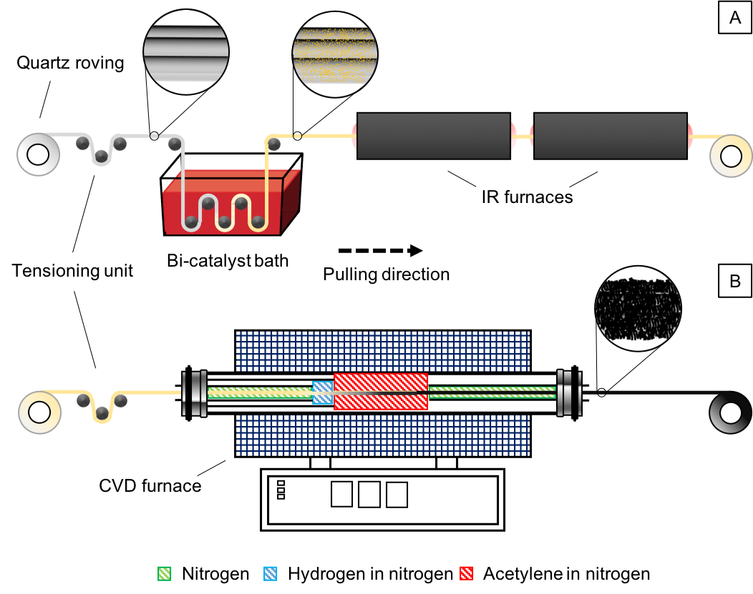
Fig. 1. Schematic of (a) the catalyst precursor deposition line with collection of the bi-catalyst decorated quartz fibres (after drying in infrared radiation (IR) furnaces) on the right-hand side reel; (b) The bi-catalyst deposited quartz fibres are introduced in the continuous chemical vapour deposition set-up for CNT-synthesis.
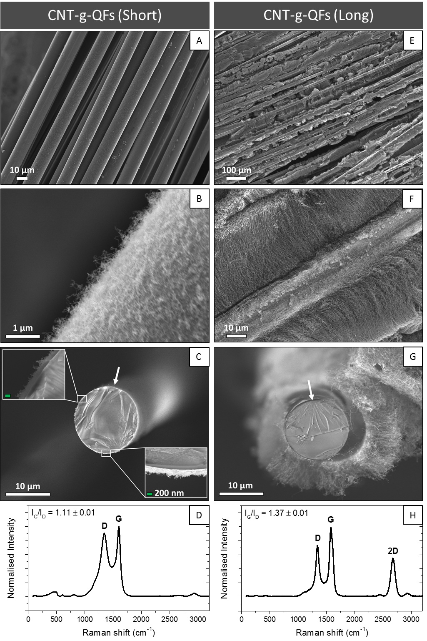
Fig. 2. Field emission-scanning electron microscopy micrographs of the hierarchical fibres produced with (a, b, c) a short and uniform CNT coverage, namely CNT-g-QF (S) and (e, f, g) long “mohawk” CNT arrays, referred to as CNT-g-QF (L). Arrows correspond to the scalpel cutting locations and directions, both scale bars in the inserts (c) are 200 nm. Raman spectra for CNT-g-QF (S) and CNT-g-QF (L), corresponding to a residence time in the furnace hot-zone of 15 min (d) and 30 min (h), respectively. 2D-peak (2700 cm⁻¹), G-peak (1582 cm⁻¹) and D-peak (1350 cm⁻¹) and corresponding I_{G} to I_{D} ratio are included.
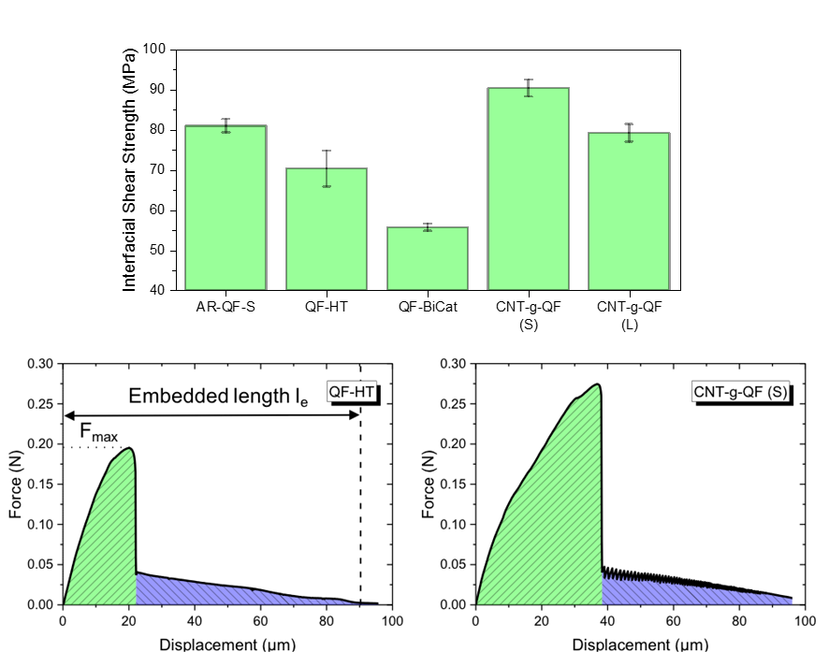
Fig. 3. Apparent interfacial shear strength obtained from single fibre pull-out tests (top) and typical single fibre pull-out test curves for heat-treated and short CNT-grafted quartz fibres (bottom). The green area corresponds to the debonding region where the fibre/epoxy interface has not yet failed; the blue area highlights the extraction region. Tabulated IFSS data can be found in the Supplementary Information (Table S3).

Fig. 4. Field emission-scanning electron microscopy micrographs of fracture surfaces after pull-out from cured epoxy droplets with corresponding Raman spectra for (a, b) CNT-g-QF (S) and (c, d) CNT-g-QF (L), respectively. Red arrows indicate the location of CNTs whilst blue arrows show epoxy-CNTs agglomerates.

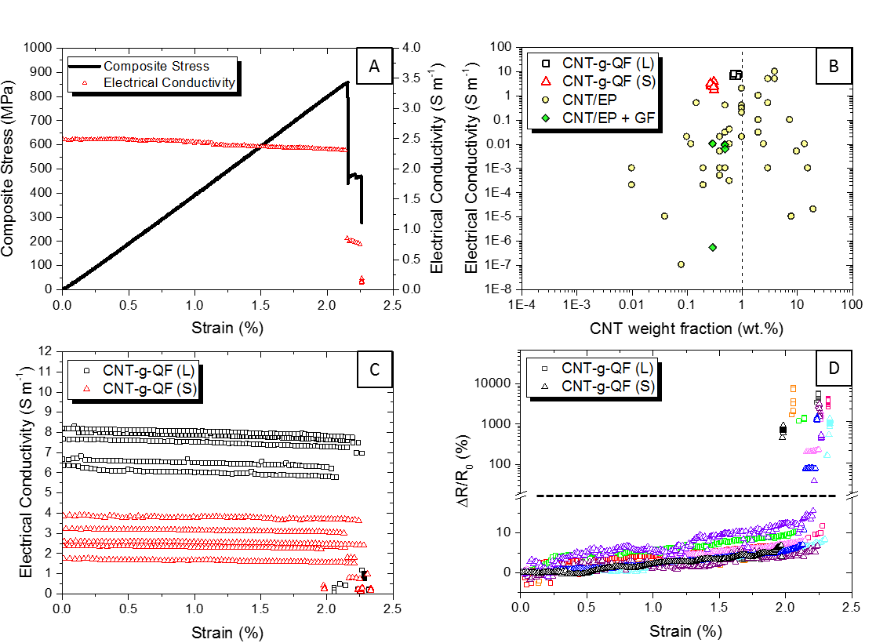
Fig. 5. (a) Representative stress-strain curve with real-time electrical conductivity measurements for CNT-g-QF (S). (b) Influence of CNT loading in composites on electrical conductivity for CNT-g-QF (S) (open squares) and CNT-g-QF (L) (open triangles) bundles both in the fibre direction (longitudinal). For comparison, various CNT/epoxy systems (filled circle) [12] and CNT/epoxy glass fibre composites (filled diamond) [71-75]. The typical CNT weight fraction upper limit for CNT/epoxy viable incorporation in composites (dashed vertical line) is included for reference. (c) Collated electrical conductivity for all CNT-g-QF (S) and CNT-g-QF (L) bundles. (d) Resistance variation ∆R/R₀ for all hierarchical bundle composites; (dashed horizontal line) corresponds to a break in the ordinate with the upper part plotted on a logarithmic scale, for clarity.
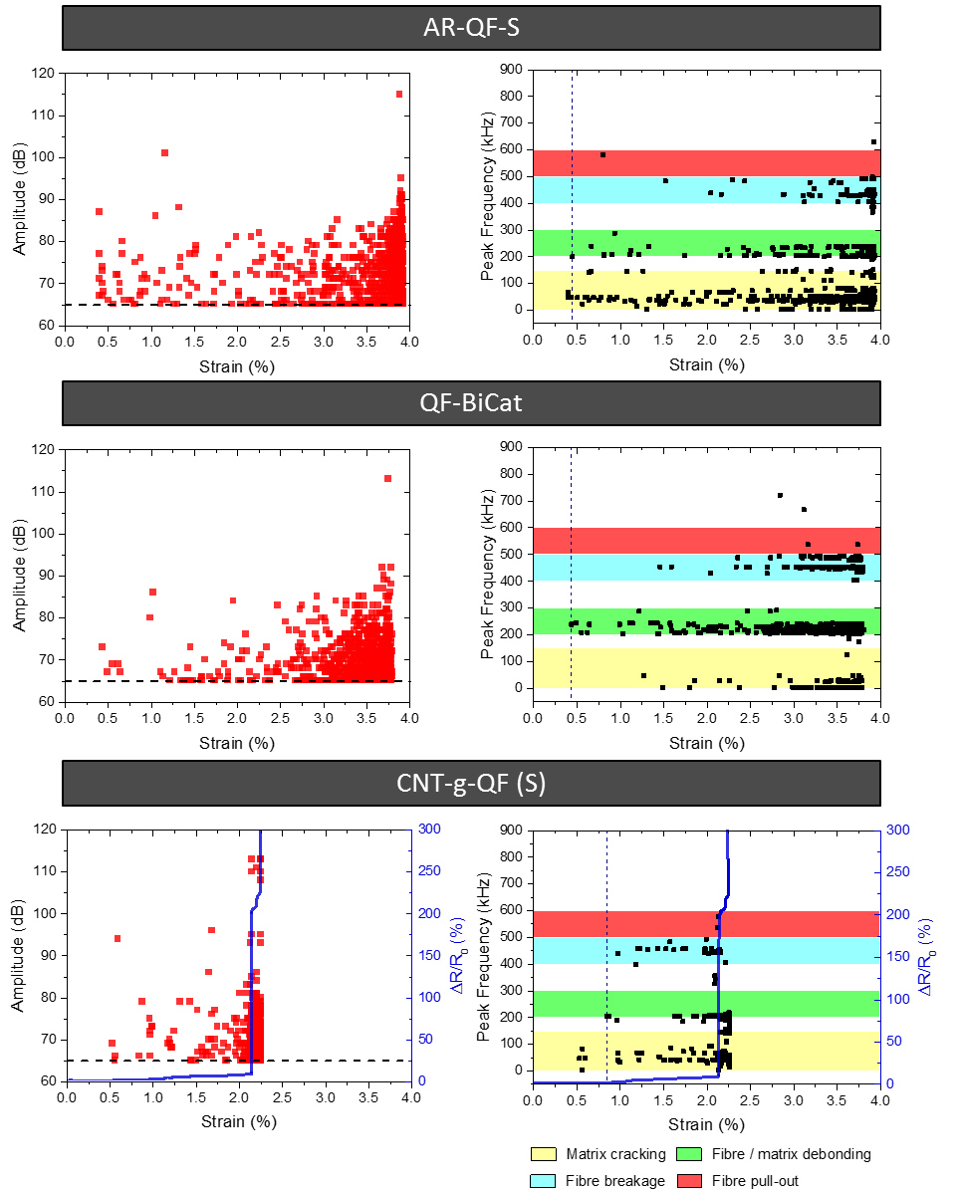
Fig. 6. Signal amplitude (left column) and peak frequency (right column) from acoustic emission events measured for bundle composites (AR-QF-S, QF-BiCat and CNT-g-QF (S)) during tensile testing, and associated resistance-change (ΔR/R₀) for the hierarchical bundle. Vertical and horizontal dashed line correspond to 65 dB threshold and the onset of fibre/matrix debonding, respectively. Coloured peak frequency ranges were obtained from [81]. 0 – 150 kHz (yellow): matrix cracking; 200 – 300 kHz (green): fibre/matrix debonding; 400 – 500 kHz (blue): fibre failure; 500 – 600 kHz (red): fibre pull-out.

