A New Method to Determine Dispersive Surface Energy Site Distributions by Inverse Gas Chromatography

Robert R. Smith ª, Daryl R. Williams ª, Daniel J. Burnett ^{b}, Jerry Y. Y. Heng ^{a,*}
ªSurfaces and Particle Engineering Laboratory, Department of Chemical Engineering, Imperial College London, South Kensington Campus, London SW7 2AZ, U.K.
^{b}Surface Measurement Systems Ltd., 2125 28th Street SW, Suite 1, Allentown, PA 18103, USA.
* Corresponding author: jerry.heng@imperial.ac.uk
Phone: +44-(0)207-594-0784. Fax: +44-(0)207-594-5700 Web: www.imperial.ac.uk/spel

Abstract:
A computational model to predict the relative energy site contributions of a heterogeneous material from data collected by finite dilution - inverse gas chromatography (FD-IGC) is presented in this work. The methodology employed a multi-solvent system site filling model utilizing Boltzmann statistics, expanding on previous efforts to calculate ‘experienced energies’ at varying coverage, yielding a retention volume distribution allowing calculation of a surface free energy distribution. Surface free energy distributions were experimentally measured for racemic ibuprofen and β-mannitol powders, the energies of each were found to range from 43 – 52 mJ/m² and 40 – 55 mJ/m² respectively over a surface coverage range of 0 - 8 %. The computed contributions to surface energy values were found to match closely with data collected on macroscopic crystals by alternative techniques (+/-<1.5mJ/m²).

Introduction:
Physical characterization of particulates is an important area for processing of materials, with surface area, particle shape, surface roughness and surface energy amongst others being of great importance from an industrial standpoint. The surface energy alone has wide ranging effects on material behavior, from powder flowability¹ to effects on mixing² and even in end-user considerations such as dry powder inhalation (DPI) performance.³ Further, simple arguments about the relative expression of functional groups and structural differences expressed on the different faces and edges of a crystal structure can be made to suggest the inherent surface energetic heterogeneity of crystalline materials,⁴ demonstrating a fundamental need for a methodology for estimating the contributions to the heterogeneous nature of a materials surface free energy.
For over 50 years inverse gas chromatography (IGC) has been used as a tool for assessing the surface energy of powders. This typically took the form of infinite dilution inverse gas chromatography (ID-IGC) and more recently finite dilution inverse gas chromatography (FD-IGC). FD-IGC provides data over a wide range of probe-surface coverages, yielding information about the relative heterogeneity of the surface energy distribution of a material. To this point however, methods to interpret this data have been based on erroneous assumptions. Many methods for measuring this heterogeneity have been proposed in the past utilising IGC, some being probe dependent (adsorption potential model),⁵ making assumptions about material-probe interactions (stepwise condensation approach),⁶ providing limited data requiring further analysis (basic FD-IGC)⁷ or inadvertently imposing limiting constraints impinging accuracy which may lead to incorrect conclusions about extrapolated material behavior (deconvolution).⁸ By better understanding the underlying heterogeneity of a material its effect on various aspects of demonstrated mechanical⁹ and chemical¹⁰ behavior can be better understood, and so the need for a more realistic approach to heterogeneity calculation is clearly realized.
However, IGC is not the only means of measuring surface energy heterogeneity; alternative techniques can be employed, a consideration of several alternative techniques used for measuring surface free energy is made. For example, sessile drop contact angle measurement requires macroscopic crystals to find specific energy contributions. Such measurements on specific crystalline facets may neglect edge effects and defects, and reflect a bulk average for powders.¹¹ Another approach is the adhesion force measurement by atomic force microscopy, though there are theoretical and technical challenges to this methodology. Theoretical problems range from multiple model interpretations of the force¹² to choices of tip shape. Technically, difficulty in making measurements due to sensitivity, resulting in the need for a high number of individual measurements over a multitude of particles to build a realistic distribution of energies for a material. There are many other conventional approaches, each with its own challenges, and is reviewed elsewhere.¹³
The limitations of these methodologies give purview to the development of a new approach to the analysis of the surface energetic heterogeneity of the materials. This paper aims to establish a new numerical model modality for energy calculation; it aims to circumvent many of the limitations stated here of other methodologies and past computational efforts. The fitting uses a non-constrained optimization procedure¹⁴ to find the energy contributions comprising the measured distribution, a method similar to that used in PXRD Rietveld refinement.¹⁵

Theory

Inverse Gas Chromatography
Methods for FD-IGC was utilized in this model, below is a summary of their application, however more details can be found elsewhere.⁷ The basic ideas of ID-IGC for surface energy calculation are presented here.
The surface energy is calculated using the retention times (defined as the time taken for the centre of mass of the probe peaks to pass through the material investigated) of various n-alkane probes. This allows the retention volume to be calculated from the following relation
$V_{n}=\frac{j}{m}F(t_{r}-t_{0})\frac{T_{col}}{T_{Ref}}$ Equation 1
Where $V_{n}$ is the retention volume of the material, j is the James-Martin pressure drop correction factor, m is the sample mass, t_{r} is the retention time of the interacting species, F is the flow rate of the carrier gas, t₀ is the dead time of a non-interacting species, T_{col} is the temperature of the column and T_{Ref} is the reference temperature.
The retention volume is related to the surface energy by the following relation, allowing a linear plot of the n-alkanes to yield the surface energy
$RT_{col}lnV_{n}+K=2N_{a}a_{m}\sqrt{γ_{L}^{d}γ_{S}^{d}}$ Equation 2
Where R is the universal gas constant, K is a constant, a_{m} is the cross sectional area of the solvent used, $N_{a}$ is Avogadro’s number, $γ_{L}^{d}$ and $γ_{S}^{d}$ are the dispersive surface free energies of the solvent and solid respectively.
The surface energy can be calculated at multiple injection sizes/partial pressures; yielding multiple coverages. The different coverages are calculated using a BET surface area and a calculated number of molecules injected calculated with:
$n=\frac{1}{RT_{col}m_{s}}\int{V_{n}dP}$ Equation 3
Where,
$P=\frac{h}{F.A}.V_{loop}.\frac{T_{Ref}}{T_{Loop}}.P_{inj}$ Equation 4
P is the equilibrium partial pressure, n is the number of moles adsorbed, $m_{s}$ is the mass of the material, h and A are the height and area of the chromatogram respectively, V_{loop} is the volume of the injection loop, T_{loop} is the temperature of the loop and P_{inj} is the partial pressure of the solvent injected.
The retention data with coverage can then be used to create a surface energy vs. coverage dataset. This is described in detail elsewhere.⁷

Computation
The model proposed here expands on initial efforts from the model proposed by Jefferson et al.⁸ Specifically, the use of thermodynamic considerations for the filling of energetic sites. This is an important step in characterizing the effect of differing energetic contributions as it is a non-trivial problem, as can be seen by the non-linear relationship displayed by mixtures of materials at different energies.¹⁶ In this instance, the Boltzmann distribution can be used to estimate the relative occupancy of an energetic state compared with all energetic states as it can be considered itself a thermodynamic ensemble by simple equivalency arguments, as described in the equation below:¹⁷
$\frac{N_{i}}{N}=\frac{e^{{{-(E}_{i}}/{k_{B}T})}}{\sum_{i}{e^{{{-(E}_{i}}/{k_{B}T)}}}}$ Equation 5
where N_{i} is the number of particles in state i, N is the total number of particles E_{i} is the energy of state i, $k_{B}$is the Boltzmann constant and T is temperature.
In this instance, the energy E_{i} will be a product of the adsorption of a probe molecule with the surface; this is equal to the Gibbs free energy of adsorption per molecule:
$∆G_{A}=-2a_{m}\sqrt{γ_{L}^{d}γ_{S}^{d}}$ Equation 6
where, G_{A} is the Gibbs free energy of adsorption.

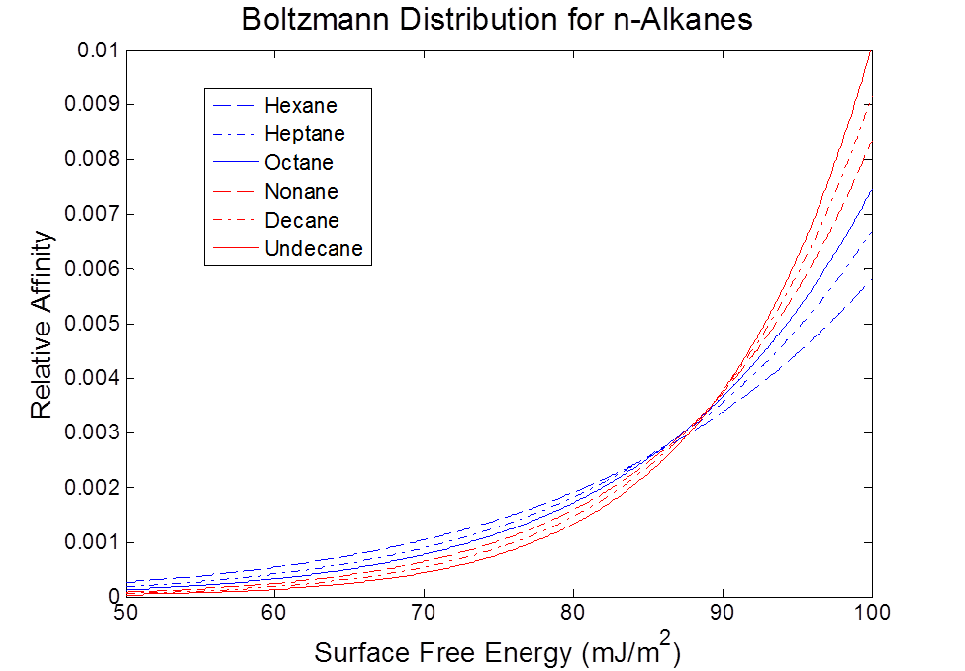
This equation then provides, by a relative occupancy argument, the probability of adsorption of a molecule on a particular energy site. This is shown in Figure 1:

Figure 1. Boltzmann distribution for n-alkanes showing the probabilistic affinity for site changes for different n-alkanes.
As shown in Figure 1, the distribution changes depending on probe used, a limitation not addressed by the computational methodology mentioned earlier, an issue which may seem trivial but whose impact will be further discussed.
Given this probability by energy, it is now necessary to address the probability by weight, that is by number of energy states. In this instance, it would seem appropriate to use multiple single energy values in different weightings to simulate states. An example demonstrating the validity of this approach is the differing energy values of facets by contact angle. To account for slight defects around these energy sites, which can be reasonably assumed will demonstrate differing energy values to main sites,⁴ the use of a normal distribution for each is proposed, with the standard equation as follows:
$f\left(γ_{S}^{d}\right)=\frac{1}{σ\sqrt{2π}}e^{-{\frac{1}{2}\left(\frac{γ_{S}^{d}-μ}{σ}\right)}^{2}}$ Equation 7
where, $σ$ is the standard deviation, and $μ$ is the centre of the energy.

The distribution for each energy state is then combined to form a single distribution whose sum is normalised to value 1 (as this sets the total energy sites to 100% of the surface).
A normalised combination of these factors yields the total probability of adsorption. That is the product of the two, normalised to a value of 1 yields a probability of adsorption for each probe.
This probability can be used to ascribe the relative filling of sites in a selected incremental coverage. This concept is shown graphically in Figure 2 and can be found described in the work of Jefferson et al.⁸
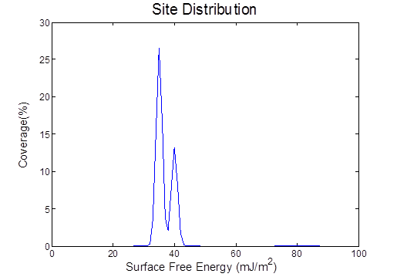
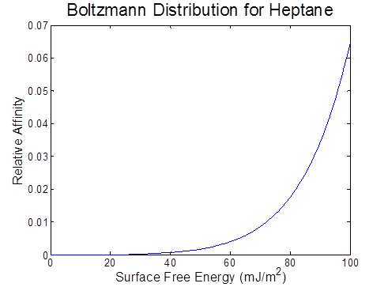
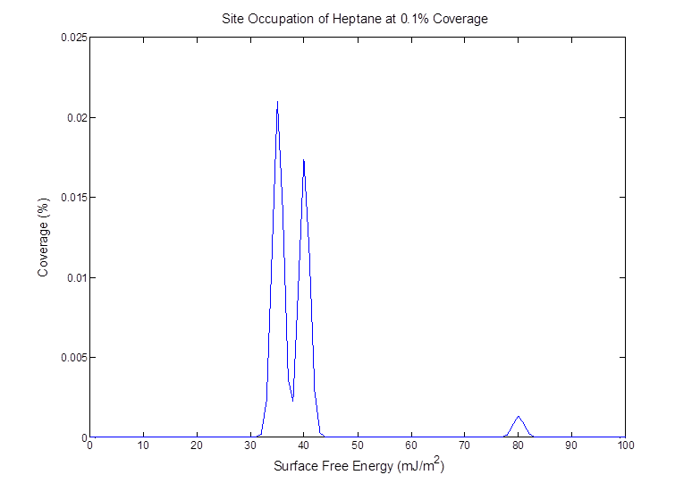
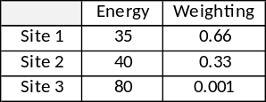
b.
a.

c.

Figure 2. The probabilistic weightings of the site filling, by (a) the relative number weighting of relative sites (normalized to 1) and (b) the Boltzmann distribution or a specific solvent, in this case n-heptane and (c) the relative filling achieved by increment of 0.1% as shown for a given distribution, this would be subtracted from the original distribution yielding a new set of relative sites to be occupied.

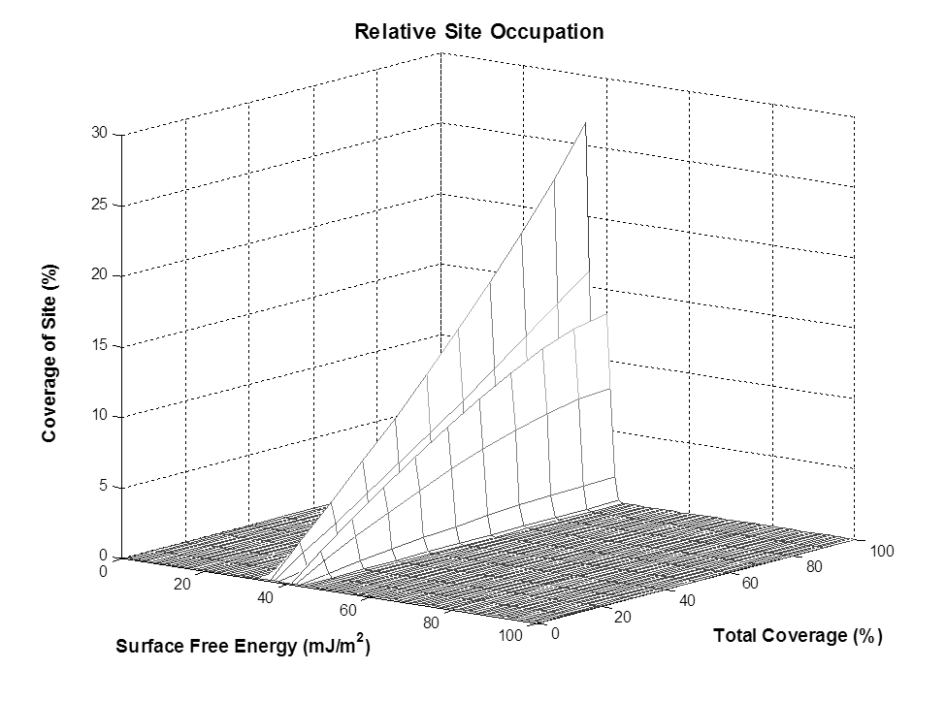
A nominal filling of 0.1% is used in this instance. Caution must be taken at this point that fidelity of appropriate size is used; otherwise the risk could be run that the filling of a site is greater than its total size. This relative filling is then subtracted from the distribution of energies yielding the new distribution for 99.9% vacant sites. This process can be repeated until the sites are occupied in toto. An example of the effect on relative occupancy of sites is shown in Figure 3:

Figure 3. The relative site occupancy changes with coverage for the model distribution used. Note the relative rate of change of occupation is not linear for the three different sites.

From this filling, a distribution of energies can be calculated, using the average of the total occupied states at a given coverage as the energy. However, this is where the inaccuracy of previous models becomes apparent and is shown in Figure 4:
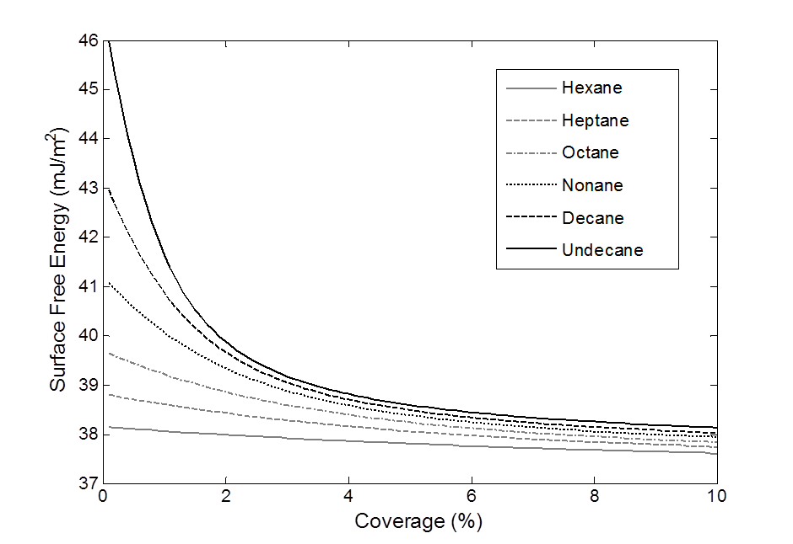
Figure 4. The “experienced” energies of n-alkanes over a range of coverages. Note that the longer chain alkanes show a much higher preference for the higher energy sites and so experience a higher energy than those of shorter length n-alkanes.

Given the differences in the adsorption of probes, the value for this distribution of energies is largely varied for each. Clearly, this is not the true energy distribution as it varies by probe choice, yielding information more on the specific energy 'experienced' by this probe.
It is this 'experienced' energy which forms the basis of the method proposed. By performing the procedure as proposed with multiple probes, the 'experienced' energy for each can be determined. This can then be used to calculate an energy value by the same methodology as it would be measured in a typical FD-IGC experiment, which can then be directly compared with experimental data. The method for this requires a look back at the initial methodology for surface energy calculation based on retention data.
The Gibbs free energy of adsorption in this instance can be represented for each solvent as:
$∆G_{A}=-RTlnV_{n}-K$ Equation 8
They can be represented as a function of surface energies as proposed earlier, though this time modified to represent the interaction per mole not per molecule:
$∆G_{A}=-2{N_{a}a}_{m}\sqrt{γ_{L}^{d}γ_{S}^{d}}$ Equation 9
This equation can be used to calculate the Gibbs free energy 'experienced' by each solvent at a different filling state by using the 'experienced' energy value. By combining equations 8 and 9, and using this 'experienced' energy a distribution of retention volumes can be calculated, taking the same format as equation 2 for experimentally derived data:
$RTlnV_{ni}+K=2N_{a}a_{m}\sqrt{γ_{L}^{d}γ_{Si}^{d}}$ Equation 10
where $V_{ni}$ and $γ_{Si}^{d}$ are the ‘experienced’ retention volumes and surface free energies respectively.
These retention volume distributions can be calculated for each probe molecule, and then be used in the methods described by Dorris and Gray¹⁸ or Schultz,¹⁹ the choice of which leads to similar values (several mJ/m²)²⁰ for most materials and can be viewed as a matter of personal choice, to give an energy distribution comparable with experimental data. An example of this process is shown below in Figure 5:

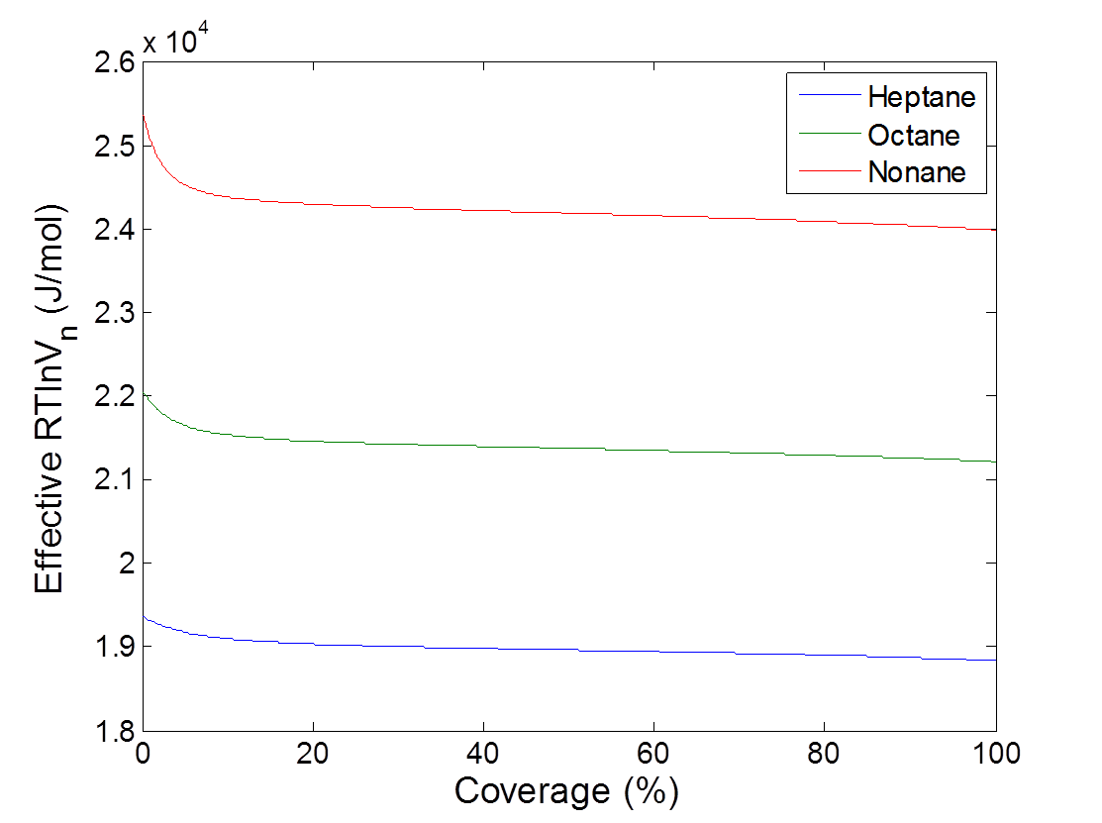
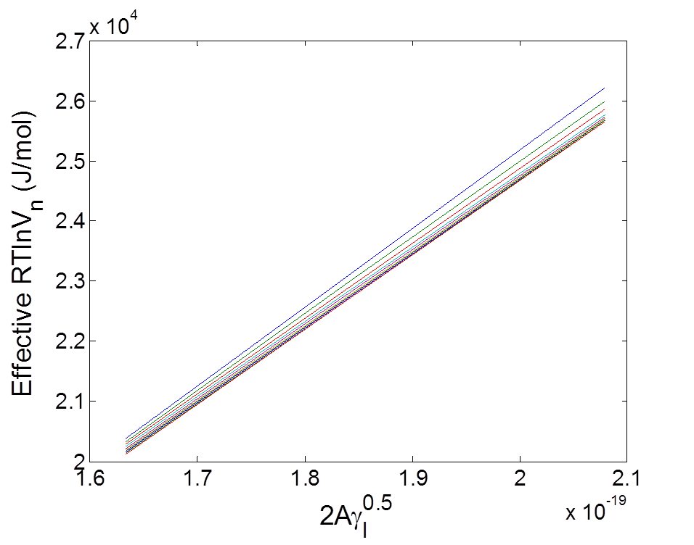
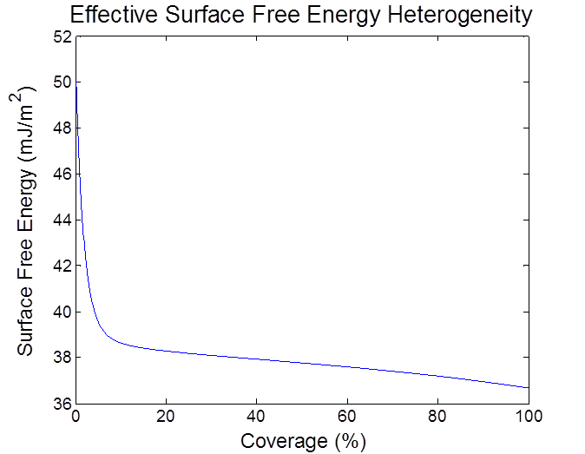
a.
b.

c.

Figure 5. (a) The computed retention volume-coverage plot for heptane, octane and nonane, (b) a Schultz plot corresponding to the retention volumes computed at various surface coverages, yielding energy values directly comparable with calculations made from experimental data and (c) the resultant energy distribution from the Schultz calculation based on the computed retention.

Experimental Methods
To provide a validation for the model, data is presented for racemic ibuprofen and β-mannitol. Racemic ibuprofen (2-(4-isobutylphenyl)propionic acid) (Shasun, London, U.K.) and D-mannitol (Ph Eur Pearlitol® 160C, Roquette, France), were used as received. The surface energetic properties of macroscopic crystals of these materials can be found in literature,^{21, 22} calculated from sessile drop contact angles.
FD-IGC was applied using a 3-solvent system (heptane, octane and nonane) with a Surface Energy Analyser (SEA, Surface Measurement Systems Ltd., London, U.K.). First a BET isotherm is determined using nonane as the solvent probe, to obtain a surface area measurement of the material being analysed. In turn, surface energy calculations were performed at identical target coverages from 0.006-0.1, and repeated in triplicate to yield an average energy plot. The flow rate of the system was set to 10 sccm and performed at 303.15 K. Prior to surface energy analysis each sample was conditioned with dry helium at the same temperature and flow rate for 60 minutes.

Results

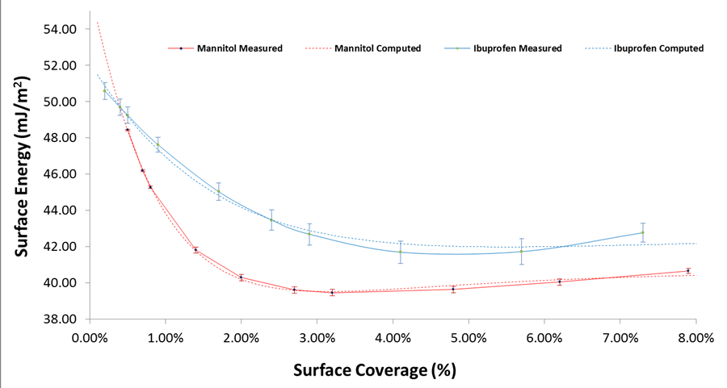
β-Mannitol and Racemic Ibuprofen

Figure 6. The surface energy profiles of racemic ibuprofen and β-mannitol obtained from FD-IGC measurements.
Figure 6 shows the surface energy profiles measured by FD-IGC for β-mannitol and racemic ibuprofen. This surface energy profile was then analysed using the approach delineated in Section 2, to provide an array of energies for the surface of the materials. The number of sites used was limited to the number of unique energy sites measured for the differing facets of the material by contact angle, plus an additional site to account for any defect/crystal edge energies which are not observed due to the averaging nature of the contact angle approach to measure surface energy (typically found to have an energy >60 mJ/m² and to represent <0.01% of the surface). The deconvoluted surface energy is shown in Figure 7. For means of comparison energies measured macroscopically and the computed contributions are shown in Tables 1 and 2 respectively.
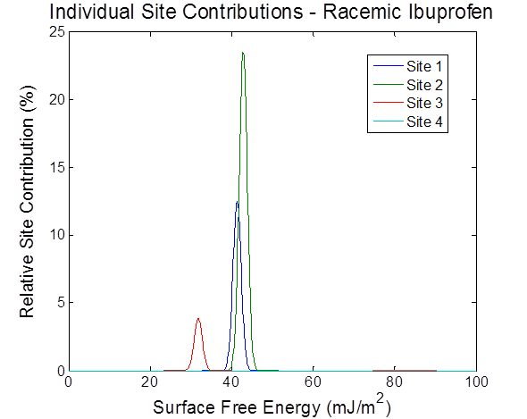
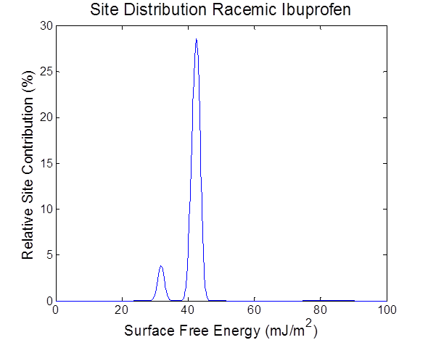
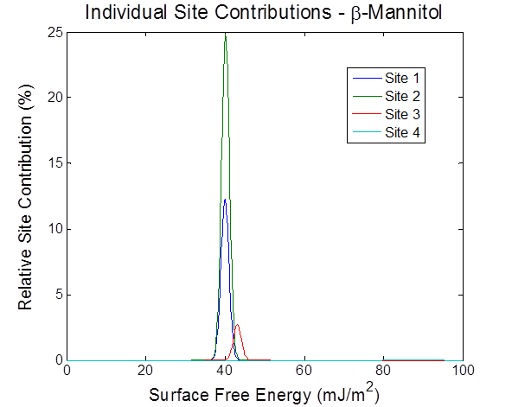
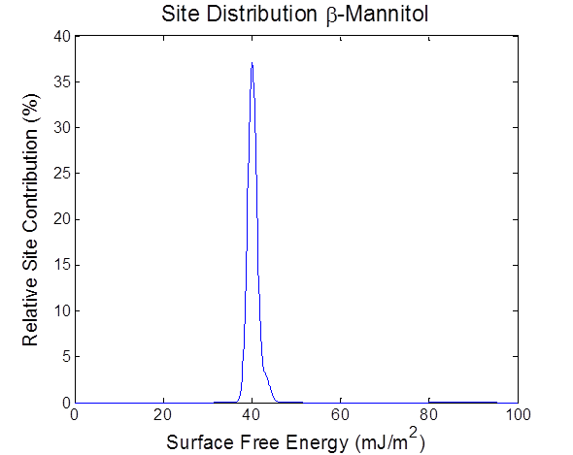
a.
b.

c.
d.

Figure 7. (a) The total site energy distribution calculated for β-mannitol, (b) the individual site contributions for β-mannitol, (c) the total site energy distribution calculated for racemic ibuprofen and (d) the individual site contributions for racemic ibuprofen.

Table 1. The surface energy of specific facets of macroscopic β-mannitol and racemic ibuprofen as measured by sessile drop contact angle (miller index of crystal facets of a macroscopic crystal in parentheses).
Material | Facet A | Facet B | Facet C
Mannitol²¹ | 44.1 mJ/m²  (010) | 43.3 mJ/m²  (120) | 39.5 mJ/m²  (011)
Ibuprofen²² | 42.1 mJ/m²  (001) | 40.0 mJ/m²  (011 | 33.4 mJ/m²  (100)

Table 2. The deconvoluted surface energy for β-mannitol and racemic ibuprofen and calculated site proportion in parentheses.
Material | Site 1 | Site 2 | Site 3
β -Mannitol | 39.97 mJ/m²  (30.92%) | 40.11 mJ/m²  (62.29%) | 43.09 mJ/m²  (6.72%)
Racemic Ibuprofen | 41.33 mJ/m²  (31.37%) | 42.83 mJ/m²  (58.86%) | 31.81 mJ/m²  (9.65%)

Discussion
The energy distributions found by our modelling approach show comparable results for various energy sites. The energy values for β-mannitol found by macroscopic techniques as being 44.1 mJ/m², 43.3 mJ/m² and 39.5 mJ/m² for facets (010), (120) and (011) respectively, which compare favourably with those found by the computational method of 43.09 mJ/m², 40.11 mJ/m² and 39.97 mJ/m². And similarly the energy values for racemic ibuprofen found macroscopically were 42.1 mJ/m², 40.0 mJ/m² and 33.4 mJ/m² for facets (001), (011) and (100) respectively, which again compare favourably to those found computationally; 41.33 mJ/m², 42.83 mJ/m² and 31.81 mJ/m².
The distinct widths of the peaks make direct comparison between the site energy measured and that found computationally difficult, as peaks overlap heavily; as such giving an absolute shape of the crystal by utilizing the knowledge of the known energies of macroscopic crystal habits and the relative contribution by different energy sites predicted by the model is as yet unfeasible. However, this is a potential application for some systems which may display more distinct energy characteristics.
The fit of our model to the data measured gave tight fits, parametized by Chi² (the squared difference between energy calculated and measured), found to be 0.16 and 0.98 respectively. This is a metric comparing the sum of the squares of the difference between actual values measured at distinct coverages, with their corresponding computed values. Similarly, the metric suggested for demonstrating meaningful surface energy data,²³ the R² value for the Schultz plots were all above 0.9997 (with the majority ~>70% being 0.9999 and only a small minority below this), suggesting a good correlation of the energies measured to the actual material measured.
The interpretation of data by means of a Schultz methodology was an arbitrary decision as the application of the Dorris-Gray approach to the materials used gave practically identical results, with the average difference in energies between the two approaches found to be <0.4 mJ/m², equating to a <1% deviation for the materials in question.
The choice of a normal distribution as opposed to a Gaussian distribution of varying standard deviation was chosen for ease of application and simplification, to demonstrate the approach proposed in this work. If a higher resolution between very similar energy values is necessary (for example, (010) and (120) for β-mannitol), the effect of the distribution width needs to be considered.
Previous attempts were limited to the analysis using a single solvent system and comparing the data to multi-solvent system, leading to an increased artificiality of the fit. As shown in Figure 4, the choice of solvent can be seen to affect the energy calculable from a given distribution of sites. That is to say, the use of each separate solvent would lead to a distinct set of energetic sites, each of different values, for the same material system, which is physically incorrect. This problem is eliminated by the methodology proposed here, as a direct comparison between the modes of analysis, by utilizing the same system of analysis (in this instance the Schultz approach) as is used in experimental analysis, over the same range of solvents used for experimental characterization.
The Jefferson et al.⁸ approach allows only for monotonically decreasing adsorption/surface energy as a function of coverage. However, experimental results have revealed some cases where this is found to not be the case. The model proposed here can be used to describe heterogeneity profiles where there is some increase in surface energy as a function of surface coverage, as demonstrated in the example data presented for β-mannitol.
Finally, a note on the convergence of the system, the solution to the optimization problem set out by our methodology in both systems presented was found to be independent of starting position. This highlights the relative constrained nature of the system and implicit with it, the greater confidence that can be taken in the solution found.

Conclusion

A new methodology for interpretation of surface energy heterogeneity distributions by way of FD-IGC is presented, and was applied to 2 model pharmaceutical compounds, β-mannitol and racemic ibuprofen. The difference between model outputs and actual values the model proposed was shown to give a very close fit for all compounds tested (Chi²<1). Additionally the calculated data was shown to correspond well with the contact angle data giving facet specific energies comparable to the energy components calculated by our model (<1.5 mJ/m² maximum discrepancy between comparable facets). This methodology can provide useful insights into the materials probed and further insight into the technique of FD-IGC for surface energy analysis.

Acknowledgements. The PhD studentship, supported by the Engineering and Physical Science Research Council and Surface Measurement Systems for Robert Smith, is gratefully acknowledged.

References
1. Feeley, J. C.; York, P.; Sumby, B. S.; Dicks, H., Determination of surface properties and flow characteristics of salbutamol sulphate, before and after micronisation. International Journal of Pharmaceutics 1998, 172 (1–2), 89 - 96.
2. Das SC, Z. Q., Morton DA, Larson I, Stewart PJ, Use of surface energy distributions by inverse gas chromatography to understand mechanofusion processing and functionality of lactose coated with magnesium stearate. European Journal of Pharmaceutical Sciences 2011, 43, 325-33.
3. Chan, H. K., Dry powder aerosol delivery systems: current and future research directions. Journal of Aerosol Medicine 2006, 19 (1), 21-27.
4. Buckton, G.; Gill, H., The importance of surface energetics of powders for drug delivery and the establishment of inverse gas chromatography. Advanced Drug Delivery Reviews 2007, 59 (14), 1474 - 1479.
5. Rudzinski; Everett, D. H., Adsorption of Gases on Heterogeneous Surfaces. Academic Press: London, 1992.
6. Harris, L. B., Adsorption on a patchwise heterogeneous surface; mathematical analysis of the step-function approximation to the local isotherm. Surface Science 1968, 10 (2), 129 - 145.
7. Thielmann, F.; Burnett, D. J.; Heng, J. Y. Y., Determination of the surface energy distributions of different processed lactose. Drug Development and Industrial Pharmacy 2007, 33 (11), 1240-1253.
8. Jefferson, A. E.; Williams, D. R.; Heng, J. Y. Y., Computing the surface energy distributions of heterogeneous crystalline powders. Journal of Adhesion Science and Technology 2011, 25 (4-5), 339-355.
9. Rowe, R. C., Binder-substrate interactions in granulation: a theoretical approach based on surface free energy and polarity. International Journal of Pharmaceutics 1989, 52 (2), 149 - 154.
10. Ohta, M.; Buckton, G., The use of inverse gas chromatography to assess the acid–base contributions to surface energies of cefditoren pivoxil and methacrylate copolymers and possible links to instability. International Journal of Pharmaceutics 2004, 272 (1–2), 121 - 128.
11. Buckton, G., Interfacial Phenomena in Drug Delivery and Targeting. Harwood Academic Publishers: Chur, 1995.
12. Prokopovich, P.; Perni, S., Comparison of JKR- and DMT-based multi-asperity adhesion model: Theory and experiment. Colloids and Surfaces A: Physicochemical and Engineering Aspects 2011, 383 (1–3), 95 - 101.
13. Duncan-Hewitt W, Nisman R. Investigation of the surface free energy of pharmaceutical materials from contact angle, sedimentation, and adhesion measurements. In: Mittal KL, ed. Contact Angle, Wettability and Adhesion. VSP: Ultrecth, The Netherlands, 1993.
14. Broyden, C. G., The convergence of a class of double-rank minimization algorithms: 2. The new llgorithm. IMA Journal of Applied Mathematics 1970, 6 (3), 222-231.
15. Dinnebier, R. E.; Billinge, S. J. L., Powder Diffraction Theory and Practice. RSC Publications: London, 2008.
16. Newell, H.; Buckton, G., Inverse gas chromatography: Investigating whether the technique preferentially probes high energy sites for mixtures of crystalline and amorphous lactose. Pharmaceutical Research 2004, 21 (8), 1440-1444.
17. Gibbs, J. W., Elementary principles in statistical mechanics. Edward Arnold: London, 1902.
18. Dorris, G. M.; Gray, D. G., Adsorption of n-alkanes at zero surface coverage on cellulose paper and wood fibers. Journal of Colloid and Interface Science 1980, 77 (2), 353 - 362.
19. Schultz, J.; Lavielle, L.; Martin, C., The role of the interface in carbon fibre-epoxy composites. The Journal of Adhesion 1987, 23 (1), 45-60.
20. Shi B, W. Y., Jia L, Comparison of Dorris-Gray and Schultz methods for the calculation of surface dispersive free energy by inverse gas chromatography. Journal of Chromatography A 2011, 1218, 860-862.
21. Ho, R.; Hinder, S. J.; Watts, J. F.; Dilworth, S. E.; Williams, D. R.; Heng, J. Y. Y., Determination of surface heterogeneity of d-mannitol by sessile drop contact angle and finite concentration inverse gas chromatography. International Journal of Pharmaceutics 2010, 387 (1–2), 79 - 86.
22. Ho, R.; Heng, J. Y. Y.; Dilworth, S. E.; Williams, D. R., Wetting behavior of ibuprofen racemate surfaces. The Journal of Adhesion 2008, 84 (6), 483-501.
23. Yla-Maihaniemi, P. P.; Heng, J. Y. Y.; Thielmann, F.; Williams, D. R., Inverse gas chromatographic method for measuring the dispersive surface energy distribution for particulates. Langmuir 2008, 24 (17), 9551-9557.

For Table of Contents Use Only
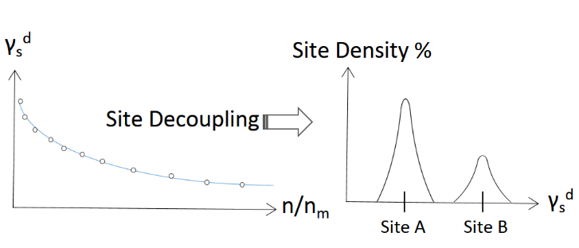

A multi-solvent site filling model utilizing Boltzmann statistics for the prediction of relative energy site contributions from a FD-IGC surface energy heterogeneity profile.

