Supplemental Material

Definition of unstable angina used in the ODYSSEY studies
A diagnosis of an unstable angina (new ACS event without elevation in cardiac biomarkers) that meets the primary endpoint requires the following:
Admission to hospital or emergency room (until at least next calendar day) with symptoms presumed to be caused by myocardial ischemia with an accelerating tempo in the prior 48 hours. and/or prolonged (at least 20 minutes) rest chest discomfort
AND
New high-risk ECG findings consistent with ischemia (or presumed new if no prior ECG available), as defined below:
- New or presumed new ST depression >0.5mm in 2 contiguous leads or T wave inversion >1mm in leads with prominent R wave or R/S >1 in 2 contiguous leads
- New or presumed new ST elevation at the J point in >2 contiguous leads >0.2mV in V2 or V3 in men or >0.15 mV in women in V2 or V3 or >0.1mV in other leads
- LBBB (new or presumed new)
AND
Definite contemporary* evidence of angiographically significant coronary disease as demonstrated by:
- Need for coronary revascularization procedure (PCI or CABG) excluding those performed to treat only restenosis lesion(s) at previous PCI site(s)
OR
- Angiographic evidence of at least 1 significant (> 70%) epicardial coronary stenosis not due to restenosis at previous PCI site.
*The coronary revascularization procedure or the diagnostic angiography must have been performed during the hospitalization for that event.

eTable 1. Key inclusion and exclusion criteria for trials included in this analysis
Study | Inclusion criteria | LDL-C exclusion criteria
FH I, FH II¹ | Patients with HeFH not adequately controlled with a maximally-tolerated stable daily dose of statin* for ≥4 weeks prior to screening ± other LLT | LDL-C <70 mg/dL (for patients with documented clinical ASCVD) or LDL-C <100 mg/dL (for patients with no documented ASCVD)
HIGH FH² | As above | LDL-C <160 mg/dL.
COMBO I,³ COMBO II⁴ | Patients with hypercholesterolemia (non-FH), not adequately controlled with a maximally-tolerated stable daily dose of statin* for ≥4 weeks prior to screening (± other LLT in COMBO I; no other LLT allowed in COMBO II) | LDL-C <70 mg/dL (for patients with documented clinical ASCVD) or LDL-C <100 mg/dL (for patients with no documented ASCVD)
LONG TERM⁵ | Included both HeFH and non-FH patients, otherwise inclusion criteria as for the FH studies above | LDL-C <70 mg/dL.
OPTIONS I,⁶ OPTIONS II⁷ | Patients with HeFH or non-FH, receiving either atorvastatin 20 or 40 mg (OPTIONS I) or rosuvastatin 10 or 20 mg (OPTIONS II) ± other LLT (apart from ezetimibe as it was used as a comparator) | LDL-C <70 mg/dL (for patients with documented clinical ASCVD) or LDL-C <100 mg/dL (for patients with no documented ASCVD)
ALTERNATIVE⁸ | Patients with HeFH or non-FH and documented statin intolerance† and moderate to very high cardiovascular risk;‡ patients were not receiving a statin but other LLT (apart from ezetimibe) were allowed | LDL-C <70 mg/dL for very-high risk, LDL-C <100 mg/dL for moderate or high risk
MONO⁹ | Subjects with 10-year risk of fatal CV events of ≥1% and 5% based on the European Systematic Coronary Risk Evaluation (SCORE)¹⁰ not receiving statin or other LLT (history of CHD or HeFH was an exclusion criterion for this study) | LDL-C <70 mg/dL or >190 mg/dL
Exclusion criteria common to all studies | - Age <18 years  - Use of fibrates, other than fenofibrate  - Fasting serum triglycerides >400 mg/dL  - Estimated glomerular filtration rate (eGFR) <60 mL/min/1.73 m²
Clinicaltrials.gov identifiers: LONG TERM, NCT01507831; FH I NCT01623115; FH II, NCT01709500; HIGH FH, NCT01617655; COMBO I, NCT01644175; COMBO II, NCT01644188; MONO, NCT01644474; OPTIONS I, NCT01730040; OPTIONS II, NCT01730053; ALTERNATIVE, NCT01709513.
ASCVD, atherosclerotic cardiovascular disease; LLT, lipid-lowering therapy.
*Maximally tolerated statin dose = the highest tolerable registered dose of daily statin currently administered to the patient, i.e. rosuvastatin 20 or 40 mg, atorvastatin 40 or 80 mg; or simvastatin 80 mg. Lower doses could be used e.g. in the case of intolerance or local practice according to the investigator’s judgment.
†Inability to tolerate 2 or more statins because of muscle-related symptoms.
‡Moderate risk = 10-year risk of fatal CV events of ≥1% and 5% (SCORE); high risk = SCORE ≥5%; eGFR 30 to <60 mL/min/1.73 m²; type 1 or 2 diabetes mellitus without target organ damage; or HeFH; very-high risk = CHD, ischemic stroke, peripheral artery disease, transient ischemic attack, abdominal aortic aneurysm, or carotid artery occlusion >50% without symptoms; carotid endarterectomy or carotid artery stent procedure; renal artery stenosis or renal artery stent procedure; or type 1 or type 2 diabetes mellitus with target organ damage.

References
1. Kastelein JJ, Ginsberg HN, Langslet G, Hovingh GK, Ceska R, Dufour R, Blom D, Civeira F, Krempf M, Lorenzato C, Zhao J, Pordy R, Baccara-Dinet MT, Gipe D, Geiger MJ, Farnier M. ODYSSEY FH I and FH II: 78 week results with alirocumab treatment in 735 patients with heterozygous familial hypercholesterolaemia. Eur Heart J. 2015;36:2996-3003.
2. Ginsberg HN, Rader DJ, Raal FJ, Guyton JR, Baccara-Dinet MT, Lorenzato C, Pordy R, Stroes E. Efficacy and Safety of Alirocumab in Patients with Heterozygous Familial Hypercholesterolemia and LDL-C of 160 mg/dl or Higher. Cardiovasc Drugs Ther. 2016. DOI: 10.1007/s10557-016-6685-y [Epub ahead of print].
3. Kereiakes DJ, Robinson JG, Cannon CP, Lorenzato C, Pordy R, Chaudhari U, Colhoun HM. Efficacy and safety of the PCSK9 inhibitor alirocumab among high cardiovascular risk patients on maximally tolerated statin therapy: the ODYSSEY COMBO I study. Am Heart J. 2015;169:906-915.e913.
4. Cannon CP, Cariou B, Blom D, McKenney JM, Lorenzato C, Pordy R, Chaudhari U, Colhoun HM. Efficacy and safety of alirocumab in high cardiovascular risk patients with inadequately controlled hypercholesterolaemia on maximally tolerated doses of statins: the ODYSSEY COMBO II randomized controlled trial. Eur Heart J. 2015;36:1186-1194.
5. Robinson JG, Farnier M, Krempf M, Bergeron J, Luc G, Averna M, Stroes ES, Langslet G, Raal FJ, El Shahawy M, Koren MJ, Lepor NE, Lorenzato C, Pordy R, Chaudhari U, Kastelein JJ. Efficacy and safety of alirocumab in reducing lipids and cardiovascular events. N Engl J Med. 2015;372:1489-1499.
6. Bays H, Gaudet D, Weiss R, Ruiz JL, Watts GF, Gouni-Berthold I, Robinson J, Zhao J, Hanotin C, Donahue S. Alirocumab as add-on to atorvastatin versus other lipid treatment strategies: ODYSSEY OPTIONS I randomized trial. J Clin Endocrinol Metab. 2015:3140-3148.
7. Farnier M, Jones P, Severance R, Averna M, Steinhagen-Thiessen E, Colhoun HM, Du Y, Hanotin C, Donahue S. Efficacy and safety of adding alirocumab to rosuvastatin versus adding ezetimibe or doubling the rosuvastatin dose in high cardiovascular-risk patients: the ODYSSEY OPTIONS II randomized trial. Atherosclerosis. 2016;244:138-146.
8. Moriarty PM, Thompson PD, Cannon CP, Guyton JR, Bergeron J, Zieve FJ, Bruckert E, Jacobson TA, Kopecky SL, Baccara-Dinet MT, Du Y, Pordy R, Gipe DA. Efficacy and safety of alirocumab versus ezetimibe in statin-intolerant patients, with a statin-re-challenge arm: The ODYSSEY ALTERNATIVE randomized trial. J Clin Lipidol. 2015;9:758-769.
9. Roth EM, Taskinen MR, Ginsberg HN, Kastelein JJ, Colhoun HM, Robinson JG, Merlet L, Pordy R, Baccara-Dinet MT. Monotherapy with the PCSK9 inhibitor alirocumab versus ezetimibe in patients with hypercholesterolemia: results of a 24 week, double-blind, randomized Phase 3 trial. Int J Cardiol. 2014;176:55-61.
10. Reiner Z, Catapano AL, De Backer G, Graham I, Taskinen MR, Wiklund O, Agewall S, Alegria E, Chapman MJ, Durrington P, Erdine S, Halcox J, Hobbs R, Kjekshus J, Filardi PP, Riccardi G, Storey RF, Wood D. ESC/EAS Guidelines for the management of dyslipidaemias: the Task Force for the management of dyslipidaemias of the European Society of Cardiology (ESC) and the European Atherosclerosis Society (EAS). Eur Heart J. 2011;32:1769-1818.

eFigure 1. Overview of studies included in this analysis
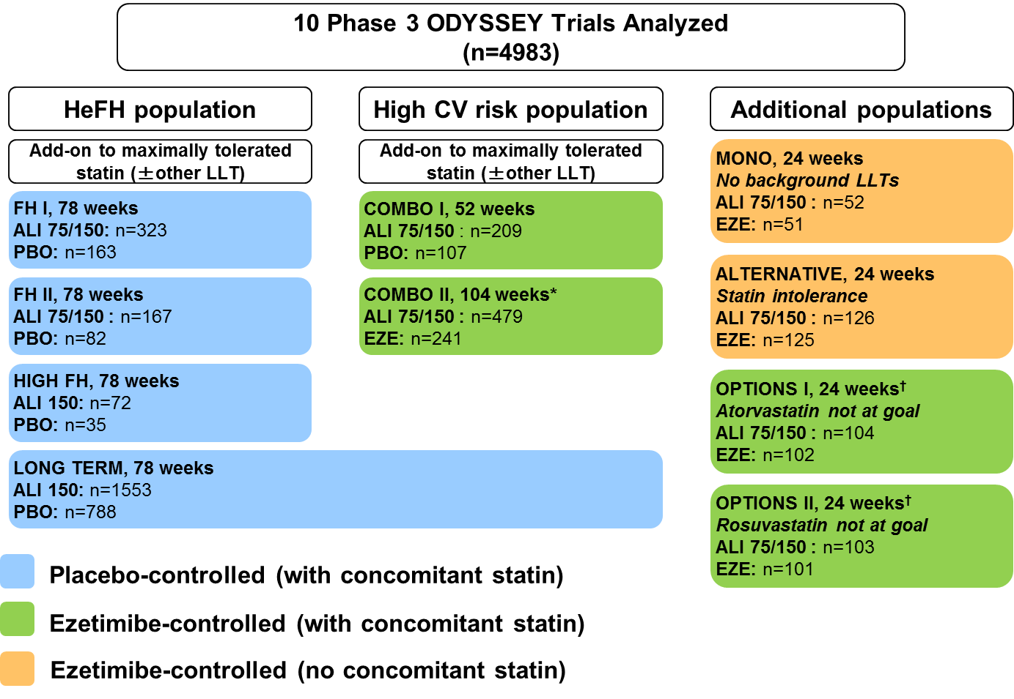
ALI, alirocumab; CV, cardiovascular; EZE, ezetimibe; HeFH, heterozygous familial hypercholesterolemia; LLT, lipid-lowering therapy; PBO, placebo; Q2W, every 2 weeks.
ALI 75/150 indicates studies using a dose titration strategy, whereby ALI 75 mg Q2W was increased to 150 mg Q2W at Week 12 if LDL-C at Week 8 was ≥70 mg/dL (or, in OPTIONS I, OPTIONS II, and ALTERNATIVE, ≥70 or 100 mg/dL, depending on CV risk). ALI 150 indicates studies where patients received 150 mg Q2W from the outset. In all but two studies, patients also received background statin therapy ± other LLT (EZE was not allowed as background LLT in EZE-controlled studies). The statin was at maximally tolerated dose in 6 studies (85% of all patients in the 10 trials). Under “additional populations”, 2 studies were performed without background statin (ALTERNATIVE, in patients with documented statin intolerance, and MONO, a monotherapy study performed without background LLT). OPTIONS studies included patients at high CV risk receiving moderate to high doses of potent statins.
*No other non-statin LLT allowed in COMBO II. †Concomitant statin and doses were atorvastatin 20 or 40 mg in OPTIONS I and rosuvastatin 10 or 20 mg in OPTIONS II.
eTable 2. Baseline characteristics in Phase 3 ODYSSEY trials (randomized population)
Study | Group | Age, years, mean (SD) | Male,  n (%) | Race, white  n (%) | BMI, kg/m², mean (SD) | HeFH, n (%) | Type 2 diabetes, n (%) | ASCVD, n (%)
Placebo-controlled
LONG TERM  (MTD statin) | ALI 150  (n = 1553) | 60.4 (10.4) | 983 (63.3) | 1,441 (92.8) | 30.2 (5.7) | 276 (17.8) | 545 (35.1) | 1,187 (76.4)
 | PBO  (n = 788) | 60.6 (10.4) | 474 (60.2) | 730 (92.6) | 30.5 (5.5) | 139 (17.6) | 269 (34.1) | 612 (77.7)
HIGH FH  (MTD statin) | ALI 150  (n = 72) | 49.8 (14.2) | 35 (48.6) | 64 (88.9) | 28.8 (5.2) | 72 (100) | 9 (12.5) | 32 (44.4)
 | PBO  (n = 35) | 52.1 (11.2) | 22 (62.9) | 30 (85.7) | 28.9 (4.2) | 35 (100) | 6 (17.1) | 22 (62.9)
COMBO I  (MTD statin) | ALI 75/150  (n = 209) | 63.0 (9.5) | 131 (62.7) | 170 (81.3) | 32.6 (6.3) | 0 | 94 (45.0) | 179 (85.6)
 | PBO  (n = 107) | 63.0 (8.8) | 77 (72.0) | 88 (82.2) | 32.0 (7.1) | 0 | 42 (39.3) | 87 (81.3)
FH I  (MTD statin) | ALI 75/150  (n = 323) | 52.1 (12.9) | 180 (55.7) | 300 (92.9) | 29.0 (4.6) | 323 (100) | 32 (9.9) | 154 (47.7)
 | PBO  (n = 163) | 51.7 (12.3) | 94 (57.7) | 144 (88.3) | 30.0 (5.4) | 163 (100) | 25 (15.3) | 81 (49.7)
FH II  (MTD statin) | ALI 75/150  (n = 167) | 53.2 (12.9) | 86 (51.5) | 164 (98.2) | 28.6 (4.6) | 167 (100) | 7 (4.2) | 63 (37.7)
 | PBO  (n = 82) | 53.2 (12.5) | 45 (54.9) | 80 (97.6) | 27.7 (4.7) | 82 (100) | 3 (3.7) | 32 (39.0)
Ezetimibe-controlled
COMBO II  (MTD statin) | ALI 75/150  (n = 479) | 61.7 (9.4) | 360 (75.2) | 404 (84.3) | 30.0 (5.4) | 0 | 145 (30.3) | 461 (96.2)
 | EZE  (n = 241) | 61.3 (9.2) | 170 (70.5) | 206 (85.5) | 30.3 (5.1) | 0 | 76 (31.5) | 224 (92.9)
OPTIONS I (atorvastatin 20-40 mg) | ALI 75/150  (n = 104) | 63.1  (10.2) | 64 (61.5) | 91  (87.5) | 31.2  (6.9) | 12  (11.5) | 58  (55.8) | 59  (56.7)
 | EZE  (n = 102) | 64.8  (9.6) | 67  (65.7) | 91  (89.2) | 31.2  (5.9) | 4  (3.9) | 45  (44.1) | 66  (64.7)
OPTIONS II  (rosuvastatin 10-20 mg) | ALI 75/150  (n = 103) | 59.9  (10.2) | 59 (57.3) | 87  (84.5) | 31.0  (6.9) | 14  (13.6) | 37  (35.9) | 60  (58.3)
 | EZE  (n = 101) | 61.8  (10.3) | 57 (56.4) | 88  (87.1) | 31.1  (6.4) | 14  (13.9) | 44  (43.1) | 63  (61.8)
ALTERNATIVE  (no statin) | ALI 75/150  (n = 126) | 64.1 (9.0) | 70 (55.6) | 117 (92.9) | 29.6 (6.6) | 14 (11.1) | 36 (28.6) | 71 (56.3)
 | EZE  (n = 125) | 62.8 (10.1) | 67 (53.6) | 116 (92.8) | 28.4 (4.9) | 25 (20.0) | 24 (19.2) | 58 (46.4)
MONO  (no statin) | ALI 75/150  (n = 52) | 60.8 (4.6) | 28 (53.8) | 46 (88.5) | 30.1 (5.9) | 0 | 3 ( 5.8) | 0
 | EZE  (n = 51) | 59.6 (5.3) | 27 (52.9) | 47 (92.2) | 28.4 (6.7) | 0 | 1 ( 2.0) | 0
ALI = alirocumab; ASCVD = atherosclerotic cardiovascular disease; atorva = stoarvastatin; BMI = body mass index; EZE = ezetimibe; LDL-C = low-density lipoprotein cholesterol; MTD, maximally tolerated dose of statin; PBO = placebo; Q2W = every 2 weeks: rosuva = rosuvastatin; SD = standard deviation.

eTable 3. Baseline lipid values in individual studies (randomized population)
Trial | LONG TERM |  | HIGH FH |  | COMBO I |  | FH I |  | FH II |  | COMBO II |  | OPTIONS I |  | OPTIONS II |  | ALTERNATIVE |  | MONO
Group | ALI n=1550 | PBO  n=788 | ALI n=72 | PBO  n=35 | ALI n=207 | PBO  n=107 | ALI n=322 | PBO  n=163 | ALI n=167 | PBO  n=81 | ALI n=479 | EZE n=241 | ALI n=104 | EZE n=101 | ALI n=103 | EZE n=101 | ALI n=126 | EZE n=124 | ALI n=52 | EZE n=51
LDL-C | 122.7 (42.6) | 121.9 (41.4) | 196.3 (57.9) | 201.0 (43.4) | 100.2 (29.5) | 106.0 (35.3) | 144.8 (51.1) | 144.4 (46.8) | 134.6 (41.1) | 134.0 (41.4) | 108.6 (36.5) | 104.6 (34.1) | 109.6 (36.4) | 99.7 (29.2) | 113.1 (30.0) | 111.1 (45.7) | 191.1 (72.7) | 193.5 (70.9) | 141.1 (27.1) | 138.3 (24.5)
non-HDL-C | 152.6 (46.6) | 152.0 (45.8) | 223.9 (58.8) | 231.5 (47.6) | 130.0 (34.0) | 133.4 (39.8) | 170.3 (54.6) | 169.6 (50.6) | 159.0 (44.8) | 157.5 (43.7) | 139.1 (40.4) | 136.8 (40.4) | 137.3 (39.3) | 126.7 (35.1) | 142.1 (37.1) | 140.8 (49.8) | 230.0 (80.4) | 229.8 (82.7) | 167.4 (0.3) | 164.0 (29.7)
apoB | 101.9 (27.7) | 101.4 (27.3) | 138.2 (32.0) | 146.6 (28.3) | 90.8 (21.4) | 91.4 (24.1) | 114.4 (30.8) | 113.4 (28.5) | 107.9 (27.4) | 107.7 (23.9) | 94.3 (23.2) | 93.5 (23.1) | 93.1 (23.7) | 86.5 (20.3) | 95.8 (21.5) | 95.1 (26.4) | 141.7 (39.5) | 138.2 (37.4) | 104.3 (18.4) | 104.3 (19.1)
ALI, alirocumab; EZE, ezetimibe; non-HDL-C, non-high-density lipoprotein cholesterol; LDL-C, low-density lipoprotein cholesterol; PBO, placebo. Lipids are means (SD), mg/dL.
eFigure 2. Distribution of lipid levels at baseline in pooled treatment groups according to control used in the ODYSSEY trials and overall distributions for all groups combined

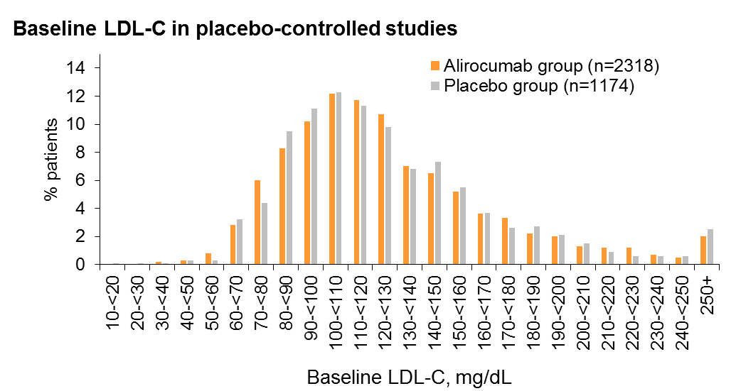

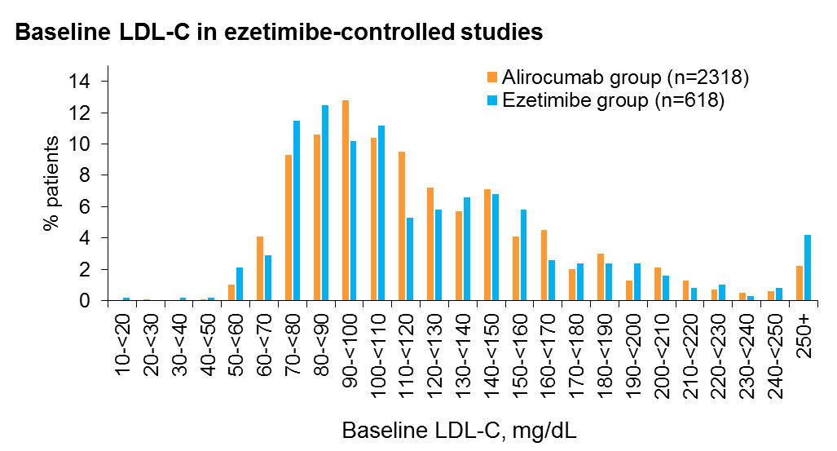

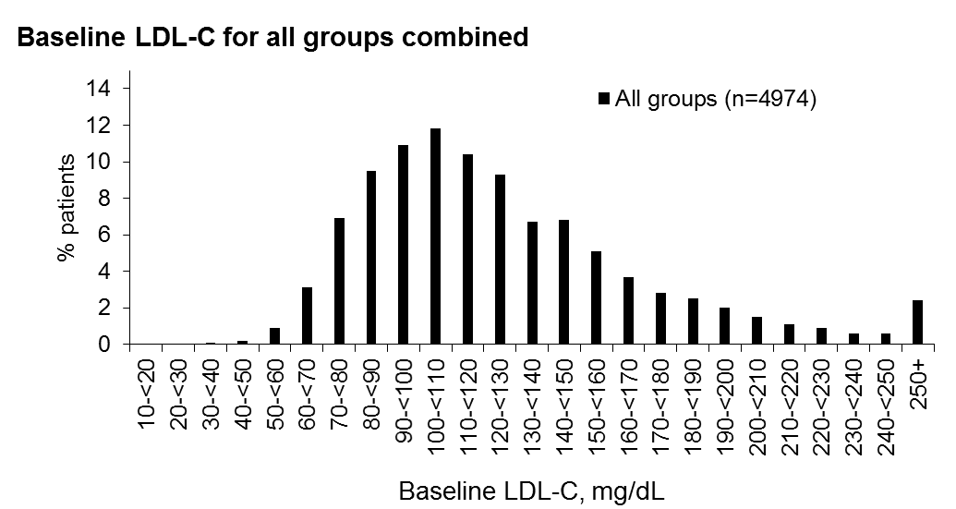

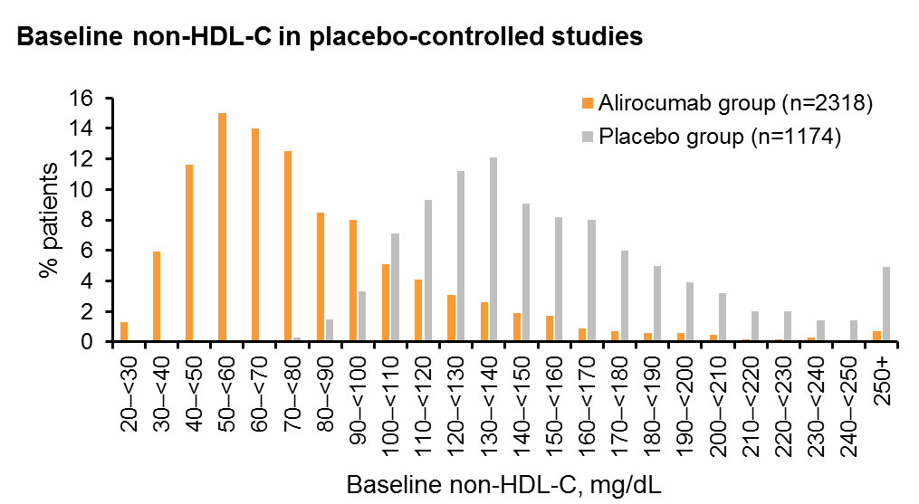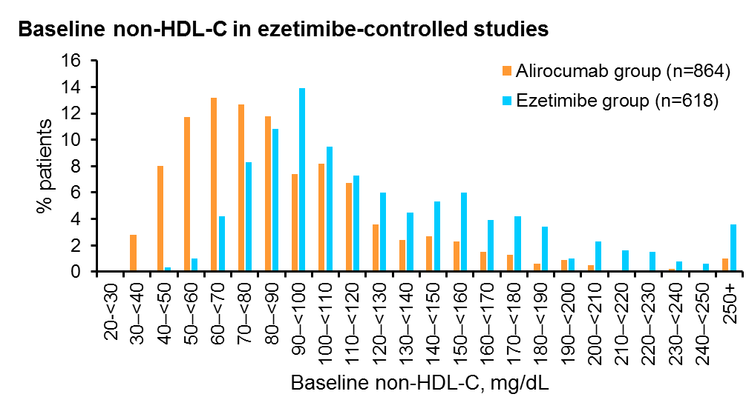
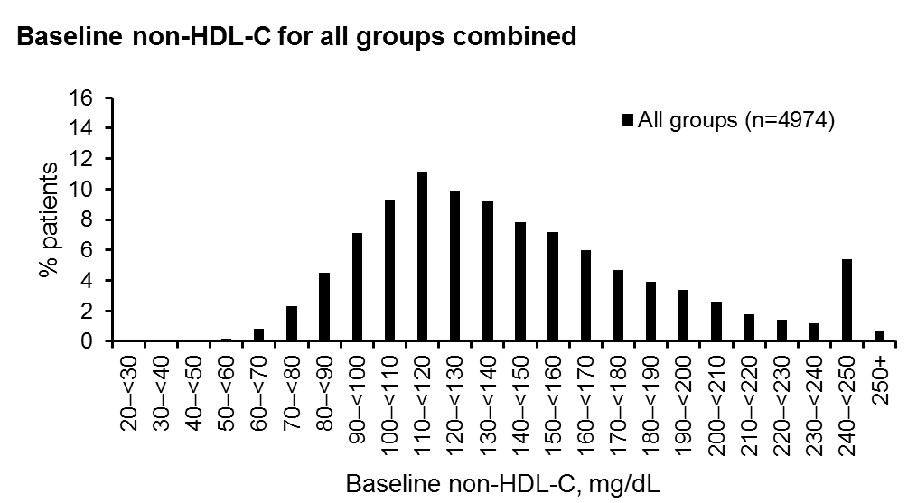

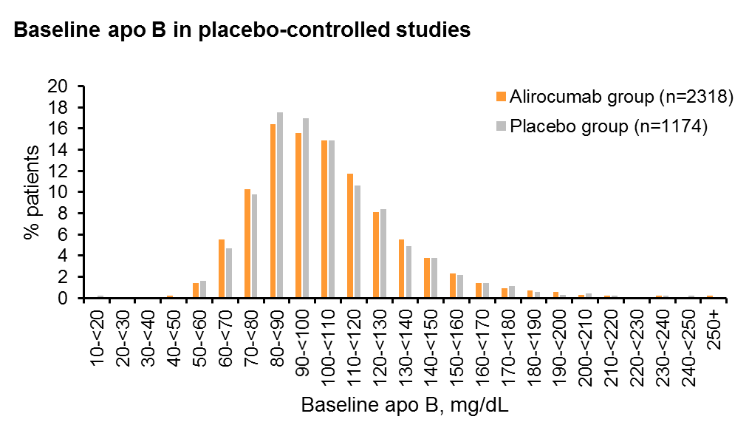
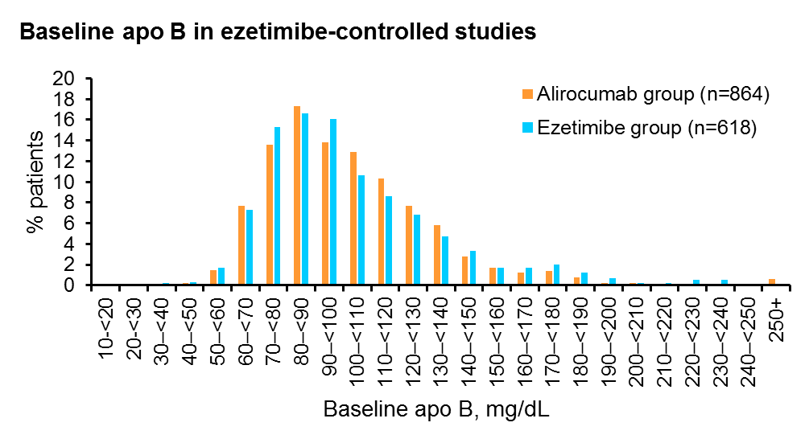
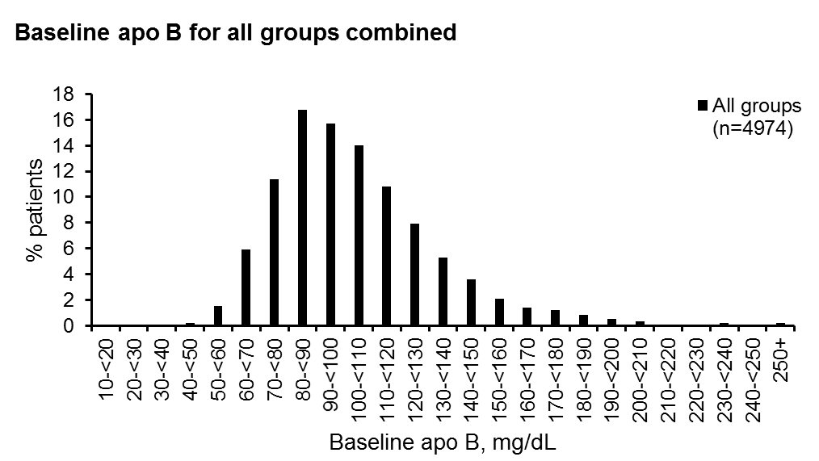
Two patients with missing baseline LDL-C and 3 patients with missing apo B were excluded from the analysis.
Non-HDL-C, non-high-density lipoprotein cholesterol; LDL-C, low-density lipoprotein cholesterol.
eFigure 3. Distribution of average achieved lipid levels and percent reduction in lipids from baseline during treatment for all treatment groups combined
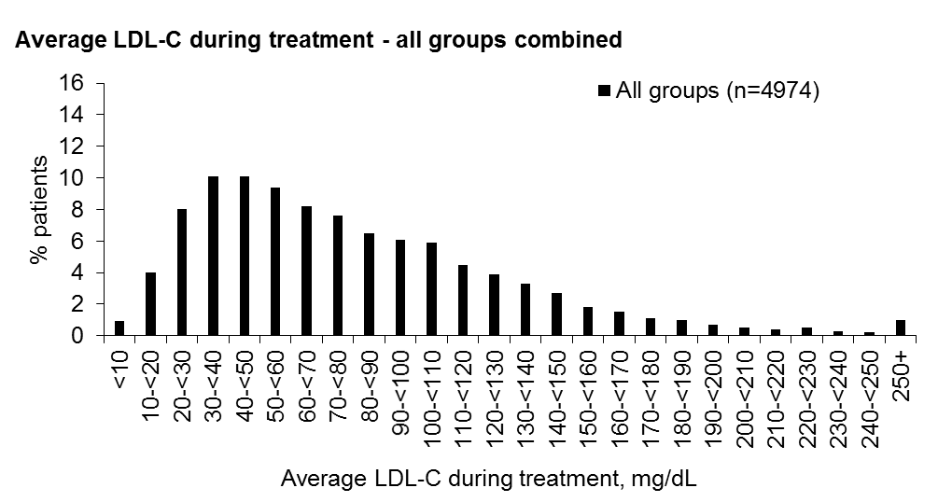
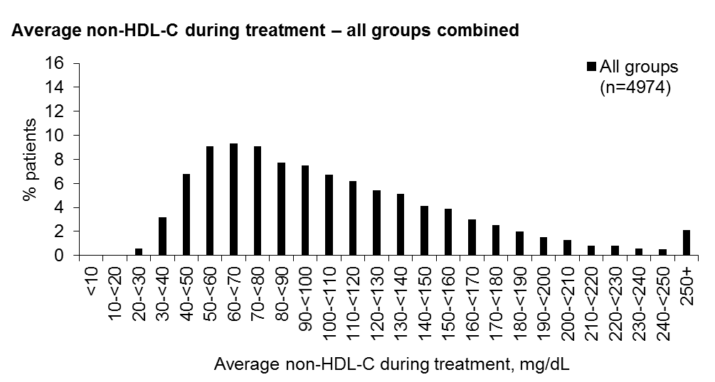
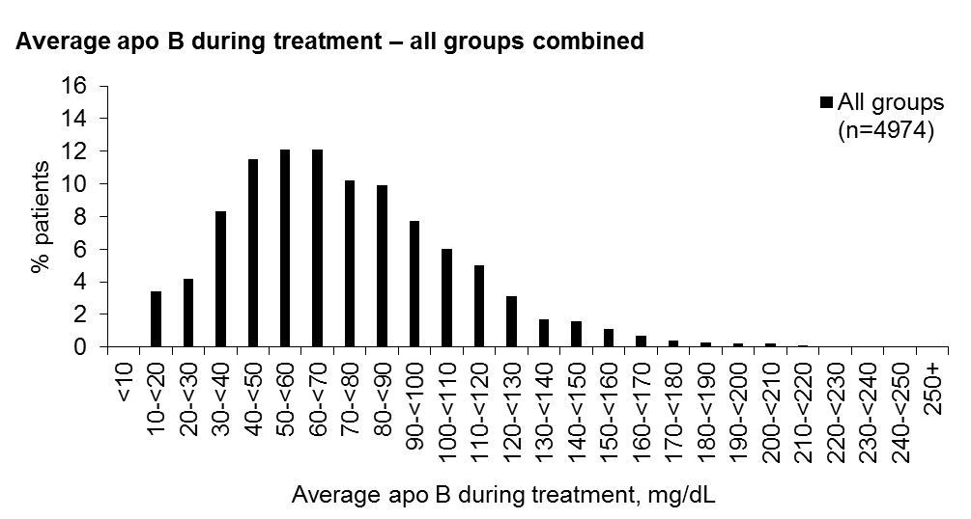
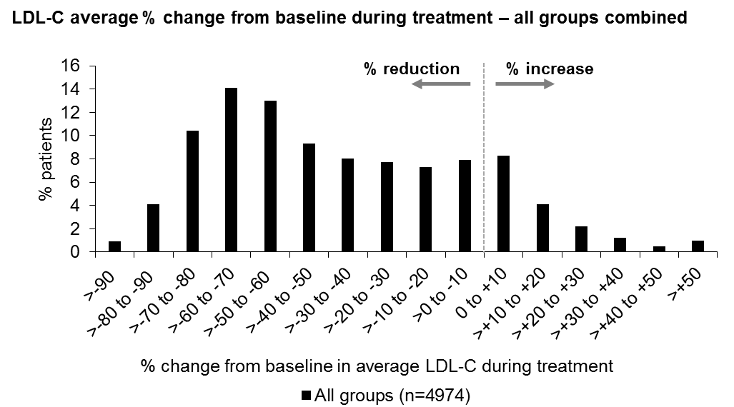
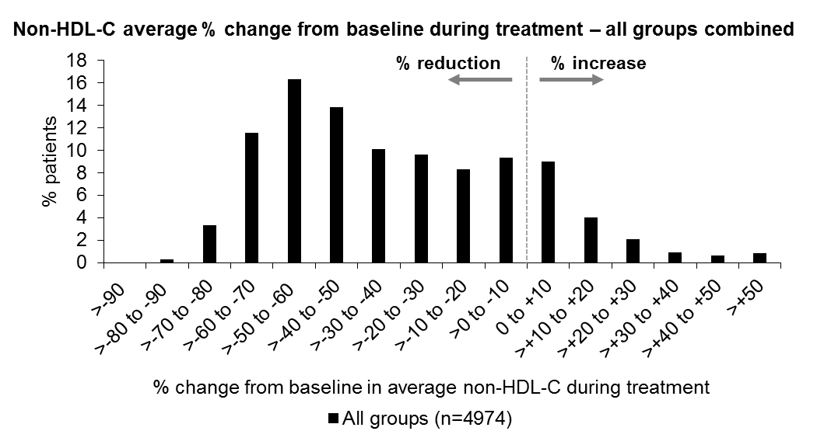
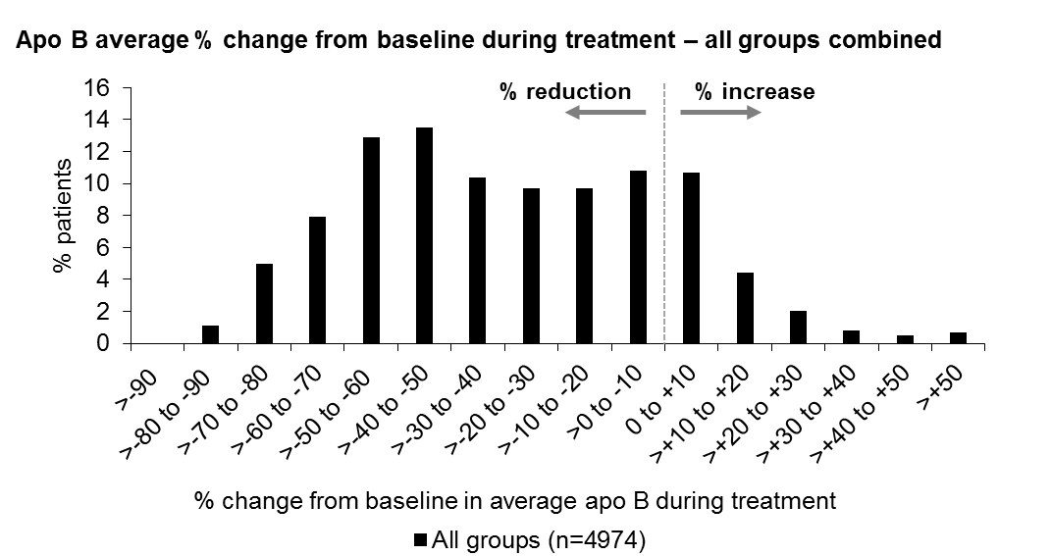
Non-HDL-C, non-high-density lipoprotein cholesterol; LDL-C, low-density lipoprotein cholesterol.

eTable 4. Average achieved lipid levels and percentage reductions during treatment in individual trials (safety population)
Trial | LONG TERM |  | HIGH FH |  | COMBO I |  | FH I |  | FH II |  | COMBO II |  | OPTIONS I |  | OPTIONS II |  | ALTERNATIVE |  | MONO
Group | ALI n=1550 | PBO  n=788 | ALI n=72 | PBO  n=35 | ALI n=207 | PBO  n=107 | ALI n=322 | PBO  n=163 | ALI n=167 | PBO  n=81 | ALI n=479 | EZE n=241 | ALI n=104 | EZE n=101 | ALI n=103 | EZE n=101 | ALI n=126 | EZE n=124 | ALI n=52 | EZE n=51
Average achieved, mg/dL
LDL-C | 49.8 (34.6) | 120.5 (39.0) | 111.5 (65.0) | 183.9 (47.0) | 52.2 (25.6) | 102.2 (34.9) | 76.3 (41.0) | 153.4 (49.1) | 68.2 (35.9) | 138.7 (41.5) | 53.5 (31.4) | 82.4 (33.3) | 58.7 (33.4) | 78.1 (32.2) | 67.9 (33.1) | 89.3 (42.4) | 103.3 (68.0) | 160.7 (58.3) | 68.3 (20.5) | 111.7 (22.6)
non-HDL-C | 75.1 (38.1) | 151.1 (42.7) | 137.5 (65.1) | 213.8 (50.2) | 80.1 (31.2) | 130.4 (38.6) | 99.7 (44.3) | 181.0 (52.4) | 91.0 (39.2) | 163.2 (46.3) | 80.6 (34.2) | 110.2 (38.2) | 83.4 (36.8) | 103.3 (36.5) | 93.1 (38.2) | 116.5 (44.3) | 135.5 (70.4) | 191.6 (64.2) | 91.1 (20.3) | 135.8 (26.6)
apoB* | 51.5 (28.4) | 101.0 (26.3) | 90.5 (36.2) | 136.4 (30.1) | 59.5 (20.3) | 91.2 (25.8) | 71.4 (27.0) | 118.9 (29.6) | 64.4 (23.7) | 107.6 (23.4) | 59.0 (22.5) | 79.6 (24.2) | 58.3 (25.9) | 76.3 (25.7) | 67.0 (27.3) | 83.8 (26.5) | 90.2 (38.0) | 121.5 (32.2) | 65.9 (14.6) | 92.8 (17.2)
Average % change from baseline
LDL-C† | -59.9 (22.1) | 2.3 (27.6) | -42.9 (27.4) | -7.2 (21.5) | 46.8 (23.7) | -1.6 (17.5) | -45.8 (23.8) | 8.6 (23.8) | -48.6 (22.2) | 5.0 (16.5) | -50.1 (24.6) | -19.4 (26.3) | -45.8 (27.1) | -21.4 (20.3) | -40.2 (24.7) | -13.5 (51.7) | -47.5 (19.0) | -15.7 (16.0) | -51.1 (13.0) | -18.7 (11.0)
non-HDL-C | -50.5 (19.4) | 2.0 (22.1) | -38.0 (24.4) | -6.3 (20.0) | -37.7 (20.3) | -0.5 (15.8) | -39.9 (21.4) | 8.5 (20.7) | -42.1 (20.1) | 4.6 (16.0) | -41.0 (20.8) | -18.0 (22.2) | -38.3 (23.5) | -18.2 (18.0) | -34.4 (21.4) | -13.8 (28.9) | -41.9 (14.5) | -15.7 (11.8) | -44.9 (11.3) | -16.7 (11.2)
apoB‡ | -50.1 (22.6) | 2.0 (26.4) | -33.6 (24.4) | -5.6 (18.5) | -34.2 (20.3) | 1.5 (18.8) | -36.3 (19.9) | 6.2 (19.2) | -39.6 (18.2) | 0.8 (12.3) | -36.9 (20.6) | -13.9 (19.8) | -36.4 (24.7) | -12.2 (20.5) | -29.4 (25.1) | -9.2 (28.9) | 36.9 (15.9) | -11.1 (12.3) | -36.7 (13.4) | -10.2 (11.8)
ALI, alirocumab; EZE, ezetimibe; non-HDL-C, non-high-density lipoprotein cholesterol; LDL-C, low-density lipoprotein cholesterol; PBO, placebo. Lipids are means (SD), mg/dL.
For patients with no post-baseline lipid values, baseline values were used. *Two patients with missing baseline and no post-baseline apoB were excluded from the analysis. †Two patients with missing baseline LDL-C were excluded from the analysis. ‡103 patients with missing baseline apoB were excluded from the analysis.
eTable 5. Week 4* achieved lipid levels and percentage reductions in individual trials (safety population)
Trial | LONG TERM |  | HIGH FH |  | COMBO I |  | FH I |  | FH II |  | COMBO II |  | OPTIONS I |  | OPTIONS II |  | ALTERN. |  | MONO |  | MACE vs average achieved level  (pool of all patients from the trials)
Group | ALI n=1550 | PBO  n=788 | ALI n=72 | PBO  n=35 | ALI n=207 | PBO  n=107 | ALI n=322 | PBO  n=163 | ALI n=167 | PBO  n=81 | ALI n=479 | EZE n=241 | ALI n=104 | EZE n=101 | ALI n=103 | EZE n=101 | ALI n=126 | EZE n=124 | ALI n=52 | EZE n=51
Average achieved mg/dL |  |  |  |  |  |  |  |  |  |  |  |  |  |  |  |  |  |  |  |  | Category | N | HR  (95% CI) | P-value
LDL-C | 47.9 (37.1) | 120.1 (42.5) | 100.4 (74.3) | 181.7 (51.5) | 52.2 (33.0) | 101.6 (36.0) | 77.8 (43.3) | 146.5 (53.8) | 76.2 (37.8) | 134.3 (43.9) | 52.4 (34.4) | 76.6 (31.3) | 50.4 (30.6) | 72.7 (30.6) | 62.5 (33.9) | 79.0 (36.4) | 107.1 (69.8) | 156.4 (55.9) | 68.0 (20.6) | 112.1 (24.7) | Per 39 mg/dL difference | 4972 | 0.79 (0.67 to 0.94) | 0.0092
non-HDL-C | 71.0 (39.6) | 149.5 (46.5) | 124.6 (73.0) | 209.9 (57.6) | 78.3 (37.6) | 128.0 (41.3) | 100.6 (47.8) | 173.5 (57.5) | 97.4 (43.6) | 156.8 (46.8) | 78.2 (38.2) | 103.8 (35.7) | 73.7 (32.9) | 96.8 (36.8) | 86.8 (39.7) | 104.6 (38.9) | 138.8 (79.2) | 189.7 (67.0) | 91.6 (23.1) | 136.5 (29.2) | Per 42 mg/dL decrease | 4974 | 0.81 (0.68 to  0.96) | 0.0141
apoB† | 48.8 (30.9) | 99.5 (27.6) | 84.4 (36.2) | 131.7 (29.3) | 61.4 (25.5) | 93.2 (31.7) | 75.8 (30.0) | 115.6 (29.5) | 73.6 (30.2) | 105.7 (24.9) | 58.6 (24.8) | 76.8 (22.8) | 60.4 (26.7) | 73.3 (23.2) | 66.7 (27.9) | 81.1 (25.5) | 91.2 (37.9) | 121.4 (33.1) | 66.3 (18.4) | 92.1 (17.8) | Per 27 mg/dL decrease | 4871 | 0.79 (0.67 to  0.94) | 0.0072
Average % change from baseline |  |  |  |  |  |  |  |  |  |  |  |  |  |  |  |  |  |  |  |  | MACE vs % change in average level
LDL-C‡ | -61.6 (24.3) | 1.3 (30.1) | -50.7 (27.2) | -9.4 (19.3) | -48.7 (25.3) | -1.7 (25.0) | -46.1 (22.9) | 3.5 (33.3) | -43.7 (20.2) | 1.2 (16.0) | -52.0 (26.3) | -24.9 (23.7) | -53.4 (25.4) | -26.4 (22.6) | -45.4 (23.8) | -23.7 (46.4) | -45.9 (18.2) | -18.3 (11.8) | -51.5 (12.8) | -18.6 (12.2) | Per 50% reduction | 4972 | 0.74 (0.60 to  0.90) | 0.0030
non-HDL-C | -53.4 (20.1) | 0.5 (24.0) | 45.1 (23.9) | -9.0 (19.0) | -40.3 (21.0) | -2.4 (20.8) | -40.4 (20.9) | 4.0 (29.5) | 39.2 (18.8) | 0.3 (15.2) | -43.4 (22.5) | -22.3 (21.4) | -45.3 (21.7) | -23.1 (19.4) | -39.5 (20.5) | -22.9 (24.4) | -41.2 (15.0) | -16.9 (11.0) | -45.1 (10.5) | -16.3 (12.1) | Per 50% reduction | 4974 | 0.71 (0.54 to 0.94) | 0.0147
apoB§ | -52.8 (2.54) | 0.4 (30.5) | -38.1 (24.4) | -9.1 (16.6) | -32.9 (22.9) | 3.2 (21.1) | -32.8 (20.4) | 2.9 (18.3) | -31.9 (20.1) | -1.0 (15.1) | -37.7 (21.8) | -16.5 (19.9) | -34.4 (23.8) | -15.0 (16.8) | -29.4 (25.9) | -12.1 (26.4) | -35.3 (19.2) | -11.2 (13.5) | -35.8 (16.7) | -11.1 (13.9) | Per 50% reduction | 4871 | 0.75 (0.61 to 0.92) | 0.0064
ALI, alirocumab; ALTERN., ALTERNATIVE; EZE, ezetimibe; non-HDL-C, non-high-density lipoprotein cholesterol; LDL-C, low-density lipoprotein cholesterol; PBO, placebo. Lipids are means (SD), mg/dL. *Week 12 data shown for apoB as no Week 4 values were collected.
For patients with no lipid values at Week 4 (or Week 12 for apoB), baseline values were used. †14 patients with missing baseline apoB and no Week 12 apoB were excluded from the analysis. ‡Two patients with missing baseline LDL-C were excluded from the analysis. §103 patients with missing baseline apoB were excluded from the analysis.
eTable 6. Correlation between average LDL-C, non-HDL-C and apoB during the treatment period
 | Average  LDL-C | Average  non-HDL-C | Average apoB
Average LDL-C during the treatment period | - | 0.973  (P<0.0001) | 0.922  (P<0.0001)
Average non-HDL-C during the treatment period | 0.973  (P<0.0001) | - | 0.948  (P<0.0001)
Average apoB during the treatment period | 0.922  (P<0.0001) | 0.948  (P<0.0001) | -
Pearson correlation coefficient
Non-HDL-C, non-high-density lipoprotein cholesterol; LDL-C, low-density lipoprotein cholesterol.
eTable 7. Safety summary for the 10 Phase 3 trials used in this analysis*
 | Placebo-controlled trials |  | Ezetimibe-controlled trials
n (%) | Alirocumab  (n=2318) | Placebo  (n=1174) | Alirocumab  (n=864) | Ezetimibe  (n=618)
TEAEs | 1851 (79.9) | 954 (81.3) | 657 (76.0) | 457 (73.9)
Treatment-emergent SAEs | 385 (16.6) | 202 (17.2) | 147 (17.0) | 86 (13.9)
TEAEs leading to death | 16 (0.7) | 13 (1.1) | 6 (0.7) | 9 (1.5)
TEAEs leading to discontinuation | 144 (6.2) | 67 (5.7) | 84 (9.7) | 66 (10.7)
TEAEs in ≥5% of patients
Nasopharyngitis | 291 (12.6) | 142 (12.1) | 52 (6.0) | 41 (6.6)
Injection site reaction | 167 (7.2) | 62 (5.3) | 25 (2.9) | 13 (2.1)
Upper respiratory tract infection | 162 (7.0) | 94 (8.0) | 62 (7.2) | 40 (6.5)
Influenza | 147 (6.3) | 63 (5.4) | 37 (4.3) | 23 (3.7)
Urinary tract infection | 128 (5.5) | 65 (5.5) | 21 (2.4) | 25 (4.0)
Back pain | 123 (5.3) | 70 (6.0) | 33 (3.8) | 26 (4.2)
Diarrhoea | 123 (5.3) | 57 (4.9) | 30 (3.5) | 21 (3.4)
Headache | 119 (5.1) | 64 (5.5) | 43 (5.0) | 24 (3.9)
Arthralgia | 118 (5.1) | 76 (6.5) | 42 (4.9) | 26 (4.2)
Myalgia | 111 (4.8) | 46 (3.9) | 62 (7.2) | 48 (7.8)
Accidental overdose | 30 (1.3) | 17 (1.4) | 54 (6.3) | 24 (3.9)
SAE, serious adverse event; TEAE, treatment-emergent adverse event.
*Placebo-controlled studies: Phase 3 (LONG TERM, FH I, FH II, HIGH FH, COMBO I); ezetimibe-controlled studies: Phase 3 (COMBO II, OPTIONS I, OPTIONS II, ALTERNATIVE, MONO).
eFigure 4. Adjusted rate of any TEAE by average LDL-C during treatment period: (A) achieved LDL-C during treatment, (B) percentage reduction in LDL-C from baseline (multivariate analysis adjusted on baseline characteristics; pool of Phase 3 studies)
A
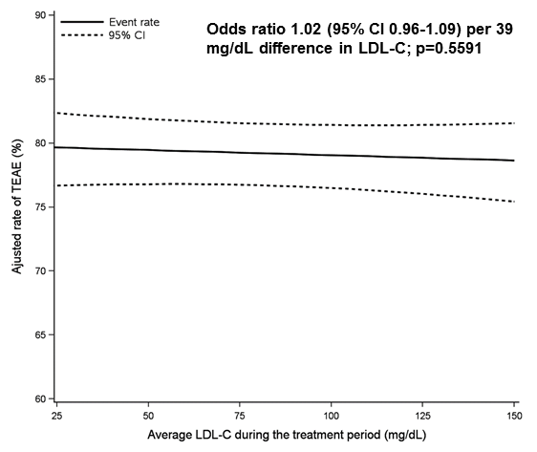
B
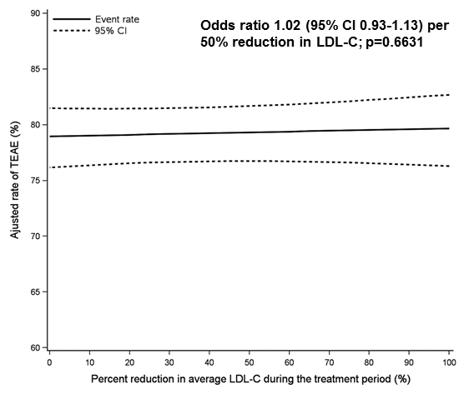
LDL-C, low-density lipoprotein cholesterol; TEAE, treatment-emergent adverse event.

