Supporting Information

Overlooked interference of antibiotics on quorum sensing inhibitors for membrane biofouling mitigation by affecting AHLs and PQS pathway
Huijie Xu ª, Yu Yang ^{a,*}, Tian Xia ª, Yuruo Feng ª, Xinhui Liu ª, Nigel J.D. Graham ^{b}, Kwang-Ho Choo ^{c}, Satoshi Takizawa^{d}, How Yong Ng ^{e,f}, Li-an Houª

ª State Key Laboratory of Water Environment Simulation, School of Environment, Beijing Normal University, Beijing 100875, China
^{b} Department of Civil and Environmental Engineering, Imperial College London, South Kensington Campus, London SW7 2AZ, UK
^{c} Department of Environmental Engineering, Kyungpook National University, 80 Daehak-ro, Buk-gu, Daegu 41566, Republic of Korea
^{d} Department of Urban Engineering, Graduate School of Engineering, The University of Tokyo, 7-3-1 Hongo, Bunkyo-ku, Tokyo 113-8656, Japan
^{e} Center for Water Research, Advanced Institute of Natural Sciences, Beijing Normal University, Zhuhai 519087, China
^{f} Environmental Research Institute, National University of Singapore, 5A Engineering Drive 1, Singapore 117411, Singapore

* Corresponding author: Yu Yang
Email address: yangyu@bnu.edu.cn

Contents
Method S1. Short-term adhesion experiments 4
Method S2. Quantification of antibiotics by LC-MS/MS 4
Method S3. High-throughput sequencing 5
Fig. S1. Schematic diagram of laboratory self-assembled crossflow flat membrane system. 6
Fig. S2. Effect of QSIs on the rejection of TET and SMX during P. aeruginosa-mediated membrane biofouling. 6
Fig. S3. Proportion of gram-negative and gram-positive bacteria in each sample. 7
Fig. S4. Bacterial community composition changes at class level (a), and genus level (b), of each sample with antibiotics addition. 7
Fig. S5. The relative abundance of genes related to carbohydrate / amino acid metabolism with antibiotic stress. 8
Fig. S6. Effects of QSIs, either alone or with antibiotics, on the relative abundance of QS genes in the QS pathway (map 02024) of SW and SE systems. 9
Table S1. The properties of commercial nanofiltration membrane 10
Table S2. Primers in RT-qPCR assays. 10
Table S3. Salt rejection during dynamic biofouling with QSIs and antibiotics addition. 11
Table S4. Richness and diversity indices of microbial community in influent and on membrane surface with the influence of QSIs and antibiotics. 12
Table S5. The typical genes and abundance analysis of carbohydrate/amino acid metabolisms based on KEGG in SW system. 13
Table S6. The typical genes and abundance analysis of carbohydrate/amino acid metabolisms based on KEGG in SE system. 14
Table S7. The abundance analysis of typical QS genes based on KEGG in SW system. 15
Table S8. The abundance analysis of typical QS genes based on KEGG in SE system. 15

Method S1. Short-term adhesion experiments
Initially, the NF membrane was cut into 2 × 2 cm² pieces, exposed to UV light for 30 min, and subsequently positioned at the bottom of 6-well plates. Then 5 mL of LB suspension containing P. aeruginosa was added to each well, with an initial bacterial concentration of 10⁷ CFU/mL, accompanied by TET and SMX concentrations of 500 μg/L. Following incubation at 37℃ for 1-5 h, the membrane pieces were gently rinsed with PBS buffer to eliminate loosely attached bacteria from the P. aeruginosa suspension. Next, the membrane coupons were transferred to a centrifuge tube containing 10 mL of PBS buffer and sonicated for 15 min to detach the adherent bacteria from the membrane surface. Subsequently, the resulting bacterial suspensions were diluted to 10⁻³, 10⁻⁴, and 10⁻⁵, respectively, and plated on an LB solid medium for overnight incubation at 37℃ to facilitate subsequent colony counting.

Method S2. Quantification of antibiotics by LC-MS/MS
The chromatographic column used was XBridge C18 (Waters), with ultrapure water containing 0.05% chromatographic-grade formic acid as mobile phase A and chromatographic-grade methanol as mobile phase B. The mobile phase flow rate was 0.3 mL/min, and the injection volume was 10 μL. Prior to detection, both mobile phase A and B were subjected to 20 min of ultrasound treatment for degassing.

Method S3. High-throughput sequencing
After the completion of dynamic biofouling experiments, the biofouled membrane was immersed in normal saline and sonicated in an ice-bath for 30 min. The resulting bacterial suspension was then centrifuged at 4℃ and 1800 rpm for 15 min to obtain the mixed bacteria that was on the membrane surface. The aforementioned bacteria samples were stored at -80℃ for further processing. Shanghai Majorbio Bio-Pharm Technology Co., Ltd. was contracted to conduct 16S rRNA sequencing, which involved total DNA extraction, PCR amplification, Illumina Miseq sequencing, sequence assembly and annotation. Amplification of 16S rRNA genes was performed using the universal bacterial primer pair 338F-806R, and the Illumina MiSeq PE300 sequencing platform was utilized.

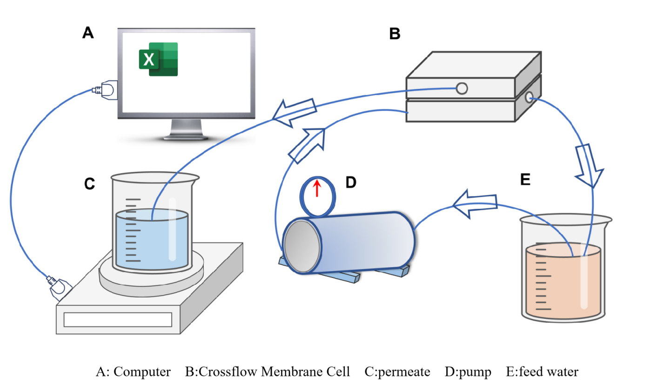

Fig. S1. Schematic diagram of laboratory self-assembled crossflow flat membrane system.
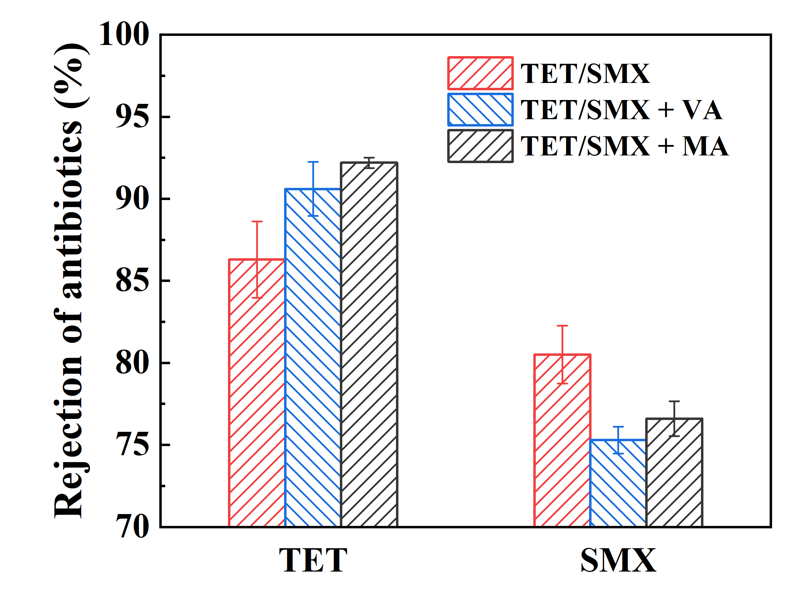

Fig. S2. Effect of QSIs on the rejection of TET and SMX during P. aeruginosa-mediated membrane biofouling.

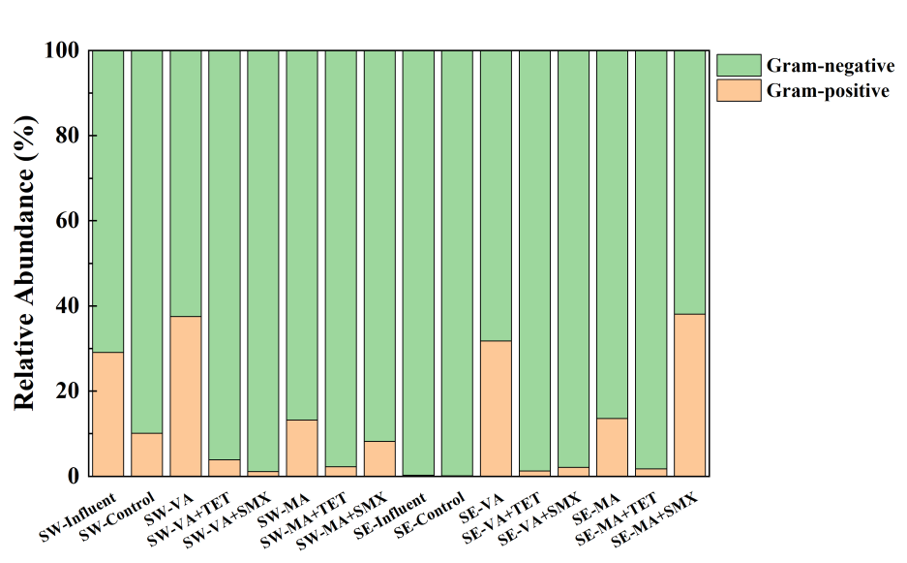

Fig. S3. Proportion of gram-negative and gram-positive bacteria in each sample.

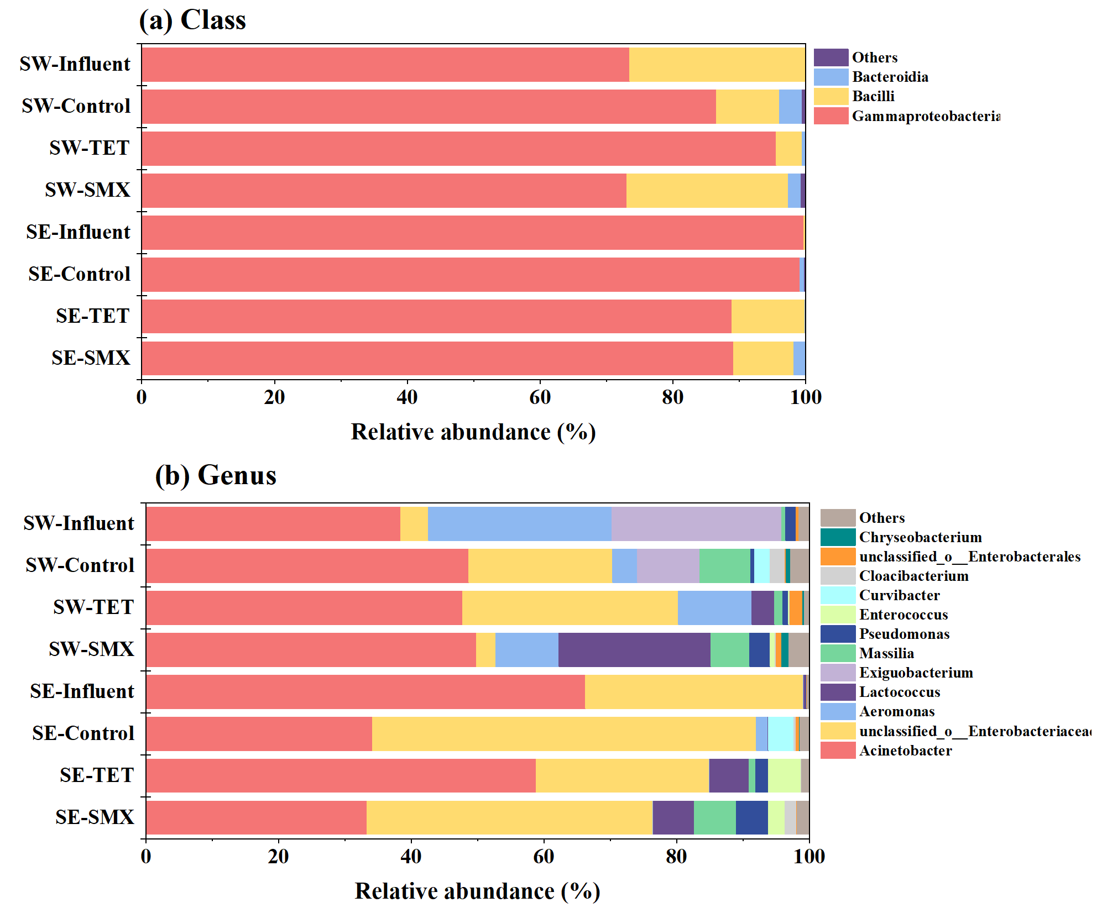

Fig. S4. Bacterial community composition changes at class level (a), and genus level (b), of each sample with antibiotics addition.

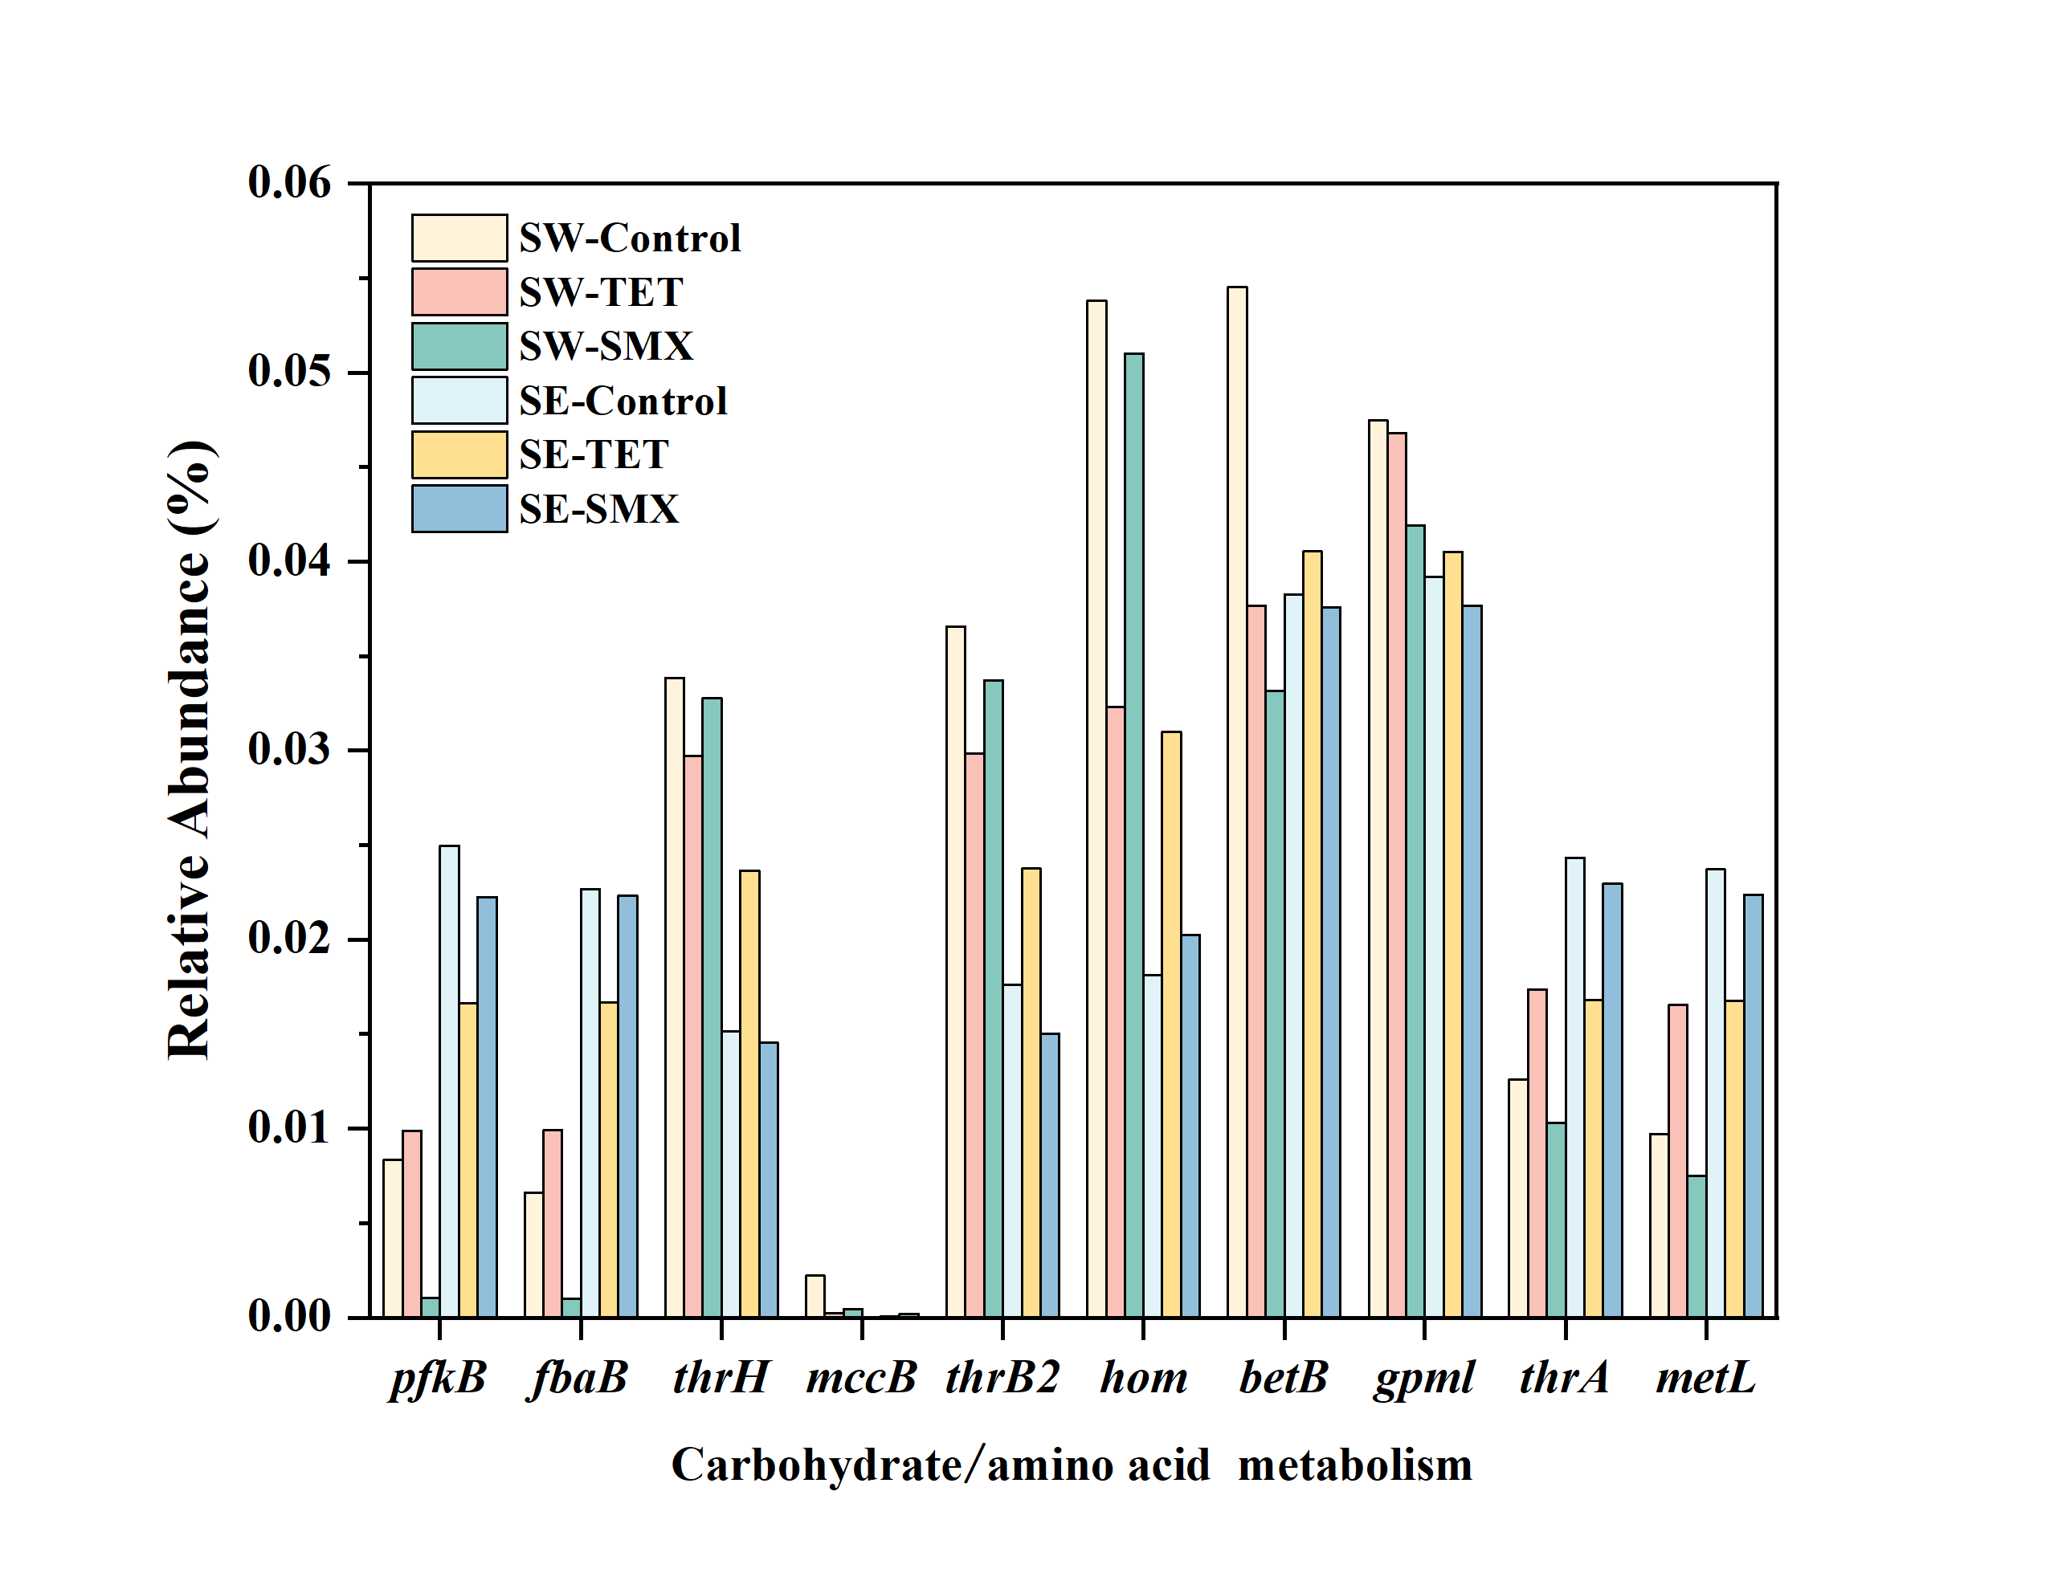

Fig. S5. The relative abundance of genes related to carbohydrate / amino acid metabolism with antibiotic stress.

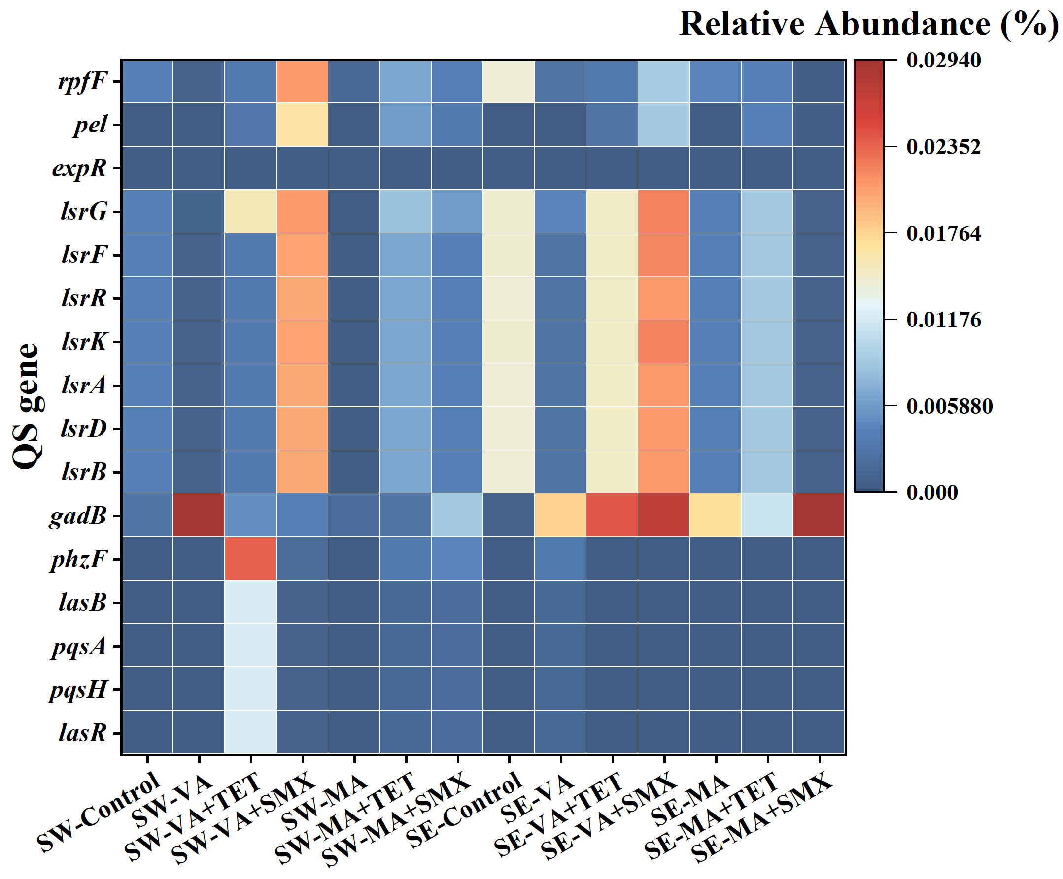

Fig. S6. Effects of QSIs, either alone or with antibiotics, on the relative abundance of QS genes in the QS pathway (map 02024) of SW and SE systems.

Table S1. The properties of commercial nanofiltration membrane
Membrane | NF270
pure water flux (L/m²h) | 75
pore size (nm) | 0.85
Molecular weight cut-off (Da) | 300
surface charge (mV) | -56.4
contact angle (°) | 23.4

Table S2. Primers in RT-qPCR assays.
Gene name | Primer sequence (5’-3’)
fabD | GGGTCTTGTCGGTCTGGTTCA (F)  GCATCCCTCGCATTCGTCTT (R)
lasI | TGCGTGCTCAAGTGTTCAAGGAG (F)  GGACTGAGTGCGTCATAACCATCG (R)
lasR | CATCGTCGGCAACTACCCG (F)  GCGCACCACTGCAACACT (R)
rhlI | CTCTGAATCGCTGGAAGGGCTTTC (F)  TTTGCGGATGGTCGAACTGGTC (R)
rhlR | GAGCGATACCAGATGCAGAACTACG (F)  TCCAGACCACCATTTCCGAGGAG (R)
pqsA | ACCGCGAAGGACACACTATCG (F)  GGCAGGTAGGAACCAGAACCGC (R)
pqsB | GCCCTCTACGTGGTCGATACCC (F)  GACTCGCTGTCCACTTCCAATCC (R)
pqsC | GAACGAGTTCAGCCTGGTGGTC (F)  GCGAGGAAGCCGAACAGATCAG (R)
pqsD | TGAGCTGACCCTGGACGACATC (F)  GAATGCCCAGTTGCTCCTGTACC (R)
pqsE | AATTGGTTTGGGCGGACCTGTG (F)  GGTCGTAGTGCTTGTGGGTGATC (R)
pqsH | CCGCCTTGGTCAATGGGAATCG (F)  CGGTGAAAAGACGCTGGTGGAG (R)
pqsR/  mvfR | TCGTTCTGCGATACGGTGAG (F)  GCACTGGTTGAAGCGGGAG (R)
lasA | GCTGAATGACGACCTGTTCCTCTAC (F)  CAGTGCTCCAGGTATTCGCTCTTG (R)
rhlA | GCGCGAAAGTCTGTTGGTATCG (F)  ATTTCCACCTCGTCGTCCTTGG (R)
tetA
  CATGACACTTATCCTGCCGTTCCTC (F)
  GATACCCGACCACTGCACGATTG (R)
mexA
  CATGGTGCTCTCGGCGGTATTC (F)
  CGACACGATGGTGATGGAGAACTG (R)
mexB
  CAGGTGAACGGCATCATCCTCAAG (F)
  GCTCTGGTAGTCGGCCTCGTAG (R)
oprM | CGGTTCGGGTTCCTGGTTGTTC (F)  TCTGGATCGCCTTCTCGTACTGC (R)

Table S3. Salt rejection during dynamic biofouling with QSIs and antibiotics addition.
Salt rejection (%) | SW | SE
Control | 42.65 | 47.67
TET | 38.33 | 48.82
SMX | 44.67 | 39.38
VA | 49.52 | 54.21
MA | 52.49 | 56.87
VA + TET | 47.56 | 52.28
VA + SMX | 50.63 | 49.34
MA + TET | 49.73 | 55.74
MA + SMX | 51.92 | 50.95

Table S4. Richness and diversity indices of microbial community in influent and on membrane surface with the influence of QSIs and antibiotics.
Sample | Coverage | Species richness indices |  | Species diversity indices
Sample | Coverage | Ace | Chao | Shannon | Simpson
SW-Influent | 99.97% | 36.67 | 38.00 | 1.59 | 0.2638
SW-Control | 99.96% | 58.33 | 56.80 | 2.27 | 0.1443
SW-VA | 99.95% | 57.69 | 60.00 | 2.45 | 0.1520
SW-MA | 99.95% | 63.30 | 58.50 | 2.22 | 0.1312
SW-TET | 99.96% | 50.53 | 46.50 | 1.67 | 0.2773
SW-SMX | 99.94% | 6.52 | 68.20 | 2.15 | 0.2017
SW-VA+TET | 99.98% | 58.18 | 52.00 | 1.46 | 0.3341
SW-VA+SMX | 99.98% | 58.83 | 47.50 | 1.60 | 0.3566
SW-MA+TET | 99.99% | 49.55 | 47.67 | 1.47 | 0.3221
SW-MA+SMX | 99.98% | 56.83 | 50.00 | 1.79 | 0.2501
B2F | 99.97% | 29.49 | 27.33 | 1.29 | 0.3708
SE-Control | 99.98% | 44.91 | 44.00 | 1.67 | 0.2536
SE-VA | 99.96% | 51.33 | 50.67 | 2.22 | 0.1536
SE-MA | 99.97% | 62.82 | 61.43 | 2.73 | 0.1058
SE-TET | 99.94% | 57.38 | 50.86 | 1.71 | 0.2602
SE-SMX | 99.97% | 43.43 | 47.50 | 2.05 | 0.2041
SE-VA+TET | 99.98% | 50.31 | 44.00 | 1.36 | 0.3714
SE-VA+SMX | 99.99% | 33.27 | 37.00 | 1.68 | 0.2534
SE-MA+TET | 99.98% | 37.38 | 39.50 | 1.43 | 0.3580
SE-MA+SMX | 99.99% | 48.00 | 47.20 | 1.92 | 0.2015

Table S5. The typical genes and abundance analysis of carbohydrate/amino acid metabolisms based on KEGG in SW system.
Pathway | K Number | Symbol | KO_Description | Relative Abundance (%)
 |  |  |  | SW-Control | SW-VA | SW-MA | SW-VA+TET | SW-VA+SMX | SW-MA+TET | SW-MA+SMX
M00001 Glycolysis (Embden-Meyerhof pathway) | K16370 | pfkB | 6-phosphofructokinase 2 | 0.01387 | 0.00268 | 0.00150 | 0.00356 | 0.02006 | 0.00657 | 0.00380
M00001 Glycolysis (Embden-Meyerhof pathway) | K11645 | fbaB | fructose-bisphosphate aldolase, class I | 0.01231 | 0.00270 | 0.00040 | 0.00358 | 0.02020 | 0.00660 | 0.00384
M00001 Glycolysis (Embden-Meyerhof pathway) | K00134 | gapA | glyceraldehyde 3-phosphate dehydrogenase | 0.09383 | 0.08898 | 0.08328 | 0.08620 | 0.07841 | 0.10232 | 0.10041
M00001 Glycolysis (Embden-Meyerhof pathway) | K15633 | gpml | 2,3-bisphosphoglycerate-independent phosphoglycerate mutase | 0.04412 | 0.03283 | 0.04901 | 0.04504 | 0.04156 | 0.05207 | 0.05321
M00020 Serine biosynthesis | K02203 | thrH | phosphoserine / homoserine phosphotransferase | 0.02607 | 0.01641 | 0.02208 | 0.03677 | 0.01261 | 0.04306 | 0.04043
M00338 Cysteine biosynthesis | K17217 | mccB | cystathionine gamma-lyase / homocysteine desulfhydrase | 0.00182 | 0.00132 | 0.00113 | 0.00428 | 0.00120 | 0.00211 | 0.00675
M00018 Threonine biosynthesis | K02204 | thrB2 | homoserine kinase type II | 0.02841 | 0.01652 | 0.02437 | 0.03395 | 0.01018 | 0.04170 | 0.04045
M00018 Threonine biosynthesis | K00003 | hom | homoserine dehydrogenase | 0.04273 | 0.03714 | 0.03555 | 0.04170 | 0.02625 | 0.04577 | 0.04971
M00018 Threonine biosynthesis | K12524 | thrA | bifunctional aspartokinase / homoserine dehydrogenase 1 | 0.01725 | 0.01525 | 0.06587 | 0.00370 | 0.03718 | 0.00667 | 0.00441
M00018 Threonine biosynthesis | K12525 | metL | bifunctional aspartokinase / homoserine dehydrogenase 2 | 0.01484 | 0.01438 | 0.00196 | 0.00363 | 0.02020 | 0.00661 | 0.00388
M00555 Betaine biosynthesis | K00130 | betB | betaine-aldehyde dehydrogenase | 0.05349 | 0.02496 | 0.03537 | 0.03784 | 0.02786 | 0.04400 | 0.04293

Table S6. The typical genes and abundance analysis of carbohydrate/amino acid metabolisms based on KEGG in SE system.
Pathway | K Number | Symbol | KO_Description | Relative Abundance (%)
 |  |  |  | SE-Control | SE-VA | SE-MA | SE-VA+TET | SE-VA+SMX | SE-MA+TET | SE-MA+SMX
M00001 Glycolysis (Embden-Meyerhof pathway) | K16370 | pfkB | 6-phosphofructokinase 2 | 0.02560 | 0.00463 | 0.01190 | 0.01490 | 0.02258 | 0.00912 | 0.00072
M00001 Glycolysis (Embden-Meyerhof pathway) | K11645 | fbaB | fructose-bisphosphate aldolase, class I | 0.02400 | 0.00464 | 0.00890 | 0.01497 | 0.02267 | 0.00924 | 0.00074
M00001 Glycolysis (Embden-Meyerhof pathway) | K00134 | gapA | glyceraldehyde 3-phosphate dehydrogenase | 0.09308 | 0.08112 | 0.08094 | 0.07890 | 0.07670 | 0.08086 | 0.09895
M00001 Glycolysis (Embden-Meyerhof pathway) | K15633 | gpml | 2,3-bisphosphoglycerate-independent phosphoglycerate mutase | 0.03863 | 0.02989 | 0.03887 | 0.04537 | 0.03885 | 0.05129 | 0.05298
M00020 Serine biosynthesis | K02203 | thrH | phosphoserine / homoserine phosphotransferase | 0.01375 | 0.02338 | 0.01340 | 0.01512 | 0.00869 | 0.01575 | 0.03125
M00338 Cysteine biosynthesis | K17217 | mccB | cystathionine gamma-lyase / homocysteine desulfhydrase | 0.00001 | 0.00011 | 0.00344 | 0.00002 | 0.00008 | 0.00001 | 0.01596
M00018 Threonine biosynthesis | K02204 | thrB2 | homoserine kinase type II | 0.01544 | 0.02341 | 0.02069 | 0.01515 | 0.00869 | 0.01580 | 0.03139
M00018 Threonine biosynthesis | K00003 | hom | homoserine dehydrogenase | 0.01577 | 0.04127 | 0.03446 | 0.03238 | 0.02050 | 0.03441 | 0.06126
M00018 Threonine biosynthesis | K12524 | thrA | bifunctional aspartokinase / homoserine dehydrogenase 1 | 0.02511 | 0.00653 | 0.02627 | 0.06045 | 0.04386 | 0.08693 | 0.01252
M00018 Threonine biosynthesis | K12525 | metL | bifunctional aspartokinase / homoserine dehydrogenase 2 | 0.02469 | 0.00597 | 0.01080 | 0.01496 | 0.02266 | 0.00922 | 0.00073
M00555 Betaine biosynthesis | K00130 | betB | betaine-aldehyde dehydrogenase | 0.03958 | 0.03666 | 0.02644 | 0.04377 | 0.03166 | 0.03740 | 0.03172

Table S7. The abundance analysis of typical QS genes based on KEGG in SW system.
Symbol | K Number | KO_Description | Relative Abundance (%)
Symbol | K Number | KO_Description | SW-Control | SW-VA | SW-VA+TET | SW-VA+SMX | SW-MA | SW-MA+TET | SW-MA+SMX
lasR | K18304 | quorum-sensing system regulator LasR | 0.00000 | 0.00020 | 0.01186 | 0.00075 | 0.00000 | 0.00167 | 0.00212
pqsH | K17940 | 2-heptyl-3-hydroxy-4(1H)-quinolone synthase | 0.00000 | 0.00020 | 0.01186 | 0.00075 | 0.00000 | 0.00167 | 0.00212
pqsA | K18000 | anthranilate-CoA ligase | 0.00000 | 0.00020 | 0.01186 | 0.00075 | 0.00000 | 0.00167 | 0.00212
phzF | K06998 | trans-2,3-dihydro-3-hydroxyanthranilate isomerase | 0.00003 | 0.00043 | 0.02378 | 0.00179 | 0.00001 | 0.00341 | 0.00431
gadB | K01580 | glutamate decarboxylase | 0.00273 | 0.02936 | 0.00481 | 0.00415 | 0.00196 | 0.00258 | 0.00883
lsrB | K10555 | AI-2 transport system substrate-binding protein | 0.00367 | 0.00065 | 0.00357 | 0.01997 | 0.00018 | 0.00659 | 0.00383
lsrD | K10557 | AI-2 transport system permease protein | 0.00367 | 0.00065 | 0.00357 | 0.01997 | 0.00018 | 0.00659 | 0.00383
lsrA | K10558 | AI-2 transport system ATP-binding protein | 0.00367 | 0.00065 | 0.00357 | 0.01997 | 0.00018 | 0.00659 | 0.00383
lsrK | K11216 | autoinducer-2 kinase | 0.00379 | 0.00075 | 0.00358 | 0.02019 | 0.00019 | 0.00660 | 0.00383
lsrR | K11531 | lsr operon transcriptional repressor | 0.00367 | 0.00065 | 0.00357 | 0.01997 | 0.00018 | 0.00659 | 0.00383
lsrF | K08321 | 3-hydroxy-5-phosphonooxypentane-2,4-dione thiolase | 0.00378 | 0.00075 | 0.00358 | 0.02019 | 0.00019 | 0.00660 | 0.00383
lsrG | K11530 | (4S)-4-hydroxy-5-phosphonooxypentane-2,3-dione isomerase | 0.00379 | 0.00096 | 0.01544 | 0.02094 | 0.00019 | 0.00826 | 0.00595
pel | K01728 | pectate lyase | 0.00016 | 0.00010 | 0.00293 | 0.01631 | 0.00003 | 0.00591 | 0.00362
rpfF | K13816 | DSF synthase | 0.00388 | 0.00081 | 0.00362 | 0.02100 | 0.00161 | 0.00660 | 0.00386

Table S8. The abundance analysis of typical QS genes based on KEGG in SE system.
Symbol | K Number | KO_Description | Relative Abundance (%)
Symbol | K Number | KO_Description | SE-Control | SE-VA | SE-VA+TET | SE-VA+SMX | SE-MA | SE-MA+TET | SE-MA+SMX
lasR | K18304 | quorum-sensing system regulator LasR | 0.00000 | 0.00157 | 0.00001 | 0.00001 | 0.00000 | 0.00001 | 0.00010
pqsH | K17940 | 2-heptyl-3-hydroxy-4(1H)-quinolone synthase | 0.00000 | 0.00157 | 0.00001 | 0.00001 | 0.00000 | 0.00001 | 0.00010
pqsA | K18000 | anthranilate-CoA ligase | 0.00000 | 0.00157 | 0.00001 | 0.00001 | 0.00000 | 0.00001 | 0.00010
lasB | K01399 | pseudolysin | 0.00000 | 0.00157 | 0.00001 | 0.00001 | 0.00000 | 0.00001 | 0.00010
phzF | K06998 | trans-2,3-dihydro-3-hydroxyanthranilate isomerase | 0.00001 | 0.00314 | 0.00001 | 0.00002 | 0.00027 | 0.00001 | 0.00020
gadB | K01580 | glutamate decarboxylase | 0.00077 | 0.01785 | 0.02421 | 0.02736 | 0.01705 | 0.01116 | 0.02924
lsrB | K10555 | AI-2 transport system substrate-binding protein | 0.01427 | 0.00255 | 0.01460 | 0.02078 | 0.00393 | 0.00870 | 0.00069
lsrD | K10557 | AI-2 transport system permease protein | 0.01427 | 0.00255 | 0.01460 | 0.02078 | 0.00393 | 0.00870 | 0.00069
lsrA | K10558 | AI-2 transport system ATP-binding protein | 0.01427 | 0.00255 | 0.01460 | 0.02078 | 0.00393 | 0.00870 | 0.00069
lsrK | K11216 | autoinducer-2 kinase | 0.01431 | 0.00265 | 0.01467 | 0.02190 | 0.00397 | 0.00886 | 0.00071
lsrR | K11531 | lsr operon transcriptional repressor | 0.01426 | 0.00255 | 0.01460 | 0.02078 | 0.00393 | 0.00870 | 0.00068
lsrF | K08321 | 3-hydroxy-5-phosphonooxypentane-2,4-dione thiolase | 0.01432 | 0.00264 | 0.01461 | 0.02181 | 0.00401 | 0.00876 | 0.00069
lsrG | K11530 | (4S)-4-hydroxy-5-phosphonooxypentane-2,3-dione isomerase | 0.01434 | 0.00422 | 0.01468 | 0.02191 | 0.00404 | 0.00886 | 0.00080
expR | K19734 | LuxR family transcriptional regulator, quorum-sensing system regulator ExpR | 0.00007 | 0.00004 | 0.00006 | 0.00009 | 0.00008 | 0.00010 | 0.00002
pel | K01728 | pectate lyase | 0.00002 | 0.00008 | 0.00279 | 0.00891 | 0.00025 | 0.00387 | 0.00047
rpfF | K13816 | DSF synthase | 0.01428 | 0.00267 | 0.00311 | 0.00903 | 0.00428 | 0.00413 | 0.00050

