Improving the hospital ‘soundscape’ – a framework to measure individual perceptual response to hospital sounds
Mackrill, J.B ¹., Jennings, P.A ¹., and Cain, R ¹.
¹WMG, University of Warwick, CV4 7AL.

Corresponding Author: Dr Jamie Mackrill - j.mackrill@imperial.ac.uk
Abstract
Work on the perception of urban soundscapes has generated a number of perceptual models which are proposed as tools to test and evaluate soundscape interventions. However, despite the excessive sound levels and noise within hospital environments perceptual models have not been developed for these spaces. To address this, a two stage approach was developed by the authors to create such a model. Firstly, semantics were obtained from listening evaluations which captured the feelings of individuals from hearing hospital sounds. Thirty participants then rated a range of sound clips representative of a ward soundscape based on these semantics. Principal component analysis extracted a two-dimensional space representing an emotional-cognitive response. The framework enables soundscape interventions to be tested which may improve the perception of these hospital environments.
Key Words: Perception; Hospital; Sound; Environment
Practitioner summary: Hospital sound is commonly measured in terms of objective sound level. This does not consider the positive or negative subjective reactions to these sounds. This paper understands these reactions and produces a perceptual framework which can be used to measure the subjective response to a hospital soundscape.

1. Introduction

In recent decades research on healthcare design and planning has highlighted strong relationships between environmental characteristics and human health (Monti et al. 2012). The soundscape is an important component of this, as staff and patients in hospital are exposed to complex sounds (Salandina et al. 2011). One part of a soundscape is sound level, for which the World Health Organisation (WHO) and the UK’s Department of Health produce guidelines (Berglund et al. 2000; DoH, 2008) in an effort to control adverse effects from excessive sound exposure within these environments. In the past Minckley (1968b) recorded median sound levels to be 50-60 dB(A) in hospital and during periods of heightened activity this increased to 60-70 dB(A). The problem however, still exists as there is a clear trend for rising hospital sound levels since 1960, as most research shows that the average sound level is 20-40 dB(A) higher than that set out by the WHO (Busch-Vishniac et al. 2005). Additional research concurs by reporting sound levels of 60-70dB(A) (Tijunelis et al. 2005; Bailey and Timmon, 2005; Siebein and Skelton, 2009; Okcu et al. 2011; Salandina et al. 2011).
Such levels and noise can be linked to burnout and stress (Topf and Dillon, 1988) whilst sound also distracts, alters concentration, and increases tiredness (Xie and Kang, 2010). Such comments highlight the issues of sound in these environments, and begins to recognise the perceptual aspect of it. Architects however, focus on measurable components of the therapeutic environment such as sound level, and fail to consider the more qualitative features, such as subjective feelings (Gesler et al. 2004). The notion of a soundscape can be used to change this, and evaluate the sounds of a hospital space in a different way.
1.1. The components of a soundscape
A soundscape is essentially the auditory version of a visual landscape (Hall et al, 2012). Of course, sound level is one part of this; however there are different approaches to assess sound in this context, such as considering the array of sound sources and subjective reaction. For example, Momtahan et al., (1993) reported that operating room staff can identify just 14 out of 23 different alarms of which most are perceived as unpleasant. Siebein and Skelton (2009) classified sound sources within a neonatal intensive care unit by documenting a vast 75 acoustic events under five categories of building equipment noise, occupational sounds, medical equipment sounds, conversational sounds, and sounds from outside. Both Akansel and Kaymakci (2008) and Topf (1985) documented the most disturbing hospital noises for patients, classed as snoring, crying, staff conversation, doors slamming, and objects banging. Using Siebein and Skelton’s (2009) classification, these can be classed as occupational and conversational sound. However, it is of interest to note that medical equipment and alarms are not the most disturbing from these two studies which is somewhat contra to expectation. Furthermore, although patients cite hospital as noisy, 91.4% also said that the presence of technology and staff made them feel safe (Akansel and Kaymakci, 2008) supporting the notion that the absence of negative sound does not necessarily create a positive environment (Truax, 1984). The perception to these soundscapes, therefore, needs further understanding along with the feelings that a hospital soundscape elicits.
Rice (2003) explored sound in a UK hospital from patients’ perspectives. This led to the suggestion that hearing becomes pronounced at hospital as the visual environment is dull meaning other senses are made redundant as the hospital stimuli are experienced in an hierarchical fashion. Dawson (2005) suggesting that unacceptable noise for patients and staff requires examination of the sources with scope for research into the positive effect of sound. In support, Salandina et al. (2011) suggests the use of masking sound (ocean, music, random noises) to improve the sound quality of a ward environment, as it reduced the distance between the background noise and disturbing noises. These trends cumulate to suggest that a positive hospital soundscape may exist and requires investigation. To do so a framework may be beneficial to understand these subjective aspects in more detail and be used in a practical sense.
Much effort has been made to understanding urban soundscape and how the perception of sound can be used to improve the subjective experience of these places (Axelsson, Nilsson, and Berglund, 2010; Cain, Jennings, and Poxon, 2013; Davies et al. 2013). This moves away from acoustic analysis of sound to integration of objective measures with subjective perception, thus building a richer picture of the individuals’ response, which can feed into design. As a result, arguably a deeper understanding of the meaning of sound in context and possibly the influence on the subjective wellbeing of individuals is obtained. One way of doing this is to establish perceptual dimensions which define how a person may describe and/or feel when exposed to a soundscape (Axelsson et al. 2010; Guillen and Lopez Barrio, 2007; Hall et al. 2012; Cain et al. 2013). As audition plays an important part in the expression of emotion (Schifferstien and Desmet, 2007) such frameworks are particularly useful in understanding the experience of a space and may help improve them.
Such an approach can be justified more broadly as during service-scape encounters, customers experience both physical and non-physical elements which serve as a cognitive process that stimulates their emotional response which can be mapped for improvement (Hartono and Chuan, 2011). Likewise automotive manufacturers use such aspects to understand subjective perspectives for optimum sounds which may not be the quietest but the most appropriate (Humphreys et al. 2011). There is no reason to consider sound within hospitals any differently, and an appropriate soundscape may be a way to enhance the environment much like a product or service.

1.2. Aim
This paper details the process of developing a framework defining perception to a cardiothoracic (CT) UK hospital ward soundscape. Such a framework can then be used to understand how to improve and map interventions to improve the perception of the soundscape. The study involved laboratory listening evaluation across two parts. Part A reports on a laboratory listening evaluation to capture the language participants used to describe their feelings from hearing hospital ward sounds. Part B discusses the use of Principal Component Analysis (PCA) to extract the principal dimension, which describes the perception of the soundscape and thus construct a perceptual framework defining this.
2. Methods
2.1. Sound stimuli
It was necessary to obtain representative recordings of the CT ward soundscape to use as experimental stimuli. Thirty two recordings were made within the CT ward using a Bruel and Kjaer binaural recording device. These recordings captured a snapshot of the ward soundscape over a 5 minute period across five locations within the ward. This time period ensured that the broad character of the soundscape was captured and increased the chance of obtaining key sounds that marked the soundscape. These raw recordings were analysed according to Poxon et al. (2009) classification method to understand the variety of sounds. From these, 19 sound recordings were selected for use in the listening evaluations. These contained a range of dominant features using Axelsson et al’s. (2010) definition that “dominance refers to a category of sounds in the foreground and not to a single sound event”.
To encourage a breadth of semantics and responses, three clips were manipulated with the addition of bird song, a babbling stream, and a steady state sound. These sounds were digitally mixed into the sound clips using Nuendo 4 sound software to form a congruent background addition. Sound clip details and associated playback sound level are listed in table 1.
The recordings were not normalised for sound level but were set to represent levels found within hospital environments based on the mean A-weighted decibel level (dB(A)). Stimuli were presented in the same order to each participant with Clip 1 used as the practice stimuli and repeated at the end of the experiment for inclusion in the analysis.

Table 1. Sound clip details including playback dB(A) level and clip content. Note, dB(A) taken as a 95% average over the period of the clip.
Sound clip | Playback dB(A) (^{95%} mean) | Location within cardiothoracic ward | Classification | Soundscape within clip
1 (practice) | 72.31 | Ward Corridor | Human conversation and Occupational sounds | Conversation and sterilising machine sounding.
2 | 65.78 | Ward Corridor | Occupational sounds | Conversation and footsteps. Doors opening and closing with objects banging.
3 | 74.21 | Ward Corridor | Human conversation | Conversation and footsteps in background, cups jingling.
4 | 63.24 | Ward Corridor | Occupational sounds | Conversation and footsteps in background. Trolley passing with objects banging, doors opening and closing.
5 | 64.67 | Ward Corridor | Monitor sounds | Quiet corridor. Objects banging in background.
6 | 68.20 | Ward Corridor | Occupational sounds | Deep rumble of trolley passing.
7 | 68.03 | Ward Corridor | Human Patient sounds | Conversation and footsteps in background. Patient screaming intermittently.
8 | 63.78 | Ward Corridor | Human conversation | Conversation and footsteps in background. Trolley passing.
9 | 67.56 | Patient Bay | Human conversation and monitor sounds | Talking by nurse talking patient observations monitors beeping and sounds of a car from outside.
10 | 70.56 | Patient Bay | Human conversation | Talking by nurse talking patient observations, monitors beeping and patient talking.
11 | 62.34 | Patient Bay | Background sounds | Quiet patient bay with private conversation from nurse to patient in background.
12 | 65.43 | Patient Bay | All background sounds | Quiet patient bay with monitor beeps, rustling, and talking in background.
13 | 69.64 | Patient Bay | Occupational sounds | Floor cleaning buffer, long monitor beeps.
14 | 59.72 | Patient Bay | Occupational sounds | Rustling of bins being changed, water running, background conversation.
15 | 76.80 | Patient Bay | Human Patient to nurse conversation | Various monitor beeps, patient conversation.
16 | 68.75 | Nurse Station | Human conversation | Loud nurse conversation with laughter, monitor beeps.
17 | 64.67 | Patient Bay | Background sounds (sound of stream added) | Quiet corridor. Objects banging in background.
18 | 70.16 | Ward Corridor | Background sounds (steady state sound added) | Quiet corridor. Objects banging in background.
19 | 64.67 | Patient Bay | Background sounds (sound of birdsong added) | Quiet patient bay with monitors beeping, quiet conversation in background.
20 | 72.31 | Ward Corridor | Human conversation and Occupational | Conversation and sterilising machine sounding.

2.2. Listening evaluation procedure
Listening evaluations were held in a Sound Room laboratory. This consisted of a 16 speaker system (using KEF iQ70 and HTS3001SE speakers) operated via a PC computer using Nuendo 4 sound editing software to play the sound stimuli (figure 1). The system played back the binaural hospital recordings through all 16 speakers with the ceiling speakers positioned 225cm above the floor speakers.
Figure 1. Sound room laboratory and speaker set up. Note, three images used to create photograph hence slight distortion.
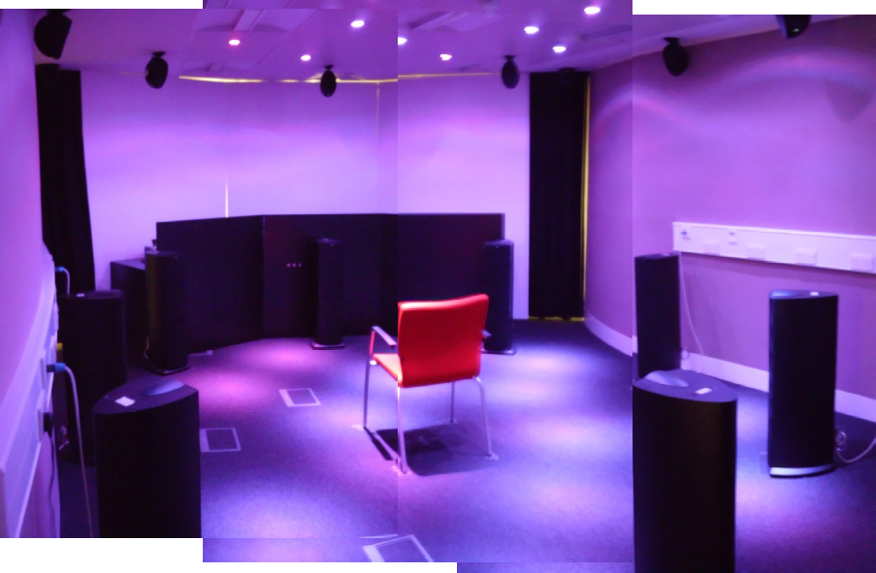
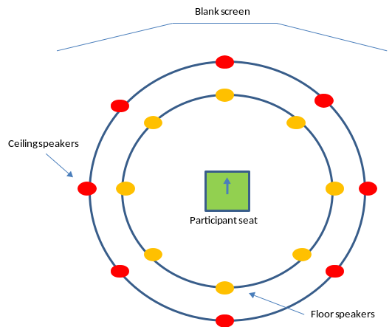

Lights were dimmed to increase immersion in the environment. Participants were briefed on the task and freely written responses were recorded on a paper questionnaire stating, “Listen to the recording. How does it make you feel?” This was to extract an emotional response, defined as a description of how the person felt from hearing the soundscape. Each sound clip lasted around 20 seconds and was repeated four times resulting in the total stimulus being presented for an 80 second period. This was then followed by a 20 second inter stimulus period of silence to allow completion of any scales and to differentiate between clips. The total evaluation length was around 40 minutes. No visual stimulus was presented to ensure judgements were made purely in response to the sounds.
2.3. Research ethics
Research ethics approval was sought from two committees. To obtain sound recordings from the CT ward environment, UK National Health Service Research Ethics approval was granted as part of a previous study. The listening evaluation study was also approved by an internal University Ethics Committee board
3. Part A. Obtaining semantics
The aim Part A was to gather key semantics that captured how individuals felt when listening to the CT soundscape. This was based on freely written answers responding to the posed question. The study also compared the semantics collected to that of a previous interview study conducted by the authors (see Mackrill et al. 2013ª).
Mackrill et al. (2013ª) aimed to understand the perception of a cardiothoracic ward soundscape from patients and nurses. The results developed a conceptual model describing perception. A cohort of semantics describing patient and nurse feelings were directly recorded from this.
A comparison between the presented study and Mackrill et al. (2013ª) was used to assess if the listening evaluation method produced similar responses. This ensured that the semantics captured were comparable to those of patients and thus any findings were valid. These semantics were then used to create semantic rating scales relating to these feelings to be used in Part B.
3.1. Sample
A total of 18 participants were recruited for Part A with a mean age of 35 (S.D.=12.4) years. Eleven of the participants were male with the remaining seven female. The sample contained a broad range of demographics from within and outside the University community. Two participants, both female, were healthcare professionals. Sample size was determined by ‘semantic saturation’. This was defined as the point at which no new semantics were frequently written by participants, which added to this list of words recorded.
3.2. Analysis
Each questionnaire was analysed by listing the various semantics participants used. These were then grouped into positive and negative cohorts along with words/phrases which were neutral. Frequency counts were used to extract the dominantly used words.
3.3. Results
A total of 45 different positive semantics were obtained. Of these, the most frequently reported semantics were ‘calm’ followed by ‘relaxed’, ‘reassured’, ‘at ease’, ‘intrigued’, ‘peaceful’, ‘comfortable’, ‘curious’, ‘alert’ and ‘happy’. Seventy nine negative semantics were obtained. The most commonly described feelings were ‘annoyed’, ‘distracted’, ‘irritated’, ‘frustrated’, ‘disturbed’, ‘stressed’, ‘uncomfortable’, ‘worried’, ‘anxious’, and ‘concerned’. A large array of other semantics were classed as neutral. Often these had a frequency count of one and therefore did not describe the dominant feelings and so were not considered further.
Table 2 shows the results of the study and the integration from a previous study by the authors (see, Mackrill et al.2013ª). This produced a cumulative frequency to ensure the most common semantics were used for semantic pairing in Part B.

Table 2. Frequency counts of semantics obtained from listening evaluations and interview study of Mackrill et al. (2013ª).
Positive semantics | Frequency |  | Combined frequency with Mackrill et al. (2013ª) |  | Negative semantics | Frequency | Combined frequency with Mackrill et al. (2013ª)
Calm  Relaxed  At ease  Reassured  Peaceful  Comfortable  Intrigued  Curious  Alert  Happy  Reflective |  | 52  16  10  14  6  7  9  7  6  6  1 |  | 63  26  10  15  9  9  9  7  7  6  1 | Annoyed  Distracted  Irritated  Frustrated  Disturbed  Stressed  Uncomfortable  Worried  Anxious  Concerned  Angry  Confused  Bored | 52  41  19  18  17  9  16  15  13  13  11  7  3 | 60  41  22  20  19  17  17  15  13  13  11  7  3

4. Part B. Establishing the perceptual dimensions
Using the semantics obtained from Part A, this listening evaluation was used to establish the principal dimensions which could be used to form measurement scales and the dimensions of the perceptual framework.
4.1. Measurement scales
The semantic differential technique of Osgood et al.(1957) was used to create rating scales as this technique is valuable for identifying the psychological dimensions with which sensory stimuli are evaluated (Kidd and Watson, 2003). Furthermore, these are often used to explore emotional attributes of a given physical or non-physical item (Hartono and Chuan, 2011). Fifteen seven-point semantic scales were made from the results of Part A (table 3). The scales were constructed based on the most frequently reported words and paired according to meaning. Where pairing was not possible based on the collected semantics, assessment of previous soundscape and sound quality research was used to find suitable alternative along with the Oxford English Dictionary (2005).
Table 3. Fifteen bipolar semantic differential scales used in evaluation to create the perceptual dimensions of the CT ward soundscape.
 | Bipolar Semantic Scales
1 | Calm | 1 2 3 4 5 6 7 | Agitated
2 | Relaxed | 1 2 3 4 5 6 7 | Stressed
3 | Reassured | 1 2 3 4 5 6 7 | Worried
4 | At ease | 1 2 3 4 5 6 7 | Anxious
5 | Intrigued | 1 2 3 4 5 6 7 | Bored
6 | Comfortable | 1 2 3 4 5 6 7 | Uncomfortable
7 | Curious | 1 2 3 4 5 6 7 | Apathetic
8 | Alert | 1 2 3 4 5 6 7 | Unprepared
9 | Annoyed | 1 2 3 4 5 6 7 | Content
10 | Peaceful | 1 2 3 4 5 6 7 | Troubled
11 | Attentive | 1 2 3 4 5 6 7 | Distracted
12 | Tolerant | 1 2 3 4 5 6 7 | Irritated
13 | Satisfied | 1 2 3 4 5 6 7 | Frustrated
14 | Undisturbed | 1 2 3 4 5 6 7 | Disturbed
15 | Unconcerned | 1 2 3 4 5 6 7 | Concerned

4.2. Analysis
The results were analysed using Principal Component Analysis (PCA), comparable to similar research defining perceptual attributes (Harris, Chan-Pensely and McGarry, 2007; Axelsson et al. 2010; Jennings et al. 2010; Cain et al.2013). A rotational factor model enabled the variables to be displayed visually, consequently forming the perceptual framework. Cronbach’s reliability test was performed to assess if the scales were suitably understood by participants. All analysis was performed using statistical software SPSS 19 with any missing data replaced with the variable mean.

4.3. Sample
A ration method of sample size calculation was applied using a ratio of two participants to one variable, proposed by Brace, Kemp and Snelgar (2006). Therefore, 30 participants were recruited for the study. Sample size adequacy was checked before analysis using the Kaiser-Meyer-Olkinn (KMO) test.
The sample consisted of four healthcare professionals (two physiotherapists, a research nurse, and intensive care sister) and 26 members of the public from within and outside the University community. There was an even gender split with 15 male and 15 female participants with a mean age of 36yrs (S.D.=12.4). Twenty of the participants had experienced a hospital environment within the year.
5. Main results
KMO measure verified the sampling adequacy of the test, KMO = .94 (consequently superb according to Field, 2009) and all KMO values for individuals scales = >.71 (above the acceptable limit of .5 (Field, 2009)). Therefore the sample size was adequate despite being relatively small. Bartlett's Test of Sphericity was significant x² (105) = 7344.25, p =<.001, which indicated that correlations between the semantic scales were sufficiently large and allowed valid use of PCA.
5.1. Principal Component Analysis
The data showed a normal distribution and PCA was conducted on the 15 semantic scales with an orthogonal (varimax) rotation. Analysis revealed a two dimensional framework representing the perceptual dimensions of the soundscape (figure 2). Components 1 and 2 explained 56.8% and 13.2% of the variance within the data respectively. This represented 70.1% of the total variation within the results.

Figure 2. Rotated component model showing the factor loadings of each semantic. Cluster for ‘Relaxation’ on the right of the space and ‘Interest and Understanding’ on the top.
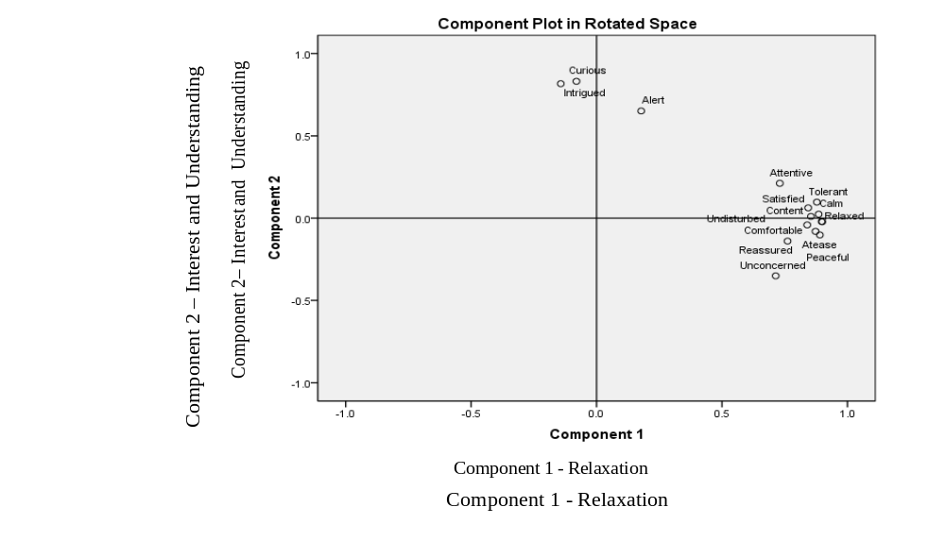
5.2. Semantic scale loadings
Table 4 displays the item loadings for each semantic scale. The first dimension is best explained by the four scales of ‘relaxed-stressed’, ‘comfortable-uncomfortable’, ‘at ease-anxious’, and ‘calm-agitated’. All other scales were highly loaded. Based upon these semantic scales, this dimension was classified as ‘Relaxation’.
The second dimension was best explained by two scales, ‘curious-apathetic’ and ‘intrigued-bored’ with loadings of 0.832 and 0.817 respectively. The third loading on the ‘alert-unprepared’ semantic scale was lower at .651. This dimension was thus classified as ‘Interest and Understanding’ based on these scales.

Table 4. PCA item loadings for each of the principal components (obtained through a varimax rotation) along with reliability measurement for each scale. Note, item loadings of less than 0.3 omitted to improve clarity.
Semantic scale | Principal Component |  | Scale reliability analysis (Cronbach’s α)
Semantic scale | 1 | 2 | Scale reliability analysis (Cronbach’s α)
Relaxed - Stressed | .900 |  | .858
Comfortable - Uncomfortable | .897 |  | .874
At ease - Anxious | .890 |  | .876
Calm - Agitated | .885 |  | .846
Tolerant - Irritated | .878 |  | .723
Peaceful - Troubled | .873 |  | .808
Content - Annoyed | .854 |  | .867
Satisfied - Frustrated | .844 |  | .848
Undisturbed - Disturbed | .840 |  | .809
Reassured - Worried | .761 |  | .824
Attentive - Distracted | .730 |  | .674
Unconcerned - Concerned | .714 |  | .876
Curious - Apathetic |  | .832 | .587
Intrigued - Bored |  | .817 | .408
Alert - Unprepared |  | .651 | .538
Variance explained (%) | 56.8 | 13.2

5.3. Scale reliability
A Cronbach’s α reliability test was carried out to understand the internal consistency of each of the scales (table 4). Twelve of the 15 scales related to the ‘Relaxation’ dimension recorded high reliability; overall Cronbach’s α = .961. This shows high internal consistencies for these scales and can be used to represent the ‘Relaxation’ element of the soundscape. Both the ‘relaxed-stressed’ and ‘comfortable-uncomfortable’ scales individually recorded the high internal constancy, Cronbach’s α = .858 and .874 respectively. This revealed these as the strongest scales for representing the ‘Relaxation’ dimension.
The three ‘Interest and Understanding’ scales recorded a lower level of reliability; overall Cronbach’s α = .693. This showed only moderate internal consistency in the scales. Both ‘curious-apathetic’ and ‘intrigued-bored’ recorded independent Conbach’s α = .587 and α = .538 respectively. This moderate reliability may be due to the concept of the scale, for example the notions of curious and apathetic, being ambiguous. This ambiguity may have resulted in a greater variance in the participant’s interpretation of the meaning and therefore a greater range of responses recorded. To explore this further, ‘alert-unprepared’ was removed to improve the internal consistency of these scales resulting, Cronbach’s α = .721, thus suggesting this scale was causing most ambiguity and subsequently limiting reliability.
6. Discussion
Schafer’s (1976) perspective on a soundscape encapsulated the sound sources, and the sonic environment as a subjective and personal experience (Hall et al. 2012). As Rice (2003) remarks, the lack of stimuli for other sensory modalities may be a reason why the soundscape becomes pronounced within the hospital setting and particularly affects patients. This supports the value of understanding the perception to these sounds. Therefore, understanding and defining this subjective reaction is important, and something that existing research which concentrates on sound level measurement fails to recognise. Arguably, it is not possible to improve the sound of a hospital environment if the perception of the soundscape has yet to be defined in an understandable format – what type of intervention would improve perception and in what way? The presented results go some way to address this by defining perception towards a hospital ward soundscape in a simple way.
The extracted two-dimensional framework of CT soundscape is in line with other sound quality, soundscape, and environment research (Axelsson et al. 2010; Cain et al. 2013; Giudice et al. 2010; Jennings et al. 2010; Russell, 1980) in describing perception towards an environmental stimulus within a perceptual space. The principal dimensions, labelled ‘Relaxation’ and ‘Interest and Understanding’ create these and describe not only an emotional response, but a cognitive element, thereby creating an emotion-cognitive framework. These results are reinforced by Guillen and Lopez-Barrio (2007) and Hall et al. (2012) who aimed to discover the perceptual properties of the urban soundscape. Their results are comparable as they include notions of relaxation and interest. It is noteworthy that the second dimension in the case of Guillen and Lopez-Barrio (2007), accounts for a similar level of variance within the results, 13.6%, compared to 13.2%.
The principal dimension ‘Relaxation’ accounted for 56.8% of the variability within the data set and describes an emotional reaction – a feeling from hearing the soundscape. As hospitals should minimise anxiety and promote healing through the creation of an overall inviting, calming, and engaging environment (Douglas and Douglas, 2005) this is inherently tied to feelings of relaxation. Arguably, most of the bipolar semantic scales represent this dimension and such a result is unsurprising. However, it should be remembered that these semantics were obtained from patients, nurses, and members of the public as a direct result of exposure to the ward sounds thus aiding validity to this extraction.
‘Interest and Understanding’ suggests a cognitive reaction and appraisal of the soundscape. This secondary dimension of perception showed that the ward soundscape is partly one that involves a level of understanding and relates to the information content within the soundscape, which is unsurprising since sound plays an analogous role in communicating information (Schifferstein and Desmet, 2007). Indeed, when discussing auditory warnings Catchpole and McKeown (2004) state meaning is one aspect, which refers to the ability of the human to understand the semantic information contained within the sound which can be learned via association. As auditory warnings and verbal communication is commonplace within a hospital soundscape, this dimension reflects this.
The scales ‘curious-apathetic’, ‘intrigued-bored’ were found to represent this appraisal connected to information and familiarity towards the soundscape. Information content within a soundscape is not a new concept as Irwin et al. (2011) found that ‘information formation’ had positive loading within a ‘vibrancy and information content’ when five participants rated 219 urban soundscape clips. Furthermore, informational properties are substantial contributors to soundscape perception (Axelsson et al. 2010). At a more subjective level of interpretation, a soundscape approach deals with the transfer of information rather than energy and therefore deals with the cognitive processes that underlie it (Truax, 1984).
6.1. Value and future extension of work.
Based on these findings, improvements to the hospital ward soundscape could move beyond sound level to facilitate these notions of ‘Relaxation’ and ‘Interest and Understanding’. Importantly, these relate to aspects of a healing environment which can be defined as environments encouraging recovery and feelings of wellbeing thus reducing stress, anxiety, and the adverse reactions associated with it (Dijkstra et al. 2006). This may relate to the emotional-cognitive dimensions as a soundscape providing relaxation and understanding may aid this.
Therefore, soundscape interventions can be tested to understand how to create a positive perception. For instance, does natural sound produce a more positive response and does information about the sound sources aid understanding and thereby relaxation? It may also be used and developed to consider how auditory alarms influence perception and aid the theory driven approach to tackle their design problems (e.g. Raymer, Bergstorm, and Nyce, 2012).
In an example of this future work, the emotional-cognitive space was used by the authors in an in-situ study (see Mackrill et al. 2013^{b}). This investigated the use of sound source information (SSI) to improve patients’ comfort within a cardiothoracic ward across three time periods (9am, 12noon and 4pm). Patient response to the soundscape was recorded using the rating scales presented here with the control containing only the rating scales and the intervention containing SSI and the rating scales. The perceptual framework was used to map the results (figure 3) which showed that SSI effects mostly the ‘Interest & Understanding’ dimension of patient perception (p= < .05) representing a 21-26% positive change (Mackrill et al. 2013^{b}). Importantly, this study shows the value of the perceptual framework in mapping results and how the framework may be used in practice in providing a way to benchmark changes to a hospital ward soundscape.

Figure 3. The emotional-cognitive framework showing the results of Mackrill et al. (2013^{b}). Note, ‘Relaxation’ dimension on x-axis, ‘Interest and Understanding’ on y-axis.
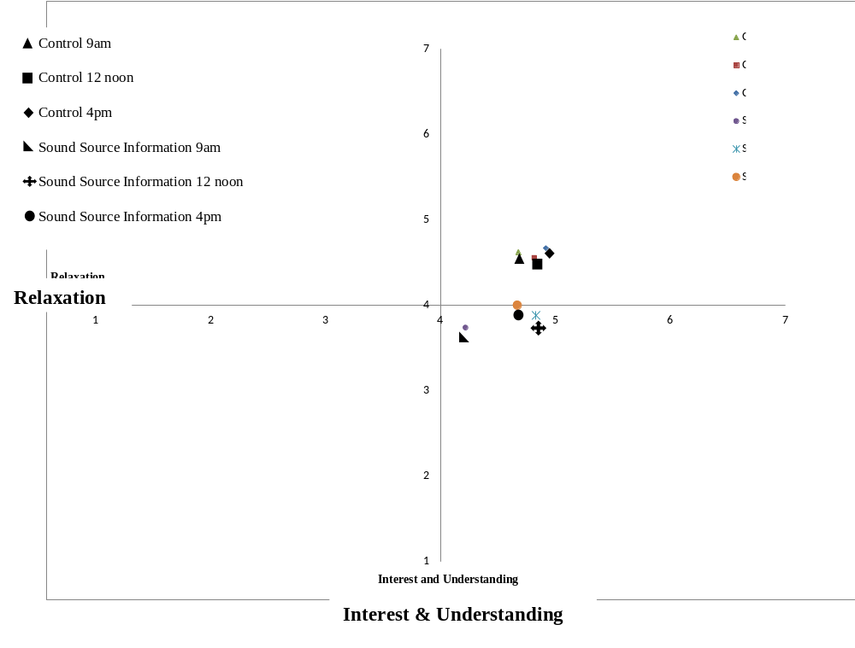
Limitations are acknowledged. Arguably, a semantic differential scale has a number of limitations. Raimbault (2006) suggests that averaging calculations of semantic answers can be misleading as inter-individual differences are not accounted, along with differences in the interpretation of such scales. However, the scales were developed from both interviews and the presented study and therefore should match interpretation and the definition of them.
The scales representing ‘Interest and Understanding’ had weaker internal constancy than the ‘Relaxation’ counter parts. This may limit the reliability of this as a measure and further work would be required to improve the comprehension of them.
The largest limitation was the lack of context. Listening evaluations create a controlled environment to assess perception in a repeatable manner. However, hospitals are complex environments and contextual factors may affect the perception of sounds as a result. Such auditory, visual, and contextual interactions are not investigated here and the emotional-cognitive perceptual framework should tested in-situ within a ward environment to explore specifically the ecological validity of the work.
7. Conclusion
The response to hearing a CT ward soundscape can be represented by the emotional-cognitive dimensions of a two dimensional framework. These relate to the emotional feelings of ‘Relaxation’ caused by the soundscape and a more cognitive process of ‘Interest and Understanding’. The results are by no means conclusive but offer the ability to be used as a way to map interventions in an effort to improve the perception of a hospital ward soundscape. This moves away from the negative association of sound and noise in these spaces, to consider positive sound rather than the absence of sound. The extracted dimensions relate to notions of a healing environment, particularly relaxation, which can be used as a rationale to improve the hospital soundscape. The authors have successfully carried positive interventions based on the framework described here, which provides a new way to examine and consider sound within these spaces. Future work can carry this forward.
Acknowledgements
The authors would like to thank University Hospital, Coventry UK for their help with this project. This research was funded through the UK’s Engineering and Physical Sciences Research Council and the Warwick Innovative Manufacturing Research Centre at WMG, University of Warwick.

References
Akansel, N., and Kaymakci, S., 2008. Effects of intensive care unit noise on patients: A study on coronary artery bypass graft surgery patients. Journal of Clinical Nursing, 17, 1581-1590.

Axelsson, O., Nilsson, M.E., and Berglund, B., 2010. A principal components model of soundscape perception. The Journal of the Acoustical Society of America, 128 (5), 2836-2846.

Bailey, E., and Timmons, S., 2005. Noise levels in PICU: An Evaluative Study. Paediatric Nursing, 17 (10), 22-26.

Berlund, B., Lindvall, T., and Schewela, D., 2000. Guidelines for Community Noise. Geneva, Switzerland: World Health Organisation.

Brace, N., Kemp, R., and Snelgar, R., 2006. Spss for Psychologists: A Guide to Data Analysis using SPSS for Windows (Versions 12 and 13). 3rd Edition. Palgrave Macmillan, Basingstoke, UK, pp 311.

Busch-Vishniac, I. J., West, J. E., Barnhill, C., Hunter, R, T., Orellana, D., and Chivukula, R., 2005. Noise levels in Johns Hopkins Hospital. Journal of the Acoustical Society of America, 118, 3629-3645.

Cain, R., Jennings, P., and Poxon, J., 2013. The development and application of the emotional dimensions of a soundscape. Applied Acoustics, 74 (2), 232-239.
Catchpole, K., and Mckeown, D., 2007. A framework for the design of ambulance sirens. Ergonomics, 50 (8), 1287-1301.

Davies, W., Adams, M., Bruce, N., Cain, R., Carlyle, A., Cusack, P., Hall, D., Hume, K., Irwin, A., Jennings, P., Marselle, M., Plack, C., and Poxon, J., (2013). Perception of soundscape: An interdisciplinary approach. Applied Acoustics, 74 (2), 224-231.
Dawson, D. 2005. The problem of noise and the solution of sound? Intensive Critical Care Nursing, 21, 197-8.

Department of Health Gateway Review, Estates and Facilities Division. 2008. Health Technical Memorandum 08-01: Acoustics. Department of Health, Leeds, UK.

Douglas, C.H., and Douglas, M.R., 2005. Patient-centred improvements in health-care built environments: Perspectives and design indicators. Health Expectations, 8, 264-276.

Dijkstra, K., Pieterse, M., and Pruyn, A., 2006. Physical environmental stimuli that turn healthcare facilities into healing environments through psychologically mediated effects: Systematic Review. Journal of Advanced Nursing, 56, 166-181.

Field, A., 2009. Discovering statistics using SPSS. 3rd Edition. Sage Publications, London, UK, pp 647,671.

Gesler, W., Bell, M., Curtis, S., Hubbard, P., and Francis, S., 2004. Therapy by design: evaluating the UK hospital building program. Health and Place, 10 (2),117-128.

Guillen, J. D., and Lopez Barrio, I., 2007. The Soundscape Experience. Preceedings of the 19th International Congress on Acoustics 2007, 2-7th September. Madrid, Spain.

Hall, D.A., Irwin, A., Edmondson-Jones, M., Phillips, S., and Poxon, J.E.W., 2013. An exploratory evaluation of perceptual, psychoacoustic and acoustical properties of urban soundscapes. Applied Acoustics, 74 (2), 248-254.

Harris, D., Chan-Pensley, J., and McGarry, S., 2005. The development of a multidimensional
scale to evaluate motor vehicle dynamic qualities. Ergonomics, 48 (8), 964-982.

Hartono, M., and Chuan, T.K., 2011. How the Kano model contributes to Kansei engineering in services. Ergonomics, 54 (11), 987-1004.

Humphreys, L., Giudice, S., Jennings, P., Cain, R., Song, W., and Dunne, G., 2011. The influence of company identity on the perception of vehicle sounds. Ergonomics, 54 (4), 338-346.

Irwin, A., Hall, D., Peters, A., and Plack, C., 2011. Listening to urban soundscapes: Physiological validity of perceptual dimensions. Psychophysiology, 48 (2), 258-268.

Jennings, P., and Cain, R., 2013. A framework for improving urban soundscapes. Applied Acoustics, 74 (2), 293-299.

Jennings, P., Dunne, G., Williams, R., andGiudice, S., 2010. Tools and techniques for understanding the fundamentals of automotive sound quality. Proceedings of the institution of mechanical engineers, Part D: Journal of Automobile Engineering, 224 (d10), 1263-1278.

Kidd, G.R., and Watson, C.S., 2003. The perceptual dimensionality of environmental sounds. Noise Control Engineering Journal, 51 (4), 884-6.

Mackrill, J., Cain., R., and Jennings, P., 2013ª. Experiencing the hospital ward soundscape: Towards a model. Journal of Environmental Psychology, 36, 1-8.

Mackrill, J., Cain, R., Jennings, P., England, M., 2013^{b}. Sound source information to improve cardiothoracic patients’ comfort, British Journal of Nursing, 22 (7), 387-393.

Minckley, B.B., 1968b. A study of noise and its relationship to patient discomfort in the recovery room. Nurse Research, 17, 247-50.

Momtahan, K., Hetu, R., and Tansley, B., 1993. Audibility and identification of auditory alarms in the operating room and intensive care unit. Ergonomics, 36 (10), 1159-1176.

Monti, F., Agostini, F., Dellabartola, S., Neri, E., Bozicevic, L., and Pocecco, M., 2012. Pictorial intervention in a paediatric hospital environment: Effects on parental affective perception of the unit. Journal of Environmental Psychology, 32, 216-224.

Okcu, S., Ryherd, E.E., Zimring, C., and Samuels, O., 2011. Soundscape evaluations in two critical healthcare settings with different designs. Journal of the Acoustical society of America, 130, 3, 1348-1358.

Osgood, C.E., Suci, G.J., and Tannenbaum, P.H., 1957. The measurement of meaning. Urbana: University of Illinois Press. pp 1-125.

Oxford English Dictionary. 2005. 3rd Edition. Accessed online: http://www.oed.com/ (last viewed 10/2/12).

Poxon, J., Jennings, P., and Cain, R., 2009. Creation and use of a simple method for displaying and analysing soundscape recordings. Preceedings of Inter-noise 2009, 23-26th August. Ottawa, Canada.

Raimbault, M., 2006. Qualitative judgements of urban soundscapes: Questionning, questionnaires and semantic scales. Acta Acustica United with Acustica, 92, 929-937.

Raymer, K.E., Bergstrom., and Nyce, J.M., 2012. Anaesthia monitor alarms: a theory-driven approach. Ergonomics. 55(12), 1487-1501.

Russell, J.A., 1980. A circumplex model of affect. Journal of Personality and Social Psychology, 39 (6), 1161-1178.

Rice, T., 2003. Soundselves: An Acoustemology of sound and self in the Edinburgh Royal Infirmary. Anthropology Today, 19, 4-9.

Salandina, A., Arnold, J., and Kornadt, O., 2011. Noise in an intensive care unit. Journal of the Acousitcal society of America, 130, 6, 3754–3760.

Schafer, R.M., 1976. Exploring the new Soundscape. The Unesco Courier, November, 4-8.

Schifferstein, H.N.J., and Desmet, P.M.A., 2007. The effects of sensory impairment on product experience and personal well-being. Ergonomics, 50 (12), 2026-2048.

Siebein, G.W., and Skelton, R., 2009. Soundscape analysis of a neonatal intensive care unit. Proceedings of Inter-noise 2009, 23-26th August. Ottawa, Canada.

Tijunelis, M.A., Fitzsullivan, E., and Henderson, S.O., 2005. Noise in the ED. American Journal of Emergency Medicine, 23, 332-335.

Topf, M., 1985. Personal and environmental predictors of patient disturbance due to hospital noise. Journal of Applied Psychology, 70, 22-28.

Topf, M., and Dillon, E., 1988. Noise-induced stress as a predictor of burnout in critical care nurses. Heart and Lung, 17, 567-573.

Truax, B., 1984. Acoustic Communication. Alex Publishing Corporation, Norwood, New Jersey, USA, pp1-244.

Xie, H., Kang, J., 2010. “The evolving perception of staff on the acoustic environment of Critical Care Units”. Proceedings of Inter-noise 2010, 13-16th June. Lisborn, Portgual.

