etiBsu1209: a comprehensive multiscale metabolic model for Bacillus subtilis
Xinyu Bi^{a,b}, Yang Cheng^{a,b}, Xianhao Xu^{a,b}, Xueqin Lv^{a,b}, Yanfeng Liu^{a,b}, Jianghua Li^{a,b}, Guocheng Du^{a,b}, Jian Chen^{a,b}, Rodrigo Ledesma-Amaro^{c}, Long Liu ^{a,b†}

ªKey Laboratory of Carbohydrate Chemistry and Biotechnology, Ministry of Education, Jiangnan University, Wuxi, 214122, China
^{b}Science Center for Future Foods, Ministry of Education, Jiangnan University, Wuxi, 214122, China.
^{c}Department of Bioengineering and Centre for Synthetic Biology, Imperial College London, London SW7 2AZ, UK
†Corresponding author: Long Liu, Tel: +86-0510-85918312, Fax: +86-0510-85918309, E-mail: longliu@jiangnan.edu.cn.

ABSTRACT
Genome-scale metabolic models (GEMs) have been widely used to guide the computational design of microbial cell factories, and to date, seven GEMs have been reported for Bacillus subtilis, a model gram-positive microorganism widely used in bioproduction of functional nutraceuticals and food ingredients. However, none of them are widely used because they often lead to erroneous predictions due to their low predictive power and lack of information on regulatory mechanisms. In this work, we constructed a new version of GEM for B. subtilis (iBsu1209), which contains 1209 genes, 1595 metabolites, and 1948 reactions. We applied machine learning to fill gaps, which formed a relatively complete metabolic network able to predict with high accuracy (89.3%) the growth of 1209 mutants under 12 different culture conditions. In addition, we developed a visualization and code-free software, Model Tool, for multi-constraints model reconstruction and analysis. We used this software to construct etiBsu1209, a multiscale model that integrates enzymatic constraints, thermodynamic constraints, and transcriptional regulatory networks. Furthermore, we used etiBsu1209 to guide a metabolic engineering strategy (knocking out fabI and yfkN genes) for the overproduction of nutraceutical menaquinone-7, and the titer increased to 153.94 mg/L, 2.2-times that of the parental strain. To the best of our knowledge, etiBsu1209 is the first comprehensive multiscale model for B. subtilis and can serve as a solid basis for rational computational design of B. subtilis cell factories for bioproduction.
Keywords: comprehensive multiscale metabolic model, thermodynamics constraints, enzymatic constraints, transcriptional regulatory network model, Bacillus subtilis

1. INTRODUCTION
Genome-scale Metabolic Models (GEMs) are important mathematical frameworks for analyzing the interactions between genotypes and phenotypes in cells (O'Brien et al., 2015). GEMs have been widely used to explore the interactions between metabolic networks, guide the development of chassis cells, and predict engineering targets for overproducing a variety of biochemicals (Kim et al., 2017). To date, there are annotated genome-wide data and reconstructed GEMs for approximately 6000 microorganisms, including Escherichia coli, Saccharomyces cerevisiae, and Bacillus subtilis. For these classical industrial microorganisms several generations of GEMs have been built by mining genomic information and with the help of advances in omics technologies (Gu et al., 2019).
B. subtilis is a gram-positive microorganism commonly used as a chassis to produce a variety of enzymes, natural products, functional nutraceuticals, and biomass feedstocks (Su et al., 2020). To date, seven GEMs have been reported for B. subtilis (Table 1). In particular, the central model (Goelzer et al., 2008), iYO844 (Oh et al., 2007), and iBsu1103 (Henry et al., 2009) determined the biomass equation and maximized cellular synthesis. With three updates in genome annotation, the scale of the models was expanded in iBsu1103V2 (Tanaka et al., 2013), and iBsu1147 was used for the metabolic engineering-based design of riboflavin and isobutanol (Hao et al., 2013); interestingly, iBsu1144 was used to guide the synthesis of the serine alkaline protease (Kocabaş et al., 2017). Finally, the enzymatic data of central carbon metabolism was integrated in eciYO844, which was eventually used to design strains producing poly-γ-glutamic acid at high levels (Massaiu et al., 2019). However, the abovementioned GEMs of B. subtilis were constructed based on different database sources and only limited experimental data or functions from the cobra toolbox were used to identify gaps in the metabolic network. Therefore, there existing metabolic networks are still incomplete and show low prediction accuracy.
With the continuously increased availability of biological big data, machine learning has been used in the construction and prediction of GEMs. For example, combining GEM with machine learning to screen biosensors effectively increased tryptophan titers by 74% (Zhang et al., 2020); the integration of convolutional neural network with random forest algorithm can effectively predict the corresponding metabolic pathways of compounds with an accuracy rate of 95.16% (Baranwal et al., 2019); the enzymatic kinetic properties of the metabolic network in a model were elucidated by machine learning (Heckmann et al., 2018). Recently, an automated metabolic model ensemble-driven elimination of uncertainty with statistical learning (AMMEDEUS) was developed to apply machine learning to identify structural changes in the model with the greatest impact on the simulations (Medlock and Papin, 2020). This function informs about which parts of the model needs to be changed to further improve predictability.
Flux balance analysis (FBA) is the most widely used algorithm for characterizing model phenotypes (Orth et al., 2010), however it has limitations in calculating enzyme catalytic capacity, exploring the feasibility of metabolic reaction fluxes, and characterizing genetic perturbations under environmental conditions. To overcome these issues, multiple constraints and omics data have been incorporated into models. For example, thermodynamically based flux equilibrium analysis (TFA) couples each reaction direction in the model with the Gibbs free energy of the reactions in the metabolic network to resolve infeasible predictions of the reversibility of reactions in the model (Henry et al., 2007; Salvy et al., 2019). Genome-scale models with Enzymatic Constraints using Kinetic and Omics data (GECKO) incorporate the kinetic parameters of enzymes into metabolic reactions (Sanchez et al., 2017), adding enzyme abundance constraints to the reactions in the model to reveal the effects of the catalytic activities of enzymes on metabolic regulation. Probabilistic regulation of metabolism (PROM) can directly integrate transcriptional regulatory networks and metabolic networks during modeling to explore the effect of gene expression on metabolic fluxes under dynamic environmental signals (Chandrasekaran and Price, 2010). However, a comprehensive multiscale GEM integrating multiple constraints and omics has not yet been reported for B. subtilis.
In this study, we constructed an updated version of the GEM based on the latest B. subtilis 168 genome annotation, named iBsu1209. We filled gaps by machine learning tool AMMEDEUS and visualized the metabolic network by BiKEGG. We developed a graphical user interface based on GECKO, matTFA and PROM, called Model Tool, for the construction and analysis of multiscale GEMs with multiple omics and constraints. Based on this, we constructed a comprehensive metabolic model, etiBsu1209, integrating enzymatic constraints, thermodynamic constraints, and transcriptional regulatory networks from B. subtilis (Fig. 1). The simulation results showed that etiBsu1209 effectively reduced the solution space through multiple constraints and improved the prediction accuracy of the model. In addition, we used etiBsu1209 to guide a metabolic engineering strategy to improve the production of menaquinone-7 (MK-7), which increased to 2.2 times that of the parental strain. etiBsu1209 provides new insights into B. subtilis metabolism and theoretical guidance for the computational design of model-driven chassis cells for bioproduction. Further, Model Tool can be generally used to construct comprehensive multiscale models for the other organisms and strains without the need of computational skills.

2. MATERIALS AND METHODS

2.1 Multiple constraints of the model
The stoichiometry and rate constraints were added to the model for flux balance analysis (Orth et al., 2010) as follows:
（2）
（1）
$$S∙v=0$$
$$lb≤v≤ub$$
where S is the stoichiometric matrix of a metabolic network, v is the rate of metabolic flux, and the equation represents steady-state mass balance constraints of the stoichiometric matrix. Moreover, lb and ub represent the flux of the lower and upper bounds, respectively, wherein the lower bounds were set as 0 and the upper bounds were set as 1000. In particular, the substrate uptake reaction (such as the consumption of glucose, oxygen, or ammonia) could be set at a specific value according to the actual situation of cell growth.
The enzymatic constraints of the model were added based on the GECKO toolbox (Sánchez et al., 2017) according to the following formula:
$$\frac{1}{k_{cat}^{ij}}∙v_{j}+e_{i}=0$$
$$0≤e_{i}≤[E_{i}]$$
$$v_{j}≤k_{cat}^{ij}∙[E_{i}]$$
（3）
（5）
（4）
where v_{j} is the metabolic flux of reaction j, e_{i} is the enzyme cost of a reaction i, k_{cat} is the turnover number of E_{i} catalyzing reaction j, and [E_{i}] is the intracellular concentration of E_{i}.
Furthermore, thermodynamic constraints were applied using the following equations, according to the previous studies (Soh and Hatzimanikatis, 2014):
（6）
（7）
（8）
$$∆_{r}G_{i}^{'}=∆_{r}G^{'o}+\sum_{j=1}^{m}{μ_{j}}$$
$$μ_{j}=∆_{f}G_{i}^{'o}+RTln\left(\prod_{j=1}^{m}{x_{j}^{n_{i,j}}}\right)$$
$$\frac{∆_{r}G_{i}^{'}}{(1-z_{i})}<K$$

At pH 7.0, ionic strength of 0.25 M, and temperature of 298.15 K, the standard-transformed Gibbs free energy of the reaction, ΔG°, is a constant. Moreover, Δ_{r}G_{i}′ is the transformed Gibbs energy of reaction i, which is a function of the chemical potentials of its reaction μ_{j}. These two parts form a general expression for the Gibbs free energy of a reaction, as shown in Eq.6. In Eq. 7, R and T represent the universal gas constant and reaction temperature, respectively, whereas the chemical potential of the reactants is a function of the standard-transformed Gibbs free energy of the formation of the compound Δ_{f}G_{i}′°. The binary “flux usage” variable (zi) was introduced to determine the directionality of the Gibbs-energy-determined reaction. To formulate on–off variables and condition ranges, a constant K value with an arbitrarily large value was introduced. Eq. 8 implements thermodynamic constraints exclusively for reactions (r > 0) involved in the metabolic path of the model.

2.2 Collection of model data
iBsu1209 model reconstruction was based on the updated version of iBsu1147 (Hao et al., 2013), the new gene–metabolite–reaction data retrieved from KEGG, ModelSEED, BioCyc, and other databases, and the updated genome annotations of B. subtilis 168 (Borriss et al., 2018; Brito et al., 2018). The Gibbs energies of the reactions were downloaded from the ModelSEED by python scripting and the API of the eQuilibrator. The k_{cat} parameters were retrieved from the BRENDA, SABIO-RK, and UniProt databases using the functions of GECKO Toolbox. Moreover, the protein abundance data were downloaded from the PaxDb database and were used for constraining the enzyme levels in the model. The transcriptional regulation data were obtained via the following two methods: first, mining from the literature on transcriptional regulatory network models (Arrieta-Ortiz et al., 2015; Koo et al., 2017; Leyn et al., 2013; Rychel et al., 2020); second, retrieving data from transcriptional regulatory databases, such as DBTBS, RegPrecise, and SubtiWiki.

2.3 Model reconstruction and parameter processing
All models were built using the 96-step procedure for metabolic network reconstruction (Thiele and Palsson, 2010). The reconstruction was assembled using the MATLAB software platform, and the analysis of iBsu1209 was performed using the COBRA Toolbox (Navid, 2022). The filling of gaps in the model was performed using AMMEDEUS (Medlock and Papin, 2020). Furthermore, BiKEGG was used for visual flux analysis of metabolic networks (Jamialahmadi et al., 2016). The gene and metabolite data of B. subtilis were collected from multiple databases using web crawler prepared in this study.
After collecting all enzymatic data for B. subtilis 168, the process of integrating enzymatic constraints in iBsu1209 was performed according to the scripts of the GECKO Toolbox, which mainly included eight steps, such as modifying model format, matching enzymatic data, and building enzymatic constraint model. To avoid the problem of excessive model constraints, the model’s enzyme flux was scaled according to the literature (Sanchez et al., 2017) and actual model simulations. Moreover, the process of integrating thermodynamic constraints and transcriptional regulatory network models in iBsu1209 was performed according to the scripts of the matTFA Toolbox (Salvy et al., 2019) and PROM function (Chandrasekaran and Price, 2010). Additional details can be found in Supplementary Methods.

2.4 Development of Model Tool
Using the GUI of MATLAB as the platform, the main codes of GECKO toolbox, matTFA and PROM toolbox were integrated, and appropriate modifications were made to develop a visual code-free multi-constraint model building and analysis software. Additional details can be found in Supplementary Methods. The code for Model Tool and analysis of the model is available at https://github.com/bixinyuJN/Model_Tool.

2.5 Simulation analysis of the model
The COBRA Toolbox was used to assess the quality of the model. FBA was used to simulate all experimental conditions and validate iBsu1209. A comparison of the ¹³C metabolic flow analysis of the experimental data (Kleijn et al., 2010; Ruhl et al., 2012; Rühl et al., 2012; Ruhl et al., 2010) revealed that the uptake rates of key metabolites in the model, such as glucose and pyruvate, were limited to 5–10 mmol gDW⁻¹h⁻¹. To explore the robustness of the biomass growth rate of the model, the uptake rates of glucose and oxygen were changed within the range of 0–5 mmol gDW⁻¹ h⁻¹. The range of reaction flux in the model was determined by the fluxVariability function under specific simulation conditions. To simulate the growth of mutant strains under different culture conditions, the singleGeneDeletion function was used for growth simulation after gene knockout. The predicted result was compared with the experimental data for B. subtilis (Koo et al., 2017). Before the model simulated the gene knockout, the culture medium was modified according to previous studies (Koo et al., 2017). Additional details can be found in Supplementary Methods. In the MK-7 synthesis reaction, the calculation of the enzyme cost is based on the ECM algorithm (Noor et al., 2016), and the calculation of the thermodynamic driving force is based on the OptMDFpathway function (Hädicke et al., 2018). PCC was used as a metric to evaluate the correlation between model simulation values and experimental data. To simulate the relationship between cell growth and substrate utilization, the model set the uptake of glucose as the sole carbon source and several essential inorganic compounds and oxygen as fixed values, according to the literature (Hao et al., 2013; Oh et al., 2007). MEMOTE (https://memote.io/) was used to assess the quality of the models (Lieven et al., 2020).

2.6 Strains and media
The strains BS3A was developed by Cui et al (Cui et al., 2019). All strains were cultivated in Luria−Bertani (LB) liquid culture or on LB agar plates at 37 °C for genetic experiments. LB medium consisted of 10 g L⁻¹ Tryptone, 5 g L⁻¹ yeast extract and 5 g L⁻¹ NaCl. The culture medium used for MK-7 production was as described previously by Cui et al (Cui et al., 2019). The fermentation medium consisted of 50 g L⁻¹ glucose, 50 g L⁻¹ sucrose, 50 g L⁻¹ soy peptone, and 0.6 g L⁻¹ KH₂PO₄. The components of the M9 minimal medium can be found in Norizan et al (Norizan et al., 2020). The M9 minimal medium consisted of 3 g L⁻¹ g glucose, 0.1 mM CaCl₂, 1 mM MgSO₄, 0.05 mM FeCl₃, 8.5 g L⁻¹ Na₂HPO₄·2H₂O, 3 g L⁻¹ KH₂PO₄, 1 g L⁻¹ NH₄Cl, 0.5 g L⁻¹ NaCl, 1 mg L⁻¹ MnCl₂, 1.7 mg L⁻¹ ZnCl₂, 0.43 mg L⁻¹ CuCl₂·2H₂O, 0.6 mg L⁻¹ CoCl₂·6H₂O and 0.6 mg L⁻¹ Na₂MoO₄·2H₂O. All chemicals were purchased from Sangon Biotech Co., Ltd (Shanghai, China). All the strain used in this study are listed in Table S1. All the primers used in this study were synthesized by GENEWIZ (Suzhou, China), and listed in Table S2.

2.7 DNA manipulation
The method used for gene knockout was the same as that reported by Cui et al (Cui et al., 2019). Briefly, approximately 1, 000 bp of sequences upstream and downstream of the deletion target in B. subtilis genome were amplified. Subsequently, fusion PCR was performed to join the two fragments with the lox71-zeo-lox66 cassette amplified from plasmid p7Z6. Finally, the purified PCR products were used to transform competent B. subtilis cells.

2.8 Culture conditions and analytical methods
The culture conditions and analytical methods used for MK-7 production in recombinant strains are described in the methods reported by Cui et al (Cui et al., 2019). Briefly, engineered strains were cultured in 250 mL flasks containing 20 mL of fermentation medium and shaken at 220 rpm and 40 °C for 7 days. Cell density was determined from the optical density at 600 nm with a spectrophotometer. Glucose concentrations in the culture medium were measured with glucose-glutamate analyzer (SBA-40C; Biology Institute of Shandong Academy of Sciences, Shandong, China). MK-7 concentrations were determined using C18 ODS column (5 μm, 250 × 4.6 mm, Thermo Fisher Scientific, Waltham, MA, USA) and High-performance liquid chromatography (Agilent 1260, Santa Clara, CA, USA) at 40 °C and the wavelength of 254 nm. Methanol: dichloromethane (9:1, v/v) was used as the mobile phase at flow rate of 1 mL min⁻¹.

2.9 Statistical analysis
All experiments were independently carried out at least three times, and the results were expressed as mean ± standard deviation (SD). All the statistical evaluation (p-value) was performed by two-sided t-test, *p< 0.05, **p< 0.01, ***p< 0.001.

2.10 Tool for model construction and analysis
All software and functions used for model construction and analysis in this study are listed in Table S3.

3. RESULTS

3.1 Reconstruction of iBsu1209
To construct the latest GEM of B. subtilis, we conducted the following three tasks (Fig. 2a). First, the latest B. subtilis 168 genome annotations and metabolic reactions were retrieved from the literature (Borriss et al., 2018; Brito et al., 2018) and various databases, such as KEGG, BsubCyc, and SubtiWiki, and normalize them in Bigg database form; subsequently, we constructed the draft model by integrating the collected data, which included 1198 genes, 2290 metabolites, and 2435 reactions (Table S4, 5). Next, we identified the necessary genes and reactions from the previously reported model, iBsu1147. Partial reactions in iBsu1147 were removed using metabolic flux analysis, including 118 ineffective macromolecular membrane transporters [such as 3-(n-morpholino) propanesulfonic acid, lanthionine, and hexanesulfonate] and orphan reactions (reactions without known associated genes, such as the degradation of 3-methyl-2-oxobutanoic acid, isobutyraldehyde, and isobutanol) (Table S6). Then, we integrated the draft model with iBsu1147 to construct the updated model, iBsu1209.
Next, we filled gaps in the network of iBsu1209 by machine learning (AMMEDEUS) (Medlock and Papin, 2020) (Fig. 2b, Fig. S1). Compared with traditional gapfilling in bottom-up reconstruction, AMMEDEUS provides a more efficient method of gap filling, removing unnecessary reactions from the target database (Machado et al., 2018). Briefly, growth phenotype data were used to evaluate biomass equations by knocking out single genes in the model. Then, K-means was applied to distinguish the presence or absence of responses in the simulated clusters of the model, which were prioritized as the input to the next layer. Finally, the random forest algorithm was used to draw reactions from a set of 1000 given models to fill the gap in the simulated growth, and the process was performed iteratively until the model was able to grow under all conditions. In the prioritized reactions list of the analysis results, the highest fractional importance with a cluster ratio of 1 was succinate: quinone oxidoreductase, which is involved in the generation of fumarate from succinate. Finally, we visualized each complementary reaction in the prioritized reaction list by BiKEGG (Jamialahmadi et al., 2016) (Fig. 2c). Accordingly, we added 336 reactions, including the hydrogen carbonate phosphorylation of adenosine 5′-triphosphate, ubiquitination of reduced nicotinamide adenine dinucleotide, and quinone redox reaction of nitrite (Table S6).
In total, the refined iBsu1209 contained 1209 genes, 1595 metabolites and 1948 reactions, including 63 new genes, 136 new metabolites, and 336 new reactions compared with iBsu1147 (Table S7, 8). The main features of iBsu1209 are listed in Table 2.
Moreover, information on protein structure and gene expression and regulation were incorporated in iBsu1209. To improve the prediction range of iBsu1209, we added 1096 protein domain annotations from Protein Data Bank and UniProt. Moreover, 1090 gene expression product annotations and 1029 gene function annotations from SubtiWiki and BSubCyc were added in the model. This implies that each gene in iBsu1209 is connected to the gene expression product, its catalysis data, and protein structure (Table S9).

3.2 Validation of iBsu1209
To demonstrate the prediction accuracy of iBsu1209, we first predicted growth phenotypes on different carbon, nitrogen, phosphorus and sulfur sources. Under minimal medium-based conditions, we simulated growth on the substrate by altering one of the abovementioned four sources and setting its specific uptake rate at 10 mmol gDW⁻¹ h⁻¹. Compared with iBsu1147, the proportion of carbon sources supporting growth in iBsu1209 was significantly increased from 66.9% (117/175) to 71.4% (125/175) (Table 3). Among 93 possible nitrogen sources in the model, 57 were predicted to support growth in iBsu1147, whereas this number was 62 in iBsu1209, representing a 5.4% increase. In addition, iBsu1209 contained the same number of growth-supporting phosphorus and sulfur sources as iBsu1147. It is important to notice that model predictions are often impaired by the fact that not all energy sources in the model can be utilized by cells, and not all compounds are transported into cells. To further determine the accuracy of the model, we compared the predicted values of the model with experimental growth data on different carbon, nitrogen and phosphorus sources. The corresponding experimental growth data was available from the existing literature (Hao et al., 2013; Oh et al., 2007). We found that iBsu1209 could predict the correct substrate utilization rate in 83% (20/24), whereas iBsu1147 could do so in 79% (19/24) (Table S10). Besides, the quality of the models, iBsu1209 and iBsu1147, was evaluated and compared with metabolic model tests (MEMOTE) (Lieven et al., 2020). The score of iBsu1209 significantly increased to 71%, 3.9-times that of iBsu1147 (18%), by adding stoichiometric consistency and annotation of reactions and metabolites (Fig. S2).
GEM can also be used to predict the effects of genetic perturbations on cell growth. To validate iBsu1209, we simulated cell growth after knocking out all genes (1209) in iBsu1209 under 12 different culture conditions. Subsequently, we identified 202 essential genes in iBsu1209, 128 of which were essential under specific conditions. Compared with the 123 out of 198 essential genes included in iBsu1147, the gene range and prediction accuracy of iBsu1209 were improved. Moreover, among the 349 major metabolites of B. subtilis, iBsu1209 contained 176, representing an increase of 20 metabolites compared with iBsu1147 (Fig. S3). Notably, iBsu1209 predicted gene essentiality in the 12 conditions with an accuracy of 89.3%—12,869 out of 14,412 phenotypes were correctly predicted compared to experimental data (Fig. 2d, Table S11). iBsu1147 cannot predict growth when cultured with a single carbon or nitrogen source because its incomplete metabolic network. Therefore, we compared the growth of mutant strains in the two models under Luria–Bertani culture conditions, for which the growth prediction accuracy reached 92.9% (1124/1209) in iBsu1209 vs. 86.7% (995/1147) in iBsu1147 (Table S12). Next, we calculated the metabolic fluxes of 12 different carbon sources into the central carbon metabolism. Compared to the pentose phosphate pathway, the model had higher accuracy in the Embden–Meyerhof pathway and tricarboxylic acid (TCA) cycle by comparing the simulated values with the experimental data (Fig. S4).
Next, we compared the model-predicted metabolic flux distributions with ¹³C-traced metabolic flux data of B. subtilis cultured in minimal medium containing different carbon and nitrogen sources (Kleijn et al., 2010; Ruhl et al., 2012; Ruhl et al., 2012; Ruhl et al., 2010) (Fig. 2e). The biomass equation was used as the objective function, and all flux data were normalized to the uptake rate (100%) of carbon and nitrogen sources. Comparing the different inputs of glucose, ammonia, and malate, the Pearson’s correlation coefficient (PCC) between the experimental value and iBsu1209 simulation was >0.9, indicating that iBsu1209 provides accurate intracellular flux distribution in different culture conditions (Fig. 2e). Notably, iBsu1209 provided accurate metabolic predictions of central carbon metabolism in glucose and ammonia, and when compared with the experimental data the PCC reached 0.97. However, the absence of a critical reaction in iBsu1147, i.e., the reaction from succinic acid to fumaric acid in the TCA cycle (ModelSEED ID rxn06109), where the PCC was 0, led to a failed prediction due to the disruption of succinic acid metabolism.

3.3 Development of Model Tool
At present, the construction and analysis of models requires users to be proficient in one or more programming languages, but this is a huge challenge for many experimental scientists and non-computationally skilled users. To facilitate model building and analysis, we developed a general-purpose graphical user interface (GUI) application (Model Tool) that allows users to not only construct enzymatic constraint models, thermodynamic constraint models, and metabolic models integrating transcriptional regulatory networks but also analyze the metabolic flux of the models in a code-free and visual manner (Fig. 3a).
Model Tool uses MATLABR2021a as the platform, and includes three model-building modules—Build Enzymatic Constraint Model, Build Thermodynamic Constraint Model, and Integrate Transcriptional Regulatory Network—and a model-analysis module—Metabolic Flux Analysis of Model. Users can click on the corresponding buttons to navigate through the processes of model building and analysis using pop-up prompts in the operation interface (Fig. 3b). Briefly, in the model-building module, we simplified the core codes of the GECKO Toolbox, matTFA and PROM, so users can perform model construction without complicated model-format modifications and the collection of data from databases. In the Model-analysis module, Users can input multiple model conditions in the corresponding text box according to actual cell growth requirements and then perform metabolic flux analysis including FBA and flux variability analysis (FVA). Finally, all the running results in the software are saved in Excel or mat format at the location where the software has been installed.

3.4 Construction and characterization of etiBsu1209 using Model Tool
Using Model Tool, we constructed etiBsu1209, an iBsu1209-based comprehensive multiscale metabolic network model of B. subtilis that integrates enzymatic constraints, thermodynamic constraints, and transcriptional regulatory network models (Fig. 3c, Table 4). etiBsu1209 includes 1209 genes, 4167 metabolites, and 6295 reactions. In addition to expanding the model size, etiBsu1209 also covers Gibbs free energy of 2327 reactions, and 2049 enzymes, including 450 isozymes and 337 transcription factors, which led to the mapping of 15955 transcriptional regulatory networks (Table S13-16). We mapped the undirected networks of metabolites using Cytoscape to calculate model connectivity and calculated the associated connectivity indices for iBsu1209 and etiBsu1209 (Fig. 3d). Although the addition of enzymes and putative metabolites expanded the nodes and edges of the metabolic network in etiBsu1209, it also decreased the clustering coefficients (Table 5).
In etiBsu1209, we simulated the biosynthesis of 2049 enzymes coupled to 765 related genes in 2749 reactions by collecting enzymatic data for B. subtilis. Notably, we retrieved 996 isozymes from different strains of B. subtilis, making the model not limited to B. subtilis 168 (Table S17, 18). Enzyme constraints were specified by coupling reaction and enzyme kinetic data, which require information on the k_{cat} value and protein abundance. We analyzed the data of 2049 enzymes with k_{cat} values covering 12 orders of magnitude, with a median value of 1.494 × 10^{–5} s^{–1}, and enzyme abundance spanning 3 orders of magnitude, with a median value of 36.01 kDa (Fig. 3e). Among these enzymes, 88 were transporters associated with 141 transport reactions (Table S17).
We estimated the Gibbs free energies of 4176 unique metabolites in etiBsu1209 using the eQuilibrator database and determined the Gibbs free energies of 2327 reactions by comparing eQuilibrator and ModelSEED databases (Table S13). Notably, almost all reactions with no added free energy in the model were exchange reactions, transport reactions, enzyme-exchange reactions. We did not apply thermodynamic constraints to the metabolic reactions for enzymatically constrained splits because the chemical structures of the putative metabolites of the ligation split reactions are not sufficiently defined to allow Gibbs free energy calculations using the group contribution method.
We explored the effect of transcriptional regulation on the model’s metabolic network analysis using PROM. We constructed a regulatory network based on the role of transcription factors by integrating multiple transcriptional regulatory networks in B. subtilis (Arrieta-Ortiz et al., 2015; Koo et al., 2017; Leyn et al., 2013; Rychel et al., 2020) and relevant databases, such as SubtiWiki and DBTBS. Moreover, for building a comprehensive metabolic network, we collected rich gene expression data, in which transcriptomic data from various environmental and genetic perturbations were included (Koo et al., 2017). We introduced gene expression data and gene–transcription factor interactions to predict that 47 of the 292 transcription factors were able to perturbe 911 growth-related reactions using etiBsu1209 (Fig. 4a). In addition, etiBsu1209 accurately predicted the growth rate of 10 KO phenotypes using PROM, with a correlation coefficient of 0.83 (P < 1e-3; Fig. 4b).
We then analyzed the robustness of the models by exploring the effects on growth rates in the presence of increased glucose and oxygen uptake rates. With the increase of glucose and oxygen supply, the simulated growth rate of etiBsu1209 reached a plateau and then began to decrease, which was consistent with the experimental cell growth trend (Fig. 4c). We observed that the cell growth rates were limited by enzymatic and thermodynamic constraints in etiBsu1209, and the simulated specific growth rate was 0.343 h^{–1} at the glucose uptake rate of 1.82 mmol gDW⁻¹ h⁻¹. Compared to the value of 0.36 h^{–1} detected using the experimental data, the prediction accuracy of etiBsu1209 reached 95.3%, which was 8.7% higher than that of iBsu1209 (Fig. S5).

3.5 Prediction of metabolic flux in the multi-constraints model
To investigate the effects of including or excluding enzymatic and thermodynamic constraints on the prediction accuracy of the model, we developed the following three types of models with the letter “tc” in the model name (tciBsu1209), reflecting that the model contained thermodynamic constraints, the letter “ec” in the model name (eciBsu1209), reflecting that the model contained enzymatic constraints, etiBsu1209 contained both. We assumed that the highest growth rate of the cells could be achieved in M9 minimal medium. Subsequently, we simulated the optimal growth using FBA for the abovementioned three constraint models (Fig. 4d). Compared with iBsu1147, the growth rate simulated by the iBsu1209 model was closer to the experimental value at low glucose uptake rates. Compared with tciBsu1209, the predicted growth rate was affected to a greater extent in eciBsu1209. The simulated growth rates in the enzyme-constrained models (eciBsu1209 and etiBsu1209) stabilized at higher values of glucose uptake rate, which is consistent with the experimental data; moreover, the maximum predicted growth rates of eciBsu1209 and etiBsu1209 were 0.39 h^{–1} and 0.37 h^{–1}, respectively. This difference suggests that the integration of two constraints in etiBsu1209 effectively reduces the flux of infeasible pathways accounting for thermodynamic or enzymatic costs in cell growth simulations. Apparently, the experimental cell growth rate showed a decreasing trend after reaching a maximum of 0.378 h^{–1}; however, the cell growth rate in the model was affected by infinite substrate supply and fixed enzyme activity to ensure that the growth rate remained constant.
To explore the effect of different constraints on the range of predicted fluxes of the model, we further compared the four models—iBsu1209, tciBsu1209, eciBsu1209 and etiBsu1209 with the reported iBsu1147 by performing FVA. Among the 6295 fluxes in etiBsu1209, the variability of 4798 and 1757 reduced following the inclusion of enzyme constraints and thermodynamic constraints, respectively. Among the 4798 fluxes with reduced variability, the mean reduced variability was >90% (Fig. 4e).
In addition, we performed a metabolic flux analysis of the central carbon metabolism of the model and compared it with ¹³C-tracer experimental data to explore specific flux changes for each reaction. As shown in Figure 5, the metabolic fluxes of the different models showed significant differences in the Embden–Meyerhof pathway, pentose phosphate pathway, and TCA cycle. In the Embden–Meyerhof pathway, there was a clear increase in the metabolic flux of glyceraldehyde-3-phosphate (GAP) in the experimental data, which was consistent with the simulated value of etiBsu1209. However, in iBsu1147, the metabolic flux of GAP was a negative value, leading to the wrong prediction of the downstream effect of the Embden–Meyerhof pathway and TCA cycle. We speculate that this was due to the reaction directionality being wrong in this model. It was clearly observed that the addition of thermodynamic constraints effectively narrowed the metabolic flux range in the model. For instance, the metabolic flux of GAP in tciBsu1209 was reduced from 996 to 30 mmol gDW⁻¹ h⁻¹ when compared with iBsu1209, whereas in etiBsu1209, it was reduced from 1000 to 200 mmol gDW⁻¹ h⁻¹ when compared with eciBsu1209. However, the metabolic flux of phosphoenolpyruvate in eciBsu1209 increased from 10 to 700 mmol gDW⁻¹ h⁻¹ compared with the experimental value of 221 mmol gDW⁻¹ h⁻¹, whereas the metabolic flux of the model without enzyme constraints (iBsu1209 and tciBsu1209) was below 100 mmol gDW⁻¹ h⁻¹. The observed higher metabolic flux can be justified by the fact that phosphoenolpyruvate is linked to pyruvate, a key metabolite in central carbon metabolism，which was consistent with the experimental data (Fig. 5). In addition to the central carbon cycle, we also simulated the synthesis of 10 glucose-based metabolites. The synthesis rate of metabolites in etiBsu1209 is lower than that in iBsu1209, indicating that multiple constraints are limiting factors in the synthesis of metabolites and make the simulated values more closer to the experimental data (Fig. S6). In summary, etiBsu1209 added thermodynamic constraints and enzymatic constraints to limit the range of metabolic fluxes and effectively solved issues related to abnormal metabolic fluxes.

3.6 Model-driven metabolic engineering to increase MK-7 production
MK-7 is a highly medicinal vitamin K2 that is widely used to prevent osteoporosis, arterial calcification, and cardiovascular disease (El Asmar et al., 2014). MK-7 is composed of a quinone skeleton and a variable side chain (C35). The quinone skeleton is synthesized via the chorismate pathway, whereas the variable side chain (C35) is derived from the isoprenoid pathway. Since the synthesis of MK-7 in B. subtilis is linked to the biomass equation, it is difficult to rationally identify novel targets for metabolic engineering strategies based on traditional GEMs, such as iBsu1147. To further investigate the optimal synthetic pathway of MK-7, we calculated the enzymatic cost and thermodynamic driving force of the MK-7 synthesis reaction (Fig. 6a, b). We found that the high enzymatic cost required for the conversion of pyruvate to 3-dehydroquinate, which diverts energy to other overflow pathways, may hinder the production of MK-7. Therefore, targeting precursor supply could be an engineering strategy to enhance MK-7 production.
To investigate whether etiBsu1209 is an effective tool for designing metabolic engineering strategies in B. subtilis, we calculated the key targets of MK-7 biosynthesis in the metabolic network using optKnock (Fig. 6a, b) (Burgard et al., 2003). Through the analysis of the MK-7 biosynthesis pathway, we predicted four target genes to be knocked out, including fabI (encoding enoyl-(acyl-carrier protein) reductase I), yfkN (encoding 2',3'-cyclic nucleotidase), pucL (encoding 2-oxo-4-hydroxy-4-carboxy-5-ureidoimidazoline decarboxylase), and Udk (encoding uridine kinase). The combinatorial deletions of these four genes were performed in both strain MK-7-producing BS3A developed by Cui et al (Cui et al., 2019) (BS3A1 to BS3A14) and B. subtilis 168 (BS1 to BS14). When fabI was knocked out, the titer of MK-7 (111.19 mg/L, BS3A2) in shake flask increased to 1.6-times that of BS3A (69.71 mg/L) (Fig. 6c). As shown in Fig. 6c, blocking fabI may favor the flow of pyruvate to 3-deoxy-arabino-heptulonate 7-phosphate, promoting the synthesis of MK-7. We found that the three recombinant strains, namely, BS3A6 (ΔpucL and ΔUdk), BS3A7 (ΔfabI and ΔpucL), and BS3A8 (ΔfabI and ΔyfkN) significantly improved the production of MK-7. The titer of MK-7 in BS3A8 reached 153.94 mg/L, 2.2-times that of BS3A (Fig. 6d), maybe due to a reduction in overflow pathways. However, the combinatorial deletions of three or four genes (BS3A10 to BS3A14) affected cell growth and resulted in decrease in MK-7 production (Fig. S7).
The above-described knockout strategy for the production of MK-7 was also tested in B. subtilis 168 (BS1), and the titer of MK-7 (27.33 mg/L, BS3) in shake flask increased to 2.9-times that of BS1 (9.36 mg/L) when yfkN was knocked out (Fig. 6d). The knockout of yfkN may block the overflow pathway of 5-phospho-alpha-D-ribose 1-diphosphate, which enhances the conversion of 6-phospho-D-gluconate to heptaprenyl diphosphate and promotes the biosynthesis of MK-7 (Fig. 6b). We also found that the combinatorial deletion of yfkN and Udk genes in the strain BS9 (ΔyfkN and ΔUdk) significantly improved the production of MK-7 to 23.47 mg/L, 2.5-times that of BS1. Similarly, to the BS3A background, the multigene knockout strains in B. subtilis 168 (BS10 to BS14) also showed a marked decrease in MK-7 synthesis (Fig. 6c). These results show that the multiscale model etiBsu1209 can accurately predict the metabolic network of various mutant strains of B. subtilis under different substrates and growth conditions, reflecting the general utibility of etiBsu1209.

4. DISCUSSION
In B. subtilis, seven GEMs have been reported and used to predict key targets to facilitate the synthesis of valuable products. However, the lack of comprehensive genome annotation and well-defined metabolic network relationships may lead to erroneous predictions. In this work, we collected the latest genome annotation data and filled the gaps in the metabolic network using machine learning. Compared with the gap filling methods used in previously reported models, AMMEDEUS conducts single-gene knockout tests starting from the growth phenotype, and iteratively fills the gaps in the model comparing to 1000 ensemble models. We demonstrated that the latest iBsu1209 has a more complete metabolic network, enabling it to predict gene knockout under different culture conditions containing 12 carbon and nitrogen sources with a prediction accuracy of 89.3%.
Although tools for building multi-constraints models have been developed, such as ETGEM (Yang et al., 2021) and ETFL (Oftadeh et al., 2021), nonexperts still need to spend a substantial amount of time learning different programming languages and toolkits. Most importantly, the application of these toolkits in model building often results in errors, which may not be resolved by unskilled users. Here, we created the first visual code-free model building and analysis software (Model Tool) based on the core code of multiple toolkits. Model Tool improves multi-constraints model building and analysis by reducing error transfer between multiple types of constraints, providing data from multiple databases, and designing multi-input analysis methods. Users can follow buttons and pop-up prompts for the code-free visualization of modeling and analysis (Fig. S8). Notably, all modules of the software can be freely combined to build different models according to the needs of the users. Users no longer need to spend time learning specific codes or solving problems when using different scripts. In the future, Model Tool can be expanded to include new modules with novel functionalities.
The applications of GEMs to metabolic engineering are often limited by the lack of regulatory constraints. In this work, we used Model Tool on iBsu1209, to construct the first comprehensive multiscale metabolic model of B. subtilis, which integrates enzymatic constraints, thermodynamic constraints, and transcriptional regulation models. Our study demonstrated that introducing thermodynamic and enzymatic constraints can not only narrow down the feasible solutions in metabolic pathways but also take into account enzyme cost and thermodynamic feasibility. Moreover, we considered the perturbations of transcription factors in the model, expanding the ability of the model to predict metabolic regulation. As a proof of concept, we used etiBsu1209 to design an in silico strategy that once implemented experimentally increased for the production of MK-7.
Overall, etiBsu1209 can serve as a tool for improving our understanding of genotype–phenotype relationships and guide the computational design of metabolic engineering strategies for improved bioproduction. However, there are still limitations, such as the fact that the prediction capcity of the multi-constraints metabolic model is limited to those conditions used to constraint the model and cannot dynamically predict the growth and metabolism. In future work, the use of machine learning to analyze models in dynamic environments will provide more valuable insights on the regulatory mechanisms in B. subtilis (Vohradsky et al., 2021). We envision that etiBsu1209 may act as the basis for the constructing of a whole-cell model of B. subtilis, integrating multiple frameworks to dynamically simulate the entire cell life cycle using deep learning, as it has been achieved in E. coli (Macklin et al., 2020). In summary, the comprehensive multiscale model etiBsu1209 provides insights on the growth and metabolism of B. subtilis and can help rationally design strains for metabolic engineering applications. We anticipate that etiBsu1209 will serve as a powerful computation platform for both fundamental studies and in silico cell factory design of B. subtilis.

ACKNOWLEDGMENTS
This work was financially supported by the Key Research and Development Program of China (2020YFA0908300), the National Natural Science Foundation of China (31870069 and 32021005), and the Fundamental Research Funds for the Central Universities (JUSRP121010, JUSRP52019A, JUSRP221013, and SKLF-ZZB-202106).

AUTHOR CONTRIBUTIONS
X.Y.B., J.C. and L.L. proposed the concept of comprehensive multiscale metabolic model for Bacillus subtilis. X.Y.B. and Y.C. reconstructed the model. X.Y.B., X.H.X. and X.Q.L carried out model optimization. Y.F.L., G.C.D, R.L.A and L.L. made suggestions for the manuscript. All authors participated in writing, review and editing of the manuscript.

Competing interests
The authors declare no competing interests.

REFERENCES
Arrieta-Ortiz, M. L., Hafemeister, C., Bate, A. R., Chu, T., Greenfield, A., Shuster, B., Barry, S. N., Gallitto, M., Liu, B., Kacmarczyk, T., et al., 2015. An experimentally supported model of the Bacillus subtilis global transcriptional regulatory network. Mol. Syst. Biol. 11, 839.
Baranwal, M., Magner, A., Elvati, P., Saldinger, J., Violi, A., Hero, A. O., 2019. A deep learning architecture for metabolic pathway prediction. Bioinformatics. 36, 2547-2553.
Barbe, V., Cruveiller, S., Kunst, F., Lenoble, P., Meurice, G., Sekowska, A., Vallenet, D., Wang, T., Moszer, I., Medigue, C., Danchin, A., 2009. From a consortium sequence to a unified sequence: the Bacillus subtilis 168 reference genome a decade later. Microbiology. 155, 1758-1775.
Belda, E., Sekowska, A., Le Fevre, F., Morgat, A., Mornico, D., Ouzounis, C., Vallenet, D., Medigue, C., Danchin, A., 2013. An updated metabolic view of the Bacillus subtilis 168 genome. Microbiology. 159, 757-770.
Borriss, R., Danchin, A., Harwood, C. R., Medigue, C., Rocha, E. P. C., Sekowska, A., Vallenet, D., 2018. Bacillus subtilis, the model gram-positive bacterium: 20 years of annotation refinement. Microb. Biotechnol. 11, 3-17.
Brito, P. H., Chevreux, B., Serra, C. R., Schyns, G., Henriques, A. O., Pereira-Leal, J. B., 2018. Genetic competence drives genome diversity in Bacillus subtilis. Genome Biol. Evol. 10, 108-124.
Burgard AP, Pharkya P, Maranas CD., 2003. Optknock: a bilevel programming framework for identifying gene knockout strategies for microbial strain optimization. Biotechnol Bioeng. 84, 647-57.
Chandrasekaran, S., Price, N. D., 2010. Probabilistic integrative modeling of genome-scale metabolic and regulatory networks in Escherichia coli and Mycobacterium tuberculosis. Proc. Natl. Acad. Sci. U. S. A. 107, 17845-17850.
Cui, S., Lv, X., Wu, Y., Li, J., Du, G., Ledesma-Amaro, R., Liu, L., 2019. Engineering a bifunctional Phr60-Rap60-Spo0A quorum-sensing molecular switch for dynamic fine-tuning of menaquinone-7 synthesis in Bacillus subtilis. ACS Synth. Biol. 8, 1826-1837.
El Asmar, M. S., Naoum, J. J., Arbid, E. J., 2014. Vitamin k dependent proteins and the role of vitamin k2 in the modulation of vascular calcification: a review. Oman Med. J. 29, 172-177.
Goelzer, A., Bekkal Brikci, F., Martin-Verstraete, I., Noirot, P., Bessieres, P., Aymerich, S., Fromion, V., 2008. Reconstruction and analysis of the genetic and metabolic regulatory networks of the central metabolism of Bacillus subtilis. BMC Syst. Biol. 2, 20.
Gu, C., Kim, G. B., Kim, W. J., Kim, H. U., Lee, S. Y., 2019. Current status and applications of genome-scale metabolic models. Genome Biol. 20, 121.
Hädicke, O., von Kamp, A., Aydogan, T., Klamt, S., 2018. OptMDFpathway: Identification of metabolic pathways with maximal thermodynamic driving force and its application for analyzing the endogenous CO2 fixation potential of Escherichia coli. PLoS Comput. Biol. 14, e1006492.
Hao, T., Han, B., Ma, H., Fu, J., Wang, H., Wang, Z., Tang, B., Chen, T., Zhao, X., 2013. In silico metabolic engineering of Bacillus subtilis for improved production of riboflavin, Egl-237, (R,R)-2,3-butanediol and isobutanol. Mol. Biosyst. 9, 2034-2044.
Heckmann, D., Lloyd, C. J., Mih, N., Ha, Y., Zielinski, D. C., Haiman, Z. B., Desouki, A. A., Lercher, M. J., Palsson, B. O., 2018. Machine learning applied to enzyme turnover numbers reveals protein structural correlates and improves metabolic models. Nat. Commun. 9, 5252.
Henry, C. S., Broadbelt, L. J., Hatzimanikatis, V., 2007. Thermodynamics-based metabolic flux analysis. Biophys. J. 92, 1792-805.
Henry, C. S., Zinner, J. F., Cohoon, M. P., Stevens, R. L., 2009. iBsu1103: a new genome-scale metabolic model of Bacillus subtilis based on SEED annotations. Genome biol. 10, R69.
Jamialahmadi, O., Motamedian, E., Hashemi-Najafabadi, S., 2016. BiKEGG: a COBRA toolbox extension for bridging the BiGG and KEGG databases. Mol. Biosyst. 12, 3459-3466.
Kim, W. J., Kim, H. U., Sang, Y. L., 2017. Current state and applications of microbial genome﹕cale metabolic models. Curr. Opin. Syst. Biol. 2, 9-17.
Kleijn, R. J., Buescher, J. M., Le Chat, L., Jules, M., Aymerich, S., Sauer, U., 2010. Metabolic fluxes during strong carbon catabolite repression by malate in Bacillus subtilis. J. Biol. Chem. 285, 1587-1596.
Kocabaş, P., Çalık, P., Çalık, G., Özdamar, T. H., 2017. Analyses of extracellular protein production in Bacillus subtilis – I: Genome-scale metabolic model reconstruction based on updated gene-enzyme-reaction data. Biochem. Eng. J. 127, 229-241.
Koo, B. M., Kritikos, G., Farelli, J. D., Todor, H., Tong, K., Kimsey, H., Wapinski, I., Galardini, M., Cabal, A., Peters, J. M., et al., 2017. Construction and analysis of two genome-scale deletion libraries for Bacillus subtilis. Cell Syst. 4, 291-305.
Kunst, F., Ogasawara, N., Moszer, I., Albertini, A. M., Danchin, A. J. N., 1997. The complete genome sequence of the gram-positive bacterium Bacillus subtilis. Nature 390, 249-256.
Leyn, S. A., Kazanov, M. D., Sernova, N. V., Ermakova, E. O., Novichkov, P. S., Rodionov, D. A., 2013. Genomic reconstruction of the transcriptional regulatory network in Bacillus subtilis. J. Bacteriol. 195, 2463-2473.
Lieven, C., Beber, M. E., Olivier, B. G., Bergmann, F. T., Ataman, M., Babaei, P., Bartell, J. A., Blank, L. M., Chauhan, S., Correia, K., et al., 2020. MEMOTE for standardized genome-scale metabolic model testing. Nat. Biotechnol. 38, 272-276.
Machado D, Andrejev S, Tramontano M, Patil KR., 2018. Fast automated reconstruction of genome-scale metabolic models for microbial species and communities. Nucleic Acids Res. 6, 7542-7553.
Macklin, D. N., Ahn-Horst, T. A., Choi, H., Ruggero, N. A., Carrera, J., Mason, J. C., Sun, G., Agmon, E., DeFelice, M. M., Maayan, I., et al., 2020. Simultaneous cross-evaluation of heterogeneous E. coli datasets via mechanistic simulation. Science. 369, eaav3751.
Massaiu, I., Pasotti, L., Sonnenschein, N., Rama, E., Cavaletti, M., Magni, P., Calvio, C., Herrgard, M. J., 2019. Integration of enzymatic data in Bacillus subtilis genome-scale metabolic model improves phenotype predictions and enables in silico design of poly-gamma-glutamic acid production strains. Microb. Cell Fact. 18, 3.
Medlock, G. L., Papin, J. A., 2020. Guiding the refinement of biochemical knowledgebases with ensembles of metabolic networks and machine learning. Cell Syst. 10, 109-119.
Navid, A., 2022. A beginner's guide to the COBRA Toolbox. Methods Mol. Biol. 2349, 339-365.
Noor, E., Flamholz, A., Bar-Even, A., Davidi, D., Milo, R., Liebermeister, W., 2016. The protein cost of metabolic fluxes: prediction from enzymatic rate laws and cost minimization. PLoS Comput. Biol. 12, e1005167
Norizan, N., Halim, M., Tan, J. S., Abbasiliasi, S., Mat Sahri, M., Othman, F., Ariff, A. B., 2020. Enhancement of beta-mannanase production by Bacillus subtilis ATCC11774 through optimization of medium composition. Molecules 25, 3516
O'Brien, E. J., Monk, J. M., Palsson, B. O., 2015. Using genome-scale models to predict biological capabilities. Cell, 161,971-987.
Oftadeh, O., Salvy, P., Masid, M., Curvat, M., Miskovic, L., Hatzimanikatis, V., 2021. A genome-scale metabolic model of Saccharomyces cerevisiae that integrates expression constraints and reaction thermodynamics. Nat. Commun. 12, 4790.
Oh, Y. K., Palsson, B. O., Park, S. M., Schilling, C. H., Mahadevan, R., 2007. Genome-scale reconstruction of metabolic network in Bacillus subtilis based on high-throughput phenotyping and gene essentiality data. J. Biol. Chem. 282, 28791-28799.
Orth, J. D., Thiele, I., Palsson, B. Ø., 2010. What is flux balance analysis? Nat. Biotechnol. 28, 245-248.
Ruhl, M., Le Coq, D., Aymerich, S., Sauer, U., 2012. 13C-flux analysis reveals NADPH-balancing transhydrogenation cycles in stationary phase of nitrogen-starving Bacillus subtilis. J. Biol. Chem. 287, 27959-27970.
Ruhl, M., Rupp, B., Nöh, K., Wiechert, W., Sauer, U., Zamboni, N., 2012. Collisional fragmentation of central carbon metabolites in LC-MS/MS increases precision of ¹³C metabolic flux analysis. Biotechnol. Bioeng. 109, 763-771.
Ruhl, M., Zamboni, N., Sauer, U., 2010. Dynamic flux responses in riboflavin overproducing Bacillus subtilis to increasing glucose limitation in fed-batch culture. Biotechnol. Bioeng. 105, 795-804.
Rychel, K., Sastry, A. V., Palsson, B. O., 2020. Machine learning uncovers independently regulated modules in the Bacillus subtilis transcriptome. Nat. Commun. 11, 6338.
Salvy, P., Fengos, G., Ataman, M., Pathier, T., Soh, K. C., Hatzimanikatis, V., 2019. pyTFA and matTFA: a python package and a MATLAB toolbox for thermodynamics-based flux analysis. Bioinformatics. 35, 167-169.
Sanchez, B. J., Zhang, C., Nilsson, A., Lahtvee, P. J., Kerkhoven, E. J., Nielsen, J., 2017. Improving the phenotype predictions of a yeast genome-scale metabolic model by incorporating enzymatic constraints. Mol. Syst. Biol. 13, 935.
Soh, K. C., Hatzimanikatis, V., 2014. Constraining the flux space using thermodynamics and integration of metabolomics data. Methods Mol. Biol. 1191, 49-63.
Su, Y., Liu, C., Fang, H., Zhang, D., 2020. Bacillus subtilis: a universal cell factory for industry, agriculture, biomaterials and medicine. Microb. Cell Fact. 19, 173.
Tanaka, K., Henry, C. S., Zinner, J. F., Jolivet, E., Cohoon, M. P., Xia, F., Bidnenko, V., Ehrlich, S. D., Stevens, R. L., Noirot, P., 2013. Building the repertoire of dispensable chromosome regions in Bacillus subtilis entails major refinement of cognate large-scale metabolic model. Nucleic Acids Res. 41, 687-699.
Thiele, I., Palsson, B., 2010. A protocol for generating a high-quality genome-scale metabolic reconstruction. Nat. Protoc. 5, 93-121.
Vohradsky, J., Schwarz, M., Ramaniuk, O., Ruiz-Larrabeiti, O., Vankova Hausnerova, V., Sanderova, H., Krasny, L., 2021. Kinetic modeling and meta-analysis of the Bacillus subtilis SigB regulon during spore germination and outgrowth. Microorganisms 9, 112.
Yang, X., Mao, Z., Zhao, X., Wang, R., Zhang, P., Cai, J., Xue, C., Ma, H., 2021. Integrating thermodynamic and enzymatic constraints into genome-scale metabolic models. Metab. Eng. 67, 133-144.
Zhang, J., Petersen, S. D., Radivojevic, T., Ramirez, A., Pérez-Manríquez, A., Abeliuk, E., Sánchez, B. J., Costello, Z., Chen, Y., Fero, M. J., et al., 2020. Combining mechanistic and machine learning models for predictive engineering and optimization of tryptophan metabolism. Nat. Commun. 11, 4880.

Table 1 Model content overview in B. subtilis
Genome annotations | GEMs | Genes | Metabolites | Reactions | Gap-filling | Database | Refs.
1997(Kunst et al., 1997) | Center model | 534 | 456 | 563 | _ | EcoCyc | (Goelzer et al., 2008)
1997(Kunst et al., 1997) | iYO844 | 844 | 988 | 1021 | experiment | SubList | (Oh et al., 2007)
1997(Kunst et al., 1997) | iBsu1103 | 1103 | 1139 | 1437 | GrowMatch | ModelSEED | (Henry et al., 2009)
2009(Barbe et al., 2009) | iBsu1103v2 | 1103 | 1156 | 1451 | Gapfilling | ModelSEED | (Tanaka et al., 2013)
2009(Barbe et al., 2009) | iBsu1147 | 1147 | 1456 | 1742 | Gapfilling | KEGG | (Hao et al., 2013)
2013(Belda et al., 2013) | iBsu1144 | 1144 | 1103 | 1955 | _ | MicroCyc | (Kocabaş et al., 2017)
-- | eciYO844 | 844 | 988 | 1021 | _ | BRENDA | (Massaiu et al., 2019)

Table 2 Properties of iBsu1209 and iBsu1147
Type | iBsu1209 | iBsu1147
Genes | 1209 | 1147
Metabolites | 1596 | 1592
Cytoplasmic metabolites | 1403 | 1207
Extracellular metabolites | 193 | 258
Reactions | 1950 | 1755
Transport reactions | 223 | 294
Exchange reactions | 205 | 258

Table 3 Growth prediction of different sources in iBsu1209 and iBsu1147
Source | iBsu1209 |  | iBsu1147
Source | Potential  substrates | Growth  supporting(proportion) | Potential  substrates | Growth  supporting(proportion)
Carbon | 175 | 125(71.4%) | 175 | 117(66.9%)
Nitrogen | 93 | 62(66.7%) | 93 | 57(61.3%)
Phosphorus | 41 | 31(75.6%) | 41 | 31(75.6%)
Sulfur | 20 | 9(45%) | 20 | 9(45%)

Table 4 Properties of the etiBsu1209
 | Number
Genes | 1209
Metabolites | 4167
hypothesized metabolites | 532
Reactions | 6295
Enzymes | 2049
Isoenzyme | 450
transcription factors | 292
transcriptional regulatory networks | 15955
metabolites ΔG′°_{f} | 4176
reactions ΔG′°_{r} | 2327

Table 5 Metabolic network characteristics of iBsu1209 and etiBsu1209
 | iBsu1209 | etiBsu1209
Number of nodes | 3543 | 8526
Number of edges | 8290 | 19760
Average number of neighbors | 4680 | 4635
Clustering coefficient | 0.279 | 0.264

FIGURE CAPTIONS
Fig. 1. Framework for the design, construction, refinement and validation of etiBsu1209.

Fig. 2. Gene deletion validation of iBsu1209. (a) Model reconstruction process for iBsu1209. It mainly includes three steps: collecting model data from datasets and literature, building the model using the toolkit and filling gaps in model by machine learning; (b) Gap-filling by AMMEDEUS. Single gene knockouts were performed using ensembles to evaluate biomass equations. K-means clustering was used to differentiate model responses, simulations generated two simulated clusters (cluster 1 [red] and cluster 2 [blue]), and PCoA was used to visualize the similarity of simulated data for all models in the ensemble. Simulation results for filling gaps, the size of each point representing the amount of material filling the reaction; (c) Visualization of the metabolic network of iBsu1147 and iBsu1209 by BiKEGG. Using the metabolic network diagram of KEGG as a template, the data of the model is converted into the ID of the KEGG in order to realize the visualization of the metabolic network of the model by BiKEGG; (d) Comparison of growth simulation and experimental data of the single-knockout mutant of the whole gene in iBsu1209. This simulates the growth of 1209 single-gene mutant strains under 12 different culture conditions, resulting in a total of 14,412 phenotypes excluding essential genes. The iBsu1209 reconstruction is 89.3% accurate in predicting the effect of gene knockouts; (e) Comparison of metabolic fluxes of central carbon metabolism between the 13C-tracer experimental data and simulated values in iBsu1209 with four different inputs of glucose (blue), malate (green), glucose and NH4(orange), and malate and NH4(purple). The absorption rate of carbon and nitrogen sources in iBsu1209 is set according to literature reports. Metabolic fluxes of key metabolites in the central carbon metabolism pathway were calculated using the optimizeCbModel function. Pearson correlation coefficients (PCC) of metabolic fluxes of central carbon metabolism between the 13c tracer experimental data and simulated values in iBsu1209 with four different inputs of glucose (blue), malate (green), glucose and NH4(orange), and malate and NH4(purple). The units of the x-axis and y-axis are mmol gDW⁻¹ h⁻¹.
Fig. 3. Software construction process(a) and operation interface(b) of Model Tool. (a) The construction process of Model Tool. Model Tool is based on MATLAB, integrates the core codes of GECKO, matTFA and PROM, simplifies the data processing code of the model, and collects various strain data from KEGG, uniprot and swiss-prot databases, and use solvers such as Gurobi and Cplex for simulation analysis Model Tool uses the GUI interface for visual and code-free operations in MATLAB; (b) The operation interface of the model tool. The operation interface is divided into four modules: build enzymatic constraint model, build thermodynamic constraint model, integrate transcriptional regulatory network and metabolic flux analysis of model. Users can click the button and follow the pop-up prompts to construct and analyze the model; (c) Pipeline for integrating enzymatic constraints, thermodynamic constraints and transcriptional regulatory networks in etiBsu1209. S1 refers to the stoichiometric matrix, S2 to the transcriptional regulatory networks model, v to metabolic fluxes, E to Enzymes, T to thermodynamic parameters of the reactions, g to genes, TF to transcription factors, A and B to metabolites in reaction, LB and UB to the metabolite flux of lower and upper bounds, P to protein abundance of the enzymes, ΔG to Gibbs free energy of the reactions; (d) Visualization of metabolic networks for iBsu1209 and etiBsu1209; (e) Cumulative distribution of k_{cat} values and molecular weights. All distributions were significantly different with P < 0.05 using a non-parametric Wilcoxon rank-sum test (Sanchez et al., 2017).

Fig. 4. Visual analysis of the metabolic network of etiBsu1209. (a) Influence of flux of 911 reactions in etiBsu1209 under the absence of 47 transcription factors. Simulation analysis was done using functions in the PROM toolkit; (b) PCC between the simulated growth of etiBsu1209 and the experimental data in the absence of 47 transcription factors. The experimental data were from Koo et al (Arrieta-Ortiz et al., 2015). The units of the x-axis and y-axis are mmol gDW⁻¹ h⁻¹.; (c) The effects of glucose and oxygen uptake on growth rates were compared in iBsu1147, iBsu210 and etiBsu1209. The detection of the model is carried out through the function in the cobra tool, and all simulations are carried out in MATLAB; (d) The maximum growth rate predicted by different models. The simulated growth rates of iBsu1147, iBsu1209, tciBsu1209 (model with thermodynamic constraints), eciBsu1209 (model with enzymatic constraints) and etiBsu1209 (model with enzymatic and thermodynamic constraints) were compared with experimental data under glucose as the sole carbon source. The simulated values were solved using the Flux balance analysis (FBA) function in Cobra Toolbox. The experimental data were detected under M9 medium; (e) Flux variability analysis (FVA) of five models (iBsu1147, iBsu1209, tciBsu1209, eciBsu1209 and etiBsu1209). FVA are analyzed by the fluxVariability function in the Cobra Tool.

Fig. 5. Simulation analysis of carbon metabolism flux distribution in different model centers. Metabolic flux distributions in central carbon metabolism (EM pathway, TCA cycle and PP pathway) showing 13C-tracer experimental data (black) and simulated values in etiBsu1209 (red). Experimental data obtained by Rühl et al(Ruhl et al., 2012). The glucose absorption rate simulated by etiBsu1209 is the same as the experimental data. Flux variability analysis of key metabolites of central carbon metabolism in five models (iBsu1147, iBsu1209, tciBsu1209, eciBsu1209 and etiBsu1209) is presented in the bar chart, by using fluxVariability function in Cobra Toolbox. EM pathway: Embden–Meyerhof pathway (glycolytic pathway); TCA: tricarboxylic acid cycle. PP pathway: pentose phosphate pathway.

Fig. 6. Validation of menaquinone 7 (MK-7) synthesis in mutant strains. (a) Schematic illustration of the prediction process in silico; (b) Prediction of the MK-7 synthesis pathway by etiBsu1209. The enzymatic cost of the MK-7 synthesis reaction was calculated by the ECM toolkit (Noor et al., 2016), and the thermodynamic cost was calculated by the optMDFpathway function (Hädicke et al., 2018). The enzyme cost of the reaction (blue, on the top) and the unit is mg/gDW; the maximum thermodynamic driving force of the reaction (orange, at the bottom) and the unit is kJ/mol. DHQ, 3-dehydroquinate; EPSP, 5-O-(1-carboxyvinyl)-3-phosphoshikimate; SHCHC, 2-succinyl-6-hydroxy-2;4-cyclohexadiene-1-carboxylate; SEPHCHC, 2-succinyl-5-enolpyruvyl-6-hydroxy-3-cyclohexene-1-carboxylate; DHS, 3-dehydroshikimate; S3P, shikimate 3-phosphate; ICHA, isochorismite; OSB, 2-succinylbenzoate; DHNA, 1;4-dihydroxy-2-naphthoate; DMK, 2-demethylmenaquinone; MEP, methyl-erythritol-4-diphosphate; MK-7, menaquinone-7; Ma-CoA, malonyl coenzyme A; DOD, dodecanoyl-[acp]; PRPP, 5-Phospho-alpha-D-ribose 1-diphosphate; UMP, uridine 5'-monophosphate; GMP, guanosine 5'-phosphate; CMP, cytidine-5'-monophosphate; XMP, xanthosine 5'-phosphate; URL, uracil; GUA, guanosine; CYD, cytidine; URA, urate; HYS, 5-hydroxyisourate; HMBPP, 1-hydroxy-2-methyl-2-butenyl 4-diphosphate; HDP, heptaprenyl diphosphate; (c) MK-7 titers were altered by deleting the predicted target genes of OptKnock [ BS3A1 to BS3A14 (BS3A) and BS1 to BS14(B. subtilis 168)]. fabI: enoyl-[acyl-carrier protein] reductase I, yfkN: 2',3'-cyclic nucleotidase, pucL: 2-oxo-4-hydroxy-4-carboxy-5-ureidoimidazoline decarboxylase, Udk: uridine kinase; (d) Cell growth and MK-7 production in BS3A8; cells were cultured in shake flasks for 144h. All experiments were performed in triplicate and error bars show standard deviation (SD).

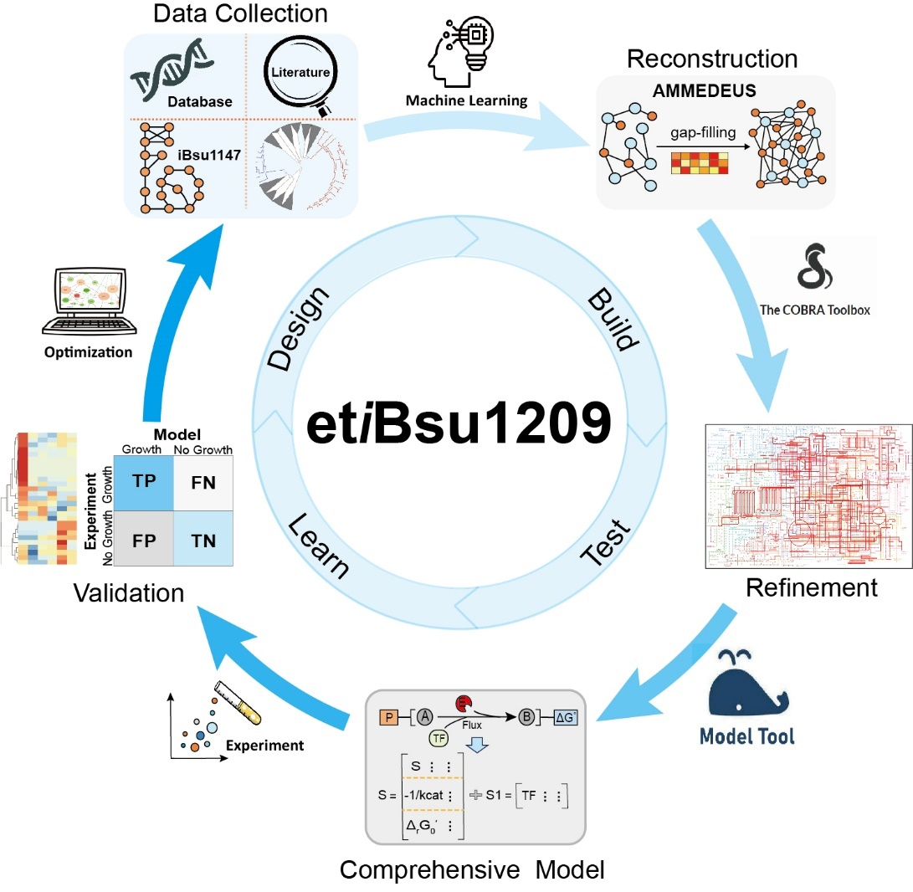
Figure 1

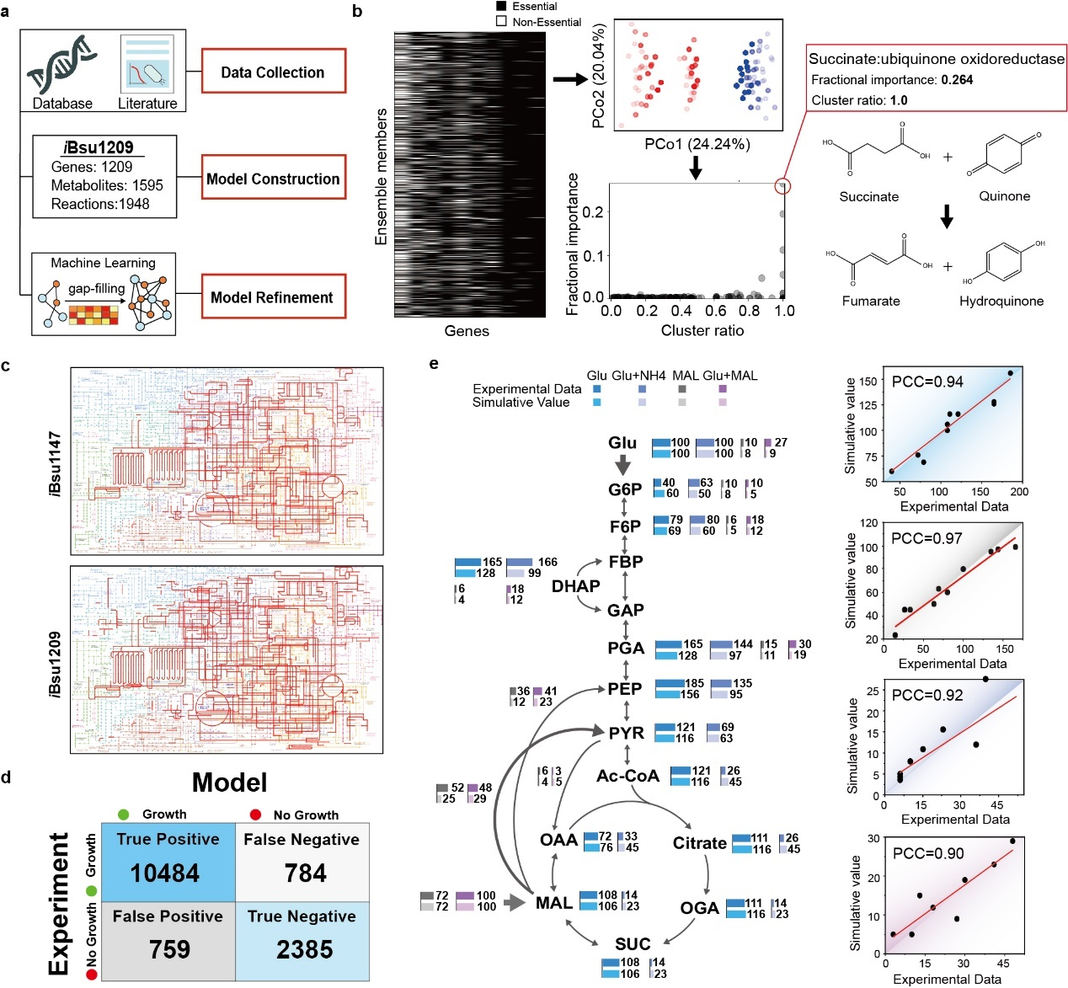
Figure 2

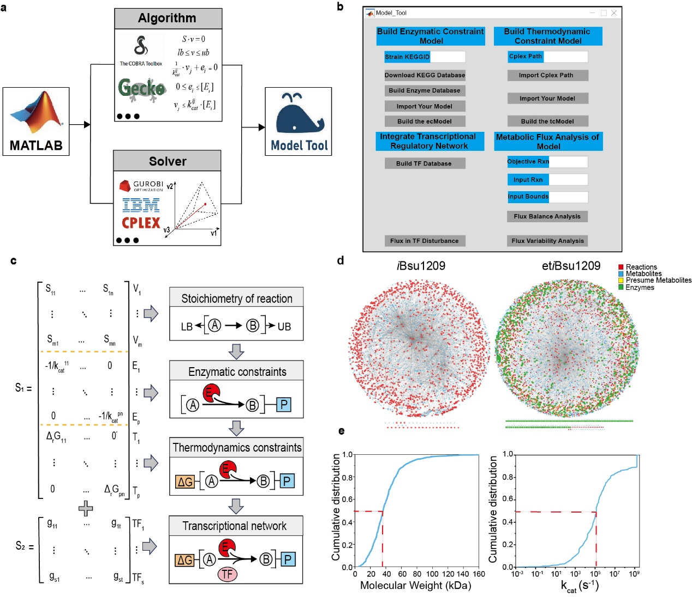
Figure 3

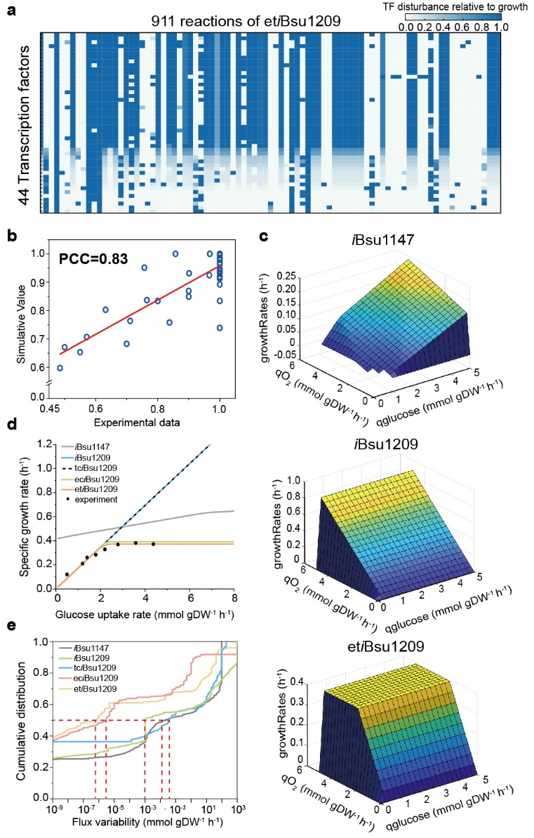
Figure 4

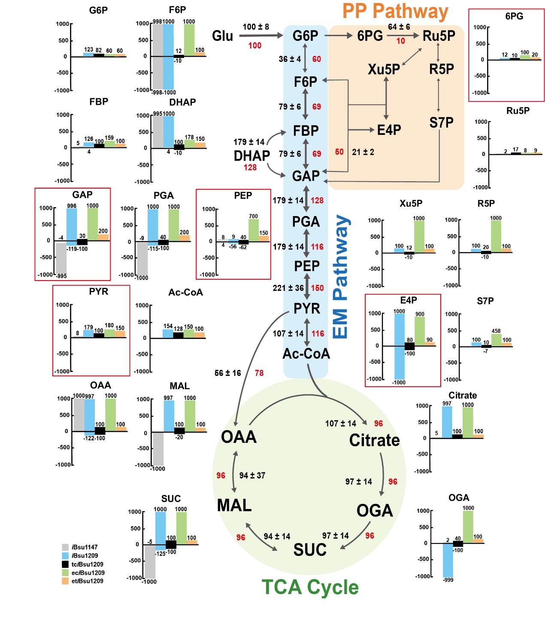
Figure 5

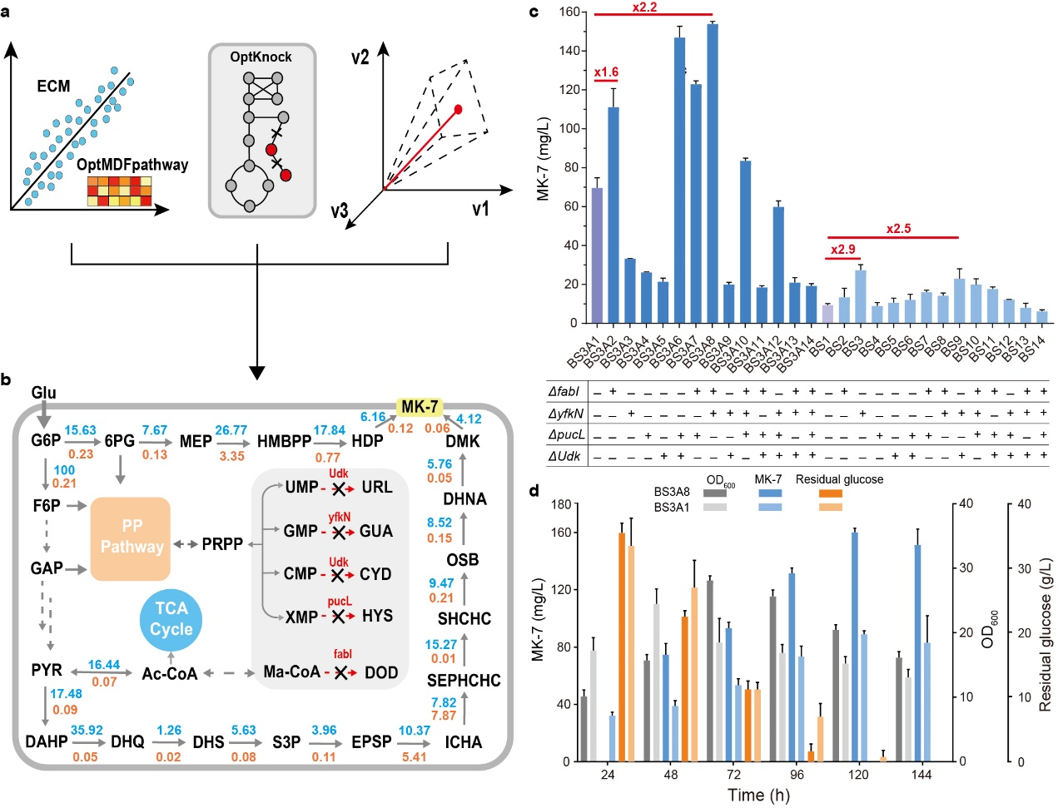
Figure 6

Abbreviations
Glu: glucose
G6P: glucose 6-phosphate
F6P: fructose-6-phosphate
FBP: beta-D-Fructose 1,6-bisphosphate
DHAP: dihydroxyacetone phosphate
GAP: glyceraldehyde-3-phosphate
PGA: phosphoglycerate
PEP: phosphoenolpyruvate
PYR: pyruvic acid
Ac-CoA: acetyl coenzyme A
OGA: 2-oxoglutarate
SUC: succinyl-CoA
MAL: malate
OAA: oxaloacetate
bG6P: beta- glucose 6-phosphate
6PG: 6-Phospho-D-gluconate
Ru5P: ribulose-5-phosphate
Xu5P: xylulose-5-phosphate
R5P: ribose-5-phosphate
E4P: erythrose-4-phosphate
S7P: sedoheptulose-7-phosphate
DAHP: 3-deoxy-arabino-heptulonate 7-phosphate

