Tables and Figures
Figure 1: Population of patients with HIV associated lymphoma (HIV+Ly), refractory/relapsed HIV associated lymphoma (r-HIV+Ly) and treatment with Autologous Stem Cell Transplant (ASCT)
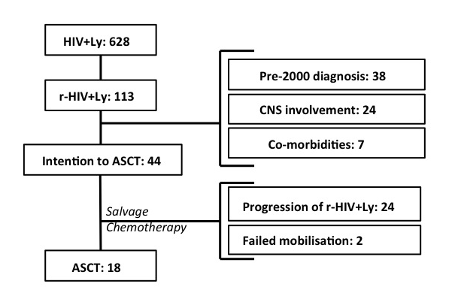

Table 1: Characteristics of r-HIV-Ly patients with intention to transplant and those treated with ASCT
 | Relapse n =113 | Intention to Transplant (ITT) n=44 | ASCT n=18
Male | 98 (87%) | 36 (82%) | 14 (78%)
History of prior AIDS | 20 (18%) | 5 (11%) | 1 (6%)
Median age at HIV (range) | 38 (0-73) years | 40 (0-63) years | 36 (0-59) years
Median age at lymphoma (range) | 42 (22-73) years | 45 (22-71) years | 44 (22-71) years
Median age at relapse (range) | 43 (22-73) years | 47 (22-72) years | 45 (22-72) years
Median duration HIV till relapse (range) | 4 (0.1-26) years | 5 (0.1-26) years | 8 (2.5-23) years
Lymphoma Subtypes
Systemic B cell
DLBCL | 61 (54%) | 15 (34%) | 6 (35%)
BL | 24 (21%) | 7 (16%) | 3 (18%)
PEL | 2 (2%) | 2 (5%) | 1 (6%)
Hodgkins | 19 (54%) | 16 (36%) | 7 (41%)
Plasmoblastic | 4 (4%) | 2 (5%) | 0 (0%)
T-cell | 3 (3%) | 2 (5%) | 1 (6%)
Survival
2 year overall survival (95% confidence interval) | 62% (41-78%) | 61% (37-78%) | 74% (45-89%)
5 year overall survival (95% confidence interval) | 34% (15-54%) | 34% (13-56%) | 74% (45-89%)

Table 2: Salvage treatment regimens and imaging response prior to and following ASCT
DHAP (dexamethasone, cytarabine and cisplatin), R-DHAP (rituximab, dexamethasone, cytarabine and cisplatin), R-IVE (rituximab, ifosfamide, epirubicin and etoposide)

 | ITT underwent ASCT N=18 | ITT did not proceed to ASCT N=26
Salvage treatment regimens
DHAP | 12 (66%) | 16 (62%)
R-DHAP | 4 (22%) | 8 (31%)
Others | 1 (6%) | 1 (4%)
None | 1 (6%) | 1 (4%)
Brentuximab (2nd line post DHAP) | 2 (11%) | 1 (4%)
Response prior to ASCT
Complete Response | 8 (44%) | 2 (8%)
Partial Response | 5 (28%) | 2 (8%)
Stable Disease | 2 (11%) | 0 (0%)
Progressive Disease | 0 (0%) | 12 (46%)
Unknown | 3 (17%) | 10 (38%)
Response following ASCT
Complete Response | 13 (72%) | -
Partial Response | 1 (6%) | -
Progressive Disease | 4 (22) | -
Cause of Death
Progression of Lymphoma | 4 (22%) | 22 (84%)
Infection | - | 2 (7%)
Other | - | 1 (4%)

A
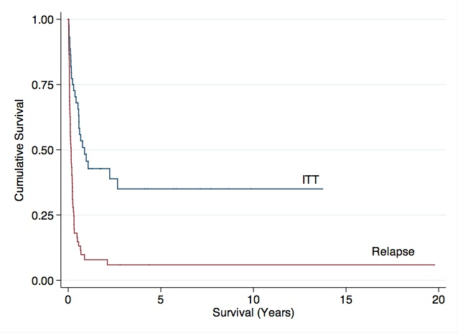
B
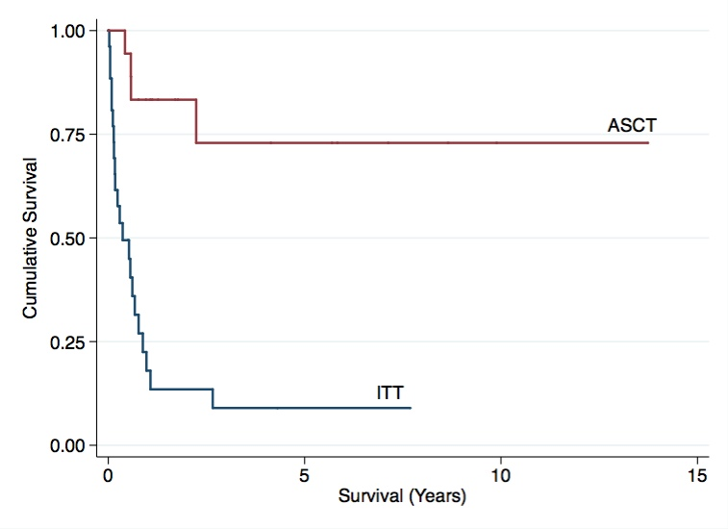
Figure 2: A) Cumulative survival of patients with intent to transplantation compared to patients who relapsed (log rank p<0.05) B) Cumulative survival of patients treated with ASCT among those who were treated with chemotherapy with intention to transplant.

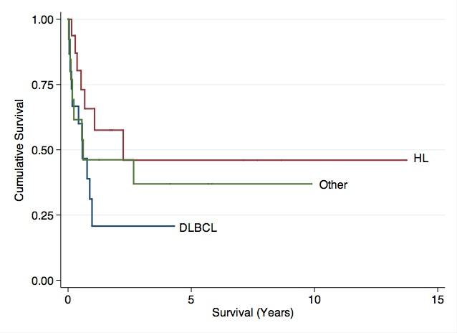
*? To include – Cumulative survival of all patients who relapsed stratified by histological subtype: Hodgkins lymphoma (HL), diffuse large B cell lymphoma (DLBCL) and other

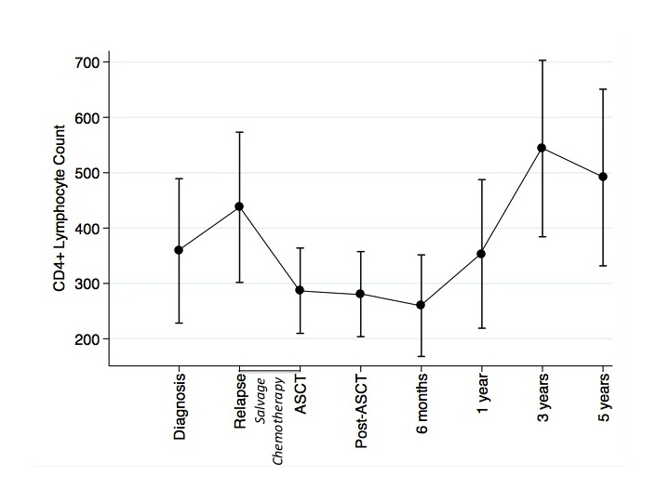
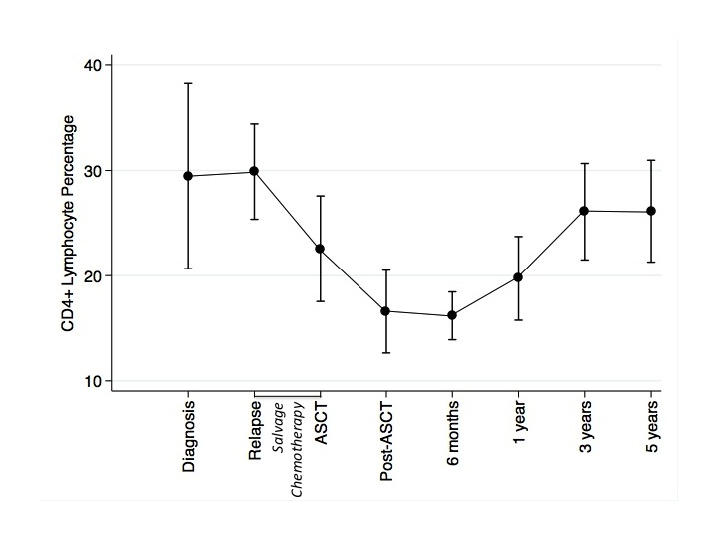
Figure 3: Box plots to demonstrate change in CD4+ lymphocyte count (A), percentage (B) over the course of ASCT.

Subtype HR 0.79 (0.47-1.33) p=0.38
Response HR 0.21 (0.09-0.51) p<0.05 – Complete response

