High-capacity open bore membrane chromatography column based on micro-packed ceramic hollow fibres
Melanie Lee, Bo Wang, Kang Li*
Department of Chemical Engineering, Imperial College London, SW7 2AZ, UK.
Abstract
Micro-structured ceramic hollow fibres as a new (GC) column configuration has been designed, fabricated, and executed for the separation of gases. The design consists of ceramic hollow fibres with intensively self-arranged open micro-channels in its wall as storage space, and the stationary phase is packed inside the micro-channels. The hollow lumen leads to negligible pressure drop along the GC column that is similar to the common capillary columns, whilst the intensively distributed micro-channels provide spacious volume for packing the stationary phase to realise much enhanced capacity that is close to common packed columns. Using alumina hollow fibre as an example, this novel design has been demonstrated as a GC column packed with 5Å molecular sieve particles and used to successfully separate nitrogen and oxygen. Such a GC column with a length of 8 m was able to separate O₂ and N₂ completely, with an injection volume of 90 μL, which is 20 -30 times higher than a typical capillary column, and a negligible pressure drop of only 0.01 bar. The theoretical plate number of this column for oxygen is up to almost 30 times higher than a commercial packed column’s, and for nitrogen it is almost 10 times higher.
Keywords: Ceramic membrane; Gas chromatography; high-capacity; hollow fibre; packed micro-channels
*Corresponding Author
E-mail: kang.li@imperial.ac.uk

1. Introduction
Packed and open capillary columns currently dominate the gas chromatography (GC) industry, and albeit both have their own advantages, they each have their unique shortcomings as well [1-3]. Packed bed of adsorbents provides high available surface area and adsorption capacity but is subjected to high pressure drops; and although the coated film of catalyst/adsorbent on the inner surface gives low pressure drop, the surface area/adsorption capacity is limited (Figure 1). Furthermore, it suffers from losing catalyst/adsorbent over time. Hence, solutions of constructing catalytic micro-reactors to overcome these shortages are needed.
Ceramic hollow fibre membranes offer high chemical, thermal and mechanical stability as well as high packing densities [4-6]. The common asymmetric ceramic hollow fibre membranes can possess intensive self-arranged micro-channels, which can potentially be used to contain a wide range of functional materials to form various functional devices [7, 8]. In most of the previous literature, access to the volume of micro-channels is difficult, due to the presence of two barrier layers that sandwich them at the inner and outer surfaces [7]. However, the barrier layers can be selectively removed during the fabrication process, allowing easy access to these free spaces from either the inner or the outer surface [8-10]. So far, ceramic hollow fibre membranes with open micro-channels accessible from the lumen surface have been studied to pack catalysts to form catalytic micro-reactors, but such catalytic micro-reactors are inconvenient to assemble and the catalyst will potentially be lost with the flowing fluid.
Much research has been placed on membrane chromatography, particularly in liquid chromatography for various bioprocessing applications [11]. They possess many advantages such as low pressure drops and high mass transfer, and can achieve membrane separation and chromatography in a single step. These membranes are found in various forms, such as flat sheet and hollow fibres, and are made from organic materials in almost all cases. The material of the membrane itself is the stationary phase and is also the current drawback of this technology. Currently, the low binding capacity of the membrane materials, which determines the chromatographic capability of the system, is retarding the wide-spread use of membrane chromatography systems. The beauty of the new type of chromatography column introduced this study is its flexibility, stability, and high capacity. The most suitable adsorbent on the market can be chosen and packed into the vast amounts of micro-channels in the walls of the inorganic hollow fibre membrane, and the membrane support can be made from different inorganic or metal materials. This gives a lot of flexibility in the operating conditions that can be used, such as at very high and low temperatures, across a wide pH scale, and can be cleaned and regenerated easily.
In this study, for the first time, the application of micro-structured ceramic hollow fibre membranes for gas chromatography has been explored. We prepared alumina hollow fibre membranes by an interfacial instability-induced micro-channelling method [4], whereby micro-channels are open on the outer surface but closed on the inner surface (Figure 1c). In this proof-of-concept study, for the first time, we test the feasibility of using alumina hollow fibres as the support for storing the stationary phase to form an open-bore gas chromatography column to separate oxygen and nitrogen in air. The 5Å molecular sieve particles were first deposited and packed into the micro-channels using vacuum suction, and the lumen side layer acts like a membrane barrier to prevent the loss of the particles. Then, the packed hollow fibres were dried and packed into stainless steel tubing to form columns of different lengths, which were connected to a mass spectrometer to detect and analyse the composition of the column outlet.
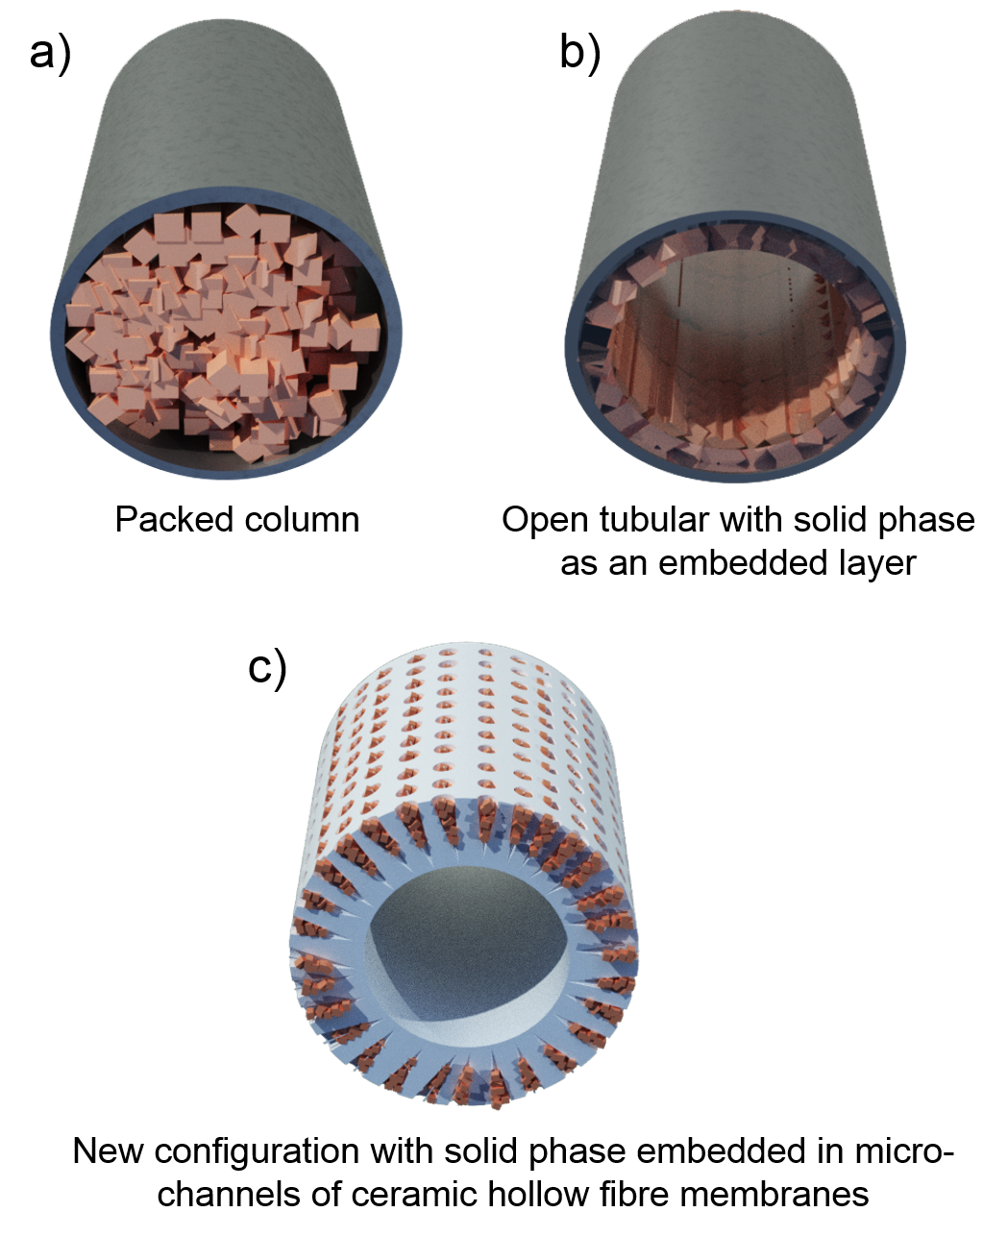

Figure 1. Common gas chromatography configurations a, b) and the proposed new configuration using packed micro-channels in hollow fibres c)
2. Experimental
2.1 Materials and chemicals
Aluminium oxide (Al₂O₃) (alpha, 99.9% metals basis, surface area 6-8 m²/g, mean particle size (d₅₀) 1µm, Inframat Corporation) was used as supplied. Polyethersulfone (PESf) (Radal A300, Ameco Performance, USA) was used as the polymeric binder. Dimethyl sulphoxide (DMSO, HPLC grade, VWR), and N-methyl-2-pyrrolidone (NMP, HPLC grade, VWR) were used as solvents. Arlacel P135 (polyethylene glycol 30-dipolyhydroxystearate, Uniqema) is used as the additive. De-ionized water was used as the bore fluid and NMP was used as the outer coagulant. 5Å molecular sieve was purchased form Sigma Aldrich, UK. The carrier gas was Argon, purchased from BOC, UK.

2.2 Fabrication of alumina hollow fibre membranes with open micro-channels
The fabrication process is based on the phase-inversion technique used to prepare the hollow fibres with open micro-channels on the outer surface. A triple-layered spinneret was used to spin a layer of ceramic fibre inside an outer layer consisting of solvent only to achieve an open structure on the outer surface. A uniform suspension composed of ceramic particles (59.9 wt. %), DMSO (33.6 wt. %) and polymeric binder (6.0 wt. %), as well as an additive acting as a dispersant (0.5 wt. %), was prepared via ball milling. The ceramic suspension was then degassed under vacuum with stirring to fully remove bubbles, and then transferred into a 200mL stainless steel syringe that was controlled by a syringe pump (Harvard PHD22/200 HPsi and KDS410). NMP was then transferred into a 100 mL stainless steel syringe controlled by another syringe pump. At an air gap of 25 cm, the bore fluid, ceramic suspension and solvent were extruded through the triple-layered spinneret into the external coagulation water bath via syringe pumps with flow rates 40 mL/min, 7 mL/min and 5 mL/min, respectively. The precursor hollow fibre membranes were removed from the external coagulant bath when phase-inversion was complete, and were dried and straightened at room temperature. They were then cut into the required length for subsequent calcination and sintering. The membranes were heat treated in air (CARBOLITE furnace) and the temperature was increased from room temperature to 600 °C at a rate of 2 °C/min and held for 2 h, then to a target temperature of 1500 °C at a rate of 3 °C/min and held for 4 h, and the temperature was reduced back to room temperature at a rate of 5 °C/min.
2.3 Set up of the hollow fibre GC system
The sintered hollow fibres were then potted into ¼ inch NPT male connectors and sealed with epoxy resin. On the other hand, 5Å molecular sieve particles were dispersed in water (1.2 g/L) under mechanical stirring. The fibre was then connected to a vacuum filtering flask connected to a vacuum pump, as shown in Figure 2. A vacuum is applied from the lumen of the hollow fibre, suctioning the molecular sieve particles into the micro-channels and clear water through the membrane and into the flask. The hollow fibres were then dried in ambient conditions. The hollow fibres were broken from the NPT male connectors and packed into 20 cm long stainless steel tubes with 1/8-inch outer diameter and 1.75 mm inner diameter, which were connected by 1/16 inch tubes to form the gas chromatography column, as displayed in Figure 3. Prior to using the columns for gas separation, the entire column was placed in an oven overnight at 200 °C with argon gas purging through at 30 mL/min to activate the zeolite as well as to remove the water and air entrapped in the fibres and the molecular sieve.
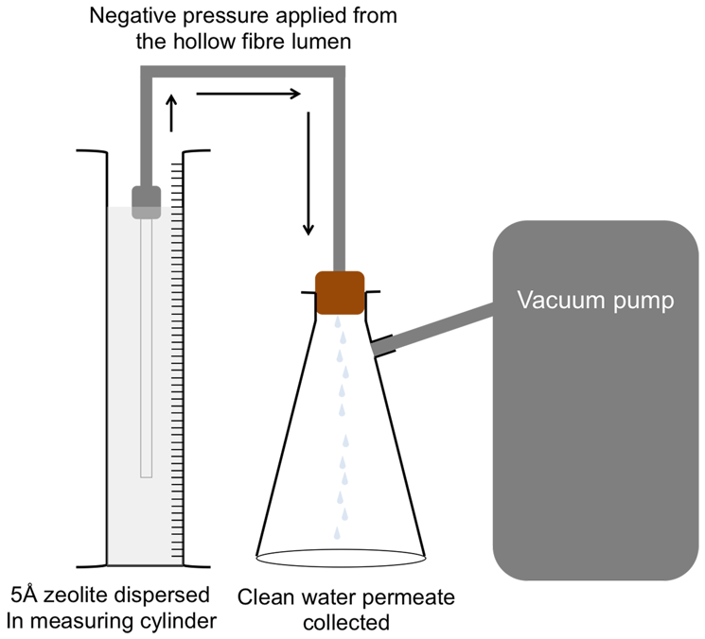
Figure 2. The set-up for depositing zeolite into the hollow fibre micro-channels via vacuum suction
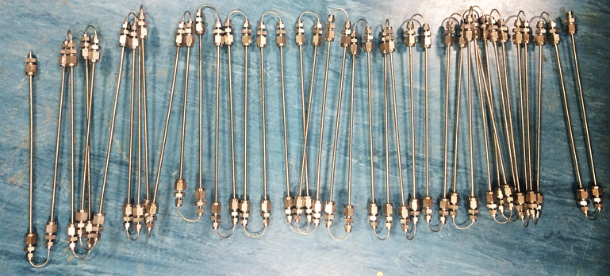
Figure 3. Photograph of the 8 m GC column
2.4 Membrane characterisation and gas chromatography performance study
Morphologies and microstructures were characterized by scanning electron microscopy (SEM, JEOL JSM–5610 LV). The pore size of the hollow fibre membrane was determined by gas-liquid displacement measurements with PoroLux 1000 Porometer. The separation of nitrogen and oxygen in air was carried out using the set up in Figure 4 at room temperature (22 ± 1 °C), whereby argon was used as the carrier gas, air was used as the sample gas, and a mass spectrometer was used to detect the gases. The GC column inlet was connected to a 6-way valve whereby the sample gas was injected and mass flow controllers (Omega FMA-2600A) were used to control its composition. The outlet of the GC column was then connected to the mass spectrometer (FLIR Griffin 400) to analyse the flue gas. The column efficiency (theoretical plate number) was calculated from the chromatograph results using the following equation [12]:
$N_{A}=5.545{\left(\frac{t_{R}(A)}{w_{h}(A)}\right)}^{2}$ (1)
where N_{A} is the number of theoretical plates for analyte A, t_{R} is the retention time for analyte A and w_{h} is the peak width at half-height of analyte A.
The chromatograph resolution can be calculated using the following equation [1]:
$R_{AB}=2\frac{t_{R}\left(B\right)-t_{R}(A)}{w_{h}\left(B\right)+w_{h}(A)}$ (2)
where R_{AB} is the resolution, t_{R}(A) and t_{R}(B) are the retention times of analytes A and B, and w_{h}(A) and w_{h}(B) are the peak widths of the analytes.

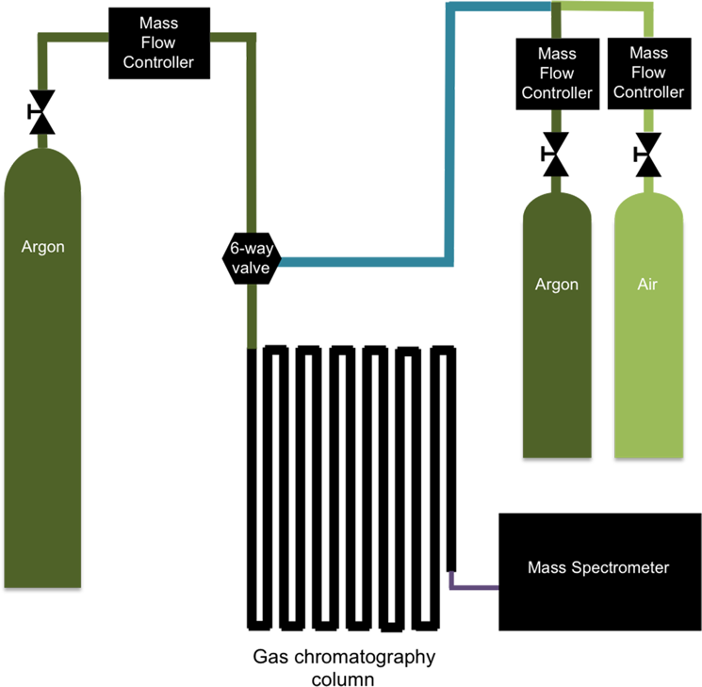
Figure 4. Gas chromatography column paired with a mass spectrometer using argon as the carrier gas and air as the sample gas
3. Results and Discussion
3.1 Alumina hollow fibre membrane characterisation
The alumina hollow fibre membrane obtained is unique in that it is asymmetric in structure with densely self-arranged, 300 μm long and cylindrical micro-channels, with micro-channel openings of between 20 – 35 µm, and micro-channel densities of around 560 openings per mm², as displayed in Figure 5(a-b). Furthermore, at the lumen side there is a thin barrier layer, whose average pore size is 1 µm (Figure 6), which prevents anything larger than the layer’s pore size to pass through. This design was achieved by using a concentric triple-layered spinneret, which delivers three components during fabrication: a water coagulant in the centre, then a ceramic suspension, followed by a solvent outer layer into a non-solvent water bath. During spinning, the micro-channels were initiated from the lumen side, and propagated through to the shell side. At the same time, the polymer additive in the ceramic suspension also began to precipitate from the lumen to the shell side due to phase inversion and thus maintain the shape of the micro-channels. Due to the presence of a solvent layer surrounding the shell side of the nascent ceramic hollow fibre, phase inversion is delayed at the ceramic suspension and solvent interface and the micro-channels had time to reach the shell side before immersion into the water bath. With sufficient momentum, the micro-channels crossed the ceramic suspension and solvent interface, and left large openings on the outer surface.
The open micro-channels in such a hollow fibre can be easily accessed by catalysts and adsorbents from outside, and the barrier layer at the inner surface keep the catalysts/adsorbents safe from being flushed away by flowing fluids. As illustrated in Figure 5(c-d), by simply filtrating suspended catalyst or adsorbent from the shell side to the lumen side, the catalyst/adsorbent can be carried by the liquid and enter into the channels, which are then stopped by the inner surface, eventually forming a fixed bed inside individual micro-channels. Figure 5(e-f) show an example using 3-5 µm 5Å molecular sieve particles as the adsorbent to assemble an integrate adsorbing column. It can be seen that the molecular sieve particles are evenly distributed in the micro-channels and are closely packed in the micro-channels. Such an integrate configuration is distinct from conventional chromatography columns with packed adsorbent bed or coated adsorbent film (Figure 1).
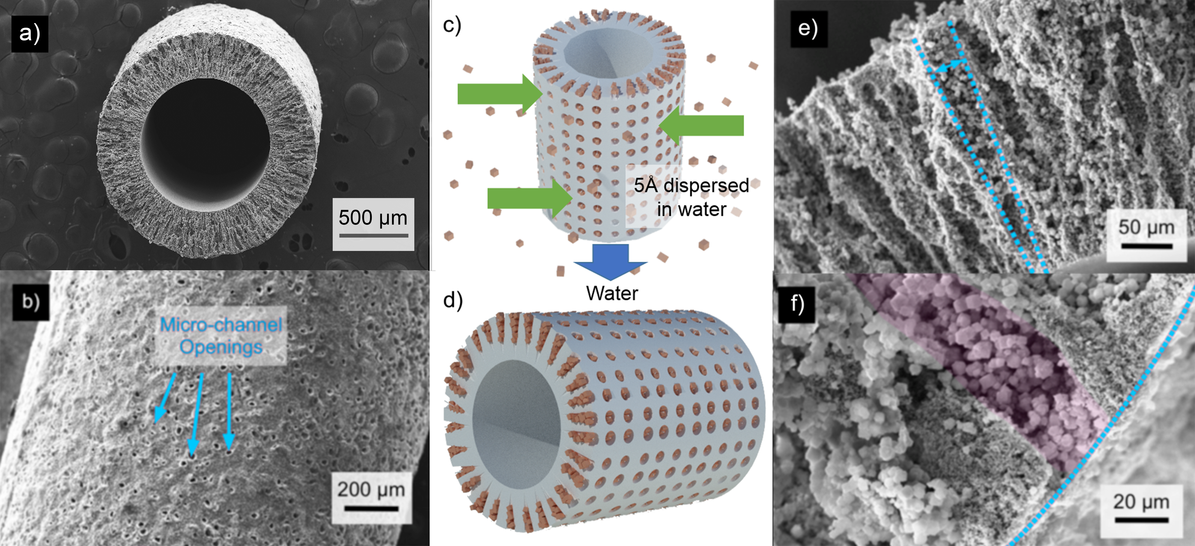
Figure 5. SEM of the hollow fibres a) the hollow fibre cross-sectional overview; b) the outer surface of the hollow fibre with micro-channel openings, the arrows indicates open micro-channels; c) a schematic of the deposition process to pack the 5Å molecular sieve particles into the micro-channels; d) an illustration of the hollow fibre with packed molecular sieve particles; e) the cross-sectional view in which the dashed line highlights a micro-channel capsuling molecular sieve; and f) a close-up cross-sectional view, the dashed line highlights the open shell side of the hollow fibre, and the pink shading highlights the example of an area where molecular sieve particles were deposited.
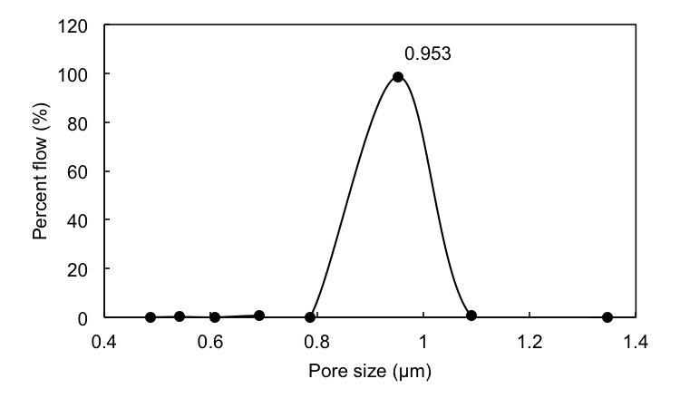
Figure 6. Pore size distribution of the hollow fibre membrane obtained by the gas-liquid displacement method
3.2 Gas chromatography performance study
In order to evaluate a potential new application of ceramic hollow fibres with open micro-channels, the molecular sieve-packed hollow fibres were inserted into stainless steel tubing and assembled to form gas choromatography (GC) columns (Figure 3). A GC column is chosen to be an example application in this research because there is a colossal amount of commercial GC column data available for comparison, and the column efficiency can be easily assessed by analysing the separation performance with well-established standard protocols.
The traditional packed columns are cheap, easy to set up as well as to operate but are prone to heterogeneities and are often limited in their lengths due to high pressure drop. The open capillary columns (with coated adsorbent film) are highly efficient but their sampling capacities are very low, for example, typically 3 - 5 µL injection volume for a 0.32 mm x 30 m column [13] and requires complex GC systems with an extra sample splitting unit. In essence, the new GC column configuration is an upgraded capillary column with much higher loading rates of stationary phase, which is due to the unique structure of the ceramic hollow fibre that provide larger accessible free volume. During the deposition process, approximately 46 mg is loaded into every metre of fibre. On the contrary, the porous layer of the stationary phase in commercial porous-layer open tubular (PLOT) columns is often only less than 15 μm thick. Taking a commercial PLOT column with 5Å molecular sieve as the stationary phase with an inner diameter of 0.32 mm and 12 µm thick stationary layer as an example [13], it has a total 5Å molecular sieve loading of around 2.8 mg per metre of column, which is significantly smaller than the column presented here. Therefore, the column in principle combines the high capacity of packed columns and low pressure drop of open capillary columns, and it can also avoid the loss of the stationary phase by the inner membrane barrier layer.
The GC column was then tested for its performance of separating oxygen and nitrogen in the air. Figure 7 displays the air separation characteristics of the GC column at different column lengths. Firstly, a sample size of 90 μL was injected with an argon carrier gas flow rate of 10 mL min⁻¹. It can be seen that separation of oxygen and nitrogen could be effectively improved with longer columns. The degree of the separation can be evaluated by the resolution of two peaks. The separation results shown in Figure 7 give resolutions of 0.40, 0.50, 0.69 and 0.82 for the oxygen and nitrogen peaks when the column lengths were 2, 4, 6 and 8 m, respectively. When the injection volume is reduced to 45 μL, a higher resolution of 1.03 for the oxygen and nitrogen peaks was obtained with an 8 m long column (Figure 8a). It is suggested that a resolution of 1 represents 94% separation of two symmetric peaks of same height, and such degree of separation will be adequate for most GC analysis [1]. Therefore, an 8 m column is almost good enough for usual purposes, and the resolution can be easily improved by using longer columns if stringent separation is needed. Besides, the entire prototype column at 8 m long has an extra-column dead volume of around 1.2 mL generated by the connections, which can cause broadening of the peaks but can be negated by reducing or eliminating the connection lengths by better industrial designs in the future to get better resolutions. Please note that the time-scale of the chromatograph is arbitrary and does not represent the true retention times, but only displays the retention time difference between the two solutes. Retention time data can be found in Table 1.
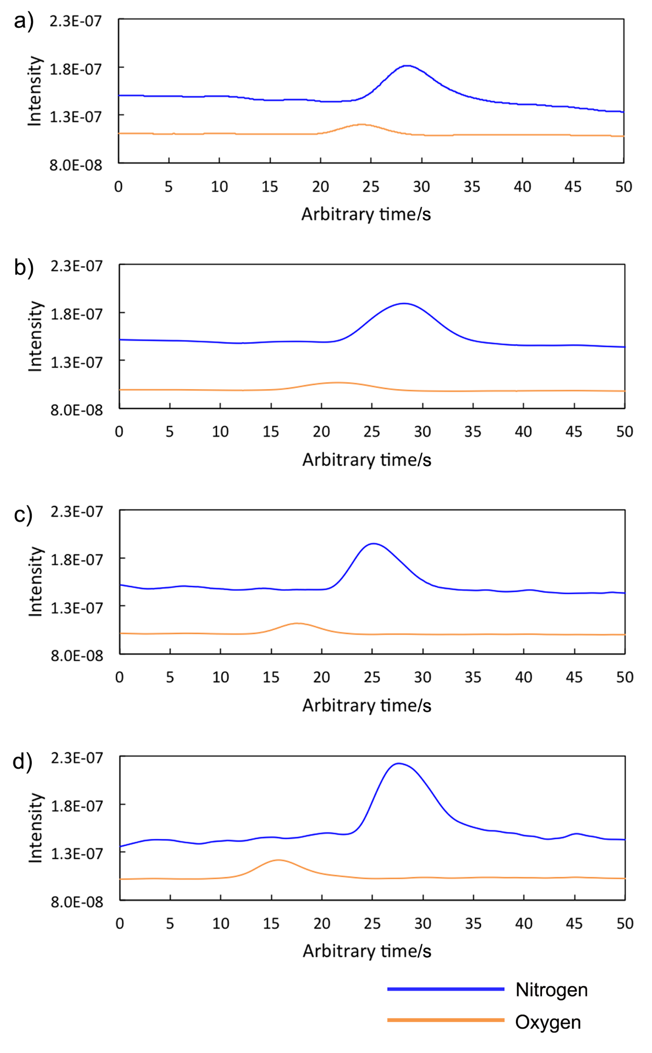
Figure 7. Mass chromatograms of nitrogen and oxygen through a a) 2 m, b) 4 m, c) 6 m and d) 8 m long GC columns with 10 mL min⁻¹ argon carrier gas and 90 μL air injection volume
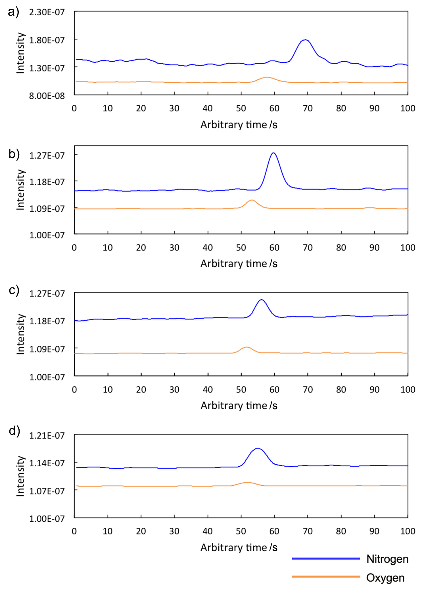
Figure 8. Mass chromatograms of nitrogen and oxygen through an 8 m column with 45 μL air injection volume and argon carrier flow rates of a) 10 mL min⁻¹, b) 20 mL min⁻¹, c) 30 mL min⁻¹ and d) 40 mL min⁻¹
As expected, the flow rate of the argon carrier gas also makes significant changes to the column’s separation capabilities. It can be seen from Figure 8 that with an 8 m long column and an injection volume of 45 μL, the separation property of the column increased with decreasing flow rate, and the resolution decreased from 1.03 to 0.57, 0.47 and 0.23 when the carrier gas flow rate increased from 10 to 20, 30 and 40 mL min⁻¹, respectively. In order to achieve sharper peaks with even better resolution, the dead volume within the column needs to be reduced, as mentioned above, longer columns can be constructed to improve the resolution, and different carrier gas flow rates can be used to reduce peak broadening. It should also be noted that the pressure drop across the columns were very small. At 8 m and a flow rate of 10 mL min⁻¹, a pressure drop of only 0.01 bar was experienced, whereas in literature, micropacked and packed capillary columns can experience pressure drops per meter of between 0.51 – 203 bar [2].
The wall thickness of the hollow fibre used here is around 300 μm, and it would be of interest how this thickness may affect the mass transfer of gases to reach the adsorbents that distributed along the radius direction. It can be estimated from the diffusion coefficients of the solutes in argon gas [14], the oxygen and nitrogen molecules can diffuse through a distance of around 4 mm per second, which is significantly higher than the outer radius of the hollow fibres (around 0.80 mm). The big pore size, which is around 1 µm, and the highly porous structure of the hollow fibre would not slow down the diffusion significantly, as studied previously [15, 16]. This means that the mass transfer resistance for the analytes to reach the stationary phase should not affect the separation performance too much. Such an assumption is supported by the theoretical plate numbers (N_{eff}) and plate heights (H_{eff}) calculated from the experimental results, as displayed in Table 1. A comparison with commercial packed column and PLOT column is also made in Table 1. Separation performances of the commercial columns, including plate numbers and heights were calculated from the chromatograms cited. The hollow fibre configuration achieved efficiencies (H_{eff}) that are comparable with a packed and a capillary column. The N_{eff} is normally low for packed columns because high pressure drops place a practical threshold on their lengths at a few metres, and therefore the peak separation resolution is also limited. On the other hand, capillary columns can be assembled to up to 100 m long, due to their hollow bores, although in practice they are most commonly found at 30 m or 60 m length. Capillary columns can have high N_{eff} due to their long lengths but can only take on very small sample loads due to the very low amount of stationary phase layered on the capillary walls. The hollow fibre column in principle can easily reach high N_{eff} that is comparable to capillary columns, and at the same time obtain much large sample capacities.
In this prototype column, some technical limitations were imposed due to the brittleness of the alumina material, such as the interruption of the column’s continuity due to the number of connections, which not only reduce the separation efficiency of the column, but also increase the difficulty of preparing longer columns. However, the beauty of this column fabrication method is its flexibility, and can be applied easily to other materials, such as metals like nickel and stainless steel, or polymer materials that can withstand high temperatures, for example, polybenzimidazole (PBI), which can be easily coiled and form very long columns. With these alternative materials, continuous columns with unlimited lengths can be easily obtained, and the column diameter can also be easily reduced during the spinning fabrication process, therefore the separation resolution can be significantly improved.

Table 1. Comparing the properties and performance of the packed micro-channel hollow fibres and commercial GC columns using 5Å molecular sieve as the stationary phase
 | Packed column [17] | Open capillary column [13] | Packed hollow fibre column
Column length (m) | 1 | 30 | 8
Carrier gas | H₂ | He | Ar
Carrier gas flow rate (mL min⁻¹) | 30 | 2 | 10
O₂ retention time (min) | 0.43 | 1.88 | 2.08
N₂ retention time (min) | 0.82 | 2.55 | 2.28
Column inner diameter (mm) | 2 | 0.32 | 1.6
N_{eff} for O₂ | 121 | 14600 | 3580
N_{eff} for N₂ | 248 | 11900 | 2450
H_{eff} for O₂ (mm) | 8.28 | 2.05 | 2.23
H_{eff} for N₂ (mm) | 4.03 | 2.52 | 3.26

4. Conclusions
In conclusion, micro-structured ceramic hollow fibres as a novel chromatography column configuration is demonstrated based on state-of-art hollow fibre fabrication techniques. This design consists of hollow fibres with intensively arranged micro-channels as the carrier whereby the catalyst/adsorbent is packed into. This design has an open-tubular structure, and the loaded catalyst/adsorbent is substantially increased when compared with coated capillary columns or micro-reactors, due to the large free volume provided by the micro-channels. The feasibility of this design was demonstrated by alumina hollow fibres with 5Å molecular sieve particles filled into the micro-channels and used as a GC column, which showed comparable column efficiency with commercial packed and capillary columns, suggesting fast mass transfer in the integrate micro-reactor design. Through additional tweaking and optimisation, the performance of this column configuration is expected to improve further. The results of this study can potentially make a significant step for membrane micro-reactor configurations, and also could be potentially advantageous among GC column designs since it combines both low pressure drop and high sample capacity that is difficult to achieve with previous commercial columns.
Notes
The authors declare no competing financial interests.
Author Contributions
The manuscript was written through contributions of all authors. All authors have given approval to the final version of the manuscript. These authors contributed equally.
Acknowledgements
K. Li would like to acknowledge the research funding provided by EPSRC in the United Kingdom (Grant no EP/J014974/1). B. Wang thanks the Marie Curie International Incoming Fellowships (Grant No.627591). The authors would like to thank Chenghong Wang for the manual labour contributed in the column set up process.

References

[1] C.F. Poole, The essence of chromatography, Elsevier, 2003.
[2] C.F. Poole, S.K. Poole, Chromatography today, Elsevier, 2012.
[3] T.J. Bruno, A Review of Capillary and Packed Column Gas Chromatographys, Separation & Purification Reviews, 29 (2000) 27-61.
[4] K. Li, Ceramic Membranes for Separation and Reaction, John Wiley & Sons Ltd, Chichester, 2007.
[5] A. Leo, S. Smart, S. Liu, J.C. Diniz da Costa, High performance perovskite hollow fibres for oxygen separation, Journal of Membrane Science, 368 (2011) 64-68.
[6] W. Li, T.-F. Tian, F.-Y. Shi, Y.-S. Wang, C.-S. Chen, Ce0.8Sm0.2O2−δ−La0.8Sr0.2MnO3−δ Dual-Phase Composite Hollow Fiber Membrane for Oxygen Separation, Industrial & Engineering Chemistry Research, 48 (2009) 5789-5793.
[7] B.F.K. Kingsbury, K. Li, A morphological study of ceramic hollow fibre membranes, Journal of Membrane Science, 328 (2009) 134-140.
[8] M. Lee, B. Wang, K. Li, New designs of ceramic hollow fibres toward broadened applications, Journal of Membrane Science, 503 (2016) 48-58.
[9] B. Zydorczak, Z. Wu, K. Li, Fabrication of ultrathin La0.6Sr0.4Co0.2Fe0.8O3–δ hollow fibre membranes for oxygen permeation, Chemical Engineering Science, 64 (2009) 4383-4388.
[10] W. Yin, B. Meng, X. Meng, X. Tan, Highly asymmetric yttria stabilized zirconia hollow fibre membranes, Journal of Alloys and Compounds, 476 (2009) 566-570.
[11] V. Orr, L. Zhong, M. Moo-Young, C.P. Chou, Recent advances in bioprocessing application of membrane chromatography, Biotechnology Advances, 31 (2013) 450-465.
[12] K. Dettmer-Wilde, W. Engewald, Practical Gas Chromatography: A Comprehensive Reference, Springer Berlin Heidelberg, 2014.
[13] A. Vickers, PLOT Column Selection, https://www.agilent.com/cs/library/eseminars/Public/PLOT%20Column%20Selection.pdf, 05/01
[14] A.B. Murphy, C.J. Arundelli, Transport coefficients of argon, nitrogen, oxygen, argon-nitrogen, and argon-oxygen plasmas, Plasma Chemistry and Plasma Processing, 14 (1994) 451-490.
[15] T.R. Marrero, E.A. Mason, Gaseous Diffusion Coefficients, Journal of Physical and Chemical Reference Data, 1 (1972) 3-118.
[16] J. Kestin, K. Knierim, E.A. Mason, B. Najafi, S.T. Ro, M. Waldman, Equilibrium and Transport Properties of the Noble Gases and Their Mixtures at Low Density, Journal of Physical and Chemical Reference Data, 13 (1984) 229-303.
[17] RESTEK, Permanent Gases on Molecular Sieve 5A and Molecular Sieve 13X, http://www.restek.com/chromatogram/view/GC_PC00166/5a%7C7782-44-7, 17/11

