A Review on Hydrothermal Pre-treatment Technologies and Environmental Profiles of Algal Biomass Processing

Bhavish Patel, Miao Guo, Arash Izadpanah, Nilay Shah and Klaus Hellgardt*

Imperial College London, Dept. of Chemical Engineering, Exhibition Road, South Kensington, London SW7 2AZ, UK

E-mail: k.hellgardt@imperial.ac.uk | Tel: +44 (0)20 7594 5577

Abstract
The need for efficient and clean biomass conversion technologies has propelled Hydrothermal (HT) processing as a promising treatment option for biofuel production. This manuscript discussed its application for pre-treatment of microalgae biomass to solid (biochar), liquid (biocrude and biodiesel) and gaseous (hydrogen and methane) products via Hydrothermal Carbonisation (HTC), Hydrothermal Liquefaction (HTL) and Supercritical Water Gasification (SCWG) as well as the utility of HT water as an extraction medium and HT Hydrotreatment (HDT) of algal biocrude. In addition, the Solar Energy Retained in Fuel (SERF) using HT technologies is calculated and compared with benchmark biofuel. Lastly, the Life Cycle Assessment discusses the limitation of the current state of art as well as introduction to new potential input categories to obtain a detailed environmental profile.
Keywords: Environmental Impact, LCA, Hydrothermal Technology, Microalgae, Biofuels

Graphical Abstract

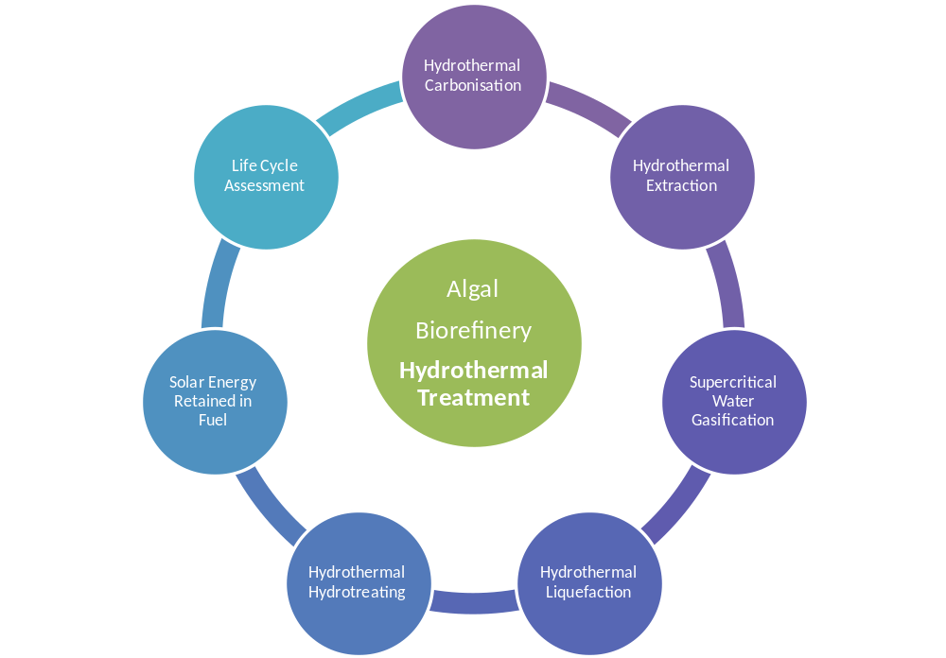

1.0 Introduction
Fossil fuels dominate world primary energy supply, currently meeting 80% of global energy demand (IEA, 2013). Accelerating fossil fuel depletion is accompanied by the increasing concerns about greenhouse gas (GHG) levels. The use of fossil fuels has evidently resulted in atmospheric carbon emissions surpassing 400 ppm (IPCC, 2014) as well the initiation of climate change. With predicted energy demand growth contributing to the existing problem, it is of utmost important to utilise a non-fossil based renewable energy source to limit the effect it has on the environment. Several alternatives have been suggested which utilise wind, solar, water and heat, but ultimately the need for liquid and gaseous energy capable of integrating into existing infrastructure can only be provided by biomass. Terrestrial plants including 1st Generation (1G) and 2nd Generation (2G) biomass feedstock such as sugarcane, corn and rapeseed oil are currently utilised commercially, predominantly for biodiesel and ethanol production. However due to terrestrial plants especially 1G biomass’ innate requirement of cultivation on productive land and associated competition with food crop for resources, a demand for an alternative advanced feedstock such as microalgae has garnered significant interest globally.
In addition to the lack of land requirement the other advantages that algae offers compared to terrestrial biomass feedstock, termed 1G and 2G, is its high productivity and yield, ability to fix atmospheric carbon, potential to grow in diverse climates and water quality as well as its capability to synthesise lipids, carbohydrates, proteins and value chemicals simultaneously (Patel et al., 2012). In the context of a biorefinery, the assortment of potential products makes it a preferred feedstock, and thus cost effective and environmentally sound extraction/pre-treatment/conversion processes are sought.
The compounds of interest in a microscopic alga cell are contained within the cell wall which requires some sort of mechanical or chemical engagement to rupture/disrupt and liberate the cell constituents. Generally the technologies for biomass conversion/treatment are categorised as physical or chemical (biochemical & thermochemical) and for algae they are not much different. Thus mechanical systems such as bead beating or milling have been employed, usually in conjunction with a chemical treatment involving the use of solvents to manipulate, fraction or extract the different constituents. Very recently, emerging technologies such as ionic liquid extraction and ultrasonic treatment appear to be promising but they are still in their infancy. Biochemical treatment is also an option but incompatibility of biocomponents with algal species and the controlled nature of the reaction limit its use (Barreiro et al., 2013, Patel et al., 2012, Peterson et al., 2008 and Toor et al., 2013).
Most of these pre-treatment techniques involve the use of dry algae, which comes with a substantial energy penalty. It is suggested that over 50% energy savings (Patel et al., 2012) can be achieved by using concentrated wet algae paste and therefore emphasis on wet processing is seen as means to reduce processing costs. Given the importance of applying clean processing technologies in the chemical/energy industry, it is imperative to pursue the same for biomass processing as well, especially given the fact that it’s a renewable feedstock. Thus the concept of using wet algae with water itself as a treatment/conversion medium is appealing and as such the field of hydrothermal technology for pre-treatment of algal biomass is understood to be the most promising method for algae processing (Barreiro et al., 2013). Unlike conventional treatment method where focus is on fractionation, hydrothermal treatment works on the principle of conversion first followed by subsequent fractionation.
Thus, this manuscript presents the current state of the art for hydrothermal technologies in the algal processing field for pre-treatment/conversion of biomass to chemical or fuel precursor using wet algae. In addition to the technological aspect, the environmental perspectives of algal biorefinery supply chain are also addressed with a focus on the hydrothermal processing strategies to give an in-depth view of the up-to-date research carried out on the algal biorefinery in the environmental modelling field.
2.0 Hydrothermal Water
Interest in water as a reaction/treatment medium stems from the fact that it is cheap, widely available and an inert substance with virtually no environmental impact, thus satisfying the criteria of a green processing. Hot compressed water (HCW), sub/super critical water (SCW) and hydrothermal water (HTW) are synonymous terms used to describe the existence of water under elevated temperature and pressure. It is well known that when heated, a fluid such as water undergoes a transformation in its physical state by transitioning from a liquid to a gas. But unlike water at ambient conditions (and open environment), increasing the temperature inside an isolated sealed chamber followed by subsequent formation of pressure causes a change in several of the fluids chemical (and physical) properties (Savage, 1999).
With an increase in temperature (and pressure), the ordered hydrogen bonds in water tend to become weaker and break to form clusters of concentrated molecules. This basic alteration in structural property causes a whole set of changes to its behaviour resulting in its multiple utility as a solvent, catalyst or a reactant. Hence, a striking decrease in the density from 0.997 g/cm³ to gas like 0.17 g/cm³ is observed from 25 to 400°C (Kruse & Dinjus, 2007 and Savage, 1999), respectively owing to the molecular rearrangement and taking place without a phase change. Acids and bases are commonly used to catalyse chemical reactions. When subjected to above ambient conditions, the ionic product of the water decreases from 14 to 11 (at 250°C) resulting from dissociation and formation of water ions (OH⁻ and H₃O⁺) which aid acid or base catalysed reactions. Surprisingly, above the critical point, the ionic product (K_{w}) once again increase (19.4 at 400°C) during which bond breaking is prevalent and thus the reaction feedstock is subjected to the gasification regime. The enhancement in solvation property of water is attributed to a reduction in the density and hydrogen bonding. Gas like behaviour combined with molecular rearrangement enables non polar organic chemicals as well as ionic bonded substances to easily dissolve. Thus, the miscibility, characterised by an increase in the dielectric constant (ε) from 75.5 to 4.9 at ambient temperature and 400°C, respectively gradually decrease the mass transfer constraint arising from potential phase boundaries. Another aspect of interest is the change in heat capacity from 4.2 at ambient temperature to 13 kJ/kg/K at 400°C. The increase makes the reaction medium a better heat carrier and thus the energy required to maintain the reaction temperature is reduced, leading to an important economic advantage (Peterson et al., 2008 and Savage 1999).
The abovementioned change in the physiochemical characteristics of water resultant from just temperature and pressure variation has a profound outcome on the reaction product of treated biomass. Thus by merely varying the temperature, pressure and Residence Time (RT), the product pool formed exhibits a significant difference.
Under ambient to low severity (~50-120°C), the reaction environment is suitable for decoupling or fractionating biomass components without substantial change in its biochemical properties. Rapid hydrolysis of the outer material is achieved without profound change in the molecular structure through steam explosion at relatively low pressure. Although not associated with microalgae, the process is commonly applied for lignocellulosic feedstock treatment for bioethanol production (Peterson et al., 2008)
Treatment of biomass at low severity to moderate temperature (~120-250°C) at extremely long RTs (hours) results in formation of a carbon rich coal/char like substance in a process referred to as Hydrothermal Carbonisation (HTC) (Knez et al., 2015). Correspondingly, in a similar temperature range but lower RT, it is possible to extract chemicals in a process synonymous to supercritical CO₂ extraction with the added advantage of transforming molecules as they are extracted thus representing reactive extraction in a process termed Hydrothermal Extraction (HTEx).
Moving forward on the temperature scale, Hydrothermal Liquefaction (HTL) occurs between moderate to SC point (~250-374°C and <220 bar), whereby several chemical transformations take place simultaneously to predominantly produce a liquid product with chemical properties entirely different to that of the processed biomass (Tian et al., 2014). By operating beyond the SC point, there is substantial degradation and destruction of the macromolecules such that bond cleavage results in simple gas molecule production, the intended product (Peterson et al., 2008).
All of the aforementioned processes can be conducted with catalyst or co-solvents to enhance intended outcome. Nonetheless, it is clear that several product vectors can be formed by tuning the reaction conditions of the water without necessarily adding further chemical, thus providing a green route for algal biomass treatment. The next few sections will discuss the use of HTW as a medium for pre-treatment of algal biomass within the various product (and temperature) range.
3.0 Reaction of Algal Components in HTW
An algal cell is composed from a mixture of 3 different compounds groups (lipids, carbohydrates and proteins) which react under HTW to produce a range of products.
The lipid fraction is the most energy dense and composed of neutral, phospo- and galacto- lipids whose chemical structure includes 3 Fatty Acids (FA) held together by a glycerol backbone. Under HT conditions, specifically over 300°C, this bond is readily broken to produce FAs and hydrophilic glycerol. Upon further treatment the FAs can decompose to its subsequent hydrocarbon, thus providing a route for direct conversion of TAGs to alkanes. Some species of algae can accumulate over 50wt.-% of their mass as lipids which result in higher biocrude yield as well as HHV (Toor et al., 2013 and Peterson et al., 2008).
Depending on the species, the polysaccharide fraction is present in the form of storage material (starch), structural cell walls and cellulose which depolymerise under HT conditions to produce monomers (Toor et al., 2013). Likewise, the peptide bond linking amino acids form proteins which are susceptible to hydrolysis at relatively moderate temperature to produce amino acids which can further deaminate or decarboxylate to produce organic/carbonic acid, amide or ammonia (Peterson et al., 2008). The aforementioned products individually have commercial applications, but when put in context of HTW, especially operating over temperature of 300°C, the product of choice is biocrude. From existing investigation on HT reaction of protein and carbohydrates, it is understood that they do not contribute towards oil formation individually. But when the reaction takes place as a mixture of components, as present in algae, the interactions as well as products are very different. In fact it is widely acknowledged that the biochemical content of the algae will ultimately dictate the product quality and yield (Leow et al., 2015). The relationship between the algal feedstock components and the products formed after HTL do not necessarily have a direct correlation, but several attempts have been made (Leow et al., 2015) to predict the output based on individual contribution with varying degree of success. Although lipid based models are marginally easier to implement, the presence of carbohydrates and protein gives rise to the Maillard reaction (Patel & Hellgardt, 2013a), which has multiple pathways for product formation and given the varying levels of the salts and trace metals from algal biomass (and cultivation medium), it is challenging to agree on a particular mechanism owing to potential catalytic effects. Nonetheless, there is a general consensus that during algal HTL hydrolysis, decarboxylation/decarbonylation, denitrogenation, repolymerisation and condensation reactions occur simultaneously to decompose, rearrange and form new molecules during different stages of the reaction.
3.1 HTC and HTEx
Owing to the high N content and expense associated with cultivation (Patel et al., 2012), algal biomass is not necessarily an ideal feedstock for carbonisation. Nonetheless with constant improvement in cultivation and reduction in costs, combined with the possibility of using waste water grown algae, carbonisation for C rich solid generation is one of the product vectors of interest. HTC is an exothermic reaction with a RT of several hours generally employed to waste sludge (He et al., 2013). However for microalgae this is reduced substantially as demonstrated by (Heilmann et al., 2010) during their investigation of char production from two different microalgae species. Having achieved gravimetric yields of up to 60wt.-% in approximately 1 hour at 200°C under a pressure of 20 bar, it becomes apparent that there is considerable potential to explore this reaction. The physical surface of algal char was observed to be tortuous with a HHV of approximately 30MJ/kg making both characteristics similar to natural coal.
Although solid, the char is a good absorber of the hydrophobic lipids present in the mixture. It would be expected that the TAGs (of FAs) bound in the char do not necessarily form an integral part of its structure and hence could be extracted. In a follow up investigation (Heilmann et al., 2011) performed analysis of the product from HTC reaction and establish that most of the FAs are retained in the hydrochar, and can be recovered by a simple solvent extraction. In fact (Lu et al., 2014) exploited this phenomenon as means to extract FA from the char for nutraceutical application at just 180°C and 15 min RT. A downside of FA removal from the char is that its HHV is reduced depending on the quantity of FAs in the original feedstock retained in the char and its subsequent removal. Furthermore, the majority of the C (~55%) partitions into the char phase as expected with ca. 45% going to the aqueous phase and miniscule quantity produced as gas.
Conversely, up to 80% N is recovered (Heilmann et al., 2011, 2010 and Levine et al., 2013) in the aqueous phase providing an ideal opportunity to recycle the nutrient rich phase for algal cultivation. The chemical species present are a mixture of sugars, amino acids as well as Maillard reaction synthesised heterocyclic compounds (Levine et al, 2013). It should be noted that although the growth of algae has been demonstrated in recovered water, some compounds formed during the reaction, such as acetic acid (Peterson et al., 2008 and Tian et al. 2014) can be of commercial interest and potentially contribute as an income stream.
The aqueous phase of HTEx is of significant importance, because essentially at lower severity, the carbohydrate rich cellular wall is degraded easily and the hydrolysis of the protein forms amino acid of which a good proportion is hydrophilic, thus making its recovery in the aqueous phase possible. The operation parameters are such that only hydrolysis and primary degradation occurs with limited change in algal components, thus providing a medium for their extraction. This was demonstrated by (Garcia-Moscoso et al., 2013) where flash hydrolysis at 280°C and 10s RT yielded 66wt.-% aqueous fraction consisting of peptides and amino acid and leaving behind lipid rich solid phase. HTEx is probably not a standalone treatment option and the products formed will certainly require subsequent processing to obtain the final product. Nonetheless, in view of heat integration low temperature HTEx probably offers an advantage to fraction some of the algal constituents using energy from other higher temperature treatment units (such as HTL).
3.2 HTL
HTL is considered to be the most promising treatment option for algal biomass and substantial work has been carried out in the field. The basic concept of behind implementing HTL is to convert solids biomass to liquid fuel (precursor) resulting in energy densification, reduction in O, N and S as well as degrade the macromolecules to produce biocrude with improved boiling point distribution.
The key variables that define the HTL reaction are temperature and RT whilst biomass loading and co-solvent addition also contribute, but to a lesser extent. Although temperature and RT are separate variables, their effect on the HTL product is substantial. Understanding the length and the severity of the reaction can help produce biocrude with required characteristics economically. Algal feedstock exposed to high temperature tends to undergo several reactions simultaneously and consequently the change in the chemical properties of water with temperature dictates the outcome. At low reaction temperature the biocrude yield is lower due to incomplete cell rupture and conversion of macromolecules. (Patel & Hellgardt, 2013a) observed that biocrude yield was consistently less at low temperature even at with increasing RT. This observation was confirmed by (Garcia et al., 2011), but a common exception in both the investigations was that at a temperature over 375°C, highest biocrude yield of 38wt.-% and 49.4wt.-% was achieved at 5 min RT, respectively.
Longer RT and higher temperature tend to promote deoxygenation which essentially increases the HHV of the biocrude as well as the energy recovery (Toor et al., 2013). However, the increase in deoxygenation is not substantial and subsequent reduction in yield can prove unfavourable. The case against long RT also includes loss of mass from the aqueous phase (Patel & Hellgardt, 2015). Recent investigation has reported that over 50wt.-% of mass can partition as water soluble compounds which enable nutrient reclamation or energy generation (via AD or gasification) (Patel et al., 2015). But increasing RT accompanied by high temperature results in a significant quantity of water soluble compounds fractionating into the gas phase which is not the desired product. Besides, there is an increase in N content in the biocrude at longer RT due to the ensuing rearrangement/repolymerisation reactions. It has been suggested that longer RT might be necessary for high biocrude yields (Zou et al. 2010), but from recent development (Elliot et al., 2015 and Patel & Hellgardt, 2015) in the field it is very unlikely since shorter RT and higher reaction temperature are sought after. From a reaction point of view, shorter RT enables rapid macromolecule decoupling and limited conversion of formed product consequently restricting further reactions which is understood to reduce the biocrude yield. In fact an investigation by (Bach et al., 2014) demonstrated that at a rapid heating of 585°C/min and biocrude yield of 79wt.-% is achievable and theoretically, substantially higher yields than this are possible if faster heating rates can be attained resulting in a process that mimics hydropyrolysis. Increasing RT and temperature is accompanied by greater gas yield and reduction in biocrude and aqueous soluble yields. The severe conditions tend to decompose the biocrude resulting in the formation of non biocrude products that reduce yield. On average, HTL is capable of producing biocrude with a HHV of ~38-50 MJ/kg, ~50-70 % deoxygenation and ~50% denitrogenation (Tian et al., 2014). There is a correlation with the biochemical content and the HTL product yield and quality which has been computed (Leow et al., 2015) recently with varying degrees of success.
An alternative to neat HTL, is to perform HTL in presence of a catalyst to attempt and enhance the biocrude yield, promote better deoxygenation/denitrogenation as well improve the product boiling point distribution. Since the reaction is carried out in the liquid state, heterogeneous catalyst would appear to be advantageous due to its easy recovery, but only limited research exists on the topic. (Duan & Savage, 2010) used a range of Al₂O₃ and C catalysts for HTL of Nannochloropsis sp. under H₂ and inert atmosphere at 350°C and 60 min RT. Their investigation yielded biocrude with marginally better HHV, O and N content than non-catalytic reaction. But the most significant difference observed was that apart from Pt/C and non-catalytic reaction, the use of catalyst particularly Pd/C enhanced the biocrude yield to 57wt.-% compared to 35wt.-% for the non-catalytic reaction. In addition, catalysed reactions in presence of H₂ were deemed to produce more alkanes thus, confirming deoxygenation of lipids. Under similar HTL (inert atmosphere) reaction conditions (Biller et al., 2011) noticed an increase in biocrude yield for Pt/Al₂O₃ and Co-Mo/Al₂O₃ catalysed reaction as well as presence of gasification for Ni/Al₂O₃ reaction. The Pt catalysed reaction on different support have shown opposite results in that the yield for Pt/C was lower than un-catalysed HTL (Duan & Savage, 2010) compared to Pt/Al₂O₃ experiments by (Biller et al., 2011) ,elucidating that Al₂O₃ support is slightly better. An alternative method suggested by (Yang et al., 2011a) involved treatment at 200°C, 60 min RT under 20 bar H₂ to obtain high oil yields of 72.-wt-% using Dunaliella sp. in a reaction catalysed by Ni/REHY. However coking and deactivation from high biomass N content has resulted in not much interests being shown in heterogeneous catalyst utilisation. To counteract this, (Yang et al., 2014) proposed a two chamber reactor system to keep the catalyst separate from the bulk biomass which resulted in a product with better boiling point distribution as well as consistently higher yields compared to unanalysed and single chambered reactor reaction.
Unlike heterogeneous catalysts, homogenous catalysts have been tested extensively, probably owing to their cost and ease of use. Several acidic, alkalis as well as metal salt catalyst have been utilised. (Ross et al., 2010) concluded that for enhanced biocrude yield the following order is favoured: Na₂CO₃>CH₃COOH>KOH>HCOOH. However, there is no conclusive outcome because much of the reaction outcome is dependent of the fraction of lipids, carbohydrates and proteins present in the original feedstock. For instance, the use of Na₂CO₃ is not suitable for species with high lipid content (Biller et al., 2011) because it tends to promote saponification. Conversely acids are better suited for lipids since they can promote better boiling point profile as well as deoxygenation. The use of metal oxides/salts has been investigated sparsely. (Jena et al., 2012) observed a reduction in biocrude yield accompanied by substantial (25-30%) gas yield using NiO and Ca₃(PO₄)₂ catalyst on Spirulina sp. However, inclusion of a hydrogen donor solvent such as tetralin as well as Fe(CO)₅ catalyst yielded 66.9wt.-% biocrude from Spirulina sp. at 350°C and 60 min RT. Even though the yield was lower than the 79.3wt.-% from un-catalysed reaction and due to lack of characterisation, the concept investigated by (Matsui et al., 1997) should be explored further. Especially given that HTL and in situ upgrading could be carried out simultaneously. Nonetheless, for homogeneous catalyst the difficulty in recovery is a limiting factor and any process utilising homogeneous catalyst should account for this.
The use of co-solvents during HTL of lignocellulosic biomass has proved to return enhanced yields, but this has not been extensively explored in the microalgae field. Investigation by (Yuan et al., 2011) demonstrated yields of 56wt.-% using co-solvent 1-4 dioxane whilst neat HTL biocrude yield under the same condition was only 38wt.-%. To further add to the advantages of using a co-solvent, (Patel & Hellgardt, 2015) claim to have limited their char formation by using cycloheaxane at concentration of 10vol.-% during their HTL reaction. In the context of HTL, the solvent should not take part in the reaction but facilitate formation and extraction of organic molecules, thus ethanol and other such alcohols which induce reaction (transesterification) are discussed in the next section.
Almost all the investigations for HTL thus far have employed batch reactors which are usually pressurised autogenically. Although pressure is understood to not have a significant effect on the reaction, the heating/cooling rate and mixing/stirring characteristics will certainly have considerable implication resulting in varying heat and mass transfer condition. To date only 3 research groups have attempted to perform algal HTL in a continuous flow reactor system i.e. (Elliot et al., 2015, Jazrawi et al., 2014, and Patel & Hellgardt, 2015). In each of these, the biocrude yield and gas yields were almost similar to batch reactions, but at a significantly shorter RT. For instance, (Patel & Hellgardt 2015) demonstrated a ~38wt.-% yield in a PFR at 380°C and 0.5 min RT which was equivalent to their previous batch reactor HTL work at the same temperature but at 5 min RT.
Even with numerous investigations related to algal HTL, there is still a substantial knowledge gap in the chemistry taking place during the reaction. By understanding the pathways of the chemical species it can be possible to target specific product and suppress formation of undesirable compounds. As such, attempt to identify the kinetic pathway (Valdez et al., 2014) has recently been investigated, but without accurate understanding at a molecular level the HTL reaction will remain to be a challenging process to decipher.
3.3 HTL with in situ SCT
Transesterification is a well-established and extensively utilised industrial reaction used for conversion of organic fats (or TAGs) to esters with methanol as a reactant catalysed by a homogeneous acid or alkaline species at ambient pressure and approximately 70°C. This reaction stipulates the feed to be contaminant/moisture free and a FA content of less than 1%, thus requiring feed purification . Even though a two-step processing for conversion of the fats using acid and base catalysed reactions for esterification and transesterification, respectively has been suggested the pre-processing is not cost efficient, especially for algal systems. Therefore, via in situ SCT operated over the critical point of the alcohol negates the above restrictions and at the same time exploits the presence of water to rupture the cells and extract the lipids for reaction resulting in HTL (Patel et al., 2012).
Biodiesel from microalgae was understood to be one of the key drivers behind microalgae as a sustainable biofuel feedstock, albeit using the lipid extraction pathway. Given that SCT is a more agreeable processing option, research in this area applied to algae has been quite limited. Based on the limited number of investigation, (Patil et al., 2011) used a 90% moisture containing feedstock to conclude that the optimum reaction condition is at 255°C, 25 min RT using a methanol:wet algae ratio of 1:9 resulting in a methyl ester conversion yield of 85.8%. In a follow up investigation, (Patil et al., 2013) used ethanol instead of methanol as well as microwave heating to further enhance the reaction. Once again similar reaction condition was found to be optimal, but the product pool contained more middle distillates resulting from direct energy transfer from the microwave in addition to the HTW conditions.
However it should be noted that pre-treatment of the wet biomass via in situ SCT, does require further processing or purification to fraction the produced species which has remained largely ignored thus far. Investigation by Patel & Hellgardt, (2013b) demonstrated in situ SCT and separation of the produced biocrude/methyl ester mixture using hexane to obtain a methyl ester and light molecular weight containing fraction as well as a heavier, almost solid non hexane soluble fraction. Via in situ SCT (and ensuing HTL) route which converts all the lipid classes such as phospholipids, glycolipids and polar lipids to its consequent methyl ester (Patil et al., 2011), generally higher overall yield of methyl ester is achieved unlike convention transesterification where stringent feedstock quality is necessary, hence all species do not react to completion. As a consequence hexane soluble fraction from work conducted by Patel & Hellgardt, (2013b) was shown to have a better boiling point distribution compared to biocrude from HTL, but the N content remained similar, elucidating that some sort of chemical transformation is imperative following in situ SCT and hence institutes the limitation of the project.
As substitute, (Levine, 2013) investigated the possibility of HTEx followed by SCT of the lipid containing hydrochar which proved to be an alternative to treatment of the whole biomass as discussed above. Although, high ester yield of 89% was achieved at 275°C , the RT of 180 min is too long and in addition product separation/purification is still essential, therefore this route does not necessarily prove advantageous over the whole biomass in situ SCT.
Nonetheless, the addition of a co-solvent tends to enhance biocrude yield during HTL and similarly methanol or ethanol can potentially aid producing a biocrude with better middle distillate distribution in addition to making a methyl/ethyl ester rich fuel.
3.4 Supercritical Water Gasification (SCWG)
SCWG is used to convert algal feed to CH₄, CO, H₂ , C₂-C₄ gases as well as CO₂ as a secondary unwanted products. The use of water for gasification is advantageous due to lower tar generation compared to neat gasification (Kruse & Dinjus, 2007), higher carbon efficiency as well as the possibility of using high protein (or N) containing species to produce a N-free fuel. SCWG of model compounds and feedstock has already been investigated by several researchers to elucidate appropriate reaction pathway, perform reactor design and suggest suitable catalysts (Azadi & Farnood, 2011). But given the variability in algal composition, identification of the appropriate conditions for SCWG based on existing knowledge from terrestrial biomass feedstock is challenging and therefore there is substantial variability in yields, Carbon Gasification Efficiency (CGE), RT and temperature as highlighted in Table 1.
The temperature and RT are both known to result in a change in the product distribution of the produced gas. Moderate SCWG temperature of up to 500°C is ideal for methane production, whereas harsher conditions result in enhanced H₂ yields (Peterson et al., 2008 and Zhang et al., 2014) demonstrated over three fold increase in overall gas yields by an increase of just 100°C from 400°C to 500°C to obtain yields of up to 38%. In the same investigation it was found that both H₂ and CH₄ yields increase with RT, with the former performing slightly better. SCWG is considered to be a fairly efficient process, especially for algal systems. CGE of over 50% can be achieved at lower biomass loading and high water density attributed mostly - to a three-fold increase in H₂ production (Guan et al., 2012).
One of the key issues related to SCWG of microalgae is the presence of inorganic salts which tend to precipitate owing to their lack of solubility in SCW. Even with low S content in the feedstock, the reaction conditions result in the production of H₂S and various salts that poison gasification catalysts, thus rendering it ineffective. To counter this problem, (Stucki et al., 2009) have suggested a two-stage reaction whereby in the first stage treatment the salts are contained and separated using gravity and pH allowing the salt free phase to tread over appropriate catalyst for gasification.
The demonstration of both heterogeneous and homogeneous catalyst for SCWG has showed varying results. Whilst homogenous catalysed reaction using KOH and NaOH increased the LHV of the gas, produced less CO₂ as well achieved CGE of 92% (for NaOH) (Onwudili et al., 2013), however combining homogeneous with a heterogeneous catalyst such as Ru/Al₂O₃ was shown to further increase CGE to 109% , albeit at longer RT. As a standalone system Ru based catalysts are superior compared to other metallic catalysts for both H₂ and CH₄ production, having achieved 100 and 200% increase in H₂ and CH₄ yield respectively for Ru/Al₂O₃ catalysed experiments by (Cherad et al., 2014 and 2013). To increase H₂, the activity of metal used as catalyst is in order of Ru > NiMo > Inconel > Ni > PtPd > CoMo (Chakinala et al., 2009).
Lastly, under the extreme conditions exhibited during SCWG the phenomenon of reactor wall effect could be present. To that effect, (Chikanala et al., 2009) used quartz capillary reactor for SCWG of Chlorella sp, to achieve gas yields of 28 and 38% at 500 and 550°C whereas (Guan et al., 2012) obtained yield of 12 and 19% under similar condition. However, the authors (Guan et al., 2012) claimed the higher yield could be attributed to faster heating rate, although possible, without a direct comparison of the significance as well as presence of wall effects during SCWG is inconclusive. The use of SCWG of algal systems offers promising prospects, especially if applied to aqueous phase from HTL (Patel et al., 2015), and ultimately it might play a pivotal part in integration and value creation in an algal biorefinery.

Table 1 – Summary of key algal SCWG investigation with reaction parameters (organised based on catalyst used)
Catalyst | Composition | Temperature ℃  RT (min) | Feed concentration  (wt.-%) | CGE (%) | Ref
Ru/Al₂O₃ | 5%, 10%, 20% | 500  0-120 | 3.3-13.3 | 59.7-97.4 | (Cherad et al., 2014, 2013)
Ru/C | 2% | 400  12-67 | 2.5-13 | 4-109 | (Haiduc et al., 2009 and Stucki et al., 2009)
Ru/ZrO₂ | 2% | 400  61-360 | 2.5-20 | 18-93 | (Stucki et al., 2009)
Ru/TiO₂ | 2% | 400-700  1-15 | 2.9, 7.3 | 29.1-70.2 | (Chikanala et al., 2009)
Ni/Al₂O₃ | 5% | 500  30 | 5, 6.66 | 64.6 -76.6 | (Cherad et al. 2014, 2013).
NiMo/ Al₂O₃ | Ni4% Mo21% | 600  2 | 7.3 | 64 | (Chikanala et al., 2009)
CoMo/ Al₂O₃ | Co5% Mo20% | 600  2 | 7.3 | 67.7 | (Chikanala et al., 2009)
PtPd/Al₂O₃ | Pt0.63% Pd0.68% | 400-700  1-15 | 2.9, 7.3 | 21.4-70.39 | (Chikanala et al., 2009)
Inconel | Nickel alloy | 400-700  1-15 | 2.9, 7.3 | 38.3-84 | (Chikanala et al., 2009)
Ni wire |  | 400-700  1-15 | 2.9, 7.3 | 14.4-84.1 | (Chikanala et al., 2009)
NaOH | 0.5M, 1.5M, 1.67M, 3M | 500  0-120 | 0.33-13 | 29.1-92.6 | Cherad et al., 2014, 2013).

3.5 HT HDT
The biocrude produced from HTL is not entirely suitable for direct use due to high heteroatoms functionality, (O,N,S) content, acidity as well as viscosity. Besides, the HHV of algal biocrude of about 40 MJ/kg is less than that of fossil crude (approximately 45 MJ/kg) (Li & Savage, 2013) necessitating further treatment. In the context of HTL, the output stream is composed of the organic and aqueous phase and consequently the idea of further treatment of the same stream has been considered, thus the use of SCWHDT has been suggested. A summary of all existing studies on this topic can be found in Table 2.
Non catalytic upgrading of algal biocrude at 400°C and RT of 3 hours demonstrated by (Duan et al., 2011) reduced the acidity of the biocrude from 256.5 to 49 resulting from fatty acid removal as well as N removal of over 50%. Although the upgraded biocrude was S free with lower O content there was no noticeable change in its viscosity. An improvement in the O removal was achieved by using HZSM-5 catalysed reaction yielding upgraded biocrude with high aromatic and paraffinic functionality with higher temperatures favouring the formation of gases (Li & Savage, 2013) as well as concluding compound removal difficulty in the following order: amines>phenols, nitriles>fatty acid/amides. Increasing the catalyst loading tends to have a greater impact on the deoxygenation and denitrogenation compared to increase in RT (Duan and Savage, 2011b and 2011c), albeit resulting in lower biocrude yields. HTHDT is rather niche research area that has only been explored by one research group to show mixed results. To properly decipher the prospects of using SCW for upgrading bicorude, employing actual aqueous phase rather than DIW should be attempted because the inorganics present in the HTL output stream will certainly affect the HTHDT reaction.

Table 2 - Summary of HTHDT of algal biocrude with reaction conditions and upgraded biocrude properties
Catalyst | HTL and pre-treatment conditions and species | HDT | Medium | Oil yield (wt.-%) | H/C | N/C | O/C | HHV (Mj/kg) | Ref
- | 350$℃$ - 1 hr then HT treatment with H₂ at 350$℃$-4hr | 400$℃$ - 4hr | H₂ [SCW] | 59.5-77.2 | 1.56-1.77 | 0.017-0.044 | 0.01-0.054 | 41.7-45.3 | (Bai et al., 2014)
No catalyst
Pt/C
Pt/C-S
Ru/C
Pd/C
Activated C
CoMo/$γ$-Al₂O₃
Mo₂C
MoS₂
Ni/SO₂- Al₂O₃
Alumina
HZSM-5
Raney-Ni
Ru/C+
Raney-Ni
Pt/C | 350$℃$ - 1 hr then HT treatment with H₂ at 350$℃$-4hr | 400$℃$ - 4hr | n-Hexane
HZSM-5 | 350$℃$ - 1hr | 400 - 500$℃$ 4 and 0.5hr | H₂ |  | 0.91-1.56 | 0.015-0.026 | 0.008-0.025 | 40.3-43.8 | (Li & Savage 2013)
Pd/C | 350$℃$ - 4hr | 400$℃$ 1-8hr | H₂ [SCW] | 39.9-75.4 | 1.65-1.79 | 0.021-0.039 | 0.028-0.067 | 40.60-43.79 | (Duan & Savage, 2011a)
Pt/C | 350$℃$ - 4hr | 400$℃$ - 4hr | H₂ [SCW] |  | 1.56-1.64 | 0.022-0.030 | 0.039-0.044 | 41.9-43.0 | (Duan & Savage 2011b)
Pt/C  Mo₂C  HZSM-5 | 350$℃$ - 4hr | 450 to 530$℃$  2 to 6 hr | H₂ [SCW] |  | 0.74-1.59 | 0.002-0.035 | 0.001-0.049 | 38.5-43.4 | (Duan & Savage 2011c)
Pt/$γ$Al₂O₃ | 350$℃$ - 1hr | 400$℃$ - 1hr | H₂, Formic acid [SCW] | 58.2-69.98 | 1.47-1.48 | 0.051-0.059 | 0.053-0.125 | 35.6-40.0 | (Duan et al., 2013)

4.0 Solar Energy Retention in Fuel (SERN) and process integration
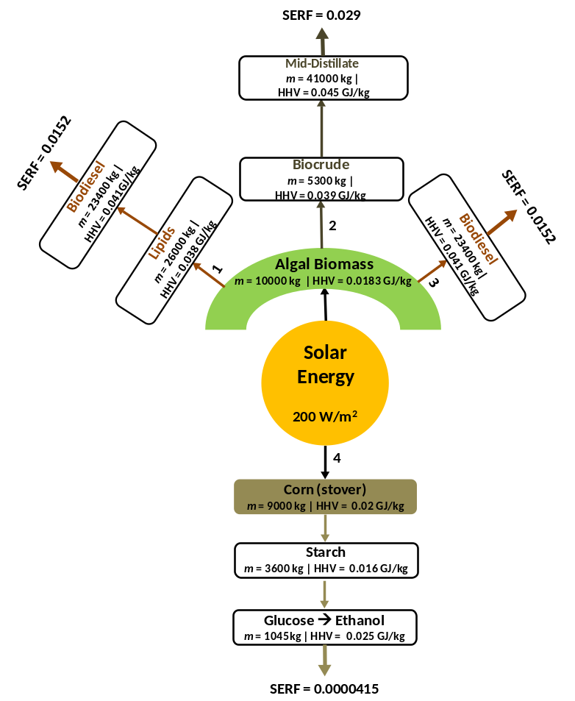
In order to understand the advantage of algae based biofuels, especially through pre-treatment methods involving hot compressed water, an approximation of the net solar energy flow is performed. Presented in Figure 2, is the comparison of biofuel production (biodiesel, ethanol, and middle-distillates) using HTL, SCT, fermentation and transesterification of algae and corn (for bioethanol) as feedstock. Based on the assumption of solar insolation of 200W/m² for a 10000 m² cultivation area, the relevant annual productivity for algae and corn is calculated. Owing to the high productivity, from the beginning it becomes clear that the yield of algal biomass is substantially greater than that of 1G/2G biofuel feedstock. After accounting for the yield and energy content of the feedstock following major processing steps, the net energy flows and efficiency of each process are computed followed by the overall energy retained in the end product based on the solar insolation.
Figure 2 – Solar Energy Flow and energy retained in Fuel [Calculations presented in SI-1]
The solar energy retained in the untreated cultivated biomass has efficiencies of 0.029 and 0.0028 for algae and corn, respectively. Purely in terms of the energy flow, algae is able to utilise more of the sunlight due to the high biomass turnover. This is reflected in the Solar Energy Return in Fuel (SERF) which equates to 0.029 for middle-distillates via HTL, 0.0004 for corn based ethanol and 0.015 for biodiesel via transesterification/SCT. Thus, overall algal biofuels have a greater efficacy at capturing solar energy and cascading it to the fuel. But the limitation withheld by algae thus far is the higher cost of processing and capital intensive equipment. Even with such low productivity (compared to algae), corn is used commercially, elucidating that the conversion route for algae to biofuel is in dire need for improvement. As such, value chemicals have been suggested to add another product vector to contribute towards lowering the overall cost, but these will only remain lucrative during the initial stages before the market expands. Hence, it would be expected that the long term value creation or cost reduction will be a result of improvement in existing conversion/pre-treatment technology either via new methods or process integration to make it competitive with existing biofuels.
From earlier sections it is apparent that improvement in HTL is from reduction in RT, thus negating long processing times and reusing products from associated process can aid adding value. The integration of these hydrothermal processing technologies is already in conception as demonstrated by several researchers, particularly via the two-step HTL (Elliot et al., 2015). Ultimately this lays the foundation for continuous processing whereby HTEx is used to fractionate some of the biomass constituents followed by downstream processing employing other HT options available, as show in Figure 3 to convert the remaining matter. From recent studies it has become clear that the aqueous phase is a major mass carrier and where over 50wt.-% of the feedstock matter is partitioned (Patel & Hellgardt, 2015). Consequently, it should be utilised either for algae cultivation or for energy generation via SCWG or AD, processes that yield environmental benefit. Similarly, HTC is particularly interesting for waste water (including sludge) cultivated algae or feedstock with a mixture of several organic constituents owing to its long RT and extraction/formation of organic molecules. Additionally, the destruction of toxic/hazardous wastewater bacteria (Knez et al., 2015, Peterson et al., 2009 and Savage, 1999) is also performed in situ as well as nutrient reclamation. Lastly, the heat integration for these high temperature processes further adds to the economics of using multiple processing technologies.

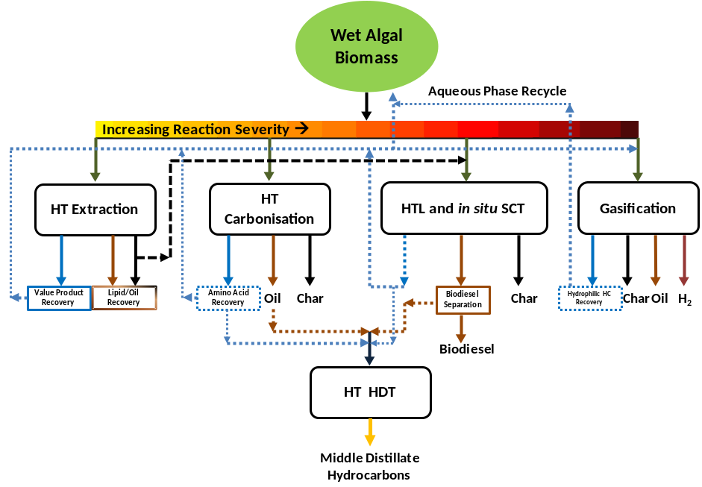
Figure 3 – Hydrothermal processing technologies product pool and product stream integration

5.0 Environmental profiles of algal pre-treatment
Life cycle assessment (LCA) is a cradle-to-grave approach used to evaluate the environmental impacts of products and services. The LCA method has been formalised by the International Organization for Standardization and is becoming widely used to evaluate the holistic environmental aspects of various products and services derived from renewable resources including algal biofuels.
5.1 LCA of algal biofuel supply chains
Key algal biofuel supply chain networks are summarised in Figure 4. A literature review carried out by Quinn & Davis (2015) indicated that majority of LCAs evaluated conventional liquid extraction and transesterification routes. Several LCAs have focused on thermochemical routes (Aresta et al., 2005, Azadi et al., 2015, Connelly et al., 2015, Handler et al., 2014 and Orfield et al., 2014), whereas biochemical routes have been only concerned in very few studies (Quinn et al., 2014). In addition, the biological routes with direct conversion of CO₂ to algal photosynthetic biofuel (i.e. bioethanol, biohydrogen) based on the Calvin cycle provides alternative energy-saving options for biofuel production without additional energy inputs for creating or destroying biopoloymers (used for cell structure) (Singh & Olsen, 2011). This potential biological route has been only investigated in very limited LCAs (Jin et al., 2015). As highlighted in previous studies, cultivation and dewatering/drying processes are major energy sinks and GHG contributors across the entire algal biofuel supply chain (Handler et al., 2014).
Amongst algal biofuel supply chains, thermochemical routes especially HTL represent promising technologies due to the capability to covert wet biomass to biofuels (Quinn & Davis, 2015), as discussed in previous sections. LCA comparisons indicated that HTL biocrude with nutrient recycling is environmentally advantageous over petroleum counterparts and 1G/2G bioethanol benchmarks but might not be environmentally competitive to lipid extraction in terms of energy or GHG profiles due to its higher energy demands for high HTL temperature and pressure (Connelly et al., 2015 and Liu et al., 2013). The LCA results for algal biofuel found in previous studies vary significantly, for instance GWP100 profiles in the papers reviewed in this study range between -75 to 195kg CO₂/MJ biofuel. Such variation in LCA profile is dependent on a wide range of factors such as the system boundary defined, the environmental issues and applications investigated, assumptions and data quality (Azadi et al., 2015 and Quinn & Davis, 2015). Generally, the infrastructure aspect is neglected in most LCAs (e.g. GREET model), whereas the assumptions on upstream (e.g. CO₂ source) or downstream (e.g. biofuel application, blending scenarios aqueous phase fate) processes vary, which could be sensitive factors (Connelly et al., 2015). Thus the system boundary expansion with inclusion of infrastructure and varying processing scenarios might lead to different comparison findings (Quinn & Davis, 2015).
All LCAs under this review adopted a well-to-pump or well-to-wheel system boundary definition (Figure 4) with closed-loop assumptions, defined as the use of 100% energy/nutrient recovery for algal biofuel system (Jin et al., 2015 and Yang et al., 2011b). On the other hand, ‘open-loop’ assumptions could be also considered with an expanded system boundary to include fertiliser or any other substituted products beyond algal biofuel.
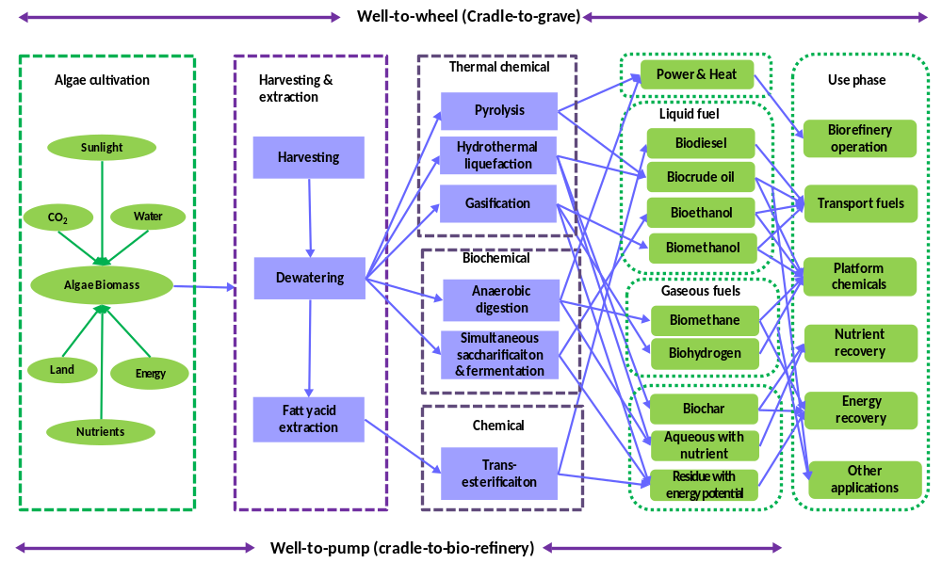
Figure 4 - LCA system boundary for algal biofuel supply chains

5.2 Environmental issues in algal biofuel systems
Thus far this literature review indicates that the majority of LCAs tend to focus on energy aspect and global warming potential (GWP100) with less attention paid to the wider range of environmental impact categories such as water footprint which is only quantified in very few studies (Clarens et al., 2011, Farooq et al., 2015, Mu et al., 2014 and Yang et al., 2011b). As demonstrated in the water-energy-algae nexus (Figure 5), water and nutrients in addition to energy also play essential roles in the algal biofuel system. Considering the algae cultivation stage only, theoretically 1 kg dry algae biomass requires 5-10kg water based on the algae water content (80-85%) and dissociation of approximately one mole of water per mole of CO₂ for the photosynthetic process (Williams & Laurens, 2010). The study conducted by Yang et al. (2011b) concluded that 1 kg biodiesel production would need 3726 kg fresh water, 0.33kg N and 0.71 kg P, which could be reduced by 55-90% by water and nutrient recycling or switching to wastewater. Previous LCAs paid more attention to indicators for quantity of the energy generated (e.g. net energy ratio or energy return on and investment as indicators (Quinn & Davis, 2015) but not the energy quality. As a consequence, Jin et al. (2015) introduced molar chemical exergy indicator as a measure of potentially useful energy quality to evaluate the solar energy utilisation efficiency of a closed-loop algal biofuel system via biochemical route. Despite the advantage of high land use efficiency of algal systems in terms of biofuel productivity (Singh & Olsen, 2011) and capability of growing biomass on marginal lands (Pontau et al., 2015), land use issues are rarely addressed in the LCAs (Handler et al., 2014, Pontau et al., 2015 and Zhang et al., 2013). In addition to GHG as a measure of land use change, area requirements and land use intensity and efficiency were also introduced as land use indicators (Pontau et al., 2015). To fill the significant knowledge gaps identified here and avoid problem-shifting, holistic LCAs are needed in future research to evaluate the overall environmental issues of algal biofuel systems.
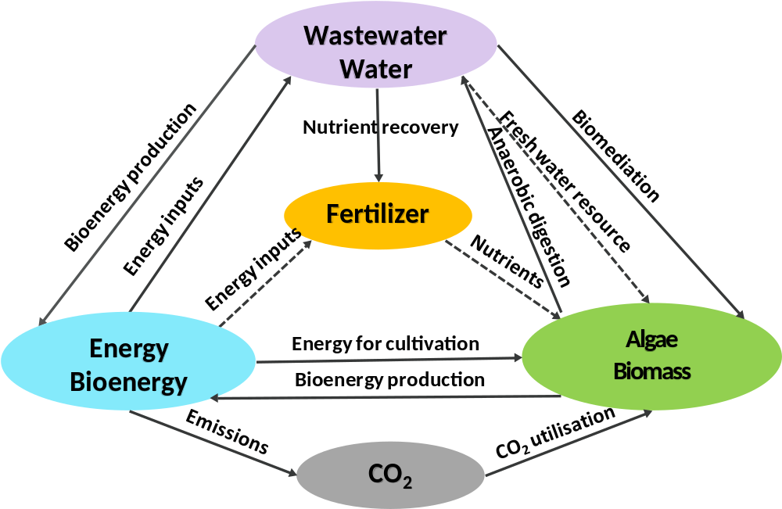
Figure 5 - water-energy-biomass nexus for algae bioenergy system (dash lines indicate the diversion of algal biofuel system from fresh water and artificial nutrient inputs by using wastewater for algae cultivation)

5.3 Algae vs. terrestrial plants for biofuel production
Algae have been regarded as 3G or 4G biofuel feedstocks and have gained an increasing research attention recently. The desirable traits of algal strains as sustainable aquatic plants for biofuel production in comparison with terrestrial plants have been highlighted in previous studies (Singh & Olsen, 2011) including high resource-utilisation efficiency, high CO₂ sequestration capacity, ability to dominate wild strains in open pond, tolerance to a wide range of conditions and seasonal variations, rapid production cycle and high photosynthesis efficiency. Such features could lead algae biofuel to be environmentally beneficial e.g. GHG mitigation potential, biomediation potential. Microalgae can tolerate and capture substantially higher levels of flue gas CO₂ emitted from industrial sources with a wide range of concentration from ambient (0.036%v/v) to extremely high (100% v/v) thus are considered as promising candidate biofixation technologies to mitigate CO₂ (Singh & Olsen, 2011). This potential has been investigated in previous LCAs. A study concluded that macroalgae as feedstock for CO₂ fixation and biofuel production could deliver overall energy benefits, depending on conversion technology choice (Aresta et al., 2005). Besides, the algal bioremediation of wastewater has been also examined – LCAs indicate that it could not only deliver environmental savings by avoiding artificial fertiliser inputs but also lead to reduced water demand (Farooq et al., 2015, Mu et al., 2014 and Yang et al., 2011b). Higher energy yield per unit land (about 30 times more oil) than terrestrial oilseed crops (Singh & Olsen, 2011) plus the avoidance of competition of productive land with food (Clarens et al., 2010) can bring potentially environmental benefits to algal biofuel systems. As demonstrated by Campbell et al. (2011) and Clarens et al. (2010), algae biofuel performs better than terrestrial crops on GWP100, land use and eutrophication but not all impact categories. This indicates that further research efforts are needed on algal biofuel optimisation at both process and supply chain levels.
5.4 Algal biofuel process and supply chain – integration and optimisation
Various scenarios for optimising the conceptual algal biofuel biorefinery have been investigated in LCAs, including strain screening, process integration by recycling or recovering energy, water and nutrient resources from waste streams (Aitken & Antizar-Ladislao, 2012, Mu et al., 2014 and Yang et al., 2011b), the supply chain integration by incorporating algal biofuel system into anaerobic digestion or other production systems (Mu et al., 2014 and Zhang et al., 2013). The genetic traits of different algae strains vary significantly in terms of their oil content (Azadi et al., 2015) and tolerance to CO₂ concentration and other conditions (Bahadar & Khan, 2013), additionally Bahadar & Khan (2013) reviewed several microalgae strains with preferable features for biofuel production. Although these microalgae strains have been extensively investigated from technological perspectives, only one publically accessible LCA has been found to compare different strain performance (Yang et al., 2011b). The importance of accounting for spatially-explicit resource constraints in LCAs has been addressed by Farooq et al. (2015) and Quinn & Davis (2015). Due to the geographical variation, climatic conditions, land, CO₂ and water resource accessibility, LCA should be context-specific and spatially-explicit. Aitken & Antizar-Ladislao (2012) and Yang et al. (2011b) highlighted the spatial variation in LCA profiles due to the impact of cultivation site location on dominant species and algae growth leading to a conclusion that in general, high solar radiation and temperature benefit microalgae growth and lower water footprint. Limited analyses have been performed at spatially explicit levels (Moody et al., 2014 and Pontau et al., 2015). Moody et al. (2014) mapped out the global potential for algal biofuels and identified the optimal locations for algae growth and concluded that an algal bio-refinery provides a promising solution to meet significant fractions of transport fuel demands in many regions if without water and nutrient resource constraints.
As shown in Figure 5, algal biofuel systems can operate with reduced inputs of fresh water, artificial nutrient and unnecesary energy by process integration and optimisation which have already been considered in LCAs. As analysed by Frank et al. (2012), the fate of the residual nitrogen fraction is important for GHG profiles and thus nutrient recovery offers environmental saving potential. The significance of heat integration, renewable energy substitution, energy recovery from residues (HTL aqueous phase, liquid-extracted algal residue and solid residues) for offsetting operational energy demands and increasing sustainability have been demonstrated in previous LCAs (Orfield et al., 2014 and Quinn et al., 2014). Future research efforts should be made to explore spatially-explicit optimal solutions for algal biofuel process and supply chain designs, which can be achieved by combining LCA and optimisation modelling approaches.
5.5 LCA data quality
Most LCAs of algal biofuels were developed either based on laboratory experimental data (Orfield et al., 2014) or by adopting theoretical data (Connelly et al., 2015, Liu et al., 2013 and Mu et al., 2014) and computer-aided simulations (Azadi et al., 2015). The difference between laboratory-scale and theoretical data lead to dramatically varying LCA findings and some LCAs have attempted to address the issue (Liu et al., 2013). However, the key assumptions on reaction parameters (e.g. HTL temperature and residence time) and downstream/upstream processing (e.g. CO₂ sources or nutrient and energy recovery) vary with LCAs. Although such assumptions could be sensitive factors for research findings (Connelly et al., 2015 and Quinn & Davis, 2015), not all published LCAs cover sensitivity analyses. Furthermore, uncertainty analyses have been only performed in limited studies (Liu et al., 2013). LCAs lacking explicit interpretation of the degree of uncertainty and sensitivities should not be used as robust evidence for policy or comparative assertions. Thus, more research efforts need to be focused on LCA inventory development with indication of data reliability and the comprehensive data quality analyses should be applied as a general practice in future LCAs on algal biofuel.
6.0 Conclusion
Hydrothermal water treatment is a well developed technology being applied to algal systems. The challenge is not in the conversion of the feed to the product but rather in understanding the chemistry taking place within the reactor to achieve the product efficiently. Without knowing the reaction pathways of the species involved in the mixture, the investigation merely become observations, thus limiting innovation in the field. Additionally, the LCA methodologies employed need to be standardised as there are large discrepancies in calculated impacts. Ultimately, with further detailed work HTL has the potential to realise the algal biorefinery concept.

References

- Aitken, D., Antizar-Ladislao, B. 2012. Achieving a Green Solution: Limitations and Focus Points for Sustainable Algal Fuels. Energies, 5(5), 1613-1647.

- Aresta, M., Dibenedetto, A., Barberio, G. 2005. Utilization of macro-algae for enhanced CO2 fixation and biofuels production: Development of a computing software for an LCA study. Fuel Process. Technol., 86(14-15), 1679-1693.

- Azadi, P., Brownbridge, G., Mosbach, S., Inderwildi, O., Kraft, M. 2015. Simulation and life cycle assessment of algae gasification process in dual fluidized bed gasifiers. Green Chem., 17(3), 1793-1801.

- Azadi, P., and Farnood, M. 2011. Review of heterogeneous catalysts for sub-and supercritical water gasification of biomass and wastes. Int. J. Hydrogen Energy., 36, 16, 9529-9541.
- Bach, Q-Vu, Sillero, M.,, Tran, K-H., Skjermo, J. 2014. Fast hydrothermal liquefaction of a norwegian macro-alga: Screening tests. Algal Res., 6 , 271-276.
- Bahadar, A., Khan, M.B. 2013. Progress in energy from microalgae: A review. Renew. Sust. Energ. Rev., 27, 128-148.

- Bai, X., Duan, P., Xu, Y., Zhang, A., Savage, P. 2014. Hydrothermal catalytic processing of pretreated algal oil: a catalyst screening study. Fuel 120, 141-149.
- Barreiro, D., Prins, W., Ronsse, F., & Brilman, W., 2013. Hydrothermal liquefaction (HTL) of microalgae for biofuel production: state of the art review and future prospects. Biomass Bioenergy. 53, 113-127.

- Biller, P., R. Riley, and A. B. Ross. 2011. Catalytic hydrothermal processing of microalgae: decomposition and upgrading of lipids. Bioresour. Technol., 102(7), 4841-4848.
- Campbell, P.K., Beer, T., Batten, D. 2011. Life cycle assessment of biodiesel production from microalgae in ponds. Bioresour. Technol, 102(1), 50-56.

- Chakinala, A.G., Brilman, D.W.F., van Swaaij, W.P.M., Kersten, S.R.A., 2009. Catalytic and non-catalytic supercritical water gasification of microalgae and glycerol. Ind. Eng. Chem. Res. 49 (3), 1113–1122

- Cherad, R., Onwudili, J.A., Williams, P.T., Ross, A.B., 2014. A parametric study on supercritical water gasification of Laminaria hyperborea: A carbohydrate-rich macroalga. Bioresour. Technol., 169, 573-580.

- Cherad, R., Onwudili, J. A., Ekpo, U., Williams, P. T., Lea‐Langton, A. R., Carmargo‐Valero, M., Ross. A. B. 2013. Macroalgae supercritical water gasification combined with nutrient recycling for microalgae cultivation. Environ. Prog. Sustain. Energy ,32(4), 902-909.
- Clarens, A.F., Nassau, H., Resurreccion, E.P., White, M.A., Colosi, L.M. 2011. Environmental Impacts of Algae-Derived Biodiesel and Bioelectricity for Transportation. Environ. Sci. Technol., 45(17), 7554-7560.
- Clarens, A.F., Resurreccion, E.P., White, M.A., Colosi, L.M. 2010. Environmental Life Cycle Comparison of Algae to Other Bioenergy Feedstocks. Environ. Sci. Technol., 44(5), 1813-1819.

- Connelly, E.B., Colosi, L.M., Clarens, A.F., Lambert, J.H. 2015. Life Cycle Assessment of Biofuels from Algae Hydrothermal Liquefaction: The Upstream and Downstream Factors Affecting Regulatory Compliance. Energy Fuels, 29(3), 1653-1661.

- Duan, P., Bai, X., Xu, Y., Zhang, A., Wang, F., Zhang, L., Miao, J. 2013. Catalytic upgrading of crude algal oil using platinum/gamma alumina in supercritical water. Fuel 109, 225-233.

- Duan, P., Savage, P. 2011a. Catalytic hydrotreatment of crude algal bio-oil in supercritical water. Appl. Catal., B: Environ., 104(1)1, 136-143.

- Duan, P., Savage, P. 2011b.Upgrading of crude algal bio-oil in supercritical water. Bioresour. Technol., 102(2), 1899-1906.
- Duan, P., Savage, P. 2011c. Catalytic treatment of crude algal bio-oil in supercritical water: optimization studies. Energy Environ. Sci,. 4(4), 1447-1456.

- Duan, P., Savage, S. 2010. Hydrothermal liquefaction of a microalga with heterogeneous catalysts. Ind. Eng. Chem. Res., 50(1), 52-61.
- Elliott, D. C., Biller, P., Ross, A. B., Schmidt, A. J., Jones, S. B., 2015. Hydrothermal liquefaction of biomass: Developments from batch to continuous, process. Bioresour. Technol. 178, 147-156.

- Farooq, W., Suh, W.I., Park, M.S., Yang, J.W. 2015. Water use and its recycling in microalgae cultivation for biofuel application. Bioresour. Technol., 184, 73-81.

- Frank, E.D., Han, J., Palou-Rivera, I., Elgowainy, A., Wang, M.Q. 2012. Methane and nitrous oxide emissions affect the life-cycle analysis of algal biofuels. Environ. Res. Lett., 7(1), 10.

- Garcia, A.L., Torri, C., Samorì, C., van der Spek, J., Fabbri, D., Kersten, S. R., Brilman, D. W., 2011. Hydrothermal treatment (HTT) of microalgae: evaluation of the process as conversion method in an algae biorefinery concept. Energy Fuels. 26(1), 642-657.

- Garcia-Moscoso, J.L., Obeid, W., Kumar, S., Hatcher, P.G. 2013. Flash hydrolysis of microalgae (Scenedesmus sp.) for protein extraction and production of biofuels intermediates. J. Supercrit. Fluids, 82, 183-190.

- Guan, Q., Savage, P.E., Wei, C. 2012. Gasification of alga Nannochloropsis sp. in supercritical water. J. Supercrit. Fluids, 61, 139-145.

- Haiduc, A.G., Brandenberger, M., Suquet, S., Vogel, F., Bernier-Latmani, R., Ludwig, C. 2009. SunCHem: an integrated process for the hydrothermal production of methane from microalgae and CO2 mitigation. J. Appl. Phycol., 21(5), 529-541.
- Handler, R.M., Shonnard, D.R., Kalnes, T.N., Lupton, F.S. 2014. Life cycle assessment of algal biofuels: Influence of feedstock cultivation systems and conversion platforms. Algal Res., 4, 105-115.

- He, C., Giannis, A., Wang, J-Y. 2013. Conversion of sewage sludge to clean solid fuel using hydrothermal carbonization: Hydrochar fuel characteristics and combustion behaviour. Appl. Energy,111, 257-266.
- Heilmann, S.M., Jader, L.R., Harned, L.A., Sadowsky, M.J., Schendel, F.J., Lefebvre, P.A., Von Keitz, M.J., Valentas, K.J. 2011. Hydrothermal carbonization of microalgae II: fatty acid, char and algal nutrient products. Appl. Energy, 88(10), 3286-3290.

- Heilmann, S.M., Davis, H.T., Jader, L.R., Lefebvre, P.A., Sadowsky, M.J., Schendel, F.J., Keitz, M.G.V., Valentas, K.J., 2010. Hydrothermal carbonization of microalgae. Biomass Bioenergy 34, 875–882.
- IEA.2013. http://www.iea.org/Textbase/npsum/resources2013SUM.pdf [ Accessed 07/07/2015 - 19:35].

- IPCC. 2014. https://www.ipcc.ch/publications_and_data/ar4/wg1/en/spmsspm-human-and.html [ Accessed 07/07/2015 - 19:34].
- Jazrawi, C., Biller, P., Ross, A. B., Montoya, A., Maschmeyer, T., Haynes, B. S., 2013. Pilot plant testing of continuous hydrothermal liquefaction of microalgae. Algal Res. 2(3), 268-277.

- Jena, U., Das, K. C., Kastner, J.R. 2012. Comparison of the effects of Na 2 CO 3, Ca 3 (PO 4) 2, and NiO catalysts on the thermochemical liquefaction of microalga Spirulina platensis. Appl. Energy 98, 368-375.

- Jin, Q., Chen, L., Li, A.M., Liu, F.Q., Long, C., Shan, A.D., Borthwick, A.G.L. 2015. Comparison between solar utilization of a closed microalgae-based bio-loop and that of a stand-alone photovoltaic system. Bioresour. Technol., 184, 108-115.

- Knez, Ž., Markočič, E., Knez Hrnčič, M., Ravber, M., Škerget, M. 2015. High pressure water reforming of biomass for energy and chemicals: A short review. J. Supercrit. Fluids, 96, 46-52.
- Kruse, A., Dinjus, E. 2007. Hot compressed water as reaction medium and reactant: properties and synthesis reactions. J. Supercrit. Fluids, 39(3), 362-380.
- Leow, S., Witter, J.R., Vardon, D.R., Sharma, B.K., Guest, J.S., Strathmann, T.J. 2015. Prediction of microalgae hydrothermal liquefaction products from feedstock biochemical composition. Green Chem..
- Levine, R.B., Sierra, C.O.S., Hockstad, R., Obeid, W., Hatcher, P.G., Savage, P.E. 2013. The use of hydrothermal carbonization to recycle nutrients in algal biofuel production. Environ. Progr. Sustain.. Energy, 32(4), 962-975.

- Levine, R.B. 2013. The production of algal biodiesel using hydrothermal carbonization and in situ transesterification. PhD Diss., The University of Michigan.

- Li, Z., Savage, P.E. 2013. Feedstocks for fuels and chemicals from algae: treatment of crude bio-oil over HZSM-5. Algal Res. 2(2), 154-163.

- Liu, X.W., Saydah, B., Eranki, P., Colosi, L.M., Mitchell, B.G., Rhodes, J., Clarens, A.F. 2013. Pilot-scale data provide enhanced estimates of the life cycle energy and emissions profile of algae biofuels produced via hydrothermal liquefaction. Bioresour. Technol., 148, 163-171.

- Lu, Y., Levine, R.B., Savage, P.E. 2014. Fatty Acids for Nutraceuticals and Biofuels from Hydrothermal Carbonization of Microalgae. Ind. Eng. Chem. Res., 54(16), 4066-4071.
- Matsui, T-O., Nishihara, A., Ueda, C., Ohtsuki, M., Ikenaga, N., Suzuki, T. 1997. Liquefaction of micro-algae with iron catalyst. Fuel, 76(11), 1043-1048.
- Moody, J.W., McGinty, C.M., Quinn, J.C. 2014. Global evaluation of biofuel potential from microalgae. Proc. Natl. Acad. Sci. U. S. A., 111(23), 8691-8696.

- Mu, D.Y., Min, M., Krohn, B., Mullins, K.A., Ruan, R., Hill, J. 2014. Life Cycle Environmental Impacts of Wastewater-Based Algal Biofuels. Environ. Sci. Technol., 48(19), 11696-11704.

- Onwudili, J.A., Lea-Langton, A.R., Ross, A.B., Williams, P.T., 2013. Catalytic hydrothermal gasification of algae for hydrogen production: composition of reaction products and potential for nutrient recycling. Bioresour. Technol. 127, 72–80.

- Orfield, N.D., Fang, A.J., Valdez, P.J., Nelson, M.C., Savage, P.E., Lin, X.N., Keoleian, G.A. 2014. Life Cycle Design of an Algal Biorefinery Featuring Hydrothermal Liquefaction: Effect of Reaction Conditions and an Alternative Pathway Including Microbial Regrowth. ACS Sustain. Chem. Eng., 2(4), 867-874.

- Patel, B., and Hellgardt, K. 2015. Hydrothermal upgrading of algae paste in a continuous flow reactor. Bioresour. Technol., 191, 460-468.

- Patel, B., and Hellgardt, K. 2013a. Hydrothermal upgrading of algae paste: Application of 31P‐NMR. Environ. Prog. Sustain. Energy., 32, 1002-1012.

- Patel, B. and Hellgardt, K. 2013b. Simultaneous Supercritical Transesterification and Hydrothermal Liquefaction of Algae Paste. In: AIChE 2013 Annual Meeting. [online] Available at: http://www3.aiche.org/proceedings/Abstract.aspx?PaperID=341203 [Accessed 10 Sep. 2015].

- Patel, B., Tamburic, B., Zemichael, F. W., Dechatiwongse, P., Hellgardt, K. 2012. Algal biofuels: a credible prospective?. ISRN Renew. Energy 2012

- Patil, P.D., Gude, V.G., Mannarswamy, A., Deng, S., Cooke, P., Munson-McGee, S., Rhodes, I., Lammers, P., Nirmalakhandan, N. 2011. Optimization of direct conversion of wet algae to biodiesel under supercritical methanol conditions. Bioresour. Technol. 102 (1), 118–122

- Patil, P.D., Reddy, H., Muppaneni, T., Schaub, T., Holguin, F.O., Cooke, P., Lammers, P., Nirmalakhandan, N., Li, Y., Lu, X. 2013. In situ ethyl ester production from wet algal biomass under microwave-mediated supercritical ethanol conditions. Bioresour. Technol. 139, 308–315.
- Peterson, A.A., Vogel, F., Lachance, R.P., Fröling, M., Antal, M.J. 2008.Thermochemical biofuel production in hydrothermal media: a review of suband supercritical water technologies. Energy Environ. Sci. 1, 32–65.

- Pontau, P., Hou, Y., Cai, H., Zhen, Y., Jia, X.P., Chiu, A.S.F., Xu, M. 2015. Assessing land-use impacts by clean vehicle systems. Resour. Conserv. Recycl., 95, 112-119.

- Quinn, J.C., and Davis, R. 2015. The potentials and challenges of algae based biofuels: A review of the techno-economic, life cycle, and resource assessment modeling. Bioresour. Technol., 184, 444-452.

- Quinn, J.C., Hanif, A., Sharvelle, S., Bradley, T.H. 2014. Microalgae to biofuels: Life cycle impacts of methane production of anaerobically digested lipid extracted algae. Bioresour. Technol., 171, 37-43.

- Ross, A. B., Biller, P., Kubacki, M. L., Li, H., Lea-Langton, A., Jones, J. M. 2010. Hydrothermal processing of microalgae using alkali and organic acids. Fuel, 89(9), 2234-2243.

- Savage, P. E. 1999. Organic chemical reactions in supercritical water. Chem.rev. 99(2), 603-622.
- Singh, A., Olsen, S.I. 2011. A critical review of biochemical conversion, sustainability and life cycle assessment of algal biofuels. Appl. Energy, 88(10), 3548-3555

- Stucki, S., Vogel, F., Ludwig, C., Haiduc, A.G., Brandenberger, M., 2009. Catalytic gasification of algae in supercritical water for biofuel production and carbon capture. Energy Environ. Sci. 2, 535–541.
- Tian, C., Li, B., Liu, ., Zhang, Y., Lu, H., 2014. Hydrothermal liquefaction for algal biorefinery: A critical review. Ren. Sustain. Energy Rev. 38, 933-950.

- Toor, Saqib S., Harvind Reddy, Shuguang Deng, Jessica Hoffmann, Dorte Spangsmark, Linda B. Madsen, Jens Bo Holm-Nielsen, and Lasse A. Rosendahl. 2013. Hydrothermal liquefaction of Spirulina and Nannochloropsis salina under subcritical and supercritical water conditions. Bioresource technology131, 413-419.

- Valdez, P.J., Tocco, V.J., Savage, P.E. 2014. A general kinetic model for the hydrothermal liquefaction of microalgae. Bioresour. Technol. 163, 123-127.
- Williams, P.J.l.B., Laurens, L.M.L. 2010. Microalgae as biodiesel & biomass feedstocks: Review & analysis of the biochemistry, energetics & economics. Energy Environ. Sci., 3(5), 554-590

- Yang, L., Li, Y., Savage, P.E. 2014. Catalytic Hydrothermal Liquefaction of a Microalga in a Two-Chamber Reactor. Ind. Eng. Chem. Res., 53(30), 11939-11944.

- Yang, C., Jia, L., Chen, C., Liu, G., Fang, W., 2011a. Bio-oil from hydro-liquefaction of Dunaliella salina over Ni/REHY catalyst. Bioresour. Technol., 102, 4580–4584.
- Yang, J., Xu, M., Zhang, X.Z., Hu, Q.A., Sommerfeld, M., Chen, Y.S. 2011b. Life-cycle analysis on biodiesel production from microalgae: Water footprint and nutrients balance. Bioresour. Technol., 102(1), 159-165.

- Yuan, X., Wang, J., Zeng, G., Huang, H., Pei, ., Li, H., Liu, ., Cong, M.M. 2011. Comparative studies of thermochemical liquefaction characteristics of microalgae using different organic solvents. Energy, 36(11), 6406-6412.
- Zhang, H., Zhu, W., Xu, Z., Gong, M. 2014. Gasification of cyanobacteria in supercritical water. Environ. Technol., 35(22), 2788-2795.
- Zhang, Y.L., White, M.A., Colosi, L.M. 2013. Environmental and economic assessment of integrated systems for dairy manure treatment coupled with algae bioenergy production. Bioresour. Technol., 130, 486-494.
- Zou, S., Wu, Y., Yang, M., Li, C., Tong, J., 2010. Bio-oil production from sub-and supercritical water liquefaction of microalgae Dunaliella tertiolecta and related properties. Energy Environ. Sci. 3, 1073–1078.

