An agent-based modelling approach to simulate the investment decision of industrial enterprises
Sara Budinis¹, Julia Sachs¹, Sara Giarola^{2*} and Adam Hawkes¹
¹ Chemical Engineering Department, Imperial College London, South Kensington, London SW7 2AZ, UK
² Earth Science and Engineering Department, Imperial College London, South Kensington, London SW7 2AZ, UK
*s.giarola10@imperial.ac.uk
Abstract
China is the leading ammonia producer and relies on a coal-based technology which makes the already energy intensive Haber-Bosch process, one of the most emission intensive in the world This work is the first to propose an agent-based modelling framework to model the Chinese ammonia industry as it characterizes the specific goals and barriers towards fuel switching and carbon capture and storage adoption for small, medium, and large enterprises either private or state-owned. The results show that facilitated access to capital makes investments in sustainable technologies more attractive for all firms, especially for small and medium enterprises. Without policy instruments such as carbon price, the decrease in emissions in the long-term is due to investments in natural gas-based technologies, as they typically have lower capital and operating costs, and also lower electricity consumption than coal-based production. Conversely, with policy instruments in place, a strong decrease in emissions occurs between 2060 and 2080 due to investors choosing natural gas and biomethane-based technologies, with carbon capture and storage. In the long term, natural gas and biomethane could compete, with the outcome depending on infrastructure, supply chain availability and land use constraints.
Graphical abstract
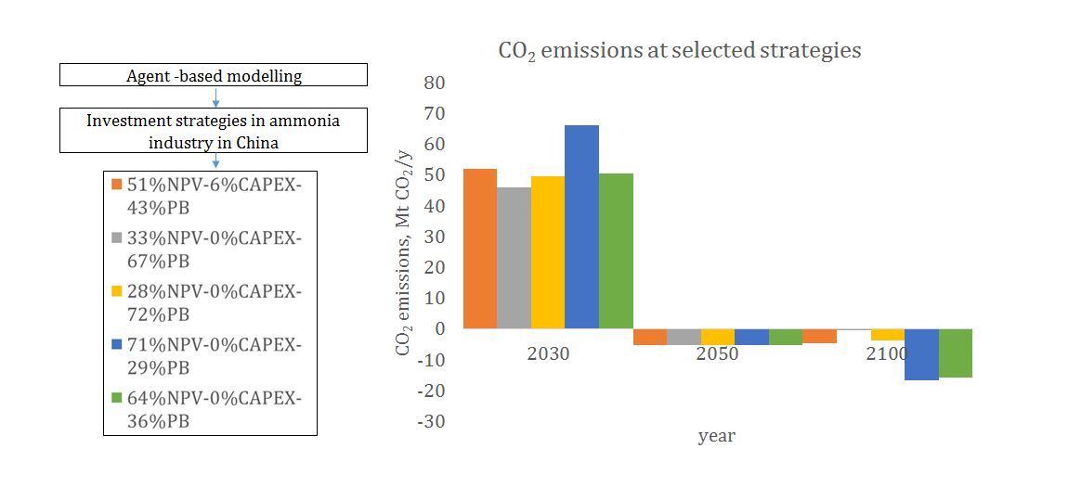
Keywords: Energy systems modelling; agent -based modelling; net-zero emissions; ammonia manufacturing
Highlights:
- An agent-based model is proposed to characterise investment in industry
- A carbon price is effective to promote sector decarbonisation
- Fuel switching and CCS may be pivotal to reduce emissions
- 28% of ammonia market in China may struggle to decarbonise even with a carbon price

Introduction
The industrial sector is one of the most energy and emission intensive sectors, accounting for 36% of global total final energy consumption (TFEC) and for 24% of global CO₂ emissions (IEA, 2017). Globally, 69% of industrial TFEC is consumed by five subsectors: iron and steel, cement, chemicals and petrochemicals, aluminium, and pulp and paper (Zhou et al., 2010).
The chemicals sector accounts for 28% of the total industrial consumption and for 13% of the total industrial CO₂ emissions (IEA, 2017). Among the chemicals, high value chemicals, ammonia and methanol account for 73% of total energy use within the chemicals sector and have recently significantly grown in production (19% growth for high value chemicals, 13% for ammonia and 51% for methanol in the period 2009-2014). In view of reaching carbon neutrality by mid-century to limit global warming to less than 2°C (COP21, 2015), the chemical industry would need to reduce its energy consumption from 1.5% per year to 1.2% per year (IEA, 2017).
Decarbonisation in industry can be achieved through energy saving technologies, fuel switching, management approaches, imposition of standards, fiscal policies and agreements on specific energy targets (Abdelaziz et al., 2011), light-weighting, and non-destructive recycling (Allwood et al., 2010). In the chemical industry, there is an urgent call for novel processing routes which could move away from the current use of fossil hydrocarbons (IEA, 2017). Higher capital costs at which novel technologies are available prevent investments, especially for small companies in developing countries (Danielson and Scott, 2006). In many circumstances, also institutional, organizational, and individual considerations might come into play leading to apparently irrational behaviours (Escrig-Olmedo et al., 2017). For example, energy efficient solutions might not be known to the investors, or, if known, they might be not implemented even when the payback time is very short (Palm and Thollander, 2010). Hidden costs, access to capital, split incentives, risks and uncertainty are also barriers to technology innovation (Fleiter et al., 2011).
As the industrial manufacturing is progressively concentrating in the non-OECD regions, there is great attention to the decarbonisation of developing countries. As capital cost is the main metric used for investments decisions (Hermes et al., 2007) in emerging economies, such as China, the introduction of novel and low-emitting technologies is more challenged.
With a production of more than 150 Mt in 2015 (USGS, 2017), ammonia is one of most abundantly manufactured high-value chemicals, at the same time being highly energy and emission intensive, with about 1,000 PJ of energy consumption and 360 Mt CO₂-eq emitted worldwide in 2015 (Schiffer et al., 2017). Ammonia demand is expected to increase mainly driven by urea-based fertilisers which are projected to keep growing although at lower rates compared to the past because of uncertain biofuel regulations, limits on nitrogen applications, as well as geopolitical tensions affecting the commodity market (IFA, 2019). A new demand for ammonia could also come from the fuel market as a potential hydrogen carrier (Bicer et al., 2017).
Ammonia manufacturing is based on the Haber-Bosch process, which uses molecular hydrogen and nitrogen. The source of hydrogen is the reforming of fossil-fuels. In China, the leading producing country with about a third of global ammonia production (USGS, 2017), the reliance on coal results in a highly emitting manufacturing process, with a subsector total emission equal 185.05 Mt of CO₂ in 2007 (Zhu et al., 2010). Emerging solutions for a less polluting Haber-Bosch process could come from water electrolysis, integrated with renewable electricity as a source for hydrogen; in the long-term novel enzymatic catalysts might open alternative synthetic avenues (Schiffer et al., 2017). Currently, mostly available solutions would come from fuel switching and improvement of the efficiency of the technologies used (IEA, 2017). Ammonia is also a process which releases high-purity CO₂ streams, thus acknowledged as a priority area for the carbon capture and storage integration (CCS) (IEA – UNIDO, 2011).
In this paper, we investigate the decarbonisation of the Chinese ammonia industry through the integration of CCS, in addition to fuel switching, investigating the potential uptake of negative emissions obtained from the combination of bioenergy with CCS. The methodology is based on an agent-based formulation integrated into a simulation-based industrial sector model, which aims to simulate real investment strategies in the energy sector made by agent-investors in China and allows to model barriers preventing technology innovation due to the decision-making process.
The structure of the paper is as follows. First, the relevant literature concerning the characterisation of the industry within integrated assessment models is discussed. Then, the methodology is presented, with a focus on: techno-economic characterisation of production processes, procedure to estimate commodity demand, investment decision-making algorithm, overview of current ammonia market in China, and description of key investors. Finally, results are presented and discussed.

Literature review
Integrated assessment models are widely-applied tools to evaluate different pathways for the decarbonisation of the energy system (IPCC, 2014). They have broad interdisciplinary scope, often covering the energy system, economy, climate system, land use and sometimes water use (Krey, 2014). They can be categorised as intertemporal optimisation models or recursive dynamic models and are the subject of ongoing refinement and development (Kriegler et al., 2015; Pfenninger et al., 2014). Integrated assessment models are used to generate pathways that feed into high impact publications such as the IPCC Special Reports and Assessment Reports (IPCC, 2019) and the IEA World Energy Outlook (International Energy Agency (IEA), 2019). The studies on the technological transition of industry tend to highlight that technological measures for decarbonisation (e.g. energy efficiency measures, fuel switching, alternative production processes or CCS) can be cost-effective in the presence of policy instruments that internalise the cost of climate change impacts such as a carbon price (Guo et al., 2014). Integrated assessment models are also used within model comparison studies to understand how different modelling approaches influence results (Krey et al., 2019). For example, the Energy Modelling Forum (EMF) aims to improve the use of energy and policy models for better decision making (Kriegler et al., 2014). Within integrated assessment models, the industrial sector is characterised as an end-use demand sector, producing commodities and demanding energy, in the form of fuels (fossil or renewable) and/or electricity. Industrial commodity demand is calculated from macroeconomic drivers in the majority of the models (Edelenbosch et al., 2017), although they widely differ in terms of disaggregation into market subsectors, commodities, and approach to the technology characterisation.
Most articles focus on specific subsectors, such as cement (Kermeli et al., 2019) and steel (van Ruijven et al., 2016) whereas only a few contributions assess the role of the whole industrial sector decarbonisation potential (Fais et al., 2016). The techno-economic modelling has various levels of granularity in the literature.
- POLES-JRC (the JRC version of the Prospective Outlook on Long-term Energy System) is a partial equilibrium model of the energy system using recursive dynamic simulation. It determines the market shares of competing options based on their relative cost and performance (Jacques et al., 2018). Within POLES-JRC, the industrial energy demand is broken down into four subsectors (iron and steel; chemicals; non-metallic minerals; others). For steel making, the competition among different technology options is based on pre-existing capacities, evolution of steel consumption and production costs. For the other sectors, first the demand for process heat is calculated, and then the heat demand is fulfilled by different fuels based on their relative costs. Other models only partially characterise the chemical subsector.
- The DNE21+ model, a dynamic, linear programming optimisation model of the energy system, uses a bottom-up approach for the energy intensive subsectors in industry (RITE, 2008). GCAM (Global Change Assessment Model) a dynamic-recursive model with technology-rich representations of the economy, evaluates the energy demand of the industrial sector by means of energy service price elasticities, with central estimate driven by population level, economic activity (gross domestic product, GDP) and the market prices of primary energy (JGCRI, 2019). The demand for cement and fertilizers is explicitly determined, while the remaining subsectors are modelled as a single homogeneous industrial good (Edelenbosch et al., 2017).
- In the WITCH (World Induced Technical Change Hybrid) model, the industrial sector is aggregated together with the service and residential sectors in the category of “non-electric sectors” (RFF CMCC, 2019).
- In NEMS (the National Energy Model), the Industrial Demand Module estimates energy consumption by energy source (fuels and feedstocks) for fifteen manufacturing (energy-intensive and non-energy intensive) and six non-manufacturing industries (represented in less detail). Each manufacturing industry is modelled using either an end-use model approach (based on three components: Boiler/Steam/Cogeneration, Buildings, and Process/Assembly activities) or a process-flow model approach (based on two components only: Buildings and Process/Assembly activities). The energy intensive manufacturing industries include food products, paper products, bulk chemicals, glass products, cement and lime, iron and steel, and aluminium. The non-energy intensive manufacturing industries include metal-based durables, wood products, and plastic products. Finally, the non-manufacturing industries include agriculture, as well as coal mining, natural gas and oil extraction, metal and non-metallic mining, and construction (EIA, 2013).
- In the DECC Energy and Emissions Model, an econometric, partial equilibrium model providing energy demand and emissions projections for the UK, the industrial sector is broken down into ten subsectors (food products, textile products, pulp and paper products, chemicals and chemical products, non-metallic minerals, iron and steel, non-ferrous metals, engineering and vehicles, construction and other manufacturing). The industry subsectors are not explicitly represented from a technology perspective, and instead their energy consumption is projected using an econometric approach based on key macroeconomic drivers (AEA, 2011).
- Only a few models disaggregate the industrial sector into subsectors (such as chemicals, cement, pulp and paper, iron and steel), and when that happens, the chemical industry is represented through a limited number of commodities (Kermeli et al., 2019). Only key commodities, typically ammonia or urea, are represented in detail while all remaining ones are collapsed into a single macro-category (International Energy Agency (IEA), 2019). This is due the high complexity and heterogeneity of the subsector, together with a lack of publicly available data regarding installed capacity and production. In the public domain, only some data are available regarding commodity trade, for instance from the United Nations Comtrade Database (UN, 2019). Often the description of the adopted modelling approach, via model documentation or scientific publications, is limited.
In the perspective of decarbonisation of industries, improved energy efficiency and implementation of low-carbon fuels and renewable energy represent a more direct way to reduce carbon emissions compared to CCS (Huisingh et al., 2015). The decarbonisation of the Chinese industry has attracted quite a lot of attention in the literature, being China one of the largest CO₂ emitters worldwide. Chang (2015) developed an input–output methodology integrated with a multi-objective framework including constraints on resource availability and emission targets to identify key CO₂ emission sectors and the optimised production structure with respect to the emission reduction targets in the Chinese economy. The uptake of natural gas would be an important step for decarbonising industries as it would promote a reduction in the dependence on coal in China. However, governmental intervention should guarantee a relatively stable natural gas market price to reduce resistance to adoption from the chemical sector, one of mostly influenced industries by natural gas price variations (Zhang, et al., 2017). The deployment of CCS is necessary to curb emissions in a way aligned with the carbon neutrality targets defined by the Paris Agreement, which China also ratified (IEA, 2017). High costs, uncertainty around the technology, financial and technical risks, as well as side effects of geoengineering schemes are important barriers (Huisingh et al., 2015). Studies have suggested the importance of the relative value of the CCS using the capture readiness addressed along the entire supply chain for the iron and steel industry in China (Ding et al., 2020). The ammonia industry, one of the biggest contributors to Chinese industrial emissions, could look at CCS-retrofit as an important opportunity for coal gasification-based ammonia decarbonisation (Bicer et al., 2017). However, important barriers to the technology innovation which affect investors’ choices may depend on the national context, customary practices, local environment, as well as the firms’ size (Chan et al., 2010). The interactions between investors and the local regulative and geographical environment are are not a mature field of energy systems modelling research (Lopion et al., 2018) as well as the inclusion of industrial practices in modelling (Edelenbosch et al., 2017). In the specific context of the ammonia manufacturing, China has specific features related to the market segmentation which leads to different investors’ behaviours towards innovation. Profound behavioural divergence can be found between small and medium enterprises (SME) versus large enterprises (LE), as well as between state-controlled versus foreign firms. Such discrepancies ought to be considered in energy modelling to support decision-making for the promotion of decarbonisation and sustainability in the sector (Yu et al., 2020).

Contribution of the study
This paper aims to assess the role of fuel switching and CCS for curbing the emissions in the ammonia industry in China, which not only is an industry projected to grow, but also represents a priority sector with high challenges for decarbonisation. This is especially important, considering that the country has shown willingness to curb emissions and that ammonia is quite an energy and emission intensive industry where the deployment of CCS, which would be promising despite the challenges, has been overlooked in the literature.
This paper proposes a novel approach to assess the fuel switching and CCS uptake in the Chinese industry. The methodology is based on an agent-based model for the industrial sector module developed within the MUSE (ModUlar energy systems Simulation Environment) framework. Including the ammonia production, 200 industrial technologies are modelled in industry using 12 key commodities. The model develops energy transition scenarios adopting a bottom-up approach, which quantifies the energy consumption, emissions, capital costs, and maintenance costs of each single modelled technology. With this granularity, the model overcomes the lack of a detailed techno-economic characterisation of the industrial modelling which is typical of integrated assessment models. In addition, the agent-based formulation enables the representation of the specific objectives, constraints and decision-making strategies available for selected industrial players, such as SMEs and LEs.

Materials and methods
This paper presents a development of the industrial sector module in MUSE (ISM) (Luh et al., 2020) to an agent-based framework (Sachs et al., 2019). An overview of MUSE is presented in the section 1 of the supplementary material.
The approach follows the schematic of Figure 1, which shows the integration between the agent-based framework and the industrial sector module. The ISM first projects the material commodity demand (such as ammonia demand) in a region disaggregated into three sub-year time slices (winter, spring-autumn, summer). It then simulates which technologies should supply the demand using selected metric (such as net present value or capital/operating costs).
To project the future demand of a commodity, the historical commodity demand (United Nations Environment Programme and UNEP, 2013) has been regressed against macroeconomic drivers (IIASA, 2016) for a 25 year-long timeseries. Specifically, there is a strong correlation between the commodity demand and the Gross Domestic Product per capita ($GDPpc$). The Non-Linear Inverse (Equation 1) best represents the correlation between demand and $GDPpc$ (van Ruijven et al., 2016). In Equation 1, $C$ is the material demand per capita, $a$ and $b$ are constants obtained through the time series correlation.
 | $$C= a× e^{b/GDPpc}$$ | Equation 1
To decide on which technologies could fulfil demand, the ISM applies a sorting method based on the characterisation of each industrial process installed in the base year (2010), along with projected improvements of these processes in the future. As further detailed in section 2.1, the technology characterisation includes unit input energy commodities, unit output material commodities, unit emissions, technical life, utilisation factor, capital (capex), variable and fixed operating costs, installed capacity in 2010, decommissioning profile, maximum capacity addition, percentage growth, and total capacity limit per year. Section 2 of the supplementary material reports the full list of the modelled technologies in the ISM.


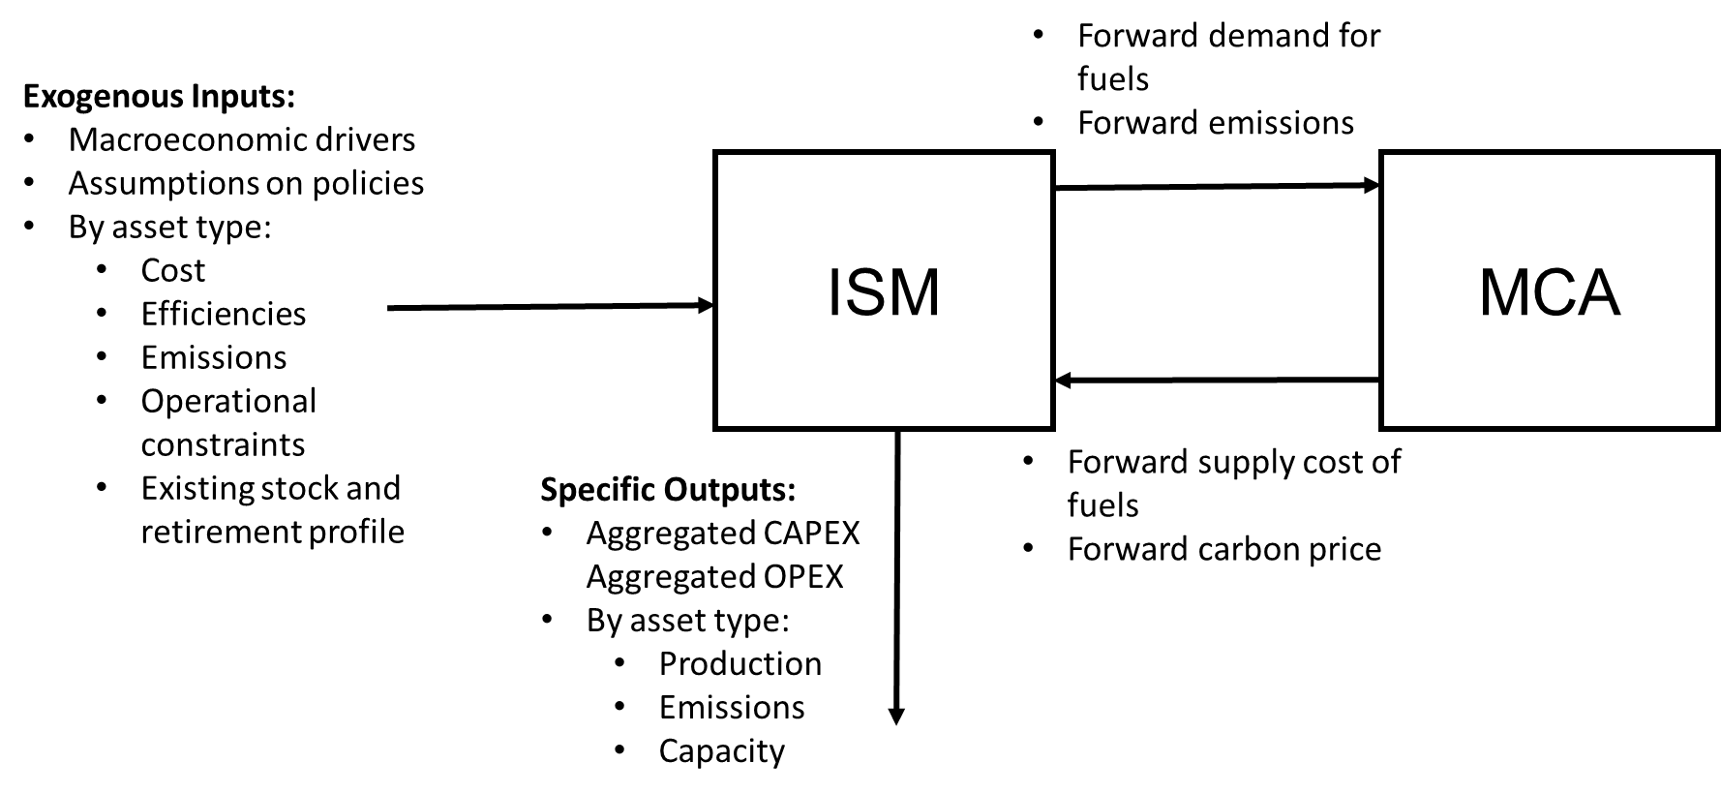
Figure 1. a) The approach used in the agent-based development of the ISM model (top), b) Input/output structure of the Industrial Sector Module (ISM) (bottom)
The ISM uses a two-step simulation approach to model investment decisions and operating strategies representing real investors’ behaviour in the market. The investment algorithm initially calculates the future stock of assets by taking into account the total assets in the base year and their decommissioning profile over time. The future stock and its supply potential (estimated as installed capacity multiplied by the utilisation factor) are then compared with the commodity demand. If the demand is equal or below the supply potential, there is no investment, and the model sorts the existing technologies using an indicator such as the Discounted Cash Flow (DCF) in order to decide which ones to operate (step 1). If the demand is higher than the supply potential, the model invests in new assets (step 2). The step 2 of the ISM algorithm embeds an agent-based formulation, as explained in the remaining part of the section.
In each time period, the selected indicator for technology sorting is estimated using the updated capital costs, efficiencies, energy (fuels consumed by operation of a technology), material (output commodities produced by the operation of a technology) and CO₂ prices (emissions from the operation of a technology).

Agent based modelling approach for investment
The industrial subsector modelling is based on the definition of private investors in energy technologies, acknowledged as being agent-investors. The agents operate with bounded rationality. The bounded rationality is based on the acknowledgement that individuals and organizations act with incomplete knowledge of all the possible alternatives to a specific decision and with inability to evaluate all the possible consequences of their decisions (Gigerenzer and Selten, 2001). In this work, we extend the implementation of the agent-based formulation in MUSE (Sachs et al., 2019) to the industrial sector module ISM (Luh et al., 2020). In the energy context, models of bounded rationality would specify the process and outcome leading to new investments in energy technologies by each agent characterising:
- Goals: objectives leading to agents’ investments, which is obtained from survey or reviews of surveys of firms, as described later in this work. From sectoral level surveys, industrial investors tend to behave rationally (Sorrell et al., 2004), and, especially in energy-intensive industries tend to prioritise cost goals and perceive that hidden costs are barriers to the introduction of novel technologies.
- Search rule: procedure for acquiring information about a novel investment and identify all the possible alternative energy technologies for the decision
- Stopping rules: when more alternatives are available, available energy technologies are sorted according to the selected metric until a decision is made.
- Budget: defines an upper bound on the available budget to face investment decisions.
- Maturity threshold: defines a threshold of maturity readiness acceptable by investors before investing
- Technology stock: technology capacity available in the base year. The stock then retires over time depending on the technology lifetime.
- Percentage: fraction of the market served by each agent. Each agent is apportioned a certain fraction of the market which it would fulfil performing an investment, first looking at all the available technologies able to supply a certain commodity, then considering the possibilities of buying new technological assets.
- Decision Strategy: accounts for the way goals are prioritized to select among alternatives; it could be either one or multiple goals. Multiple objective could be rationally counterbalanced using a weighted sum approach. When the full space of technologies is known, each agent would sort the space with a user-defined objective (or several objectives) such as the Net Present Value (NPV). Accordingly, the technologies are ordered by each agent from the most profitable (highest NPV) to the least profitable (lowest NPV). The model invests in the most profitable technology calculating a supply potential, until an upper constraint (represented by either a capacity growth rate limit, the maximum capacity addition per period, or the maximum total capacity) is hit, and then moves on to invest into the second most profitable technology, and so on, until the supply meets the demand. The investment decision making process takes into account investors with single or multiple objectives, for example shifting from a single economic criterion (e.g. DCF, NPV) to also include Socially Responsible Investment (SRI) criteria, environmental (e.g. emissions reduction), social (e.g. value-driven orientation) and governance (e.g. risk attitude) preferences (Escrig-Olmedo et al., 2017). When multiple objectives are present, a decision rule applies to prioritise the investment decisions. Specifically, the weighted sum strategy is the most appropriate to represent a decision process where multiple criteria are considered altogether, as characteristic of the industrial sector. The weighted sum strategy, which transforms the set of objectives ${obj}_{i}$ into a single objective ${obj}_{WS}$ by multiplying each objective by a weight, $w_{i}$, has been used as reported in Equation 2.
 | $${obj}_{WS}= min\sum_{i=1}^{3}{w_{i}}{obj}_{i}$$ | Equation 2
The ISM applies a technology-oriented bottom-up model to simulate decisions on future investments, where the macro-level appraisal of consumption, emissions, and costs is estimated from the aggregation of each single technology. Each technology is characterized in terms of
- Input energy consumption: energy required to produce one output material commodity. Fuel and electricity consumptions have been estimated based on the (IEA, 2009) and (Tunå et al., 2014)
- Output material commodities: output material commodity per unit of technologies’ main input material commodity
- Emissions: CO₂ (emitted or captured) and N₂O, emissions per unit of output material commodity. CO₂ and N₂O emissions have been estimated based on the fuel consumption using the 2006 IPCC Guidelines (IPCC, 2006). Negative emissions for biomass coupled with CCS are modelled according to (Zakkour et al., 2014).
- Specific capital investment (CAPEX): unit costs for investments in new capacity. Capex have been estimated based on (Daly and Fais, 2014)
- Specific fixed operating expenditures (fixed OPEX): unit fixed operating costs due to regular maintenance or closures of facilities. Fixed opex have been assumed to be equal to 10% of capex (Sinnott, 1993)
- Initial stock: capacity installed in the base year of the simulation
- Maximum capacity addition per year: Upper boundary for absolute amount of annual capacity addition
- Maximum capacity growth per year: Upper boundary for annual capacity growth in relation to the already existing capacity
- Technical lifetime: operational year before capacity is decommissioned
- Utilisation factor: ratio of operating hours of a plant in a year over the total number of hours in a year (number of shutdowns for the planned maintenance of the plants in a year)
Technological modelling is dynamic over time. As shown in Table b of the supporting information energy intensity and emission intensity for the modelled technologies in China are reported in relation to the values of coal-based technologies. Specifically, a 1.5 % per year of fuel reduction in fuel consumption is assumed on all the technologies (ICF International, 2015). Technologies using CCS perform a 90 % capture rate and show energy efficiency penalties which was modelled assuming an increase in consumption, according to the hypotheses presented in (IEA-ETSAP, 2018). CAPEX and OPEX are reported in relation to coal technologies in Table c of the supporting information. As natural gas, oil, and coal technologies are mature, their costs remain constant over time. For plants with CCS, the relative additional costs in comparison to the same plants without CCS are assumed to decrease over time: CAPEX and OPEX of plants with CCS are in 2010 48% higher, and from 2030 onwards 32% higher than the same plants without CCS (IEA-ETSAP, 2018). Over time exogenous technological learning is modelled, assuming with cost reduction equal of 2.5 % per year.

Case study: ammonia production in China
Worldwide, 88% of ammonia demand is driven by the production of nitrogen-based fertilizers (IEAGHG, 2019). China, Russia, USA and India are the largest producers, with a production share of 34%, 8%, 7% and 7%, respectively. Due to the strategic role of ammonia production for food security, it is often the subject of preferential policies in many countries, sometimes resulting in less restrictive constraints on energy consumption and atmospheric emissions (Zhou et al., 2010). On a global scale, natural gas (i.e. gas) is the main feedstock (71%), followed by coal (21%) and HFO (8%) (IEA, 2009), while biomass-based and electrolysis-based ammonia production are currently at pilot scale.
The outlook is different for China, where due to abundant local resources, coal is the main feedstock (71%), followed by natural gas (21%) and HFO (8%). Ammonia is produced by means of coal gasification, steam reformation of natural gas or partial oxidation of HFO, with a huge variability in terms of plant performances (Zhou et al., 2010). Ammonia manufacturing in China is one of the most emission intensive in the world, with up to 5.21 t of CO₂ equivalent per t of ammonia (Bicer et al., 2017).

Agents’ definition and simulated scenarios
The definition of the agents in terms of type was based on a critical assessment of multiple sources:
- 71 % of ammonia capacity production in China included plants with a capacity lower than 300,000 t per year in 2014 (Zeng, 2014). SMEs tend to use internal R&D and exploit local resources such as coal and oil (Zhuo et al., 2010).
- Foreign large companies import their own technology and mainly use natural gas as a feedstock (Zhou et al., 2010). Foreign investors would include global players operating in the industry, such as Yara International and BASF SE (company websites).
- From a financial perspective, when foreign investors are large companies with a wide access to capital, they may choose more easily capital-intensive plants investments, than SMEs which may struggle to afford these options without subsidies (Poncet et al., 2010).
- The top ten companies accounting for more than 30 % of the total installed ammonia production capacity in the country in 2013, include Jinmei group, Yihua group, and PetroChina, and are state or provincial government-owned companies.
- More than 80 % of ammonia capacity uses coal as the main feedstock, while the remaining facilities make use of natural gas (Zeng, 2014).
As the factory utilisation factor may vary, there is uncertainty on the actual production levels, SMEs could represent up to 82 % of the total production, while the remaining fraction would mainly come from foreign industries (Zhuo et al., 2010).
From the market analysis, the identified agents were distinguished by the size (SMEs versus LEs) and ownership (private versus public; Chinese versus foreign). Based on the information reported by the National Bureau of Statistics of China (The State Council of the People’s Republic of China, 2011) for the year 2010, the full market has been divided into the following six agents (also reported in Table 4):
- Agent 1 represents a private, Chinese SME
- Agent 2 represents a private, foreign SME
- Agent 3 represents a public, Chinese SME
- Agent 4 represents a private, Chinese LE
- Agent 5 represents a private, foreign LE
- Agent 6 represents a public, Chinese LE.
The definition of the decision metric per agent and their weights (used in Equation 2) was based on the available surveys, summarised in section 3 of the supplementary material. The analysis of the surveys highlighted that there is a clear distinction between local and foreign industries as well as between small and private companies. Specifically:
- Chinese firms are more likely to make use of non-discounted investment metrics (PB i.e. Payback Time; capex) compared to foreign firms, which usually rely on discounted investment metrics (such as NPV (Net Present Value) and IRR (Internal Rate of Return)) (Hermes et al., 2007; Chan et al., 2010)
- Small and privately owned Chinese enterprise are likely to be more capital constrained, than public Chinese firms and large foreign firms ( Danielson and Scott, 2006; Poncet et al., 2010)
In order to represent the uncertainty in the decision metrics adopted by the selected agents, in addition to a baseline tuning additional sensitivity tunings have been applied, which differ from the relative importance given to each metric, as reported in Table 5.
The timeframe for the simulations goes from the base year 2010 until the year 2100, broken into 10-year time intervals, in order to analyse both medium and long-term effect of the investment decision making on the ammonia market. Fuel price profiles for electricity, hard coal, natural gas, HFO and biomethane have been assumed according to the (IEA, 2018a).

Table 4. Agents’ definition and market share
Agent # | Market  share (%) | SME | LE | Private | Public | Chinese | Foreign
Agent 1 | 19.0 | x |  | x |  | x
Agent 2 | 18.9 | x |  | x |  |  | x
Agent 3 | 28.9 | x |  |  | x | x
Agent 4 | 9.5 |  | x | x |  | x
Agent 5 | 9.4 |  | x | x |  |  | x
Agent 6 | 14.3 |  | x |  | x | x

Table 5. Agents’ weights based on mentioned references (pub: public; pr.: private; Ch.: Chinese; for: foreign; SME: Small Medium Enterprise; LE: Large Enterprise; NPV: Net Present Value; PB: Payback Time)
 | Agent # 1  SME, pr., Ch. | Agent # 2  SME, pr., for. | Agent # 3  SME, pub., Ch. | Agent # 4  LE, pr., Ch. | Agent # 5  LE, pr., for. | Agent # 6  LE, pub., Ch.
baseline tuning
NPV | 0.2 | 0.75 | 0.4 | 0.36 | 1 | 0.6
CAPEX | 0.2 | 0 | 0 | 0.2 | 0 | 0
PB | 0.6 | 0.25 | 0.6 | 0.44 | 0 | 0.4
(Danielson and Scott, 2006)
NPV | 0 | 0 | 0 | 1 | 1 | 1
CAPEX | 0 | 0 | 0 | 0 | 0 | 0
PB | 1 | 1 | 1 | 0 | 0 | 0
(Hermes et al., 2007)
NPV | 0 | 1 | 0 | 0 | 1 | 0
CAPEX | 0 | 0 | 0 | 0 | 0 | 0
PB | 1 | 0 | 1 | 1 | 0 | 1
(Poncet et al., 2010)
NPV | 0 | 1 | 1 | 0 | 1 | 1
CAPEX | 0 | 0 | 0 | 0 | 0 | 0
PB | 1 | 0 | 0 | 1 | 0 | 0
(Chan et al., 2010)
NPV | 0.5 | 1 | 0.5 | 0.5 | 1 | 0.5
CAPEX | 0 | 0 | 0 | 0 | 0 | 0
PB | 0.5 | 0 | 0.5 | 0.5 | 0 | 0.5

Table 6. Simulation scenarios used for sensitivity analysis. The variations of fuel price are calculated from a reference value used in the “Single objective functions”, the “Multiple objective functions”, and the “Technology growth rates” scenarios.
Scenario | Details | Range
Single objective functions | NPV | Defined in Table 5
Single objective functions | Capex | Defined in Table 5
Single objective functions | Payback time | Defined in Table 5
Multiple objective functions | Baseline tuning | Defined in Table 5
Multiple objective functions | (Danielson and Scott, 2006) | Defined in Table 5
Multiple objective functions | (Hermes et al., 2007) | Defined in Table 5
Multiple objective functions | (Poncet et al., 2010) | Defined in Table 5
Multiple objective functions | (Chan et al., 2010) | Defined in Table 5
Technology growth rates | Annual growth rate (%) | 1%; 2%; 3%; 5%; 10%
Fuel price | Biomethane | 1.5x; 3x; 5x
Fuel price | Electricity | 0.5; 1.5x; 3x; 5x

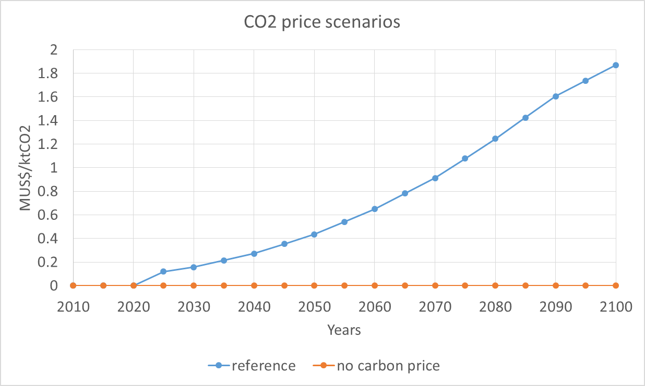
Figure 2: CO₂ price scenarios

Results
Two simulated policy cases are analysed regarding the technology penetration for ammonia production in China:
- In the zero-carbon price case (case 1), no policies are in place to incentivise the decarbonisation of the sector
- In the carbon price case (case 2), a carbon price (reported in Figure 2) has been imposed. The carbon price trajectory (Budinis et al., 2018) is the average value for the “Full technology portfolio scenario” of the IPCC Fifth Assessment report.
A sensitivity analysis was applied on these input parameters (as reported in Table 6):
- Single objective functions: each agent uses a single decision metric, either NPV, capex or payback time
- Multiple objective functions: each agent is using all three decision metrics, according to the weights reported in Table 5
- Technology growth rates: the maximum annual growth rate of each technology ranges from 1% per year to 10% per year. The growth rate is a modelling feature to represent the willingness of the investors or the perceived benefit, because either favoured by policy or the by capital mobilisation, to move away from incumbent technologies.
- Fuel prices, with a focus on biomethane and electricity prices: the annual variation of prices has been varied between 0.5 and 5 times the reference value. In particular, the price of electricity gives insight on the competition between coal based and natural gas-based technologies during the first half of the century. Biomethane price might affect the competition between natural gas based and biomethane based technologies during the second half of the century.
In the following, the results for the simulated scenarios are presented first the technology supply mix, the trend of emissions and the CO₂ captured with CCS. In the diagrams, emissions are represented with positive bars when there is a net release of CO₂ to the atmosphere, whereas reported with negative bars accounting for biogenic CO₂ in the biomass used in addition to CCS.

Single objective scenarios
Figure 3 reports the supply of ammonia (in Mt) in China for the timeframe 2010-2100 with a 10-year interval with a break-down by technology when no carbon price applies (left) and when an exogenous carbon price is imposed (right) for a single objective (i.e. NPV) for all investors. Without a carbon price, natural gas-based ammonia production increases over time, from the initial 21% share in 2010 to 100% share in 2050 and beyond. This is due to the lower capex and higher efficiency of natural gas-based technology. Natural gas-based ammonia production benefits from complementarity with cogeneration, which increases the overall efficiency reducing electricity consumption from the grid.
Although the current predominance of coal in the ammonia supply mix, high uptake of natural gas even without a carbon price in the Chinese industry is in line with the goal of recent reforms aiming for improved air quality in China through a coal-to-gas switch (Dong et al., 2017).

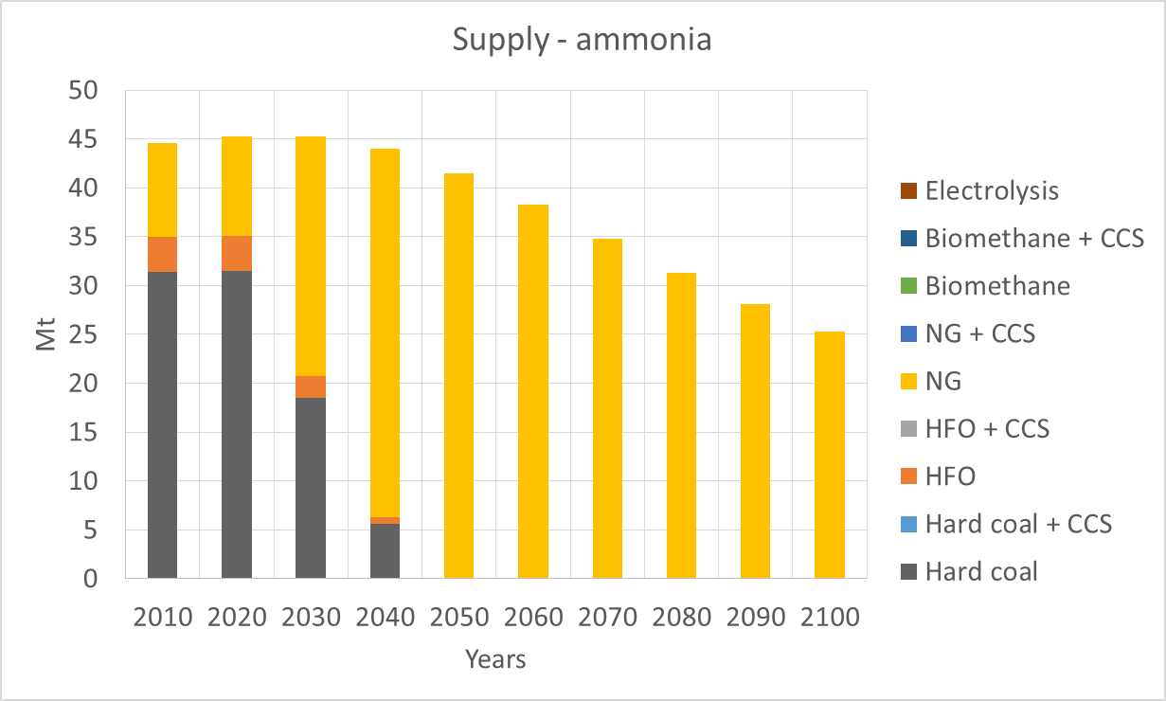 | 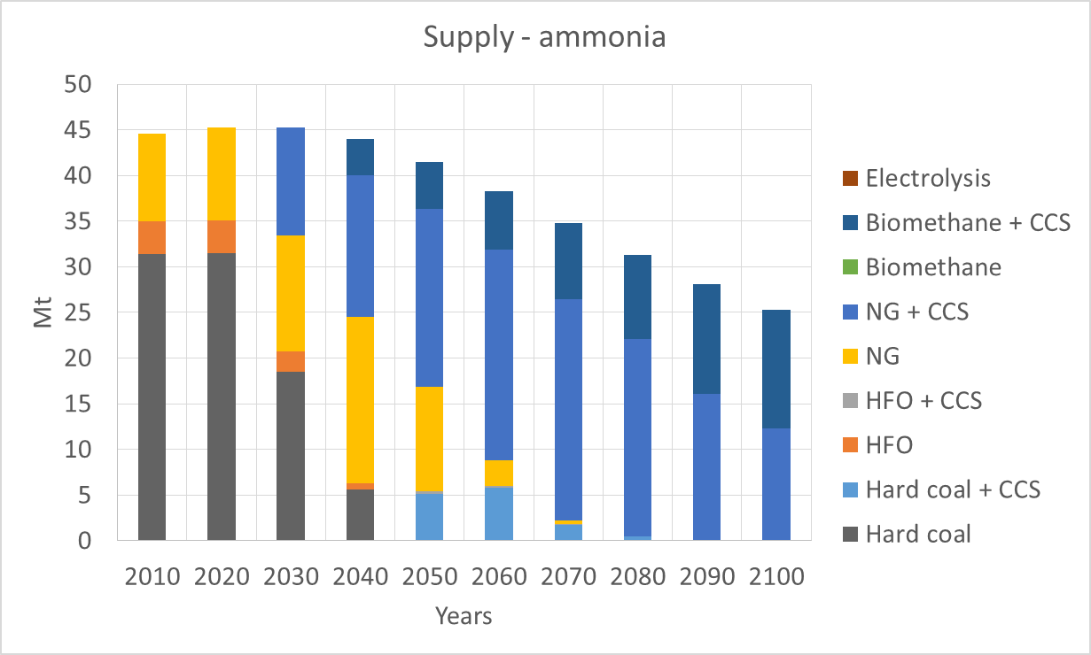
Figure 3. Supply of ammonia by feedstock without (left, case 1) and with (right, case 2) a carbon price (Mt); single objective function: NPV

When a carbon price is in place to incentivise the decarbonisation of the sector, the investment decisions change. Natural gas and biomethane take over the market, from an initial 21% share to a 99% share in 2050. The remaining 1% is HFO-based production. It is to note that CCS plays an important role, entering the market in combination with natural gas in 2030 and with biomethane in 2040. Captured emissions then result in an overall negative emission from the ammonia production from 2070 (Figure 4).
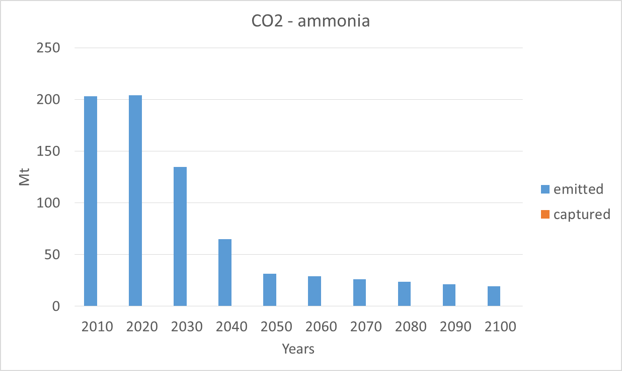 | 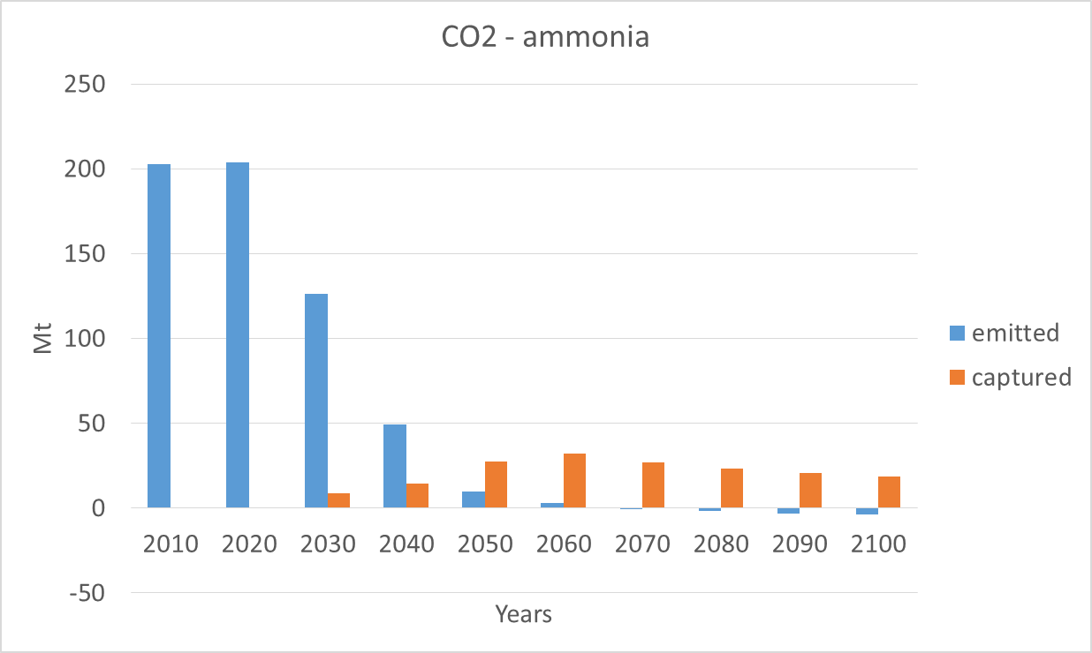
Figure 4. Emission and capture of CO₂ without (left, case 1) and with (right, case 2) a carbon price (Mt); single objective function: NPV

The same cases have been tested using single investment decision metrics of capex (Figure 5) and payback time (Figure 6 and Figure 7). As the carbon price only affects opex, if the capex of a plant is the investment decision metric, the market moves towards the cheapest technology, the natural gas-based ammonia, independent of the presence of a carbon price.
Figure 5. Supply of ammonia by feedstock (Mt); single objective function: capex (cases 1 and 2)

If the payback time is used, the market moves again towards natural gas- and biomethane-based ammonia production with post-combustion CCS. The transition occurs at a slower pace than the scenario where NPV is used. Figure 6 reports the supply of ammonia in China, in Mt, over time, under a carbon price (right). Natural gas maintains a substantial share of the market until 2030 without CCS, and until 2100 with CCS. Over time, biomethane replaces natural gas reaching 54% of the market by 2100. Emissions and emissions captured in the PB-scenario show that the overall emissions from the sector become negative from 2090 (Figure 7).

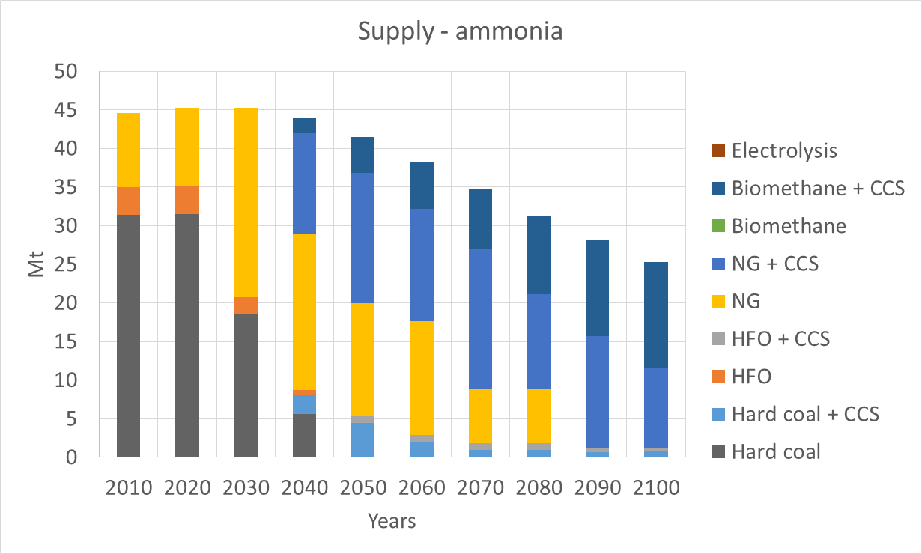
Figure 6. Supply of ammonia by feedstock without (left, case 1) and with (right, case 2) a carbon price (Mt); single objective function: payback time

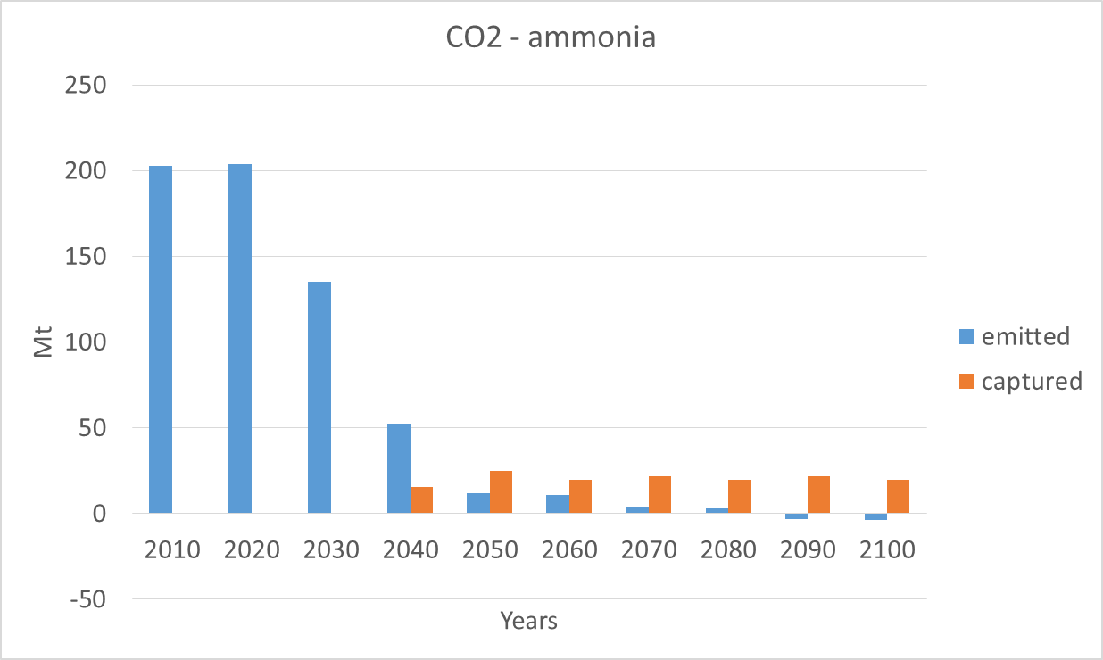
Figure 7. Emission and capture of CO₂ without (left, case 1) and with (right, case 2) a carbon price (Mt); single objective function: payback time

The results show that over time natural gas or a mix of natural gas and biomethane replace coal and HFO, respectively without and with a carbon price. In absence of carbon policies (case 1), HFO and coal disappear from the market share by 2050, regardless of the agents’ objectives. In presence of carbon price (case 2), in the baseline scenario emissions progressively reduce for becoming negative between 2070 and 2090 but the presence of solids and liquid fossil fuels is longer due to CCS:
- Coal-based ammonia remains in the market until 2080, although adopting exclusively CCS after 2040
- HFO-based ammonia remains in the market until 2070, although adopting exclusively CCS after 2040
- Natural gas -based ammonia with CCS enters the market in 2030, while the biomethane-based process with integrated with CCS in 2040. These two technologies saturate the market by 2090
Projections of a shift in the Chinese ammonia market from coal towards natural gas (regardless of a carbon price) is in line with what recently reported by the IEA on China being the new largest natural gas importer in the world (IEA, 2018b). Moreover, a number of recent studies have highlighted the commitment of the Chinese government towards more sustainable practices and towards replacing coal based production with natural gas based production (Qin et al., 2018; Shaikh and Ji, 2016).

Baseline tuning: multi-objective agents
Figure 8 reports the supply of ammonia (left) and the CO₂ emission (right) under a carbon price (case 2) when multiple investment objectives are taken into account.
In the baseline tuning scenario for the agents’ definition (whose parameters are reported in Table 5), natural gas-based production with CCS enters the market in 2030; biomethane-based production with CCS enters the market in 2040 reaching 51% of the market by 2100. Consequently, CO₂ is captured from 2030, resulting in negative emissions from 2080. The energy consumption for case 1 and 2 is reported in Figure 9, which shows that the shift towards natural gas and biomethane introduce more efficient options for ammonia generation compared to coal and HFO.

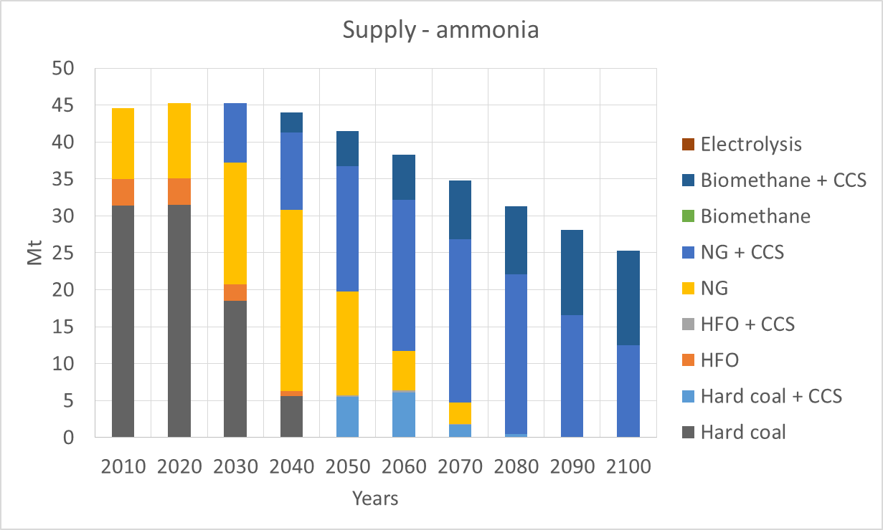 | 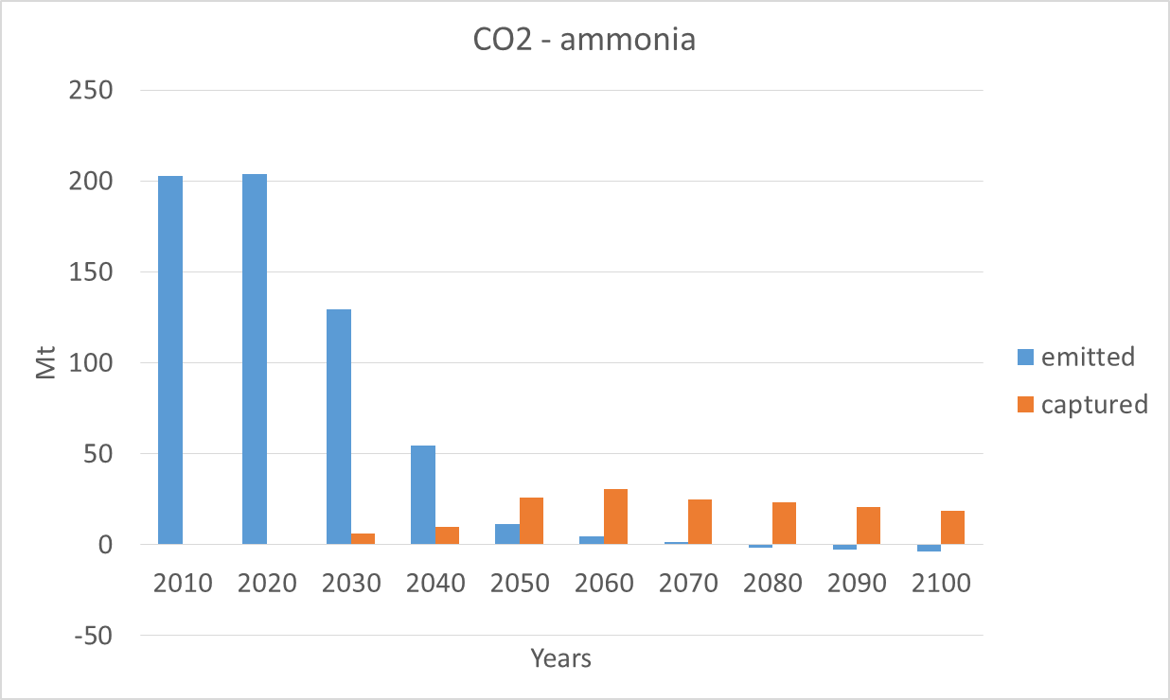
Figure 8. Supply of ammonia by feedstock (left) and emissions and capture of CO₂ (right) with a carbon price (Mt); multiple objective functions – case 2, baseline tuning

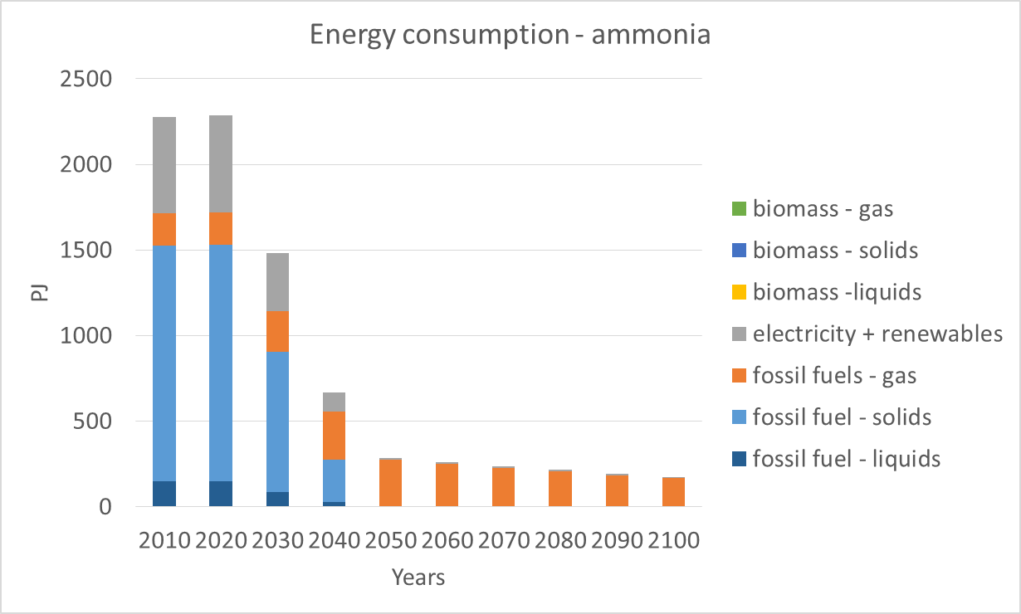 | 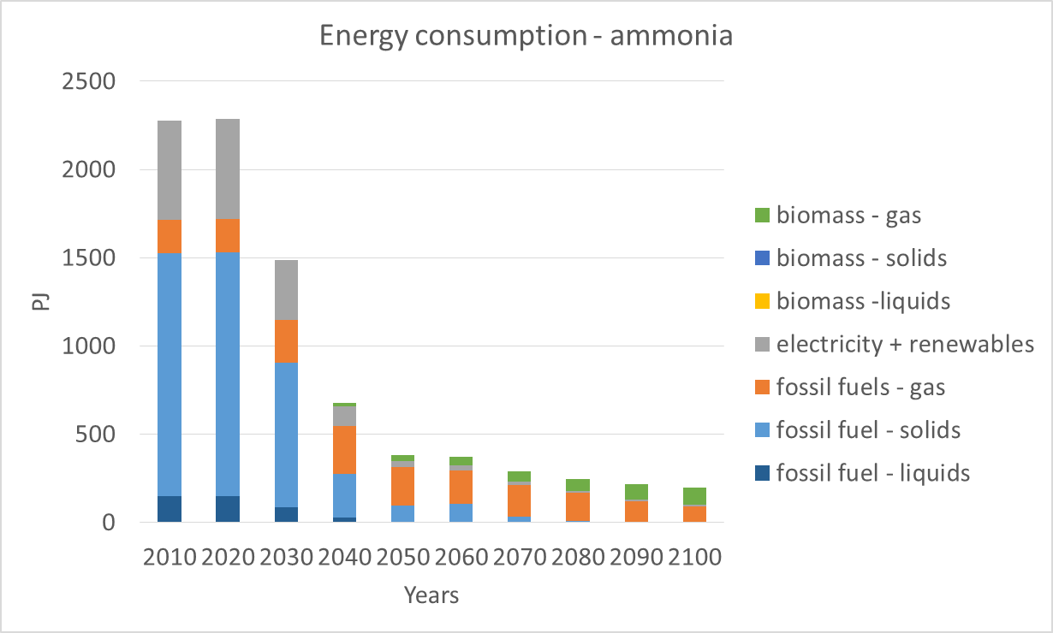
Figure 9. Consumption of fuels and electricity without (left, case 1) and with (right, case 2) a carbon price (Mt); multiple objective functions – baseline tuning

Multi-agent and multi-objective scenarios: sensitivity analysis
The sensitivity analysis on the multi-agent and multi-objective scenario with a carbon price, characterised by six agents, three objective functions, have been reported is in section 4 of the supplementary material. The sensitivity analysis includes the preferences in the investors’ strategy (number and weights of the objective function), the maximum technology growth rate, and the fuel prices.
Figure f and Figure g in the supplementary material report the trend in emissions released to the atmosphere and the captured ones when a sensitivity on the agents’ objectives is carried out. The sensitivity analysis shows that:
- Limiting the investment decision metric to the project capex only would reduce emissions over time, as the market would move from HFO and coal-based production to natural gas. However, capex driven investments would never meet stringent carbon emission reduction and be able to generate negative emissions, in the absence of other policy tools promoting a switch to biomethane based production with CCS. If either NPV or PB time applies as investment metric, the investments shift towards natural and biomethane integrated with CCS. The use of NPV as a single metric would make emissions become negative earlier than PB (2070 compared to 2090).
- The baseline tuning scenario shows the lowest level of negative environmental emissions in 2100 (-3.7 Mt compared to -3.8 Mt for NPV only and -4 Mt for payback time only) after becoming negative in 2080. When multiple objectives drive, due to the divergent contribution of NPV and Capex, the transitional phase before the emissions become negative, can start as early as in 2070 if both SMEs and LEs are evenly using PB and NPV metrics (according to the agents’ behaviour reported by (Chan et al., 2010), as shown in Table 5), or be postponed until 2090 if all SMEs use exclusively PB as a metric (according to the agents’ behavior reported by (Danielson and Scott, 2006), as shown in Table 5).
Figure h in the supplementary material represent the trend in emissions when the growth rates vary. The sensitivity analysis shows that a large growth rate moves the market towards CCS and biomethane more rapidly than a lower growth rate. A growth rate lower than the market average (2% per year or below) would maintain CCS-retrofitted coal and HFO in the market share until the end of the century. Growth rates higher than the market average reduce emissions and increase the share of CCS in the market at a faster pace: negative emissions can occur as early as in 2060.
Figure i and Figure j in the supplementary material report the trend in CO₂ released to the atmosphere and the captured ones when fuel prices vary. The variations on the prices do not cause change in the year at which negative emissions are realised (2080 in all the cases), although these general trends can be observed:
- with a lower electricity price, coal-based production plus CCS enters the market earlier (2040 instead of 2050) while HFO based production remains in the market share until 2060 (instead of 2040)
- a high electricity price reduces the rate of captured CO₂ over time (between 2050 and 2080) as it makes HFO- and the natural gas-based technologies plus CCS respectively less and more competitive than the reference electricity price
- biomethane is competing over time with natural gas. In the baseline tuning scenario, combined natural gas based and biomethane based production takes almost 100% of the market share by 2080. If the price of biomethane increases, its share against natural gas decreases compared to the reference biomethane price. In a long-term decarbonisation, this competition would depend on infrastructure, supply chain availability and land use constraints.

Discussion
The paper fills in the literature gap addressing how sustainable industrial manufacturing can be implemented in the ammonia industry, which represents a priority area for the CCS deployment IEA – UNIDO, 2011). Long-term scenarios of decarbonisation based on fuel switching and CCS have been developed for the Chinese ammonia industry, which, being almost fully coal-based, represents one of the most emission-intensive processes worldwide (Bicer, et al. 2017).

Implications for theory
Our paper contributes to current research in the industrial sector sustainability modelling by providing an agent-based framework to represent investors’ decision-making process. Many studies have shown that technological measures exist to achieve industry decarbonisation, for example via energy efficiency measures, fuel switching, alternative production processes or CCS (Abdelaziz et al., 2011). No existing study explicitly considers technological choices in industry within their national context, local environment, and industrial practices (Edelenbosch et al., 2017). In doing so, the literature has been missing the link between investors and economic, technical, regulatory, geographical, and social aspects (Escrig-Olmedo et al., 2017). Closely modelling the decision-making process is essential to capture fundamental limitations to innovative technologies diffusion due to corporative and individual practices in industry. For example, energy efficient solutions, even if available at a short payback time, might not be implemented as companies fear hidden costs or exposure to financial risks (Fleiter et al., 2011). Companies may also be limited by market size and interaction with the environment: recent studies (Yu et al., 2020) found that a regional innovative milieu is more important to trigger innovation in SMEs than in Les, as the former tend to rely more on internal R&D investments.
This paper presents an agent-based framework allowing to model investors in the energy sector. The focus is given to the identification of agent-investors which are modelled in the objectives driving their investments, in their allocation of the commodity market, and energy technology choices. The investors’ objectives and attributes are tailored to represent firms’ size, ownership, and capital access. This paper identifies and characterises six agents, capturing private or public, Chinese or foreign, and large or small-to-medium size enterprises. The proposed framework is a suitable modelling platform where to include effects of highly perceived hidden costs of companies (Sorrell et al., 2004) as well as the consequences of incoherent behaviours between explicit and implicit preferences towards CCS (Sun et al., 2020). The proposed framework is also suitable to include corporate social responsibility, as an emerging approach to management which includes environmental, economic, and social principles in corporate decision-making, as well as to assess how institutional, organisational and individual barriers may be overcome (Yu et al., 2020). The proposed framework, can also be applied to model ways to highlight and overcome technological barriers which alternative energy intensive sectors, such as iron and steel, may have to face as investments in carbon lock-in infrastructures could put at stake the transition towards sustainability of the industrial sector in China (Ding et al., 2020).

Implications for practice
The Chinese government has shown willingness to pursue sustainability goals defining climate change mitigation and energy efficiency targets. In its Intended Nationally Determined Contribution, China has announced four principal climate goals: to achieve CO₂ emissions peak around 2030; to lower the GDP carbon intensity by 60%–65% by 2030; to increase the share of non-fossil fuels in primary energy to around 20% by 2030; and to increase the forest stock volume by around 4.5 billion cubic meters by 2030 compared to 2005 (Sandalow et al., 2019). In order to achieve climate targets in line with the Paris Agreement, CCS needs to be developed and deployed (Ding et al., 2010). Although the analysis focused on CCS uptake in the ammonia industry, considerations can be generalized to sustainable ammonia manufacturing based on electrolysis (Bicer et al., 2017) and to other energy intensive industries in China, especially the iron&steel industry (Ding et al., 2020), dominated by state-owned companies with a high global market share.
First, our analysis has shown the importance of fuel prices stability in the long-term policies for sustainability, as industries show a high resistance to energy price volatility. As raised by Zhang et al. (2017), the Chinese government has been promoting policies to reduce natural gas price fluctuations. These efforts would need to be maintained in the future and possibly strengthened to embrace biomass-derived fuels, in order to accelerate the transition from coal to less emitting energy vectors.
Second, our analysis has shown how firms can react differently to the availability of a technology depending on their size and ownership, as this affects their decision metrics. For example, Chinese SMEs typically rely on local R&D and make more use than LEs of capex or low payback time as decision metrics. In that perspective, governments and financiers need to ensure funding mechanisms are in place order to ease off capital constraints that many firms would be facing to deploy CCS. Also, governments should be proactively supporting CCS demonstration programs, necessary to build knowledge about best practice on CCS from CCS-operating plants at different scale as well as to build confidence on the technology feasibility. Demonstration programs would support investors’ decision-making balancing their concerns about “hidden costs” of the deployment of sustainable technologies, which arise from the design, to the installation, to the operation of the technology (Sorrell et al., 2004). In this perspective, SMEs cooperation as well as their links with research and financial institutions should be supported by governments as a means of knowledge sharing and risk leverage (Yu et al., 2020). As Ding et al. (2020) showed that the CCS value in the Chinese steel sector should be assessed also in terms of capture readiness regarded as an integrated plant across the full chain of capture, transportation and storage.

Conclusions
This paper sets out an agent-based modelling approach designed to characterise the investment decision making process in the industrial sector. The methodology has been tested on a specific case study involving ammonia production in China. Two cases have been simulated, with and without a carbon price, in order to show the effect of a carbon price on investment in novel and more sustainable technologies. The results have demonstrated a series of insights that can be summarised as follows.
Firstly, the adoption of a carbon price as a policy instrument to push the decarbonisation of the industrial sector can be effective, although carbon emission reduction can also be achieved where capex is lower and efficiency higher than incumbent technologies, as is the case with gas-based versus coal-based ammonia production. The carbon price applied could also be viewed as a proxy for any other decarbonisation policy instrument.
Secondly, if there is a carbon price in place, then carbon capture and storage could be pivotal to reduce CO₂ emissions. This is due to the fact that while CCS is expensive where no market for CO₂ reduction exists, it can become a profitable technology if CO₂ emissions are priced with the aim of reaching a 2 °C target globally. In addition, in the long term, gas-based and biomethane-based ammonia production could compete under a high carbon price, with the outcome dependent on infrastructure, supply chain availability and land use constraints.
Finally, the adopted agent based approach allows a comprehensive characterisation of the industrial key players as it accounts for multiple investment objectives, as well as the presence of constraints on novel technologies diffusion in the market. According to the statistical data, 28% of the ammonia market in China (represented by both small and large private Chinese firms) accounts for capital costs in the investment decision making. Consequently, more than a quarter of ammonia production in China may struggle to decarbonise even under a substantial carbon price. Facilitated access to capital would therefore make investment in novel technologies more attractive for all firms. Moreover, the results show that both net present value and payback time can be adopted and are suitable as investment metrics for the purpose of decarbonisation. On the other hand, capex driven investment would not be affected by carbon price policies, however novel, more efficient technologies may enter the market if supported by capital subsidies.

Acknowledgements
The authors would like to acknowledge the funding from the Sustainable Gas Institute. Funding for the Sustainable Gas Institute is gratefully received from Royal Dutch Shell, Enagas SA and the Newton/NERC/FAPESP Sustainable Gas Futures project NE/N018656/1. Note that funding bodies were not involved in the design, implementation or reporting of this study.
List of symbols
a, b: regression constant for the material demand projections
ABM: Agent-Base Model
C: Material Demand per capita
CCS: Carbon Capture and Storage
DCF: Discounted Cash Flow
DECC: Department of Energy and Climate Change
EMF: Energy Modelling Forum
GCAM: Global Change Assessment Model
GDP: Gross Domestic Product
GDPpc: Gross Domestic Product per capita
HFO: Heavy Fuel Oil
IRR: Internal Rate of Return
ISM: Industrial Sector Module
LE: Large Enterprise
NEMS: National Energy Model
NPV: Net Present Value
${obj}_{i}$: Investor’s objective
${obj}_{WS}$: Weighted-average investor’s objective
PB: Payback Time
R&D: Research and Development
SRI: Socially Responsible Investment
SME: Small and Medium Enterprise
TFEC: Total Final Energy Consumption
$w_{i}$: Weight for objective ${obj}_{i}$
WITCH: World Induced Technical Change Hybrid

Bibliography
Abdelaziz, E.A., Saidur, R., Mekhilef, S., 2011. A review on energy saving strategies in industrial sector. Renew. Sustain. Energy Rev. 15, 150–168. https://doi.org/http://dx.doi.org/10.1016/j.rser.2010.09.003
AEA, 2011. Comparative Review of the DECC Energy Model [WWW Document]. URL https://www.theccc.org.uk/archive/aws/AEA (2011) Comparative review of the DECC Energy Model.pdf
Allwood, J.M., Cullen, J.M., Milford, R.L., 2010. Options for Achieving a 50% Cut in Industrial Carbon Emissions by 2050. Environ. Sci. Technol. 44, 1888–1894. https://doi.org/10.1021/es902909k
Bicer, Y., Dincer, I., Vezina, G., Raso, F., 2017. Impact Assessment and Environmental Evaluation of Various Ammonia Production Processes. Environmental Management, 59(5), 842–855. doi: 10.1007/s00267-017-0831-6.
Budinis, S., Dowell, N.M., Krevor, S., Dixon, T., Kemper, J., Hawkes, A., 2017. Can Carbon Capture and Storage Unlock “Unburnable Carbon”?, in: Energy Procedia. https://doi.org/10.1016/j.egypro.2017.03.1883
Budinis, S., Krevor, S., Dowell, N.M.N.M., Brandon, N., Hawkes, A., 2018. An assessment of CCS costs, barriers and potential. Energy Strateg. Rev. 22, 61–81. https://doi.org/10.1016/j.esr.2018.08.003
Bureau Van Dijk, 2019. Oriana [WWW Document]. URL https://www.bvdinfo.com/en-gb/our-products/data/international/oriana
Chan, H., Haddad, K.M., Sterk, W., 2010. Capital Budgeting Practices of Chinese Firms [WWW Document]. J. Glob. Bus. Manag. URL http://www.jgbm.org/page/18 Kamal M. Haddad .pdf
Chang, N., 2015. Changing industrial structure to reduce carbon dioxide emissions: a Chinese application, Journal of Cleaner Production. Elsevier, 103, 40–48. doi: 10.1016/J.JCLEPRO.2014.03.003.
COP21, 2015. Adoption Of The Paris Agreement [WWW Document]. URL http://www.cop21.gouv.fr/wp-content/uploads/2015/12/l09r01.pdf
Daly, H.E., Fais, B., 2014. UK TIMES MODELS: OVERVIEW [WWW Document]. URL https://www.ucl.ac.uk/energy-models/models/uktm-ucl/uktm-documentation-overview
Danielson, M., Scott, J., 2006. The capital budgeting decisions of small businesses.
Ding, H., Zheng, H., Liang, X., Ren, L., 2020. Getting ready for carbon capture and storage in the iron and steel sector in China: Assessing the value of capture readiness. Journal of Cleaner Production, 244, doi: 10.1016/J.JCLEPRO.2019.118953.
Dong, H., Dai, H., Geng, Y., Fujita, T., Liu, Z., Xie, Y., Wu, R., Fujii, M., Masui, T., Tang, L., 2017. Exploring impact of carbon tax on China’s CO2 reductions and provincial disparities. Renew. Sustain. Energy Rev. 77, 596–603. https://doi.org/10.1016/J.RSER.2017.04.044
Dong, X., Pi, G., Ma, Z., Dong, C., 2017. The reform of the natural gas industry in the PR of China. Renew. Sustain. Energy Rev. 73, 582–593. https://doi.org/https://doi.org/10.1016/j.rser.2017.01.157
Edelenbosch, O.Y., Kermeli, K., Crijns-Graus, W., Worrell, E., Bibas, R., Fais, B., Fujimori, S., Kyle, P., Sano, F., van Vuuren, D.P., 2017. Comparing projections of industrial energy demand and greenhouse gas emissions in long-term energy models. Energy 122, 701–710. https://doi.org/http://dx.doi.org/10.1016/j.energy.2017.01.017
Edenhofer, O., Pichs-Madruga, R., Sokona, Y., Kadner, S., Minx, J.C., Brunner, S., Agrawala, S., Baiocchi, G., Bashmakov, I.A., Blanco, G., Broome, J., Bruckner, T., Bustamante, M., Clarke, L., Conte Grand, M., Creutzig, F., Cruz-Núñez, X., Dhakal, S., Dubash, N.K., Eickemeier, P., Farahani, E., Fischedick, M., Fleurbaey, M., Gerlagh, R., Gómez-Echeverri, L., Gupta, S., Harnisch, J., Jiang, K., Jotzo, F., Kartha, S., Klasen, S., Kolstad, C., Krey, V., Kunreuther, H., Lucon, O., Masera, O., Mulugetta, Y., Norgaard, R.B., Patt, A., Ravindranath, N.H., Riahi, K., Roy, J., Sagar, A., Schaeffer, R., Schlömer, S., Seto, K.C., Seyboth, K., Sims, R., Smith, P., Somanathan, E., Stavins, R., von Stechow, C., Sterner, T., Sugiyama, T., Suh, S., Ürge-Vorsatz, D., Urama, K., Venables, A., Victor, D.G., Weber, E., Zhou, D., Zou, J., Zwickel, T., IPCC, Stocker, T.F., Qin, D., Plattner, G.-K., Tignor, M., Allen, S.K., Boschung, J., Nauels, A., Xia, Y., Bex, V., Midgley, P.M., 2014. Climate Change 2014: Mitigation of Climate Change. Contribution of Working Group III to the Fifth Assessment Report of the Intergovernmental Panel on Climate Change. Cambridge University Press, Cambridge, United Kingdom and New York, NY, USA. https://doi.org/10.1017/CBO9781107415324
EIA, 2013. Model documentation report: industrial demand module of the national energy modeling system. Retrieved from the EIA website:, [WWW Document]. URL http://www.eia.gov/forecasts/aeo/nems/documentation/industrial/pdf/m064%282013%29.pdf
Escrig-Olmedo, E., Rivera-Lirio, J.M., Muñoz-Torres, M.J., Fernández-Izquierdo, M.Á., 2017. Integrating multiple ESG investors’ preferences into sustainable investment: A fuzzy multicriteria methodological approach. J. Clean. Prod. 162, 1334–1345. https://doi.org/http://dx.doi.org/10.1016/j.jclepro.2017.06.143
Fais, B., Sabio, N., Strachan, N., 2016. The critical role of the industrial sector in reaching long-term emission reduction, energy efficiency and renewable targets. Appl. Energy 162, 699–712. https://doi.org/http://dx.doi.org/10.1016/j.apenergy.2015.10.112
Fleiter, T., Worrell, E., Eichhammer, W., 2011. Barriers to energy efficiency in industrial bottom-up energy demand models -- a review. Renew. Sustain. Energy Rev. 15, 3099–3111. https://doi.org/http://dx.doi.org/10.1016/j.rser.2011.03.025
Fricko, O., Havlik, P., Rogelj, J., Klimont, Z., Gusti, M., Johnson, N., Kolp, P., Strubegger, M., Valin, H., Amann, M., Ermolieva, T., Forsell, N., Herrero, M., Heyes, C., Kindermann, G., Krey, V., McCollum, D.L., Obersteiner, M., Pachauri, S., Rao, S., Schmid, E., Schoepp, W., Riahi, K., 2017. The marker quantification of the Shared Socioeconomic Pathway 2: A middle-of-the-road scenario for the 21st century. Glob. Environ. Chang. 42, 251–267. https://doi.org/https://doi.org/10.1016/j.gloenvcha.2016.06.004
Guo, Z., Zhang, X., Zheng, Y., Rao, R., 2014. Exploring the impacts of a carbon tax on the Chinese economy using a CGE model with a detailed disaggregation of energy sectors. Energy Econ. 45, 455–462. https://doi.org/10.1016/j.eneco.2014.08.016
Hermes, N., Smid, P., Yao, L., 2007. Capital budgeting practices: A comparative study of the Netherlands and China. Int. Bus. Rev. 16, 630–654. https://doi.org/http://dx.doi.org/10.1016/j.ibusrev.2007.05.002
Huisingh, D., Zhang, Z., Moore, J.C., Qiao, Q., Li, Q., 2015. Recent advances in carbon emissions reduction: policies, technologies, monitoring, assessment and modeling. J. Clean. Prod. 103, 1–12. https://doi.org/10.1016/J.JCLEPRO.2015.04.098
ICF International, 2015. STUDY ON ENERGY EFFICIENCY AND ENERGY SAVING POTENTIAL IN INDUSTRY AND ON POSSIBLE POLICY MECHANISMS [WWW Document]. URL https://ec.europa.eu/energy/sites/ener/files/documents/151201 DG ENER Industrial EE study - final report_clean_stc.pdf
IEA, 2018a. WEO Model [WWW Document]. URL https://www.iea.org/weo/weomodel/ (accessed 5.21.19).
IEA, 2018b. Gas 2018 [WWW Document]. URL https://www.iea.org/gas2018/
IEA, 2017. Energy Technology Perspectives 2017 Catalysing Energy Technology Transformations Together Secure Sustainable. https://doi.org/10.1787/energy_tech-2017-en
IEA, 2014. World Energy Outlook 2014 [WWW Document]. URL http://www.iea.org/textbase/npsum/weo2014sum.pdf
IEA, 2009. Chemical and Petrochemical Sector: Potential of best practice technology and other measures for improving energy efficiency [WWW Document]. URL https://www.iea.org/publications/freepublications/publication/chemical_petrochemical_sector.pdf
IEA-ETSAP, 2018. Energy Supply Technologies Data [WWW Document]. URL https://iea-etsap.org/index.php/energy-technology-data/energy-supply-technologies-data
IEAGHG, 2019. Sustainability in Petrochemicals.
IEA - UNIDO, 2011. Technology Roadmap Carbon Capture and Storage in Industrial Applications.
IFA (International Fertilizer Association), 2019. Executive Summary Fertilizer Outlook, in IFA (ed.) IFA Annual Conference. Montréal.
IIASA, 2016. SSP Database (Shared Socioeconomic Pathways) - Version 1.1 [WWW Document]. URL https://tntcat.iiasa.ac.at/SspDb/dsd?Action=htmlpage&page=about
International Energy Agency (IEA), 2019. World Energy Outlook [WWW Document]. URL https://www.iea.org/weo/
IPCC, 2019. Reports [WWW Document]. URL https://www.ipcc.ch/reports/
IPCC, 2014. Integrated Assessment Modelling Consortium (IAMC) AR5 Scenario Database (Working Group III) [WWW Document]. URL https://secure.iiasa.ac.at/web-apps/ene/AR5DB/
IPCC, 2006. IPCC Guidelines for National Greenhouse Gas Inventories [WWW Document]. URL https://www.ipcc-nggip.iges.or.jp/public/2006gl/index.html
Jacques, D., Kimon, K., Andreas, S., Alban, K., Burkhard, S., Ana, D.V., Silvana, M., Peter, R.H., Tobias, W., 2018. POLES-JRC model documentation [WWW Document]. URL https://ec.europa.eu/jrc/en/publication/poles-jrc-model-documentation-0
JGCRI, 2019. Global Change Assessment Model [WWW Document]. URL http://www.globalchange.umd.edu/gcam/
Kermeli, K., Edelenbosch, O.Y., Crijns-Graus, W., van Ruijven, B.J., Mima, S., van Vuuren, D.P., Worrell, E., 2019. The scope for better industry representation in long-term energy models: Modeling the cement industry. Appl. Energy 240, 964–985. https://doi.org/https://doi.org/10.1016/j.apenergy.2019.01.252
Krey, V., 2014. Global energy-climate scenarios and models: a review. Wiley Interdiscip. Rev. Energy Environ. 3, 363–383. https://doi.org/10.1002/wene.98
Krey, V., Guo, F., Kolp, P., Zhou, W., Schaeffer, R., Awasthy, A., Bertram, C., de Boer, H.-S., Fragkos, P., Fujimori, S., He, C., Iyer, G., Keramidas, K., Köberle, A.C., Oshiro, K., Reis, L.A., Shoai-Tehrani, B., Vishwanathan, S., Capros, P., Drouet, L., Edmonds, J.E., Garg, A., Gernaat, D.E.H.J., Jiang, K., Kannavou, M., Kitous, A., Kriegler, E., Luderer, G., Mathur, R., Muratori, M., Sano, F., van Vuuren, D.P., 2019. Looking under the hood: A comparison of techno-economic assumptions across national and global integrated assessment models. Energy 172, 1254–1267. https://doi.org/10.1016/J.ENERGY.2018.12.131
Kriegler, E., Petermann, N., Krey, V., Schwanitz, V.J., Luderer, G., Ashina, S., Bosetti, V., Eom, J., Kitous, A., Méjean, A., Paroussos, L., Sano, F., Turton, H., Wilson, C., Van Vuuren, D.P., 2015. Diagnostic indicators for integrated assessment models of climate policy. Technol. Forecast. Soc. Change 90, 45–61. https://doi.org/10.1016/J.TECHFORE.2013.09.020
Kriegler, E., Weyant, J.P., Blanford, G.J., Krey, V., Clarke, L., Edmonds, J., Fawcett, A., Luderer, G., Riahi, K., Richels, R., Rose, S.K., Tavoni, M., van Vuuren, D.P., 2014. The role of technology for achieving climate policy objectives: overview of the EMF 27 study on global technology and climate policy strategies. Clim. Change 123, 353–367. https://doi.org/10.1007/s10584-013-0953-7
Lopion, P., Markewitz, P., Robinius, M., Stolten, D., 2018. A review of current challenges and trends in energy systems modeling, Renewable and Sustainable Energy Reviews, 96, 156–166. doi: https://doi.org/10.1016/j.rser.2018.07.045.
Luh, S., Budinis, S., Giarola, S., Schmidt, T.J., Adam Hawkes, 2020. Long-term development of the industrial sector – Case study about electrification, fuel switching, and CCS in the USA, Computers & Chemical Engineering, 133, 106602, ISSN 0098-1354, https://doi.org/10.1016/j.compchemeng.2019.106602.
Palm, J., Thollander, P., 2010. An interdisciplinary perspective on industrial energy efficiency. Appl. Energy 87, 2033–2042. https://doi.org/http://dx.doi.org/10.1016/j.apenergy.2010.04.019
Pfenninger, S., Hawkes, A., Keirstead, J., 2014. Energy systems modeling for twenty-first century energy challenges. Renew. Sustain. Energy Rev. 33, 74–86. https://doi.org/10.1016/J.RSER.2014.02.003
Poncet, S., Steingress, W., Vandenbussche, H., 2010. Financial constraints in China: Firm-level evidence. China Econ. Rev. 21, 411–422. https://doi.org/10.1016/j.chieco.2010.03.001
Qin, Y., Tong, F., Yang, G., Mauzerall, D.L., 2018. Challenges of using natural gas as a carbon mitigation option in China. Energy Policy 117, 457–462. https://doi.org/10.1016/j.enpol.2018.03.0
RFF CMCC, 2019. WITCH documentation [WWW Document]. URL https://www.witchmodel.org/documentation/
RITE, 2008. Overview of DNE21+ [WWW Document]. URL http://www.rite.or.jp/system/en/global-warming-ouyou/modeltodata/overviewdne21/
Sachs, J., Meng, Y., Giarola, S., Hawkes, A., 2019. An agent-based model for energy investment decisions in the residential sector. Energy 172, 752–768. https://doi.org/https://doi.org/10.1016/j.energy.2019.01.161
Sandalow, D., 2019. Guide to Chinese Climate Policy, Books. Edited by Columbia Center on Energy Policy. New York.
Shaikh, F., Ji, Q., 2016. Forecasting natural gas demand in China: Logistic modelling analysis. Int. J. Electr. Power Energy Syst. 77, 25–32. https://doi.org/10.1016/j.ijepes.2015.11.013
Schiffer, Z. J. and Manthiram, K., 2017. Electrification and Decarbonization of the Chemical Industry. Joule. Cell Press, 1(1), 10–14. doi: 10.1016/J.JOULE.2017.07.008.
Sinnott, R.K., 1993. CHAPTER 6 - Costing and Project Evaluation, in: SINNOTT, R.K. (Ed.), Coulson and Richardson’s Chemical Engineering (Second Edition), Chemical Engineering Technical Series. Pergamon, Amsterdam, pp. 209–244. https://doi.org/https://doi.org/10.1016/B978-0-08-041865-0.50014-3
Sorrell, S., O’Malley, E., Schleich, J., Scott, S., 2004. The economics of energy efficiency: barriers to cost-effective investment. Cheltenham: Edward Elgar.
Sun, Y., Li, Y., Cai, B.F., Li, Q., 2020. Comparing the explicit and implicit attitudes of energy stakeholders and the public towards carbon capture and storage. Journal of Cleaner Production. 254,. doi: 10.1016/J.JCLEPRO.2020.120051.
Tunå, P., Hulteberg, C., Ahlgren, S., 2014. Techno-economic assessment of nonfossil ammonia production. Environ. Prog. Sustain. Energy 33, 1290–1297. https://doi.org/10.1002/ep.11886
UN, 2019. UN Comtrade Database [WWW Document]. URL https://comtrade.un.org/
United Nations Environment Programme, UNEP, 2013. Global Chemicals Outlook - Towards Sound Management of Chemicals [WWW Document]. URL https://sustainabledevelopment.un.org/index.php?page=view&type=400&nr=1966&menu=35
USGS, 2017. National Minerals Information Center [WWW Document]. URL https://minerals.usgs.gov/minerals/
van Ruijven, B.J., van Vuuren, D.P., Boskaljon, W., Neelis, M.L., Saygin, D., Patel, M.K., 2016. Long-term model-based projections of energy use and CO2 emissions from the global steel and cement industries. Resour. Conserv. Recycl. 112, 15–36. https://doi.org/http://dx.doi.org/10.1016/j.resconrec.2016.04.016
Yu, F., Shi, Y., Wang, T., 2020. R&D Investment and Chinese Manufacturing SMEs Corporate Social Responsibility: The Moderating Role of Regional Innovative Milieu. Journal of Cleaner Production. Elsevier, doi: 10.1016/J.JCLEPRO.2020.120840.
Zakkour, P., Kemper, J., Dixon, T., 2014. Incentivising and Accounting for Negative Emission Technologies. Energy Procedia 63, 6824–6833. https://doi.org/https://doi.org/10.1016/j.egypro.2014.11.716
Zeng, C., 2014. Overview of China ammonia industry. Ammonia Plant Safety and Related Facilities, 55, 119–125.
Zhang, W., Yang, J., Zhang, Z., Shackman, J.D., 2017. Natural gas price effects in China based on the CGE model. J. Clean. Prod. 147, 497–505. https://doi.org/https://doi.org/10.1016/j.jclepro.2017.01.109
Zhou, W., Zhu, B., Li, Q., Ma, T., Hu, S., Griffy-Brown, C., 2010. CO₂ emissions and mitigation potential in China’s ammonia industry. Energy Policy 38, 3701–3709. https://doi.org/http://dx.doi.org/10.1016/j.enpol.2010.02.048
Zhua, B., Zhou, W., Hu, S., Li, W., Griffy-Brown, C., Jin, Y. CO₂ emissions and mitigation potential in China’s ammonia industry, Energy Policy, 38(7), 3701–3709. doi: http://dx.doi.org/10.1016/j.enpol.2010.02.048..

