Recent advances in developing bridging materials between the interfaces of BiVO₄ photoanodes for water splitting applications: A comprehensive review

Uji Pratomo ^{1,5*}, Dea Hasna Tsary ^{1, 3}, Nova Rachmadona ¹, Irwan Kurnia ¹, Atiek Rostika Noviyanti ¹, Rifky Adhia Pratama ², Indah Primadona ³, Jacob Yan Mulyana ⁴, Andreas Kafizas ⁶

¹ Department of Chemistry, Universitas Padjadjaran, Sumedang, West Java 45363, Indonesia.
² Department of Materials Science and Engineering, Monash University, Clayton, Victoria 3800, Australia.
³ Research Centre for Electronics, National Research and Innovation Agency, Bandung 40135, Indonesia.
⁴ Department of Applied Chemistry, Graduate School of Urban Environmental Sciences, Tokyo Metropolitan University, 1-1 Minami-ohsawa, Hachioji, Tokyo 192-0397.
⁵ Study Centre of Sensor and Green Chemistry, Faculty of Mathematics and Natural Sciences, Universitas Padjadjaran, Bandung, Indonesia.
⁶ Department of Chemistry, Molecular Science Research Hub, Imperial College London, London W12 0BZ, UK.

*Corresponding author: u.pratomo@unpad.ac.id
Abstract: Green hydrogen has established its position as a potential alternative to fossil fuels due to its high energy density, versatility in upgrading chemicals and decarbonizing industrial processes, and zero associated carbon dioxide emissions when used. An emerging method for producing green hydrogen is through photoelectrochemical (PEC) water splitting, where solar energy is used to drive the conversion of water into hydrogen and oxygen. Bismuth vanadate (BiVO₄) has emerged as one of the most promising photoanode materials owing to its visible light active band gap, ease of fabrication, and chemical stability. However, the intrinsically fast recombination of charge carriers and sluggish oxygen evolution reaction (OER) hinder solar energy conversion efficiency for water splitting in this material. While significant progress has been made in developing multi-layered BiVO₄-based photoelectrodes to elevate solar-to-chemical conversion efficiency (STC), charge transfer across each interface can be restricted when there is weak electrical and interfacial alignment between layers. To address this issue, researchers are developing ‘bridging materials’ that can rectify charge transport between the layers of such systems; improving interfacial charge transfer, regulate charge transfer directions, enhance catalyst stability, and ultimately increase PEC performance. This review presents recent progress in interface engineering for BiVO₄-based photoelectrochemical systems, emphasizing how bridge materials at key photoelectrode interfaces enhance performance. Intrinsic limitations of BiVO₄ are first outlined, along with strategies to overcome them through rational materials design. The functions of bridge materials in different electrode architectures are then described, including fabrication methods ranging from dry to wet chemical routes. Finally, current challenges and future directions for this emerging approach are discussed.
Keywords: green hydrogen, photoelectrochemical water splitting, bismuth vanadate (BiVO₄) photoanode, heterojunction, and bridging materials.

Introduction: The development of BiVO₄-based PEC systems for solar water splitting
Global energy use continues to rise due to world population growth and increasing consumer energy demand, which have been accelerated by technological advancements and their widespread adoption. These energy demands have primarily been met through the combustion of fossil fuels, which are limited in supply and are having profound negative impacts on the planet. Therefore, developing clean and sustainable technologies that harness renewable energy is a key challenge to relieving the global energy crisis [1–3]. An emerging renewable energy vector is hydrogen (H₂); a high energy density chemical that shows minimal environmental impact when consumed.
The current and forthcoming applications of hydrogen energy encompass several industrial, transportation, and energy sectors. Hydrogen can be utilized for power generation using gas turbines and fuel cells, providing clean and adaptable electricity production, particularly in off-grid regions [4]. In the transportation industry, using green hydrogen as fuel and electrifying vehicles are better for the environment than using fossil fuels. In addition, hydrogen is very important in the chemical and manufacturing industries, where it is used to make ammonia, refine petroleum, and make steel. Therefore, the market size of hydrogen energy is estimated to be exploded from USD 16.64 billion in 2024 to USD 20 billion in 2028 due to the high demand from industries since this type of energy could help them cut down on carbon emissions and speed up the shift to renewable energy sources [5–7].
Hydrogen can be generated through various methods, including fossil fuel reforming, coal gasification, and water electrolysis powered by renewable energy. Each hydrogen production method has allocated a color-code, depending on their associated environmental impacts [8]. Grey hydrogen is generated from fossil fuels and is deemed the least environmentally friendly due to its production process, which generates a greater carbon footprint than other varieties. Blue hydrogen is also generated from fossil fuels, but employs carbon capture, utilization, and storage (CCUS) technologies in the hydrogen production process, thereby substantially decreasing carbon emissions. Green hydrogen is generated using renewable energy. This can be through wind/ solar/ hydro power coupled to water electrolysis, or emerging methods that directly use solar energy.
Photoelectrochemical (PEC) water splitting is a promising approach to generate green hydrogen. The four main components in PEC system are photoelectrode, counter electrode, electrolyte, and reference electrode. A photoelectrode is an electrode that uses light to drive chemical transformations, which typically consists of a semiconductor on an electrode. There are two classes of photoelectrode: a photocathode that drives cathodic reactions and a photoanode that drives anodic reactions. [9,10]. An n-type semiconductor is employed in photoanodes. Prior to achieving equilibrium, the semiconductor and the electrolyte each have their own distinct energy levels (Fig. 1a). Upon immersion of the semiconductor in the electrolyte, charge transfer happens from the semiconductor to a redox couple in a solution until the Fermi levels equilibrate, resulting in band bending at the semiconductor/electrolyte interface (Fig. 1b). In an n-type semiconductor, the band bending occurs upward, creating a space-charge layer or SCL (depletion layer due to removal of electrons) that produces an internal electric field [11]. This field is essential for segregating photogenerated carriers, propelling electrons into the bulk and holes to the surface. The band bending corresponds to the disparity between the Fermi levels of the semiconductor and the redox electrolyte and thus, defined by the parameter B_{sc}.
When exposed to light with energy exceeding the semiconductor’s band gap (E_{g}), electron–hole pairs are generated and the Fermi rises (Fig. 1c). Photoexcitation divides the Fermi level of the semiconductor into two quasi-Fermi levels: the quasi-Fermi level for electrons in the conduction band (E_{F,e}⁻) and the quasi-Fermi level for holes in the valence band (E_{F,h}⁺). The quasi-Fermi level describes the non-equilibrium carrier population in both conduction band and valence band of the semiconductor, where the splitting between these two levels represents the maximum theoretical photovoltage the cell can generate. The divergence of these quasi-Fermi levels reduces the band bending and generates the requisite impetus for redox reactions [12,13].
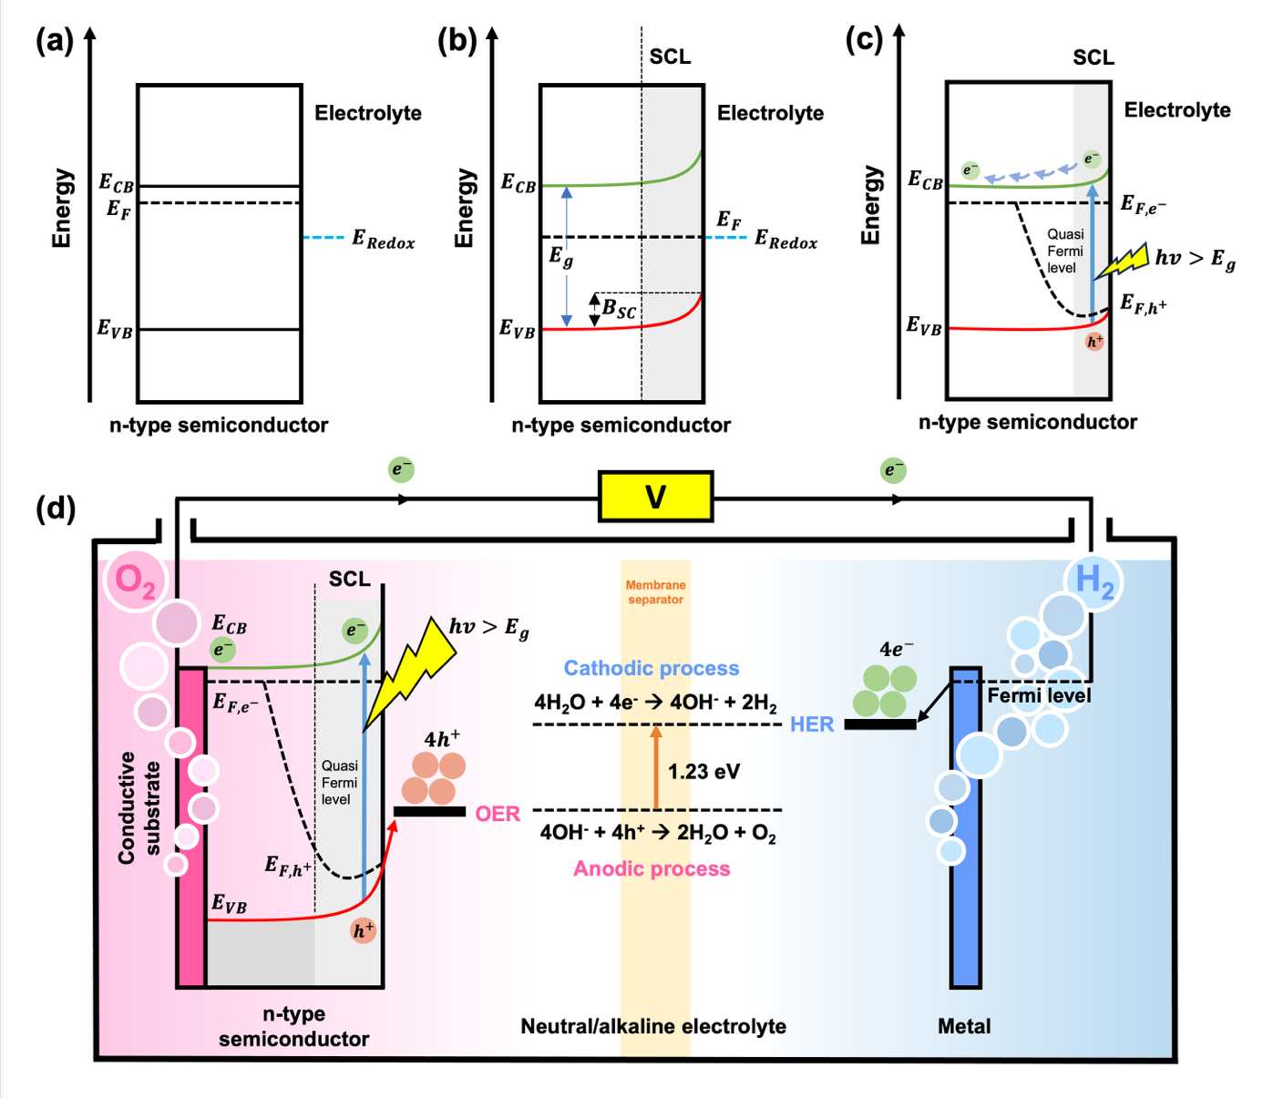
Fig. 1. Energy diagram and band positions in an n-type semiconductor (a) Before equilibrium state and (b) Under equilibrium state after semiconductor-electrolyte contact. (c) Quasi-Fermi level formation under light irradiation, and (d) A complete PEC configuration where all components are placed in neutral/alkaline electrolyte with external bias. E_{CB}, E_{VB}, and E_{F}$-$energy level for conduction band, valence band, and Fermi level, respectively. E_{g}$-$band gap energy, SCL$-$space charge layer, B_{SC}$-$band bending degree in semiconductor.
Applying an external bias shifts the electrolyte potential relative to semiconductor. If the bias is positive (for n-type photoanode), band bending increases, enhancing the built-in electric field. This facilitates charge separation by driving photogenerated electrons to bulk and holes to surface (Fig. 1d). Holes move from photoanode to the surface to oxidize water, generating oxygen through the oxygen evolution reaction (OER), while electrons traverse the external circuit to the cathode, where they engage in the hydrogen evolution reaction (HER) [14]. The theoretical minimum thermodynamic energy necessary for water splitting is 1.23 V. However, kinetic barriers result in higher energy requirements for the reaction to occur. Thus, external bias is frequently employed to surmount these barriers and facilitate continuous charge flow . This interplay of band alignment, carrier separation, and quasi-Fermi level splitting under illumination is fundamental to the functioning of a semiconductor photoelectrode in PEC water splitting.
Considering the energy demands of the water-splitting process, two essential criteria exist for semiconductors to be suitable for use as photoelectrodes. For photocathodes, the semiconductor's conduction band minimum (CBM) value must be more negative than the reduction potential of H⁺/H₂ ($E°$vs NHE = 0 V at pH 0, its absolute potential is approximately -4.44 eV when compared to the energy of an electron in vacuum). For photoanodes, the valence band maximum (VBM) value must exceed the standard oxidation potential of H₂O/O₂ ($E°$vs NHE = +1.23 V at pH 0, its absolute potential is approximately -5.67 eV when compared to the energy of an electron in vacuum) [15,16]. Consequently, semiconductors with bandgaps ranging from approximately 1.23 eV to 3.1 eV (relative to NHE) is requisite to provide a sufficiently substantial overpotential for the external bias in water-splitting (see Fig. 2a). The selection of a suitable photoanode is crucial to achieve high solar-to-hydrogen (STH) efficiency [17], where the STH is defined as the ratio of chemical energy produced from hydrogen generation to the incident solar energy input without external assistance (zero bias / short-circuited condition) [18,19]. The equation for calculating STH is shown below, where the short-circuit photocurrent (Jsc) influences the thermodynamic potential of water splitting (1.23 V), the faradaic efficiency (ηF), and the incident lighting power density (P_{in}).
STH = $\left[\frac{Jsc × 1.23 V × ηF}{Pin}\right]$AM 1.5 G (1)
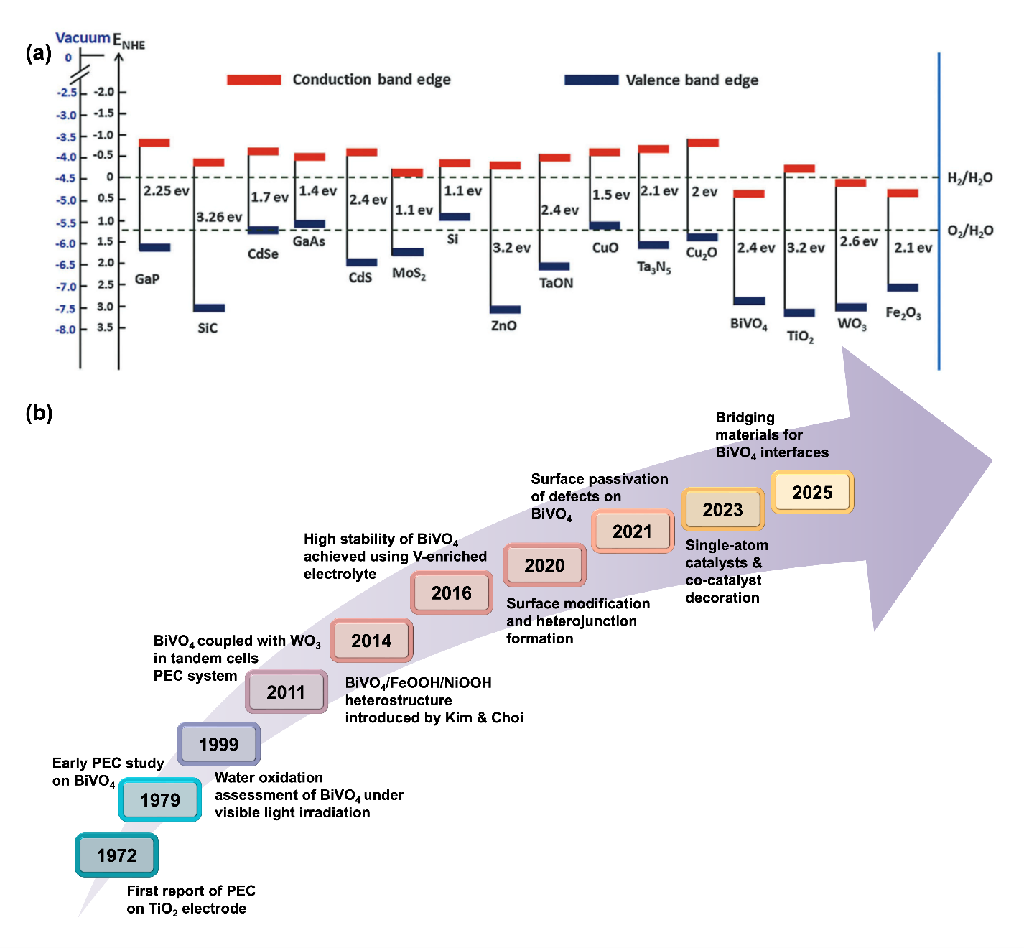
Fig. 2. (a) The conduction band and valence band positions of commonly used semiconductors at pH neutral with reference to the water redox potential vs NHE (normal hydrogen electrode). Adapted with permission from ref [20]. Copyright 2016, Royal Society of Chemistry. (b) A timeline-based milestone of BiVO₄ photoanodes for water splitting application.
Of all the available light absorbers, oxide-based photoelectrochemical (PEC) devices are the most thoroughly investigated materials for PEC water splitting owing to numerous intrinsic advantages. They provide exceptional chemical and photoelectrochemical stability in aquatic settings, an essential factor for prolonged operation. Moreover, many oxides can be fabricated using simple and scalable production methods, rendering them suitable for commercial applications. Also, many metal oxides possess deep and highly oxidising VBM energy levels with a high overpotential to drive the oxygen evolution process (OER) [21].
Nevertheless, a notable limitation of metal oxide-based photoelectrodes is their wide bandgap energies, which limits the amount of solar energy they can absorb. This arises from the large difference in electronegativity between the oxygen anions and metal cations in the lattice, increasing the energy required to excite an electron from the orbitals in the oxygen anions that make up the VBM to the orbitals in the metal cations that make up the CBM [22]. Due to this intrinsic band gap constraint, metal oxide-based photoelectrodes must attain high quantum yields to achieve commercially viability, indicating their necessity to effectively transform absorbed photons into charge carriers that facilitate surface catalytic reactions with high efficiency. This can only be achieved where the photoelectrode effectively separates charge, minimizes recombination losses, and drives surface catalytic reactions effectively [23].
Since Fujishima and Honda’s initial demonstration of the PEC water splitting process using titania (TiO₂) electrodes in 1972, researchers began developing a wide range of photoelectrode materials, including metal oxides (WO₃, TiO₂, Fe₂O₃, NiO and BiVO₄) [24–26], metal nitrides (C₃N₄, and Ta₃N₅) [27,28], metal chalcogenides (ZnInS₄, and Sb₂S₃) [29], and perovskite systems [30]. However, in 1998, the pioneering work of Kudo et al. first demonstrated the water splitting capability of the visible-light active metal oxide system, bismuth vanadate (BiVO₄) [31], which inspired Sayama et al. in 2003 to incorporate this material within a photoanode, achieving an incident photon-to-current efficiency (IPCE) of 29% at 420 nm under an applied voltage bias [32]. BiVO₄ has since become one of the most promising materials explored for PEC water splitting applications. The advancement of BiVO₄ PEC research encompasses various critical phases and significant achievements (see Fig. 2b).
BiVO₄ occupies a unique niche among oxide-based photoanodes because of its moderate band gap ($\sim$2.4 eV), which facilitates visible-light absorption. The narrow bandgap arises from the blending of the Bi 6s orbitals with the O 2p orbitals that form the VBM, raising the VBM energy level and narrowing the band gap energy [33]. This bandgap energy facilitates the absorption of ~10.8% of AM 1.5 G solar energy flux, resulting in a theoretical maximum photocurrent density of around 7.5 mA/cm² and STH of 9.2% under these conditions (see the comparison with other semiconductors in Fig. 3) [34]. Compared with other materials, the advantages of BiVO₄ are clear. For example, despite silicon and III-V compounds possessing narrower bandgaps and thus being capable of producing higher photocurrent densities for PEC water splitting, they are prone to photo-oxidation or photocorrosion, resulting in a rapid loss of activity. Also, while hematite (Fe₂O₃) offers narrower band gap ($\sim$2.1 eV) than BiVO₄, it suffers from faster electron-hole recombination and poor charge carrier mobility, severely limiting photocurrent densities, often below 3 mA/cm² [35]. BiVO₄, has achieved photocurrent densities as high as 6.7 mA/cm² [36].
The early 2010s witnessed significant advancements in the development of BiVO₄, with this material incorporated in heterojunction PEC cells combined with WO₃, leveraging their complimentary energy levels to form a type II heterojunction that effectively separated charge to enhance overall system efficiency [37]. From 2014 to 2020, focus transitioned to surface changes and heterojunction forms on BiVO₄ [38]. Methods including co-catalyst decorating and passivation promoted charge separation, reduced surface recombination, and improved water oxidation kinetics. In 2023, the implementation of single-atom catalysts and complex co-catalyst modifications on BiVO₄ surfaces further enhanced catalytic activity and stability, showcasing atomic-level regulation of the interfacial chemistry [39].
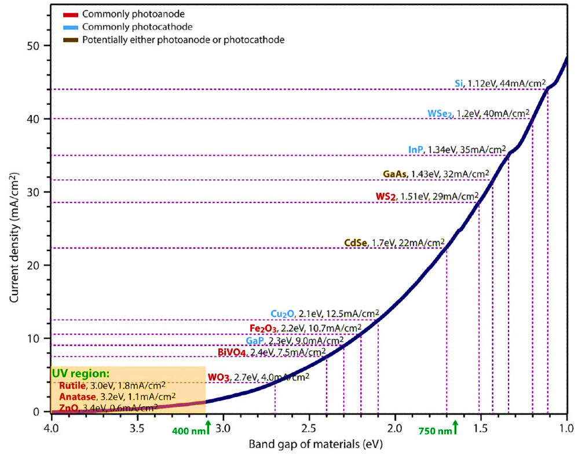
Fig. 3. Theoretical photocurrent densities of different semiconductors under AM 1.5 G illumination. Adapted with permission from ref [40]. Copyright 2013, American Chemical Society.
Recent developments this decade have shown how PEC water splitting prototypes are now being developed and examined in the field to test their technology readiness level for commercialization [41]. Despite the optimistic advancements in their scalable fabrication and prototype device development, the efficiencies of BiVO₄-based devices, when examined at length-scales commensurate to their intended application (i.e. > 10’s of cm² scale) remain a barrier. The principal cause of low efficiency remains the kinetic rivalry between rapid charge recombination and the slower interfacial charge transfer [42–44]. Also, long-term durability under outdoor sunlight, electrical bias, and electrolyte conditions are also important factors that must be considered. There are several factors that weaken the interfacial contact of semiconductor materials in PEC systems: limited contact areas, unfavorable hydrophobic-hydrophilic properties, interparticle boundary formation, and mismatched lattice patterns [45]. To address these issues, bridging materials can reinforce the interface contact and improve the efficiency of charge separation and transfer.
Earlier this year, Wang et al. presented a method to improve the performance of BiVO₄ photoanodes by including an Al–O bridging unit between the NiFeOx co-catalyst and the BiVO₄ surface via a straightforward impregnation process. The Al–O bridge acts as a chemical channel, enabling efficient hole transfer from BiVO₄ to NiFeOx. This bridging layer markedly enhances the kinetics of water oxidation by diminishing interfacial charge recombination and expediting hole extraction. The system achieved a notable applied-bias photon-to-current efficiency (ABPE) of 2.19% at a modest potential of 0.67 V vs RHE. This discovery indicates that incorporating a bridging material at the semiconductor–catalyst interface is an effective approach to enhancing the photoelectrochemical performance of BiVO₄ under reduced bias, thereby improving its applicability to solar fuel technologies.
To our understanding, the term "Bridge engineering" was initially introduced by Zhong et al. [46] in their review article, which summarises essential insights into the functions and underlying mechanisms of bridge materials within diverse photocatalytic/PEC systems and their roles in enhancing activity across various reactions. Based on their findings, there are three general and fundamental design principles for preparing bridged systems in photoelectrocatalysis: (i) understanding the function of bridges in the prepared structures based on the desired kinetics of the photocatalytic/PEC system, (ii) selecting bridge materials and designs based on the roles of bridges, and, (iii) mitigating adverse effects from implementing these bridge materials, including the formation of interfacial defects and light obstruction [46]. Differ from previous report, this review provides recent updates regarding interface engineering design, specifically in BiVO₄-based photoelectrochemical systems and validates how incorporating bridge materials at the various interfaces in the photoelectrode between BiVO₄ and the conductive substrate and also between BiVO₄ and other semiconductor layers. The general features of BiVO₄ are first discussed to highlight the intrinsic properties that limit photoelectrochemical performance and how these can be overcome through rational materials design. Following this, bridge materials are then defined and their roles in each architectural type are provided, together with insights on the various techniques that have been used to fabricate them, from dry processes to wet chemical approaches. Finally, the existing barriers and future outlooks for this emerging strategy for improving BiVO₄-based photoelectrodes are presented.

General properties of bismuth vanadate
BiVO₄ manifests in three crystalline structures: tetragonal zircon (t-z), monoclinic scheelite (m-s), and tetragonal scheelite (t-s). All polymorphs are n-type semiconductors, where BiVO₄ consistently features V ions coordinated with four O atoms in a tetrahedral configuration, while Bi ions are coordinated with eight O atoms from eight distinct VO₄ tetrahedral units [47]. The distinction between scheelite and zircon structures is attributed to the connection of Bi ions. In the scheelite structure, Bi ions are coordinated with eight VO₄ tetrahedral, but in the zircon structure, Bi ions are associated with just six VO₄ tetrahedral. In the t-s phase of BiVO₄, all V-O bond lengths are uniform at 1.72 Å. The m-s phase displays two unique V-O bond lengths: 1.77 Å and 1.69 Å (see Fig. 4a-c) [48,49].
Among the various crystalline phases of BiVO₄, the monoclinic scheelite (m-s) structure consistently demonstrates superior photocatalytic activity compared to the zircon-type. This form is characterized by a direct band gap of 2.4 eV, enabling it to absorb visible light in the wavelength range of 400-517 nm [50]. In comparison to other commonly studied metal oxide semiconductors, m-s BiVO₄ has an impressive theoretical STH efficiency of 9.2% [51], where ZnO (E_{bg} ~3.2 eV), rutile TiO₂ (Ebg ~3.0 eV) and WO₃ (E_{bg} ~2.7 eV) possess theoretical STH efficiencies of 1.3%, 2.3% and 5.0% respectively [52,53]. Its hole mobility (~ 2 cm² V⁻¹ s⁻¹) is also significantly greater than that of Fe₂O₃ (0.0001 cm² V⁻¹ s⁻¹) [50,54]. The enhanced performance of the m-s phase is closely tied to its electronic and optical properties, shaped by orbital interactions. In the m-s and t-z phases, the valence band is primarily composed of hybridized O 2p and Bi 6s orbitals, forming antibonding states near the valence band edge [55]. This hybridization lowers the bandgap energy by elevating the valence band maximum, enabling more efficient visible light absorption. On the other hand, the conduction band is dominated by V 3d orbitals with minor contributions from O 2p and Bi 6s orbitals, facilitating effective charge transport by a smaller effective mass for electrons and holes. Compared to the tetragonal zircon phase, where the bandgap arises mainly from O 2p to V 3d transitions, the m-s phase benefits from additional Bi 6s and O 2p coupling, which enhances charge separation and reduces recombination [56]. Additionally, the distortion of its Bi and V ion coordination environments in the m-s phase introduced asymmetrical and local polarization, which produces an internal electric field within the material [57].
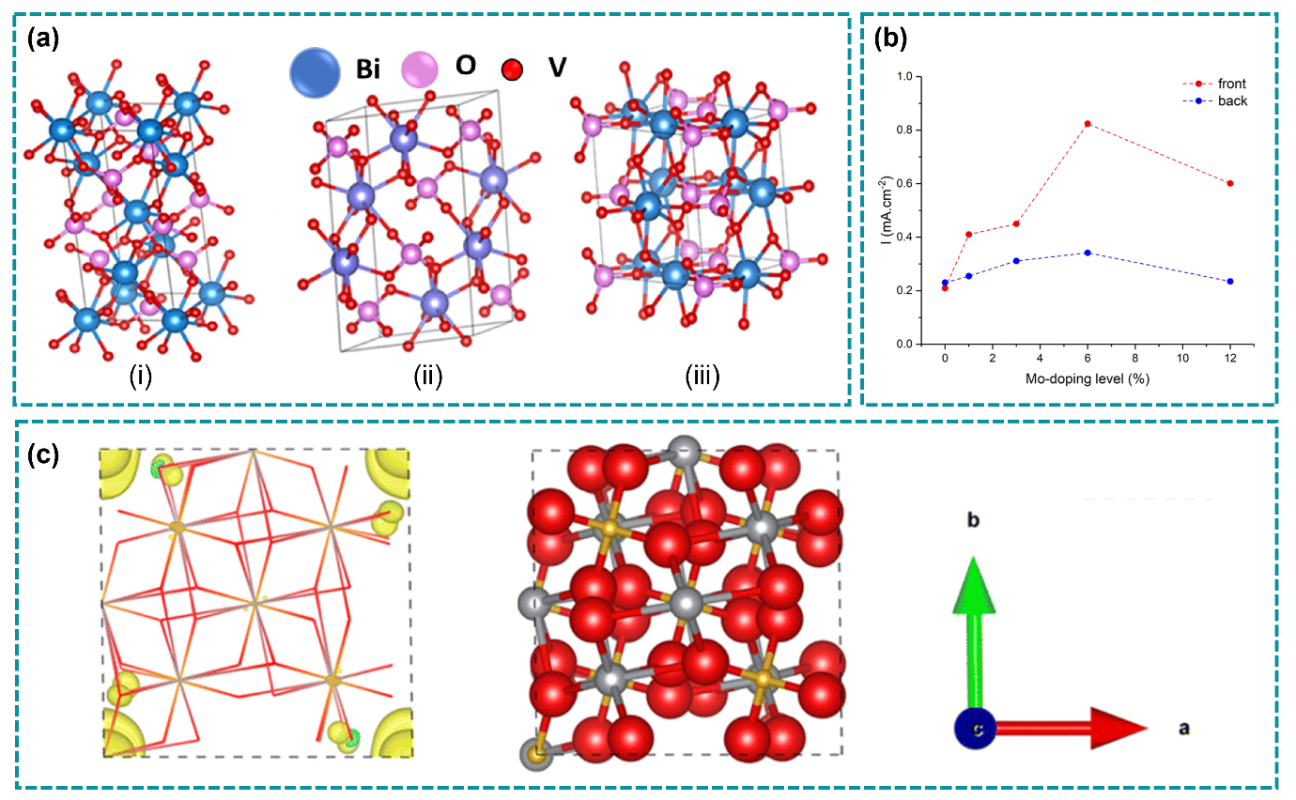
Fig. 4. (a) Crystal structures of BiVO₄ in (i) Tetragonal scheelite phase, (ii) Monoclinic scheelite phase, and (iii) Tetragonal zircon phase. Adapted with permission from ref [49]. Copyright 2025, Tsinghua University Press. (b) The photocurrent densities of all Mo-doped BiVO₄ samples observed at 1.23 V vs RHE for both back and front irradiation. (c) c-axis view of 2 $×$ 1 $× 1$ supercell of the calculated structure for 6.25% Mo doping at a V site in tetragonal BiVO4 [the atomic color code of Bi: silver, V: gold, O: red, and Mo: light blue]. Adapted with permission from ref [58]. Copyright 2024, Royal Society Chemistry.
It is well-established from various literature that micrometer-scale monoclinic BiVO₄ powders can be obtained through solid-state reactions, metal organic decompositions, and solution processes. Venkatesan et al. [59] prepared highly crystalline monoclinic BiVO₄ nanostructured powders by mixing bismuth oxide (Bi₂O₃) with vanadium pentoxide (V₂O₅) stoichiometrically through mechanical milling, while Thurston et al. [60] achieved monoclinic BiVO₄ from the pyrolysis process of BiV(O)(O₂CC₆H₄-2-OH)(O₂CC₆H₄-2-O)(ethylenebis(3-methoxysalicylimine))·CH₂Cl₂. Recently, Mansha et al.[52] reported the fabrication of pure monoclinic BiVO₄ through a facile hydrothermal technique. The hydrothermal approach facilitates the growth of uniformly sized and shaped crystals at lower temperatures. However, under different pH conditions, various morphologies of BiVO₄ could be easily prepared [52]. In contrast, the sol-gel method is favored for its capacity to yield highly pure and homogeneous materials [61,62]. In addition to hydrothermal and sol-gel methods, thin-film deposition techniques such as chemical vapor deposition (CVD), sputtering and spray-pyrolysis are widely utilized for the synthesis of BiVO_{4,} especially in the construction of photoelectrodes. These techniques provide accurate control of film thickness, crystallinity, and composition. The quantity of layers, size, morphology, and the inclusion of dopants or defects can be adjusted by modifying growth parameters [63].
In Earth’s crust, the abundance of vanadium and bismuth is approximately 135 ppm and 0.17 ppm, respectively. Despite bismuth’s relative rarity relative to silver, its market accessibility is less restricted. This is primarily owing to bismuth’s restricted industrial applications, resulting from its brittle and flexible characteristics, leading to lower demand. Furthermore, bismuth is frequently generated as a by-product of lead, copper, and tin extraction, so ensuring a consistent supply despite its inherent scarcity. In comparison to the other semiconductor photocatalysts (e.g., ZnO and TiO₂), the emergence of BiVO₄ has significantly altered the landscape. especially because this material can harness the visible region of the solar spectrum[64].
However, BiVO₄ presents multiple challenges, including fast electron-hole recombination, short hole diffusion length, slow electron mobility, and brief charge carrier lifetimes [65]. The hole diffusion length of BiVO₄ is ~70 nm, meaning that the distance a hole can travel before recombining with an electron is restricted, which can diminish photocatalytic efficiency. Moreover, the electron mobility in BiVO₄ is relatively low, with average reported values ranging from 0.02 to 0.044 cm²/Vs, which constrains the generated photocurrent. The observed slow electron mobility can be explained by the imperfect overlap between the Bi 6p orbitals and V 3d orbitals at the conduction band minimum (CBM) [57]. Hence, elemental doping is widely believed to be key to modifying the band structure and orbital interactions within BiVO₄.
Doping BiVO₄ lattice with transition-metal ions such as Mo⁶⁺ or W⁶⁺ has been shown to consistently increase charge-carrier density and reduce internal charge-transfer resistance. Specifically, substituting Mo⁶⁺ for V⁵⁺ sites increase the photocurrent by approximately 6-fold relative to pure BiVO₄ [66]. The addition of W⁶⁺ yields a similar increase of up to 4.6-fold through improvements in electrical conductivity and charge separation [67]. Further optimization through gradient W-doping even yielded a photocurrent exceeding 2.2 mA cm⁻² at 1.23 V vs RHE [68], while W doping in the 1-5% range achieved a surface charge separation efficiency of 50–60% at 1.4 V vs RHE, in contrast to around 10% for undoped BiVO₄ [69].Nevertheless, the study by Zhao et al. [58], revealed that the increase in bulk conductivity due to doping has a critical upper limit at a Mo concentration of 12.5%, the donor states converge with the CMB to form a degenerate semiconductor that enhances electron-hole recombination and suppresses the effective photovoltage. This phenomenon indicates doping enhances carrier generation and conductivity, resulting in a greater influx of electrons and holes to the surface. Nevertheless, in the absence of a bridge component, numerous carriers recombine at inadequately passivated or kinetically sluggish surfaces. When integrated correctly, doped BiVO₄ provides an enhanced flux of carriers, while the bridge swiftly collects and utilizes them, which can result in prolonged carrier lifetime, and improvements in separation efficiency (η_{sep}) and interfacial charge transfer efficiency (η_{tran}).

Bridge engineering for PEC systems and their architectures
In photocatalytic and photoelectrocatalytic systems, a bridge refers to a material or a functional entity that facilitates charge transfer between distinct components without being actively generating charge carriers and does not host the terminal surface redox reaction. Incorporating a bridge layer into doped BiVO₄ photoanodes is not merely an additive method. It is a synergistic approach to enhance overall performance in the PEC system. According to Zhong et al. bridge materials can be broadly categorized into two types: solid nanostructured materials and functional groups or coordination ligands [46]. Nanostructured bridge materials include metal nanoparticles (Au, Pd, Cu) [70–72], carbon materials (rGO, CQDs, graphite) [73,74], metal oxides (TiO₂, ZnO, BiOCl) [75–77], and MOFs [78,79]. Additionally, functional groups (phosphates, silicates, and aluminates) and ligands (dopamine, cysteine, and caffeine) can form conductive chemical bonds that connect different components in heterostuctured systems [80–82]. Among all the materials listed above, metal nanoparticles and carbon materials have been the most widely studied bridge materials, primarily due to their high electrical conductivity.
Three-dimensional graphene (3D-G) has been incorporated to the heterojunction system of BiVO₄ with SnO₂ [83]. The incorporation of 3D-G has augmented the material's conductivity, resulting in an increased photocurrent at reduced overpotential from 0.72 to 1.21 mA/cm². Two dimensional bismuthene has also being used as a functional interlayer between BiVO₄ and NiFeOOH co-catalyst [84]. The photocurrent improvement is 5.8 times greater than that of BiVO₄ alone, attained by integrating bismuthene and NiFeOOH with BiVO₄. This enhancement is attributed to bismuthene’s role in enhancing interfacial bend bending and occupying oxygen vacancies-related electron traps, leading to more effective charge extraction.
Bridges typically do not serve as the primary sites for surface reactions, but instead act as conductive or semiconductive channels that enhance interfacial charge separation and transport, while also can simultaneously correcting an electronic mismatch across the interface [46]. Although bridges are often conceptualized as passive conduits, the bridge component may also engage in the absorption of photons to generate additional charge carriers in certain architectures. When reduced graphene oxide (rGO) serves as a highly conductive 2D bridging layer between BiVO₄ and Ag nanoparticles, it facilitates a high-mobility pathway for electrons and contributes a modest photoresponse owing to its π-conjugated structure [85].
The aforementioned examples illustrate that the functionality and efficiency of the bridge component within the interfacial system of BiVO₄ photoanodes are contingent upon the nature of the bridge material (conductive or otherwise) and, crucially, their geometric arrangement with the supported components. Fig. 5 presents six major bridged architectures for PEC systems, where unique geometrical settings define whether the bridge acts as a passive charge transfer conduit or an active participant in the whole processes. Across the six representative configurations, the spatial arrangement of the bridge relative to functional components dictates charge-transfer directionality, interfacial recombination probability, and carrier diffusion length. Identical bridge materials have divergent functions when utilized in various structures, highlighting that bridge engineering is mostly a structure-driven approach to charge management, rather than only a matter of compositional alteration [86,87].
In bridge-supported architectures (Types I and II), performance disparities predominantly stem from variations in interfacial connection. Type I arrangements, where two functional components are individually anchored to a shared bridge scaffold, offer extensive surface accessibility and structural adaptability to directly participate in surface redox reactions [88]. In contrast, Type II architectures facilitate direct component–component interaction while maintaining the bridge as a parallel transport conduit. This dual-pathway arrangement significantly reduces charge-transfer distances and enhances carrier extraction, resulting in improved interfacial charge separation while maintaining catalytic surface exposure [89,90]. Graphene, MOF, carbon nanotubes, and other large materials are usually used as bridges in Type I and Type II architecture [46].
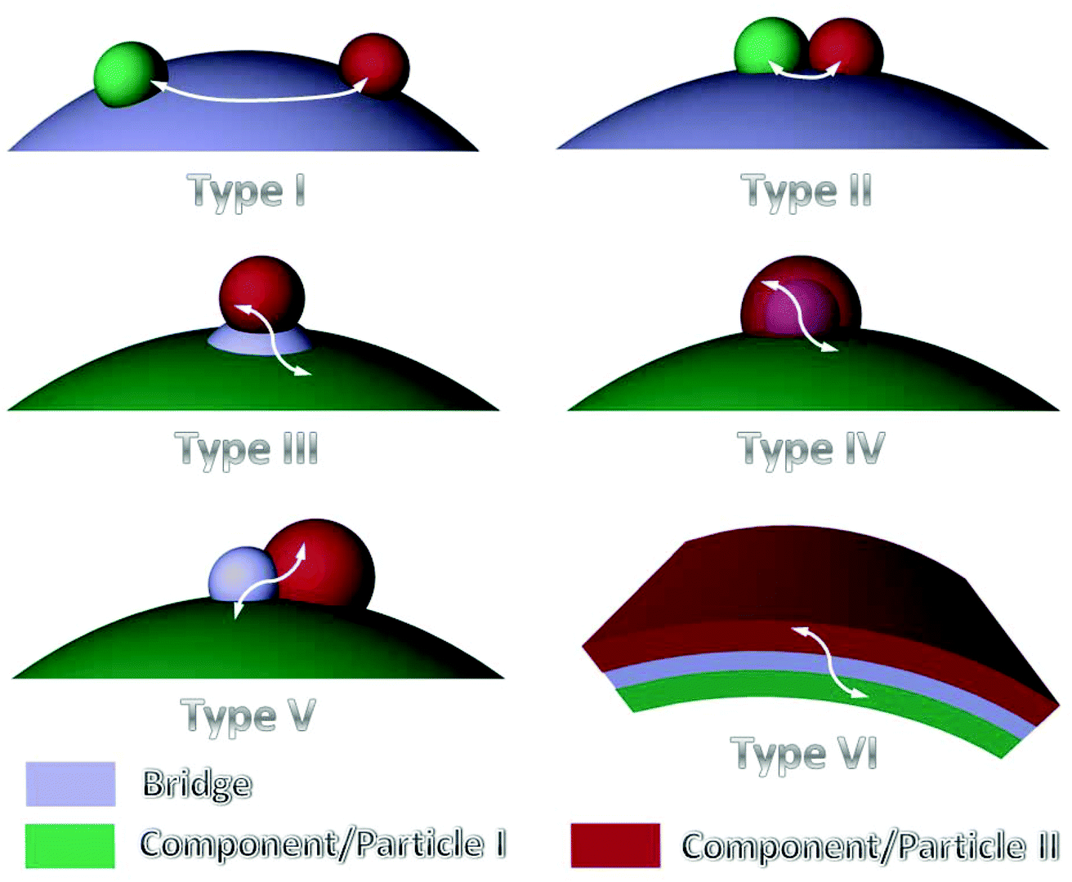
Fig. 5. Six architecture types of bridged engineering for examples of PEC systems with 2 active components. Type I & II involve far and near contacted components, respectively, connected by exposed bridges that provide additional charge transport pathways. Type III and IV feature stacked and interfacial bridge configurations that enhance interfacial coupling and regulate carrier migration. Type V & VI integrate junction-based or hierarchical bridges to enable multi-channel charge transfer. Adapted with permission from ref [46]. Copyright 2020, Royal Society Chemistry.
Interfacial and encapsulated bridge designs (Type III and IV) offer greater control over electronic coupling by imposing nanoscale spatial confinement. In Type III topologies, ultrathin bridges positioned at the component interface function as electronic mediators that align energy levels and mitigate adverse interfacial states. Such strategies are well established in molecularly bridged Z-scheme and ligand-modified photocatalysts, where covalent or coordination bonding enables directional charge transfer and reduces recombination at mismatched interfaces [91,92]. Type IV core–shell architectures extend this principle by isolating the bridge within a protected interfacial domain, maximizing charge-transfer area while shielding sensitive bridge components from photocorrosion. Encapsulation-based designs have repeatedly shown superior durability and sustained activity in photoelectrochemical systems, particularly under oxidative water-splitting conditions [93,94].
Advanced neighboring-contact and sandwich architectures (Types V and VI) exemplify the most spatially efficient bridge configurations. Type V systems provide simultaneous contact between the bridge and both functional components while maintaining partial exposure to the reaction environment, and can promote synergistic charge transport and surface catalysis. Type VI sandwich topologies, by contrast, restrict the connection between two planar components, creating a continuous charge-transfer interface with low diffusion distance. This planarization optimizes interfacial area, can diminish resistive losses, and can facilitate atomic-scale thickness regulation of the bridge layer, therefore reducing light-shielding effects [95]. These results collectively indicate that precise spatial confinement and interfacial engineering of bridges are crucial for simultaneous enhancements in charge separation, transport efficiency, and photochemical stability, positioning architectural typology as a fundamental design principle for next-generation bridged PEC systems.

Roles of bridges in BiVO₄ PEC systems
Bridge engineering can be broadly defined as an interface-centered design strategy in which intermediate layers, phases, or molecular entities are deliberately introduced to regulate charge transport, energetic alignment, interfacial stability, and reaction kinetics across functional junctions, including component–component, component–substrate, and component–electrolyte interfaces. This expanded framework unifies a broad range of interfacial strategies that are currently treated as independent or empirical modifications, providing a common language to rationalize performance gains across PEC devices.
  - Bridge engineering between the conductive substrate and BiVO₄
The utilization of transparent conductive oxides (TCOs) as substrates for the deposition of thin films serving as photoelectrodes has increased in importance compared to conventional opaque metal electrodes (e.g., gold, platinum, or stainless steel) and non-transparent conductive substrates such as carbon paper, nickel foam, or graphite [96]. Due to its stability and affordability, fluorinated tin oxide (FTO) functions as a competitive and perhaps most widely explored TCO substrate for PEC applications [97]. The substrates enable the electrode to be illuminated from both sides.
Carrera-Crespo et al. evaluated the relationship between front and back irradiation of a BiVO₄ photoanode grown on FTO [98]. The PEC performance was found to be lower under front illumination than back illumination. This difference arises from the difference in electron and hole mobilities in BiVO₄, where the electron diffusion length for BiVO₄ film ranges from 10 to 70 nm, while the hole diffusion length spans from 100 to 200 nm [99]. Consequently, in thicker BiVO₄ films exceedingly 100 nm, most electrons generated near the top surface during frontside illumination fail to reach the rear FTO electrode and instead undergo recombination [100]. Furthermore, the FTO/BiVO₄ interface is purported to exhibit intricate defect states (DFS) that can capture photogenerated electrons prior to extraction, hence resulting in diminished performance due to the band flattening phenomenon and the creation of recombination centers within the FTO/BiVO₄ interface [101].
The interaction between the FTO and the BiVO₄ thin film is therefore crucial for the PEC activity of the photoanodes. Moreover, achieving improved photocurrent from front illumination of the BiVO₄ layer may be required for tandem systems where BiVO₄ is the narrower bandgap material, and other architectures. Diverse strategies have been proposed to modify the FTO-BiVO₄ interface to improve PEC activity and reduce charge recombination [102]. Inserting bridge materials, such as a metal oxide layer, between the FTO and BiVO₄ thin film is one potential approach. In this context, the most commonly used metal oxide layers that have been explored is SnO₂. For example, a BiVO₄ photoanode supported by the optimum thickness (65 nm) of SnO₂ underlayer showed a much more enhanced PEC performance (3.76 mA/cm² at 1.23 V vs. RHE) than that bare BiVO₄ (2.58 mA/cm² at 1.23 V vs. RHE) [103]. At the FTO-BiVO₄ interface, this bridging agent functions as a hole mirror, preventing holes from reaching recombination centers [104,105]. Furthermore, it reduces the BiVO₄ band-bending that occurs in the interfacial region, enhancing the catalyst's efficacy in driving the OER by accelerating the transport of electrons towards the FTO electrode.
Ho-Kimura & Luo reported a rare case in which the photocurrent density of the BiVO₄ photoanode was improved with the incorporation of a Fe₂O₃ underlayer, solely at a low bias [106]. The photocurrent density of the composite anode attained 0.95 mA/cm² at 0.6 V vs RHE, which is six times greater than that of unmodified BiVO₄. Gao et al. [100] illustrated the interface engineering of BiVO₄ photoanodes with a palladium oxide (PdO) underlayer at the BiVO₄/FTO interface, significantly enhancing the front illumination photoelectrochemical characteristics and photo-conversion efficiency of the bare BiVO₄ electrode (Fig. 6a). The optimized BiVO₄/PdO photoanode achieved a photocurrent of 4.90 mA cm² at 1.23 V vs RHE (the highest IPCE was observed at 80% from the range of 350-550 nm), with a notable onset potential of 0.15 V vs RHE (Fig. 6b), and demonstrated remarkable durability exceeding 80 hours (Fig. 6d). This study demonstrates that PdO serves as an efficient gate interlayer, enhancing electronic transport to the rear of the hydrogen reaction, mitigating photocorrosion between the electrode and substrate, and therefore expediting the kinetics of water oxidation by actively passivating the BiVO₄/PdO defect states, proven by an ultrathin layer formation (2–4 nm) observed in Fig. 6c.
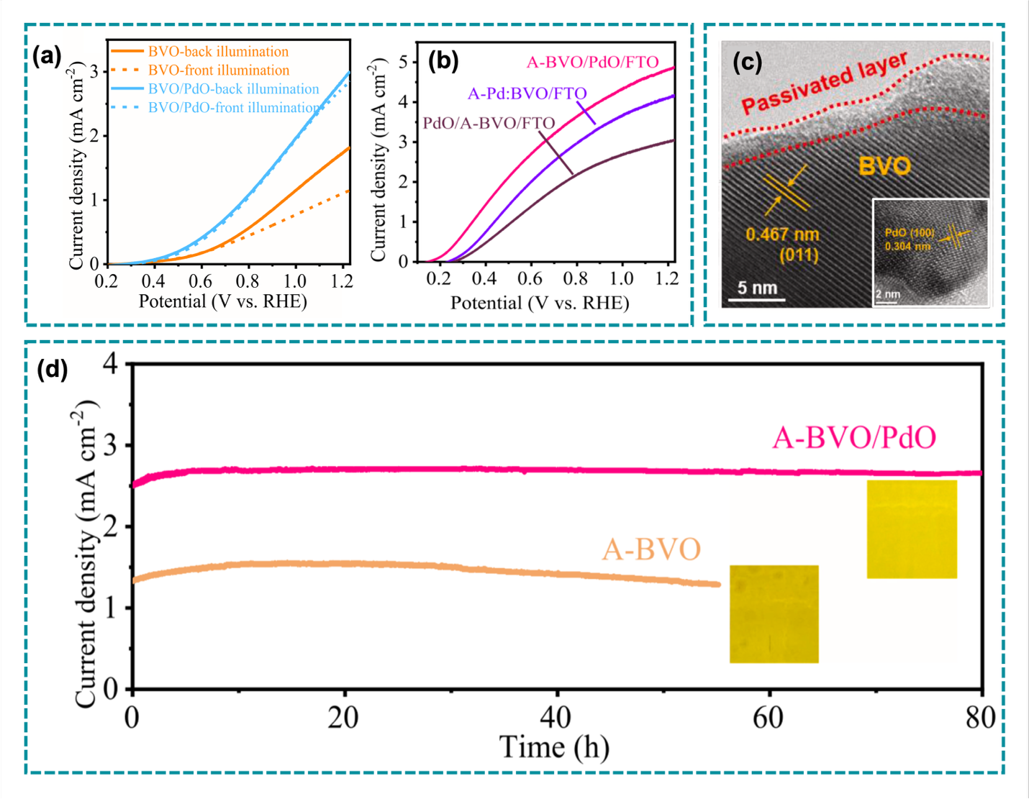
Fig. 6. LSV curves of (a) BiVO₄ and BiVO₄/PdO under AM 1.5 G front and back illumination, and (b) Activated BiVO₄/PdO/FTO, Pd: BiVO₄/FTO, and PdO/ BiVO₄/FTO electrodes after potentiostatic polarization under AM 1.5 G front illumination. (c) HRTEM image of BiVO₄/PdO. Inset shows the PdO TEM image on FTO. (d) Photostability of A-BiVO₄ (activated BiVO₄) and A-BiVO₄/PdO electrodes under solar front illumination at 0.6 V vs RHE. All electrochemical performance were performed in 1 M KBi electrolyte. Adapted with permission from ref [100]. Copyright 2021, Elsevier.
Plasmonic palladium nanoparticles have also being integrated at the electrode-BiVO₄ interface, effectively improves charge transfer pathways in the solar-driven glycerol oxidation process. The transient absorption spectroscopy results indicated that hot electron injection from Pd to BiVO₄ rapidly increased the conduction band electron density upon photoexcitation, while the newly formed plasmon-coupled states prolonged hole lifespan and reduced recombination rates. Additionally, photoelectrochemical measurements reveal that a moderate palladium loading (achieved with 4 mg of palladium precursor) markedly enhanced photocurrent density at 1.23 vs RHE, with the current rising from 0.62 mA cm⁻² in bare BiVO₄ samples without glycerol to 1.58 mA cm⁻² in BiVO₄-coated palladium samples with glycerol, alongside an increase in the IPCE from approximately 15% to around 40% [107].
  - Bridge engineering within BiVO₄-based heterojunctions
A heterojunction, defined as the interfacial region between two distinct semiconductors, is a prevalent method for improving the charge separation efficiency of BiVO₄ photoanodes [50]. In BiVO₄-based photoelectrochemical systems, the heterojunction structure utilizes the disparities in band positions between BiVO₄ and an auxiliary semiconductor, thus creating a built-in electric field at the interface. This internal field enables the spatial separation of photogenerated electron-hole pairs, diminishes bulk recombination, and may broaden the light absorption spectrum if the secondary material possesses a shorter bandgap [89]. Furthermore, heterojunctions frequently enhance the photochemical stability of BiVO₄ in more alkaline electrolytes by passivating surface flaws or expeditiously removing holes, with the incorporation of ZnFe₂O₄ additional layer for example [108].
The type II (staggered) heterojunction is the most favoured among the many forms of heterojunctions for BiVO₄-based systems [85,109]. In a Type II alignment, the conduction band minimum (CBM) and valence band maximum (VBM) of one semiconductor are either both elevated or both depressed relative to those of another semiconductor, facilitating the migration of photogenerated electrons to one material and holes to the opposing material [110]. When BiVO₄ is combined with an appropriate n-type or p-type semiconductor (such as WO₃, SnO₂, or g-C₃N₄), the staggered band alignment facilitates effective charge carrier separation at the interface, thereby optimizing the availability of electrons for reduction reactions at the cathode and holes for water oxidation at the photoanode surface.
Nonetheless, type II heterojunctions possess intrinsic drawbacks. A type II heterojunction improves carrier separation but at the sacrifice of potential energy, resulting in less energetic electrons and holes after their separation. As a result, the isolated electrons exhibit diminished reducing power, while the separated holes demonstrate reduced oxidizing capability compared to those in a singular semiconductor system [111]. This thermodynamic penalty may diminish the photovoltage and the total photoelectrochemical conversion efficiency. Moreover, inadequate interfacial contact, lattice mismatch, and defect states at the heterojunction interface may serve as recombination sites, undermining the advantages of charge separation [112].
S-scheme heterojunction has emerged as one of the most thermodynamically and kinetically favorable strategy for achieving efficient charge separation. Unlike conventional type-I heterojunctions that accumulate both carriers on a single component, or type-II heterojunctions that separate carriers at the expense of their redox potentials, the S-scheme configuration preserves high-energy electrons in the higher conduction and and high-energy holes in the lower valence band, thereby maintaining strong reduction and oxidation capabilities simultaneously [113]. This selective charge retention is driven by a spontaneous internal electric field (IEF) formed at the interface due to Fermi level differences between the two semiconductors, which is further stabilized by van der Waals forces, electrostatic interaction, and hydrogen bonding [114,115]. However, the practical implementation of S-scheme heterojunctions remains challenged by the difficulty in experimentally distinguishing its charge transfer pathway from that of conventional type-II systems, given their similar band alignments and charge migration behavior. The intrinsic interfacial contact quality, the density of recombination centers at the junction, and the kinetic mismatch between charge carrier arrival and surface reaction rates collectively impose additional barriers that band engineering alone cannot resolve [44].
To significantly improve the photoelectrochemical performance of BiVO₄ heterojunction-based systems, strategic bridge engineering is employed to connect BiVO₄ with the other active materials. The goal of this method is to enhance charge separation, surface reaction kinetics, and light harvesting in the heterojunction system through the loading of the co-catalyst for example. This type of engineering not only increases the connections between layers, but also allows for exact control of energy band alignment and catalytic activity. One of the positive results on the incorporation of bridge materials to fix the lattice mismatch within the BiVO₄ and TiO₂ heterojunction system has reported by Xie et al. [116]. They utilized phosphate anions as molecular bridges that could replace hydroxyl groups on the oxide surface, forming P-O-M linkages where M represents the metal cation of either TiO₂ or BiVO₄. The direction of charge transfer is confirmed through ultra-low-temperature ESR measurements. The ESR reveals a Ti³⁺ signal only under visible-light irradiation, showing that electrons originate from BiVO₄ and move to TiO₂, opposite to the conventional band alignment expectation. The phosphate-bridged sample exhibits a stronger Ti³⁺ signal and lower charge-transfer resistance, confirming that phosphate facilitates and accelerates electron transfer from BiVO₄ to TiO₂. The resulting photocurrent density was proven to be increased by around 1.74 mA/cm² at 0.8 V vs Ag/AgCl.
Besides phosphate, carbon-based materials, such as rGO [117] and GQDs [118] are used as bridges between two heterojunction materials. Carbon-based materials generally have a large surface area, high electron mobility, and excellent conductivity, making them well-suited for bridging heterojunction materials. A study conducted by Bai et al. utilized rGO as an electron transport bridge to accelerate charge transfer at the interface and provide a larger contact area than the BiVO₄/NiO material [117]. The photocurrent density produced by BiVO₄/NiO/rGO reached 1.52 mA cm⁻² at 1.23 V vs RHE, which was 1.39 times higher than BiVO₄/NiO and 2.41 times greater than pure BiVO₄. As illustrated in Fig. 7a, the charge transfer mechanism proceeds via a staggered band alignment between NiO and BiVO₄ under illumination. Photoexcitation generates electron–hole pairs, after which photogenerated electrons in the conduction band of NiO are efficiently injected into the conduction band of BiVO₄, followed by transport through the external circuit to drive proton reduction at the cathode. Concurrently, holes accumulated in the valence band of BiVO₄ are transferred to the valence band of NiO, where they participate in interfacial water oxidation reactions.
Another study conducted by Jia et al constructed a ternary BiVO₄/Bi₂S₃/rGO photoanode, where rGO served as a conductive scaffold to accelerate interfacial charge transfer and provide abundant active sites for water oxidation. The photocurrent density achieved by BiVO₄/Bi₂S₃/rGO reached 2.40 mA cm⁻² at 1.23 V vs RHE, which was 3.4 times higher than bare BiVO₄ and 1.26 times greater than BiVO₄/Bi₂S₃ alone. As shown in Fig. 7b, the charge transfer mechanism proceeds via a staggered type-II band alignment between BiVO₄ and Bi₂S₃, enabling efficient separation of photogenerated carriers. Under illumination, electrons excited in the conduction band of Bi₂S₃ are injected into the conduction band of BiVO₄, while holes accumulate in the valence band of BiVO₄ and migrate toward Bi₂S₃, where they drive interfacial water oxidation [119]. The incorporation of rGO serves as a bridge, creating an effective ohmic junction at the interface between rGO and each semiconductor layer. As the main connector, rGO accelerates electron transfer both within the heterojunction and at the electrode-electrolyte interface. This capability arises from the delocalized electrons within the π-conjugated carbon system, where the sp² carbon structure forms optimal pathways for electron movement, thus enhancing charge transfer efficiency.
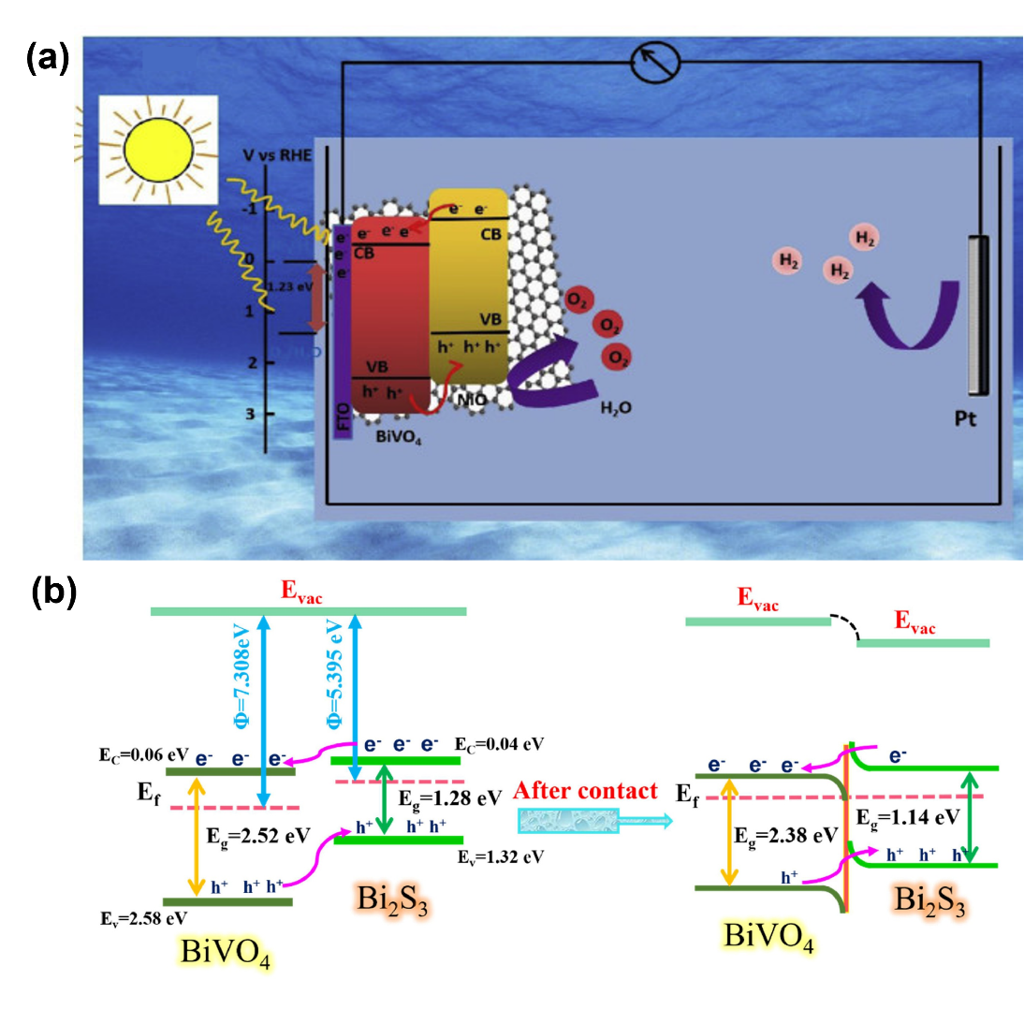
Fig. 7. (a) The PEC water-splitting mechanism on BiVO₄/NiO/rGO photoanode. Adapted with permission from ref [117]. Copyright 2022, Elsevier. (b) Energy band diagram of BiVO₄ and Bi₂S₃ before and after contact. Adapted with permission from ref [119]. Copyright 2025, Elsevier.
Interestingly, another study conducted by Samsudin et al. revealed that graphene quantum dots (GQDs) act as a more effective electron mediator compared to reduced graphene oxide (RGO). The ternary BiVO₄/GQD/g-C₃N₄ heterostructure achieved a photocurrent density of 19.2 mA cm⁻² at 1 V vs Ag/AgCl, outperforming the BiVO₄/rGO/g-C₃N₄ composite, which reached 14.6 mA cm⁻². This superior PEC performance is attributed to the bridge engineering role of GQDs, which provide quantum confinement and abundant edge sites that facilitate efficient charge transfer. Computational DFT analysis further substantiated these experimental results the BiVO₄/GQD/g-C₃N₄ system exhibited stronger orbital hybridization and greater electronic cloud sharing at the heterojunction interface, leading to enhanced charge redistribution and lower interfacial resistance. In contrast, the BiVO₄/rGO/ g-C₃N₄ composite showed weaker orbital overlap and less pronounced charge density redistribution, resulting in higher carrier resistance and reduced efficiency. GQDs establish delocalized π-electron pathways that accelerate electron migration while directing holes toward g-C₃N₄, ensuring spatial separation of carriers and suppressing recombination [120].
Based on this comparison, one practical way to decide between carbon-based and molecular bridges in BiVO₄ heterojunction engineering is to consider the interfacial conditions and the system's optical requirements. Carbon-based bridges are generally more appropriate when the constituent semiconductors exhibit substantial lattice mismatch over an extended contact area and when enhanced light-harvesting capacity is also required [117]. On the other hand, molecular bridges are more appropriate when the objective is to establish a well-defined, directional bonding interaction between specific atomic or ionic species at the interface. This type of bridge is especially useful when interface stability is a major concern, because the bonding is more localized and controlled than in the broader contact area of carbon-based bridges[116].
  - Bridge engineering between BiVO₄ and surface cocatalysts
The application of OER electrocatalysts (OECs) often faces challenges such as weak adhesion to photoelectrodes and volume changes during stability measurements. These issues motivated surface passivation strategies, particularly surface-protected etching of the material. Hence why, the other progressively favored method for altering BiVO₄ entails the utilization of oxygen evolution reaction (OER) electrocatalysts, often designated as co-catalysts incorporation. In OER photocatalysis, co-catalysts serve several key roles: (1) Reducing overpotential by providing active sites that facilitate O₂ formation. (2) Enhancing electron-hole separation by offering appropriate trapping sites for generated charges. (3) Mitigating photo-corrosion by selectively removing light-induced charges, particularly holes, to improve stability [121]. Additionally, integrating co-catalysts helps lower charge transfer resistance at the interface and decreases activation energy (E_{a}) in water oxidation reactions, thereby accelerating overall redox processes [122]. With these advantages, co-catalyst integration addresses some limitation of BiVO₄, such as photo-corrosion and sluggish oxidation kinetics [123].
Recent studies have highlighted that the interface between BiVO₄ and co-catalyst can be hindered by the formation of a Schottky junction that impedes efficient hole migration. Alam & Qureshi developed graphene quantum dots (GQDs) as a bridge between BiVO₄ and CoSn-LDH to facilitate hole extraction from the surface of BiVO₄ [124]. These holes were then transferred to the oxygen evolution catalyst (OEC), accelerating hole migration to the electrolyte and enhancing the efficiency of the water oxidation reaction. The photocurrent density generated by the BiVO₄/GQDs/CoSn-LDH material reached 4.15 mA.cm⁻² at 1.23 V vs RHE, which is 3x higher than pristine BiVO₄ (1.33 mA cm⁻²), 1.5x higher than BiVO₄/GQDs (2.83 mA cm⁻²), and 1.2 times higher than BiVO₄/CoSn (3.35 mA cm⁻²), as shown in Fig. 8a-b. Additionally, the onset potential of BiVO₄/GQDs/CoSn shifted, indicating a lower overpotential required for water oxidation. The mechanism that occurs is illustrated in Fig. 8c. When exposed to light, electrons in BiVO₄ are excited into the conduction band, leaving holes in the valence band. GQDs' negative surface charge attracts holes from BiVO₄, speeding up charge separation. CoSn-LDH then transfers holes to its surface, facilitating the oxidat pion of Co²⁺ into Co³⁺ within CoSn-LDH. The Co³⁺ species oxidize water into oxygen, then returns to its Co²⁺ state, continuing the catalytic cycle. The incorporation of GQDs as an electron bridge in this system not only improves charge separation efficiency but also significantly enhances overall photocatalytic activity.
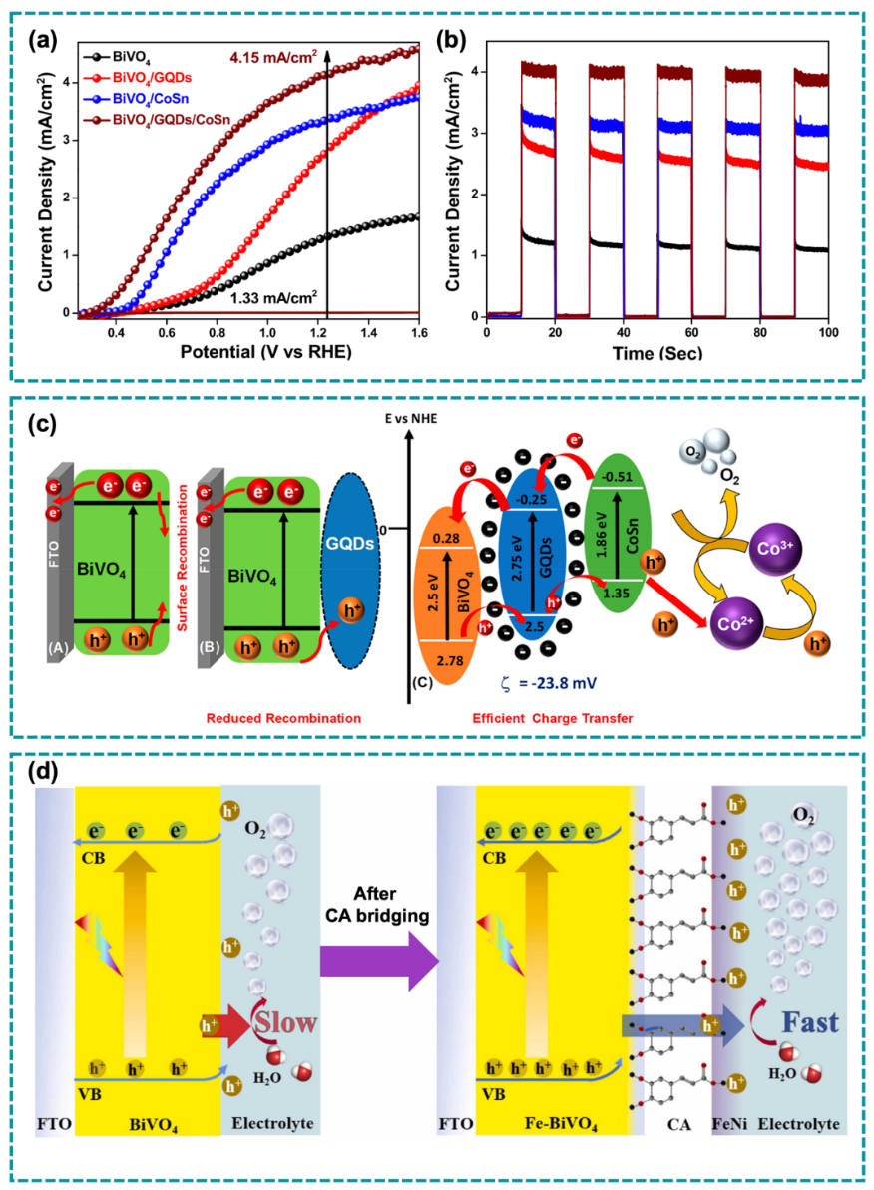
Fig. 8. (a) Current density−potential and (b) Chronoamperometry for BiVO₄ (black), BiVO₄/GQDs (red), BiVO₄/CoSn-LDH (blue), and BiVO₄/GQDs/CoSn-LDH (wine) photoanodes, respectively. (c) Schematic representation of the mechanism for enhanced PEC water splitting driven by BiVO₄/GQDs/CoSn-LDH. Adapted with permission from ref [124]. Copyright 2021, American Chemical Society. (d) Rapid charge transfer illustration in the water oxidation process of NiFe/CA/Fe-BiVO₄ photoelectrode. Adapted with permission from ref [125]. Copyright 2024, Elsevier.
In addition to GQDs, small organic acids can serve as bridging agents between BiVO₄ and metal-based co-catalysts. Li et al. investigated the use of caffeic acid (CA) as a bridging agent to connect Fe-BiVO₄ with the NiFe co-catalyst [125]. The carboxyl groups on caffeic acid coordinate directly with Ni and Fe atoms, and this coordination guides the NiFeOOH layer to form more evenly across the Fe-BiVO4 surface during the impregnation step, rather than growing as scattered clusters. With this bridges structure, the resulting NiFe/CA/Fe-BVO photoanode reached a photocurrent density of 6.2 mA.cm⁻²at 1.23 V vs RHE, and the photocurrent stayed close to its initial value even after a 12 hours test at 0.8 V vs RHE.
The directionality of charge transfer through this bridge was confirmed computationally. Bader charge analysis in the study showed that without the CA bridge, the NiFe layer donates about 0.13 electron to the underlying Fe-BiVO₄. Once CA is inserted as the linking layer, that transferred charge nearly doubles to about 0.25 electron. The proposed pathway, shown in the Fig. 8d, describes holes moving quickly from Fe-BiVO₄ to the NiFe surface for the oxidation reaction, while electrons are pulled away through the external circuit. By integrating the CA bridging layer, the Fe-BiVO₄ surface is effectively stabilized, helping regulate electron movement and strengthening the connection between Fe-BiVO₄ and the NiFe co-catalyst.
Another example of the use of a small bridging organic molecule is 1,3,5-benzenetricarboxylic acid (BTC), as investigated by Lin et al. [126]. Its three carboxyl groups bind directly to Bi atoms, as evidenced by XPS peak shifts and DFT charge density calculations that reveal electron transfer from BiVO₄ toward BTC. The photocurrent density generated at 1.23 V vs. RHE was 2.49 mA.cm⁻², approximately 1.67 times higher than pristine BiVO₄ (1.5 mA.cm⁻²), and when Co²⁺ were introduced, BTC also acted as a chelating anchor for cobalt, further boosting the photocurrent to 4.82 mA.cm⁻². This improvement was attributed to the BTC molecules aiding in the uniform distribution of Co²⁺ ions, serving as a bridge between BiVO₄ and Co ions, thereby optimizing charge transfer efficiency.
To provide a comprehensive comparison of the performance and functions of bridge engineering systems in BiVO₄-based PEC applications, Table 1 summarizes a variety of bridge materials categorized by their system type. The table includes key information such as the type of bridge used, its main function, photocurrent density or photocatalytic performance, and the corresponding reference. This overview allows for a clearer understanding of how different bridge designs influence PEC efficiency and can guide the selection of suitable bridge components for future applications.

Table 1. Key characteristics of various bridge types used in recent structural evaluations.
Bridge role | Material | Bridge function | Photocurrent density, charge separation efficiency ($ƞ$_{sep}), and surface transfer efficiency ($ƞ$_{trans}) | Measurement condition | Stability | Ref.
Under-layer | SnO₂ | Improving electron extraction at the interface between BiVO₄ and the electrode through reductions in defect states (i.e. the dead-layer effect) | 3.76 mA/cm² at 1.23 V vs RHE  $ƞ$_{sep} = n/a  $ƞ$_{trans} = n/a | Electrolyte: Na₂SO₄ (0.5 M, pH $\sim$ 7) and Na₂SO₃ (0.5 M, pH $\sim$ 7).  I = 100 mW cm⁻² from 300 W Xe arc lamp with an AM 1.5 G filter. | n/a | [103]
Under-layer | Fe₂O₃ | Improving charge separation efficiency and matching the electronic energy levels | 0.95 mA/cm² at 0.6 V vs RHE  $ƞ$_{sep} = 100% at 1.3 V vs RHE (2 times higher than that bare BiVO₄)  $ƞ$_{trans} = $\sim$ 38% at 1.3 eV vs RHE (decreased 1.6-fold from the bare BiVO₄) | Electrolyte: H₃BO₃ (0.5 M, pH $\sim$ 9.5)  I = 100 mW cm⁻² from 100 W Xe arc lamp with an AM 1.5 G filter. | n/a | [106]
Under-layer | PdO | Acting as an efficient gate interlayer to boost the electron transfer within the system | 4.90 mA/cm² at 1.23 V vs. RHE  $ƞ$_{sep} = n/a  $ƞ$_{trans} = n/a | Electrolyte: KBi (1 M, pH $\sim$ 9.5)  I = 100 mW cm⁻² from AAA class solar simulator with an AM 1.5 G filter. | Exhibited a long-term photo-durability over 80 hours with a photocurrent of $\sim$ 2.5 mA/cm²at 0.6 V vs RHE without the addition of co-catalyst | [100]
Multi-component layer | Phosphate anion | Molecular linkages | 1.74 mA/cm² at 1.41 V vs RHE  $ƞ$_{sep} = n/a  $ƞ$_{trans} = n/a | Electrolyte: NaOH (1 M, pH $\sim$ 13.6)  I = 500 W Xe lamp with CM110 monochromator. | n/a | [116]
 | rGO | Electron transport medium | 1.52 mA cm⁻² at 1.23 V vs. RHE  $ƞ$_{sep} = n/a  $ƞ$_{trans} = n/a | Electrolyte: Na₂SO₄ (0.5 M, pH $\sim$ 7)  I = 100 mW cm⁻² from 300 W Xe arc lamp with an AM 1.5 G filter. | n/a | [117]
 | C₃N₄ | electronic bridge | 5.89 mA cm⁻² at 1.23 V vs. RHE  $ƞ$_{sep} = 92% at 1.2 V vs RHE (~3 times higher than that bare BiVO₄)  $ƞ$_{trans} = n/a | Electrolyte: KBi (0.5 M, pH $\sim$ 9.3) and Na₂SO₃ (0.5 M, pH $\sim$ 7).  I = 100 mW cm⁻² from 300 W Xe arc lamp with an AM 1.5 G filter. | The photoanode retained a photocurrent of ~6 mA/cm² at 1.23 V vs RHE over a 10-hour test | [118].
 | GQDs | Accelerates hole transport for enhanced water oxidation | 4.15 mA cm⁻² at 1.23 V vs. RHE  $ƞ$_{sep} = 66% at 1.23 V vs RHE (~2 times higher than that bare BiVO₄)  $ƞ$_{trans} = n/a | Electrolyte: KBi (0.5 M, pH $\sim$ 11) and Na₂SO₃ (0.5 M, in 0.5 M KBi solution).  I = 100 mW cm⁻² from 300 W Tungsten halogen lamp. | The sample kept about 90% of its initial photocurrent after 4 hours of continuous operation | [124]
 | CA | Bridging agent connecting Fe-BVO₄ and NiFe | 6.2 mA cm⁻² at 1.23 V vs. RHE  $ƞ$_{sep} = Slightly higher than BiVO₄ bare  $ƞ$_{trans} = 81% at 1.23 V vs RHE (~4 times higher than BiVO₄ bare) | Electrolyte: KBi (0.5 M, pH $\sim$ 9.5) and Na₂SO₃ (0.2 M)  I = 100 mW cm⁻² from 300 W Xe lamp with an AM 1.5 G filter. | Show photostable activity for 12 hours when tested at 0.8 V vs RHE | [125]
 | FeVO₄ | Reduces space/potential barriers, improves charge transport efficiency | 5.59 mA cm⁻² at 1.23 V vs. RHE  $ƞ$_{sep} = 93% at 1.23 V vs RHE  $ƞ$_{trans} = 63.3% at 1.23 V vs RHE (~2 times higher than BiVO₄ bare) | Electrolyte: Borate buffer (0.5 M, pH $\sim$ 9.5) and Na₂SO₃ (0.2 M)  I = 100 mW cm⁻² from Xe lamp with an AM 1.5 G filter. | A stable photocurrent density of 4.2 mA/cm² was maintained at 0.75 V vs RHE throughout a 14-hour test. | [1]
 | Urea | Surface-protected etching for stability improvement | 4.8 mA cm⁻² at 1.23 V vs. RHE  $ƞ$_{sep} = n/a  $ƞ$_{trans} = n/a | Electrolyte: KBi (1 M, pH $\sim$ 9.5)  I = 100 mW cm⁻² from Xe lamp with an AM 1.5 G filter | The optimized electrode showed impressive stability over 40 h at 0.8 V vs RHE | [127]
 | BTC | Molecular bridge optimizing Co²⁺ passivation and catalyst loading | 4.82 mA cm⁻² at 1.23 V vs. RHE  $ƞ$_{sep} = 90% at 1.23 V vs RHE  $ƞ$_{trans} = Reach around 1.3 times that BiVO₄ bare at 1.23 V vs RHE | Electrolyte: KBi (1 M, pH $\sim$ 9.7)  I = 100 mW cm⁻² from 300 W Xe lamp with an AM 1.5 G filter. | n/a | [126]
 | Al₂O₃ | Carrier shuttle bridge between OEC and BiVO₄ | 5.87 mA cm⁻² at 1.23 V vs. RHE  $ƞ$_{sep} = 85.2% at 1.23 V vs RHE (increased 1.4-fold compared to BiVO₄ bare)  $ƞ$_{trans} = Reaches nearly 90% efficiency, representing an improvement of more than twofold relative to BiVO₄ | Electrolyte: Borate buffer (0.5 M, pH $\sim$ 9.5)  I = 100 mW cm⁻² from Xe lamp with an AM 1.5 G filter. | n/a | [128]

Fabrication strategies
The chosen fabrication strategy of a given bridge material plays a critical role in maintaining a high-quality interfacial contact within BiVO₄ photoanodes. An inadequately bonded heterostructure interface would result in the detachment of the overlayer from the photoabsorber and impede effective charge carrier transfer, thereby diminishing the performance and photostability of the photoanode. To this purpose, many strategies have emerged that enhance the cohesiveness of the bridge material in BiVO₄-based PEC systems through the design of an appropriate fabrication procedure. The selection of fabrication process is significantly influenced by the intended shape of the photoanode, as several procedures can provide unique nanostructural characteristics that promote water oxidation performance. Henceforth, the following section will elaborate on the merits and demerits of synthesis techniques for the fabrication of bridge engineering in the BiVO₄ PEC system. The method is classified into dry process and wet chemical process.
5.1 Dry processes
Dry synthetic processes facilitate the production of various materials, including single metal elements, metal oxides, metal carbides, and metal nitrides without the use of solvents. Ma et al. presented a unique solid-state synthesis of BiVO₄ in 2019 by merely combining bismuth and vanadium salts, followed by direct annealing of the combination at 450°C without any additional media [129]. The dry synthesis routes, by the definition itself, do not require any single chemicals as a solvent; thus, they are recognized as a safer method in materials fabrication. However, dry fabrication methods are often more costly, as they need advanced equipment as compared to wet chemical methods [130]. This process typically entails the vapour-phase deposition of materials and includes several production techniques such as chemical vapour deposition (CVD), atomic layer deposition (ALD), magnetron sputtering, and physical vapour deposition (PVD).
5.1.1 Chemical vapour deposition (CVD)
Chemical vapour deposition (CVD) is regarded as a "bottom-up" method, wherein materials are synthesized atom-by-atom or molecule-by-molecule from the vapour phase, facilitating meticulous control over thickness, content, and homogeneity. As depicted in Fig. 9a, essential steps in CVD encompass the supply of raw material gases, transportation of gases to the substrate surface, diffusion and chemical reactions at the surface, nucleation and film growth, and the elimination of gaseous reaction byproducts. The temperature, pressure, gas composition, and flow rates are calibrated to regulate film quality and growth rate. Various CVD versions exist, including thermal CVD, which utilizes heat to facilitate reactions, and plasma-enhanced CVD, where plasma aids chemical reactions, allowing for depositions at reduced temperatures [131].
It is widely known that CVD is a scalable, controlled, and economical method extensively employed to produce high-quality crystalline thin films, such as BiVO₄, which serves as a potential photoanode material for water splitting in PEC devices. CVD enables meticulous regulation of layer stoichiometry, shape, and crystallinity by adjusting factors like temperature, pressure, and gas flow rate throughout the deposition process (see Fig. 9b) [63]. This yields stoichiometric monoclinic BiVO₄ thin films devoid of secondary phases, ensuring enhanced crystallinity and homogeneity crucial for effective PEC activity. The application of the CVD method in the preparation of BiVO₄ photoelectrochemical systems is crucial for improving their performance, stability, and mechanical strength, which are essential for practical uses in PEC systems like bridge engineering.
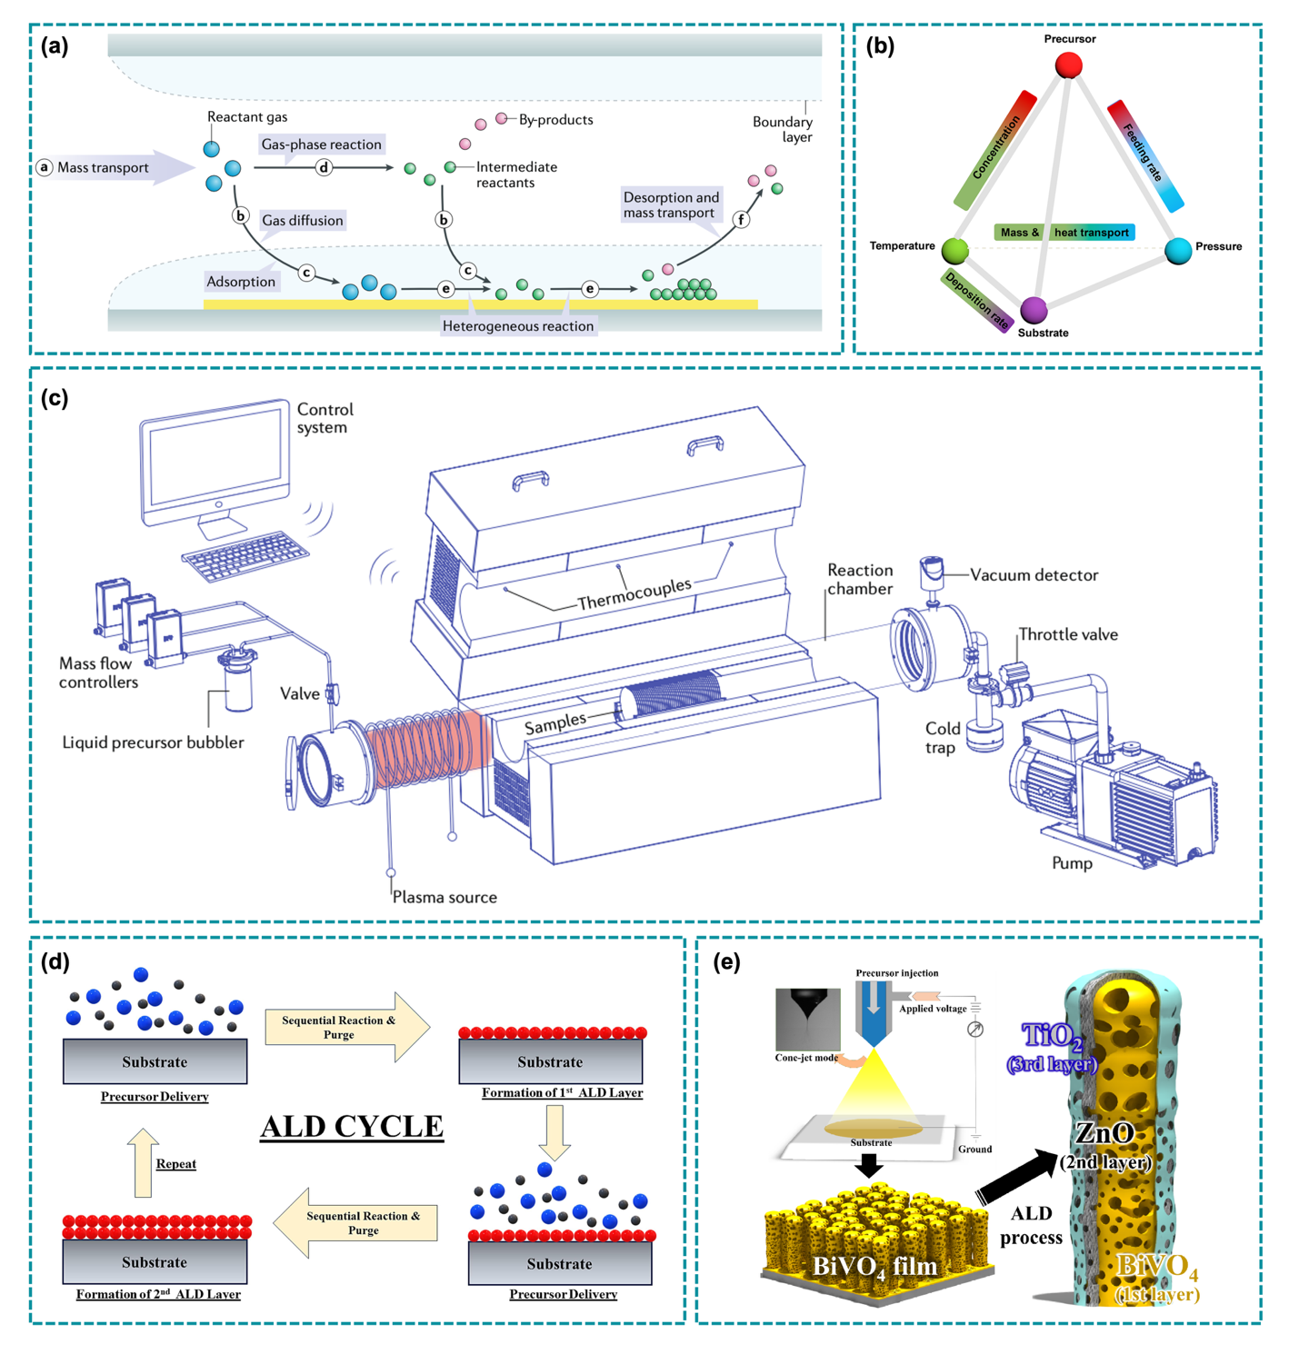
Fig. 9. (a) Schematic of the CVD process. Adapted with permission from ref [131]. Copyright 2021, Springer Nature. (b) Parameters affecting the thermodynamics and kinetics in the CVD growth of 2D materials. Adapted with permission from ref [63]. Copyright 2018, American Chemical Society. (c) Components in a low-pressure CVD system. Adapted with permission from ref [131]. Copyright 2021, Springer Nature. (d) General steps in an ALD cycle. Adapted with permission from ref [132]. Copyright 2024, Elsevier. (e) Schematic illustration of the ZnO/ TiO2 layers formation over the nanopillars by the ALD technique. Adapted with permission from ref [133]. Copyright 2018, Elsevier.
Recent work by Creasey et al. showed that aerosol-assisted CVD is capable of producing a nanostructured WO₃/BiVO₄/NiFeOOH heterojunction system, suppressing BiVO₄ dissolution at the electrode/electrolyte interface and enhancing water oxidation performance to 1.75 mA cm⁻² photocurrent density at 1 simulated sun irradiance (1.23 V vs RHE) within 24 hours of testing in a continuous PEC flow reactor operated at 0.5 cm s⁻¹ [134]. CVD facilitates robust attachment of photoelectrode layers to substrates like fluorine-doped tin oxide (FTO), enhancing mechanical durability and enabling the electrodes to endure flow-induced shear stress in PEC reactors operated under continuous flow. This stability is essential for practical applications where an electrolyte will be flowed through the cell to carry the produced hydrogen gas, necessitating robust photoelectrodes.
The implementation of CVD in the real world of industry is often hampered by the complexity of equipment, leading to a high cost in overall operation. CVD systems comprise specialized vacuum chambers, gas distribution systems, and heating gear (see the details in Fig. 9c), rendering their setup and maintenance costly. These elevated expenses can be restrictive for small-scale or budget-constrained applications. Likewise, the thin films generated by the CVD process may experience residual stress owing to elevated operating temperatures, resulting in cracking, peeling, or warping, particularly as thickness increases. Moreover, growing flaws might restrict material quality, adversely affecting performance in critical applications.
5.1.2 Atomic layer deposition (ALD)
The core principle of atomic layer deposition (ALD) in material manufacturing relies on consecutive, self-limiting surface chemical processes that facilitate the precise deposition of thin films one atomic layer at a time. In contrast to conventional CVD, atomic layer deposition divides the reaction into two discrete half-reactions by alternately exposing the substrate surface to various precursor gases [38,132]. Each precursor interacts with the substrate surface to saturate all accessible reactive sites, resulting in the formation of a monolayer of atoms or molecules. Following a precursor pulse and surface response, surplus precursor and by-products are eliminated prior to the introduction of the second precursor, which then interacts with the adsorbed species to create a homogenous thin film layer. The cycle of precursor exposure and purging is reiterated until the target film thickness is attained (see Fig. 9d). Due to the self-limiting nature of surface reactions, film formation is meticulously regulated, allowing for atomic-scale precision in layer thickness. This control produces conformal, pinhole-free coatings that uniformly envelop complicated, high-aspect-ratio structures, irrespective of shape or topology [135]. The layer thickness increases linearly with the number of ALD cycles, enabling precise adjustment at the sub-nanometer scale.
A significant application of ALD is the deposition of metal oxide overlayers, such as TiO₂, which fulfill various roles. Kim et al. reported the deposition of thin TiO₂ and ZnO layers on the BiVO₄ nanopillars grown on ITO substrate through the ALD method (see Fig. 9e) [133]. The ALD-derived TiO₂ and ZnO layers function as a protective passivation coating that reduces photocorrosion in BiVO₄ while adjusting surface electronic states to improve charge transfer. These overlayers reduce surface recombination by neutralizing trap states, which may improve the lifespan of charge carriers only if there are more trap states formed. In the study by Kim et al., the photocurrent density of the ZnO/TiO₂-coated BiVO₄ was 2.5 times higher than that of pristine BiVO₄. The regulated thickness, typically tuned at approximately 50 nm, guaranteed the preservation of maximum light absorption by BiVO₄ while enhancing the injection efficiency of holes into the electrolyte. This bridge engineered heterojunction system efficiently establishes an interface that enhances charge transfer from the BiVO₄ absorber to the electrolyte, considerably increasing photocurrent density [136].
ALD techniques have also been utilized to construct BiVO₄ heterojunctions and composite layers with other semiconductors, including SnO₂, WO₃, and metal cocatalysts [38,137]. Nanoporous SnO₂, produced through anodic oxidation and covered with BiVO₄, demonstrated significant enhancements in visible-light photoresponse, charge separation efficiency, and photoelectrochemical stability during prolonged operation [138]. ALD's meticulous regulation of morphology and thickness facilitates the adjustment of crystallinity and stoichiometry of BiVO₄, thereby enhancing PEC performance.
Besides improving charge separation and stability, ALD can create surface catalytic sites by depositing metal or metal sulfide clusters onto the BiVO₄ photoanode surface [139]. Clusters formed using ALD have been demonstrated to reduce the activation energy barrier for OER; hence, they can enhance reaction kinetics [140]. While ALD offers new opportunities due to the monolayer-by-monolayer deposition approach at low temperatures, this fabrication method still faces several limitations that affect its feasibility and broader commercial adoption [135]. A major constraint is the sluggish deposition rate. ALD procedures require the substrate to be sequentially exposed to various precursors, with alternating purge phases, resulting in significant time consumption [141]. This results in comparatively low throughput when compared to other thin-film deposition techniques, such as chemical vapour deposition (CVD) or physical vapour deposition (PVD) [135,141]. Growth rates typically range from several angstroms to fractions of a nanometer every cycle, rendering thick film manufacture laborious and impractical for large-scale manufacturing. Another significant limitation is the limited range of precursors and materials suitable for ALD. They must exhibit volatility at the deposition temperature, maintain chemical stability while being reactive with the surface, and produce benign by-products to facilitate clean and efficient layer growth.
5.2 Wet chemical method
5.2.1. Hydrothermal
The hydrothermal method is a synthesis technique that replicates natural mineralization processes, enabling crystal growth from aqueous solutions within a sealed system under controlled temperature and pressure. Under these conditions, water undergoes significant changes in its physical and chemical properties, such as vapour pressure, density, surface tension and viscosity, which all play crucial roles in influencing reaction dynamics and crystal formation [142]. This technique offers several advantages, such as facile, cost-effective, and controllable synthetic process. Additionally, it allows for shorter reaction durations and provides precise control over crystallization processes, particle size, product purity, and morphological characteristics [130].
Several studies have demonstrated that hydrothermal synthesis parameters, particularly pH, temperature, and reaction duration, play a critical role in determining the crystal structure, morphology, and photoelectrochemical performance of BiVO₄. Chen et al. showed that adjusting the pH to neutral (around pH 7) and maintaining a temperature of 195°C for 6 hours facilitated the formation of a monoclinic BiVO₄ phase with enhanced photocatalytic activity [143]. Lin et al. confirmed that while all samples synthesized across a wide pH range exhibited pure monoclinic phases, the intensity ratios of specific XRD peaks varied with pH, indicating changes in preferred crystal orientation [144]. Complementing these findings, Tian et al. revealed that both pH and reaction time influence the formation of mixed-phase m-BiVO₄/t-BiVO₄ heterostructures [145]. As reaction time increased, the monoclinic phase became more dominant, indicated by the rising intensity of the (121) XRD peak. Meanwhile, pH adjustments from 0.5 to 10 revealed a gradual phase transition from tetragonal to monoclinic BiVO₄, driven by NH₃·H₂O through a dissolution-recrystallization mechanism. The optimal photoelectrochemical performance was achieved at pH 7 with a 24-hour reaction time, yielding a stable monoclinic structure and a photocurrent density of 500 µA/cm².
Hydrothermal synthesis is not only effective for producing high-quality BiVO₄ crystals, but also widely applied in the fabrication of bridge-engineered BiVO₄ systems. This method enables the simultaneous or sequential integration of bridge materials into the BiVO₄ matrix under controlled temperature and pressure conditions. The aqueous environment and tunable reaction parameters enable intimate interfacial contact and tailored morphology, which are crucial for enhancing charge separation and improving photoelectrochemical performance.
One notable example of hydrothermal-assisted bridge engineering is the fabrication of a Bi-loaded BiVO₄ system, where partial reduction of BiVO₄ under controlled conditions leads to the in-situ formation of metallic Bi nanoparticles [146]. This hydrothermally prepared BiVO₄ was then subjected to reductive calcination, partially reducing Bi³⁺ species to metallic Bi nanoparticles directly on the BiVO₄ surface. Crucially, this transformation enabled the formation of Bi–O–V covalent bridges at the interface, which act as efficient electron transfer channels. The hydrothermal method contributes indirectly but critically to this bridge formation by producing a BiVO₄ matrix with exposed oxygen atoms and structurally compatible vanadium sites, allowing strong orbital overlap and chemical bonding with the reduced Bi species.
Another example of hydrothermal-assisted bridge engineering is the fabrication of graphite-bridged TiO₂–C–BiVO₄ film, where graphite acts as an electron-conducting bridge in an indirect Z-scheme heterojunction [147]. In this system, graphite is generated in situ from glucose through hydrothermal carbonization, enabling tight interfacial contact between TiO₂ and BiVO₄. The hydrothermal conditions not only facilitate the crystallization of BiVO₄ but also promote the formation of graphitic carbon with high conductivity and surface functionality. This integration significantly enhances charge carrier separation and prolongs electron lifetimes. The hydrothermal process also allows precise control over the morphology and porosity of the composite film, resulting in a high surface area and improved light absorption. The graphite bridge effectively mediates electron transfer from TiO₂ to BiVO₄, enabling the formation of reactive oxygen species such as ·O₂⁻ and ·OH, which are crucial for photoelectrocatalytic degradation.
5.2.2. Electrodeposition
Among the various methods for fabricating bridge layers at BiVO₄ interfaces, electrodeposition holds a distinctive role as it enables us to directly construct the bridge on an existing photoanode surface under electrochemical regulation, at or close to ambient temperature, instead of depending on gas-phase or elevated-temperature techniques [62]. This is crucial for BiVO₄ as the material's photoelectrochemical efficacy is inherently limited by inadequate charge carrier mobility and slow surface oxygen evolution kinetics, which explains the prevalence of solution-based, low-temperature bridge/cocatalyst deposition in the interface-engineering literature instead of more intense thermal processes. Research integrating in-situ electrochemical doping with electrodeposited bridging and cocatalyst layers clearly indicates that the gentle, near-room-temperature process of electrodeposition maintains the reduced crystal dimensions and enhanced surface areas obtained during BiVO₄ synthesis, reinforcing the notion that this method facilitates bridge formation as a final step without negating prior advancements in photoanode structure [148].
The fundamental mechanistic advantage of electrodeposition in bridge engineering is in the preferred flow of deposition current through established conductive or photoactive routes, resulting in the bridge material predominantly nucleating near sites of ongoing charge transfer. This is illustrated in triadic photoanode structures (see Fig. 10a) where reduced graphene oxide is initially applied to BiVO₄ as an electron mediator, followed by the deposition of a NiFe-layered double hydroxide onto the BiVO₄/rGO heterojunction through two successive electrodeposition processes, resulting in a BiVO₄/rGO/NiFe-LDH assembly [149]. The temporal control of electrodeposition constitutes a critical, yet frequently underexamined, process parameter governing the functional performance of bridge layers, as identical chemical compositions can yield markedly divergent photoelectrochemical outcomes depending on deposition duration. This dependence was systematically demonstrated in a BiVO₄/rGO/NiFe-LDH triadic photoanode architecture, in which rGO was first deposited as an interfacial electron-shuttling mediator, followed by electrodeposition of NiFe-LDH under systematically varied deposition times. Optimization of the deposition time was found to be essential for achieving the highest photocurrent density, with both insufficient and excessive NiFe-LDH loading resulting in diminished performance relative to the optimized condition (see Fig. 10b). This temporal sensitivity is inherently coupled to the applied deposition potential, given that BiVO₄ has been reported to undergo irreversible deactivation at potentials more negative than −0.1 V vs. RHE, whereas conventional LDH electrodeposition typically requires a more negative potential to proceed at an appreciable rate. The incorporation of a pre-deposited rGO interlayer was shown to shift the accessible deposition potential window from −0.3 V vs. RHE, required in the absence of rGO, to a considerably milder −0.1 V vs. RHE, while simultaneously yielding a photocurrent density of 3.26 mA cm⁻² at 1.23 V vs. RHE, approximately twice the 1.8 mA cm⁻² obtained for the rGO-free counterpart deposited at the same mild potential.
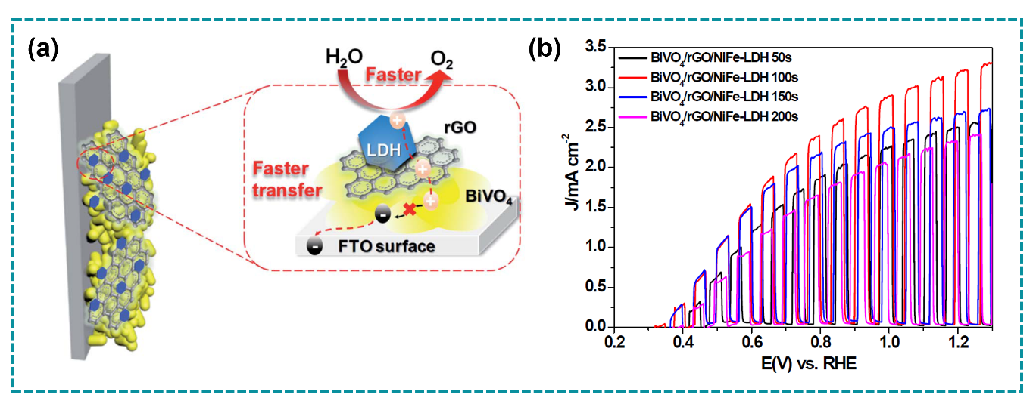
Fig. 10. (a) Schematic illustration of the triadic photoanode structure of BiVO₄/rGO/NiFe-LDH, and (b) LSV curves of BiVO₄/rGO/NiFe-LDH with various LDH deposition time. Adapted with permission from ref [149]. Copyright 2020, Royal Society of Chemistry.
In another connected system, rGO situated between Co₃O₄ and BiVO₄ has demonstrated metallic properties that extract holes from the BiVO₄ substrate, while Co₃O₄ functions independently as the catalytic site for oxygen evolution, as the rGO layer transmits holes instead of utilising them in a terminal reaction [150]. However, the regulation of thickness and conformality of high-surface-area BiVO₄ photoanodes prepared by electrodeposition remains one of the challenges, as electrodeposition generally favours growth at areas of maximum local current density instead of uniformly over a textured surface. This implies that achieving really uniform bridge coverage on intricate BiVO₄ topologies may need hybrid photo-assisted electrodeposition methods instead of relying solely on conventional potentiostatic or galvanostatic electrodeposition [151].
Notwithstanding these hesitations, electrodeposition continues to be one of the most feasible and scalable approaches for bridge engineering in BiVO₄ systems, especially in contrast to vacuum-based procedures like ALD or PLD. The significance is clearly demonstrated in systems where a photo-assisted electrodeposited bridge (bismuthene) exists between BiVO₄ and a more active external catalyst (NiFeOOH) facilitating a more uniform self-assembled distribution of the cocatalyst on the BiVO₄ surface and achieving a photocurrent density of 4.7 mA/cm² at 1.23 V vs. RHE [84]. To conduct a comprehensive comparative analysis of the aforementioned fabrication strategies, we present a summary in Table 2 detailing the advantages and disadvantages of each technique, as well as the suitability level of the synthesis method for bridge engineering within the interfacial BiVO₄ PEC system.

Table 2. Advantages and disadvantages of numerous fabrication strategies and their uses for the bridge engineering within the interfacial engineering system of BiVO₄ photoanode.
Fabrication methods | Advantages | Disadvantages | BiVO₄ / conductive substrate interface | BiVO₄ / other active material interface
CVD | - Fast, simple, affordable, and scalable  - Capable of depositing secondary layer onto complex and irregular surfaces of photoelectrode | - Requires high temperature  - Requires careful control to prevent BiVO₄’s photo-corrosion | Moderate  Good adhesion to conductive substrates, but high temperature may induce interdiffusion or BiVO₄ phase instability | Low-Moderate  Sharp interfaces possible, but difficult to engineer ultrathin “bridge” layers without damaging junction energetics
ALD | - Precise thickness control at nanoscale range  - Capable of deposition onto nanostructured substrate/  photoelectrode | - Limited to precursors that have a good stability in harsh conditions  - Expensive process  - Excessive ALD cycles may reduce PEC performance | Excellent  Ideal for ultrathin conductive or passivation bridges that reduce contact resistance and suppress recombination | Excellent  Enables controlled tunnel layers or band-alignment bridges between BiVO₄ and secondary semiconductors
Hydrothermal/  solvothermal | - Environmentally friendly  - Better contact quality between the secondary layer and the main photoabsorber  - Cost-effective and widely used  - Promotes high crystallinity and controlled morphology | - Less scalable for large-area photoelectrodes  - Crystal growth times can be longer  - Requires careful tuning synthesis parameters (e.g. pH and temperature) | Moderate  Direct growth improves adhesion, but interfacial disorder can increase recombination | Moderate-Good  Suitable for forming heterojunctions, but difficult to precisely engineer nanoscale bridges
Electrodeposition | - Allows tuning of grain size, porosity, and optical properties through deposition parameters  - Low temperature process  - Does not require post-annealing process  - Offers excellent control over film morphologies and crystallinity | - Slower process relative to others  - Requires conductive substrates like FTO  - Photoabsorber layer must be chemically and electrochemically stable in the electrolyte | Excellent  Direct electrical contact enables efficient charge-transfer bridges and reduced interfacial resistance | Good  Effective for depositing redox-mediating or conductive bridges between BiVO₄ and secondary phases

Summary and future outlook
The imminent necessity for a clean energy transition underscores the critical role of green hydrogen production in addressing global warming. Nonetheless, the scaling up of the solar-driven water splitting system presents significant hurdles due to the inadequate performance and stability of the photoelectrodes. Despite extensive study over decades into the development of the PEC water splitting system, the performance of metal oxide-based photoanodes remains inadequate in delivering the desired 10% STH conversion efficiency and a device lifespan above 10 years required for commercial applications. Consequently, new synthetic strategies are being explored to enhance performance of the metal-oxide-based photoelectrodes, to meet these performance metrics.
In recent years, the advancement of BiVO₄ as a viable photoanode has created a promising pathway for the practical implementation of BiVO₄-based PEC devices for generating green hydrogen through PEC water splitting mechanism. As solar energy conversion moves toward practical deployment, incremental material improvements will no longer suffice. Expanding bridge engineering into a universal framework offers a powerful route to systematically control interfacial processes, bridging the gap between materials chemistry and device engineering. When applied at the BiVO₄/electrode interface, bridging layers primarily function to reduce contact resistance and inhibit back-electron recombination by facilitating electron extraction. Research indicates that conductive oxides, ultrathin passivation layers, and redox-active interlayers can enhance electrical coupling while preserving the photovoltage of BiVO₄. When bridge materials are placed between BiVO₄ heterojunctions, this can regulate band alignment to improve the spatial segregation of charge carriers. This mitigates interface-induced recombination; a prevalent issue in conventional heterojunction devices. These bridge types are most effective when their electrical configuration and thickness are engineered to facilitate unidirectional charge transport rather than mere physical contact.
The efficacy of bridge engineering is intricately connected to the methods employed in the fabrication of these interlayers. Based on our comprehensive review, atomic layer deposition (ALD) and electrodeposition are two approaches that have proven highly effective because to their precision and compatibility at the interface. ALD enables the regulation of thickness and conformality to the angstrom scale, rendering it ideal for the fabrication of ultrathin tunnel layers or electronic bridges at solid–solid interfaces. Electrodeposition is the optimal method for fabricating redox-active and catalytic bridges under mild circumstances, particularly at electrochemically active interfaces. Hydrothermal methods effectively integrate various shapes. Nevertheless, they lack precision at the nanoscale. CVD exhibits excellent crystallinity; however, it is often constrained by thermal incompatibility with BiVO₄ and the difficulty in modifying it for the construction of extremely thin bridges. These data highlight that bridge performance is influenced not just by material selection but also by the coherence of the synthesis interface.
Significant challenges and opportunities are on the horizon. Future research should advance beyond optimizing single interfaces to developing full multi-interface bridge engineered systems, where electron extraction, charge separation, and surface catalysis are simultaneously optimized within an integrated interfacial framework. Secondly, greater emphasis should be placed on bridge design influenced by electrical structure, which integrates theoretical modelling with operando characterization to meticulously adjust band alignment, defect states, and interfacial dipoles in a coherent manner. Third, scalable and energy-efficient methods should be developed to fabricate PEC devices to enable their future commercial deployment. To date, the electrode sizes reported for bridge-engineered BiVO₄ systems remain limited to the lab scale, typically ranging between 1 and 6 cm² [135]. No study has yet explicitly examined how the performance of the photoanode changes as electrode size is scaled beyond this range. Future research should therefore explore this scale-up behaviour alongside cost evaluations to assess the strategy's practical applicability more comprehensively. Ultimately, long-term stability in practical working conditions must be examined systematically, as interfacial degradation remains a significant issue for BiVO₄-based systems. In summary, bridge engineering represents a significant transformation in the design of BiVO₄ photoanodes, shifting from passive interface modification to active interfacial orchestration. By adeptly integrating material chemistry with precise synthesis and interface-specific functionality, bridging materials aim to fully exploit the promise of BiVO₄ for efficient and durable solar-driven energy conversion and environmental remediation.

CRediT authorship contribution statement
Uji Pratomo: original draft, conceptualization, investigation, funding acquisition. Dea Hasna Tsary: writing – original draft, visualization. Nova Rachmadona: review & editing. Irwan Kurnia: review & editing. Atiek Rostika Noviyanti: review & editing. Rifky Adhia Pratama: writing – original draft, visualization. Indah Primadona: supervision, review & editing. Jacob Yan Mulyana: review & editing. . Andreas Kafizas: supervision, review & editing.

Declaration of competing interest
The authors declare that they have no known competing financial interests or personal relationships that could have appeared to influence the work reported in this paper.

Data availability
No data was used for the research described in the article.

Acknowledgments
Authors are grateful for a grant provided by Universitas Padjadjaran through the Indonesian Endowment Fund for Education (LPDP) on behalf of the Indonesian Ministry of Higher Education, Science and Technology and managed under the EQUITY-WCU Grant Program (Contract No.4303/83/ DT.03.08/ 2025 and 3927/ UN6.RKT/HK.07.00/2025) for Article Review Scheme (No.3996/UN6.3.1/PT.00/2025)
References
[1] Y. Wang, J. Huang, Y. Chen, H. Yang, K.H. Ye, Y. Huang, Modulating built-in electric field via Bi-VO4-Fe interfacial bridges to enhance charge separation for efficient photoelectrochemical water splitting, J. Colloid Interface Sci. 672 (2024) 12–20. https://doi.org/10.1016/j.jcis.2024.05.218.
[2] U. Pratomo, R.A. Pratama, I. Irkham, A.P. Sulaeman, J.Y. Mulyana, I. Primadona, 3D-ZnO Superstructure Decorated with Carbon-Based Material for Efficient Photoelectrochemical Water-Splitting under Visible-Light Irradiation, Nanomaterials 13 (2023) 1380.
[3] A.S. Giasari, R.A. Pratama, D.R. Eddy, Irkham, M.D. Adzani, N. Fransisca, U. Pratomo, N.S. Gultom, Indriyati, I. Primadona, Role of Sulfur in Enhancing UV-Light Absorption and Photoelectrochemical Performance of ZnO/N,S-doped CQDs Nanocomposite, ChemistrySelect 9 (2024) e202404072. https://doi.org/https://doi.org/10.1002/slct.202404072.
[4] R. Tatti, M. Petrollese, M. Lucariello, F. Serra, G. Cau, Hydrogen storage integrated in off-grid power systems: a case study, Int. J. Hydrogen Energy 79 (2024) 164–176. https://doi.org/https://doi.org/10.1016/j.ijhydene.2024.06.308.
[5] Y.S. Gupta, A.S. Gupta, R. Sivanraju, K.R. Padmavathi, A. Kumar R., P. Prabakar, Hydrogen Fuel Cell Technologies for Decarbonization: Opportunities, Challenges, and Strategic Pathways—A Comprehensive Review, Energy Sci. Eng. 14 (2026) 1584–1600. https://doi.org/https://doi.org/10.1002/ese3.70411.
[6] K. Gomonov, C.T. Permana, C.T. Handoko, The growing demand for hydrogen: сurrent trends, sectoral analysis, and future projections, Unconventional Resources 6 (2025) 100176. https://doi.org/https://doi.org/10.1016/j.uncres.2025.100176.
[7] S. Ahmad, M. Egilmez, W. Abuzaid, F. Mustafa, A.M. Kannan, A.S. Alnaser, Efficient medium entropy alloy thin films as bifunctional electrodes for electrocatalytic water splitting, Int. J. Hydrogen Energy 52 (2024) 1428–1439. https://doi.org/10.1016/J.IJHYDENE.2023.07.177.
[8] R. Roy, G. Antonini, K.S. Hayibo, M.M. Rahman, S. Khan, W. Tian, M.S.H. Boutilier, W. Zhang, Y. Zheng, A. Bassi, J.M. Pearce, Comparative techno-environmental analysis of grey, blue, green/yellow and pale-blue hydrogen production, Int. J. Hydrogen Energy 116 (2025) 200–210. https://doi.org/https://doi.org/10.1016/j.ijhydene.2025.03.104.
[9] A. Franco, C. Giovannini, Recent and Future Advances in Water Electrolysis for Green Hydrogen Generation: Critical Analysis and Perspectives, Sustainability (Switzerland) 15 (2023). https://doi.org/10.3390/su152416917.
[10] M. Awad, A. Said, M.H. Saad, A. Farouk, M.M. Mahmoud, M.S. Alshammari, M.L. Alghaythi, S.H.E. Abdel Aleem, A.Y. Abdelaziz, A.I. Omar, A review of water electrolysis for green hydrogen generation considering PV/wind/hybrid/hydropower/geothermal/tidal and wave/biogas energy systems, economic analysis, and its application, Alexandria Engineering Journal 87 (2024) 213–239. https://doi.org/10.1016/j.aej.2023.12.032.
[11] L.M. Peter, Photoelectrochemistry: From Basic Principles to Photocatalysis, in: J. Schneider, D. Bahnemann, J. Ye, G. Li Puma, D.D. Dionysiou, J. Schneider, D. Bahnemann, J. Ye, G. Li Puma, D.D. Dionysiou (Eds.), Photocatalysis: Fundamentals and Perspectives, The Royal Society of Chemistry, 2016: p. 0. https://doi.org/10.1039/9781782622338-00001.
[12] N. Guijarro, M.S. Prévot, K. Sivula, Surface modification of semiconductor photoelectrodes, Phys. Chem. Chem. Phys. 17 (2015) 15655–15674. https://doi.org/10.1039/C5CP01992C.
[13] E. Kusmierek, Semiconductor electrode materials applied in photoelectrocatalytic wastewater treatment—An overview, Catalysts 10 (2020). https://doi.org/10.3390/catal10040439.
[14] S. Ahmad, N. Hussain, M. Egilmez, A. Alashkar, D. Zhang, R. Straubinger, A.H. Alami, Phase-Dependent Electrocatalytic Activity in Fe−Cu Alloys toward Efficient Alkaline Water Splitting, ACS Appl. Energy Mater. 9 (2026) 6089–6105. https://doi.org/10.1021/acsaem.6c00260.
[15] M.S.H. Khan, M.R. Islam, M.S. Islam, I.M. Mehedi, M.T. Hasan, Tunable Photocatalytic Properties of Planar GaN/GeC Hetero-Bilayer: Production of H Fuel, IEEE Access 8 (2020) 209030–209042. https://doi.org/10.1109/ACCESS.2020.3037036.
[16] K. Chaoui, A. Hamidani, K. Zanat, A novel Janus InN/PtSSe heterostructure for highly efficient overall water splitting via a third-generation Z-scheme: A first-principles study, Int. J. Hydrogen Energy 174 (2025) 151360. https://doi.org/https://doi.org/10.1016/j.ijhydene.2025.151360.
[17] U. Pratomo, R. Adhia Pratama, A. Pramudya Sulaeman, Irkham, G.T.M. Kadja, M. Khalil, I. Primadona, Enhancement of the ZnO nanotube photoelectrochemical performance by MXene layer, Mater. Lett. 337 (2023) 133932. https://doi.org/10.1016/j.matlet.2023.133932.
[18] J.-H. Jang, S. Chaule, J. Kang, Chapter 13 - Hematite (α-Fe2O3) as a solar energy harvesting photoanode for photo-electrochemical (PEC) water splitting, in: S. Kazim, M.N. Tahir, S. Ahmad, S. Mathur (Eds.), Photoelectrochemical Engineering for Solar Harvesting, Elsevier, 2024: pp. 373–404. https://doi.org/https://doi.org/10.1016/B978-0-323-95494-5.00012-4.
[19] I.R. Hamdani, A.N. Bhaskarwar, Recent progress in material selection and device designs for photoelectrochemical water-splitting, Renewable and Sustainable Energy Reviews 138 (2021) 110503. https://doi.org/https://doi.org/10.1016/j.rser.2020.110503.
[20] A.G. Tamirat, J. Rick, A.A. Dubale, W.-N. Su, B.-J. Hwang, Using hematite for photoelectrochemical water splitting: a review of current progress and challenges, Nanoscale Horiz. 1 (2016) 243–267. https://doi.org/10.1039/C5NH00098J.
[21] A.A. Mohd Raub, R. Bahru, S.N.A. Mohd Nashruddin, J. Yunas, Advances of nanostructured metal oxide as photoanode in photoelectrochemical (PEC) water splitting application, Heliyon 10 (2024) e39079. https://doi.org/https://doi.org/10.1016/j.heliyon.2024.e39079.
[22] H. Wang, T. Zhai, Y. Wu, T. Zhou, B. Zhou, C. Shang, Z. Guo, High-Valence Oxides for High Performance Oxygen Evolution Electrocatalysis, Advanced Science 10 (2023) 2301706. https://doi.org/https://doi.org/10.1002/advs.202301706.
[23] M. Kumar, B. Meena, P. Subramanyam, D. Suryakala, C. Subrahmanyam, Recent trends in photoelectrochemical water splitting: the role of cocatalysts, NPG Asia Mater. 14 (2022) 88. https://doi.org/10.1038/s41427-022-00436-x.
[24] H. Jang, Y. Kim, H. Choi, J. Yang, Y. Jung, S. Choi, D. Lee, H. Won Jang, S. Lee, Enhancing BiVO4 photoanode performance by insertion of an epitaxial BiFeO3 ferroelectric layer, Journal of Energy Chemistry 89 (2024) 71–78. https://doi.org/https://doi.org/10.1016/j.jechem.2023.10.041.
[25] R. Ullah, M. Pei, J. Wu, Y. Tian, Z. Gu, Q. Zhang, C. Song, Y. Yang, M. Ahmad, J. Zeb, F. Qayyum, Y. Liu, X. An, L. Gu, X. Wang, J. Zhang, Bifunctional Photoelectrode Driven by Charged Domain Walls in Ferroelectric Bi2WO6, ACS Appl. Energy Mater. 3 (2020) 4149–4154. https://doi.org/10.1021/acsaem.0c00503.
[26] J. Khan, G. Ali, A. Samreen, S. Ahmad, S. Ahmad, M. Egilmez, S. Amin, N. Khan, Quantum-dot sensitized hierarchical NiO p–n heterojunction for effective photocatalytic performance, RSC Adv. 12 (2022) 32459–32470. https://doi.org/10.1039/d2ra05657g.
[27] Q. Zhu, Z. Xu, B. Qiu, M. Xing, J. Zhang, Emerging Cocatalysts on g-C3N4 for Photocatalytic Hydrogen Evolution, Small 17 (2021) 2101070. https://doi.org/https://doi.org/10.1002/smll.202101070.
[28] Y. Xiao, C. Feng, J. Fu, F. Wang, C. Li, V.F. Kunzelmann, C.-M. Jiang, M. Nakabayashi, N. Shibata, I.D. Sharp, K. Domen, Y. Li, Band structure engineering and defect control of Ta3N5 for efficient photoelectrochemical water oxidation, Nat. Catal. 3 (2020) 932–940. https://doi.org/10.1038/s41929-020-00522-9.
[29] P. Zhong, J. Xie, R. Bagheri, Q. Yi, Q. Chen, J. Tan, L. He, F. Zhang, L. Zhang, G. Zou, An aqueous solution method towards Sb2S3 thin films for photoanodes, Chem. Commun. 55 (2019) 14530–14533. https://doi.org/10.1039/C9CC07005B.
[30] A.M.K. Fehr, A. Agrawal, F. Mandani, C.L. Conrad, Q. Jiang, S.Y. Park, O. Alley, B. Li, S. Sidhik, I. Metcalf, C. Botello, J.L. Young, J. Even, J.C. Blancon, T.G. Deutsch, K. Zhu, S. Albrecht, F.M. Toma, M. Wong, A.D. Mohite, Integrated halide perovskite photoelectrochemical cells with solar-driven water-splitting efficiency of 20.8%, Nat. Commun. 14 (2023) 3797. https://doi.org/10.1038/s41467-023-39290-y.
[31] A. Kudo, K. Ueda, H. Kato, I. Mikami, Photocatalytic O2 evolution under visible light irradiation on BiVO4 in aqueous AgNO3 solution, Catal. Letters 53 (1998) 229–230. https://doi.org/10.1023/A:1019034728816.
[32] K. Sayama, A. Nomura, Z. Zou, R. Abe, Y. Abe, H. Arakawa, Photoelectrochemical decomposition of water on nanocrystalline BiVO4 film electrodes under visible light, Chem. Commun. (2003) 2908–2909. https://doi.org/10.1039/B310428A.
[33] A. Walsh, Y. Yan, M.N. Huda, M.M. Al-Jassim, S.-H. Wei, Band Edge Electronic Structure of BiVO4: Elucidating the Role of the Bi s and V d Orbitals, Chemistry of Materials 21 (2009) 547–551. https://doi.org/10.1021/cm802894z.
[34] Z. Xie, D. Chen, J. Zhai, Y. Huang, H. Ji, Charge separation via synergy of homojunction and electrocatalyst in BiVO4 for photoelectrochemical water splitting, Appl. Catal. B 334 (2023). https://doi.org/10.1016/j.apcatb.2023.122865.
[35] J. Xiao, C. Li, X. Jia, B. Du, R. Li, B. Wang, Enabling high low-bias performance of Fe2O3 photoanode for photoelectrochemical water splitting, J. Colloid Interface Sci. 633 (2023) 555–565. https://doi.org/https://doi.org/10.1016/j.jcis.2022.11.134.
[36] Y. Pihosh, I. Turkevych, K. Mawatari, J. Uemura, Y. Kazoe, S. Kosar, K. Makita, T. Sugaya, T. Matsui, D. Fujita, M. Tosa, M. Kondo, T. Kitamori, Photocatalytic generation of hydrogen by core-shell WO3/BiVO4 nanorods with ultimate water splitting efficiency, Sci. Rep. 5 (2015) 11141. https://doi.org/10.1038/srep11141.
[37] J. Su, L. Guo, N. Bao, C.A. Grimes, Nanostructured WO3/BiVO4 Heterojunction Films for Efficient Photoelectrochemical Water Splitting, Nano Lett. 11 (2011) 1928–1933. https://doi.org/10.1021/nl2000743.
[38] J.H. Baek, B.J. Kim, G.S. Han, S.W. Hwang, D.R. Kim, I.S. Cho, H.S. Jung, BiVO4/WO3/SnO2 Double-Heterojunction Photoanode with Enhanced Charge Separation and Visible-Transparency for Bias-Free Solar Water-Splitting with a Perovskite Solar Cell, ACS Appl. Mater. Interfaces 9 (2017) 1479–1487. https://doi.org/10.1021/acsami.6b12782.
[39] Y. Miao, J. Liu, L. Chen, H. Sun, R. Zhang, J. Guo, M. Shao, Single-atomic-Co cocatalyst on (040) facet of BiVO4 toward efficient photoelectrochemical water splitting, Chemical Engineering Journal 427 (2022) 131011. https://doi.org/https://doi.org/10.1016/j.cej.2021.131011.
[40] C. Liu, N.P. Dasgupta, P. Yang, Semiconductor Nanowires for Artificial Photosynthesis, Chemistry of Materials 26 (2014) 415–422. https://doi.org/10.1021/cm4023198.
[41] A. Vilanova, P. Dias, T. Lopes, A. Mendes, The route for commercial photoelectrochemical water splitting: a review of large-area devices and key upscaling challenges, Chem. Soc. Rev. 53 (2024) 2388–2434. https://doi.org/10.1039/D1CS01069G.
[42] T. He, Y. Zhao, D. Benetti, B. Moss, L. Tian, S. Selim, R. Li, F. Fan, Q. Li, X. Wang, C. Li, J.R. Durrant, Facet-Engineered BiVO4 Photocatalysts for Water Oxidation: Lifetime Gain Versus Energetic Loss, J. Am. Chem. Soc. 146 (2024) 27080–27089. https://doi.org/10.1021/jacs.4c09219.
[43] P. Zhou, I.A. Navid, Y. Ma, Y. Xiao, P. Wang, Z. Ye, B. Zhou, K. Sun, Z. Mi, Solar-to-hydrogen efficiency of more than 9% in photocatalytic water splitting, Nature 613 (2023) 66–70. https://doi.org/10.1038/s41586-022-05399-1.
[44] R.A. Pratama, N.A. Zahra, A. Mahannada, M. Khalil, G.T.M. Kadja, J.Y. Mulyana, I. Primadona, U. Pratomo, Recent advancements in the formation of isotype heterojunction photocatalysts constructed by mixed-phase BiVO4 for energy and environmental applications, Catal. Today 476 (2026) 115881. https://doi.org/10.1016/J.CATTOD.2026.115881.
[45] Z.-L. He, C. Yuan, H. Gao, Z. Mou, S. Qian, C. Zhai, C. Lu, Significantly Enhanced Photoelectrocatalytic Alcohol Oxidation Performance of CdS Nanowire-Supported Pt via the “Bridge” Role of Nitrogen-Doped Graphene Quantum Dots, ACS Sustain. Chem. Eng. 8 (2020) 12331–12341. https://doi.org/10.1021/acssuschemeng.0c05097.
[46] S. Zhong, Y. Xi, Q. Chen, J. Chen, S. Bai, Bridge engineering in photocatalysis and photoelectrocatalysis, Nanoscale 12 (2020) 5764–5791. https://doi.org/10.1039/c9nr10511e.
[47] J.H. Kim, J.S. Lee, Elaborately Modified BiVO4 Photoanodes for Solar Water Splitting, Advanced Materials 31 (2019) 1–35. https://doi.org/10.1002/adma.201806938.
[48] H.L. Tan, R. Amal, Y.H. Ng, Alternative strategies in improving the photocatalytic and photoelectrochemical activities of visible light-driven BiVO4: A review, J. Mater. Chem. A Mater. 5 (2017) 16498–16521. https://doi.org/10.1039/c7ta04441k.
[49] O. Maurya, V. Khapekar, K. Pawar, S. Khaladkar, G. Kamble, H. Mohane, G. Gund, B. Sinha, J.H. Kim, R. Deshmukh, D. Dubal, A. Kalekar, Visible light sensitive bismuth vanadate for energy, environmental, and catalytic applications, Nano Res. 18 (2025) 94907364. https://doi.org/10.26599/NR.2025.94907364.
[50] X. Zhong, Y. Li, H. Wu, R. Xie, Recent progress in BiVO4-based heterojunction nanomaterials for photocatalytic applications, Materials Science and Engineering: B 289 (2023) 116278. https://doi.org/10.1016/j.mseb.2023.116278.
[51] M. Tayebi, B.K. Lee, Recent advances in BiVO4 semiconductor materials for hydrogen production using photoelectrochemical water splitting, Renewable and Sustainable Energy Reviews 111 (2019) 332–343. https://doi.org/10.1016/j.rser.2019.05.030.
[52] M.S. Mansha, T. Iqbal, M. Farooq, K.N. Riaz, S. Afsheen, M.S. Sultan, N. Al-Zaqri, I. Warad, A. Masood, Facile hydrothermal synthesis of BiVO4 nanomaterials for degradation of industrial waste, Heliyon 9 (2023) e15978. https://doi.org/https://doi.org/10.1016/j.heliyon.2023.e15978.
[53] X.M.C. Ta, R. Daiyan, T.K.A. Nguyen, R. Amal, T. Tran-Phu, A. Tricoli, Alternatives to Water Photooxidation for Photoelectrochemical Solar Energy Conversion and Green H2 Production, Adv. Energy Mater. 12 (2022) 2201358. https://doi.org/https://doi.org/10.1002/aenm.202201358.
[54] J. Chi, Z. Jiang, J. Yan, A. Larimi, Z. Wang, L. Wang, W. Shangguan, Recent advancements in bismuth vanadate photoanodes for photoelectrochemical water splitting, Mater. Today Chem. 26 (2022) 101060. https://doi.org/https://doi.org/10.1016/j.mtchem.2022.101060.
[55] A. Walsh, Y. Yan, M.N. Huda, M.M. Al-Jassim, S.-H. Wei, Band Edge Electronic Structure of BiVO4: Elucidating the Role of the Bi s and V d Orbitals, Chemistry of Materials 21 (2009) 547–551. https://doi.org/10.1021/cm802894z.
[56] T.D. Nguyen, V.-H. Nguyen, S. Nanda, D.-V.N. Vo, V.H. Nguyen, T. Van Tran, L.X. Nong, T.T. Nguyen, L.-G. Bach, B. Abdullah, S.-S. Hong, T. Van Nguyen, BiVO4 photocatalysis design and applications to oxygen production and degradation of organic compounds: a review, Environ. Chem. Lett. 18 (2020) 1779–1801. https://doi.org/10.1007/s10311-020-01039-0.
[57] J. Chi, Z. Jiang, J. Yan, A. Larimi, Z. Wang, L. Wang, W. Shangguan, Recent advancements in bismuth vanadate photoanodes for photoelectrochemical water splitting, Mater. Today Chem. 26 (2022) 101060. https://doi.org/10.1016/j.mtchem.2022.101060.
[58] S. Zhao, C. Jia, X. Shen, R. Li, L. Oldham, B. Moss, B. Tam, S. Pike, N. Harrison, E. Ahmad, A. Kafizas, The aerosol-assisted chemical vapour deposition of Mo-doped BiVO4 photoanodes for solar water splitting: an experimental and computational study, J. Mater. Chem. A 12 (2024) 26645–26666. https://doi.org/10.1039/D4TA02605E.
[59] R. Venkatesan, S. Velumani, A. Kassiba, Mechanochemical synthesis of nanostructured BiVO4 and investigations of related features, Mater. Chem. Phys. 135 (2012) 842–848. https://doi.org/https://doi.org/10.1016/j.matchemphys.2012.05.068.
[60] J.H. Thurston, T.O. Ely, D. Trahan, K.H. Whitmire, Nanostructured Bimetallic Oxide Ion-Conducting Ceramics from Single-Source Molecular Precursors, Chemistry of Materials 15 (2003) 4407–4416. https://doi.org/10.1021/cm0342851.
[61] S. Hernández, G. Gerardi, K. Bejtka, A. Fina, N. Russo, Evaluation of the charge transfer kinetics of spin-coated BiVO4 thin films for sun-driven water photoelectrolysis, Appl. Catal. B 190 (2016) 66–74. https://doi.org/https://doi.org/10.1016/j.apcatb.2016.02.059.
[62] K.R. Tolod, S. Hernández, M. Castellino, F.A. Deorsola, E. Davarpanah, N. Russo, Optimization of BiVO4 photoelectrodes made by electrodeposition for sun-driven water oxidation, Int. J. Hydrogen Energy 45 (2020) 605–618. https://doi.org/https://doi.org/10.1016/j.ijhydene.2019.10.236.
[63] Z. Cai, B. Liu, X. Zou, H.-M. Cheng, Chemical Vapor Deposition Growth and Applications of Two-Dimensional Materials and Their Heterostructures, Chem. Rev. 118 (2018) 6091–6133. https://doi.org/10.1021/acs.chemrev.7b00536.
[64] A. Shah, Bismuth Vanadate Nanoparticles: Structure, Synthesis, and Emerging Engineering Applications, Biomed. J. Sci. Tech. Res. 62 (2025). https://doi.org/10.26717/bjstr.2025.62.009758.
[65] C. Liu, J. Zhou, J. Su, L. Guo, Turning the unwanted surface bismuth enrichment to favourable BiVO4/BiOCl heterojunction for enhanced photoelectrochemical performance, Appl. Catal. B 241 (2019) 506–513. https://doi.org/10.1016/j.apcatb.2018.09.060.
[66] W. Luo, Z. Yang, Z. Li, J. Zhang, J. Liu, Z. Zhao, Z. Wang, S. Yan, T. Yu, Z. Zou, Solar hydrogen generation from seawater with a modified BiVO4 photoanode, Energy Environ. Sci. 4 (2011) 4046–4051. https://doi.org/10.1039/C1EE01812D.
[67] H. Ye, J. Lee, J.S. Jang, A.J. Bard, Rapid Screening of BiVO4-Based Photocatalysts by Scanning Electrochemical Microscopy (SECM) and Studies of Their Photoelectrochemical Properties, The Journal of Physical Chemistry C 114 (2010) 13322–13328. https://doi.org/10.1021/jp104343b.
[68] X. Yang, S. Liang, J. Miao, Y. Yang, s. K. Zhang, Gradient-Doped BiVO4 Dual Photoanodes for Highly Efficient Photoelectrochemical Water Splitting, ChemPhysChem 26 (2025). https://doi.org/10.1002/cphc.202400692.
[69] M. Petruleviciene, K. Spilarewicz, I. Savickaja, J. Juodkazyte, J. Kuncewicz, G. Stochel, W. Macyk, A. Ramanavicius, W-Doped BiVO4 Photoanodes for Light-to-Chemical Energy Conversion, ACS Appl. Energy Mater. 8 (2025) 7919–7928. https://doi.org/10.1021/acsaem.5c00150.
[70] J. He, D.W. Shao, L.C. Zheng, L.J. Zheng, D.Q. Feng, J.P. Xu, X.H. Zhang, W.C. Wang, W.-H. Wang, F. Lu, H. Dong, Y.H. Cheng, H. Liu, R.K. Zheng, Construction of Z-scheme Cu2O/Cu/AgBr/Ag photocatalyst with enhanced photocatalytic activity and stability under visible light, Appl. Catal. B 203 (2017) 917–926. https://doi.org/https://doi.org/10.1016/j.apcatb.2016.10.086.
[71] F. Ye, Y. Su, X. Quan, S. Chen, H. Yu, H. Li, Constructing desired interfacial energy band alignment of Z-scheme TiO2-Pd-Cu2O hybrid by controlling the contact facet for improved photocatalytic performance, Appl. Catal. B 244 (2019) 347–355. https://doi.org/https://doi.org/10.1016/j.apcatb.2018.10.066.
[72] H. Li, Y. Gao, Y. Zhou, F. Fan, Q. Han, Q. Xu, X. Wang, M. Xiao, C. Li, Z. Zou, Construction and Nanoscale Detection of Interfacial Charge Transfer of Elegant Z-Scheme WO3/Au/In2S3 Nanowire Arrays, Nano Lett. 16 (2016) 5547–5552. https://doi.org/10.1021/acs.nanolett.6b02094.
[73] X. Wu, J. Zhao, L. Wang, M. Han, M. Zhang, H. Wang, H. Huang, Y. Liu, Z. Kang, Carbon dots as solid-state electron mediator for BiVO4/CDs/CdS Z-scheme photocatalyst working under visible light, Appl. Catal. B 206 (2017) 501–509. https://doi.org/https://doi.org/10.1016/j.apcatb.2017.01.049.
[74] X. Yu, J. Zhang, Z. Zhao, W. Guo, J. Qiu, X. Mou, A. Li, J.P. Claverie, H. Liu, NiO–TiO2 p–n heterostructured nanocables bridged by zero-bandgap rGO for highly efficient photocatalytic water splitting, Nano Energy 16 (2015) 207–217. https://doi.org/https://doi.org/10.1016/j.nanoen.2015.06.028.
[75] J. Shang, Y. Cheng, F. Wang, X. Wang, Sensitize BiVO4 with rhodamine B using BiOCl as a bridge to yield more photoelectrons for photoelectrochemical application, Applied Physics A 130 (2024) 311. https://doi.org/10.1007/s00339-024-07471-1.
[76] H. Lahmar, A. Azizi, G. Schmerber, A. Dinia, Effect of the thickness of the ZnO buffer layer on the properties of electrodeposited p-Cu2O/n-ZnO/n-AZO heterojunctions, RSC Adv. 6 (2016) 68663–68674. https://doi.org/10.1039/C6RA04834J.
[77] P. Wang, X. Wen, R. Amal, Y.H. Ng, Introducing a protective interlayer of TiO2 in Cu2O–CuO heterojunction thin film as a highly stable visible light photocathode, RSC Adv. 5 (2015) 5231–5236. https://doi.org/10.1039/C4RA13464H.
[78] Z. Jin, Y. Zhang, Q. Ma, Orthorhombic WP co-catalyst coupled with electron transfer bridge UiO-66 for efficient visible-light-driven H2 evolution, J. Colloid Interface Sci. 556 (2019) 689–703. https://doi.org/https://doi.org/10.1016/j.jcis.2019.08.107.
[79] L. Wu, Y. Tong, L. Gu, Z. Xue, Y. Yuan, MOFs as an electron-transfer-bridge between a dye photosensitizer and a low cost Ni2P co-catalyst for increased photocatalytic H2 generation, Sustainable Energy Fuels 2 (2018) 2502–2506. https://doi.org/10.1039/C8SE00168E.
[80] X. Cui, J. Wang, B. Liu, S. Ling, R. Long, Y. Xiong, Turning Au Nanoclusters Catalytically Active for Visible-Light-Driven CO2 Reduction through Bridging Ligands, J. Am. Chem. Soc. 140 (2018) 16514–16520. https://doi.org/10.1021/jacs.8b06723.
[81] L. Sun, B. Li, X. Chu, N. Sun, Y. Qu, X. Zhang, I. Khan, L. Bai, L. Jing, Synthesis of Si–O-Bridged g-C3N4/WO3 2D-Heterojunctional Nanocomposites as Efficient Photocatalysts for Aerobic Alcohol Oxidation and Mechanism Insight, ACS Sustain. Chem. Eng. 7 (2019) 9916–9927. https://doi.org/10.1021/acssuschemeng.9b00711.
[82] C. Xiao, L. Zhang, K. Wang, H. Wang, Y. Zhou, W. Wang, A new approach to enhance photocatalytic nitrogen fixation performance via phosphate-bridge: a case study of SiW12/K-C3N4, Appl. Catal. B 239 (2018) 260–267. https://doi.org/https://doi.org/10.1016/j.apcatb.2018.08.012.
[83] A. Sharma, S. Manna, S. Kumar, A.K. Satpati, Bismuth Vanadate and 3D Graphene Composite Photoanodes for Enhanced Photoelectrochemical Oxidation of Water, ACS Omega 8 (2023) 33452–33465. https://doi.org/10.1021/acsomega.3c03229.
[84] J. Cui, M. Daboczi, M. Regue, Y.-C. Chin, K. Pagano, J. Zhang, M.A. Isaacs, G. Kerherve, A. Mornto, J. West, S. Gimenez, J.-S. Kim, S. Eslava, 2D Bismuthene as a Functional Interlayer between BiVO4 and NiFeOOH for Enhanced Oxygen-Evolution Photoanodes, Adv. Funct. Mater. 32 (2022) 2207136. https://doi.org/https://doi.org/10.1002/adfm.202207136.
[85] A.O. Oluwole, T.L. Yusuf, S.M. Tichapondwa, M.O. Daramola, S.A. Iwarere, Fabrication of BiVO4/Ag2CrO4 heterojunction composites modified with graphene oxide for enhanced photoelectrochemical and photocatalytic performance, RSC Adv. 14 (2024) 38044–38058. https://doi.org/10.1039/D4RA07144A.
[86] P. V Kamat, Manipulation of Charge Transfer Across Semiconductor Interface. A Criterion That Cannot Be Ignored in Photocatalyst Design, J. Phys. Chem. Lett. 3 (2012) 663–672. https://doi.org/10.1021/jz201629p.
[87] X. Li, J. Yu, J. Low, Y. Fang, J. Xiao, X. Chen, Engineering heterogeneous semiconductors for solar water splitting, J. Mater. Chem. A 3 (2015) 2485–2534. https://doi.org/10.1039/C4TA04461D.
[88] Y. Wang, Q. Wang, X. Zhan, F. Wang, M. Safdar, J. He, Visible light driven type II heterostructures and their enhanced photocatalysis properties: a review, Nanoscale 5 (2013) 8326–8339. https://doi.org/10.1039/C3NR01577G.
[89] J. Low, J. Yu, M. Jaroniec, S. Wageh, A.A. Al-Ghamdi, Heterojunction Photocatalysts, Advanced Materials 29 (2017) 1601694. https://doi.org/https://doi.org/10.1002/adma.201601694.
[90] G. Zhang, Z.-A. Lan, X. Wang, Surface engineering of graphitic carbon nitride polymers with cocatalysts for photocatalytic overall water splitting, Chem. Sci. 8 (2017) 5261–5274. https://doi.org/10.1039/C7SC01747B.
[91] T. Tachikawa, T. Majima, Single-molecule, single-particle fluorescence imaging of TiO2-based photocatalytic reactions, Chem. Soc. Rev. 39 (2010) 4802–4819. https://doi.org/10.1039/B919698F.
[92] K. Maeda, Z-Scheme Water Splitting Using Two Different Semiconductor Photocatalysts, ACS Catal. 3 (2013) 1486–1503. https://doi.org/10.1021/cs4002089.
[93] F.F. Abdi, R. van de Krol, Nature and Light Dependence of Bulk Recombination in Co-Pi-Catalyzed BiVO4 Photoanodes, The Journal of Physical Chemistry C 116 (2012) 9398–9404. https://doi.org/10.1021/jp3007552.
[94] K. Sivula, R. van de Krol, Semiconducting materials for photoelectrochemical energy conversion, Nat. Rev. Mater. 1 (2016) 15010. https://doi.org/10.1038/natrevmats.2015.10.
[95] S. Chen, T. Takata, K. Domen, Particulate photocatalysts for overall water splitting, Nat. Rev. Mater. 2 (2017) 17050. https://doi.org/10.1038/natrevmats.2017.50.
[96] Y. Fang, D. Commandeur, W.C. Lee, Q. Chen, Transparent conductive oxides in photoanodes for solar water oxidation, Nanoscale Adv. 2 (2020) 626–632. https://doi.org/10.1039/C9NA00700H.
[97] J.A. Abarca, M. Molera, I. Merino-Garcia, G. Díaz-Sainz, A. Irabien, J. Solla-Gullón, C. Fàbrega, T. Andreu, J. Albo, Electrodeposited BiVO4-based photoanodes for an energy-efficient photo-assisted CO2-to-formate conversion, Chemical Engineering Journal 514 (2025) 163348. https://doi.org/https://doi.org/10.1016/j.cej.2025.163348.
[98] J.E. Carrera-Crespo, I. Fuentes-Camargo, R.E. Palma-Goyes, U.M. García-Pérez, J. Vazquez-Arenas, I. Chairez, T. Poznyak, Unrevealing the effect of transparent fluorine-doped tin oxide (FTO) substrate and irradiance configuration to unmask the activity of FTO-BiVO4 heterojunction, Mater. Sci. Semicond. Process. 128 (2021) 105717. https://doi.org/https://doi.org/10.1016/j.mssp.2021.105717.
[99] Y. Kuang, Q. Jia, G. Ma, T. Hisatomi, T. Minegishi, H. Nishiyama, M. Nakabayashi, N. Shibata, T. Yamada, A. Kudo, K. Domen, Ultrastable low-bias water splitting photoanodes via photocorrosion inhibition and in situ catalyst regeneration, Nat. Energy 2 (2016) 16191. https://doi.org/10.1038/nenergy.2016.191.
[100] R.-T. Gao, X. Liu, X. Zhang, L. Wang, Steering electron transfer using interface engineering on front-illuminated robust BiVO4 photoanodes, Nano Energy 89 (2021) 106360. https://doi.org/https://doi.org/10.1016/j.nanoen.2021.106360.
[101] M. García-Tecedor, D. Cardenas-Morcoso, R. Fernández-Climent, S. Giménez, The Role of Underlayers and Overlayers in Thin Film BiVO4 Photoanodes for Solar Water Splitting, Adv. Mater. Interfaces 6 (2019). https://doi.org/10.1002/admi.201900299.
[102] X. Yao, X. Zhao, J. Hu, H. Xie, D. Wang, X. Cao, Z. Zhang, Y. Huang, Z. Chen, T. Sritharan, The Self-Passivation Mechanism in Degradation of BiVO₄ Photoanode, IScience 19 (2019) 976–985. https://doi.org/10.1016/j.isci.2019.08.037.
[103] S. Byun, B. Kim, S. Jeon, B. Shin, Effects of a SnO2 hole blocking layer in a BiVO4-based photoanode on photoelectrocatalytic water oxidation, J. Mater. Chem. A Mater. 5 (2017) 6905–6913. https://doi.org/10.1039/c7ta00806f.
[104] S. Murcia-López, C. Fàbrega, D. Monllor-Satoca, M.D. Hernández-Alonso, G. Penelas-Pérez, A. Morata, J.R. Morante, T. Andreu, Tailoring Multilayered BiVO4 Photoanodes by Pulsed Laser Deposition for Water Splitting, ACS Appl. Mater. Interfaces 8 (2016) 4076–4085. https://doi.org/10.1021/acsami.5b11698.
[105] Y. Liang, T. Tsubota, L.P.A. Mooij, R. van de Krol, Highly Improved Quantum Efficiencies for Thin Film BiVO4 Photoanodes, The Journal of Physical Chemistry C 115 (2011) 17594–17598. https://doi.org/10.1021/jp203004v.
[106] S. Ho-Kimura, W. Luo, Reinforcement of a BiVO4 anode with an Fe2O3 underlayer for photoelectrochemical water splitting, Sustainable Energy Fuels 5 (2021) 3102–3114. https://doi.org/10.1039/D1SE00310K.
[107] J. Xie, B. Tam, Y. Cai, L. Li, Z. Lin, K. Lambrecht, A.A. Bakulin, A. Kafizas, Plasmonic Pd nanoparticles at the electrode-semiconductor interface enhance the activity of bismuth vanadate for solar-driven glycerol oxidation, Inorg. Chem. Front. 12 (2025) 8785–8799. https://doi.org/10.1039/D5QI01542A.
[108] T.W. Kim, K.-S. Choi, Improving Stability and Photoelectrochemical Performance of BiVO4 Photoanodes in Basic Media by Adding a ZnFe2O4 Layer, J. Phys. Chem. Lett. 7 (2016) 447–451. https://doi.org/10.1021/acs.jpclett.5b02774.
[109] L. Shuai, L. Tian, X. Huang, J. Dou, J. Yu, X. Chen, Enhanced charge carrier separation and stable photoelectrochemical water splitting via a high-performance BiVO4/BiOBr Type-II heterojunction, Int. J. Hydrogen Energy 88 (2024) 19–28. https://doi.org/https://doi.org/10.1016/j.ijhydene.2024.09.166.
[110] M. Bilal, M.Q. Alfaifi, S. Ben Ahmed, M.M. Abduljawad, Y.I. Alrashed, E.S. Aldurahim, Y.A. Alassmy, A review of strategies to switch heterojunction system from type-II to S-scheme for photocatalytic applications, Mater. Sci. Semicond. Process. 186 (2025) 109051. https://doi.org/https://doi.org/10.1016/j.mssp.2024.109051.
[111] S.J.A. Moniz, S.A. Shevlin, D.J. Martin, Z.-X. Guo, J. Tang, Visible-light driven heterojunction photocatalysts for water splitting – a critical review, Energy Environ. Sci. 8 (2015) 731–759. https://doi.org/10.1039/C4EE03271C.
[112] Z. Algarni, H.S. Sultan Aljibori, A. Amari, D.J. Jasim, M.A. Diab, H.A. El-Sabban, N. Elboughdiri, I. Abdullayeva, A.A.H. Kadhum, Charge separation by switching heterojunction system from Type-II to S-scheme for enhanced photocatalytic activity: Environmental detoxification and H2 production, Sep. Purif. Technol. 357 (2025) 130069. https://doi.org/https://doi.org/10.1016/j.seppur.2024.130069.
[113] Z. Lei, X. Cao, J. Fan, X. Hu, J. Hu, N. Li, T. Sun, E. Liu, Efficient photocatalytic H2 generation over In2.77S4/NiS2/g-C3N4 S-scheme heterojunction using NiS2 as electron-bridge, Chemical Engineering Journal 457 (2023) 141249. https://doi.org/https://doi.org/10.1016/j.cej.2022.141249.
[114] Y. Che, K. Wang, C. Wang, B. Weng, S. Chen, S. Meng, Lattice match-enabled Zn3In2S6@CdS S-scheme heterojunction with S covalent bond bridge for simultaneous H2O2 photosynthesis and H2 production, J. Mater. Sci. Technol. 243 (2026) 228–236. https://doi.org/https://doi.org/10.1016/j.jmst.2025.04.030.
[115] F. Li, G. Zhu, J. Jiang, L. Yang, F. Deng, Arramel, X. Li, A review of updated S-scheme heterojunction photocatalysts, J. Mater. Sci. Technol. 177 (2024) 142–180. https://doi.org/https://doi.org/10.1016/j.jmst.2023.08.038.
[116] M. Xie, Y. Feng, X. Fu, P. Luan, L. Jing, Phosphate-bridged TiO2–BiVO4 nanocomposites with exceptional visible activities for photocatalytic water splitting, J. Alloys Compd. 631 (2015) 120–124. https://doi.org/https://doi.org/10.1016/j.jallcom.2015.01.091.
[117] S. Bai, J. Han, K. Zhang, Y. Zhao, R. Luo, D. Li, A. Chen, rGO decorated semiconductor heterojunction of BiVO4/NiO to enhance PEC water splitting efficiency, Int. J. Hydrogen Energy 47 (2022) 4375–4385. https://doi.org/https://doi.org/10.1016/j.ijhydene.2021.11.122.
[118] S. Xia, F. Xu, B. Weng, An optimized heterointerface of BiVO4/C3N4 by Co single atom and F-doping for boosting photoelectrochemical water splitting, J. Mater. Chem. A 12 (2024) 4635–4642. https://doi.org/10.1039/D3TA06532D.
[119] S. Jia, L. Zha, X. Zhao, S. Bai, K. Tian, Y. Feng, rGO modified in situ transformed Bi2S3/BiVO4 heterostructure for photoelectrochemical water oxidation, Electrochim. Acta 543 (2025) 147648. https://doi.org/https://doi.org/10.1016/j.electacta.2025.147648.
[120] M.F.R. Samsudin, H. Ullah, A.A. Tahir, X. Li, Y.H. Ng, S. Sufian, Superior photoelectrocatalytic performance of ternary structural BiVO4/GQD/g-C3N4 heterojunction, J. Colloid Interface Sci. 586 (2021) 785–796. https://doi.org/https://doi.org/10.1016/j.jcis.2020.11.003.
[121] T. Palaniselvam, L. Shi, G. Mettela, D.H. Anjum, R. Li, K.P. Katuri, P.E. Saikaly, P. Wang, Vastly Enhanced BiVO4 Photocatalytic OER Performance by NiCoO2 as Cocatalyst, Adv. Mater. Interfaces 4 (2017) 1–10. https://doi.org/10.1002/admi.201700540.
[122] P. Mane, I. V. Bagal, H. Bae, A.N. Kadam, V. Burungale, J. Heo, S.W. Ryu, J.S. Ha, Recent trends and outlooks on engineering of BiVO4 photoanodes toward efficient photoelectrochemical water splitting and CO2 reduction: A comprehensive review, Int. J. Hydrogen Energy 47 (2022) 39796–39828. https://doi.org/10.1016/j.ijhydene.2022.09.146.
[123] M. Sun, C. Yuan, R.T. Gao, R. Zhang, X. Liu, T. Nakajima, X. Zhang, Y. Su, L. Wang, A bridging coordination of urea tailoring metal hydroxides oxygen evolution catalysts promotes stable solar water splitting, Chemical Engineering Journal 426 (2021) 131062. https://doi.org/10.1016/j.cej.2021.131062.
[124] S. Alam, M. Qureshi, Interfacial Bridging Strategy for Charge Extraction/Injection in the BiVO4/CoSn-Layered Double Hydroxide p–n Heterojunction Approach Using Graphene Quantum Dots for Enhanced Water Oxidation Kinetics, J. Phys. Chem. Lett. 12 (2021) 8947–8955. https://doi.org/10.1021/acs.jpclett.1c02664.
[125] X. Li, J. Wu, C. Dong, Y. Kou, C. Hu, J. Zang, J. Zhu, B. Ma, Y. Li, Y. Ding, Boosting photoelectrocatalytic oxygen evolution activity of BiVO4 photoanodes via caffeic acid bridged to NiFeOOH, Applied Catalysis B: Environment and Energy 353 (2024) 124096. https://doi.org/https://doi.org/10.1016/j.apcatb.2024.124096.
[126] J. Lin, X. Li, Z. Wang, R. Liu, H. Pan, Y. Zhao, L. Kong, Y. Li, S. Zhu, L. Wang, Organic ligand nanoarchitectonics for BiVO4 photoanodes surface passivation and cocatalyst grafting, Nano Res. 17 (2024) 3667–3674. https://doi.org/10.1007/s12274-023-6262-1.
[127] M. Sun, C. Yuan, R.-T. Gao, R. Zhang, X. Liu, T. Nakajima, X. Zhang, Y. Su, L. Wang, A bridging coordination of urea tailoring metal hydroxides oxygen evolution catalysts promotes stable solar water splitting, Chemical Engineering Journal 426 (2021) 131062. https://doi.org/https://doi.org/10.1016/j.cej.2021.131062.
[128] L. Wang, H. Wang, Q. Bu, Q. Mei, J. Zhong, B. Bai, Q. Wang, Al-O bridged NiFeOx/BiVO4 photoanode for exceptional photoelectrochemical water splitting, Chinese Chemical Letters 36 (2025) 110139. https://doi.org/https://doi.org/10.1016/j.cclet.2024.110139.
[129] J.-S. Ma, L.-Y. Lin, Y.-S. Chen, Facile solid-state synthesis for producing molybdenum and tungsten co-doped monoclinic BiVO4 as the photocatalyst for photoelectrochemical water oxidation, Int. J. Hydrogen Energy 44 (2019) 7905–7914. https://doi.org/https://doi.org/10.1016/j.ijhydene.2019.02.077.
[130] F.R. Syahnur, M.D. Permana, R.A. Pratama, Y. Deawati, M. Lutfi Firdaus, D. Rakhmawaty Eddy, I. Rahayu, Exploring chemical, physical, and biosynthesis methods for ZnO/SiO2: Synthesis strategies and applications, Inorg. Chem. Commun. 171 (2025) 113659. https://doi.org/https://doi.org/10.1016/j.inoche.2024.113659.
[131] L. Sun, G. Yuan, L. Gao, J. Yang, M. Chhowalla, M.H. Gharahcheshmeh, K.K. Gleason, Y.S. Choi, B.H. Hong, Z. Liu, Chemical vapour deposition, Nature Reviews Methods Primers 1 (2021) 5. https://doi.org/10.1038/s43586-020-00005-y.
[132] V.A. Maske, A.P. More, Conformal coatings for lithium-ion batteries: A comprehensive review, Prog. Org. Coat. 188 (2024) 108252. https://doi.org/https://doi.org/10.1016/j.porgcoat.2024.108252.
[133] M.-W. Kim, K. Kim, T.Y. Ohm, H. Yoon, B. Joshi, E. Samuel, M.T. Swihart, S.K. Choi, H. Park, S.S. Yoon, Electrosprayed BiVO4 nanopillars coated with atomic-layer-deposited ZnO/TiO2 as highly efficient photoanodes for solar water splitting, Chemical Engineering Journal 333 (2018) 721–729. https://doi.org/https://doi.org/10.1016/j.cej.2017.09.130.
[134] G.H. Creasey, T.W. McCallum, G. Ai, B. Tam, J.W. Rodriguez Acosta, A. Mohammad Yousuf, S. Fearn, F. Eisner, A. Kafizas, A. Hankin, Mechanically and photoelectrochemically stable WO3|BiVO4|NiFeOOH photoanodes synthesised by a scalable chemical vapour deposition method, J. Mater. Chem. A 13 (2025) 11585–11604. https://doi.org/10.1039/D5TA00440C.
[135] R.W. Johnson, A. Hultqvist, S.F. Bent, A brief review of atomic layer deposition: from fundamentals to applications, Materials Today 17 (2014) 236–246. https://doi.org/https://doi.org/10.1016/j.mattod.2014.04.026.
[136] A. Sharma, S. Manna, A.K. Satpati, Enhancement in Photoelectrochemical Efficiency and Modulation of Surface States in BiVO4 through the TiO2 Outer Layer Using the Atomic Layer Deposition Technique, The Journal of Physical Chemistry C 127 (2023) 4395–4406. https://doi.org/10.1021/acs.jpcc.2c08039.
[137] B. Lamm, L. Zhou, P. Rao, M. Stefik, Atomic Layer Deposition of Space-Efficient SnO2 Underlayers for BiVO4 Host–Guest Architectures for Photoassisted Water Splitting, ChemSusChem 12 (2019) 1916–1924. https://doi.org/https://doi.org/10.1002/cssc.201802566.
[138] A. Tavazohi, H. Abdizadeh, M.R. Golobostanfard, Hierarchical mesoporous SnO2/BiVO4 photoanode decorated with Ag nanorods for efficient photoelectrochemical water splitting, Int. J. Hydrogen Energy 47 (2022) 18992–19004. https://doi.org/https://doi.org/10.1016/j.ijhydene.2022.04.100.
[139] A. Soundarya Mary, C. Murugan, P. Murugan, A. Pandikumar, Unravelling the Superior Photoelectrochemical Water Oxidation Performance of the Al-Incorporated CoOOH Cocatalyst-Loaded BiVO4 Photoanode, ACS Sustain. Chem. Eng. 11 (2023) 13656–13667. https://doi.org/10.1021/acssuschemeng.3c03520.
[140] R. Lei, Y. Tang, S. Yan, W. Qiu, Z. Guo, X. Tian, Q. Wang, K. Zhang, S. Ju, S. Yang, X. Wang, De-Pinning Fermi Level and Accelerating Surface Kinetics with an ALD Finish Boost the Fill Factor of BiVO4 Photoanodes to 44%, Small 20 (2024) 2306513. https://doi.org/https://doi.org/10.1002/smll.202306513.
[141] M. Shahmohammadi, R. Mukherjee, C. Sukotjo, U. Diwekar, C. Takoudis, Recent Advances in Theoretical Development of Thermal Atomic Layer Deposition: A Review, Nanomaterials 12 (2022) 831. https://doi.org/10.3390/nano12050831.
[142] L.-Y. Meng, B. Wang, M.-G. Ma, K.-L. Lin, The progress of microwave-assisted hydrothermal method in the synthesis of functional nanomaterials, Mater. Today Chem. 1–2 (2016) 63–83. https://doi.org/https://doi.org/10.1016/j.mtchem.2016.11.003.
[143] Q. Chen, M. Zhou, D. Ma, D. Jing, Effect of Preparation Parameters on Photoactivity of BiVO4 by Hydrothermal Method, J. Nanomater. 2012 (2012) 621254. https://doi.org/https://doi.org/10.1155/2012/621254.
[144] Y. Lin, C. Lu, C. Wei, Microstructure and photocatalytic performance of BiVO4 prepared by hydrothermal method, J. Alloys Compd. 781 (2019) 56–63. https://doi.org/https://doi.org/10.1016/j.jallcom.2018.12.071.
[145] H. Tian, H. Wu, Y. Fang, R. Li, Y. Huang, Hydrothermal synthesis of m-BiVO4/t-BiVO4 heterostructure for organic pollutants degradation: Insight into the photocatalytic mechanism of exposed facets from crystalline phase controlling, J. Hazard. Mater. 399 (2020) 123159. https://doi.org/https://doi.org/10.1016/j.jhazmat.2020.123159.
[146] L. Li, Z. Chen, D. Fang, J. Low, J. Yi, Covalent Bridges in Bi Loaded BiVO4 Enabling Rapid Charge Transfer for Efficient Photocatalytic Water Oxidation, Advanced Science 12 (2025) e00666. https://doi.org/https://doi.org/10.1002/advs.202500666.
[147] Y. Wang, J. Guan, L. Li, Z. Wang, X. Yuan, Y. Yan, X. Li, N. Lu, Graphite-bridged indirect Z-scheme system TiO2–C–BiVO4 film with enhanced photoelectrocatalytic activity towards serial bisphenols, Environ. Res. 191 (2020) 110221. https://doi.org/https://doi.org/10.1016/j.envres.2020.110221.
[148] D. Xu, X. Gao, Z. Gui, Y. Duan, Y. Li, X. Meng, N. Gao, W. Shi, Enhancement of BiVO4 photoanode surface oxygen evolution kinetics via Ni-Fe-ZIF derived bimetallic NiFeOx co-catalyst for water oxidation, Chem. Eng. Sci. 303 (2025) 120965. https://doi.org/10.1016/J.CES.2024.120965.
[149] H. Chen, S. Wang, J. Wu, X. Zhang, J. Zhang, M. Lyu, B. Luo, G. Qian, L. Wang, Identifying dual functions of rGO in a BiVO4/rGO/NiFe-layered double hydroxide photoanode for efficient photoelectrochemical water splitting, J. Mater. Chem. A Mater. 8 (2020) 13231–13240. https://doi.org/10.1039/d0ta04572a.
[150] N.D. Quang, S. Majumder, P.C. Van, J.R. Jeong, C. Kim, D. Kim, Co3O4/reduced graphene oxide/BiVO4 nanorod as high performance photoanode for water oxidation, Electrochim. Acta 364 (2020) 137283. https://doi.org/10.1016/J.ELECTACTA.2020.137283.
[151] K.O. Hatfield, E. Dervishi, D. Johnson, C. Clark, N. Brown, G.C. Kidman, D.J. Williams, D.E. Hooks, Electrodeposition and analysis of thick bismuth films, Sci. Rep. 13 (2023) 1202. https://doi.org/10.1038/s41598-023-28042-z.

