From Spent Zinc-Carbon batteries to Lithium-ion batteries:
An Eco-friendly method to Recycle Graphite
Karthik kumar Chinnakutti ^{a, †}, Hojung Yun ^{a, b, †}, Soorathep Kheawhom ^{c},
Hongyi Gao ^{d}, Nuria Tapia-Ruiz ^{e, f}, Pinit Kidkhunthod ^{g}, Supinya Nijpanich ^{g},
Yasuyuki Sawada ^{h}, Nagahiro Saito ^{h}, Jitti Kasemchainan ^{a, i, *}

ªDepartment of Chemical Technology, Faculty of Science, Chulalongkorn University, Bangkok 10330, Thailand
^{b}International Collaborative Program in Sustainable Materials and Technology for Industries (i-SMaT), Faculty of Science, Chulalongkorn University, Bangkok 10330, Thailand
^{c}Department of Chemical Engineering, Faculty of Engineering, Chulalongkorn University, Bangkok 10330, Thailand
^{d}Beijing Advanced Innovation Center for Materials Genome Engineering, Beijing Key Laboratory of Function Materials for Molecule & Structure Construction, School of Materials Science and Engineering, University of Science and Technology Beijing, Beijing 100083, PR China
^{e}Department of Chemistry, Molecular Sciences Research Hub, Imperial College London, White City Campus, London, W12 0BZ, United Kingdom
^{f}The Faraday Institution, Quad One, Harwell Science and Innovation Campus, Didcot, OX11 0RA, UK
^{g}Synchrotron Light Research Institute (Public Organization), Nakhon Ratchasima, 30000, Thailand
^{h}Department of Materials Science and Engineering, Graduate School of Engineering, Nagoya University, Nagoya, 464-8603, Japan
^{i}Center of Excellence on Advanced Materials for Energy Storage, Faculty of Science, Chulalongkorn University, Bangkok, 10330, Thailand

† These authors equally contributed
*Correspondence Email address: jitti.k@chula.ac.th

Abstract
The eco-friendly recycling of graphite from used zinc-carbon (Zn-C) batteries presents a viable and economical approach for the advancement of lithium-ion battery (LIB) anodes. This investigation involved the recovery of graphite through ball milling techniques, followed by a detailed structural characterization. XRD analysis showed that the ball milled graphite had a partially ordered structure with lattice parameters a= 2.4704 Å and c= 6.7516 Å, which is comparable to that of commercial graphite (a= 2.4725 Å and c= 6.7526 Å) and higher defect density (I_{D}/I_{G} = 1.069) as revealed by Raman spectroscopy as compared to commercial graphite (I_{D}/I_{G} = 0.22). TEM images showed increased structural disorder with broken layers and the XPS results further confirms the presence of predominant sp²-hybridized carbon with C–C/C=C peak at 284.70 eV. FTIR analysis revealed the presence of surface functional groups, such as C-H bonds, indicating possible surface alterations in the recycling process. These structural characteristics, in particular higher defects, and disorder, promote Li-ion diffusion and surface reactivity. Ball milled graphite showed a specific capacity of 367.52 mAh/g at 1C, maintained over 200 cycles at a Coulombic efficiency of 99.05%. This value is similar to that for commercial graphite with a capacity of 371.39 mAh/g and a Coulombic efficiency of ca. 100 %. Although the recycled graphite demonstrates a slightly reduced initial efficiency, it provides effective long-term stability, economic advantages, and positive environmental impacts. This work demonstrates that a safe and scalable approach to defect-engineered graphite with impressive electrochemical performance and provides promise of environmentally friendly anode for Li-ion battery applications.

Keywords: recycling; ball-milling; graphite; Zinc-carbon batteries; Li-ion batteries

1. Introduction
Non-rechargeable or primary batteries, such as alkaline and zinc-carbon batteries (Zn-C), have been used in various portable applications – flashlights, toys, clocks, remote controls, and other handheld devices. However, their disposal (after the end of life) presents significant health and environmental risks, since the majority of the spent batteries are not well taken care of – simply end up in landfills or incineration, possibly owing to public ignorance and commercial unfeasibility of recycling [1,2]. This effectively generates adverse pollution into air, land, and water. In fact, these batteries contain useful metals, including zinc and manganese, from the electrodes, ammonium and/or zinc chloride or potassium hydroxide from the electrolytes, as well as copper or graphite (carbon) rods serving as the current collectors. Apart from economic perspectives, all these components prompt the awareness of waste recycling and valorization as nowadays it is always to consider how to tackle and what to do with the end-of-life products in order to approach the “net-zero” emission. Henceforth, the graphite material in the spent Zn-C batteries will be revitalized for reuse in a more sustainable and high-performance application in Li-ion batteries, where graphite, still remains the first choice as anode material.
A growing interest in recovering graphite coincides with a demand for sustainable waste management, especially in recycling spent Zn–C batteries. This study overcomes a significant lack of research through the exploration of the reusability of waste graphite originating from spent batteries and its application in energy storage systems. The toxicity of various metals in recovered graphite is low (Ni, Pb, Zn < 0.5 wt. %) [3] and trace impurities (e.g. Fe, Al, Cu), which could be resolved via functionalisation. Battery recycling can be generally categorized into pyrometallurgical, hydrometallurgical, and direct physical recycling techniques. Pyrometallurgical routes, while efficient for retrieving precious metals (e.g., Co, Ni, Cu), cause graphite loss and release further emissions by the generation of energy at higher temperatures [4]. Hydrometallurgical approaches like acid leaching and solvent extraction allow for recovering material, but they also result in toxic wastewater and expensive processing processes [5–7]. Pyrometallurgical methods can lead to several environmental issues (e.g., eutrophication, ozone depletion, and carcinogenic toxicity) mainly due to the high-energy input and generation of inert gas emissions. The limitations identified demonstrate the need to develop a sustainable, green, and economic pathway for graphite recovery. This problem is exacerbated when considering Zn-C batteries, in which graphite electrodes, despite their electrochemical importance, are commonly neglected in favor of recovering metals. Efficient recycling of graphite has become more demanded and, in most of cases of Zn-C batteries, the excessive focus has been given on the separation of zinc and manganese via hydrometallurgical methods such as acid leaching, solvent extraction, or electrolysis [8–11]. The methods used for metal extractions are effective but involve toxic reagents as well as energy-and-waste intensive process. The graphite rod, which is an essential part of construction of Zn-C cells, has been commonly ignored or treated as a nonactive byproduct in this process [12]. Recent works have explored the electrochemical exfoliation or chemical oxidation for upcycling carbonaceous materials [13]. Nevertheless, these methods usually require several steps, rely on certain reagents and are difficult to scale. Therefore, a simple, solvent-free, large-scale, and waste-minimized method focused on the recovery and recycling of graphite from spent Zn-C batteries is still needed.
In overcoming these challenges, ball milling has emerged as an effective and sustainable process for recycled material processing. In this work, a solvent free ball milling method was used to recycle the spent graphite derived from the spent Zn-C batteries, to enhance its electrochemical performance for lithium-ion battery anodes. Graphite from these spent batteries generally exhibits an anisotropic, flake-liked structure that reduces Li-ion intercalation [14]. Li-ions preferentially inserts via edge-plane sites. Such structural limitations can impair capacity and cycling performance. However, dry milling, as used here, produced high edge defect densities and damaged graphitic stacking, thereby increasing the surface area, and exposing additional electrochemically active sites. In contrast to the typical wet milling process, with their inevitable high degree of fragmentation and subsequent post processes, the solvent-free method employed here is cleaner, scalable, and eco-friendly route to activate spent graphite. Consequently, the lithium storage behavior of the ball-milled graphite was greatly enhanced, which basically originated from a higher surface reactivity and the modified structural properties to improve intercalation and surface-controlled process. In this study, graphite recovered from spent Zn-C batteries is used as an anode for lithium-ion batteries after ball milling. This approach is not just sustainable, it also adds value to used battery materials and allows recycling into high-performance energy storage devices.

2. Experimental section
2.1 Graphite recovery from spent Zn-C batteries
For this study, spent AA- or AAA-type Zn-C batteries were gathered from collection points in the university campus (Chulalongkorn University, Thailand). The dismantling of the batteries was performed with heavy tools like knife and hacksaw blades and was done under a fume hood to ensure safety. Each of the disassembled battery modules was carefully separated into its raw parts, including paper plates, separators, zinc cans (anodes), positive poles, polyethylene gaskets, tubes, carbon rods, manganese-based cathodes, and negative poles. The carbon rods were first washed with deionized water to remove water-soluble impurities, and then thoroughly dried in a hot-air oven to remove moisture. The carbon rods were then ground using a grinding machine (Retsch Gmbid 5657 Haan West-Germany, type SK1, Nr.60717, 1100 Watt) to obtain recycled graphite powder (hereinafter referred to as “recycled graphite” in the manuscript). The obtained material was subjected to ball milling for enhancement of its physical, electrochemical properties. We studied the effect of ball milling on the functionality of the recycled graphite in two different ways. The approach consisted of directly using the graphite powder right after grinding, without further treatment. In the first method, the ground graphite powder was sieved through a 100 µm mesh to obtain fine particles for further use. In the second strategy, the graphite powder was subjected to a ball milling process. This is to enhance the physical and electrochemical properties of the graphite powder. Ball milling was performed using a Tencan XQM-0.4A instrument with a zirconia grinding jar and zirconia balls. We fixed the weight ratio of the milling-ball to the graphite-powder at 10:1. To achieve an optimum particle size, milling was performed at 600 RPM for 6 h. Ball milling was performed for the recovered graphite powder, which was then sieved using a 100 µm mesh to obtain a uniform particle size. Later, the sieved powder was washed with deionised (DI) water to remove any unwanted powder and was dried overnight at 110 °C to remove any moisture. Fig. S1 presents an integrated schematic illustrating the recycling and ball milling processes. Anodes for LiBs were prepared from untreated recycled graphite and ball-milled graphite. This comparative study underlines the importance of ball milling to improve the properties of recycled graphite and the effectiveness of the advanced energy storage systems.

2.2 Electrode preparation and cell assembly
The electrode mixture was prepared by mixing 82 wt% active material (ball-milled graphite/recycled graphite), 14 wt% carbon black (MSE supplies, USA), and 4 wt% dispersant and 2 wt% binder (sodium dodecyl sulfate and sodium alginate). The slurry was prepared using deionized water as solvent. To ensure that it is well mixed throughout, the final mixture was magnetically stirred overnight. The resulting paste was spread on the copper foil (99.9%) using the doctor-blade technique. To remove any residual water, the coated foil was vacuum-oven dried at 110 °C for 12 h. After drying, the electrode sheet was pressed, punched into circular shapes, and weighed. To prevent contamination, coin cells (CR2032-type) were assembled in an argon-filled glove box (H₂O and O₂ < 0.01 ppm). The assembly used a polypropylene porous membrane (cytiva, china) as the separator and 180 μL of a standard electrolyte of 1 M LiPF₆ in a 1:1 v/v mixture of ethylene carbonate (EC) and dimethyl carbonate (DMC) as the electrolyte. For the coin cells, graphite electrodes were placed in the positive casing and high-purity lithium (≥99.9 wt%) was used as the counter electrode in the negative casing (Fig. S2). The fabricated graphite half-cells were subjected to cycling tests in the potential range of 0.01 – 1.5 V (vs. Li⁺/Li) at different current densities.

2.3 Characterization
Chemical composition analysis of graphite samples was performed by X-ray fluorescence (XRF) using an XRF, Bruker S8 Tiger. Structural characterisation was carried out using X-ray diffraction (XRD) on a Bruker D8 Advance diffractometer, equipped with Cu Kα radiation (λ = 1.5406 Å). The XRD patterns for the recycled and ball-milled graphite samples were obtained in a 2θ range of 5–80° at room temperature. The interlayer distance (d₀₀₂) of the graphite samples was calculated using Bragg’s equation (Eq.1):
$$d_{002}\left(nm\right)=\frac{λ}{2\sin{θ}} (1)$$
where λ is the X-ray wavelengths, θ is the diffraction angle, and n is the diffraction order (n=1). The out of plane crystallite size (L_{c}) was calculated using the Scherrer equation (Eq. 2) [15].
$$L=\frac{kλ}{βcosθ} (2)$$
Where L is the crystallite size in a specific direction, $β$ is the FWHM of the Bragg reflection, and $k$ is a constant concerning the crystal direction. For $k$=0.91 [15] was used in the calculation of L_{c} from (002) reflection. Also, the micro-strain (𝜀) in the prepared materials was evaluated using Williamson-Hall method (Eq. 3) and the results are provided in table 2.
$$ε=\frac{β}{4tanθ} (3)$$
The structural characterization was performed via micro-Raman spectroscopy using a Horiba, iHR-550 and a 532 nm laser as the excitation source. Spectra were collected under identical experimental conditions to facilitate appropriate comparison. The surface area, pore size and pore volume of graphite samples were measured via the Brunauer–Emmett–Teller (BET) method using a Altamira instruments (AMI) micropore analyzers. Functional groups and chemical bonding were analysed by Fourier Transform Infrared (FTIR) spectroscopy (Thermo Ficher Nicolet iS5). The chemical states of carbon in the recycled graphite were characterized by X-ray photoelectron spectroscopy (XPS) measurements using a PHI 5000 Versaprobe II, ULVAC-PHI, Japan (SUT-NANOTEC-SLRI BL3.1) instrument with monochromated Al Kα radiation (hv = 1486.6 eV). Binding energy values were calibrated based on the adventitious carbon (C 1s) peak at 284.8 eV. TEM (Thermo Scientific TALOS F200X) was used to study the morphology of the recycled graphite and to investigate their structural and non-structural changes at the nanoscale.
Cycling performance and rate capability for the graphite-based half-cells was evaluated by galvanostatic charge–discharge cycling tests. The tests were conducted at a voltage range of 0.01–1.5 V (vs. Li⁺/Li) using a multichannel Neware battery testing system (BTS4000-5V10mA). The different charge discharge current densities used to evaluate the performance of the cells were 0.1C, 0.2C, 0.5C, and 1C, respectively. Electrochemical impedance spectroscopy (EIS) measurements were performed with Gamry Instruments-Interface 1010E Potentiostat. Impedance spectra were recorded over selected frequency ranges from 1 MHz to 0.01 Hz in order to provide detailed insights into both the ionic and electronic nature of the systems. All electrochemical tests were performed at room temperature. All experiments were performed multiple times to confirm the reliability and consistency of the results.

3. Results and discussion
3.1 XRF
XRF analysis provides essential insights into the elemental composition of commercial, recycled and ball milled graphite (table 1). From table S1, it can be observed that the elemental impurities increase significantly from commercial to recycled graphite which is likely due to contamination of the graphite during the usage for Zn-C batteries. The increased level of elements suggests presence of residual battery parts, electrode materials, and corrosion products. Subsequent ball milling process further affects the impurity profile. While some impurity levels have been slightly increased due to the smaller particle size, providing a higher surface area which ensure the XRF is sensitive enough to identify these elements more readily. As a result of more surface exposure during ball milling, this process also revels trace elements such as P and Pb that were not detected in the recycled graphite samples. The most notable difference presented in ball milling graphite is Zr element not available in both commercial and recycled graphite. This can be attributed to the utilization of Zr balls during the ball milling.

Table 1: XRF analysis of commercial, recycled and ball milled graphite.

Element | Commercial graphite (%) | Recycled graphite (%) | Ball-milled graphite (%)
Mn | 0.27 | 0.039 | 0.10
S | 0.62 | 2.57 | 3.05
Fe | 0.04 | 0.727 | 0.89
Ca | 0.22 | 0.215 | 0.40
P | ___ | ___ | 0.05
Al | ___ | 0.058 | 0.11
K | ___ | 0.09 | 0.17
Ti | 0.14 | 0.036 | 0.08
Si | ___ | 0.275 | 0.34
Zn | ___ | 0.072 | ___
Pb | ___ | ___ | 0.07
V | ___ | 0.006 | 0.02
Cl | ___ | 0.05 | 0.12
Zr | ___ | ___ | 0.16

3.2 TEM
The TEM image of commercial graphite (Fig. 1a) is observed to possess a well-organized layered morphologies with obvious defined lattice fringes, which implies its crystallinity and low defects density. Interlayer distance measured in the sample is 3.41 Å, that is consistent with those of pristine synthetic graphite. This provides a basis for assessing the recycled and ball milled ones. In contrast, the recycled graphite (Fig. 1b), recovered from spent Zn-C batteries by mechanical grinding, displays an obvious structure damage. The layers are not uniform, with poorly defined lattice fringes and localized fractures being present. The interlayer distance has been measured to be 3.38 Å, presumably due to the compression and strain in the layer which was generated in the physical separation process. The morphological deformations observed are in agreement with the increased disorder revealed by Raman spectroscopy (I_{D}/I_{G} = 1.04) and the large lattice strain of the XRD patterns, respectively. The ball milled graphite (Fig. 1c) presents the most significant changes in morphology. The layered structure is heavily fragmented, including uncertain edge regions and considerable deformations. The interlayer spacing slightly increases to 3.42 Å, reflecting the expansion of the layer separation upon high-energy impact. Defects such as edge sites, vacancies, and dislocations are clearly present, consistent with the higher defect density found from the Raman data (I_{D}/I_{G} = 1.07) and increased surface area determined from BET measurements. The observed properties are the direct result of the mechanical energy supplied by ball milling, hence, the importance of the process in tailoring the graphite structure for enhanced lithium-ion storage properties.
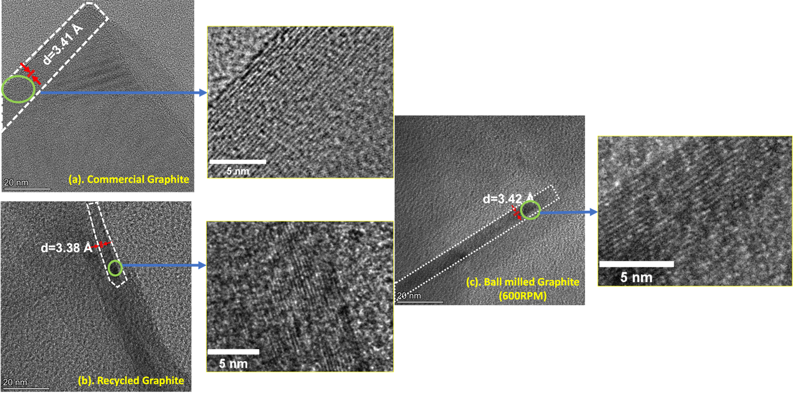
Figure 1: TEM images of commercial, recycled and ball-milled graphite.

3.3 XRD
The XRD patterns of commercial graphite, recycled graphite, and ball-milled graphite (600 RPM) are shown in Fig. 2. Distinct diffraction peaks that correspond to the carbon-graphite crystal planes with a hexagonal structure, specifically (002), (100), (101), (004), (103), and (110), were observed for all samples. As shown in all samples, the significant peak at about ∼ 2𝜃=26°, referring to the (002) crystal plane of graphite, confirmed that the basic structure of graphite was preserved during the recycling and ball-milling processes. The (002) peak of the recycled and ball-milled graphite shift slightly to higher 2𝜃 values compared to the commercial graphite, suggesting changes in the interlayer spacing during the recovery process or due to mechanical deformation taking place due to subsequent ball milling. These changes might affect Li-ion intercalation and electrode integrity, which may potentially impact long-term cycling stability. In addition to this, the intensities of the (100), (101), (004), (103) and (110) peaks are lowered in recycled and ball-milled graphite, likely due to graphitic fragmentation and deliverance of some disorders which is a part of processing stages. Interestingly, the patterns of both recycled and ball-milled graphite showed extra diffraction peaks at ∼ 23.5° 2𝜃. The peaks shown were specific to the peaks seen for the observed polyethylene oxide (PEO) that originated from polyethylene gasket materials used in the Zn-C batteries. The ball-milled graphite exhibits more intense and sharper peaks for (002) than that of recycled graphite. Instead of general crystallinity improvement, this could be related to the ball-milling process that breaks down graphitic domains into smaller domains of uniform size with similar d-spacing. In general, ball milling leads to initial defects and loss of crystallinity (table 2), however, prolonged milling can make the graphite structure reorganize in a long-range manner along c-axis which gives sharper (002) peaks. This observation is consistent with previous studies showing that prolonged ball milling of graphite in air retains the crystalline phase and increases the ordering of structure [16]. This improvement indicates that ball milling boosts the structural order of graphite, and could make it suitable for applications that require high degrees of graphitisation.
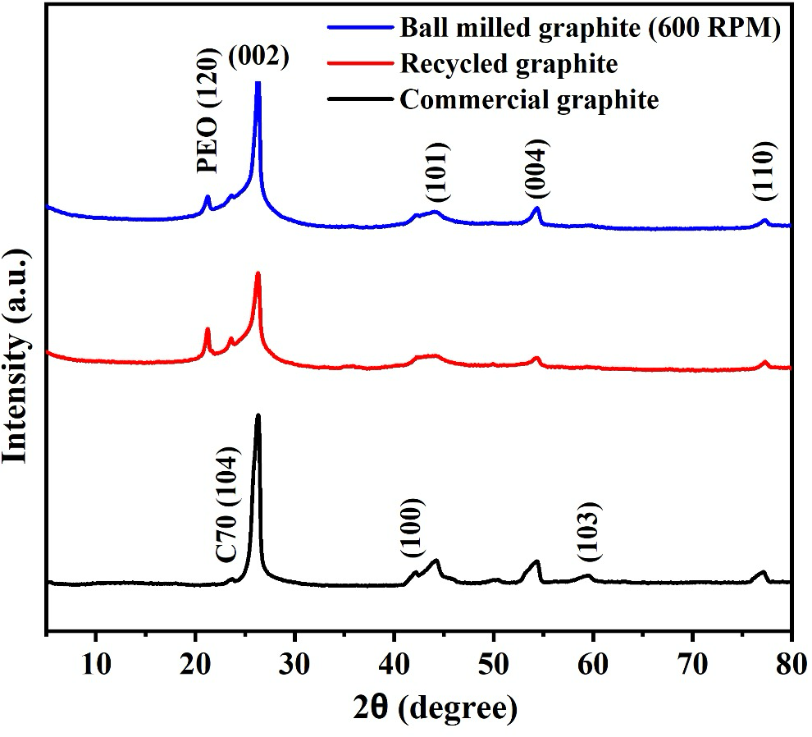
Figure 2: XRD patterns of commercial graphite, recycled graphite, and ball-milled graphite.

The structural properties of the graphite samples were determined using XRD, with the results noted in Table 2. The lattice parameters of the commercial graphite (a= 2.4725 Å, c= 6.7526 Å) agree well with the reported values and when combined with the well-defined peak shapes confirm a high level of crystallinity [17]. The recycled graphite had a small increase in c-axis (a=2.4696 Å, c=6.7618 Å), suggestive of possible stacking disorder, residual contaminants from previously residing Zn-C battery carbon rods, and structural degradation due to long-term cycling. This structural change illustrates the impact of the recycling process on the crystalline structure of graphite. After ball milling, the lattice parameters for graphite (a=2.4704 Å, c=6.7516 Å) revealed a slight decrease in the c-axis, suggesting that intercalants were effectively removed during the ball milling procedure. The reduction of the c-axis compared to commercial graphite (c=6.7516 Å), is not yet to imply the long-range order has been returned. This change shows that a localized rearrangement of graphitic framework has taken place. This is further supported by the strain values where recycled graphite showed the highest strain of 0.012, while the ball-milled produced the next lowest strain of 0.010, just above the commercial graphite. This indicates a local structure homogenization rather than a complete structural recovery. The crystallite size int c-axis (L_{c}) (table 2) is another indicator for partial structure reorganization. The L_{c} of the ball milled graphite is also slightly higher than that of the recycled graphite (13.04 nm), but significantly lower than the value obtained for the commercial graphite (28.21 nm), indicating some structural disorder still present. Thus, ball milling contributes to some texture refinement and enhances their electrochemically accessibility, but it fails at restoring long-range graphitic order. The d₀₀₂ values calculated for each of the graphite samples were found to be less than 0.3440 nm, and were in close agreement to the theoretical graphite value 0.3354 nm [18].

Table 2: The structural parameters of graphite samples
Sample name | Lattice parameter (Å) |  | d₀₀₂ (Å) | L_{c} (nm) | Strain
Sample name | a | c | d₀₀₂ (Å) | L_{c} (nm) | Strain
Commercial graphite | 2.4725 | 6.7526 | 3.38 | 28.21 | 0.01
Recycled  graphite | 2.4696 | 6.7618 | 3.40 | 13.04 | 0.12
Ball-milled graphite | 2.4704 | 6.7516 | 3.39 | 14.22 | 0.01

3.4 Raman spectroscopy
Commercial, recycled and ball-milled graphite samples were analyzed using Raman and typical Raman spectra are shown in Fig. 3, indicating very specific structural features of these carbonaceous materials. As can be seen in both spectra, there are two major peaks, the D-band ∼ 1330 cm⁻¹ and the G-band ∼ 1590 cm⁻¹ [19]. The D-band arises from structural defects or disordered carbon atoms and the G-band arises from the sp² hybridized carbon atoms, which form a graphitic structure. The intensity ratio of these peaks (I_{D}/I_{G}) provides quantitative information about the defect density and graphitic degree of the samples [20]. The commercial graphite has the lowest I_{D}/I_{G} ratio (0.22), showing high structural order with few defects. On the other hand, the recycled graphite and ball-milled graphite, with I_{D}/I_{G} ratios of 1.04 and 1.07, respectively, were indicative of an increase of defect densities. These observations indicate that the recycling and ball milling process creates structural defects due to mechanical impact and the inherent heterogeneous nature of the recycled materials. The XRD results revealed that the c-axis lattice parameter of recycled graphite (6.7618 Å) was larger than that of commercial graphite (6.7526 Å), which means that the recycled graphite had some stacking disorder and retained some contaminations. The ball milling process resulted in a significantly lowered c-axis lattice parameter of 6.7516 Å, which indicates a partial return of structural homogeneity. In a similar way, the Raman spectra show evidence of a higher defect density during ball milling, which is illustrated by the slight increase in the value of I_{D}/I_{G}, as well as a strong packing of the graphitic layers. These observations highlight on an equilibrium that must be reached between inducing structural homogeneity and defects during the ball milling process. XRD depicts improved layer alignment and decreased interlayer gap, with Raman validating the mechanical strain induced in the process. These two related aspects elucidate the complexity in improving recycling and processing techniques for graphite-containing materials, and achieving optimal balance between the extent of graphitisation and amount of structural defects is critical for tuning electrochemical properties. The increased defect density observed in this work, compared to previous methods for recycling graphite, is attributed to the absence of high-temperature treatments and chemical leaching. This differs from the methods described by Jian Peng et al [14]. and Lai et al [19]. as it avoids environmentally unfriendly processes such as acid leaching and treatments with eutectic solvents. While these alternate approaches have lower defect densities, they also translate to higher energy consumption, with both strategic and environmental implications.

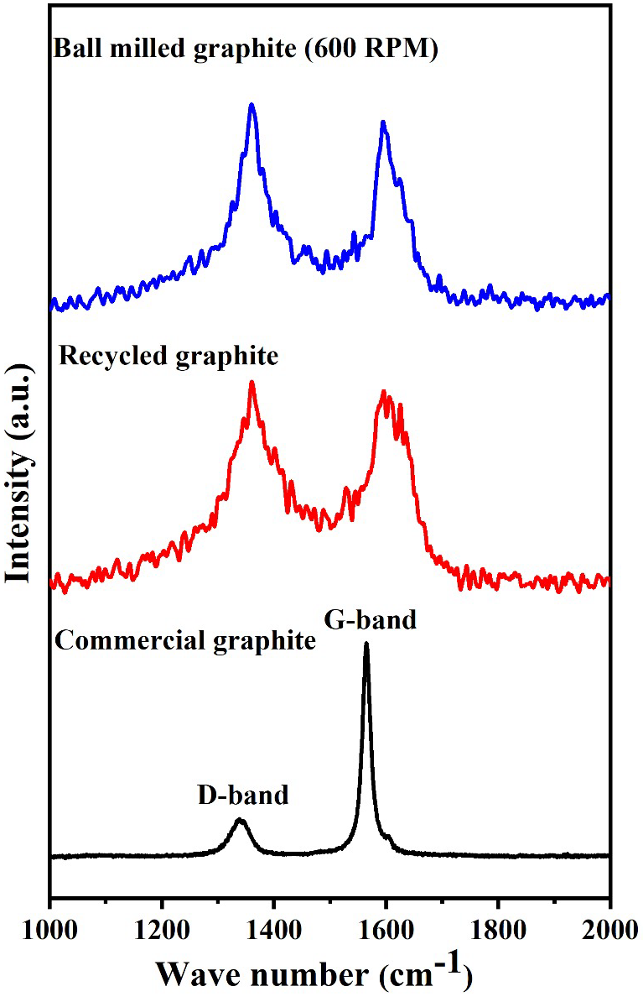
Figure 3: Raman spectra of commercial, recycled, and ball-milled graphite.

3.5 FTIR
Fourier-transform infrared (FTIR) spectroscopy was used to study the functional groups and structure of commercial graphite, recycled graphite and ball-milled graphite, as shown in Fig. S3. The spectra provide vital insights on the chemical transformations induced by recycling and by the ball milling processes. Commercial graphite spectra show a simple profile featuring a high and sharp peak at 1587 cm⁻¹, attributed to the C=C stretching mode in graphitic forms. This suggests the presence of organized graphitic domains and very few functional groups, which demonstrates its high purity. Additionally, one small peak in the medium of 1960–2150 cm⁻¹ was identified. This peak may be associated with the electric dipole induced by changing charge states of carbon atoms, which has also been reported previously [21]. On the spectrum of recycled graphite, the C=C stretching peak is displayed at 1587 cm⁻¹, which suggests that the graphitic carbon structure was retained after recycling. However, additional peaks appear at 2845.9 cm⁻¹ and 2912.4 cm⁻¹ ascribed to C-H stretching vibration. The observed peaks indicating these organic contaminants are likely from the constituents of spent Zn-C batteries such as polyethylene gaskets, paper plates, or insulators. Polymeric impurities are known to be characterized by their natural C-H stretching in the same range, as has been shown in prior studies [22]. Compared to recycled graphite, the spectrum of ball-milled graphite clearly shows an increase in the C-H stretching peaks at 2845.9 cm⁻¹ and 2912.4 cm⁻¹. This increase would suggest that ball milling either exposed additional surface-bound polymer-based impurities. Despite these changes, there remains a characteristic peak for the C=C stretching at 1587 cm⁻¹ indicating that the graphitic structure has been preserved.

3.6 BET
The BET analysis showed significant differences in the surface area, pore volume and pore size of the commercial, recycled and ball-milled graphite samples, presented in table 3. The BET surface area of the ball-milled graphite was found to be 30.89 m²/g, much higher than that of commercial graphite (13.93 m²/g) and recycled graphite (15.80 m²/g), indicating that there was a substantial increase in surface area due to the ball milling process, which reduces the graphite particles size and exposes more active sites. In comparison with the commercial graphite, the surface area of the recycled graphite was improved slightly, probably due to the structural transformation that occurs when ball milling that reduces particle size and, therefore, increases the exposed surface area.
The total pore volume value of ball-milled graphite is 0.05 cm³/g, comparable to commercial graphite (0.06 cm³/g), but higher than that of recycled graphite (0.03 cm³/g) indicating that the mechanical method of ball milling does not increase pore volume significantly but mostly produces smaller and more numerous pores. The average pore diameter decreased in the order followed, the average pore diameter of ball-milled graphite was the smallest (7.01 nm), that of recycled graphite was (8.66 nm), and that of commercial graphite was 17.81 nm. The reduction of pore size occurs due to the breakage of larger pores into smaller during milling. This process increases the surface area and may generate more active sites for lithium storage, through the significantly smaller pore size may hinder lithium-ion diffusion, restricting electrolyte access and reducing ion transport within the electrode.

Table 3: BET surface area and pore characteristics values of commercial, recycled and ball milled graphite.
Sample | BET surface area (m²/g) | Total pore volume (cm³/g) | Average pore diameter (nm)
Commercial graphite | 13.93 | 0.06 | 17.81
Recycled graphite | 15.80 | 0.03 | 8.66
Ball-milled graphite | 30.89 | 0.05 | 7.01

3.7 XPS
The chemical environment and electronic structure of commercial, recycled, and ball-milled graphite are examined through XPS. The XPS survey spectra for commercial, recycled, and ball-milled graphite is shown in Fig. S4. Commercial graphite shows strong peaks (C 1s and O 1s) indicating very low surface oxygen and accordingly high purity of the sample. The intensity of the O 1s peak of the recycled graphite is significantly higher, suggesting an improved surface oxidation level during the recycling process. For the ball-milled graphite, the O 1s peak is smaller than that of the recycled graphite, implying a lower level of oxidation.
The XPS spectrum from commercial graphite (Fig. 4a) exhibits a clear C–C/C=C peak centered at 284.57 eV, corresponding to graphitic sp² hybridized structure. Moreover, the presence of a minor C-H peak at 285.70 eV may correspond with trace amounts of surface defects or contaminants. The results correspond to the XRD pattern of commercial graphite which presents a strong peak of (002), in addition, the Raman spectrum showing a strong G-band and a weak D-band confirm its well-ordered crystalline structure and low defect density. The C–C/C=C peak of the recycled graphite appears at 284.57 eV, which means that the graphitic bonding are preserved during the recycling. However, the C-H peak shifts to 285.86 eV, suggesting impurities and structural defects likely come from residual residues and preparation (Fig. 4b). The XRD pattern shows a similar reduction in intensity and slight broadening of the (002) peak relative to commercial graphite whereas the Raman spectrum shows an increased D/G intensity ratio, indicating a higher defect density in the recycled material. For ball-milled graphite, the peak C-C/C=C was slightly shifted to about 284.70 eV, which is the result of strain and defects accumulation during the ball milling. The peak of C−H at about 285.86 eV matches the characteristics of recycles graphite (Fig. 4c), suggesting that ball milling enhances structural defects but does not add substantial new chemical functionalities.

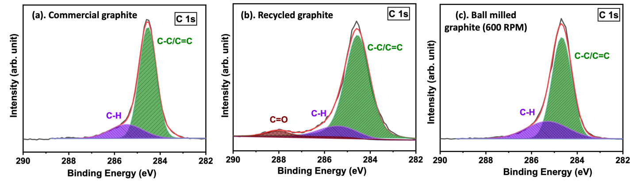
Figure 4: XPS spectra of (a) commercial, (b) recycled and (c) ball-milled graphite.

3.8 Electrochemical performance
Fig. 5a presents the rate capability tests of commercial, ball milled, and recycled graphite at different rates of 0.1C, 0.2C, 0.5C and 1C (C is equivalent to ca. 37 mA/g). Of the three, ball milled graphite had the highest rate capability, with specific capacities of 369.94, 369.15, 356.27, 331.19 mAh/g at 0.1, 0.2, 0.5, 1.0 C, respectively. The superior performance due to its remarkably larger BET surface area (30.89 m²/g) that facilitates effective Li-ion intercalation/deintercalation, improves electronic conductivity and minimises polarisation. In contrast, commercial graphite demonstrated a moderate rate capability with the specific capacities being 367.07, 352.52, 334.50, and 306.98 mAh/g at the same current densities. Between them, this performance is relatively lower than ball milled graphite, endowed at high current densities, due to reduced BET surface area (13.93 m²/g) and intrinsic conductivity restrictions. Recycled graphite was the least effective at rate, with specific capacities of 231.65, 221.2, 215.08, and 207.14 mAh/g, despite both having slightly higher BET surface area of 15.80 m²/g than CG. This reduction shows that structural degradation, impurities, or irreversible damage during the recycling process. A detailed comparison of the recycled and ball-milled graphite including their structural and electrochemical characteristics is given in table S1 of the supporting information. This clearly reveals the improved graphitic texture, surface reactivity and lithium storage ability via ball milling.
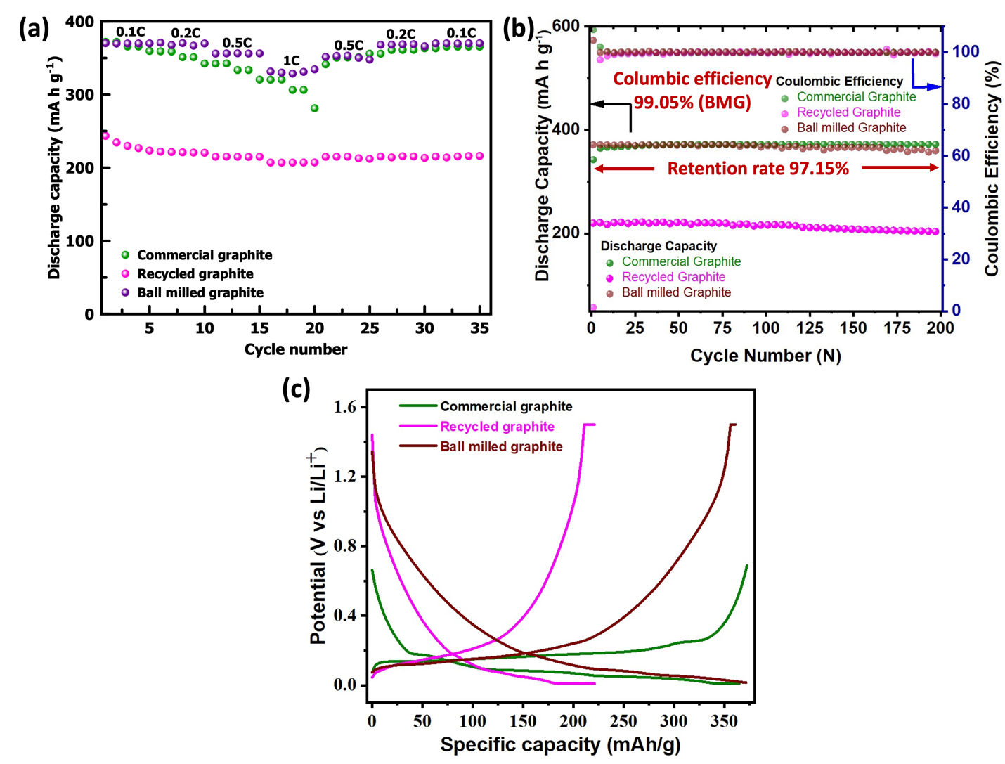
Figure 5: Electrochemical performance of commercial graphite, ball milled graphite and recycled graphite (a) rate performance at different rate, (b) cycling stability at 1C, (c) 5th cycle charge-discharge curve and

Fig. 5b showed the cycling performance in Li-ion half-cells of commercial, recycled, and ball-milled graphite samples. Commercial graphite gives an initial discharge capacity close to 342.61 mAh/g averaging around 371.39 mAh/g. This good stability can be linked to their ordered structure, a few defects as well as a strong solid electrolyte interphase (SEI) that limits irreversible capacity loss during long-term cycling [23]. Upon insertion and removal of lithium ions, the well-ordered structure of commercial graphite with several defects that facilitate the intercalation and deintercalation of lithium ions promotes excellent intercalation and results in a specific capacity closer to the theoretical maximum of 372 mAh/g. The recycled graphite recovered from spent Zn-C batteries exhibits an initial discharge capacity of about 220.25 mAh/g as well as an average specific capacity of 214.46 mAh/g, and the decrease in capacity is mainly attributed to residual impurities and structural degeneration during the recycling process. Polyethylene gaskets leave residues which become barriers preventing the effective intercalation of lithium ions. This suppression leads to SEI instability, the continual decomposition of the electrolyte, and poor long-term cycling stability. Although recycled graphite has a higher BET surface area than commercial graphite (15.80 m²/g vs 13.93 m²/g), this additional surface area is likely related to the defects and inaccessible pores that don't contribute to lithium-ion storage capacities. Instead, these defects hinder the diffusion of lithium ions and intercalation, result in performance decrease. Ball-milled graphite shows substantially improved electrochemical performance with an initial discharge capacity of 371.58 mAh/g and an average discharge capacity of 367.52 mAh/g for long-term cycling. This variation in electrochemical performance can be attributed to the optimised graphite microstructure that facilitates the mobility of lithium-ions while reducing diffusion resistance. In addition, the ball milling process increases the specific surface area of graphite, which promotes better contact with the electrolyte and optimizes the electrochemical kinetics. This structural disruption of the graphite layers reduces the energy barrier associated with the intercalation of lithium ions, thus improving the efficiency of the charge-discharge process. In addition, the presence of amorphous carbon regions and distorted graphite layers decreases the lithium-ion diffusion pathways, providing more efficient storage. Deeper insight into the impact of the surface attributes on the electrochemical performance was obtained through BET surface area analysis. Commercial graphite (13.93 m²/g) has a low surface area because of its highly ordered structure, which favours effective intercalation of lithium ions, and limits the number of accessible active sites. Despite the slightly larger surface area (15.80 m²/g) of recycled graphite particles, they do not perform better as impurities and structural faults hinder Li-ion transport. The surface area of the ball-milled graphite is found to be much higher (30.89 m²/g) than that of a commercial graphite, indicating abundant active sites for lithium-ion intercalation. Furthermore, enhanced accessibility of the pore structure owing to the ball-milling process improves electrolyte penetration and consequently the mobility of Li-ions. In this study, ball milling promotes the electrochemical performance of recycled graphite, hence making it an alternative for commercial graphite. This approach leads to more effective improvement of graphite morphology, increased lithium-ion intercalation sites and prolonged cycling stability. The right y-axis of Fig. 5b, all three materials maintain a significantly high coulombic efficiency, consistently near the limit of 100%, which suggests high electrochemical reversibility. The higher CE values signify that there are fewer side reactions or irreversible processes during the charge and discharge process. Fig. 5b shows the long-term cycle stability of ball milled graphite at 1C. The half-cell built with a ball milled sample showed a significant retention rate of 97.15% and the average coulombic efficiency was about 99.05% after 200 cycles.
The charge–discharge curves were obtained at 1C rate after the 5th cycle as shown in Fig. 5c, which indicates the electrochemical behavior of the commercial, recycled and ball-milled graphite. These materials exhibit discharge-specific capacities of 364.74, 221.10, and 371.58 mAh/g, with corresponding coulombic efficiencies of 102.09%, 99.96%, and 97.13%. Commercial graphite exhibits an apparent potential plateau at ∼ 0.2 V during discharge, indicative of an ordered solvation structure in the Li⁺ in its layered graphene structure (Fig. 6a). This plateau indicates a simplified and efficient staging process that takes place with intercalated lithium ions. Recycled graphite indicates a voltage slope without characteristic plateaus, suggesting intercalation is disrupted by residual impurities and structural disorder. These defects, however, prevent lithium insertion and cause a lower accessible capacity (Fig. 6b). Ball-milled graphite exhibits unique electrochemical behaviour as compared to commercial and recycled graphite. Despite a large discharge capacity (371.58 mAh/g) similar to those of commercial graphite the charge–discharge curve lacks a clear plateau, displaying rather a continuous voltage slope. This behavior owing to ball milling not only increases the surface area but also introduces structural disorder with abundant surface defects and edge planes that serve as additional lithium storage sites (Fig. 6c). Nonetheless, the high capacity and long-term stability (97.15% retention after 200 cycles) evidence against there being a complete absence of intercalation processes. Thus, the storage mechanism in ball-milled graphite can be close to both partial lithium-intercalation in the remaining graphitic domains, and surface adsorption/desorption and defect-induced pseudocapactive contribution. This hybrid behavior, wherein both lithium intercalation and surface adsorption mechanisms operate synergistically to enhance electrochemical performance.
Fig. S5 displays the galvanostatic charge/discharge curves of ball-milled graphite at the current density of 1C. Fig S5, also provide a deep understanding of the migration behaviour of Li⁺ in the half-cell system. In the initial discharge profile, one can observe a distinct plateau around ∼0.7 V, followed by a gradual decrease in voltage. This plateau is commonly related to the formation of the solid electrolyte interphase (SEI) on the graphite surface [24]. The formation of the solid electrolyte interphase for the recovered graphite is attributed to multiple reasons, including the enhanced surface delamination and defects generated during the used battery life cycle and the ball-milling process. In addition, the presence of residual species from the spent battery configuration can greatly affect the growth of the solid electrolyte interphase. The pseudo-plateau disappears in the later stage of discharge cycles, and the charge/discharge curves of electrode become much more consistent after the first cycle. A slight polarisation is established during charging and a steep potential rise is observed above ~0.2 V, indicative of delithiation of the graphite structure. The charge and discharge curves demonstrate a steady potential progression, characteristic of improved lithium-ion kinetics and stabilised electrodes, in the subsequent cycles. The potential of subsequent cycles shows a continuous lowering, without evident plateaus, confirming that the irreversible reactions associated to SEI formation occur mainly in the first cycle. The 2nd, 50th, 100th, and 200th cycles all have discharge capacity values of 371.57, 370.46, 367.90, and 361 mAh/g, respectively, which suggests good cycle performance. Such minor structural rearrangements or gradual SEI thickening results in slight capacity decrease, but no major capacity fading is seen. The cycling data shows that ball-milled graphite retains its structural stability and electrochemical activity over long cycling. There was no drastic capacity loss indicating the recovered graphite is a potential sustainable anode material for LiBs.
The charge transfer kinetics and ion transport properties of different graphite-based electrodes were further studied by electrochemical impedance spectroscopy (EIS). The Nyquist plot (Fig. S6) shows a well-defined semicircle in the high-frequency range, corresponding to charge transfer resistance (R_{ct}), followed by a linear Warburg region at lower frequencies, reflecting ion diffusion behaviour. A comparative analysis of the impedance spectra indicates apparent differences in the electrochemical activity of the three electrodes. As shown in the Nyquist plot, the three electrode materials all have a similar semi-circle plot, that is the commercial graphite has the smallest semicircle indicating lowest charge transfer resistance. This implies that enhanced electrical conductivity and higher charge transfer kinetics, which can be ascribed to its highly ordered crystalline structure with relatively larger average pore size of 17.81 nm (table 3). On the other hand, ball-milled graphite (600 RPM) is represented by a large circle, which indicates its high impedance despite the higher BET surface area. This contradictory behavior can be accounted for by the much lower average pore size (7.01 nm, table 3) that is achieved from the ball-milling process. The increased surface area could offer more active sites, but the decreased pore size most likely restricts lithium ions from moving and thus increases resistance. The mechanical aspects of ball milling possibly introduce defects and disrupt surface chemistry of graphitic structures, yielding a higher resistance and observed small decrease in a specific capacity to 367.52 mAh/g. For the three materials, the recycled graphite has the largest circle, indicating that it has the highest impedance and the greatest charge transfer resistance. This is likely due to residual impurities and structural degradation that hinder the diffusion of Li-ions. Notably, the specific capacity (214.46 mAh/g) represents a considerable loss of efficiency, identifying this one as the least effective of the electrodes being studied.

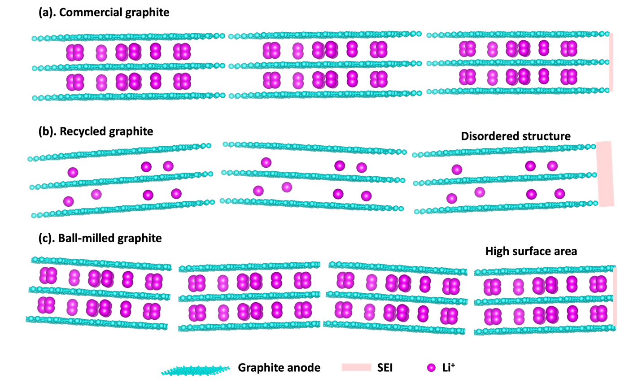
Figure 6: Lithium-ion intercalation mechanism in (a) commercial,
(b) recycled, and (c) ball-milled graphite.

3.9 Electrochemical reaction mechanism
The electrochemical processes in Li-ion half-cell involve the fact that Li ions intercalate and de-intercalate in the graphite electrode and the counter reactions at the Li metal electrode, depending on the direction of the current imposition. During the intercalation in the graphite, Li⁺ ions are pulled out from the Li metal (Eq. (4))) and travel through the electrolyte and into the graphite. Lithium ions insert themselves into the graphite lattice to produce Li_{x}C₆ compounds as in Eq. (3).
Graphite electrode (intercalation):
$$C_{6}+{xLi}^{+}+{xe}^{-}→{Li}_{x}C_{6} (3)$$
Lithium metal electrode (counter reaction):
$$Li→{Li}^{+}+e^{-} (4)$$
The process is reversed during the de-intercalation; lithium ions move out of the graphite electrode returning to the Li electrode via the electrolyte, and electrons move through an external circuit to the Li electrode, where Li⁺ ions are reduced and re-deposited as the Li metal. The reactions that take place can be summarized as follows:
Graphite electrode (de-intercalation):
$${Li}_{x}C_{6}→C_{6}+{xLi}^{+}+{xe}^{-} (5)$$
Lithium metal electrode (counter reaction):
$${Li}^{+}+e^{-}→Li (6)$$
Note that the electrochemical reaction in Eq. (3) and (5) happens during the respective charge and discharge processes when the graphite electrode is the negative electrode in typical lithium-ion batteries. This reversible intercalation and de-intercalation occurring in the graphite electrode is essential to the energy storage with high cycleability and long cycle-life.
The above observations represent the common Li intercalation/deintercalation process in graphitic structures, in which structural integrity of the graphite electrode considerable impacts this behavior. The extensive structural disruption induced in ball milling leads to a notable structural deviation from the common mechanism. The absence of the distinctive voltage plateau 0.2V, which is typically indicative of staged intercalation of Li-ions into the bulk of the material, suggests that lithium storage in the ball-milled sample is dominated by surface adsorption, defect-assisted storage, and possibly pseudocapacitance. Overall, these observations suggest that while intercalation still happen in residual crystalline domains, the predominant insertion mechanism in ball-milled graphite is not purely intercalative, but a hybrid phenomenon that reflects the disordered structure of the material.

3.10 Long cycling performance: A Study of 201-500 Cycles
The present work also seeks to evaluate the cycling performance of ball-milled graphite electrodes over an extended period beyond the conventional 100–200 cycles commonly described in the previous work [14,25]. Instead of limiting our analysis to short-term cycling at less than 1C, we expanded the cycling to 500 cycles to gain deeper insight into the material performance during an extended usage timeline. Our study expands upon previously published studies that also looked at cycling graphite for high cycle counts by investigating the cycling stability and efficiency of ball milled graphite electrodes across a much wider depth of discharge. The key results aim to enhance the understanding of mechanisms of capacity degradation, enhancement of coulombic efficiency, and stability of anodes for the demanding application of LiBs using graphite-based anodes.
The first discharge capacity of the ball-milled graphite obtained 371.58 mAh/g as shown in Fig. 5a, while the average discharge capacity of the first 200 cycles was 367.52 mAh/g. This demonstrates a high retention of 97.15% and a high coulombic efficiency of 99.05%. And, extending for the charging and discharging process as seen the average discharging capacity was 324.94 mAh/g during the 201–500 cycle (Fig. S7 (a)), indicative of a capacity retention of 77.37%. A progressive loss of capacity is observed, but it remains within expected limits for long cycling. The degradation is associated with normal degradation factors, such as mild electrode degradation, SEI thickening, and lithium inventory losses. Significantly, despite this, graphite anode shows considerable electrochemical activity, demonstrating its superior stability over extended cycling. Extended cycling data demonstrate an outstanding coulombic efficiency of ca. 100 % on average in the 201–500 cycle range (Fig. S7(b)). This remarkable efficiency indicates that intercalation and deintercalation of lithium-ion in this system are reversible with minimal side reactions. The stable coulombic efficiency suggests that the ball-milled graphite retains a good electrochemical interface and structure even after excessive cycling. The mechanisms proposed are detailed in supporting information Fig. S8 (a&b) for 1-200 cycles and 201-500 cycles. This presents a demanding benchmark for the suitability of the material for real LiBs applications.

3.11 Assessment of sustainability and economic feasibility
Recycling graphite from the batteries is essential for sustainability and reducing the environmental impact of waste disposal and raw material extraction. An analysis of existing techniques for graphite recovery reveals that many of the same approaches, particularly those used for recycling spent lithium-ion batteries, employ corrosive acids, organic solvents and high-temperature calcination procedures [19,25–30]. For example, the use of sulphuric acid curing (calcination at 1500 °C) or acid leaching and calcination leads to significant carbon emissions related to the use of chemicals such as sulphuric acid, citric acid, and HCl and generates highly hazardous waste streams. While these methods contribute to reasonable specific capacities, they also present severe environmental issues requiring advanced waste management approaches. This work presents a ball milling method which is a more sustainable option. Herein, we demonstrate via mechanical milling of recycled graphite recovered from spent Zn-C batteries, its subsequent structural changes and defect engineering without the requirement of corrosive acids or high-temperature treatment. This approach produces very little waste, eliminates the need for destructive solvents, and runs at ambient temperature and pressure, significantly reducing its carbon footprint. Furthermore, as compared to high-temperature calcination methods, the energy consumption related to ball milling is drastically lowered. From an economic perspective, the ball milling process is simple and relies on easily available, low-cost equipment, making it particularly inexpensive. It is economically attractive, as the relevant cost of expensive chemicals. The ball-milled graphite demonstrates outstanding electrochemical properties with a average specific capacity of 367.52 mAh/g at 1C after 200 cycles, and an higher Coulombic efficiency of 99.05%, outperforming many chemical-treated comparison samples listed in Fig. 7. This work uses ball-milled graphite which has a different structural composition than that of the graphite used in many previous studies. The enhanced specific capacity observed at 1C could be attributed to the extended cycling stability and the structural alterations occurring within ball milled graphite. Not only does this comparison help to understand performance improvements, but it also highlights defect engineering importance in capacity retention. With its encouraging performance and low production cost, ball-milled graphite demonstrates its potential as a practical material for LiBs.
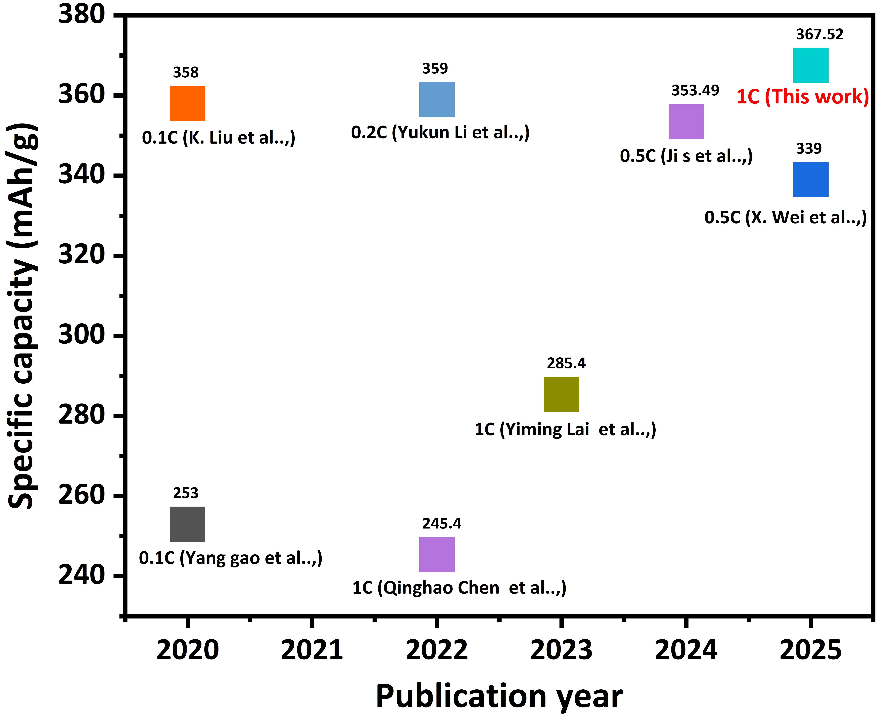
Figure 7: The specific capacity comparison of different chemical leaching and heat treatment methods reported in earlier studies. (Note: In contrast to previous works that utilize unmodified graphite, this work implements the use of ball milled recycled graphite, where structural modifications and defect engineering can occur, allowing for the substantial C-rate performance improvement observed at 1C).

Conclusion
This work proposes a novel and cost-effective way for the recovering and recycling of graphite from disposable Zn-C batteries to address major environmental and economic problems. The ball milling method demonstrated its ability to recover graphite and produce a carbonaceous material with excellent electrochemical performance, recording a specific capacity of 367.52 mAh/g at a 1C rate over 200 cycles with a corresponding Coulombic efficiency of 99.05%. In addition to confirming crystallinity, structural analyses demonstrated increases in defect density and disorder (I_{D}/I_{G} ratio and TEM imaging). Nevertheless, the essential graphitic bonding was preserved, validating the material for lithium-ion battery use. In addition, such an approach also helps eliminate hazardous chemicals and reduces energy consumption, not only making it an appropriate approach for fabricating energy storage materials with a much lower environmental impact but also providing a novel way to produce sustainable energy storage materials in the future. This highlights the potential of ball milled graphite as a commercially viable and effective alternative to the graphite now used, paving the way for the development of green battery technologies.

CRediT authorship contribution statement
Karthik kumar Chinnakutti: Data curation; Formal analysis; Writing – original draft, Hojung Yun: Conceptualization; Data curation; Formal analysis, Soorathep Kheawhom: Investigation, Hongyi Gao: Investigation, Nuria Tapia-Ruiz: Writing – review & editing, Pinit Kidkhunthod: Project administration, Supinya Nijpanich: Data curation; Formal analysis, Yasuyuki Sawada: Supervision,Nagahiro Saito: Supervision; Validation, Jitti Kasemchainan: Conceptualization; Supervision; Writing – review & editing.

Declaration of competing interest
The authors declare that they have no known competing financial interests or personal relationships that could have appeared to influence the work reported in this paper.

Acknowledgments
This project is funded by National Research Council of Thailand (NRCT) (grant number N42A661035) for research consumables and analytical expenses. The authors also acknowledge the support by the NSRF via the Program Management Unit for Human Resources & Institutional Development, Research and Innovation (grant number B49G680115) for dissemination of outcome and participation in an international symposium as well as by the Second Century Fund (C2F), Chulalongkorn University, Thailand for the postdoctoral researcher allowance.

References:
[1] M.M. Devi, Ankush, S.K. Guchhait, Sunaina, S.B. G. N., M. Sreekanth, N. Kalaiselvi, A.K. Ganguli, M. Jha, Energy efficient electrodes for lithium-ion batteries: Recovered and processed from spent primary batteries, J. Hazard. Mater. 384 (2020) 121112. https://doi.org/https://doi.org/10.1016/j.jhazmat.2019.121112.
[2] R.K. Biswas, A.K. Karmakar, S.L. Kumar, Recovery of manganese and zinc from spent Zn–C cell powder: Experimental design of leaching by sulfuric acid solution containing glucose, Waste Manag. 51 (2016) 174–181. https://doi.org/https://doi.org/10.1016/j.wasman.2015.11.002.
[3] J. Yang, E. Fan, J. Lin, F. Arshad, X. Zhang, H. Wang, F. Wu, R. Chen, L. Li, Recovery and Reuse of Anode Graphite from Spent Lithium-Ion Batteries via Citric Acid Leaching, ACS Appl. Energy Mater. 4 (2021) 6261–6268. https://doi.org/10.1021/acsaem.1c01029.
[4] B. Moradi, G.G. Botte, Recycling of graphite anodes for the next generation of lithium ion batteries, J. Appl. Electrochem. 46 (2016) 123–148. https://doi.org/10.1007/s10800-015-0914-0.
[5] W. Fan, J. Zhang, R. Ma, Y. Chen, C. Wang, Regeneration of graphite anode from spent lithium-ion batteries via microwave calcination, J. Electroanal. Chem. 908 (2022) 116087. https://doi.org/https://doi.org/10.1016/j.jelechem.2022.116087.
[6] Y. Xu, X. Song, Q. Chang, X. Hou, Y. Sun, X. Feng, X. Wang, M. Zhan, H. Xiang, Y. Yu, The regeneration of graphite anode from spent lithium-ion batteries by washing with a nitric acid/ethanol solution, New Carbon Mater. 37 (2022) 1011–1020. https://doi.org/https://doi.org/10.1016/S1872-5805(22)60648-6.
[7] H. Da, M. Gan, D. Jiang, C. Xing, Z. Zhang, L. Fei, Y. Cai, H. Zhang, S. Zhang, Epitaxial Regeneration of Spent Graphite Anode Material by an Eco-friendly In-Depth Purification Route, ACS Sustain. Chem. Eng. 9 (2021) 16192–16202. https://doi.org/10.1021/acssuschemeng.1c05374.
[8] F. Ferella, I. De Michelis, F. Beolchini, V. Innocenzi, F. Vegliò, Extraction of Zinc and Manganese from Alkaline and Zinc-Carbon Spent Batteries by Citric-Sulphuric Acid Solution, Int. J. Chem. Eng. 2010 (2010) 659434. https://doi.org/https://doi.org/10.1155/2010/659434.
[9] F. Ferella, I. De Michelis, F. Vegliò, Process for the recycling of alkaline and zinc–carbon spent batteries, J. Power Sources. 183 (2008) 805–811. https://doi.org/https://doi.org/10.1016/j.jpowsour.2008.05.043.
[10] S. Maryam Sadeghi, J. Jesus, H.M.V.M. Soares, A critical updated review of the hydrometallurgical routes for recycling zinc and manganese from spent zinc-based batteries, Waste Manag. 113 (2020) 342–350. https://doi.org/https://doi.org/10.1016/j.wasman.2020.05.049.
[11] S. Abid Charef, A.M. Affoune, A. Caballero, M. Cruz-Yusta, J. Morales, Simultaneous recovery of Zn and Mn from used batteries in acidic and alkaline mediums: A comparative study, Waste Manag. 68 (2017) 518–526. https://doi.org/https://doi.org/10.1016/j.wasman.2017.06.048.
[12] S. Vadivel, W. Tejangkura, M. Sawangphruk, Graphite/Graphene Composites from the Recovered Spent Zn/Carbon Primary Cell for the High-Performance Anode of Lithium-Ion Batteries, ACS Omega. 5 (2020) 15240–15246. https://doi.org/10.1021/acsomega.0c01270.
[13] S. Pattaweepaiboon, W. Hirunpinyopas, P. Iamprasertkun, K. Pimphor, S. Roddecha, D. Dirayanti, A. Boonchun, W. Sirisaksoontorn, Upcycling electrode materials from spent single-use zinc‑carbon/alkaline batteries into rechargeable lithium-ion battery application, J. Energy Storage. 76 (2024) 109755. https://doi.org/https://doi.org/10.1016/j.est.2023.109755.
[14] J. Peng, S. Maslek, N. Sharma, Spent graphite from lithium-ion batteries: re-use and the impact of ball milling for re-use, RSC Sustain. 2 (2024) 1418–1430. https://doi.org/10.1039/d4su00094c.
[15] H. Wu, R. Gakhar, A. Chen, S. Lam, C.P. Marshall, R.O. Scarlat, Comparative analysis of microstructure and reactive sites for nuclear graphite IG-110 and graphite matrix A3, J. Nucl. Mater. 528 (2020) 151802. https://doi.org/10.1016/j.jnucmat.2019.151802.
[16] Q. Tang, J. Wu, H. Sun, S. Fang, Crystallization degree change of expanded graphite by milling and annealing, J. Alloys Compd. 475 (2009) 429–433. https://doi.org/10.1016/j.jallcom.2008.07.063.
[17] D.M. Stefanescu, G. Alonso, R. Suarez, Recent Developments in Understanding Nucleation and Crystallization of Spheroidal Graphite in Iron-Carbon-Silicon Alloys, Metals (Basel). 10 (2020) 221. https://doi.org/10.3390/met10020221.
[18] R.E. Franklin, The structure of graphitic carbons, Acta Crystallogr. 4 (1951) 253–261. https://doi.org/10.1107/S0365110X51000842.
[19] Y. Lai, X. Zhu, J. Li, Q. Gou, M. Li, A. Xia, Y. Huang, X. Zhu, Q. Liao, Recovery and regeneration of anode graphite from spent lithium-ion batteries through deep eutectic solvent treatment: Structural characteristics, electrochemical performance and regeneration mechanism, Chem. Eng. J. 457 (2023) 141196. https://doi.org/10.1016/j.cej.2022.141196.
[20] D.S. Premathilake, F. Colombi, A.B. Botelho Junior, J.A. Soares Tenório, D.C. Romano Espinosa, M. Vaccari, Recycling lithium-ion battery graphite: Synthesis of adsorbent materials for highly efficient removal of dye and metal ions from wastewater, Results Eng. 22 (2024) 102232. https://doi.org/https://doi.org/10.1016/j.rineng.2024.102232.
[21] S. Ruiz, J.A. Tamayo, J. Delgado Ospina, D.P. Navia Porras, M.E. Valencia Zapata, J.H. Mina Hernandez, C.H. Valencia, F. Zuluaga, C.D. Grande Tovar, Antimicrobial Films Based on Nanocomposites of Chitosan/Poly(vinyl alcohol)/Graphene Oxide for Biomedical Applications, Biomolecules. 9 (2019). https://doi.org/10.3390/biom9030109.
[22] N.S. Vrandečić, M. Erceg, M. Jakić, I. Klarić, Kinetic analysis of thermal degradation of poly(ethylene glycol) and poly(ethylene oxide)s of different molecular weight, Thermochim. Acta. 498 (2010) 71–80. https://doi.org/10.1016/j.tca.2009.10.005.
[23] J.S. Edge, S. O’Kane, R. Prosser, N.D. Kirkaldy, A.N. Patel, A. Hales, A. Ghosh, W. Ai, J. Chen, J. Yang, S. Li, M.C. Pang, L. Bravo Diaz, A. Tomaszewska, M.W. Marzook, K.N. Radhakrishnan, H. Wang, Y. Patel, B. Wu, G.J. Offer, Lithium ion battery degradation: what you need to know, Phys. Chem. Chem. Phys. 23 (2021) 8200–8221. https://doi.org/10.1039/d1cp00359c.
[24] J. Yao, G.X. Wang, J. Ahn, H.K. Liu, S.X. Dou, Electrochemical studies of graphitized mesocarbon microbeads as an anode in lithium-ion cells, J. Power Sources. 114 (2003) 292–297. https://doi.org/https://doi.org/10.1016/S0378-7753(02)00585-2.
[25] S. Ji, A. Zhang, W. Hua, S. Yan, X. Chen, Regeneration of graphite from spent lithium-ion batteries as anode materials through stepwise purification and mild temperature restoration, Batter. Energy. 3 (2024) 20230067. https://doi.org/https://doi.org/10.1002/bte2.20230067.
[26] Y. Gao, C. Wang, J. Zhang, Q. Jing, B. Ma, Y. Chen, W. Zhang, Graphite Recycling from the Spent Lithium-Ion Batteries by Sulfuric Acid Curing–Leaching Combined with High-Temperature Calcination, ACS Sustain. Chem. Eng. 8 (2020) 9447–9455. https://doi.org/10.1021/acssuschemeng.0c02321.
[27] Q. Chen, L. Huang, J. Liu, Y. Luo, Y. Chen, A new approach to regenerate high-performance graphite from spent lithium-ion batteries, Carbon N. Y. 189 (2022) 293–304. https://doi.org/https://doi.org/10.1016/j.carbon.2021.12.072.
[28] Y. Li, W. Lv, H. Zhao, Y. Xie, D. Ruan, Z. Sun, Regeneration of anode materials from complex graphite residue in spent lithium-ion battery recycling process, Green Chem. 24 (2022) 9315–9328. https://doi.org/10.1039/D2GC02439J.
[29] X. Wei, Z. Guo, Y. Zhao, Y. Sun, A. Hankin, M. Titirici, Recovery of graphite from industrial lithium-ion battery black mass, RSC Sustain. 3 (2025) 264–274. https://doi.org/10.1039/D4SU00427B.
[30] K. Liu, S. Yang, L. Luo, Q. Pan, P. Zhang, Y. Huang, F. Zheng, H. Wang, Q. Li, From spent graphite to recycle graphite anode for high-performance lithium ion batteries and sodium ion batteries, Electrochim. Acta. 356 (2020) 136856. https://doi.org/https://doi.org/10.1016/j.electacta.2020.136856.

