Supporting Information

Facile Preparation of Drug-Loaded Tristearin Encapsulated Superparamagnetic Iron Oxide Nanoparticles using Coaxial Electrospray Processing
Manoochehr Rasekh¹*, Zeeshan Ahmad*², Richard Cross³, Javier Hernández-Gil¹, James D. E. T. Wilton-Ely¹*, Philip W. Miller*¹

¹Department of Chemistry, Imperial College London, South Kensington, London SW7 2AZ, UK
²Leicester School of Pharmacy, De Montfort University, Leicester LE1 9BH, UK
³Emerging Technologies Research Centre, De Montfort University, Leicester LE1 9BH, UK

* Corresponding authors:
philip.miller@imperial.ac.uk
j.wilton-ely@imperial.ac.uk
m.rasekh15@imperial.ac.uk
zahmad@dmu.ac.uk

KEYWORDS: Encapsulation, Electrospraying, Imaging, Drug delivery, Cancer, Theranostics

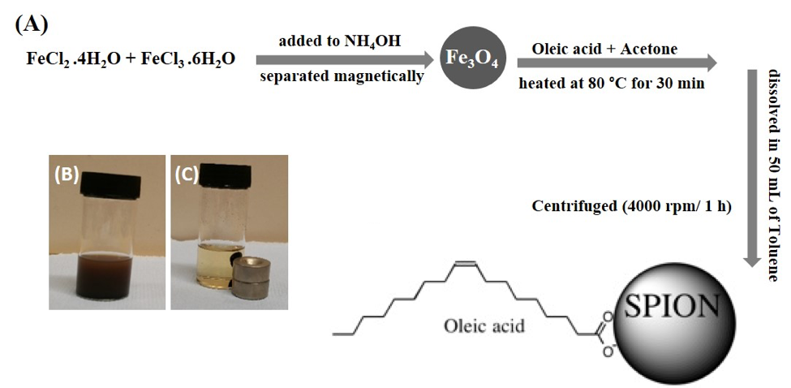
Figure S1. Schematic representing synthesis of SPIONs; the synthesis of SPIONs (A), SPIONs dispersed in acetone solution (B) Magnetic purification (C).

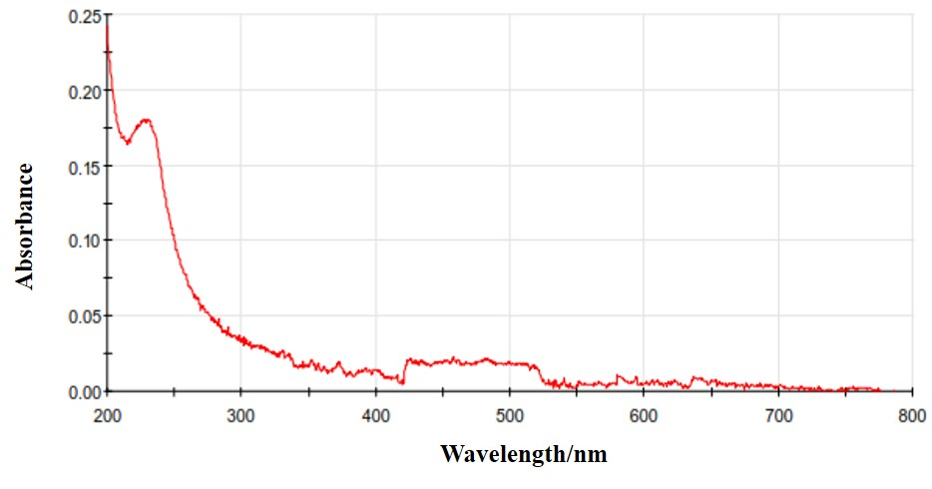

Figure S2. UV-vis spectroscopy further confirmed the synthesis of the iron oxide NPs characteristic of SPIONs.
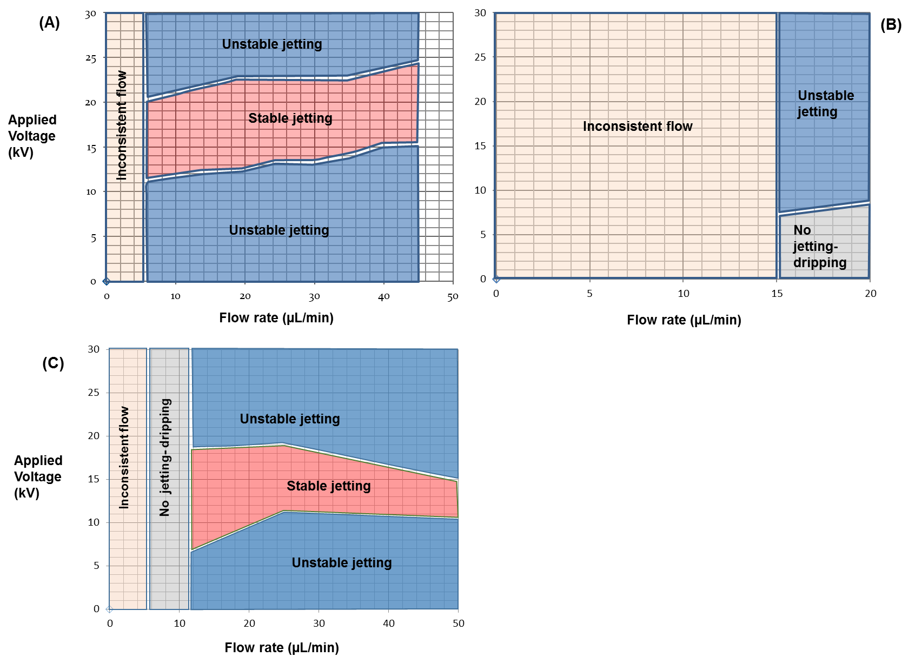

Figure S3 (A-C). Mode mapping and optimization of coaxial needle ES process for encapsulation of SPIONs, (A) PEG / Ethanol (5 w/v %), (B) PEG / Ethanol / SPIONs (0.5 w/v %) and (C) tristearin in dichloromethane (2 w/v %).

Table S1 (A-D). Mode mapping tables, which were generated during mapping optimization of the electrospraying (ES) process, (A) single-needle ES process of the PEG / Ethanol (5 w/v %), (B) single- needle ES process of the PEG / Ethanol / SPIONs (0.5 w/v %), (C) single-needle ES process of the tristearin in dichloromethane (2 w/v %), (D) coaxial needle ES process (encapsulation of SPIONs) for the final formulation [(tristearin / dichloromethane - 2 w/v % in outer needle) and (PEG / Ethanol (5 w/v %), genistein (1 mg/mL), SPIONs (0.5 w/v %) in inner needle)]; Inner flow rate was fixed at 20 µL/min.

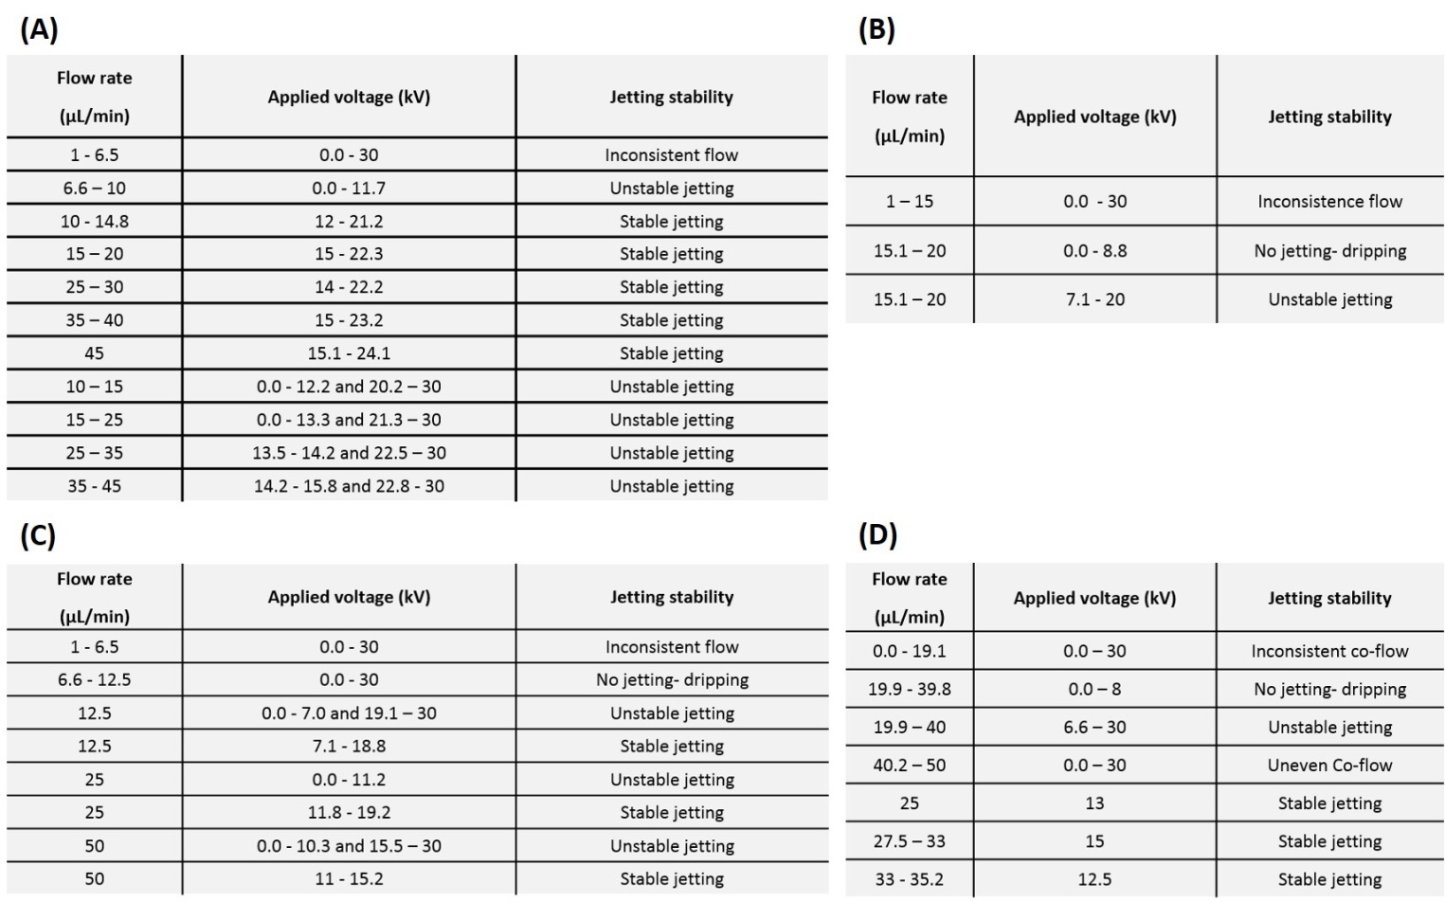

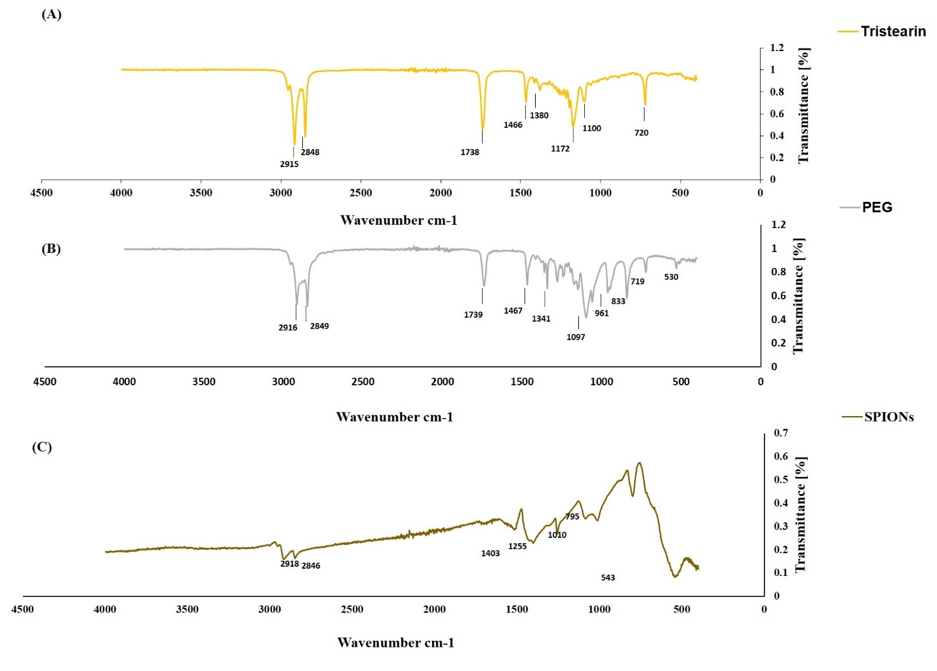

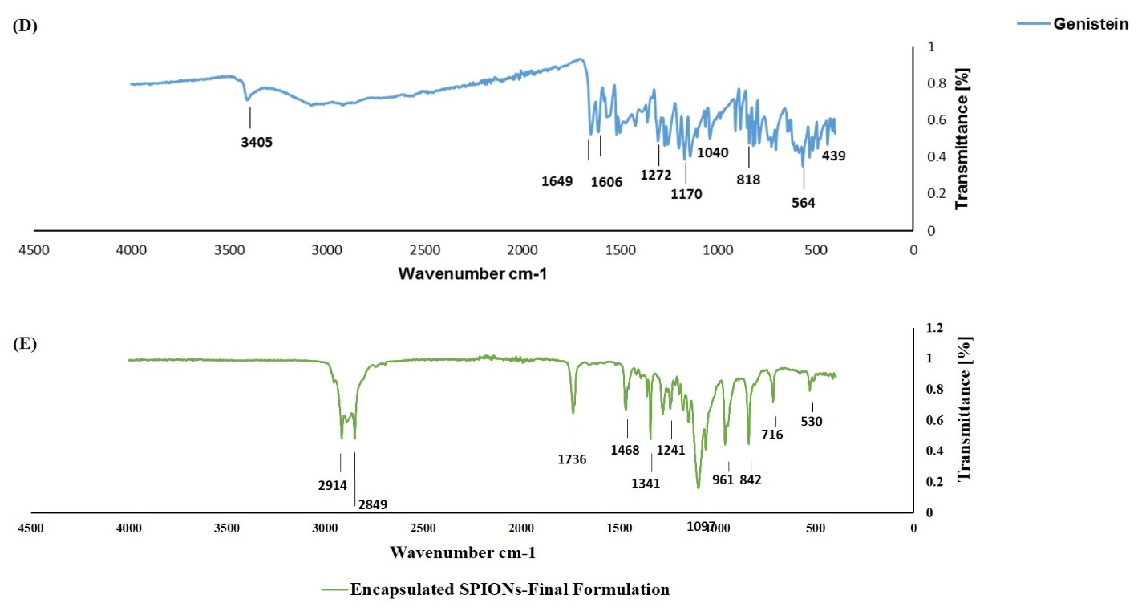

Figure S4. Fourier transform infrared (FTIR) spectra of the individual constituents (tristearin, PEG, SPIONs, genistein) (A-D) and the final formulation encapsulated SPIONs (E).
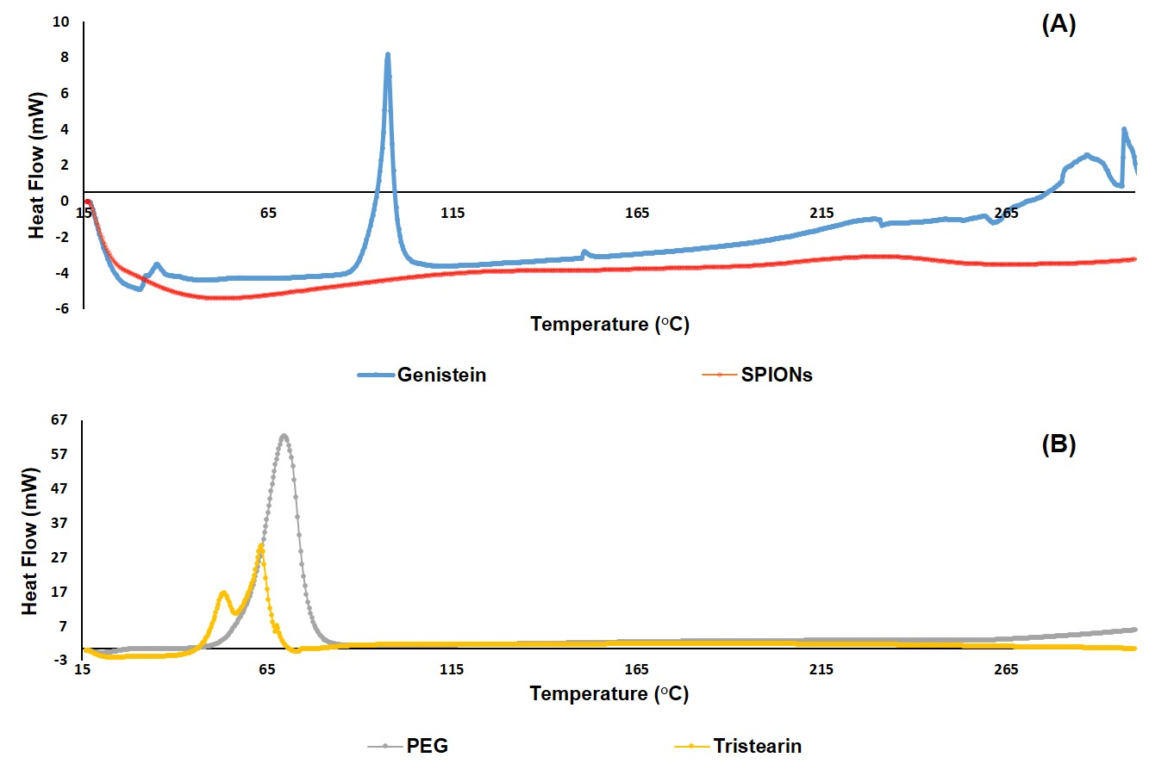

Figure S5. Differential scanning calorimetric (DSC) of the individual components (genistein and SPIONs) (A), and (PEG and tristearin) (B).

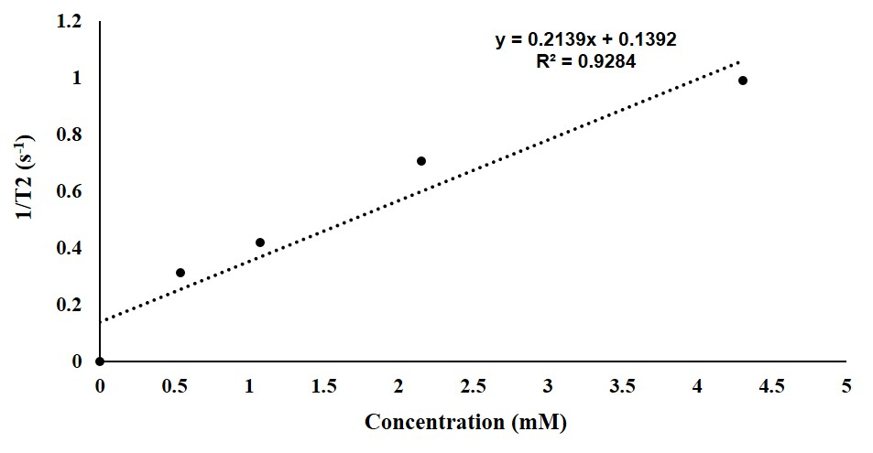
Figure S6. T₂ relaxation rate of the encapsulated SPIONs at different concentrations (mM) measured at 9.4 T (400 MHz) NMR, ($r_{2}$ = 0.214 mM⁻¹ s⁻¹).

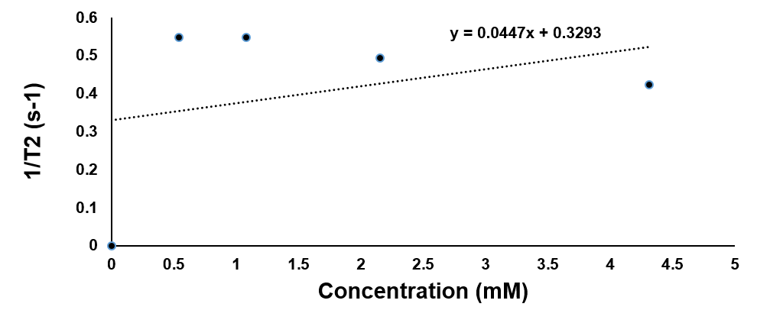

Figure S7. T₂ relaxation rate of the coaxial electrosprayed particles without SPIONs at different concentrations (mM) measured at 9.4 T (400 MHz) NMR, ($r_{2}$ = 0.045 mM⁻¹ s⁻¹).

