Direct incorporation of [¹⁸F] into aliphatic systems: A promising Mn-catalysed labelling technique for PET imaging
Sara Cesarec,^{†a} Jonathan A. Robson,^{†a} Laurence S. Carroll,*^{a,b} Eric O. Aboagyeª and Alan C. Spivey^{c}
- Comprehensive Cancer Imaging Centre, Department of Surgery and Cancer, Imperial College London, Hammersmith Campus, Du Cane Road, London W12 0NN, UK.
- Russell H. Morgan Department of Radiology and Radiological Sciences, Johns Hopkins Medical Institutions, Baltimore, MD 21231, USA.
- Department of Chemistry, Molecular Sciences Research Hub (MSRH), White City Campus, 80 Wood Lane, London W12 0BZ, UK.
† These authors contributed equally.
* Correspondence E-mail: lcarro19@jhmi.edu
Abstract
One of the challenges in positron emission tomography (PET) is labelling complex aliphatic molecules. We report here on the optimisation of an aliphatic C-H to C-¹⁸F bond transformation catalysed by a Mn(porphyrin) complex. The successful oxidation of 11 aliphatic molecules including progesterone are reported. Radiochemical Incorporations (RCIs) up to 69% were achieved within 60 min without the need for pre-activation or specialist equipment. The method features mild conditions (60 °C) and promises to constitute a valuable approach to labelling of biomolecules and drug substances.
Introduction
The molecular imaging technique of Positron Emission Tomography (PET) has become widely used for clinical disease diagnosis and monitoring,¹ for the development of pharmaceuticals,^{2,3} and for theranostic⁴ applications.⁵ Fluorine-18 is one of the most commonly used radioisotopes in PET due to its favourable balance of long half-life, high photon flux, and low positron energy (109 min, 97% β+ and 0.6 MeV Eβ+, respectively),⁶ as well as the prevalence of fluorine in marketed drugs. Currently, approximately 25% of all pharmaceuticals contain a fluorine atom (cf. only 2% in 1970),⁷ in part reflecting increased awareness of the beneficial pharmacokinetic properties that fluorine can impart on drug substances.⁸ Consequently, there is high demand for the development of [¹⁸F]tracers to build upon the notable success of clinical agents such as [¹⁸F]fluorodeoxyglucose⁹ and [¹⁸F]fluorodopa¹⁰ which have been widely used in oncology and neurology, respectively.
Methods of [¹⁸F]radiofluorination can be broadly categorised as using either electrophilic (i.e. F⁺) or nucleophilic (i.e. F⁻) fluorine-18, with nucleophilic methods generally being preferred as fluoride anion can be routinely prepared with high specific activity.^{11,12} Thus anhydrous [¹⁸F]potassium fluoride, usually in the presence of a Phase Transfer Catalyst (PTC) such as the cryptand Kryptofix₂₂₂, is used routinely to effect C-[¹⁸F] bond formation in aromatic tracers by aromatic nucleophilic substitution (S_{N}Ar) with activated (i.e. electron deficient) aryl precursors and in aliphatic tracers by bimolecular nucleophilic substitution (S_{N}2) with alkyl precursors.¹¹ However, the sometimes harsh reaction conditions and low functional group tolerance associated with these approaches has encouraged the development of alternative methods suitable for late stage labelling.^{13,14} Of note for aromatic tracers are Ritter’s Pd-^{15,16} and Ni-mediated^{17–19} haloarene fluorination protocols, Sandford’s Cu-mediated fluorination of aryliodonium salts,^{20,21} boronic acids²² and arylstannanes, and Gouverneur’s Cu-mediated fluorination of aryl boronic acids.²³ Of note for aliphatic tracers is Doyle’s Co(salen)F catalyzed enantioselective epoxide opening,^{24a} Doyle’s photoredox catalyzed decarboxylative fluorination protocol,^{24b} and recent C-H activation methods which obviate the requirement for installation of a suitable leaving group in the labelling precursor molecule such as Gouverneur’s organocatalytic α-fluorination of aliphatic aldehydes,^{25,26} Britton’s photoactivated decatungstate-catalyzed fluorination of branched α-amino acids,²⁷ and Groves’ benzylic fluorination of benzylic positions using Mn(salen)OTs^{28,29} and most recently unactivated aliphatic positions using a Mn(porphyrin)OTs pre-catalyst.³⁰
We also recently disclosed a protocol similar to that of Groves et al.²⁸ for the efficient preparation of benzylic [¹⁸F]-trifluoromethyl-containing compounds using the commercially available Jacobsen-type Mn(salen)Cl pre-catalyst.³¹ We report here an extension of our work to the [¹⁸F]-labelling of non-benzylic aliphatic molecules using a Mn(III) tetramesityl porphyrin coordinated with a chloride ligand, (TMP)MnCl. Once again our protocol is similar to that recently reported by Groves et al.³⁰ but is differentiated by employing this more readily available pre-catalyst; Groves uses Mn(III) tetrakis(pentafluorophenylporphyrin coordinated with a tosylate ligand, Mn(PFP)OTs. Although numerous commercial drugs and candidate pharmaceuticals comprise alkyl moieties, late-stage [¹⁸F] fluorination of saturated positions, prior to the aforementioned disclosure of Groves, has not hitherto been possible.³² The direct C-H to C-[¹⁸F] bond transformation of non prefunctionalised aliphatic tracer precursors using Mn(porphyrin) pre-catalysts is a simple, functional group tolerant transformation, which significantly expands the diversity of methods in a radiochemists toolbox for labelling complex molecules.
Results and Discussion
For our development studies, three pre-catalysts [(TMP)Mn-Cl (1a), (DCP)Mn-Cl (1b), and Jacobsen’s pre-catalyst (2)], and three substrates (norbornane, cycloheptane and indane) were investigated (Table 1).
Table 1: Optimisation of conditions for [¹⁸F]radiolabelling of norbornane, cycloheptane and indane using pre-catalysts 1a, 1b and 2.
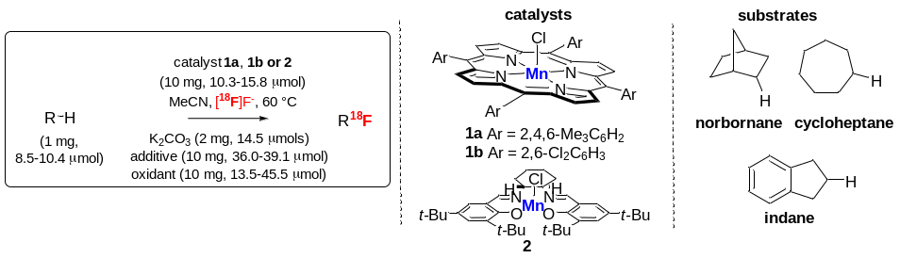
Entry | RH | Pre-catalyst |  | [O] | Additive | Time | %RCIª
1^{b} | norbornane | 2 |  | PhIO (16a) | AgOTs | 30 | trace^{c}
2 | norbornane | 1a |  | PhIO (16a) | AgOTs | 30 | 5
3 | norbornane | 2 |  | PhIO (16a) | AgOTs | 60 | 12
4 | norbornane | 1a |  | PhIO (16a) | AgOTf | 30 | 7
5 | norbornane | 1a^{d} |  | PhIO (16a)^{e} | AgOTf | 30 | 20
6 | norbornane | 1a |  | PhIO (16a) | AgOTf | 60 | 46
7^{b} | norbornane | 1a |  | PhIO (16a) | AgOTf | 60 | 10
8 | cycloheptane | 1a |  | PhIO (16a) | AgOTf | 30 | 15
9 | cycloheptane | 1b |  | PhIO (16a) | AgOTf | 30 | trace^{c}
10 | cycloheptane | 1a | (PhIO)₃·SO₃ (16d) |  | AgOTf | 30 | 8
11 | cycloheptane | 1a |  | IBX ester 16c^{f} | AgOTf | 30 | 0
12 | indane | 1a |  | PhIO (16a) | AgOTf | 60 | 69
13 | indane | 1c^{g} |  | PhIO (16a) | AgOTf | 60 | 19

ª RCI = radiochemical incorporation calculated from radio-HPLC analysis, all conditions carried out 3 separate times, ^{b} acetone as solvent, ^{c} RCI detected by radio-HPLC, though too low to be quantified, ^{d} four aliquots of the pre-catalyst (i.e. 4 × 1 equiv.) were added at 0.25 h intervals, ^{e} four batches of the oxidant (i.e. 4 × 1 equiv.) were added at 0.25 h intervals, ^{f} IBX ester is isopropyl 2-iodoxybenzoate, ^{g} 1c refers to the oxo-complex corresponding to pre-catalyst 1a (i.e. Mn=O cf. Mn-Cl, where Ar = 2,4,6-Me₃C₆H₂); 1c is simple to prepare from 1a, is air stable and has a characteristic IR absorption at 755 nm.³³
Using norbornane as a substrate, AgOTs as additive and iodosylbenzene (PhIO, 16a) as oxidant, tetramesityl porphyrin pre-catalyst [(TMP)Mn-Cl, 1a] was found to give improved radiochemical incorporation (RCI) of [¹⁸F]fluoride relative to Jacobsen’s salen complex 2 which we had used previously in our benzylic oxidation work³¹ (RCI 5% vs. traces; cf. entries 1 and 2). Switching the electron donating mesityl meso-substituents in the pre-catalyst for electron withdrawing 2,6-dichlorophenyl substituents [i.e. (DCP)Mn-Cl, 1b] resulted in poorer performance when using cycloheptane as a substrate, AgOTf as additive and PhIO (16a) as oxidant (RCI 15% vs. traces; cf. entries 8 and 9). Deploying the Mn-oxo complex 1c (see Table 1, footnote g) in place of pre-catalyst 1a was found to be detrimental to performance (RCI 69% vs. 19%; cf. entries 12 and 13). Complex 1a was thereby deemed to be the most suitable pre-catalyst for the process.
Using pre-formed (TMP)Mn-OTf complex, which is presumed to form by reaction of the (TMP)Mn-Cl pre-catalyst with the AgOTf additive under the reaction conditions, led to an identical result with cycloheptane to that achieved with the more convenient in situ mixing (RCI 15%; cf. entry 8, data not shown). A general comparison of AgOTs and AgOTf as additives revealed that although the former additive gave slightly cleaner radio-HPLC traces, the latter led to higher overall RCIs. The high reactivity of AgOTf presumably not only leads to fast chloride exchange but also some isotopic exchange. All reactions were carried out at 60 °C as it was found that at temperatures of 70 °C and higher significantly more side products were formed.
Since PhIO (16a) has relatively low solubility in organic solvents including MeCN, 3 other oxidants were evaluated as potential alternatives. meta-chloroperoxybenzoic acid (m-CPBA) was evaluated with progesterone and pre-catalyst 1a but performed less well than PhIO (RCI 13% vs. 38%; see ESI). Iodone(III) oxidants (PhIO)₃·SO₃ (16d) and isopropyl(2-iodoxybenzoate) (IBX ester, 16c) were evaluated with cycloheptane as more soluble analogues³⁴ of PhIO (16a). Both oxidants are readily soluble in MeCN at room temperature, but both delivered lower RCIs as compared to PhIO [(PhIO)₃.SO₃ 8% s. IBX ester 0% vs. PhIO 15%; cf. entries 10, 11 and 8). Therefore, the effect of adding further equivalents of PhIO was explored with norbornane (3): it pertained that the batch-wise addition of three additional equivalents of the oxidant and pre-catalyst at 0.25 h intervals had a positive effect on final RCI relative to the addition of just a single equivalent at the start (RCI 20% vs. 7%, cf. entries 5 and 4). When the reaction duration was prolonged from 30 to 60 min, the resulting RCI increased to 46% (entry 6), without the need of batch-wise addition of extra oxidant and pre-catalyst. Optimisation of the reaction duration in a radiochemical labelling reaction invariably reflects a compromise between the radioactive decay and the increasing RCI. Here, the longer reaction time outweighed radioactive decay (i.e. the extra 30 min increased the RCI by almost 50% despite the inevitable 17% loss of activity by decay).
In light of findings by Groves et al.,²⁸ the possibility of using acetone in place of MeCN was briefly explored using norbornane. It was found that a higher RCI was obtained in MeCN than in acetone (RCI 10% vs. 46% entry 7 cf. entry 6).
The final optimised conditions used pre-catalyst 1a, PhIO as oxidant, AgOTf as additive in MeCN for 60 min and gave RCIs of 46%, 15% and 69% for norbornane, cycloheptane, and indane respectively (entries 6, 8 and 12). Control reactions were performed to assure that each component of the mixture was required for fluorination to occur. Radioactivity was measured after 30 min and after 60 min; the measured final activities were 1.57 and 1.30 mCi respectively, indicating no loss in radioactivity and no volatile side products. The synthesis of the cold fluorocycloalkane standards for radiochemical HPLC analysis is detailed in the ESI.
5-10 Membered cycloalkane rings are found in many biologically active and drug molecules,³⁵ and so to exemplify the utility and demonstrate the scope of the method a further 9 substrates containing saturated rings were [¹⁸F] labelled under the optimised conditions (Figure 1).
The ascending RCI values with ring size from 5-18% for formation of the fluorocycloalkanes [¹⁸F]4,5,8-10 reflects their relative boiling points; in particular fluorocyclopentane [¹⁸F]4 is extremely volatile leading to losses via evaporation. trans-Decalin was labelled to give [¹⁸F]7b with an RCI of 9% despite its low solubility in MeCN. Interestingly, there was a divergence of behaviour between the two ester-functionalised cyclohexanes examined: cyclohexylacetate gave [¹⁸F]11 in 9% RCI whereas ethyl cyclohexanecarboxylate was inert to the oxidation conditions and no [¹⁸F]13 was obtained. Application of our method to the oxidation of two steroid derivatives yielded particularly pleasing results: 16β-fluoro-progesterone [¹⁸F]14 and 16β-fluoro-5α-dihydrotestosterone (FDHT) [¹⁸F]15 were obtained with RCIs of 38% and 31% respectively.
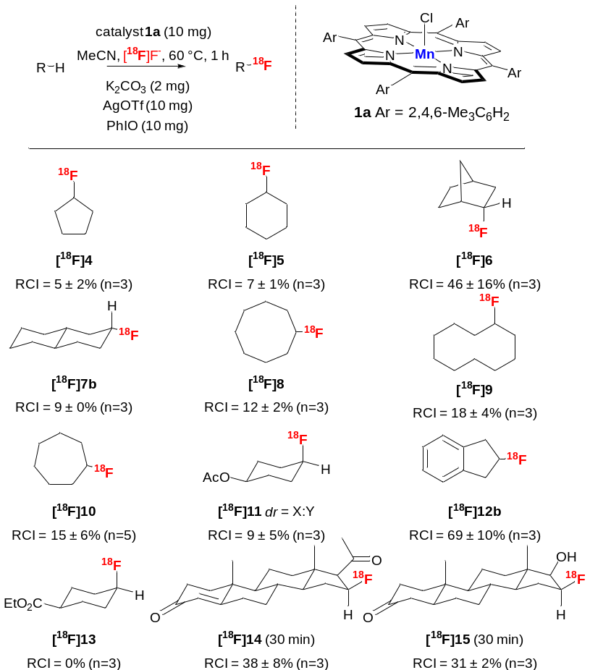
Figure 1. [¹⁸F]Fluorination of eleven cycloalkanes and derivatives using our optimised method (i.e. pre-catalyst 1a and oxidant PhIO (16a) 1:1 equiv. in MeCN for 60 min). The indicated diastereoisomers are tentatively assigned for compounds 6,7b,11 and 14-15; single peaks were observed by HPLC analysis (see ESI).
The reactions to give [¹⁸F]14 and [¹⁸F]15 (FHDT) displayed remarkable regio- and apparent stereoselectivity as well as functional group tolerance (to alcohol, carbonyl and alkene functions) and were conducted in just 30 min. The conventional [¹⁸F]FDHT radiochemical syntheses take ca. 100 min from a pre-functionalised precursor and give similar RCI.^{36,37} It is notable that the 2 most efficiently labelled substrates are the originally optimised cycloalkanes: norbornane (→ [¹⁸F]6, RCI 46%) and indane (→ [¹⁸F]12b, RCI 69%) and that the latter labels exclusively in the non-benzylic position. All the labelling reactions were run at least in triplicate and the consistency between repeats was high, indicating a high degree of reproducibility.
Although the final RCIs obtained by this method are moderate, the simplicity of the protocol, combined with the fact that no special precursor derivatives need to be prepared make this approach attractive particularly for applications where access to pre-functionalised derivatives is synthetically problematic. Automation of the protocol should also be feasible although the viscosity of the current reaction mixtures will likely need to be reduced.
Conclusion
In summary, we have described a method for radiolabelling aliphatic molecules via site-selective oxidative C-H fluorination with [¹⁸F]fluoride to give [¹⁸F]fluorocycloalkane compounds. Optimisation has allowed [¹⁸F]fluorination of 11 cycloalkanes with low to moderate RCIs including the labelling of clinically relevant progesterone analogues. This late-stage method is notable for completely circumventing the normal requirement for ‘pre-functionalisation’ or introduction of activating groups into the substrate; the reactions are achieved directly on unmodified target molecules using a simple non-technically demanding protocol. Future studies will focus on further exploring the scope and yield of the method, its application to additional clinically relevant tracers and adapting the method for automated clinical PET probe production.
Acknowledgements
The authors acknowledge MRC Advanced Course Masters MR/J015881/1 award (MRes in Bioimaging Sciences) for SC and JAR and Cancer Research UK grants C2536/A10337 and C2536/A16584. EOA acknowledges infrastructure support from Imperial College NIHR Biomedical Research Centre, Imperial College Experimental Cancer Medicines Centre and the (Imperial) National Cancer Imaging Translational Accelerator.
References
(1) Kubota, K. From Tumor Biology to Clinical PET: A Review of Positron Emission Tomography (PET) in Oncology. Ann. Nucl. Med. 2001, 15 (6), 471–486. https://doi.org/10.1007/BF02988499.
(2) Hargreaves, R. J. The Role of Molecular Imaging in Drug Discovery and Development. Clin. Pharmacol. Ther. 2008, 83 (2), 349–353. https://doi.org/10.1038/sj.clpt.6100467.
(3) Donnelly, D. J. Small Molecule PET Tracers in Drug Discovery. Semin. Nucl. Med. 2017, 47 (5), 454–460. https://doi.org/https://doi.org/10.1053/j.semnuclmed.2017.05.006.
(4) Kelkar, S. S.; Reineke, T. M. Theranostics: Combining Imaging and Therapy. Bioconjug. Chem. 2011, 22 (10), 1879–1903. https://doi.org/10.1021/bc200151q.
(5) Ametamey, S. M.; Honer, M.; Schubiger, P. A. Molecular Imaging with PET. Chem. Rev. 2008, 108 (5), 1501–1516. https://doi.org/10.1021/cr0782426.
(6) Preshlock, S.; Tredwell, M.; Gouverneur, V. 18F-Labeling of Arenes and Heteroarenes for Applications in Positron Emission Tomography. Chem. Rev. 2016, 116 (2), 719–766. https://doi.org/10.1021/acs.chemrev.5b00493.
(7) Wang, J.; Sánchez-Roselló, M.; Aceña, J. L.; del Pozo, C.; Sorochinsky, A. E.; Fustero, S.; Soloshonok, V. A.; Liu, H. Fluorine in Pharmaceutical Industry: Fluorine-Containing Drugs Introduced to the Market in the Last Decade (2001-2011). Chem. Rev. 2014, 114 (4), 2432–2506. https://doi.org/10.1021/cr4002879.
(8) Gillis, E. P.; Eastman, K. J.; Hill, M. D.; Donnelly, D. J.; Meanwell, N. A. Applications of Fluorine in Medicinal Chemistry. J. Med. Chem. 2015, 58 (21), 8315–8359. https://doi.org/10.1021/acs.jmedchem.5b00258.
(9) d’Amico, A. Review of Clinical Practice Utility of Positron Emission Tomography with 18F-Fluorodeoxyglucose in Assessing Tumour Response to Therapy. Radiol. Med. 2015, 120 (4), 345–351. https://doi.org/10.1007/s11547-014-0446-4.
(10) Vingerhoets, F. J. G.; Schulzer, M.; Ruth, T. J.; Holden, J. E.; Snow, B. J. Reproducibility and Discriminating Ability of Fluorine-18-6-Fluoro-L-Dopa PET in Parkinson’s Disease. J. Nucl. Med. 1996, 37 (3), 421–426.
(11) Jacobson, O.; Kiesewetter, D. O.; Chen, X. Fluorine-18 Radiochemistry, Labeling Strategies and Synthetic Routes. Bioconjug. Chem. 2015, 26 (1), 1–18. https://doi.org/10.1021/bc500475e.
(12) Mossine, A. V; Brooks, A. F.; Ichiishi, N.; Makaravage, K. J.; Sanford, M. S.; Scott, P. J. H. Development of Customized [18F]Fluoride Elution Techniques for the Enhancement of Copper-Mediated Late-Stage Radiofluorination. Sci. Rep. 2017, 7 (1), 233. https://doi.org/10.1038/s41598-017-00110-1.
(13) Brooks, A. F.; Topczewski, J. J.; Ichiishi, N.; Sanford, M. S.; Scott, P. J. H. Late-Stage [ 18 F]Fluorination: New Solutions to Old Problems. Chem. Sci. 2014, 5 (12), 4545–4553. https://doi.org/10.1039/C4SC02099E.
(14) Sanford, M. S.; Scott, P. J. H. Moving Metal-Mediated 18 F-Fluorination from Concept to Clinic. ACS Cent. Sci. 2016, 2 (3), 128–130. https://doi.org/10.1021/acscentsci.6b00061.
(15) Lee, E.; Kamlet, A. S.; Powers, D. C.; Neumann, C. N.; Boursalian, G. B.; Furuya, T.; Choi, D. C.; Hooker, J. M.; Ritter, T. A Fluoride-Derived Electrophilic Late-Stage Fluorination Reagent for PET Imaging. Science (80-. ). 2011, 334, 639–642. https://doi.org/10.1126/science.1212625.
(16) Kamlet, A. S.; Neumann, C. N.; Lee, E.; Carlin, S. M.; Moseley, C. K.; Stephenson, N.; Hooker, J. M.; Ritter, T. Application of Palladium-Mediated 18F-Fluorination to PET Radiotracer Development: Overcoming Hurdles to Translation. PLoS One 2013, 8 (3), e59187. https://doi.org/10.1371/journal.pone.0059187.
(17) Lee, E.; Hooker, J. M.; Ritter, T. Nickel-Mediated Oxidative Fluorination for PET with Aqueous [18F] Fluoride. J. Am. Chem. Soc. 2012, 134 (42), 17456–17458. https://doi.org/10.1021/ja3084797.
(18) Ren, H.; Wey, H.-Y.; Strebl, M.; Neelamegam, R.; Ritter, T.; Hooker, J. M. Synthesis and Imaging Validation of [18F]MDL100907 Enabled by Ni-Mediated Fluorination. ACS Chem. Neurosci. 2014, 5 (7), 611–615. https://doi.org/10.1021/cn500078e.
(19) Hoover, A. J.; Lazari, M.; Ren, H.; Narayanam, M. K.; Murphy, J. M.; van Dam, R. M.; Hooker, J. M.; Ritter, T. A Transmetalation Reaction Enables the Synthesis of [18F]5-Fluorouracil from [18F]Fluoride for Human PET Imaging. Organometallics 2016, 35 (7), 1008–1014. https://doi.org/10.1021/acs.organomet.6b00059.
(20) Ichiishi, N.; Brooks, A. F.; Topczewski, J. J.; Rodnick, M. E.; Sanford, M. S.; Scott, P. J. H. Copper-Catalyzed [18F]Fluorination of (Mesityl)(Aryl)Iodonium Salts. Org. Lett. 2014, 16 (12), 3224–3227. https://doi.org/10.1021/ol501243g.
(21) McCammant, M. S.; Thompson, S.; Brooks, A. F.; Krska, S. W.; Scott, P. J. H.; Sanford, M. S. Cu-Mediated C–H 18F-Fluorination of Electron-Rich (Hetero)Arenes. Org. Lett. 2017, 19 (14), 3939–3942. https://doi.org/10.1021/acs.orglett.7b01902.
(22) Mossine, A. V; Brooks, A. F.; Makaravage, K. J.; Miller, J. M.; Ichiishi, N.; Sanford, M. S.; Scott, P. J. H. Synthesis of [18F]Arenes via the Copper-Mediated [18F]Fluorination of Boronic Acids. Org. Lett. 2015, 17 (23), 5780–5783. https://doi.org/10.1021/acs.orglett.5b02875.
(23) Tredwell, M.; Preshlock, S. M.; Taylor, N. J.; Gruber, S.; Huiban, M.; Passchier, J.; Mercier, J.; Génicot, C.; Gouverneur, V. A General Copper-Mediated Nucleophilic 18 F Fluorination of Arenes. Angew. Chemie Int. Ed. 2014, 53 (30), 7751–7755. https://doi.org/10.1002/anie.201404436.
(24) a) Graham, T. J. A.; Lambert, R. F.; Ploessl, K.; Kung, H. F.; Doyle, A. G. Enantioselective Radiosynthesis of Positron Emission Tomography (PET) Tracers Containing [18F]Fluorohydrins. J. Am. Chem. Soc. 2014, 136 (14), 5291–5294. https://doi.org/10.1021/ja5025645. b) Webb, E. W.; Park, J. B.; Cole, E. L.; Donnelly, D. J.; Bonacorsi, S.J.; Ewing, W. R.; Doyle A.G. Nucleophilic (Radio)Fluorination of Redox-Active Esters via Radical-Polar Crossover Enabled by Photoredox Catalysis. J. Am. Chem. Soc. 2020, 142 (20), 9493–9500. https://dx.doi.org/10.1021/jacs.0c03125.
(25) Buckingham, F.; Kirjavainen, A. K.; Forsback, S.; Krzyczmonik, A.; Keller, T.; Newington, I. M.; Glaser, M.; Luthra, S. K.; Solin, O.; Gouverneur, V. Organomediated Enantioselective 18 F Fluorination for PET Applications. Angew. Chemie Int. Ed. 2015, 54 (45), 13366–13369. https://doi.org/10.1002/anie.201506035.
(26) Buckingham, F.; Gouverneur, V. Asymmetric 18F-Fluorination for Applications in Positron Emission Tomography. Chem. Sci. 2016, 7 (3), 1645–1652. https://doi.org/10.1039/C5SC04229A.
(27) Nodwell, M. B.; Yang, H.; Čolović, M.; Yuan, Z.; Merkens, H.; Martin, R. E.; Bénard, F.; Schaffer, P.; Britton, R. 18F-Fluorination of Unactivated C–H Bonds in Branched Aliphatic Amino Acids: Direct Synthesis of Oncological Positron Emission Tomography Imaging Agents. J. Am. Chem. Soc. 2017, 139 (10), 3595–3598. https://doi.org/10.1021/jacs.6b11533.
(28) Huang, X.; Liu, W.; Ren, H.; Neelamegam, R.; Hooker, J. M.; Groves, J. T. Late Stage Benzylic C–H Fluorination with [ 18 F]Fluoride for PET Imaging. J. Am. Chem. Soc. 2014, 136 (19), 6842–6845. https://doi.org/10.1021/ja5039819.
(29) Liu, W.; Groves, J. T. Manganese Catalyzed C–H Halogenation. Acc. Chem. Res. 2015, 48 (6), 1727–1735. https://doi.org/10.1021/acs.accounts.5b00062.
(30) Liu, W.; Huang, X.; Placzek, M. S.; Krska, S. W.; McQuade, P.; Hooker, J. M.; Groves, J. T. Site-Selective 18F Fluorination of Unactivated C-H Bonds Mediated by a Manganese Porphyrin. Chem. Sci. 2018. https://doi.org/10.1039/C7SC04545J.
(31) Carroll, L.; Evans, H. L.; Spivey, A. C.; Aboagye, E. O. Mn–Salen Catalysed Benzylic C–H Activation for the Synthesis of Aryl [ 18 F]CF 3 -Containing PET Probes. Chem. Commun. 2015, 51 (40), 8439–8441. https://doi.org/10.1039/C4CC05762G.
(32) Bume, D. D.; Harry, S. A.; Lectka, T.; Pitts, C. R. Catalyzed and Promoted Aliphatic Fluorination. J. Org. Chem. 2018, 83 (16), 8803–8814. https://doi.org/10.1021/acs.joc.8b00982.
(33) Groves, J. T.; Stern, M. K. Synthesis, Characterization, and Reactivity of Oxomanganese(IV) Porphyrin Complexes. J. Am. Chem. Soc. 1988, 110 (26), 8628–8638. https://doi.org/10.1021/ja00234a009.
(34) Geraskin, I. M.; Pavlova, O.; Neu, H. M.; Yusubov, M. S.; Nemykin, V. N.; Zhdankin, V. V. Comparative Reactivity of Hypervalent Iodine Oxidants in Metalloporphyrin-Catalyzed Oxygenation of Hydrocarbons: Iodosylbenzene Sulfate and 2-Iodylbenzoic Acid Ester as Safe and Convenient Alternatives to Iodosylbenzene. Adv. Synth. Catal. 2009, 351 (5), 733–737. https://doi.org/10.1002/adsc.200800784.
(35) Nassar, E.; El-Farargy, A. F.; Abdelrazek, F. M. Synthesis of Some Novel Cyclooctane-Fused-Heterocycles with Anticipated Biological Activities. J. Heterocycl. Chem. 2015, 52 (5), 1395–1399. https://doi.org/10.1002/jhet.2246.
(36) Larson, S. M.; Morris, M.; Gunther, I.; Beattie, B.; Humm, J. L.; Akhurst, T. A.; Finn, R. D.; Erdi, Y.; Pentlow, K.; Dyke, J.; et al. Tumor Localization of 16{beta}-18F-Fluoro-5{alpha}-Dihydrotestosterone Versus 18F-FDG in Patients with Progressive, Metastatic Prostate Cancer. J. Nucl. Med. 2004, 45 (3), 366–373.
(37) Lazari, M.; Lyashchenko, S. K.; Burnazi, E. M.; Lewis, J. S.; Michael van Dam, R.; Murphy, J. M. Fully-Automated Synthesis of 16β-18F-Fluoro-5α-Dihydrotestosterone (FDHT) on the ELIXYS Radiosynthesizer. Appl. Radiat. Isot. 2015, 103 (Supplement C), 9–14. https://doi.org/https://doi.org/10.1016/j.apradiso.2015.05.010.

