The determination of oxidation rates and quantum yields during the photocatalytic oxidation of As(III) over TiO₂

Hany Fathy Heiba,^{a,b}* Jay C. Bullen,ª Andreas Kafizas,^{c,d} Camille Petit,^{e} Stephen J Skinner,^{f} Dominik Weiss^{a,g}*

ª Department of Earth Science & Engineering, Imperial College London, London, SW7 2AZ, UK
^{b} Marine Chemistry Department, Environmental Division, National Institute of Oceanography and Fisheries (NIOF), Alexandria, Egypt
^{c} Department of Chemistry, Molecular Science Research Hub, Imperial College London, London, W12 0BZ, UK
^{d} The Grantham Institute, Imperial College London, London, SW7 2AZ, UK
^{e} Barrer Centre, Department of Chemical Engineering, Imperial College London, London SW7 2AZ, UK
^{f} Department of Materials, Imperial College London, London SW7 2AZ, UK
^{g} The Department of Civil and Environmental Engineering, Princeton University, Princeton, New Jersey 08544, United States

*corresponding authors
h.heiba@imperial.ac.uk, d.weiss@imperial.ac.uk

Graphical abstract
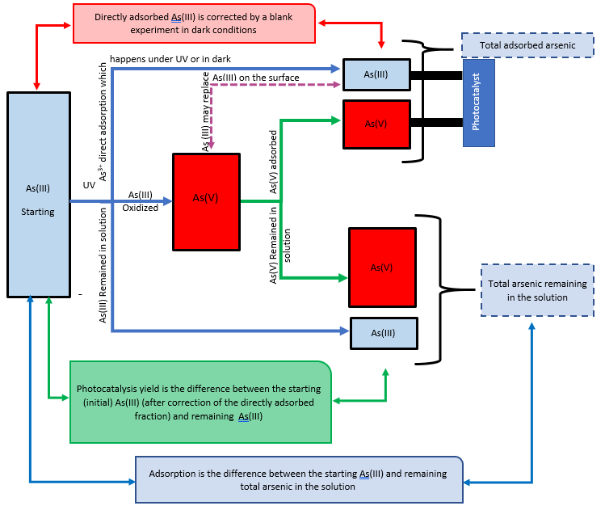

Abstract
The determination of reaction rates for the photocatalytic oxidation (PCO) of arsenite (As(III)) using TiO₂ using UV radiation is challenging due to the numerous experimental processes. This includes chemical processes running simultaneously with PCO (e.g. adsorption of arsenic species, direct UV photolysis of As(III)) and the analytical approach used (e.g. whether As(III) or As(V) are measured and used in the calculation of the PCO rate). The various experimental approaches used to date have led to oxidation rates and rate constants which vary by orders of magnitude and contradicting information on rate laws. Here we present the results of a critical examination of possible controls affecting the experimental determination of PCO rates. First, we demonstrate that the choice of analytical technique is not critical, provided that the rate constants are calculated based on the depletion of As(III) after correction of the directly adsorbed As(III). Second, we show the correction of the directly adsorbed As(III) at each time interval is best done by running two parallel experiments (one under UV and the other in dark) instead of running sequential experiment (i.e. running the experiment in the dark then turning on the UV lamp). These findings are supported by XPS analysis of the oxidation state of TiO₂-sorbed As. Third, we demonstrate that photolysis by the light source itself, as well as the chemical composition of the solution (i.e. the presence of HEPES and the ionic strength), can significantly increase As(III) oxidation rates and need to be corrected. Finally, to determine the quantum yield of As(III) oxidation, we measured the photon absorption by the TiO₂ photocatalyst. Our results showed that the quantum yield (Ø) for this oxidation reaction was low, and in the region of 0.1 to 0.2 %.
Keywords
Photocatalysis, PCO kinetic rates, Arsenite Oxidation, Arsenic species analysis, Molar absorptivity, Quantum yield.

Introduction
Arsenic is a potent carcinogen, with tens of millions of people exposed to dangerous levels worldwide [1]. Due to severe toxicity, in 2009 the World Health Organization (WHO) imposed strict regulations lowering the permitted level of arsenic in drinking water from 50 to 10 μg L⁻¹ [2–4]. The toxicity of arsenic is determined by its speciation: inorganic arsenic is more harmful than organic arsenic [3,4], and inorganic arsenite (As(III)) is 60 times more toxic than inorganic arsenate (As(V)). The removal of As(III) from contaminated water is more challenging [5] since it predominantly forms non-ionic species at neutral and acidic pH (H₃AsO₃), whereas As(V) exists as anionic species (H₂AsO₄⁻ and HAsO₄²⁻) [6]. Therefore, effective water treatment necessitates the oxidation of As(III) to As(V) prior to its removal using strategies such as adsorption, precipitation, or ion exchange [7].
Photocatalytic oxidation (PCO) of As(III) to As(V) using TiO₂ is a promising solution [8] due to the high chemical stability, corrosion resistance, non-toxicity and photocatalytic activity of the material [9]. The accurate determination of oxidation rates is crucial to successfully implement photocatalysts into arsenic treatment plants [10], however, this is challenged by various process that occur during the experimental determination, such as co-occurring adsorption (Fig. S1). To date, investigations of the photocatalytic oxidation of As(III) using TiO₂ have reported a wide range of rates. For instance, Bissen et al. identified first-order kinetics, with respect to aqueous As(III), during the oxidation of 50 μg L⁻¹ As(III) using Degussa P25 TiO₂ (0.001-0.05 g L⁻¹) [11]. In contrast, Dutta et al. found zero-order kinetics during the oxidation of 3-25 mg L⁻¹ As(III), using Degussa P25 TiO₂ (0.1 g L⁻¹) [12].
Table 1 highlights the wide variety of experimental conditions under which the PCO of As(III) has been investigated. Whilst the light intensity is often stated, it is normally provided only (i) normalized to surface area, or (ii) normalized to volume. It has been shown that As(III) PCO rates change from first-order to zero-order as light intensity is increased [11]. To date, no study has considered how (i) the choice of analysis method (e.g. HPLC-ICP-MS, spectrochemical UV-Vis molybdenum blue, etc.), and (ii) the choice of sequential versus parallel measurements affects the derived PCO kinetics.
Table 1: The variety of experimental conditions used in the PCO of As(III) using TiO₂
Light source (nm) | Light intensity (mW cm⁻²) | Light intensity (mW L⁻¹) | TiO₂  (g L⁻¹) | [As (III)]  (mg L⁻¹) | pH | electrolyte | Dark absorption (hr) | Analysis method | reference
Xe lamp (polychromatic) | 3*10⁻⁵ Einstein m² s⁻¹ (renormalise units) | ns | 0.001-0.05 | 0.1 | 5,7,9 | blank | 0 | [As(III)] HPLC-ICP-MS | [13]
Hg lamp (polychromatic) | 213 W m⁻² (renormalise units) | ns | 0.01, 0.1 | 3--25 | 4, 9 | benzoic acid, salicylic acid,  17 μM Fe(III) | 2 | [As(V)] UV-Vis/molybdenum blue | [12]
UVC lamp (254 nm) | 8.9 | ns | 0.01-1 | 0.1-1 | 6.7 | blank | 2 | [As(III)] Anion exchange/HGAAS | [14]
Xe arc lamp (>300 nm) | 300 | 3.46 *10-3 Einstein L⁻¹ min⁻¹ | 0.5 | 15 | 3 | blank, formic acid, methanol, or t-butanol | 0.5 | [As(V)]  Ion chromatography | [15]
UVA lamp (8 W, 365 nm) | ns | ns | 0.05 | 42 | 6.4 | NaNO₃ | ns | [As(III)]  LC-ICPMS | [16]
Hg lamp (125 W, λ_{max} = 366 nm) | ns | 127 μ Einstein s⁻¹ L⁻¹ | 1 | 39 | 3 | Blank, 0.4 M MeOH | ns | [As(V)] UV-Vis  molybdenum blue | [17]
Xe arc lamp (300 W, < 300 nm) | ns | ns | 1.5 | 37 | 3, 9 | t-BuOH, blank | ns | IC-ICPMS | [18]
Hg lamp (125 W, λ_{max} = 366 nm) | ns | ns | 1 | 25 | 7 | blank | 0.5 | [As(V)] UV-Vis/molybdenum blue | [19]
UV lamp (320 -400 nm) | 4.25 | ns | 0.25 | 1-100 | 4, 7, 9 | Blank | 1 | [As(V)] UV-Vis/molybdenum blue | [20]
ns = not stated; blank = de-ionised water
Like most mineral oxides, TiO₂ adsorbs As(V) with the formation of covalently-bonded inner-sphere surface complexes [21]. This can form a significant proportion of the total arsenic added to a TiO₂ suspension when the total As concentration is low. Most studies measure the PCO of As(III) on TiO₂ using the sequential method, where first the experiment is run in the dark until As(III) adsorption reaches an equilibrium and then the kinetics of PCO are measured starting from the point at which the UV light source is turned on [22–24]. However, if one measures the kinetics of PCO using aqueous As(III) alone, the desorption of As(III) from TiO₂, following the competitive adsorption of As(V), will possibly lead to an underestimation of the PCO yield. In contrast, if one measures the PCO of As (III) using the parallel method, where two identical solutions are measured in parallel, with one being in the dark and the other in the light, without accounting for equilibrium adsorption the adsorption of As(III) to TiO₂ should lead one to overestimate the PCO kinetics (unless one corrects for the fraction of adsorbed As(III)).
The primary techniques used to determine arsenic speciation are (i) solid phase extraction using ion exchange resins to analyse both As(III) and As(V) [25], (ii) determination of [As(V)] using UV-Vis spectroscopy and the molybdenum blue method [26], and (iii) determination of [As(III)] using anodic stripping voltammetry [27].
Many PCO studies monitor the PCO kinetics using [As(V)_{(aq)}] alone (Table 1). In these studies, the adsorption of As(V) in both sequential and parallel experiments will lead to underestimation of the true PCO yield. The competitive adsorption between As(III) and As(V) is a complex process, whilst As(V) shows a stronger affinity for the inner sphere complexation to mineral oxide surfaces, adsorption capacities are often greater for As(III) at neutral pH, due to the formation of multilayer surface precipitates [28]. Consequently, when a significant fraction of total arsenic is adsorbed, the speciation of the adsorbed phase must be accounted for. Additionally, there are other important processes that can affect the determination of PCO rate of As(III) by TiO₂ and are often overlooked in the literature and poorly quantified to date. These include the UV induced photolysis of As(III) (i.e. light-mediated and not catalyst-mediated oxidation to As(V)). Aqueous phase UV photolysis of As(III) is significant under certain conditions, and the PCO quantum yield is greater than unity have been reported using hard ultraviolet light [29]. In addition, the ionic strength of the electrolyte ions and the presence of ions such as chloride (Cl⁻) and bicarbonate (HCO₃⁻) are known to promote other photocatalytic reactions through the formation of reactive oxygen species (ROS) intermediates [30,31].
Equally important is the determination of the quantum yield (Ø) of the PCO of As(III) by TiO₂, which is often not reported [29]. The quantum yield offers a more universally comparable measure of the photocatalytic activity due to the vastly different experimental set-ups and light sources used to date in the PCO of As(III) to As(V) [32].
The aim of this study was to characterise and to better understand the processes that control the determination of As(III) PCO rates, and to develop guidelines for best practice. To this end, we first assess possible differences in the calculated PCO yield when, (i) determining [As(V) (aq)] using the spectrochemical UV-Vis molybdenum blue method, (ii) determining [As(III) (aq)] using anodic stripping voltammetry (ASV) and (iii) using calculated As(III) concentration from measured As(V) and total As using ICP-MS. Second, we compare the widely used sequential method with an alternative strategy, where two experiments are run in parallel, one under UV light to drive the PCO reaction, and the other in the dark as an absorption control. We show that this method is superior to the sequential method, as it provides a point of reference of As(III) adsorption to TiO₂ for each time interval where As(III) is determined (analytically or calculated) during the PCO reaction (where the sequential method relies on a single measure of absorption at equilibrium). Third, we quantify the effect on PCO rates by processes other than photocatalysis, such as direct photolysis (due to visible and UV light) and the reaction medium (e.g. HEPES buffer and ionic strength). Forth, we determine for the quantum yield of the PCO reaction, and show how this measure can provide insight on how the setup can be improved. And finally, we make recommendations on the experimental set up that should be used when measuring the PCO of As(III).

Materials and Methods

Chemicals and reagents
All chemicals and reagents were of analytical grade. Ultrapure water was used in all experiments. All glassware was cleaned using 1% nitric acid (VWR) followed by distilled water washing and then left to dry. A stock solution of 1,000 mg/L As(V) was prepared by dissolving Na₂HAsO₄.₇H₂O (Sigma Aldrich) in ultrapure water. A stock solution of 1,000 mg/L As(III) was prepared by dissolving As₂O₃ in 1 M NaOH and making up to volume using ultrapure water. The pH was adjusted to 7.4 using 1 M HCl (VWR) and 1 M NaOH. Working solutions were prepared by sequential dilution of the stock solutions. A molybdenum blue solution (100 ml) was prepared by subsequently dissolving 0.5 g ammonium molybdate (Sigma Aldrich), 0.04 g potassium antimony tartrate (AnalaR), 4 mL conc. H₂SO₄ (95-99) % (VWR) and 0.5 g ascorbic acid (Sigma Aldrich) in ultrapure water. Anatase TiO₂ was obtained from Sigma Aldrich (99% purity), and P25 TiO₂ from Evonik.

Characterisation of TiO₂
X-ray diffraction (XRD) patterns were measured using a Bruker D2 Phaser X-ray diffractometer equipped with a Lynx-Eye detector and a monochromated Cu-K_{α} (1.5406 Å) X-ray source. Patterns were recorded between 2θ = 5 and 75°. A Le Bail model was fit to each pattern using the GSAS and EXPGUI software suite [33]. The surface morphology of anatase TiO₂ was imaged using scanning electron microscopy (SEM), using the high-resolution LEO Germini at 1525 at 5 kW in secondary electron mode (InLens detector). Surface analysis was performed using X-ray photoelectron spectroscopy (XPS), using the Thermo Scientific K-Alpha⁺ X-ray photoelectron spectrometer equipped with a MXR3 Al Kα monochromatic X-ray source (hν = 1486.6 eV). Samples were dried at 100 ºC for 4 hours to remove adsorbed water prior to analysis. Survey spectra and the <O1s, C1s etc> regions were recorded. XPS peaks were analysed using the CASAXPS software. Surface functional groups were measured by ATR-IR (NICOLET is5-iD7 ATR - Thermoscientific), the sample was scanned in the wavelength range 4000-400 cm⁻¹.

Photocatalytic oxidation kinetics
Photocatalytic oxidation (PCO) experiments were conducted using anatase TiO₂ (unless otherwise stated) under UV light using a purpose-made photoreactor (Fig. 1). The distance between the UV lamp (18 W UVA lamp – 370 nm; Sylvania) and the sample surface was 3.5 cm. At this distance, the light intensity at the surface of the TiO₂ suspension was per surface area was 5.59 mW cm⁻². The surface area of the reactor was 20.4 cm⁻², giving a light intensity of 1.14 mW L⁻¹. The UV lamp was turned on during in the oxidation step while it was off in the other experiment used to evaluate the adsorption fraction. Suspensions of 1 mg L⁻¹ As(III) and 0.1 g L⁻¹ TiO₂ (100 mL total volume) were prepared, with the pH adjusted to 7.4 using 1 M HCl and 1 M NaOH. Suspensions were stirred magnetically. Sequential experiments were carried out by stirring suspensions in the dark for 2 hr, and time t=0 corresponds to when the ultraviolet lamp was switched on. Parallel experiments, TiO₂ was added to the solution of As(III) at time t=0, with or without ultraviolet irradiation. Aliquots (1 mL) were collected at predetermined time intervals (1, 3, 5, 10, 20, 40, 60 and 120 mins) and centrifuged to separate TiO₂ from the aqueous phase. The concentration and speciation of arsenic in the aqueous phase was then determined.
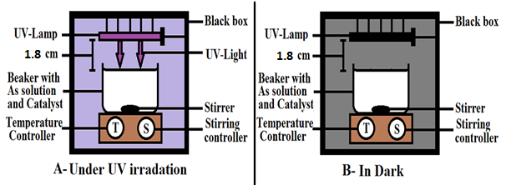
Fig. 1 Schematic diagram for the photoreactor (A- Samples under UV irradiation for PCO and B- Samples in dark while UV is off for adsorption correction). A suspension (100 mL) of 1 mg/L As(III) and 0.1 g/L TiO₂)

Analytical determination of As(V), As(III) and total As in solution
2.4.1. Spectrochemical UV-Vis molybdenum blue method
The spectrochemical molybdenum method was used to determine As(V) in solution. Using this method, 80 µl of the molybdenum analytical solution was added to 1 ml of 5 mg/L As(V) and 1 ml of 5 mg/L As(III) separately. The solutions were shaken well and left for 1 hr. to allow the complexation reaction to complete. The UV-visible absorption was then measured from 350 to 1000 nm. The molybdenum blue method is limited to detection of As(V) and not As(III) [34]. Total arsenic is thus determined by oxidizing As(III) to As(V) prior to the addition of molybdate. For total As determination, 100 µL KMnO₄ (0.32 mmol/L) was used oxidize all As(III) to As(V) and the solution was left for 1 hr before adding the molybdate reagent. After addition of the molybdate, samples were left for 1 hr and the absorbance at 882 nm measured. To verify the selectivity of this method, a series of different arsenic standards were prepared, with (i) 100% As(V), (ii) 50% As(V) and 50% As(III) and (iii) 100% As(III). The detailed validation procedures and results of the molybdenum blue method are presented in the SI (S3.2 Validation of the spectrochemical UV-Vis analytical method).
2.4.2. Square wave anodic stripping voltammetry
Concentrations of As(III) were determined electrochemically, using square wave anodic stripping voltammetry (SWASV) and a previously described method [27,35], using the Metrohm 663 VA Stand, the IME663 interface and the General Purpose Electrochemical System (GPES) software. Detection was made using a 25 µm diameter gold microwire working electrode, iridium wire auxiliary electrode, and a silver-silver chloride reference electrode (Ag/AgCl/NaNO₃(1M)). As(III) was detected at pH 2 (with the addition of 0.01 M HCl) in the presence of 40 μM hydrazine to prevent oxidation of arsenic. The solution was also purged of oxygen by bubbling nitrogen for several minutes prior to analysis. The working electrode was first conditioned at +0.7 V (5 s) before arsenic was deposited at -0.7 V (20 s). Arsenic was then stripped using a sweep between -0.5 and +0.7 V. The square wave profile had an amplitude of 50 mV, frequency of 50 Hz, and 8 mV step size. A background scan was recorded under the same operating conditions, albeit with only 1 s deposition, and subtracted from the analytical scan. The peak derivative was used for quantification. Uncertainties were calculated from the standard error between 2 or 3 measurements of the same example. The working electrode was conditioned each day by performing a cyclic voltammetry (CV) scan in 0.5 M H₂SO₄. The electrode was conditioned at -2.5 V (30 s), followed by 5 repeat scans between -0.2 and +1.5 V (scan rate 1 V s⁻¹).
2.4.3. Inductively coupled plasma mass spectroscopy
Concentrations of total As were validated using inductively coupled plasma mass spectroscopy (ICP-MS), using the Agilent 7900 quadrupole ICP-MS with a helium collision cell. Samples were acidified by addition of 2% (v/v) HNO₃. An external calibration curve was recorded using a certified single-element standard (Fluka, 1000 ± 4 mg L⁻¹, trace CERT), and the data was normalized to internal standards (yttrium).

Calculations of adsorption and PCO kinetic rates
To calculate the adsorption kinetics we need to calculate the adsorption capacity of TiO₂ at time t (Q_{t}) and at equilibrium (Q_{e}) [36] which were calculated using eqs. (1) and (2) respectively.
$Q_{t}= \frac{\left(C_{o}-C_{t}\right)V}{m}$ (1)
$Q_{e}= \frac{\left(C_{o}-C_{e}\right)V}{m}$ (2)
where C_{o}, C_{e} and C_{t} represent arsenic concentrations (µg/L) at the time (0) and at time (t) respectively, V is the sample volume in liter (L) and m is the TiO₂ mass in grams (g).
The first order kinetic rate (k₁ min⁻¹) is calculated using:
$\frac{\ln{C_{t}}}{C_{i}}=-kt$ (3)
Pseudo-second-order (PSO) kinetics is calculated using:
$\frac{t}{Q_{t}}=\frac{1}{{k_{2}Q}_{e}^{2}}+\frac{t}{Q_{e}}$ (4)
where k₂ (g mg⁻¹ min⁻¹) is the second order rate coefficient.
The standard deviation was calculated based on the linear fitness of the points.

Determination of the quantum yield of photocatalytic oxidation of As(III) to As(V)
The photon flux from the UV lamp (18 W UVA lamp, λ=370 nm, Sylvania) used in our PCO experiments was measured using an Ocean Optics detector (USB4000-VIS-NIR) equipped with a fiber optic cable (QP600-2-UV/BX) and processed using Spectra Suite software, scanning its emission from 350 nm to 1000 nm. The light intensity was measured using an optical power meter (PM 100, Thorlabs) connected to a power sensor (S120UV, Thorlabs).
To determine the photon flux, various short pass filters were used to prevent visible light from the lamp reaching the power meter (λ < 400 nm, λ < 475 nm and λ < 610 nm). Emission spectra were adjusted to achieve the corresponding measured photon energy output (J) using:
$J= \frac{hν}{C}$ (5)
where h represents the Planks constant, ν the frequency in (Hz) and c the speed of light in cm.s⁻¹. Lamp power was then converted to photon flux (cm⁻².s⁻¹) using:
$photon flux \left(Փ, cm^{-2}s^{-1}\right)= lamp power (W.cm^{-2})/ photon energy (J)$ (6)
The optical transmittance of powder suspensions of our photocatalyst (TiO₂ = 0.01 g/ 100 ml) was measured using a Shimadzu UV-2700 equipped with an integrating sphere. The transmittance was converted to molar absorptivity (ε, M⁻¹ cm⁻¹) at different pathlengths (l) using the Beer-Lambert law (Eq. 7):
$ε= \frac{A}{(c.l)}$ (7)
where A is the absorbance, C is the molar concentration and l is the pathlength in cm.
The photon flux (cm⁻².s⁻¹) absorbed at a given depth was determined using:
$I_{abs, ,l}=I_{0, }\left(1-{10}^{\left(-{ɛ }_{}∙c∙l\right)}\right)$ (8)
where I_{abs,λ} represents the photon fraction absorbed at the wavelength (λ) and pathlength (l), I_{o,λ} is the overall emitted photon flux at λ, ε_{λ} (M⁻¹ cm⁻¹) is the molar absorption coefficient, c (M) is the concentration of TiO₂ in water and l (cm) is the pathlength of the light solution.
The quantum yield (Ø) expresses the ratio between the number of converted species and the number of photons absorbed by the photocatalyst:
Ø = $\frac{reaction rate }{rate of photon absorption}$ (9)
where the reaction rate is given by Eq. 10 and the photon absorption rate is given by Eq. 11:
Reaction rate (moles.cm⁻².s⁻¹) = $\frac{reacted species \left(moles\right)}{time\left(s\right) ∙ surface area \left({cm}^{2}\right)}$ (10)
Rate of photon absorption (moles.cm⁻².s⁻¹) = $\frac{absorbed photons \left(moles\right)}{time\left(s\right) ∙ surface area \left({cm}^{2}\right)}$ (11)

Results and Discussions

Physical characterisation of TiO₂
Characterisation of the material structure is crucial in PCO studies therefore, XRD analysis was used to determine the crystal phases present in commercial TiO₂. The results (Fig. S2A) indicate a TiO₂ composition of 85.5 wt% anatase and 14.5 wt% rutile, with an average crystallite size of 25 nm in both phases; in line with previous studies [37]. SEM analysis showed a homogenous distribution of spherical-like structures with dimensions less than 50 nm in diameter (Fig. S2B). Characterisation of surface functional groups is important in studying the adsorption phenomena. IR characterisation of the TiO₂ sample (Fig. S2C) reveals bands at 660 cm⁻¹ for Ti-O-Ti lattice vibrations [38] and 400–650 cm⁻¹ for Ti–O stretching modes [39]. XPS analysis was used to confirm the purity of the TiO₂ surface (Fig. S2D; Table S1) and determine the valence band energy (Fig. S2E). Titanium (as Ti⁴⁺) and oxygen were present with 17 % and 51.9 % abundance by mass respectively (Table S1). Valence band analysis suggested a valence band energy relative to the Fermi level of 2.85 eV [40] which covers the oxidation potential of water.

Spectrochemical analysis of As species and cross-calibration using electrochemical and mass spectrometry
Spectrochemical analysis using the UV-vis molybdenum blue method was used to determine As(III) and As(V) concentrations in solution during the PCO of As(III) using TiO₂. The method is described and validated in detail in the SI (section S3.2, and Fig. S3 to Fig. S5). To further validate the spectrochemical the UV-vis molybdenum blue method, PCO experiments were also performed and the As (III) and As (V) concentrations measured using electrochemical SWASV and mass spectrometry ICP-MS methods. Fig. 2 compares the As(III) oxidation kinetics calculated by monitoring [As(III)_{(aq)}] and [As(V)_{(aq)}]. In the first case, ASV is used to directly monitor the decrease in [As(III)_{(aq)}]. In the second case, [As(III)_{(aq)}] is calculated by subtracting [As(V)_{(aq)}] from [total As_{(aq)}] where the spectrochemical method is used to determine [As(V)_{(aq)}] and ICP-MS to determine total [As_{(aq)}]. PCO experiments were carried out using a commercially available photocatalyst (Degussa P25 TiO₂). The measured concentrations for the same samples using both ASV and spectrochemical analyses are in very close agreement (Fig. 2A). First order kinetics were observed using both analytical methods (Fig. 2B). The respective reaction rates were 0.086 ± 0.004 min⁻¹ (R²=0.995) and 0.106 ± 0.005 (R²=0.993) for the ASV and spectrochemical UV-Vis molybdenum blue method, respectively. The T-test was 0.022 which means that there is a significant difference between the results if the two analytical techniques which should be considered. In our subsequent PCO measurements, changes in arsenic concentrations were measured exclusively using the spectrochemical UV-Vis molybdenum blue method.
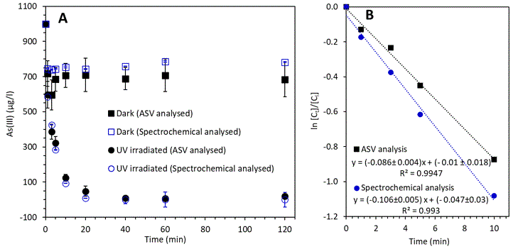
Fig. 2 PCO of As(III) on P25 TiO₂ analysed using ASV and UV-Vis molybdenum blue method (UV/Vis) [100 ml solution of As(III) = 1,000 µg/L, P25 TiO₂ = 0.01 g, pH = 7.4]. A- Decreases in [As(III) (aq)] with time. As(III) was measured directly using ASV or calculated using As(T)-As(V) with As(V) directly measured using UV-Vis. B- Linearised first order kinetic plots using the As(III) concentrations from Fig. 2A. The error bars represent the standard error based on triplicate measurements.

Correction of directly adsorbed As(III), parallel versus sequential methods
Fig. 3 shows the results of two photo oxidation experiments, one carried out using the sequential method (dark adsorption followed by UV irradiation) and one using the parallel method (one dark adsorption and one UV irradiation experiment run in parallel). Both As(III) and As(V) form inner-sphere covalently bonded surface complexes with TiO₂ (as shown in XPS results in section 3.5), resulting in a significant proportion of arsenic being adsorption during the determination of PCO kinetics (i.e. 30% as shown in Fig. 3A). To calculate the reaction kinetics in case of sequential method, we subtract the amount of arsenic adsorbed (before turning the UV lamp on) from the total decrease in arsenic at each point as presented in Fig. S6. In case of parallel method, at each time interval, we subtract the amount of arsenic absorbed in the dark from the decrease in arsenic seen under UV light.
The data were fit to first order kinetics and the statistical parameters are shown Table S2. For the sequential method, the PCO rate constant was 0.13 ± 0.001 min⁻¹, and for the parallel method the PCO rate constant was 0.083 ± 0.006 min⁻¹ without an adsorption correction and 0.040 ± 0.004 min⁻¹ with an absorption correction.
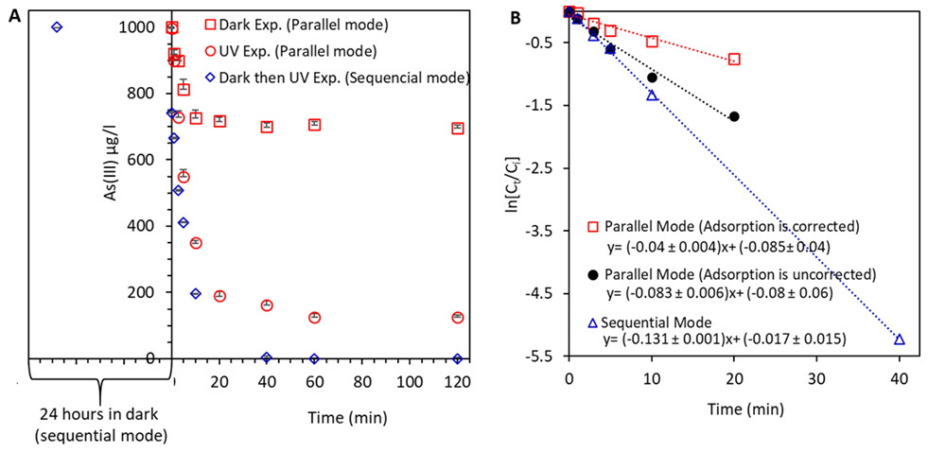
Fig. 3 A- PCO of As(III) on TiO₂ for sequential (dark adsorption followed by UV irradiation) and in parallel methods (one reaction carried out in the dark and one reaction carried out in UV light, in parallel). B- First order kinetics for sequential mode, parallel mode without As(III) adsorption correction and parallel mode after As(III) adsorption correction [100 ml solution of As(III) = 1,000 µg/L, TiO₂ = 0.01 g, pH = 7.4].
In the parallel mode, the PCO rate constant without correction of the directly adsorbed As(III) is twice the PCO rate constant after correction of the directly adsorption As(III). This is because the decrease in As(III) due to direct adsorption was counted as being oxidized, where in fact it is not. The rate constant (k₁) is lower (38%) for the in-parallel method than the sequential method. In the sequential method, we first allow adsorption of As(III) to the surface of TiO₂, and then we relate the subsequent decrease to one lower initial reference point after adsorption in dark (which herein is 742.2 µg/L, and is significantly less than the starting value of 1000 µg/L). It is this difference that results in a significant increase in the PCO rate for the sequential method.

Evaluation of PCO rates based on [As(III)] and [As(V)]
In order to describe the PCO of As(III) more precisely, the PCO rate constants were calculated and compared in two ways: (i) based on the depletion of aqueous As(III) applying Eq. 12 (option 1), and (ii) based on the generation of aqueous As(V) applying Eq. 13 (option 2). The results presented in Fig. 4 show that the PCO yields are underestimated by 7.1% at equilibrium (after 2 hrs) when the kinetics are derived from changes in As(V) concentrations. This difference can be explained by considering the speciation of TiO₂-adsorbed arsenic. As(V) has a higher affinity to be absorbed on TiO₂ than As(III) [41], and the adsorbed fraction of As(V) is masked from the solution and not captured by the spectrochemical method employed herein, as illustrated in Fig. S7 (this argument is further supported by the latter XPS study). Therefore, the decrease in As(III) concentration is recommended for a more precise calculation of the PCO rate.
${As}_{(oxidised at time X) } =[{As(III)]}_{(in dark at time X)} –{[As(III)]}_{(under UV at time X)}$ (12)
${As}_{(oxidised at time X) } ={[As\left(V\right)]}_{(under UV at time X)} –[{As(V)]}_{(in dark at time X)}$ (13)
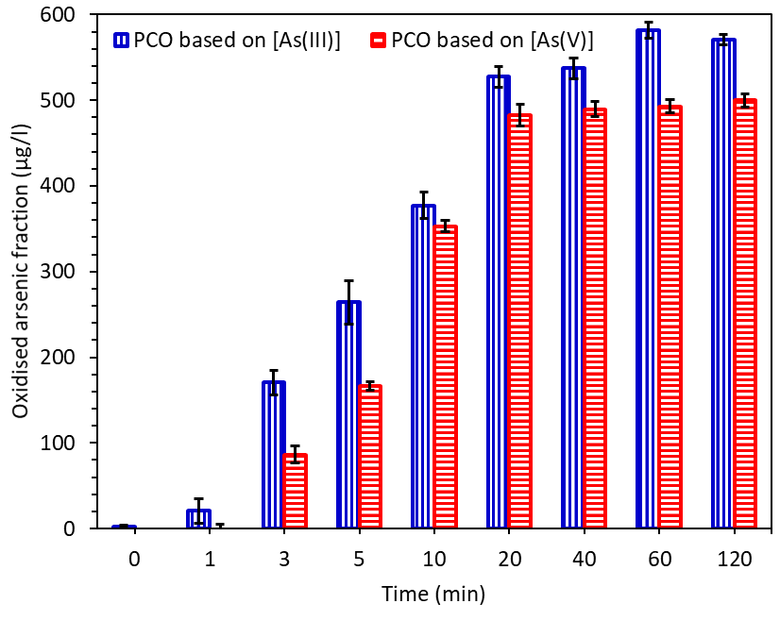
Fig. 4. The oxidized fraction of arsenic based on changes in the As(III) and As(V) concentration [100 ml of As(III) = 1,000 μg/L, TiO₂ = 0.01 g, pH 7.4], error bars represent the standard deviation.
To measure the surface adsorbed fraction of As(V), we used XPS to investigate the arsenic species adsorbed to the surface of TiO₂ after the PCO of As(III). A series of experiments were performed where the concentrations of As(V) and As(III) were monitored under UV irradiation and As(III) in the dark. After 2 hr, samples were centrifuged and TiO₂ was collected, dried, and analysed using XPS. The XPS survey scan for TiO₂ before and after photocatalysis is shown in Fig. S7 The results before PCO exhibit the binding energies (BEs) of C 1s, Ti 2p, O 1s, Ti2s at ~ 285, 459, 530.1, and 563 eV, respectively [41]. After the PCO experiment, a new XPS peak is observed at ~1327 eV, which is attributed to As 2p, in addition to changes in the O1s peak position and intensity (Fig. S8 and Table S3), which are indicative of arsenic species binding to the surface of TiO₂. The XPS peak deconvolution for As (2p) presented in Fig. 5 reveals the presence of arsenic (~1324-1331 eV) bound to the surface of TiO₂ after As(V) and As(III) adsorption under UV irradiation, and As(III) adsorption in the dark. The findings show that after adsorption and PCO of As(III), only As(V) is detected on the surface of TiO₂ at ~1327.6 eV. Whereas, with As(III) adsorption in the dark, only As(III) is detected on the surface of TiO₂ at ~1326.5 eV [42,43]. Previous findings show that the adsorbed As fraction after UV irradiation is mainly As(V), which supports our argument that As(V) adsorbs preferably on TiO₂ compared to As(III) [43]. Therefore, using aqueous As(V) as a measure for the oxidation process underestimates the PCO rates by failing to account for the significant amount of As(V) adsorbed to the surface of TiO₂. Since As(III) is a minor adsorbed species, determination of PCO kinetics using aqueous As(III) will likely provide a more accurate and precise PCO rate (as the error associated with adsorbed As(III) is smaller).
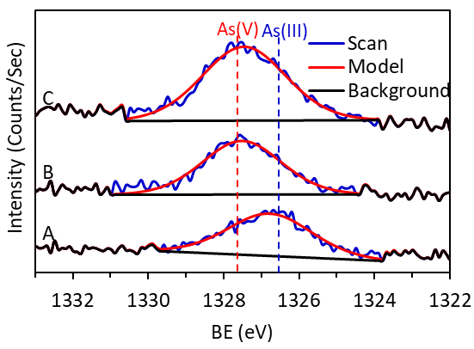
Fig. 5. XPS core scan for the As 2p binding energy region in A- TiO₂ anatase after adsorption of As(III) in the dark, B- TiO₂ anatase after adsorption of As(III) under UV PCO where the remaining concentration of As(III) in solution was 126 µg/L, and C- TiO₂ after adsorption of As(V) under UV [100 ml of As(III)/ As(V) = 100 μg/L, TiO₂ = 0.01 g, pH 7.4, 2 hrs].

Effect of PCO on the adsorption rates and capacity
One advantage of the parallel method is the capacity to distinguish between the adsorbed and oxidised fraction of arsenic at any time. Therefore, it is possible to calculate the PCO kinetics based on the remaining As(III) concentration in addition to the adsorption kinetics based on the remaining total arsenic concentration. The adsorption kinetics in the dark and under UV during the parallel experiment was calculated based on the remaining total arsenic concentration in the dark and under UV irradiation, where the kinetics was best fit with pseudo-second order adsorption (PSO) kinetics (Eq. 4), as shown in Fig. S10. The calculated parameters, presented in Table S4, show that the adsorption capacity is close to experimental values, where the experimental and calculated adsorption capacities under UV irradiation were 3.093 ± 0.01 and 3.184 ± 0.01 mg/g and in the dark were 2.4 ± 0.03 and 2.6 ± 0.03 mg/g respectively. The PCO resulted in a ~23% increase in adsorption (where adsorption capacity increased from 2.38 mg/g in the dark to 3.09 mg/g under UV irradiation after 120 mins). This increase in the adsorption is thanks to the PCO of As(III) to As(V), which has a greater tendency to be adsorbed by TiO₂.

Contribution of UV and visible light to direct photolysis of As(III)
Light oxidises As(III) through both PCO and photolysis [29]. The contribution of photolysis using UV and visible light was investigated in non-buffered media (100 ml of As(III) = 1,000 µg/L, pH = 7.4) without the addition of photocatalyst. Results showed that UV and visible light respectively contributed to 3.1% and 1.1% of the total As(III) oxidation after 2 hours (Fig. S11). UV light is more energetic than visible light and has a greater capacity to generate reactive oxygen species, and therefore contributes to a greater photolysis yield. Although UV photolysis contributed to the oxidation of As(III) (3.1%; 18 W UVA lamp, λ_{max} = 370 nm, 2 hrs of irradiance), it was minimal in comparison to the contribution of PCO, which oxidised more than 80% of As(III) to As(V) under the same conditions, as also seen in Fig. 3.
Previous studies in literature show an agreement with our findings. Tian et al., 2012 [45] reported that there is no significant change in As(III) concentration under visible light photolysis (using As (III) = 2 μg/L, 1 hr of irradiance). Whereas under UV irradiation, Wang et al., 2016 [46] reported a 4.1% oxidation (using As (III) = 200 μg/L, 30 W UVC lamp, λ_{max} =254 nm, 20 mins of irradiance).

Effect of solution composition on the PCO rates

Effect of HEPES buffer on PCO rates
HEPES buffer is used to maintain reaction pH during the PCO of As(III) to As(V) [47,48], however, no previous work has investigated its contribution to the oxidation process. This is despite the fact that HEPES buffer is known to promote the generation of intermediate oxidants; otherwise known as reactive oxygen species (ROS) [49]. In this work, we studied the effect of HEPES on the PCO of As(III) to As(V) by comparing activity in the HEPES-buffered system against an unbuffered solution. Fig. 6 shows that HEPES buffer enhanced the PCO yield, compared to unbuffered experiments, in both UV light and dark, by 12.6% and 32.8%, respectively. This rise in the oxidation yield in HEPES is likely due to the HEPES buffer stimulating free radical generation (e.g. ȮH radicals) that mediate the oxidation of As(III) to As(V) [49]. Our finding is further supported by Masson et al., 2008 and Lepe-Zuniga et al., 1987 [50,51] who reported that HEPES buffer generates hydrogen peroxide, which boosts the oxidation rate. The contribution of HEPES buffer towards As(III) oxidation is therefore significant and should be considered during the PCO rate calculations.
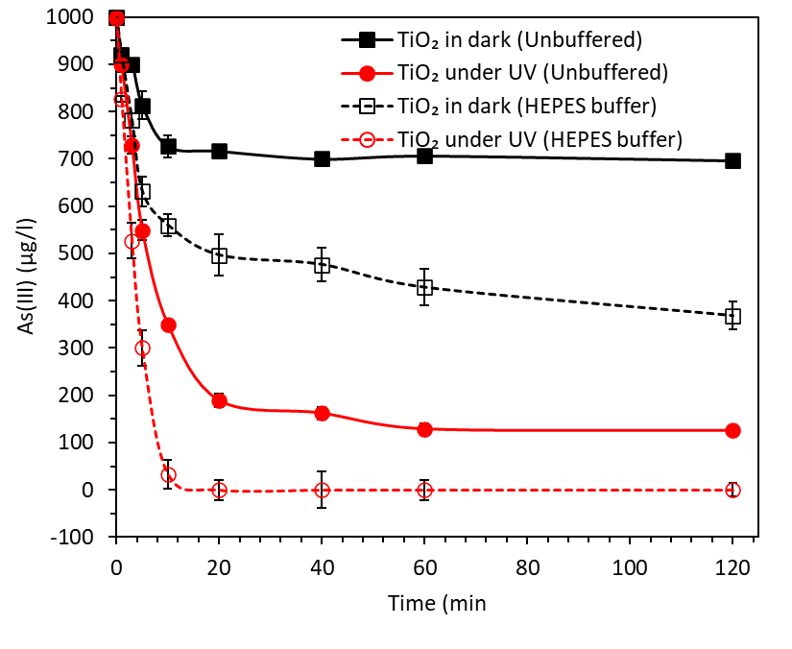
Fig. 6. Effect of HEPES buffer on the PCO of As(III) [100 ml of As(III) = 1,000 μg/L, TiO₂ = 0.01 g]. pH was adjusted to pH 7.4 using 10 mM HEPES for the buffered experiment and using NaOH/ HNO₃ for the unbuffered experiment, error bars represent the SD.

Effect of ionic strength on PCO rates
The effect of ionic strength on the PCO yield was studied, since previous studies have shown enhanced photocatalytic degradation of other contaminants in the presence of Cl⁻ due to the formation of ROS intermediates [30,52]. This experiment was conducted using synthetic seawater with different ionic strengths. The results are summarised in Fig. 7, with detailed raw results shown in Fig. S12. The results demonstrate that the higher ionic strength of seawater increases the PCO activity of TiO₂. We attribute this to the increasing presence of Cl⁻ ions that can assist the PCO of As(II) through the formation of reactive oxygen species Eqs. 14-16 [53–56]. First, Cl– is oxidised by the photogenerated hole and forms chlorine (Cl₂) Eq. 14, and in turn hypochlorous acid (HClO) Eq. 15. The formation of Cl₂ and HClO depend on the pH, and in neutral conditions HClO is a major component [53,54]. HClO is a strong oxidant which can either oxidise As(III) to As(V) (Eq. 16), enhancing PCO rates, or decompose to O₂ and Cl⁻ (Eq. 17) [57].
$4{ Cl}^{-} + 4{ h}^{+}+ \underset{→}{ hυ } {2Cl}_{2}$ (14)
${2Cl}_{2}+2H_{2}O ⇄2HClO+ {2H}^{+}+ {2Cl}^{-}$ (15)
$2HClO +As\left(III\right)\underset{→}{ hυ } As\left(V\right)+O_{2}+{2H}^{+}+ {2Cl}^{-}$ (16)
$2HClO \underset{→}{ hυ } O_{2}+2H^{+}+ {2Cl}^{-}$ (17)

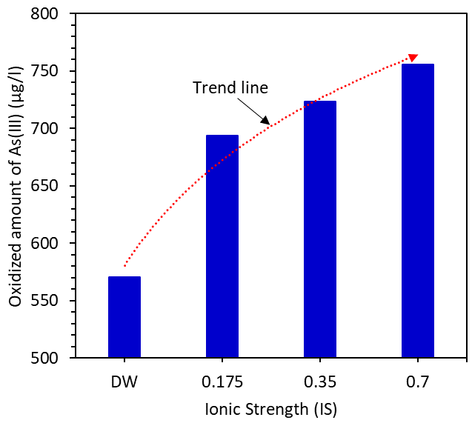
Fig. 7. Effect of ionic strength on the PCO of As(III) to As(V) [DW = deionised water, 0.175 IS = 25% synthetic seawater, 0.35 IS = 50% synthetic seawater and 0.7 IS = 100% synthetic seawater], [Conditions; 100 ml of As(III) = 1,000 μg/L, TiO₂ = 0.01 g, pH=7.4].

Photon flux absorption, penetration depth and quantum yield
In most experimental arrangements, the PCO rate will depend upon the intensity of the irradiation [12]. Therefore, determining the photon flux and quantum yield is necessary to understand the relationship between light input and reaction.
We achieved this by determining the spectral output of our lamp, light intensity delivered to the suspension, and the proportion of light absorbed by the TiO₂ suspension.
The lamp showed a broad emission band in the UV region, centered at ~370 nm, and some sharp emission bands in the visible region at ~405 nm, ~430 nm, ~545 nm and ~580 nm. The counts/energy and cumulative counts/energy are presented in (Fig. S13). By comparing the intensity of light capable of exciting the TiO₂ photocatalyst (i.e. with wavelengths smaller than the bandgap of TiO₂ at ~387 nm) against the total intensity of light emitted by the lamp, we calculated that our TiO₂ photocatalyst is capable of absorbing ~37% of emitted photons from the lamp (or rather, ~45% of the total energy emitted).
The penetration depth describes the depth penetrated by the light before being absorbed. The overall emitted photon flux was determined, as described in section 2.6, using Eq. 5 and Eq. 6, with the results shown in Fig. S14. In order to calculate the flux absorbed with solution depth, we first measured the transmittance of our photocatalyst suspended in water (TiO₂ = 0.01 g/ 100 ml) and used this to determine the molar absorptivity at various wavelengths (350 - 400 nm) using Eq. 7 as presented in Fig. S15. The photon flux absorbed at different penetration depths was then determined using Eq. 8 [58]. The results presented in Fig. 8 shows that all UV light was absorbed upon travelling ~2.0 cm into the solution, with shorter wavelengths absorbed at shallower depths. Given that our reactions were carried out in vessels 5.6 cm deep, this indicates that the majority of incident UV light is absorbed nearest to the surface of the solution. This is important, as in more dilute TiO₂ suspensions, where the penetration depth is less, energy may be lost due to transmittance through the reactor vessel, resulting in a decrease in PCO efficiency.

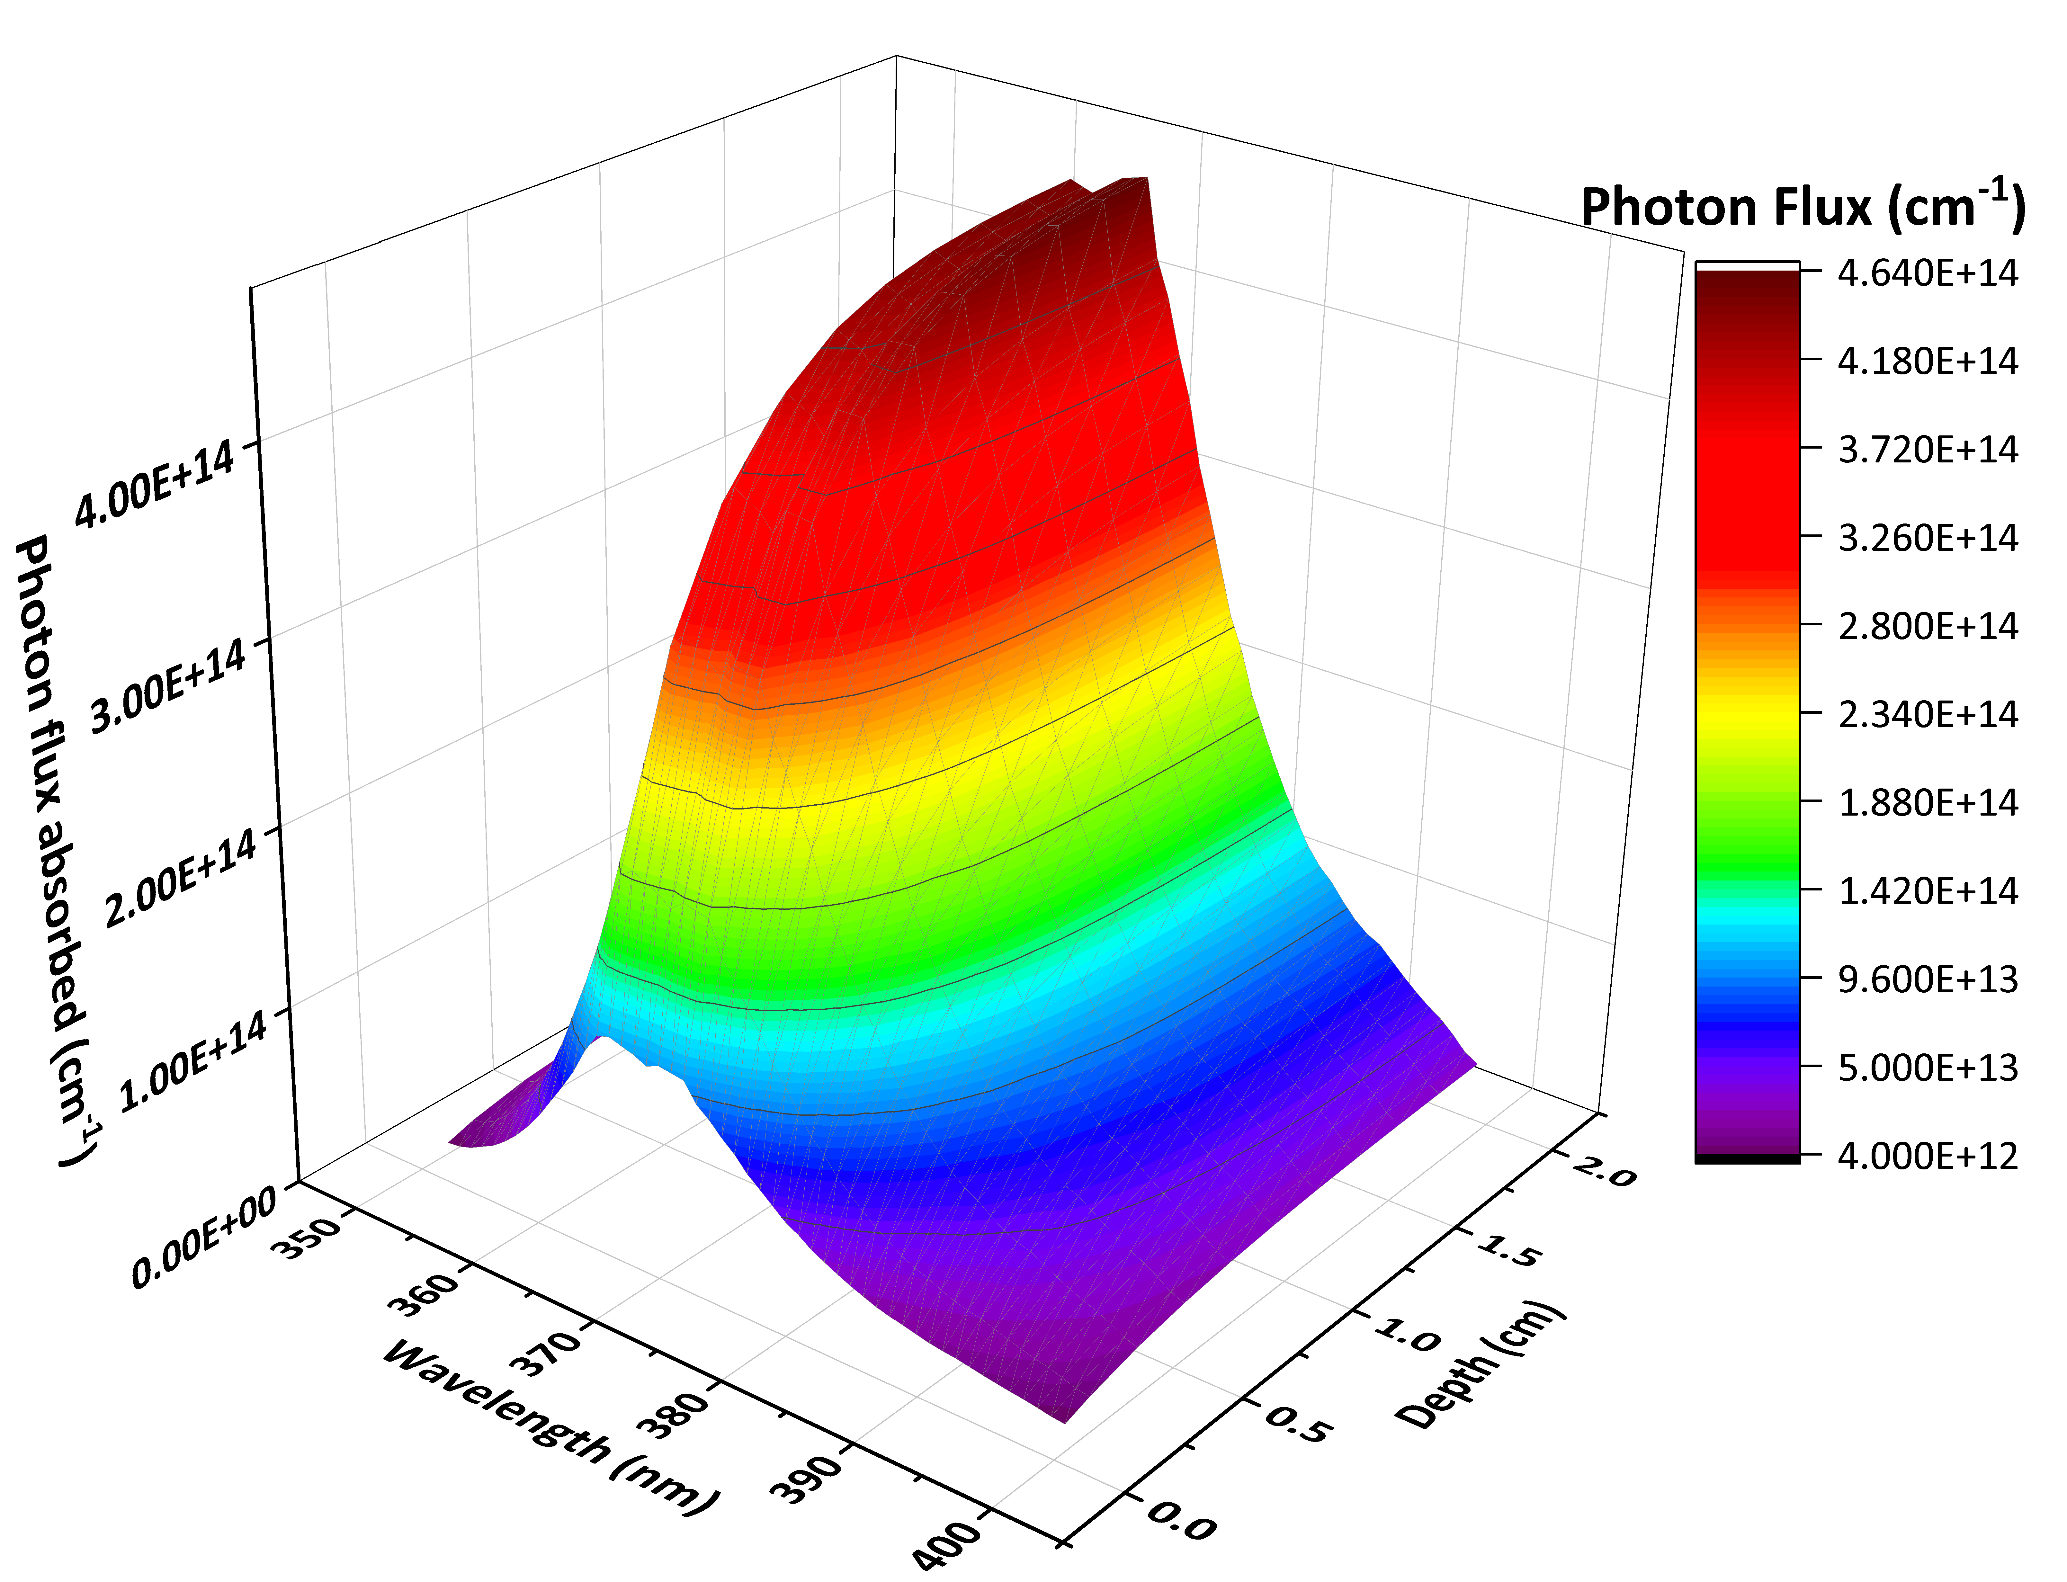
Fig. 8. Photon flux absorption and wavelength with penetration depth for our TiO₂ photocatalyst at wavelengths < 400 nm (TiO₂ = 0.01 g/ 100 ml; optical band gap of ~387 nm).
The quantum yield (Ø) expresses the ratio between the number of converted species and the number of photons absorbed by the photocatalyst [59,60]. Eq. 9 was used to calculate Ø (%) for the PCO experiments, and the findings summarised in Table 2. The results again confirm that HEPES buffer boosts the PCO of As(III) to As(V), and that using generated As(V) to evaluate the PCO yield results in an underestimation of activity. The literature contains very few studies where the Ø of the PCO of As(III) is determined. In 2013, Ryu et al. [29], estimated a Ø higher than 1 for the PCO of As (III) [100 μM (7492 µg/l)] under 254 nm Irradiation at pH 7, where the reaction was kept under continuous purging of oxygen during the course of the reaction. This substantially higher Ø, compared to the values we found in this study, is due to a difference in reaction conditions, where harder UV light was used (which may have also contributed to a higher photolysis yield), higher As(III) concentrations, and continuous purging with oxygen that is known to promote the generation of H₂O₂ that boosts As(III) oxidation [29].

Table 2. Quantum yield (Ø) values for different photocatalytic experiments (at pH = 7.4, after 2 hrs of irradiation).
Experimental details | Ø % | Reaction conditions
Experimental details | Ø % | Adsorption correction | Buffer | TiO₂ (g/100 ml) | Species used in calculation
UV Photolysis | 0.002± 0.0004 | - | - | - | *
UV Photolysis | 0.008± 0.009 | - | HEPES | - | *
Buffer Effect | 0.321 ± 0.061 | Parallel | HEPES | 0.01 | Decrease in As (III)
Parallel Mode | 0.164± 0.043 | Parallel | - | 0.01 | Decrease in As(III)
Sequential mode | 0.101± 0.046 | Sequential | - | 0.01 | Decrease in As(III)
Parallel Mode | 0.161± 0.031 | Parallel | - | 0.01 | Generated As(V)
*Both decrease in As(III) and generated As(V) are equivalent.

Conclusions
- Herein, anatase TiO₂ was used as a model photocatalyst to development a robust, simple and accurate method for measuring the PCO rate of As(III) to As(V) and the quantum yield.
- The molybdenum blue spectrochemical method was used and cross checked against traditional methods of arsenic analysis (anodic stripping voltammetry and ICP-MS), and the results were in close agreement, demonstrating the high accuracy of our simple spectrochemical method in comparison to traditional, more complex methods.
- A new correction method for adsorption was developed herein, where PCO experiments are run in parallel (one dark adsorption experiment and one UV irradiation experiment run in parallel). This was found to be more accurate than the traditional method, where the PCO experiment is run sequentially (dark adsorption followed by UV irradiation).
- Measuring changes in As(III), to determine the PCO, is more accurate than measuring changes in As(V), as As(V) has a greater preference to be adsorbed by TiO₂. This result was supported by evidence from XPS analysis, which showed that the adsorbed fraction on TiO₂, after the PCO reaction, is mainly As(V).
- The calculated arsenic adsorption rates in the dark and under UV irradiation showed that adsorption under UV irradiation is ~23% higher than in the dark, which means that oxidation of As(III) to As(V) assists in its removal.
- The impact of light-induced photolysis was also measured, where our UV source was found to falsely increase the PCO yield by 3.1%. The effect of reaction medium was investigated, where the widely used HEPES buffer increased the PCO yield. In addition, we found that an increase in ionic strength (namely chloride concentration) increases the PCO yield.
- The molar absorptivity and quantum yields were determined for the PCO reactions studied herein, with values ranging from 0.002 ± 0.0004 to 0.32 ± 0.06 %, depending on the reaction conditions.

Acknowledgments
H. F. H. thanks the Newton-Mosharafa Scholarship (a joint fund between the British council and the Egyptian Missions sector) for supporting this work. H. F. H and D. J. W. also acknowledge support from the EPSRC Centre for Doctoral Training in Advanced characterisation of Materials Grant Ref: EP/L015277/1). A. K. thanks the EPSRC for a Capital Award Emphasising Support for Early Career Researchers, the Royal Society for an Equipment Grant (RSG\R1\180434), and the Grantham Institute and Energy Futures Lab for a pump priming award.

References
[1] C.R. Tyler, A.M. Allan, The Effects of Arsenic Exposure on Neurological and Cognitive Dysfunction in Human and Rodent Studies: A Review, Curr. Environ. Heal. Reports. 1 (2014) 132–147. doi:10.1007/s40572-014-0012-1.
[2] X. Guan, J. Du, X. Meng, Y. Sun, B. Sun, Q. Hu, Application of titanium dioxide in arsenic removal from water: A review, J. Hazard. Mater. 215–216 (2012) 1–16. doi:10.1016/j.jhazmat.2012.02.069.
[3] V.K. Sharma, M. Sohn, Aquatic arsenic: Toxicity, speciation, transformations, and remediation, Environ. Int. 35 (2009) 743–759. doi:10.1016/j.envint.2009.01.005.
[4] M. Rahim, M.R.H. Mas Haris, Application of biopolymer composites in arsenic removal from aqueous medium: A review, J. Radiat. Res. Appl. Sci. 8 (2015) 255–263. doi:10.1016/j.jrras.2015.03.001.
[5] K.B. Fontana, G.G. Lenzi, E.C.R. Seára, E.S. Chaves, Comparision of photocatalysis and photolysis processes for arsenic oxidation in water, Ecotoxicol. Environ. Saf. 151 (2018) 127–131. doi:10.1016/j.ecoenv.2018.01.001.
[6] F.S. Zhang, H. Itoh, Photocatalytic oxidation and removal of arsenite from water using slag-iron oxide-TiO2 adsorbent, Chemosphere. 65 (2006) 125–131. doi:10.1016/j.chemosphere.2006.02.027.
[7] M. Deng, X. Wu, A. Zhu, Q. Zhang, Q. Liu, Well-dispersed TiO2 nanoparticles anchored on Fe3O4 magnetic nanosheets for efficient arsenic removal, J. Environ. Manage. 237 (2019) 63–74. doi:10.1016/j.jenvman.2019.02.037.
[8] D.H.K. Reddy, S.M. Lee, J.K. Yang, Y.J. Park, Characterization of binary oxide photoactive material and its application for inorganic arsenic removal, J. Ind. Eng. Chem. 20 (2014) 3658–3662. doi:10.1016/j.jiec.2013.12.062.
[9] V. Binas, D. Venieri, D. Kotzias, G. Kiriakidis, Modified TiO2 based photocatalysts for improved air and health quality, J. Mater. 3 (2017) 3–16. doi:10.1016/j.jmat.2016.11.002.
[10] J.C. Bullen, C. Lapinee, P. Salaün, R. Vilar, D.J. Weiss, On the application of photocatalyst-sorbent composite materials for arsenic(III) remediation: Insights from kinetic adsorption modelling, J. Environ. Chem. Eng. 8 (2020) 104033. doi:https://doi.org/10.1016/j.jece.2020.104033.
[11] M. Bissen, M.M. Vieillard-Baron, A.J. Schindelin, F.H. Frimmel, TiO2-catalyzed photooxidation of arsenite to arsenate in aqueous samples, Chemosphere. 44 (2001) 751–757. doi:10.1016/S0045-6535(00)00489-6.
[12] P.K. Dutta, S.O. Pehkonen, V.K. Sharma, A.K. Ray, Photocatalytic oxidation of arsenic(III): Evidence of hydroxyl radicals, Environ. Sci. Technol. 39 (2005) 1827–1834. doi:10.1021/es0489238.
[13] M. Bissen, M.M. Vieillard-Baron, A.J. Schindelin, F.H. Frimmel, TiO2-catalyzed photooxidation of arsenite to arsenate in aqueous samples, Chemosphere. 44 (2001) 751.
[14] T. V Nguyen, S. Vigneswaran, H.H. Ngo, J. Kandasamy, H.C. Choi, Arsenic removal by photo-catalysis hybrid system, Sep. Purif. Technol. 61 (2008) 44.
[15] W. Choi, J. Yeo, J. Ryu, T. Tachikawa, T. Majima, Photocatalytic oxidation mechanism of As(III) on TiO2: Unique role of As(III) as a charge recombinant species, Environ. Sci. Technol. 44 (2010) 9099.
[16] M.A. Ferguson, M.R. Hoffmann, J.G. Hering, TiO2-photocatalyzed As(III) oxidation in aqueous suspensions: Reaction kinetics and effects of adsorption, Environ. Sci. Technol. 39 (2005) 1880.
[17] I.K. Levy, M. Mizrahi, G. Ruano, G. Zampieri, F.G. Requejo, M.I. Litter, TiO2-Photocatalytic Reduction of Pentavalent and Trivalent Arsenic: Production of Elemental Arsenic and Arsine, Environ. Sci. Technol. 46 (2012) 2299–2308. doi:10.1021/es202638c.
[18] H. Lee, W. Choi, Photocatalytic oxidation of arsenite in TiO2 suspension: Kinetics and mechanisms, Environ. Sci. Technol. 36 (2002) 3872.
[19] M. Navarrete-Magaña, A. Estrella-González, L. May-Ix, S. Cipagauta-Díaz, R. Gómez, Improved photocatalytic oxidation of arsenic (III) with WO3/TiO2 nanomaterials synthesized by the sol-gel method, J. Environ. Manage. 282 (2021) 111602. doi:https://doi.org/10.1016/j.jenvman.2020.111602.
[20] M. Rosales, J. Orive, R. Espinoza-González, R. Fernández de Luis, R. Gauvin, N. Brodusch, B. Rodríguez, F. Gracia, A. García, Evaluating the bi-functional capacity for arsenic photo-oxidation and adsorption on anatase TiO2 nanostructures with tunable morphology, Chem. Eng. J. 415 (2021) 128906. doi:https://doi.org/10.1016/j.cej.2021.128906.
[21] L. Yan, S. Hu, C. Jing, Recent progress of arsenic adsorption on TiO2 in the presence of coexisting ions: A review, J. Environ. Sci. 49 (2016) 74–85. doi:https://doi.org/10.1016/j.jes.2016.07.007.
[22] V. Vaiano, G. Iervolino, L. Rizzo, Cu-doped ZnO as efficient photocatalyst for the oxidation of arsenite to arsenate under visible light, Appl. Catal. B Environ. 238 (2018) 471–479. doi:10.1016/j.apcatb.2018.07.026.
[23] A. Samad, M. Furukawa, H. Katsumata, T. Suzuki, S. Kaneco, Photocatalytic oxidation and simultaneous removal of arsenite with CuO/ZnO photocatalyst, J. Photochem. Photobiol. A Chem. 325 (2016) 97–103. doi:10.1016/j.jphotochem.2016.03.035.
[24] J.I. Garza-Arévalo, I. García-Montes, M.H. Reyes, J.L. Guzmán-Mar, V. Rodríguez-González, L.H. Reyes, Fe doped TiO<inf>2</inf> photocatalyst for the removal of As(III) under visible radiation and its potential application on the treatment of As-contaminated groundwater, Mater. Res. Bull. 73 (2016) 145–152. doi:10.1016/j.materresbull.2015.08.034.
[25] S. Yalçin, X.C. Le, Speciation of arsenic using solid phase extraction cartridges, J. Environ. Monit. 3 (2001) 81–85. doi:10.1039/B007598L.
[26] V. Vaiano, G. Iervolino, D. Sannino, L. Rizzo, G. Sarno, A. Farina, Enhanced photocatalytic oxidation of arsenite to arsenate in water solutions by a new catalyst based on MoOx supported on TiO2, Appl. Catal. B Environ. 160–161 (2014) 247–253. doi:https://doi.org/10.1016/j.apcatb.2014.05.034.
[27] J.C. Bullen, A. Torres-Huerta, P. Salaün, J.S. Watson, S. Majumdar, R. Vilar, D.J. Weiss, Portable and rapid arsenic speciation in synthetic and natural waters by an As(V)-selective chemisorbent, validated against anodic stripping voltammetry, Water Res. 175 (2020) 115650. doi:10.1016/j.watres.2020.115650.
[28] J.C. Bullen, J.P.L. Kenney, S. Fearn, A. Kafizas, S. Skinner, D.J. Weiss, Improved Accuracy in Multicomponent Surface Complexation Models Using Surface-Sensitive Analytical Techniques: Adsorption of Arsenic onto a TiO2/Fe2O3 Multifunctional Sorbent, J. Colloid Interface Sci. 580 (2020) 834–849. doi:10.1016/j.jcis.2020.06.119.
[29] J. Ryu, D. Monllor-Satoca, D. -h. Kim, J. Yeo, W. Choi, Photooxidation of arsenite under 254 nm irradiation with a quantum yield higher than unity, Environ. Sci. Technol. 47 (2013) 9381.
[30] R. Brüninghoff, A.K. van Duijne, L. Braakhuis, P. Saha, A.W. Jeremiasse, B. Mei, G. Mul, Comparative Analysis of Photocatalytic and Electrochemical Degradation of 4-Ethylphenol in Saline Conditions, Environ. Sci. Technol. 53 (2019) 8725–8735. doi:10.1021/acs.est.9b01244.
[31] W. Choi, M. Kim, B. Kim, Y. Park, D.S. Han, M.R. Hoffmann, H. Park, Electrocatalytic arsenite oxidation in bicarbonate solutions combined with CO2 reduction to formate, Appl. Catal. B Environ. 265 (2020) 118607. doi:https://doi.org/10.1016/j.apcatb.2020.118607.
[32] L. Palmisano, V. Augugliaro, R. Campostrini, M. Schiavello, A proposal for the quantitative assessment of heterogeneous photocatalytic processes, J. Catal. 143 (1993) 149–154. doi:10.1006/jcat.1993.1261.
[33] B.H. Toby, EXPGUI, a graphical user interface for GSAS, J. Appl. Crystallogr. 34 (2001) 210–213. doi:10.1107/S0021889801002242.
[34] V. Vaiano, G. Iervolino, D. Sannino, L. Rizzo, G. Sarno, MoOx/TiO2 immobilized on quartz support as structured catalyst for the photocatalytic oxidation of As(III) to As(V) in aqueous solutions, Chem. Eng. Res. Des. 109 (2016) 190–199. doi:10.1016/j.cherd.2016.01.029.
[35] A. Cheng, R. Tyne, Y.T. Kwok, L. Rees, L. Craig, C. Lapinee, M. D’Arcy, D.J. Weiss, P. Salaün, Investigating Arsenic Contents in Surface and Drinking Water by Voltammetry and the Method of Standard Additions, J. Chem. Educ. 93 (2016) 1945–1950. doi:10.1021/acs.jchemed.6b00025.
[36] H.F. Heiba, A.A. Taha, A.R. Mostafa, L.A. Mohamed, M.A. Fahmy, Preparation and characterization of novel mesoporous chitin blended MoO3-montmorillonite nanocomposite for Cu(II) and Pb(II) immobilization, Int. J. Biol. Macromol. 152 (2020) 554–566. doi:https://doi.org/10.1016/j.ijbiomac.2020.02.254.
[37] T. Ohno, K. Sarukawa, K. Tokieda, M. Matsumura, Morphology of a TiO2 photocatalyst (Degussa, P-25) consisting of anatase and rutile crystalline phases, J. Catal. 203 (2001) 82–86. doi:10.1006/jcat.2001.3316.
[38] D. Wang, J. Huang, F. Liu, X. Xu, X. Fang, J. Liu, Y. Xie, X. Wang, Rutile RuO2 dispersion on rutile and anatase TiO2 supports: The effects of support crystalline phase structure on the dispersion behaviors of the supported metal oxides, Catal. Today. 339 (2020) 220–232. doi:10.1016/j.cattod.2019.02.038.
[39] R. Ashiri, Detailed FT-IR spectroscopy characterization and thermal analysis of synthesis of barium titanate nanoscale particles through a newly developed process, Vib. Spectrosc. 66 (2013) 24–29. doi:10.1016/j.vibspec.2013.02.001.
[40] D.O. Scanlon, C.W. Dunnill, J. Buckeridge, S.A. Shevlin, A.J. Logsdail, S.M. Woodley, C.R.A. Catlow, M.J. Powell, R.G. Palgrave, I.P. Parkin, G.W. Watson, T.W. Keal, P. Sherwood, A. Walsh, A.A. Sokol, Band alignment of rutile and anatase TiO2, Nat. Mater. 12 (2013) 798–801. doi:10.1038/nmat3697.
[41] S. Sun, C. Ji, L. Wu, S. Chi, R. Qu, Y. Li, Y. Lu, C. Sun, Z. Xue, Facile one-pot construction of α-Fe2O3/g-C3N4 heterojunction for arsenic removal by synchronous visible light catalysis oxidation and adsorption, Mater. Chem. Phys. 194 (2017) 1–8. doi:10.1016/j.matchemphys.2017.03.023.
[42] Y. Wang, P. Zhang, T.C. Zhang, G. Xiang, X. Wang, S. Pehkonen, S. Yuan, A magnetic γ-Fe2O3 @PANI@TiO2 core–shell nanocomposite for arsenic removal via a coupled visible-light-induced photocatalytic oxidation–adsorption process, Nanoscale Adv. 2 (2020) 2018–2024. doi:10.1039/d0na00171f.
[43] Q. Xue, Y. Ran, Y. Tan, C.L. Peacock, H. Du, Arsenite and arsenate binding to ferrihydrite organo-mineral coprecipitate: Implications for arsenic mobility and fate in natural environments, Chemosphere. 224 (2019) 103–110. doi:10.1016/j.chemosphere.2019.02.118.
[44] W. Yan, M.A.V. Ramos, B.E. Koel, W.X. Zhang, Multi-tiered distributions of arsenic in iron nanoparticles: Observation of dual redox functionality enabled by a core-shell structure, Chem. Commun. 46 (2010) 6995–6997. doi:10.1039/c0cc02311f.
[45] Q. Tian, J. Zhuang, J. Wang, L. Xie, P. Liu, Novel photocatalyst, Bi2Sn2O7, for photooxidation of As(III) under visible-light irradiation, Appl. Catal. A Gen. 425–426 (2012) 74–78. doi:10.1016/j.apcata.2012.03.005.
[46] Y. Wang, J. Duan, W. Li, S. Beecham, D. Mulcahy, Aqueous arsenite removal by simultaneous ultraviolet photocatalytic oxidation-coagulation of titanium sulfate, J. Hazard. Mater. 303 (2016) 162–170. doi:10.1016/j.jhazmat.2015.10.021.
[47] M. Kanematsu, T.M. Young, K. Fukushi, D.A. Sverjensky, P.G. Green, J.L. Darby, Quantification of the Effects of Organic and Carbonate Buffers on Arsenate and Phosphate Adsorption on a Goethite-Based Granular Porous Adsorbent, Environ. Sci. Technol. 45 (2011) 561–568. doi:10.1021/es1026745.
[48] R.B. Johnston, P.C. Singer, Redox reactions in the Fe–As–O2 system, Chemosphere. 69 (2007) 517–525. doi:https://doi.org/10.1016/j.chemosphere.2007.03.036.
[49] J.A. Simpson, K.H. Cheeseman, S.E. Smith, R.T. Dean, Free-radical generation by copper ions and hydrogen peroxide. Stimulation by Hepes buffer., Biochem. J. 254 (1988) 519–523. doi:10.1042/bj2540519.
[50] J.F. Masson, E. Gauda, B. Mizaikoff, C. Kranz, The interference of HEPES buffer during amperometric detection of ATP in clinical applications, Anal. Bioanal. Chem. 390 (2008) 2067–2071. doi:10.1007/s00216-008-2015-y.
[51] J.L. Lepe-Zuniga, J.S. Zigler, I. Gery, Toxicity of light-exposed Hepes media, J. Immunol. Methods. 103 (1987) 145. doi:10.1016/0022-1759(87)90253-5.
[52] W.W.-P. Lai, Y.-C. Chuang, A.Y.-C. Lin, The effects and the toxicity increases caused by bicarbonate, chloride, and other water components during the UV/TiO2 degradation of oxazaphosphorine drugs, Environ. Sci. Pollut. Res. 24 (2017) 14595–14604. doi:10.1007/s11356-017-9005-6.
[53] Z. Chen, J.J. Concepcion, N. Song, T.J. Meyer, Chloride-assisted catalytic water oxidation †, 1 (2014) 8053–8056. doi:10.1039/c4cc04071f.
[54] S. Nakagawara, T. Goto, M. Nara, Y. Ozawa, K. Hotta, Y. Arata, Spectroscopic Characterization and the pH Dependence of Bactericidal Activity of the Aqueous Chlorine Solution, Anal. Sci. 14 (1998) 691–698. doi:10.2116/analsci.14.691.
[55] Y. Miseki, K. Sayama, High-efficiency water oxidation and energy storage utilizing various reversible redox mediators under visible light over surface-modified WO 3, RSC Adv. 4 (2014) 8308–8316. doi:10.1039/c3ra47772j.
[56] L. Huang, R. Li, R. Chong, G. Liu, J. Han, C. Li, Cl− making overall water splitting possible on TiO2-based photocatalysts, 4 (2014) 2913–2918. doi:10.1039/c4cy00408f.
[57] K. Mase, M. Yoneda, Y. Yamada, S. Fukuzumi, Seawater usable for production and consumption of hydrogen peroxide as a solar fuel, Nat. Commun. 7 (2016) 1–7. doi:10.1038/ncomms11470.
[58] A. Roibu, S. Fransen, M.E. Leblebici, G. Meir, T. Van Gerven, S. Kuhn, An accessible visible-light actinometer for the determination of photon flux and optical pathlength in flow photo microreactors, Sci. Rep. 8 (2018) 1–10. doi:10.1038/s41598-018-23735-2.
[59] N. Serpone, Relative photonic efficiencies and quantum yields in heterogeneous photocatalysis, J. Photochem. Photobiol. A Chem. 104 (1997) 1–12. doi:10.1016/S1010-6030(96)04538-8.
[60] M.J. Muñoz-Batista, A. Kubacka, A.B. Hungría, M. Fernández-García, Heterogeneous photocatalysis: Light-matter interaction and chemical effects in quantum efficiency calculations, J. Catal. 330 (2015) 154–166. doi:10.1016/j.jcat.2015.06.021.

