Liquid spread mechanisms in packed beds and heaps. The separation of length and time scales due to particle porosity
I. M. S. K. Ilankoon ^{1,2, *}, S. J. Neethling¹
¹Rio Tinto Centre for Advanced Mineral Recovery, Department of Earth Science and Engineering, Imperial College London, London, United Kingdom, SW7 2AZ
²Department of Chemical Engineering, Monash University Malaysia Campus, Jalan Lagoon Selatan, Bandar Sunway, 47500, Selangor, Malaysia

ABSTRACT
The distribution of liquid within a heap is a key factor in the system performance as it has a strong effect on the transport of both reagents and leached species and thus the leaching rate. How liquid spreads from drippers and the subsequent development of flow paths and any associated channelling is thus important. In this paper a pseudo 2-D column was used to investigate the horizontal spread of liquid in the vicinity of dripper in columns packed with both narrowly sized particles and more realistic particle size distributions. Both systems had distinct separation of the time scales at which different saturation features developed. There was an initial rapid formation of flow paths in the inter-particle spaces with only local wetting of the intra-particle spaces, though this was associated with little spread. Over a much longer time period there was extensive horizontal spread of the liquid within the ore particles, though this was associated with virtually no vertical flow. The externally held liquid (liquid content between the particles) showed strong channelling behaviour, especially in the realistically sized particles, despite the care that was taken to ensure uniform packing. This effect can be reduced by changing initial bed conditions and employing dense drip emitter locations, but it cannot be completely eliminated as particle level heterogeneities in heap leaching systems affect external flow paths creation. Hysteresis in the amount of liquid spread was also demonstrated, with the total spread depending not only on the current flow rate, but also on the flow history.
Keywords: Channelling, Heap leaching, Hydrodynamics, Liquid spread, Wetted area
1. Introduction
Although various mineral processing techniques are used to extract metals from run-of-mine (ROM) ore, most increase in cost and decrease in efficiency markedly as the grade decreases. Heap leaching, though, is far less sensitive to low grades than other mineral processing techniques. However, the recovery in heap leaching is generally relatively low compared to other separation techniques such as froth flotation and thus heap leaching leaves a lot of scope for improvement. Potential sources of improvement are not only in the chemistry and bio-chemistry of these systems, but also in the hydrodynamics of the heaps.
The fluid flow in these systems is unsaturated, consisting of both liquid, which is added at the top during irrigation, and air. The fluid flow in heap leaching is complicated not only due to it being unsaturated, but also because of the different length scale of the channels involved. The porosity of the packed particles has two distinct length scales, namely that of the channels between the particles (i.e. interstitial space), which will typically have a length scale of order millimetres, and that within the particles (i.e. intra-particle space), which will typically have a length scales of order tens of microns or even smaller. The Bond number, which is the ratio of gravity to capillary forces, will be around 1 for the fluid flow between the particles, indicating that this flow is in the transition region between capillary and gravity dominated flow. However, the existing micro-pores within the particles will have Bond numbers that are many orders of magnitude less than 1, indicating capillary dominated flow (Ilankoon, 2012; Ilankoon and Neethling, 2013). These differences in length scale result in very different fluid flow behaviours.
In industrial heap leaching, solution application using drip emitters is very common and drip emitter lines are generally separated by about 50-100 cm with a spacing of about 50 cm between drippers on a particular line to cover a targeted wetted area of about 0.25-1 m² per dripper. Afewu (2009) suggested that a denser grid of drippers would result in more uniform wetting and ultimately better performance.
In order to achieve good leaching, particles in a heap should be in close proximity to actively flowing fluid. Transport of reagents and leached metal species by diffusion is a slow process and it decreases rapidly with distance as any flux requires concentration gradients. The liquid addition at the top of the heap is however not uniform in practice and the liquid trickles as preferential channels between particles from top to bottom (Petersen and Dixon, 2007). Bartlett (1992) demonstrated the relationship between superficial liquid velocity, intrinsic permeability, and hydraulic conductivity of porous media. He explained that Micro-flooding occurs in areas where the average velocity exceeds the local limiting velocity depending on the local hydraulic conductivity. Channelling and perched water tables form due to higher flows at the top of the heap. Short-circuiting through channels will be ineffective in transporting reagent and dissolved species and it would also dilute the grade of the pregnant solution (Bartlett, 1992).
The bulk density of the heap was observed to vary across the bed due to particle segregation (Howard, 1968; Roman, 1977; Yusuf, 1984, Bartlett, 1992). Areas of lower bulk density have higher permeability or less resistance to flow; these result in preferential flow through larger openings. The presence of significant quantities of clay results in localised compaction with low permeability. Often, high permeability channels surround these low permeability areas (Yusuf, 1984). The existence of preferential flow pathways instead of homogeneous flow is often observed and is generally referred to as channelling (Yusuf, 1984; Wu et al., 2009). Inhomogeneous wetting of particles is thus observed at various depths in the heap, which results in highly variable liquid content in different regions. Previous experimental studies have indicated this behaviour within both laboratory scale and large scale ore columns, heaps and dumps (eg. Howard, 1968; Armstrong et al., 1971; Murr, 1979; Cathles and Murr, 1980, Murr et al., 1981; Wu et al., 2007, 2009; Fagan et al., 2014).
While the fluid flow experiments indicate that differential flow and channelling is a very real effect in heaps, these previous studies do not show the mechanisms at work. Furthermore, large scale columns cannot be effectively used to study the underlying mechanisms (eg. Murr and co-workers), because the scale limits the extent to which the fluid flow behaviour can be directly observed and are thus of less use in the elucidation of the mechanisms at work. In order to understand the particle level mechanisms, experiments need to be conducted at a smaller scale where the impact of particle scale effects can be seen. Insights into these particle scale behaviours and mechanisms can then be used to better understand the behaviour of industrial scale heap. The main objective of this study is thus to examine the wetting behaviour and liquid flow path development in laboratory scale narrow “2-D” ore systems using both narrow and realistic particle size distributions in order to better understand the mechanisms involved in liquid spread and channelling. The effects will be discussed in terms of actively flowing liquid channels, wetted area of the bed and channelling flow features. In addition, possible strategies to minimise these effects will also be discussed.
2. Experimental Design and Methods
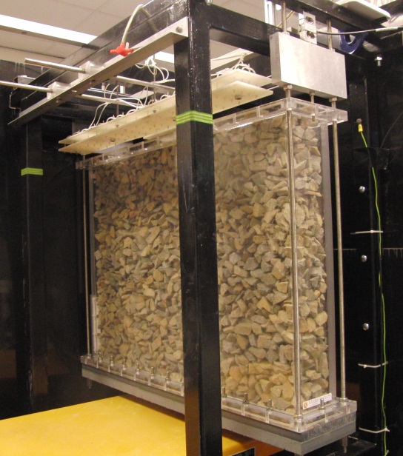
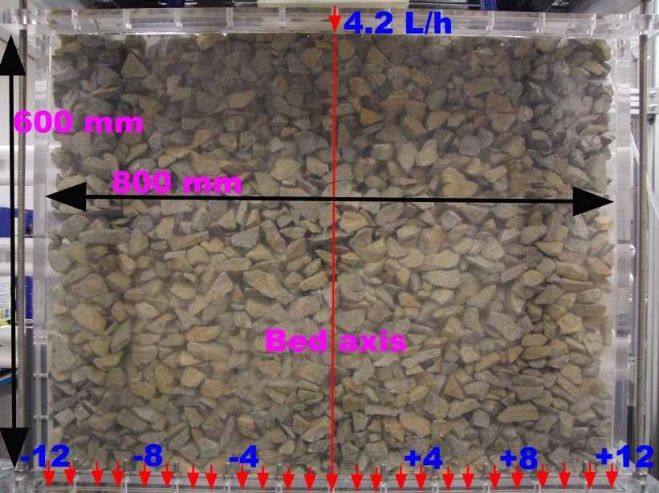
In order to investigate both the horizontal and vertical liquid flow behaviour in ore mixtures, a rectangular Perspex column with a width of 800 mm and a height of 600 mm, and a depth of only 100 mm was designed (see Figure 1) and hereafter referred to as the pseudo 2-D column. The 2-D column was suspended from two load cells so that the liquid content could be measured continuously with time. The system required careful calibration as the overall measurement is a combination of the two load cell measurements. The variation in liquid content is only a small proportion of the overall weight of the column (measured changes of a few grams of liquid in a packed column weighing about 100 kg) further adding to the requirement for accurate calibration. The calibration procedure and its validation against independent measures of liquid holdup has been described in previous papers (Ilankoon and Neethling, 2012, 2013).
600 mm
Load cell
Liquid distributor
100 mm
Liquid addition
Figure 1: 2-D column rig and its main components. In here the column is filled with the narrowly sized ore particles (20-26.5 mm) and the bed is initially dry.
The ore system used consisted of copper ore particles collected from Kennecott Utah Bingham Canyon Mine. The average water accessible porosity was measured by soaking the particles in water for 24 hours and was found to be about 5%. The particle properties are described in more details in Ilankoon and Neethling (2013). The experimentally determined (based on load cell measurements) average external voidage (excluding internal porosity) was about 30.7% for the narrowly sized particles (20-26.5 mm) and around 18.7% for the more realistic size distribution (2-26.5 mm). Typically, about 75 kg of particles were required to randomly fill the 2-D column. The fluid flow experiments were performed with both a narrowly sized fraction of ore particles, namely 20-26.5 and more realistic ore size distribution, namely, 2-26.5 mm. Even though industrial heap leaching does not employ narrowly sized fractions, the 20-26.5 mm size fraction was selected to represent a typical particle size in a heap leaching system, with the similarities and differences in the behaviour of the narrowly sized and more realistic size distributions providing insights into the mechanisms involved. In order to prepare the 2-26.5 mm mixture a Gaudin Schumann (GS) distribution was employed with a gradient of 1.5. The distribution was created by mixing together the appropriate amounts of material from 7 particle size fractions (2-4, 4-8, 8-11.2, 11.2-13.2, 13.2-16, 16-20, 20-26.5 mm). The bottom plate of the column has apertures of slightly less than 2 mm, thus setting the smallest size of particles (i.e. 2 mm) that could be tested in this work.
In all experiments (both narrowly sized fraction and realistic mixture) random packing was used and the initial condition of the bed was dry. To avoid particle segregation, especially during the packing of the poly-dispersed material, the column was packed using a series of thoroughly mixed small batches (approximately 15 kg each) rather than pouring in the whole mixture at once.
As this was a flow study rather than experimental leaching study, deionised water was used as the liquid for all the experiments in this work. At the bottom of the column there was a series of channels and collection ports spaced 30 mm apart from which the out-flowing liquid was collected (see Figure 1). In all experiments, the flow from each collection port was recorded separately and the wetting of the bed was also filmed.
The following fluid flow experiments were conducted using the 2-D bed packed bed. These experiments were conducted using both the narrowly sized ore (20-26.5 mm) and the realistic ore mixture (2-26.5 mm):
- Single drip emitter liquid addition tests to investigate horizontal liquid spread and inter-particle flow paths development - A single horizontal drip point is located at the centre of the top of the bed (see Figure 1). This was done to mimic the behaviour around a single dripper (the width of the 2-D column is similar to the typical spacing between drippers in an industrial heap). Liquid was added at 4.2 L/h.
- Intermittent liquid addition tests using the realistic ore mixture to determine the effect of packing on the creation of external flow paths – The realistic ore mixture at steady state was allowed to drain naturally for 3 months and then the drip emitter liquid addition was again started at the top centre of the bed at 4.2 L/h.
- Flooding of the realistic ore bed in order to determine the effect of micro-scale non-uniformities on the development of external flow paths - The realistic ore mixture (initial bed condition was dry) was flooded by closing all the liquid-outflow ports and adding liquid into the top of the column until it was completely saturated. The out-flow ports were then reopened while maintaining the liquid addition at the top centre of the bed at 4.2 L/h. Once the bed reached steady state, out-flow liquid measurements were made.
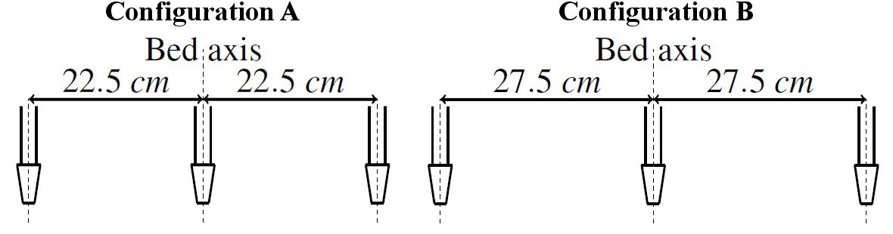
- Experiments with increased drip emitter density (more uniform wetting at the top compared to single drip emitter wetting) were carried out to study its effects on flow path formation – Two drip emitter configurations (see Figure 2) were employed in addition to the single drip emitter liquid addition method. For all the configurations the overall liquid addition rate of 4.2 L/h was used. The outermost drip emitters are located at offsets of either 22.5 cm (configuration A) or 27.5 cm (configuration B) from the centre line of the bed. These new configurations were tested after the single drip experiment without draining the bed. The out-flow liquid distribution was measured after 24 hours.
Figure 2: Additional drip emitter configurations used in this work. For both drip emitter layouts the central dripper flow rate is twice that of either the left or right hand dripper.

3. Liquid flow behaviour

The comparatively large channels between the ore particles mean that even though they will have a lower saturation than that within the pore spaces of the neighbouring particles, the flow velocity in these channels will be much higher. This means that after the flow into the bed is initiated there is initially a comparatively strong downward flow of liquid with relatively little horizontal spread. This is caused by the development of external flow paths, which is accompanied by the wetting of the porosity of the neighbouring particles. This initial external flow path formation is rapid (see Table 1 for breakthrough times) compared to the time over which the bed beyond the region of these external flow paths wet. In this 600 mm tall column the external flow paths reach steady state within about an hour, while the capillary transport that is required to wet the intra-particle porosity of much of the rest of the bed takes many days before it reaches steady state (see Figures 4, 5 and section 3.1 for details). These observations again confirm the separation of time scales observed in previous studies using a vertical column (Ilankoon and Neethling, 2013).
Table 1: Breakthrough times for the 2-D system filled with ore particles at 4.2 L/h liquid addition.
Size range (mm) | Particle Type | Breakthrough time (s)
20-26.5 (at 4.2 L/h)  2-26.5 (at 4.2 L/h) | Narrowly sized ore  Ore mixture | 103  685

This difference in the time scales and the extent of spreading in the inter-particle voids compared to that in intra-particle pore spaces has a large impact on the flow behaviour in the vicinity of the liquid addition points.
3.1. Liquid Spread and Wetted Area Results
The spread of the liquid is strongly influenced by the particle size distribution. This was tested by comparing the liquid spread rate and extent in the column using the wetted area images. As ore particles became wet they experienced a marked change in colour (see Figure 3) which can be tracked relatively easily by image analysis. This was performed using the ImageJ software. While the interface between the wetted and non-wetted particles is quite sharp, this is not a direct measure of the internal liquid as the saturation of the wetted particles will be a function of position and time. This wetted area is expressed as a fraction of the total area of the bed as viewed from the front as the front and back wetted area profiles were virtually identical.
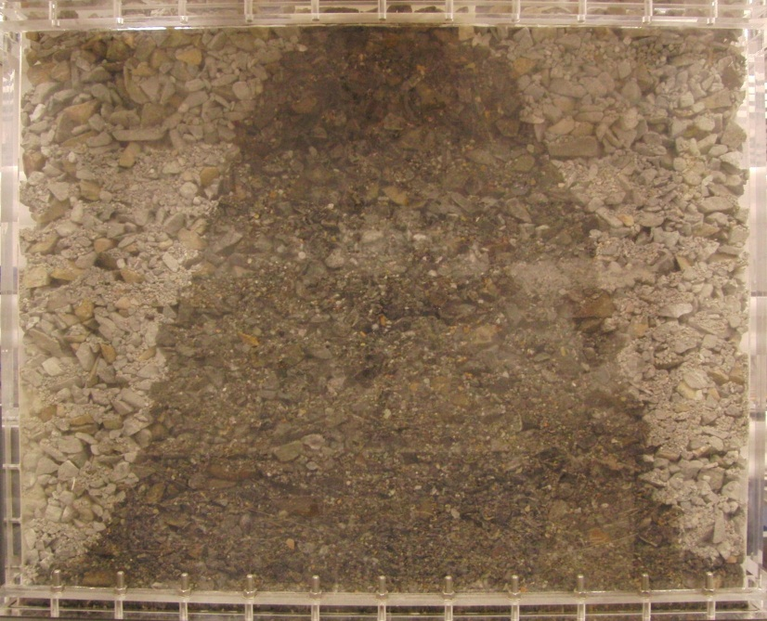

Figure 3: Wetted and non-wetted regions of the ore system. Similar images with marked change in colour can be used to calculate wetted area of the system using image analysis (eg. Figures 4 and 5).
The extent of the liquid spread at different time points is shown in Figures 4 and 5. The shaded area of each image represents the visibly wetted region of the bed. In Figures 4 and 5 the graphs under each image plot the percentage of the liquid flow out of the bed that occurs through each of the collection channels over different time intervals. In addition, all graphs (except the one at the first time interval) show the liquid distribution at the previous time point in order to compare the changes in liquid distribution and flow paths with time. The scale bar at the bottom of each image represents the locations of the 25 collection points (spaced 30 mm apart), with the numbering indicating the distance from the centre line of the column, which is also the horizontal position of the drip point. The red circles on some of the graphs (eg. see Figures 4a and 4b) highlight collection points at which flow was detected in the current time interval, but where no flow occurred in previous time intervals.

Much greater spread was observed in the ore mixture than in the narrowly sized fraction (compare Figures 4 and 5). After 5 days the wetted area of the realistic ore mixture was approaching its maximum extent of about 96% wet, whereas the narrowly sized fraction had only wet about 47% of the bed and reached a maximum extent of about 61% after 14 days of liquid addition.
The main difference between the systems is the size and connectivity of the channels. The realistic ore mixture has smaller channels and thus capillary transport in the inter-particle channels was stronger than in the narrowly sized ore system. This is unlikely to be the whole reason for the increased spread as capillarity is still comparatively weak in these external channels (given millimetre scale channels, capillary entry pressures will be of the order of tens of Pascals compared to the kPa entry pressures for the intra-particle pore spaces). Another likely reason for the increase in horizontal spread is that the channels are smaller relative to the capillary length (about 2 mm for pure water). This means that liquid held at capillary junctions is more easily able to bridge multiple particles and can thus more easily experience horizontal liquid dispersion. Note that this effect, while relying on capillarity, is not the same as capillary transport, which is based on gradients in the capillary pressure.

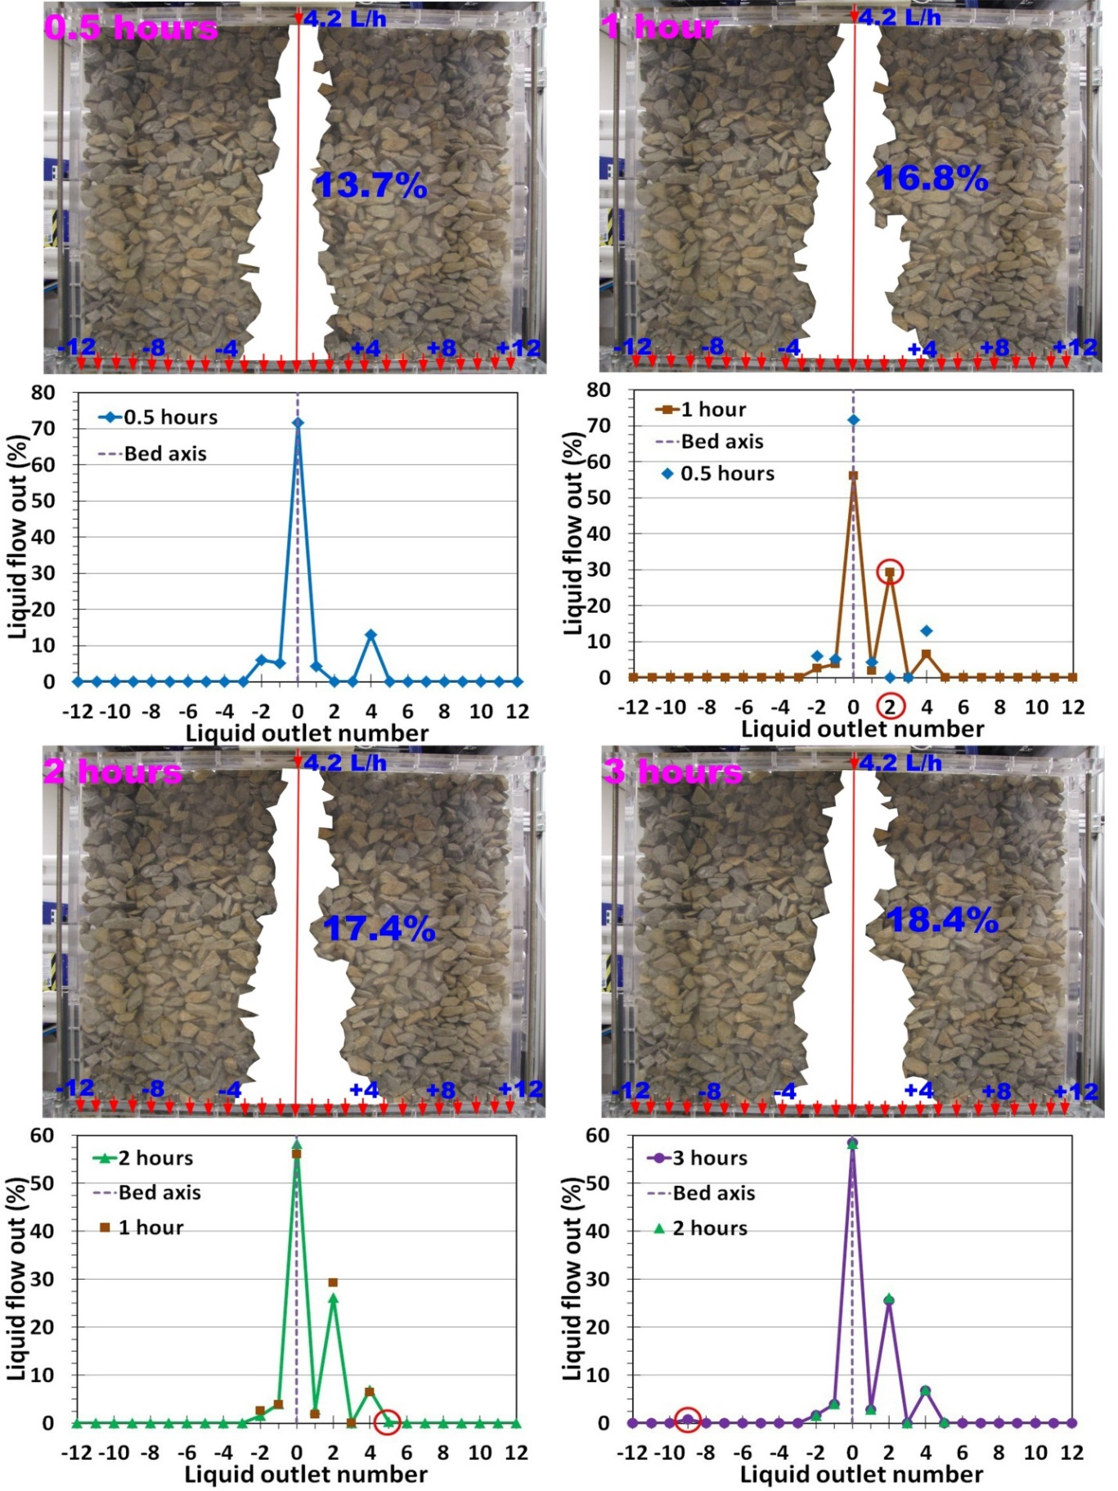
Figure 4a: Wetted area of the bed and liquid distribution at the bottom at 4.2 L/h using 20-26.5 mm ore particles: 0.5, 1, 2 and 3 hours after initial liquid addition.

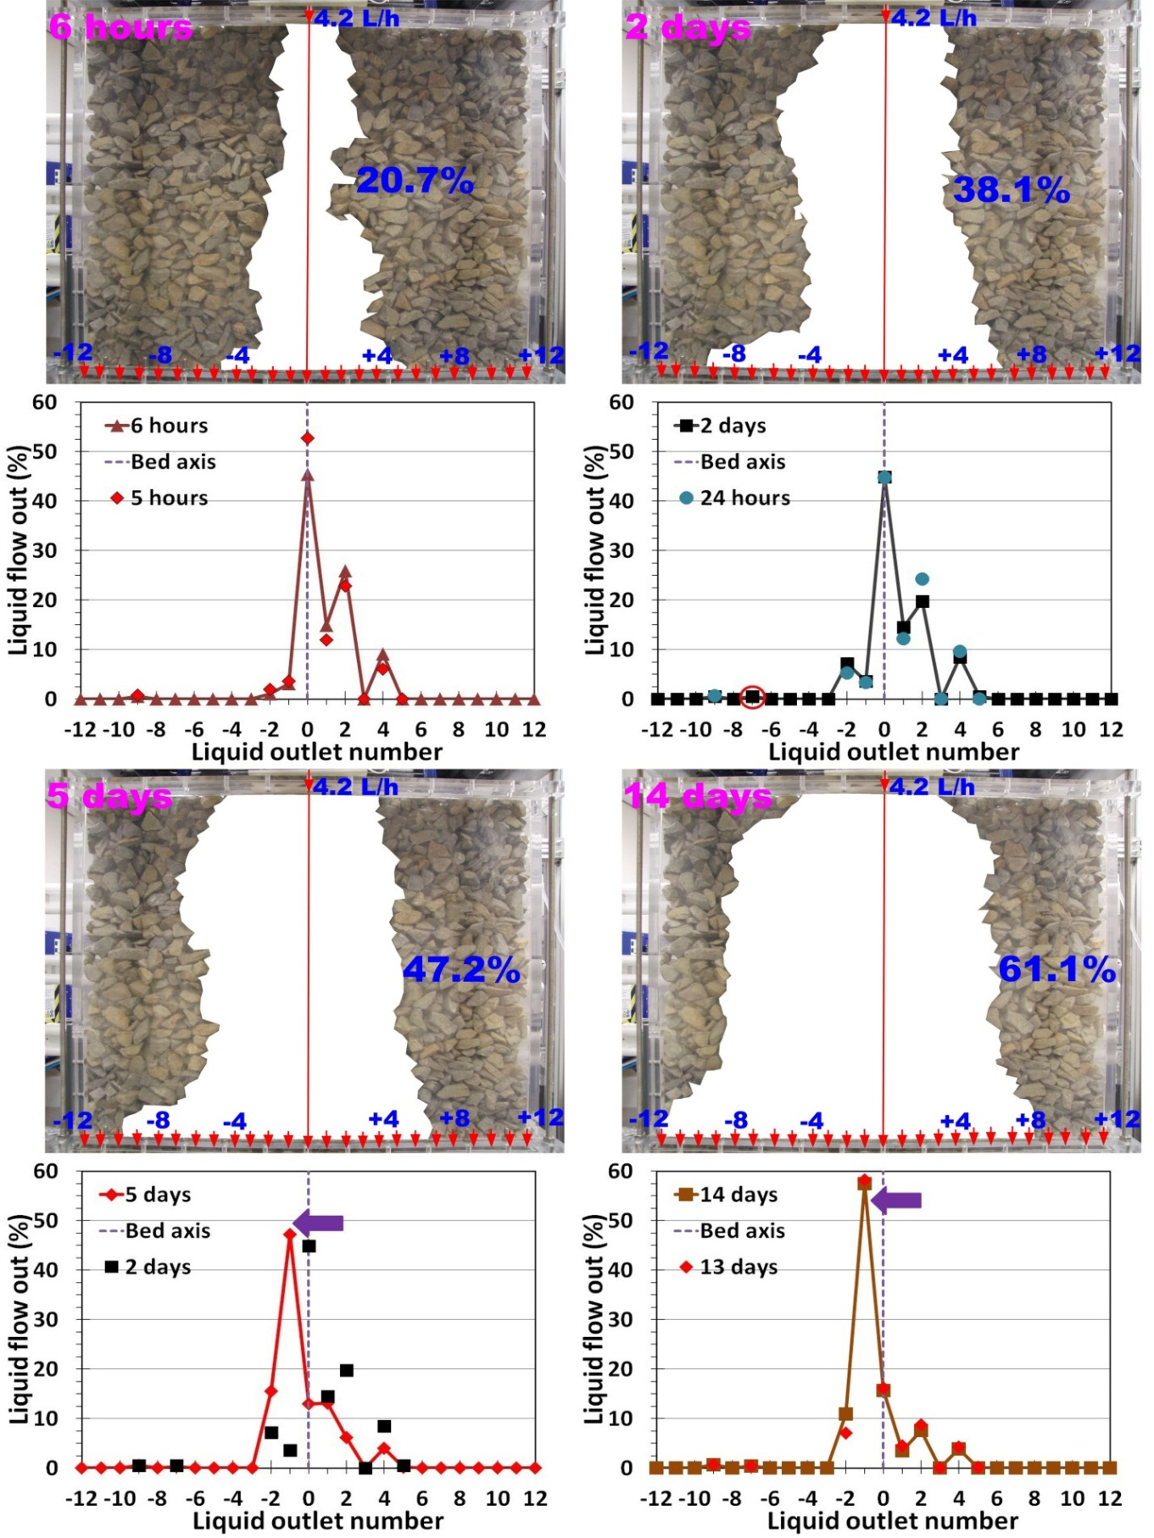
Figure 4b: Wetted area of the bed and liquid distribution at the bottom at 4.2 L/h using 20-26.5 mm ore particles: 6 hours, 2, 5 and 14 days after initial liquid addition.
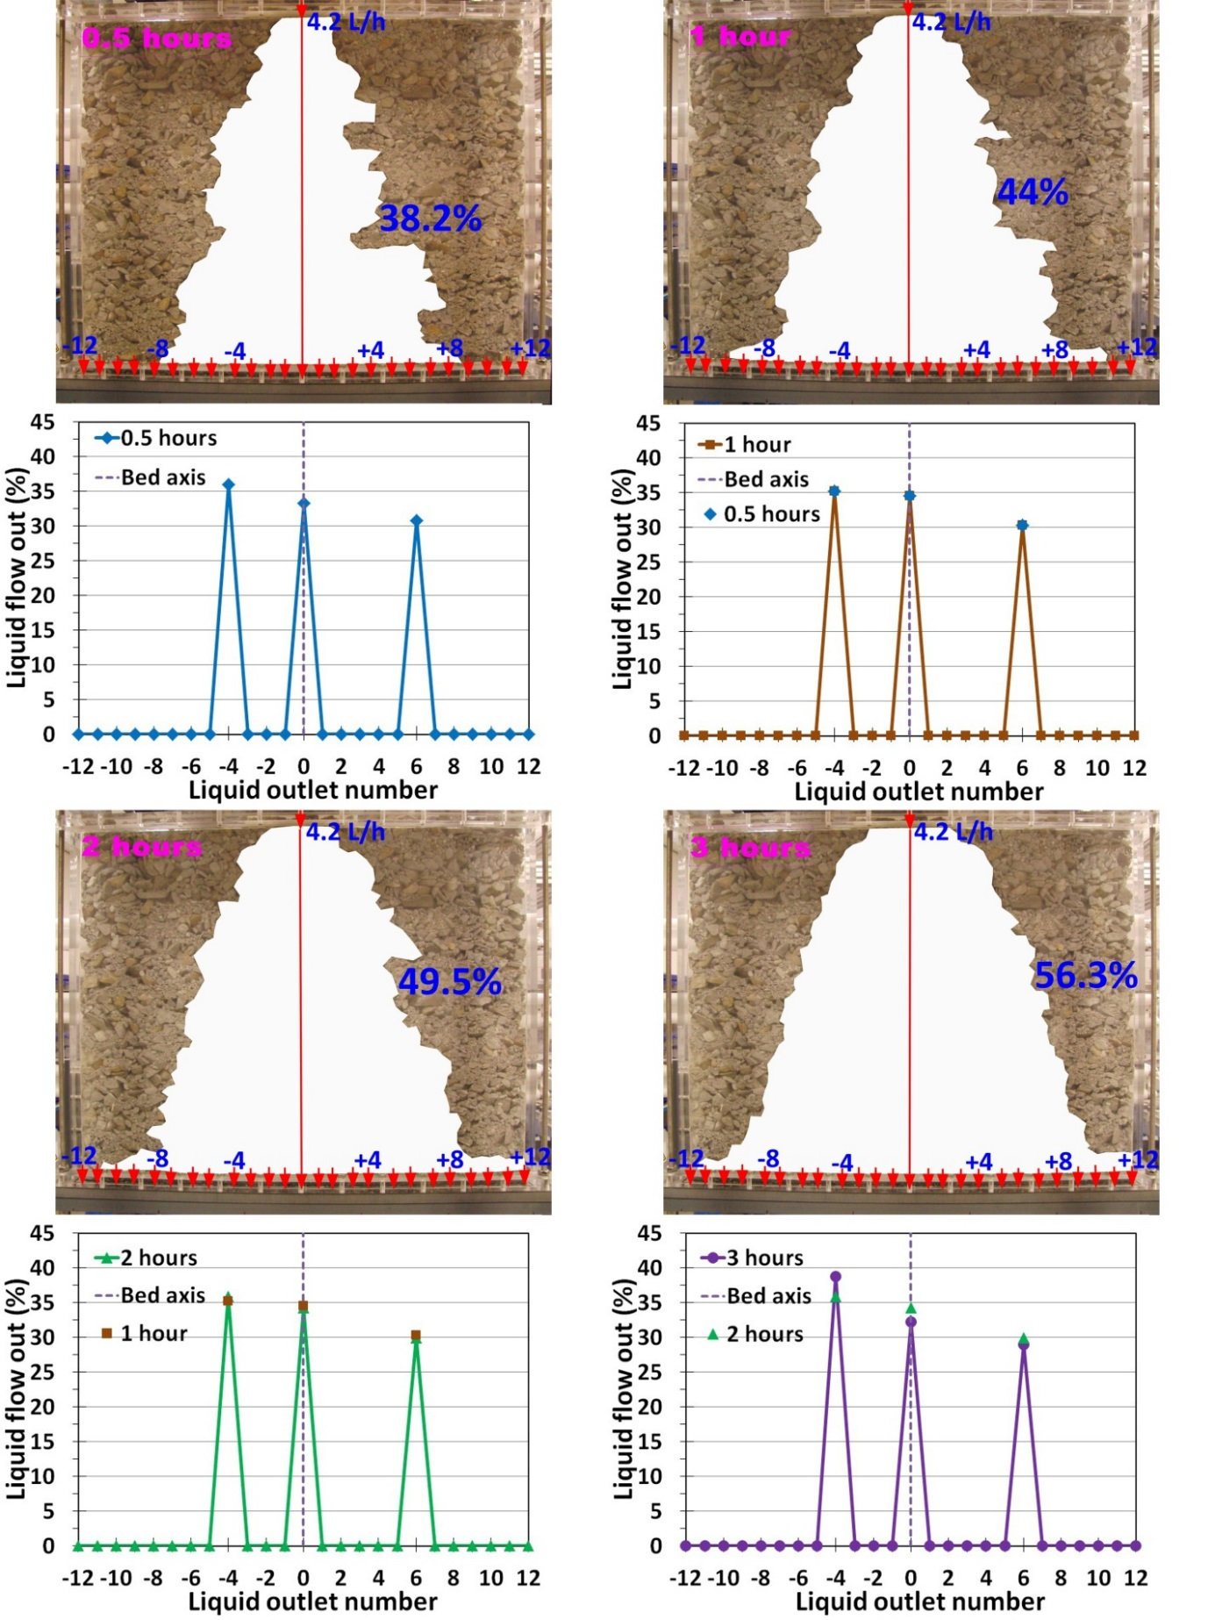
Figure 5a: Wetted area of the bed and liquid distribution at the bottom at 4.2 L/h using 2-26.5 mm ore mixture: 0.5, 1, 2 and 3 hours after initial liquid addition.
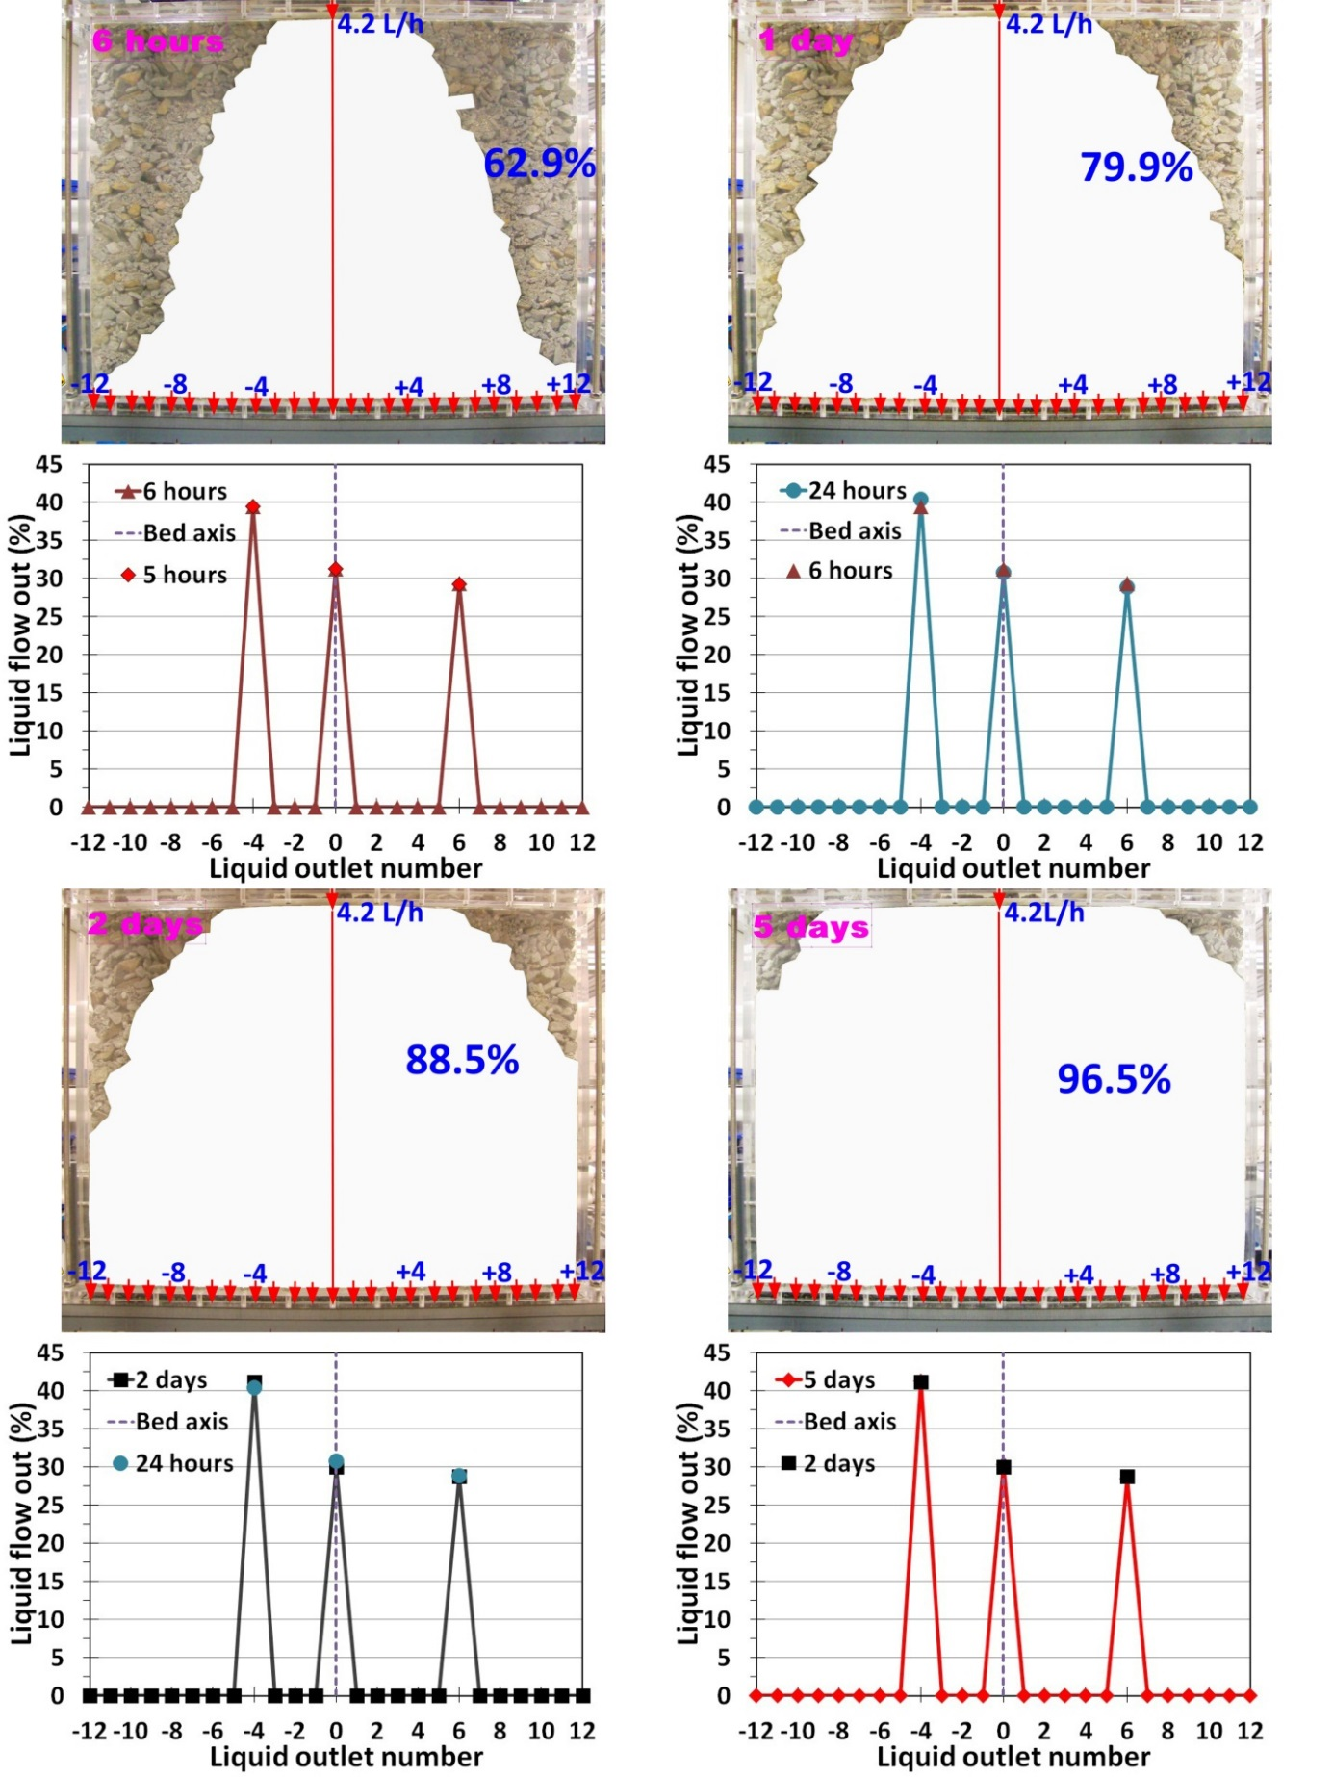

Figure 5b: Wetted area of the bed and liquid distribution at the bottom at 4.2 L/h using 2-26.5 mm ore mixture: 6 hours, 1, 2 and 5 days after initial liquid addition.
Since the size of the intra-particle pores is predominantly a property of the ore, they are unlikely to vary much with particle size distribution. This means that pore size cannot account for the increase in the spread. There are two likely reasons for this increased spread rate and final extent in the realistic ore system; firstly, the increase in the spread of the inter-particle liquid means that this external liquid will be pulled into the intra-particle pores over a wider region of the bed. Secondly, the number of particle-particle contacts increases as both the poly-dispersity increases and average particle size decreases. The particle to particle wicking of liquid will be very dependent on not just the capillary pressure gradient, but also the number of particle to particle contacts.
Figure 6 shows the total volume of liquid in the bed and the wetted area both as a function of time. For both systems the total volume of liquid in the bed and the wetted area initially increase rapidly followed by a gentler rise. A direct proportionality between the wetted area and the total liquid content of the bed is not expected as the local liquid holdup in the wetted portion is likely to vary considerably with position, particularly between regions with externally held liquid and those with liquid held only within the pore spaces. The rapid initial rise in liquid holdup is predominantly associated with the formation of the flow paths in the inter-particle channels, while the longer term slower increase is associated with the wetting of the intra-particle porosity.
For a given wetted area the bed with wider size distribution contains more liquid than that with the narrowly sized ore fraction. For a given flow, the holdup increases as the size of the channels decreases (Ilankoon and Neethling, 2013, 2014), which means that the amount of externally held liquid will be higher in the more realistic ore system.
While a large portion of the bed ultimately experiences some wetting, not all liquid is equal in terms of its effect on mass transport and thus leaching rate. The liquid held within the ore particles will only flow very slowly if at all, which means that mass transport will be very slow as it will rely on diffusion to a large degree. This means that the distance from an active flow path is likely to be a greater factor than the liquid content at a particular location.

Figure 6: Change of the liquid content and the wetted area of the bed with time for 2-26.5 mm ore mixture and 20-26.5 mm size fraction at liquid addition rate of 4.2 L/h.

4. Development of External Flow Paths
4.1. Effect of Particle Size distribution
Both the similarities and differences in the flows found in the narrowly sized ore and the realistic ore beds in terms of external flow paths are quite illuminating (Figures 4 and 5). In both systems the actively flowing paths through the bed establish themselves very quickly (typically within an hour) compared to the time scales of days for particle wetting. The flow out of the column is dominated by the flow around the particles. The liquid spread at the bottom was about 180 mm in the narrowly sized fraction and about 300 mm in the realistic ore mixture (a 9 and 14 degree spread angle respectively). Fagan et al. (2014) obtained similar experimental liquid distribution results. Dixon (2003) also showed narrow horizontal liquid spreading values theoretically by solving Richards’s equation at steady state in 2-D axisymmetric coordinates assuming a point source of water at the origin and an isotropic porous medium.
The exception to the steady flow pattern out of the column is a distinct shift after 5 days in the narrowly sized ore fraction (see Figure 4b), with the new pattern persisting for the remaining 9 days. This change was probably caused by a random disturbance altering the flow pattern at one point in the system, with a subsequent change in all the flow patterns below that point. In their work using MRI scans on the flow in a similar, albeit much smaller system, Fagan et al. (2014) also noted that the flow paths were relatively steady with occasional changes. That a change in the flow pattern was observed in the narrowly sized fraction rather than the realistic mixture is unsurprising because the smaller the size of the channels the stronger the capillary forces will be relative to the gravity forces (which would be the dominant driver for a change in flow path).
The external flow paths in the realistic ore bed system shows strong evidence of channelling (see Figures 5a and 5b), with the liquid emerging from only three collection points. On the other hand, in the system with the narrowly sized ore particles the spread of external flow paths (see Figures 4a and 4b) was very limited and thus it was not possible to say whether there was any channelling associated with the bed itself. While non-uniform packing of beds undoubtedly exacerbates channelling, the implicit implication of this explanation is that if the packing could be made more uniform channelling could be avoided for beds packed as uniform as possible, with no significant visible variability in packing. However, results suggest that channelling, while exacerbated by non-uniform packing, does not require macroscopic non-uniformity in packing, but can be triggered by the small scale variability that is unavoidable in a randomly packed bed.
The difference between the apparent uniformity of the wetting as seen from the visual inspection compared to the non-uniformity of the liquid out of the column is striking. Apparently uniform wetting can mask large variability in the distribution of the flow through the system.
4.2. Effect of Intermittent Liquid Addition
Once the flow rate in the realistic ore mixture was at steady state, the liquid addition was stopped and the bed was allowed to drain for a long period (about 3 months). Although there is visible drying of the particles, especially within the top 50-100 mm section, there is still significant liquid retention despite the extended drainage time. This is mainly due to very slow drainage of intra-particle liquid. The long time period over which the drainage occurs coupled to significant evaporation makes the determination of a long term residual liquid holdup for the system problematic (Ilankoon and Neethling, 2014) and hence final long term residual liquid content was not determined in this work. The very different time scales for drainage of the inter- and intra-particle spaces means that a single residual liquid content is also not very useful, though it is possible to identify a short term residual associated with the inter-particle liquid (Ilankoon and Neethling, 2014).
After the column was restarted at the same flow rate, the liquid flowed out of the three locations at the bottom from which it had flowed before, but also flowed out of an additional 2 locations immediately on either side of the centreline (see Figure 7). This new distribution is still very non-uniform, with strong evidence of channelling.
There are two reasons why the channelling could occur out of the original outflow locations (albeit with the 2 additional locations): The liquid remnants of the original flow paths could make it easier for the flow to re-establish itself along those previous paths and, despite the macroscopic uniformity of the packing, the channelling could be triggered and directed by the same small scale variations and non-uniformity in the packing.
4.3. Effect of Initial Bed Conditions
The realistic ore mixture at steady state was flooded to determine the extent to which the channelling is triggered by specific small scale non-uniformities in the bed. Even though industrial heap leaching does not practice this, if the bed exhibits hysteresis the flow behaviour depends not only on the current flow rate but also on the flow history. Flooding has the effect of destroying the remnants of previous flow paths. Unlike the initial experiments that started with a dry pack and where the number of ports out of which liquid flows initially increases with time, in this experiment liquid initially flows out of all ports, but after a few hours most ports stop flowing (Figure 7).
Flooding created liquid connections over the entire area of the bed allowing flow paths to be established over a wider region (greater spread angle) than was observed with a dry bed. The spread angle thus exhibits hysteresis, being a function of not just the current liquid addition rate, but also the flow history. Hysteresis in holdup as the flow is increased and decreased has been demonstrated in previous work (Ilankoon and Neethling, 2012), while this study shows that there also hysteresis in the spread angle and channelling.

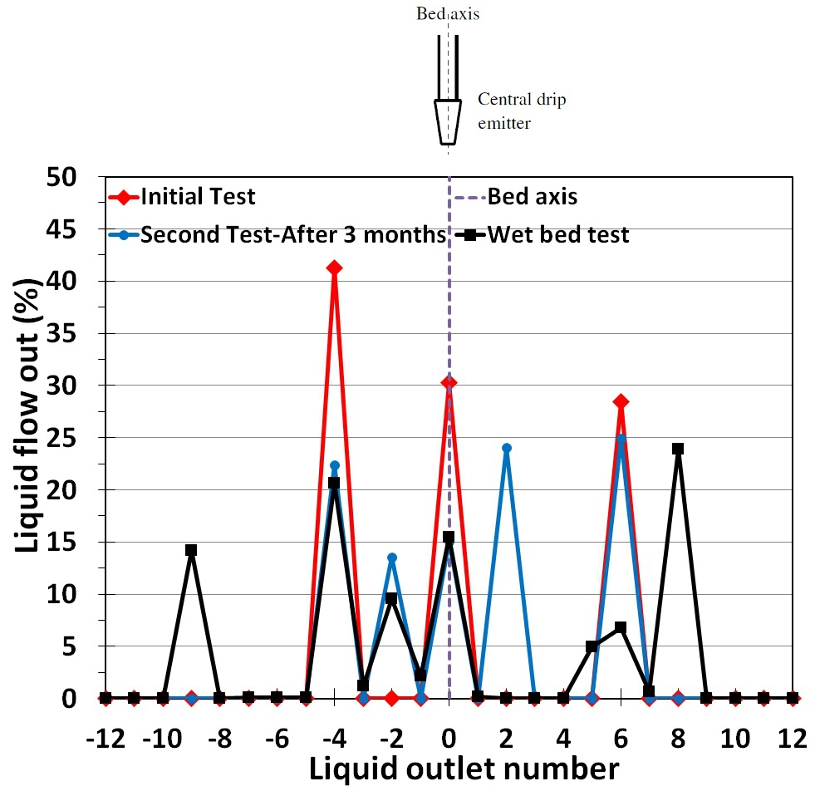

Figure 7: Liquid distribution of initially dry (the first test at the steady state and the second test after 3 months of drainage and subsequent liquid addition at the same flow rate) and fully wetted 2-D beds packed with 2-26.5 mm ore mixture at liquid addition rate of 4.2 L/h at the centre of the bed.

4.4. Effects of Liquid Addition at the Top

Once the flow in the bed with the realistic particle size distribution reached steady state, the single drip emitter liquid addition was changed to increase the number of drip emitters. This did not change the overall liquid addition rate (4.2 L/h for both single dripper and multiple drippers), but did increase the area of the liquid addition at the top. Thus this mimics more uniform liquid addition strategies at the top of the heap compared to more typical dripper spacing.

Even with more uniform wetting at the top there is still strong evidence of channelling as shown in Figure 8. The resultant out-flow profile is slightly more uniform with 3 drip emitters than from the first 2 experiments with a single dripper location (6 or 7 active outflow points compared to 3 or 5 outflow points – compare Figure 7 and 8), but the uniformity is only comparable to the flooded bed experiment with a single addition point (compare Figure 7 and 8). This indicates that in the top region of the bed by increasing the drip emitter density (one emitter changes to 3 for the same bed area at the top, which is 80 cm times 10 cm) can improve the external liquid flow paths. However, the channelling effect cannot be completely eliminated.
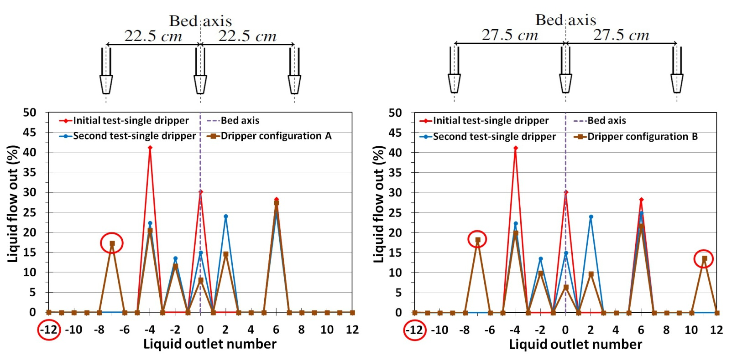

Figure 8: Effect of drip emitter spacing on the initial liquid distribution and the graphs show external flow paths distribution under two new drip emitter configurations. The experiments were performed using 2-26.5 mm ore mixture at a flow rate of 4.2 L/h.

5. Conclusions

The spread of the liquid within the ore particles compared to that around them are very different in terms of both their extent and time scales. Liquid flow around particles establishes itself quickly, but with limited horizontal spread, while liquid within particles spreads much wider, but over a much longer time period. This wider spread is associated with virtually no active flow, though. In an industrial heap this wider capillary spread would thus be less useful than the spread of the active paths as the transport of dissolved species through these regions would be through slow diffusive transport rather than much faster convective transport. Of course this wetting is a requirement for any transport to occur. Leaching may proceed with available capillary held reagents in the areas away from drip emitter locations, but effective transport of metal ions require flowing channels. Together with changes in the chemical environment, this may be one of the reasons why intermittent irrigation has been shown to improve performance as the wetting and drying cycles will cause changes in the capillary gradients in these otherwise stagnant regions and thus induce some convective transport in this fluid.

The difference between the uniform wetting of the particles and the strong channelling indicates the extent to which apparent uniform wetting can hide large flow variability.

This channelling of the liquid appears to be caused by local micro-scale heterogeneities that cannot be eliminated; channelling cannot be eliminated by good packing alone. This adverse flow behaviour is likely to reduce leaching and recovery efficiencies. Since heaps are stacked with wider size distributions, channelling needs to be minimised for more uniform distribution of flow channels. Flooding of the bed (not practical in industrial heap leaching, but practical in experimental columns) or application of higher flow rates initially as well as more uniform liquid addition at the top of the heap reduces channelling, but does not eliminate it. Initially increasing the flow rate will, though, also increase the saturation even after the addition has been reduced back to the desired long term value. This will have a positive impact on wetting, but could negatively influence air motion in the bed, for instance.

Acknowledgements
The authors gratefully acknowledge Rio Tinto for their financial support of this project. Graham Nash and Gary Speakman are recognised for their support during the test work.

References
- Afewu, K.I., 2009. Development and testing of a 2D axisymmetric water flow and solute transport model for heap leaching. PhD thesis, University of British Columbia, Canada.
- Armstrong, F.E, Evans, G.C., Fletcher, G.E., 1971. Tritiated water as a tracer in the dump leaching of copper. US Bureau of Mines, Report of Investigations 7510.
- Bartlett, R.W., 1992. Solution mining: leaching and fluid recovery of materials, second ed. Gordan and Breach Science, Amsterdam.
- Cathles L.M. and Murr L.E., 1980. Evaluation of an experiment involving large column leaching of low grade copper sulphide waste: A critical test of a model of the waste leaching process. In: Schlitt, W.J. (Editor), Leaching and recovery of copper from as-mined materials, Society of Mining Engineers of AIME, Warrendale, PA, pp. 29-48.
- Dixon, D.G., 2003. Heap leach modelling – the current state of the art. In: Hydrometallurgy 2003, Proceedings of the 5th International Symposium in honor of Professor Ian M. Ritchie, Volume 1: Leaching and Solution Purification (C.A. Young, A.M. Alfantazi, C.G. Anderson, D.B. Dreisinger, B. Harris and A. James, editors), TMS (The Minerals, Metals & Materials Society), Warrendale, PA, 2003, pp. 289–314.
- Fagan, M.A., Ngoma, I.E., Chiume, R.A., Minnaar, S., Sederman, A.J., Johns, M.L., Harrison, S.T.L., 2014. MRI and gravimetric studies of hydrology in drip irrigated heaps and its effect on the propagation of bioleaching micro-organisms. Hydrometallurgy 150, 210-221.
- Howard E.V., 1968. Chino uses radiation logging for studying dump leaching process. Mining Engineering April 1968, 70-74.
- Ilankoon, I.M.S.K., Neethling, S.J., 2012. Hysteresis in unsaturated flow in packed beds and heaps. Minerals Engineering 35, 1-8.
- Ilankoon, I.M.S.K., 2012. Hydrodynamics of unsaturated particle beds pertaining to
heap leaching. PhD thesis, Imperial College London.
- Ilankoon, I.M.S.K., Neethling, S.J., 2013. The effect of particle porosity on liquid holdup in heap leaching. Minerals Engineering 45, 73-80.
- Ilankoon, I.M.S.K., Neethling, S.J., 2014. Transient liquid holdup and drainage variations in gravity dominated non-porous and porous packed beds. Chemical Engineering Science 116, 398-405.
- Murr, L.E., 1979. Observations of solution transport, permeability and leaching reactions in large, controlled, copper-bearing waste bodies. Hydrometallurgy 5, 67-93.
- Murr, L.E., Schlitt, W.J., Cathles, L.M., 1981. Experimental observations of solution flow in the leaching of copper-bearing waste. In: SME-AIME fall meeting and exhibit, Denver, Colorado, November 1981, pp. 1-18.
- Petersen, J., Dixon, D.G., 2007. Modelling zinc heap bioleaching. Hydrometallurgy 85, 127-143.
- Roman, R.J., 1977. Solution channeling in leach dumps. Transactions of Society of Mining Engineering, AIME 262, 73-74.
- Wu, A., Yin, S., Yang, B., Wang, J., Qiu, G., 2007. Study on the preferential flow in dump leaching of low grade ores. Hydrometallurgy 87, 124–132.
- Wu, A., Yin, S., Qin, W., Liu, J., Qiu, G., 2009. The effect of preferential flow on extraction and surface morphology of copper sulphides during heap leaching, Hydrometallurgy 95, 76-81.
- Yusuf, R., 1984. Liquid flow characteristics in heap and dump leaching. M.Sc. Thesis. University of New South Wales, Australia.

Authors are not happy about some of the comments and wording used by the Reviewer 1 in their report without completely understanding some of the contents in our original manuscript. furthermore, rather than giving typed comments on a PDF file, which is very easy, the Reviewer 1 has simply given hand-written and untidy (difficult to read) comments. Thus it has been very tedious to write this revised manuscript.

If the editor agrees with this please consider alternative reviewers for Reviewer 1.

