Hydrogel substrate stress-relaxation regulates the spreading and proliferation of mouse myoblasts
Aline Bauer^{a,b}, Luo Gu^{a,c}, Brian Kwee^{a,c}, Aileen Li^{a,c}, Maxence Dellacherie^{a,c}, Adam D. Celiz^{a,d,e}, David J. Mooney^{a,c*}
ª Wyss Institute for Biologically Inspired Engineering, Harvard University, Cambridge, MA 02138, USA
^{b} Department of Bioengineering, École Polytechnique Fédérale de Lausanne, Route Cantonale, Lausanne 1015, Switzerland
^{c} School of Engineering and Applied Sciences, Harvard University, Cambridge, MA 02138, USA
^{d} Advanced Materials and Healthcare Technologies, School of Pharmacy, University of Nottingham, Nottingham, NG7 2RD, UK
^{e} Present address: School of Bioengineering, Imperial College London, London SW6 7PB, UK
*Corresponding author at:
School of Engineering and Applied Sciences, Harvard University, Cambridge, MA 02138, USA, email address: mooneyd@seas.harvard.edu (David Mooney), Phone: (617) 384-9624, Fax: (617) 495-9837
aline.bauer@hispeed.ch
luogu@seas.harvard.edu
bkwee@seas.harvard.edu
wli@fas.harvard.edu
mdellacherie@g.harvard.edu
a.celiz@imperial.ac.uk
mooneyd@seas.harvard.edu
Abstract
Mechanical properties of the extracellular microenvironment are known to alter cellular behavior, such as spreading, proliferation or differentiation. Previous studies have primarily focused on studying the effect of matrix stiffness on cells using hydrogel substrates that exhibit purely elastic behavior. However, these studies have neglected a key property exhibited by the extracellular matrix (ECM) and various tissues; viscoelasticity and subsequent stress-relaxation. As muscle exhibits viscoelasticity, stress-relaxation could regulate myoblast behavior such as spreading and proliferation, but this has not been previously studied. In order to test the impact of stress relaxation on myoblasts, we created a set of two-dimensional RGD-modified alginate hydrogel substrates with varying initial elastic moduli and rates of relaxation. The spreading of myoblasts cultured on soft stress-relaxing substrates was found to be greater than cells on purely elastic substrates of the same initial elastic modulus. Additionally, the proliferation of myoblasts was greater on hydrogels that exhibited stress-relaxation, as compared to cells on elastic hydrogels of the same modulus. These findings highlight stress-relaxation as an important mechanical property in the design of a biomaterial system for the culture of myoblasts.
Keywords
Viscoelasticity; Stress-relaxation; Myoblast; Hydrogel; Alginate
1. Introduction
Hydrogel-based biomaterials hold enormous potential for regenerative medicine and tissue engineering applications[1]. They can serve as synthetic instructive extracellular matrix (ECM) microenvironments, providing mechanical support as well as physical and biochemical signals to cells[2], [3]. The ECM is a complex environment and hydrogel-based biomaterials have been used to recapture some elements of the ECM niche[4]. For example, hydrogels incorporating various soluble and bound biochemical signaling factors[5], and structural and mechanical cues such as porosity[6], [7] or stiffness[8] have been fabricated and shown to influence cell behavior. However, viscoelasticity has often been neglected and is rarely used as a design parameter, even though it is an important mechanical property displayed by natural ECM-derived materials such as type I collagen gels[9] and tissues including muscle[10], brain[11] and adipose[12].
The mechanical properties of biomaterials are clearly an important design parameter from the perspective of regulating the behavior of adhesive cells. Indeed, there is a reciprocal mechanical interaction between cells and the ECM[13], [14], as cells can remodel their surrounding ECM while the mechanical, structural and chemical composition of the surrounding ECM can regulate intracellular processes and cell behavior including spreading, proliferation and differentiation[15], [16]. Importantly, matrix stiffness has been highlighted as an important mechanical parameter. For example, it influences the ability of stem cells to differentiate towards specific lineages. Mesenchymal stem cells (MSC) were shown to differentiate towards a neurogenic lineage when cultured on soft 0.1-1 kPa substrates, towards a myogenic lineage when cultured on 8-17 kPa substrates and towards an osteogenic lineage when cultured on stiffer 25-40 kPa substrates[17].
Many studies have focused on the effect of matrix stiffness using hydrogels that are almost purely elastic, such as polyacrylamide hydrogels, consequently neglecting the viscoelastic behavior of the ECM and various tissues. Viscoelastic gels or tissues under constant strain will exhibit partial stress-relaxation, or a decrease in the stress required to maintain the strain over time[18]. Recent studies using viscoelastic hydrogels as cell culture substrates have reported an influence of viscoelasticity on cell spreading[19],[20], proliferation[19],[21] and differentiation[21], [22]. More specifically, the effect of stress-relaxation was investigated with mesenchymal stem cells cultured on 2D[20] or in 3D[21] hydrogels, as well as with fibroblasts and human osteosarcoma cells (U2OS) cultured on 2D hydrogels[19].
Muscle, as many other tissues within the body, is viscoelastic in nature. This could be an important mechanical component for regulating the behavior of the cells that reside in this tissue; myoblasts. (3.2) Nevertheless, the effect of stress-relaxing substrates on the behavior of myoblasts is currently unknown. In the past, changes in substrate rigidity have been shown to affect myoblast spreading[23], proliferation[24] and differentiation[23] as well as skeletal muscle stem cell self-renewal[25]. This study addresses the hypothesis that substrate stress-relaxation can regulate myoblast cell spreading and proliferation in vitro. To test this hypothesis, we designed two sets of hydrogel substrates; elastic and stress-relaxing alginate hydrogels. Myoblast cells (myoblast cell line C2C12 and primary myoblasts) were cultured on these 2D alginate substrates. The aim of the study was to investigate the effect of the material on two different cell types, the myoblast cell line C2C12 and primary myoblasts, independently. Alginate is a polysaccharide derived from algae composed of linearly assembled (1-4)-linked β-mannuronic acid (M) and α-guluronic acid (G). As alginate does not contain any integrin-binding sites for cells, cell adhesion was promoted through covalent coupling of an arginine (R), glycine (G), and aspartic acid (D) (RGD)-containing peptide to alginate using carbodiimide chemistry[26]. Purely elastic and viscoelastic alginate hydrogels were synthesized by changing the nature of the alginate crosslinking using covalent crosslinking and ionic crosslinking respectively, as previously reported[18].
2. Materials and Methods
2.1. Preparation and functionalization of alginate
Ultrapure sodium alginate (MVG, FMC Biopolymer) with high guluronic acid content was used as the high molecular weight alginate. Low molecular weight alginates were produced by irradiating high molecular weight alginate with a 3 or 5 Mrad cobalt source. The alginates were prepared as previously described[26]. RGD alginate was made by coupling the oligopeptide GGGGRGDSP (Peptides International) to alginate using carbodiimide chemistry. The peptide concentration was such that 20 RGD peptides were coupled to 1 alginate chain on average (degree of substitution, DS = 20), corresponding to 1500 µM in a 2 % wt/vol alginate gel. The reaction was performed as previously described[19]. Briefly, 2 g of alginate was reconstituted overnight at 1 % wt/vol in MES buffer (0.1 M MES, 0.3 M NaCl, pH 6.5), then 548 mg of sulfo-NHS (Alfa Aesar), 968 mg of EDC (TCI chemicals) and 224 mg of GGGGRGDSP peptide were slowly added and the reaction was allowed to proceed for 20 h before being quenched with 130 mg of hydroxylamine hydrochloride (Sigma). The alginate was then dialyzed and purified using tangential flow ultrafiltration (TFF, molecular weight cut off of 3,500 Da), sterile filtered, lyophilized and stored at -20 °C. Finally, the modified alginates were reconstituted in serum-free DMEM for ionic crosslinking or MES buffer for covalent crosslinking to obtain 2.5 % wt/vol solutions prior to gelation and were stored at 4 °C. The same RGD-modified alginate batches were used for all cell experiments.
2.2. Alginate molecular weight characterization
Molecular weights of alginates were analyzed by gel permeation chromatography (GPC) in water (0.1 M NaNO₃) using a 1260 Infinity Multi-Detector GPC/SEC System (Agilent Technologies) with two TSK-gel columns (G5000PWxl/G6000PWxl), connected in series equipped with a triple detector system including a refractive index (RI) detector, a multi-angle light scattering detector and a viscometer calibrated in relation to pullulan standards (Agilent). Samples were dissolved in 0.1 M NaNO₃ buffer solution at a concentration of 2 mg/ml, filtered through a 0.2 µm filter before injection (100 µl) using a 0.35 mL/min flow rate.
2.4. Alginate hydrogel preparation
RGD alginate hydrogels (1 mm thick, 15 mm diameter) were prepared as previously described[19]. For ionically crosslinked gels, 1.12 ml RGD DS 20 alginate (2.5 % w/v) in serum-free DMEM was rapidly mixed with 0.28 ml DMEM containing the appropriate amount of calcium sulfate (concentrations are detailed in the supplementary Table 1). The resulting solution was rapidly deposited between two glass plates (1 mm spacing) and allowed to gel for 45 min. After gelation, 15 mm disks were punched out and equilibrated overnight in serum-free media supplemented with 1 % penicillin/streptomycin (P/S). For covalently crosslinked gels, 1.12 ml RGD DS 20 alginate (2.5 % w/v) in MES buffer was first mixed with 140 µl of MES buffer containing the appropriate amount of 1-hydroxybenzotriazole (HOBT) and adipic acid dihydrazide (AAD) (concentrations are detailed in the supplementary Table 1). The resulting solution was mixed with 140 µl of MES buffer containing EDC (100 mg/ml). The mixed solution was rapidly deposited between two glass plates (1 mm spacing) and allowed to gel for 3 h. After gelation and punching out of 15 mm disks, the gels were washed in serum-free media supplemented with P/S four times over two days to remove excess reagents and by-products. All hydrogel formulations can be found in supplementary Table 1.
2.3. Mechanical characterization of alginate hydrogels and rat muscle
The stiffness and stress-relaxation properties of alginate gels were assessed from compression tests using an Instron 3342 single-column mechanical tester[18]. The gels used for mechanical testing were 2 mm thick, 15 mm diameter and were equilibrated in DMEM for 24 h before measurements. For the stiffness measurements, the gels were compressed to 15% strain with a deformation rate of 1 mm/min. The Young’s modulus (corresponding to the elastic modulus) was then calculated as the slope of the linear stress strain curve between 5-10 % strain. For the stress-relaxation measurements, the gels were compressed to 15 % strain with a deformation rate of 1 mm/min, consequently the strain was held constant and then stress was recorded as a function of time. The stress-relaxation rate was calculated as the half stress-relaxation time. Stress relaxation measurements of biological tissues were performed using the same procedure. Sprague Dawley Rats (male, 7 weeks of age, Charles River Lab) were euthanized in compliance with National Institutes of Health and institutional guidelines. Rat hindlimb muscles were collected after euthanization and tested immediately with the Instron 3342 single column apparatus.
Stress relaxation tests on biological tissues are typically conducted between 10-30% strains. With relation to the relevance for interactions with cells, various different strains have been reported. In cell mechanotransduction studies, strains of a few percent to 30% have been observed [27], [28]. The 15 % strain used here is within the strain range generated by cells and has been used in previous mechanotransduction studies[19]. A compression rate of 1 mm/min was used here so that a 15% strain could be applied on the soft, thin hydrogel samples quickly but without generating excessive strain or large noise at the beginning of the test due to the inertia from the heavy arm and load cell of the Instron mechanical tester. (2.1)
2.5. Cell isolation and culture
C2C12 mouse myoblasts (cell line obtained from ATCC) were cultured in high glucose DMEM (Invitrogen) supplemented with 10 % fetal bovine serum (FBS, Gibco) and 1 % P/S. The cells were cultured in T75 flasks in a humidified incubator (37 °C and 5% CO2) and were passaged so that confluency of the culture was kept below 60 %. Cells used in experiments were always between passages 4 to 6.
Satellite cells (SCs) were derived from 2-week to 12-week old C57BL/6J mice hindlimb skeletal musculature. Four days before the isolation, the muscle was injured with 50 µl of 1.2 % BaCl₂ (Sigma) in deionized water (10 µl into each of the following muscles: middle of tibialis anterior, front and back of quadriceps, front and back of hamstring). Mice were euthanized in compliance with National Institutes of Health and institutional guidelines. Under sterile conditions, the tibialis anterior, and gastrocnemius muscles were surgically removed, minced and incubated in a collagenase type II solution (Gibco, 250 U/ml in DMEM with 1 % P/S) for 90 min at 37 °C. The muscle fibers when then triturated with a 5 ml pipet, 10 ml pipet and finally 18G needle. After centrifugation at 300 x g, the muscle fibers were incubated in a collagenase-dispase solution (250 U/ml-10 U/ml in F10 media) for 60 min at 37 °C in a slow rocking water bath and vortexed for 1 min at maximum speed to release the SCs from the myofibers. The solution was filtered through a 40 µm filter, followed by a 20 µm filter and the cells were collected by centrifugation at 500 x g. The SC isolation kit (Miltenyi Biotec) was used to deplete non-target cells with magnetic-activated cell sorting (MACS) according to the manufacturer’s instructions. SCs were cultured in F10 media (Invitrogen), supplemented with 20 % FBS, 1 % P/S and 5 ng/ml murine basic FGF (Peprotech) in a humidified 5 % CO₂ incubator at 37 °C.
2.6. Cell characterization methods
2.6.1. Determination of C2C12 spreading and morphology
The gels were held at the bottom of a 12 well-plate by a custom plastic insert to avoid floating of the gel when submerged with media. C2C12 cells were plated at a density of 10,000 cells/cm² and were cultured for 22 h to allow adherence and spreading of the cells as well as analysis of single cells. (1.7) Media was removed from each well and cells were fixed with 4 % paraformaldehyde (PFA) in Dulbecco’s phosphate buffered saline (DPBS) for 15 min at RT. Gels were washed two times in DPBS, cells permeabilized with 0.3 % Triton-X in DPBS for 15 min at RT and washed two more times in DPBS. Gels were transferred into custom made PDMS wells that allowed for the use of less reagents and direct imaging of the gels. The cells were incubated with Alexa Fluor (AF) 488 phalloidin (1:80 dilution, Invitrogen) to stain actin and Diamidopyridine (DAPI, 1:1000 dilution, Invitrogen) for 30 min. Gels were washed three times in DPBS before imaging. For measurements of the cell-spreading area, images of phalloidin and DAPI stained cells were taken with 10 x objective on a laser scanning confocal microscope (LSM 710 Zeiss). Only single cells were considered in the analysis and their projected area was determined using ImageJ64. Circularity and Aspect Ratio were quantified using ImageJ64 and the shape factor plug-in. (3.1) DPBS with calcium and magnesium (Lonza) was used throughout the experiments.
For the C2C12 spreading experiment: we cultured cells for 22 hours to enable the cells to adhere and spread on the hydrogels. Prolonged culture was not explored as we wanted to capture single-cell division before the entire population of cells had divided. (1.7)
2.6.2. Determination of C2C12 proliferation
Click-IT plus EdU AF 555 kit (Invitrogen) was used to quantify cells actively synthesizing DNA. The gels were held at the bottom of a 12 well-plate by a custom plastic insert to avoid floating of the gel when submerged with media. C2C12 cells were plated at a density of 10,000 cells/cm² and were allowed to adhere for 8 h whereupon half of the media was replaced with media containing the thymidine analog EdU (final concentration 10 µM). After another 8h, cells were fixed with 4 % PFA in DPBS for 15 min at RT. Cells were washed twice for 2 min with 3 % bovine serum albumin (BSA) in DPBS and permeabilized with 0.3 % Triton X-100 in DPBS for 15 min at RT. Gels were transferred into custom made PDMS wells that allowed for the use of less reagents and direct imaging of the gels. Click-iT EdU reaction cocktail was prepared as described by the manufacturer and 280 µl per well was added for 30 min at RT protected from light. Cells were then washed once with 3 % BSA in DPBS and were incubated with Hoechst 33342 diluted 1:2000 in DPBS for 20 min at RT protected from light. Cells were finally washed twice with DPBS and imaged using Zeiss Axio Zoom V16 (ZoomV16) and Zen software. Images were processed and cell nuclei were counted with ImageJ64 software using a custom made script. The percentage of cells synthesizing DNA was computed as the ratio of cells positively stained with AF 555 divided by the total number of cells given by Hoechst counter-staining. DPBS with calcium and magnesium (Lonza) was used throughout the experiments.
C2C12 cells were allowed to adhere for 8 hours, after that EdU was added for the next 8 hours of culture to capture cell proliferation. The EdU incubation time was optimized so as to have an optimal ratio of divided/non-divided cells. (1.7)
2.6.3. Primary myoblast characterization by fluorescence-activated cell sorting (FACS)
After isolation, SCs were expanded for 6 days on collagen-coated dishes (Corning). Media was removed and dishes were rinsed with PBS and incubated for 10 min at 37 °C. Subsequently, the dish was firmly knocked against a hard surface in order to release the cells. The PBS was collected and trypsin was added for 2 min in order to release the remaining cells. All staining was performed on ice and in flow cytometry staining buffer consisting of PBS supplemented with 5 % FBS and 5 % BSA. Briefly, cells were blocked with Fc block (5 µg/ml, BD Biosciences) and stained with a PE-conjugated Syndecan-4 antibody (1 µg/ml, BD Biosciences) and an unconjugated M-cadherin primary antibody (1 µg/ml, R&D systems) followed by an AF 594 secondary antibody (1 µg/ml, Invitrogen). A dead cell dye (7-AAD, BD biosciences) was used to discriminate between live and dead cells. Flow cytometry data was collected on a LSRII flow cytometer (BD Biosciences, Franklin Lakes, NJ) and analyzed using FlowJo software.
2.6.4. Determination of primary myoblasts proliferation
The gels were prepared on sterile 15 mm coverslips (1 mm total thickness) and put in a 24 well-plate so that the gels covered the majority of the surface of the well. After SC isolation, cells were expanded for 6 days on collagen-coated dishes (Corning) before being collected. The cells were then incubated for 15 min at 37 °C in 1 µM carboxyfluorescein succinimidyl ester (CFSE - Invitrogen) in PBS and washed with fresh media before incubating for another 30 min at 37 °C to ensure complete modification. The cells were then seeded on the gels at a density of 20,000 cells/cm² and incubated at 37°C for 3 days. The gels were removed from the wells and digested separately; covalently crosslinked alginate gels were digested with alginate lyase (10 U/ml) and ionically crosslinked alginate gels were digested with 50 mM EDTA in DPBS. After centrifugation at 500 x g, the pellets were incubated with trypsin for 2 min to ensure complete detachment of the cells and the final cell solution was filtered through a 40 µm filter. For the staining, cells were blocked with Fc block and a dead cell dye (7-AAD) was used to discriminate between live and dead cells. Flow cytometry data was collected on a LSRII flow cytometer (BD Biosciences, Franklin Lakes, NJ) and analyzed using FlowJo software.
CFSE dye was incorporated prior to cell culture on the gels and enables monitoring of the cell division cycles over time. Three days of culture with CFSE were chosen based on a previous publication[29] and the slow division cycle of these cells. (1.7)
2.7. Statistical analysis
Statistical analysis was performed using two-tailed unpaired Student t-test (Graphpad - Prism). A value of p < 0.05 was considered to be statistically significant. (* p < 0.05, ** p < 0.01, *** p < 0.001) Quantitative data are expressed as the mean ± standard deviation (SD) of minimum three replicates.
3. Results
The viscoelastic behavior of muscle tissue was first characterized with a stress-relaxation test of a rat hindlimb muscle at 15 % strain (Fig. 1A). The muscle was found to be rapidly stress-relaxing under the applied constant strain. As the muscle displays viscoelastic behavior, the aim of this study was to test how substrate stress-relaxation could regulate muscle cell (myoblast) spreading and proliferation in vitro (Fig. 1B). To this end, mouse myoblasts were cultured on alginate hydrogel substrates of various stiffness that were elastic or stress-relaxing. Both the myoblast cell line C2C12 and freshly isolated, primary myoblasts were used in these studies, as C2C12 cells can lose sensitivity to environmental cues. (1.1)
3.1 Fabrication and mechanical characterization of stress-relaxing and non-stress-relaxing RGD-modified alginate hydrogels
We used three alginate polymers of different molecular weights to fabricate hydrogels. Ionically crosslinking alginate with the divalent cation Ca²⁺ resulted in hydrogels exhibiting stress-relaxation, consistent with previous findings[18], whereas covalently crosslinking alginate with carbodiimide chemistry led to hydrogels exhibiting little stress-relaxation as assessed from compression tests at 15 % strain (Fig. 2A, 2B). A range of elastic and viscoelastic hydrogel substrates were fabricated that exhibited similar initial elastic moduli of 2.8 kPa (low crosslinking), 12.2 kPa (mid-low), 18.5 kPa (mid-high) and 49.5 kPa (high). No statistically significant differences between the initial elastic moduli of paired covalently and ionically crosslinked hydrogel substrates were observed (Fig. 2C). The specific stress-relaxation half-times varied from 79 to 519 seconds among gels of different stiffness (Supp. Table 1). To minimize the variance in stress-relaxation half-times of the gels, alginates of different molecular weights were chosen e.g. higher molecular weight alginate reduces the stress-relaxation half time. For example, to synthesize a slower stress-relaxing 50 kPa hydrogel that would match rates of other conditions a high MW alginate is required, however, the viscosity of the resulting solution is too high to mix it homogeneously with the calcium solution. (1.1) All hydrogel formulations can be found in Supplementary Table 1.
3.2 Effect of stress-relaxation on the spreading and proliferation of C2C12 myoblasts
The effect of substrate stress-relaxation on the spreading of mouse myoblasts (C2C12 cells) was assessed by measuring the area of individual myoblasts cultured for 22 hours on RGD-alginate hydrogel substrates of varying initial elastic moduli, with and without stress-relaxation and stained with phalloidin to visualize actin.
Representative images of actin staining show single cells cultured on each substrate condition (Fig. 3 A). An unpaired two-tailed Student t-test was used to compare the difference in the mean cell spreading on elastic and stress-relaxing gels of same modulus and to determine the significance. (1.2) The cell-spreading area significantly increased at higher stiffness as the initial elastic modulus was increased from 2.8 kPa to 49.5 kPa on elastic gels (Fig. 3 B). On stress-relaxing gels however, the cell-spreading area significantly increased from 2.8 to 12.2 kPa, but did not further increase as the modulus was increased. Additionally, the spreading of myoblasts was found to be significantly enhanced on stress-relaxing gels with initial elastic modulus of 2 and 12 kPa, compared to the corresponding elastic gels, but was significantly lower on 49.5 kPa stress-relaxing gels compared to the corresponding elastic gels.
Furthermore, specific cell shape morphology descriptors, including circularity (Fig. 3 C) and aspect ratio (Fig. 3 D) were quantified and statistical significance was assessed using an unpaired two-tailed Student t-test. Myoblasts cultured on 2.8 and 12.2 kPa hydrogels were significantly more elongated and had higher aspect ratio on stress-relaxing gels relative to elastic gels. Significant higher aspect ratio was observed on stiff (49.5 kPa) stress-relaxing hydrogels, but no significant difference in circularity was observed on the stiffer hydrogels. (3.1)
Next, we assessed the proliferation of the myoblasts (C2C12). Myoblasts were cultured on different substrate conditions for 16 hours and incubated with the thymidine analog EdU for the last 8 hours to capture dividing cells. We quantified the proliferation as the percentage of cells positive for EdU compared to the total number of cells (Fig. 3 E). Increasing proliferation was observed for myoblasts on elastic and stress-relaxing substrates with increasing initial elastic moduli (Fig. 3 F). Moreover, myoblast proliferation was higher on stress-relaxing substrates compared to elastic substrates for all initial elastic moduli tested. Additionally, proliferation of C2C12 was assessed on 12.2 kPa gels of different stress-relaxing rates (slow: 1827 seconds, mid: 1250 sec, fast: 224 seconds) in supplementary figure 3. No difference in proliferation was observed for C2C12 cultured on stress-relaxing hydrogels of various stress-relaxing rates. Furthermore, to determine if the phenomena of C2C12 spreading and proliferation were related we compared these datasets and found there to be no correlation across the gels that were studied (Supplementary figure 4 (2.5))
3.3 Effect of stress-relaxation on the proliferation of primary myoblast cells
The effect of stress-relaxation on the proliferation of primary mouse myoblasts was next analyzed. To determine myogenic purity, cells were analyzed for the expression of two cell-surface antigens, M-Cadherin and Syndecan-4, using fluorescent-activated cell sorting (FACS). M-Cadherin[30] and Syndecan-4[31] are muscle satellite cell markers commonly used for the isolation and identification of satellite cells. (2.6) The isolated cell population exhibited high myogenic content, as more than 90% of cells were positive for M-Cadherin while approximately 65 % of the cells were positive for both M-Cadherin and Syndecan-4 (Fig. 4 A-B). The primary gating strategy is shown in supplementary Figure 1. The isolated population was then cultured on collagen-coated dishes for 6 days. Subsequently, proliferation on 12.2 kPa hydrogel substrates, with and without stress-relaxation was assayed using the Cell Trace CFSE dye, a membrane dye that is diluted upon cell division. We observed a left shift of the curve representing the CFSE dye for primary myoblasts cultured on stress-relaxing gels (Fig. 5 C), and quantification of the mean CFSE intensity confirmed that primary myoblasts cultured on stress-relaxing hydrogels retained on average significantly lower levels of Cell Trace CFSE, indicating a higher proliferation rate, compared to primary myoblasts cultured on elastic hydrogels (Fig. 5 D). Proliferation of primary myoblasts on elastic and stress-relaxing gels of 2 and 50 kPa as well as on slow-stress-relaxing 12 kPa gel is shown in supplementary figure 2. Higher proliferation rate was observed for primary myoblasts cultured on soft (2.8 kPa) stress-relaxing gels compared to elastic gels, whereas no statistical difference was observed for primary cells cultured on stiff (49.5 kPa) stress-relaxing and elastic gels. Proliferation was not statistically different for primary cells cultured on stress-relaxing gels of different stress-relaxation rates (slow: 1827 seconds, fast: 224 seconds). (1.3)
Cell-spreading was not quantified with primary myoblasts as these cells are characteristically rounded in nature and exhibit limited spreading in their undifferentiated state (see Figure 4A). Also, it is well known that satellite cells have different adherence profiles[32] to cell culture materials (as well tissue culture plastic). (1.3)
4. Discussion
This study employed alginate hydrogel substrates to examine whether stress-relaxation regulated the spreading and proliferation of myoblasts. Alginate hydrogels can display stress-relaxing or purely elastic behavior depending on the crosslinking type[18]. Ionically crosslinked gels displayed rapid relaxation, as expected, while covalently crosslinked alginate hydrogels displayed low levels of stress-relaxation at long time scales. Previous studies demonstrated the latter was due to water migration out of alginate gels during bulk compression (poroelasticity), not viscoelasticity of the hydrogels [18]. In this study, the general stress-relaxation behavior of the muscle was mimicked with the viscoelastic hydrogels. The stress-relaxation half-times were not exactly matched among gels of different stiffness but variance in half-times were minimized by using alginates of different molecular weights. This variance in stress-relaxation half-times does not interfere with the scope of this study that investigates the general effect of stress-relaxation on myoblast proliferation and spreading. Further studies could modify this system to match stress-relaxation half-times among varying stiffness and evaluate the impact on these cell types. (1.1) By adjusting the crosslinker concentrations for both types of hydrogels, we achieved substrate stiffness mimicking that of healthy skeletal muscle[25] (~12 kPa), diseased or aged muscle[33] that present stiffer modulus (>18 kPa) as well as a lower limit (~3 kPa) and an upper limit (~50 kPa).
We found that the spreading and proliferation of C2C12 cells increased with increasing stiffness on elastic and viscoelastic substrates. The impact on spreading is consistent with a previous study on myoblasts cultured on collagen-coated polyacrylamide gels[23]. These results are also generally consistent with past studies suggesting that stiffer gels lead to a higher ability of the cells to generate traction forces and to enter the cell cycle, resulting in increased spreading and proliferation[34],[8]. Moreover, myoblasts were generally more elongated when cultured on stress-relaxing substrates compared to elastic substrates. (3.1)
Interestingly, stress-relaxation impacted the morphology, spreading and proliferation of myoblasts. Furthermore, myoblast spreading area was greater on stress-relaxing substrates relative to elastic substrates on gels with lower moduli. Proliferation of myoblasts and primary myoblasts cultured on stress-relaxing substrates of varying stiffness was greater than on elastic substrates. Typically, cell spreading and proliferation are thought to be greatly reduced on softer hydrogels compared to stiffer gels. However, in this study, cell spreading and proliferation on softer stress-relaxing substrates was similar to stiffer elastic substrate. These findings are consistent with a previous study suggesting that rapid stress-relaxation could compensate for matrices with lower stiffness[19]. This study suggested β1 integrin, actin polymerization and actomyosin-based contractility as a mechanistic basis for this event. Additionally, increased translocation of the YAP transcriptional regulator, a mechanosensor for cells on 2D substrates[35] was reported with stress-relaxing substrates. These findings suggest that the effect of stress-relaxation might be moderated in part through some similar, not necessarily overlapping, pathways as stiffness. However, further experiments are required to investigate this. Add smthg about LINC components
Add smthg about sr-rates -> not a significant difference
The myogenic purity of the freshly isolated primary cells was confirmed by analyzing two well-known myogenic markers (M-Cadherin and Syndecan-4) with FACS (Fig. 5) and was consistent with previous work[36]. Two different methods were used to analyze the proliferation of myoblasts and primary myoblasts. Due to the weak adherence of primary myoblasts on culture substrates, the thymidine analog EdU was not used with these cells since the process of fixing and staining could remove the cells. Therefore, a membrane dye (CFSE) enabling FACS analysis that incorporates into living cells and dilutes upon every division was preferred here. While we expanded the primary myoblasts for 6 days on collagen coated tissue-culture plastic dishes prior to plating them on the hydrogel substrates, one may observe a more dramatic effect by plating them on the hydrogel substrates directly after their isolation[37].
In summary, this study demonstrates that morphology, spreading area and proliferation of myoblasts is impacted by both the stiffness and stress relaxation behavior of the substrates to which they adhere. These findings highlight the potential importance of substrate stress-relaxation in designing materials for regenerative medicine and tissue engineering applications.
Acknowledgments
This work was supported by the NIH (R01 DE013349) and the European Commission (A.D.C.) under FP7 IOF project Stem Cell Hydrogels (agreement no. 629320). The authors want to thank Michael Lewandowski for helping with GPC characterization, Christine Cezar teaching us satellite cell isolation as well as Tom Ferrante for his help with the confocal microscopy.
References
[1] K. Y. Lee and D. J. Mooney, “Hydrogels for Tissue Engineering,” Chem. Rev., vol. 101, no. 7, pp. 1869–1879, 2001.
[2] M. P. Lutolf and J. A. Hubbell, “Synthetic biomaterials as instructive extracellular microenvironments for morphogenesis in tissue engineering,” Nat. Biotechnol., vol. 23, no. 1, pp. 47–55, 2005.
[3] W. L. Murphy, T. C. McDevitt, and A. J. Engler, “Materials as stem cell regulators,” Nat. Mater., vol. 13, no. 6, pp. 547–557, 2014.
[4] J. L. Drury and D. J. Mooney, “Hydrogels for tissue engineering: Scaffold design variables and applications,” Biomaterials, vol. 24, no. 24, pp. 4337–4351, 2003.
[5] J. A. Rowley and D. J. Mooney, “Alginate type and RGD density control myoblast phenotype,” J. Biomed. Mater. Res., vol. 60, no. 2, pp. 217–223, 2002.
[6] M. Dadsetan, T. E. Hefferan, J. P. Szatkowski, P. K. Mishra, S. I. Macura, L. Lu, and M. J. Yaszemski, “Effect of Hydrogel Porosity on Marrow Stromal Cell Phenotypic Expression,” Biomaterials, vol. 29, no. 14, pp. 2193–2202, 2008.
[7] G. Kumar, C. K. Tison, K. Chatterjee, P. S. Pine, J. H. Mcdaniel, M. L. Salit, M. F. Young, and C. G. Simon Jr, “The Determination of Stem Cell Fate by 3D Scaffold Structures through the Control of Cell Shape,” Biomaterials, vol. 32, no. 35, pp. 9188–9196, 2011.
[8] T. Yeung, P. C. Georges, L. A. Flanagan, B. Marg, M. Ortiz, M. Funaki, N. Zahir, W. Ming, V. Weaver, and P. A. Janmey, “Effects of substrate stiffness on cell morphology, cytoskeletal structure, and adhesion,” Cell Motil. Cytoskeleton, vol. 60, no. 1, pp. 24–34, 2005.
[9] D. M. Knapp, V. H. Barocas, A. G. Moon, K. Yoo, L. R. Petzold, and R. T. Tranquillo, “Rheology of reconstituted type I collagen gel in confined compression,” J. Rheol. (N. Y. N. Y)., vol. 41, no. 5, p. 971, 1997.
[10] K. Hoyt, T. Kneezel, B. Castaneda, and K. J. Parker, “Quantitative sonoelastography for the in vivo assessment of skeletal muscle viscoelasticity,” Phys Med Biol., vol. 53, no. 15, pp. 4063–4080, 2008.
[11] I. Levental, P. C. Georges, and P. A. Janmey, “Soft biological materials and their impact on cell function,” Soft Matter, vol. 3, no. 3, pp. 299–306, 2007.
[12] M. Geerligs, G. W. M. Peters, P. A. J. Ackermans, C. W. J. Oomens, and F. P. T. Baaijens, “Linear viscoelastic behavior of subcutaneous adipose tissue,” Biorheology, vol. 45, no. 6, pp. 677–688, 2008.
[13] M. Ahearne, “Introduction to cell – hydrogel mechanosensing,” Interface Focus, vol. 4, no. 2, pp. 1–12, 2014.
[14] C. C. DuFort, M. J. Paszek, and V. M. Weaver, “Balancing forces: architectural control of mechanotransduction,” Nat. Rev. Mol. Cell Biol., vol. 12, no. 5, pp. 308–319, 2011.
[15] J. H. Wen, L. G. Vincent, A. Fuhrmann, Y. S. Choi, K. C. Hribar, H. Taylor-Weiner, S. Chen, and A. J. Engler, “Interplay of matrix stiffness and protein tethering in stem cell differentiation,” Nat. Mater., vol. 13, no. 10, pp. 979–987, 2014.
[16] N. D. Leipzig and M. S. Shoichet, “The effect of substrate stiffness on adult neural stem cell behavior,” Biomaterials, vol. 30, no. 36, pp. 6867–6878, 2009.
[17] A. J. Engler, S. Sen, H. L. Sweeney, and D. E. Discher, “Matrix elasticity directs stem cell lineage specification,” Cell, vol. 126, no. 4, pp. 677–689, 2006.
[18] X. Zhao, N. Huebsch, D. J. Mooney, and Z. Suo, “Stress-relaxation behavior in gels with ionic and covalent crosslinks,” J. Appl. Phys., vol. 107, no. 6, pp. 1–5, 2010.
[19] O. Chaudhuri, L. Gu, M. Darnell, D. Klumpers, S. A. Bencherif, J. C. Weaver, N. Huebsch, and D. J. Mooney, “Substrate stress relaxation regulates cell spreading,” Nat. Commun., vol. 6, p. 6364, 2015.
[20] A. R. Cameron, J. E. Frith, and J. J. Cooper-white, “The influence of substrate creep on mesenchymal stem cell behaviour and phenotype,” Biomaterials, vol. 32, no. 26, pp. 5979–5993, 2011.
[21] O. Chaudhuri, L. Gu, D. Klumpers, M. Darnell, S. A. Bencherif, J. C. Weaver, N. Huebsch, H. Lee, E. Lippens, G. N. Duda, and D. J. Mooney, “Hydrogels with tunable stress relaxation regulate stem cell fate and activity,” Nat. Mater., vol. 14, no. 3, pp. 1–25, 2015.
[22] A. R. Cameron, J. E. Frith, G. A. Gomez, A. S. Yap, and J. J. Cooper-White, “The effect of time-dependent deformation of viscoelastic hydrogels on myogenic induction and Rac1 activity in mesenchymal stem cells,” Biomaterials, vol. 35, pp. 1857–1868, 2014.
[23] A. J. Engler, M. A. Griffin, S. Sen, C. G. Bönnemann, H. L. Sweeney, and D. E. Discher, “Myotubes differentiate optimally on substrates with tissue-like stiffness: Pathological implications for soft or stiff microenvironments,” J. Cell Biol., vol. 166, no. 6, pp. 877–887, 2004.
[24] T. Boontheekul, E. E. Hill, H.-J. Kong, and D. J. Mooney, “Regulating myoblast phenotype through controlled gel stiffness and degradation.,” Tissue Eng., vol. 13, no. 7, pp. 1431–1442, 2007.
[25] P. M. Gilbert, K. L. Havenstrite, K. E. G. Magnusson, A. Sacco, N. A. Leonardi, P. Kraft, N. K. Nguyen, S. Thrun, M. P. Lutolf, and H. M. Blau, “Substrate elasticity regulates skeletal muscle stem cell self-renewal in culture,” Science (80-. )., vol. 329, pp. 1078–1081, 2010.
[26] J. A. Rowley, G. Madlambayan, and D. J. Mooney, “Alginate hydrogels as synthetic extracellular matrix materials,” Biomaterials, vol. 20, no. 1, pp. 45–53, 1999.
[27] D. E. Discher, P. Janmey, and Y. Wang, “Tissue Cells Feel and Respond to the Stiffness of Their Substrate,” Science (80-. )., vol. 1139–1143, no. 2005, p. 1139, 2013.
[28] W. R. Legant, J. S. Miller, B. L. Blakely, D. M. Cohen, M. Guy, and C. S. Chen, “Measurement of mechanical tractions exerted by cells within three-dimensional matrices,” Nat. Methods, vol. 7, no. 12, pp. 969–971, 2011.
[29] K. A. Kafadar, L. Yi, Y. Ahmad, L. So, F. Rossi, and G. K. Pavlath, “Sca-1 expression is required for efficient remodeling of the extracellular matrix during skeletal muscle regeneration,” Dev. Biol., vol. 326, no. 1, pp. 47–59, 2009.
[30] A. H. Corbett, P. A. Silver, M. Mol, B. Rev, D. Gorlich, U. Kutay, A. Rev, C. Dev, I. M. Conboy, M. J. Conboy, G. M. Smythe, and T. A. Rando, “Notch-Mediated Restoration of Regenerative Potential to Aged Muscle,” Science (80-. )., vol. 302, no. 11, pp. 1575–1577, 2003.
[31] K. K. Tanaka, J. K. Hall, A. A. Troy, D. D. W. Cornelison, S. M. Majka, and B. B. Olwin, “Syndecan-4-Expressing Muscle Progenitor Cells in the SP Engraft as Satellite Cells during Muscle Regeneration,” Cell Stem Cell, vol. 4, no. 3, pp. 217–225, 2009.
[32] B. Gharaibeh, A. Lu, J. Tebbets, B. Zheng, J. Feduska, M. Crisan, B. Pe, J. Cummins, and J. Huard, “Isolation of a slowly adhering cell fraction containing stem cells from murine skeletal muscle by the preplate technique,” Nat. Protoc., vol. 3, no. 9, pp. 1501–1509, 2008.
[33] B. D. Cosgrove, A. Sacco, P. M. Gilbert, and H. M. Blau, “A home away from home: challenges and opportunities in engineering in vitro muscle satellite cell niches,” Differentiation, vol. 78, no. 2, pp. 185–194, 2009.
[34] H. J. Kong, T. R. Polte, E. Alsberg, and D. J. Mooney, “FRET measurements of cell-traction forces and nano-scale clustering of adhesion ligands varied by substrate stiffness,” Proc. Natl. Acad. Sci., vol. 102, no. 12, pp. 4300–4305, 2005.
[35] S. Dupont, L. Morsut, M. Aragona, E. Enzo, S. Giulitti, M. Cordenonsi, F. Zanconato, J. Le Digabel, M. Forcato, S. Bicciato, N. Elvassore, and S. Piccolo, “Role of YAP / TAZ in mechanotransduction,” Nature, vol. 474, pp. 179–183, 2011.
[36] C. A. Cezar, “Magnetically responsive biomaterials for enhanced skeletal muscle regeneration,” Doctoral Dissertation, Harvard University, 2015.
[37] C. Yang, M. W. Tibbitt, L. Basta, and K. S. Anseth, “Mechanical memory and dosing influence stem cell fate,” Nat. Mater., vol. 13, no. 6, pp. 645–652, 2014.

Figure caption
Figure 1 – Summary of the experimental approach and muscle stress-relaxation.
A) C2C12 cells and primary myoblasts were cultured on elastic and stress-relaxing alginate hydrogels and their spreading and proliferation were assessed. B) Explanted muscle from a rat hindlimb was subjected to a constant 15 % strain compression, and the stress required to maintain the strain was monitored.
Figure 2 – Alginate hydrogels used for culture studies.
A) Chemical structure of the ionically crosslinked and covalently crosslinked alginate gels. Calcium was utilized for ionic crosslinking, while adipic acid dihydrazide (AAD) was utilized to form covalent linkages. B) Stress-relaxation behavior of ionically and covalently crosslinked alginate hydrogels subjected to constant 15 % strain compression. C) Initial elastic modulus of elastic (covalent) and stress-relaxing (ionic) hydrogels. Gels were crosslinked to different levels to allow the initial moduli to be matched. Moduli were measured from compression tests.
Figure 3 – Spreading and proliferation of C2C12 cells on elastic and stress-relaxing hydrogels of various initial elastic moduli.
A) Representative images of C2C12 cells cultured for 22 h on elastic and stress-relaxing hydrogels with initial moduli of 2.8, 12.2, 49.5 kPa. Actin is represented in green and the nucleus is represented in blue. Scale bar: 20 µm. B) Quantification of the spreading area of single C2C12 cells cultured on the different hydrogel conditions. C) Cell circularity was quantified. A value of 1 indicates a perfect circle and as the value approaches 0, the shape is increasingly elongated. D) The Aspect Ratio (ratio between the major and minor axis) was quantified. B,C,D) The area and the shape factors were quantified using ImageJ and the shape factor plug-in. For each condition, the values of cell area, circularity or aspect ratio were pooled from four gels, resulting in n = 434-737 cells analyzed per condition. E) Representative images of C2C12 cells stained for EdU, as a metric of cell proliferation. EdU positive nuclei are represented in red and non-EdU nuclei are represented in blue. Scale bar: 200 µm F) Quantification of the proliferation of C2C12 cells cultured on the different hydrogel conditions, as indicated by the percentage of EdU positive cells versus the total number of cells. Values represent the mean and the standard deviation (SD) of minimum three replicates.
All data were compared using a two-tailed unpaired Student’s t-test (* p < 0.05, ** p < 0.01, *** p < 0.001). a.u. : arbitrary units.
Figure 4 – Proliferation of primary myoblasts on elastic and stress-relaxing hydrogels of 12.2 kPa stiffness.
A) Representative phase contrast image of primary myoblasts cultured on collagen-coated TCP at day 6. Scale bar; 1000 µm. B) Representative FACS plot demonstrating M-Cadherin and Syndecan-4 staining of primary myoblasts, and table with the percentage of cells staining positive for each marker. C-D) Representative CFSE staining profiles (C) and quantification of mean CFSE intensity (D) of primary myoblasts on elastic or stress-relaxing substrates, both with initial elastic modulus of 12.2 kPa. (E) Quantification of mean CFSE intensity of M-Cadherin positive primary myoblasts on elastic or stress-relaxing substrates of 12.2 kPa D-E) Values represent the mean and the standard deviation (SD) of minimum three replicates. Data were compared using a two-tailed unpaired Student’s t-test (** p < 0.01, ** p < 0.001).
Appendix A. Supplementary data
Supplementary Figure 1 – FACS primary gating strategy for the characterization of the myogenic purity of primary myoblast cultures.
A) Primary FACS data showing gating strategy for the characterization of staining for M-Cadherin and Syndecan-4 individually. B) FACS plot showing results of co-staining for M-Cadherin and Syndecan-4.
Supplementary Figure 2 – Proliferation of primary myoblasts on elastic and fast or slow stress-relaxing hydrogels of 2.8, 12.2 and 49.5 kPa.
Quantification of mean CFSE intensity of primary myoblasts on elastic, fast stress-relaxing (224 sec) and slow stress-relaxing (1827 sec) substrates of 2.8, 12.2 and 49.5 kPa. Values represent the mean and the standard deviation (SD) of minimum three replicates. Data were compared using a two-tailed unpaired Student’s t-test (ns: non-significant, * p < 0.5, ** p < 0.01, ** p < 0.001)
Note: The CFSE intensity varies dependent on the particular experiment, explaining the different CFSE intensities observed in supplementary figure 2 and figure 4 D and E.
Supplementary Figure 3 – Proliferation of C2C12 cells on 12.2 kPa elastic and stress-relaxing hydrogels with various stress-relaxing rates
Relative proliferation of C2C12 cells on 12.2 kPa elastic, fast- (224 sec), mid- (1250 sec) and slow- (1827 sec) stress-relaxing hydrogels. Values represent the mean and the standard deviation (SD) of minimum n = 4-8 replicates. Data was compared using a one-way ANOVA with Bonferroni Multiple Comparison Test. (n.s. non-significant, *** p < 0.001)
Supplementary Figure 4 – Comaparison between C2C12 proliferation and C2C12 spreading area.
The C2C12 proliferation and spreading data for each hydrogel condition (elastic and stress-relaxing, 2.2,12.8, 49.5 kPa) were plotted, a linear regression was applied and the R squared coefficient was determined.
Supplementary Table 1 –Specific composition and mechanical properties for each gel condition utilized in these studies.
The molecular weights and concentration of the alginate polymer (M_{W} , obtained by GPC) used for each gel condition are specified, as well as the crosslinking type and concentration. Values for initial moduli and stress relaxation halftime represent mean and standard deviation (SD). * These slower stress-relaxing conditions are showed in the supplementary figure 2 and 3.
Condition
Stiffness | Alginate M_{W} | Alginate M_{W} (kDa) | Final alginate % wt/vol | AAD crosslinker conc. (mM) | Ca²⁺ crosslinker conc. (mM) | Initial elastic modulus (kPa, mean +/- SD) | Stress relaxation halftime t_{1/2} (sec, mean +/- SD)
Low | Low | 51 | 2 | - | 17 | 3.0 +/- 1.0 | 519 +/- 100
Low | High | 227 | 2 | 0.4 | - | 2.5 +/- 0.3 | -
Mid-low | Mid | 76 | 2 | - | 24 | 12.9 +/- 1.4 | 224 +/- 27
Mid-low* | Mid | 120 | 2 | - | 13 | 11.7 +/-1.6 | 1250 +/-240
Mid-low* | High | 227 | 2 | - | 12 | 11.6 +/- 0.4 | 1827 +/- 140
Mid-low | High | 227 | 2 | 1.5 | - | 11.6 +/- 0.8 | -
Mid-high | Low | 51 | 2 | - | 38 | 19.2 +/- 3.4 | 79 +/- 17
Mid-high | High | 227 | 2 | 3.1 | - | 17.7 +/- 0.2 | -
High | Mid | 76 | 2 | - | 43 | 49.4 +/- 6.8 | 81.0 +/- 18.2
High | Mid | 76 | 2.8 | 5.7 | - | 42.3 +/- 3.6 | -
Supplementary Table 2 –Values of means, standard deviations, and number of cells analyzed for each characteristic studied (Area, Circularity, Aspect Ratio). For each condition, single cells from four gels were pooled and the mean and the standard deviation calculated from there.
 | Covalent  2.8 kPa | Stress-relaxing  2.8 kPa | Covalent  12.2 kPa | Stress-relaxing  12.2 kPa | Covalent  49.5 kPa | Stress-relaxing  49.5 kPa
Number of cells analyzed | 434 | 575 | 647 | 735 | 692 | 713
Mean Area (µm²) | 545 | 681 | 651 | 718 | 850 | 713
SD Area (µm²) | 217 | 239 | 233 | 246 | 377 | 290
Mean Circularity (a.u.) | 0.58 | 0.49 | 0.50 | 0.44 | 0.46 | 0.44
SD Circularity (a.u.) | 0.21 | 0.20 | 0.19 | 0.19 | 0.17 | 0.20
Mean Aspect Ratio (a.u.) | 2.52 | 2.88 | 2.69 | 3.11 | 2.43 | 3.12
SD Aspect Ratio (a.u.) | 1.93 | 2.19 | 1.81 | 2.19 | 1.47 | 2.23

Figures
Figure 1 (Fig 1 and 2 merged)
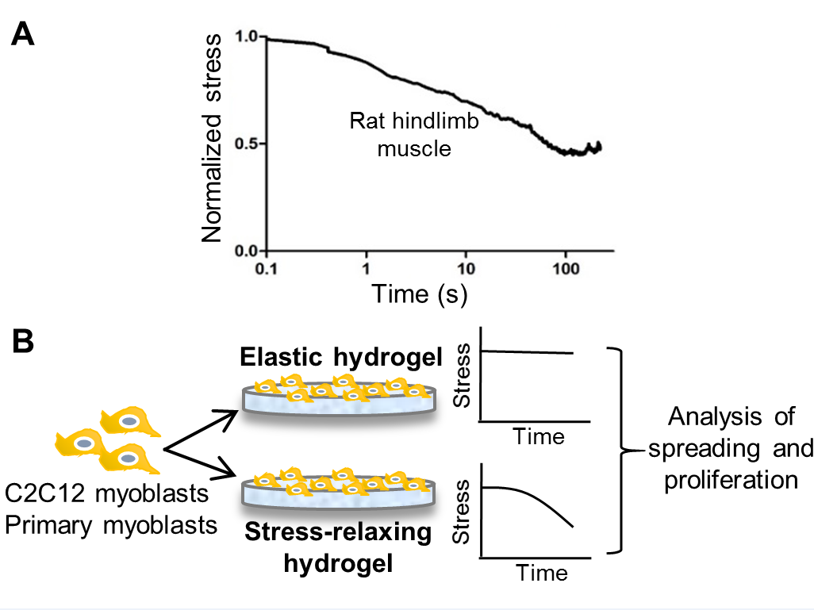
Figure 2 (Previously was Fig 3)
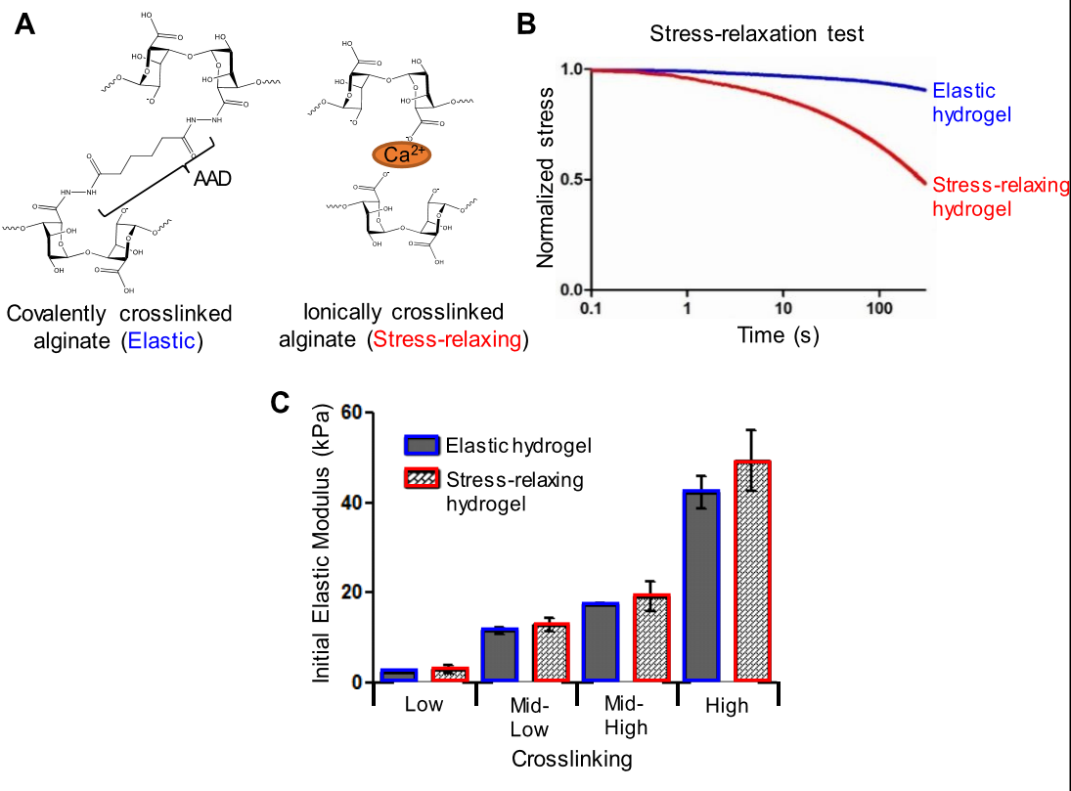
Figure 3 (Previously was Fig 4)
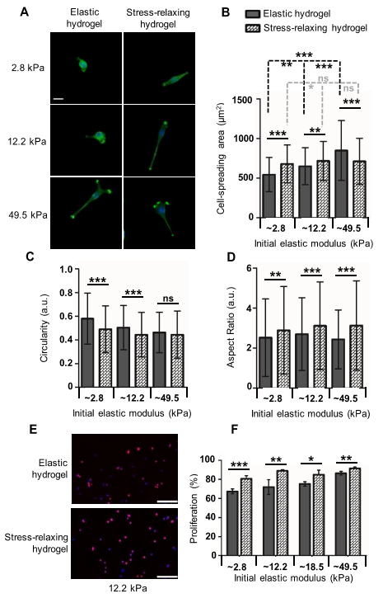
Figure 4 (Previously was Fig 5)
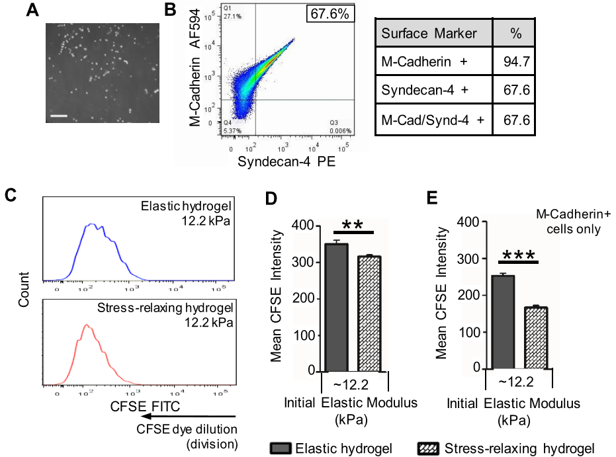
Graphical abstract
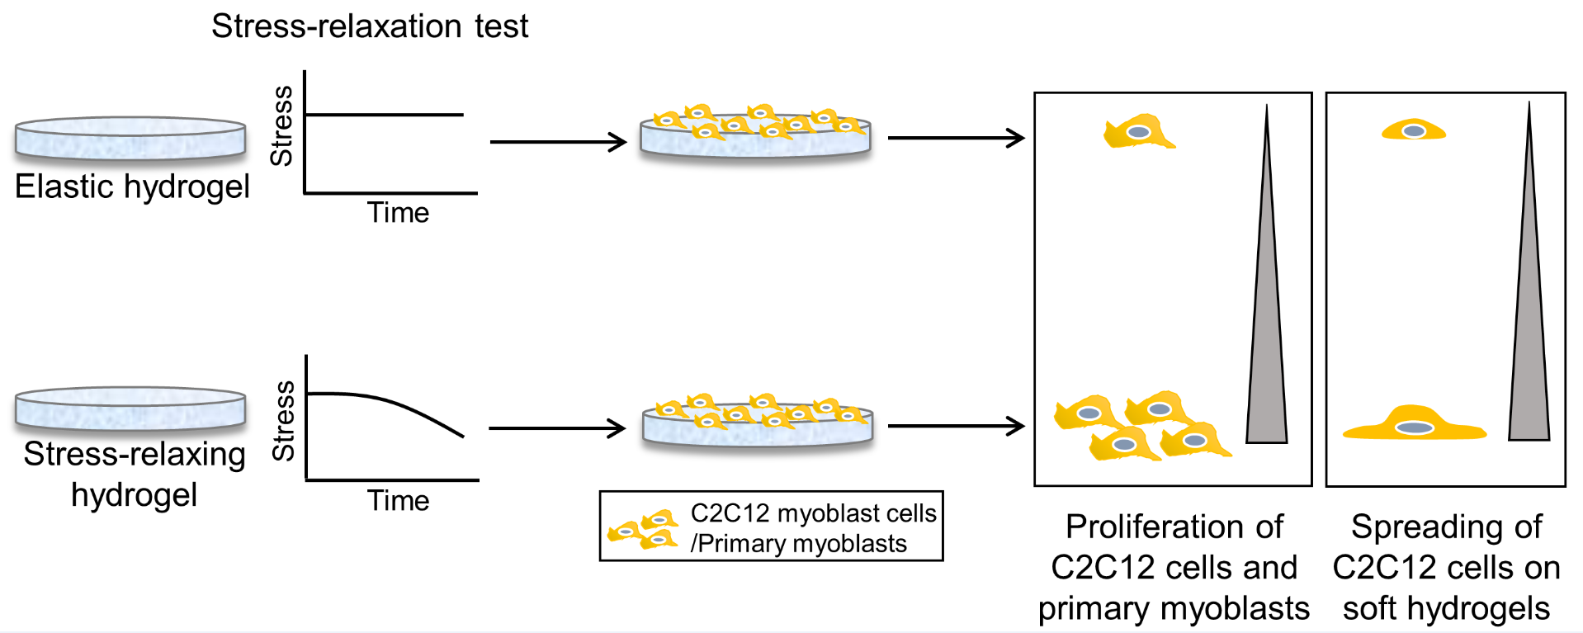
Supplementary figure 1
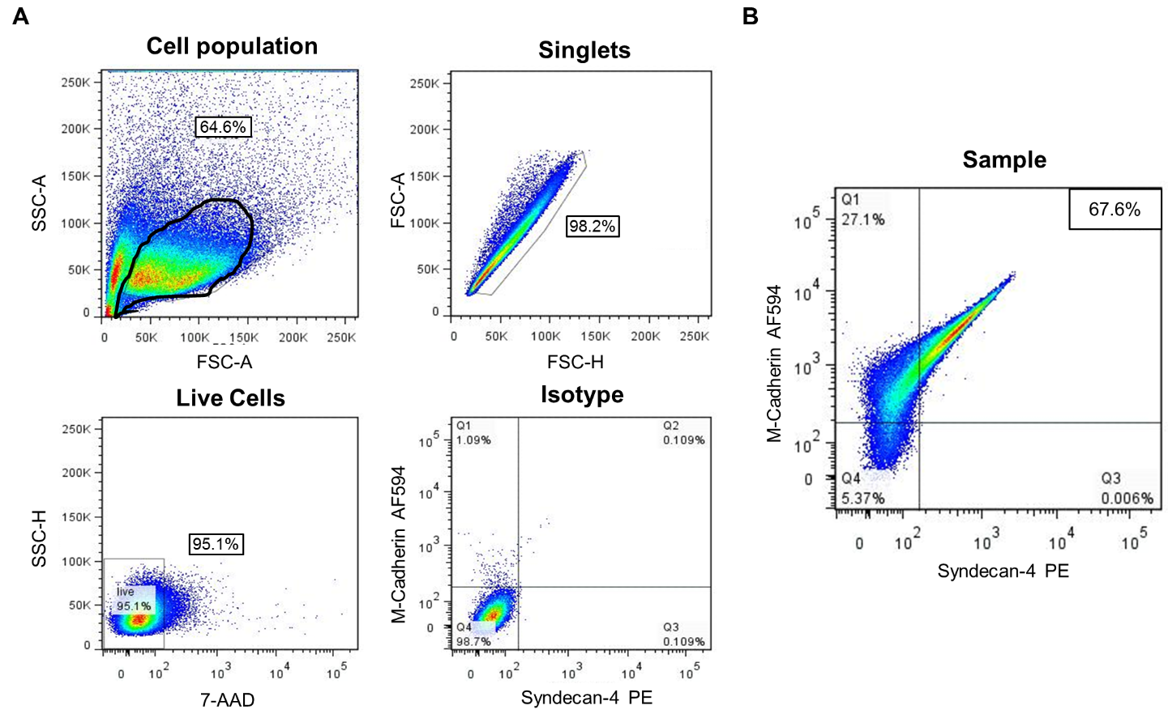
Supplementary figure 2
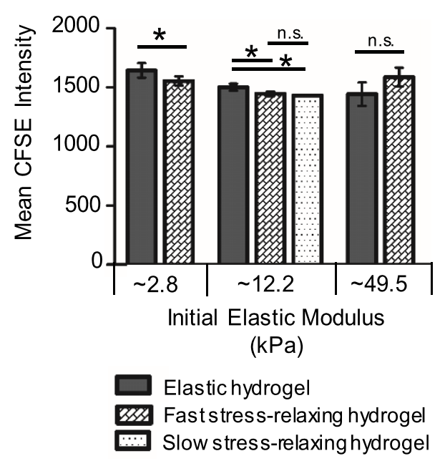

Supplementary figure 3
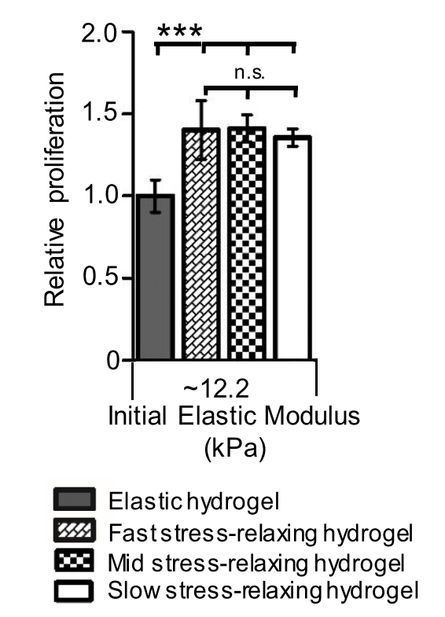
Supplementary figure 4

