Ian R. McDonald (1938-2020)
Editor of Molecular Physics

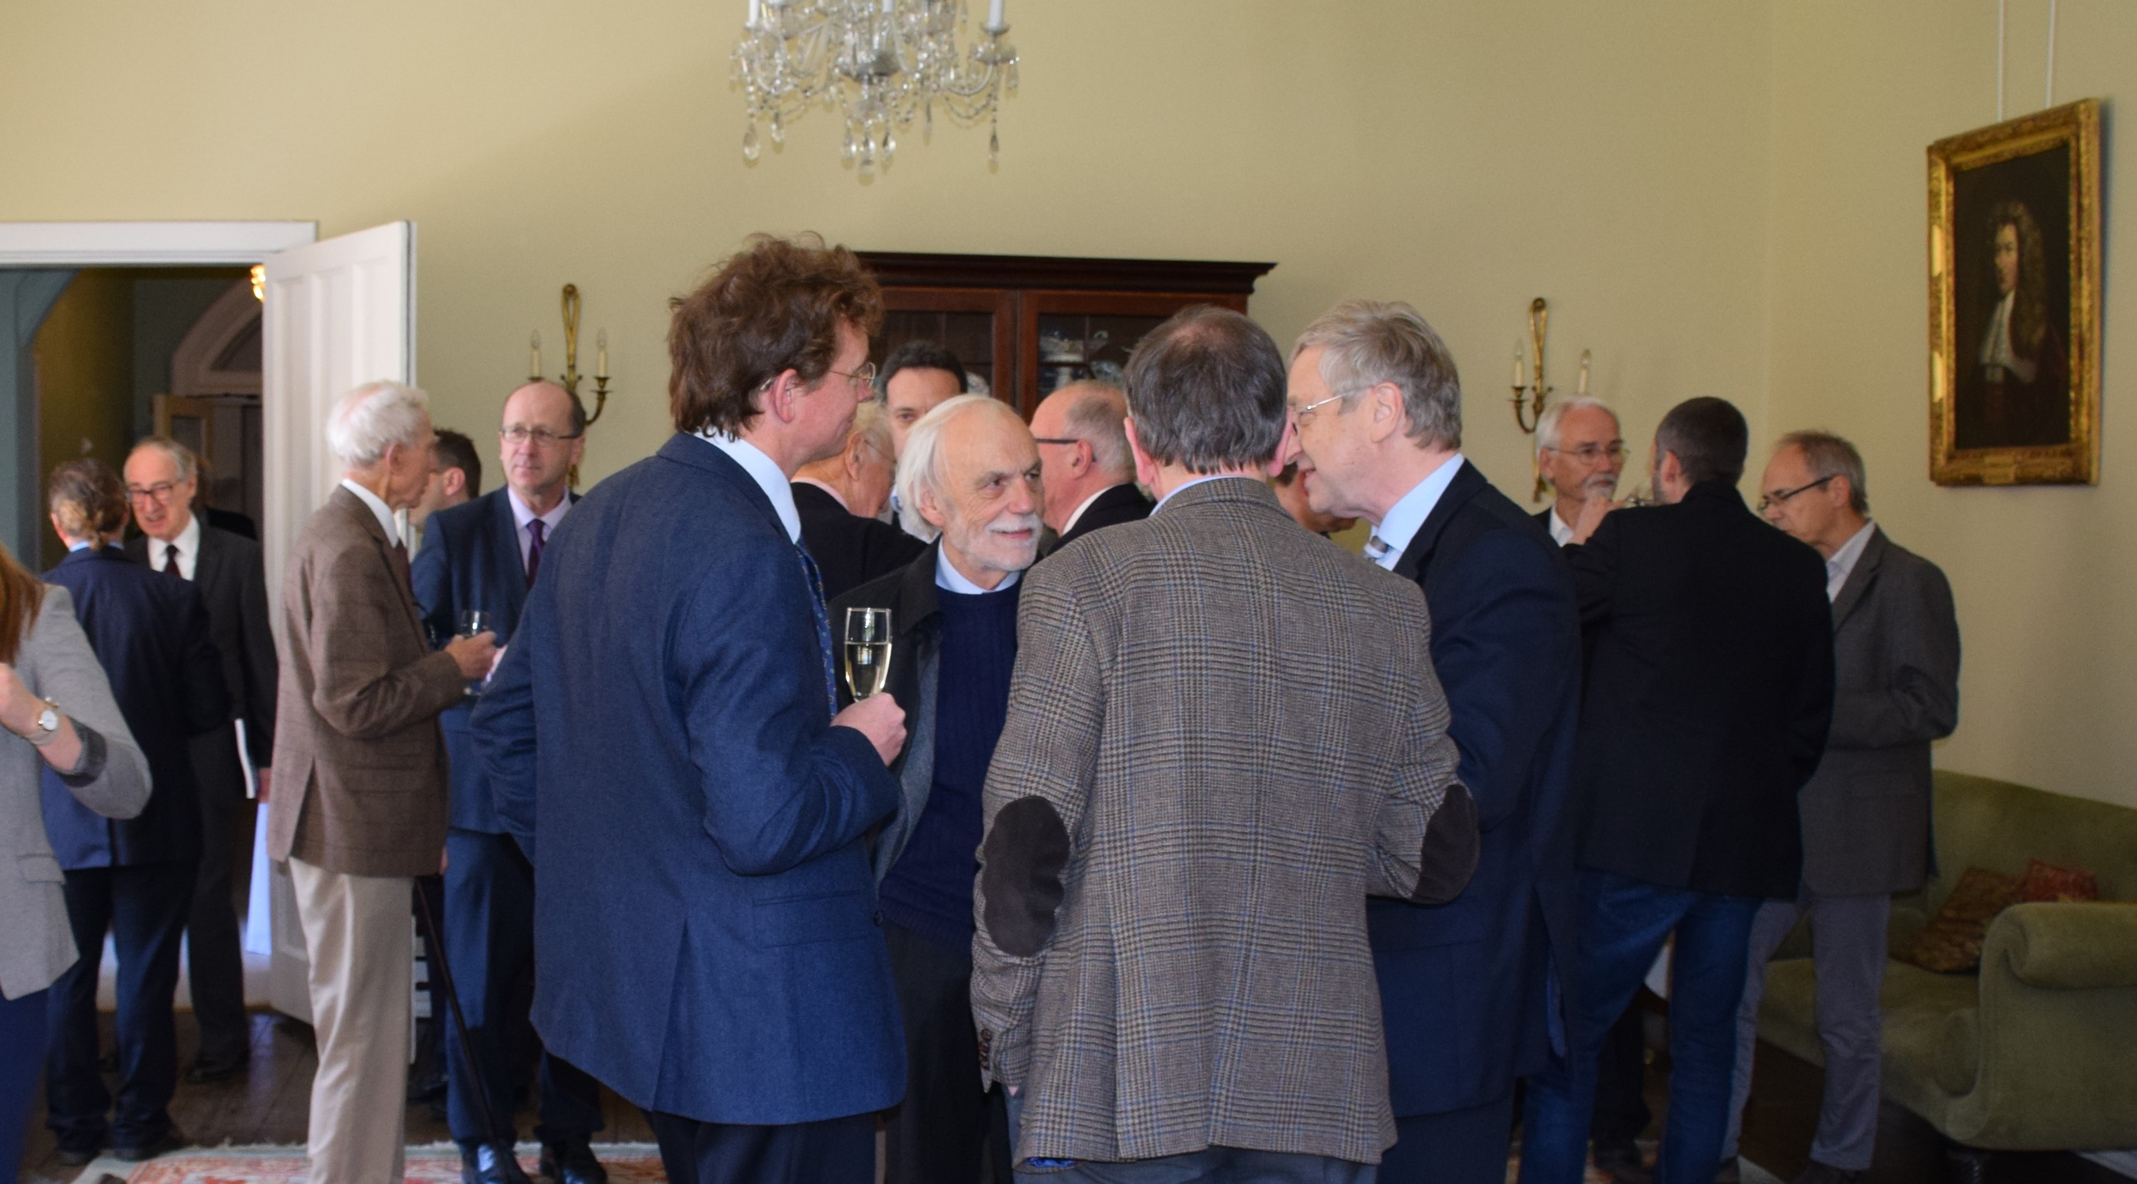
Figure 1. Ian McDonald (centre) with the Editors and Advisory Board Members of Molecular Physics (29 April 2016).

The Editors of Molecular Physics are very saddened to announce the passing of Ian McDonald, who died on 19 July 2020.

Ian was internationally renowned in the area of statistical mechanics and molecular simulation. As the son of Scottish parents, he was born in Southampton on 19 April 1938. After attending Prior Park Public School in Bath, Ian read Physics at the University of Hull, and then undertook a PhD in nuclear magnetic resonance spectroscopy at the University of Nottingham.

Ian was a pioneer in Monte Carlo and molecular-dynamics computer simulation having cut his academic teeth as a postdoctoral research with Konrad Singer at Royal Holloway College in the late 1960s; together they published seminal work which is still held up as the gold standard today. Ian was the first to champion the use of the isothermal-isobaric Monte Carlo method to simulate the thermodynamic properties of mixtures [,].

In 1979 Ian was appointed as a Teaching Fellow in Theoretical Chemistry at Trinity College Cambridge and Lecturer in the Chemistry Department at the University of Cambridge, where he remained until the end of his career.

During a 1973–1974 research stay at CECAM Orsay in Paris, Ian worked with Jean-Pierre Hansen (his long-time collaborator and friend) on their book “Theory of Simple Liquids”, which they published in 1976 []. The seminal textbook has now appeared in four editions, the latest published in 2013 []; the text remains an indispensable source of material on the fundamental theory of the liquid state for postgraduate students, early career researchers, and established academics alike.

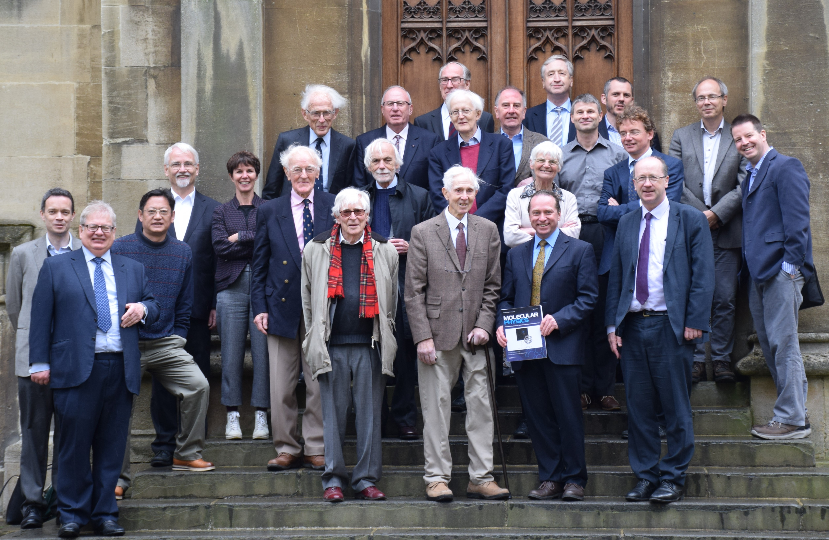
Figure 1. Lunch for Past Editors and Advisory Board Members of Molecular Physics, Exeter College Oxford, 29 April 2016. Front row: Andrew Orr-Ewing, Dominic Tildesley, Wenjian Liu, Ian Mills, John Rowlinson, George Jackson, and Tim Softley. Second row: Hans-Joachim Werner, Amparo Galindo, David Buckingham, Ian McDonald, Ruth Lynden-Bell, Frédéric Merkt, and David Tozer. Third row: Joan van der Waals, Laurence Barron, Peter Hore, Bob Evans, and Gunnar Jeschke. Back row: Geoffrey Luckhurst, Martin Quack, Fred Manby, and Trygve Helgaker.

Ian was a dedicated, selfless, and meticulous Editor of Molecular Physics for two periods during 1979–1985 and 1992−1994 where he rigorously maintained the high quality of the many excellent research papers that were published under his stewardship. He patiently showed me the ropes when I took over from him as an Editor in 1994, for which I am personally forever grateful. Ian remained committed to the success of Molecular Physics and served on the Advisory and Editorial Boards of the journal until the end of his career (see Figure 1).

Ian’s death follows that of our other eminent friend and supporter Sir John Rowlinson (Editor of Molecular Physics 1967−1973) who had sadly passed away two years earlier on 15 August 2018. On a happier note, we were able to celebrate the achievements of the journal with Ian, John, and other Editors and Advisory Board Members [] at our lunch in 2016 (see Figure 2). We were also very happy that Joan H. van der Waals (who was a founding Editor of Molecular Physics in 1958 with H. Christopher Longuet-Higgins) could join us for this event; all at Molecular Physics wish Joan (who turned 100 on 2 May 2020) our best wishes for his centenary year.

The Editors and Advisory Board Members of Molecular Physics are very grateful to Ian for his lasting contributions to the journal, as Editor, author, and longstanding member of the Advisory and Editorial boards. His effort and dedication attest to the continuing influence of the journal in statistical mechanics and molecular simulation. Ian will always be held with enormous respect and admiration, as a world leading scientist and a true gentleman, and will be sorely missed.

George Jackson
Imperial College London
For the Editors

I. R. McDonald, Chem. Phys. Lett., 3, 241–243 (1969).
I. R. McDonald, Mol. Phys., 23, 41–58 (1972).
J.-P. Hansen and I. R. McDonald, Theory of Simple Liquid, Academic Press, London (1976).
J.-P. Hansen and I. R. McDonald, Theory of Simple Liquid (with Applications to Soft Matter), Fourth Edition, Academic Press, London (2013).
G. Jackson, Mol. Phys., 23, 41–58 (1972).

