Tropical logging and deforestation impacts multiple scales of weevil beta-diversity

Abstract
Half of Borneo’s forest has been logged and oil palm plantations have replaced millions of hectares of forest since the 1970’s. While this extensive land-use change has been shown to reduce species richness across landscapes, there is limited current knowledge on how deforestation affects the spatial arrangement of ecological communities. Identifying responses of beta-diversity to land-use change may reveal processes which could mitigate total biodiversity loss. We sampled weevils (superfamily: Curculionoidea) at multiple spatial scales across a land-use gradient at the Stability of Altered Forest Ecosystems (SAFE) Project in Sabah, Malaysia, in 2011-2012. We caught 160 taxa of weevil and calculated the response of alpha-diversity (1-ha scale) and beta-diversity (10-, 100-, and 1,000-ha scales) to disturbance. Alpha-diversity of weevils was greatest in unlogged forest but landscape-level beta-diversity (100- and 1,000-ha scale) was maintained across logged and unlogged due to high rates of spatial turnover. Turnover at smallest spatial scales (10-ha) in unlogged forest was highest in rough, flat terrain but smooth, sloping terrain had highest turnover in logged forest. Logging of flat terrain at small spatial scales has potential to decrease beta-diversity at greater scales. Plantation beta-diversity at landscape-level remained high but was propagated by abundance shifts of few species instead of spatial turnover of many species. High temporal beta-diversity in unlogged forest was evident through periodic fluxes in abundance of many weevil species. We conclude that unlogged forest is irreplaceable for high beetle biodiversity but increased spatial turnover in some terrains may help conserve beetle communities in heavily-degraded landscapes.

Keywords
Beetles; beta-diversity; topography; tropical forests; logging; oil palm plantations

Introduction
Tropical forests are increasingly damaged by human activity (Lewis et al. 2015; Taubert et al. 2018). Borneo’s tropical forest, the largest remaining in SE Asia, has suffered extensive logging and clearing since the 1970’s (Gaveau et al. 2014), predominantly for high-quality timber and the expansion of industrial plantations (Fitzherbert et al. 2008; Tsujino et al. 2016). Unlogged forest is largely considered to be more biodiverse than degraded forest (Gibson et al. 2011), and large-scale land-use in Borneo change has caused significant declines in species richness of birds, mammals and invertebrates (Chung et al. 2000; Fitzherbert et al. 2008; Edwards et al. 2010; Wearn et al. 2016). While broad declines in species have been well-documented, there has been little focus on how forest modification impacts the spatial and temporal processes which define landscape-level community structure. Identifying how communities disassemble, especially in degraded forest, will inform how best to use limited conservation resources in increasingly degraded and fragmented landscapes.
The concept of beta-diversity, change in diversity between points, helps to explain community structure (Whittaker 1972; Magurran 2004). In Borneo, beta-diversity has been shown to contribute greatly to total diversity in Borneo’s modified landscapes (Hamer & Hill 2000; Pfeiffer & Mezger 2012; Kitching et al. 2013; Wearn et al. 2016). Beta-diversity is inherently linked to search area, and so selecting the optimal scales at which to study this concept is important in deriving valid conclusions (Berry et al. 2008; Pfeiffer & Mezger 2012). Similarly, decomposing beta-diversity into multiple scales may highlight those scales which are important to ecological community structure (Veech & Crist 2007; Astorga et al. 2014). Such research is necessary in landscapes where remnant forest fragments are becoming ever-smaller (Taubert et al. 2018).
Habitat heterogeneity is largely accepted as being a key driver of high beta-diversity (Veech & Crist 2007), and forest modification can either generate or remove habitat heterogeneity. At small scales, differences in logging intensity and methods can result in vast variation in the quality and structure of remaining forest (Burivalova et al. 2014; Pfeifer et al. 2016). Despite this, studies comparing biodiversity in logged forest to unlogged forest are often limited in that they consider the two as discrete habitat types. Continuous variation in forest structure should ideally be considered to identify the subtle drivers of diversity (Edwards et al. 2011; Burivalova et al. 2014). Conversely to logged forest, oil palm plantations are considered spatially homogeneous habitats (Azhar et al. 2015) although temporally heterogeneous (Luskin & Potts 2011). There is currently limited understanding of how disturbance and habitat heterogeneity influence landscape-level patterns in beta-diversity.
There has also been little previous work on the effect of heterogeneity in topography on spatial biodiversity patterns. Ridges, valleys and plateaus foster ecologically distinct communities of trees in Borneo (Webb & Peart 2000), yet we remain uninformed about how these small-scale patterns manifest in landscape-level beta-diversity of other taxa. At large scales, flatter terrain is logged more extensively compared to rugged terrain (Bryan et al. 2013). Uncovering the interactions between topography-mediated vegetation heterogeneity and non-random logging activity on beta-diversity may highlight processes by which diversity loss is either mitigated or exacerbated in degraded landscapes. This is because logging prevalence may be indirectly linked with areas of highest beta-diversity through topography or vice versa.
Beta-diversity can be applied to differences in diversity between points in time as well as in space (Magurran 2004), and this concept has already been examined in Borneo’s forest. Temporal beta-diversity has been shown to contribute significantly alongside habitat structure to community structure in some taxa (Hamer et al. 2005; Beck & Vun Khen 2007). It is therefore evident that temporal patterns in biodiversity should not be overlooked in studies on land-use (Hamer et al. 2005), however information on temporal beta-diversity in plantations compared to forest is currently lacking.
We aimed to quantify spatial and temporal patterns in beta-diversity across a land-use gradient spanning unlogged forest, logged forest and oil palm plantation in a massively-diverse taxonomic group: the weevils (superfamily: Curculionoidea; Oberprieler et al. 2007). Weevils, a predominantly herbivorous clade, are an ideal focus for their co-evolution alongside flowering angiosperms (Farrell et al. 2001; McKenna et al. 2009) and therefore direct dependence on tropical forest heterogeneity and structure.
We hypothesised that while weevil alpha-diversity may be highest in unlogged forest, weevil spatial beta-diversity would be greatest in heterogenous logged forest in rugged terrain, for the increased spatial variation in vegetation structure, and lowest in homogeneous oil palm habitat. Uncovering the spatial scaling of beta-diversity in degraded landscapes should provide insight into critical thresholds of forest quality and area which should be maintained to preserve natural community structure. We also hypothesised that temporal beta-diversity would be highest in heavily-degraded habitat because of increased heterogeneity through time, which would emphasise mechanisms by which biodiversity loss from those habitats might be mitigated to some extent.

Materials and Methods
We collected weevils over three separate sampling periods (February 2011, November/December 2011 and June/July 2012) at the Stability of Altered Forest Ecosystems (SAFE) Project in Sabah, Malaysian Borneo. The SAFE Project comprises 11 blocks of sampling points across a land-use gradient that extends from unlogged forest, through logged forest to oil palm plantation (Fig. 1a; Ewers et al. 2011). Of those 11 blocks, there were three “control” blocks (Fig. 1b), six “experimental” blocks (Fig. 1c) and two “linear” blocks (Fig. 1d). The first control block was in Maliau Basin Conservation Area (MBCA), where two-thirds of sampling sites had never been logged and one-third of sites had been logged lightly for construction of the nearby field centre. The second control block was positioned in oil palm plantation (OP) that had been planted between 2000 and 2006 and therefore consisted of a closed or nearly-closed oil palm canopy. The third control block (LF) along with six experimental blocks and two linear blocks were dispersed around the experimental area at the SAFE Project (Fig. 1e) and comprised of forest that had initially been logged in the 1970’s (removing 113 m³ ha⁻¹) and logged again between 2000 and 2008 (removing a further 66 m³ ha⁻¹, Struebig et al. 2013). Logging intensity in this area was vastly uneven, so logged sites included forest of varying quality and structure (Pfeifer et al. 2016). All forest sites were connected within a single expanse of forest extending over one million ha in area.
Sampling points within blocks were positioned in a fractal design devised specifically for the study of beta-diversity over multiple spatial scales (Marsh & Ewers 2012). While the sampling blocks contained differing arrangements of sampling points (Fig. 1b-d), all arrangements followed the same hierarchical structure whereby first-order points (n = 579) were clustered around second-order points (n = 193), which were in turn clustered around third-order (n = 83) and then fourth-order points (n = 37). Distance between sites of increasing order increased exponentially: first-order points were separated by 10^{1.75} m (56 m), second-order points by 10^{2.25} m (178 m), third-order points by 10^{2.75} m (562 m) and fourth-order points by 10^{3.25} m (1,778 m, Fig. 1b-d).
Insect traps were set for three days per sampling period at each of the 579 first-order points in the SAFE Project landscape. Traps were designed to target species of many different behaviours, and comprised a design combining pitfall (diameter 25 cm), flight-intercept (area 1 m²) and malaise traps. Insects either fell into the bottom section of the trap (the pitfall) or were directed upwards into a collection bottle at the top of the malaise. Top and bottom samples were combined for analysis. Weevils were separated from the rest of the captured insects and were sorted into morphospecies or, where possible, species.
In order to validly quantify trends in weevil beta-diversity, we had to identify the optimal grain of sampling points to avoid confusing the signals of alpha-diversity with beta-diversity (Jost 2007). This was achieved by testing for spatial autocorrelation between insect traps at the first-order, then grouping insect traps to second- and third-order and testing for spatial autocorrelation at those grouping levels. Spatial autocorrelation was calculated as the Spearman’s rank correlation coefficient of Bray-Curtis dissimilarity against geographic distance. All autocorrelations were calculated within sampling blocks nested within sampling period. Fourth-order points were not tested because there were insufficient points within a single block to calculate a meaningful correlation. We employed Z-tests to decipher which point-groupings were significantly positively spatially autocorrelated, and therefore represented a suitable grain for our analysis. There was significant positive autocorrelation between first-order points (Z = 2.75, P_{adj} = 0.009) but not second-order (Z = 0.97, P_{adj} = 0.333) or third-order (Z = -0.17, P_{adj} = 0.432, adjustment according to Holm, 1979). Second-order was therefore the smallest spatial scale before points became spatially autocorrelated and thus we chose this grouping of insect traps as the grain most suitable for our analysis.
We quantified alpha-diversity of weevils at second-order scale and beta-diversity at the full set of larger spatial scales. By grouping second-order points within higher hierarchical levels, we were able to explicitly examine beta-diversity at third-order, fourth-order and block-level scales. To convert these arrangements of points into sampling areas, we treated each sampling point as a circular area centred on that point (Fig. 1). We chose areas for these circles that increased in size exponentially with point order (as did number of insect traps grouped to respectively higher order) and that fitted into the SAFE Project sampling design with minimal overlap. We chose areas of 1-ha for second-order (relevant to alpha-diversity of weevils), 10-ha for third-order, 100-ha for fourth-order and 1,000-ha for block-level groupings of insect traps. There was an unavoidable degree of overlap in circular areas at each scale: < 1% at second-order, 1% at third-order, 13% at fourth-order and 8% at block-level.
Each of total weevil count, number of species and Shannon diversity were calculated per second-order point, nested within sampling period. We calculated beta-diversity at all higher orders by using the abundance-based Bray-Curtis methods of Baselga (2017). These metrics are proportions and therefore insensitive to sampling effort, so two values can be validly compared where based on the same sampling grain. These equations were ideal because they provided scope to separate total beta-diversity into two components: balanced variation (equivalent to turnover in taxa richness), and abundance-gradient variation between sites (roughly equivalent to nestedness in richness). Balanced variation is the subset of beta-diversity which can be attributed to difference in species identity between sampling sites. Abundance-gradient variation is the subset of beta-diversity that is attributable to uneven numbers of individuals between sites. Bray-Curtis dissimilarity is equal to the sum of these two components.
We derived measures of forest quality and topographic variation that were relevant to each of the four spatial scales we had selected for analysis. These measures were calculated for forest sites only as plantation sites comprised mature oil palm and had been terraced. Forest quality was taken as above-ground biomass of vegetation (AGB) and was measured at every second-order point in the landscape by Pfeifer et al. (2016) between 2010 and 2011. No forest modification occurred at SAFE Project between this period and our third and final insect collection in 2012. AGB was derived for third-order, fourth-order and block-level scales by calculating the mean of AGB values at second-order points below that higher point in the hierarchical design.
We calculated two complementary measures of topographic variation – topographic roughness (Ascione et al.2008) and slope. Both were derived from ASTER satellite elevation data with a 30 m x 30 m resolution (NASA/METI/AIST/Japan Spacesystems, and U.S./Japan ASTER Science Team, 2009). Topographic roughness (TR) per pixel within each circular area was calculated as:
$$TR=\frac{Mean-Value}{Range}$$
where “Mean” refers to the mean elevation of that pixel and it’s eight neighbours, “Value” refers to the elevation of that centre pixel, and “Range” refers to the difference between maximum and minimum elevation in the pixel and it’s eight neighbouring pixels. This index of roughness returned a value between negative one and one and described how each pixel is elevated or lowered in relation to surrounding pixels. We converted these values to a single value per circular area by calculating the mean of the absolute values. Slope was taken as the “Range” value and was calculated per circular area as the mean of per-pixel values. Roughness and slope in forest were negatively correlated at all spatial scales (second-order: ρ = -0.40, P < 0.001; third-order: ρ = -0.41, P < 0.001; fourth-order: ρ = -0.54, P = 0.004; block-level: ρ = -0.81, P = 0.008). The strong negative correlation between topography variables suggested that our forest sites were positioned along a topographic gradient from high TR/low slope to low TR/high slope. Because of this strong relationship, we chose to focus on roughness in our analysis, we which believed to be more clearly relatable to vegetation structure (Webb & Peart 2000).
All of weevil count, alpha-diversity (richness and Shannon index) and beta-diversity (total, balanced variation and abundance-gradient variation) were analysed for both oil palm plantation and forest (categorical, ignoring forest quality) using generalized mixed models with sampling period as a random intercept. Within forest sampling blocks, forest quality and roughness were correlated at some spatial scales (second-order: ρ = -0.07, P = 0.381; third-order: ρ = -0.28, P = 0.022; fourth-order: ρ = -0.33, P = 0.093; block-level: ρ = -0.19, P = 0.610). This multicollinearity prohibited the inclusion of both raw AGB and roughness within regular models and so we instead created models based on principal components (Dodge 2003). We log₁₀-transformed AGB so that both variables were normally-distributed, scaled and centred variables on 0, transformed those variables into orthogonal principal components and then performed mixed models with those components as predictors. Because principal component transformation preserves the linearity of input variables, we were able to back-transform to derive parameter estimates for the original (log₁₀-transformed) variables. Statistical significance of variables was estimated via permutation: variables were randomized 9,999 times in turn, transformed into principal components as before, used to fit new models by maximum likelihood, and the proportion of those randomized models which were more statistically likely than our single observed model was calculated as a P-value.
Final models were generated via backward-selection on the terms AGB, roughness and their interaction; terms were removed sequentially where P > 0.050. Models which were late in the model selection process and therefore univariate (after the interaction term and one main term had been dropped) did not incorporate principal components but were instead linear models with a single predictor. In this way, we predicted weevil count and species richness via generalized mixed models, and Shannon index and each measure of logit-transformed beta-diversity via linear mixed models. In all models, sampling period was included as a random intercept.
We expanded on our results on spatial beta-diversity by examining whether temporal variation in weevil community structure differed significantly across this land-use gradient. This was achieved by taking each sampling block in turn, selecting only the weevil species where we caught 10 or more individuals over the three sampling periods in that block, and calculating a χ² statistic describing the unevenness in the abundances of that species caught between sampling periods. With those statistics, we predicted unevenness in abundance first between oil palm plantation and forest, and then used the principal component methods previously described to predict evenness from forest AGB and roughness. As before, we employed backward-selection on the variables and their interactions but included species as a random intercept.

Results
We caught 3,447 beetles of the Curculionoidea superfamily: 1,119 in the first sampling period, 370 in the second and 1,958 in the third. We identified 160 species and morphospecies (referred to henceforth as “species”). Species of the families Curculionidae (141 species), Anthribidae (nine species), Attelabidae (five species) and Brentidae (five species) were present. Most individuals, 3,220, belonged to the Scolytinae subfamily within the family Curculionidae. The most abundant species caught belonged to the genera Coccotrypes, Xylosandrus, Xyleborus, Ambrosiodomus, Scolytoplatypus and Debus, all within the Scolytinae.
Significant trends were identified in alpha-diversity, both between forest and oil palm plantation and within forest disturbed to various extents. There was no significant difference (estimate: 2.38, Z = 1.83, P = 0.067) in the number of weevils caught per second-order point between oil palm plantation and forest (Fig. 2a). Despite the similarities in weevil abundance, we found significantly more weevil species at forest points compared to plantation (estimate: 1.72, Z = 5.24, P < 0.001, Fig. 2b) and greater Shannon diversity (estimate: 0.57, Z = 5.94, P < 0.001, Fig. 2c). Within forest sites, there was a significant increase in number of weevils caught (slope: 0.50, Z = 4.97, P < 0.001, Fig. 2a), number of species caught (slope: 0.31, Z = 3.74, P < 0.001, Fig. 2b) and Shannon diversity with increasing AGB (slope: 0.22, Z = 4.50, P < 0.001, Fig. 2c). Roughness was not selected for inclusion in any models of count or alpha-diversity.
Trends in beta-diversity were predominantly driven by balanced variation in weevil diversity in forest and abundance-gradient variation in oil palm plantation. At 10-ha scales, balanced variation in weevil diversity was significantly greater in forest compared to plantation (estimate: 0.31, Z = 4.30, P < 0.001, Fig. 3a) but there was a significant decline in abundance-gradient variation (estimate: -0.85, Z = -2.16, P = 0.034, Fig. 3d). Despite the decline in abundance-gradient variation, total beta-diversity was greatest in forest at 10-ha scale (estimate: 0.70, Z = 2.68, P = 0.009, Fig. 3g). Within forest, significant interactions were observed between AGB and roughness (Table 1). Balanced variation in diversity was greatest at high AGB in high roughness or at low AGB in low roughness (LR₃ = 14.88, P = 0.002) and the same was true of total beta-diversity (LR₃ = 25.32, P < 0.001). Neither AGB (estimate: 0.00, Z = -0.32, P = 0.749) nor roughness (estimate: 5.93, Z = 1.01, P = 0.318) had a significant effect on abundance-gradient variation (Fig. 3d).
We found no significant effect (P > 0.050) of either AGB or roughness on forest beta-diversity at scales greater than 10-ha. There were, however, significant differences between oil palm plantation and forest. Total beta-diversity did not vary between the two land-use categories at 100-ha scale (estimate: -0.20, Z = -0.52, P = 0.604, Fig. 3h) or 1,000-ha scale (estimate: -0.32, Z = -0.75, P = 0.460, Fig. 3i). However, abundance-gradient variation was greatest in oil palm plantation at both 100-ha (estimate: 1.28, Z = 2.62, P = 0.012, Fig. 3e) and 1,000-ha scales (estimate: 1.84, Z = 4.10, P < 0.001, Fig. 3f), while balanced variation was lowest (100-ha estimate: -1.10, Z = -2.92, P = 0.005, Fig. 3b & 1,000-ha estimate: -1.65, Z = -3.56, P = 0.002, Fig. 3c). Balanced variation increased with spatial scale in forest and abundance-gradient variation increased in plantation.
Our results showed unevenness in weevil abundance over the three sampling periods. Temporal unevenness was greater in oil palm plantation than forest (estimate: 1.93, Z = 3.90, P < 0.001) and increased with AGB within forest (estimate: 0.90, Z = 2.32, P = 0.020, Fig. 4). In oil palm plantation (a single sampling block), there were four mid-sized scolytids (Xylosandrus crassiusculus, Xyleborus monographus, Xyleborinus artestriatus and one morphospecies of Ambrosiodomus) which were caught in significantly uneven numbers across the sampling periods (χ² > 5.99, P < 0.050). In unlogged forest (also a single sampling block; MBCA) there were eleven such species, including Coccotrypes spp., Debus spp. and Ambrosiodomus spp., which were all members of the Scolytinae.

Discussion
Our results on weevil diversity add to extensive evidence that unlogged forest is unmatched for high levels of biodiversity. However, while of lesser conservation value than unlogged forest, logged forest likely retains stable community structure through shifts in beta-diversity. Small-scale trends in weevil beta-diversity highlight the importance of topography in determining the conservation value of modified forest and may indicate processes by which targeted industrial logging impacts biodiversity loss.
Weevil alpha-diversity was greatest in unlogged forest and any intensity of forest modification caused declines. Both high species richness and high Shannon index (Fig. 2b-c) indicates that many weevil species are present at any one point (1-ha area) and that they are represented in relatively even abundances. Such high alpha-diversity is likely a consequence of high tree species richness (Slik et al. 2003) and therefore large numbers of microhabitats available to large numbers of herbivorous insects (Fig. 2a). Selective removal of tree biomass (Pfeifer at al.2016) removes whole microhabitats and therefore causes declines in some species, particularly specialist wood-boring weevils (Farrell et al. 2001). Our results therefore support previous findings that unlogged forest supports maximum numbers of species (Gibson et al. 2011). Despite high numbers of weevils caught in oil palm plantation (Fig. 2a), both species richness and Shannon index were low (Fig. 2b-c), indicating that most plantation points we sampled were dominated by one or two species in high abundance. These species were presumably generalist pests of the high-density palm fruits and contribute very little to landscape biodiversity.
Despite the large differences in alpha-diversity across the land-use gradient, total landscape spatial beta-diversity (1,000 ha scale, Fig. 3i) remained constant. This is in concordance with previous work that found beta-diversity was a significant force in mitigating biodiversity loss in heavily-modified landscapes (Hamer & Hill 2000; Pfeiffer & Mezger 2012; Kitching et al. 2013; Wearn et al. 2016). However, expanding on those studies, we found that beta-diversity in oil palm plantation is driven primarily by fluxes in the abundance of just a handful of species (Fig. 3d-f, Fig. 4), presumably in response to either pest management strategies or periods of particularly harsh climate in plantations (Hardwick et al. 2015). Conversely, high beta-diversity in forest was driven by constant, even turnover in many weevil species (Fig. 3b-c). Landscape-level differences in forest beta-diversity manifested themselves in temporal patterns, whereby unlogged forest saw stronger fluxes in the abundance of several species (Fig. 4). Such patterns could be driven by the phenology of dipterocarp and other canopy trees (Iku et al. 2017) that are high-value and therefore removed first in logging.
Our results reveal a spatial hierarchy in forest beta-diversity patterns. In rough terrain at small scales (10-ha), unlogged forest is highly beta-diverse because of balanced turnover in weevil species at small scales (Fig. 3a, g). This beta-diversity could be attributed to local differences in vegetation species and structure accompanying flats, ridges and gullies (Webb & Peart 2000). With logging and removal of that vegetation, beta-diversity is reduced, caused in by part by the fact that differences in tree communities associated with topography do not extend strongly to seedlings and regrowth (Webb & Peart 2000). In smooth terrain at the same scales, heavily-logged forest is more beta-diverse than unlogged forest (Fig. 3a, g). We hypothesis that in these conditions, with increased canopy openness (Pfeifer et al. 2016), there is a greater density and diversity of generalist seedlings and shrubs that provide heterogeneous habitat for herbivores. Because there is no difference between logged and unlogged forest beta-diversity at greater scales (Fig. 3h-i), it can be implied that landscape-level beta-diversity in logged forest is maintained through high beta-diversity on plateaus and low beta-diversity in rough terrain, while the opposite is true in unlogged forest. Therefore, while there is no difference between landscape-level beta-diversity in logged and unlogged forest, that apparent resilience to logging is itself a result of small-scale shifts in beta-diversity.
The trends in weevil beta-diversity, differing over spatial scales, can be applied to make broad recommendations for land management. Balanced variation in weevil species was high across all forest qualities (Fig. 3a-c) and so our results provide evidence that invertebrate community structure is maintained in even heavily-degraded forest. Maximum total beta-diversity was found at the largest spatial scales (Fig. 3i), although there was no difference between logged and unlogged forest at scales greater than 10-ha (Fig. 3g-i). We therefore suggest that 100-ha should be considered a cut-off, below which local forest quality and topography become important to beta-diversity.
Worryingly, the relationships between roughness, slope and AGB indicate that non-random logging activity may have detrimental effects on weevil beta-diversity. Logging is often targeted on flat land (Bryan et al. 2013), and this was evident at our study site where AGB remaining after logging correlated positively with slope at smallest (1-ha) scales (ρ = 0.21, P = 0.010). Because of the strong negative correlation between slope and roughness (ρ = -0.40, P < 0.001), it could be deduced that the effects of slope are opposite to the effects of roughness. Therefore, high beta-diversity in unlogged forest on rough terrain (Fig. 3g) suggests high beta-diversity in unlogged forest on flat areas. Similarly, high beta-diversity in logged forest on smooth terrain suggests high beta-diversity in logged forest on large-scale slopes. Following this logic, areas of high beta-diversity in unlogged forest (on rough flats) are at greatest risk of modification, while areas of high beta-diversity in logged forest (on smooth slopes) are unlikely to be created through modification. Such uneven logging activity at small scales has the potential to reduce beta-diversity at greater spatial scales. Our results on high alpha-diversity already add to extensive evidence that unlogged forest supports greatest levels of biodiversity, however these potential impacts on beta-diversity suggest further mechanisms by which biodiversity may be reduced in heavily-degraded landscapes.
We recommend that future research on Borneo’s biodiversity investigate multiple spatial scales and the action of topography on spatial patterns. Likewise, the neglected impacts of temporal beta-diversity may be responsible for long-term biodiversity losses in logged forest and require further examination. While logged forest supports fewer species than unlogged (Gibson et al. 2011), shifts in community structure maintain equal rates of some important ecosystem processes (Ewers et al. 2015), which is likely facilitated in part by high beta-diversity. Conversely, while oil palm plantations maintain similar beta-diversity to forest, that beta-diversity arises mostly from spatial and temporal patchiness in a low number of abundant species. In-depth study of beta-diversity evidently reveals mechanisms by which ecological communities alter following extensive land-use change.

References
Ascione, A., Cinque, A., Miccadei, E., Villani, F., & Berti, C. (2008). The Plio-Quaternary uplift of the Apennine chain: new data from the analysis of topography and river valleys in Central Italy. Geomorphology 102(1), 105–118.
Astorga, A., Death, R., Death, F., Paavola, R., Chakraborty, M., & Muotka, T. (2014). Habitat heterogeneity drives the geographical distribution of beta diversity: the case of New Zealand stream invertebrates. Ecology and Evolution, 4(13), 2693–2702.
Azhar, B., Saadun, N., Puan, C. L., Kamarudin, N., Aziz, N., Nurhidayu, S., & Fischer, J. (2015). Promoting landscape heterogeneity to improve the biodiversity benefits of certified palm oil production: Evidence from Peninsular Malaysia. Global Ecology and Conservation 3, 553–561.
Baselga, A. (2017). Partitioning abundance-based multiple-site dissimilarity into components: balanced variation in abundance and abundance gradients. Methods in Ecology and Evolution 8(7), 799–808.
Beck, J., & Vun Khen, C. (2007). Beta-diversity of geometrid moths from northern Borneo: effects of habitat, time and space. Journal of Animal Ecology 76(2), 230–237.
Berry, N. J., Phillips, O. L., Ong, R. C., & Hamer, K. C. (2008). Impacts of selective logging on tree diversity across a rainforest landscape: the importance of spatial scale. Landscape Ecology 23(8), 915-929.
Bryan, J. E., Shearman, P. L., Asner, G. P., Knapp, D. E., Aoro, G., & Lokes, B. (2013). Extreme differences in forest degradation in Borneo: Comparing practices in Sarawak, Sabah, and Brunei. PLOS ONE, 8(7).
Burivalova, Z., Sekercioglu, C.H. & Koh, L.P. (2014). Thresholds of logging intensity to maintain tropical forest biodiversity. Current Biology 24(16), 1893–1898.
Chung, A., Eggleton, P., Speight, M., Hammond, P. & Chey, V. (2000). The diversity of beetle assemblages in different habitat types in Sabah, Malaysia. Bulletin of Entomological Research 90(6), 475–496.
Dodge, Y. (2003). The Oxford Dictionary of Statistical Terms. New York: Oxford University Press.
Edwards, D.P., Hodgson, J.A., Hamer, K.C., Mitchell, S.L., Ahmad, A.H., Cornell, S.J. & Wilcove, D.S. (2010). Wildlife-friendly oil palm plantations fail to protect biodiversity effectively. Conservation Letters 3(4), 236–242.
Ewers, R.M., Didham, R.K., Fahrig, L., Ferraz, G., Hector, A., Holt, R.D., ... Turner, E.C. (2011). A large-scale forest fragmentation experiment: the Stability of Altered Forest Ecosystems Project. Philosophical Transactions of the Royal Society of London. Series B, Biological Sciences 366(1582), 3292–3302.
Ewers, R. M., Boyle, M. J. W., Gleave, R. A., Plowman, N. S., Benedick, S., Bernard, H., … Turner, E. C. (2015). Logging cuts the functional importance of invertebrates in tropical rainforest. Nature Communications 6, 6836.
Farrell, B. D., Sequeira, A. S., O’Meara, B. C., Normark, B. B., Chung, J. H., & Jordal, B. H. (2001). The evolution of agriculture in beetles (Curculionidae: Scolytinae and Platypodinae). Evolution 55(10), 2011-2027.
Fitzherbert, E. B., Struebig, M. J., Morel, A., Danielsen, F., Brühl, C. A., Donald, P. F., & Phalan, B. (2008). How will oil palm expansion affect biodiversity? Trends in Ecology & Evolution, 23(10), 538–545.
Gaveau, D. L. A., Sloan, S., Molidena, E., Yaen, H., Sheil, D., Abram, N. K., … Meijaard, E. (2014). Four decades of forest persistence, clearance and logging on Borneo. PLOS ONE, 9(7).
Gibson, L., Lee, T. M., Koh, L. P., Brook, B. W., Gardner, T. A., Barlow, J., … Sodhi, N. S. (2011). Primary forests are irreplaceable for sustaining tropical biodiversity. Nature 478(7369), 378–381.
Hamer, K. C., & Hill, J. K. (2000). Scale-dependent effects of habitat disturbance on species richness in tropical forests. Conservation Biology 14(5), 1435–1440.
Hamer, K. C., Hill, J. K., Mustaffa, N., Benedick, S., Sherratt, T. N., Chey, V. K., & Maryati, M. (2005). Temporal variation in abundance and diversity of butterflies in Bornean rain forests: opposite impacts of logging recorded in different seasons. Journal of Tropical Ecology 21(4), 417–425.
Hardwick, S. R., Toumi, R., Pfeifer, M., Turner, E. C., Nilus, R., & Ewers, R. M. (2015). The relationship between leaf area index and microclimate in tropical forest and oil palm plantation: forest disturbance drives changes in microclimate. Agricultural and Forest Meteorology 201, 187–195.
Holm, S. (1979). A simple sequentially rejective multiple test procedure. Scandinavian Journal of Statistics 6(2), 65–70.
Iku, A., Itioka, T., Kishimoto-Yamada, K., Shimizu-kaya, U., Mohammad, F. B., Hossman, M. Y., … Meleng, P. (2017). Increased seed predation in the second fruiting event during an exceptionally long period of community-level masting in Borneo. Ecological Research 32(4), 537–545.
Jost, L. (2007). Partitioning diversity into independent alpha and beta components. Ecology 88(10), 2427–2439.
Kitching, R. L., Ashton, L. A., Nakamura, A., Whitaker, T., & Khen, C. V. (2013). Distance-driven species turnover in Bornean rainforests: homogeneity and heterogeneity in primary and post-logging forests. Ecography 36(6), 675–682.
Lewis, S. L., Edwards, D. P., & Galbraith, D. (2015). Increasing human dominance of tropical forests. Science 349(6250), 827–832.
Luskin, M. S., & Potts, M. D. (2011). Microclimate and habitat heterogeneity through the oil palm lifecycle. Basic and Applied Ecology 12(6), 540–551.
Magurran, A.E. (2004). Measuring Biological Diversity. New Jersey: Wiley-Blackwell.
Marsh, C.J. & Ewers, R.M. (2013). A fractal-based sampling design for ecological surveys quantifying beta-diversity. Methods in Ecology and Evolution 4(1), 63–72.
McKenna, D. D., Sequeira, A. S., Marvaldi, A. E., & Farrell, B. D. (2009). Temporal lags and overlap in the diversification of weevils and flowering plants. Proceedings of the National Academy of Sciences 106(17), 7083–7088.
NASA/METI/AIST/Japan Spacesystems, and U.S./Japan ASTER Science Team (2009). ASTER Global Digital Elevation Model Terra ASTER v2. NASA EOSDIS Land Processes DAAC.
Oberprieler, R. G., Marvaldi, A. E., & Anderson, R. S. (2007). Weevils, weevils, weevils everywhere. Zootaxa 520(1668), 491–520.
Pfeifer, M., Kor, L., Nilus, R., Turner, E., Cusack, J., Lysenko, I., … Ewers, R. (2016). Mapping the structure of Borneo’s tropical forests across a degradation gradient. Remote Sensing of Environment 176, 84–97.
Pfeiffer, M., & Mezger, D. (2012). Biodiversity assessment in incomplete inventories: Leaf litter ant communities in several types of Bornean rain forest. PLOS ONE, 7(7), e40729.
Slik, J. W. F., Poulsen, A. D., Ashton, P. S., Cannon, C. H., Eichhorn, K. A. O., Kartawinata, K., … Wilkie, P. (2003). A floristic analysis of the lowland dipterocarp forests of Borneo. Journal of Biogeography 30(10), 1517–1531.
Struebig, M. J., Turner, A., Giles, E., Lasmana, F., Tollington, S., Bernard, H., & Bell, D. (2013). Quantifying the biodiversity value of repeatedly logged rainforests: Gradient and comparative approaches from Borneo. In Advances in Ecological Research p. 183–224. New York: Academic Press.
Taubert, F., Fischer, R., Groeneveld, J., Lehmann, S., Müller, M. S., Rödig, E., … Huth, A. (2018). Global patterns of tropical forest fragmentation. Nature 554(7693), 519-522.
Tsujino, R., Yumoto, T., Kitamura, S., Djamaluddin, I. & Darnaedi, D. (2016). History of forest loss and degradation in Indonesia. Land Use Policy 57, 335–347.
Veech, J. A., & Crist, T. O. (2007). Habitat and climate heterogeneity maintain beta-diversity of birds among landscapes within ecoregions. Global Ecology and Biogeography, 16(5), 650–656.
Wearn, O.R., Carbone, C., Rowcliffe, J.M., Bernard, H. & Ewers, R.M. (2016). Grain-dependent responses of mammalian diversity to land use and the implications for conservation set-aside. Ecological Applications 26(5), 1409–1420.
Webb, C. O., & Peart, D. R. (2000). Habitat associations of trees and seedlings in a Bornean rain forest. Journal of Ecology 88(3), 464–478.
Whittaker, R.H. (1972) Evolution and measurement of species diversity. Taxon 21(2-3), 213–251.
Model |  | Mixed Model Statistics |  |  |  |  |  | Back-Transformed Estimates
Model |  | Parameter | Est. | SE | Z | P |  | Parameter | Est. | P
Balanced Variation |  | Intercept | 0.36 | 0.23 | 1.57 | 0.244 |  | AGB | -2.19 | 0.053
Balanced Variation |  | PC1 | 0.11 | 0.07 | 1.71 | 0.092 |  | TR | -60.18 | 0.019
 |  | PC2 | 0.22 | 0.07 | 2.91 | 0.005 |  | AGB x TR | 28.03 | 0.020
 |  | PC3 | -2.46 | 1.03 | -2.40 | 0.020
Bray-Curtis Dissimilarity |  | Intercept | 0.92 | 0.08 | 11.59 | < 0.001 |  | AGB | -3.04 | 0.003
Bray-Curtis Dissimilarity |  | PC1 | 0.09 | 0.06 | 1.57 | 0.120 |  | TR | -79.29 | < 0.001
 |  | PC2 | 0.24 | 0.07 | 3.59 | < 0.001 |  | AGB x TR | 36.29 | < 0.001
 |  | PC3 | -3.24 | 0.89 | -3.65 | < 0.001
Table 1. Model summaries for principal component models at 10-ha spatial scale. Only models which included both AGB and roughness are shown. Predictor estimates were back-calculated after fitting linear mixed models with principal components as predictors.
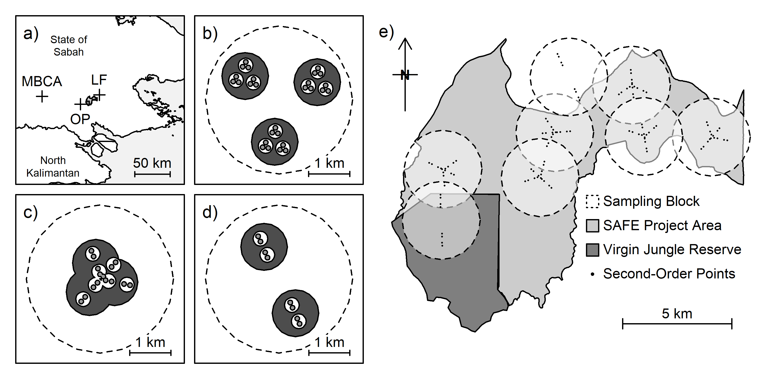
Figure 1. Maps of the sampling design, where (a) shows the location of the MBCA (unlogged forest) control block, LF (logged forest) control block, OP (oil palm plantation) control blocks and SAFE Project area (eight further blocks). The arrangement of 1-ha (light grey area), 10-ha (white area), 100-ha (dark grey area) and 1,000-ha circular areas (dashed perimeter) are shown for each of the three designs of sampling block: (b) control blocks, (c) experimental blocks and (d) linear blocks. The spatial arrangement of the six experimental blocks and two linear blocks within and adjacent to the SAFE Project area are shown in (e), where those eight sampling blocks are represented inside 1,000-ha circles and comprise forest logged to various extents.
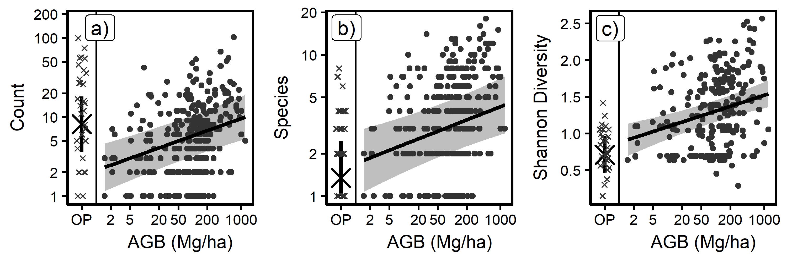
Figure 2. The (a) total abundance, (b) species richness and (c) Shannon diversity of weevils caught at second-order points (1-ha scale). Within each panel, samples collected from oil palm plantation are presented on the left (crosses) and forest on the right (dots). The large cross in each plot represents mixed model predictions (with vertical 95% confidence intervals) for oil palm plantation. The plotted lines (with light grey 95% confidence intervals) represent mixed model predictions of the y-axis from AGB for points in forest only.
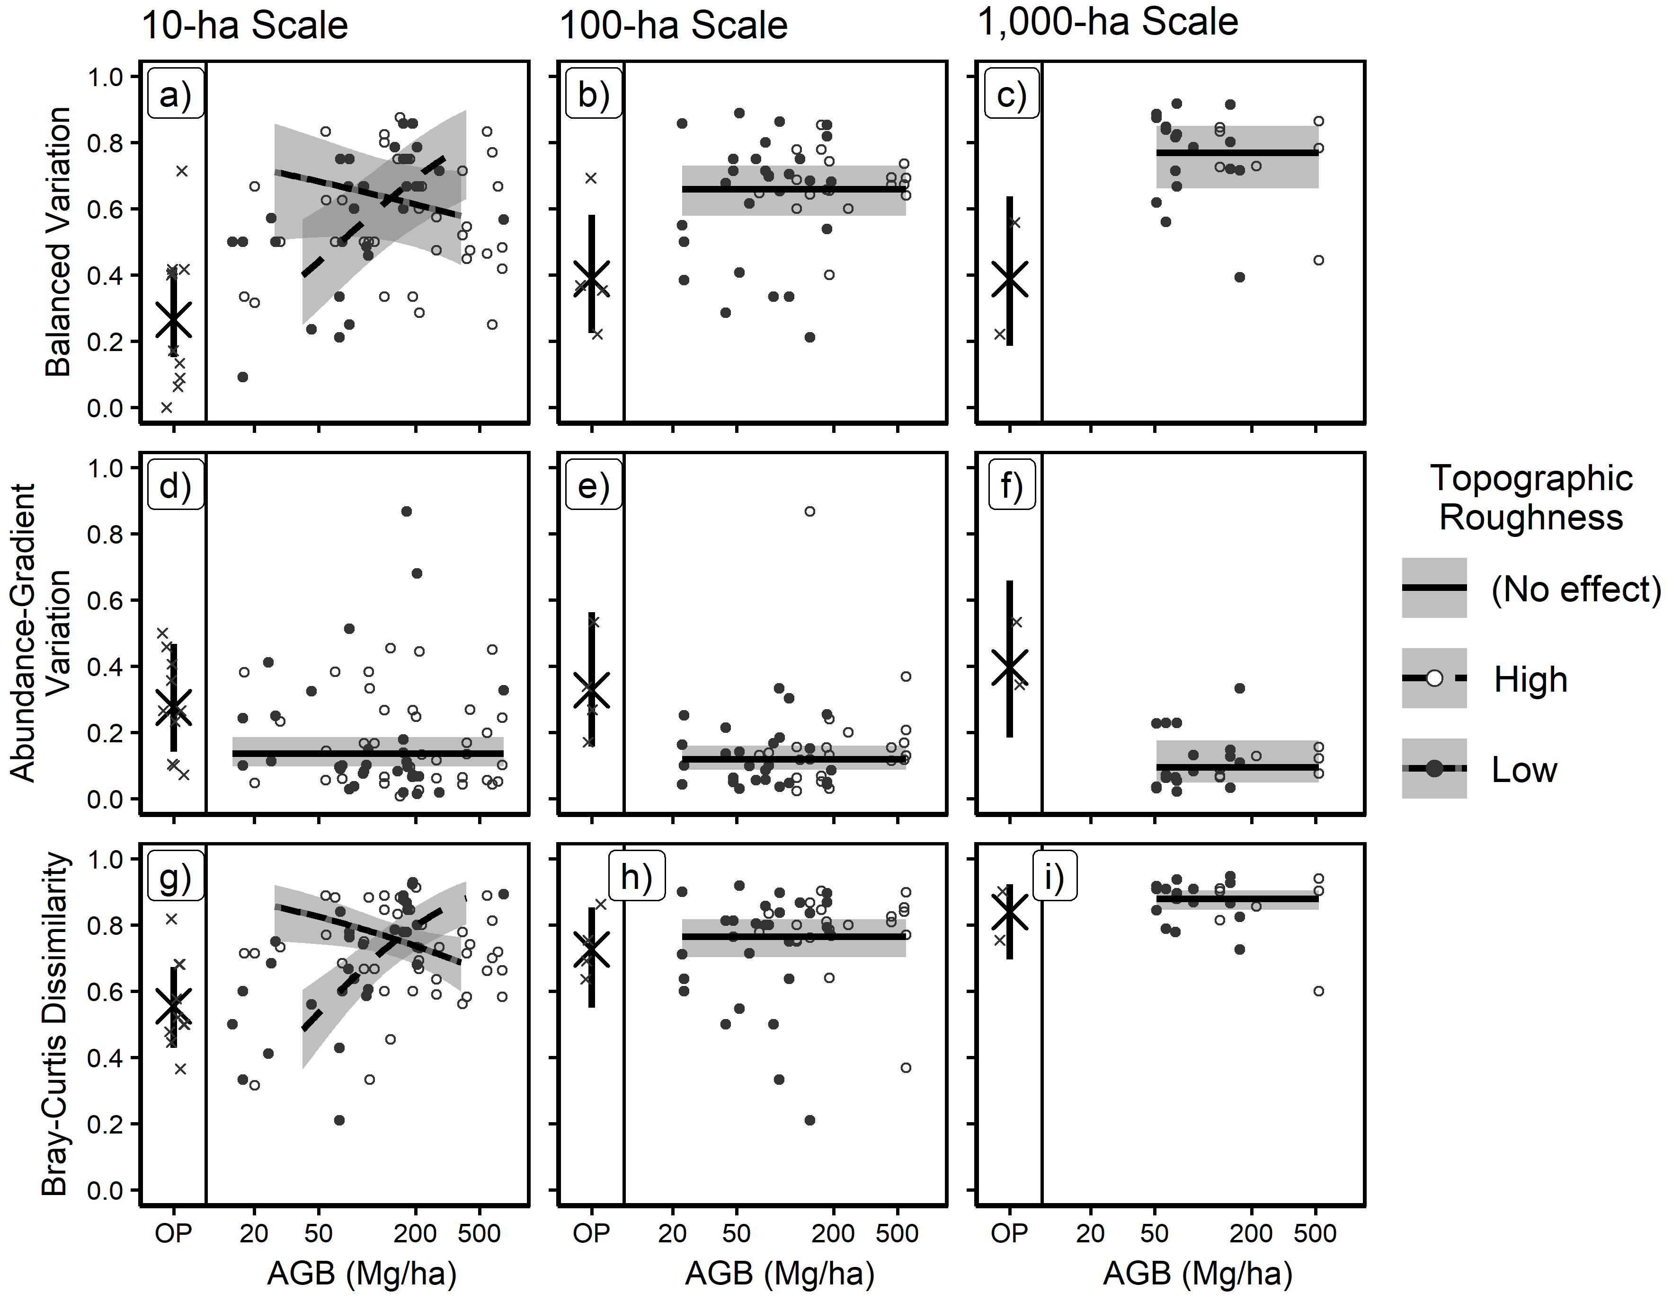
Figure 3. Beta-diversity of weevils at three spatial scales: 10-ha (first column), 100-ha (second column) and 1,000-ha (third column). Beta-diversity is partitioned by rows, where “balanced variation” is beta-diversity attributable to turnover in community structure, “abundance-gradient variation” is beta-diversity attributable to differences in weevil abundance between sites, and “Bray-Curtis dissimilarity” is total beta-diversity. Within panels, samples collected from oil palm plantation is represented on the left (crosses) and forest on the right (dots). Large crosses (with vertical 95% confidence intervals) indicate model predictions for oil palm plantation. Plotted lines (with grey 95% confidence intervals) represent response of forest sites to AGB and topographic roughness. Roughness is a continuous measure in our analyses, so for visualisation purposes we set “Low” roughness as a value of 0.06 and “High” roughness as a value of 0.14.
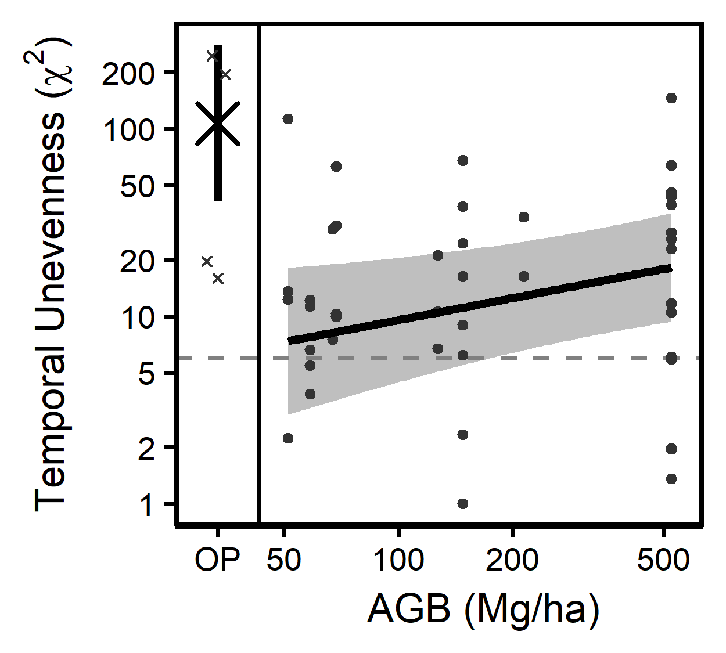
Figure 4. Temporal unevenness in the abundances of weevil species caught per sampling block. Samples collected from oil palm plantation are represented on the left (crosses), and forest on the right (dots). The critical value of χ² on two degrees of freedom for P = 0.050 is shown as a grey dashed line, so all points above that line represent one species that was caught in significantly uneven abundances across sampling periods.

