Online Supplement: ATOMIC-AHF
Online Supplement: Committees and Investigators
Online Supplement Table 1: Post-Randomization Myocardial Infarction events in ATOMIC-AHF
Online Supplement Figure 1: Study Cohort Study Design
Online Supplement Figure 2: Clinical Study Design
Online Supplement Figure 3: ATOMIC-AHF trial profile
Online Supplement Figure 4: Effect of Omecamtiv mecarbil on Renal Impairment
Online Supplement Figure 5: Relationship between Omecamtiv mecarbil exposure by AUC_{0-48h} and Maximal Change in Troponin Concentration, Panel A (range -40 to 100 ng/mL) and Panel B with expanded y-axis (range -4 to 4 ng/mL) excluding outliers
Online Supplement Figure 6: Relationship between Maximal Change in Left Ventricular Systolic Ejection Time and Maximal Change in Troponin Concentration
Online Supplement Figure 7: Relationship between Maximal Change in Left Ventricular End-systolic Dimension and Maximal Change in Troponin Concentration

Online Supplement: Committees and Investigators
- Executive Committee: G. Michael Felker, John McMurray, John R. Teerlink (Chair)
- Steering Committee: John Cleland, Kenneth Dickstein, Justin Ezekowitz, Gerasimos Filippatos, Marco Metra, Piotr Ponikowski
- Data Monitoring Committee: Henry Dargie, Barry H. Greenberg, James Januzzi (Advisor), Julie Johnson (Advisor), Marv Konstam (Chair), Joseph Massaro, Barry M. Massie
Investigators: Joanna Szachniewicz, Mikhail Kotelnikov, Zhanna Kobalava, Jindrich Spinar, Veselin Mitrovic, Janos Tomcsanyi, Bela Merkely, Dinesh Gupta, Mason Weiss, Kalman Toth, Pranas Serpytis, Andrzej Wysokinski, Alain Cohen Solal, Kirkwood Adams, Michel Galinier, Gintare Sakalyte, Hans Vandekerckhove, Fedya Nikolov, Marco Metra, Steven Krueger, Boycho Boychev, Eustathios Iliodromitis, Ioannis Nanas, Jooyoung Shin, Javed Butler, Petar Lazov, Guy Proulx, Gaetano De Ferrari, Dmitry Zateyshchikov, Ivan Gordeev, Boris Goloshchekin, Peter MacDonald, Borislav Atzev, Assen Goudev, Jan Belohlavek, Kumudha Ramasubbu, Nina Shehova-Iankova, Haissam Haddad, Richard Isnard, Kenneth Dickstein, Jadwiga Nessler, Svetlana Boldueva, Glenn Hamroff, John Morrow, Lynne Wagoner, Jiri Vitovec, Jans Stevlik, Stephen Gottlieb, Frank McGrew, Arthur Eberly, Thao Huynh, Henning Ebelt, Thomas Heitzer, Panagiotis Vardas, Dirk Lok, Sergey Tereshenko, Nina Novikova, Marian Hranai, Debra Weinstein, Eugene Chung, David Lanfear, Denise Barnard, Chetan Patel, Mark Dunlap, James Maher, Inder Anand, Marc Vanderheyden, Michel de Ceuninck, Ditmar Raev, Robert Stewart, Pavel Cervinka, Angelika Costard-Jäckle, Athanasios Manolis, Jaroslaw Kasprak, Vladimir Simanenkov, David Smull, Mitchell Saltzberg, Peter McCullough, Andrew Wilson, Filip Charlier, Serge Lepage, Justin Ezekowitz, Gordon Moe, Manohara Senaratne, David Zemanek, Pascal De Groote, Rémi Sabatier, Christian Hengstenberg, Tim Schäufele, Andreas Zeiher, Stephan Felix, Dimitrios Alexopoulos, Bela Herczeg, Laszlo Zoltan, Eelko Ronner, Wlodzimierz Musial, Piotr Jankowski, Eugeny Shlyakhto, Tatyana Novikova, Elena Vasilieva, Arsenio Rodriguez, John Teerlink, Alexander Adler, Andrew McRae, Garrie Haas, Daniel Lenihan, Henry Krum, Carmine De Pasquale, Dariusz Korczyk, Aleksandra Bankova, Stefan Denchev, Debra Isaac, John David Parker, Veli-Pekka Harjola, Heikki Ukkonen, François Roubille, Gérald Roul, Michael Böhm, Ruth Strasser, Sebastian Maier, Gerhard Cieslinski, Hans-Georg Olbrich, Noemi Nyolczas, Maurizio Porcu, Claudio Fresco, Folkert Asselbergs, Lars Gullestad, Andrzej Rynkiewicz, Grigory Aroutiounov, Daniel Pella, Jozef Kaluzay, John Cleland, Hugh Bethell, Angus Nightingale, John McMurray, Philip Adamson, Todd Kovach, Jalal Ghali, Andrew Keller, Adrian Van Bakel, James Mudd, Gregory Ewald, Stephanie Dunlap, Edward McMillan, Freidoon Ghazi, Glenn Barquet, Joshua Larned, Rami Alharethi

Online Supplement Table 1: Post-Randomization Myocardial Infarction events in ATOMIC-AHF
Cohort | Subject  (age, sex) | Trigger | Nominal Day of Event | Completed Infusion | Baseline  Troponin  (ng/mL) | Peak  Troponin  (ng/mL) | OM C_{max}  (ng/mL) | Comments and Clinical Outcome
Placebo
1 | 78 y, M | Troponin | 3 | Yes | <0.016 | 0.060 | – | Typical chest pain symptoms. ECG without changes. Completed study (Day 30); alive at 6-mo F/U
1 | 70 y, M | Troponin | 6 | Yes | 0.098 | 0.672 | – | ECG dynamic T wave changes after atrial fibrillation cardioversion. Patient developed sepsis. Completed study (Day 30); alive at 6-mo F/U
1 | 50 y, M | Re-Hosp | 15* | Yes | 27 | 55 | – | Re-Hospitalized for MI; presented with angina. Underwent PCI to in-stent restenosis. Completed study (Day 30); alive at 6-mo F/U
Omecamtiv mecarbil
1 | 69 y, M | Troponin | 3 | Yes | 0.071 | 0.352 | N/A | Asymptomatic for myocardial ischemia. ECG ST-T wave changes. Completed study (Day 30); alive at  6-mo F/U
1 | 95 y, F | Re-Hosp | 11* | No | 0.09† | 7.12 | (52)¶ | OM discontinued after 4 hours for hypotension. No change in troponins during index hospitalization. Re-Hospitalized day 11 for MI. Baseline LBBB. Disposition at Day 30: Rehabilitation facility; died (reason unknown) before the 6-month F/U
3 | 63 y, M | Investigator | 2 | Yes | 0.024 | 0.064 | 273 | Asymptomatic. ECG dynamic T wave changes. Completed study (Day 30); alive at 6-mo F/U
3 | 85 y, F | Investigator | 2 | No | <0.016 | 0.168 | 450 | History of chronic stable angina. Experienced typical angina while walking to bathroom. OM infusion discontinued per protocol. Angina resolved after 2 administrations on SL NTG. No acute ECG changes. Completed study (Day 30); alive at 6-mo F/U
3 | 64 y, M | Troponin | 3 | Yes | 0.586 | 3.859 | 88 | Coronary angiography on Day 2 for evaluation of etiology of AHF revealed severe 3V CAD. MI was adjudicated as secondary to PCI procedure on Day 2. Completed study (Day 30); alive at 6-mo F/U
3 | 80 y, F | Troponin | 12* | Yes | 0.026 | 0.077 | (709) ¶ | Known h/o CCS II angina and ECG with digitalis effect. Experienced angina walking to bathroom with ECG showing ST depressions. Resolved in 10 minutes with SL NTG and discharged home the same day. Completed study (Day 30); alive at 6-mo F/U
3 | 84 y, M | Investigator | 22* | Yes | 0.404 | 1.86 † | (659) ¶ | On day 22, experienced chest pain with ECG ST depressions, consistent with MI. Died on Day 29; autopsy showed extensive CAD with post-infarction sclerosis and LV aneurysm without evidence of new MI.

* Event occurred > 5 half-lives after completion or discontinuation of investigational product infusion.
¶ Plasma concentrations in parentheses are peak measured during infusion period. Estimated plasma concentrations near time of event are 0.
† Local lab
Note: There were three patients with MI in the placebo group and two in the OM group that occurred in Cohort 1 (low dose). None occurred in either treatment group in Cohort 2 (Intermediate dose) and none occurred in the placebo group of cohort 3. Of the five patients with MI in OM-treated patients of cohort 3 (High dose), two (day 12 and 22) occurred well beyond the active half-life of OM (approximately 20 hours) while another was triggered by post-PCI troponin elevations, making these events unlikely to be causally related to OM administration. The remaining two patients with MI had troponin elevations (peak of 0.064 and 0.168 ng/mL) with the first being asymptomatic and the second being related to a transient episode of exertional angina relieved by nitroglycerin in the setting of a history of chronic exertional angina.

Online Supplement Figure 1: Study Cohort Study Design

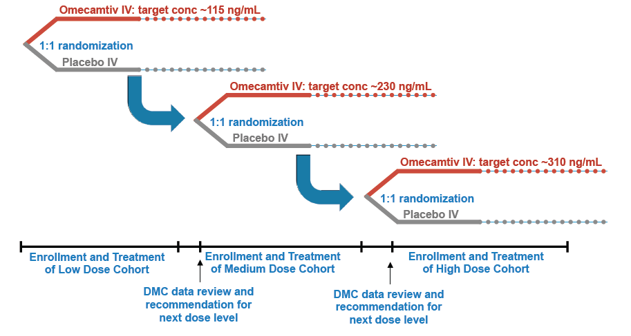

Online Supplement Figure 2: Clinical Study Design

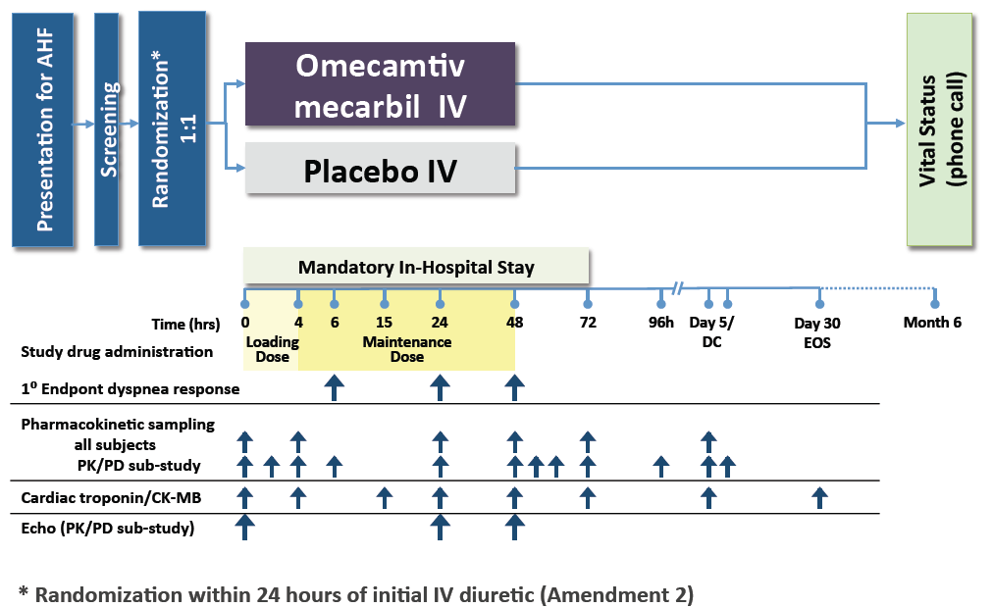

Online Supplement Figure 3: ATOMIC-AHF Trial Profile

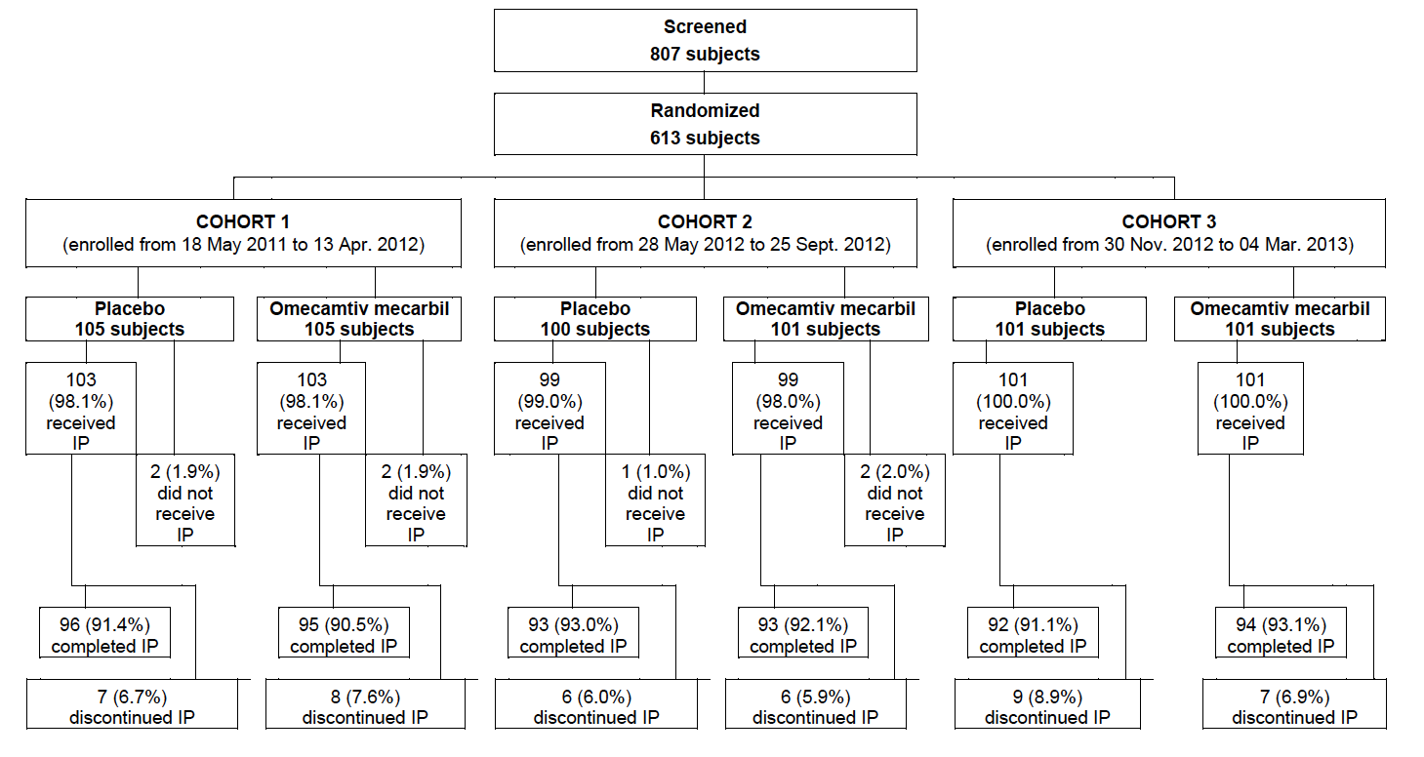

Online Supplement Figure 4:

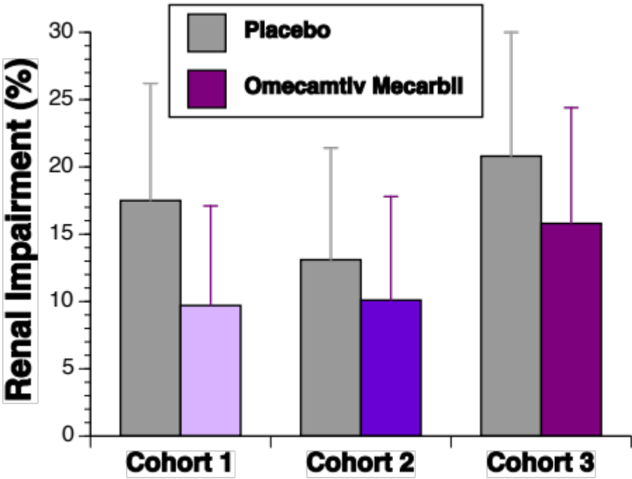

Online Supplement Figure 5, Panel A:
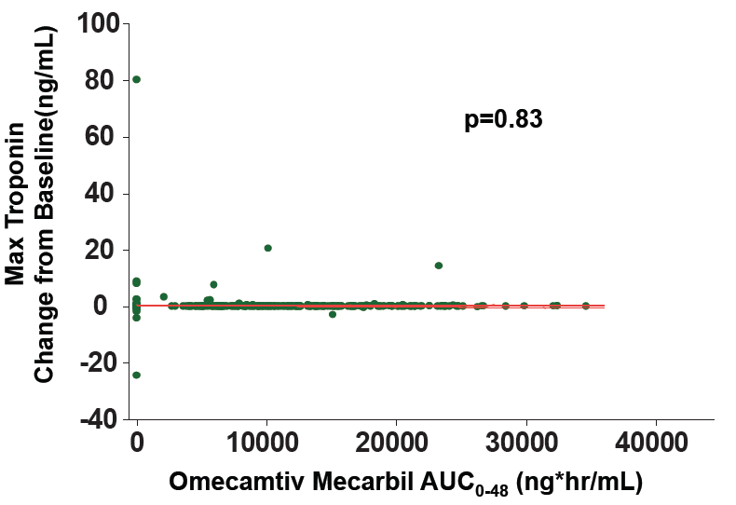
Online Supplement Figure 5, Panel B:
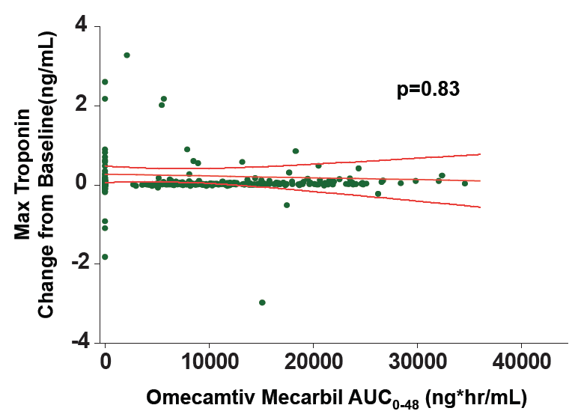
Online Supplement Figure 6:

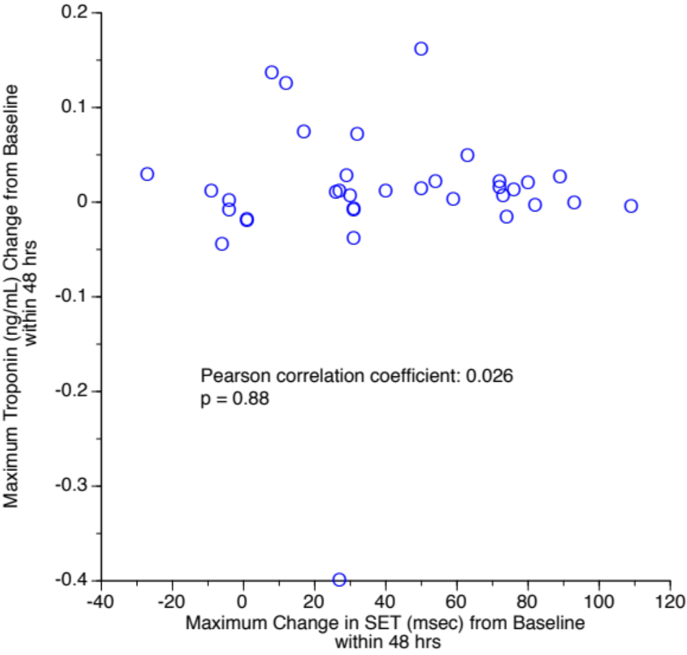

Online Supplement Figure 7:

