The Pliocene: The Last Time Earth had >400 ppm of Atmospheric CO₂
3 April 2019
Imperial College London

Message in a Fossil?

Lessons from the Last Plants on Antarctica

In September 2016, the concentration of carbon dioxide (CO₂) in the atmosphere exceeded 400 parts per million (ppm). As of April 2019 it’s 411 ppm¹, nearly 50% more than was in the atmosphere in 1850 (280 ppm), before the Industrial Revolution. This spectacular rise is due to fossil fuel burning, which is pumping CO₂ into the atmosphere at an exceptional rate².

In fact, the last time the Earth experienced more than 400 ppm CO₂ was over 3 million years ago, in a time period called the Pliocene. According to scientists studying Earth’s past climate, the Pliocene featured sea levels 10 to 20 m higher than today, global temperatures about 3°C warmer, and perhaps even trees on Antarctica³. At a Royal Meteorological Society meeting last week, palaeoclimate scientists came together to discuss the Pliocene and the lessons it holds for the future. Are these the conditions in store for us in the decades and centuries to come?

First, why does extra CO₂ warm the climate? Well, it’s like throwing an extra duvet on your bed at night, or putting on an extra coat. Carbon dioxide acts like a blanket, warming up the planet by trapping heat, originally from the sun, in Earth’s atmosphere.

Fossil fuel burning has pumped CO₂ into the atmosphere so fast, “instantly, on geological timescales”, that the oceans and atmosphere haven’t had time to fully adjust yet, just like it takes a few minutes to warm up when you climb into bed, or switch on your oven.

But, today, global temperature is already 1°C warmer than before the Industrial Revolution, said Professor Martin Siegert of the Grantham Institute at Imperial College London, and we are just beginning see the broader impact of this warmth all around us. Glaciers are melting, as are the polar ice caps. As a result, sea level is about 18 cm higher than in 1900 and is rising by about 3 mm per year and at an increasing rate⁴, according to Professor Rob DeConto of the University of Massachusetts-Amherst.

So, how can the Pliocene inform future climate, and climate policy? Professor Dan Lunt of the University of Bristol outlined four key ways:

First, the Pliocene provides “a window onto a world different to our own”, an analogue for future climate change⁵. Second, it provides independent geological data that we can use to test the computer models designed to predict future climate. Third, we can use the Pliocene to estimate long-term (century and millennia scale) changes that can’t be simulated with these complex, energetically expensive climate models.

Most importantly, palaeoclimate data can be used to quantify key metrics such as climate sensitivity, which is the amount of warming we expect for a doubling of atmospheric CO₂ concentrations. Climate sensitivity is the so-called “holy grail of climate science”, because it allows policy makers to answer the pressing question of today:

How much CO₂ can I emit whilst restricting warming to 1.5°C, the goal of the Paris Agreement?

First estimates from the Pliocene indicate that climate sensitivity is about 2 to 4°C warming for a doubling of CO₂. Active research is ongoing to improve this estimate⁶.

Much of the meeting focussed on the response of the Antarctic ice sheets to warming. Melting ice on Antarctica has the potential to cause massive sea level rise, with up to 5 m from the West Antarctic Ice Sheet (WAIS), and an additional 53 m of sea level rise were the entire East Antarctic Ice Sheet (EAIS) to melt.

The EAIS was previously assumed to be stable, because most of the ice sits on solid rock. But large areas of the EAIS, holding approximately 19 m of sea level potential, are actually below sea level, in huge ‘sub-glacial’ basins (Fig. 1). According to Professor Tina van de Flierdt, also of Imperial College London, data from marine sediments suggests that lots of the ice in these sub-glacial basins melted during the Pliocene⁷, with more than 10 m of sea level rise at the time.
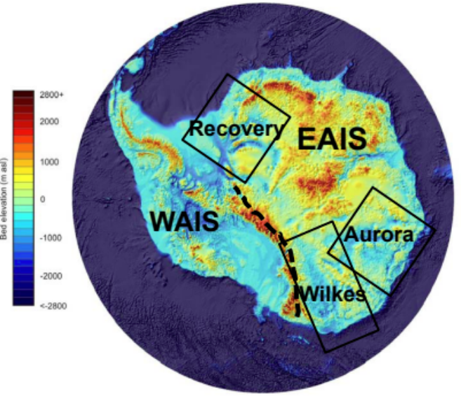
Figure 1. Antarctica with its two major ice sheets, the West and East Antarctic Ice Sheets (WAIS, EAIS). Three large sub-glacial basins in the EAIS are labelled.

Why did the ice on East Antarctica melt in the Pliocene? And could this happen in the coming centuries? How quickly are the ice sheets on Greenland and West Antarctica likely to respond to warming in the coming decades? These are the questions addressed by Professor DeConto, via a state-of-the-art ice sheet computer model⁸.

Marrying the geological data and model findings suggests that ice sheets are inherently more unstable than we had previously realised. We know sea level will rise in future; our new understanding of the physical mechanisms of ice sheet retreat is hugely valuable for predicting just how far, and how fast.

So, is there any good news? Well, the most recent ice sheet model findings suggest that, if we limit global temperature rise to less than 2°C, sea level rise by the end of this century is likely to be modest (< 10 cm). Above 2°C warming, and the rise is likely to be much more abrupt.

My conclusion? It’s time to act urgently on reducing CO₂ emissions! The alternative, as spelled out by Professor Alan Haywood of University of Leeds, is:

“After studying the Pliocene for 21 years, and all things being equal in the decades ahead, I will experience first hand a climate state that has not existed for more than 3 million years.”

References:
- Mauna Loa observatory: https://www.esrl.noaa.gov/gmd/ccgg/trends/
- The Intergovernmental Panel on Climate Change: https://www.ipcc.ch
- https://www.bbc.co.uk/news/science-environment-47806440
- Nerem, R. S., et al. "Climate-change–driven accelerated sea-level rise detected in the altimeter era." Proceedings of the National Academy of Sciences 115.9 (2018): 2022-2025.
- Burke, K. D., et al. "Pliocene and Eocene provide best analogs for near-future climates." Proceedings of the National Academy of Sciences 115.52 (2018): 13288-13293.
- Martínez-Botí, M. A., et al. "Plio-Pleistocene climate sensitivity evaluated using high-resolution CO 2 records." Nature 518.7537 (2015): 49.
- Cook, C. P., van de Flierdt, T. et al. "Dynamic behaviour of the East Antarctic ice sheet during Pliocene warmth." Nature Geoscience 6.9 (2013): 765.
- DeConto, R. M., and Pollard, D. "Contribution of Antarctica to past and future sea-level rise." Nature 531.7596 (2016): 591.

