Portable and rapid arsenic speciation in synthetic and natural waters by an As(V)-selective chemisorbent, validated against anodic stripping voltammetry

Supplementary Information

Jay C. Bullen^{a*}, Aaron Torres-Huerta^{b}, Pascal Salaün^{c}, Jonathan S. Watsonª, Swachchha Majumdar^{d}, Ramon Vilar^{b}, Dominik J. Weiss^{a*}
ª Department of Earth Science and Engineering, Faculty of Engineering, Imperial College London, London, UK, SW7 2BX
^{b} Department of Chemistry, White City Campus, Imperial College London, London, UK, W12 OBZ
^{c} Department of Earth, Ocean and Ecological Sciences, School of Environmental Sciences, University of Liverpool, Liverpool, UK, L69 3BX
^{d} CSIR-Central Glass and Ceramic Research Institute, 196, Raja SC Mullick road, Kolkata, 700032, India

* Corresponding authors
Email address: j.bullen16@imperial.ac.uk (Jay Bullen), d.weiss@imperial.ac.uk (Dominik Weiss)

Preparation of Synthetic Groundwaters
Challenge Water (CW) was prepared by purging 1 L Milli-Q water with nitrogen gas for 1 hour to which was added 0.04 g Na₂SiO₃ and 0.25 g NaHCO₃. The pH was adjusted to pH 7.5 with a small amount of 1 M HCl. Separately 1.2 g NaNO₃, 0.22 g NaF and 0.035 g HNa₂PO₄.7H₂O were added to 100 mL of Milli-Q. An aliquot of this solution (1 mL) was added to the 1 L stock. To the 1 L stock solution was added 0.15 g CaCl₂.H₂O. The pH was adjusted to 7.47 with addition of a small volume of 1 M HCl. Synthetic groundwater SGW-1 was prepared by purging 1 L Milli-Q water with nitrogen gas for 1 hour, to which 0.08 g Na₂SiO₃, 0.8 g NaHCO₃ and 0.037 g MgSO₄.7H₂O were added. In a separate volumetric flask, 0.085 NaNO₃, 0.3 g HNa₂PO₄.7H₂O and 0.7 g KHCO₃ were dissolved in 100 mL Milli-Q water. An aliquot of this solution (1 mL) was added to the 1 L stock, followed by 0.11 g CaCl₂.2H₂O, 0.28 g MgCl₂.6H₂O and 0.004 g MnCl₂.4H₂O. The pH was adjusted to 7.1. Synthetic ground water SGW-2 was prepared by purging 1 L Milli-Q water with nitrogen gas for 1 hour, to which 0.9 g NaHCO₃ and 0.3 g MgCl₂.6H₂O were added. 0.1 g KH₂PO₄, 0.15 g Ca(NO₃)₂, 1.5 g MgSO₄.7H₂O and 4 g NH₄Cl were then dissolved in 50 mL N₂-purged Milli-Q water and from this solution 1 mL was added to the 1 L stock solution. The pH of SGW-2 was 8.32.

Table S1: Chemical reagents used in this work.
Reagent | Name | Manufacturer | Grade/purity | CAS #
Na₂HAsO₄·7H₂O | Sodium arsenate dibasic heptahydrate | Sigma | ACS reagent | 10048-95-0
As₂O₃ | Arsenic trioxide | Aldrich | 99% | 1327-53-3
As (aq) | Arsenic standard | Fluka | 1000 ± 4 mg L⁻¹  traceCERT | -
N₂H₄.H₂O | Hydrazine hydrate | Fisher | Analytical reagent | 7803-57-8
N₂H₆SO₄ | Hydrazinium sulphate | Fluka OR Aldrich | ACS reagent ≥ 99.0% | 10034-93-2
C₁₀H₂₀N₂Na₄O₁₀ | EDTA tetrasodium salt, dihydrate | Fisher | BioReagent | 10378-23-1
FeSO₄·7H₂O | Iron(II) sulfate heptahydrate | Fluka OR Sigma Aldrich | ACS reagent ≥ 99.0% | 7782-63-0
MnCl₂.4H₂O | Manganese(II) chloride tetrahydrate | Sigma Aldrich | ACS reagent ≥ 98.0% | 13446-34-9
C₈H₁₈N₂O₄S | HEPES free acid | Amresco | High purity grade | 7365-45-9
1.0 M NaOH | Sodium hydroxide | Honeywell Fluka | - | 1310-73-2
Na₂SiO₃ | Sodium metasilicate | Aldrich | SiO2, 50-53% | 6834-92-0
NaHCO₃ | Sodium bicarbonate | BDH | 99 to 101% assay | 144-55-8
1.0 M HCl | Hydrochloric acid | Honeywell Fluka | - | 7647-01-0
NaNO₃ | Sodium nitrate | VWR | AnalaR NORMAPUR  ACS reagent | 7631-99-4
NaF | Sodium fluoride | Alfa Aesar | 99% min  ACS reagent | 7681-49-4
HNa₂PO₄.7H₂O | Sodium phosphate dibasic heptahydrate | Acros organics | 99+% for analysis | 7782-85-6
CaCl₂.2H₂O | Calcium chloride dihydrate | BDH | AnalaR, 99.5% minimum assay | 10035-04-8
MgSO₄.7H₂O | Magnesium sulphate hexahydrate | Sigma | BioReagent | 10034-99-8
KHCO₃ | Potassium hydrogen carbonate | Merck | EMSURE, ACS | 298-14-6
MgCl₂.6H₂O | Magnesium chloride hexahydrate | Sigma | BioReagent | 7791-18-6
KH₂PO₄ | Potassium dihydrogen phosphate | Riedel-de-Haë | 98-100.5% assay | 7778-77-0
Ca(NO₃)₂.4H₂O | Calcium Nitrate Tetrahydrate | Fluka Analytical | ACS ≥99.0% | 13477-34-4
NH₄Cl | Ammonium chloride | Fisher | Analytical reagent grade | 12125-02-9
- | Multi-element standard (10 μg mL⁻¹)  Ag, Al, As, B, Ba, Be, Ca, Cd, Ce, Co, Cr(3), Cs, Cu, Dy, Er, Eu, Fe, Ga, Gd, Ho, K, La, Lu, Mg, Mn, Na, Nd, Ni, P, Pb, Pr, Rb, S, Se, Sm, Sr, Th, Tl, Tm, U, V, Yb, Zn | Inorganic Ventures | NIST-traceable standard | -

Figure S1: As(V) removal for different ImpAs synthesis batches used to indicate adsorption capacity. Here we show improvements in performance of the material compared with the original Zn-Hypogel reported by Moffat et al., 2014. Adsorption capacity was determined as the amount of As(V) removed during a batch experiment between ImpAs and excess As(V). Conditions were 30 mg L⁻¹ As(V), 1 g L⁻¹ ImpAs, 10 mM HEPES (pH 7.44) (50 mL total volume). Suspensions were shaken overnight, filtered gravimetrically and analysed by ICP-MS. The error bar shows the standard deviation between all batches tested (N=10). Previous work reported removal of 10 mg g⁻¹ As(V) when C_{e} (the equilibrium concentration of aqueous As(V)) equals 11 mg L⁻¹, with a maximum adsorption capacity of 10.2 ± 0.6 mg g⁻¹ using the Langmuir adsorption isotherm model (Moffat et al., 2014). In this work the synthesised ImpAs removed on average 16.0 ± 1.3 mg g⁻¹ As(V), with C_{e} = 14.0 ± 1.3 mg g⁻¹. Moffat et al., 2014 identified saturation of the material and a plateau in the Langmuir adsorption isotherm at 2 mg L⁻¹. With >10 mg L⁻¹ As(V) remaining in solution it is likely that ImpAs was saturated in these tests.

Table S2: ASV operating parameters. Detection limits (LoD) and limits of quantification (LoQ) are reported for both blank HCl and acidified SGW-2 media.
Potentiostat |  |  | PDV6000ultra
Determination |  |  | As(III) | Total As
pH (in HCl) |  |  | 2 | 1
Hydrazine (μM) |  |  | 20 | None
N₂ purge |  |  | None
Rest |  |  | +600 mV
Deposition |  |  | -700 mV (15 s) | -1300 mV (15 s)
Hold |  |  | +400 mV (10 s)
Stripping | Start potential |  | -400 mV
Stripping | Final potential |  | +700 mV
Stripping | Profile |  | Linear sweep
Stripping | Sweep rate |  | 8000 mV s⁻¹
Cleaning |  |  | +700 mV (2 s)
LoD (3σ)  (µg L⁻¹) |  | HCl | 0.095 | 0.058
 |  | SGW-2 | 0.34 | 0.44
LoQ  (10σ)  (µg L⁻¹) |  | HCl | 0.32 | 0.19
 |  | SGW-2 | 1.1 | 1.5
Linear range (µg L⁻¹) |  |  | 6 | 6

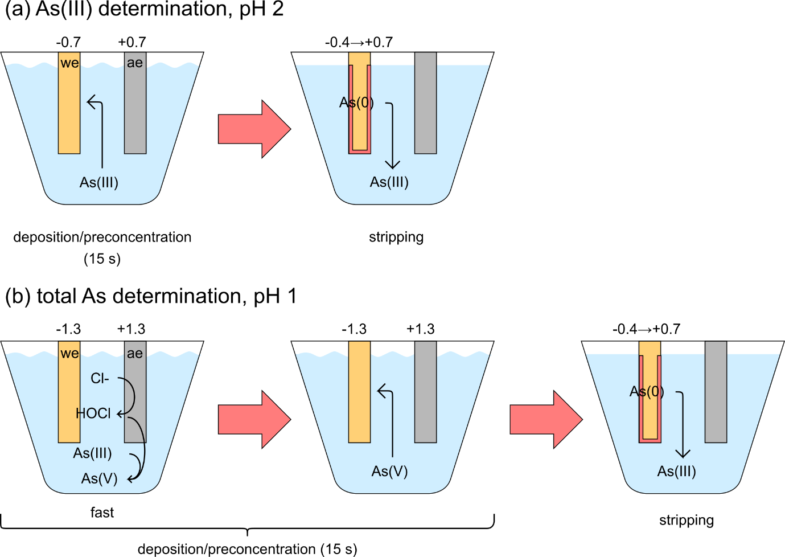
Figure S2: Speciation of arsenic in media acidified with HCl by Anodic Stripping Voltammetry with a gold microwire electrode. This set-up uses a gold microwire working electrode (30 μm diameter, 5 mm length), a platinum auxiliary electrode, and an Ag/AgCl/KCl(3M) reference electrode. The sample is mixed by a propeller during deposition, and 20 μM hydrazine is added to samples for As(III) determination, to prevent oxidation of arsenic during deposition.
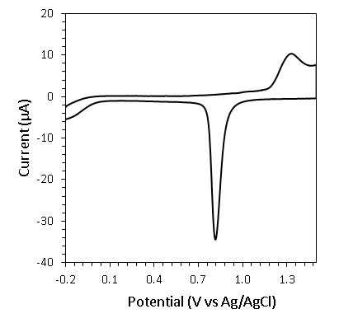
Figure S3: Typical cyclic voltammogram of gold microwire electrode in 0.5 M H₂SO₄, showing expected behaviour with oxidation of gold at +1.3 V followed by the reduction of gold oxide at +0.8 V. CV scans were used frequently when measuring synthetic groundwater samples to clean the electrode and restore sensitivity, with 30 seconds conditioning at -2.5 V to desorb organics, followed by a CV scan between -0.2 and +1.5 V with a sweep rate of 1 V s⁻¹. See (Salaün and van den Berg, 2006) for a further discussion.
Table S3: Efficiency of As(V) removal using syringes loaded with 1 gram ImpAs. 1 mg L⁻¹ As(V) was filtered in each case (50 mL total) (N=2).
 |  | times filtered
 |  | 1 | 2 | 3
As(V) removed (%) | 10 mM HEPES  pH 7.44 | 97.8 ± 2.0 | 98.1 ± 1.8 | 99.6 ± 0.5
As(V) removed (%) | Challenge Water  pH 7.42 | 92.9 ± 1.1 | 97.2 ± 0.7 | 98.1 ± 0.1
As(V) removed (%) | SGW-1  pH 7.09 | 96.9 ± 0.7 | 97.5 ± 0.6 | 97.0 ± 0.6

(a)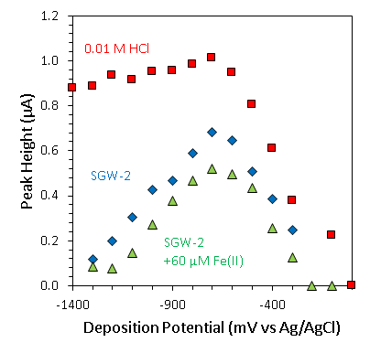 | (b)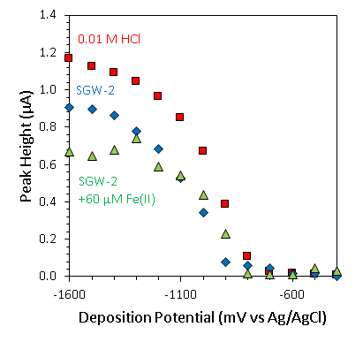
Figure S4: Influence of deposition voltage on As stripping peak intensity for (a) As(III) determination at pH 2 (40 μM hydrazine), and (b) total As determination at pH 1, both systems acidified with HCl . Media used are blank HCl (red squares), SGW-2 (blue diamonds) and SGW-2 +60 μM Fe(II) (green triangles). 15 seconds deposition, 10 seconds hold at ≤400 mV (no more negative than the deposition potential), stripping at 4 V s⁻¹. As(III) detection was made in the presence of 5 μg L⁻¹ As(III) and total As detection was made in the presence of 5 μg L⁻¹ As(V).

(a)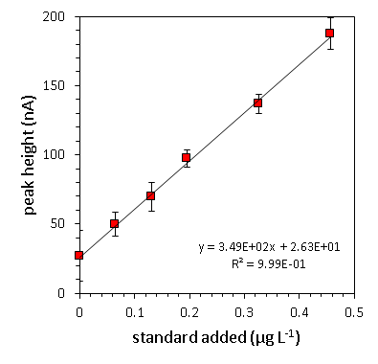(b)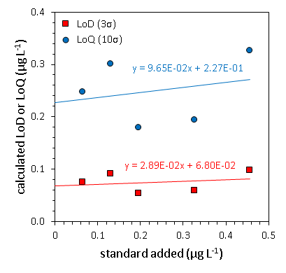
Figure S5: Determining the limit of detection (LoD) and limit of quantification (LoQ) for total As determination in 0.1 M HCl. LoD and LoQ were calculated respectively as 3 and 10 times the standard deviation (σ) of seven repeat scans of the lowest concentration of standard added (standard deviation as LoD shown as error bars in Figure a). Standard additions show the linear calibration (a), with the LoD remaining between 0.05 and 0.1 µg L⁻¹ (b). LSASV conditions: 15s at -1.3 V, 10s hold at -400 mV, stripping from -400mV to +700mV at 8 V s⁻1. The ‘peak height’ at 0 µg L⁻¹ standard added corresponds to the noise in the voltammogram owing to background current. This noise was not corrected for, as when extrapolated, this error (26 nA) contributes no more than 1.6% of the signal when 5 μg L⁻¹ As was present in the cell as was typical in this study. The background signal was found insignificant compared with the arsenic standard additions (see Figure S9).
(a)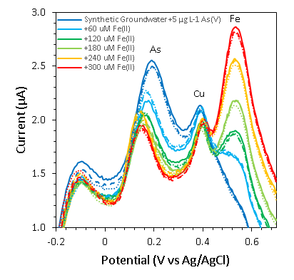 | (b)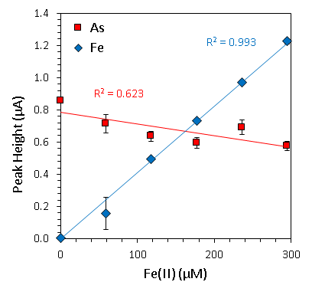
Figure S6: Influence of iron presence on voltammograms during total As at pH 1. In West Bengal and Bangladesh, concentrations of around 60 µM Fe(II) (3.3 mg L⁻¹) are commonplace for arsenic contaminated groundwaters (McArthur et al., 2004) (Hug et al., 2008) (Ayers et al., 2016). Error bars represent the standard deviation between three repeat scans between each addition. LSASV conditions: 15s at -1.3 V, 10s hold at -400 mV, stripping from -400mV to +700mV at 4 V s⁻¹.

(a)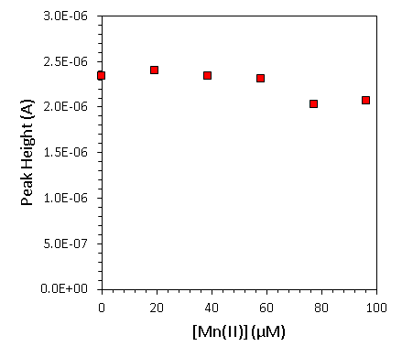 | (b)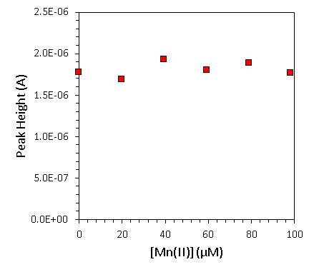
Figure S7: The (lack of) influence of Mn(II) addition on As stripping peaks for (a) 5 µg L⁻¹ As(V), pH 1, and (b) 5 µg L⁻¹ As(III), pH 2, 20 µM hydrazine. In South Asian groundwaters Mn(II) can be found in concentrations of 4-40 µM (220 μg L⁻¹ to 2.2 mg L⁻¹) (McArthur et al., 2004) (Hug et al., 2008) (Ayers et al., 2016). LSASV conditions: 15s at -1.3 V (total As) or -0.7V (As(III)), 10s hold at -400 mV, stripping from -400mV to +700mV at 4 V s⁻¹.
(a)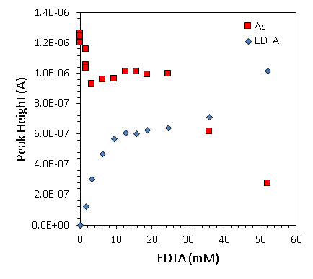 | (b)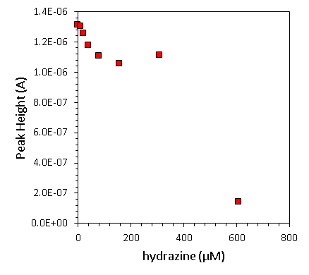
Figure S8: Influence of EDTA (a) and hydrazine (b) on As stripping peak during total As determination (5 µg L⁻¹ As(V), pH 1). The second peak labelled ‘EDTA’ appears at c.a +600 mV. 15s at -1.3 V, 10s hold at -400 mV, stripping from -400mV to +700mV at 4 V s⁻¹. Arsenic peaks remained stable with up to 25 mM EDTA, beyond which peak current fell towards zero. Addition of excess hydrazine (sometimes as low as 40 µM) was accompanied with an increase in background current at positive stripping potentials which would increase in magnitude and shift toward negative potential with repeat scans, eventually obscuring the arsenic peak. 20 µM hydrazine was identified as ideal. For total As determination, arsenic could be detected with up to 300 μM hydrazine, far beyond the concentrations used for sample preservation.

(a)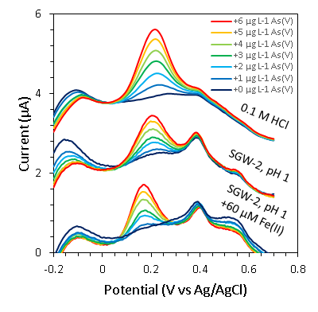 | (b)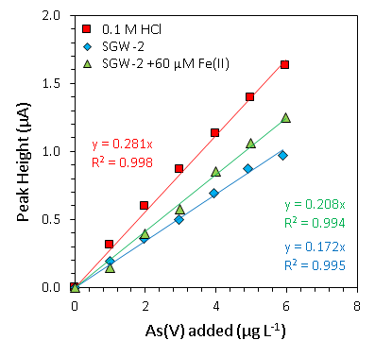
Figure S9: Voltammograms (a) and Linear range (b) of total As determinations in at pH 1 (acidified with HCl) for (i) blank 0.1 M HCl, (ii) SGW-2 and (iii) SGW-2 + 60 μM. LSASV conditions: 15s at -1.3 V, 10s hold at -400 mV, stripping from -400mV to +700mV at 4 V s⁻¹. The peak at 0.4 V is Cu, and the peak at +0.55V is Fe.

(a)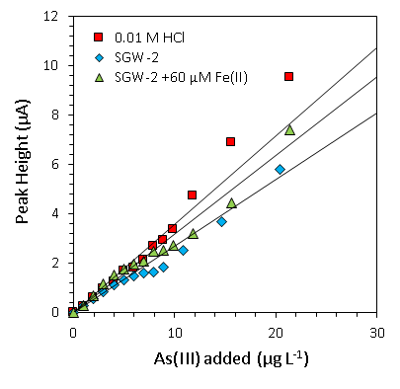 | (b) 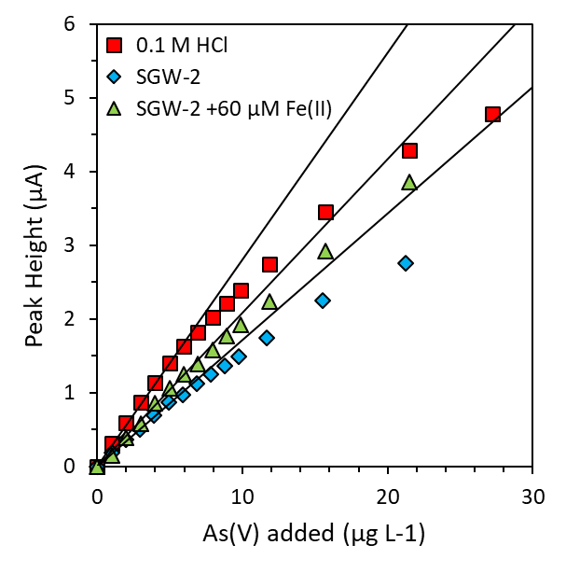
Figure S10: Upper limits to the linear range of (a) As(III) (with 10μM hydrazine) and (b) total As determinations. LSASV conditions: 15s at -1.3 V (total As) or -0.7V (As(III)), 10s hold at -400 mV, stripping from -400mV to +700mV at 4 V s⁻¹.

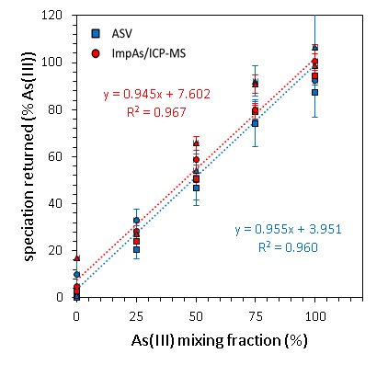
Figure S11: Comparison of anodic stripping voltammetry (blue) and ImpAs/ICP-MS (red) speciation methods in the laboratory. Conditions were 1 mg L⁻¹ total arsenic in different As(III):As(V) mixing ratios, in 10 mM HEPES (squares), Challenge Water (circles), or SGW-1 synthetic groundwater (triangles).

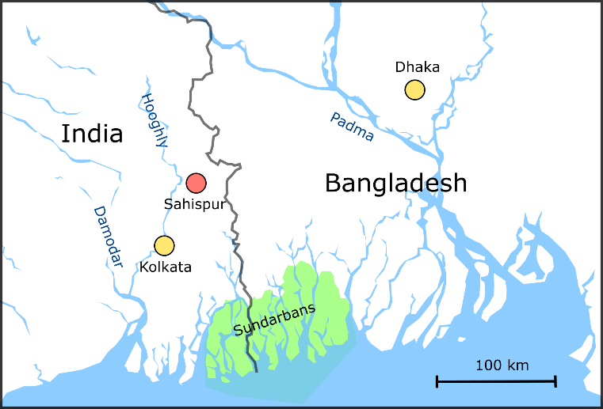  (a) | 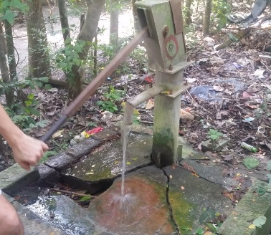  (b)
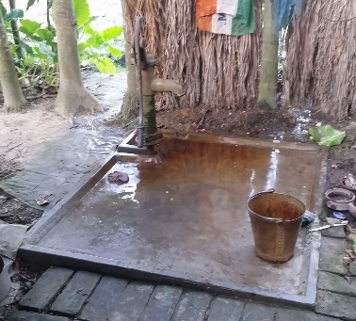
(c)
Figure S12: Sampling sites for field work. (a) Location of field site at Sahispur village (red) within the Bengal Basin, and photos of (b) well 3 and (c) well 4. Chakudanga is located around 2.5 km North East of Sahispur.

Table S4: Sampled wells and characterisation of arsenic contents by ICP-MS and ASV prior to As(V) spiking experiment.
Source |  | Well 3 | Well 4 | STN13 | STN5
Well type |  | Deep | Shallow | Shallow | Deep
pH |  | 7.3 | 7.2 | 8.2 | 8.4
ICP-MS | As (µg L⁻¹) | 9.9 ± 1.4 | 53.3 ± 2.7 |  | 100.3 ± 2.6
ASV | As(III) (µg L⁻¹) | 10 | 52 | 190 | 95
ASV | Total As (µg L⁻¹) | 12 | 63 | 180 | 110
ASV | % As(III) | 86 | 84 | >100 | 86

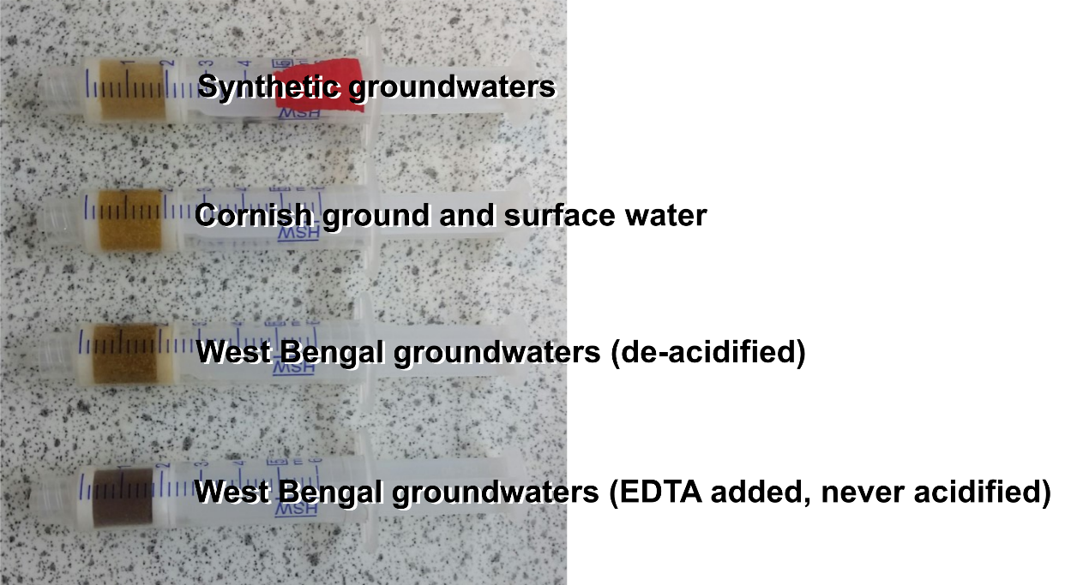
Figure S13: Colour change in ImpAs due to precipitation of iron within the syringe, especially when used for West Bengal groundwaters with high concentrations of dissolved iron. Whilst EDTA reduced the rate of iron precipitation during ImpAs treatment of West Bengal groundwaters, the final colour of the resin is darker than for the ImpAs syringe used to treat de-acidified West Bengal groundwaters. This can be explained by the darker syringe having been used to treat many more samples.
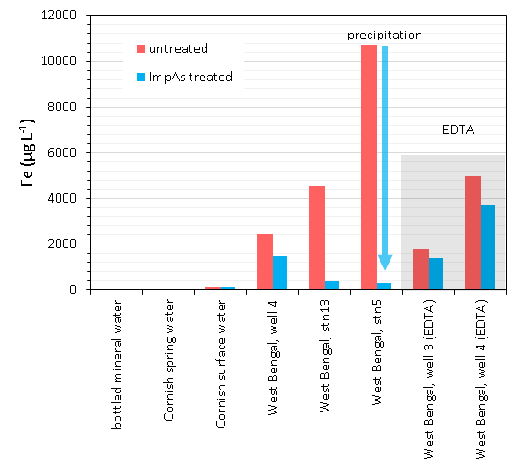
Figure S14: There is notable precipitation of iron during ImpAs treatment of West Bengal groundwater samples, especially in the case of STN5 for which a loss of total As was observed. Addition of EDTA reduces the rate of iron precipitation during treatment. Whilst STN13 also shows significant iron precipitation during ImpAs treatment, the arsenic spiking experiment was not affected.

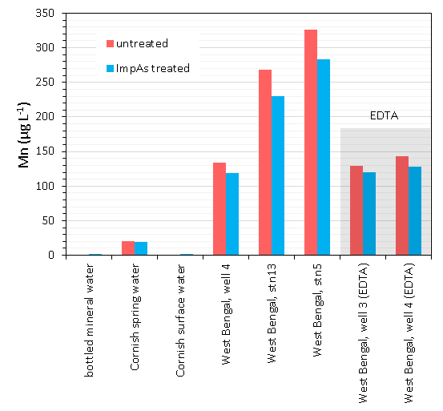
Figure S15: Precipitation of manganese during ImpAs treatment of West Bengal groundwaters is less dramatic than for iron, however, again addition of EDTA slows the rate of precipitation.

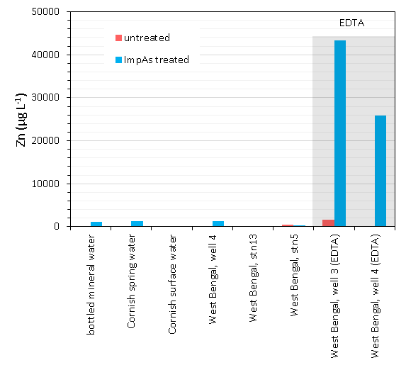
Figure S16: Presence of EDTA was associated with zinc leaching from ImpAs during treatment.
Multi-element ICP-MS analysis revealed that whilst EDTA slowed the rate of iron (and manganese) precipitation during ImpAs treatment (Figure S15 and Figure S16), presence of EDTA was associated with leaching of zinc from the syringe (Figure S17), an essential component of the ImpAs metal-organic As(V) receptor. ‘Resin fouling,’ i.e. the loss of resin performance, is not well understood (Li et al., 2014), however material loss or decomposition would explain the failure of ImpAs to remove As(V) in the presence of EDTA (Miller et al., 2009) (Gönder et al., 2006).
Dissolved organic carbon (DOC) as humic and fulvic acids are also known to complex with Zn²⁺ (Cvetkovic et al., 2015) (Hirata, 1981) however ImpAs removal of the As(V) was successful for Cornish surface water, Well 4 and STN13, all with elevated levels of humic-like content (detected by UV/vis spectroscopy at 254 nm, Table 1). The stability of the ImpAs metal-organic receptor in the presence of natural DOC and instability in the presence of EDTA can be assessed by considering the conditional complexation constant K_{cond} (for 1:1 complexes, [ML]) and the concentration of each ligand, [L], as follows (charges are omitted for simplicity):
$${K'}_{ZnL}=\frac{[ZnL]}{[Zn][L]}$$
Equation 1
The concentration of all ligands was at least two orders of magnitude greater than the concentration of Zn (Table S5), so the decrease in [L] at equilibrium is negligible. Equation can thus be rearranged to:
$${K'}_{ZnL}[L_{init}]=\frac{[ZnL]}{[Zn]}$$
Equation 2
where [L_{init}] represent the total concentration of the ligand. Determination of K’_{ZnL}[L_{init}] (Table S5) agrees with experimental observations that EDTA has a strong enough complexation constant, and is present in sufficient concentration, to leach zinc from ImpAs (for ImpAs, K_{M-L}[L_{init}]=3.51, whilst for EDTA, K_{M-L}[L_{init}]=13.8). The disruption of the metal-organic receptor results in a loss in the ability of ImpAs to retain As(V). On the other hand, it shows that humic and fulvic acids, at concentrations typical of natural waters, are probably too weak to negatively affect the speciation performance by ImpAs. Where rapid precipitation of iron does interfere with As(V) removal by ImpAs, acid should hence be used as a sample preservative rather than EDTA. However samples must then be pH neutralised as ImpAs shows weaker affinity towards As(V) at low pH, due to protonation of the pyridine groups which coordinate to zinc (Moffat et al., 2014).

ligand | log K’_{ML} | [L_{init}] (M) | log(K’_{ML}[L_{init}]) ª
ImpAs | 4.18 ^{b} | 0.21 ^{f} | 3.51
humic acid | 2.25 ^{c} | 0.0013 ^{g} | -0.65
fulvic acid | 5.66 ^{d} | 0.00045 ^{g} | 2.31
EDTA | 15.8 ^{e} | 0.010 | 13.8
Table S5: Complexation strength of each ligand in the system
ª : K’_{ML}[L_{init}] = [ZnL]/[Zn]
^{b} : (Moffat et al., 2014), ^{c} : (Cvetkovic et al., 2015), ^{d} : (Hirata, 1981), ^{e} : (Boija et al., 2014)
^{f} : pore volume of ImpAs resin is approximately 1 cm³ g⁻¹, ligand concentration taken as 16 mg g⁻¹ from adsorption data
^{g} : using the high literature DOC for Bengal Basin of 50 mg L⁻¹ (Mladenov et al., 2015) (Ayers et al., 2016), and assuming all is either humic acid (25 meq g⁻¹) or fulvic acid (9 meq g⁻¹) with high concentrations of functional groups (Tsutsuki and Kuwatsuka, 1989) (Hirata, 1981)

(a) 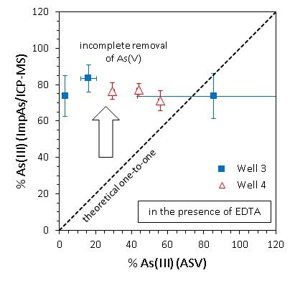 | (b) 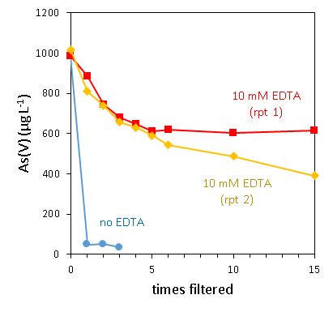
(c) 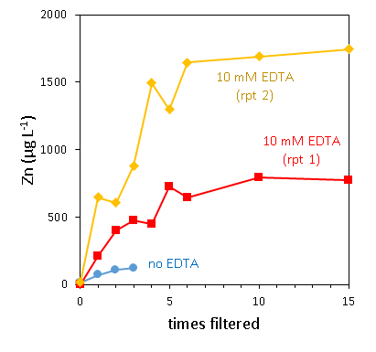 | (d)  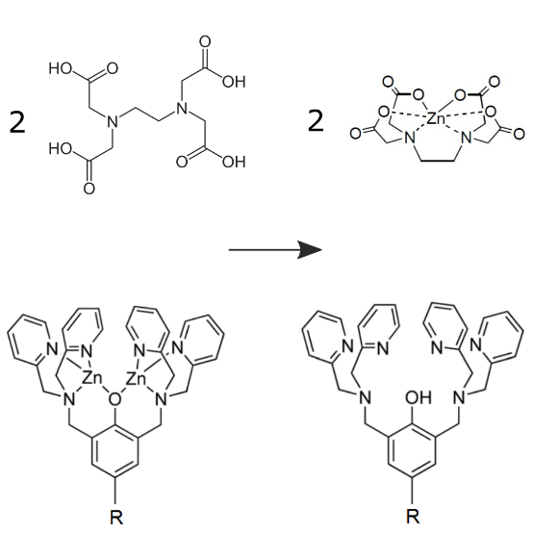
Figure S17: (a) In the presence of 10 mM EDTA ImpAs failed to remove all the As(V) spike, resulting in an overestimation of the concentration of As(III) present in the sample. (b) As(V) removal efficiency by ImpAs with and without presence of 10 mM EDTA and (c) detection of corresponding zinc leaching (all experiments in 10 mM HEPES, pH 7.44). (d) Mechanism for the leaching of zinc from ImpAs due to EDTA. Shown are the ImpAs receptor (bottom) and EDTA (top) before and after zinc leaching – unlike humic and fluvic acids present in natural groundwaters, the complexation of constant between EDTA and zinc is higher than that for ImpAs, zinc thus being extracted from the ImpAs receptor causing a loss of As(V) chemisorption efficiency.

References

Ayers, J.C., Goodbred, S., George, G., Fry, D., Benneyworth, L., Hornberger, G., Roy, K., Karim, M.R., Akter, F., 2016. Sources of salinity and arsenic in groundwater in southwest Bangladesh. Geochem. Trans. 17, 4. https://doi.org/10.1186/s12932-016-0036-6
Boija, S., Almesåker, A., Hedenström, E., Bylund, D., Edlund, H., Norgren, M., 2014. Determination of conditional stability constants for some divalent transition metal ion-EDTA complexes by electrospray ionization mass spectrometry. J. Mass Spectrom. 49, 550–556. https://doi.org/10.1002/jms.3372
Cvetkovic, T., Nikolic, R., Andjelkovic, T., Nikolic, G., Kostic, I., Andjelkovic, D., Bojic, A., 2015. Interaction of cobalt(II), nickel(II) and zinc(II) with humic-like ligands studied by ESI-MS and ion-exchange method. J. Serbian Chem. Soc. 81, 255–270. https://doi.org/10.2298/jsc150917094k
Gönder, Z.B., Kaya, Y., Vergili, I., Barlas, H., 2006. Capacity loss in an organically fouled anion exchanger. Desalination 189, 303–307. https://doi.org/10.1016/j.desal.2005.07.012
Hirata, S., 1981. Stability constants for the complexes of transition-metal ions with fulvic and humic acids in sediments measured by gel filtration. Talanta 28, 809–815. https://doi.org/https://doi.org/10.1016/0039-9140(81)80022-7
Hug, S.J., Leupin, O.X., Berg, M., 2008. Bangladesh and Vietnam: Different groundwater compositions require different approaches to arsenic mitigation. Environ. Sci. Technol. 42, 6318–6323. https://doi.org/10.1021/es7028284
Li, H., Li, A., Shuang, C., Zhou, Q., Li, W., 2014. Fouling of anion exchange resin by fluorescence analysis in advanced treatment of municipal wastewaters. Water Res. 66, 233–241. https://doi.org/10.1016/j.watres.2014.08.027
McArthur, J.M., Banerjee, D.M., Hudson-Edwards, K.A., Mishra, R., Purohit, R., Ravenscroft, P., Cronin, A., Howarth, R.J., Chatterjee, A., Talukder, T., Lowry, D., Houghton, S., Chadha, D.K., 2004. Natural organic matter in sedimentary basins and its relation to arsenic in anoxic ground water: The example of West Bengal and its worldwide implications. Appl. Geochemistry 19, 1255–1293. https://doi.org/10.1016/j.apgeochem.2004.02.001
Miller, W.S., Castagna, C.J., Pieper, A.W., 2009. Understanding ion-exchange resins for water treatment systems. GE Water Process Technol. 1–13.
Mladenov, N., Zheng, Y., Simone, B., Bilinski, T.M., McKnight, D.M., Nemergut, D., Radloff, K.A., Rahman, M.M., Ahmed, K.M., 2015. Dissolved Organic Matter Quality in a Shallow Aquifer of Bangladesh: Implications for Arsenic Mobility. Environ. Sci. Technol. 49, 10815–10824. https://doi.org/10.1021/acs.est.5b01962
Moffat, C.D., Weiss, D.J., Shivalingam, A., White, A.J.P., Salaun, P., Vilar, R., 2014. Molecular recognition and scavenging of arsenate from aqueous solution using dimetallic receptors. Chem. - A Eur. J. 20, 17168–17177. https://doi.org/10.1002/chem.201404723
Salaün, P., van den Berg, C.M.G., 2006. Voltammetric detection of mercury and copper in seawater using a gold microwire electrode. Anal. Chem. 78, 5052–5060. https://doi.org/10.1021/ac060231+
Tsutsuki, K., Kuwatsuka, S., 1989. Determination of molecular weights of humic acids by osmotic pressure measurement and by permeation chromatography on controlled pore glass. Soil Sci. Plant Nutr. 35, 393–403. https://doi.org/10.1080/00380768.1989.10434772

