Energy access through electricity storage: insights from technology providers and market enablers

Sheridan Few¹*, Oliver Schmidt^{1,2}, Ajay Gambhir¹
¹ Grantham Institute – Climate Change and the Environment, Imperial College London, Exhibition Road, London, SW7 2AZ, UK
² Centre for Environmental Policy, Imperial College London, Princes Gardens, London, SW7 1NE, UK
* Email address: sheridan.few@imperial.ac.uk

Abstract

In recent years, deployment of standalone electricity systems to provide energy access in a rural context has increased rapidly. These systems typically incorporating variable renewables alongside electrical energy storage for consistent supply, and operate at a range of scales to provide a range of services. However, there has been relatively little analysis of storage technology choices made by providers of these systems, how this varies by application, how these are influenced by priorities of providers, and how these choices could be improved. Here, we present findings from a series of interviews with providers of off grid energy solutions on choice and availability of technologies, supply chains, realised costs, technology performance, environmental impact, and anticipated impact of future technology development. Based upon these, we make recommendations for regulators and individual companies on how technology choices and life cycle management could be improved.

Introduction

At a global level, there were still 1.1 billion people without electricity access in 2016, down from 1.7 billion in 2000 (World Energy Access Outlook, 2017). Whilst challenges remain in comprehensively quantifying the impact of modern energy access (Pelz et al., 2018) and its dependence on local context (Kumar, 2018), it has been shown to be important in terms of stimulation of income generating activities (Riva et al., 2018), health (Obeng et al., 2008; Rollin et al., 2004; Zahnd and Kimber, 2009), educational outcomes (Gustavsson, 2007; Sovacool and Ryan, 2016), and internet access leading to increased connectivity (Holmes, 2017; World Economic Forum, 2016), The importance of energy to human wellbeing and economic development, as well as the need to decarbonise global energy to meet climate change goals, spurred the adoption in 2015 of the Sustainable Development Goal number 7 (SDG7), to “ensure access to reliable, sustainable and modern energy for all by 2030” (UNDP, 2016). Low-carbon electricity access is a key element of this goal.
There has been a recent expansion of analysis on the costs, benefits and broader experiences of the adoption of off-grid low-carbon electricity systems, commonly combining renewables such as solar PV with electricity storage technologies (reviewed in (Mandelli et al., 2016; Palit, 2013)). Some of these analyses have indicated that the economics of solar PV plus storage systems have improved sufficiently to make them a cost-effective and viable alternative to other energy access technologies such as local diesel generation, or to grid extension strategies (Sandwell et al., 2016; Szabó et al., 2011). In particular, the role of storage in such applications has received increasing attention, owing to recent rapid cost reductions, as well as future projected cost reductions, in lithium-ion (li-ion) batteries in off-grid stationary applications (Few et al., 2018), which have made them a viable contender to more established storage technologies such as lead-acid batteries. In addition, there is now a range of detailed analyses on the relative cost and performance of a great variety of different storage technologies, both currently available and in pre-commercial development phases (Aneke and Wang, 2016; Mahlia et al., 2014).
However, several uncertainties remain as to the suitability of different electricity storage technologies to off-grid electricity supply applications and their real-world cost and performance in these applications. Furthermore, it is important to understand the value-chain characteristics of different storage technologies, in terms of their origin of manufacture, cost of procurement and installation, and method of disposal and recycling.
This paper reports on a series of interviews undertaken with nine providers of rural off-grid electricity systems including storage technologies, to fulfil a variety of applications at a range of scales, and in a range of locations in sub-Saharan Africa as well as South Asia. The industry association for off-grid electricity systems and a recycling company specializing for waste of this type were also interviewed. The interviews were undertaken over the course of July-September 2017, with a view to exploring the range of technologies used by these suppliers and their experience of using them.
The rest of this paper is set out as follows. Section 2 describes the applications and technologies that are covered in the research undertaken in this study, so as to provide a technical basis for description and further discussion of the technologies. Section 3 details the interview process. Section 4 discusses the findings, categorised into the four different aspects of the storage technologies (suitability to off-grid applications, cost, performance and value chain) that formed the structure of the interview. Section 5 summarises the main findings and remaining gaps in knowledge and proposes particular policies and measures that are likely to be required to further stimulate the off-grid storage market and ensure availability of safe, environmentally sustainable and low-cost storage. Section 6 concludes.

Off-grid storage technologies and applications

Applications

Off-grid electricity systems may be designed to provide a range of useful applications. In this study, we break these into five key groups following (Kempener et al., 2015; Lepicard et al., 2017). However, we acknowledge that these terms are sometimes used in different ways by different stakeholders, and that in practice some systems will overlap and provide more than one application:
- Picosolar products (typically up to 10 W) provide lighting and sometimes cell phone charging. These devices were among the first solar products introduced in developing countries with quality-verified solar lanterns having reached cumulative global sales of 20 million since 2010 (Lepicard et al., 2017).

- Solar home systems (typically 5 W to 350 W) provide domestic services to a single home. Smaller systems are only for lighting and phone charging, larger ones can power additional appliances such as radios, fans or TVs.

- Nano-grids (typically 300 W and 5 kW) provide domestic services to 5-30 households through a local direct current (DC) electricity grid, able to take advantage of cost savings associated with scaling and variation in demand across households unavailable for isolated solar home systems (Lepicard et al., 2017).
- Micro-grids (typically up to 100 kW) provide domestic and potentially commercial services to entire villages of 25 to 500 households (Lepicard et al., 2017) through a local alternating current (AC) grid, which requires an inverter for a PV power source. Micro-grids can also be a solution for more developed, urban regions where customers have high power consuming AC devices already (fridge, TV, etc.), and for densely populated, developed off-grid areas.

- Productive use products provide services to generate value, such as agricultural water pumping, food processing, and refrigeration. Within this broader category, we focus only on solar irrigation pumps, grouped into large pumps for commercial agricultural use (300 W to 1500 W, 300 charge/discharge cycles per year) and small pumps for smallholder farmers and domestic agricultural use (70 W to 300 W, 150 charge/ discharge cycles per year).
In addition to the above, we consider industry applications for which we do not assign an individual category as they overlap in system size with micro-grids. These include powering off-grid areas with regular large-scale power consumers (eg. telecommunication towers and spinning reserve for mines), balancing supply of solar power with demand, and providing backup power for grid-connected businesses. (Kempener et al., 2015) also specify a mini-grid category encompassing standalone systems of up to 100,000 kW. Systems of this size fall outside of the scope of this study.

Technologies

A range of storage technologies are relevant for energy access applications. Lead-acid batteries represent the most mature battery technology with the lowest capital cost per energy capacity. However, the cycle life is low compared to competing technologies, and their energy density is relatively low, making them bulky and difficult to manoeuvre. Lead-acid batteries may be “flooded” or “sealed”. Flooded lead-acid batteries are typically cheaper, and have longer lifetime than sealed batteries, but require more maintenance and exhibit more safety risks (Luo et al., 2015).
Li-ion batteries consist of a number of li-ion cells alongside electronics for battery management. Li-ion batteries are mature for portable electronics applications, but less mature for off-grid stationary applications (Hanna et al., 2015). Performance of li-ion batteries is highly dependent on cell chemistry of the cathode and anode, but the technology generally exhibits higher cycle life, faster response, and higher energy density than lead-acid. Capital cost per energy capacity is significantly higher than lead-acid, but cost of li-ion batteries for electric vehicles (EVs) is decreasing rapidly, having knock-on effects for costs of batteries in an off-grid context (Nykvist and Nilsson, 2015; Schmidt et al., 2017).
Li-ion batteries with lithium-cobalt-oxide (LCO) cathodes and graphite anodes have been most used in portable electronics applications and represent a relatively low-cost lithium-ion chemistry. However, they are subject to safety concerns for larger applications. Batteries with lithium-iron phosphate (LFP) or nickel-manganese-cobalt (NMC) cathodes and graphite anodes are most relevant for off-grid applications at present, both of which are relatively safe, have relatively high cycle life, respond quickly to changing demand and have sufficiently high energy densities, making them of interest for EV as well as stationary applications (Cluzel and Douglas, 2012; Dinger et al., 2010; Few et al., 2018).
Hybrid lead-acid/lithium-ion systems, integrated via a battery management system such that ~90% of li-ion capacity and 20% of lead-acid capacity is used on a typical day, allow a system with a cycle life comparable to that of a pure li-ion system at a significantly reduced cost per capacity (Balance of Storage Systems, 2018). However, the additional complexity makes this approach only suitable for larger systems.
Redox flow batteries offer the potential to decouple power and energy capacity, making them particularly versatile in terms of design. They have the potential to operate at a range of scales, including in a large-scale grid and an off-grid context (International Energy Agency, 2014). However, this technology has been less widely commercialised than li-ion or lead-acid batteries, particularly for off-grid applications (Luo et al., 2015).
There are also a number of pre- and early commercial technologies which could become suitable for off-grid applications over the coming decades. Prototype Sodium-ion (Na-ion) battery cells have been produced(Réseau sur le stockage électrochimique de l’énergie (RS2E), 2015), with similar operating principles and comparable cycle life to li-ion batteries, but making use of more abundant materials with lower environmental impact and potentially lower cost. A subcategory of these batteries is the saltwater battery making use of an environmentally benign aqueous electrolyte, initially commercialized by Aquion Energy (Palomares et al., 2013). Successful hybrid systems incorporating saltwater batteries alongside lithium-ion for meeting rapid spikes in demand have also been reported(Ketelson, 2018). Li-ion batteries making use of lithium titanate cathodes exhibit exceptionally high cycle life (Siemens, 2014), but are currently prohibitively expensive for off-grid applications. Historical precedent indicates that multiple decades are required between first introduction of a new technology to market dominance (Hanna et al., 2015), and the extent to which this may be accelerated in light of crucial need for energy innovation remains unclear (Winskel and Radcliffe, 2014).

Interview process

The primary research element of this study consists of in-depth interviews with eleven organisations, each of which is either directly involved in the provision of off-grid electricity access systems and services, or which is involved in supplying the technology to retailers who then go on to supply these systems to end-user customers. Annex A lists the interviewed companies.
All interviewees were identified and contacted in conjunction with Shell Foundation, which works with a range of energy access providers across sub-Saharan Africa and South Asia. Interviewees were informed of the research objective, which is to provide information on the range of storage technologies in use, their costs and performance and the value chain from procurement to end-of-life procedures. A full set of interview questions, as listed in Annex B, was sent to interviewees in advance. This interview list was formulated through first prototyping it with one organisation, before refining it into the form included in Annex B.
Each interview lasted between 90 minutes and 2 hours and was conducted over web audio-conference, apart from one face-to-face interview. Interviewees were first asked to confirm their participation in the research, as well as to give their consent to the interviews to be recorded. Interviewees were also informed that their responses would be reported in the study’s output paper, but that individual responses would be anonymised, so as to not directly attribute views or data on storage technologies to a particular organisation. Interviewees were informed that they would be given a chance to correct, amend or clarify any points they made by viewing the interview write-ups and final paper. In all cases interviewees agreed to these terms.

Findings

Range of technology and application

We identified five main criteria that determine the choice of storage technology for energy access applications in developing countries: commercial readiness, capital cost, technology performance, financial stability of provider, and future-orientation.
The most important driver is commercial readiness of the product. The energy access sector is reactive to developments in storage technologies and testing of novel technologies in this business environment is perceived as costly and risky. Proven technology is used as it best guarantees acceptable lifetimes and low failure rates in remote and environmentally harsh conditions. Warranties provide a safeguard for businesses and are thus a key element to any storage technology in this context. Capital cost is another key driver. While one technology might be best-suited for an application in terms of lifetime cost or technology performance, another may be chosen due to difficulties in paying the high upfront capital cost. A related driver is technology performance and suitability to the respective application. For example, when considering a short operational life (3-5 years), lead-acid is adopted due to low capital costs at suitable cycle life performance. If a business case requires long operation (5-10 years), then lithium-ion is considered given its extended lifespan and deep discharge cycles, but in practice may not be chosen due to high upfront capital cost. In applications, where high charge / discharge rates, little energy storage capacity and many cycles are required, lithium-ion is likely to be preferred, despite potentially higher upfront capital costs.
A key decision criterion is also the financial stability of the storage technology provider. Many interviewees reported initial technology choices that failed due to bankruptcy of the technology provider. This resulted in increased scrutiny of the financial stability of subsequent technology providers and the preference to work with established players.
A final criterion related to the nature of companies active in the energy access industry, i.e. start-ups, is the interest in future-oriented technologies and the desire to test technologies with different characteristics. This may be driven by the companies’ funding structure (e.g. grants) and/or focus on novelty and future growth potentials. However, in some cases this was hindered by the existence of few providers for less mature technologies, some of whom failed before projects were complete, or could not offer products at a suitable scale/price.

Cost of technologies

Most interviewees gave cost information for li-ion and lead-acid batteries, reflecting their dominance in the systems offered by their organisations. In limited cases costs were also reported for other technologies including Redox Flow batteries and saltwater (sodium-ion) batteries.
Figure 1 shows the capital costs for battery packs by battery size as reported by interviewees, showing no obvious correlation between these two variables. It would have been instructive to understand how costs related to order volumes, but this information was not available from sufficient interviewees to allow a detailed comparison. Many interviewees did not specify variant amongst storage technologies, so strong conclusions about trends amongst these cannot be drawn from these results. However, results suggest that LFP is the dominant li-ion variant for battery packs of ~1 kWh and below, and flooded lead-acid batteries are predominantly considered for larger applications.
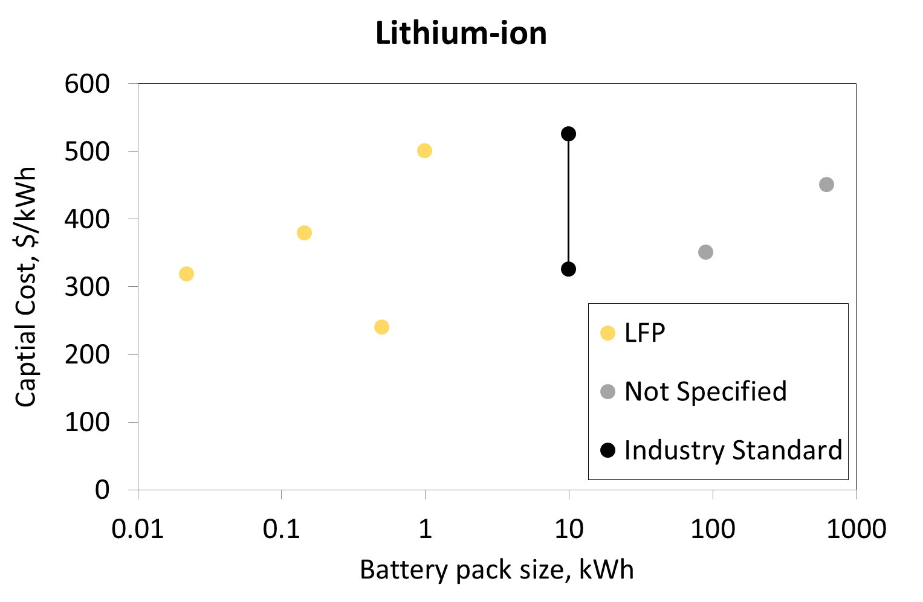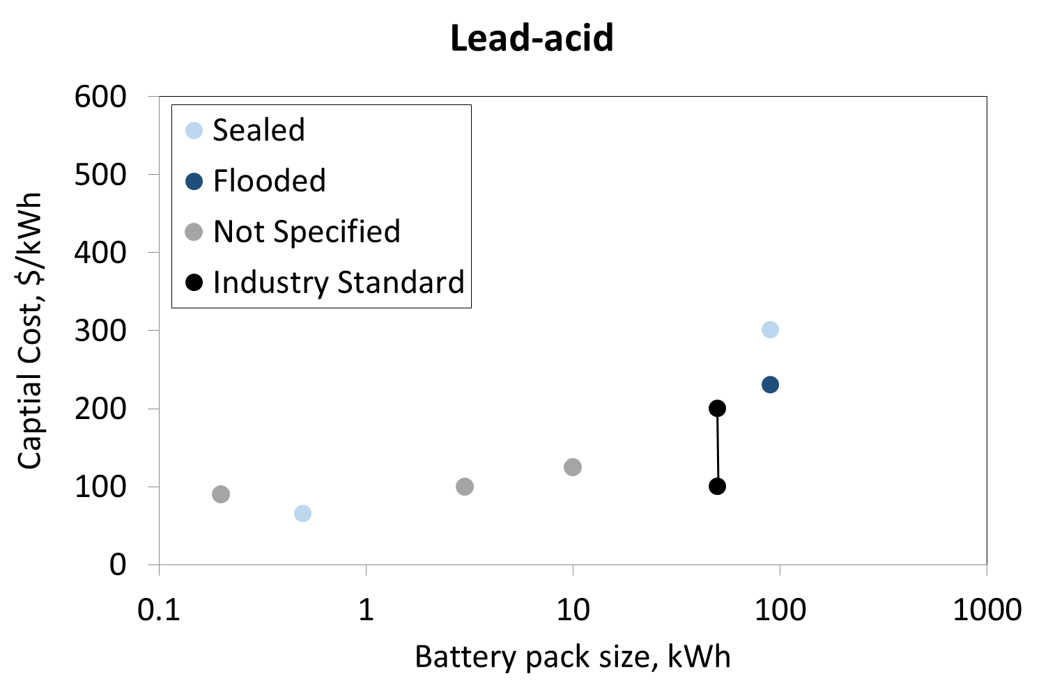
Figure 1 – Capital costs for battery packs of lithium-ion (left) and lead-acid (right) batteries as reported by interviewees and according to industry standard (Kleinberg, 2016; Matteson and Williams, 2015). Variant of battery type is included where specified.
Li-ion pack costs lie in the range US$250-500/kWh, compared to US$65-300/kWh for lead-acid batteries (full set of data points in Annex C). Most li-ion batteries are for LFP chemistries, whilst lead-acid costs are for both, flooded and sealed varieties. A note of caution in understanding these capital cost ranges is that some interviewees were not clear about the components included. Inverters, battery management systems and other peripheral electronics would be additional to the capital costs above, but not in all cases. Additionally, one interviewee did not provide cost information owing to commercial confidentiality. Nevertheless, the cost ranges are similar to recent estimates for the industry standard.
In addition to capital costs, some interviewees were also able to provide transport and installation costs. Two interviewees estimated an international transport cost for shipping, predominantly from China, of US$1-2 per battery (of a few kWh in size), which equates to about 1% or less of the capital cost. Within-country transport costs varied depending on the remoteness and accessibility of the location. Installation costs were estimated at around 5-10% of the battery or full solar home system cost.
Whilst important, capital costs were not always cited as the most critical criterion for battery cost-effectiveness, with one interviewee pointing out that higher capital cost li-ion batteries were more cost-effective than lead-acid when their higher power output is taken into account, for the particular application of replacing spinning reserves in an off-grid mine.
Considering other battery technologies, one interviewee had received a quote for redox-flow batteries of US$170/kWh, but found this unlikely to be cost-based, given another, more detailed quote of US$740/kWh, including inverter and other battery management and power electronics. This same interviewee received indicative quotes for sodium-sulphur ($330/kWh), sodium-ion ($400/kWh), zinc-air ($250/kWh) and nickel-iron ($500/kWh).
In general, and in spite of variations between interviewees, it appears that li-ion costs have fallen rapidly in recent years whereas lead-acid costs have remained relatively stable. Li-ion costs were reported to fall by 21% in the last two years by one interviewee, 16% per year over “recent years” by another, and not at all (from the same supplier) over the last five years by a third interviewee. Two interviewees predicted that li-ion packs would reach about US$250/kWh in the near future, and one of these predicted that cost would plateau at this level. However, it should be noted that, since the interviews were conducted, data has emerged indicating lithium-ion pack costs of just over $200/kWh (Frith, 2017). One interviewee reported that cost reductions for lead-acid batteries were the result of increasing order volumes or greater supplier competition, rather than through technological and manufacturing based cost improvements, as with li-ion. Finally, one interviewee felt that li-ion and lead-acid capital costs would converge in the next few years.

Performance of technologies

We refer to li-ion and lead-acid batteries here, as these are most used amongst companies represented by our interviewees. These are broken down by technology variant where relevant, chiefly between cathode chemistries for li-ion and between sealed and flooded for lead-acid. Performance is considered across a range of categories:
Ease of installation and use: For large systems, the lack of installation infrastructure, i.e. cranes, in remote locations is an issue. For lead-acid, its larger size and heavier weight than li-ion are also an issue for smaller systems in terms of transport to remote areas, maneuvering and installation. This was particularly challenging for mobile agricultural applications (eg. solar irrigation pumps).
Charge/discharge characteristics: Technologies broadly performed as interviewees expected. However, one interviewee reported limitations to current flow which meant that lead-acid batteries cannot be charged as fast as they would like.
Round trip efficiency: Most interviewees were satisfied, and reported values of above 90% for li-ion, and 75-85% for lead-acid. One interviewee indicated a 5-10% drop in efficiency of lead-acid at temperatures of around 45°C.
Cycle life: Full cycle life of batteries had not been tested by most interviewees. However, those who had more experience provided some useful insights. Interviewees indicated that:
- Operating batteries at higher temperatures than those in which battery cells were developed significantly decreases cycle life, with one interviewee specifying a rule of thumb that lifetime typically decreases by approximately 50% for every 10°C above lab temperature across battery technologies, based upon their experience with li-ion and lead-acid batteries.
- Rapid charging/discharging of lead-acid batteries, and deep discharge, significantly reduces their life. Most interviewees restricted depth-of-discharge to around 50%. For li-ion, depth-of-discharge of 80-90% appeared to have little impact on cycle life, but one interviewee indicated that high charge/discharge rates relative to storage capacity can accelerate degradation.
- Cycle life of battery technologies varies by manufacturer, particularly for li-ion with LFP cathodes, where the manufacturing sector is relatively immature and there are more players active than for lead-acid, where competition over a longer period of commercial viability has consolidated the market to a smaller number of manufacturers.
Reliability: No significant issues. One lead-acid user indicated that they typically find either very sudden, abrupt failures or slow degradation with 1-2% failure within the first 2 months. One LFP user indicated that their previous manufacturer provided an additional 10% of batteries to account for failures, but that failure rates were in some cases higher. Some interviewees indicated that they had received li-ion batteries already degraded upon delivery, following transport at high temperatures (above ~45°C), and/or in extreme states of charge.
Ease of expansion: In general, expansion of energy capacity is relatively simple and can be achieved by installing additional batteries. However, expansion to a larger power requirement is more challenging, requiring both, a larger battery and additional power electronics.
Safety: Safety represented a concern for all technologies. One interviewee indicated a preference for LFP over other cathode chemistries due to higher safety levels than NMC that are optimised for electric vehicles (EV), and expressed particular concern around the safety of second-life EV batteries. One interviewee indicated that they had experienced more safety issues with lead-acid than lithium-ion, and two interviewees indicated that issues can occur with production of hydrogen gas if lead-acid batteries are charged too quickly, which can lead to explosions without sufficient ventilation.
Interviewees using both li-ion and lead-acid batteries had mixed experience in terms of how technical performance compared to manufacturer specifications, as indicated in Table 1.
Table 1 - Technology experience of organisations interviewed in this study
Performance Experience/ Number of Interviewees | Performance below expectations | Performance as expected | Mixed experience | Insufficient Experience
Lithium-ion | 1 | 1 | 1 | 5
Lead-acid | 2 | 2 | 1 | 3

Value chain and full lifecycle

The interviews revealed that value chains for picosolar, solar home and productive use products are relatively similar. Lead-acid or li-ion based picosolar products or battery packs are nearly always manufactured in South China (e.g. Guangdong), driven by manufacturing cost and skill as well as existing company relations for related products in that region. One exception is India, which has its own lead-acid battery suppliers serving the domestic market. Some interviewees also argued that suppliers might move from south to mainland China or South East Asia as a result of tighter regulations and higher wages. Regarding li-ion, China’s production is predominantly LFP, while NMC tends to come from South Korea or Japan. Sourcing of materials for these devices fell outside of the scope of this study.
The picosolar products or battery packs are shipped by sea to their target market, which typically takes 6 to 8 weeks for East Africa. They cannot be air-shipped due to safety concerns (li-ion) or weight (lead-acid) and must be at around 30% (li-ion) or 100% (lead-acid) state-of-charge during shipment to avoid degradation. Trucks cover the transport from any harbour to a central warehouse, whilst smaller vans continue to the shops in the target market. Last mile distribution is usually done via door-to-door sales agents.
Active companies are mostly based in the EU, US or China. They can be differentiated along their vertical integration in the value chain. One interviewee argued that vertically integrated companies for picosolar products that engage in product design, contract manufacturing, and that have own marketing, distribution and retail operations in their active markets operate more successfully than companies that manufacture the products and sell through traditional routes. For retail, it is also common to have distribution offices that mange an independent last-mile salesforce. For solar home and productive use products, providers purchase battery packs and usually control the rest of the value chain down to last-mile delivery. While some companies provide the finance for customers to buy their products, others partner with micro-finance providers or operate on a pay-as-you-go (PAYG) basis.
Interviewees argued that the lack of transparency around battery performance makes choosing a supplier difficult. In addition, there is not always a direct correlation between performance and cost for battery packs. One interviewee categorised suppliers as follows:
- Top: High performance battery cells; no integrated battery pack products
- Middle: Mixed quality battery packs; challenging to identify high performance packs
- Bottom: Low performance battery packs with high failure rates; 10% extra packs as warranty
Interviewees confirmed that all desired battery types for these products are available. Telecommunication infrastructure and mobile phone penetration are perceived as key enablers of the market, enabling safe and regular payments, communication with customers and device monitoring. In addition, the lack of value added tax (VAT) on energy products in East Africa supports growth. A bottleneck is the availability of battery management systems (BMS) for higher voltage systems like large solar home or productive use products.
Value chains for battery systems used in nano- or micro-grids are more complex due to the higher level of customisation in these systems. Where standard systems are used, they are sourced from South China or India (domestic customer). In contrast, larger, capital-intensive systems require close collaboration between manufacturer and installer on business case and performance specifications, which favours internationally diversified manufacturers. They have experience with the long lead-times of 12 to 24 months and offer fully packaged solutions with suitable warranties. However, interviewees mentioned that most suppliers only deliver the core technology, i.e. battery packs. System integration has to be done at a company level, since established system integrators are too expensive for energy access applications. However, such an approach may lead to problems in battery, inverter and BMS interaction. Thus, one interviewee had chosen to purchase the battery packs separately, commission a system integrator with the full containerised solution, and ship the container to the target market.
In addition to the lack of affordable system integrators for fully packaged system-level solutions, most companies highlighted high import duties and costly certificates required for li-ion battery imports as barriers to market growth. Lead-acid batteries might be favoured in some regions due to their incumbency, the skill availability and existing lobby. Tenders that specify one particular technology are an additional barrier for hybrid battery solutions. Interviewees also mentioned shorter lead-times due to improved project experience and faster import procedures as a potential driver for more projects.
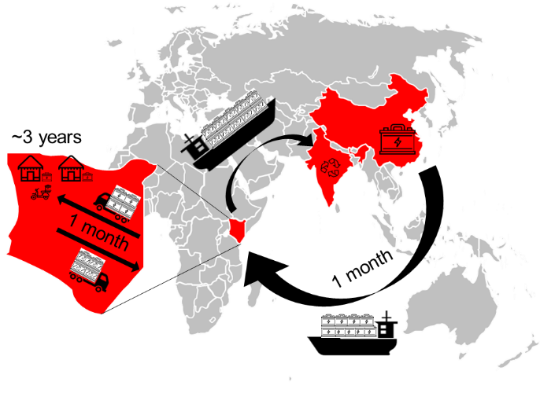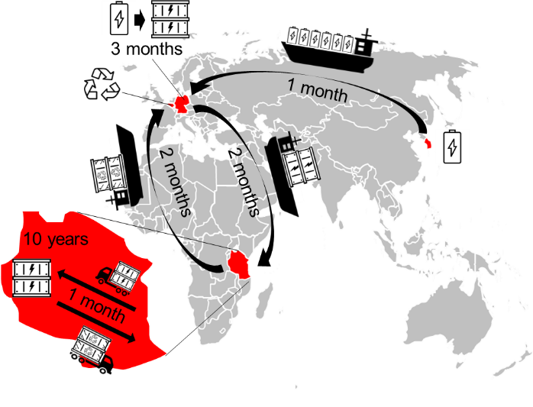
Figure 2 - Sample supply chains. Left: a solar home system technology provider in Kenya using lead-acid batteries. The batteries are manufactured in Guangdong, China, and shipped to Mombasa, Kenya, from where they reach the shop via truck. Door-to-door delivery time is between 6-8 weeks. Last mile delivery to customer is by motorcycle. In case the battery is not refurbished and resold informally after its end-of-life, it gets shipped to India for commercial recycling. Right: a micro-grid supplier for rural electrification in Tanzania with a li-ion battery. The li-ion cells are shipped from South Korea to Germany where they are assembled to a containerised AC-system. This is then shipped to Tanzania where it passes customs and is delivered by truck. Ideally, at its end of life, the battery system is disassembled and shipped to Belgium for recycling. In most cases though, li-ion batteries are dumped on landfills.
End-of-life procedures vary among interviewed companies. Whilst some return batteries to manufacturers and others contract recycling companies, the majority have no end-of-life procedure established or provided no details. Efforts being made in this regard are largely tied to companies’ ethos and reputation or investor stipulations, and only one company specified government regulations as the driver to establish end-of-life procedures.
Lead-acid battery recycling is relatively straightforward, but there is only one effluent treatment facility in East Africa. Most lead-acid batteries are refurbished and re-sold informally. Lead poisoning due to a lack of proper safety equipment and dumping of sulfuric acid is widespread according to some interviewees (in line with (Haefliger et al., 2009; Worland, 2016; World Health Organisation, 2018)). Li-ion recycling is more complex and costly due to the high number of materials used and the differences in chemistry between various types (Gaines, 2014). As a result, the majority is currently dumped in landfills as they are classified as harmful, rather than toxic like lead-acid batteries. Some interviewed companies are starting to ship used batteries to Belgium (li-ion) or India (lead-acid) for recycling. Existing best-practice end-of-life procedures entail the collection of e-waste from customers for free, dismantling, and delivery of batteries to recycling facilities with high environmental standards.
The key barriers to effective disposal procedures are the lack of responsibility and vague, ineffective regulations. One interviewee outlined the institutions available to provide support in Tanzania, namely the Vice President’s division of environment, national environmental council for environmental impact assessment, ministry of industry and trade and existing lead smelters, but indicated that none of these own overall responsibility for the issue.
The key ecosystem gaps identified by interviewees are:
- Detailed regulation on e-waste, including import/export to maximise utilization of existing recycling facilities
- Reputable, responsible and safe recycling companies
One interviewee noted that these changes could be very hard to achieve in certain regions of Africa, owing to the political influence of informal lead-acid battery recycling companies.

Summary

Figure 3 qualitatively summarises the study’s findings on technology deployment status of electricity storage technologies and observed cost, performance and value-chain characteristics. Applications with balanced energy-to-power requirements (Picosolar, Solar Home System, Productive Use) already deploy desired technologies. In contrast, applications with a higher need for energy capacity than for power (Nano-grid, Micro-grid / Industry) deploy available, cost-effective technologies with fixed energy-to-power ratios. However, desired technologies would offer more flexible designs. In general, li-ion deployment is growing across applications. This is largely driven by cost reductions and performance improvements achieved through increased battery manufacturing for EVs. It should be noted that these findings only reflect the insights gained from the interviews with energy access stakeholders that were conducted in this study.

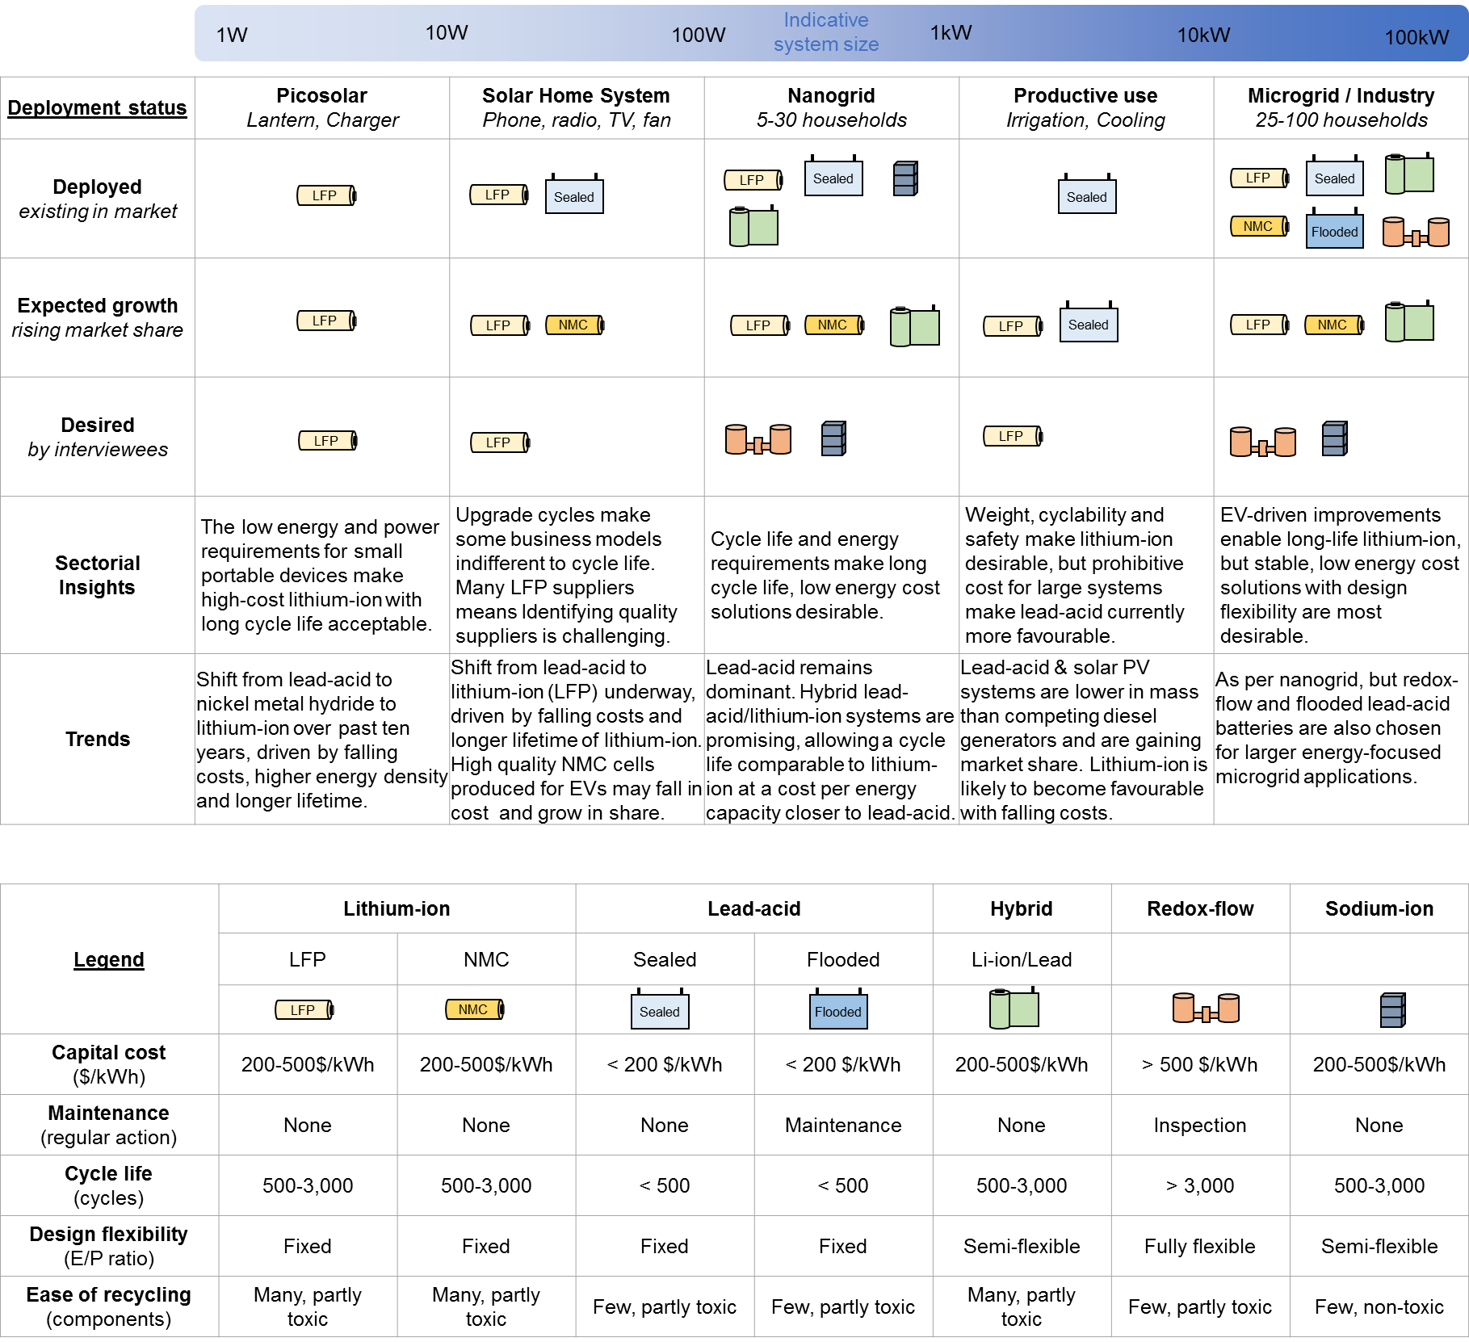
Figure 3 – Key findings for deployment status and observed technology characteristics (within Legend). Results displayed for each energy access application category (Picosolar, Solar Home System, Nano-grid, Productive Use, Micro-grid / Industry) and deployment status (Deployed, Growing, Desired). Symbols reflect employed electricity storage technologies. E/P ratio – Energy-to-Power ratio, LFP – Lithium Iron Phosphate, NMC – Nickel Manganese Cobalt. Note that this figure is based upon interviewees’ responses and is necessarily approximate. In practice, cost will vary with manufacturer, and cycle life will be strongly dependent on battery quality and how these systems are used.

Discussion and recommendations for further research and investment

Table 2 summarises the major challenges facing the off-grid energy storage market at this time, as highlighted across the range of interviews undertaken. The table is organised according to the different stages of the storage technology and energy access system lifecycle, from initial technology choice, through to quality assurance and installation, performance and end-of-life procedures. In addition, the table highlights the degree of criticality of each challenge to the establishment of a cost-effective, diverse and safe storage market.

Regarding technology choice, whilst most interviewees had access to li-ion and lead-acid batteries, there is as-yet far less availability of less mature, yet potentially low-cost and high performing, technologies such as flow batteries and sodium-ion batteries. It is thus important to stimulate greater technology availability through, for example, public funded trials and demonstrations of these less readily-available and (at this time) higher cost technologies. In addition, interviewees pointed to a lack of availability of standardised, high quality peripheral components such as battery management systems, a situation which could be helped by the establishment of standards to guide the manufacture of specific components towards compatibility with specific batteries.

Regarding product quality, there are already efforts to establish transparent standards of quality and safety, but these do not cover all products and there is scope for expansion towards more universal standardisation and quality assurance procedures.

As pointed out by many interviewees, storage technology costs have fallen, and particularly for li-ion significantly in recent years. However, in order that the off-grid stationary storage market does not become a technology follower to the EV industry, ultimately relying on the dominant technology variants therein, it is important that where possible off-grid system providers capitalise on their collective bargaining power to drive down prices for the most suitable storage technologies for their applications.

There is a potentially important role for governments and public funders in the establishment of dedicated transport and installation infrastructure, in the latter case for larger storage systems, as some interviewees noted the difficulty and delays in obtaining and installing some storage systems. In addition, given how nascent the energy access storage market is, and the lack of operational experience of technology and system performance, governments and public funders could also support the accelerated testing of different technologies in real-world circumstances, to help identify faults and improve product quality.

Of greatest importance as the off-grid, and other, energy storage markets grow is to ensure that end-of-life procedures are safe and environmentally responsible. This points to a need for explicit labelling of batteries and whole energy access systems (e.g. including solar PV panels) as e-waste, accompanied by appropriately set and enforced regulations and protocols and the availability of, or access to, high quality and safe recycling and disposal facilities. However, careful attention to the current and possible future role of existing local repair networks in extending useful life of products (or their subcomponents) and generating local revenue is required in designing such regulations (Cross and Murray, 2018). Interaction with these networks to help to facilitate eventual collection of end-of-life components for safe recycling, and ensuring availability of replacement components to extend products’ useful lifetimes, could also be beneficial. In some cases this may conflict with companies’ desire to make devices ‘tamper-proof’, particularly for those using PAYG business models. Project such as the EPSRC-sponsored Off-Grid Solar Scorecard (Off Grid Solar Scorecard, 2018) and the Better Solar Network (Cover, 2018) aim to address some of these concerns.

In summary, there is a critical role for governments, regulators, trade and standards bodies to intervene in the rapidly growing stationary off-grid storage market, in order to ensure safety, quality and cost-effectiveness are achieved as this market grows and develops.

Table 2 - Specific challenges for the energy access energy storage market and proposed solutions

Notes: Table organises the challenges according to the stage in the lifecycle, from initial technology choice, through to end of life treatment. Text for “challenges” is coloured according to the authors’ subjective judgement (based on all interview responses) of the degree of criticality of the challenge to the development of a cost-effective, diverse and safe storage market, where green = least critical and red = most critical.

Conclusions

The off-grid electricity storage market is developing rapidly, with a number of providers offering solutions for a range of applications, using a variety of storage technology products and sizes. These applications include (at the smaller end) pico-systems which provide basic home services such as lighting and mobile phone charging, and at the larger end micro-grid and industrial applications such as power for up to 100 households, for telecommunications towers, and spinning reserve backup services for mines.
The market is currently dominated by two storage technology groups – lithium-ion (li-ion) and lead-acid batteries. In general the li-ion off-grid market is dominated by lithium iron phosphate (LFP) and nickel manganese cobalt (NMC) variants, whilst lead-acid are available in flooded and sealed varieties. Other, less mature, technologies, including redox-flow batteries and saltwater (sodium-ion) batteries, have also been used in limited circumstances, but further development and cost reduction is required before they gain significant market share. Although li-ion are in general still more expensive than lead-acid batteries on a capital cost per unit energy capacity (US$/kWh) basis, according to the majority of interviewees, li-ion variants are beginning to match, and in some circumstances, outcompete lead-acid on cost and performance which points to their growing future dominance across all application types.
There has so far been relatively limited experience of both lead-acid and li-ion performance in real-world applications, owing to the relatively new nature of off-grid systems, although no major problems were identified by interviewees, with some exceptions such as performance degradation at higher temperatures. Whilst some quality assurance procedures do exist, they are not yet sufficiently widespread. Developing a better understanding of criteria adopted by companies to determine the end of life of storage devices could be an additional area of fruitful research.
Both li-ion and lead-acid batteries are commonly sourced from China when dealing with smaller (pico) applications, although India has its own lead-acid battery suppliers serving the domestic market. It is expected that China’s dominance in manufacture could decrease over time owing to tighter regulations and increasing wages. Whereas pico-size products are often sold as integrated systems, larger systems tend to be less readily available as integrated products, since they require higher levels of customisation, which can lead to a variety of problems around ensuring full compatibility between different system components such as battery packs, management systems and inverters.
In spite of there being a growing and increasingly cost-effective market for off-grid storage systems of many sizes to suit many applications, a number of government and other public interventions are recommended so as to further develop this market. Of most concern is the widespread lack of end-of-life procedures and protocols to either dispose of or recycle batteries, an area which requires immediate focus and attention.

Acknowledgements
The authors would like to acknowledge Shell Foundation and Imperial College Grantham Institute for their support of this research. SF would like to acknowledge the support of the UK Engineering and Physical Sciences Research Council through the Joint UK-India Clean Energy Centre (EP/P003605). OS would like to acknowledge support from the Imperial College Grantham Institute for his PhD research. We would like to thank Emma Stephenson, Amanda Delcore, Phillip Sandwell, and Alyssa Gilbert for useful discussions helping to frame and interpret research questions. Finally, we would like to thank all interviewees for kindly giving their time for this study.

References

Aneke, M., Wang, M., 2016. Energy storage technologies and real life applications – A state of the art review. Appl. Energy 179, 350–377. doi:10.1016/j.apenergy.2016.06.097
Balance of Storage Systems, 2018. DC Hybrid Storage Systems [WWW Document]. URL https://www.bos-ag.com/products/dc-hybrid-storage-systems (accessed 9.25.18).
Cluzel, C., Douglas, C., 2012. Cost and performance of EV batteries: Final report for The Committee on Climate Change 21.
Cover, M., 2018. Better Solar Network, in: 7th Low Carbon Energy For Development Network Conference, Loughborough.
Cross, J., Murray, D., 2018. The afterlives of solar power: Waste and repair off the grid in Kenya. Energy Res. Soc. Sci. 44, 100–109. doi:10.1016/j.erss.2018.04.034
Dinger, A., Martin, R., Mosquet, X., Rabl, M., Rizoulis, D., Russo, M., Sticher, G., 2010. Focus Batteries for Electric Cars. Bost. Consult. Gr. 1–18.
Few, S., Schmidt, O., Offer, G.J., Brandon, N., Nelson, J., Gambhir, A., 2018. Prospective improvements in cost and cycle life of off-grid lithium-ion battery packs: An analysis informed by expert elicitations. Energy Policy 114, 578–590. doi:10.1016/j.enpol.2017.12.033
Frith, J., 2017. 2017 Lithium-ion Battery Price Survey. Bloom. New Energy Financ.
Gaines, L., 2014. Sustainable Materials and Technologies The future of automotive lithium-ion battery recycling : Charting a sustainable course. Sustain. Mater. Technol. 1–2, 2–7. doi:10.1016/j.susmat.2014.10.001
Gustavsson, M., 2007. Educational benefits from solar technology—Access to solar electric services and changes in children’s study routines, experiences from eastern province Zambia. Energy Policy 35, 1292–1299. doi:10.1016/J.ENPOL.2006.03.019
Haefliger, P., Mathieu-Nolf, M., Lociciro, S., Ndiaye, C., Coly, M., Diouf, A., Faye, A.L., Sow, A., Tempowski, J., Pronczuk, J., Filipe, A.P., Bertollini, R., Neira, M., 2009. Mass lead intoxication from informal used lead-acid battery recycling in Dakar, Senegal. Environ. Health Perspect. 117, 1535–1540. doi:10.1289/ehp.0900696
Hanna, R., Gross, R., Speirs, J., Heptonstall, P., Gambhir, A., 2015. Assessment Innovation timelines from invention to maturity. UKERC Technol. Policy Assess.
Holmes, J., 2017. The Smart Villages Initiative: Findings 2014-2017, Smart Villages Program: Energy as a catalyst for development.
International Energy Agency, 2014. Electricity Storage: Costs, Value, and Competitiveness. Energy Technol. Perspect. 239–276.
Kempener, R., Lavagne, O., Saygin, D., Skeer, J., Vinci, S., Gielen, D., 2015. Off-Grid Renewable Energy Systems: Status And Methodological Issues. IRENA Work. Pap.
Ketelson, T., 2018. The potential for advanced battery storage in minigrids (AMPERES). 7th Low Carbon energy Dev. Netw. Conf. Loughbrgh.
Kleinberg, M., 2016. Battery Energy Storage Study for the 2017 IRP. Pacificorp.
Kumar, A., 2018. Energy Research & Social Science Justice and politics in energy access for education , livelihoods and health : How socio-cultural processes mediate the winners and losers. Energy Res. Soc. Sci. 40, 3–13. doi:10.1016/j.erss.2017.11.029
Lepicard, F., Kayser, O., Graf, J., Brossard, S., Darodes de Tailly, A., McGrath, L.K., 2017. Reaching scale in access to energy: Lessons from practitioners. Hystra.
Luo, X., Wang, J., Dooner, M., Clarke, J., 2015. Overview of current development in electrical energy storage technologies and the application potential in power system operation. Appl. Energy 137, 511–536. doi:10.1016/j.apenergy.2014.09.081
Mahlia, T.M.I., Saktisahdan, T.J., Jannifar, A., Hasan, M.H., Matseelar, H.S.C., 2014. A review of available methods and development on energy storage; technology update. Renew. Sustain. Energy Rev. 33, 532–545. doi:10.1016/j.rser.2014.01.068
Mandelli, S., Barbieri, J., Mereu, R., Colombo, E., 2016. Off-grid systems for rural electrification in developing countries: Definitions, classification and a comprehensive literature review. Renew. Sustain. Energy Rev. 58, 1621–1646. doi:10.1016/j.rser.2015.12.338
Matteson, S., Williams, E., 2015. Residual learning rates in lead-acid batteries: Effects on emerging technologies. Energy Policy 85, 71–79. doi:http://dx.doi.org/10.1016/j.enpol.2015.05.014
Nykvist, B., Nilsson, M., 2015. Rapidly falling costs of battery packs for electric vehicles. Nat. Clim. Chang. 5, 329–332. doi:10.1038/nclimate2564
Obeng, G.Y., Akuffo, F.O., Braimah, I., Evers, H.-D., Mensah, E., 2008. Impact of solar photovoltaic lighting on indoor air smoke in off-grid rural Ghana. Energy Sustain. Dev. 12, 55–61. doi:10.1016/S0973-0826(08)60419-6
Off Grid Solar Scorecard, 2018. Off Grid Solar Scorecard [WWW Document]. URL http://www.offgridsolarscorecard.com
Palit, D., 2013. Solar energy programs for rural electrification: Experiences and lessons from South Asia. Energy Sustain. Dev. 17, 270–279. doi:10.1016/j.esd.2013.01.002
Palomares, V., Casas-cabanas, M., Catillo-Martinez, E., Han, M.H., Rojo, T., 2013. Update on Na-based battery materials. A growing research path. Energy Environ. Sci. 2312. doi:10.1039/c3ee41031e
Pang, Q., Liang, X., Kwok, C.Y., Nazar, L.F., 2016. Advances in lithium–sulfur batteries based on multifunctional cathodes and electrolytes. Nat. Energy 1, 16132. doi:10.1038/nenergy.2016.132
Pelz, S., Pachauri, S., Groh, S., 2018. A critical review of modern approaches for multidimensional energy poverty measurement. Wiley Interdiscip. Rev. Energy Environ. e304. doi:10.1002/wene.304
Réseau sur le stockage électrochimique de l’énergie (RS2E), 2015. Na-ion batteries: a promising prototype! [WWW Document]. RS2E News. URL http://www.energie-rs2e.com/en/news/na-ion-batteries-promising-prototype (accessed 1.24.17).
Riva, F., Ahlborg, H., Hartvigsson, E., Pachauri, S., Colombo, E., 2018. Electricity access and rural development: Review of complex socio-economic dynamics and causal diagrams for more appropriate energy modelling. Energy Sustain. Dev. 43, 203–223. doi:10.1016/J.ESD.2018.02.003
Rollin, H.B., Mathee, A., Bruce, N., Levin, J., von Schirnding, Y.E.R., 2004. Comparison of indoor air quality in electrified and un-electrified dwellings in rural South African villages. Indoor Air 14, 208–216. doi:10.1111/j.1600-0668.2004.00238.x
Sandwell, P., Chan, N.L.A., Foster, S., Nagpal, D., Emmott, C.J.M., Candelise, C., Buckle, S.J., Ekins-Daukes, N., Gambhir, A., Nelson, J., 2016. Off-grid solar photovoltaic systems for rural electrification and emissions mitigation in India. Sol. Energy Mater. Sol. Cells 156, 147–156. doi:10.1016/j.solmat.2016.04.030
Schmidt, O., Hawkes, A., Gambhir, A., Staffell, I., 2017. The future cost of electrical energy storage based on experience curves. Nat. Energy 2, 17110. doi:10.1038/nenergy.2017.110
Siemens, 2014. Safe Lithium Batteries with a Long Service Life [WWW Document]. URL www.siemens.com/press/en/presspicture/innovationnews/2014/in20140901-01.htm
Sovacool, B.K., Ryan, S.E., 2016. The geography of energy and education: Leaders, laggards, and lessons for achieving primary and secondary school electrification. Renew. Sustain. Energy Rev. 58, 107–123. doi:10.1016/J.RSER.2015.12.219
Szabó, S., Bódis, K., Huld, T., Moner-Girona, M., 2011. Energy solutions in rural Africa: mapping electrification costs of distributed solar and diesel generation versus grid extension. Environ. Res. Lett. 6, 34002. doi:10.1088/1748-9326/6/3/034002
Winskel, M., Radcliffe, J., 2014. The rise of accelerated energy innovation and its implications for sustainable innovation studies: A UK perspective. Sci. Technol. Stud. 27, 8–33.
Worland, J., 2016. How Lead Poisoning Is Devastating Countries Around the World. Time Mag.
World Economic Forum, 2016. Internet for All: A Framework for Accelerating Internet Access and Adoption.
World Health Organisation, 2018. Lead Poisoning and Health [WWW Document]. URL http://www.who.int/en/news-room/fact-sheets/detail/lead-poisoning-and-health
Zahnd, A., Kimber, H.M., 2009. Benefits from a renewable energy village electrification system. Renew. Energy 34, 362–368. doi:10.1016/J.RENENE.2008.05.011

Annex A

Organisation | Description | Location
BBOXX | Designs, manufactures and distributes solar home systems and larger solar systems for productive and business use, including consumer finance component (PAYG). Operates a true data driven business model and aims to replicate this globally. Approach to expansion into new markets; ‘Build-Transfer-Operate’ model takes equity stake in local partner for strategic alignment. | UK based, sales in 14 countries including experience across East Africa
BOS AG (Balance of Storage Systems AG) | BOS offers smart hybrid energy storage solutions and DC grid technology. With their technologies, large parts of the off-grid community in developing and industrialised countries get access to high-quality, long-lasting and affordable energy solutions. | Based in Germany with system deployed across Africa and India
Crossboundary Energy | Invests, builds and operates solar installations for commercial and industrial uses – 0.05Mw-10Mw. Provides long-term power purchase agreements to supply cleaner and cheaper solar energy to established businesses. Aims to reduce buyers electricity cost by 30%+. | Kenya, Rwanda, Ghana, Nigeria
D.Light | Design and manufacture affordable pico solar energy products, including PAYG option. Expanding range to TVs. Innovative distribution models to reach low-income consumers & businesses. | Global
GOGLA | Not-for-profit industry association created to accelerate the growth of off-grid energy providers serving low-income households. | Global
Husk Power Systems | Designs, builds, owns & operates Solar/Biomass, grid compatible plants, providing 24 hour affordable power to households and businesses. Leader in the sector on experience, scale and unit economics. | India, Tanzania
Inficold | Deploys uninterrupted cooling systems operating on 5 to 8 hours electricity per day for milk cooling and agricultural produce. The systems are suited to bridge power outages or for coupling with intermittent power generation off-grid and can be retrofitted to any existing cooling system, thereby replacing diesel generators. | India
M-Kopa | Provides low-income consumers with asset financing to purchase energy products. Customers pay a small deposit and make daily instalments using mobile money. Creates a credit history for unbanked. | East Africa.
Phenix Recycling | Collects electronic waste from a variety of industries including off-grid solar, bringing it to our factory for dismantling and dispose safely the waste that is generated with the highest safety and environmental standards. | East Africa
Redaviasolar | Modular solar farms - integrates with diesel systems (hybrid) to reduce emissions. Leasing model – with no upfront costs. Serves energy needs of industry, businesses & communities. | Tanzania, Kenya, Ghana
Sunculture | Designs, manufactures, sells, installs and finances low cost solar water pumps and irrigation products. Lowest cost solar pump on the market. | Kenya

Annex B

Discussion guide to explore the use of storage in off-grid energy access solutions

Context

The Grantham Institute at Imperial College London is undertaking research for Shell Foundation, to better understand the role of energy storage technologies in helping provide off-grid energy access in emerging economies, with a specific focus on East Africa, Nigeria and India, reflecting the regions of the current activities of Shell Foundation’s partner organisations.
The overall objective of this research project is to help organisations involved in the development, delivery and operation of solar and storage home systems and mini-grids to understand the storage technology options available to them. This includes consideration of the costs and performance of these technologies, their broader environmental impact, as well as the availability of different technologies, considering current and planned international supply chains for equipment. The majority of the research will be focused on electricity systems, but there will be some focus on biogas and thermal storage systems as well.
The output will be in the form of a toolkit for Shell Foundation partners to aid with their energy storage selection comparisons and to understand new technologies reaching maturity. This toolkit will take the form of a ~20-page report, to be published in October 2017.
The research takes the form of desk-based analysis of different storage technologies and markets, as well as interviews with key stakeholders involved in the deployment of storage in different countries. The questions below are intended to form the basis of a 1-1.5 hour interview, potentially with a shorter follow-up discussion. Interviews will happen over the period July-September 2017.
Outputs of interviews will NOT be attributed to specific interviewees or organisations. Furthermore, no information of a confidential nature will be reported. Interviewees will be invited to review and if necessary amend any of the comments or data they have provided before publication of the output report.

Specific questions for discussion

- Range of technologies available:
- What are the specific off-grid/mini-grid applications for energy storage technologies in your region(s) of interest (e.g. off-grid solar home systems, mini-grids)?
  - Please describe typical power, capacity and cycling requirements, as well as lifetimes of systems.
- Which storage technologies currently exist in your region(s) of interest, that are potentially suitable for these applications?
  - For example, for electricity systems, these will be predominantly batteries of different types: Lead Acid (flooded or sealed), Redox Flow (Vanadium or Zinc Bromide), Lithium ion (with a variety of chemistries, including NMC, LFP, LCO and LTO).
- Which technologies are likely to be available in the near future (perhaps already field tested)?
  - These could include: Lithium sulphur; Sodium ion; Solid oxide fuel cells; Aluminium-Graphite dual-ion batteries, for example.

- Costs of technologies:
- How much do these technologies cost today?
  - Capital costs (ex-works or FOB, i.e. liability during shipment with supplier)
  - Transport costs (to destination country, to destination warehouse, last-mile)
  - Installation costs
  - Operation and maintenance costs
  - Replacement costs (for faulty equipment)
  - Repossession cost
  - Recycling and repurposing
  - Project financing costs - interest for finance buying storage tech until repaid by customer
  - Details of business models to repay costs (e.g. leasing, per unit electricity billing)

- Are there any costs that are particular to the off-grid / mini-grid application?

- Have costs changed and do you have a view on how costs will change in the future?

- How are these changes affecting your decisions on which technologies to employ?

- Performance of technologies
- How does each technology perform in the specified application, considering:
  - ease of installation and use (including size and weight)
  - charge and discharge characteristics (power, length of charge / discharge)
  - efficiency
  - cycle life
  - depth-of-discharge
  - shelf life
  - durability to local temperature and environmental conditions
  - operating temperature range/thermal management
  - reliability
  - flexibility (e.g. ease of expansion to larger loads)
  - safety
  - failure conditions
  - performance degradation
  - maintenance requirements
  - any other key criteria (size, weight, safety)?

- How does the performance compare to the claimed / boilerplate performance?

- Is it clear how to operate these technologies so as to maximise performance, reliability, lifetime (e.g. from supplier user guides and information)?

- Are you aware of the performance trajectory of the range of technologies? (i.e. how new versions will improve over time)

- Availability of technologies
- What does the value-chain of these technologies look like in the specific markets and who are the key intermediaries, players active - including incentives for them?
  - How many providers are there of each technology in your region(s) of interest?
  - Who are the suppliers and from where is the technology supplied?
  - To what extent do technologies used in practice correspond with those which are optimal for the application, both in terms of cost and environmental impact?
  - If poorly, what limits the supply of technologies, e.g. are providers not present in those markets, or are transport costs prohibitive?
  - Are there any forward-looking policy or regulatory drivers in any of these markets to promote one or other technologies?

  - What other barriers or specific enablers are you aware of that drive the availability of technologies in your region?
  - How does your supply chain compare to that of your competitors?
- Environmental impact of technologies

- Are any technologies subject to environmental standards which hamper their use? (For example, trade rules around e-waste, relevant to second-life batteries)

- What are the procedures for disposing of the technology at its life end?
  - How easy and commercially viable is it to recycle, refurbish/ reuse/ repurpose?
  - What are the environmental toxicity implications of non-recyclable components?
  - What organisations, regulations and procedures are in place to help disposal and recyclability, and who owns overall responsibility?
  - If nobody – what are the ecosystem gaps that exist to make the recycling feasible in the relevant markets?
  - What is best practice in these areas, considering other geographies/ markets?

Annex C

Table C1 – Capital cost for lithium-ion battery packs of different chemistry types and industry reference standard in last two columns (Kleinberg, 2016).
Type | LFP | LFP | N/A | N/A | LFP | LFP | N/A | LFP | NMC
Size (kWh) | 0.022 | 0.145 | 151.8 | 625 | 0.5 | 1 | 90 | 10 | 10
Cost ($/kWh) | 318 | 379 | 860 | 450 | 240 | 500 | 350 | 350-525 | 325-450

Table C2 – Capital cost for lead-acid battery packs of different chemistry types and industry reference standard in last column (Matteson and Williams, 2015).
Type | N/A | N/A | N/A | Sealed | N/A | Flooded | Sealed | N/A
Size (kWh) | 0.2 | 365.5 | 10 | 0.5 | 3 | 90 | 90 | 50
Cost ($/kWh) | 90 | 615 | 125 | 65 | 100 | 230 | 300 | 100-200

