Dielectric relaxations in phosphoric acid-doped poly(2, 5-benzimidazole) and its composite membranes

Wasim F. G. Saleha^{1,2}, Rahul Ramesh², Naresh Nalajala^{1,2}, Bradley P. Ladewig³ and Manoj Neergat²
¹IITB-Monash Research Academy, Powai, Mumbai, India–400076
²Department of Energy Science and Engineering, Indian Institute of Technology Bombay (IITB), Mumbai, India–400076
³Barrer Centre, Department of Chemical Engineering, Imperial College London, Exhibition Road, London SW7 2AZ, United Kingdom
Correspondence to: Manoj Neergat (E-mail: nmanoj@iitb.ac.in)

ABSTRACT
Poly(2,5-benzimidazole) (ABPBI) – a promising high-temperature polymer electrolyte membrane – is characterized over a wide range of temperature (-50–220°C) using broadband dielectric spectroscopy (BDS) to understand the various relaxation processes. The un-doped ABPBI membrane shows two major secondary relaxations and a primary α relaxation. The effect of phosphoric acid (PA) and phosphotungstic acid grafted zirconium dioxide (PWA/ZrO₂) nanoparticles on the chain relaxation and the proton conductivity is investigated. The phosphoric acid alters the relaxation trends, increases the number of free ions in the polymer matrix, and therefore the conductivity. The shift in the peak frequencies of different chain relaxation processes in the presence of PA and PWA/ZrO₂ is attributed to the increase in free volume and the consequent easy motion of the polymer chains. The Fourier transform infra-red (FTIR) spectroscopy of ABPBI and the acid-doped composites show all the relevant peaks corresponding to C=C, C=N stretching, and phosphoric acid/phosphates, confirming the formation of ABPBI and doping with PA. The proton conductivity of the membranes is estimated from electrochemical impedance spectroscopy (EIS). To establish the effect of change in crystallinity on relaxations and proton conductivity, the undoped and PA-doped membranes are characterized using thermogravimetric analysis and in-situ XRD at high temperatures.
Key words: Broadband dielectric spectroscopy; conductivity; HT-PEMs; nanocomposites; polymer relaxations.

INTRODUCTION
Nafion®, a product of Dupont, is the state-of-the-art polymer electrolyte membrane (PEM) for the low temperature fuel cell. The exceptional properties of Nafion, mechanical strength and high conductivity, are attributed to its unique polymer chain structure.¹ The water-dependent proton conductivity of Nafion limits its use to temperature below 80–90°C. Alternative polymer materials have been investigated and some of those have conductivities comparable to that of Nafion; but, the poor long-term stability in the harsh conditions makes them less desirable.² Since the optimal performance of a catalyst can only be achieved at higher temperature, a membrane with proton conductivity of 0.1 S cm⁻¹ at 160–200°C will be an ideal choice for PEM fuel cells.³ Hence, membranes for high-temperature fuel cells have also been proposed, and among them, polybenzimidazole (PBI)-based membranes operating at temperature above 160°C have shown conductivity comparable to that of Nafion (at 90°C and 98% relative humidity).^{4–10} Unlike that with Nafion, the proton conduction in PBI membranes is not entirely water-dependent; instead, the phosphoric acid content in the doped-membranes provides the conduction path.¹¹⁻¹⁵ It has been established that the molecular weight, chain orientation/entanglements and dielectric relaxation behavior of the polymer materials have a significant effect on the proton conduction of the membranes.^{3,16,17} Hence, Nafion has been widely investigated using broadband dielectric spectroscopy (BDS) for the structure-dependent conductivities at various experimental conditions.^{18–20} The temperature and dopants have been shown to significantly alter the relaxation properties of the material those in-turn affect the proton conduction behavior.¹⁹ However, similar studies with high temperature membranes are rare in the literature.^{21–24} Moreover, the incorporation of phosphoric acid and dopant nanoparticles makes the relaxation processes in these membranes even more complicated to analyze and understand. The only report on BDS of ABPBI material deals with the relaxation properties of undoped membranes, wherein, Nalawade et al. explain the sub-T_{g} relaxations and the effect of heat-treatment on the polymer crystallinity.²³
In this manuscript, the relaxation behavior of undoped and doped-ABPBI and its composite membranes are investigated with BDS in the temperature range of -50–220°C. The polymer chains exhibit unique relaxation behavior because of the dynamic nature of phosphoric acid at elevated temperature, its dimerization and the release of water. These results have been complimented with the conductivity data obtained from the impedance spectroscopy, and the change in polymer crystallinity with the in-situ X-ray diffraction patterns of undoped and acid-doped ABPBI membranes.

EXPERIMENTAL
Materials
3, 4- diaminobenzoic acid (DABA) 97%, phosphotungstic acid (PWA), and zirconium dioxide (ZrO₂) from Sigma Aldrich; phosphoric acid (PA), phosphorous pentoxide (P₂O₅), methane sulphonic acid (MSA) and ammonium hydroxide (NH₄OH) from Merck were used as-received without further treatment. De-ionized (DI) water was obtained from Direct-Q Millipore de-ionizer.

Synthesis of phosphotungstic acid-grafted zirconium dioxide (PWA/ZrO₂) particles
Phosphotungstic acid-grafted zirconium dioxide (PWA/ZrO₂) particles were synthesized following the procedure reported elsewhere.^{25,26} 2 g of ZrO₂ nanoparticles was added to 400 mg of phosphotungstic acid dissolved in 50 mL DI water and the solution was stirred for 24 h on a magnetic stirrer. Then, the dispersion was allowed to dry under continuous stirring at 100°C. When water was completely evaporated, the dried powder was calcined at 200°C for 2 h and it was stored in an air-tight bottle for further use.
Synthesis of poly(2,5-benzimidazole) (ABPBI)
ABPBI was synthesized following the method reported in the literature.²⁷ 3 g of P₂O₅ was dissolved in 22 mL of MSA for 3 h under nitrogen purging and the temperature of the solution was raised to 160°C. 2 g of DABA was added slowly to the above solution and the reaction was carried out for 30 min (Figure S1). The polymer was then precipitated in DI water. It was neutralized with 10% NH₄OH solution, washed several times with DI water and dried in an oven. The obtained filaments of the polymer were crushed and used for further characterization.
Preparation of membrane
A known amount of ABPBI polymer was taken in a beaker and it was dissolved in MSA at room temperature for 5 h on a magnetic stirrer to make a 3 wt % solution. The viscous solution was poured on a petri dish and it was heated to 200°C on a hot plate in a fume hood until the volatility ceased (Figure S2). The dried membrane of thickness ~40 μm was immersed in DI water to remove traces of acid. The wet membranes if dried as such in air or vacuum oven would shrink and curl inducing undesired stress and uneven surface. Therefore, the wet membranes were sandwiched between filter papers and compressed under a weight for 48 h to get a uniform, flexible and dry membrane. For the composite membranes, required amount of PWA/ZrO₂ was sonicated in 5 mL MSA to get a uniform dispersion of the particles and it was mixed with the ABPBI solution to get the desired loading. The mixture was magnetically stirred for 3 h and it was sonicated well before casting on a petri dish. The remaining procedure is the same as that followed for the undoped membranes; the membranes obtained were subjected to phosphoric acid doping as mentioned below.
Phosphoric acid doping of membrane
Membranes were immersed in 60 wt% phosphoric acid for 3 days, wiped with a tissue paper and dried in an oven at 80°C to get the acid-doped membranes. To calculate the percentage intake of phosphoric acid, the dry weight of the membrane was recorded before and after the doping. All the membranes showed an acid uptake of ~80%; the number of moles of phosphoric acid per ABPBI monomer unit was calculated using equation (1), and it was found to be ~1.

$x=\frac{(wt. of phosphoric acid doped)}{(Mol. wt. of phosphoric acid)}X\frac{(Mol. wt. of ABPBI repeat unit)}{(wt. of ABPBI membrane)}$………(1)

Membrane characterization
Fourier transform infrared spectroscopy (FTIR)
The FTIR spectra were recorded on a Vertex 80 model (Bruker Instruments, Germany) in the wave-number range of 400–4000 cm^{–1} with 32 scans. With a membrane thickness of ~40 µm, the FTIR spectrum showed inconclusive results due to the very high absorbance; therefore, to get the required spectra, membranes of ~10 µm thickness were cast only for this measurement.
X-ray diffraction (XRD)
XRD patterns were recorded using a Rigaku Smart Lab X-ray diffractometer (30 mA, 40 kV with Cu Kα radiation of wave length (λ), 1.5406 Å) with step size of 0.07 from 5° to 60° at a scan rate of 0.4° per minute. Since the crystallinity of the polymer plays a major role in the proton conduction, XRD patterns were used to determine the crystalline nature of the ABPBI at various temperatures.
Thermogravimetric analysis (TGA)
The TGA of all the samples was carried out using Diamond TGA/DT, Perkin Elmer, USA. Pre-conditioned samples of 5–10 mg were subjected to heat-treatment in the temperature range of 50–700°C at a heating rate of 10°C min⁻¹ and the corresponding weight change was recorded. The effect of phosphoric acid and PWA/ZrO₂ nanoparticles on the virgin ABPBI samples was also investigated.
Broadband dielectric spectroscopy (BDS)
The dielectric properties of undoped and doped ABPBI membranes were investigated using Novocontrol Concept 80, NOVOCONTROL Technologies, Germany. The membrane was sandwiched between two platinum electrodes of one cm diameter and tested in the frequency range of 10 MHz–0.1 Hz in the temperature range of -50–220°C; the dielectric response was measured at an ac amplitude of 100 mV_{rms} during the heating cycle. All the membranes were subjected to similar conditioning prior to testing. The relaxation peaks were fitted with Havriliak-Negami equation using the WinFit software.
Electrochemical impedance spectroscopy (EIS)
The EIS of the membranes was carried out using Biologic SP-300 potentiostat in the frequency range of 200 kHz–100 Hz in the temperature range of 30–220°C with a perturbation amplitude of 100 mV. The through-plane set-up consisted of a membrane sandwiched between two 1 cm diameter platinum electrodes held together by a stainless steel clamp-cell. A range of torque was applied to get optimum pressure and therefore sufficient contact between the membrane and the electrodes. The same torque was applied with all the membranes to maintain comparable testing conditions. The impedance of the blank cell (shorted; without the membrane) was also recorded in the same frequency range and the same was subtracted from the membrane impedance to get the accurate conductivity values. The conductivity was calculated from the resistance (extrapolating the impedance spike to the Z_{real} axis) obtained from the Nyquist plot.
RESULTS AND DISCUSSION
FTIR, XRD and TGA
The phosphotungstic acid grafted ZrO₂ nanoparticles were analyzed with FTIR and the spectra of PWA, ZrO₂ and PWA/ZrO₂ are shown in the Figure S3; all the relevant peaks are marked in the figure and are denoted appropriately.^{25,26} The PWA/ZrO₂ peaks usually appear in the wave number range of 500–1050 cm⁻¹, but due to its very low concentration (2 and 5%) in the membranes, the peaks are either not apparent or are masked by the high intensity polymer peaks. FTIR spectra were also recorded with the undoped and acid-doped ABPBI composite membranes (Figure 1). All the membranes show the distinct peaks corresponding to the various bonds present in the ABPBI polymer and the phosphoric acid as shown in Table 1, thus confirming the synthesized polymer and the doped acid.

Table 1. FTIR peak assignments for ABPBI and its composite membranes

Wave number (cm⁻¹) | Assignments | References
1430 (with bare polymer)  1460 (with acid-doped polymer) | C=C | 5
1250-750, 500 | Phosphoric acid bands and phosphates | 5, 28, 29
1570 (with bare polymer)  1581 (with acid-doped polymer) | C=N | 5
1628 | C=N | 5
2500-3000 | N-H stretching | 5
3415 | N-H stretching | 5, 7
2500-2250 | Hydrogen bonded N-H stretching | 5

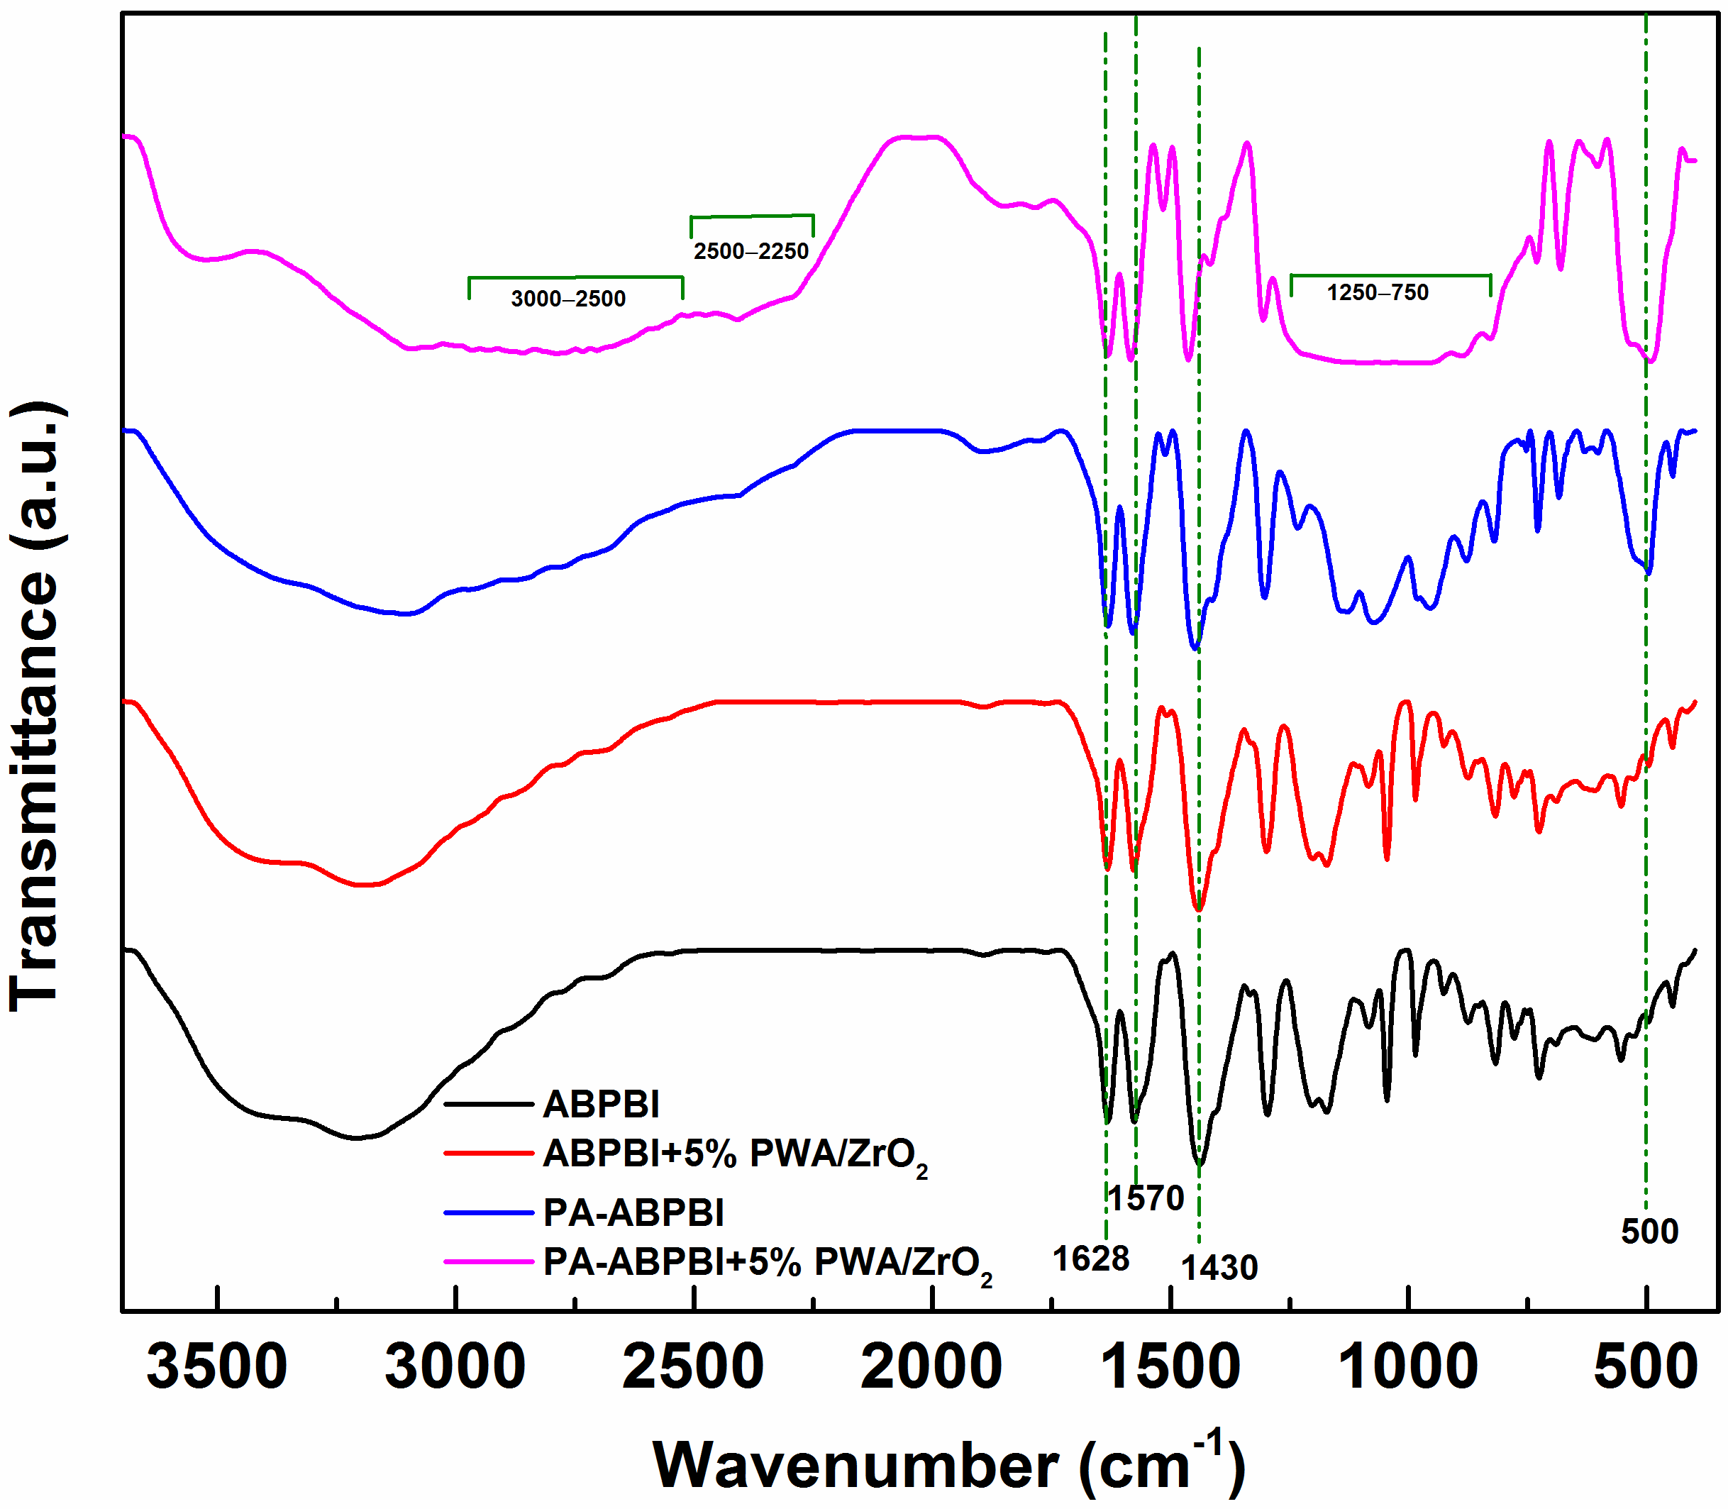
Figure 1 FTIR spectra of ABPBI and its composite membranes with and without phosphoric acid.
The polymer crystallinity plays a major role in the chain relaxations and the proton conductivity. Therefore, to study the effect of temperature on the crystallinity, the undoped and doped ABPBI composite membranes were investigated using in-situ XRD (Figure 2). The samples were heat-treated at a temperature of 100 and 250°C (5h each) prior to recording the XRD patterns; the tests were carried out on the same sample in each case, and after the annealing at 250°C, the XRD pattern was again recorded at 30°C (30°C – After HT, Figure 2). The undoped samples (Figures 2(a) and (b)) show distinct peaks at 2θ values of 10 and 26.5° attributed to the orthorhombic unit cell of ABPBI.³⁰ The broad shoulder peak observed at 2θ value of 18.5° can be attributed to short-range order in the polymer. This peak sharpens with heat-treatment temperature, due to the increased ordering from chain stacking; the change is only with respect to the peak intensity and there is no peak shift as such (see Figure 2(a)) and it is negligible with undoped composite (Figure 2(b)).²³ However, a significant shift is observed with the peak at 10° to higher 2θ values with temperature.
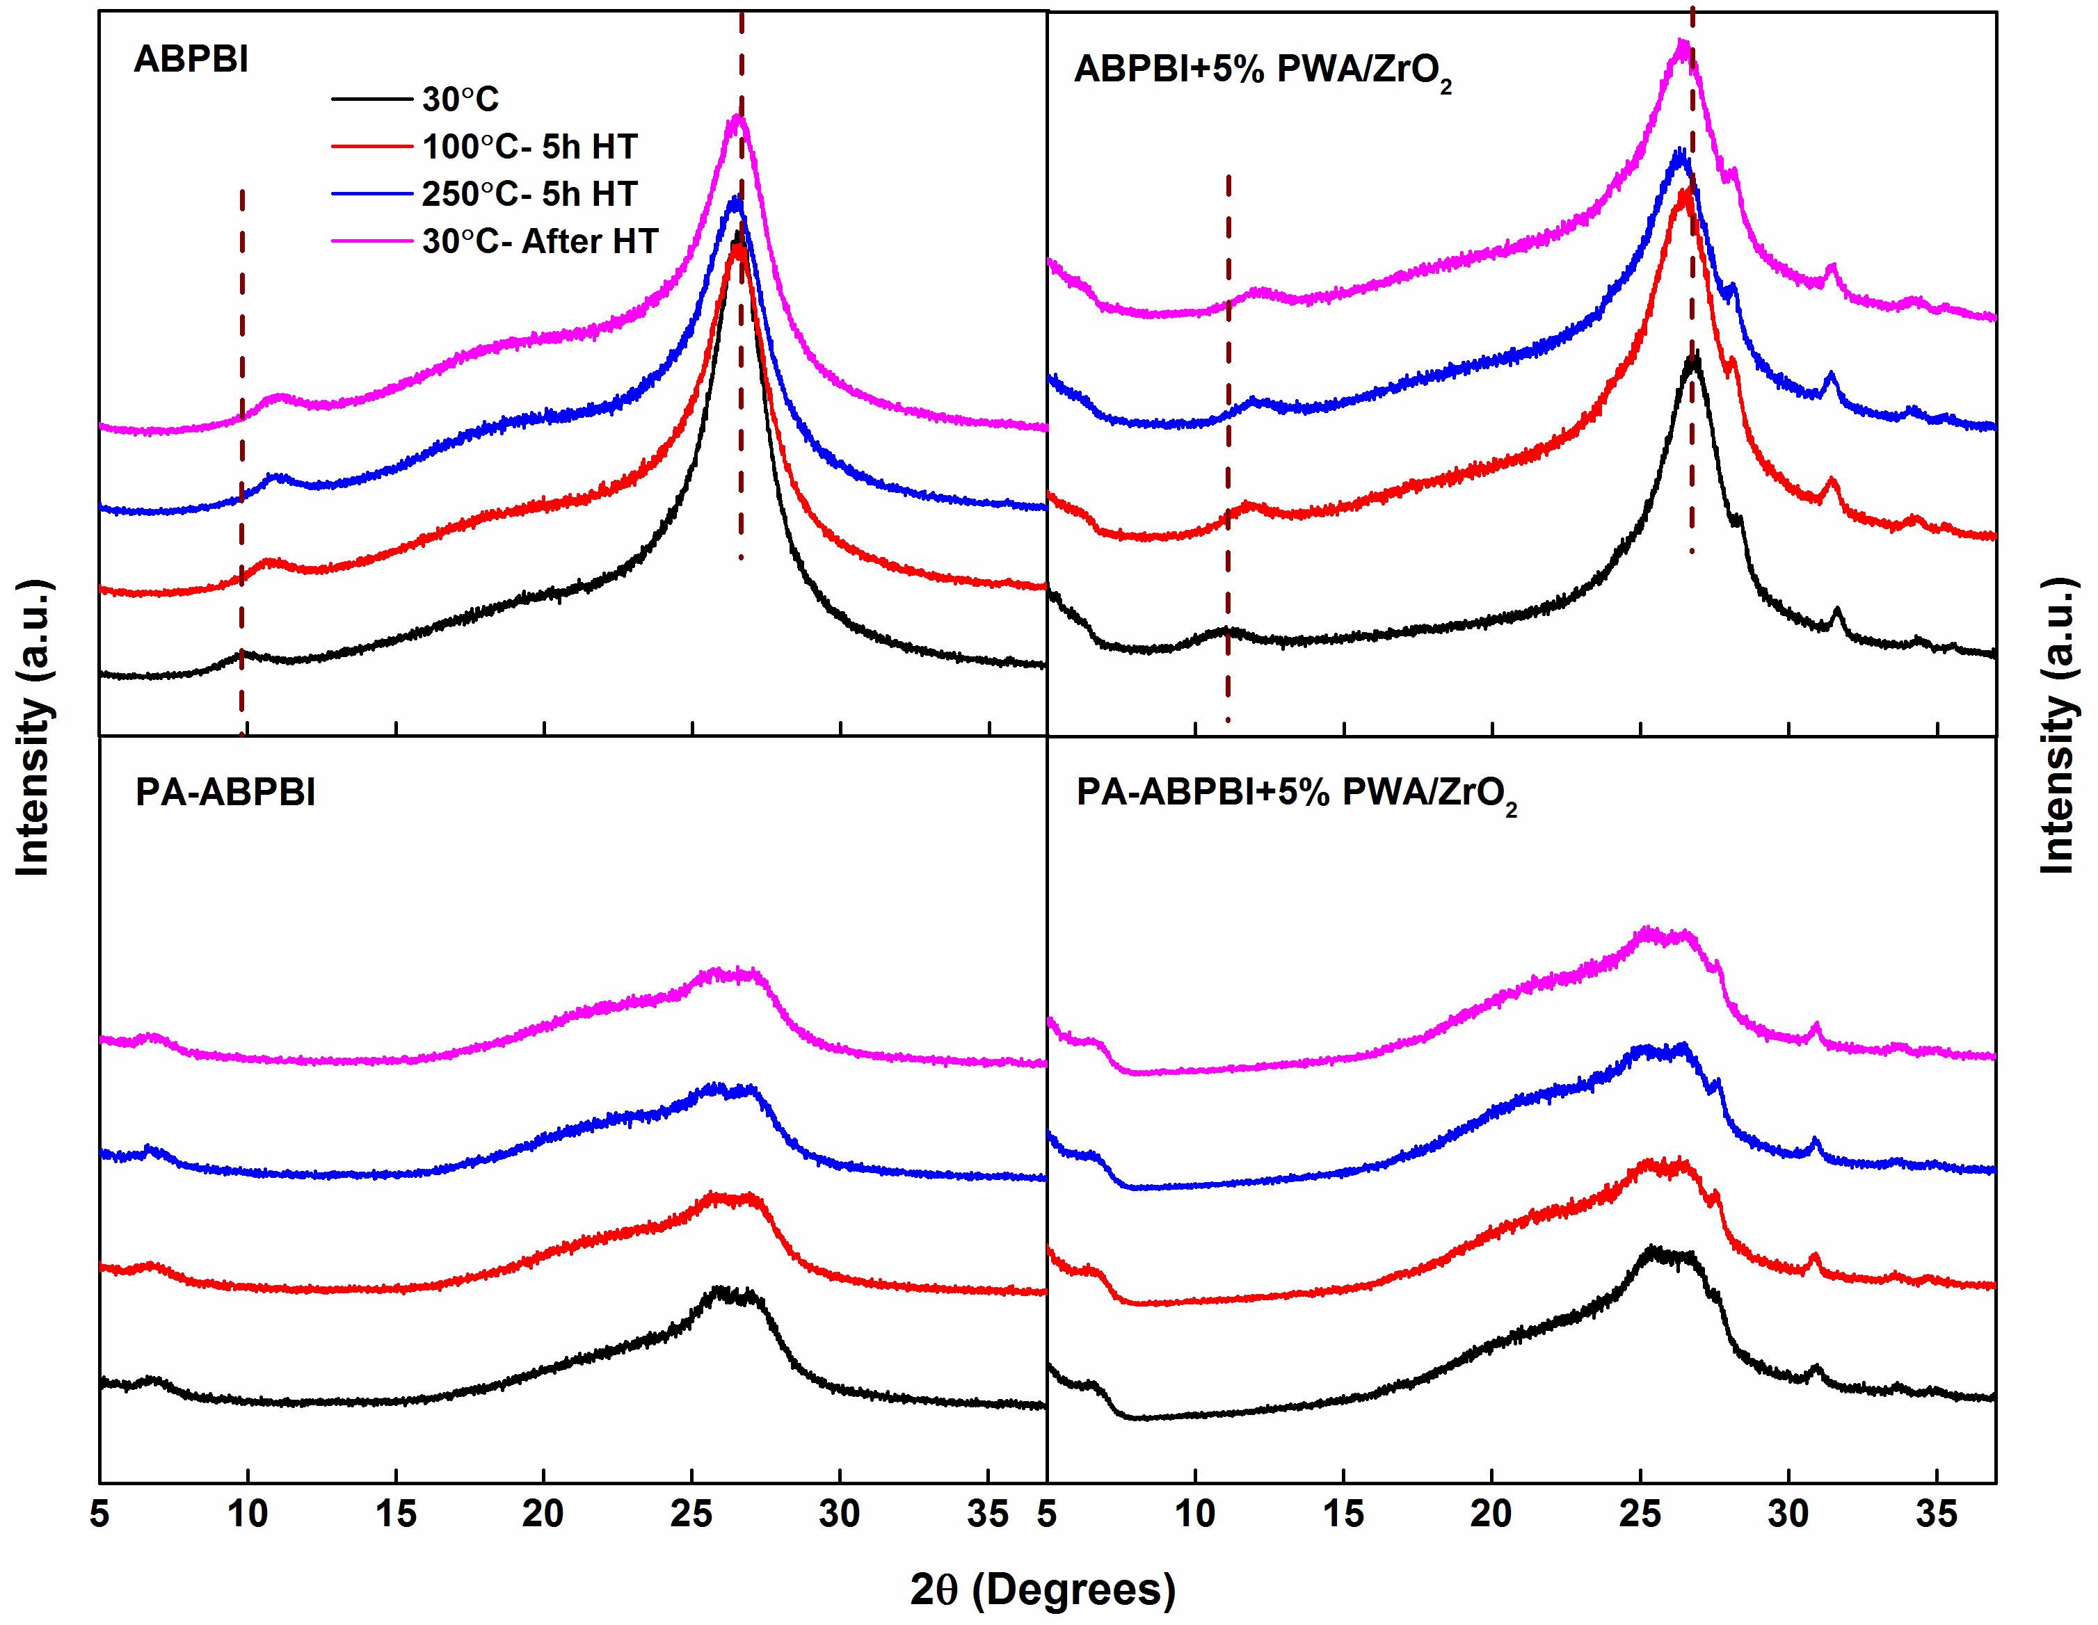
Figure 2 In-situ XRD patterns of ABPBI (a), ABPBI+5% PWA/ZrO₂ (b), PA-ABPBI (c), and PA-ABPBI+5% PWA/ZrO₂ (d) at various heat-treatment temperatures; the tests were carried out on the same sample in each case.
With filler nanoparticles, two additional peaks appear at 2 θ values of 27.5 and 32°, and they are attributed to the PWA/ZrO₂.^{25,26} With PA-doped sample, the XRD patterns change drastically (Figures 2(c) and (d)). The peak at 10° is absent in the XRD patterns and that is attributed to the decrease in crystallinity with the addition of phosphoric acid.^{5,31,32} The peak at 18.5° is shifted to higher 2θ value with PA-doped samples (Figures 2(c) and (d)). The intensity of the peak at 26° decreases significantly and it splits into two peaks those are attributed to the decrease in crystallinity with PA-doping.³³ With increase in the temperature not much change is observed with the XRD patterns, i.e., there is no change in crystallinity with heat-treatment (annealing). However, the peak at 18.5° shows a slight increase in the intensity due to water loss and subsequent close packing of the chains.³⁰ Generally, the addition of nanoparticles in low concentrations (0.5–2%) increases the crystallinity as they act as nucleating sites. But higher concentration of the nanoparticles restricts the chain stacking and lowers the crystallization; this may even lead to the formation of smaller crystallites. Therefore, with the addition of higher amount of nanoparticles, the crystallinity either remains constant or decreases (Figure 2(b)).^{34,35} To further investigate the effect of the nanoparticles and the consequent decrease in crystallinity, all the samples were analyzed with thermogravimetry (Figure S4). The undoped-ABPBI membrane shows the highest weight loss of ~65%, whereas, the ABPBI composite membrane shows ~55% weight loss indicating the presence of the PWA/ZrO₂ nanoparticles. The presence of nanoparticles helps retain the water content as evident from the first weight loss peak at temperature above 100°C; the weight loss is slightly lower with the composite membranes. But the polymer degradation temperature decreases by ~40°C when doped with nanoparticles; PWA/ZrO₂ acts as a catalyst at high temperature and initiates chain scission at the N=C bond of the polymer. The presence of dopants, residual reactants or impurities is said to reduce the degradation temperature of a polymer resulting from the early chain scissions.³⁶ Phosphoric acid also has the same effect on the composite membranes wherein the synergistic effect of both phosphoric acid and PWA/ZrO₂ causes a decrease of ~70°C in the decomposition temperature.
Broadband dielectric spectroscopy (BDS)
The waterfall plots of ε″ as a function of temperature, shown in Figure 3, are analyzed to identify the relaxations in the undoped and doped ABPBI membranes. These figures show relaxations appearing at various temperatures and frequencies.
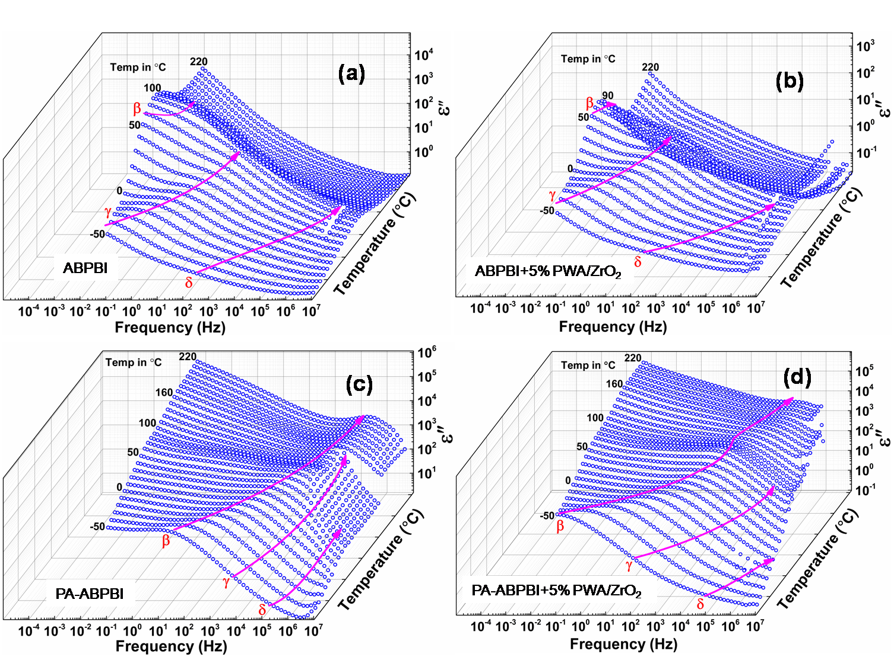
Figure 3 Dielectric loss (ε″) as a function of frequency and temperature with membranes of ABPBI (a), ABPBI+5% PWA/ZrO₂ (b), PA-ABPBI (c), and PA-ABPBI+5% PWA/ZrO₂ (d).
As reported in the literature, the low frequency region of the permittivity plot corresponds to the electrode polarization, DC conductivity and the interfacial polarization; these are followed by relaxations at higher frequencies.³⁷ The dielectric loss intensity in the low-frequency region with all the membranes (Figure 3) significantly rises with temperature and acid-content. The electrode and interfacial polarizations are expected to be present in the heterogeneous materials with phase difference (grain boundaries). However, the use of low ac amplitude (100 mV_{rms}) minimizes these polarization events. The addition of PWA/ZrO₂ nanoparticles does not influence the ε″ when compared to that of phosphoric acid, but the presence of both nanoparticles and phosphoric acid (PA) in the membrane matrix shift the relaxation peaks to lower temperatures.
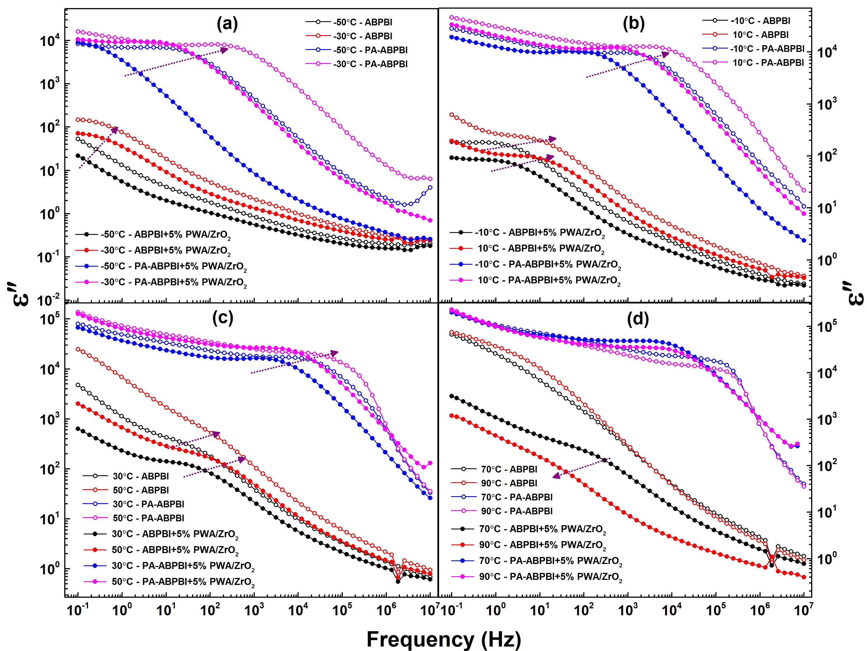
Figure 4 Comparison of the dielectric loss (ε″) data of undoped and PA-ABPBI composite membranes at various temperatures; arrows show the relaxation peak shift with temperature.
The waterfall plot also gives information about the polymer dynamics (movement of chains and groups in the polymer membrane matrix) in an electric field, which also includes the charge migration process (here proton conductivity) of the polymer. For a direct comparison of the relaxation peaks among the different membranes, the ε″ as a function of frequency is shown in Figure 4 for selected temperatures; the evolution of the various relaxation peaks and their shift towards high frequencies with temperature are quite apparent. With PA- and filler-doped samples, the relaxation peaks show a clear shift when compared to that of the undoped samples. Figure 4(a) shows the ε′′ as a function of frequency at -50 and -30°C for the undoped and acid-doped ABPBI composite membranes. With ABPBI and its composite membrane, as the temperature increases from -50 to -30 °C, the initial peak at 100 mHz shifts to ~600 mHz. However, with the addition of phosphoric acid, the same peak shifts to higher frequencies (1 to 100 Hz at -30°C) due to the easy polymer chain motion in the presence of acid and water. Similar shift in the relaxation peaks to the higher frequencies is observed in the temperature range of -10–90°C (Figures 4(b), (c) and (d)) with the acid-doped membranes compared to those of undoped membranes. These peaks are attributed to the various dielectric relaxations associated with the segmental motion of the polymer chains. To identify and understand different the relaxation processes occurring with the ABPBI membrane, a few plots (loss tangent (Tan δ = ε′′/ε′) vs. frequency, ε′′ vs. frequency at different temperatures, and ε′′ vs. temperature at different frequency) are analyzed.
The Tan δ as a function of temperature (at a frequency of 1.35 Hz) for the all membranes is shown in Figure 5; this is an important plot, which approximately shows the temperature window in which a particular relaxation is observed at a given frequency. The peak observed in the temperature range of -50–50°C (designated as δ relaxation) is attributed to the rotational motions of the backbone.²³ This peak moves to lower temperature with acid doped samples. The second relaxation starts to appear at temperature above 20°C with bare ABPBI (without PA). With acid doped samples, these relaxations are apparent even at lower temperatures.
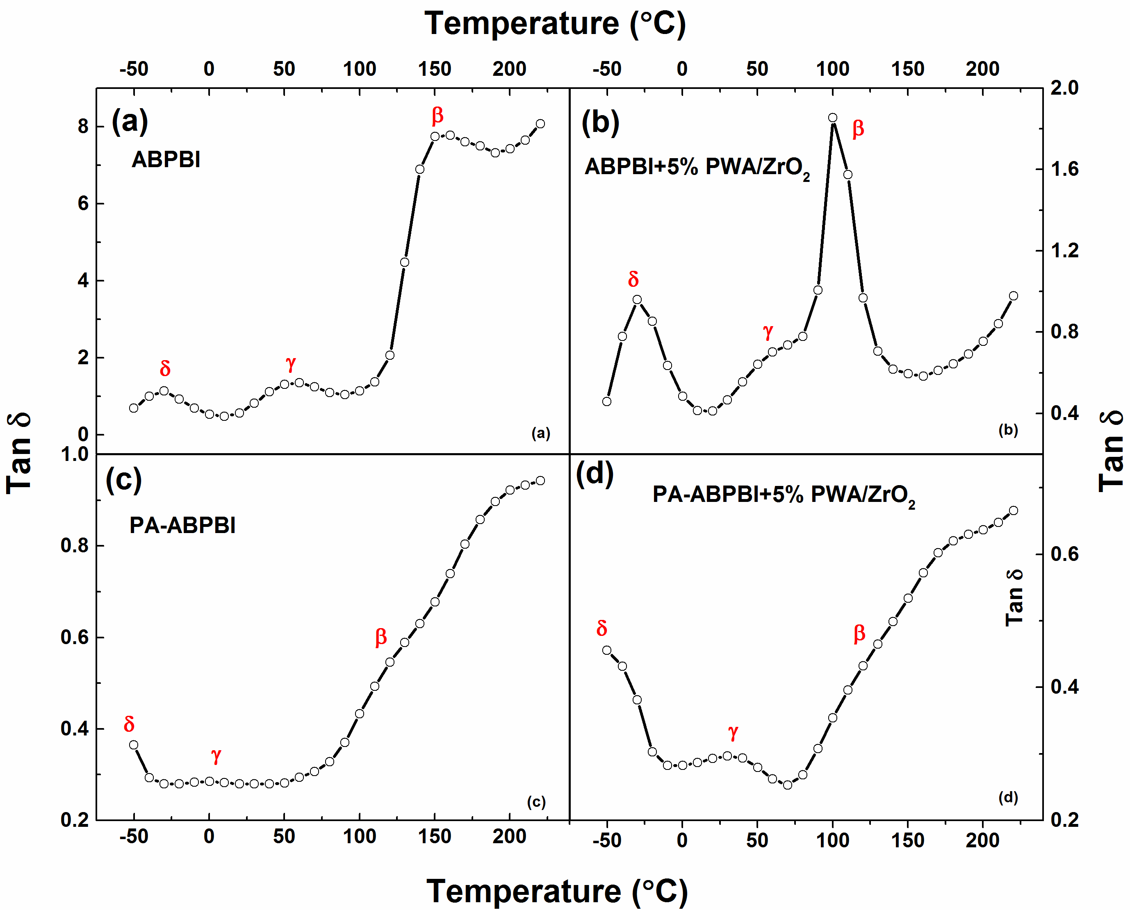
Figure 5 Tan δ at a frequency of 1.35 Hz as a function of temperature with membranes of ABPBI (a), ABPBI+5% PWA/ZrO₂ (b), PA-ABPBI (c), and PA-ABPBI+5% PWA/ZrO₂ (d).
The second relaxation can be attributed to the interaction of NH groups with water molecules. The freezing point of water is lowered due to presence of phosphoric acid, which makes the water-NH interaction possible at lower temperature. This relaxation is assigned as γ relaxation. The relaxation at higher temperature (100–200°C) is attributed to the polymer segment with relatively larger number of carbon atoms and it is assigned as β relaxation.²³ The β relaxation can be related to the motion of the local chains near crystalline regions of the material; it is observed mainly at higher temperatures wherein the water evaporation and closer packing of the material occurs.³⁰
With the addition of phosphoric acid, all the relaxations shift to lower temperature owing to the decrease in crystallinity (Figures 5(c) and (d)), but an interesting trend is observed with the undoped ABPBI composite (Figure 5(b)). In this case, only the β relaxation seems to be affected (shifted to lower temperature). As discussed above (Figure 2), the crystallinity of the polymer is altered by the addition of the PWA/ZrO₂ nanoparticles. Since the β relaxation is associated with the main-chain, it shifts to lower temperatures (Figures 5(b)) due to the reduced stacking/crystallinity. These secondary relaxations are non-cooperative in nature, i.e., the chain movement is independent of the environment, whereas, in α relaxation mode (glass-transition), the polymer segment and the surrounding environment move in a cooperative manner under an external electric field. However, the environment (free volume and crystallinity) has an indirect effect on the dynamics of the relaxation with temperature. For example, the δ relaxation originates from the crank-shaft type of rotation of the phenyl group (in PBI and similar polymers). It is highly dependent on the free volume and the packing of polymer chain results in difficulties in the movement of phenyl rings. In case of highly crystalline domains, the relaxation becomes difficult. Similarly, with other relaxations (β and γ), there exist a clear trend with temperature. Since the cell chamber with the BDS equipment has a temperature limit of ~350°C, the sample was connected to a separate home-made cell placed in a high-temperature furnace to record the relaxation behavior in the glass transition region. Figure S5 shows the Tan δ plot of the membranes characterized at higher temperature (30–550°C), and the peak due to the α relaxation is clearly evident at ~450°C. The change in crystallinity of the material is minimum in the phosphoric acid doped membranes as observed from the in-situ XRD patterns (Figure 2). Thus it may be concluded that this can also be the reason for the diminished intensity of the relaxation peaks with phosphoric acid doped membranes as observed in the Tan δ plots (Figure 5).
The relaxation time and the other parameters are obtained by fitting the dielectric loss data using the Havriliak-Negami (HN) equation (2):³⁸
…..………....(2)
where, ε′, ε′′ and ε₀ are the real, imaginary and vacuum permittivity, respectively, ω (2πf) is the frequency, and k is the number of relaxation terms which varies from 1 to 3. σ_{dc} is the dc conductivity and N characterizes conduction in terms of the nature of charge hopping pathways, degree of morphological order and macromolecular dynamics. For each relaxation, ∆ε_{k} = (ε_{R}−ε∞)_{k}, is the difference between ε′ at very low and very high frequencies. Depending on the number of relaxations in a polymer system, the BDS spectra are fitted with appropriate number of HN functions and DC conductivity term.
With undoped ABPBI samples, the permittivity data could be fitted with 2 and 3 HN functions at lower and higher temperatures, respectively. Usually in the low frequency region, the ε″ is very high due to the contributions from dc conductivity and electrode polarization those eclipse the relaxation peaks; therefore it is difficult to separate the relaxation processes using HN equation. In this study, by the use of optimum ac amplitude (~100 mV_{rms}), the electrode polarization is minimized and hence the relaxation peaks are not masked by the high intensities of the interfacial/electrode polarization (Figure S6). The choice of the amplitude is highly dependent on the inherent membrane conductivity; highly conducting membranes show smooth data even at lower amplitudes. However, the data shown in Figure S6 for PA-ABPBI collected at room temperature (25°C) is quite smooth; but, at lower temperatures with ABPBI membrane (without phosphoric acid) of very low conductivity, the data is very noisy and spectral features are barely discernable. Therefore, to maintain uniform ac amplitude with all the membranes, a value of 100 mV_{rms} was chosen to get noise-free data even at very low temperatures.
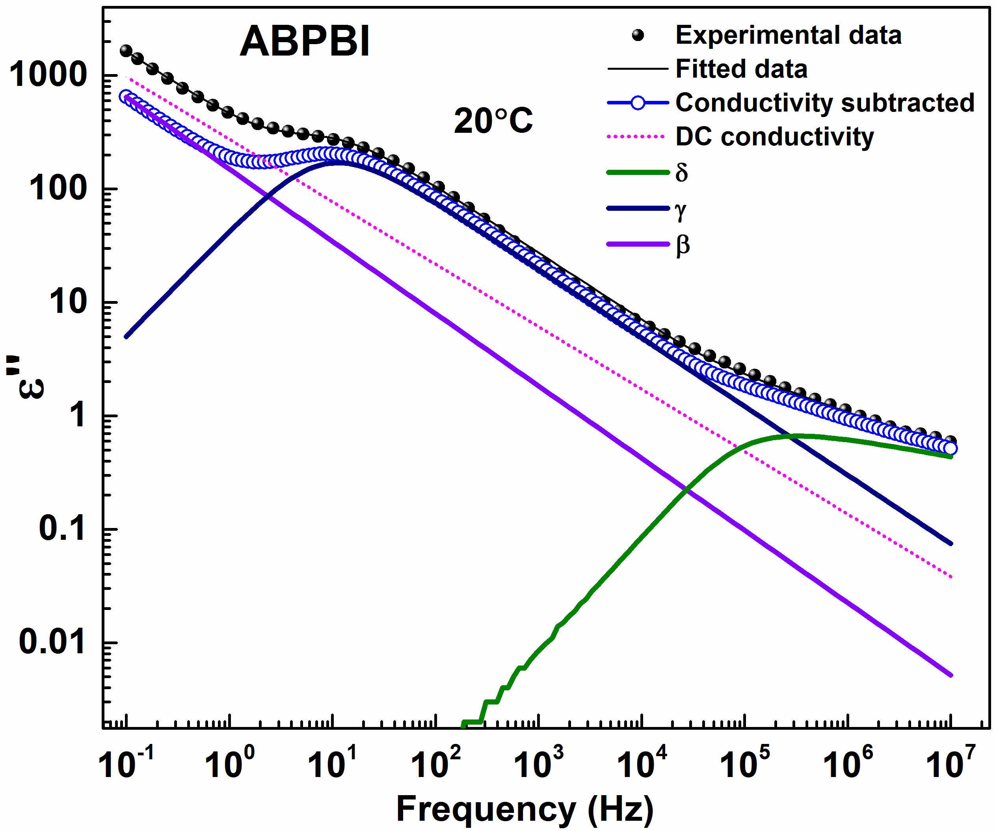
Figure 6 Dielectric loss (ε″) data of ABPBI membrane at a temperature of 20°C fitted with 3HN functions.
Figures 6 and 7 show the fitted data of undoped and acid-doped ABPBI and its composite membranes at a temperature of 20°C; the figures show an accurate fit with a low mean square deviation (MSD) value. Even in the temperature range of -50–200°C, ABPBI shows 3 distinct relaxation peaks, however, the α relaxation which is attributed to the glass-transition temperature (T_{g}) of the material generally appears at 450°C (Figure S5). Therefore, the appearance of this relaxation is ruled out in the above-mentioned temperature range. Figure 6 shows the fitted data of undoped-ABPBI membrane at a temperature of 20°C wherein the δ relaxation moves towards higher frequencies and the γ relaxation is apparent.
Figure 7 Dielectric loss (ε″) data of ABPBI+5% PWA/ZrO₂ (a), PA-ABPBI (b), and PA-ABPBI+5% PWA/ZrO₂ (c) membranes at a temperature of 20°C fitted with 3HN functions. Inset to (a) shows the magnified view of the δ relaxation.

Relaxation time and activation energy
The effect of nanoparticles and acid on the crystallinity of polymer, as established from the physical characterizations of XRD and TGA (Figures 2 and S4), is also observed from the trend in the activation energy calculated from the relaxation time (τ_{max}) of the undoped and doped samples (Figure 8). The activation energy is calculated from the equation (3);³⁹
……………………………………………………………………….(3)
where, τ is the relaxation time, τ_{o} is a pre-exponential factor, E_{A} and R are the activation energy and the universal gas constant, respectively.
As observed from the loss permittivity data (Figures 3 and 4), the relaxation peaks shift to the higher frequency region at a given temperature with the acid doped samples when compared to that of the undoped samples. This trend is also even evident from the activation energy (E_{A}) of the δ, γ, and β relaxations (Table S1). Except for a slight increase in the E_{A} of δ relaxation, in general, a significant decrease in the E_{A} is observed with the addition of the phosphoric acid to the membrane.
The δ relaxation time decreases sharply upto a temperature of 70°C and then it stabilizes to an almost constant value. Whereas, the γ relaxation shows a similar trend upto 70°C but sharply increases thereafter. The loss of water and subsequent chain packing generally affects all the relaxations, but those associated with the smaller molecules or side-chains (γ and δ) show a significant change as the free volume plays a major role in these relaxations. Since, the β relaxation is associated with the segmental motion or main-chain, it appears at higher temperature and usually does not show a prominent change with the loss of water. Above 120°C, the crystallization effect also plays a major role and the synergistic effect of water loss and polymer crystallization explains the sharp fall in the relaxation time.
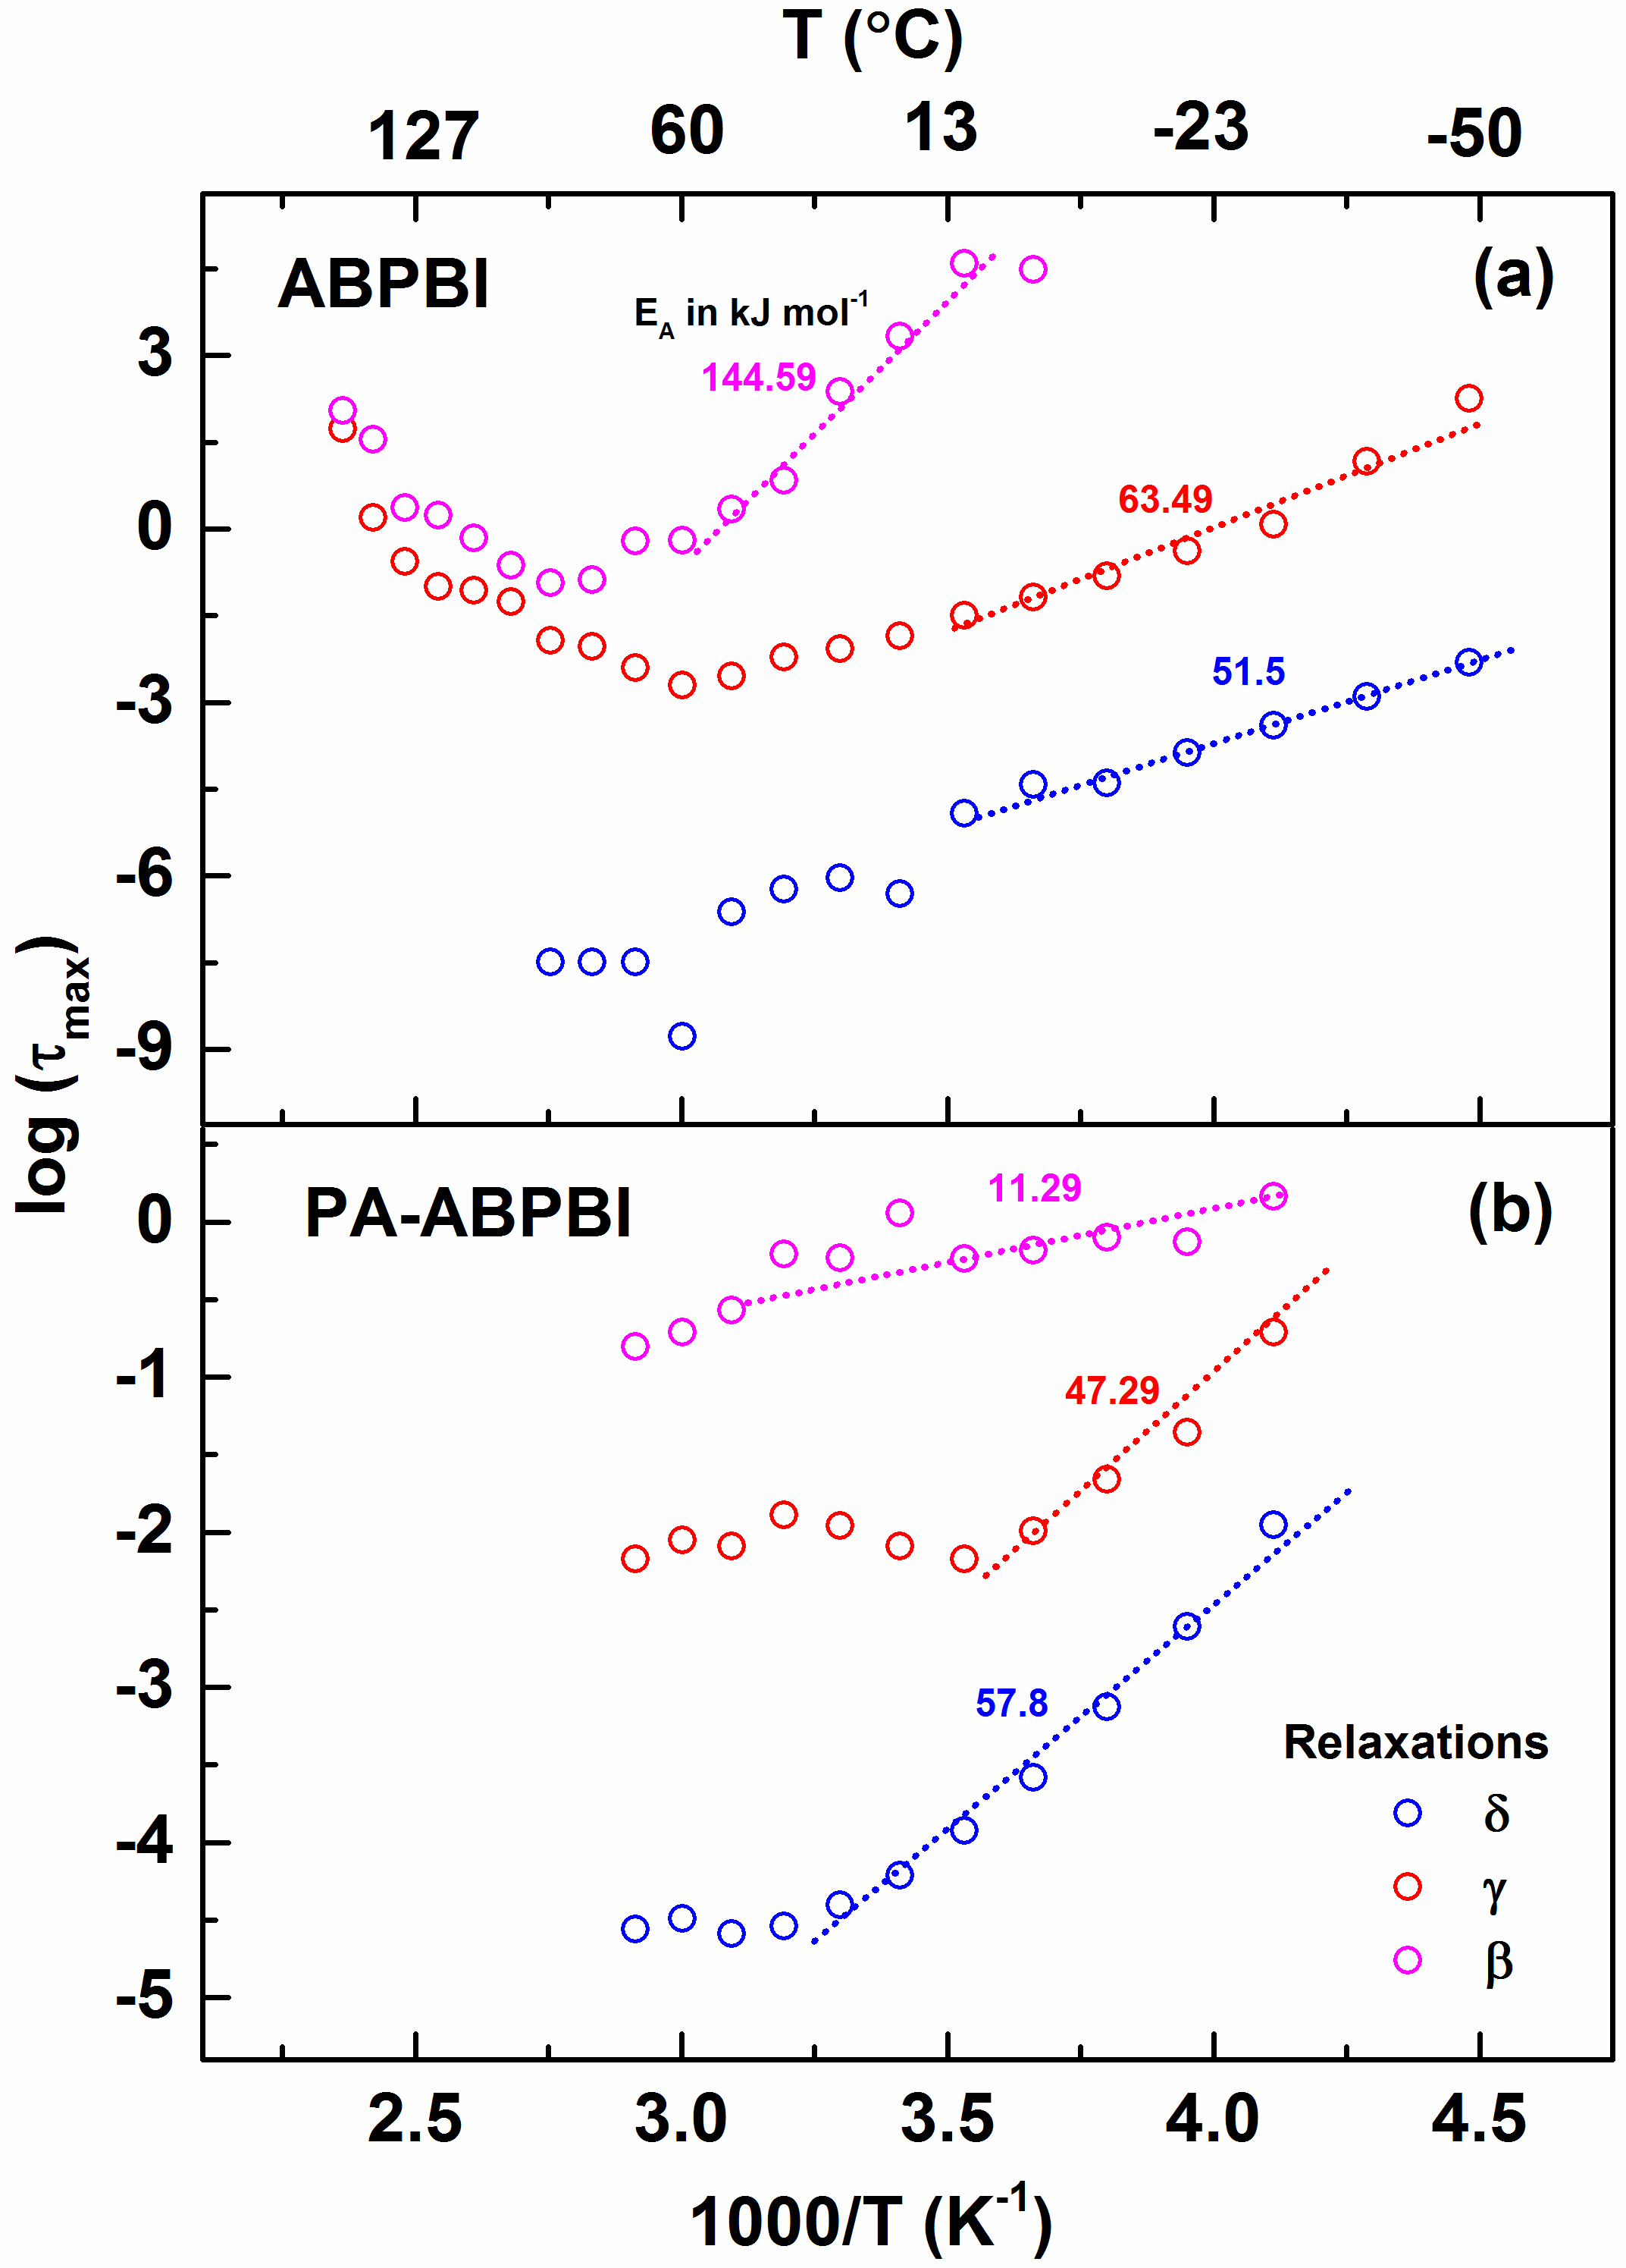
Figure 8 Logarithm of the relaxation time as a function of inverse of temperature with membranes of undoped ABPBI (a) and PA-ABPBI (b).
The trend of the decrease in the τ_{max} is also in line with the complexity of the motions involved; the δ relaxation, being one of the most easiest chain motions, reaches the lowest τ_{max}, whereas, the relaxation time reduction is lowest with the β relaxation. In case of β and γ relaxations, their τ_{max} is either constant or it increases at temperature above ~120°C. The slight decrease in relaxation times with the acid-doped membranes (Figure 8(b)), as observed from the trends in the activation energies, is due to the lower crystallinity compared to those of the undoped samples. The presence of phosphoric acid in the sample restricts the polymer crystallization and the results are also supported by the in-situ XRD patterns (Figure 2).
Trends in conductivity
Figure 9 shows the real conductivity of the ABPBI and composite membranes derived from the BDS. In Figure 9(a), bare ABPBI shows a conductivity of ~10⁻¹² to 10⁻⁵ S cm⁻¹ (entire frequency range) in the temperature range of -50–220°C. From -50°C the conductivity value gradually increases as the temperature rises upto 90°C and at temperature above 100°C, the value decreases; this is because the conduction is mainly via water and with temperature the conductivity reduces due to the water evaporation. The composite membrane (ABPBI+5% PWA/ZrO₂) also shows a similar trend in the ac conductivity in the same temperature range. In case of the acid-doped membranes (Figures 9(c) and (d)), the conductivity follows the similar increasing trend upto a temperature of ~100°C. It reaches a maximum value of 10⁻³ S cm⁻¹ and remains almost constant even at a temperature of 200°C. Above 120°C, the proton conduction happens through the phosphoric acid and the excess water.
Since the membrane conductivity obtained from the BDS set-up was lower compared to that of the reported values, the conductivity of the membranes was also measured in separate through-plane set-up (clamp cell) with EIS in the temperature range of 30–250°C (Figure 10). Though both the tests were conducted with Pt discs (1 cm diameter), the electrode tightening in the BDS test cell is much lower compared to that in the EIS cell (clamp cell); the tightening in BDS cell is limited by its design and it is much delicate due to its intricate nature (internal wiring connections). However, the clamp cell used in EIS is robust and can be tightened much more using a torque wrench.
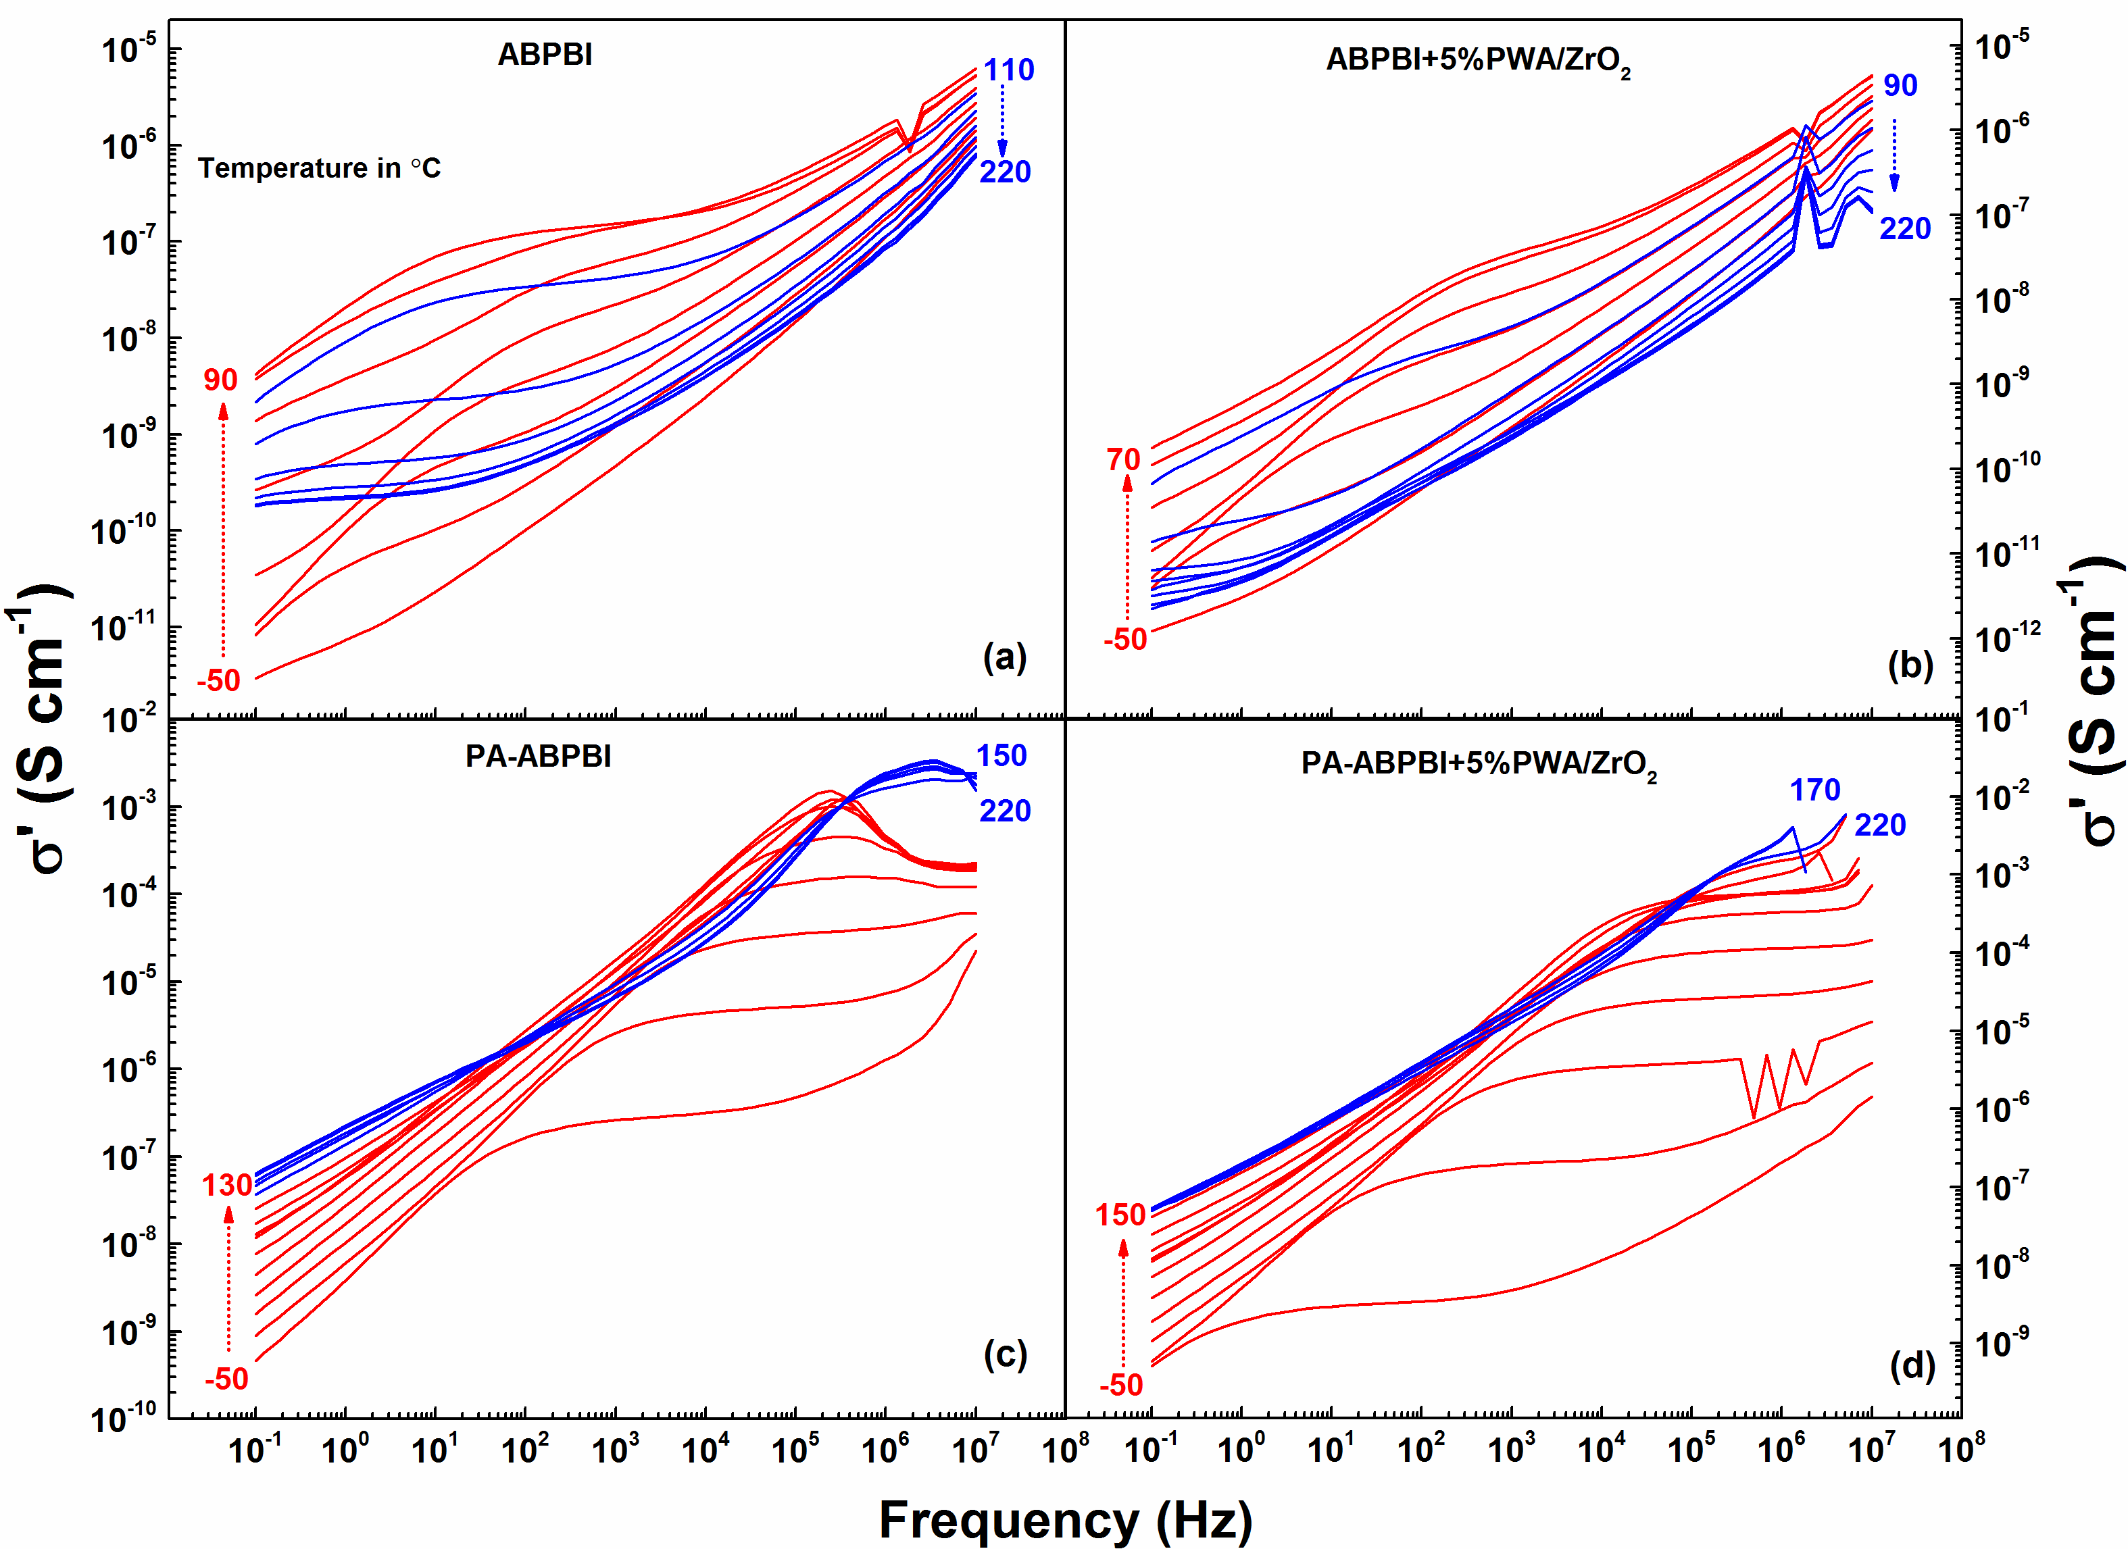
Figure 9 Real component of the conductivity calculated using the in-built WinFit software (Novocontrol Concept 80) from BDS with membranes of ABPBI (a), ABPBI+5% PWA/ZrO₂ (b), PA-ABPBI (c), and PA-ABPBI+5% PWA/ZrO₂ (d).
It has been reported widely that the electrode and membrane contact plays a crucial role in impedance spectra and the resistance value; a tightened cell gives better contact and hence lower resistance values.¹⁶ The blank cell (shorted) impedance spectra was subtracted from the membrane impedance spectra to get the accurate conductivity values; a representative Nyquist plot for PA-ABPBI is shown in Figure S7. All membranes were subjected to similar conditioning to make sure that the relative hydration is the same and a proper comparison can be made among the membranes. The water content in undoped ABPBI membrane is ~6.5% and it is about 15% with PA doped samples. The average proton conductivity at temperature above 150°C, obtained through EIS with the acid-doped membranes, is ~5 mS cm⁻¹ and the highest value is ~7 mS cm⁻¹ for PA-ABPBI+5% PWA/ZrO₂; these values are comparable to those reported in the literature for acid-doped and ABPBI composites membranes.^{40–43} This is attributed to the increase in proton mobility due to the dimerization of the phosphoric acid, which releases water molecules enhancing the conduction; the increase in conductivity is observed until ~180–190°C and at a temperature of ~210°C, it starts to decrease again. This may be due to the further release of water and the subsequent evaporation at elevated temperatures. The addition of PWA/ZrO₂ to ABPBI causes improvement in the conductivity. With low filler content of 2 and 5%, the conductivity almost doubles compared to that of the undoped samples at higher temperatures; higher loading of nanoparticles results in improper mixing, agglomeration of the particles and non-uniformity in the membrane morphology. The higher conduction can be attributed to the increased water and phosphoric acid retention capability of the membranes. Moreover, the phosphotungstic acid attached to the ZrO₂ particles also serves as a proton conduction medium.⁴⁰
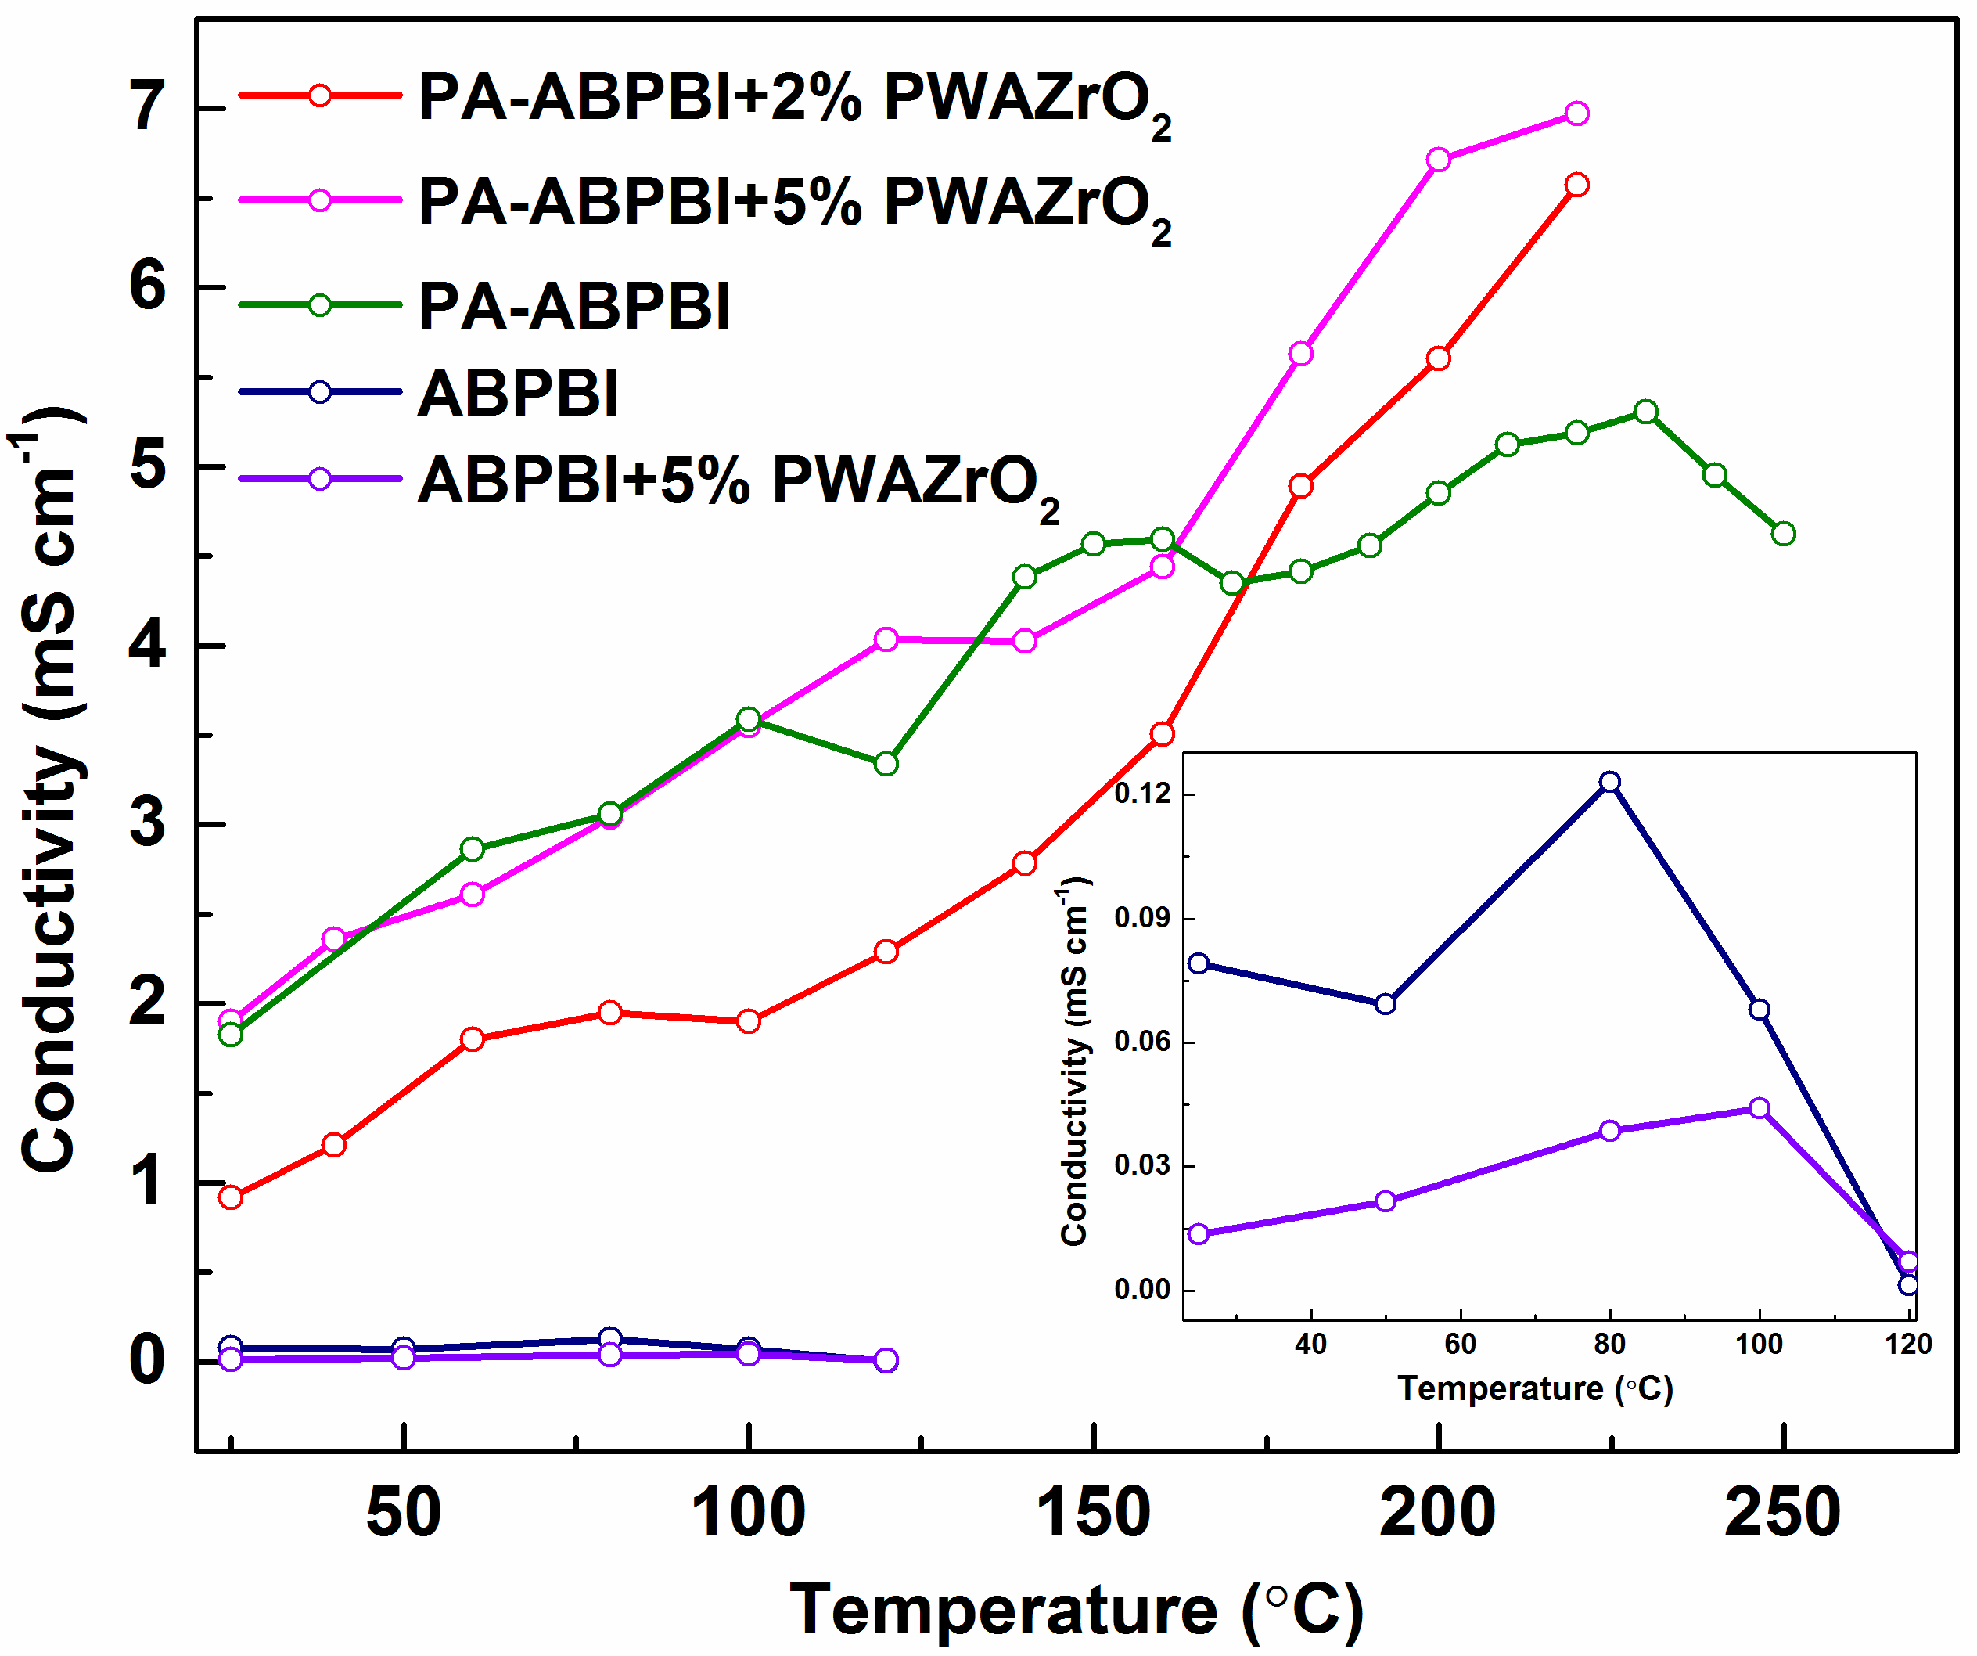

Figure 10 Proton conductivities of ABPBI, PA-ABPBI and their nanocomposite membranes calculated from the EIS measurements carried out in the clamp cell; inset shows the conductivities of the undoped samples.
Conduction mechanism and charge pathway interconnectivity parameter N
The proton conduction pathways under different conditions of phosphoric acid doped membranes was proposed by Ma et al. and Asensio et al.; the trend in conductivity with increase in temperature seems to support the proposed observations (Figures 9 and 10).^{11,12} One phosphoric acid molecule can protonate the nitrogen atom in the imidazole ring of the ABPBI membrane. Generally, the conductivity increases with water content (due to high density of water conductivity channel) and temperature (due to thermal activation of the proton transport process). Beyond the maximum degree of protonation, excess phosphoric acid behaves similar to that of phosphoric acid with different degree of dilution depending on the level of doping. In case of highly doped samples, the conductivity is close to that of concentrated phosphoric acid.¹¹ The increase in conductivity with temperature generally follows the Arrhenius type behavior, unless the polymer segmental motion influence the proton-transfer.³⁷ The proton exchange in case of the samples with lower phosphoric acid mainly happens between protonated-nitrogen and non-protonated nitrogen in the same polymer chain or between nearby chains (N-N⁺----N-H); since the level of phosphoric acid is low, the proton hopping from one acid unit to another will be difficult (H₂PO₄⁻----H₃PO₄).^{11,12,41,44}
It is suggested that the proton conductivity in acid doped PBI results from a cooperative motion of two protons along the polymer-anion chain by the Grotthus mechanism; H₂PO₄----H₃PO₄ and N-H⁺----H₂PO₄⁻ anion chain by successive proton-transfer and anion reorientation. Proton migration happens mainly along the acid and anion chain H₂PO₄-----H⁺-----H₂PO₄⁻ or the acid and H₂O chain depending on the water content.¹¹
The proton conductivity can be directly related to the charge pathway interconnectivity parameter (N) derived from the HN equation; it helps to understand the structural rearrangement at higher temperatures.^{23,45} Generally, this parameter varies between 0 to 1, where 1 indicates high connectivity and better conduction, and a value of ~0.5 indicates a blocked pathway or poor connectivity (Figure 11); however, a high value of N does not necessarily indicate high proton conductivity, it only shows better connectivity. The variation in N for undoped ABPBI with temperature is different from that of the doped composite membranes. In the temperature range of 0–100°C, the N value for undoped membrane remains almost constant at ~0.5. Whereas, with PA doped ABPBI, the value is still higher (Figure 11(b)) a slight increase from ~0.5 to ~0.6 is observed with increase in temperature.
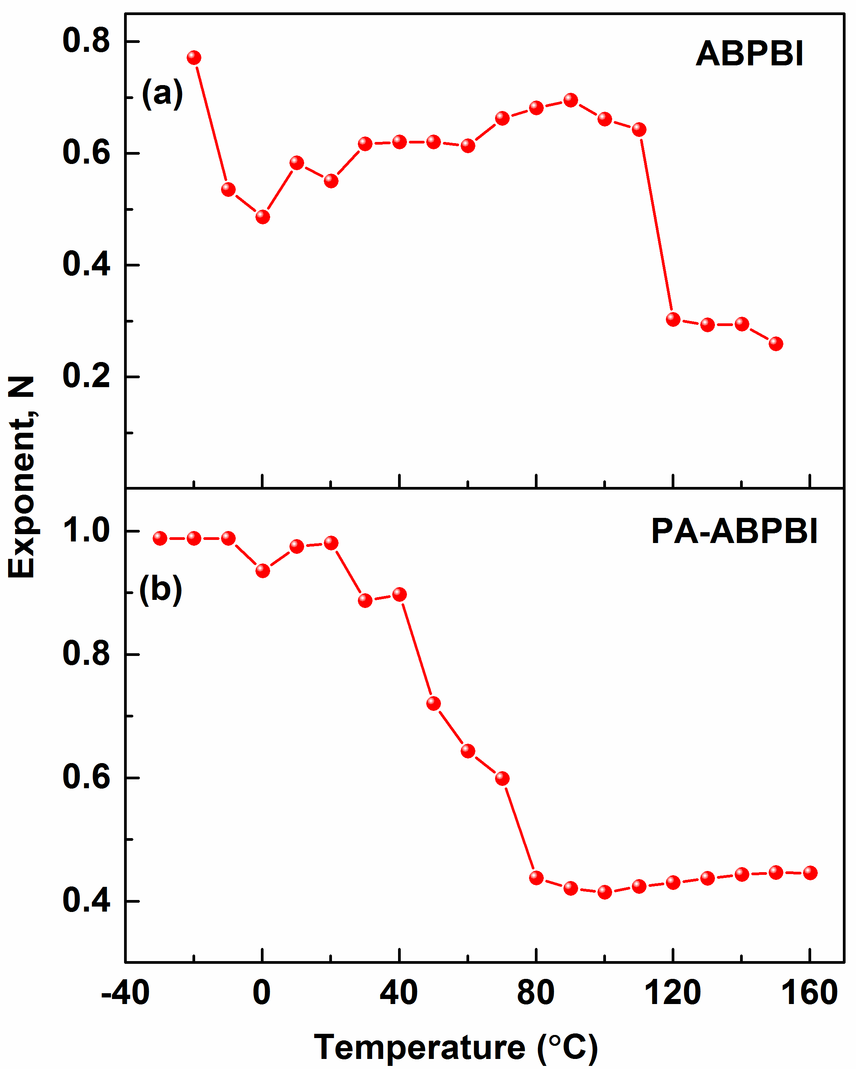
Figure 11 Charge pathway interconnectivity parameter N at various temperatures for undoped ABPBI (a) and PA-ABPBI (b).
With further increase in temperature above 120°C, the N value decreases drastically to less than ~0.3. This trend can be explained based on the conductivity path dominated by water-based channel and beyond the boiling point of water the proton conduction happens only by proton hopping vis N-H…N-H pathway. With PA doped membrane the N value remains close to ~0.9 till room temperature (~25°C), and the N value reaches ~0.6 at around ~75°C. However, when compared to that of undoped ABPBI, the decrease is N value with temperature is relatively slow. This trend can be explained based on the interplay of conducting pathways. In the temperature range of 25 to 80°C, the water channel along with phosphoric acid dominates the proton conduction, and hence, shows higher N value relative to that of undoped membrane. Beyond the water evaporation temperature, the proton conduction in undoped membrane is dominated by N-H…N-H pathway (N value of ~0.3), whereas, with PA doped membrane both N-H…N-H pathway and phosphoric acid pathway contributes to conduction (N value of ~0.45). Thus, the proton conductivity depends on the water content, thermal activation of different conductivity mechanisms (hopping, Grotthuss), and change in free volume of the membrane (change in the connectivity of conductivity channels).

CONCLUSIONS
ABPBI and its phosphoric acid doped composite membranes, were characterized using broadband dielectric spectroscopy to investigate the chain relaxations at elevated temperatures. The low frequency region of the loss permittivity spectra generally shows a high intensity resulting from the dc conductivity and electrode polarization; however, by the use of optimum ac amplitude (100 mV_{rms}), these effects are suppressed and distinct relaxation peaks can be observed even at the low frequency region. The undoped ABPBI and its composite membranes show a rise in DC conductivity with temperature upto 80°C and it decreases above 100°C due to the loss of water. But, with the phosphoric acid doped samples the conductivity shows an increasing trend upto 100°C, and a gradual increase above 120°C; this can be attributed to the presence of phosphoric acid, which assists in the conduction. Similar trend is also observed in the conductivity estimated from EIS. The trends in proton conductivity of the acid doped membranes with increase in temperature are in line with the reported conduction mechanism. With the increase in temperature, the conductivity seems to be affected by the loss of water (60–100°C) and release of water (acid dimerization above 130°C).
The undoped ABPBI membrane shows sharp relaxation peaks, which broaden in the presence of phosphoric acid. With the addition of either phosphoric acid or PWA/ZrO₂ nanoparticles the relaxations shifts to higher frequencies. Whereas, the presence of both acid and nanoparticles (PA-ABPBI+5% PWA/ZrO₂) shift the relaxation peak to lower frequencies as compared to that of PA-ABPBI. The addition of phosphoric acid decreases the material crystallinity and restricts the chain stacking at higher temperatures, which happens in the undoped samples; hence there is no crystallization with acid doped samples at high temperature. This is confirmed with in-situ XRD patterns which show negligible change in the polymer crystallinity with the phosphoric acid doped samples. The presence of PWA/ZrO₂ nanoparticles in the undoped membrane decreases the degradation temperature of the polymer by ~40°C and the addition of phosphoric acid further decreases it by ~30°C; this decrease in degradation temperature is also observed from the Tan δ plots of acid doped ABPBI and the composite membranes.

SUPPORTING INFORMATION
Supporting information may be found in the online version of this article.

ACKNOWLEDGEMENTS
The authors would like to acknowledge Department of Science and Technology (DST), India for the financial support of the research work through the grant SR/S1/PC–68/2012. The authors would also like to thank Dr. Mohamed Shahin, University of Calicut, for the useful discussions. Metallurgical Engineering and Materials Science (MEMS) department at IIT Bombay is acknowledged for providing the broadband dielectric spectroscopy (BDS) facility. Sophisticated analytical instrumentation facility (SAIF) at IIT Bombay is acknowledged for physical characterization of the samples.

REFERENCES
- Kreuer, K. D. On the development of proton conducting polymer membranes for hydrogen and methanol fuel cells, J. Memb. Sci. 2001, 185, 29–39.
- Neergat, M., Seiler, T., Savinova, E. R. and Stimming, U. Improvement of the performance of a direct methanol cell using a pulse technique, J. Electrochem. Soc. 2006, 153, A997−A1003.
- Bose, S., Kuila, T., Nguyen T. X. H., Kim N. H., Lau K. and Lee, J. H. Polymer membranes for high temperature proton exchange membrane fuel cell: Recent advances and challenges, Prog. Polym. Sci. 2011, 36, 813–843.
- Nalawade, A., Abukmail, A., Hassan, M. K. and Mauritz, K. A. Sub-T_{g} macromolecular motions in phosphoric acid doped polybenzimidazole membranes for high temperature fuel cell applications, ECS Trans. 2011, 41, 1449–1459.
- Asensio, J. A., Borrós, S. and Gómez-Romero, P. Polymer electrolyte fuel cells based on phosphoric acid-impregnated poly (2, 5-benzimidazole) membranes, J. Electrochem. Soc. 2004, 151, A304–A310.
- Asensio, J. A., Sánchez, E. M. and Gómez-Romero, P. Proton-conducting membranes based on benzimidazole polymers for high-temperature PEM fuel cells. A chemical quest, Chem. Soc. Rev. 2010, 39, 3210–3239.
- Li, Q., Jensen, J. O., Savinell, R. F. and Bjerrum, N. J. High temperature proton exchange membranes based on polybenzimidazoles for fuel cells, Prog. Polym. Sci. 2009, 34, 449–477.
- Quartarone, E., and Mustarelli, P. Polymer fuel cells based on polybenzimidazole/H₃PO₄, Energy Environ. Sci. 2012, 5, 6436–6444.
- Sen, U., Usta, H., Acar, O., Citir, M., Canlier, A., Bozkurt, A. and Ata, A. Enhancement of anhydrous proton conductivity of poly(vinylphosphonic acid)-poly(2,5-benzimidazole) membranes via in situ polymerization, Macromolecular Chem. and phys. 2005, 216, 106–112.
- Wainright, J. S.; Litt, M. H.; Savinell RF, In Handbook of Fuel Cells: Fundamentals Technology and Applications, ed. Vielstich W, Lamm A and Gasteiger HA, Wiley, 2003, 3, pp 436–446.
- Ma, Y. –L., Wainright, J. S., Litt, M. H. and Savinell, R. F. Conductivity of PBI membranes for high-temperature polymer electrolyte fuel cells, J. Electrochem. Soc. 2004, 151, A8–A16.
- Asensio, J. A. and Gómez-Romero, P. Recent developments on proton conducting poly(2,5-benzimidazole) (ABPBI) membranes for high temperature polymer electrolyte membrane fuel cells, Fuel Cells 2005, 5, 336–343.
- Vilčiauskas, L., Tuckerman, M. E., Bester, G., Paddison, S. J. and Kreuer, K. -D. The mechanism of proton conduction in phosphoric acid, Nat. Chem. 2012, 4, 461–466.
- Wainright, J. S., Wang, J. –T., Weng, D., Savinell, R. F. and Litt, M. Acid-doped polybenzimidazoles: A new polymer electrolyte, J. Electrochem. Soc. 1995, 142, L121– L123.
- Neergat, M. and Shukla, A. K. A high performance phosphoric acid fuel cell, J. Power Sources 2001, 102, 317−321.
- Soboleva, T., Xie, Z., Shi, Z., Tsang, E., Navessin, T. and Holdcroft, S. Investigation of the through-plane impedance technique for evaluation of anisotropy of proton conducting polymer membranes, J. Electroanal. Chem. 2008, 622, 145–152.
- Lobato, J. Cañizares, P., Rodrigo, M. A., Linares, J. J. and Manjavacas, G. Synthesis and characterization of poly[2,2-(m-phenylene)-5,5-bibenzimidazole] as polymer electrolyte membrane for high temperature PEMFCs, J. Memb. Sci. 2006, 280, 351–362.
- Mauritz, K. A. and Hassan, M. K. Broadband dielectric spectroscopic studies of annealed Nafion® membranes, ECS Trans. 2009, 25, 371–384.
- Noto, V. D., Piga, M., Giffin, G. A., Vezzù, K. and Zawodzinski, T. A. Interplay between mechanical, electrical, and thermal relaxations in nanocomposite proton conducting membranes based on Nafion and a [(ZrO₂)̇(Ta₂O₅)_{0.119}] core-shell nanofiller, J. Am. Chem. Soc. 2012, 134,19099–19107.
- Matos, B. R., Santiago, E. I., Rey, J. F. Q. and Fonseca, F. C. Origin of α and β relaxations of Nafion, Phys. Rev. E. 2014, 89, 052601–052607.
- Korbakov, N., Harel, H., Feldman, Y. and Marom, G. Dielectric response of aramid fiber-reinforced PEEK, Macromol. Chem. Phys. 2002, 203, 2267–2272.
- Labahn, D., Mix, R. and Schönhals, A. Dielectric relaxation of ultrathin films of supported polysulfone, Phys. Rev. E 2009, 79, 011801–011809.
- Nalawade, A., Hassan, M. K., Jarrett, W. A., Mauritz, K. A. and Litt, M. H. Broadband dielectric spectroscopy studies of glassy-state relaxations in annealed poly(2,5-benzimidazole), Polym. Int. 2012, 61, 55–64.
- Noto, V. D., Piga, M., Giffin, G. A. and Pace, G. Broadband electric spectroscopy of proton conducting SPEEK membranes, J. Memb. Sci. 2012, 390–391, 58–67.
- Naik, M. A., Samantaray, S. and Mishra, B. G. Phosphotungstic acid nanoclusters grafted onto high surface area hydrous zirconia as efficient heterogeneous catalyst for synthesis of octahydroquinazolinones and b-acetamido ketones, J. Clust. Sci. 2011, 22, 295–307.
- Hernández-Enríquez, J. M., García-Alamilla, R., Sandoval-Robles, G., Melo-Banda, J. A. and García-Serrano, L. A. Effect of the addition of phosphotungstic acid on the thermal stability of zirconium oxide, Dyna 2014, 81, 107–114.
- Kim, H. –J., Cho, S. Y., An, S. J., Eun, Y. C., Kim, J. –Y., Yoon, H. –W. and Kweon, H. -J. Synthesis of Poly(2,5-benzimidazole) for use as a fuel-cell membrane, Macromol. Rapid Commun. 2004, 25, 894–897.
- Glipa, X., Bonnet, B., Mula, B., Jones, D. J. and Rozière, J. Investigation of the conduction properties of phosphoric and sulfuric acid doped polybenzimidazole, J. Mater. Chem. 1999, 9, 3045–3049.
- Bouchet, R. and Siebert, E. Proton conduction in acid doped polybenzimidazole, Solid State Ionics 1999, 118, 287–299.
- Krause, S. J., Haddock, T., Price, G. E., O’Brien, J. F., Helminiak, T. E. and Adams, W. W. Morphology of a phase-separated and a molecular composite PBT/ABPBI polymer blend, J. Polym. Sci. Part B: Polym. Phys. 1986, 24, 1991–2016.
- Wang, S., Bao, G., Lu, Z., Wu, P. and Han, Z. Effect of heat treatment on the structure and properties of poly(2,6-benzothiazole) (ABPBT) and poly(2,5-benzoxazole) (ABPBO), J. Mater. Sci. 2000, 35, 5873–5877.
- Cho, J., Blackwell, J., Chvalun, S. N., Litt, M. and Wang, Y. Structure of a poly(2,5-benzimidazole)/phosphoric acid complex, J. Polym. Sci. Part B: Polym. Phys. 2003, 42, 2576–2585.
- Asensio, J. A., Borrós, S. and Gómez-Romero, P. Sulfonated poly(2,5-benzimidazole) (SABPBI) impregnated with phosphoric acid as proton conducting membranes for polymer electrolyte fuel cells, Electrochim. Acta. 2004, 49, 4461–4466.
- Paul, D. R. and Robeson, L. M. Polymer nanotechnology: Nanocomposites, Polymer 2008, 49, 3187–3204.
- Díez-Pascual, A. M., Naffakh, M., Gonzalez-Domínguez, J. M., Ansón, A., Martínez-Rubi, Y., Martínez, M. T., Simard, B. and Gómez, M. A. High performance PEEK/carbon nanotube composites compatibilized with polysulfones-I. Structure and thermal properties, Carbon 2010, 48, 3485–3499.
- Xing, P., Robertson, G. P., Guiver, M. D., Mikhailenko, S. D., Wang, K. and Kaliaguine, S. Synthesis and characterization of sulfonated poly(ether ether ketone) for proton exchange membranes, J. Memb. Sci. 2004, 229, 95–106.
- Kremer, F.; Schönhals, A. In Broadband dielectric spectroscopy, Springer (2002).
- Havriliak, S. and Negami, S. A complex plane analysis of α-dispersions in some polymer systems, J. Polym. Sci., Polym. Symp.1966, 14, 99−117.
- Tsuwi, J., Pospiech, D., Jehnichen, D., Ha, L. and Kremer, F. Molecular dynamics in semifluorinated-side-chain polysulfone studied by broadband dielectric spectroscopy, J. Appl. Polym. Sci. 2007, 105, 201–207.
- Staiti, P., Minutoli, M. and Hocevar, S. Membranes based on phosphotungstic acid and polybenzimidazole for fuel cell application, J. Power Sources 2000, 90, 231–235.
- Gordon, K. L., Kang, J. H., Park, C., Lillehei, P. T. and Harrison, J. S. A novel negative dielectric constant material based on phosphoric acid doped poly(benzimidazole), J. Appl. Polym. Sci. 2012, 125, 2977–2985.
- Hastak, R. S., Sivaraman, P., Potphode, D. D., Shashidhara, K. and Samui, A. B. High temperature all solid state supercapacitor based on multi-walled carbon nanotubes and poly(2,5-benzimidazole), J. Solid State Electrochem. 2012, 16, 3215–3226.
- Acar, O., Sen, U., Bozkurt, A. and Ata, A. Proton conducting membranes based on poly(2,5-benzimidazole) (ABPBI)-poly(vinylphosphonic acid) blends for fuel cells, Int. J. Hydrogen Energy 2009, 34, 2724–2730.
- Arlt, T., Lüke, W., Kardjilov, N., Banhart, J., Lehnert, W. and Manke, I. Monitoring the hydrogen distribution in poly(2,5-benzimidazole)-based (ABPBI) membranes in operating high-temperature polymer electrolyte fuel cells by using H-D contrast neutron imaging, J. Power sources 2015, 299, 125–129.
- Osborn, S. J., Hassan, M. K., Divoux, G. M., Rhoades, D. W., Mauritz, K. A. and Moore, R. B. Glass transition temperature of perfluorosulfonic acid ionomers, Macromolecules 2007, 40, 3886–3890.

