Received 00th January 20xx,
- Department of Chemical Engineering, Imperial College London, South Kensington Campus, London, SW7 2AZ (the U.K.)
- School of Engineering and Computing Sciences, Durham University, South Road, Durham, DH1 3LE, (the U.K.)Address here.
† Corresponding author: natasha.shirshova@durham.ac.uk
Electronic Supplementary Information (ESI) available: [details of synthesis and characterization of al materials; images and properties of MOF-polymer composite]. See DOI: 10.1039/x0xx00000x
Accepted 00th January 20xx
DOI: 10.1039/x0xx00000x
www.rsc.org/
One Step Synthesis of MOF-Polymer Composites
C. Le Calvezª, M. Zouboulakiª, C. Petitª, L. Peevaª, N. Shirshova^{b,} †
Two different approaches for the one step synthesis of metal organic framework - polymer composites are discussed. Emulsion templating approach allows simultaneous MOF crystallization and polymerization of the internal phase of the emulsion resulting in the formation of porous MOF-polyHIPE composites.
Metal Organic Frameworks (MOFs) have attracted significant attention due to their high surface area and tunable structure and chemistry. Their synthesis, properties and applications have been reported in several recent reviews.¹⁻⁶ Beyond MOFs, researchers are more and more interested in forming MOF-based composites by combining MOFs with other substrates including other MOF(s), metal or silica particles and polymers in order to take advantage of their complementary features ¹. MOF/polymer composites are a relatively recent addition to the class of MOF composites. They tend to attract a lot of attention owing to the variety of possible polymers functionalities as well as their light weight, facile processability and chemical stability. Moreover, these composites could potentially be integrated as devices for a variety of applications, including separation ^{7, 8} and energy storage.^{9, 10}
There are different ways to synthesize MOF/polymer composites, which could be broadly divided into three categories, specifically: (1) growing MOF crystals on a pre-synthesized polymer support; ¹¹⁻¹³ (2) carrying polymerization around the pre-formed MOF crystals ^{7, 14} or (3) copolymerizing monomers with MOF initially modified with polymerizable functional groups.¹⁵
To the best of our knowledge, there are no reported studies on the simultaneous formation of porous polymers and crystallization of MOF, even though such approach would bring a benefit of fewer synthesis steps and would potentially open the route for new structures. It is envisioned that two methods, namely templating and non-templating, could allow for the one-step synthesis of MOF/polymer composites. Precipitation polymerization, which is an established method to synthesize porous polymers,¹⁶⁻¹⁸ corresponds to a non-templating approach. Following this route, a single phase mixture of a monomer, a crosslinker and a MOF precursor solution acting as solvent/porogen (i.e. MOF metal salts, organic ligands and solvent) is prepared. Phase separation then occurs during the polymerization ^{16, 17} while MOF crystallization is taking place. Precipitation polymerization allows for the straightforward preparation of the reaction mixture. The typically low viscosity of the reaction mixture facilitates transfer to any mold and therefore could lead to the production of structured devices. An example of a templating method is High Internal Phase Emulsion (HIPE). In this case, a continuous/monomer phase is transformed into a macroporous polymer (polyHIPE) via polymerization. A range of polymerization techniques can be conveniently used to transform highly viscous liquid HIPEs into lightweight highly porous polyHIPEs, including free radical, living and “click” polymerizations.^{19, 20} Another benefit of polyHIPE is the possibility of adjusting their properties and morphology via varying the HIPE composition, for example the type of stabilization, using surfactant or particles, as well as post polymerization modification. Both templating and non-templating methods previously showed promising results when used for the synthesis of separator filled with an electrolyte for lithium ion batteries.^{21, 22} Moreover, it was shown that MOF can crystallize in polyHIPE beads ²³ and membranes.¹¹ However, in both cases polyHIPEs ^{11, 23} were synthesized first and then MOF crystals were grown on their surface. Considering the above, the aim of this study was to establish a one-step synthetic approach to producing MOF/polymer composites by simultaneously forming the polymer and the MOF crystals into an intimate and porous matrix. Both the templating and non-templating routes were explored.
First, HKUST-1, a Cu-based MOF, was selected as the MOF candidate as its synthesis is straightforward and it exhibits relatively good chemical stability. Second, the monomers used for polymer synthesis were selected based on their solubility in the MOF precursor solution, consisting of dimethylformamide, ethanol, deionized water, trimesic acid and copper nitrate pentahydrate. In the case of the precipitation polymerization approach, it was essential that not only the monomer (referred to as M) but also the crosslinker (referred to as XL) be soluble in the MOF precursor solution. Another criterion for monomers selection was their film-forming abilities. On the other hand, in the case of the HIPE approach, the monomer (M) and the crosslinker (XL) had to be insoluble/immiscible in the MOF precursor solution.
According to the above criteria, the simultaneous crystallization of MOF and polymerization of monomers was first tested via precipitation polymerization using methyl methacrylate (MMA) and vinyl acetate (VA) in combination with poly(ethylene glycol dimethacrylate) (PEGDMA) as a crosslinker. (Details of the precipitation polymerization can be found in the Supporting Information). To achieve flat and uniform samples, two parameters were varied: (i) the molar ratio of monomer to crosslinker (noted ‘M/XL’), and (ii) the total concentration of monomers in the reaction mixture (noted ‘(M+XL)/S’, where ‘S’ refers to solvent/porogen). Flat and uniform samples for both monomers (MMA and VA) and all M/XL ratios were obtained when 25 vol% MOF precursor solution was used as solvent/porogen (Figure SI 1a). Using more than 25 vol% resulted in non-flat, curvy samples (Figure SI 1b). Hence, all other analyses and characterization were done on samples prepared using (M+XL)/S ratio of 75:25 vol%.
The colour of the samples varied from blue to turquoise confirming the presence of copper-based compound(s). The variation in colour could be due to different moisture levels as well as distinct interactions between chemicals in the composites. To establish whether the copper-based compound had the expected HKUST-1 structure, XRD and SEM analyses were performed. Albeit small, the peaks on the XRD patterns of the composites based on MMA are indicative of the presence of HKUST-1 crystals (Figure 1a).²⁴ XRD spectra of the VA based MOF/polymer composites are inconclusive. The small intensity and distorted shape of the peaks could be due to relatively low HKUST-1 content in the MOF/polymer composites. Indeed, the expected (theoretical) content of HKUST-1 in the composites was 5 wt%.
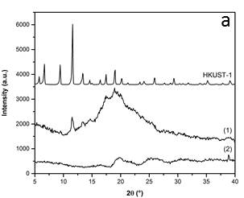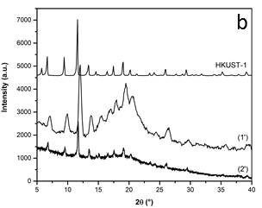
Figure 1. XRD of membranes (a) with in situ formed MOF; (1) PP_MMA_2 (MMA:PEGDMA 3:1; 75:25) and (2) PP_VA_2 (VA:PEGDMA 3:1; 75:25) and (b) MOF/polyHIPE composites MOF/polyHIPE_15 (1’) and MOF/polyHIPE_20 (2’).
Thermogravimetric analysis (TGA) confirmed the low HKUST-1 content, ranging from 1.9 to 5.6 wt% depending on the composites. This content was determined by the remaining mass at 600 °C as it was assumed that polymer thermal decomposition was completed by 500°C (Table SI 1).
Another reason for the small peak size and shape distortion of the XRD peak is the random distribution of the crystals inside the polymer bulk, as it could be seen on the SEM images (Figure 2). Indeed, crystals are mainly formed on the surface of the composite with the cross-section being almost crystal-free (Figure 2 a,b). The small number of crystals in the cross-section can be explained as follows. There are two reactions taking place during MOF-polymer composite synthesis; (i) free radical polymerization of vinyl monomers and (ii) crystallization of MOF. It is reasonable to assume that these two reactions have different rates with polymerization being faster. Formed crosslinked polymer limited swellability in the solvent/porogen, i.e. MOF precursor, leading to residual solvent/porogen being “squeezed” to the surface where MOF crystallization takes place. It is also possible that MOF crystals formation was limited as hydroxyl groups in the acrylate moiety of MMA competed with the MOF ligand (trimesic acid) for reaction with the metals.
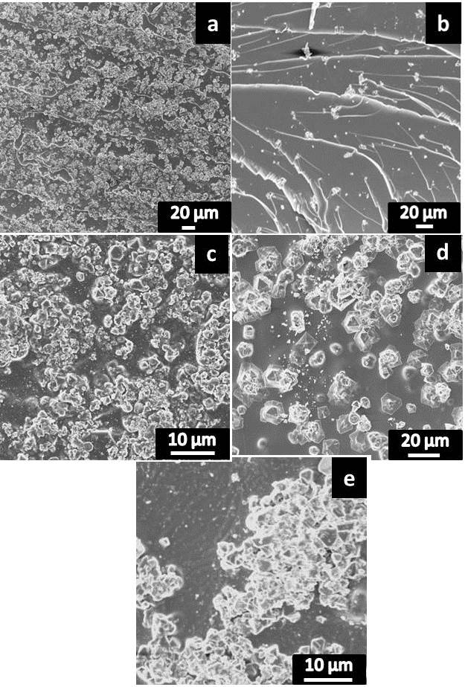

Figure 2. SEM micrographs of the surface(a,c,d,e) and cross-section (b) of polymer-MOF composites based on MMA/PEGDMA (a, b, d) and VA/PEGDMA (c,e) with different M:XL mol.ratio; a,b,d - 1:1 and c,e. 3:1.
One of the attractive features of MOFs is their surface area. N₂ sorption was evaluated for the samples prepared via precipitation polymerisation but no measurable surface area in synthesised samples was found. These data were interpreted as follows, as-synthesised samples, i.e. containing solvent/porogen, have a gel-like pore morphology, and upon extraction of the solvent/porogen pores collapsed forming smooth surface, i.e. polymer with no permanent porosity. Consequently, the MOFs formed in the bulk of the film were trapped in a non-porous matrix and not accessible to the N₂ molecules and amount of the MOF crystals formed on the surface of the films was insufficient to make a difference.
To overcome this problem, it was decided to use the templating approach and particularly, surfactant stabilized HIPEs. First, a study was conducted to find suitable conditions for the synthesis of polymerizable HIPEs, i.e. establish the effect of solvents used for the MOF synthesis on stability of HIPEs and the porous structure of resulting polyHIPEs. During this step, a range of monomers, crosslinkers and surfactants was screened before formulation for polymerizable HIPE containing stock solution was found (Details of preparation HIPEs and polyHIPEs can be found in the Supporting Information). However, once the MOF precursors (i.e. trimesic acid, copper nitrate pentahydrate, DMF, EtOH, H₂O) were used as the internal phase, instead of the stock solution (DMF, EtOH, H₂O), the developed formulation did not lead to the formation of HIPE anymore. The observed behaviour could be explained as follows. The hydrophilic blocks of polyethylene glycol PEG (or polyethylene oxide, PEO), of the surfactant could potentially interact with Cu⁺² leading to changes in stabilization ability of the surfactant. As a result, further optimization of synthesis conditions was conducted directly on the system containing the MOF precursor solution as an internal phase. As MOF precursor solution contained polar aprotic and protic solvents (EtOH, H₂O, DMF), it was essential to use apolar monomers in the continuous phase. There are numerous examples in the literature describing the successful use of hydrophobic monomers,¹⁹ including styrene (St),²⁵ ethylhexyl acrylate (EHA),²⁶ stearyl (SA) and lauryl (meth)acrylates (LMA) ²⁷⁻³⁰ to prepare polymerizable HIPEs. After screening a number of monomers, it was found that stearyl methacrylate (SMA) and 1,6-hexanediol dimethacrylate (HDMA) performed the best and were therefore chosen as monomer and crosslinker respectively for the formation of the HIPE containing MOF precursor solution as an internal phase. The choice of the surfactant to stabilize the HIPE was done by a trial and error approach, as despite the interest in polyHIPEs, no model exists to help with this task. A number of surfactants were screened for their ability to stabilized HIPE using chosen monomer and crosslinker in continuous phase and MOF precursor solution as the dispersed phase. The most stable HIPEs were produced using Arlacel P135, which is a triblock copolymer containing hydrophilic blocks of PEG and hydrophobic dipolyhydroxystearate, and it was used in all further experiments. Two different surfactant concentrations were used, 15 wt% and 20 wt% and in both cases, resulting HIPEs were blue highly viscous liquids, resulting in macroporous polymers with typical for polyHIPEs microstructure, denoted as MOF/polyHIPE_15, for sample with 15 wt% surfactant and MOF/polyHIPE_20 for sample with 20 wt% surfactant (Figure 3).
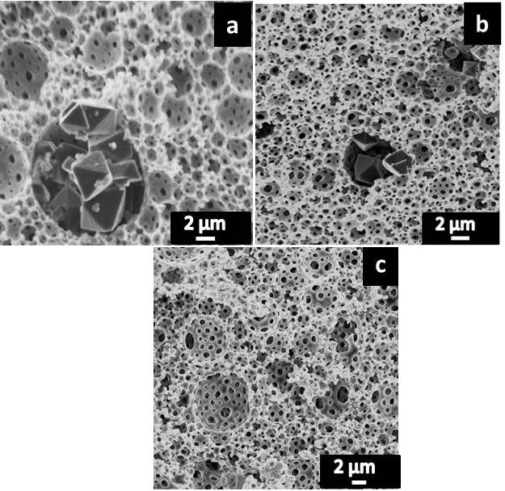
Figure 3. SEM micrographs of MOF/polyHIPE composites: MOF/polyHIPE_15 (a) and MOF/polyHIPE_20 (b); and polyHIPE without MOF (HKUST-1) (c).
This study eventually led to the formation of polyHIPE/HKUST-1 composites via simultaneous thermal crystallisation of MOF and polymerization of monomers in continuous phase. The presence of HKUST-1 crystals was also confirmed by XRD as seen in Figure 1b, as for both MOF-polymer composites peaks at 9.4° 11.6°, 13.3° could be clearly seen. Distortion in the peaks shape could be explained by the low concentration of the HKUST-1, 9.3 wt%, for MOF/polyHIPE_15 and 10.8 wt.% for MOF/polyHIPE_20, as determined by TGA. It is generally accepted that broadening of the peak is associated with the decrease in crystal size. However, as MOF crystals varied in size significantly (MOF/polyHIPE_15 – 2.45±0.66 μm and MOF/polyHIPE_20 2.43±0.82 μm) throughout the sample it is difficult to make definitive statement about correlation between peak width and crystal size at this stage.
As expected, changing the composition of the dispersed phase as well as the surfactant concentration had an effect on the microstructure of the resulting polyHIPEs (Figure 3). Increase of the surfactant concentration from 15 wt% to 20 wt% led to increase in an average pore size from 1.60±1.17 μm to 2.17±1.53 μm (Figure 3 a,b). It could be also noticed that changing internal phase content from stock solution to MOF precursor solution led to significant reduction in the pore size from 2.48±1.31 μm to 1.60±1.17 μm (Figure 3 a,c). Reduction in the pore size could be explained by change in the stabilisation efficiency of the surfactant upon addition of the MOF precursors; copper (II) nitrate pentahydrate and trimesic acid. It was reported ³¹ that addition of salt to the aqueous internal phase led to reduction of the pore size due to changes in the ionic strength of the dispersed phase. Also, the addition of the MOF precursors led to changes in the strength of the internal phase as a solvent resulting in changes of miscibility between two phases. Increase of pore size with increase in surfactant concentration was unexpected, as according to the literature ²¹ it would decreases droplet size and consequently pore size of the resulting polyHIPE. Obtained results could be explained by the presence of the MOF precursors, as it is known that copper ions and trimesic acid could interact with OH groups of the surfactant. Increase concentration of surfactant means more copper ions could interact reducing concentration of the “free” copper ion in the dispersed phase which as was mentioned earlier would lead to increase in pore size.
The presence of the MOF particles was also supported through the calculation of the specific surface area from N₂ adsorption (BET). The specific surface area of MOF/polyHIPE_15 composite was 16 m²/g which is significantly higher compared to the polyHIPE containing no MOF for which no specific surface area was measured and only four fold smaller compared to numbers reported by L. O’Neill et al ²³ (64 m²/g) for MOF/polymer composites prepared by growing MOF crystals on pre-synthesized polyHIPE beads.

Conclusions
The obtained results provide a proof-of-concept for the one-step synthesis of MOF/polyHIPE composites, which can lead to an improvement of mechanical stability of MOF and could widen their potential applications. The next step is to optimize the synthesis procedure in order to better control the structures and increase the MOF loading in the composites. We see a few different directions which could be taken to achieve an optimisation of the synthesis process of MOF-polyHIPE composites and it should include both optimisation of formulation, including monomer phase and MOF phase (using different metal could be one possibility); and a process, i.e. temperature of polymerisation and type of initiation (for example UV initiation could be used to polymerise thin films in very short period of time).
Notes and references
The authors would like to acknowledge EPSRC for the financial support under the project EP/J014974/1 entitled Molecular Builders: Constructing Nanoporous Materials.

1. Q.-L. Zhu and Q. Xu, Chem. Soc. Rev. , 2014, 43, 5468-5512.
2. N. Stock and S. Biswas, Chem. Rev., 2012, 112, 933-969.
3. S. T. Meek, J. A. Greathouse and M. D. Allendorf, Adv. Mater., 2011, 23, 249-267.
4. M. D. Allendorf and V. Stavila, Cryst. Eng. Comm., 2015, 17, 229-246.
5. V. Stavila, A. A. Talin and M. D. Allendorf, Chem. Soc. Rev., 2014, 43, 5994--6010.
6. A. Morozan and F. Jaouen, Energy Environ. Sci., 2012, 5, 9269–9290.
7. L.-M. Li, F. Yang, H.-F. Wang and X.-P. Yan, J. Chromatography A, 2013, 1316, 97- 103.
8. T. Rodenas, I. Luz, G. Prieto, B. Seoane, H. Miro, A. Corma, F. Kapteijn, F. X. L. i. Xamena and J. Gascon, Nature Materials, 2015, 14, 48-55.
9. F.-S. Ke, Y.-S. Wu and H. Deng, J. Solid State Chem., 2015, 223, 109-121.
10. X. Liang, F. Zhang, W. Feng, X. Zou, C. Zhao, H. Na, C. Liu, F. Suna and G. Zhu, Chem. Sci., 2013, 4, 983–992.
11. M.G. Schwab, I. Senkovska, M. Rose, M. Koch, J. Pahnke, G. Jonschker and S. Kaskel, Adv. Eng. Mater., 2008, 10, 1151-1155.
12. Y.-Y. Fu, C.-X. Yang and X.-P. Yan, Chem. Commun., 2013, 49, 7162-7164.
13. M. Wickenheisser and C. Janiak, Microporous & Mesoporous Materials, 2015, 204, 242-250.
14. Y. Zhang, X. Feng, H. Li, Y. Chen, J. Zhao, S. Wang, L. Wang and B. Wang, Angew. Chem., 2015, 127, 4333 -4337.
15. Z. Zhang, H. T. H. Nguyen, S. A. Miller and S. M. Cohen, Angew. Chem. Int. Ed., 2015, 54, 6152 -6157.
16. F. Svec and J. M. J. Fréchet, Chem. Mater. , 1995, 7, 707-715.
17. F. Svec and J. M. J. Fréchet, Ind. Eng. Chem. Res., 1999, 38, 34-48.
18. O. Okay, Prog. Polym. Sci., 2000, 25, 711-779.
19. M. S. Silverstein, Progress in Polym. Sci., 2014, 39, 199- 234.
20. M. S. Silverstein and N. R. Cameron, in Encyclopedia Of Polymer Science and Technology, ed. I. John Wiley & Sons, 2010.
21. N. Shirshova, P. Johansson, M. J. Marczewski, E. Kot, D. Ensling, A. Bismarck and J. H. G. Steinke, J. Mater. Chem. A, 2013, 1, 9612-9619.
22. H. Krebs, L. Yang, N. Shirshova and J. H. G. Steinke, React. Funct. Polym., 2012, 72, 931-938.
23. L. D. O’Neill, H. Zhang and D. Bradshaw, J. Mater. Chem., 2010, 20, 5720-5726.
24. C. Petit, J. Burress and T. J. Bandosz, Carbon, 2011, 49, 563-572.
25. D. Mao, T. Li, H. Liu, Z. Li, H. Shao and M. Li, Colloid. Polym. Sci., 2013, 291, 1649-1656.
26. S. Jerenec, M. Šimić, A. Savnik, A. Podgornik, M. Kolar, M. Turnšek and P. Krajnc, Reactive & Functional Polymers, 2014, 78, 32-37.
27. N. Shirshova, A. Menner, G. P. Funkhouser and A. Bismarck, Cem. Concr. Res., 2011, 41, 443-450.
28. S. Livshin and M. S. Silverstein, Macromolecules, 2007, 40, 6349-6354.
29. S. Livshin and M. S. Silverstein, Macromolecules, 2008, 41, 3930-3938.
30. S. Livshin and M. S. Silverstein, Soft Matter, 2008, 4, 1630-1638.
31. J. M. Williams, A. J. Gray and M. H. Wilkerson, Langmuir, 1990, 6, 437-444.

