How can the use of digital molecular diagnostic tools help to tackle malaria?
Martin Chamai¹, Waleed M.A. Jebreel², Jean-Bertin B. Kabuya³, Dimbintsoa Rakotomalala Robinson⁴ & Aubrey J. Cunnington⁵
¹West African Center for Cell Biology of Infectious Pathogens, University of Ghana, Accra, Ghana
²University of Khartoum, Institute of Endemic Diseases, Khartoum, Sudan
³National Health Research and Training Institute, Ndola, Zambia
⁴Medical Research Council Unit The Gambia at London School of Hygiene and Tropical Medicine, Banjul, The Gambia
⁵Section of Paediatric Infectious Disease and Centre for Paediatrics and Child Health, Imperial College, London, UK

Address for Correspondence: Professor Aubrey Cunnington, Section of Paediatric Infectious Disease, Department of Infectious Disease, Sir Alexander Fleming Building, South Kensington Campus, Exhibition Road, London, SW7 2AZ, UK. Telephone: +44 (0)2075943695 email: a.cunnington@imperial.ac.uk

Keywords: Digital; Malaria; Molecular Diagnostics; Point-of-Care; Resistance; Surveillance

How can the use of digital molecular diagnostic tools help to tackle malaria?

Introduction:
Malaria has long been one of the most important infectious disease threats to humankind. Even with concerted global efforts, cases and deaths remain high in many countries. Reducing the burden of malaria requires new tools and data-driven strategies. Emerging digital molecular diagnostics could enable new approaches to detection, prevention, and treatment of malaria, coupled with real-time data analytics, to support the most effective use of resources.

Body:
Malaria is caused by mosquito-transmitted Plasmodium parasites undergoing repeated cycles of replication in red blood cells [1]. There were estimated to be around 260 million malaria cases and 600,000 malaria deaths in 2023, the vast majority in Africa where P. falciparum is the major parasite species [2]. Many tools exist to prevent and treat malaria, including insecticide-treated nets, indoor residual spraying of insecticides, blood film microscopy, rapid diagnostic tests (RDTs), artemisinin combination therapies (ACT), targeted chemoprevention, and recently deployed malaria vaccines [1,2]. Nevertheless, there are significant threats to the effectiveness of these tools, including insecticide resistance in mosquitoes, antimalarial resistance in malaria parasites, and diagnostic evasion by parasites lacking target antigens [1,2]. Therefore, there is a constant need for innovation to combat malaria.
Digital molecular diagnostics are an evolving generation of diagnostic technologies combining the sensitivity and specificity of molecular detection with digital functionalities such as automated result read-out, real-time connectivity (usually via a mobile phone) and data integration (Figure 1). Designed with portable hardware, these tools are intended for deployment at the point-of-need [3]. Examples in development include fully digital, sample-to-result lab-on-chip platforms [4,5], and digitally-enabled paper-based [6] or “lab-in-a-bag” systems [7]. Digital molecular diagnostics have the potential to transform diagnostic ecosystems, enabling accurate diagnostics to be deployed wherever they are needed, and enabling new approaches to diagnosis and real-time surveillance of disease, which are impossible with current tests [3]. Through the digital interfaces of these new tools, there is potential for integrated decision support for healthcare workers (e.g., treatment recommendations), and through their digital outputs, for real-time, geolocated surveillance data. Many digital molecular diagnostics are being developed for resource-limited settings, as supplements or alternatives to “bricks and mortar” diagnostic laboratories. There is particular promise for digital molecular diagnostics to tackle malaria at individual and population levels (Figure 1).
Blood film microscopy and RDTs, the current standard of care approaches, are essential components of current malaria diagnosis and control, yet they have limitations [1]. Microscopy allows quantification of parasites and discrimination of parasite species, but requires an expert operator, equipment, time, and manual recording of results. RDTs are faster and easier to perform, making them the first-choice diagnostics in many settings, but they too rely on manual recording, are prone to both false-positive and false-negative results, and commonly used RDTs in Africa do not detect non-falciparum parasite species. Widely used RDTs detect P. falciparum parasites by the presence of the P. falciparum histidine-rich protein 2 (PfHRP2) antigen in blood, but their effectiveness is threatened by the emergence of parasites with deletions of pfhrp2/3 genes, which can lead to false-negative results [8]. PCR-based molecular diagnostics can overcome these challenges, with sensitive and specific detection of all parasite species infecting humans, but they are rarely performed outside specialist laboratories. Loop-mediated isothermal amplification (LAMP) using lyophilised reagents, is more easily adaptable to portable formats which do not require hard-wired power supplies and laboratory infrastructure [7]. Parallel LAMP reactions enable improved diagnosis and quantification (qLAMP) of infection (and co-infections) with all relevant parasite species [9]. This could be particularly important in settings where different parasite species need to be distinguished to determine different treatments, such as countries in the “Horn of Africa”, where P. falciparum and P. vivax are co-endemic [2].
Where facilities are available, treatment of serious bacterial infections is often guided by results of culture and antibiotic sensitivity testing, but this is not the case for malaria, despite antimalarial resistance being a pervasive threat. One reason for this is that phenotypic testing for antimalarial resistance is complex and time-consuming. However, the molecular basis of antimalarial resistance is increasingly well-understood [10]. Digital molecular diagnostics simultaneously detecting species and resistance-associated mutations in real-time at the point-of-care [9,11], could open the way to precision treatment strategies where the optimal antimalarial is selected for each individual’s infection. In a country like Ghana, where there are three first-line ACT options for treatment [2], the most suitable one could be selected based on the presence of partner drug resistance mutations. For an individual patient, this may reduce the risk of recrudescence of infection [12], but modelling suggests that such an approach could also substantially extend the useful lifespan of antimalarial drugs at a population level [13]. Detecting mutations associated with partial artemisinin resistance [11], which is emerging in an increasing number of countries worldwide [10,12], would improve the timeliness of surveillance data, allow monitoring of treatment failure risk, and inform changes in treatment policies [12]. The principle of detecting genetic changes is not limited to parasites but could also include the detection of host genetic variants with implications for treatment, potentially in the same test used for malaria diagnosis. For example, detection of glucose-6-phosphate dehydrogenase (G6PD) deficiency mutations, which causes susceptibility to haemolysis during primaquine treatment of P. vivax and P. ovale infections, could guide individual treatment decisions [1].
In most symptomatic malaria infections, the density of parasites in the blood is above the lower limit of detection for microscopy and RDTs. However, these tests can miss low levels of circulating parasites, as may occur in asymptomatic infections and malaria in pregnancy [1,7,14]. In these scenarios, a more sensitive test becomes desirable, and this is where molecular tests excel [7,14]. Asymptomatic, low-density infections, which are highly prevalent in many endemic countries, provide the major reservoir for transmission of malaria. Efforts to reduce transmission, particularly in countries aiming for malaria elimination, need to target the asymptomatic reservoir through community-based approaches such as test-and-treat strategies [7]. For these interventions to be effective, the diagnostic tools employed need to combine high sensitivity with operational simplicity to ensure successful deployment in resource-constrained settings. LAMP-based technologies offer a promising solution, along with more recent technologies such as clustered regularly interspaced short palindromic repeats (CRISPR)-based diagnostic tools [4]. Beyond technical performance, digitalised outputs promise the simultaneous collection of geolocated data, which would allow real-time and fine-scale mapping of transmission and more precise identification of hotspot areas during interventions like mass testing and treatment. Furthermore, the increasing integration of epidemiological modelling and artificial intelligence into public health systems would allow new opportunities for automated data analysis and interpretation.
Malaria in pregnancy is associated with poor maternal, foetal, and newborn outcomes. P. falciparum parasite-infected red cells sequester in the placental vasculature, leading to low peripheral parasitaemia and making infections more difficult to detect in peripheral blood [14]. In endemic countries, intermittent preventive treatment in pregnancy using sulfadoxine-pyrimethamine (IPTp-SP) is recommended, but there is increasing drug resistance [10]. While screen-and-treat strategies may be alternatives, currently available RDTs lack the sensitivity to reliably detect the low-level infections that are common in pregnancy. The enhanced sensitivity of digital molecular diagnostics could detect infections in pregnancy which are missed by RDTs, and detect resistance mutations to guide improved treatment of these infections [14].
Much of the information about malaria epidemiology and burden comes from paper-based recording, with considerable lags between detection, collation, analysis, and reporting. The COVID-19 pandemic highlighted the importance of having real-time surveillance data for public health decision-making, with live data dashboards becoming familiar. It is likely that malaria control and elimination efforts could be enhanced by leveraging real-time epidemiological, geospatial, and forecasting outputs derived from digital molecular diagnostics data, positioning them as a central pillar of malaria surveillance and elimination strategies. This value proposition becomes even more compelling when considering that the diagnostic platforms are often designed to be disease agnostic: new cartridges or kits could be added for any pathogen of interest, providing similar real-time geolocated data for multiple endemic diseases or emerging and epidemic pathogens. Molecular assays are relatively easy to develop for new pathogens, so widespread use of digital molecular diagnostics for malaria would also lay the foundation for other routine diagnostics and epidemic preparedness.
Despite great promise, digital molecular diagnostics still have to prove their worth. They will inevitably be more expensive than current malaria RDTs (Table 1). Many are at proof-of-concept stage, where it is hard to establish cost-effectiveness, especially if that relies on more than individual patient benefit. The economic value of granular data and long-term public health impacts are often hard to quantify. Efforts are being made to define target product profiles and develop criteria for “ideal” digital molecular diagnostics. Recently proposed “REST-ASSURED” criteria recommended the desirable properties: real-time connectivity; ease of specimen collection; scalable; transferable; affordable; sensitive; specific; user-friendly; rapid and robust; equipment-free; and deliverable to users at the point of need [15]. There is increasing recognition at the highest levels of strategy and policy of the need for innovation and investment in diagnostics and the frameworks that will lead to their implementation and accessibility [16]. Digital molecular diagnostics have the potential to be powerful tools to tackle malaria, but also to increase health equity by enabling diagnostic tests to be performed wherever they are needed. Achieving broad access and integration into existing health systems and One Health frameworks will require regulatory processes that are rigorous yet streamlined, effective technology transfer mechanisms to enable local production of technologies that are affordable, user-friendly, and sustainable within local contexts, along with appropriate training and robust data governance frameworks.

Funding: This manuscript was funded by the National Institute for Health and Care Research (NIHR 134694) using UK aid from the UK Government to support global health research. The views expressed in this publication are those of the authors and not necessarily those of the NIHR or the UK Department of Health and Social Care. The funders had no role in study design, data collection and analysis, decision to publish, or preparation of the manuscript.
Declaration of Interests: AJC is co-investigator on a research grant held jointly with ProtonDx Ltd. The authors have no other relevant affiliations or financial involvement with any organization or entity with a financial interest in or financial conflict with the subject matter or materials discussed in the manuscript. This includes employment, consultancies, honoraria, stock ownership or options, expert testimony, grants or patents received or pending, or royalties.

References
Papers of special note have been highlighted as either of interest (*) or of considerable interest (**) to readers.
1. Poespoprodjo JR, Douglas NM, Ansong D, et al. Malaria. Lancet. 2023;402(10419):2328-45.
2. World Health Organization. World malaria report 2024: addressing inequity in the global malaria response (2024).
3. Digital Diagnostics for Africa Network. The potential of digital molecular diagnostics for infectious diseases in sub-Saharan Africa. PLOS Digit Health. 2022:1(6):e0000064*. Presents a vision for the broad potential of digital diagnostics in Africa.
4. Lehnert T, Gijs MAM. Microfluidic systems for infectious disease diagnostics. Lab Chip. 2024;24(5):1441-93.
5. Moser N, Yu LS, Rodriguez Manzano J, et al. Quantitative detection of dengue serotypes using a smartphone-connected handheld lab-on-chip platform. Front Bioeng Biotechnol. 2022;10:892853*. A prototype digital molecular diagnostic linking lab-on-chip detection to surveillance.
6. Guo X, Khalid MA, Domingos I, et al. Smartphone-based DNA malaria diagnostics using deep learning for local decision support and blockchain technology for security. Nat Electron. 2021;4(8):615-24*. A prototype system for digitalisation and secure-connectivity of paper-based molecular diagnostic test results.
7. Robinson, DR, Pennisi, I, Cavuto ML, et al. Sensitive near point-of-care detection of asymptomatic and submicroscopic Plasmodium falciparum infections in African endemic countries. Nat Commun. 2025 ;16:8925** Large scale demonstration of the utility of a portable LAMP assay for screening for asymptomatic parasitaemia.
8. Watson OJ, Tran TN, Zupko RJ, et al. Global risk of selection and spread of Plasmodium falciparum histidine-rich protein 2 and 3 gene deletions. medRxiv. 2024; doi: 10.1101/2023.10.21.23297352.
9. Malpartida-Cardenas K, Moser N, Ansah F, et al. Sensitive detection of asymptomatic and symptomatic malaria with seven novel parasite-specific LAMP assays and translation for use at point-of-care. Microbiol Spectr. 2023;11(3):e0522222**. LAMP assays suitable for point-of-care detection of different malaria parasite species.
10. Rosenthal PJ, Asua V, Conrad MD. Emergence, transmission dynamics and mechanisms of artemisinin partial resistance in malaria parasites in Africa. Nat Rev Microbiol. 2024; 22(6):373-84.
11. Malpartida-Cardenas K, Miscourides N, Rodriguez-Manzano J, et al. Quantitative and rapid Plasmodium falciparum malaria diagnosis and artemisinin-resistance detection using a CMOS Lab-on-Chip platform. Biosens Bioelectron. 2019;145:111678.
12. Bjorkman A, Gil P, Alifrangis M. Alarming Plasmodium falciparum resistance to artemisinin-based combination therapy in Africa: the critical role of the partner drug. Lancet Infect Dis, 24(9), e540-1 (2024).
13. Okell L, Watson O, Akogo D, et al. The potential impact of point-of-care resistance diagnostics on spread of antimalarial resistance within a multi-drug population treatment strategy. Am J Trop Med and Hyg. 2022;107(4) Supplement:A0006.
14. Teferi M, Tegegne B, Kamaliddin C, et al. Active case detection using loop-mediated isothermal amplification technology and treatment versus standard of care for malaria in pregnancy in Ethiopia (LAMPREG): a pragmatic randomised diagnostic outcomes trial. Lancet Primary Care. 2025;1(2): 10000813.
15. Baldeh M, Bawa FK, Bawah FU, et al. Lessons from the pandemic: new best practices in selecting molecular diagnostics for point-of-care testing of infectious diseases in sub-Saharan Africa. Expert Rev Mol Diagn. 2024;24(3):153-9*. Proposed criteria for evaluation and selection of point-of-care molecular diagnostics.
16. Horton S, Wilson ML, Cheung ANY, et al. Moving the dial on diagnostics: an update from the Lancet Commission on diagnostics. Lancet. 2025;405(10496):2241-54.
Figure 1. Potential Applications of Digital Molecular Diagnostics to Tackle Malaria.
Digital molecular diagnostics include a variety of point-of-care nucleic acid amplification tests coupled with real-time connectivity, utilising lab-on-chip, paper-based, and tube-based assays. They offer potential for rapid, cheap, and easily usable molecular diagnostics for the detection of malaria parasites and parasite or host genetic variants. Potential applications include: detection of low-density parasitaemia associated with asymptomatic parasitaemia and malaria in pregnancy; discrimination between parasite species and detection of co-infections; detection of parasite resistance to antimalarial drugs, enabling optimal treatment choices; and detection of human genetic mutations associated with glucose-6-phosphate dehydrogenase (G6PD) deficiency, which necessitates modified treatment of P. vivax and P. ovale hypnozoites. Real-time connectivity and geolocation, often through a companion mobile phone app, create the potential for real-time surveillance of malaria cases. Created in BioRender: https://BioRender.com/d9aao1m.

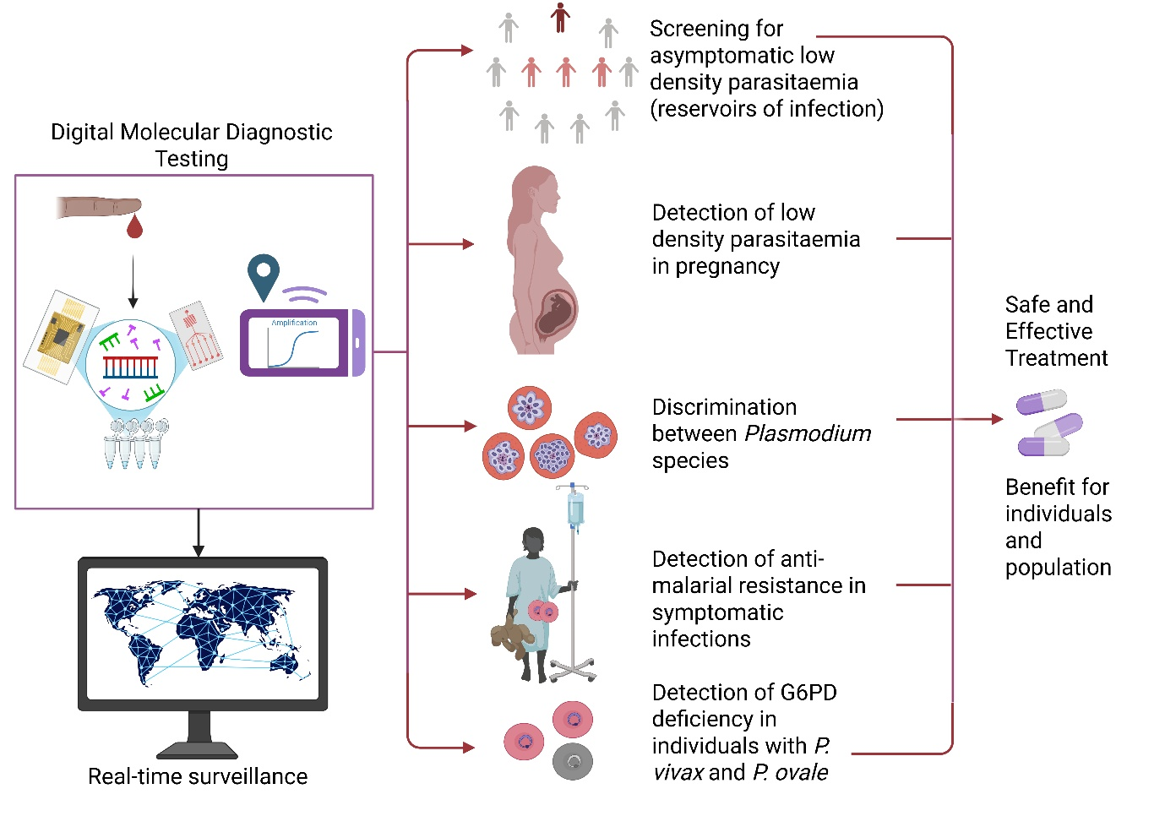

Table 1. Comparison of digital molecular diagnostic tools.

Technique | Sensitivity / Limit of Detection | Specificity | Cost per test | Portability | Robustness | Digital integration | Key limitations
Microscopy | ~50-100 parasites/µL  (experts may detect as low as 10 parasites//µL) | Moderate-High | ~$ 2.5-6 | Low | Stable reagents (Romanosky stains) | Automation possible, smartphone apps, cloud-based reporting | Digitalization is still research-based, upfront maintenance
RDT | ~50-100 parasites/µL | Moderate-High | ~$ 0.5-6 | High | Good field tolerance (temperature-stable) | Smartphone apps, RDT readers | Digitalization is still research-based
PCR platforms | Very high (<1 parasite/µL) | High | High (>$10–20)  High platform cost | Moderate–High (cartridge-based, some battery powered) | Robust in controlled field settings | Cloud-based reporting, real-time dashboards | High upfront and running costs; requires stable supply and cold chains
Digital LAMP platforms (smartphone-assisted readouts) | High (1–5 parasites/µL) | High | Moderate (~$3–5) | High (minimal equipment, battery powered) | Good field tolerance (temperature-stable reagents possible) | Smartphone apps, Bluetooth/Wi-Fi upload | Often species-specific reactions needed; moderate cost compared to RDTs
CRISPR-based diagnostics | Very high (<1 parasite/µL, depending on assay) | High | Currently moderate-high (>$5–10, not yet scaled) | High (portable readouts, paper-strip or fluorescence smartphone) | Reagent stability improving (lyophilized formats emerging) | Potential for real-time cloud-linked reporting | Early stage; limited field validation, regulatory approvals pending

