Drugs for airway disease

Matteo Bonini
Omar S. Usmani

Matteo Bonini MD PhD is Marie-Curie Researcher at the Airways Disease Section, National Heart and Lung Institute (NHLI), Imperial College London, UK, and at the Department of Public Health and Infectious Diseases, ‘Sapienza’ University of Rome, Italy. Competing interests: Matteo Bonini has received fees for speaking and reimbursement of expenses for attending symposia from Novartis, Boehringer Ingelheim and Almirall.

Omar S Usmani MBBS, PhD, FHEA, FRCP is Clinical Senior Lecturer and Honorary Consultant Physician at Imperial College London and the Royal Brompton Hospital, London, UK. Competing interests: Omar Usmani has received grant funding to his institution and financial assistance to attend advisory boards and present at symposia from the following organizations: Aerocrine, Almirall, AstraZeneca, Boehringer Ingelheim, Chiesi, Cipla, Edmond Pharma, GlaxoSmithKline, Micro-Dose Therapeutx, Mundipharma, NAPP, Novartis, Pfizer, Philips-Respironics, Pieris-AG, Prosonix, Sandoz, Takeda, UCB, Zentiva.

Abstract
Asthma is a heterogeneous disease characterized by chronic airway inflammation and variable expiratory airflow limitation. It affects 5–15% of people worldwide and shows an increasing prevalence over the last decade. The treatment of asthma is well established in current guidelines, with the aim of achieving optimal disease control and preventing acute exacerbations using a stepwise medication approach. Drugs are commonly divided into ‘relievers’, which quickly alleviate airway obstruction, and ‘controllers’, which suppress the pathophysiology and provide long-term symptom control. β₂-Adrenoreceptor agonists are the most effective therapy for reversing bronchial obstruction. Inhaled corticosteroids are recommended as first-line ‘controller’ therapy for persistent asthma. Acute exacerbations often require systemic corticosteroids. Muscarinic antagonists, methylxanthines, anti-leukotrienes, cromones and macrolides also play a key role in disease management. The use of biological agents has recently received increasing attention, prompting a drive for a so-called ‘precision-based medicine’ approach, particularly in more severe disease. The only biological drug currently licensed in Europe is the anti-IgE monoclonal antibody omalizumab. Several other antibodies and targeted molecules are under advanced development and are expected to be available on prescription soon, although they will be expensive.

Keywords
Anticholinergic; asthma; β₂-agonist; biological agent; bronchoconstriction; corticosteroid; exacerbation; inflammation; adverse effect; theophylline

Introduction
Asthma is a heterogeneous disease usually characterized by chronic airway inflammation. It is defined by a history of respiratory symptoms that vary over time and in intensity, with evidence of variable expiratory airflow limitation. Epidemiological data show that asthma affects 5–15% of people worldwide, with increasing prevalence over the last few decades.
Different asthma phenotypes have been described on the basis of clinical and functional patient characteristics (Figure 1). Asthma has long been recognized as an inflammatory T helper type 2 cell-mediated disease, but recent findings support alternative pathophysiological mechanisms and effectors, which define distinct endotypes (Figure 2).
Treatment is well established in national and international guidelines and aims to achieve optimal disease control and prevent acute exacerbations, using a stepwise approach to medication (Figure 3). Drugs are commonly divided into ‘relievers’, which quickly alleviate airway obstruction, and ‘controllers’, which suppress the pathophysiology and provide long-term symptom control (Table 1).
Most patients have disease of mild to moderate severity and are managed in the community. However, patients who have more severe disease that is refractory to conventional therapy, have co-morbidities (rhinitis, gastro-oesophageal reflux) or have the recently described asthma–chronic obstructive pulmonary disease overlap syndrome (ACOS) are hard to treat, prompting the current drive for a precision-based medicine approach involving patient-tailored treatment.
The following classes of drugs are relevant in the current management of asthma.

β₂-Adrenoreceptor agonists
These are the mainstay of asthma management and are the most effective available treatment for preventing and reversing bronchial obstruction. Initially developed for administration as tablets, they are currently best delivered by inhalation, achieving an effective local lung effect with the least systemic toxicity. The optimal site of aerosol deposition in the lungs depends on the drug particle size, pattern of breathing and anatomy of the airways. This class of drugs includes short-acting (SABA) and long-acting (LABA) β₂-adrenoreceptor agonists. More recently, ultra-LABAs (indacaterol, olodaterol, vilanterol), which potentially have a once-daily dosing regimen, have been developed; however, their use is currently mainly confined to COPD.

Mode of action
β₂-Adrenoreceptor agonists act via specific receptors (ADRβ2), localized mainly on airway smooth muscle cells. Occupation of ADRβ2 by agonists causes the activation of the Gs-adenylyl cyclase–cAMP–PKA pathway, leading to bronchial smooth muscle relaxation. However, several actions of β₂-adrenoreceptor agonists are mediated by other cAMP-regulated proteins. Numerous single-nucleotide polymorphisms and haplotypes of the human ADRβ2 gene have been described, potentially influencing the response to β₂-adrenoreceptor agonists. Clinical studies have shown that patients with the Arg16Arg variant have more frequent adverse effects and a poorer response to SABAs than heterozygotes or Gly16Gly homozygotes, but overall these differences are small. No differences have been found in responses to LABAs between these genotypes. β₂-Adrenoreceptor agonists act as functional antagonists and reverse bronchoconstriction irrespective of the contractile agent. Thus, they can cause bronchodilation not only via a direct action on airways smooth muscle, but also indirectly by inhibiting the release of bronchoconstrictor mediators from inflammatory cells and bronchoconstrictor neurotransmitters from airway nerves.

Clinical use
Inhaled SABAs (salbutamol, terbutaline) are the most widely used and effective relievers in the treatment of acute asthma with a rapid onset of action. In addition to their acute bronchodilator effect, they are effective in protecting against challenges such as exercise and allergens. SABAs should be only used as ‘rescue’ medication and not on a regular basis. Indeed, increased use (>2 times weekly) should prompt the need for more anti-inflammatory therapy.
LABAs (salmeterol, formoterol) represent a significant advance in asthma treatment. They have a bronchodilator action of >12 hours and also protect against bronchoconstriction for a similar period. Formoterol has a more rapid onset of action and is a full agonist, whereas salmeterol is a partial agonist with a slower onset of action. These differences might confer a theoretical advantage for formoterol in more severe asthma but can also make it more likely to induce tolerance. In asthma patients, LABAs should always be used in combination with inhaled corticosteroids (ICS), because LABAs do not treat the underlying chronic inflammation. LABAs are an effective add-on therapy to ICS and provide a greater clinical benefit as synergists rather than there being a doubling of the ICS dosage in symptomatic asthma.
Inhalers combining a LABA and a corticosteroid (fluticasone propionate/formoterol, fluticasone propionate/salmeterol, budesonide/formoterol, beclometasone dipropionate/formoterol) are widely used in moderate to severe asthma. There is a sound scientific rationale for their use: delivering both drugs from the same inhaler allows them to target the same airway regions and permits complementary molecular interactions between them. Combination inhalers are also more convenient for patients, simplify therapy and improve compliance with the corticosteroid because patients perceive clinical benefit from the bronchodilator.
The maintenance and reliever therapy (MART) approach involves as-needed use of a combination inhaler containing an ICS and the LABA formoterol, in addition to twice-daily maintenance doses. Only formoterol should be used as the LABA as it is a full agonist. Recent studies report that this is more effective for relieving acute symptoms, improving lung function and reducing the risk of exacerbations than either increasing the ICS dosage or using SABAs as ‘rescue’ medication. It might therefore be possible to control asthma with a single inhaler for both maintenance and relief of symptoms.
Oral and intravenous β₂-adrenoreceptor agonists are only rarely indicated as bronchodilators because of an increased risk of adverse effects.

Adverse effects
Adverse effects of β₂-adrenoreceptor agonists are dosage-related and mainly due to stimulation of extrapulmonary ADRβ2. They are usually infrequent with inhaled therapy but common with oral or intravenous administration. They include muscle tremor, tachycardia and palpitations. Dosage-related prolongation of the cardiac QTc interval and hypokalaemia have been noted. Hypokalaemia is caused by ADRβ2 stimulating potassium entry into skeletal muscle and is potentially serious, particularly in the presence of hypoxaemia, as in acute asthma, when there may be a predisposition to cardiac arrhythmias. In asthmatic individuals, tolerance can develop to the bronchoprotective effect of β₂-adrenoreceptor agonists, possibly from down-regulation of ADRβ2s; this is more marked with indirect bronchoconstrictor stimuli (allergens, exercise).
A possible causal relationship between LABAs and the rise in asthma exacerbations and deaths has been suggested, leading to doubts about the long-term safety of LABAs. Studies are currently examining this, especially in children. LABAs carry a pharmacovigilance warning cautioning against their use as monotherapy, and it is recommended that they are used only in combination with an ICS.

Muscarinic antagonists
Ancient Ayurvedic medicine used Datura stramonium (a plant with anticholinergic effects) for asthma treatment. The much later discovery of atropine, a potent competitive inhibitor of acetylcholine at postganglionic muscarinic receptors, and demonstration of the importance of the parasympathetic nervous system in bronchoconstriction, refocused interest on the potential value of antimuscarinic agents.

Mode of action
Anticholinergic drugs competitively inhibit the action of acetylcholine at the muscarinic receptors, blocking airway smooth muscle contraction and vagally induced increases in mucus secretion. Of the five subtypes of muscarinic receptor (M1–M5), bronchial tree receptors are mainly restricted to M1–M3. Antimuscarinic agents are highly selective and inhibit only the portion of the bronchomotor response mediated by muscarinic receptors. They can protect against acute exposure to sulphur dioxide, inert dusts, cold air and emotional triggers, but are less effective against allergen challenges. Muscarinic agonists are not functionally equivalent to each other, because they can act as antagonists, inverse agonists (inhibiting the constitutive activity of the M3 receptor) and modulators that up-regulate M3 receptor expression. This can have clinical relevance for their long-term use because tolerance and rebound on withdrawal could be major issues.

Clinical use
In asthmatic patients, anticholinergic drugs are less effective as acute bronchodilators than β₂-adrenoreceptor agonists and offer more limited protection against bronchial challenges. However, they can be more effective in older patients who have an element of fixed airway obstruction.⁴ Furthermore, anticholinergics exert an additional bronchodilator effect to that provided by β₂-adrenoreceptor agonists and can therefore be considered when asthma is not optimally controlled.
Among the short-acting molecules, ipratropium bromide and oxitropium bromide have long been adopted as asthma relievers. Ipratropium bromide is a selective quaternary ammonium derivative of atropine, available as a pressurized metered dose inhaler (pMDI) and nebulized preparation. The onset of bronchodilation is relatively slow and is usually maximal 30–60 minutes after inhalation, but the duration of action can persist for 6–8 hours. Ipratropium bromide is usually given three or four times daily on a regular basis. Oxitropium bromide is similar in terms of receptor blockade. It is available in higher doses by inhalation and can therefore have a more prolonged effect. It is therefore useful in some patients with nocturnal asthma.
More recently, tiotropium bromide, a long-acting molecule widely used in the management of COPD, has been reported to have a role in asthma therapy, particularly with the moderate to severe phenotype, where neutrophilic inflammation and more fixed bronchial obstruction have been reported. Tiotropium is now recommended by the Global Initiative on Asthma strategy document as an add-on bronchodilator in steps 4 and 5 of treatment for adult patients who are treated with the maintenance combination of ICS and LABAs and who experienced one or more severe exacerbations in the previous year. Tiotropium is suitable for once-daily dosing via a dry powder inhaler or slow-moving mist inhaler.

Adverse effects
Inhaled anticholinergics are generally well tolerated. On stopping treatment, a rebound increase in airway responsiveness has been described, although its clinical relevance is uncertain. Although cholinergic agonists can stimulate mucus secretion, ipratropium bromide, even in high dosages, shows no detectable effect on reduced mucociliary clearance. Anticholinergics can cause a dry mouth and an unpleasant bitter taste, contributing to poor compliance. Urinary retention is occasionally seen, so treatment should be carefully adopted in patients with urogenital disorders such as prostatic hyperplasia. Systemic adverse effects are uncommon because there is little systemic absorption. Nebulized ipratropium bromide can cause glaucoma in elderly patients from a direct effect on the eye.

Methylxanthines
Methylxanthines have been used as bronchodilators in asthma since the 1930s. Theophylline, similar in structure to caffeine, is on the British Thoracic Society management plan as add-on reliever therapy in patients with severe asthma. However, its frequency of adverse effects and relative low efficacy have lessened its use.

Mode of action
In addition to its bronchodilator action, theophylline has many non-bronchodilator effects that may be relevant in asthma (Figure 4).

Clinical use
In acute asthma, intravenous theophylline should be reserved for patients who fail to respond or are intolerant of β₂-adrenoreceptor agonists. The role of theophylline in contemporary management has been questioned. However, there is good evidence that it can provide an additional bronchodilator effect even when maximally effective doses of β₂-adrenoreceptor agonist have been given. Thus, the two can be usefully combined in specific circumstances. Theophylline can help nocturnal asthma because slow-release preparations can provide therapeutic concentrations overnight, although it is less effective than an LABA. Studies have also documented corticosteroid-sparing effects of theophylline.

Adverse effects
Unwanted effects are usually related to plasma concentration and tend to occur at concentrations >15 mg/litre. The most common are headache, nausea and vomiting (due to inhibition of phosphodiesterase-4 PDE4). There can also be increased gastric acid secretion (from PDE inhibition) and diuresis (due to inhibition of adenosine A1 receptors). At high concentrations, cardiac arrhythmias can result from inhibition of cardiac PDE3 and inhibition and antagonism of cardiac A1 receptors; seizures can occur from central A1 receptor antagonism. Corticosteroid-sparing (non-bronchodilator) effects can be achieved by aiming for plasma concentrations of 5–10 mg/litre, which largely avoids adverse events and drug interactions and makes close monitoring less necessary.

Corticosteroids
Oral corticosteroids were introduced for the treatment of asthma shortly after their discovery in the 1950s and remain the most effective controller therapy. By modifying the structure of cortisol, as secreted by the adrenal cortex, derivatives such as prednisone, prednisolone and dexamethasone were developed; these have enhanced corticosteroid effects but reduced mineralocorticoid activity. These derivatives are effective in asthma when given systemically, but the notable glucocorticoid adverse effects prompted efforts to discover new or related agents that would retain the beneficial airways action without significant adverse events.
The introduction of ICS, initially to reduce requirements for oral corticosteroids, revolutionized the treatment of chronic asthma. Substitutions in the 17α-ester position of the D-ring resulted in corticosteroids with high topical activity, such as beclometasone dipropionate, budesonide, ciclesonide and fluticasone propionate, which were found to have significant anti-inflammatory effects when given by inhalation.

Mode of action
Corticosteroids bind to glucocorticoid receptors (GRs) in the target cell cytoplasm. Moving into the nucleus, the corticosteroid–GR complex binds to specific sequences on the upstream regulatory elements of target genes. GRs also interact with protein transcription factors and co-activator molecules in the nucleus, widely influencing protein synthesis independently of direct interactions with DNA. The mechanisms of action of corticosteroids in asthma are still poorly understood, but their efficacy is probably related to their anti-inflammatory properties (Figure 5). They increase the transcription of several anti-inflammatory genes and suppress the transcription of many inflammatory genes. Moreover, they have inhibitory effects on many inflammatory and structural cells that are activated in asthma and prevent the recruitment of inflammatory cells into the airways. Furthermore, they potently inhibit the formation of cytokines (interleukin-1 (IL-1), IL-3, IL-4, IL-5, IL-9, IL-13, tumour necrosis factor-alpha (TNF-α), granulocyte–macrophage colony-stimulating factor (GM-CSF), secreted in asthma by T lymphocytes, macrophages and mast cells. Corticosteroids also prevent and reverse the increase in vascular permeability caused by inflammatory mediators, and thus lead to resolution of airway oedema. They have a direct inhibitory effect on mucus glycoprotein secretion from airway submucosal glands, and an indirect inhibitory effect by down-regulating the inflammatory stimuli that induce mucus secretion. It is important to recognize that corticosteroids suppress inflammation in the airways but do not cure the underlying disease.

Clinical use
ICS are recommended as first-line therapy for all patients with persistent asthma. For most patients, ICS is ideally used twice-daily once the asthma has been controlled. Once-daily administration of some corticosteroids (budesonide, ciclesonide) is effective when low doses are needed. If a high dose is delivered using a pMDI, a spacer device should be employed to reduce the risk of oropharyngeal adverse effects. The dose of ICS should be the minimal dose to controls asthma; once control has been achieved, the dose should be slowly reduced after 3 months of disease stability, as suggested in guidelines. Nebulized corticosteroids can be useful in the treatment of small children who are not able to use other inhaler devices.
Prednisolone and prednisone are the most commonly used oral corticosteroids. The maximal beneficial effect is usually achieved with 30–40 mg prednisone daily; the usual maintenance dose is between 10–15 mg/day. Short courses (1–2 weeks) of oral corticosteroids are indicated for exacerbations of asthma. Oral corticosteroids are usually given as a single dose in the morning because this coincides with the normal diurnal increase in plasma cortisol and produces less adrenal suppression. Intravenous corticosteroids are indicated in acute asthma if lung function (peak expiratory flow) is <30% predicted, and in patients who show no significant improvement with nebulized β₂-adrenoreceptor agonists. Hydrocortisone is the corticosteroid of choice because it has the most rapid onset (5–6 hours after administration). The required dose is uncertain, but it is common to give 4 mg/kg initially, followed by a maintenance dose of 3 mg/kg every 6 hours. Intravenous therapy is usually given until a satisfactory response is obtained, when oral treatment should be substituted.

Adverse effects
Corticosteroids inhibit adrenocorticotrophic hormone and cortisol secretion by a negative feedback effect on the pituitary gland. Hypothalamus–pituitary–adrenal (HPA) axis suppression usually occurs with prolonged courses of prednisone at doses >7.5–10 mg/day. Adverse effects of long-term oral corticosteroid therapy include fluid retention, increased appetite, weight gain, osteoporosis, capillary fragility, hypertension, peptic ulceration, diabetes mellitus, cataract and psychosis. The frequency of adverse effects tends to increase with age. Anaphylaxis from intravenous hydrocortisone has occasionally been described, particularly in aspirin-sensitive asthmatic patients. Symptoms of ‘steroid withdrawal syndrome’ include lassitude, musculoskeletal pains and occasionally fever.
Several systemic effects of ICS have been described, including dermal thinning and skin capillary fragility. HPA suppression with ICS is usually seen only when the daily inhaled dose exceeds 2000 microgram of beclometasone dipropionate or its equivalent. ICS can have local adverse effects from deposition of ICS in the oropharynx. The most common problem (up to 40% of patients) is dysphonia due to atrophy of the vocal cords following laryngeal deposition of corticosteroid. Throat irritation and coughing after inhalation are common with MDIs, apparently from additives. Oropharyngeal candidiasis occurs in ∼5% of patients. There is no evidence for increased lung infections, including tuberculosis, in patients with asthma.

Anti-leukotrienes
Leukotrienes (LT) are generated from the action of 5-lipoxygenase on arachidonic acid and are synthesized by a variety of airway inflammatory cells (eosinophils, mast cells, macrophages, basophils). LTB4 is a potent neutrophil chemoattractant, while LTC4 and LTD4 exert many effects known to occur in asthma, such as bronchoconstriction, increased bronchial reactivity, mucosal oedema and mucus hypersecretion.

Mode of action
Two different approaches have been identified to block the leukotriene pathway: inhibition of 5-lipoxygenase, preventing leukotriene synthesis, and inhibition of LTD4 binding of its receptor, preventing its action.

Clinical use
Clinical trials have shown improved asthma control with drugs of both categories, although significantly lower than that with ICS. A recent Cochrane meta-analysis showed that the addition of anti-leukotrienes to ICS was not associated with a statistically significant reduction in the need for rescue oral corticosteroids or hospital admission, compared with the same or an increased dose of ICS in children with mild to moderate asthma. Both treatments were equivalent in reducing the frequency of exacerbations. Leukotriene inhibitors have demonstrated an important role in aspirin-induced asthma, exercise-induced bronchoconstriction and distal airways disease. Although some patients appear to have particularly favourable responses to anti-leukotrienes, no clinical features allow the identification of ‘responders’ before a trial of therapy.

Adverse effects
A major advantage of anti-leukotrienes is that they are orally active, which can improve compliance with long-term therapy, particularly in children. Adverse effects are uncommon. Early reports of Churg–Strauss syndrome appear to have been coincidental, with the syndrome unmasked by the reduction in corticosteroid dosage.

Cromones
Sodium cromoglycate and nedocromil sodium were once widely used for asthma management, especially in children. However, they have now been replaced by other more effective therapies. Both have low solubility, are poorly absorbed from the gastrointestinal tract and are inhaled as a microfine powder or suspension. There has recently been interest in the pathways and mechanisms of action of these drugs to provide new targets for pharmacological therapy in asthma.

Mode of action
Sodium cromoglycate and nedocromil are thought to alter the function of delayed chloride channels in cell membranes, inhibiting cell activation. They have no effect on airway smooth muscle tone or reversal of asthmatic bronchospasm, but effectively inhibit both antigen- and exercise-induced asthma.

Clinical use
In short-term clinical trials, pre-treatment with cromones blocks the bronchoconstriction caused by allergen inhalation, exercise and a variety of causes of occupational asthma. This acute protective effect of a single dose makes Sodium cromoglycateuseful for administration shortly before exercise or unavoidable exposure to an allergen.
When taken regularly (2–4 puffs, 2–4 times daily), both agents significantly reduce symptom severity and the need for bronchodilator medications, particularly in young patients with allergic asthma. These drugs are not as effective as ICS, and the only way of determining whether a patient will respond is by a 4-week therapeutic trial.
Sodium cromoglycate and nedocromil nasal solutions are also useful in reducing symptoms of allergic rhinoconjunctivitis, which is a relevant risk factor for the development of asthma.

Adverse effects
Because the drugs are poorly absorbed, adverse effects are usually minor and localized to the sites of deposition. Effects include throat irritation, cough, mouth dryness and rarely chest tightness and wheezing. Serious adverse effects are rare. Reversible dermatitis, myositis or gastroenteritis occur in <2% of patients, and a very few cases of pulmonary infiltration with eosinophilia and anaphylaxis have been reported. This lack of toxicity accounts for their widespread use in children.

Macrolides
In view of their immunomodulatory and potential anti-inflammatory properties, macrolides can have a beneficial effect in asthma, which is often complicated by acute viral respiratory infections.^{14,15} Indeed, they are one of the most widely used antibiotic classes in the treatment of a broad range of chronic respiratory diseases. Macrolides are effective against a broad range of respiratory bacterial pathogens, including the atypical Chlamydia and Mycoplasma pneumoniae, which are both implicated in chronic asthma and asthma exacerbations.

Mode of action
Macrolides are derived from Streptomyces species. Structurally, they contain a 14-membered (erythromycin, clarithromycin, telithromycin), 15-membered (azithromycin) or 16-membered (spiramycin) lactone ring with one or more sugars attached. Macrolides are bacteriostatic and interfere with protein synthesis, altering many aspects of the lung–microorganism–environmental interface, such as biofilm and quorum sensing, as well as bacterial adherence, mobility and toxins.
They also possess anti-inflammatory properties that can contribute to clinical improvement in many patients with chronic airway inflammation. Macrolides inhibit the synthesis and/or secretion of proinflammatory cytokines such as IL-1, IL-2, IL-4, IL-6, IL-8, interferon-gamma, TNF-α and GM-CFS, while increasing the release of anti-inflammatory cytokines (IL-10, prostaglandins, transforming growth factor-beta (TGF-β)). Furthermore, they enhance several activities of alveolar macrophages, which play a key role in inflammation by phagocytizing apoptotic cells, bacteria and other inflammatory debris. In addition to their effect on the innate immune system, macrolides have an impact on adaptive immunity through T cell regulation.

Clinical use
Although the scientific rationale for the use of macrolides in asthma is persuasive, their efficacy in clinical trials has been variable, possibly related to underpowering of many studies. A Cochrane systematic review published in 2005 was inconclusive, but a more recent meta-analysis showed that macrolide treatment for ≥3 weeks produced significant improvements in clinical symptoms, peak expiratory flow, airway hyperreactivity and quality of life.

Adverse effects
Macrolides are metabolized by cytochrome P450 3A4 (CYP3A), so potentially serious interactions can occur with inhibitors or inducers of this enzyme (statins, warfarin, amiodarone); the incidence is lower with azithromycin than other macrolides. Increased hearing loss has been attributed to azithromycin use. Macrolides prolong the QTc interval, which in turn increases the risk of torsades de pointes, potentially resulting in ventricular fibrillation and sudden death. Nausea and diarrhoea are the most common gastrointestinal adverse effects. Telithromycin rarely causes liver injury, with high morbidity and mortality rates. There are concerns over the widespread use of macrolides in chronic respiratory disorders as macrolide-resistant species have emerged on both the individual and population levels.

Biological agents
The pathobiology of asthma involves several structural and inflammatory cells that cross-talk through numerous cytokines and chemokines. Many pathways of this complex network can be down-regulated using, for example, specific monoclonal antibodies and targeted small molecules (Figure 6).
The use of biologicals in asthma is receiving increasing attention, particularly for more severe disease that cannot be controlled by current drugs. The only biological agent currently available for the treatment of asthma is the anti-IgE monoclonal antibody omalizumab. Several others (mepolizumab (anti-IL-5), lebrikizumab (anti-IL-13) and dupilumab (anti-IL-4Ra)) are at an advanced stage of drug development and are expected to be available on prescription soon (Table 2); however, they will be expensive. In September 2015, mepolizumab received authorization in Europe as an add-on treatment for severe refractory eosinophilic asthma in adult patients.

Omalizumab
In severe asthma, a positive outcome for >16 weeks’ treatment with omalizumab dosed in relation to a patient’s basal total serum immunoglobulin (Ig) E concentrations is observed in approximately one-third of cases, although the effect can be lost after stopping treatment. The positive response mainly refers to a reduction in asthma exacerbations and in the dosage of ICS needed to maintain control. The effects on other outcomes such as symptom scores, pulmonary function tests and quality of life are less significant.

Mode of action Omalizumab is a recombinant humanized IgG monoclonal antibody that selectively binds the Cε3 domains of free IgE, making them unavailable for IgE receptor binding at cell level. It has also been shown to reduce concentrations of free IgE by interacting with the regulatory low-affinity FcεRII on B cells. This reduces the number of high-affinity FcεRI on effector cells and the activation of this receptor in antigen-presenting cells, leading to reduced T helper type 2 cell polarization (Figure 7).

Clinical use
In Europe, omalizumab can be prescribed for patients >6 years of age with severe asthma, poor asthma control despite an optimal inhaled treatment regimen, proven sensitization to perennial allergen(s) and total circulating IgE not exceeding the threshold of 700 kU/litre (Table 3). However, these criteria have not been shown to be a reliable predictor of treatment response. Some clinical trials have reported a positive outcome in non-atopic severe refractory asthma, possibly related to a local production of IgE.

Adverse effects
Anaphylaxis occurs in 0.09% of patients, usually after the first three doses of medication; this justifies recommending an observation period of 2 hours after the initial injections and 30 minutes after subsequent ones. Reactions at the site of injection occur in 45% of patients but tend to resolve within a week. A review of safety studies has suggested a slightly increased risk of adverse events involving blood vessels in the heart and brain (ischaemic heart disease, arrhythmias, cardiomyopathy, cardiac failure, pulmonary hypertension, cerebrovascular disorders, embolic, thrombotic and thrombophlebitic events), and the US Food and Drug Administration recently decided to add this information to the drug label. The initial concern of an increased risk of malignancy has not been substantiated by a review of 5-year safety studies in a larger patient database.

Key Points
- The treatment of asthma is well established in current guidelines and aims to achieve optimal disease control and prevent acute exacerbations
- Despite a significant increase in understanding the clinical syndrome of asthma, recent innovations in therapy have been confined to new inhaler devices and the advent of biological agents
- Asthma drugs are commonly divided into ‘relievers’ and ‘controllers’
- β₂-Adrenoreceptor agonists are the most effective therapy to prevent and reverse acute bronchial obstruction
- Tiotropium is now recommended in the GINA document as an add-on bronchodilator treatment in steps 4 and 5 for adult asthmatic patients treated with the maintenance combination of ICS and LABA, and who experienced ≥1 severe exacerbations in the previous year
- Inhaled corticosteroids are recommended as first-line ‘controller’ therapy for all patients with persistent asthma
- A recent meta-analysis showed that macrolide treatment for ≥3 weeks produced significant improvements in clinical symptoms, peak expiratory flow, airway hyperreactivity and quality of life
- Several monoclonal antibodies and targeted biological molecules are in an advanced stage of development and are soon expected to be included in strategies for management of severe asthma
- The anti-IgE monoclonal antibody omalizumab is currently the only biological drug available for the treatment of asthma; it has been shown to reduce exacerbation rates as well as decrease ICS requirements for maintaining disease control
- Patients who are refractory to conventional therapy or have co-morbidities represent an unmet need that has prompted an approach of patient-tailored treatment strategies

KEY REFERENCES
Global Initiative on Asthma. Global strategy for asthma management and prevention. www.ginasthma.com (accessed 10 September 2015)
Martinez FD, Vercelli D. Asthma. Lancet. 2013;382(9901):1360-72.
BTS/SIGN Asthma Guideline. www.brit-thoracic.org.uk (accessed 10 September 2015)
Pelaia G, Vatrella A, Maselli R. The potential of biologics for the treatment of asthma. Nat Rev Drug Discov. 2012 Dec;11(12):958-72
Fayt ML, Wenzel SE. Asthma phenotypes and the use of biologic medications in asthma and allergic diseases: the next step forward personalized care. J Allergy Clin immunol 2015;135:299-310.

FURTHER REFERENCES

Barnes PJ. Therapeutic approaches to asthma-chronic obstructive pulmonary disease overlap syndromes. J Allergy Clin Immunol. 2015;136(3):531-45.
Usmani OS, Biddiscombe MF, Barnes PJ. Regional lung deposition and bronchodilator response as a function of beta2-agonist particle size. Am J Respir Crit Care Med. 2005;172(12):1497-504.
Bonini M, Di Mambro C, Calderon MA, Compalati E, Schünemann H, Durham S, Canonica GW. Beta₂-agonists for exercise-induced asthma. Cochrane Database Syst Rev. 2013 Oct 2;10:CD003564.
Kerstjens HA, Engel M, Dahl R, Paggiaro P, Beck E, Vandewalker M, Sigmund R, Seibold W, Moroni-Zentgraf P, Bateman ED. Tiotropium in asthma poorly controlled with standard combination therapy. N Engl J Med. 2012;367(13):1198-207
Wong EH, Porter JD, Edwards MR,et al. The role of macrolides in asthma: current evidence and future directions. Lancet Respir Med. 2014;2(8):657-70.
Figures

Figure 1 Asthma phenotypes. AERD, Aspirin Exacerbated Respiratory Disease; EIA, Exercise-Induced Asthma; T_{H}2, T helper cell type 2. (Nat Med. 2012;18(5):716-25).
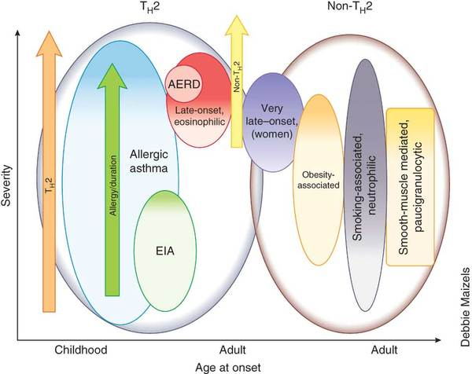
Figure 2 Pathophysiological mechanisms and effectors of asthma. CXCL, C–X–C motif ligand; IFNγ, interferon-gamma; IL, interleukin; MMP, matrix metalloproteinase; ROS, reactive oxygen species; TGFβ, tumour necrosis factor-beta; T_{H}, T helper; TSLP, thymic stromal lymphopoietin. (Nat Rev Drug Discov. 2012;11(12):958-72).
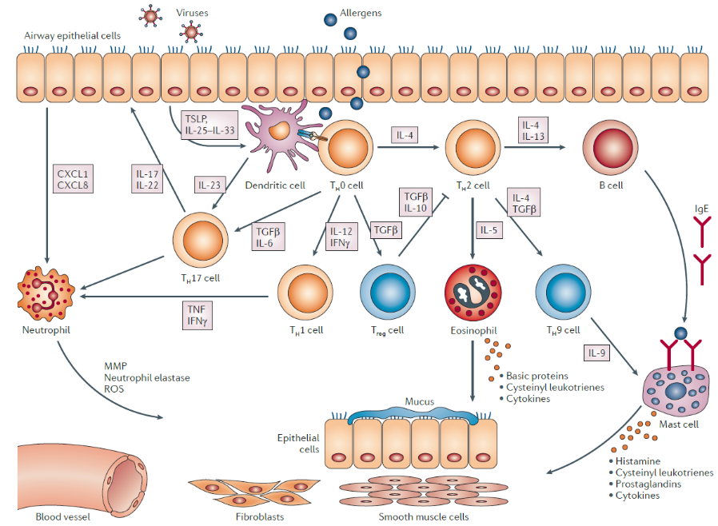

Figure 3 Effects of theophylline. (Drugs for airway disease. PJ Barnes 2012)
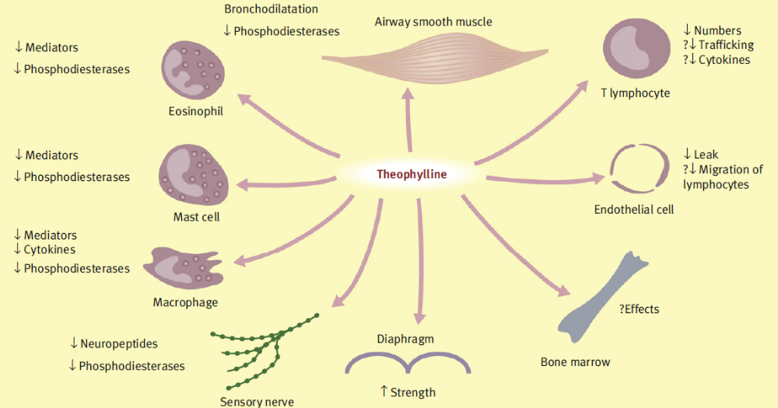

Figure 4 Effect of corticosteroids on airway inflammatory and structural cells. (Drugs for airway disease. PJ Barnes 2012)
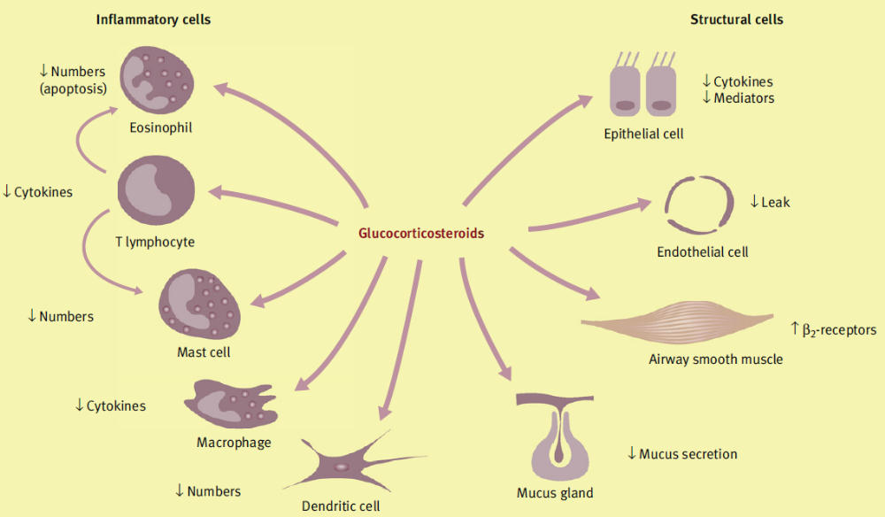

Figure 5 Therapeutic targets of biological therapy in asthma. Ab, antibody; T_{H}, T helper. (Nat Rev Drug Discov. 2012;11(12):958-72)
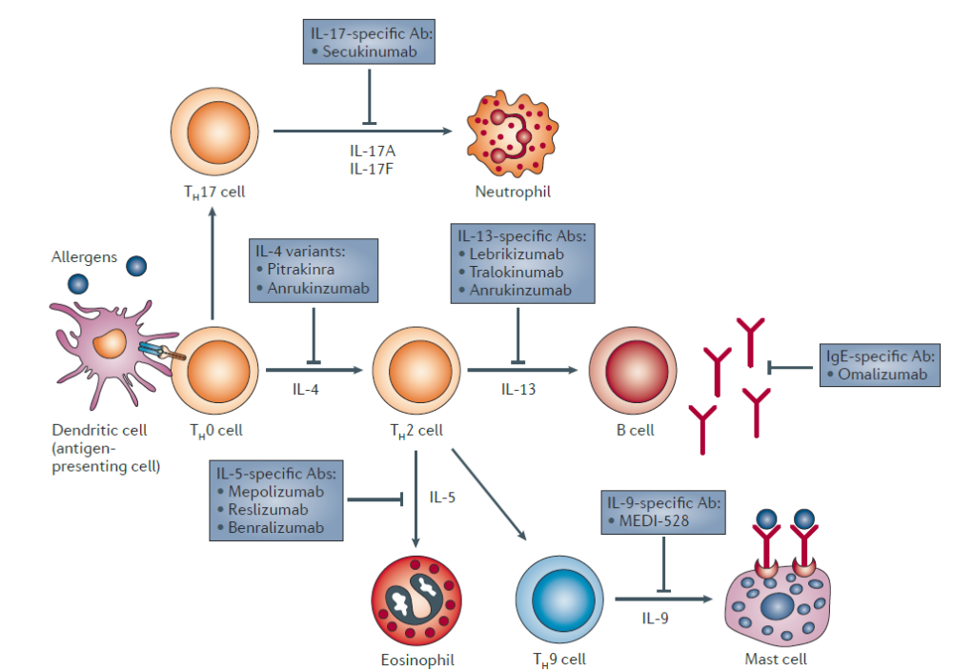

Figure 6 Mechanisms of action of omalizumab in allergic asthma. (Nat Rev immunol 2008;8:218-30)
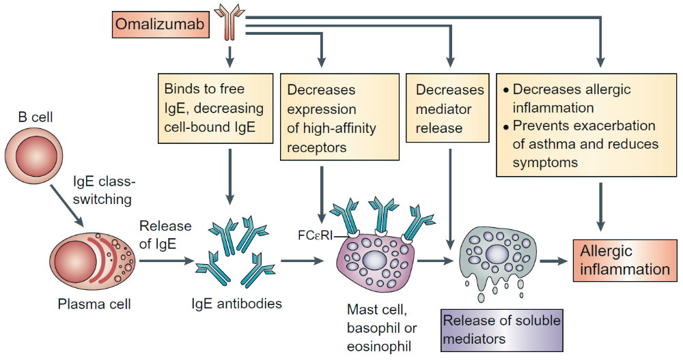
Tables

Table 1 Currently available treatments for asthma
Relievers | Controllers
β₂-Adrenoreceptor agonists | Corticosteroids
Anticholinergics | Anti-leukotrienes
Theophylline | Theophylline
 | Cromones
 | Macrolides
 | Monoclonal anti-IgE antibody

Table 2 Biological agents with encouraging results in Phase II–III studies of clinical asthma
Biologic agent | Target | Asthma in study population | Outcome
Mepolizumab | IL-5 | Mild to moderate  Severe, Th2-high | ↓Eos  ↓Eos, ↓Exacer, ↑QoL
Reslizumab | IL-5 | Severe, Th2-high | ↓Eos, ↓Exacer, ↑QoL, ↑PFT
Benralizumab | IL-5Ra | Moderate to severe | ↓Eos
Lebrikizumab | IL-13 | Moderate to severe, Th2-high | ↑FEV₁ (mainly in subjects with high periostin and IL-13)
Tralokinumab | IL-13 | Moderate to severe, Th2-high | ↑FEV₁ in subjects with high IL-13
Dupilumab | IL-4Ra | Moderate to severe, Th2-high | ↑FEV₁, ↓Exacer, ↓FeNO, ↓rescue medication
Pitrakinra | IL-4, IL-13 | Moderate to severe | ↓LPR, ↓FeNO
AMG 157 | TSLP | Mild allergic | ↓LPR, ↓Eos, ↓FeNO
OC000459 | CRTH2 | Stable atopic | ↑PFT, ↑QoL
CRTHS, xxxx ; Eos, Eosinophils; Exacer, exacerbations; FeNO, fractional expiratory nitric oxide; FEV₁, forced expiratory volume in 1 second; LPR, late-phase response; PFT, pulmonary function tests; QoL, quality of life; TSLP, thymic stromal lymphopoietin.

Table 3 Criteria required for prescribing omalizumab in Europe
Age >6 years
Severe persistent asthma
Positive skin test or in vitro reactivity to a perennial aeroallergen
IgE-mediated asthma (with IgE concentrations 30–700 IU/ml)
Body weight 30-150 kg(66–330 lb)
Symptoms that are inadequately controlled by ICS

