Mechanical failure of garnet electrolytes during Li electrodeposition observed by in-operando microscopy

William Manalastas Jr^{1,§}, Jokin Rikarte¹, Richard J. Chater², Rowena Brugge², Ainara Aguadero², Lucienne Buannic¹, Anna Llordés^{1,3}, Frederic Aguesse^{1,*}, John Kilner^{1,2}
1. CIC Energigune, Parque Tecnológico de Álava, C/ Albert Einstein 48, 01510 Miñano, Spain
2. Department of Materials, Imperial College London, Exhibition Road, SW7 2AZ, London, UK
3. IKERBASQUE, Basque Foundation for Science, Maria Diaz de Haro 3, 48013, Bilbao, Spain
* corresponding author: faguesse@cicenergigune.com

Keywords:
Ceramic electrolyte, garnet, failure mechanisms, all-solid-state batteries, Li electrodeposition/plating, soft dendrites, short-circuit

Abstract
Metallic Li anodes are key to reaching high energy densities in next-generation solid-state batteries, however, major problems are the non-uniform deposition of Li at the interface and the penetrative power of Li metal during operation, which cause failure of the ceramic electrolyte, internal short-circuits and a premature end of battery life. In this work, we explore the anode-electrolyte interface instability of a Li metal-garnet electrolyte system during Li electrodeposition, and its implications for mechanical fracture, Li metal propagation, and electrolyte failure. The degradation mechanism was followed step-by-step during in-operando electrochemical cycling using optical and scanning electron microscopy. High amounts of Li electrodeposition in a localized zone of the interface lead to ceramic fracture followed by an electrode-to-electrode electrical connection via a conductor Li metal filament. This work enables deeper understanding of battery failure modes in all-solid-state batteries containing a ceramic electrolyte membrane.

Introduction
Electric vehicles (EV) promise an eco-friendly solution for urban transportation. Their commercialization drives demand for Li-ion batteries delivering higher energy, power, cycle life and consequently vehicle mileage. Beyond battery performance metrics, safety is a major concern considering the statistics of vehicular collisions, temperature fluctuations, product design flaws, power surges, and aging.
The organic liquid electrolytes present in most manufactured Li-ion batteries exhibit low flash points and are prone to ignition which could lead to cell explosion upon thermal runaway. Hence, along with the growing demand for more powerful batteries, there is a strong drive for safer alternatives. Dense ceramic electrolytes are thus promising contenders to replace the flammable liquid electrolyte, however the poor mechanical properties of such thin ceramic membranes is a major constraint.
Ceramic electrolytes have attracted much interest in the scientific community because of their refractory properties which ostensibly remedies the safety problems of the batteries at high temperatures. Solid-state architectures eliminate fluid leakage, use of hazardous solvents and volatility concerns. Further, a stable ceramic electrolyte enables access to already developed, but commercially unused, high voltage cathodes and high capacity metallic Li anodes (3860 mAh·g⁻¹), to boost battery energy densities ^{1–4}.
Among the ceramics proposed as solid electrolyte for Li-metal batteries, Ga-substituted Li₇La₃Zr₂O₁₂ (Li_{6.55}Ga_{0.15}La₃Zr₂O₁₂) garnets exhibit a Li-ion conductivity of around 1.5 mS·cm⁻¹ ^{5,6} at room temperature, a wide electrochemical window (~6 V) ensuring stability against metallic Li reduction, as experimentally determined ⁷. A grain hardness of 6 GPa (and therefore the yield strength of a single-crystal ceramic). This yield strength value is about 3 orders of magnitude higher than that for Li metal (between 0.655 MPa to 2.0 MPa)^{8,9}. These are parameters complying with the properties required for the solid electrolyte component within an all-solid-state battery.
Battery prototypes using this material as thin coating have indeed demonstrated good rechargeability using low current densities ¹⁰. However, in bulk format even at low current densities (e.g. 50 µA·cm⁻², 30°C), the ceramic electrolyte often fails, evidencing internal metallic Li deposits ^{11–15}. Post mortem electron micrographs show either transgranular Li metal propagation ¹³ or grain-boundary electrodeposition ¹⁴. In these works, failure mechanisms have been ascribed to poor metal-electrolyte wetting, grain-boundary inhomogeneity and inhomogeneous current distribution. Recently, however, the Monroe-Newman model predicting that sufficiently-high shear modulus arrests dendrite propagation ¹⁶ may not be relevant in practice for polycrystalline samples ^{17,18} due to external factors and/or non-ideal systems. Nonetheless, the understanding of how soft metallic Li mechanically penetrates through hard and dense ceramics still remains unclear.
On a first argument, a stress-corrosion model similar to sodium beta-alumina behavior ¹⁹ was hypothesized due to the thermodynamic instability of garnet oxides against Li metal, as computed via first-principles methods ^{20–22}. Such studies predict the formation of a kinetically-driven interfacial passivation layer conferring an apparent contact stability between Li metal and bulk garnet-oxide ceramics, but leading to a possible chemical, mechanical and ion-conductivity mismatch and thus, providing sites for dendrite nucleation. In support, the experimental work of Park et al. ²³ and Ma et al. ²⁴ prove that facile cubic-to-tetragonal phase transition does tend to occur for LLZO when in contact with Li metal. Further, Sharafi et al. ^{13,25,26} and Cheng et al. ²⁷ showed correlations between critical current densities to metal/electrolyte interfacial resistances and wetting, i.e. by engineering lithiophilic layers or removing surface contaminants, garnet ceramics demonstrated dramatic improvements in critical current density values ^{28,29}.
On the other hand, a variation in localized ion conductivities across ceramic grain boundaries was detected using pinpoint two-probe scanning impedance microscopy ³⁰, and indeed, eliminating secondary phases and close pores, a remarkable improvement of the Li electrodeposition current density limit to 0.5 mA·cm⁻² at 25°C was achieved.³¹ Raj et al. further argues that dendrite nucleation exclusively originates from near-surface grain boundaries by exploiting analytical model.³² Electrodeposition creates localized mechanical stress and amplified tensile forces along remnant pores, leading to ceramic cracking. Porz et al. explain that Li-plating induces crack-tip stresses in pre-existing ceramic flaws.¹⁷ However, it is not yet experimentally observed nor understood whether the ceramic failure originates from imperfections located along grain boundaries or those within the bulk of a grain.
In this work, we combine in-operando optical microscopy, electron scanning microscopy and chemical analyses to elucidate the degradation mechanisms of the garnet electrolyte, avoiding destructive post-test analysis and its associated artefacts. We experimentally visualize the Li metal penetration in a dense Ga-doped LLZO during electrochemical operation, from its nucleation to complete cell failure. Supported by these new observations, we discuss the physical limits for application of garnet-based electrolytes in solid state batteries.

Experimental
Polycrystalline Ga-doped Li₇La₃Zr₂O₁₂ (Ga-doped LLZO) was produced via an established citrate-nitrate route ^{5,11} adopting a sintering temperature of 1200°C (6h) under dry O₂ flow. Green-body pellets were obtained by uniaxially pressing a powder-loaded cylindrical die of 6.35 mm diameter. After sintering, pellets were progressively abraded using 800, 1200, 2400 and 4000-grit SiC polishing papers (Lamplan®) to a lustrous surface finish within an Ar-filled glovebox (0.1 ppm O₂, <0.1 ppm H₂O). Samples chosen for the experiments had relative densities ranging from 92% to 96% of the theoretical density derived from the lattice parameters (5.2 g·cm⁻³) and closed porosity resulting from a liquid phase sintering process ³³. The pellet thickness was maintained at 1 mm. The relative density was determined geometrically.
Two complementary experimental setups were used to study Li metal propagation. In the first setup, a ceramic pellet was sandwiched in between two symmetric metallic Li electrodes. The pressure on both Li sides was maintained using a steel coil spring inside a two-electrode Swagelok cell (Fig. S1a of SI). Chronopotentiometric stripping/plating of metallic Li on alternating faces of this solid electrolyte was performed by applying current densities of 4, 8, 20 , 40, 80 and 200 μA·cm⁻² (10 minutes per step). This configuration enables tracking of current-voltage dynamics of Li electrodeposition/stripping through the ceramic.
The second setup consisted of co-planar mounted Li strips hand pressed on the same face of a freshly polished ceramic surface. The gap between the two strips was controlled to be about 650 µm with the help of an optical microscope. Cu wires were used as electrode leads for connecting the Li strips to an external potentiostat (Biologic). All manipulations were performed in an Ar-filled glovebox. This lateral configuration (Fig. S1b of SI) allows the non-destructive visualization under in-operando conditions of the ceramic co-planar zone experiencing Li conduction during electrochemical polarization.
Evolution of the surface of this Li conduction zone was tracked using SEM-EDAX, confocal Raman spectroscopy, optical microscopy, and Focused Ion Beam-Secondary Ion Mass Spectrometry (FIB-SIMS), during 3 stages: before applying a bias, after a 1 V bias, and after a 5 V bias polarization. Sample transfers between the Ar-glovebox and the analysis platforms were carried out using air-tight transport modules, except for the FIB-SIMS samples, which experienced minimal air exposures of 40 seconds during transfer to the chamber. The features on the surface were also analyzed in the FIB-SIMS by tilting the analysed surface to a 30° angle with respect to the gallium primary ion beam to maximize secondary ion collection.
The electron microscope used was a FEI-Quanta-200FEG model equipped with an EDAX detector, with the acceleration voltages fixed between 12 kV and 30 kV. Raman spectra of the ceramic pellet were collected using an inVia Renishaw confocal microscope in the polarized mode with an excitation wavelength of 532 nm. The laser spot size was < 2.0 μm at 1.5 mW with a step time of 50 s; signals were accumulated within the wavenumber range of 100-800 cm⁻¹. Optical micrographs and video acquisition were obtained using a Zeiss Axioscope A1 unit, through clear high-transmission borosilicate glass window (as part of the airtight sample holder). For the FIB-SIMS experiments, the ceramics were clipped onto the sample stage and sputtered with a 30 keV Ga⁺ beam incident at 30° to the normal of the ceramic surface to analyze the craters. The FIB-SIMS instrument is equipped with two SIMS detectors for positive ions and negative ions to allow the collection of positive and negative secondary electrons at the same time.³⁴ Positive ions were detected by an FEI SIMS detector whereas negative ions were detected by a Hiden EQS SIMS detector system. The SEM and FIB-SIMS are both high-vacuum instruments in which the oxygen and moisture partial pressures on pump-down (i.e. < 1 x 10⁻⁴ mbar) are equivalent to or lower than Argon-glovebox levels. All the microscopy experiments were performed at room-temperature. Thermal conductivity measurements were performed on a graphite-coated (PELCO®) ceramic with an LFA 457 MicroflashTM (Netzsch) station.

Results and Discussion
We previously reported a Ga-doped LLZO prepared by a sol-gel route presenting high ionic conductivity (~1 mS/cm) ^{5,11} and low electronic transference number (10⁻⁴-10⁻⁶).¹¹ The absence of multivalent ions impedes oxidation/reduction processes and wide band gap confers to the ceramic a significant electrochemical stability up to high voltage.^{7,35} This is supported by experimental voltammetry analyses of bulk LLZO showing a stability spanning from 0 to 6 V vs Li⁺/Li ⁷ whereas thermodynamic stability of LLZO is predicted by DFT calculation from 0.05 to 2.91 V (vs Li⁺/Li).^{20,21,24}
In the present work, the electrochemical behaviour of the Ga-doped LLZO/Li metal interface was first examined through stripping/plating experiments using a symmetric configuration with two lithium metal electrodes (Fig. 1a). Considering that Li metal electrodes were hand-pressed onto the surface of the ceramic electrolyte and that both Li metal and ceramic surface have a non-negligible roughness, imperfect contact pre-exists (Fig. 1b). The degree of imperfections/voids is difficult to quantify without advanced techniques but we could assume that areas in which areas of limited intimate contact between the ceramic and the Li metal will be non-negligible. The first current density applied facilitates contact point reinforcement at the cathodic interface due to electrochemical activity where Li metal can be reduced (plating process). Simultaneously on the other side (anodic interface), atoms of lithium from the Li metal are oxidized to Li-ions flowing into the electrolyte (stripping process) and stripping the anodic interface. At the interface of opposite electrodes, depleted zones and redox nucleation points are formed. In the subsequent current reversal, the interface dynamics are reversed: the previously stripped interface becomes a plated zone, and the previously plated interface becomes a stripped zone. One may intuitively presume that the plating and stripping will take place in the areas of direct contact between the ceramic and the Li metal so that electron transfer is possible. This implies that Li metal will deposit at the interfacial contact points creating local spill-overs whereas stripping will consume Li metal from an array of interfacial contact points at the opposite side. As this is a current-density focusing driven reaction, it is expected that the Li metal does not have time to relax within the timeframe of electrodeposition and cannot fill the empty voids and pores. Repeated current reversals may distribute metallic Li unevenly at the interface, giving rise to two main features: formation of voids and contact loss during the stripping phases, and Li metal agglomeration during plating.
The contact irregularities and the interface geometry create ion and electron preferential paths at the contact points of the interface, leaving insulating voids. High accumulation of charges and current densities are expected at the edges of the voids (Fig. 1b), worsening the stripping/plating phenomena. The interfacial resistance can be modelled as a parallel array of Randles-type circuit elements (with the capacitance components neglected and any decomposition products implicitly accounted for, for simplification). Direct-contact zones between the bulk Li-metal and the electrolyte would exhibit an intrinsic charge transfer resistance (R_{CT}), whereas no-contact zones would hold relatively infinite resistance (R_{void} =∞).
The macroscopic result is:

$$\frac{1}{R_{interface}}=n \frac{1}{R_{CT}} + \left(1-n\right) \frac{1}{R_{void}}$$
Where, n is the ratio between the true contact area and the nominal contact area. A higher ratio n implies a lower measured interfacial resistance (R_{interface}).
Microscopically, currents will flow following the least electrically resistive paths, i.e. through R_{CT}. This locally concentrates the charge transfer event (ionic current at the electrolyte and electronic current at the electrode) across the points of electrode-electrolyte contact on the stripping/plating interfaces, leading to focused electrodissolution and electrodeposition, respectively. This preferential current path means that a much higher local current density is exerted than for nominally-applied values ³⁶.
As a consequence, during the stripping/plating experiment, a three-stage behaviour is observed (Fig. 1c): Region I) at low current densities, stable cycling with ohmic behaviour of the garnet electrolyte. Region II) reaching 40 μA·cm⁻², onset of polarization instability and finally a region III) short-circuit after ~7 h of stripping/plating. Increasing the current density and the number of stripping/plating cycles, the ceramic electrolyte eventually fails as indicated by the system dropping to a 0 V potential at t ≈ 7 h (Fig. 1c, during the 80 μA·cm⁻² step). This event was previously described as Li metal penetration through the ceramic and ceramic fracture ^{11,15,37}, and constitutes an abrupt switch in charge carriers from ionic to electronic. However, the system registered a rising overpotential shortly thereafter. This suggests breakage of the metallic junction responsible of the short-circuit and a reversion from electronic to ionic in terms of charge carriers. Nonetheless, a permanent change in behavior of the failed ceramic electrolyte is noted as the system started strongly deviating from classic ohmic responses thereafter.

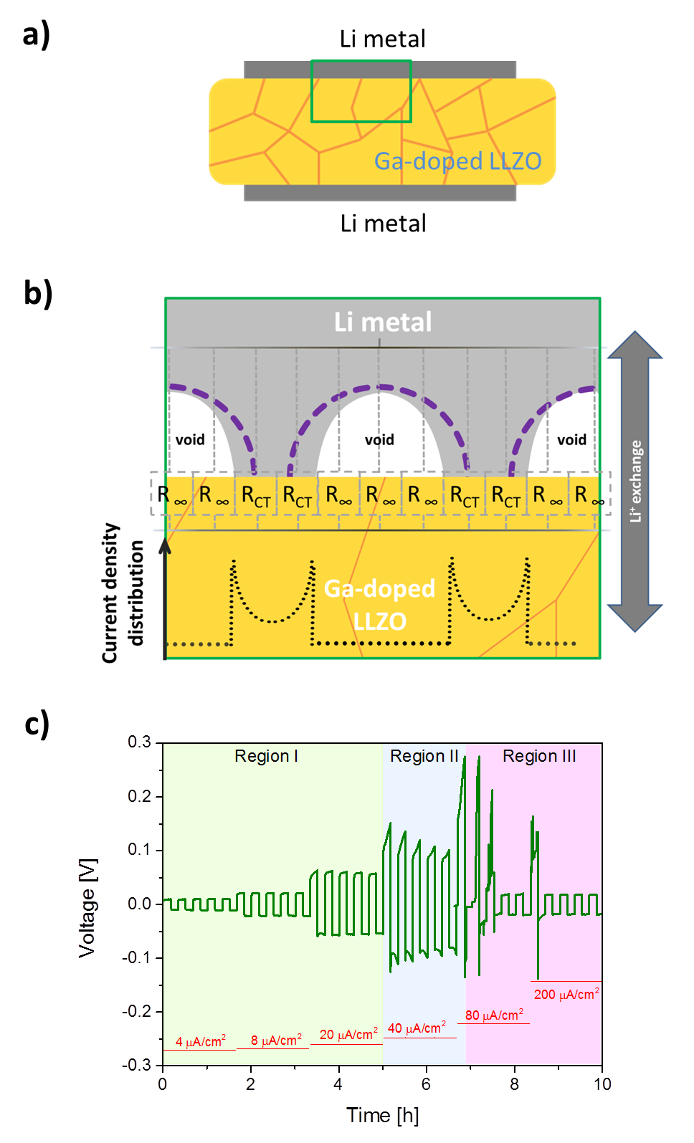
Figure 1. Interfacial evolution and electrochemical behavior in symmetric cell configuration. (a) Schematic of the symmetric cell configuration with Ga-doped LLZO in between two Li metal electrodes. (b) Enlargement of the stripping interface (green rectangle of (a)). Electrical model represented by resistor components connected in parallel; dashed purple lines illustrate the reduction in contact areas with Li dissolution when exceeding a certain current density threshold; black dotted lines indicate regions with concentrated current densities. (c) Measured overpotentials for Li electrodeposition at various current densities (4, 8, 20, 40, 80 and 200 μA·cm⁻²) on DC bias, the colored areas highlight the different regions from normal, instable and cell failure.
In order to understand this phenomenon, and to be able to visualize the Li metal penetration stages, a constant polarization was applied between two Li electrodes positioned laterally at the surface of the garnet (Fig 2 a and b). Before applying the voltage bias, the surface of the ceramic electrolyte shows the expected microstructure, with no apparent degradation (Fig. 2c). A distinctive bimodal grain size distribution (large grains of ≥ 200 µm and small grains of about 10 µm) characteristic of liquid phase sintering can be observed. Minor interspersed closed pores were also present at the surface. Such a grain-size profile increases the bulk conductivity contribution due to minimal grain boundaries, but creates expectations of low plasticity/intergranular strength.³⁸
Following the application of a low voltage bias of 1 V for 30 min, outgrowths start to appear at the surface. These outgrowths are primarily forming along the grain boundaries and not in the regions containing small grains or pores (Fig. 2d). Upon subsequent application of higher voltage bias (5 V, 1 min), multiple mechanical fracture lines are observed and the outgrowths increase in size and number (Fig. 2e). They erupt along the generated transgranular fracture lines (indicating by an arrow on Fig. 2e, and Fig S2) and exhibit optical luster, indicating a likely metallic nature.

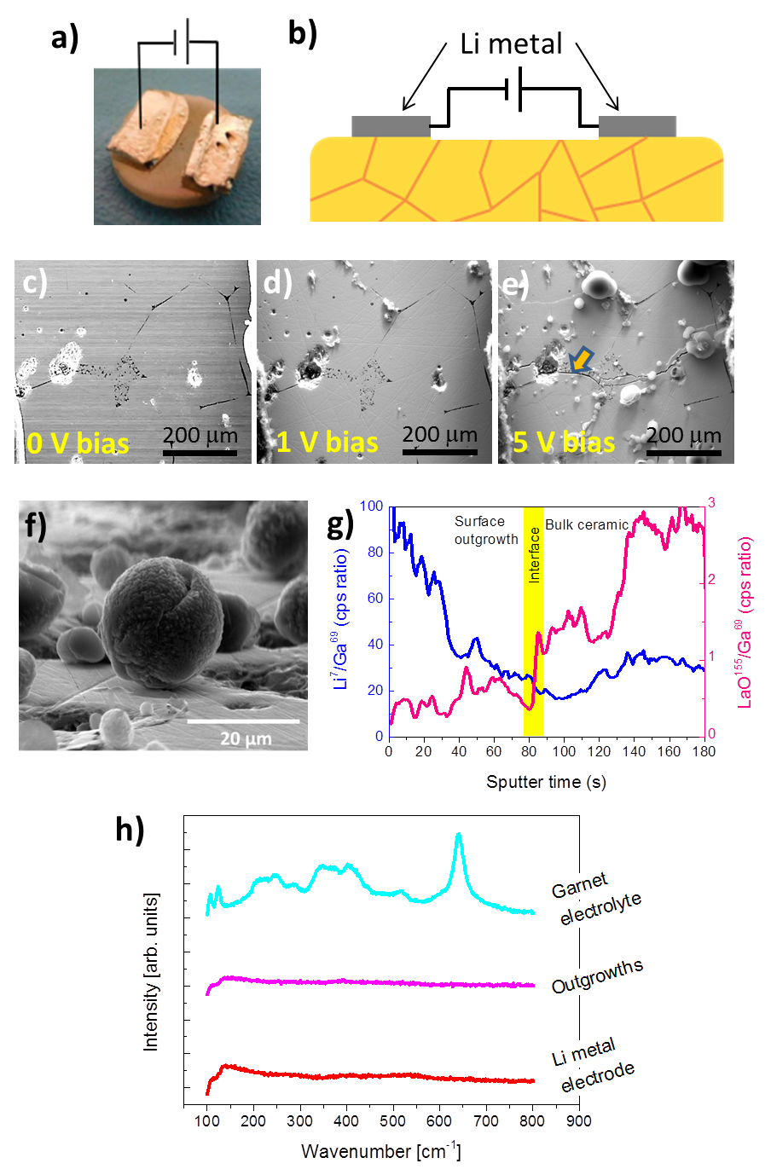
Figure 2: Characterization of the garnet surface after polarization in co-planar symmetric configuration. (a) Photograph and (b) schematic of the co-planar configuration of the Li metal electrode on top of the surface of a Ga-doped LLZO ceramic pellet. Secondary electron images (30 kV) of the ceramic surface c) prior to lateral polarization, d) after 1V bias for 30 mins, e) after 5V bias for 1 min; f) Secondary electron image of a Li metal outgrowth sitting on top of the ceramic surface; g) FIB-SIMS profile tracking of ⁷Li and ¹⁵⁵LaO intensities in ratio to ⁶⁹Ga secondary ion intensity. The yellow band represents the interface between the outgrowth and the ceramic; h) Raman spectra obtained from the surface of the garnet, the outgrowths, and the Li metal electrodes.

To gain deeper insight on the structure and chemical nature of the outgrowths, they were further analyzed by SEM, FIB-SIMS and Raman spectroscopy. Electron microscopy measurements revealed that the outgrowths are sitting on top of the surface of the ceramic. They present an almost-spherical shape similar to droplets with a diameter up to 20 µm (Fig. 2f), suggesting that they were formed through a solidification process from an intermediate liquid phase. The dark contrast images obtained using the backscattered electron imagery (Fig. S3) imply an elemental composition of predominantly low atomic number relative to LLZO. Hence, chemical identification of the material by EDAX was not possible due to poorly confined sampling volumes.³⁹
To further explore the nature of the outgrowths, high resolution elemental analysis was performed using FIB-SIMS, ion-milling down from the surface of the outgrowth using a small circular raster. The ion-beam produced a sputtered hole in the center of the sphere and subsequently into the garnet ceramic (Fig. S4). Throughout this process, the spheres were seen to be mostly solid rather than hollow and presenting a layering structure. By following the secondary ion intensity of Li and La over time, some inference could be deduced as to the composition of the spheres (Fig. S5). However, no quantitative conclusions can be made as Ga was the primary species of the sputtered beam. Normalizing against the Ga signal for Li⁺ (⁷Li/⁶⁹Ga) and LaO⁺ (¹⁵⁵LaO/⁶⁹Ga) as the sputtering progresses through the spherical particle, it could be observed that the outgrowth was Li-rich (during the first 70s of the measurement) (Fig. 2g).
Confocal optical-Raman spectroscopy provides additional details on the chemical composition of the spherical outgrowths. The comparison of Raman spectra taken at various selected points (Fig. 2h) demonstrate that the outgrowths and exposed areas of the metallic Li electrodes registered flat line Raman activity whereas exposed areas of the garnet ceramic exhibited the expected LLZO peaks.²⁵ Most metals are Raman inactive due to the strong shielding effect of free carriers.⁴⁰ The Raman observations support further the metallic character of the outgrowths.
Through the complementary analyses done by electron microscopy, FIB-SIMS and Raman spectroscopy, we clearly identified that the outgrowths formed during the applied bias are dominantly composed of metallic Li. The spherical morphology of the outgrowths also suggests that they erupted in a liquid phase before solidifying on the surface of the ceramic electrolyte. The spheres grow most probably by adding layers at the base. Moreover it is interesting to note that the angle between the spherical outgrowths and the ceramic is close to 180°, revealing the poor wettability of this material on the ceramic surface, in agreement with the litiophobicity concept.²⁹

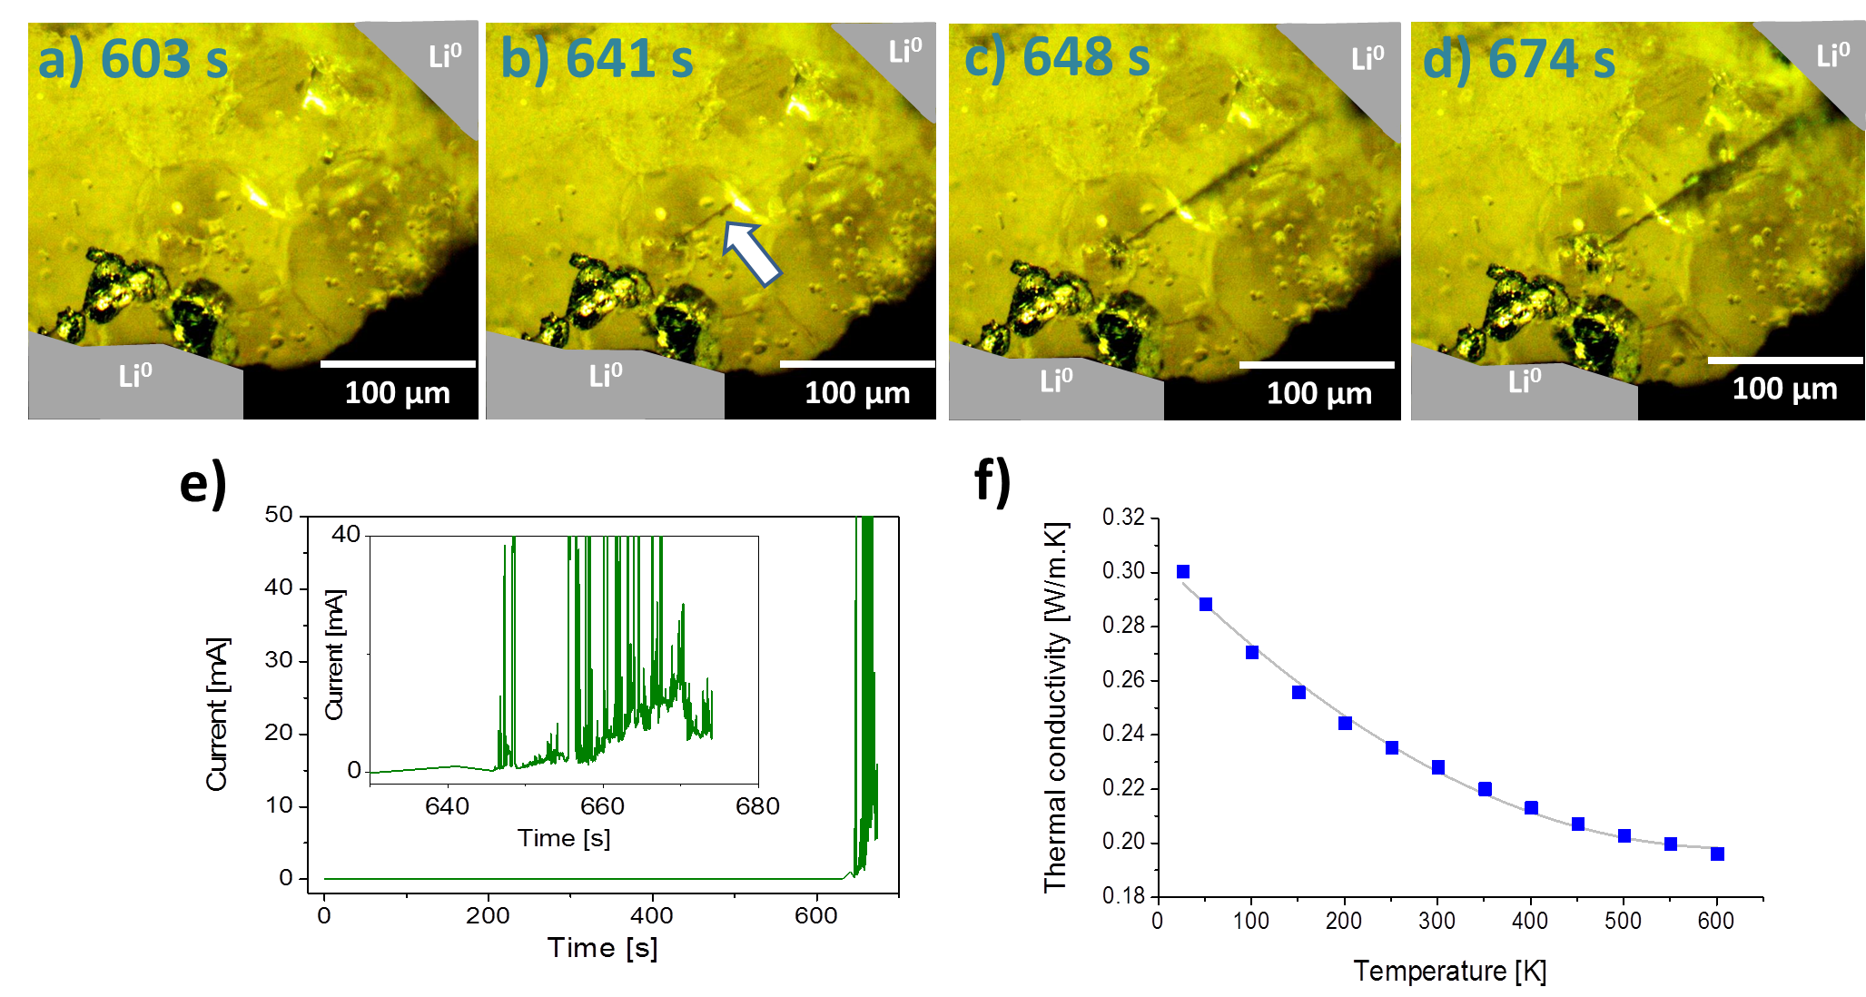
Figure 3: In-operando characterization of the garnet surface after 5V bias polarization in co-planar symmetric configuration. In-situ optical microscopy of a Ga-doped LLZO ceramic pellet with Li foil contacts (colored in grey for guidance), for which snapshots were taken at 603s (a), 641s (b), 648s (c) and 674s (d) (The complete video can be found in SI). The crack begins at 641 s (white arrow) and short-circuits the two Li metal electrodes at 648 s. e) Current evolution during the polarization experiment. f) Thermal conductivity data for a Ga-doped LLZO ceramic pellet from 25 to 600°C.
To understand how these metallic outgrowths are formed, a real-time observation by optical microscopy was recorded under applied voltage bias in a symmetrical cell with co-planar electrodes (video in SI). Optical snapshots of key moments of the experiment are reported in Fig. 3 a-d. The Li foils (coloured in grey) are present at opposite corners of the snapshots and large grains, characteristic of these samples, are readily visible in between. The voltage bias was applied in a single direction with plating occurring at the lower electrode visible in Fig. 3 a-d while stripping takes place at the upper one.
During the first 600 s of the polarization step, Li ions are directed towards the lower electrode interface. Plating occurs at the electrode interface and results in metallic agglomerates (Fig. 3a, lower electrode); presumably Li metal spills over the surface of the ceramic due to the geometrical configuration. At 641s, a fracture line begins to form in the middle of the ceramic, close to the plating side (Fig 3b, white arrow). This fracture line is gradually filled with a grey-colour material, presumably Li metal, and extends towards the opposite electrode until connecting the two electrodes (at 648 s, Fig. 3c). This connection produces a physical pathway between the two Li metal electrodes causing a short-circuit, which then fuses to break the current. This process, from the initiation of the fracture line to the connection with the opposite electrode, took about 7s. Once the short circuit is created, it slightly expanded and left a clear grey line (at 674 s, Fig. 3d). Interestingly, the galvanometric profile under the applied bias shows current spikes beginning at ~650 s, consistent with the optically-tracked completion of the short-circuiting Li filament junction (Fig. 3e). The amount of lithium transported and plated during the first 674 s at the interface is equal to about 30 μg, as calculated from the integration of the measured current vs. time.
The results from the in-operando optical microscopy study (Fig 3 a-d) and video (SI), clearly shows that the mechanism of cell failure originated, first, by crack initiation followed by Li metal propagation. Given the relatively low yield strength of Li metal (0.655 MPa) ⁹ compared to that of a ceramic oxide (approximately equal to its hardness, e.g. 6.3 GPa for Al-doped LLZO)⁸, it should not be expected that Li plating could induce mechanical fracture (a quantification of the pressure built at the interface by the Li deposition is detailed in the SI). As previously observed, the crack formation initiating the transgranular mechanical fracture occurs on the plating side. This suggests that the bias-driven plating accumulates Li metal at the surface of the ceramic until crack initiation. These experimental data evidence the failure model reported by Porz et al. where heterogeneous electrodeposition creates localized stress and leads to ceramic cracking ¹⁷.
In addition, the thermal conductivity of the Ga-doped LLZO ceramic was measured from room temperature up to 600°C (Fig. 3f), the results show that the ceramic has a thermal conductivity value no greater than 0.3 W·m⁻¹·K⁻¹ over this temperature range. For comparison, the thermal conductivity of Li metal is 85 W·m⁻¹·K⁻¹ at 27°C ⁴¹. This difference in the magnitudes of the thermal conductivity impedes any fast thermal exchange between the Li metal filament and the ceramic. As consequence, the temperature of the Li metal filament will continuously increase through Joule heating and eventually locally reach the melting point of Li metal (i.e. 180.5 °C). The combination of cracks and molten Li would explain the Li metal eruption within and outside the ceramic, in the co-planar electrodes cell configuration (Fig. 2) and as previously reported in refs ^{11,12}. Thereafter, upon cooling, the erupted Li metal solidifies into the observed spherical outgrowths. This hypothesis also explains why the outgrowths are located at the middle of the sample rather than close to an electrode. As Li metal melts, the Li filament connecting the two electrodes is fragmented and therefore the short-circuit junction across the ceramic disappears. This revives the Li-ion conduction properties of the ceramic until the next crack formation. It can be expected that this process will continuously take place creating voltage instability as observed when cycling the cell in Fig. 1c (at 80 μA·cm⁻²). This behaviour could be referred to the formation of soft dendrites that goes “on and off” while cycling and represented a charge capacity lower than the discharge one. For the first time we report this concept in ceramic electrolytes as a prelude but not exclusively leading to cell failure in operational Li metal battery cells.¹¹

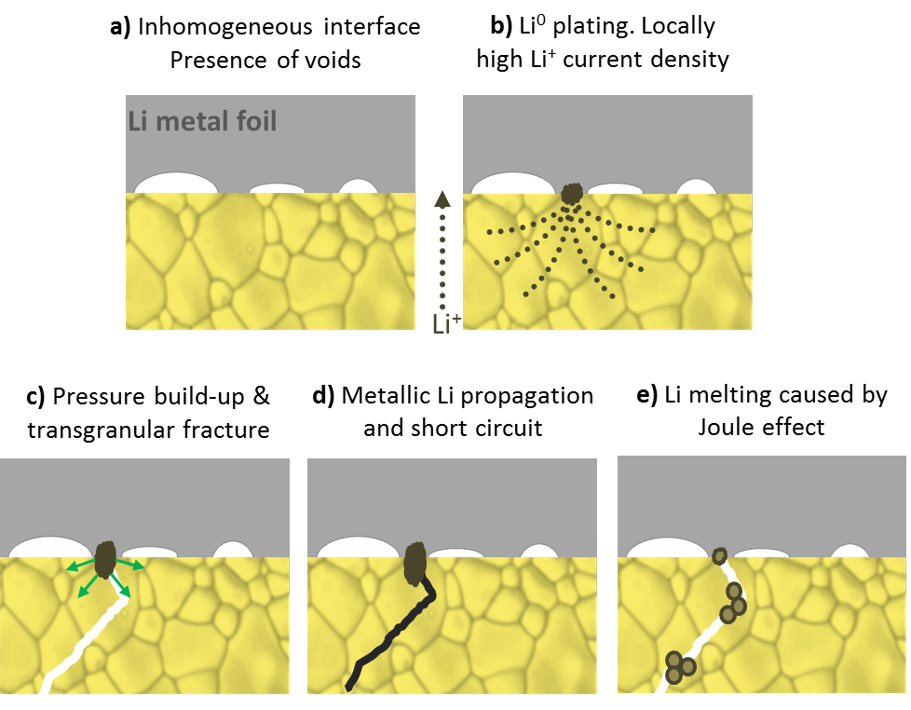
Figure 4. Proposed mechanism for the mechanical failure of the ceramic electrolyte and cell short-circuit . Electrochemical polarization induces preferential current density paths (doted line) at the Li metal interface causing first, pressure build-up (arrows), then cracking of the ceramic electrolyte and lastly crack infiltration of melted Li metal.

The schematic in Fig. 4 summarizes the proposed mechanisms of the ceramic failure when applying a bias voltage or during a plating experiment. The sequence taking place at one interface can be developed as follows:

- Interface formation: The assembly of Li metal with the ceramic leads to inhomogeneous and not-intimately contacted interfaces with voids and asperities. The direct surface area of contact between the ceramic and metallic Li is lower than the surface area of the electrode.
- Li metal plating: the Li⁺ reduction continuously occurring at the same contact point generates high amount of metallic Li in localized zones.
- Crack initiation and propagation: As a consequence of heterogeneous plating, pressure builds up locally and transgranular cracks appear and propagate.
- Short-circuit formation: Li metal propagates along the crack and fills up the empty space connecting the two electrodes and generating a short-circuit.
- Joule heating effect: The high electronic current concentration along the short-circuiting path induces a Joule heating effect that causes the Li metal to melt and erupt outside the ceramic, breaking the Li metal filament and ending the short-circuit.
Several strategies could be applied to tackle the ceramic failure during operation: interfacial engineering to homogenize the Li formation during plating as it could be realized by lithium thermal evaporation; high-temperature operation to facilitate the self-diffusion of Li-ions at the surface; and improvement of the mechanical properties of the ceramic so higher pressure of Li can be accumulated locally.

Conclusions
The failure mechanism of a polycrystalline garnet ceramic electrolyte during stripping/plating operations is proposed. Initially, the ceramic was tested in a symmetric cell configuration, confirming the limits of the material as an electrolyte against metallic Li at high current densities. We observed that, in a planar configuration, metallic Li erupts out of the ceramic in a liquid phase and solidifies on the surface. An in-operando experiment was designed to gain deeper understanding of the degradation mechanisms of the ceramic during operation. The evolution of the lithium plating between the electrodes positioned in co-planar configuration was followed and recorded by optical microscope. Initially, metallic Li plates in localized areas of the interface between the ceramic electrolyte and the Li electrode. The accumulation of material in a single spot generates locally high amount of pressure that eventually induces a mechanical cracking of the ceramic. As the crack progresses, metallic Li plates and fills the crack leading to a short-circuit in the form of a thin Li filament. The current concentrates at this low resistance path, generating tremendous local heat, and which, by Joule heating effect, melts the Li metal filament and disperses it in multiple lithium droplets, in and outside the ceramic. This behavior explains the unstable voltage polarization observed during stripping/plating experiments. Improvement of the interfacial mechanical properties of the LLZO ceramic electrolyte is crucial to overcome the failure and access the high current densities required for application in solid-state-batteries.

Acknowledgments
This research was carried out at CIC Energigune (Spain) and was funded by Gobierno Vasco, within the project framework ETORTEK CIC ENERGIGUNE 2013 and 2015. A.L. also thanks IKERBASQUE for financial support. W.M. and J.K. thank Prof. A. Virkar for inspirational discussions. F.A. thanks Dr. Michel Armand for his fruitful suggestions.

Authors contribution statement
W.M. supervised and realized the experimental work. J.R. supported the optical microscopy study. R.C. conducted the FIB-SIMS study. W.M., J.R. and R.B. prepared the samples. A.A. and J.K. supervised the work at Imperial College. F.A., A.L and L.B. supervised the work at CIC Energigune and lead the study. All the authors contributed to the manuscript

Supplementary info:
The supplementary information is composed of:
- Schematic of the experimental setup
- Repeated co-planar experiment for reproducibility
- Metallic lithium outgrowths on the surface (size and wettability)
- Post- FIBSIMS experiment: drilled crater
- Post experiment ceramic surface aspect
- Calculation of the pressure accumulation

Current address
§Department of Materials Science and Engineering, Nanyang Technological University, 639798 Singapore

References:
1 J. Janek and W. G. Zeier, Nat. Energy, (2016), 1, 16141.
2 M. Keller, G. B. Appetecchi, G.-T. Kim, V. Sharova, M. Schneider, J. Schuhmacher, A. Roters and S. Passerini, J. Power Sources, (2017), 353, 287–297.
3 A. Manthiram, X. Yu and S. Wang, Nat. Rev. Mater., (2017), 2, 16103.
4 A. Mauger, M. Armand, C. M. Julien and K. Zaghib, J. Power Sources, (2017), 353, 333–342.
5 C. Bernuy-Lopez, W. Manalastas, J. M. Lopez del Amo, A. Aguadero, F. Aguesse and J. A. Kilner, Chem. Mater., (2014), 26, 3610–3617.
6 L. Buannic, B. Orayech, J.-M. López Del Amo, J. Carrasco, N. A. Katcho, F. Aguesse, W. Manalastas, W. Zhang, J. Kilner and A. Llordés, Chem. Mater., (2017), 29, 1769–1778.
7 T. Thompson, S. Yu, L. Williams, R. D. Schmidt, R. Garcia-Mendez, J. Wolfenstine, J. L. Allen, E. Kioupakis, D. J. Siegel and J. Sakamoto, ACS Energy Lett., (2017), 2, 462–468.
8 S. Tariq, K. Ammigan, P. Hurh, R. Schultz, P. Liu and J. Shang, Proceedings of the 2003 Particle Accelerator Conference, (2003), 3, 1452–1454
9 J. E. Ni, E. D. Case, J. S. Sakamoto, E. Rangasamy and J. B. Wolfenstine, J. Mater. Sci., (2012), 47, 7978–7985.
10 X. Yan, Z. Li, Z. Wen and W. Han, J. Phys. Chem. C, (2017), 121, 1431–1435.
11 F. Aguesse, W. Manalastas, L. Buannic, J. M. Lopez del Amo, G. Singh, A. Llordés and J. Kilner, ACS Appl. Mater. Interfaces, (2017), 9, 3808–3816.
12 Y. Ren, Y. Shen, Y. Lin and C.-W. Nan, Electrochem. Commun., (2015), 57, 27–30.
13 A. Sharafi, H. M. Meyer, J. Nanda, J. Wolfenstine and J. Sakamoto, J. Power Sources, (2016), 302, 135–139.
14 E. J. Cheng, A. Sharafi and J. Sakamoto, Electrochimica Acta, (2017), 223, 85–91.
15 C.-L. Tsai, V. Roddatis, C. V. Chandran, Q. Ma, S. Uhlenbruck, M. Bram, P. Heitjans and O. Guillon, ACS Appl. Mater. Interfaces, (2016), 8, 10617–10626.
16 C. Monroe and J. Newman, J. Electrochem. Soc., (2005), 152, A396–A404.
17 L. Porz, T. Swamy, B. W. Sheldon, D. Rettenwander, T. Frömling, H. L. Thaman, S. Berendts, R. Uecker, W. C. Carter and Y.-M. Chiang, Adv. Energy Mater., (2017), 7
18 A. Sharafi, C. G. Haslam, R. D. Kerns, J. Wolfenstine and J. Sakamoto, J. Mater. Chem. A, (2017), 5, 21491–21504.
19 L. Viswanathan and A. V. Virkar, J. Mater. Sci., (1982), 17, 753–759.
20 F. Han, Y. Zhu, X. He, Y. Mo and C. Wang, Adv. Energy Mater., (2016), 6
21 Y. Zhu, X. He and Y. Mo, ACS Appl. Mater. Interfaces,(2015), 7, 23685–23693.
22 L. J. Miara, W. D. Richards, Y. E. Wang and G. Ceder, Chem. Mater., (2015), 27, 4040–4047.
23 K. Park, B.-C. Yu, J.-W. Jung, Y. Li, W. Zhou, H. Gao, S. Son and J. B. Goodenough, Chem. Mater., (2016), 28, 8051–8059.
24 C. Ma, Y. Cheng, K. Yin, J. Luo, A. Sharafi, J. Sakamoto, J. Li, K. L. More, N. J. Dudney and M. Chi, Nano Lett., (2016), 16, 7030–7036.
25 A. Sharafi, S. Yu, M. Naguib, M. Lee, C. Ma, H. M. Meyer, J. Nanda, M. Chi, D. J. Siegel and J. Sakamoto, J. Mater. Chem. A, (2017), 5, 13475–13487.
26 A. Sharafi, E. Kazyak, A. L. Davis, S. Yu, T. Thompson, D. J. Siegel, N. P. Dasgupta and J. Sakamoto, Chem. Mater., (2017), 29, 7961–7968.
27 L. Cheng, J. S. Park, H. Hou, V. Zorba, G. Chen, T. Richardson, J. Cabana, R. Russo and M. Doeff, J. Mater. Chem. A, (2013), 2, 172–181.
28 K. (Kelvin) Fu, Y. Gong, B. Liu, Y. Zhu, S. Xu, Y. Yao, W. Luo, C. Wang, S. D. Lacey, J. Dai, Y. Chen, Y. Mo, E. Wachsman and L. Hu, Sci. Adv., (2017), 3, e1601659.
29 W. Luo, Y. Gong, Y. Zhu, K. K. Fu, J. Dai, S. D. Lacey, C. Wang, B. Liu, X. Han, Y. Mo, E. D. Wachsman and L. Hu, J. Am. Chem. Soc., (2016), 138, 12258–12262.
30 S. R. Catarelli, D. Lonsdale, L. Cheng, J. Syzdek and M. Doeff, Front. Energy Res., , DOI:10.3389/fenrg.2016.00014.
31 Y. Suzuki, K. Kami, K. Watanabe, A. Watanabe, N. Saito, T. Ohnishi, K. Takada, R. Sudo and N. Imanishi, Solid State Ion., (2015), 278, 172–176.
32 R. Raj and J. Wolfenstine, J. Power Sources, (2017), 343, 119–126.
33 R. M. German, P. Suri and S. J. Park, J. Mater. Sci., (2009), 44, 1–39.
34 R. J. Chater, A. J. Smith and G. Cooke, J. Vac. Sci. Technol. B Nanotechnol. Microelectron. Mater. Process. Meas. Phenom., (2016), 34, 03H122.
35 W. Manalastas, PhD thesis, Edited at UPV, (2017), DOI:http://hdl.handle.net/10810/22130.
36 A. V. Virkar, Engineered Ceramics, eds. T. Ohji and M. Singh, John Wiley & Sons, Inc., (2016), pp. 59–76.
37 X. Han, Y. Gong, K. Fu, X. He, G. T. Hitz, J. Dai, A. Pearse, B. Liu, H. Wang, G. Rubloff, Y. Mo, V. Thangadurai, E. D. Wachsman and L. Hu, Nat. Mater., (2017), 16, 572.
38 R. Callister, WD DG, Deformation and strengthening mechanisms, Fundamentals of Materials Science and Engineering, (accessed January 11, 2018).
39 H. Demers, N. Poirier-Demers, A. R. Couture, D. Joly, M. Guilmain, N. de Jonge and D. Drouin, T Scanning, (2011), 33, 135–146.
40 R. Schrader DG, Ed., Vibrational spectroscopy of different classes and states of compounds. in Infrared and Raman Spectroscopy, Wiley-VCH Verlag GmbH, (1995), pp. 189–410.
41 Haynes, W., CRC-Handbook-of-Chemistry-and-Physics-92nd-Edition, (accessed January 11, 2018), 12-209

