AUTHOR: the supplementary figures are a little blurred at 400% - could higher quality figures be provided (as tiff or eps files, or Powerpoint? Not pdf) that are not blurry at 400%? Thank you.

Supplementary Figure S1
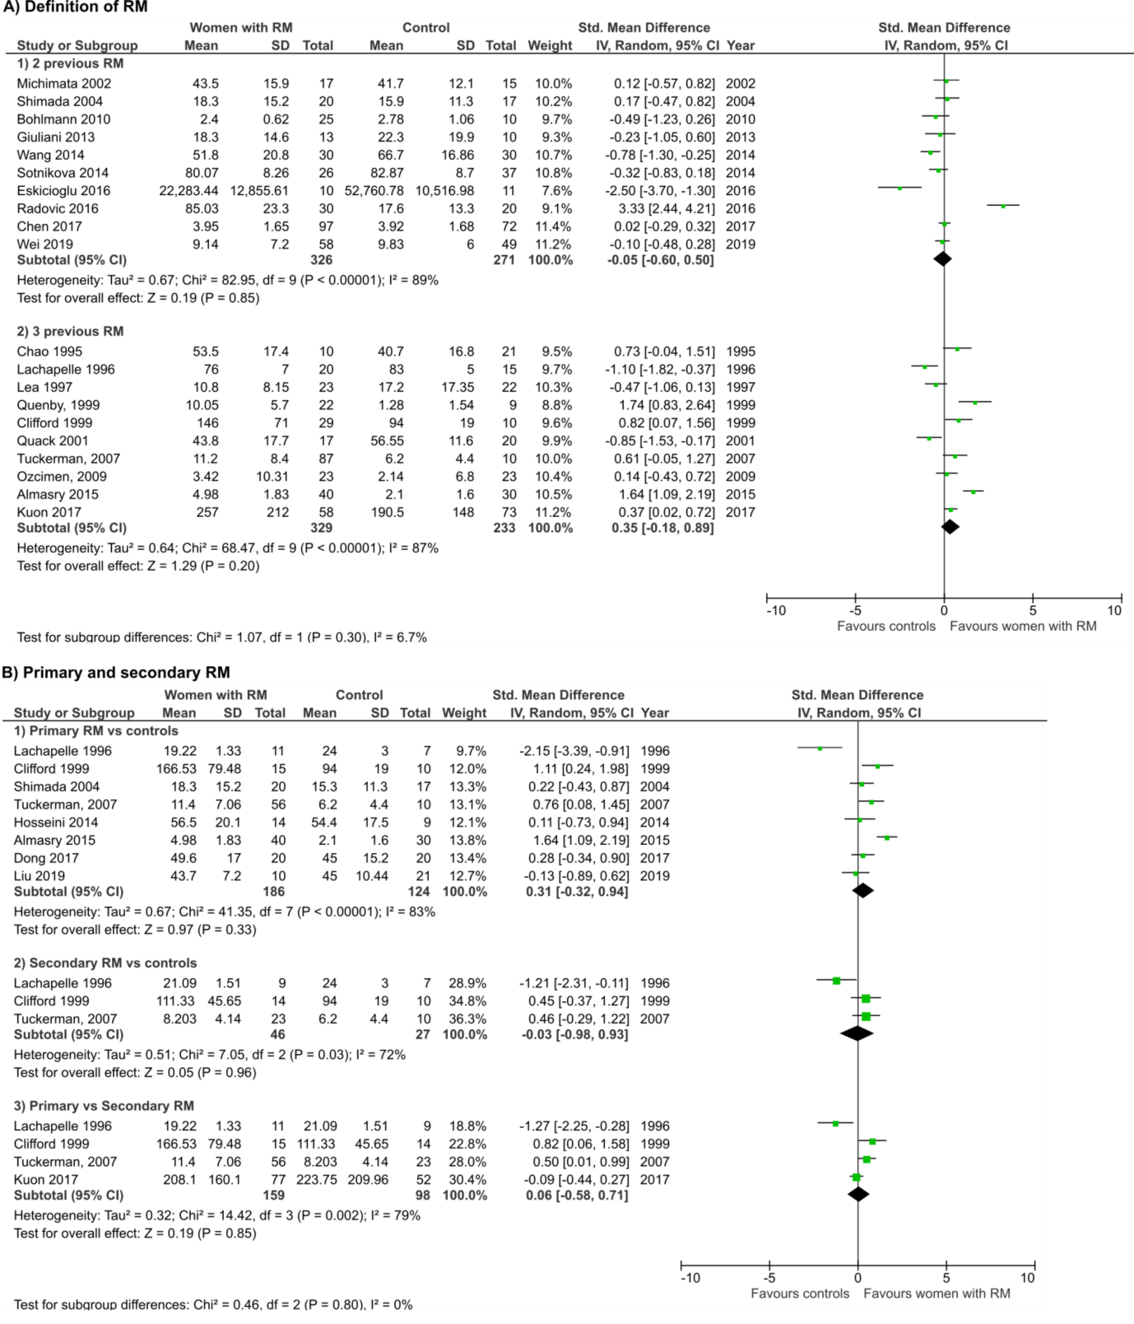 Subgroup meta-analysis of standard mean difference of uNK level of women with RM compared to controls by definition of RM (A), primary RM and secondary RM (B),
Supplementary Figure S2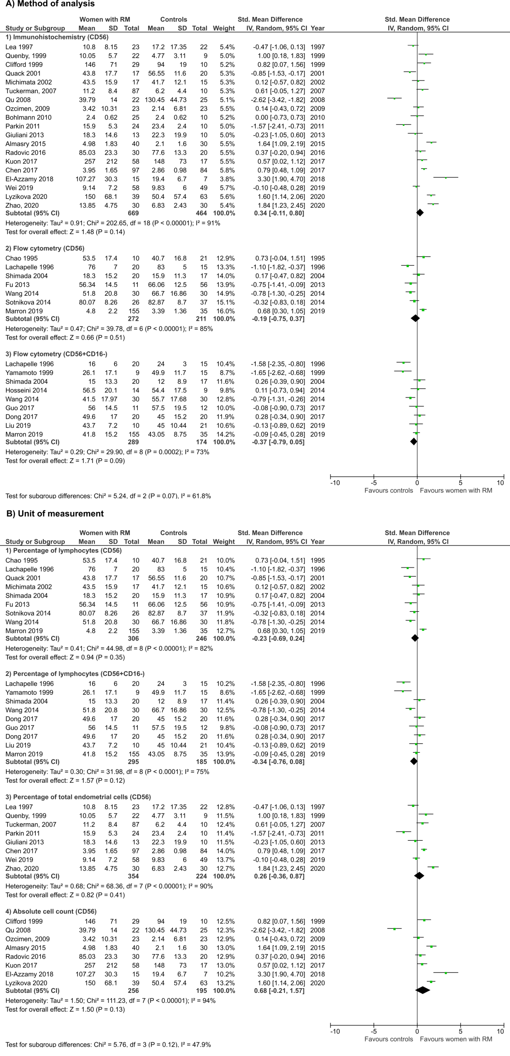
Subgroup meta-analysis of standard mean difference of uNK level of women with RM compared to controls by method of uNK analysis (A), type of sample (B) and unit of measurement (C).

Supplementary Figure S3
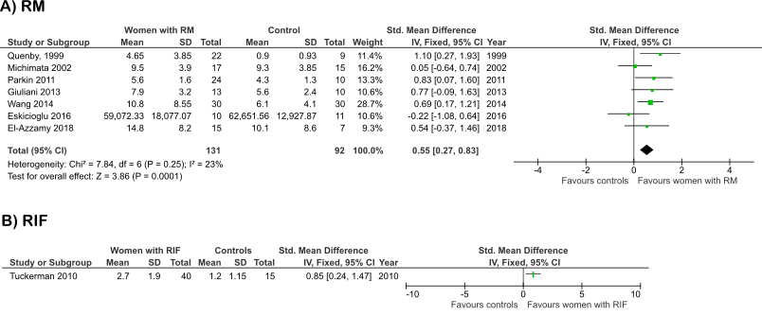
Meta-analysis of standard mean difference of CD16+ leucocytes in women with RM (A) and RIF (B) compared to controls

AUTHOR: please would you remove the yellow highlights from the supplementary tables? Thank you.
Supplementary Table SIa Search Strategy for MEDLINE and EMBASE.
AUTHOR: the journal does not use a) and b) for tables. Please would you either combine a) and b) into one table, or create a new Table II and renumber all tables here and in the main text? Also, please could you remove the yellow highlights? Thank you.
 | Subset | Keywords/MESH (MEDLINE and CENTRAL) | Keywords/MESH (EMBASE)
1 | Natural killer cell | exp KILLER CELLS, NATURAL/ OR natural killer cell* OR NK Cell* OR NKC OR CD56 OR CD69 OR uNK OR eNK OR dNK OR pNK | exp NATURAL KILLER CELL/ OR natural killer cell* OR NK Cell* OR NKC OR CD56 OR CD69 OR uNK OR eNK OR dNK OR pNK
2 | Immune lymphoid cells | Lymphoid cell* OR immune lymphoid cell* OR ILC OR innate lymphoid cell* | *LYMPHOID CELL/ OR immune lymphoid cell* OR ILC OR innate lymphoid cell*
3 |  | 1 OR 2 | 1 OR 2
4 | Recurrent Miscarriage | exp ABORTION, HABITUAL/ OR RM OR Recurrent miscarriage* OR recurrent abortion* OR recurrent spontaneous abortion* OR RSA OR recurrent pregnancy loss* OR recurrent loss* of pregnancy* OR fetus loss* OR f*etal death OR fetus death OR f*etal loss* OR habitual abortion OR embryo death OR first trimester pregnancy loss* | exp RECURRENT ABORTION/ OR RM OR Recurrent miscarriage* OR recurrent abortion* OR recurrent spontaneous abortion* OR RSA OR recurrent pregnancy loss* OR recurrent loss* of pregnancy* OR fetus loss* OR f*etal death OR fetus death OR f*etal loss* OR habitual abortion OR embryo death OR first trimester pregnancy loss*
5 | Natural killer cells AND Recurrent Miscarriage | 3 AND 4 | 3 AND 4
6 | Recurrent Implantation Failure/IVF | recurrent implantation failure* OR RIF OR implantation failure* OR repeat implantation failure* OR failed cycle* OR recurrent failure to implant OR repeat failure to implant OR recurrent failed implantation* OR recurrent reproductive failure OR poor implantation | recurrent implantation failure* OR RIF OR implantation failure* OR repeat implantation failure* OR failed cycle* OR recurrent failure to implant OR repeat failure to implant OR recurrent failed implantation* OR recurrent reproductive failure OR poor implantation
7 | IVF | exp FERTILIZATION IN VITRO/ OR IVF OR in vitro fertili?ation OR fertili?ation in vitro OR intracytoplasmic sperm injection OR ICSI OR sperm injection intracytoplasmic OR assisted reproductive technique* OR embryo transfer OR embryo implantation OR ART | Exp IN VITRO FERTILIZATION/ OR IVF OR in vitro fertili?ation OR fertili?ation in vitro OR intracytoplasmic sperm injection OR ICSI OR sperm injection intracytoplasmic OR assisted reproductive technique* OR embryo transfer OR embryo implantation OR ART
8 | Infertility | Exp Infertility, Female/ OR Infertility OR subfertility OR fertiity | Exp Female Infertility/ OR Infertility OR subfertility OR fertiity
9 | RIF/Infertility/IVF | 6 OR 7 OR 8 | 6 OR 7 OR 8
10 | Natural killer cells and RIF/Infertility/IVF | 3 AND 9 | 3 AND 9

Supplementary Table SIb Search Strategy for Web of Science.
 | Subset | Keywords
1 | Natural killer cell | TS=(Natural killer cell* OR NK Cell* OR NKC OR CD56 OR CD69 OR uNK OR eNK OR dNK OR pNK)
2 | Immune lymphoid cells | Ts=(Lymphoid cell* OR immune lymphoid cell* OR ILC OR innate lymphoid cell*)
3 |  | 1 OR 2
4 | Recurrent Miscarriage | TS=(RM OR Recurrent miscarriage* OR recurrent abortion* OR recurrent spontaneous abortion* OR RSA OR recurrent pregnancy loss* OR recurrent loss* of pregnancy* OR fetus loss* OR f*etal death OR fetus death OR f*etal loss* OR habitual abortion OR embryo death OR first trimester pregnancy loss*)
5 | Natural killer cells AND Recurrent Miscarriage | 3 AND 4
6 | Recurrent Implantation Failure/IVF | TS=(recurrent implantation failure* OR RIF OR implantation failure* OR repeat implantation failure* OR failed cycle* OR recurrent failure to implant OR repeat failure to implant OR recurrent failed implantation* OR recurrent reproductive failure OR poor implantation)
7 | IVF | TS=(IVF OR in vitro fertili?ation OR fertili?ation in vitro OR intracytoplasmic sperm injection OR ICSI OR sperm injection intracytoplasmic OR assisted reproductive technique* OR embryo transfer OR embryo implantation OR ART)
8 | Infertility | TS=(Infertility OR subfertility OR fertility)
9 | RIF/Infertility/IVF | 6 OR 7 OR 8
10 | Natural killer cells and RIF/Infertility/IVF | 3 AND 9

Supplementary Table SII Inclusion and exclusion criteria.
 | Systematic Review Question | PICO | Inclusion Criteria | Exclusion Criteria
1a | What is the level of uNK in RM or RIF versus fertile controls? | P – RM/RIF patients  I : Measurement of uNK  C : Fertile controls  O : uNK levels (mean or percentage) | - Studies with RM/ RIF versus controls  - Controls may be male factor infertility with proven fertility after IVF  - uNK level reported as absolute number or percentage in both study and control group  - May include abstracts ONLY if levels/activity reported for both study and control group | - Studies with infertile control group  - Comorbidities (e.g. antiphospholipid syndrome)  - Purely immunogenetic studies e.g. KIR and HLA haplotype  - Study on NK-22 cells – as they are now known as ILC3s, which is separate from NK cells  - Studies that included any intervention
1b | What is the activity of uNK in RM or RIF versus fertile controls? | P – RM/RIF patients  I – Measurement of uNK  C – Fertile controls  O – uNK activity (narrative review)  N.B. uNK activity can be target cell killing, activating NK receptor expression, cytokine expression (IFN-g, TNF-a), mRNA expression, CD49a,
2a | What is the pregnancy outcome of RM/RIF with elevated uNK? | P – RM/RIF patients with elevated uNK (defined as >5%)  I : None  C : RM/RIF patients with NON-elevated uNK  O : Pregnancy outcome | - Studies of RM/RIF AND  - uNK level measurement AND  - Report livebirth outcomes | - Studies with fertile control groups (because cannot compare RM or RIF and fertile groups when it comes to livebirth outcomes)  - Any studies with immunotherapy (because any intervention will affect livebirth outcome)
2b | What is the mean uNK level in women with RM/RIF who have subsequent livebirth versus miscarriage? | P: RM/RIF patients with subsequent livebirth outocmes  I: Measurement of uNK  C: All RM/RIF patients with subsequent livebirth  O: uNK levels
3 | What is the correlation between pNK and uNK in RM/RIF? | P- All RM/RIF patients with elevated uNK  I – N/A  C – All RM/RIF patients with low uNK  O – pNK levels (measured as correlation of coefficient between uNK and pNK) | - Any studies with RM/RIF measuring uNK AND pNK  - Ideally, reporting coefficient of correlation (r value) but due to scarcity of these type of studies, all studies to be included | - Studies that do not report values of both uNK or pNK  - Studies that just report pNK and uNK level in control group only

Supplementary Table SIII Excluded articles from full text screening, with reasons.
Author, Year | Reason for exclusion
Yamamoto et al., 2004, Proceedings of the IX International Congress of Reproductive Immunology | Abstract only with insufficient information
Quenby 2006 et al., Journal of Society for Gynaecologic Investigation | Abstract only with insufficient information
Sacks et al., 2007, Australian and New Zealand Journal of Obstetrics and Gynaecology | Abstract only with insufficient information
Qiu et al., 2009, International Journal of Gynaecology and Obstetrics | Abstract only with insufficient information
Petitbarat et al., 2010, Human Reproduction | Abstract only with insufficient information
Gutierrez et al., 2011, Journal of Reproductive Immunology | Abstract only with insufficient information
Pasqualini 2011 et al., Fertility and Sterility | Abstract only with insufficient information
Yokota 2012 et al., Journal of Reproductive Immunology | Abstract only with insufficient information
Ferrer 2012 et al., American Journal of Reproductive Immunology | Abstract only and insufficient info
Urquiza et al., 2013, Human Reproduction | Abstract only with insufficient information
T. Goggl et al. 2014, Human Reproduction | Abstract only and insufficient info
Dambaeva et al., 2015, American Journal of Reproductive Immunology | Abstract only with insufficient information
Fuchinoue et al., 2015, American Journal of Reproductive Immunology | Abstract only with insufficient information
Incera et al., 2016, Journal of Reproductive Immunology | Abstract only with insufficient information
Fazekas et al., 2016, Clinical Chemistry and Laboratory Medicine | Abstract only with insufficient information
Vomstein et al., 2016, Journal of Reproductive Immunology | Abstract only with insufficient information
Chen et al. 2016, American Journal of Reproductive Immunology | Abstract only with insufficient information
Dambaeva et al., 2017, Fertility and Sterility | Abstract only with insufficient information
Paiva et al., 2017, Reproductive Sciences | Abstract only with insufficient information
Li et al., 2018, International Journal of Gynaecology and Obstetrics | Abstract only with insufficient information
Pearson-Farr et al., 2018, Human Reproduction | Abstract only with insufficient information
Kamoi et al., 2018, American Journal of Reproductive Immunology | Abstract only with insufficient information
Shivalingegowda et al., 2018, Fertility and Sterility | Abstract only with insufficient information
Dons’koi et al., 2019, American Journal of Reproductive Immunology | Abstract only with insufficient information
Huang et al., Journal of Reproductive Immunology 2016 | Abstract only with insufficient information
Ulcova-Gallova et al., 2019, Ceska gynekologie | Abstract only and insufficient information
Ledee Bataille et al. 2004, Proceedings of 9th international congress of Reproductive Immunology | Abstract only, subsequent full paper (included in SR)
Laird et al., 2005, Placenta | Abstract only, full paper possibly published (included in SR)
Fu et al., 2010, American Journal of Reproductive Immunology | Abstract only, subsequent full paper (included in SR)
Fukui et al., 2010, Journal of Reproductive Immunology | Abstract only, full paper possibly published (included in SR)
Santillan et al., 2011, Journal of Reproductive Immunology | Abstract only, subsequent full paper (included in SR)
Radivic-Janosevic et al., 2016, Journal of Maternal-fetal and Neonatal Medicine | Abstract only, subsequent full paper (included in SR)
Weber et al., 2016, Journal of Reproductive Immunology | Abstract only, full paper possibly published (included in SR)
Jiang et al., 2016, Human Reproduction | Abstract only, subsequent full paper (included in SR)
Harrity et al., 2017, American Journal of Reproductive Immunology | Abstract only, subsequent full paper (included in SR)
Chen et al., 2017, Human Reproduction | Abstract only, full paper possibly published (included in SR)
Germain et al., 2018, Reproductive Sciences | Abstract only, full paper possibly published (included in SR)
Wei 2018 et al., American Journal of Reproductive Immunology | Abstract only, full paper possibly published (included in SR)
Guo et al., 2018, American Journal of Reproductive Immunology | Abstract only, subsequent full paper (included in SR)
Chiokadze et al., 2020, American Journal of Reproductive Immunology | Abstract with subsequent paper published in full text
Papamitsou et al. 2014 Histology and histopathology | Unable to access article
Lash et al. 2014, Human Reproduction | No control group
Park et al. 2010, American Journal of Reproductive Immunology | No control group
Sauerbrun-Cutler et al., 2020, Fertility and Sterility | No control group
Bildaci et al. 2013, Fertility and Sterility | Control group infertile women
Donoghue et al. 2019, Human Reproduction | Control group infertile women
Ledee 2016 et al., American Journal of Reproductive Immunology | Intervention present in patient group
O’Hern Perfetto et al., 2015, Journal of Assisted Reproduction and Genetics | Intervention present in patient group
Hill et al., 1995, American Journal of Obstetrics and Gynaecology | Insufficient data on uNK for extraction
Chiokadze et al., 2020, Diagnostics | Insufficient data on uNK for extraction
Mamedeliyeva et al., 2017, Gynaecology Endocrinology | Insufficient data on uNK for extraction and deemed critical risk of bias
Sun et al., 2016, PLoS One | uNK activity only measured in controls

Supplementary Table SIV Sensitivity analysis for uterine natural killer levels in women with recurrent miscarriage versus controls.

Excluded studies | Reason for sensitivity analysis | Women with RM (n) | Controls (n) | Heterogeneity |  | Meta-analysis model | Outcomes
 |  |  |  | I² | p-value | Meta-analysis model | SMD (95% CI) | p
Quenby 1999, Chen 2017, El-Azzamy 2018, Marron 2019, Lyzikova 2020, Zhao 2020 | Estimation from median and extraction from graph (CD56+ uNK in endometrium) | 351 | 163 | 75% | <0.01 | Random effects | -0.04 (-0.45, 0.36) | 0.83
Quenby 1999; Quack 2001; Chen 2017; Marron 2019a; Lyzikova 2020, Zhao 2020 | Estimation from median (CD56+ uNK) | 578 | 444 | 88% | <0.01 | Random effects | -0.09 (-0.51, 0.33) | 0.68
Yamamoto, 1999 | Estimation from median (CD56+CD16- uNK) | 280 | 159 | 68% | <0.01 | Random effects | -0.25 (-0.64, 0.15) | 0.22
Qu 2008; El-Azzamy 2018; Liu 2019; Marron 2019 | Extraction from graph (CD56+ uNK) | 736 | 597 | 89% | <0.01 | Random effects | 0.14 (-0.24, 0.51) | 0.47
Guo 2017 | Extraction from graph (CD56+CD16- uNK) | 278 | 162 | 76% | <0.01 | Random effects | -0.40 (-0.87, 0.06) | 0.09
Tuckerman 2007, Bohlmann 2010, Parkin 2011, Giuliani 2013, El-Azzamy 2019, Liu 2019, Lyzikova 2020 | Studies on endometrial tissue with controls of proven fertility (CD56+ uNK; Fig. 3.1.1) | 506 | 281 | 84% | <0.01 | Random effects | 0.48 (0.07, 0.90) | 0.02
Lea 1997, Quack 2001, Qu 2008, Ozcimen 2009, Fu 2013, Sotnikova 2014, Eskicioglu 2016 | Studies on decidua with controls of proven fertility only (CD56+ uNK; Fig. 3.1.1) | 110 | 101 | 92% | <0.01 | Random effects | 0.49 (-0.59, 1.56) | 0.38
Yamamoto 1999; Guo 2017; Dong 2017; Liu 2019; Marron 2019 | Studies with controls of proven fertility only (CD56+CD16- uNK; Fig, 3.1.2) | 84 | 71 | 81% | <0.01 | Random effects | -0.50 (-1.29, 0.28) | 0.21
Michimata 2002; Marron 2019; Wei 2019 | Exclusion of controls with male infertility (CD56+; Fig. 3.1.1) | 731 | 608 | 91% | <0.01 | Random effects | 0.09 (-0.33, 0.51) | 0.67
Marron 2019 | Exclusion of controls with male infertility (CD56+CD16-; Fig. 3.1.2) | 134 | 139 | 75% | <0.01 | Random effects | -0.42 (-0.94, 0.09) | 0.11
Marron 2019 | Exclusion of studies with usage of hormonal therapy (CD56+; Fig. 3.1.1) | 806 | 672 | 91% | <0.01 | Random effects | 0.09 (0.30, 0.47) | 0.66
Marron 2019 | Exclusion of studies with usage of hormonal therapy (CD56+CD16-; Fig. 3.1.2) | 134 | 139 | 75% | <0.01 | Random effects | -0.42 (-0.94, 0.09) | 0.67
Parkin 2011 | Exclusion of abstracts (CD56; Fig. 3.1.1) | 937 | 697 | 90% | <0.01 | Random efects | 0.17 (-0.19, 0.53) | 0.36
Chao 1995; Lachapelle 1996; Lea 1997; Clifford 1999; Quack 2001; Tuckerman 2007; Qu 2008; Bohlmann 2010; Giuliani 2013; Fu 2013; Sotnikova 2014; Radovic 2016; Chen 2017; El-Azzamy 2018; Liu 2019; Marron 2019; Lyzikova 2020; Zhao 2020 | Exclusion of studies with serious risk of bias (CD56; Fig. 3.1.1) | 302 | 211 | 89% | <0.01 | Random effects | -0.07 (-0.66, 0.53) | 0.83
Lachapelle 1996; Guo 2017 | Exclusion of studies with serious risk of bias (CD56+CD16-; Fig. 3.1.2) | 103 | 112 | 72% | <0.01 | Random effects | -0.28 (-0.83, 0.26) | 0.3
Hosseini 2014 | Exclusion of endometrial samples not taken at luteal phase (CD56+CD16-; Fig. 3.1.2) | 195 | 67 | 86% | <0.01 | Random effects | -0.43 (-1.33, 0.48) | 0.35
Qu 2008; Fu 2013; El-Azzamy 2018; Lyzikova 2020 | Exclusion of RM with no specific definition (CD56; Fig. 3.1.1) | 850 | 546 | 86% | <0.01 | Random effects | 0.17 (-0.15, 0.49) | 0.29
Chao 1995, Lachapelle 1996, Lea 1997, Quenby 1999, Michimata 2002, Tuckerman 2007, Qu 2008, Ozcimen 2009, Parkin 2011, Giuliani 2013, Fu 2013, Sotnikova 2014, Wang 2014, Eskicioglu 2016, Radovic 2016, Kuon 2017, El-Azzamy 2018, Wei 2019, Marron 2019, Liu 2019, Lyzikova 2020 | Inclusion of studies with normal fetal/parental karyotype only (Fig. 3.1.1) | 278 | 228 | 90% | <0.01 | Random effects | 0.34 (-0.29, 0.97) | 0.29

Supplementary Table SV Sensitivity analysis for uterine natural killer levels in women with recurrent implantation failure versus controls.
RIF: recurrent implantation failure
Excluded studies | Reason for sensitivity analysis | Women with RIF (n) | Controls (n) | Heterogeneity |  | Meta-analysis model | Outcomes
 |  |  |  | I² | p-value | Meta-analysis model | SMD (95% CI) | p
Tuckerman 2010; Junovich 2013; Chen 2017; Marron 2019 | Estimation from median | 124 | 75 | 90% | <0.01 | Random effects | 0.16 (-0.80, 1.12) | 0.74
Junovich 2013; Marron 2019 | Extraction from graph | 196 | 174 | 88% | <0.01 | Random effects | 0.40 (-0.28, 1.08) | 0.25
Tuckerman 2010; Marron 2019 | Studies with controls of proven fertility only | 182 | 177 | 88% | <0.01 | Random effects | 0.41 (-0.28, 1.09) | 0.24
Jiang 2019; Marron 2019 | Exclusion of controls with male infertility | 190 | 169 | 83% | <0.01 | Random effects | 0.64 (0.07, 1.22) | 0.03
Ledee 2004; Marron 2019 | Exclusion of studies with usage of hormonal therapy | 187 | 182 | 88% | <0.01 | Random effects | 0.39 (-0.27, 1.06) | 0.25
Ledee 2004; Santillan 2012; Junovich 2013; Chen 2017; Marron 2019; Babayeva 2020 | Exclusion of studies with serious risk of bias | 72 | 38 | 91% | <0.01 | Random effects | 0.13 (-1.22, 1.49) | 0.85
Jiang 2019; Marron 2019 | Exclusion of studies with 2 or more previous failures only | 190 | 169 | 83% | <0.01 | Random effects | 0.64 (0.07, 1.22) | 0.03

Supplementary Table SVI Sensitivity analysis for coefficient correlation between peripheral natural killer and uterine natural killer.
Excluded studies | Reason for sensitivity analysis | Number of women | Heterogeneity |  | Meta-analysis model | Outcomes
Excluded studies | Reason for sensitivity analysis | Number of women | I² | p-value | Meta-analysis model | Pooled coefficient correlation (95% CI) | p
Junovich 2013 | Exclusion of study that combined fertile women and women with RIF (CD56+pNK) | 77 | 78% | <0.01 | Random effects | 0.42 (-0.04, 0.73) | 0.07
Junovich 2013 | Exclusion of study that combined fertile women and women with RIF (CD56+CD16+pNK) | 203 | 85% | <0.01 | Random effects | 0.18 (-0.19, 0.51) | 0.34
Toth, 2019 | Exclusion of study of pRM only (CD56+CD16+) | 145 | 77% | <0.01 | Random effects | -0.01 (-0.39, 0.36) | 0.95
Toth, 2019 | Exclusion of study on sRM only (CD56+CD16+) | 193 | 83% | <0.01 | Random effects | 0.19 (-0.18, 0.51) | 0.31
AUTHOR: please could you define pRM and sRM in a footnote?

