Revealing the Anion Intercalation Behavior and Surface Evolution of Graphite in Dual-Ion Batteries via in situ AFM
Kai Yang‡ª, Langlang Jia‡ª, Xinhua Liu^{b}, Zijian Wangª,Yan Wangª, Yiwei Liª, Haibiao Chenª, Billy Wu^{b}, Luyi Yang*^{,a} and Feng Pan*^{,a}
ªSchool of Advanced Materials, Peking University Shenzhen Graduate School, Shenzhen, 518055, China.
^{b}Dyson School of Design Engineering, Imperial College London, SW7 2AZ, UK.
‡These authors contributed equally to this work.
*Email: panfeng@pkusz.edu.cn; yangly@pkusz.edu.cn

Abstract
Graphite as a positive electrode material of dual ion batteries (DIBs) has attracted tremendous attentions for its advantages including low lost, high working voltage and high energy density. However, very few literatures regarding to the real-time observation of anion intercalation behavior and surface evolution of graphite in DIBs have been reported. Herein, we use in situ atomic force microscope (AFM) to directly observe the intercalation/de-intercalation processes of PF₆⁻ in graphitein real time. First, by measuring the change in the distance between graphene layers during intercalation, we found that PF₆⁻ intercalates in one of every three graphite layers. Second, graphite will wrinkle and suffer structural damages at high voltages, along with severe electrolyte decomposition on the surface. These findings provide useful information for further optimizing the capacity and the stability of graphite anode in DIBs.
Key words：
Dual ion battery; in situ AFM; graphite positive electrode; hierarchical anion intercalation; structure evolution; surface reaction.
- Introduction
To meet the increasing demand of high-performance energy storage, especially for electric vehicles, novel electrode materials that of high performance and abundant resource are in great need. Dual ion batteries (DIBs) have drawn great interests of researchers due to their low costs and high energy densities.^{[1]} Different from traditional lithium-ion batteries (LIBs) [2] the reactions at the positive electrode of DIBs involve reversible anion (e.g. PF₆⁻[3], ClO₄⁻ [4, 5], FSI⁻ [6], TFSI⁻ [7], AlF₄⁻ [8] and Al_{x}Cl_{y}⁻ [9-12]) intercalation/de-intercalation in layered materials (e.g. graphite).The intercalation/de-intercalation behavior of the anions in DIBs generally enable a high average potential, which lead to improved high energy densities.
Many advanced characterization tools have been used to study the reaction and intercalation mechanism in graphite-based DIBs. Winter [13, 14] and co-workers employed in situ XRD to study structure and compositional changes upon different anions insertion and de-insertion processes in graphite. Wang [5] et al. utilized in situ Raman to detect the structural change of graphite after ClO₄⁻ intercalation in different solvents (PC, GBL and EC), and they found that EC suppresses the anion intercalation. Wang^{[15]} et al. utilized in situ electrochemical quartz crystal microbalance (EQCM) to probe the intercalation scenario of EC and PC solvated BF₄⁻ into graphite. Other than structural and electrochemical information, changes in surface morphology are also important for revealing the reaction mechanisms of electrodes in DIBs. Fang [16] et al. observed the thickness evolution of graphite-based positive electrode in DIBs by using real-time optical microscope and electrode volume expansion was observed after cycling. However, it is challenging for optical microscope to resolve details at the nanoscale. In recent years, in situ atomic force microscope has been considered a powerful characterization tool to visualize the evolution of the electrode surface and electrolyte decomposition during electrochemical processes in LIBs [17-21]. In situ AFM has great advantages in simulating the process in a real device at the nanoscale.
In this work, in situ AFM is employed to investigate the PF₆⁻ anion intercalation/de-intercalation processes in highly oriented pyrolytic graphite (HOPG). By measuring the changes in the thickness of HOPG layers at different voltages, the hierarchy anion intercalation behavior is observed. Meanwhile, decomposition of the electrolyte and graphite distortions are directly observed. Our work provides direct proof of the intercalation behavior of anions in graphite electrode of DIBs at the nanoscale. These findings will be potentially useful for optimizing the capacity and the stability of graphite electrode in DIBs and similar energy storage devices.
- Experimental methods
The setup of the in situ AFM cell is shown in Figure 1. The highly oriented pyrolytic graphite (HOPG, 12×12 mm³, ZYB Grade, Bruker Corporation) was situated at the bottom of the AFM fluid cell (MMTMEC, Bruker Corporation) as the working electrode as shown in Figure. 1b. Natural graphite was too rough to be used as a substrate for AFM. As a special type of graphite, HOPG has a smooth and chemically homogeneous surface which is a graphite basal plane with edge sites. Therefore, it is an ideal substrate for AFM analysis which serves as a compromise between satisfying imaging capabilities and closely simulating the real graphite surfaces. The HOPG substrate was cleaved with adhesive tape to expose a fresh surface before electrochemical tests. The lithium ring encircled in the cell was used as the reference and the counter electrode. 0.1 mL of electrolyte (1 M LiPF₆ in EC/DMC, volume ratio of 1:1) was injected into the cell in each test. The electrodes were connected to a CHI1030C electrochemical workstation (Chenhua Instument Co., Ltd., China) for cyclic voltammetry (CV) tests. AFM images were taken by using a Bruker Multimode 8 system with a Nanoscope V controller and a silicon nitride modified scanning probe (f₀ = 150 kHz, k = 0.7 N m⁻¹). The in-situ AFM experiments were carried out in an argon filled glovebox (MIKOUNA, H₂O < 0.1 ppm, O₂ < 0.1 ppm) at room temperature. AFM was operated in Scanasyst-fluid mode at a specific scan rate in specific voltage ranges. The images were captured at a scan rate of 0.5 Hz. AFM topography was collected in Scanasyst-fluid mode simultaneously, where direct force control at ultra-low forces helps protect delicate samples and tips from damage. The AFM probe was coated with silicon nitride, and will not affect the electrochemical process. After the in situ AFM tests, the HOPG was removed from the cell and washed with dimethyl carbonate (DMC) to remove the residual electrolyte on the surface. The resulting HOPG was dried in an argon filled glovebox before characterization. The X-ray photoelectron spectra (XPS) of the decomposition product was acquired on a Thermo Fisher ESCALAB 250X analysis system.
The real cell performance was analyzed by coin cells using graphite (Aladdin) as the positive electrode. A portion of NMP was added to a mixture of 90 wt.% graphite, 8 wt.% conductive carbon black and 2 wt.% PVDF as binder to form a homogeneous slurry. Then the slurry was coated on Al foil (Shenzhen Kejing), followed by drying at 80 °C for 24 h under vacuum. Lithium foil was used as the counter electrode and a glass fiber was used as the separator. 120 μL of electrolyte (1 M LiPF₆ in EC/DMC, volume ratio of 1:1) was added during cell assembling. The CV was measured at a scan rate of 2 mV s⁻¹ using a CHI1030C electrochemical workstation. The galvanostatic charge and discharge tests were conducted using a Neware battery testing system.
- Results and discussions
  - In situ observation of reversible PF₆⁻ intercalation/de-intercalation in HOPG
The setup of the in situ AFM experiment is shown in Figure 1. HOPG is employed as the working positive electrode, and a lithium ring serves as the counter and reference electrode. Figure 2a shows the image of the HOPG electrode surface scanned at the open circuit potential (OCP). Steps of different heights can be observed and each step represents a stack of graphene layers. Through height measurement and calculation, the number of graphene layers in each step can be obtained. Here, a parameter N_{G} is introduced to describe the number of the graphene layers in one step:
$N_{G}=H_{0}/H_{single layer}$ (1)
Where H₀ is the step height measured by AFM, and it is the distance between the bottom layer and the top layer of the step. H_{single layer} is the height of one single layer of graphene. More detailed definitions are listed in Table S1. Figure 2b shows the details of the measurement where Step c shows a height of 0.35 nm which can be considered as the thickness of a single layer in graphite (H_{single layer} = 0.35) [22]. Therefore, for instance, since Step a is measured to be 0.7 nm, N_{G} in this step is calculated to be 2. Measured heights and calculated number of layers in different steps are shown in Table S2.
Figure 2c-2e exhibit the real-time evolution of the HOPG surface during the electrochemical process and the corresponding CV curve is presented in Figure 2f. Since Step c represents a single layer of graphite, it is chosen for investigating the anion intercalation/de-intercalation behaviors. As shown in Figure 2g, the change in height of Step c during the electrochemical process is plotted vs. voltage. The height remained constant before 4.8 V vs Li/Li⁺, which is the on-set potential of the anodic peak in the CV curves of both in situ cell (shown in Figure 2f) and the ex situ battery (shown in Figure S2). The height then increased with potential and stabilized at 0.85 nm as the voltage reached 5.5 V vs Li/Li⁺. The increased height of 0.5 nm is consistent with the average diameter of PF₆⁻ (0.45 nm) [23, 24], indicating that the height change was very likely caused by the PF₆⁻ anion intercalation. In the following discharge process, the height of Step c decreased to 0.35 nm as the cell was discharged back to 3.5 V vs Li/Li⁺, which suggests a reversible intercalation/deintercalation process in the HOPG. To exclude the physical adsorption of the anion, control experiments with no LiPF₆ but the same electrolyte solvent was carried out (Figure S3). The height change of Step 1 is summarized in Figure S3d, and the height remained nearly unchanged during the whole CV scanning, which excludes the physical adsorption of the anion.
To further confirm the intercalation of PF₆⁻, the HOPG charged to 5.5 V vs Li/Li⁺ was taken out for XPS measurement. In Figure 3a, the surface of HOPG shows no obvious signal of PF₆⁻. As shown in Figure 3b, after being etched for 10 s, a peak at 688 eV [25] arises, which can be assigned to the existence of PF₆⁻. Hence, the XPS results confirmed the intercalation of PF₆⁻.
  - Statistical investigation of PF₆⁻ intercalation behavior
With the information of single-layer intercalation obtained above, what can we learn about the multi-layer intercalation behavior? As shown in Figure 4c, several parameters to describe the intercalated structure are defined:
$ΔH=H_{final}-H_{0}$ (2)
Where ΔH is the height change during the electrochemical process, $H_{0}$ is the original height of the graphite steps and H_{final} is the final height. Based on the previous results, the height change in a single layer caused by PF₆⁻ intercalation (ΔH_{anion}) can be regarded as a constant (ΔH_{anion} = 0.5 nm).
Figure S4a shows that the height of Step A increased to 12.6 nm (H_{final}) compared to its original height of 8.4 nm (i.e. N_{G} = 24) when charged to 5.5 V vs Li/Li⁺. Under the assumption that the thickness change is solely contributed by the anion intercalation, the number of layers (N_{I}) inserted by anions can be expressed by:
N_{I} = ΔH/ΔH_{anion} (3)
In this case, N_{I} for Step A was calculated to be 8 (Figure S4b). In this case, one third of the graphite layers in Step A were intercalated with anions. A question can be then raised: is this a general pattern or merely a coincidence? In order to obtain statistically significant correlation between N_{G} and N_{I}, additional experiments and measurements for other steps were carried out and the results are shown in Figure S5 and Figure S6 and summarized in Table S3.
The relationship between N_{G} and N_{I} is plotted in Figure 4d, where it is found that at a relatively low N_{G} (< 9), the N_{I}/N_{G} ratio (S_{N}) appears to be randomly distributed; whereas at a higher N_{G} (> 9), the value of S_{N} is very close to 1/3, suggesting that PF₆⁻ anion intercalates in one of every three graphene layers. The deviation at a low N_{G} could be attributed to the lack of sample capacity, which leads to low statistical significance and measuring errors. The similar hierarchical intercalation behavior of PF₆⁻ in graphite were previously observed by means of XRD [13], Raman measurements [5] and DFT simulations [6]. However, they failed to reveal the intercalation/deintercalation mechanism at the nanoscale. In this work, we utilized in situ AFM to directly observe the intercalation process and obtained quantitative results. While most of in situ AFM studies in lithium battery filed focus on the interfacial morphology, we demonstrated that the in situ AFM can be useful in analyzing the intercalation process and potentially can be employed to investigate other layered energy storage materials besides graphite.
  - Stability of electrolyte and graphite positive electrode
Generally, anion intercalation in graphite positive electrode occurs at a relatively high potential (> 4.5 V vs Li/Li⁺) [4], at which the electrolyte is prone to decomposition. As shown in Figure 2, nano-sized residues formed along the steps of the HOPG and then on the HOPG surface and gradually grew as the potential increased during the first charging process. These residues cannot be removed by negatively sweeping the voltage as shown in Figure S7, indicating that the process is irreversible and very likely to be the decomposition of electrolyte. Such irreversible decomposition could be the cause of the severe capacity fade in real batteries as shown in Figure S8 and Figure S9.
Herein, the effect of cut-off potential on electrolyte decomposition was also studied by in situ AFM. The pristine HOPG surfaces shown in Figure 5a are clean and flat. Figure S10 shows the AFM images taken at 4.19 V to 4.72 V and 4.72 V to 5.25 V during following charging process. No obvious electrolyte decomposition on the HOPG surface was found. Figure 5b shows the image obtained between 5.25 V and 5.78 V. Figure 5c shows that there are three stages during the electrochemical process according to the change of surface profile along the dash line in Figure 5b. In Stage I at a low potential (below 4.8 V), the surface morphology barely changed. As the potential increased to 4.8V, the average height started to increase owing to the intercalation of PF₆⁻ anion (Stage II). As the potential further increased to above 5.52 V, remarkable height increase was observed, which can be attributed to the uncontrollable electrolyte decomposition. The surface of HOPG was fully covered by thick layers (more than 50 nm) of decomposition products in Stage III. The components of the nanoparticles on the HOPG surface were analyzed by ex situ XPS. The spectra of C1s and F1s are shown in Figure S11. Figure S11a and S11b show the XPS results of HOPG before CV scanning. There are two obvious peaks in the C1s spectra and they are located at 284.8 eV and 285 eV. They can be assigned to C-C bond and -C-O-C bond [7] respectively. After CV scanning, two new peaks arose at 287 eV and 289 eV as shown in Figure S11c and S11d. They can be assigned to -COOR and -CO₃.These products mainly came from the decomposition of solvents EC and DMC under the high potentials [7]. Figure S11e and S11f show the spectra of F1s, on the surface of HOPG, the two peaks which are located at 685 eV and 687 eV can be assigned to the LiF [7, 25] and Li_{x}PF_{y}O_{z} [7, 25]. These fluorine containing products mainly come from the decomposition of PF₆⁻ under the high potentials [7]. It was previously reported that the graphite positive electrode in DIBs could also suffer from structural damage at high potentials during cycles[26]. Figure 6 shows the graphite structure evolution during electrochemical process. Compared with the original HOPG surface (Figure 6a), the flat HOPG surface appears to wrinkle (Figure 6b) under a high potential. As exhibited in Figure 6d, the flat baseline became wavy after charging, which indicates the structural change of the graphite. The height of the selected step (black line) is shown in Figure. 6e. The original height was 4 nm at OCP. The height change would be approximately 2 nm according to the intercalation mechanism as we demonstrated. However, in reality the height increased to 9 nm during sweeping voltage range of 5.07 V – 5.60 V. After discharging, the height decreased to 7 nm. The reversible height change of 2 nm matches what we predicted using the proposed intercalation mechanism. Therefore, the irreversible height change of 3 nm can be attributed to the structural distortion of the graphite. The structural change is usually responsible for the capacity decay of an electrode material and should be prevented or minimized for better performance.
- Conclusions
In summary, we successfully monitored the real-time interfacial and structure evolution of graphite in carbonate electrolyte utilizing in situ AFM. The anion (PF₆⁻) intercalation mechanism and surface evolution can be summarized in Scheme 1. After anion intercalation which starts at 4.8 V, the interlayer spacing between two graphene layers was observed to increase by approximate 0.5 nm. Next, the anion intercalation behavior in multiple numbers of graphene layers was analyzed. Through many parallel in situ AFM experiments, the results show that anion intercalates in one of every three graphite layers. Furthermore, by exploring the surface and structure evolution vs rising potentials of the HOPG graphite, the stability of the electrolyte under high potentials was investigated. The electrolyte decomposition occurred firstly along the edges of HOPG, and then on the surface of HOPG. The decomposition continued in the following cycles. When a higher potential was applied, more severe decomposition was observed, along with structural distortion of the graphite. A high anion intercalation potential in DIBs not only affects the stability of the electrolyte but also the structure of the graphite positive electrode and would definitely decreases the stability and cycle performance in real cells.
These results will help researchers to get an in-depth understanding of the intercalation mechanism and surface reactions in DIBs and directions to improve battery performance.
Author information
Corresponding Author
*Email: panfeng@pkusz.edu.cn; yangly@pkusz.edu.cn
Acknowledgment
Kai Yang and Langlang Jia contributed equally to this work. This research was financially supported by Soft Science Research Project of Guangdong Province (No. 2017B030301013) and the Shenzhen Science and Technology Research (Grant No. JCYJ20170818085823773，ZDSYS201707281026184).
Reference
[1] Wang, M.; Tang, Y. A Review on the Features and Progress of Dual-Ion Batteries. Advanced Energy Materials 2018, 8, 1703320.
[2] Lu, J.;Chen, Z.;Pan, F.;Cui, Y.; Amine, K. High-Performance Anode Materials for Rechargeable Lithium-Ion Batteries. Electrochemical Energy Reviews 2018, 1, 35-53.
[3] Zhou, Z.;Li, N.;Yang, Y.;Chen, H.;Jiao, S.;Song, W.-L.; Fang, D. Ultra-Lightweight 3D Carbon Current Collectors: Constructing All-Carbon Electrodes for Stable and High Energy Density Dual-Ion Batteries. Advanced Energy Materials 2018, 8, 1801439.
[4] Placke, T.;Heckmann, A.;Schmuch, R.;Meister, P.;Beltrop, K.; Winter, M. Perspective on Performance, Cost, and Technical Challenges for Practical Dual-Ion Batteries. Joule 2018, 2, 2528-2550.
[5] Gao, J.;Tian, S.;Qi, L.; Wang, H. Intercalation manners of perchlorate anion into graphite electrode from organic solutions. Electrochimica Acta 2015, 176, 22-27.
[6] Kravchyk, K. V.;Bhauriyal, P.;Piveteau, L.;Guntlin, C. P.;Pathak, B.; Kovalenko, M. V. High-energy-density dual-ion battery for stationary storage of electricity using concentrated potassium fluorosulfonylimide. Nature Communications 2018, 9, 4469.
[7] Qi, X.;Blizanac, B.;DuPasquier, A.;Meister, P.;Placke, T.;Oljaca, M.;Li, J.; Winter, M. Investigation of PF6− and TFSI− anion intercalation into graphitized carbon blacks and its influence on high voltage lithium ion batteries. Physical Chemistry Chemical Physics 2014, 16, 25306-25313.
[8] Wang, S.;Jiao, S.;Tian, D.;Chen, H.-S.;Jiao, H.;Tu, J.;Liu, Y.; Fang, D.-N. A Novel Ultrafast Rechargeable Multi-Ions Battery. Advanced Materials 2017, 29, 1606349.
[9] Jiao, S.;Lei, H.;Tu, J.;Zhu, J.;Wang, J.; Mao, X. An industrialized prototype of the rechargeable Al/AlCl3-[EMIm]Cl/graphite battery and recycling of the graphitic cathode into graphene. Carbon 2016, 109, 276-281.
[10] Sun, H.;Wang, W.;Yu, Z.;Yuan, Y.;Wang, S.; Jiao, S. A new aluminium-ion battery with high voltage, high safety and low cost. Chemical Communications 2015, 51, 11892-11895.
[11] Yu, Z.;Jiao, S.;Li, S.;Chen, X.;Song, W.-L.;Teng, T.;Tu, J.;Chen, H.-S.;Zhang, G.; Fang, D.-N. Flexible Stable Solid-State Al-Ion Batteries. Advanced Functional Materials 2019, 29, 1806799.
[12] Zhang, X.;Jiao, S.;Tu, J.;Song, W.-L.;Xiao, X.;Li, S.;Wang, M.;Lei, H.;Tian, D.;Chen, H.; Fang, D. Rechargeable ultrahigh-capacity tellurium–aluminum batteries. Energy & Environmental Science 2019, 12, 1918-1927.
[13] Placke, T.;Schmuelling, G.;Kloepsch, R.;Meister, P.;Fromm, O.;Hilbig, P.;Meyer, H.-W.; Winter, M. In situ X-ray Diffraction Studies of Cation and Anion Inter­calation into Graphitic Carbons for Electrochemical Energy Storage Applications. Zeitschrift für anorganische und allgemeine Chemie 2014, 640, 1996-2006.
[14] Schmuelling, G.;Placke, T.;Kloepsch, R.;Fromm, O.;Meyer, H.-W.;Passerini, S.; Winter, M. X-ray diffraction studies of the electrochemical intercalation of bis(trifluoromethanesulfonyl)imide anions into graphite for dual-ion cells. Journal of Power Sources 2013, 239, 563-571.
[15] Gao, J.;Yoshio, M.;Qi, L.; Wang, H. Solvation effect on intercalation behaviour of tetrafluoroborate into graphite electrode. Journal of Power Sources 2015, 278, 452-457.
[16] Li, N.;Xin, Y.;Chen, H.;Jiao, S.;Jiang, H.;Song, W.-L.; Fang, D. Thickness evolution of graphite-based cathodes in the dual ion batteries via in operando optical observation. Journal of Energy Chemistry 2019, 29, 122-128.
[17] Cresce, A. v.;Russell, S. M.;Baker, D. R.;Gaskell, K. J.; Xu, K. In Situ and Quantitative Characterization of Solid Electrolyte Interphases. Nano Letters 2014, 14, 1405-1412.
[18] Liu, T.;Lin, L.;Bi, X.;Tian, L.;Yang, K.;Liu, J.;Li, M.;Chen, Z.;Lu, J.;Amine, K.;Xu, K.; Pan, F. In situ quantification of interphasial chemistry in Li-ion battery. Nature Nanotechnology 2019, 14, 50-56.
[19] Lacey, S. D.;Wan, J.;Cresce, A. v. W.;Russell, S. M.;Dai, J.;Bao, W.;Xu, K.; Hu, L. Atomic Force Microscopy Studies on Molybdenum Disulfide Flakes as Sodium-Ion Anodes. Nano Letters 2015, 15, 1018-1024.
[20] Liu, C.; Ye, S. In Situ Atomic Force Microscopy (AFM) Study of Oxygen Reduction Reaction on a Gold Electrode Surface in a Dimethyl Sulfoxide (DMSO)-Based Electrolyte Solution. The Journal of Physical Chemistry C 2016, 120, 25246-25255.
[21] Liu, X.-R.;Wang, L.;Wan, L.-J.; Wang, D. In Situ Observation of Electrolyte-Concentration-Dependent Solid Electrolyte Interphase on Graphite in Dimethyl Sulfoxide. ACS Applied Materials & Interfaces 2015, 7, 9573-9580.
[22] Noel, M.; Santhanam, R. Electrochemistry of graphite intercalation compounds. Journal of Power Sources 1998, 72, 53-65.
[23] Ishihara, T.;Yokoyama, Y.;Kozono, F.; Hayashi, H. Intercalation of PF6− anion into graphitic carbon with nano pore for dual carbon cell with high capacity. Journal of Power Sources 2011, 196, 6956-6959.
[24] Seel, J. A.; Dahn, J. R. Electrochemical Intercalation of PF 6 into Graphite. Journal of The Electrochemical Society 2000, 147, 892-898.
[25] Eshetu, G. G.;Diemant, T.;Grugeon, S.;Behm, R. J.;Laruelle, S.;Armand, M.; Passerini, S. In-Depth Interfacial Chemistry and Reactivity Focused Investigation of Lithium–Imide- and Lithium–Imidazole-Based Electrolytes. ACS Applied Materials & Interfaces 2016, 8, 16087-16100.
[26] Märkle, W.;Tran, N.;Goers, D.;Spahr, M. E.; Novák, P. The influence of electrolyte and graphite type on the PF6- intercalation behaviour at high potentials. Carbon 2009, 47, 2727-2732.
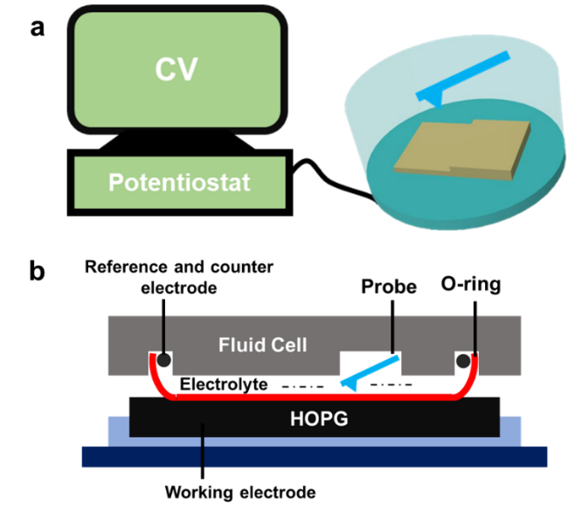
Figure 1. Schematic of (a) the setup of in situ AFM and (b) the in situ cell.
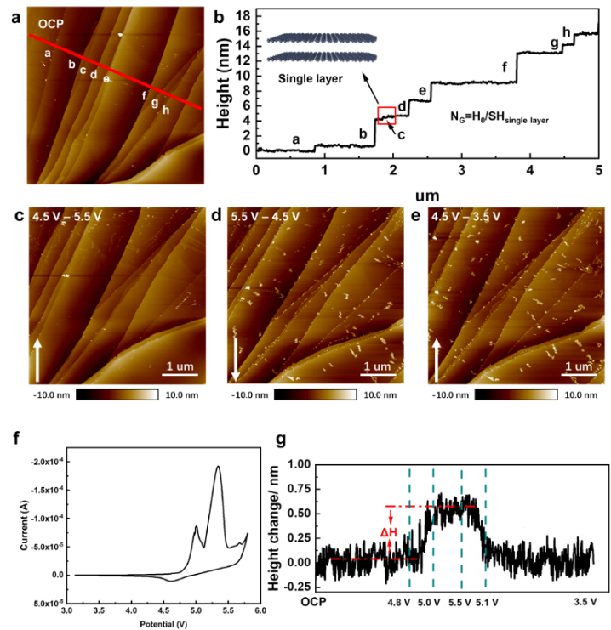
Figure 2. (a) In situ AFM images taken at OCP, (b) height profile of steps labelled in (a), in situ AFM images taken at (c) 4.5 V-5.5 V, (d) 5.5 V-4.5 V and (e) 4.5 V-3.5 V, the voltage scan rate is 2 mV s⁻¹. The white arrows show the AFM scanning direction. (f) CV curve of the in situ AFM test. (g) The height profile of the selected region with changing potential.
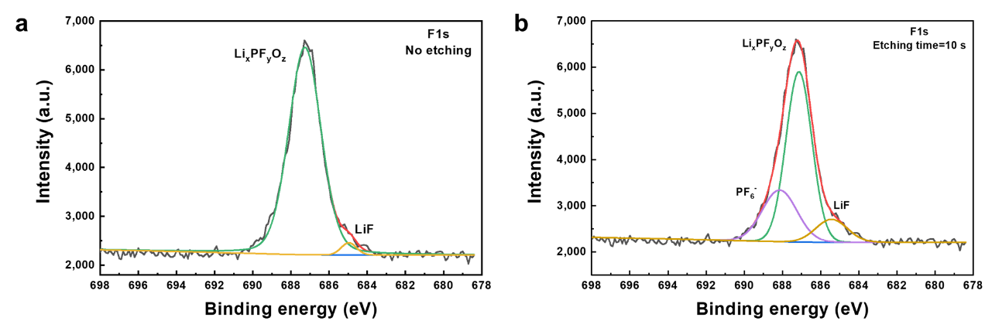
Figure 3. XPS F1s spectra: (a) no etching and (b) etched for 10 s.

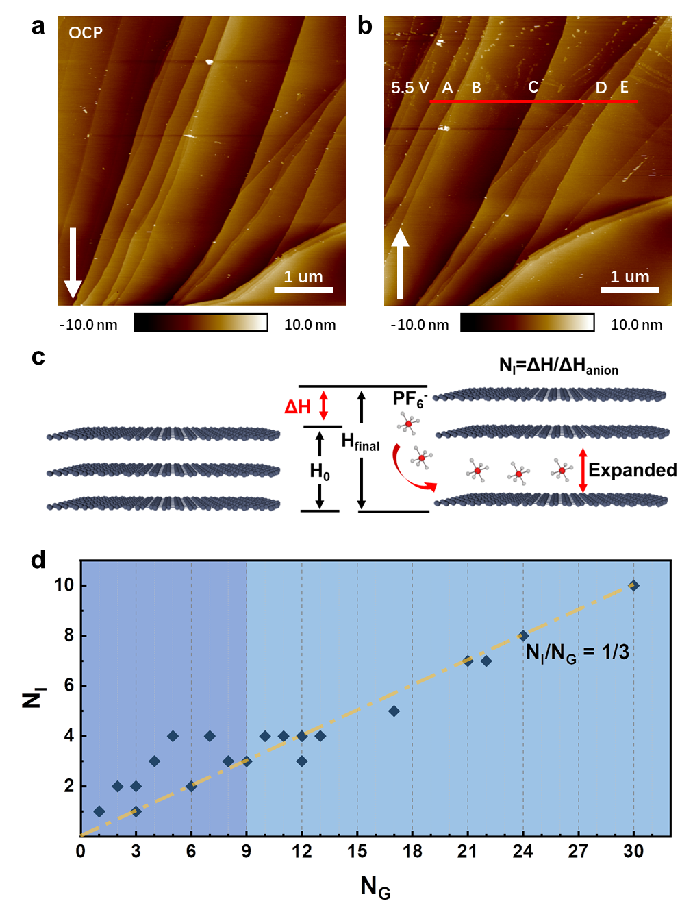
Figure 4. Anion intercalation measurement. AFM images taken at OCP(a) and 5.5 V(b), five spots (A-E) are labelled out for calculation. (c) Descriptions of several parameters related to intercalation process. (d) Statistic summarizations of N_{G}, corresponding N_{I} at cut-off potential of 5.5 V with several in situ AFM tests.
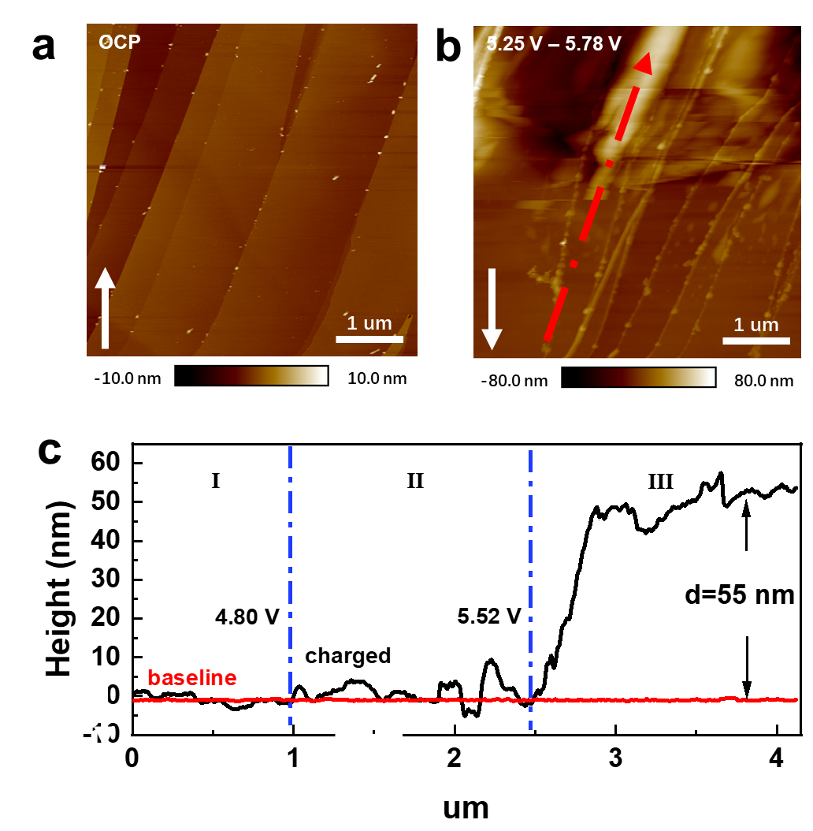
Figure 5. In situ AFM images with different cut-off potential. AFM images taken at (a) OCP, (b) 5.25 V to 5.78 V. (c) The height profile along the dashed line in (b), the baseline in red was taken at OCP, and the black line represents the height after charge.
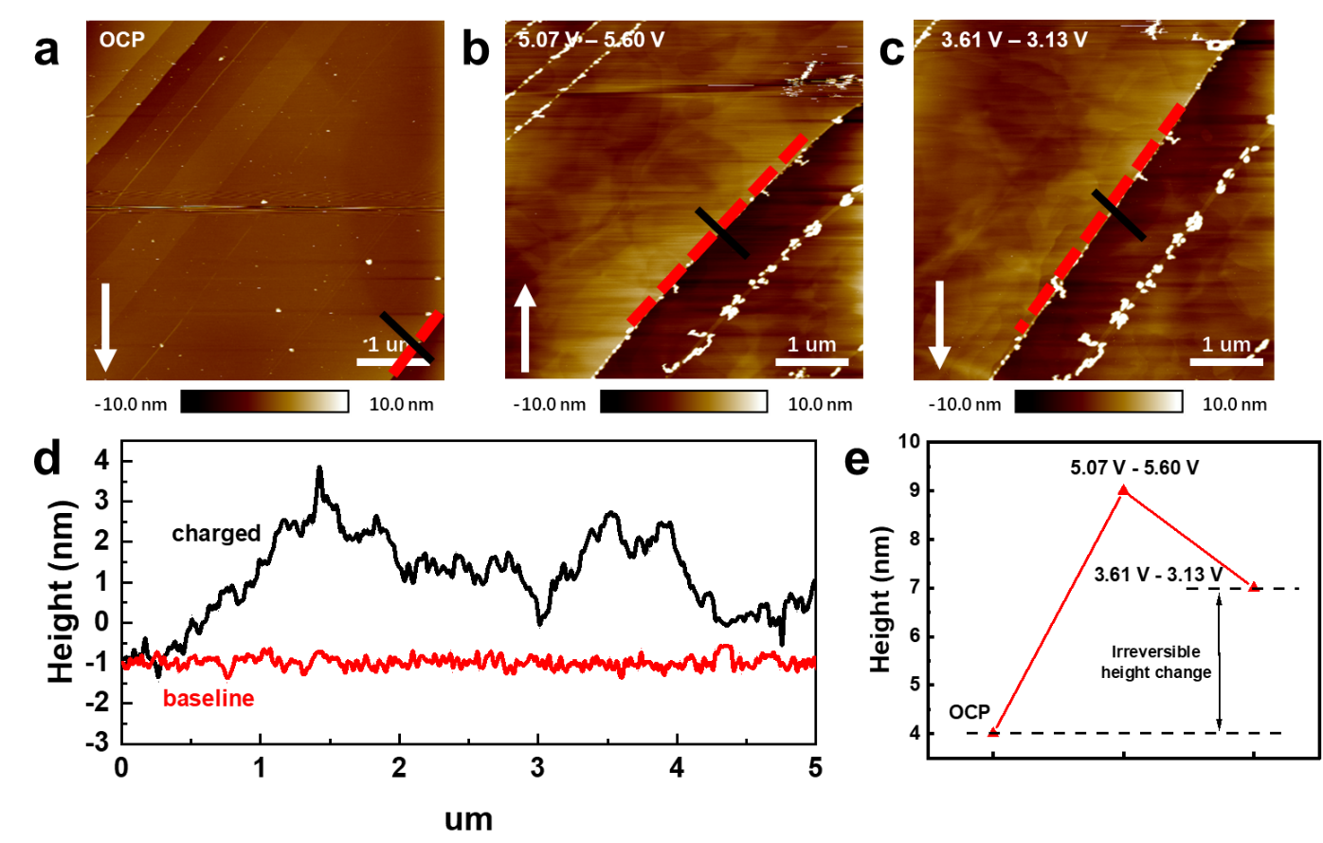
Figure 6. In situ AFM images taken at (a) OCP, (b) 5.07 V to 5.60 V and (c) 3.61 V to 3.13 V. (d) The height profile along the dashed line in AFM images, the baseline in red was taken at OCP, and the black line represents the height after charge. (e) The height changes of the selected step (black line in AFM images).
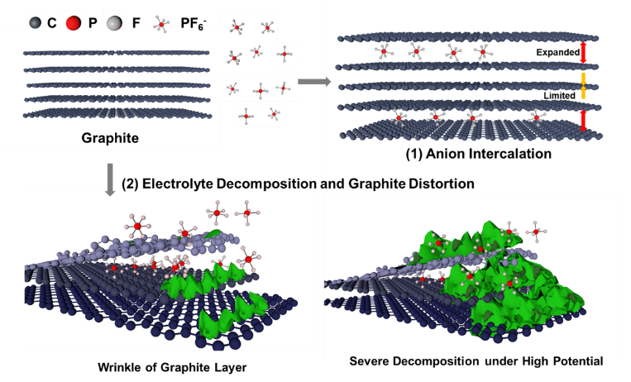
Scheme 1. A model showing the surface reaction and anion intercalation mechanism in graphite.

