Highly controlled open vessel RAFT polymerizations by enzyme degassing
Robert Chapman‡, Adam J. Gormley‡, Karla-Luise Herpoldt, and Molly M. Stevens

SUPPORTING INFORMATION

Calculation Methods
The concentration of oxygen vs distance from the surface of the solution was modelled as a function of time and GOx concentration. The GOx was assumed to be homogenously dissolved in solution, and the enzyme kinetics were assumed to be independent of glucose concentration. The rate of O₂ consumption by GOx was calculated from the Michaelis–Menten equation:

$$\frac{d[O_{2}]}{dt}=\frac{2k_{cat}\left[GOx\right][O_{2}]}{k_{m}+[O_{2}]}$$
Where k_{cat} = 920 s⁻¹, k_{m} = 3.0 x 10⁻⁵ mol.cm⁻³ and [GOx] = 0.5, 1, or 2 x 10⁻¹⁰ mol.cm⁻³ at 25°C.¹

Diffusion only case: In the diffusion only case, the solution was divided into increments of Δz = 0.025 cm from the surface. The [O₂] in the top fraction of the solution (z₀) was fixed at 7.78 x 10⁻⁷ mol.cm⁻³ (the concentration of dissolved O₂ in PBS at 101.3 kPa, 45°C).² For each z slice the rate of O₂ diffusion in and out of the slice and the consumption of O₂ by GOx within the slice was determined by the equations below.
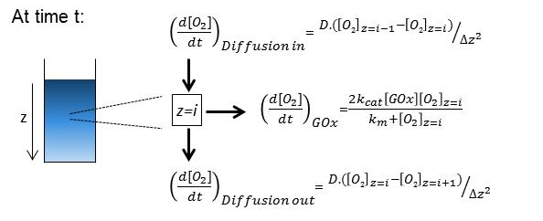

This leads to Fick’s first law where:
$$\frac{δC_{O_{2}}}{δt}= D_{O_{2}/H_{2}O}{\left.\frac{δ^{2}C_{O_{2}}}{δz^{2}}\right|}_{z=i+1}^{z=i-1}-\frac{2k_{cat}\left[GOx\right][O_{2}]}{k_{m}+[O_{2}]}$$

D is calculated by the Wilke-Chang correlation,³ such that:
$$D_{O2/H2O}=7.4×{10}^{-8}\frac{T{(φ_{H2O}.M_{H2O})}^{0.5}}{µ {{(V}_{O2})}^{0.6}}$$
Where ψ (an ‘association’ parameter for water) = 2.26, M_{H2O} (the molar volume of water) = 18 g.mol⁻¹, V_{O2} = 25.6 cm³.g⁻¹, and µ (the viscosity at 30°C) = 0.819 cps.

These equations were used to calculate the concentration of O₂ at each z increment vs time according to the following equation:
$${\left[O_{2}\right]}_{t=j+1}={\left[O_{2}\right]}_{t=j}+∆t\left[{\left(\frac{d[O_{2}]}{dt}\right)}_{Diff in}-{\left(\frac{d[O_{2}]}{dt}\right)}_{GOx}-{\left(\frac{d[O_{2}]}{dt}\right)}_{Diff out}\right]$$

Stirred solution: In the case of a stirred solution the O₂ concentration was assumed to be completely homogenous throughout the bulk. In order to determine the rate of diffusion of oxygen into the bulk, an infinitely small layer of the solution with a constant O₂ concentration of 2.4 x 10⁻⁷ mol.cm⁻³ was assumed at the interface of the solution and the atmosphere. The equations below show how the oxygen concentration as a function of time was calculated.

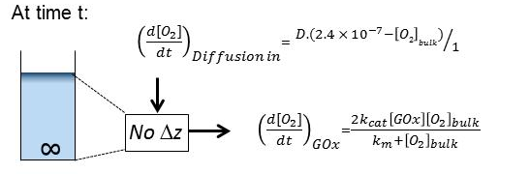

$${\left[O_{2}\right]}_{t=j+1}={\left[O_{2}\right]}_{t=j}+∆t\left[{\left(\frac{d[O_{2}]}{dt}\right)}_{Diff in}-{\left(\frac{d[O_{2}]}{dt}\right)}_{GOx}\right]$$

Calculation of kinetic parameters for VA-044:
Although the values vary greatly depending on the target molecular weight and monomer concentration, RAFT polymerizations typically use between 0.5 and 5 mM of initiator.^{[11]} Assuming an initiator efficiency of 50% the radical flux at 5 mM VA044 can be calculated from the activation energy for Va044 (1.08 x 10⁵ J.mol⁻¹) and temperature at which the half-life is 10 h (317K) which were taken from the product information sheet. From these the Arrhenius constant A can be calculated according to the Arrhenius equation:

$K_{d}=Ae^{-\frac{E_{a}}{RT}}$, where $K_{d}={ln⁡(2)}/{t_{1/2}}$
This constant A was then used to calculate the k_{d} at 45°C which was determined to be 2 x 10⁻⁵ s⁻¹, which would result in a radical flux of 1.1 x 10⁻¹⁰ mol.ml⁻¹.s⁻¹ at 5 mM Va044. As discussed in the manuscript, at this concentration in order for polymerization to occur it can be assumed that the oxygen concentration needs to be of the order 10⁻⁸ to 10⁻⁹ mol/ml or else the quenching of radicals by oxygen will overwhelm the propagation of monomer.

Additional polymerizations and characterization data

Table S1. Rate constants for polymerisation reactions in Figure 2
# | [GOx] (µM) | Method | Stirring | Rate constant  (x 10⁻² s-¹)
1 | 1 | NMR | - | 1.57 ± 0.05
2 | 0.25 | NMR | - | 1.38 ± 0.07
3 | 0.05 | NMR | - | 0.85 ± 0.04
4 | 1 (inactive) | NMR | - | 0.13 ± 0.02
4 | 0 (argon degassed) | Vial | Y | 1.67 ± 0.11
5 | 1 | Vial | Y | 0.22 ± 0.05
6 | 4 | Vial | Y | 1.72 ± 0.07
7 | 10 | Vial | Y | 1.68 ± 0.13

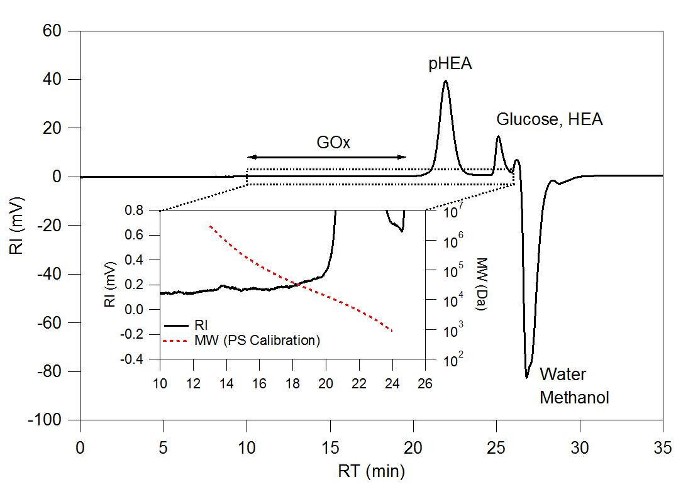
Figure S1: SEC trace (DMF) of the crude mixture from polymer 4 (Table 1) after 140 min. Glucose, water and methanol peaks can be seen, but no glucose oxidase peak is visible in the range of 160 kDa.

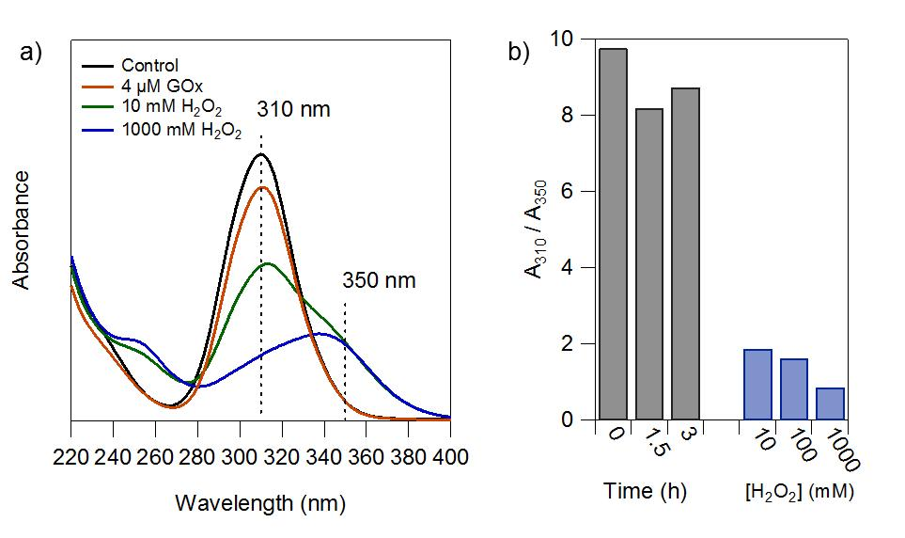
Figure S2: a) UV-Vis spectra of the chain transfer agent (CTA) after incubation with either 0 - 1000 mM H₂O₂ or 4 µM GOx and 100 mM glucose for 1.5 h at 45°C. b) Ratio of absorbance at 310 to 350 nm resulting from incubation of the CTA with the GOx for 0, 1.5 and 3 h (grey bars) and 10-1000 mM H₂O₂ for 1.5h (blue bars). In all cases the CTA was incubated at 20 mg/ml in 10% methanol / PBS and spectra were recorded after 1:1000 dilution in methanol.
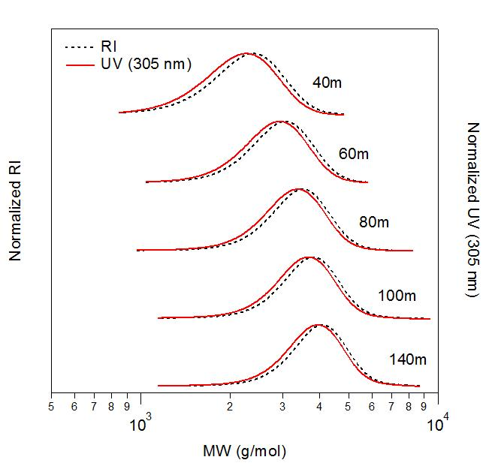
Figure S3: SEC in DMF of the crude mixture from polymer 4 (Table 1) at different time points during the reaction, showing the overlap of the refractive index (RI) and UV peak at 305 nm. Molecular weights are calculated using the Mark-Houwink parameters of PEO using a PS standard curve.

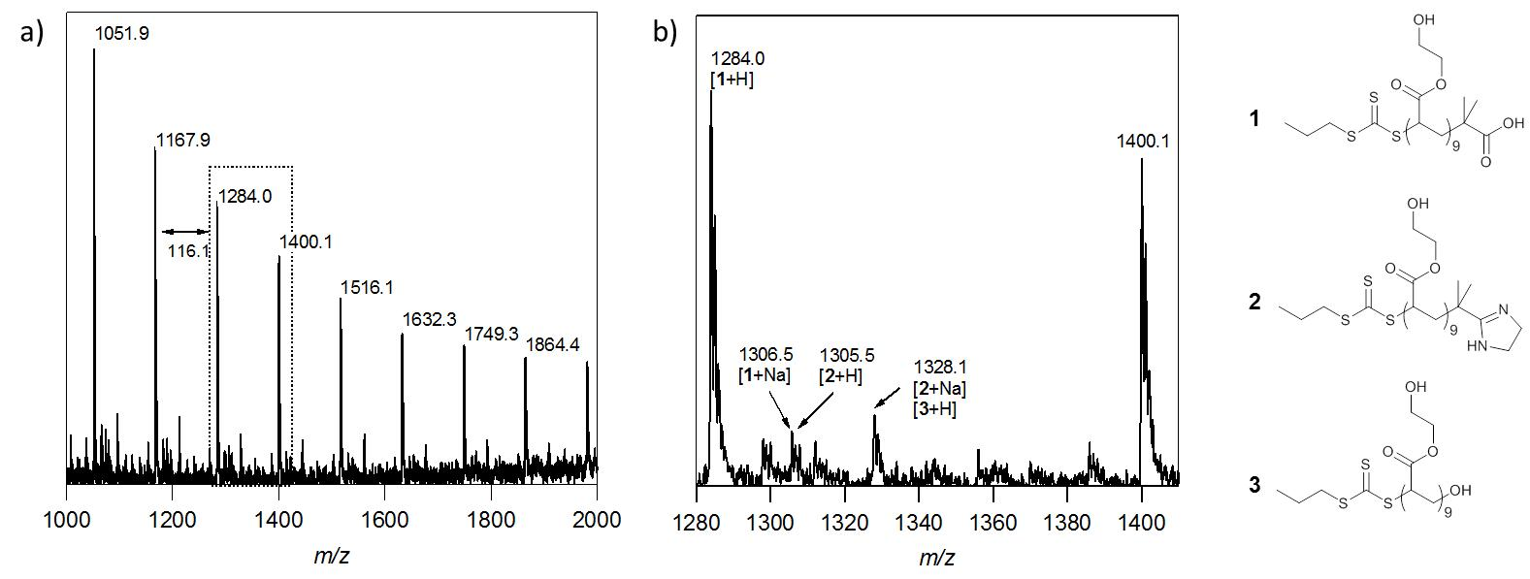
Figure S4: Matrix-assisted laser desorption/ionization time of flight (MALDI-TOF) spectra for a DP 25 HEA polymer polymerised in an open vessel with 4 µM GOx at 45°C for 2.5 h. a) Full spectrum and, b) expansion of the dotted region in (a).

Table S2. Examples of HEA polymers without stirring at low [GOx]
# | [M] / [CTA] | [VA044] (mM) | [CTA] / [VA044] | [GOx] (µM) | Time (h) | X (%) | M_{n} theor (Da)
21 | 25 | 500 | 200 | 1 | 15 | 24% | 933
22 | 25 | 2500 | 40 | 1 | 15 | 95% | 2995
23 | 25 | 5000 | 20 | 1 | 15 | 99% | 3111
24 | 25 | 2000 | 50 | 0.25 | 20 | 49% | 1649
25 | 25 | 2000 | 50 | 0.5 | 20 | 91% | 2874
26 | 25 | 2000 | 50 | 1 | 20 | 96% | 3013
Notes: Polymerizations in 1.75 ml vials without stirring, in a heating block at 45°C with 1 used as the CTA. In all polymerizations [HEA] = 2 M in 1:4 methanol : PBS.

References
(1) Sengupta, S.; Patra, D.; Ortiz-Rivera, I.; Agrawal, A.; Shklyaev, S.; Dey, K. K.; Córdova-Figueroa, U.; Mallouk, T. E.; Sen, A. Nat. Chem. 2014, 6, 415–422.
(2) Battino, R.; Rettich, T. R.; Tominaga, T. J. Phys. Chem. Ref. data 1983, 12, 163–178.
(3) Wilke, C. R.; Chang, P. AIChE J. 1955, 1, 264–270.
(4) Wood, M. R.; Duncalf, D. J.; Findlay, P.; Rannard, S. P.; Perrier, S. Aust. J. Chem. 2007, 60, 772.

