Supplementary material

Supplementary Table 1: Chemicals and suppliers
Supplementary Figure 1: Structures of carbonyl-modified nucleosides
Supplementary Figure 2: Structures of chloro- and oxo-modified nucleosides

Supplementary Table 1: Chemicals and suppliers

Common Name | Abbreviation |  | CAS |  | Supplier
Normal nucleosides
Deoxyadenosine | dA |  | 958-09-8 |  | Sigma
Deoxycytidine | dC |  | 951-77-9 |  | Sigma
Deoxyguanosine | dG |  | 961-07-9 |  | Sigma
Deoxythymidine | dT |  | 50-89-5 |  | Sigma
Adducted nucleosides
1,N6-Etheno-2′-deoxyadenosine | edA |  | 68498-25-9 |  | Santa Cruz
3,N4-Etheno-2'-deoxycytidine | edC |  | 68498-26-0 |  | Carbosynth
8-Chloro-2'-deoxyguanosine | cdG |  | 437715-62-3 |  | Carbosynth
8-Chloro-2'-deoxyadenosine | cdA |  | 85562-55-6 |  | Carbosynth
α-Methyl-γ-hydroxy-1,N2-propano-2’-deoxyguanosine | CrodG |  | 132014-87-0 |  | TRC
N2-ethyl-deoxyguanosine | EtdG |  | 101803-03-6 |  | Sigma
8-Oxo-2’-deoxyguanosine | OdG |  | 88847-89-6 |  | Sigma
Labelled nucleotides
8-Oxo-2’-deoxyguanosine-d₃ | OdG-d3 |  | n/a |  | Sigma
α-Methyl-γ-hydroxy-1,N2-propano-2’-deoxyguanosine-d₃ | CrodG-d3 |  | n/a |  | TRC
Deoxyadenosine-N¹³₅ | dA-N5 |  | n/a |  | CIL
CAS, Chemical Abstracts Service; TRC, Toronto Research Chemicals; CIL, Cambridge Isotope Laboratories

Supplementary figure 1: Structures of carbonyl-modified nucleosides

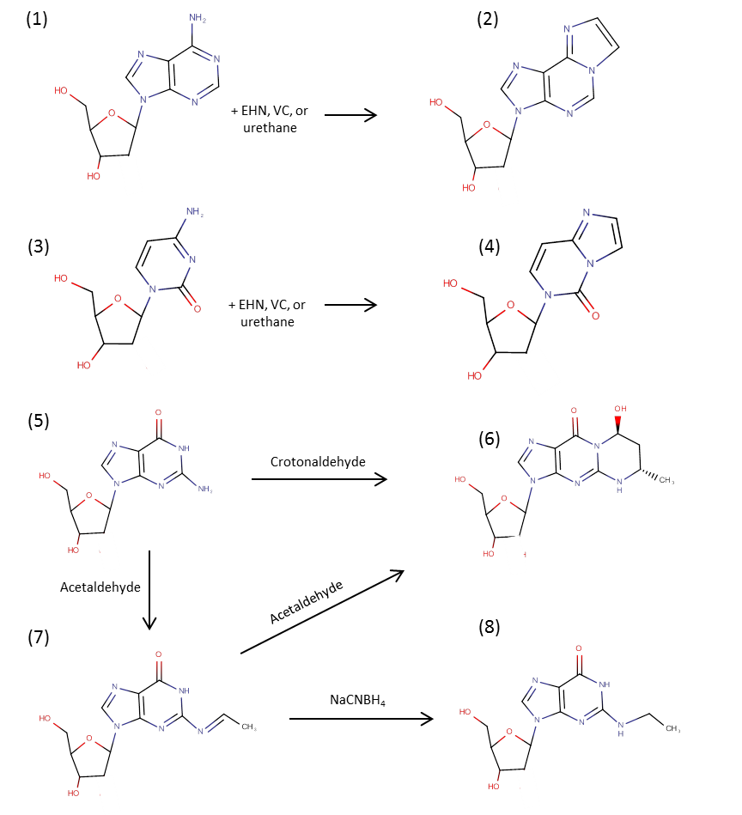

Ethenodeoxyadenosine (edA, 2) and ethenodeoxycytidine (edC, 4) are formed from a complex reaction involving epoxidated hydroxynonenal (EHN), or reaction with urethane or vinyl chloride, from dA (1) and dC (3) respectively. Crotondeoxyguanosine (CrodG, 6) is formed by reaction of dG (5) with crotonaldehyde or two acetaldehydes (forming a mixture of two stereoisomers). Acetaldehyde also gives an unstable intermediate (7) that can be converted to ethyl deoxyguanosine (EtdG, 8) by reduction.

Supplementary figure 2: Structures of chloro- and oxo-modified nucleosides

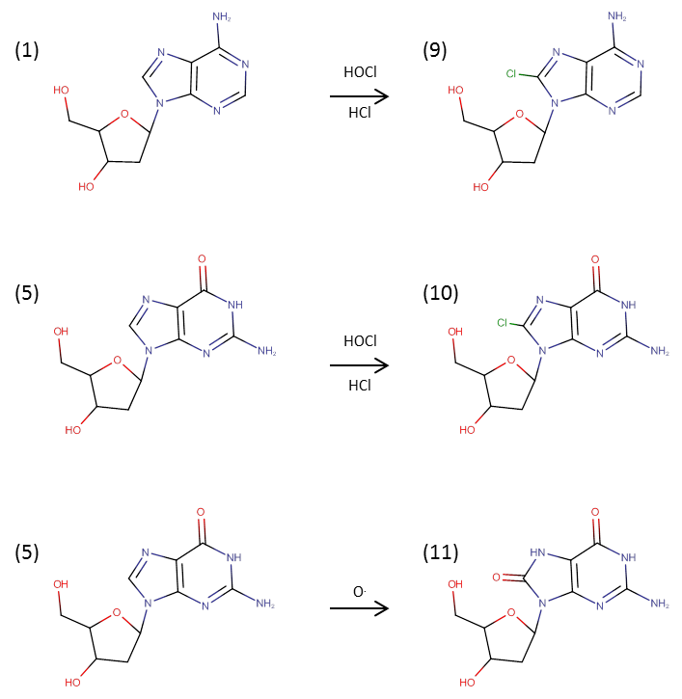

dA (1) and dG (5) can be halogenated by HOCl or HCl to give 8-chlorodeoxyadenosine (cdA, 9) or 8-chlorodeoxyguanosine (cdG, 10). dG can also be oxidised by singlet oxygen, most commonly giving 8-oxo-2-deoxyguanosine (odG, 11).

