Type: Original Article
Determination of loads carried by polypropylene ankle-foot orthoses. A preliminary study
Enrica Papi^{1,2}, John Maclean², Roy J Bowers² and Stephanos Solomonidis²
¹ Department of Surgery and Cancer, Imperial College London, London, UK
² Department of Biomedical Engineering, University of Strathclyde, Glasgow, UK

Corresponding author
Enrica Papi, Department of Surgery and Cancer, Imperial College London, Room 7L16, Floor 7, Laboratory Block, Charing Cross Hospital, Fulham Palace Road, London, W6 8RP, UK.
Email: e.papi@imperial.ac.uk

Abstract
Ankle-foot orthoses (AFOs) are prescribed for the management of gait related problems. Prescription of AFOs is based on empirical techniques due to the low level of evidence-based research on their efficacy but, primarily, poor understanding of their mechanical characteristics. The aim of this study was to establish a method which would allow the quantification of the contribution of AFOs in the control of the ankle joint during gait. A possible way of achieving this aim would be to measure strain on the AFO during walking by the use of strain gauges (SGs). Following successful experimentation with the application of SGs to polypropylene tensile specimens, an AFO was instrumented by attaching SGs to it so as to allow the moment generated on the AFO in the sagittal plane about the ankle centre to be measured. Walking trials using this AFO on an able-bodied subject indicated good step-to-step repeatability.
The use of an instrumented AFO in conjunction with gait studies involving kinematic and kinetic data acquisition would allow the contribution of the AFO and the residual anatomical loads to be determined. The advantage of such procedure over previously reported ones resides on the use of the actual orthosis being worn by patients thereby conducting tests under real life situations. It is believed that such analysis of the load actions of an orthosis, which may in future be carried out in 3 dimensions, would allow a better understanding of the interaction between the leg and the orthosis. This should ultimately enhance AFO prescription criteria and help in optimizing patient/device matching.
Keywords: Ankle-foot orthosis, strain gauges, ankle moment, orthotic loads, walking

Introduction
Ankle-foot orthoses (AFOs) are prescribed for the management of lower limb impairments. Evaluation of the efficacy of AFOs is a two-fold process, which requires both assessment of walking ability in terms of improved activity level and re-established normal kinematics and kinetics at joints, and evaluation of the mechanical characteristics of the specific intervention prescribed. With regards to the mechanical characterisation of AFOs, although several studies¹⁻⁶ have been conducted to quantify AFO stiffness, the contribution of AFO to ankle function during walking has been less explored. Moreover, most studies that quantify the contribution generated by an AFO are dated back to the 1990s showing a gap in the literature in recent years. ^{1-2, 7-11,14-15,17}
McHugh,⁷ conducted a theoretical analysis of the forces acting on an AFO in the absence of plantarflexion or dorsiflexion muscle power. Using experimental techniques, an attempt to measure an AFO’s corrective ankle moment during gait was pursued by a research group at the University of Tokyo⁸⁻¹¹ using an instrumented experimental AFO. This was a conventional AFO with double aluminium uprights and adjustable springs to control plantar and dorsiflexion movement. Although, the methodology introduced was shown to be feasible, the results are related to the particular experimental orthosis employed with the limitation on how to interpret the results to the fabrication of modern plastic AFOs commonly prescribed. More recently, the AFO’s contribution during gait was obtained by an indirect measurement from the estimated AFO stiffness, AFO inclination angle and ankle joint angle.¹² AFO stiffness and inclination angle were determined with a new device named BRUCE.⁶ A dummy leg and the AFO to be tested are mounted into the device which is manually driven to deform the AFO while measurements are taken. This method, proposed by Bergman et al., ¹² overcomes the issue related to the use of a trial AFO but, it could be argued that a direct measurement, by means of using an instrumented AFO, would more accurately determine the orthotic loads than this indirect measurement method requiring the above mentioned estimated values. Moreover, using the suggested bench test method to derive AFO properties is not representative of the loading experienced during walking. However, results obtained from such studies have been confined to research purposes and not implemented in clinical practice, with prescription of AFOs remaining based on empirical techniques.
The aim of this study was to investigate a novel methodology to quantify the AFO assistive moment during walking. Measuring the AFO moment will provide a better understanding of the interaction between the orthosis and the patient’s leg during gait in order to refine future AFO provision and achieve an effective orthosis design. Electrical resistance strain gauges attached to an AFO were used for this aim. Chu et al.¹³⁻¹⁵ used strain gauges to quantify the stresses developed on AFOs and identify where mechanical failure might occur but no load analysis on the AFO was conducted. In addition, in these studies, the accuracy of the methodology was not validated and the effect of the UV light treatment used to attach the gauges on to the polypropylene (PP) material properties was not investigated. UV light exposure to treat the plastic material before attaching the strain gauge foil is required to improve the bond between these two elements. The accuracy of such procedures is discussed in this paper.

Materials and methods
Material and strain gauged samples testing
Polypropylene, common with other plastics, is a notoriously difficult material to adhere items to it. Combined with its viscoelastic properties, consideration of adhering strain gauges to it in order to measure strain accurately, presents a challenge. Therefore it was necessary to take several steps in order to ensure that the application of strain gauges was sufficiently accurate to fulfil the aims of the project.
Ten dumb bell-shaped specimens were cut from a homopolymer polypropylene sheet (North Sea Plastics Ltd., Glasgow, UK) with a measured thickness of 6 mm, following the dimensions specified in the American Standard ASTM D638-2008.¹⁶ Five samples were left untreated and five were treated with UV light emitted from a CS410-EC UV curing system (Thorlabs Inc, New Jersey, USA). The samples’ surface was positioned at approximately 25 mm from the UV light source (90 mW/cm² @365 nm) for 30 minutes.¹³
The PP specimens were tested on an Instron 5800R tensile testing machine (Instron, Norwood, USA). An extensometer (Instron, Norwood, USA) with a gauge length of 10 mm, attached on the side of the specimen, was used to measure strain during the test. The samples were tested in tension in a stress range between 0 and 2 MPa, which covers the tensile stress likely to be applied on a PP AFO in use, according to either experimental or finite element analysis studies.^{14-15, 17} A test protocol was created which consisted of 200 loading cycles up to120 N which corresponds to a stress of 2 MPa at the given cross sectional area, followed by a 30 minutes hold step at full load. For each cycle, 5 s were allowed for the load to reach the maximum value and 5 s to return to 0 N.
Strain data from the extensometer and the corresponding load applied by the testing machine were collected at 10 Hz. A statistical analysis was performed using two-sample t-test at 0.05 level of significance, to compare the Young’s Modulus of untreated and UV light treated samples. The Young’s Modulus was calculated using the method described in BS 527-1¹⁸ for computer aided equipment. The stress was computed by dividing the load (N) applied by the initial cross sectional area (mm²) of each sample, whereas strain was calculated by dividing the extensometer readings by its gauge length (10mm).
Two additional samples were cut with the same dimensions as those described above and strain gauges were attached on them (Figure 1).
Figure 1. Strain gauged homopolymer polypropylene sample with details of strain gauges in the upper and lower surface connected to form a Wheatstone bridge (diagram on the left).
E: Bridge Voltage; e_{o} Voltage Output.

The upper and lower surfaces of the samples designated for attachment of the strain gauges were locally exposed to UV-light for 30 minutes each. ¹³ Two, two-element 90° rosette strain gauges (EA-13-062TT-120, Vishay Precision Group, Malvern, USA) were used and connected so as to create a full Wheastone bridge circuit. The strain gauges were attached, aligned to the principal axes of the sample, with cyanoacrylate adhesive on both sides of the sample. Once the adhesive was cured a coating agent was applied over the gauges and lead wires.
The two strain gauged samples were tested in the Instron machine twice, (referred in the text as Test1, Test2) in two separate occasions following the same procedure as described above.
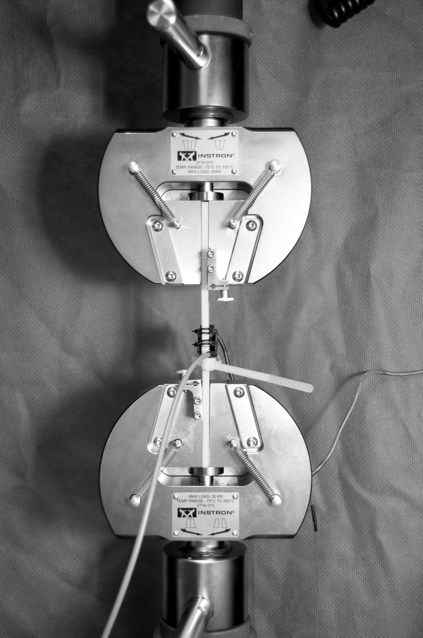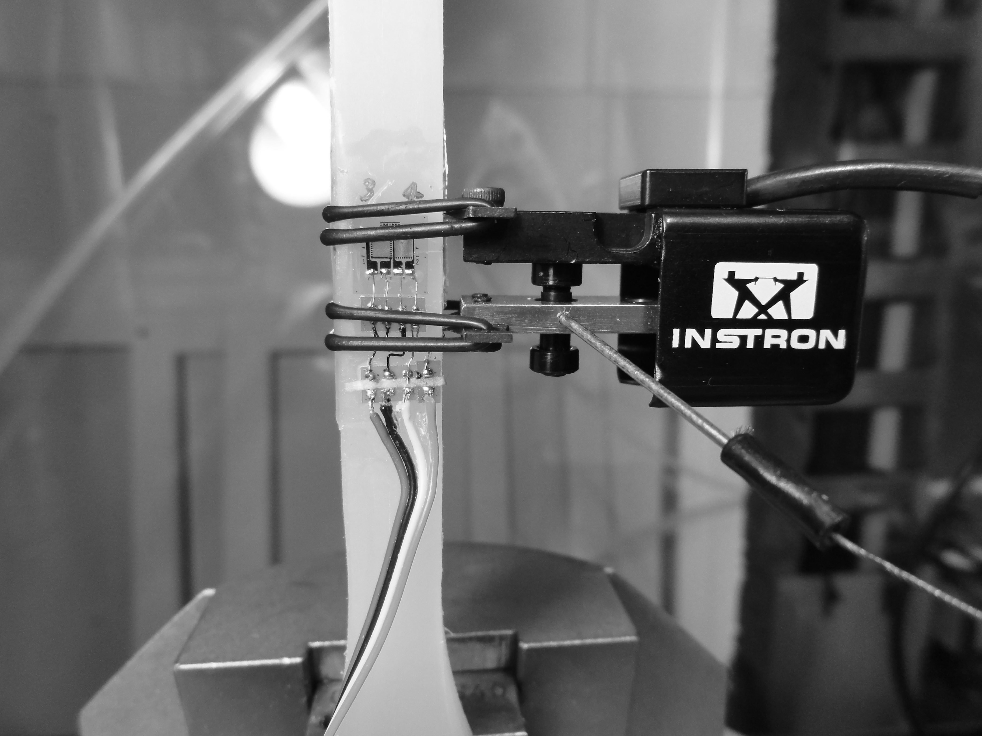
Figure 2. Picture showing the extensometer position relative to the strain gauges attached to the polypropylene sample during tensile testing. Frontal and side views are shown.

The extensometer was positioned on the side of the sample allowing a simultaneous measurement of strain along with the strain gauge readings (Figure 2). The Wheatstone bridge was connected to an amplifier and the outputs, together with extensometer measurements and loads applied, were transferred into a computer via a data acquisition card (PCI-6040E, National Instruments, Texas, USA). From the computer with a custom-built Labview program (Labview software 8.6, National Instruments, Texas, USA) the three signals were acquired and stored in a Microsoft Excel spread sheet for subsequent data processing. Data sampling was at 10 Hz. Data collected were filtered prior to analysis to reduce slight noise introduced by the recording system. For this purpose, a custom-made moving average filter with a window of five samples implemented via Matlab signal processing software (The MathWorks Inc., Massachusetts, USA), was applied to the data.
The voltage outputs from the Wheatstone Bridge were applied to equation 1, derived from the analysis of the circuit, to calculate strain values

$ε=\frac{2∙e_{o}}{\left(1+ν\right)E∙K_{s}∙G}$ (1)

where: ε is the strain (mm/mm), e_{o} is the Bridge output (V); ν is the Poisson’s Ratio, E is the Bridge supply voltage set at 3V, K_{S} is the Gauge Factor provided by the strain gauges manufacturer; and G is the Amplifier Gain that was set at 200. A Poisson’s Ratio for polypropylene of 0.36 was used.¹⁹
The feasibility of the strain measurement obtained by means of strain gauges attached to polypropylene material was assessed by means of a comparison with simultaneously recorded extensometer readings under the given load conditions. The discrepancy between the systems was expressed as percentage difference (equation 2) of the strain readings computed with both methods. The percentage was calculated relatively to the readings obtained by the strain gauges

$\% Difference=\left(\frac{Strain Gauge Readings-Extensometer Readings}{Strain Gauge Readings}\right)∙100$ (2)

This equation was applied throughout the range of strain measured during the test protocol. A Pearson’s correlation coefficient (r) was computed to assess the association between the measurements of the two systems. In addition the differences between strain gauges and extensometer derived strains were explored using paired t-test, whereby statistical significance was accepted at p<0.05.

Strain gauged AFO testing
An AFO manufactured from a cast of the left leg of an able-bodied subject (Body mass 82 kg) was strain gauged (Figure 3, Left) and a preliminary test with the subject walking in the orthosis was conducted.
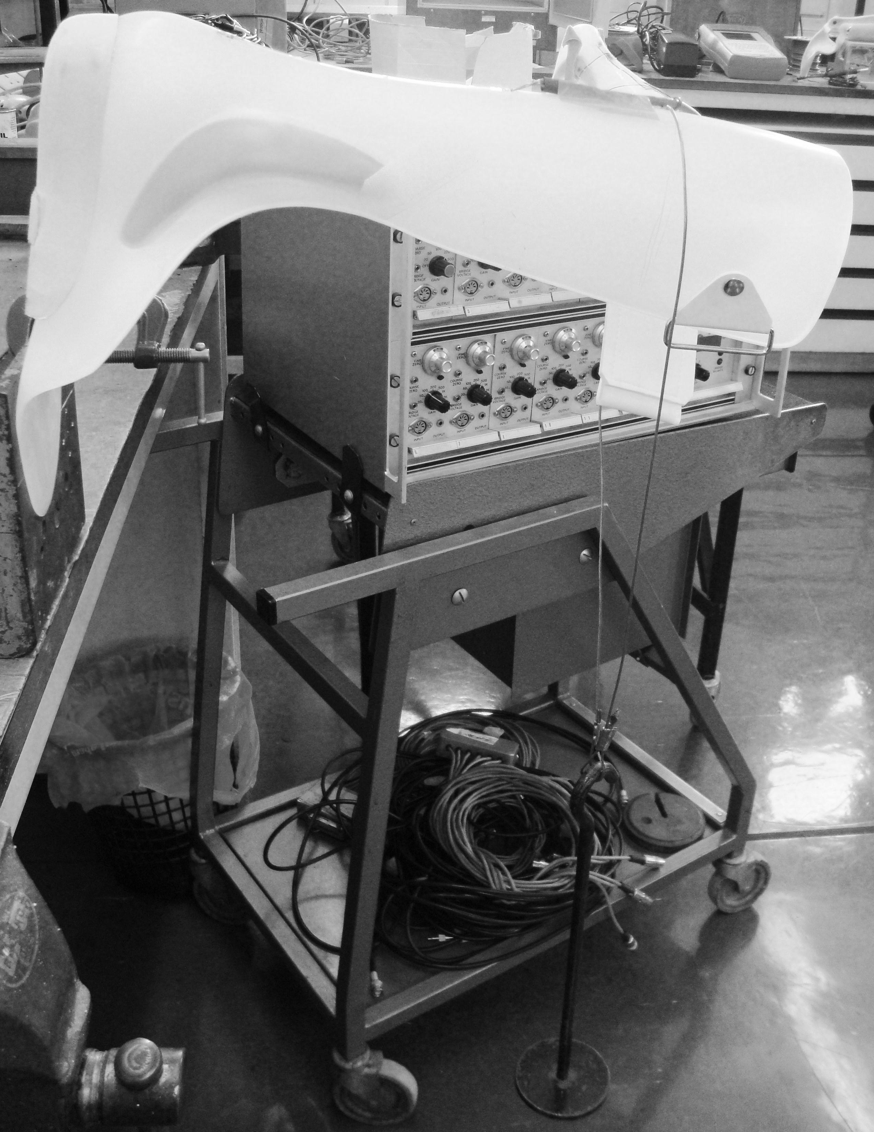
Hanger
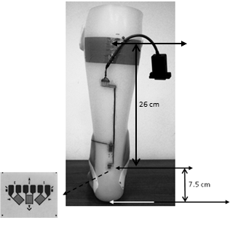
Figure 3. Left: Posterior view of the strain gauged AFO. Right: AFO plantarflexion static test set up. For dorsiflexion static test, the AFO is reversed by 180 degrees.

The AFO was made of 5 mm homopolymer polypropylene (North Sea Plastics Ltd., Glasgow, UK) with carbon fibre reinforcements (PolyCar-C Ankle Inserts, Fillauer Inc., Tennessee, USA) at malleoli level. A 45° three-element rosette (EA-06-031RB-120, Vishay Precision Group, Malvern, USA) was applied on the Achilles tendon region of the AFO with each element connected to three resistors (bridge completion resistors, ERA8AEB121P, Panasonic, New Jersey, USA) to complete a full Wheastone bridge circuit to measure axial strains in the Y (axial, along the tibia) direction, in the 45° and -45° to the axial direction. The surface area of the AFO, where the gauges were to be attached, was exposed to UV-light for approximately 30 minutes. The foil gauges were then attached using cyanoacrylate adhesive.
Strain gauge performance, when attached to the AFO, was tested prior to conducting the test with the subject. A static test to verify the linearity of the strain gauge response was performed by clamping the AFO on a bracket so as to reproduce first a dorsiflexion moment and secondly a plantarflexion moment at the ankle and by applying a maximum mass of 4 kg (39.2 N of force) in increments of 1 kg every 30 seconds (Figure 3, Right). The weights were added onto a hanger attached perpendicular to the AFO (at right angles to the Z_{SG} axis, see Figure 4) creating a lever arm of 26 cm from the strain gauges (Figure 3) and then gradually removed at the same rate. Loads (9.8 to 39.2 N) were applied perpendicularly to the strain gauge while the corresponding outputs (Volt) were recorded by means of a P3 strain indicator from Vishay Precision Group (Malvern, USA). The outputs from the gauges were plotted against the loads applied to verify if the strain gauges showed a linear behaviour (R²). The same procedure was repeated at the end of the subject test to determine the conversion factor that allows the calculation of AFO dorsiflexion/plantarflexion moments from the voltage outputs recorded during walking. The conversion factors (Nm/V) were determined by a linear regression procedure applied to the moment/strain gauges outputs curves. The moment values for both plantarflexion and dorsiflexion were obtained by multiplying the loads applied by the distance (26 cm, Figure 3) between the strain gauges and the load application point. This represents the AFO moment calculated at the gauge location. Strain gauge outputs were acquired with the same instrumentation used during the subject test described below.
A gait analysis test was conducted with the subject wearing the instrumented orthosis in the Biomechanics Laboratory of the University of Strathclyde (Glasgow, UK). Synchronous to the strain gauge outputs, ground reaction forces from four force plates (Kistler Instrumente AG, Switzerland) flush with the ground and 3-D marker trajectories using a 3-D motion capture system with twelve cameras (Vicon MX Giganet, Oxford Metrics Ltd., UK) were recorded. The 3-D position and orientation of left and right tibia and feet of the subject were obtained during walking by tracking the trajectories of 14 mm diameter retro-reflective markers attached onto rigid clusters in the distal part of the tibia and individual markers on the feet (1st and 5th metatarsal head and calcaneus). Anatomical landmark markers at the knee epicondyles and malleoli were used for static calibration and then removed during dynamic capture. This marker set allowed the definition of anatomical frames of reference in accordance with standard recommendations.²⁰⁻²¹ In addition, a rigid cluster of four markers was attached on the rear part of the AFO aligned with the three-element strain gauge rosette. These were used to construct the strain gauge technical reference frame. All markers and clusters were attached using hypoallergenic double-sided tape.
Before commencing data recording, the subject was given time to get accustomed to the orthosis and to precondition the material. The AFO was provided with four 15m long multicore shielded cables (Pro Power, part No 860128-25M, Farnell UK Limited, UK) so as to not restrict subject movements during the test and to prevent stress being imposed on the wire connections. Cables were terminated with 5 pin standard DIN plugs which plugged each strain gauge’s output (+45°, 0°, -45° channels from the rosette) directly to the amplifiers. The amplifiers were custom-built by using the RS Components strain gauge amplifier IC and corresponding printed circuit boards (RS Components Ltd.,Northants, NN17 9RS, UK). The amplifiers were connected to the Vicon laboratory computer to allow simultaneous data collection with force plates and marker trajectories data. The bridge voltage and gain settings were set at 1V and 500 respectively for each channel. The outputs of each channel were zeroed before starting the test. Data acquisition started with a static anatomical landmark calibration trial, after which gait trials were captured. The subject walked at his comfortable speed across the laboratory with a calibrated field of 6 m in length. Four walking trials with clear heel strikes on separate force plates were used for the analysis. Data from strain gauges, force plates and infrared cameras were sampled at 100 Hz.
Marker trajectories and force plate data were processed using Nexus and Bodybuilder software (Oxford Metrics Ltd., UK) to reconstruct tibia and foot anatomical frame of references. Knee and ankle joint centres were considered as the mid point between the epicondyles and the malleoli respectively. Woltring’s general cross-validatory quintic smoothing spline²² with a predicted mean-squared error of 15 mm was used to filter coordinate data. An inverse dynamic approach was used to compute internal ankle joint moments and forces expressed in the tibia reference frame. Inertial and mass properties were extrapolated from Winter.²³
Further analysis of ankle kinetics and strain gauge outputs was performed with a custom-built Matlab script (The MathWorks Inc., Massachusetts, USA). The first step of the analysis was to convert the strain gauge output expressed in Volts into moment quantities expressed in Nm by the conversion factors obtained from the static bench test of the AFO. For this preliminary investigation only the signal recorded by the central axial strain gauge (i.e. along Y_{SG} axis, see Figure 4) in the three-element rosette was considered. To allow comparison between total ankle moment and AFO moment, both were calculated with respect to the gauge location (origin of strain gauge reference frame) and expressed in the tibia reference frame. The AFO moment, being expressed in the strain gauge technical frame (Step 1 in Figure 4), was firstly transformed into the global reference frame (Step 2 in Figure 4) and then into the tibia reference frame through constructed direction cosine matrices (Step 3 in Figure 4).
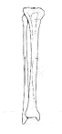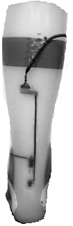

Figure 4. Steps followed to transform the strain gauges outputs from the strain
gauge reference frame (1) to the tibia reference frame (3). R indicates direction
cosine matrix for the transformation of the axes systems, also illustrated.

The total ankle moment, recorded by the force plate and Vicon system, at the gauge location was computed by adding to the total ankle moment calculated at the ankle joint centre, the moment contribution from the 3-D internal ankle forces
$M_{ankle_gaugelocation}$=$M_{ankle_jointcentre}+ r x F_{ankle_jointcentre}$ (3)
Where M_{ankle_gaugelocation} is the total ankle moment about the gauge location, M_{ankle_jointcentre} is the total ankle moment about the ankle joint centre, r is the position vector between the strain gauge location and the ankle joint centre, F _{ankle_jointcentre} is the total ankle intersegmental force. Although the analysis was carried out in 3D only dorsiflexion/plantarflexion moments are presented. The distance between the strain gauges and the ankle joint centre was 0.05m in the sagittal plane.
AFO moments and total ankle moment were time normalised to 100% of stance phase. The convention used is that of internal moments with plantarflexor moment being represented as positive.
From the known total ankle moment and AFO moment, the moment provided by the subject active and passive tissues can be determined from equation 4

M_{TOT} = M_{AFO} + M_{ANATOMY} (4)

where M_{TOT} is the ankle total moment about the gauge location, M_{AFO} is the moment carried by the AFO, M_{ANATOMY} is the moment provided by the subject’s active and passive tissues.
The moment provided by the subject’s tissues would be of interest particularly when considering people with impaired gait for whom muscle power may be lost and the actual contribution of the AFO can be better understood. This approach should also provide orthotists information on the effects of an AFO on anatomical structures.

Results
Material and strain gauged samples testing
The tests conducted in PP samples showed the material’s viscoelastic nature. As expected, a preconditioning phase occurred in each sample before reaching a steady state as the number of cycles increased; hysteresis, although minimal for the stresses applied, was observed as well as creep during the 30 minutes hold step.
For the applied test speed and stress between 0 and 2 MPa, the stress-strain relationship for polypropylene is approximately linear and thus Hooke’s law applies in the determination of the Young’s Modulus. Table 1 lists the values of Young’s Modulus of untreated and UV treated samples as mean of the moduli of the last 5 recorded cycles. No significant differences were found between the two sample groups (p = 0.09).
Table 1. Mean (±SD) over 5 cycles of Young’s Modulus values found experimentally for standard and UV treated samples.

Strains, calculated from the Wheastone Bridge output as determined from equation 1, were compared to strain values obtained from the extensometer (Figure 5 (a), (b)).
Figure 5. (a) Typical microstrain against time curves measured by the extensometer and strain gauges; the approaching of a steady state is noticeable. (b) Details from one selected cycle of graph (a).

Although similar patterns of strain against time can be generally noticed between the two, differences existed in the values of strain measured. The average percentage differences in the range of measurement as computed from the strain gauges and the extensometer are presented in Table 2 for all tests conducted.
On average, a difference of 11.4 (±0.2) % was obtained between the two measurement systems and comparable discrepancies were identified among the tests conducted. High correlation (r > 0.98) was found between the two systems measurements.
Table2. Average percentage differences (± SD) between strain gauges and extensometer values of strain in the two samples tested twice.

It was also observed that data measured by the strain gauges were more repeatable than values recorded by the extensometer and the values obtained were more similar to what observed when samples of the same dimensions without strain gauges were tested (Figure 6). The bar chart in Figure 6 allows a comparison of absolute peak strain values as obtained at the end of the 200 cycles for non-strain gauged and strain gauged samples.
Figure 6. Microstrain peak values for cycle 200 as measured by strain gauges and extensometer in the strain gauged samples (2 samples, 2 tests on each). Mean (± SD) bars are also shown relatively to the two systems for non-strain gauged (reference value) and strain gauged samples.

The microstrain obtained as average of microstrains of samples without strain gauges treated and untreated with UV light is assumed to be the reference value (dotted bars in the chart) to which new measured strains can be compared. A standard deviation (SD) of ± 33.7 and ± 101.8 microstrain was found for the strain gauge and extensometer readings respectively. Standard deviation bars are shown in the graph in each mean bar (Figure 6). The difference, between strain gauges and extensometer mean values to that of the reference samples (dotted bars Figure 6), was quantified as percentage difference.
The values obtained are reported in Table 3. Negative values indicate a strain measurement from either strain gauges or extensometer higher than the reference strain. The percentage is in terms of the reference strain. No statistically significant differences were observed when comparing: (i) extensometer readings against strain gauge readings (p = 0.63), (ii) extensometer readings against reference strain (p = 0.64), (iii) strain gauge readings against reference strain (p = 0.74).
Table 3. Percentage differences between strain value from non-strain gauged samples and strain measured by strain gauges and extensometer for the peak values during cycle 200.

Strain gauged AFO testing
The three-element rosette showed approximately a linear behaviour, although hysteresis was observed during the static test prior to subject measurements with R² values of 0.99 for both plantarflexion and dorsiflexion when plotting loads (N) against voltage outputs. Same behaviour was observed following the subject test (R² = 0.98) as illustrated in Figure 7 which also shows the conversion factor calculation.
Figure 7. AFO static bench test plot: applied moments at gauge location against strain gauge voltage outputs showing linearity of the response and conversion factor calculation. Slight hysteresis can be noticed.

A conversion factor in plantarflexion and dorsiflexion of 46.3 Nm/V and 43.1 Nm/V respectively was found from the static AFO test (Figure 7).
Two steps for each of the four recorded walking trials were analysed, although the corresponding force plate data were only available for one of the two steps. Moments on the AFO at the gauge location expressed in the tibia reference frame throughout the stance phase of the gait are shown in Figure 8. Good consistency was observed among trials with an average standard deviation throughout stance phase of ± 2.2 Nm. A peak in the dorsiflexor moment with a mean of -19.2 (± 1.7) Nm occurred at foot flat between the 9% and 11% of stance phase of each step. A peak in the plantarflexion direction of on average of 25.0 (± 2.1) Nm was observed at heel rise between 77% and 80% of stance phase of each step.
Figure 8. Moment measured in the AFO versus percentage of stance phase for all steps recorded. Positive values represent a plantarflexor moment.

Mean total ankle moments across four steps for left and right legs are plotted in Figure 9(a). The total ankle moment of the left leg showed a reduced dorsiflexion moment during early stance phase but higher peaks of plantarflexion in the second half of stance phase when compared to the right ankle moment without orthosis. Moreover, a smaller standard deviation (bars in Figure 9a) was observed for left ankle moment, fitted with AFO, than for the right ankle moment throughout the gait cycle with an average standard deviation of ± 3.5 Nm and ± 5.3 Nm respectively.
The contributions, to the total ankle moment, from the subject’s anatomical structure and the AFO are shown in Figure 9(b).
Figure 9. (a) Mean (± SD) total ankle dorsiflexion/plantarflexion moment for left leg with AFO and right leg with shoe only. (b) Total mean ankle moment of the left leg and moment contribution of the AFO and anatomy.

Discussion
The effect of UV light treatment on polypropylene samples was investigated through the analysis of the material behaviour under tensile load condition. Exposure to UV light did not alter the polypropylene properties as no significant differences (p = 0.09) were found between the Young’s Moduli of untreated and treated samples. This allows the utilisation of UV exposure in the preparation of polypropylene surface prior to attachment of strain gauges.
Having established the suitability of UV pre-treatment, the next step was to investigate the achievable accuracy of using strain gauging techniques on the polypropylene material before proceeding to the measurement of the loads carried by a polypropylene AFO.
Comparison between strains determined by the strain gauges to those measured by the extensometer provided an insight into the accuracy of strain gauges when attached to the viscoelastic material. Strain gauges and extensometer measurements showed a high correlation despite a difference of 11% on average between the strain values measured.
Good consistency within each trial (SDs in Table 2) and among trials (average SD ± 1.7%) was found for the % difference. This indicates a systematic error exists between the two systems that could be related to the methodology adopted during the test rather than a poor capability of the strain gauges of measuring strain when attached to polypropylene. The discrepancy in strain values can be explained in fact by the different positioning of the extensometer and strain gauges on the samples. The extensometer could not be placed directly alongside the strain gauges in the samples and, consequently, the measurements were taken at different positions: laterally of the specimens by the extensometer and from the front and back surfaces by strain gauges. Moreover, whereas strain gauges measured the average strain over 2 mm gauge length, the extensometer measured strains over a gauge length of 10 mm. Given that the material is viscoelastic and thus the strain response is time dependant, averaging the strains over different area could have resulted in different values of strain.
Supporting the use of strain gauges is also the fact that results from strain gauges reflected well the outputs from non-strain gauged samples, and more so than the extensometer (Figure 6, Table 3). The similar values obtained with those from non-strain gauged samples, no statistically significant difference was found (p = 0.64), negate an increase of stiffness due to local or global reinforcement occurring on the surface of the polypropylene due to the application of the strain gauges.²⁴
The results obtained showed high correlation, no statistically significant difference and consistent discrepancy with the extensometer, supporting our intent to use strain gauges, in a proof of concept investigation, as sensing modality for estimating the AFO contribution to the ankle moment. This enabled an unmodified AFO to be used without the need to insert metal bars on which strain gauges would be attached, thereby altering the mechanical properties of the AFO. The fact that alterations of the orthosis were not necessary allows for the test to be conducted on the actual AFOs provided to patients and thus more realistic estimations of AFO loading can be obtained. The AFO maintains its properties, the loads applied come from real walking conditions, and the orthotic moment about the ankle joint is obtained directly from the strain gauge measurements. The possibility to conduct tests in a realistic setting to measure AFO moment was seen as a great advantage despite an 11% difference with extensometer measured values, given also the viscoelastic nature of the material. This, in fact, will never allow the accuracy achievable when strain gauging a metal.
Previously conducted studies that attempted the determination of AFO moments and stresses developed in the orthosis were limited by the use of modified/experimental orthoses ^{8,10-11,25} or conventional metal and leather AFOs,²⁶⁻²⁷ which are nowadays superseded by plastic AFOs. Alternatively loads were simulated in finite element analysis studies but based on restrictive assumptions simplifying material properties ^{12,28-30} or through a muscle-training machine¹⁴ to mimic gait movements. The use of an indirect method exploiting ankle joint angle and AFO stiffness for moment calculation was also introduced ⁶, but these measures are not easy to quantify, limiting the applicability of such procedure.
The method proposed in this paper overcomes the limitations found amongst all published reports allowing for AFO moments estimation under real conditions without the need to alter the properties of the prescribed orthosis or to estimate additional parameters for the calculation.
Although this is a preliminary study, the results obtained from the test on a subject, without musculoskeletal problem, were encouraging. The method utilized was able to produce repeatable results as shown by the good consistency in the strain gauges measurements across the analysed steps (Figure 8).
The AFO, fitted on the left leg, restricted dorsiflexion movement during the stance phase in comparison to the right ankle. Constraints in ankle movement were expected due to the high stiffness of the AFO used in this test. The AFO was of the rigid type with additional reinforcement provided by carbon fibre insertions at the malleoli level. The more repeatable movement at the ankle level, of the leg fitted with the AFO, is seen as a result of the AFO in controlling ankle mobility. The AFO did not allow the ankle to freely move as the contralateral side and it reduced the intrinsic variation in human movement usually seen. This was quantified in a reduced standard deviation (Figure 9a) considered a measure of movement variability in this context.
AFO contribution in this test is unrepresentative of the actual effect AFO has in impaired gait as the subject tested did not present any gait related problems and was capable of full muscle power. In addition, the results are limited to one subject although more than one trial were analysed. The results obtained, however, suggested the feasibility of the procedure in estimating the fraction of the ankle joint moment attributable to the orthosis during walking. This paper presents a novel method rather than an investigation on the actual effect of AFO on gait, which will follow in future studies.

Conclusions
In this study an investigation was carried out in order to explore the use of strain gauges for the determination of the loads carried by polypropylene AFOs during gait. Consistency in the outcomes measured was obtained, verifying the methodology proposed and providing a satisfactory way to determine plantarflexion/dorsiflexion moment contribution of the AFO.
Knowledge of the AFO contribution to the ankle moment represents an important parameter for the understanding of the effect an AFO has on pathological gait. Being able to quantify such a variable will be of value to refine orthosis prescription to better match patient needs with AFO appropriate mechanical properties. Ideally the stiffness of the orthosis should also be available. AFOs with different stiffness contribute differently to the ankle moment and at various instants of the gait cycle;^{2,8} knowing also this measure will allow for an enhanced AFO prescription decision making. AFOs could be classified with respect to stiffness and ankle moment contributions thus providing orthotists with a spectrum of AFOs to choose from. This classification will contribute towards a more analytical prescription process and the practice of evidence-based AFO provision.
Tests will be conducted with stroke survivors to verify the effect of such orthosis in hemiplegic gait.

Conflict of interest
The authors declare that there is no conflict of interest.

References
- Yamamoto S, Ebina M, Iwasaki M, Kubo S, Kawai H, Hayashi T. Comparative study of mechanical characteristics of plastic AFOs. J Prosthet Orthot 1993; 5: 59-64.
- Sumiya T, Suzuki Y, Kasahara T. Stiffness control in posterior-type plastic ankle-foot orthoses: Effect of ankle trimline. Part 2: Orthosis characteristics and orthosis/patient matching. Prosthet Orthot Int 1996; 20(2):132–37.
- Major RE, Hewart PJ, MacDonald AM. A new structural concept in moulded
fixed ankle foot orthoses and comparison of the bending stiffness of four constructions. Prosthet Orthot Int 2004; 28(1):44-48.
- Cappa P, Patanè F, Di Rosa G. A continuous loading apparatus for measuring three-dimensional stiffness of ankle-foot orthoses. J Biomech Eng 2005; 127(6):1025-1029.
- Novacheck TF, Beattie CB, Rozumalski A, Gent G, Kroll G. Quantifying the spring-like properties of ankle-foot orthoses (AFOs). J Prosthet Orthot 2007; 19(4):98–103.
- Bregman DJJ, Rozumalski A, Koops D et al. A new method for evaluating Ankle Foot Orthoses characteristics: BRUCE. Gait & Posture 2009; 30: 144–149.
- McHugh B. Analysis of body-device interface in the sagittal plane for patients wearing ankle-foot orthoses. Prosthet Orthot Int 1999; 23: 75-81.
- Yamamoto S, Miyazaki S, and Kubota T. Quantification of the effect of the mechanical property of ankle-foot orthotics on hemiplegic gait. Gait Posture 1993: 1: 27- 34.
- Yamamoto S, Ebina M, Kubo S, Kawai H et al. Quantification of the effect of Dorsi-/Plantarflexibility of ankle-foot orthoses on hemiplegic gait: A preliminary study. J Prosthet Orthot 1993; 5: 88-94.
- Miyazaki S, Yamamoto S, Ebina M, and Iwasaki. A system for the continuous measurement of ankle joint moment in hemiplegic patients wearing ankle-foot orthoses. Front Med Biol Eng 1993; 5: 215-232.
- Miyazaki S, Yamamoto S, and Kubota T. Effect of ankle-foot orthosis on active ankle moment in patients with hemiparesis. Med Biol Eng Comput 1997; 35: 381- 385.
- Bregman DJ, De Groot V, Van Diggele P et al. Polypropylene ankle foot orthoses to overcome drop-foot gait in central neurological patients: a mechanical and functional evaluation. Prosthet Orthot Int 2010; 34: 293-304.
- Chu TM, Gent AN, Sukthankar S, and Reddy NP. Bonding Methods for Strain Gages on Polypropylene Material. Experimental Techiques 1996; 20: 29.
- Chu TM and Feng R. Determination of stress distribution in various ankle-foot orthoses: experimental stress analysis. J Prosthet Orthot 1998; 10: 11-16.
- Chu TM. Determination of peak stress on polypropylene ankle-foot orthoses due to weight change using strain gage technology. Exp Tech 2000; 24: 28-30.
- ASTM D638: 2008 Standard Test Method for Tensile Properties of Plastics.
- Chu TM, Reddy NP, Padovan J. Three-dimensional finite element stress analysis of the polypropylene, ankle-foot orthosis: static analysis. Med Eng Phys 1995; 17: 372-379.
- BS 527-2: 1996 Plastics-Determination of tensile properties-Part 2:Test conditions for moulding and extrusion plastics.
- Crawford RJ. Plastics Engineering, 3rd ed. Oxford: Butterworth-Heinemann, 1991, p.59.
- Wu G et al. ISB recommendation on definitions of joint coordinate system of various joints for the reporting of human joint motion--part I: ankle, hip, and spine. International Society of Biomechanics. J Biomech 2002; 35: 543-548.
- Baker R. ISB recommendation on definition of joint coordinate systems for the reporting of human joint motion-part I: ankle, hip and spine. J Biomech 2003; 36: 300.
- Woltring HJ. A FORTRAN package for generalized, cross-validatory spline smoothing and diﬀerentiation. Adv Eng Softw 1986; 8:104–113.
- Winter DA. Biomechanics and motor control of human movement, 3rd Edition, New Jersey: John Wiley & Sons Inc, 2004.
- Perry CC. Strain-Gage Reinforcement Effects on Low-Modulus materials. Exp Tech 1985; 9: 25-27.
- Yamamoto S, Ebina M, Iwasaki M et al. Comparative study of mechanical characteristics of plastic AFOs. J Prosthet Orthot 1993; 5: 59-64.
- Magora A, Robin GC, Adler E, Libai A, and Eitan A. Dynamic strain analysis of below-knee orthopaedic braces. Am J Phys Med 1968; 471: 31- 40.
- Robin GC, and Magora A. Dynamic stress analysis of below-knee drop foot braces; studies on patients with paralysis of the lower limb. Med Biol Eng 1969; 7: 221-226.
- Syngellakis S, ArnoldMA, and Rassoulian H. Assessment of the non-linear behaviour of plastic ankle foot orthoses by the finite element method. Proc Inst Mech Eng H 2000; 214: 527-39.
- Uning R, Abu Osman NA, and Abdul Rahim RB. 3D Finite Element Analysis of Ankle-Foot Orthosis on Patients with Unilateral Foot Drop: A Preliminary Study. In: 4th Kuala Lumpur International Conference on Biomedical Engineering, Malaysia, IFMBE Proceedings, 2008, Volume 21: 366-369.
- Chu TM, and Reddy NP. Stress distribution in the ankle-foot orthosis used to correct pathological gait. Rehabil Res Dev 1995; 32:349-360.

