Highlights from the Faraday Discussion:
Bio-resources: Feeding a Sustainable Chemical Industry, 19-21 June 2017, London, UK,
Agnieszka Brandt-Talbot^{a,b} and Lisa Weigand^{b}
ªDepartment of Chemistry, Imperial College London
^{b}Department of Chemical Engineering, Imperial College London
Introduction and opening lecture
The Faraday Meeting on ‘Bio-resources: Feeding a Sustainable Chemical Industry’ took place at the elegant home of the Royal Society of Chemistry in Burlington House, Central London, on 19-21 June 2017 (Figure 1). It addresses a rapidly expanding, interdisciplinary field of research: developing technologies that enable the transformation of the chemical industry from a fossil fuel dominated industry into a renewable industry.
The final volume containing the papers, records of general discussions, the poster list and a list of participants are available online. This meeting was divided into four areas of interest: ‘Development of bio-based materials’, ‘Development of bio-based chemicals’, ‘Lignocellulose conversion technologies’, and ‘Feedstocks and analysis’. At Faraday meetings, the majority of presenting time is dedicated to debate and questions from the audience. Discussions are continued the end of sessions by a panel of speakers, a poster session as well as informally during numerous breaks, and a conference dinner, while the meeting is framed by inspiring opening and closing lectures.
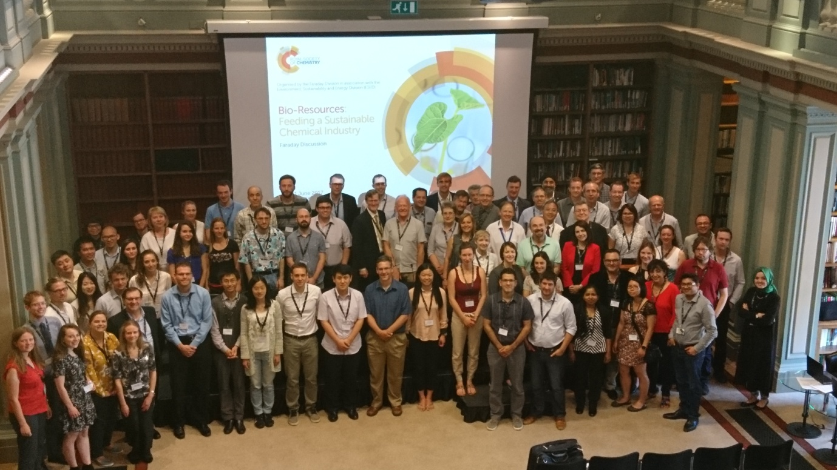
Figure 1: Participants of the Faraday Discussion on Bio-resources : feeding a sustainable chemical Industry in the library at the Royal Society of Chemistry in London, UK.
Prof Bruce Dale from Michigan State University was invited to present a thought-provoking opening lecture (DOI: 10.1039/C7FD00173H). He set out to challenge a number assumptions encountered within the community in order to provide stimulus for critically discussing the meeting’s individual contributions. Prof Dale began with highlighting the strong link between energy use and prosperity, concluding that a rate of energy consumption which enables prosperous healthy living is 5 kW per person and day (Figure 2). He highlighted that excessive energy consumption occurred in a few economies (Prof Dale coined the term ‘energy Lala land’) and equally a proportion of countries had not developed such a rate, yet, but would hopefully get there one day. He also made clear that despite the obvious dominance of fossil fuel use in our current economic system, it clearly had an ‘expiration date’ sooner or later, and that society would become poorer if we did not shift to sustainable feedstocks. The new feedstock base would very likely entail a substantial contribution from biomass (suggested to be around 25%). Prof Dale pointed out that the task was an urgent one, as only a few decades were left in order to accomplish a profound global transformation, before a breaking point for our planet and our society might be reached.
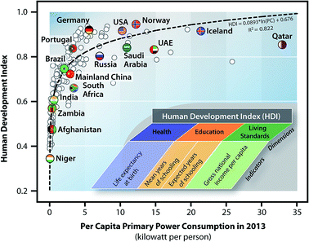
Figure 2: Link between energy consumption and human prosperity
The first key aspect that the field should be focussing on more according to Prof Dale is considering the whole production chain when developing bio-based chemical technologies. In particular, he urged the community to ‘not forget the farmers’, who are at the very beginning of the value chain. Prof Dale challenged the assumption that lignocellulosic biomass was very cheap or even free. He made clear that provision of large quantities of feedstock needed a meaningful incentive, calling for a higher feedstock price than historically assumed. He further highlighted the new relationship with the agricultural sector that the chemical industry has to develop and expand by highlighting that fuel, chemical and food production are likely to be integrated in the future system. Farms will provide an array of products and services: food for humans, feed for livestock, bio-products, bio-energy and environmental services. Also many biorefineries will be built close to the farm, forest or waste source, as the low density of lignocellulosic feedstock restricts transportation range. Prof Dale also challenged a common belief that ‘first-generation’ biofuels and chemicals (from food based sugars and oils) are subject to a straightforward ‘food versus fuel’ competition. On the contrary, food-crop based biofuel markets have been shown to encourage farmers to grow more, providing a positive buffer for food supply when farm yields decrease due to environmental fluctuations.
Bio-based materials (Session 1)
The majority of products of the chemical industry will result in materials such as packaging, furniture, coatings and paints. Since this is unlikely to change, developing viable bio-based materials is an essential part of transitioning the chemical industry from a fossil feedstock base to a renewable feedstock base.
The first contribution of the meeting was presented by Prof Matharu from the University of York. The work demonstrated the isolation of the carbohydrate polymer pection from mango peel using hot water and flow reactor technology (http://dx.doi.org/10.1039/C7FD00035A). The work demonstrated that reactor design has an effect on yields, highlighting the impact that engineering can have in making the sustainable chemical industry effective. Discussion of the work focussed on the need to evaluate solvent use throughout the entire process (a variety of volatile organic solvents were used before and after pectin extraction), finding uses for the 80% of post-extraction residue, and the effect the processing had on the chemical and physical properties of the isolated pectin.
Simo Sarkanen from the University of Minnesota used his contribution to challenge an assumption in the field that lignin is universally a poor polymer pre-cursor. His message was that as long as a suitable purification and casting strategies were in place, good polymer materials with characteristics comparable to commonly used petroleum derived polymers could be created from any lignin, despite its ‘amorphousness’. The paper (DOI: 10.1039/C7FD00083A) characterises polymer materials created from ball-milled lignins. The discussion of this work showed that achieving the desired properties came at a high price in this case, as energy and chemical-intensive extraction, purification and modification of lignin could be potential road-blocks.
Work from the lab of Mark Mascal at University of California Davis represented the production of polyesters from carbohydrate-derived diols and diacids (DOI: 10.1039/C7FD00057J). Polyesters are a group of industrially important polymers that are particularly suited to being derived from biomass, due to the presence of oxygenated functional groups in diol and diacids. The study expanded the knowledge base around using chloromethylfurfural (CMF), which can be obtained from glucose, as a key platform chemical. Polyesters from branched diols such 2,5-hexandiol and 2,7-octandiol were synthesised and characterised. The discussion focussed on product yields and the toxicity of the CMF precursor. It became evident that renewability can occasionally clash with other Green Chemistry principles such as reducing health-hazards and toxicity. Particpants remained undecided whether compromises on toxicity may should be made when searching for economically attractive plant-derived chemical intermediates, or not.
Next, Xingdong Mu from the Qingdao Institute of Bioenergy and Bioprocess Technology presented work on the production of catalytically active carbon materials based on bamboo shoots, which was used as a catalyst support for platinum (DOI: 10.1039/C7FD00041C). The solid catalyst was applied in the hydrogenation of the bio-derived platform molecule furfural to furfuryl alcohol or cyclopentanone. Discussion focussed on the mechanistic effect of the heteroatom doping originating from the relatively high protein content in bamboo shoot biomass, as well as the effect biomass composition may have on the characteristics of the resulting material. A leading theme of the discussion was the important but also difficult aspect of designing appropriate control materials which could help elucidate which characteristics of the catalyst material were responsible for the observed advantageous properties.
Jakob Albert from FAU Erlangen-Nürnberg presented new aspects of using polyoxometallate catalysts for co-producing cellulose and formic acid from lignocellulosic biomass (DOI: 10.1039/C7FD00047B). The formic acid can be used as a C1 chemical building or a source of bio-derived hydrogen gas. The latter is needed to synthesise reduced chemical products from often highly oxygenated biomass building blocks. In this work, a semi-selective POM catalyst was identified that leaves the cellulose as a solid, while converting the hemicellulose and lignin portions to formic acid. It was shown that the cellulose retained characteristics of high-quality cellulose, and hence could be used for material applications rather than a source of glucose. Discussion centred on the reasons for the exhibited selectivity and the properties of the isolated cellulose.
At the end of the materials session, Gadi Rothenburg from Dutch start-up company Plantics told the audience a tale about turning an accidental discovery in an academic lab into products made from a unique renewable polyester resin, including plant pots, water-sensitive glues and insulation (DOI: 10.1039/C7FD00054E). He demonstrated that novel materials need to be matched carefully with applications, giving the example that Plantic’s glycerol citric acid polyester (Figure 3) is hydro and biodegradable, making it suitable for applications where degradability is welcome while applications such as outdoor furniture where long-term stability is desired may be a less good fit.
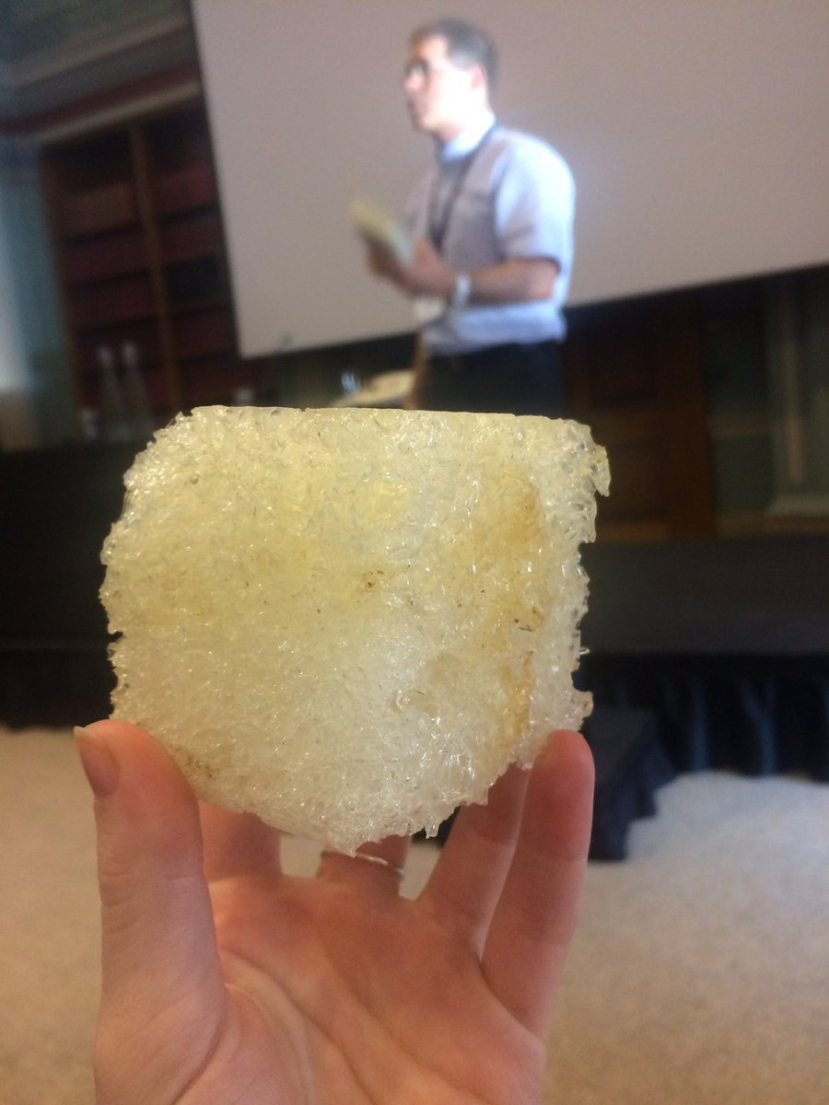
Figure 3: A foamed sample of the renewable and biodegradable material Plantics-GX.
The session was followed by the official poster session, for which a prize was given out on the second day of the meeting during the conference dinner (Figure 4).
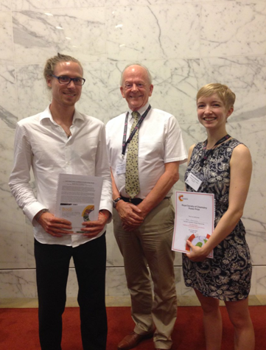
Figure 4: Prof James Clark from the University of York with the winners of the poster competition, Servann Herou and Anna Zhenova.
Bio-based Chemicals (Session 2)
The second key area that was covered by the meeting was the development of bio-based chemicals. Such small molecules can be used as fuels, solvents, monomers for producing polymers, and building blocks for complex chemicals, such as drugs and agrichemicals.
The first contribution of the biobased chemicals session was by Xiaoming Huang from TU Eindhoven, and it focussed on the so-called lignin first approach, which aims to generate small aromatic molecules from lignin by contacting lignocellulose with hydrogen, a solvent and a catalytic system (DOI: 10.1039/C7FD00039A). Here, reductive cleavage was carried out in a system composed of methanol, hydrogen, palladium and a co-catalyst. It was found that strong acids such as hydrochloric (HCl) and sulfuric acid were suitable inexpensive replacements for the Lewis acidic metal triflate. Mechanistic aspects were discussed, such as impact of acid strength, the amount of monomers created versus dimers and oligomers, the fate of the hemicellulose and ash components and practicalities of the final process, including catalyst recovery and the number and order of reaction steps.
Andrew Hunt from the University of York show-cased a screening method aimed at accelerating discovery of renewable solvents, consisting of computer and lab based selection tests applied in sequence (DOI: 10.1039/C7FD00049A). A number of candidates were selected based on solvent polarity parameters. The story came with a twist as the key candidate molecule selected for lab testing turned out to be unexpectedly toxic in later tests. This highlighted the challenge in finding a bio-derived molecules that can satisfy a long list of demands regarding its chemical, economic and environmental properties. Presenter and audience debated whether and how the screening could be made more effective, for example by changing the order of the steps, or whether steps were or could be carried out in parallel.
Marta Coma from the University of Bath presented the work of an academic biorefinery consortium aiming to integrate biological and chemical conversion technologies in one process and enable the conversion of a heterogenic bio-resource. Here anaerobic digestion and hydrothermal treatment were used to convert the organic streams lignocellulosic by-products, food residues, algal biomass and plastic into bio-based products (DOI: 10.1039/C7FD00070G, Figure 5). The primary chemical products were short alcohols, in addition to energy, oil, and ‘crude’. Questions were mainly of technical nature, for example the effect that algae addition had on plastic liquefaction, the rationale behind the selection of products and their anticipated purification.
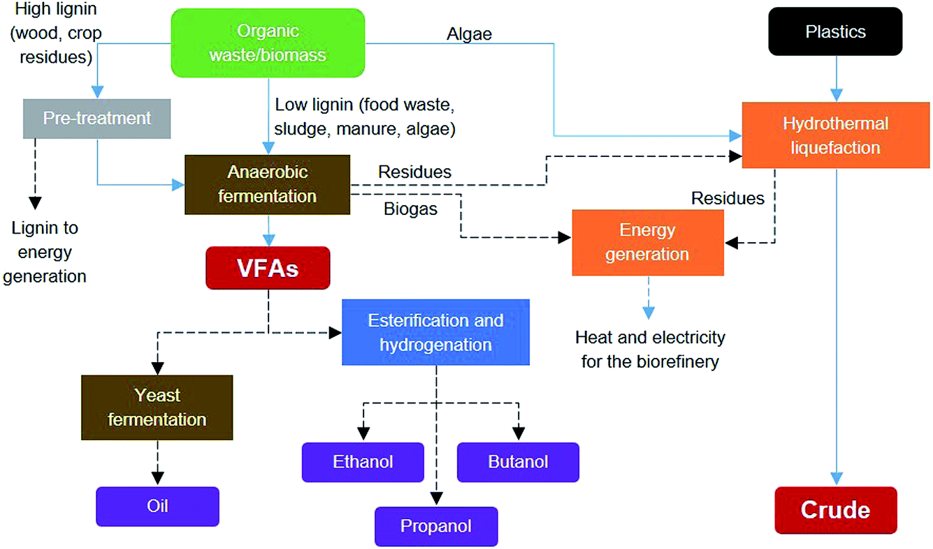
Figure 5: Integrated biorefinery concept proposed by Coma et al (DOI: 10.1039/C7FD00070G)
The next speaker was Changwei Hu from Sichuan University. His work focussed on converting parts of algal bloom biomass into bio-oil using pyrolysis (DOI: 10.1039/C7FD00065K). The study focussed on how the separation of the main components (lipids and saccharides) prior to pyrolysis affected the bio-oil product. The contribution prompted a lively discussion about the definition of the word ‘waste’. A consensus appeared to emerge that usage of the word required care, as many waste have a value today (albeit low), and words such as ‘side stream’ or ‘by-product’ may be more appropriate in many instances. The audience also queried choices made by the experimenters, for example the use of pyrolysis versus and catalytic upgrading and properties of the products.
The contribution also prompted a lively debate on the general economic viability of algal biofuels. Prof Dale was unsure how the requirement for a sunny climate, large amounts of flat land, concentrated CO₂ and fresh water, could be found in sufficient locations around the place to match the scale of biofuel need. Material-intensive growing conditions were also cited as concerns. There was a debate whether research in areas with so many challenges regarding scale and economic feasibility should continue, and whether genetic modification/biotechnology could be the answer to the fundamental challenges.
Jose-Vitor Bomtempo from the Federal University of Rio de Janeiro presented a paper exploring how a company or entity developing a novel bio-based platform molecule could act to capture maximum value from their efforts (DOI: DOI: 10.1039/C7FD00052A). After defining key chemical characteristics that bio-based chemicals need to exhibit in order to serve as an effective platform, parallels were drawn with other technological platforms in car manufacturing and IT, rather than with the petrochemical industry. The metrics that were suggested are a chemical structure that can result in several derivatives due the presence of more than one functionality (although the need for multiple functionalities was debated later), the potential to be produced at a competitive cost (few, efficient processing steps from biomass), and the potential for a large market volume (which can be a mixture of smaller scale higher value products and larger scale lower value applications). The study concluded that the platform molecule producer should become involved on the product-side before the molecule becomes a commoidty to maximise their own benefit.
Conversion Technologies (Session 3)
In order to produce chemicals and materials, both new physical, chemical and biological conversion technologies must be developed. A selection of such conversion technologies was highlighted and debated in the third session of the meeting.
George Huber from the University of Wisconsin-Madison presented a concept research for producing renewable polyester building blocks from sugars (1,5-pentanediol and 1,6-hexanediol) as direct replacements for the respective petroleum derived diols (DOI: 10.1039/C7FD00036G). The work was exemplary in breadth as it included experimental data all the way from pretreatment to final products, as well as a techno-economic analysis. The economic model assumed that the two diols could be co-produced from biomass (one from hemicellulose via furfural and one from cellulose via HMF), with lignin providing process heat and fossil gas providing a relatively lower cost but non-renewable source of hydrogen for several hydrogenation reactions. The discussion focussed on reaction conditions, yields and by-products.
The second contribution of the session was by Christoph Seidel from ETH Zürich and put the spotlight on one of the most commonly applied lignocellulose pretreatment technologies in the nascent cellulosic bio-product industry, steam explosion (DOI: 10.1039/C7FD00066A). The work explored to what degree the decompression/explosion aspect of the processing had a positive impact on the subsequent sugar release by hydrolytic enzymes (cellulases), for both grass and hard wood biomass. Discussion of the word was mostly of technical nature, enquiring how the cellulose and hemicellulose are affected by the explosion, or the effect feedstock porosity prior to the explosion may have.
The next discussion was led by Joseph Samec from Stockholm University and based on his review exploring the current state of analytical methods and standards for lignocellulosic biomass, and the future needs for lignocellulose based chemical industry (DOI: 10.1039/C7FD00046D), both before and after feedstock pretreatment. The speaker pointed out that the state of the art in feedstock analysis is currently derived from the paper pulping industry which focuses on cellulose, while the bio-based chemical industry will require additional analytical tools, for example methods that characterise the hemicellulose and lignin in more detail. The discussion focussed on how great the need is for novel, generally accepted ‘standard biomass’ is and how such standardisation might be achieved. Another part of the discussion evolved around establishing a minimum data set that is required for academic publications in order to pass peer-review.
Valentina Matveeva from Tver State Technical University presented work on producing enzyme preparations immobilised on inorganic magnetic supports to convert (oxidise) glucose to gluconic acid (DOI: 10.1039/C7FD00042A). Supporting enzymes in such a way improves stability and recyclability of the enzymes which are often major cost contributors to bio-based chemical processes. A comment pointed out that there may be problems if low substrate and product concentrations are not increased. The concentration was limited due to inhibition by glucose, so protein design may be needed to overcome this for a commercial process.
The next contribution to the conversion technologies theme was presented by Eero Kontturi from Aalto University. His work explored the preparation dispersed suspensions of cellulose nanocrystals, which were produced using a novel HCl vapour process developed previously and has the potential to result in a higher yielding, more economical production process for nanocellulose (DOI: 10.1039/C7FD00053G). It was shown that the nanocrystals are well-formed but that the desired dispersion can only be achieved in very few solvents, otherwise the crystals need to be functionalised by oxidation. Discussion focussed on the fact that formic acid was a uniquely good dispersion solvent for the unmodified nanocystals. There was also a debate around the lack of commercial success for nanocellulose materials in the past, which was assigned to the high cost of production by the currently dominant process and the lack of sufficiently developed applications.
Next was a paper by Jason Hallett from Imperial College London, who presented work on a comparatively new pretreatment technology, ionoSolv pretreatment, which fractionates lignocellulosic biomass using low cost ionic liquids (DOI: 10.1039/C7FD00059F). The pretreatment yields a hydrolysed solid lignin and a cellulose that is amenable to enzymatic hydrolysis. The work investigated the impact of a number of processing parameters on a commercially relevant willow feedstock. Several questions were asked about IL residues in the product fractions and vice versa. The feedstock session also included a debate around the lack of a feedstock agnostic/independent pretreatment. On that occasion, it was noted that the term ‘feedstock independent’ should be preferred instead of ‘feedstock-agnostic’. It was suggested by the speaker that ionoSolv pretreatment may fall into this category, as it allows high sugar release from grass, hardwood and softwood biomass.
The last contribution of the conversion session was by Vitaliy Budarin from the University of York, and it looked at another lignocellulose pretreatment technology, termed microwave-assisted acidolysis (DOI: 10.1039/C7FD00102A). This approach combines dilute aqueous acids and microwave irradiation, which solubilises the carbohydrate fraction while leaving the lignin as an undissolved solid. The broth also contains organic acids, oligosaccharides and furans. Two oil-producing yeasts with known tolerances to inhibitors such as the acids and furans were used to ferment the solution. Questions were aimed at properties of the lignin and the feasibility of microwave treatment at a large scale.
Important general comments were made during this session (Figure 6), for example the absence of comprehensive studies comparing several pretreatment technologies on one feedstock or the action of one pretreatment technology on a number of different biomasses was highlighted. The absence of applying industrially relevant enzyme loadings in academic studies was also criticised, and the need for more publications on later chemical transformations and fermentations to include pretreatment in a holistic approach to bio-refining, as by-products generated in this step can affect the performance of one or more subsequent conversion steps.
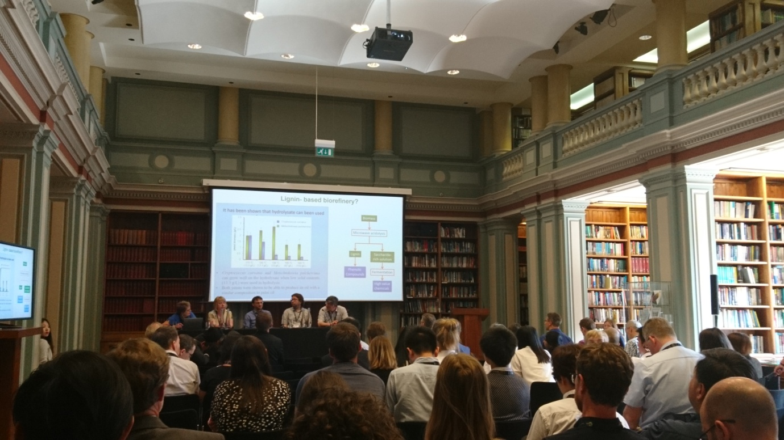
Figure 6: A general discussion during the ‘Conversion technologies’ session, led by Karen Wilson from Aston University.
Feedstocks and analysis (Session 4)
The last session of the meeting addressed a breadth of different aspects, such as dedicated lignocellulosic crops, an agricultural by-product fraction, CO₂ and waste paper. It also showcased the development of novel purification and analytical strategies.
Keith Waldron from the Quadram Institute Bioscience in Norwich started the last session of the meeting with a comparison study conditioning eight lignocellulosic feedstocks with one pretreatment technology to release sugars for fermentation. The pretreatment technology used was microwave assisted liquid hot water pretreatment (DOI: 10.1039/C7FD00044H). A highlight of the study was the large data set, as eight feedstocks, selected to represent different botanical origins, were subjected to 26 severity conditions each. This allowed looking for trends and optima for the subsequent sugar release by enzymes. IT was confirmed that different feedstocks respond differently to a neutral or slightly acidic aqueous pretreatment, depending on their biological origins which determine cell wall composition and structure, with softwoods responding generally poorly. Discussion probed general roadblocks to commercial success of biorefineries, such as separations, unfavourable price competition with petroleum derived chemicals and fuels, and the historic dominance of petroleum in the chemical market.
The next contribution was by Roberto Rinaldi from Imperial College London, with a second contribution to the ‘lignin first’ approach towards fractionating and valorising lignocellulosic feedstocks (DOI: 10.1039/C7FD00069C). In this work, the solvent participates as H-transfer reagent in lieu of molecular hydrogen. This study compared the effect of using two alcohol solvents with solid supported Ni catalysts .It was shown that methanol instead of iso-propanol resulted in different yields and lignin oil compositions. The discussion focussed on various aspects of the work and technology, for example identifying and isolating the final lignin-derived molecules, the role of hemicellulose during CUB treatment and stability of the catalyst.
This was followed by a contribution by Gary Lye from University College London, which showcases concept work into extending the product range of an existing UK based sugar-beet biorefinery (DOI: 10.1039/C7FD00094D). The project looked at converting the three main monosaccharides present in sugar beet pulp (present in the biopolymers cellulose, hemicellulose and pectin) into GluHep, bioethanol and potentially 6-amino-2,3,4,5-tetrahydroxyhexanoic acid. A preliminary process design was shown. Participants asked whether the purified polymeric biomaterials itself could be the products versus breaking the biopolymers down and converting the monomers into bio-derived chemicals, as shown. Other questions addressed purification and separation, and the timing of the LCA analysis (should it be carried out before or after the experimental proof of concept).
Next, a contribution put the spotlight on the production of chemicals (here acetic acid) from carbon dioxide and electricity, which can be catalysed by microbes (microbial electrosynthesis, DOI: 10.1039/C7FD00050B). This was led by Deepak Pant from the Flemish Institute for Technological Research. It is an alternative to photosynthetic fixation of atmospheric CO₂ into plant or algal matter and electrocatalytic CO₂ fixation in the solar fuels approach. This study focussed on comparing batch-mode versus continuous mode. The participants were interested in knowing more about general aspects of the microbial electrosynthesis strategy for valorising CO₂, such as suitable sources of CO₂ (atmospheric versus a point source), CO₂ purity requirements, energy balances, economics, and product isolation at scale.
Vânia G. Zuin from the Federal University of Sao Carlos presented work on isolating plant-derived molecules through absorption and desorption using renewable porous carbon materials (e.g. Starbon, DOI: 10.1039/C7FD00056A). The sorbents were produced from the carbohydrate polymers starch, alginic acid and pectin. They were used to investigate isolation of ten bioactive phenolic compounds from an aqueous solution. The phenolic compounds were selected on the basis of their presence in a variety of fruits, seeds and vegetables, and their chemical functionality. Key factors that determined the recovery efficiency were the micro-to-mesoporous surface area ratio, and the oxygen, hydrogen and ash contents of the carbonaceous materials, as these determine the interaction with the target molecules. Participants asked questions about the performance of the bio-derived sorbents compared to commercial sorbents, and the consistency of material characteristics across batches, among others.
The next speaker was Daniel Hayes from Celignis Limited, based in Limerick. He presented work on using near-infrared spectroscopy as a faster, lower-cost analysis method of quantifying the amount of the major components in lignocellulosic biomass. Such an analytical procedure could potentially be used in biorefineries to monitor their feedstock intake. In this study, the focus was on waste paper and cardboard feedstocks, which were divided into sub-groups, including kitchen roll, till receipts and birthday cards (DOI: 10.1039/C7FD00081B). The paper waste was analysed with a standard, labour-intensive wet analysis method and the results compared against the composition obtained with the infrared method. Statistical analysis was used to test the reliability of the method. It was shown that paper waste can vary substantially in composition, depending on its origin and concluded that the model is suitable for quantification for total sugars, glucose, xylose, and lignin, but had problems for components such as mannose, extractives and ash. The contribution had a positive reception among participants, showing the great desire in the field for faster and easier compositional analysis methods. Questions probed aspects such as the effect of sample heterogeneity and interference with non-wood organic matter such as glues.
The last contribution of this discussion was dedicated to the rapid identification of promising biorefinery value chains using data mining, by Alexei Lapkin from the University of Cambridge. The presented tool could guide research and speed up implementation of the sustainable chemical industry. Automated synthesis routes were compiled using data deposited in a chemical reaction data base (REAXYS). The presented case study was a multi-step synthesis of paracetamol from limonene (DOI: 10.1039/C7FD00073A). Synthetic pathways were created and filtered using a newly developed algorithm, from data downloaded from the database. A process model of a selected synthetic pathway was then designed ‘by hand’. The contribution triggered a lively discussion, touching on topics such as the effect that false reporting and over-exaggerations may have on pathway generation. Prof Lapkin expressed the hope that the scientific community will soon require codification of experimental protocols and the use of standardised equipment and methods to help make literature results more reproducible. Request for expanding the model were also issued by some participants, such as starting with complex (mixed) starting molecules, or the integration of enzymatic and metabolic reactions and processes. A concern was voiced that such a tool might restrict the creativity of organic chemists, but the speaker was convinced that correctly used the tool will help organic chemists, for example by finding new reaction pathways that they may not have thought of or by pointing them towards areas where a new reaction must be developed. Although this method requires more work, it appeared to resonate well with participants, as such a tool could help many projects with looking at the whole value chain, and with including engineering early on.
Closing lecture
The closing lecture was given by Andrzej Stankiewicz from Delft University of Technology (DOI: 10.1039/C7FD00178A). He used the Penrose triangle as a metaphor for the challenge that the envisaged change in the chemical industry poses (Figure 7)
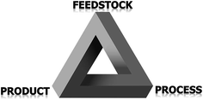
Figure 7: The Penrose triangle for a successful transition from a petroleum0based to a bio-based industry
Prof Stankiewicz pointed out that in contrast to the traditional chemical industry, biorefineries will entail aspects that are new, for example handling low-density solid feedstocks, dilute aqueous solutions, microbial transformation and enzymatic reactions. These differences mean that new features have to emerge and be optimised, which takes time and effort.
He also addressed the impression that many of the contributions would have fitted in more than one of the sessions, as the multidisciplinary work required to develop sustainable chemical process often spans feedstocks, pre-processing, analytics and product generation and separation. Prof Stankiewicz, for example, presented an alternative grouping of the contributions in terms of the question/challenges the papers were addressing, for example: how to increase the market share of a bio-based product?
He finally made a link between Michael Faraday, the name patron of the meeting format, who substantially advanced the field of electromagnetism and electrochemistry, by highlighting that the sustainable chemical industry will also require sustainable electricity (Figure 8).
Despite focussing on immediate research in the individual papers, there discussion regularly came back to the bigger picture, some of which Prof Stankiewicz summarised in his closing lecture. Although the discussions necessarily represent a selection of a very broad research theme that spans academia and business alike across the world, a diverse range of research expertise present at the discussions gave glimpse into some of the current research efforts in the field.

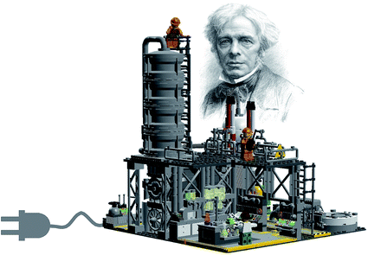
Figure 8: Artist impression of a bio-product plant based on LEGO: small, modular and driven by green electricity.

Concluding impressions
A key theme running through the meeting was economic feasibility, highlighted in contributions and the debates alike, a sign that the academic community developing sustainable chemical processes has become acutely aware that the economic aspect of new reactions and processes will make or break their success. Despite this, many feel that we should not lose sight of other (Green) metrics, foremost energy balances, but also waste factors, safety and environmental impacts.
Many questions filed during the discussion of research contributions related to separations and purifications of intermediates and products. There was a feeling that many bio-based value chains suffer from high energy consumption, and that more attention should be paid to energy and material efficient separation.
The need for collaboration with engineering was also felt many times during the discussions: for optimising reaction and separation performance, integrating energy use, and providing economy of scale. Experimental works should increasingly be complemented with screening and modelling, especially Life cycle assessment for energy balances and economic modelling for feasibility.
The conference also showed that the multi-faceted challenges have resulted in the formation of academic multi PI biorefinery consortia, supported and guided by industry players. An exciting observation was that papers were presented by companies, and that a number of academic research papers were accompanied by commercialisation efforts/the formation of start-up companies, showing that there is a drive in the community to bring research out of the lab into industrial reality.
It was also uplifting to see that the research field is looking widely for inspiration to tackle its many challenges. Inspiration is being taken from the petrochemical industry, the bio-based industry’s main predecessor but also its main competitor. It was felt that sometimes comparison between the bio-based industry and petrochemical industry are helpful and sometimes not. For example the scales and locations of biorefineries will very likely to be different. There were also thoughts around the transition period that would see coexistence of the sustainable chemical industry with the petroleum-based chemical industry. Even the possibility of ‘green brown’ hybrid processes (for example the use of non-renewable heat, hydrogen, electricity and even some reagents and building blocks) was contemplated.
Other adjacent industries that came into focus during this meeting were the forestry, paper pulping and agricultural sectors. Bruce Dale urged everyone to ‘remember the farmer’ and pointed out that not a single one was present at the meeting. Someone added to also ‘remember the miner’, referring to the reliance of many bio-refining processes catalysis on expensive and rare metals (Pt, Co, Pd).
Conference organiser Christian Stevens delivered an important concluding remark, in which he reminded the participants to also not forget the public, but set aside time to discuss with them the challenges and advantages connected to biorefining: “We have to inform consumers about, and discuss with them, ‘food versus fuel’ issues or ‘land use change’ issues related to the production of materials for non-food use, in order to fight the use of false arguments for blocking viable sustainable solutions.”
The discussion demonstrated in a powerful way not only the variety of processes that are being developed but also the variety of feedstocks that are being processed: projects showcased in this discussion dealt with waste paper, algal bloom biomass, lignocellulosic energy crops (poplar, willow, pine), agricultural residues (straw and beet pulp), food waste residues (mango peel), even plastic as a co-feed. This illustrates the challenge that the bio-based chemical industry faces regarding feedstock variability and reproducibility. A common criticism for the processing of lignocellulosic biomass was that analytical methods applied in biorefining were not sufficiently standardised, yet. The discussions also showed that CO₂, a by-product of petroleum- and biorefining alike, can also have a place as a feedstock for chemical industry.
The discussions also highlighted the fact that several emerging technologies are trying to solve the same problem and are being developed in parallel; it is unclear whether one or all of them will be part of the matured biorefining industry, and to what extent. As an example, the first step in lignocellulose processing, the pretreatment operation, is being developed in many forms, for example as the reductive lignin-first approach, hydrolytic aqueous or solvent based fractionation approaches or as pyrolysis followed by upgrading. It appears this is a type of tension that the community has to cope with at this early development stage. Alexei Lapkin captured the unpredictability of the development phase: “Regarding ... the shape of the future industry, as the industry is a complex hierarchical system, it cannot easily be designed from first principles.”...”We need to explore this. Like in any complex system, its dynamic equilibrium state will be arrived at by evolution, not by design.”
Hence it will be interesting to see how the field will have ‘evolved’ when a follow-up Faraday meeting takes place in 5-7 years. Until then everyone will be likely busy back at work, developing and exploring sustainable chemical industry technologies as best as they can, hopefully heeding Prof Dale’s advice to ask “Are we doing something that makes a difference?” As conference organiser David Constable said in his concluding remarks: “The challenges are great, but the opportunities are also great.”

http://pubs.rsc.org/en/journals/journalissues/fd?_ga=2.191962787.86908288.1509543208-764267119.1498721628#!issueid=fd017202&type=current&issnprint=1359-6640

