Synthesis of Cu₃N and Cu₃N-Cu₂O Multicomponent Mesocrystals: Non-Classical Crystallization and Nanoscale Kirkendall Effect

Darinka Primc^{1,2,¶}, Luca Indrizzi¹, Elena Tervoort¹,
Fang Xie², Markus Niederberger¹

¹Laboratory for Multifunctional Materials, Department of Materials, ETH Zurich, Vladimir-Prelog-Weg 5, 8093 Zurich, Switzerland.
²Department of Materials and London Centre for Nanotechnology, Imperial College London, London SW7 2AZ, United Kingdom.

Current address:
¶Department of Chemical and Biomolecular Engineering, University of California Berkeley, Berkeley, CA 94720, United States
Energy Storage and Distributed Resources Division, Lawrence Berkeley National Laboratory, Berkeley, CA 94720, United States

Abstract
Mesocrystals are superstructures of crystallographically aligned nanoparticles and are a rapidly emerging class of crystalline materials displaying sophisticated morphologies and properties, beyond those originating from size and shape of nanoparticles alone. This study reports the first synthesis of Cu₃N mesocrystals employing structure-directing agents with a controlled tuning of the reaction parameters. Cu₃N mesocrystals form with non-classical crystallization and variation in their sizes and morphologies are traced back to the two distinct binding pathways of mesocrystal subunits. In the presence of oleylamine, the mesocrystal subunits in the early reaction stages prealign in crystallographic fashion and afterwards grow forming final mesocrystals, while in the presence of hexadecrylamine the subunits come into contact through misaligned attachment, subsequently, to some degree, realign in crystallographic register. Upon prolonged heating both types of mesocrystals undergo chemical conversion processes resulting in structural and morphological changes. A two-step mechanism of chemical conversion is proposed, involving Cu₃N decomposition and anion exchange driven by the nanoscale Kirkendall effect, resulting first in multicomponent/heterostructured Cu₃N-Cu₂O mesocrystals, which subsequently convert into Cu₂O nanocages. It is anticipated that combining nanostructured Cu₃N and Cu₂O in a mesocrystalline and hollow morphology will provide a platform to expend their application potential.

Introduction
Spontaneous organization of nanoparticles into ordered structures, e.g. superstructures can result in collective or even completely new physiochemical properties, beyond those governed by size and shape of the nanoparticles.^{1,2} One example includes mesocrystals, which are a new class of superstructures with a crystallographically ordered alignment of nanoparticles.³⁻⁴ Their special morphology gives rise to unique properties by combining high crystallinity with enhanced surface area and ordered porosity, large pore accessibility, and good electronic conductivity.⁵⁻⁶ Such combinations of properties in a single-material are unrivalled compared to amorphous, polycrystalline or single-crystalline materials.^{6,5} Hence mesocrystals were found as efficient materials in many areas of nanotechnological applications, including energy storage and conversion,^{7,8} photocatalysis,^{9,10} sensing¹¹ and photovoltaics.¹²
Mesocrystals can form kinetically stabilized intermediates in the non-classical particle-mediated crystallization process, ^{3-4,13} and were to date reported for a variety of functional materials, including metals,¹⁴ binary and ternary metal oxides⁵⁻¹¹ and even organic materials.^{3,15} The most common synthesis approach is based on a template-directed sol-gel synthesis, whereby oriented-aggregation of nanoparticles is achieved along an ordered organic matrix by spatial constraints, often supported by external physical fields.^{1,13,14} However, such approaches are incompatible with multicomponent systems, thus making the synthesis of multicomponent mesocrystals still challenging, the latter evident by the fact that only few studies were reported to date. Nonetheless, multicomponent mesocrystals are particularly interesting since they are combining intimately connected subunits of different functional nanomaterials, thus allowing the utilization of the collective material’s functionalities.¹⁶ For example, Bian et al. reported on the topotactic synthesis of nanocomposite ZnO-CuO mesocrystals displaying excellent charge transport properties as a result of intimately connected n- and p-type semiconductors.¹⁵ Such properties are highly desired in photovoltaics, solar fuels and photocatalysis.⁹ Another example reported by Primc D. and Niederberger M. presents the first one-pot synthesis of a multicomponent mesocrystal.¹⁰ In particular, Sb-Nb:TiO₂ mesocrystals with superior photocatalytic activity are obtained, which is reasoned by high crystallinity, visible light activity and abundant porosity as a result of mesocrystal morphology, leading to larger exposed reactive surfaces.¹⁰ Hence, it is anticipated that the development of new synthesis pathways, in particular to multicomponent mesocrystals would lead to important conceptual advances, allowing for expanding the compositional variety of mesocrystals and their functionalities.

Transition metal nitrides are of particular interest by virtue of their electronic, catalytic and magnetic properties, reflected in enhanced electrical conductivity, excellent environmental durability and high reaction selectivity.¹⁷⁻¹⁹ One example is copper nitrite (Cu₃N), which is an important non-toxic semiconductor material with a narrow band gap (1.2-1.6 eV).¹⁸ Due to its interesting optical and electronic properties, it has been widely studied in areas of optoelectronic energy conversion,¹⁸⁻²¹ such as solar cells,²² light-emitting diodes and as non-precious cathode material in electrochemical devices.^{23,24}
Traditionally, Cu₃N as thin films is prepared using physical methods such as vapor-deposition, SC magneton sputtering,²⁵ and RF sputtering,²¹ and nanocrystalline Cu₃N powders can be synthesized via thermal nitration of metal oxide nanoparticles.²⁶ More recent reports include solution phase synthesis of colloidal Cu₃N.^{23,27} Examples include, Cu₃N nanoparticles of 20-30 nm in size synthesized via decomposition of Cu-azide,²⁸ or via decomposition of Cu(NO₃)₂ with oleaylamine in octadecane.^{24,23} The synthesis of ultrafine Cu₃N nanoparticles of only 2-3 nm in size was also achieved at lower temperatures via benzylalcohol route. ²⁹ However, to the best of our knowledge the synthesis of Cu₃N mesocrystals has not been reported yet. Furthermore, it is known that Cu₃N decomposes into nitrogen and copper at temperatures above 200 °C, hence providing the opportunity for the controlled synthesis of Cu₂O/CuO-Cu₃N composite nanostructures, leading (providing pathways) to p-n-type semiconductor heterostructures.
In this study, surfactant-assisted synthesis of Cu₃N mesocrystals is reported. High-resolution transmission electron microscopy (HRTEM) and high-angle annular scanning transmission electron microscopy (HAADF-STEM) studies combined with energy-dispersive X-ray spectroscopy (EDXS) analyses were used for in-depth structural, morphological and chemical analyses of Cu₃N mesocrystals. Furthermore, a chemical conversion of Cu₃N mesocrystals into multicomponent Cu₃N-Cu₂O, and Cu₂O nanocages is investigated, and the structural and chemical analyses of the products is used to define their formation mechanism.

Material and Methods
Materials. Copper (II) nitrate trihydrate (99.9 % Cu) was purchased from Alpha Aesar Chemicals, 1-octadecene (90% tech.), oleylamine (80-90%) and 1-hexadecylamine (90%) were from Acros Organics. Ethanol (99.8%), diethyl ether (99.8%), acetone (99.5%) and chloroform (99.8%) of reagent grade were purchased from Sigma Aldrich. All employed chemicals were used without further purification.

Synthesis. Cu₃N mesocrystals were synthesized by the subtle heating of a precursors’ solution. In a typical experiment Cu(II)nitrate trihydrate (n = 0,64 mmol) was dissolved in octadecane (10 mL), and subsequently, 10 mL of oleylamine or hexadecylamine was added. Subsequently, the reaction mixture was degassed with argon for one hour and afterwards heated, first to 150 °C for and keep at this temperature for three hours. During the heating the color of the reaction solution color changed from blue to green, then yellow and finally amber. After elapsed time, a reaction mixture was heated to 220 °C and interrupted by cooling to 150°C for 10 min, and subsequently, heated to 250 °C for 10, 15, or 20 min and afterwards cooled down. The reaction product was centrifuged off and washed twice with warm ethanol (60 °C).

Characterization. X-ray powder diffraction (XRD) patterns were measured on a X’Pert Pro (PANalytical B.V., Netherlands) powder diffractometer equipped with Cu Kα radiation (45 kV, 40 mA) operating in reflection mode. A peak fitting routine was applied to extract full width at half-maximum values for (100) peak at 23°. The HRTEM analyses were done on X-FEG FEI Talos operating at 200 kV coupled with Super X EDXS system. The atomic number sensitive high angle dark field (HAADF) imaging of STEM with a probe size of ~ 0.7 nm was complemented by high resolution EDXS analysis. Cs-abreaction corrected HRTEM analyses were done on FEI Titan, operating at 300 kV. For HRTEM investigation the samples were redispersed in chloroform and deposited onto a copper-grid-supported perforated carbon support.

Results
Synthesis of Mesocrystals. Copper nitride (Cu₃N) mesocrystals were synthesized by a subtle heating of a reaction solution of Cu(II) nitrate in a mixture of octadecane and different capping agents, i.e. surfactants, the latter acting as a surface stabilizing- and mild reducing reagent. We first review the effect of the addition of the different surfactants in the reaction mixture on the morphology of the final Cu₃N mesocrystals.

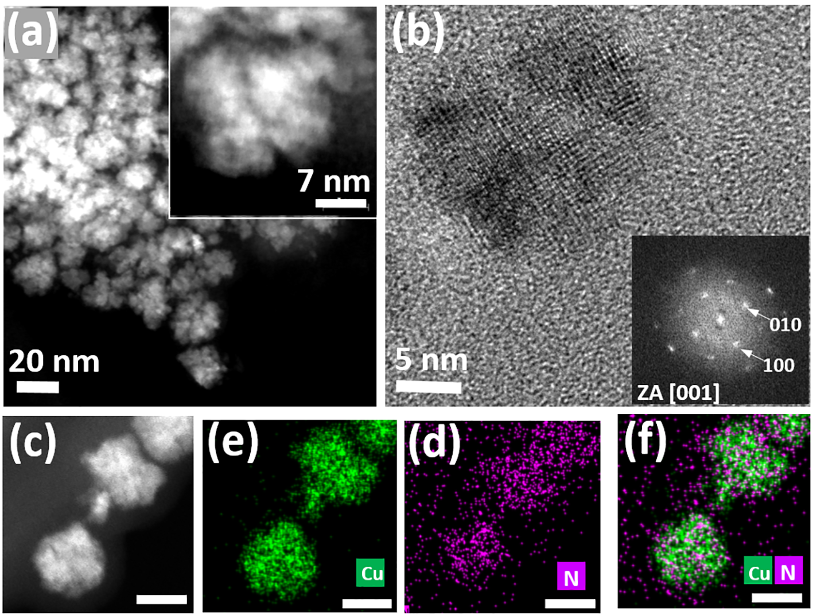

Figure 1: An overview HAADF-STEM micrograph showing Cu₃N mesocrystals of mcCu₃N-O (a) and the insets showing enlarged HAADF-STEM of one mesocrystal. HRTEM pattern of one mesocrystal with the corresponding FFT (b), and HAADF-STEM (c) with the corresponding EDXS maps of N (d), Cu (e) and overlaid Cu/N map (f). Scale bars in panel (c-f) correspond to 20 nm.

Figure 1 shows an overview high-angle annular scanning transmission electron microscopy (HAADF-STEM) micrograph of a product synthesized in the presence of oleylamine as surfactant (mcCu₃N-O). The HAADF-STEM micrograph shows the occurrence of relatively uniform nanoparticles of approximately 20-25 nm. The corresponding X-ray diffraction (XRD) pattern correlating to anti-ReO₃ cubic structure (JCPDS No. 47-1088) confirms the formation of nanocrystalline Cu₃N (Figure S2, Supporting Information). Interestingly, imaging under higher magnification (Figure 1a, inset) reveals that these nanoparticles are nanocrystalline aggregates, composed of smaller faceted subunits of approximately 7-8 nm in size, in agreement with the crystallite size of 8.5 nm determined with Scherrer equation by using (100) reflection of XRD pattern (Figure S2, supporting information). Moreover, combined high-resolution transmission electron microscopy (Figure 1b) and fast Fourier transform (FFT) pattern (Figure 1b, inset) show that the subunits of aggregates are aligned in mutual crystallographic orientation, thus confirming the occurrence of Cu₃N mesocrystals. Additionally, chemical analysis carried out with energy dispersive X-ray spectroscopy (EDXS) mapping shows the uniform distribution of N and Cu (Figure 1d-f).

Interestingly, when in the reaction system oleylamine is replaced by hexadecylamine (mcCu₃N-H) the size and morphology of the product significantly changed. An overview field-emission scanning electron microscopy (FE-SEM) image (Figure 2a) of mcCu₃N-H reveals the presence of 3D assemblies of cube-like nanoparticles, i.e. nanocubes. Selected area electron diffraction (SAED, Figure S2b) recorded over the representative area of mcCu₃N-H (Figure S2a, Supporting Information) confirms anti-ReO₃ structure. The assemblies are inhomogeneous in size and morphology and ranging around 150-400 nm in size, and are composed of face-to-face aligned nanocubes, of approximately 50 nm in size (Figure 2a, Figure S2a, Supporting Information). EDXS mapping analyses of the area in Figure 2b reveals a uniform distribution of N and Cu. Moreover, SAED analysis (Figure 2g) of one typical assembly (area denoted with the dotted blue circle in Figure 2f) shows the distinct texture of the diffraction pattern, which indicates that the nanoparticles are packed in a regular fashion, and also nearly perfectly aligned in crystallographic register. Moreover, a comparison of SAED (Figure 2g) with FFT pattern in (Figure 2i) reveals that the crystallographic axes of the Cu₃N nanocubes in mcCu₃N-H (Figure 2f) indicating mesoscale ordering are identical to the atomic scale ordering in the individual Cu₃N nanocube (Figure 2h), thus again confirming the occurrence of Cu₃N mesocrystals.
The subunits of Cu₃N mesocrystals in mcCu₃N-H are predominately interspaced, however, in some cases they appear to be partially connected as seen in Figure 2b (denoted with dotted square). An aberration corrected atomic resolution pattern of this area (Figure 2h) shows that the fusion of Cu₃N subunits occurs through (100) crystallographic surface and terminating planes with fully epitaxial interfaces resulting in single-crystalline FFT pattern (Figure 2i).

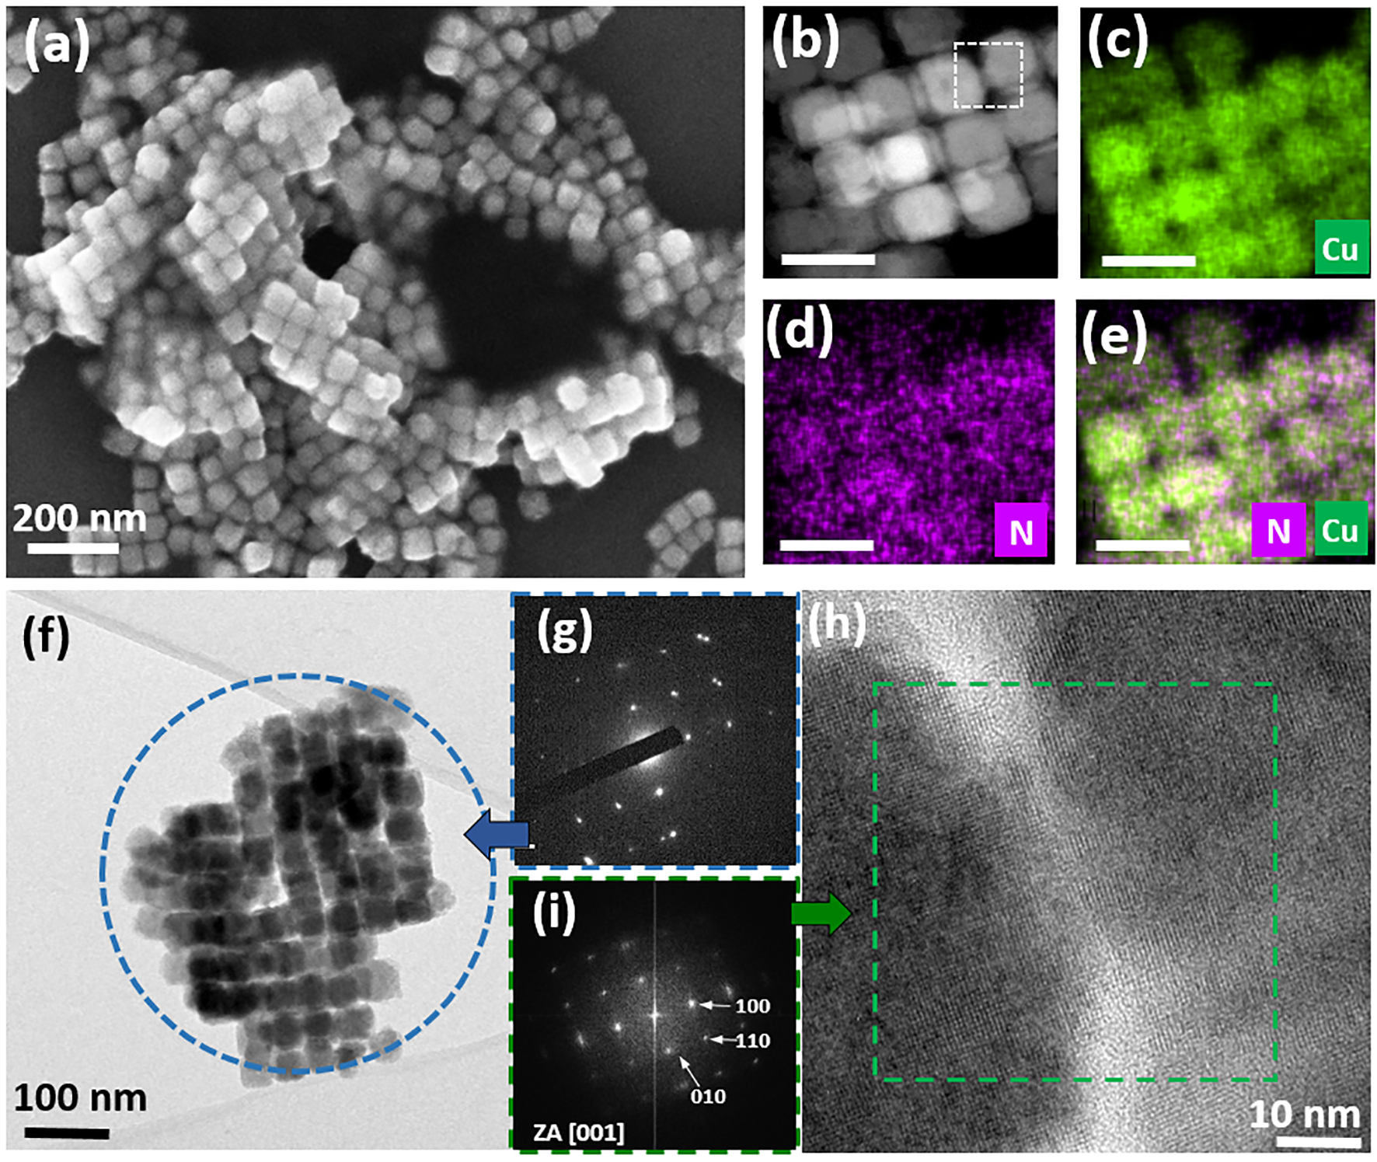
Figure 2: An overview FE-SEM (a) and HAADF-STEM micrograph (b) of mcCu₃N-H with the corresponding Cu (c), N (d) and composite Cu/N (e) EDXS elemental maps. TEM micrograph (f) with the corresponding SAED (g) of the area denoted with blue circle in (f), and HRTEM pattern (h) with corresponding FFT (i) of the area denoted with green square in (h). Scale bars in panels (b-e) correspond to 100 nm.

Chemical conversion. We assume that mesocrystals of mcCu₃N-O and mcCu₃N-H obtained by heating the reaction solution for 10 min at final temperature, are kinetically stabilized by oleylamine and hexadecylamine, respectively, preventing the fusion of the mesocrystals subunits. Hence, under prolonged reaction time desorption and/or decomposition of the capping agents, leading to fusion of the subunits at the planar interfaces, forming larger single crystalline nanoparticles would be expected. However, by prolonged heating time of 20 min, phase transformations were observed in both samples, as a result of partial Cu₃N decomposition, leading to an interesting morphology.
When the reaction time of the precursors’ solution containing oleylamine as surfactant is prolonged from 10 min to 15 min, the color of the reaction suspension changes from brown to reddish-brown. The XRD pattern of the product indicated the occurrence of cubic Cu₂O (JCPDS No.73-6237) in addition to Cu₃N (Figure 3a). When heating the reaction solution for 20 min a dark-brown suspension is obtained, and according to SAED Cu₂O is detected as the only crystalline phase (Figure 3b). The HAADF-STEM analysis of mcCu₂O (Figure 3c) shows the occurrence of nanocrystals aggregates, of about 25 nm in size, which correlate well to the size of mesocrystals in mcCu₃N-O. However, a closer inspection reveals that prolonged heating appears to cause the subunits of mesocrystals that initially forms after 10 min, to fuse at the planar interfaces. At the same time, the cores of the subunits become hollow (indicated by white arrows in Figure 3b), which leads to the occurrence of ordered nanocages, and in turn again results in the material’s porosity.

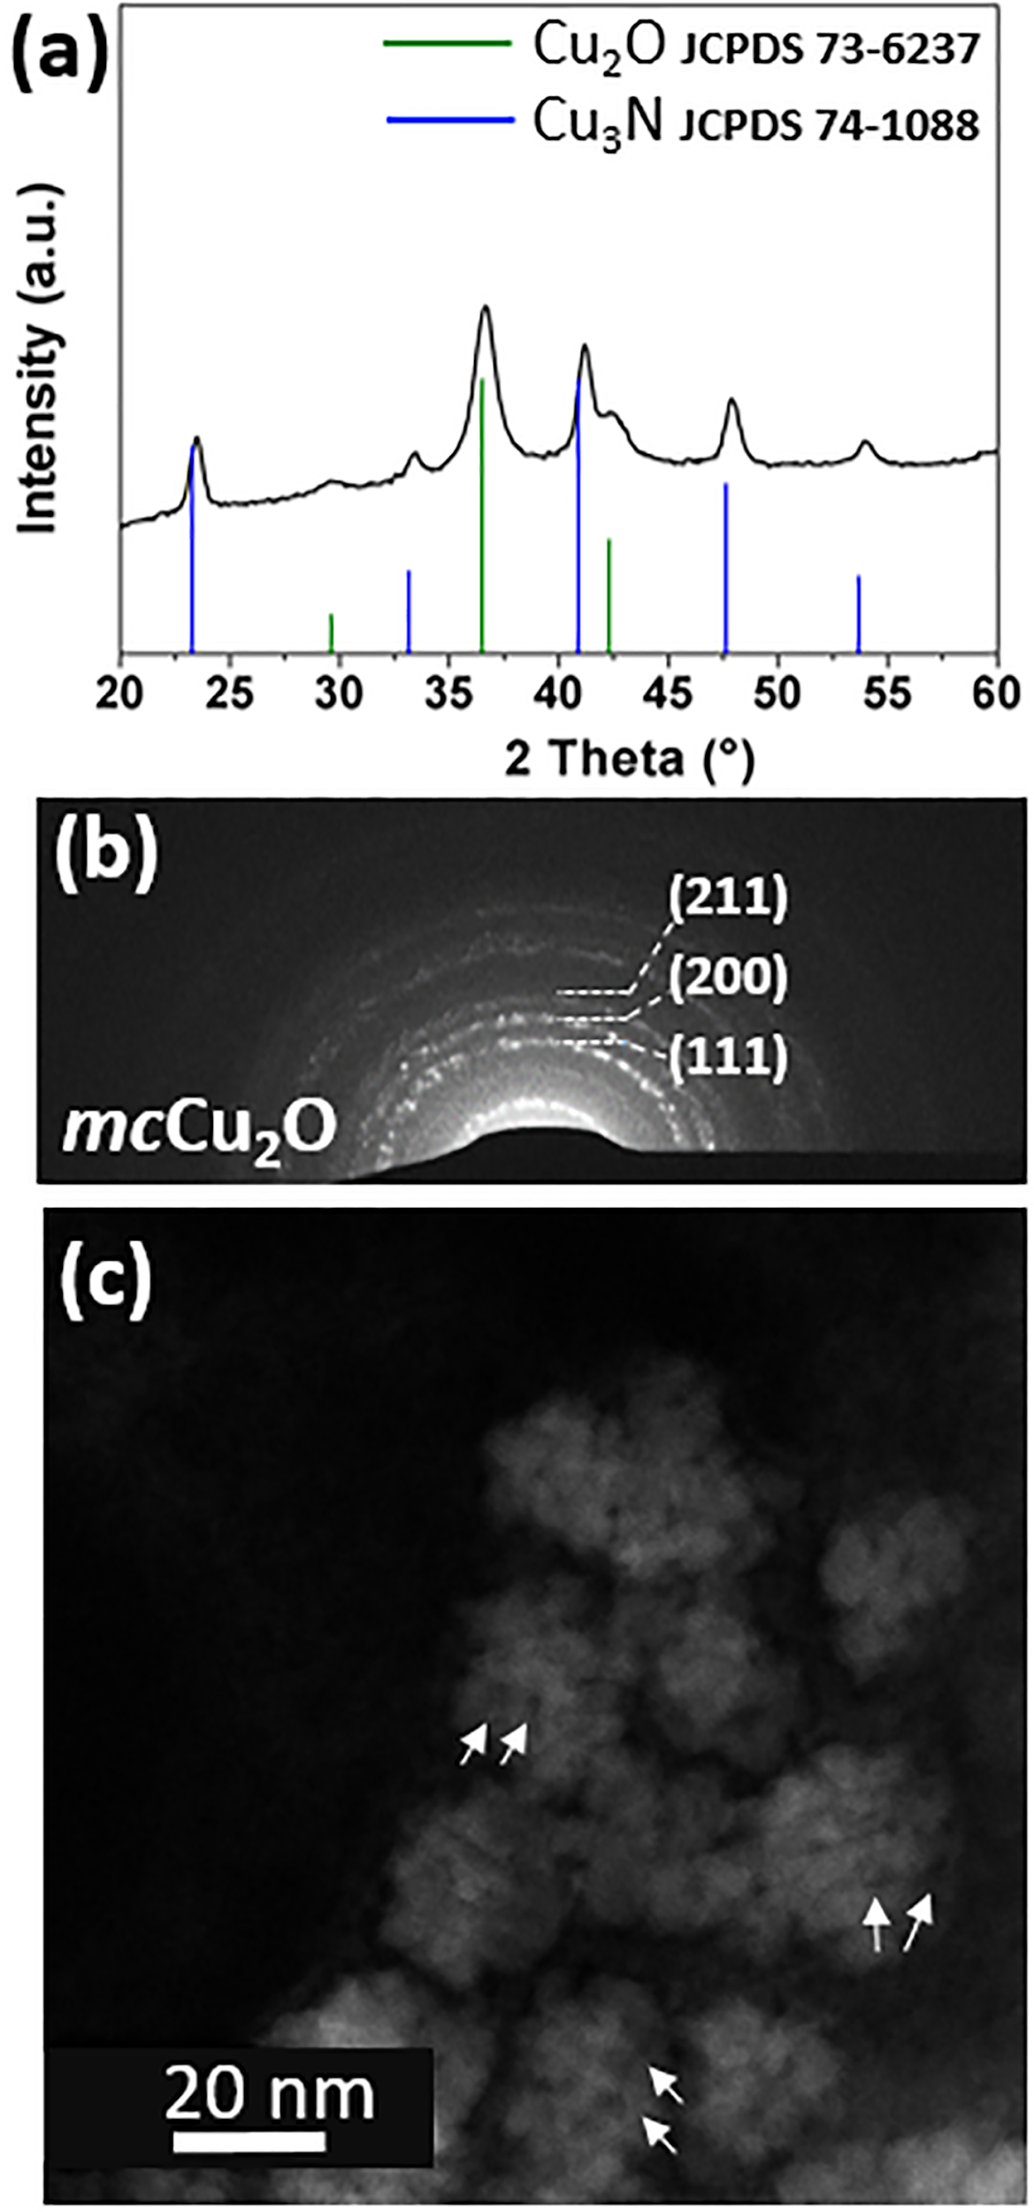
Figure 3: The XRD pattern of a product heated for 15 min at the final temperature (a). SAED pattern of mcCu₂O (b), acquired over HAADF-STEM micrograph of mcCu₂O (c), showing the occurrence of the nanocages (highlighted with the white arrows).

Variations in the product’s morphology and composition are also observed in the case when the precursor's solution containing hexadecylamine as surfactant is heated for prolonged time of 20 min (mcCu₃N-Cu₂O). Moreover, in comparison to mcCu₃N-O, the morphological and chemical transformations of mcCu₃N-H apparently proceed less rapidly, thus providing valuable insights into how the hollow core formation process of the mesocrystals occurs.
The HAADF-STEM analyses of mcCu₃N-Cu₂O (Figure 4a) reveals that under these conditions Cu₃N subunits in mesocrystals start to reduce in volume, in a such a way that the core shrinks while the outer shell remains, which in turn results in the shell-void-core morphology of the material (Figure 4a). The core retains its cube-shape, which is centered in the void and connected to the shell through the filaments in a symmetrical manner (highlighted with the arrow in Figure 4b). Such morphology is typically observed as intermediate stage in the nanoscale Kirkendall diffusion in nanoparticles, where the filaments provide pathways for the outward diffusion of metal ions from the core to the shell, resulting in hollow nanoparticles.^{30,31}

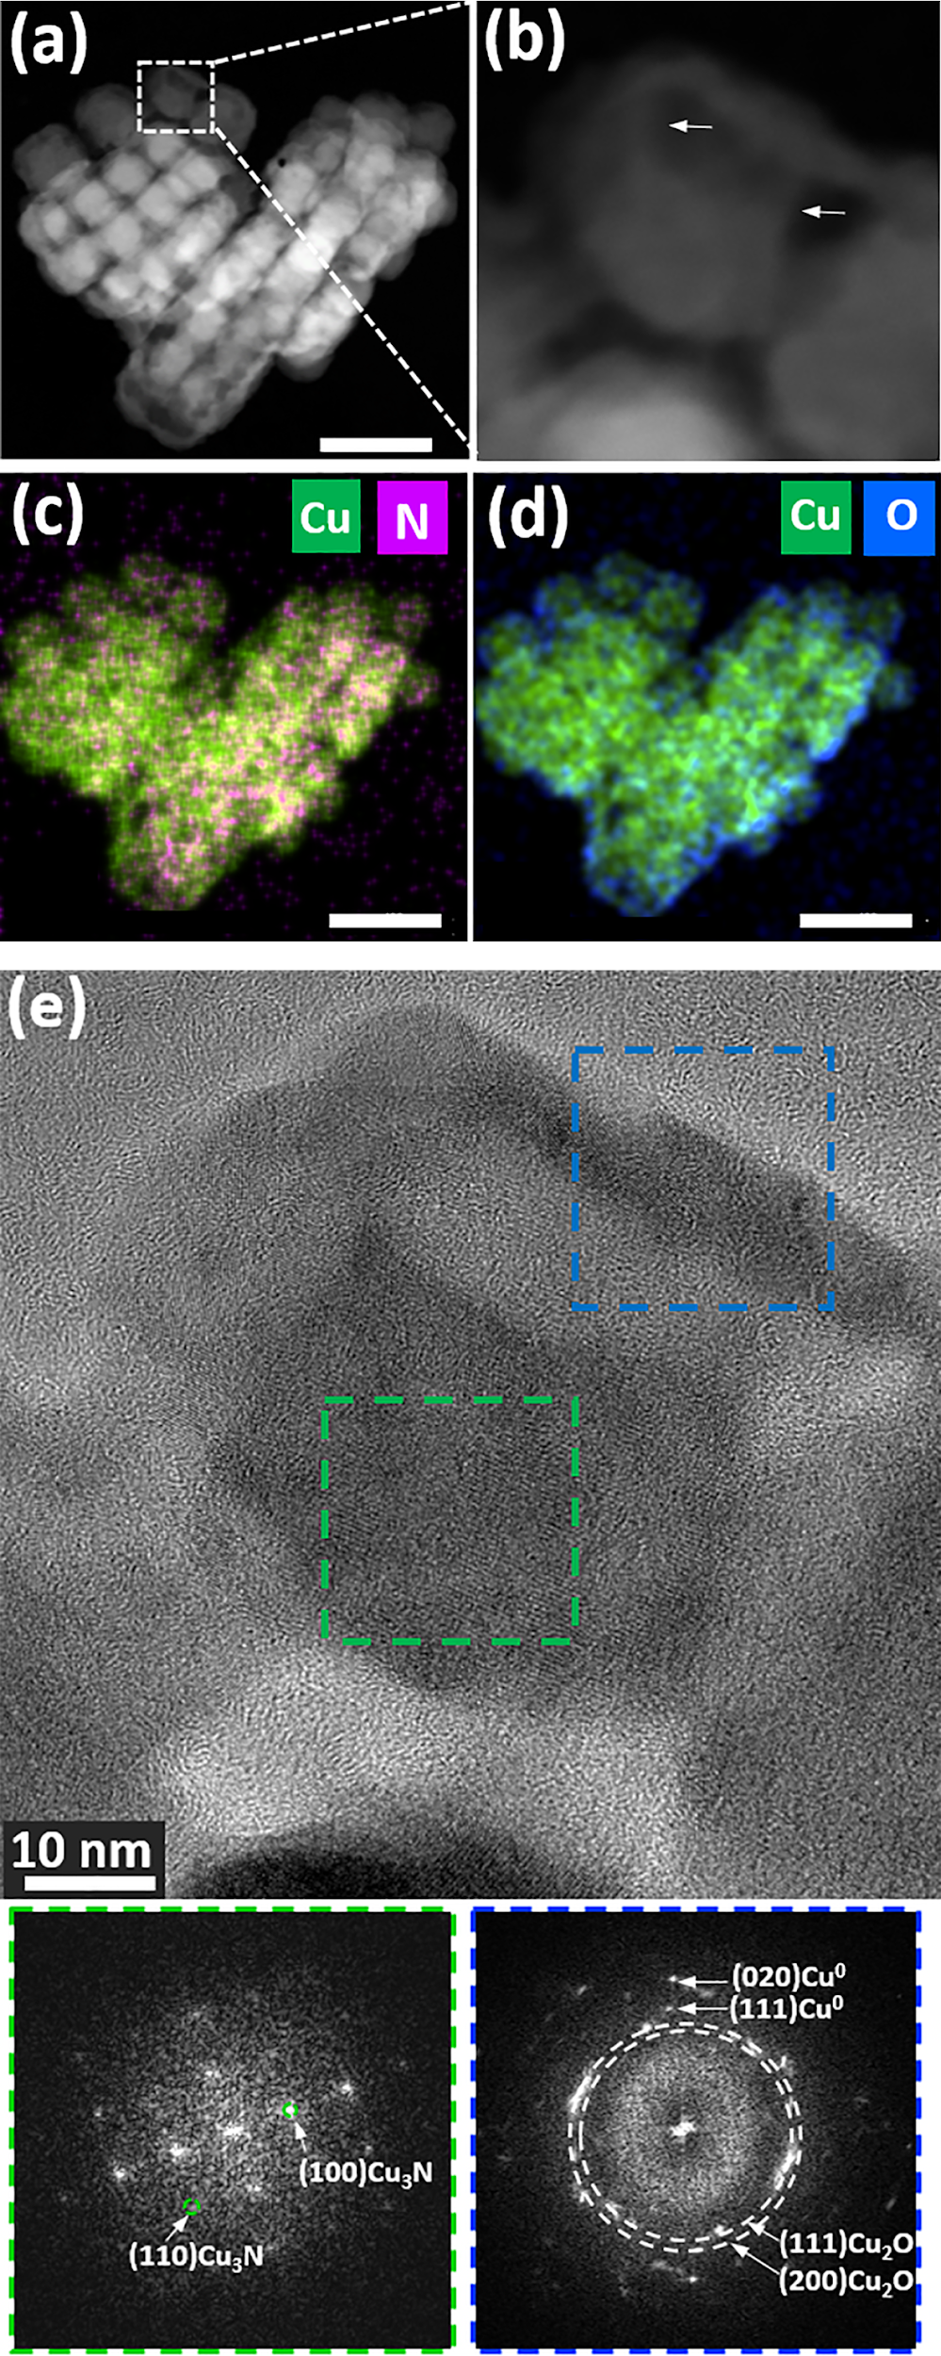
Figure 4: HAADF-STEM micrograph of one mesocrystal of mcCu₃N-Cu₂O (a), and part marked with the dotted square at higher magnification (b). The N/Cu (c) and O/Cu (d) overlaid EDXS maps of the area in panel (a). The HRTEM micrograph of the area highlighted in panel (a) with the insets showing the corresponding FFT patterns of the areas marked with a green, blue and yellow dotted square in panel (e). Scale bars in panels (a, c-d) correspond to 100 nm.
The chemical nature of mcCu₃N-Cu₂O investigated with EDXS (Figure 4c-d) analyses reveals that the copper is present in the core as well as in the shell, whereas the weak signal of N is found predominantly in the core, and the oxygen signal is confined to the shell. Peculiar morphology of mcCu₃N-Cu₂O and its crystalline nature is also confirmed by HRTEM analyses. The HRTEM pattern (Figure 4e) of the area delaminated with the white dotted square in Figure 4a, and the corresponding FFT pattern of the core and shell areas (delaminated with the green and blue dotted square, respectively), reveals a single-crystalline core corresponding to the Cu₃N structure, and a polycrystalline shell, indexed according to Cu₂O, thus confirming the occurrence of the multicomponent/heterostructured Cu₃N-Cu₂O mesocrystals. In some areas of the shell, the presence of metallic copper is also detected. The structure of the filaments on the other hand cannot be elucidated due to their small dimension, namely small thicknesses.

Discussion
The results of the analyses show that the use of two different surfactants in precursors’ solution, reacted under the same subtle heating regime, in both cases lead to the formation of Cu₃N mesocrystals. However, it is interesting to observe that mcCu₃N-O and mcCu₃N-H greatly differ in size and morphology of Cu₃N mesocrystals and their subunits. Large differences in the sizes of the mesocrystal subunits in mcCu₃N-O and mcCu₃N-H could be correlated to the use of different surfactants oleylamine and hexadecylamine, respectively, whereby the oleylamine more effectively blocks the growth of the subunits.²⁴ On the other hand, reasons for the variations in overall morphology of mesocrystals in mcCu₃N-O and mcCu₃N-H can likely be linked to the different binding scenarios of the corresponding subunits, namely to how and when the crystallographic alignment of subunits takes place with respect to their attachments.
Generally, the subunits of mesocrystals are subjected to different competitive attractive interactions, including van der Walls, dipole-dipole and solvation forces, which can be directional and shape dependent.^{3,32-34} In this regard, it was recently demonstrated for nanoparticulate assemblies that nanoparticles with flat surfaces tend to bind following two different pathways.³⁴ The nanoparticles either first align with their faces before the attachment, which, can also be detected as crystallographically aligned nanoparticles in our case due to materials’ cubic structure. As another option, the nanoparticles come into contact through misaligned attachment, which is followed by realignment of nanoparticles’ faces after the attachment.³⁴ In the latter case, the process of realignment is not always perfect after reaction is complete, often leading to the noticeable crystallographic misalignments. In fact, by comparing both samples, slight crystallographic misalignments of the mesocrystal subunits are sometimes detected in mcCu₃N-H as exemplified by FFT (Figure 2h) and confirmed by throughout TEM and FFT analyses of a large number of mesocrystals (Figure S4, Supporting Information). On the contrary, TEM and FFT analyses of mcCu₃N-O reveal that the mesocrystal subunits are always perfectly aligned in the crystallographic register.
Hence, to get more insights into the possible role of different binding pathways of subunits in mcCu₃N-O and mcCu₃N-H and on how they influence the overall mesocrystals morphology, the reaction products corresponding to the early reaction stages are sampled and analyzed. Given that for mcCu₃N-O the reaction at the final temperature is too rapid, the analysis is gained from the product, reacted at the intermediate reaction temperature of 220 ° C.
A combination of XRD and TEM analysis of the intermediate product intCu₃N-O (Figure 5a, Figure S3, Supporting Information) confirms the formation of small 4-5 nm sized Cu₃N nanoparticles, i.e. mesocrystal subunits, which at this reaction stage are already starting to organize into aggregates. The HRTEM pattern (Figure 5b, Inset) further confirms that the subunits of these aggregates are highly crystalline, and interestingly, are already arranged in a mutual crystallographic direction, although they are still away from each other. These results suggest that the mesocrystal formation of mcCu₃N-O follows the first binding pathway where subunits initially pre-align with their faces, and with their subsequent growth form final mcCu₃N-O. Such face-to-face organization of the subunits is thermodynamically most favorable therefore it is not surprising that the mesocrystals of mcCu₃N-O exhibit uniform size and morphology, with the shape resembling to that predicted by the Wulff construction.¹⁰⁻¹³

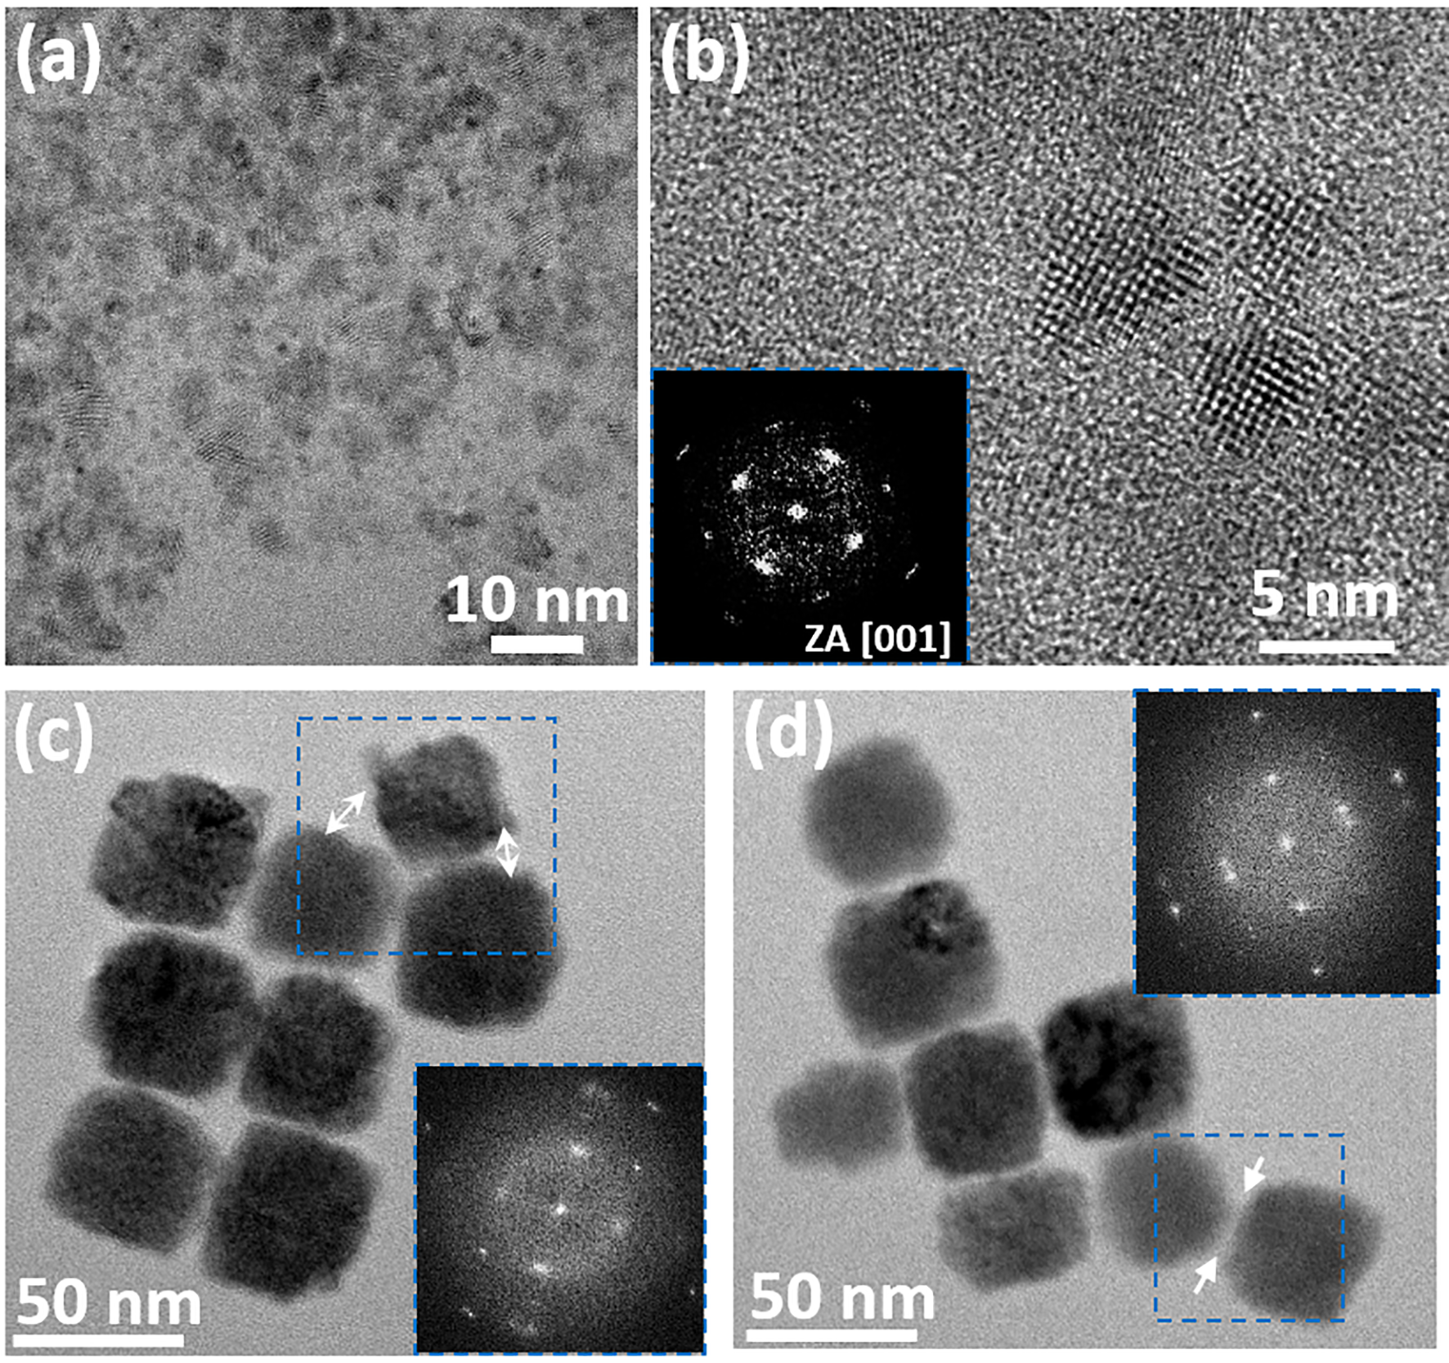
Figure 5: Representative TEM image of a sample corresponding to early reaction stages of mcCu₃N-O (a) and HRTEM pattern with corresponding FFT showing crystallographically aligned subunits. Representative TEM images showing early reaction stages of mcCu₃N-H (c,d), revealing misaligned attachment of subunits, with white arrows indicating face-to-face (c) and edge-to-face (d) attachment of the subunits.

On the contrary, the relatively uneven size and shape mesocrystals of mcCu₃N-H suggests that their final morphology is likely not governed by thermodynamic factors alone. TEM analysis of a product corresponding to the early reaction stages of mcCu₃N-H shows that subunits are of approximately the same size as in the final mcCu₃N-H, and in majority, are in aligned face-to-face configuration. Nevertheless, in some cases the subunits are still misaligned as exemplified by FFT analysis of the areas marked the dotted blue squares (Figure 5c,d, Inset). The analyses further reveal that the subunits come into contact through either misaligned face-to-face (Figure 5c) or edge-to-face (Figure 5d) attachment, which are thermodynamically less favored, and likely the contributing to the uneven morphologies of mesocrystals in final mcCu₃N-H. In fact, a direct comparison of the frequency count between aligned and misaligned subunits of intermediate and the final product in mcCu₃N-H reveals only slight variations (FigureS4, Supporting Information), therefore suggesting that subunits after they come into misaligned contact they stay permanently immobile, and no longer rotate into aligned face-to-face configuration. As a matter of fact, the occurrence of crystallographically ordered assemblies, with detected slight misalignments were reported before for drying-directed assemblies of nanoparticles´ suspensions during the solvent evaporation.^{35,36} Although, in our case, this process cannot be completely ruled out during the drop-casting of the product´s suspension on SEM or TEM specimen support, our studies on chemical conversion of Cu₃N mesocrystals show that the mesocrystals must form during the chemical reaction at elevated temperature. If that would not be the case, then the chemical conversion of individual Cu₃N nanoparticles would be expected, likely resulting in the occurrence of discrete multicomponent Cu₃N-Cu₂O or hollow Cu₂O nanoparticles. As such, the presented approach to Cu₃N mesocrystals, obtained in one-pot synthesis shows considerable advantages over the time-consuming drying-directed assembly of pre-synthesized nanoparticles, where highly ordered superstructures can be obtained during solvent evaporation.

In continuation, the mechanism for the chemical transformation of Cu₃N mesocrystals into Cu₃N-Cu₂O multicomponent mesocrystals and Cu₂O nanocages is proposed and discussed. We assume that in spite of large differences in size/morphology of mcCu₃N-O and mcCu₃N-H, their chemical conversion under longer heating is governed by the same reaction mechanisms but proceeds with the different reaction rates. Furthermore, we assume that the complex architecture and chemical composition of the products is a result of several parallel and consecutive processes, involving (i) chemical transformation of Cu₃N into Cu₂O and (ii) the anion exchange with nanoscale Kirkendall effect causing the hole formation of the nanostructure.

Scheme 2: Schematic illustrating the evolution of the morphology during chemical conversion of Cu₃N mesocrystals into Cu₂O nanocages.
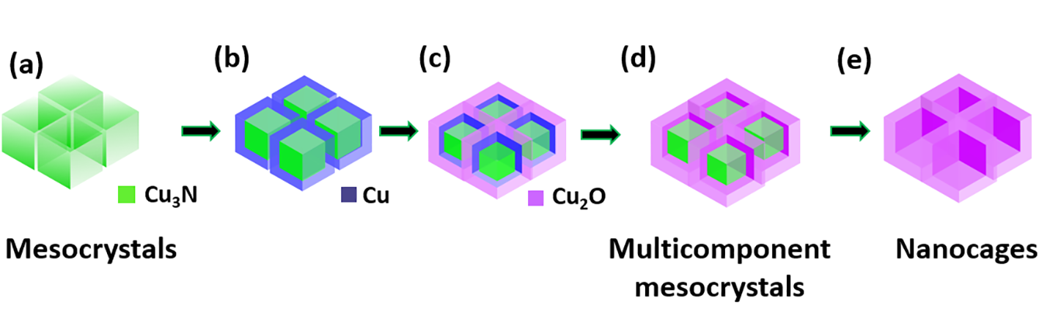

We propose that the chemical conversion of mesocrystals is initiated by partial decomposition of the Cu₃N, according to 2Cu₃N $→$ 6Cu⁰ + N₂ (Scheme 2 a-b). The occurrence of intermediate Cu⁰ is confirmed by HRTEM (Figure 4). The formation of Cu⁰, apparently proceeds in the outermost layer of the Cu₃N subunits, and then oxidizes forming Cu₂O shell. The shell subsequently grows causing the fusion of the subunits (Scheme 2, b-c). Concurrently with respect to Cu₂O formation, the hole formation of the nanostructure is triggered by the diffusion of the Cu⁰ from the core to the shell through the filaments, which is faster that the inward diffusion of anions. Diffusivity differences are balanced by the inward diffusion of vacancies, which coalesce forming voids, resulting in the shell-void-core morphology. This process leads to the occurrence of the intermediate multicomponent Cu₃N-Cu₂O mesocrystals (Scheme 2, d). As the reaction proceeds, the filaments become longer and thinner until the Cu₃N core is completely consumed, resulting in the final Cu₂O nanocages (Scheme 2, e).
Several experimental evidences, such as typical morphological features and the occurrence of the intermediate Cu⁰, support the above mechanism. However, concurrent processes of anion exchange, fostering hole formation through the faster outward diffusion of the nitrogen from Cu₃N with respect to slower inward diffusion of oxygen from Cu₂O, cannot be ruled out.

Conclusion
The solution-phase synthesis of two types of Cu₃N mesocrystals in the presence of surfactants is reported. When oleylamine is used as the surfactant the synthesis of 25 nm Cu₃N mesocrystals, composed of 8 nm sized subunits is achieved. In the presence of hexadecylamine, mesocrytals with size of approximately 150-450 nm, , composed of 50 nm Cu₃N subunits are formed. The analysis of intermediate products suggests the mesocrystals form as a result of non-classical crystallization and follow two different binding scenarios. Upon prolonged heating both types of mesocrystals undergo chemical conversion processes resulting in either Cu₂O nanocages or in Cu₃N-Cu₂O multicomponent mesocrystals. The chemical conversion is ascribed to the concurrent processes, involving (i) chemical transformation of Cu₃N into Cu₂O, and (ii) the anion exchange with nanoscale Kirkendall effect, causing the hole formation of the nanostructure. It is anticipated that these new members of the mesocrystal-family and the insights into their formation pathways will enhance the basic understanding of the crystallization mechanisms of the (multicomponent) mesocrystals, thus allowing for expanding their compositional variations. It is also anticipated that combining nanostructured Cu₃N and Cu₂O in an interesting mesocrystal-, and hollow morphology will provide novel opportunities for expanding the applicative potential of these interesting materials. Specifically, multicomponent Cu₃N-Cu₂O mesocrystals are combining n-type Cu₃N with the p-type Cu₂O semiconductor in an mesocrystals morphology, expected to allow the enhanced charge transport important for photocatalysis and solar fuels applications.

Literature

(1) De Yoreo, J. J.; Gilbert, P. U. P. A.; Sommerdijk, N. A. J. M.; Penn, R. L.; Whitelam, S.; Joester, D.; Zhang, H.; Rimer, J. D.; Navrotsky, A.; Banfield, J. F.; Wallace, A. F.; Michel, F. M.; Meldrum, F. C.; Cölfen, H.; Dove, P. M. Crystallization by Particle Attachment in Synthetic, Biogenic, and Geologic Environments. Science 2015, 349 6247
(2) Ye, X.; Zhu, C.; Ercius, P.; Raja, S. N.; He, B.; Jones, M. R.; Hauwiller, M. R.; Liu, Y.; Xu, T.; Alivisatos, A. P. Structural Diversity in Binary Superlattices Self-Assembled from Polymer-Grafted Nanocrystals. Nat. Commun. 2015, 6, 10052.
(3) Sturm (née Rosseeva), E. V; Cölfen, H. Mesocrystals: Structural and Morphogenetic Aspects. Chem. Soc. Rev. 2016, 45 (21), 5821–5833.
(4) Cölfen, H.; Antonietti, M. Mesocrystals: Inorganic Superstructures Made by Highly Parallel Crystallization and Controlled Alignment. Angew. Chemie Int. Ed. 2005, 44 (35), 5576–5591.
(5) Zhou, L.; Obrien, P. Mesocrystals - Properties and Applications. J. Phys. Chem. Lett. 2012, 3 (5), 620–628.
(6) Ma, M. G.; Cölfen, H. Mesocrystals - Applications and Potential. Curr. Opin. Colloid Interface Sci. 2014, 19 (2), 56–65.
(7) Chen, S.; Wang, M.; Ye, J.; Cai, J.; Ma, Y.; Zhou, H.; Qi, L. Kinetics-Controlled Growth of Aligned Mesocrystalline SnO2nanorod Arrays for Lithium-Ion Batteries with Superior Rate Performance. Nano Res. 2013, 6 (4), 243–252.
(8) Ye, J.; Liu, W.; Cai, J.; Chen, S.; Zhao, X.; Zhou, H.; Qi, L. Nanoporous Anatase TiO2mesocrystals: Additive-Free Synthesis, Remarkable Crystalline-Phase Stability, and Improved Lithium Insertion Behavior. J. Am. Chem. Soc. 2011, 133 (4), 933–940.
(9) Sun, S.; Yu, X.; Yang, Q.; Yang, Z.; Liang, S. Mesocrystals for Photocatalysis: A Comprehensive Review on Synthesis Engineering and Functional Modifications. Nanoscale Adv. 2018.
(10) Primc, D.; Niederberger, M. Synthesis and Formation Mechanism of Multicomponent Sb–Nb:TiO 2 Mesocrystals. Chem. Mater. 2017, 29 (23), 10113–10121.
(11) Deng, S.; Tjoa, V.; Fan, H. M.; Tan, H. R.; Sayle, D. C.; Olivo, M.; Mhaisalkar, S.; Wei, J.; Sow, C. H. Reduced Graphene Oxide Conjugated Cu2O Nanowire Mesocrystals for High-Performance NO 2 Gas Sensor. J. Am. Chem. Soc. 2012, 134 (10), 4905–4917.
(12) Di, M.; Li, Y.; Wang, H.; Rui, Y.; Jia, W.; Zhang, Q. Ellipsoidal TiO2mesocrystals as Bi-Functional Photoanode Materials for Dye-Sensitized Solar Cells. Electrochim. Acta 2018, 261, 365–374.
(13) Niederberger, M.; Cölfen, H. Oriented Attachment and Mesocrystals: Non-Classical Crystallization Mechanisms Based on Nanoparticle Assembly. Phys. Chem. Chem. Phys. 2006, 8 (28), 3271–3287.
(14) Fang, J.; Ding, B.; Gleiter, H. Mesocrystals: Syntheses in Metals and Applications. Chem. Soc. Rev. 2011, 40 (11), 5347–5360.
(15) Zhou, L.; O’Brien, P. Mesocrystals: A New Class of Solid Materials. Small 2008, 4 (10), 1566–1574.
(16) Bian, Z.; Tachikawa, T.; Zhang, P.; Fujitsuka, M.; Majima, T. A Nanocomposite Superstructure of Metal Oxides with Effective Charge Transfer Interfaces. Nat. Commun. 2014, 5, 1–9.
(17) Mazumder, B.; Hector, A. L. Synthesis and Applications of Nanocrystalline Nitride Materials. J. Mater. Chem. 2009, 19 (27), 4673–4686.
(18) Zhong, Y.; Xia, X. H.; Shi, F.; Zhan, J. Y.; Tu, J. P.; Fan, H. J. Transition Metal Carbides and Nitrides in Energy Storage and Conversion. Adv. Sci. 2015, 3 (5).
(19) Ningthoujam, R. S.; Gajbhiye, N. S. Synthesis, Electron Transport Properties of Transition Metal Nitrides and Applications. Prog. Mater. Sci. 2015, 70, 50–154.
(21) Dong, S.; Chen, X.; Zhang, X.; Cui, G. Nanostructured Transition Metal Nitrides for Energy Storage and Fuel Cells. Coord. Chem. Rev. 2013, 257 (13–14), 1946–1956.
(22) Zakutayev, A.; Caskey, C. M.; Fioretti, A. N.; Ginley, D. S.; Vidal, J.; Stevanovic, V.; Tea, E.; Lany, S. Defect Tolerant Semiconductors for Solar Energy Conversion. J. Phys. Chem. Lett. 2014, 5 (7), 1117–1125.
(23) Xi, P.; Xu, Z.; Gao, D.; Chen, F.; Xue, D.; Tao, C. L.; Chen, Z. N. Solvothermal Synthesis of Magnetic Copper Nitride Nanocubes with Highly Electrocatalytic Reduction Properties. RSC Adv. 2014, 4 (27), 14206–14209.
(24) Wu, H.; Chen, W. Copper Nitride Nanocubes: Size-Controlled Synthesis and Application as Cathode Catalyst in Alkaline Fuel Cells. J. Am. Chem. Soc. 2011, 133 (39), 15236–15239.
(25) Maruyama, T.; Morishita, T. Copper Nitride and Tin Nitride Thin Films for Write-Once Optical Recording Media. Appl. Phys. Lett. 1996, 69 (7), 890–891. https://doi.org/10.1063/1.117978.
(26) Giordano, C.; Antonietti, M. Synthesis of Crystalline Metal Nitride and Metal Carbide Nanostructures by Sol-Gel Chemistry. Nano Today 2011, 6 (4), 366–380.
(27) Sithole, R. K.; MacHogo, L. F. E.; Airo, M. A.; Gqoba, S. S.; Moloto, M. J.; Shumbula, P.; Van Wyk, J.; Moloto, N. Synthesis and Characterization of Cu3N Nanoparticles Using Pyrrole-2-Carbaldpropyliminato Cu(II) Complex and Cu(NO3)2as Single-Source Precursors: The Search for an Ideal Precursor. New J. Chem. 2018, 42 (4), 3042–3049.
(28) Choi, J.; Gillan, E. G. Solvothermal Synthesis of Nanocrystalline Copper Nitride from an Energetically Unstable Copper Azide Precursor. 2005, 44 (21), 7385–7393.
(29) Deshmukh, R.; Zeng, G.; Tervoort, E.; Staniuk, M.; Wood, D.; Niederberger, M. Ultrasmall Cu3N Nanoparticles: Surfactant-Free Solution-Phase Synthesis, Nitridation Mechanism, and Application for Lithium Storage. Chem. Mater. 2015, 27 (24), 8282–8288.
(30) Oh, M. H.; Yu, T.; Yu, S.-H.; Lim, B.; Ko, K.-T.; Willinger, M.-G.; Seo, D.-H.; Kim, B. H.; Cho, M. G.; Park, J.-H.; Kang, K.; Sung, Y.-E.; Pinna, N.; Hyeon, T. Galvanic Replacement Reactions in Metal Oxide Nanocrystals. Science (80-. ). 2013, 340 (6135), 964–968.
(31) Anderson, B. D.; Tracy, J. B. Nanoparticle Conversion Chemistry: Kirkendall Effect, Galvanic Exchange, and Anion Exchange. Nanoscale 2014, 6 (21), 12195–12216.
(32) Tan, S. F.; Chee, S. W.; Lin, G.; Mirsaidov, U. Direct Observation of Interactions between Nanoparticles and Nanoparticle Self-Assembly in Solution. Acc. Chem. Res. 2017, 50 (6), 1303–1312.
(33) Welch, D. A.; Woehl, T. J.; Park, C.; Faller, R.; Evans, J. E.; Browning, N. D. Understanding the Role of Solvation Forces on the Preferential Attachment of Nanoparticles in Liquid. ACS Nano 2016, 10 (1), 181–187.
(34) Tan, S. F.; Raj, S.; Bisht, G.; Annadata, H. V.; Nijhuis, C. A.; Král, P.; Mirsaidov, U. Nanoparticle Interactions Guided by Shape-Dependent Hydrophobic Forces. Adv. Mater. 2018, 30 (16), 1–8.
(35) Agthe, M.; Plivelic, T. S.; Labrador, A.; Bergström, L.; Salazar-Alvarez, G. Following in Real Time the Two-Step Assembly of Nanoparticles into Mesocrystals in Levitating Drops. Nano Lett. 2016, 16 (11), 6838–6843.
(36) Disch, S.; Wetterskog, E.; Hermann, R. P.; Salazar-Alvarez, G.; Busch, P.; Brückel, T.; Bergström, L.; Kamali, S. Shape Induced Symmetry in Self-Assembled Mesocrystals of Iron Oxide Nanocubes. Nano Lett. 2011, 11 (4), 1651–1656.

