Figure Legend

Figure 1: The ASCOT-Legacy study profile: patient population stratified by the treatment allocation

Figure 2 (a-d): The risk of cause-specific deaths among those allocated to the amlodipine based treatment as compared to those on the atenolol-based treatment in the 16 year follow up of the ASCOT-Legacy cohort assigned to the BPLA

Figure 3 (a-d): The risk of cause-specific deaths among those allocated to the atorvastatin compared with placebo in the 16 year follow up of the ASCOT-Legacy cohort assigned to LLA

Figure 4: The risk (hazard ratios) of the cause specific mortality amongst those assigned to two treatments in the BPLA and LLA of the ASCOT-Legacy cohort

Figure 1: The ASCOT-Legacy study profile: patient population stratified by the treatment allocation

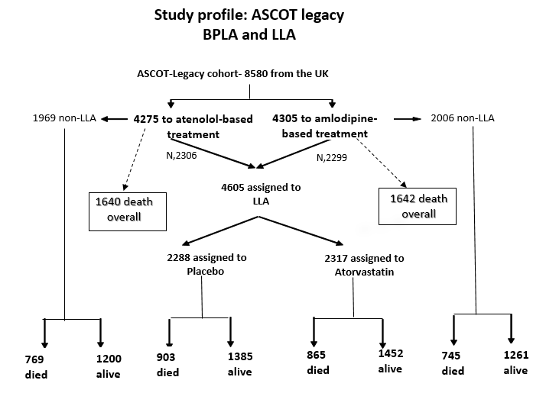

BPLA: blood pressure lowering arm ; LLA: lipid-lowering arm

Figure 2a: Kaplan Meirer plots for cumulative incidence of all-cause mortality amongst those allocated to the two BP-treatment groups

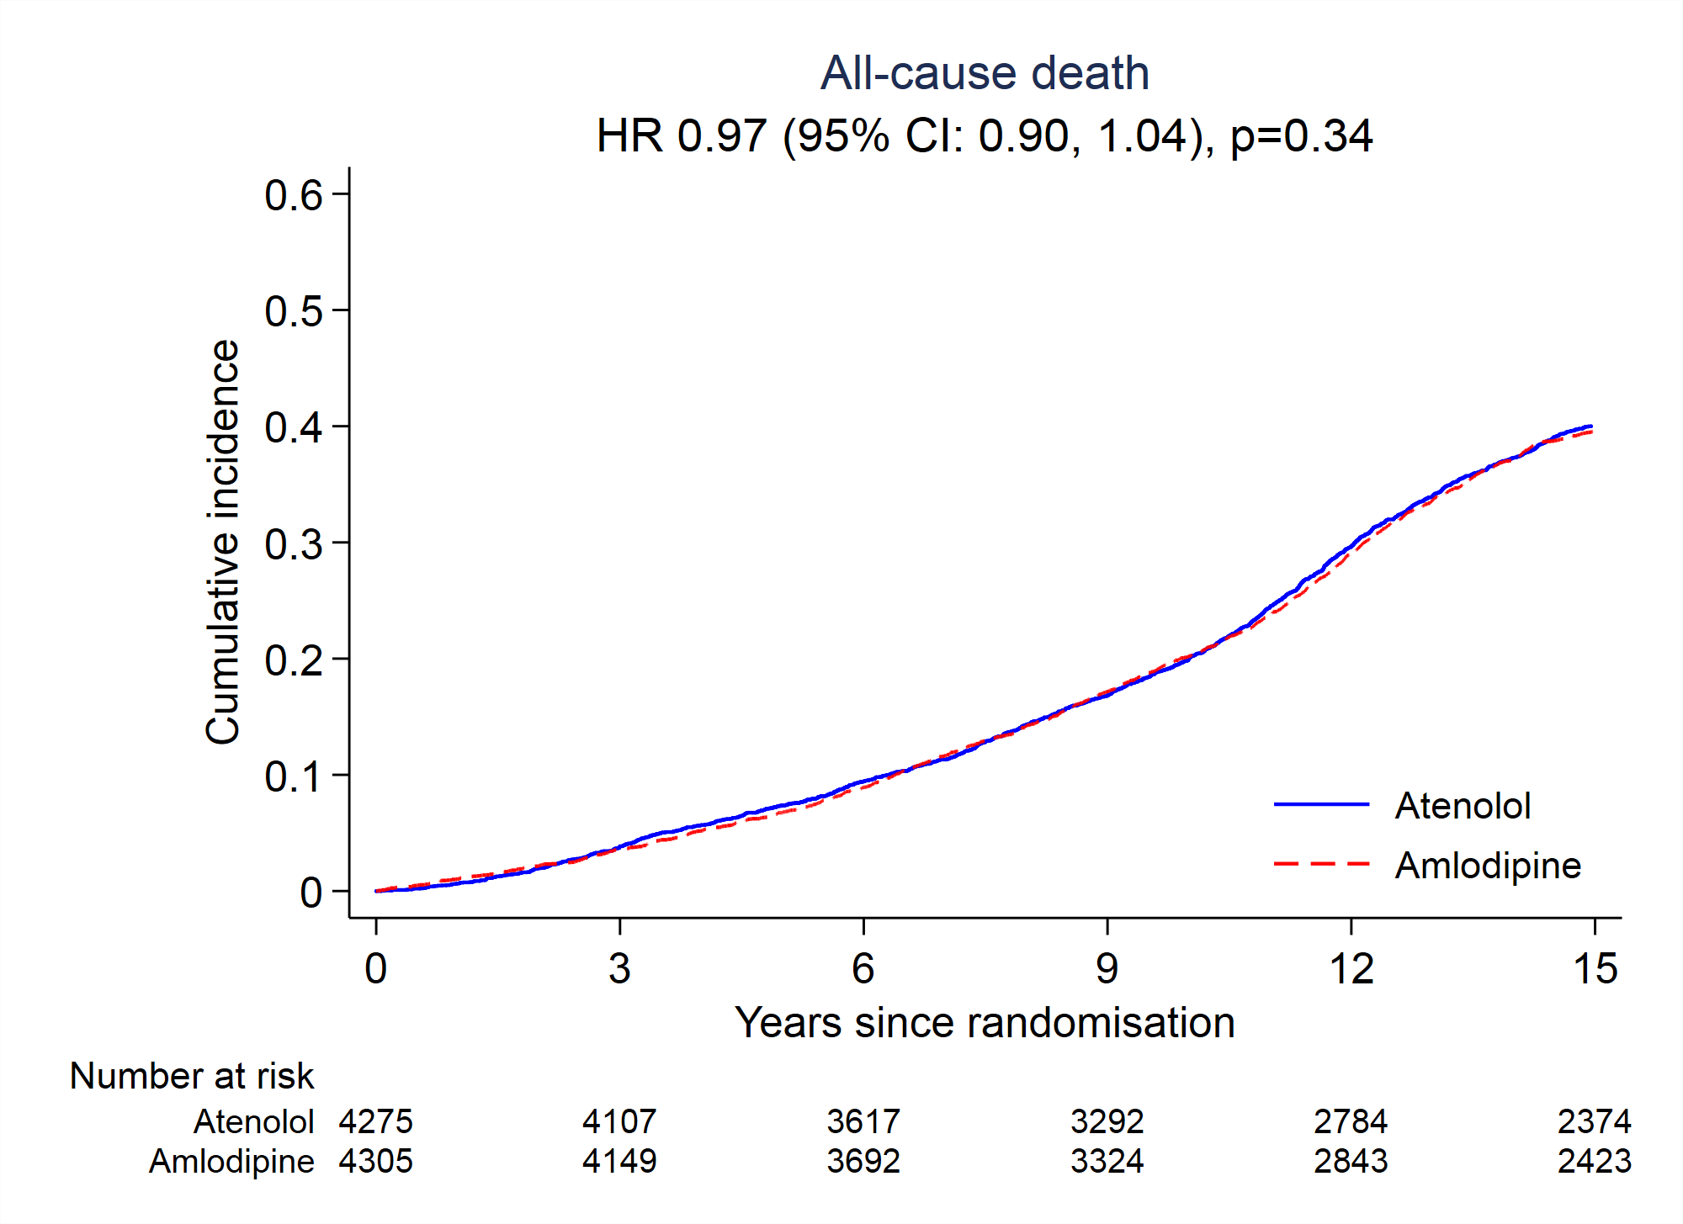

HR: hazard ratio

Figure 2b: KM plots for the cumulative incidence of the cardiovascular mortality amongst those allocated to the two BP-treatment groups

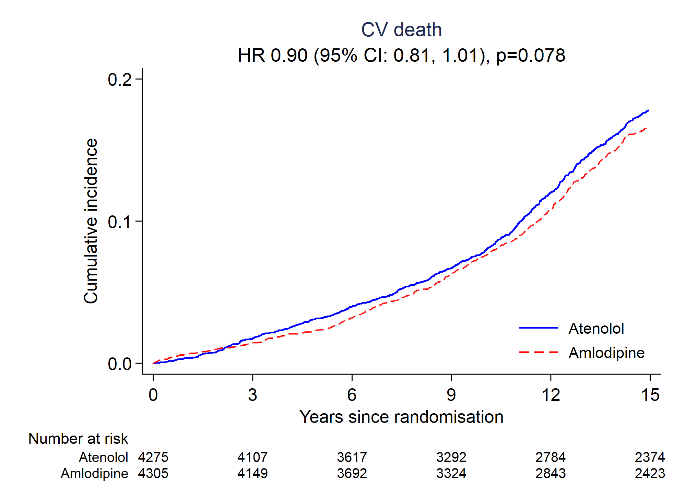

CV: cardiovascular mortality

Figure 2c: KM plots for the cumulative incidence of the coronary heart disease mortality amongst those allocated to the two BP-treatment groups

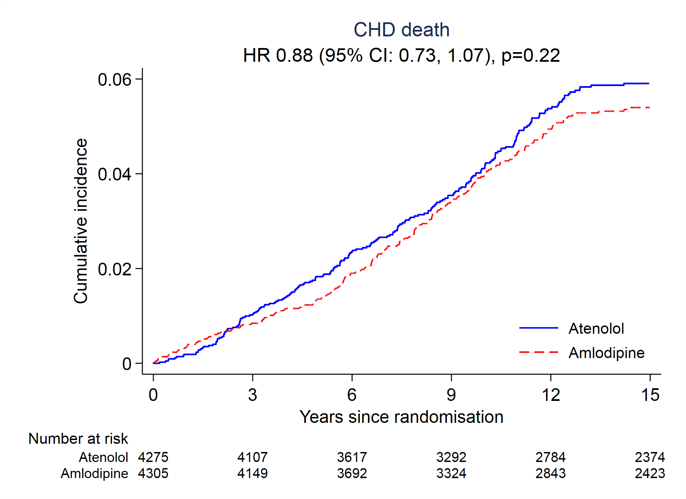

CHD: coronary heart disease -related mortality

Figure 2d: KM plots for the cumulative incidence of the stroke mortality amongst those allocated to the two BP-treatment groups

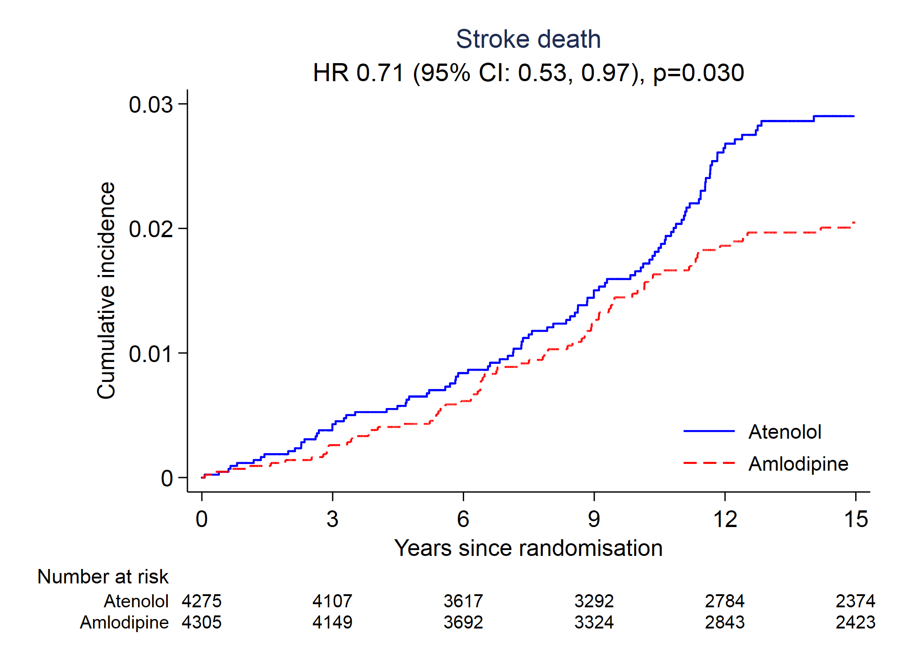

Figure 3a: KM plots for cumulative incidence of the all-cause mortality amongst those allocated to the atorvastatin or a placebo

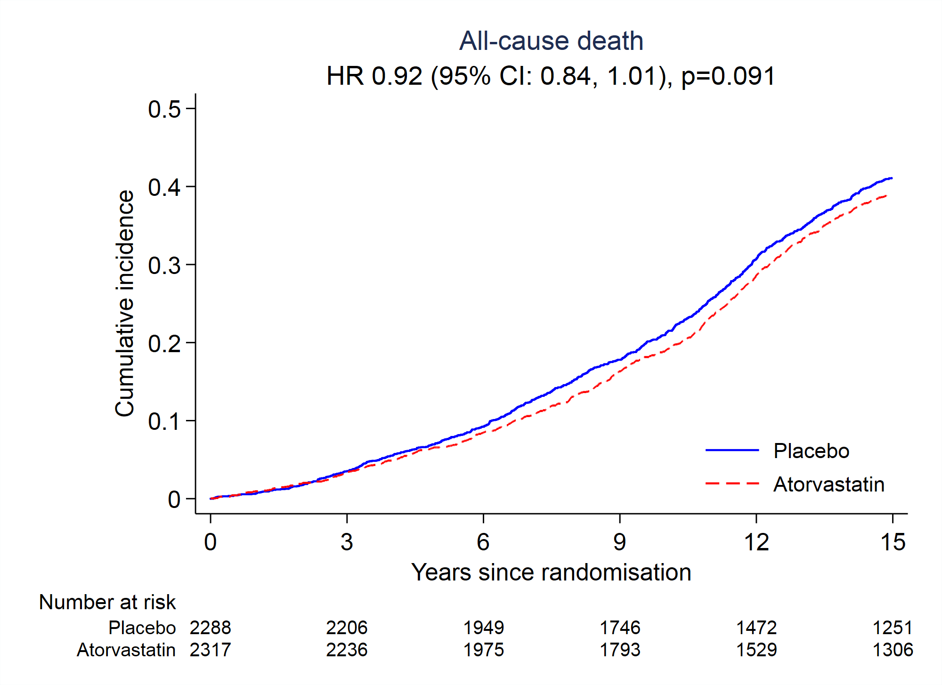

Figure 3b: KM plots for the cumulative incidence of the cardiovascular mortality amongst those allocated to the atorvastatin or a placebo

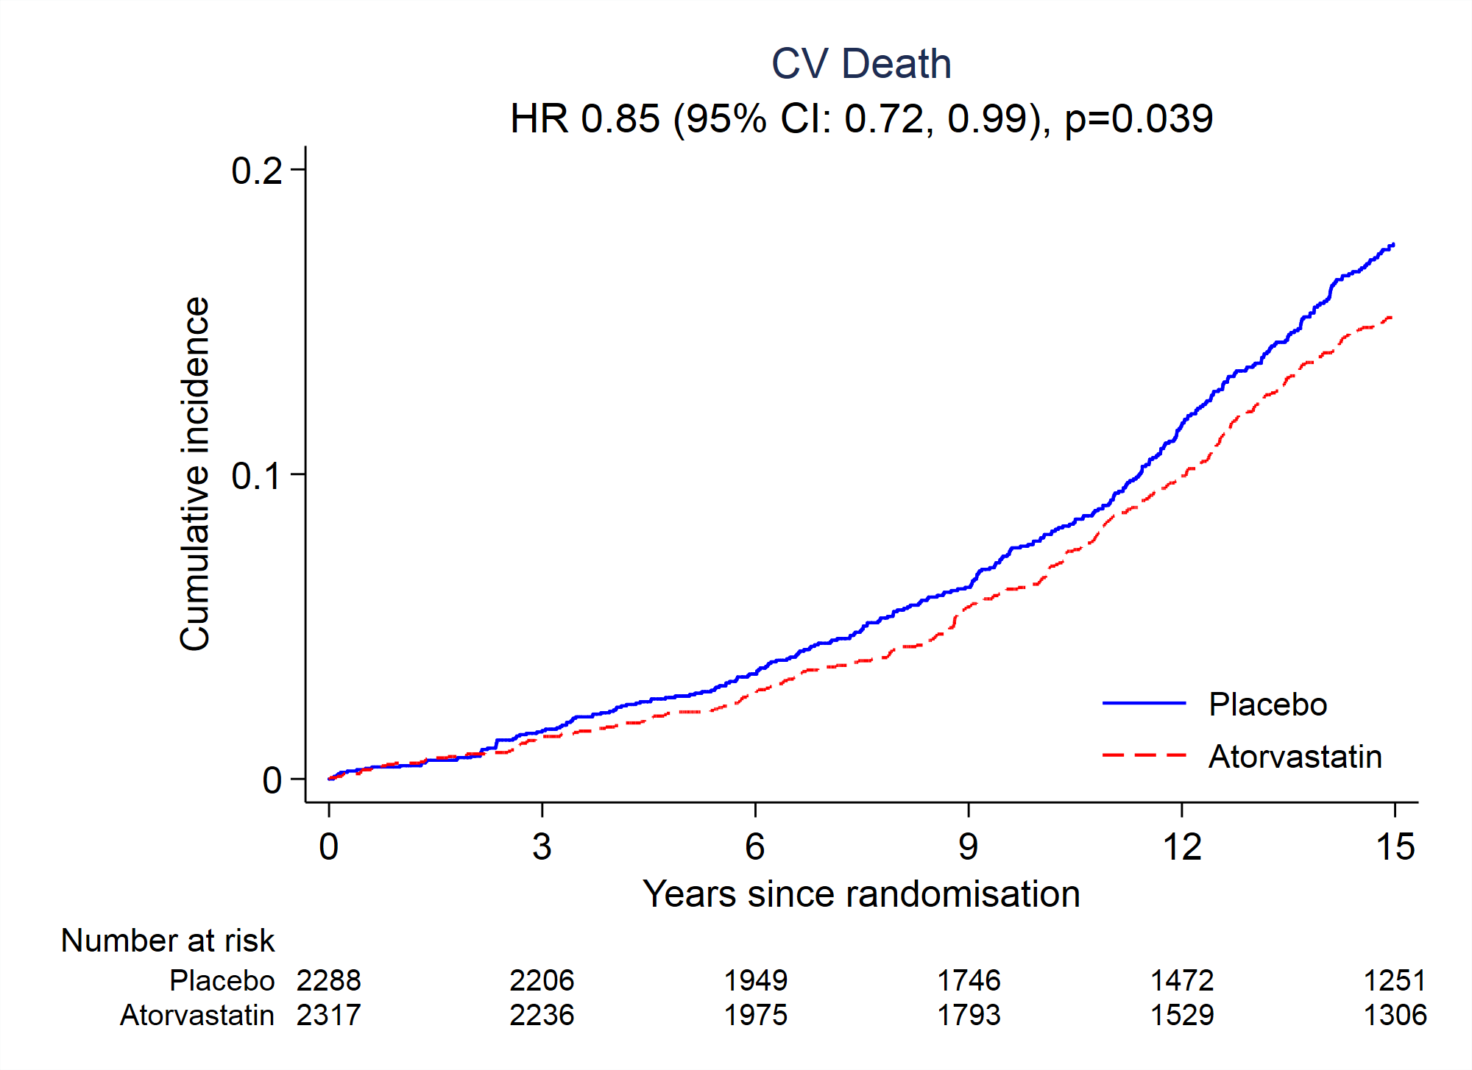

Figure 3c: KM plots for the cumulative incidence of the coronary heart disease mortality amongst those allocated to the atorvastatin or a placebo

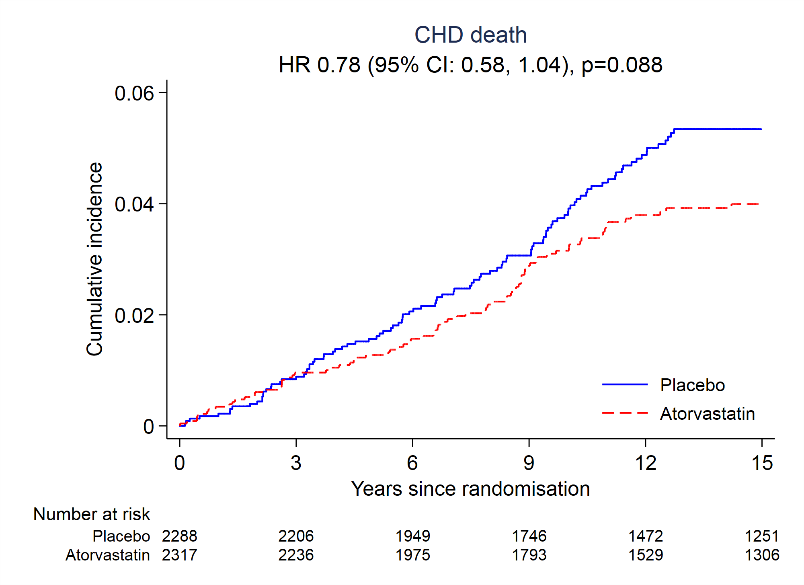

Figure 3d: KM plots for the cumulative incidence of the stroke mortality amongst those allocated to the atorvastatin or a placebo

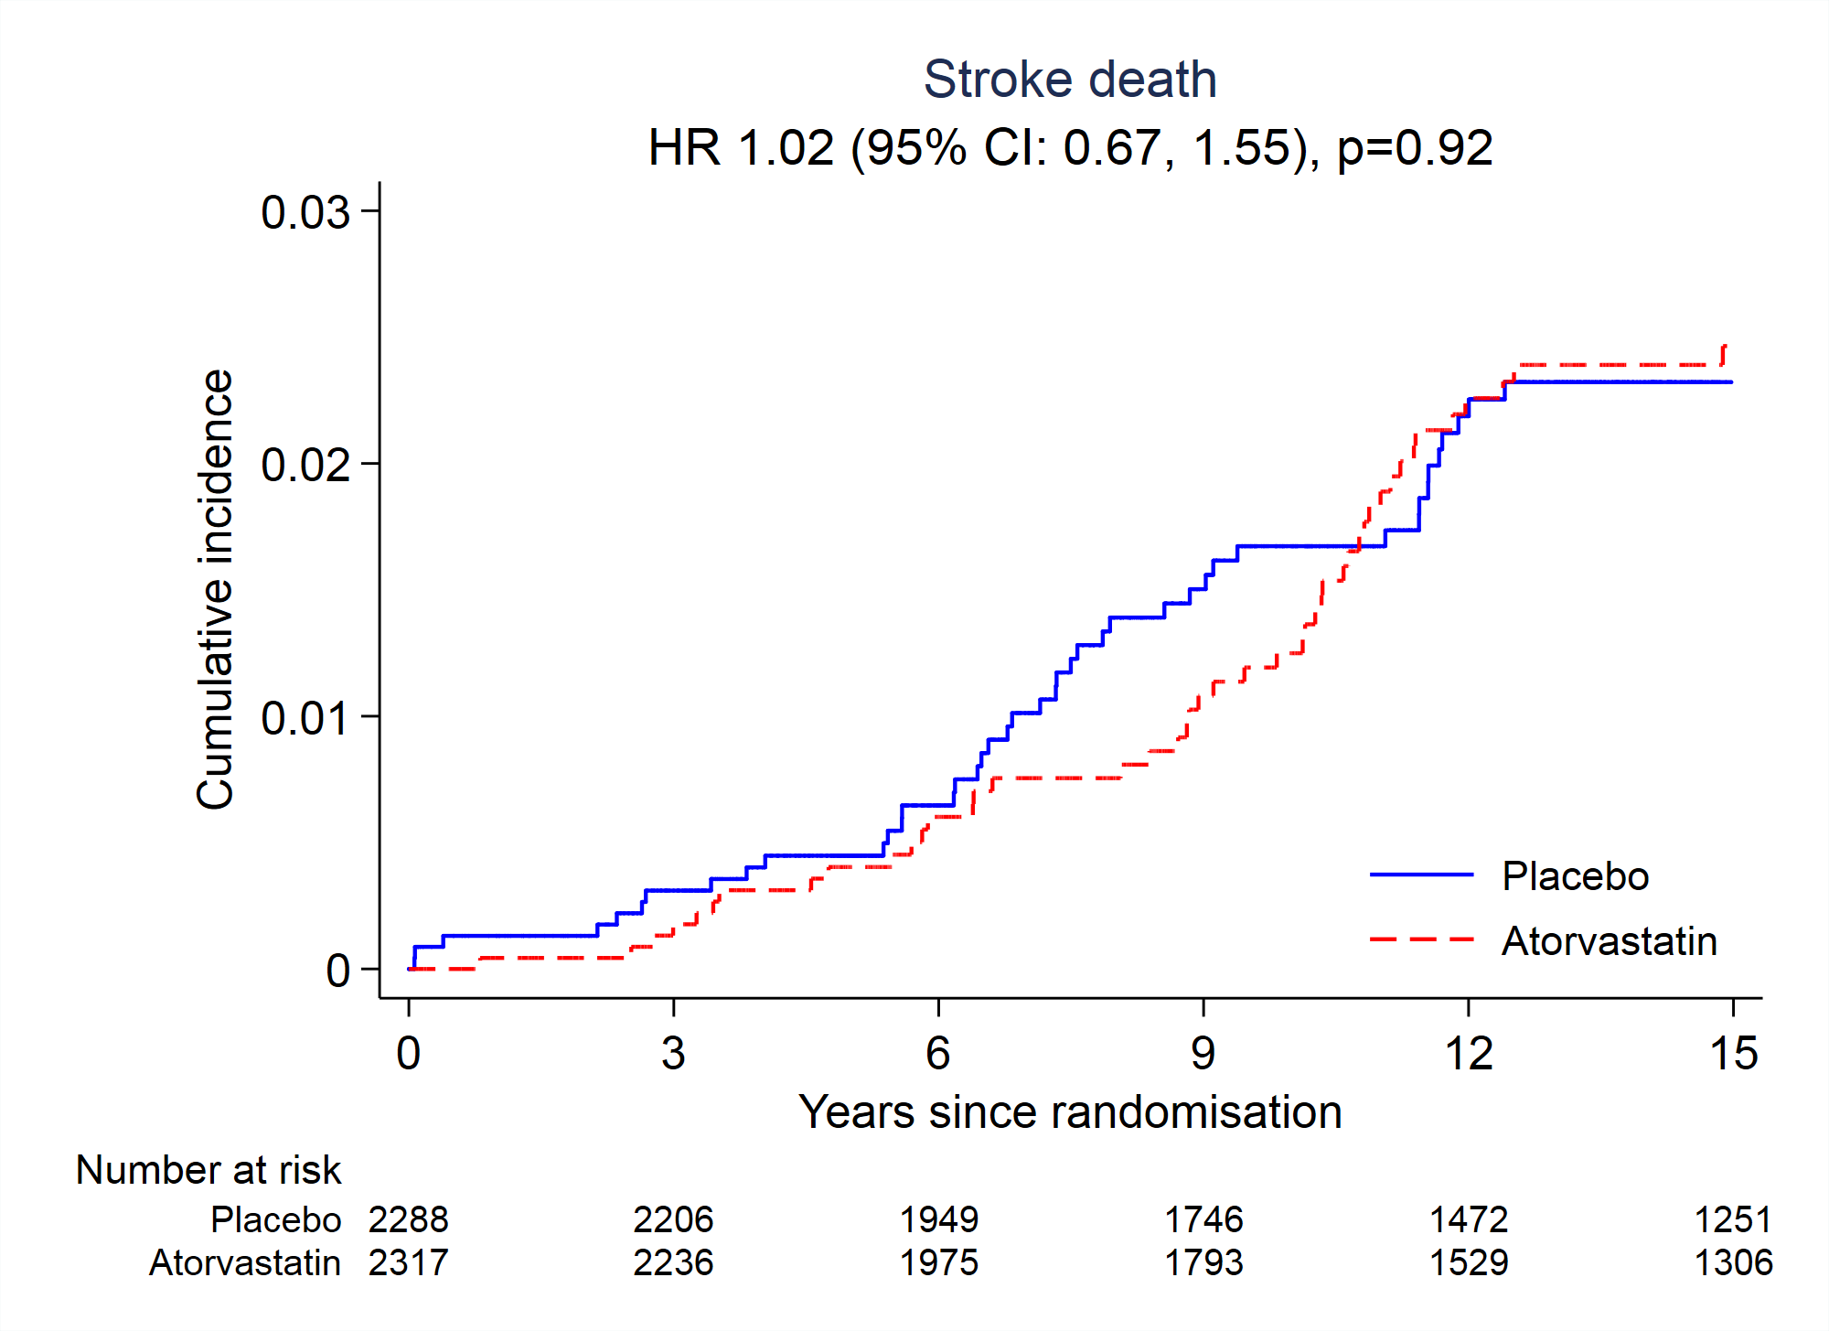

Figure 4 The risk (hazard ratios) of the cause specific mortality amongst those assigned to the two treatment groups in the BPLA and LLA of the

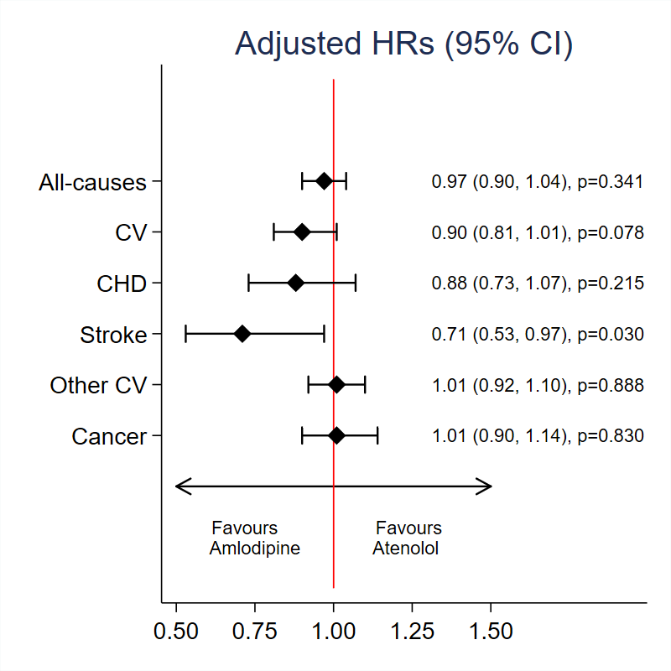 | 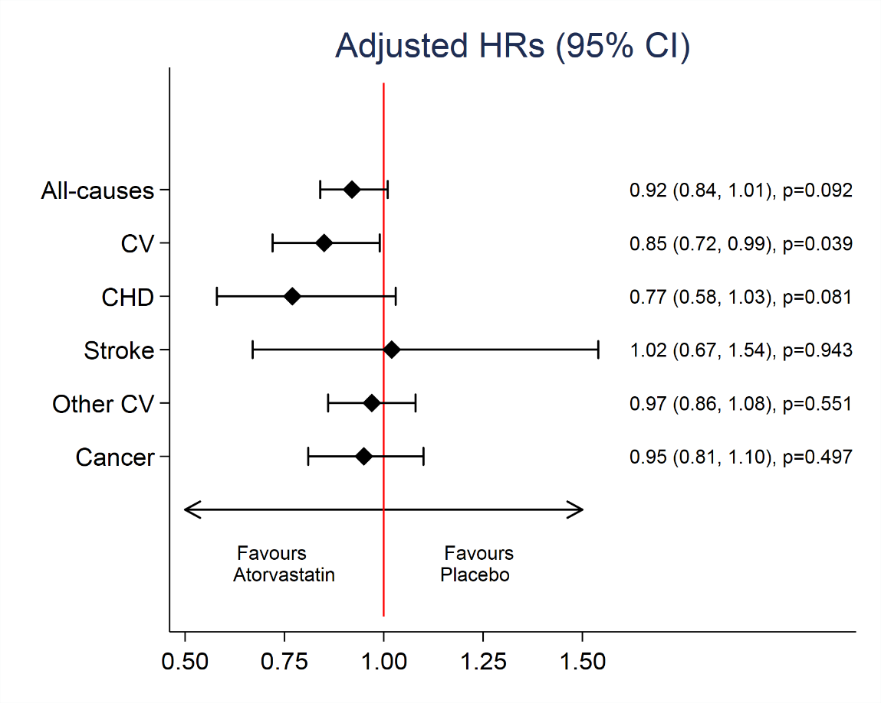
BPLA LLA

